MERGEFORMAT
Delegations will find attached the Opinion of the UK House of Lords on the Proposal for a regulation of the European Parliament and of the Council on new psychoactive substances and on the Proposal for a Directive of the European Parliament and of the Council amending Council Framework Decision 2004/757/JHA of 25 October 2004 laying down minimum provisions on the constituent elements of criminal acts and penalties in the field of illicit drug trafficking, as regards the definition of drug.

Encl.: Opinion of 12 November 2013

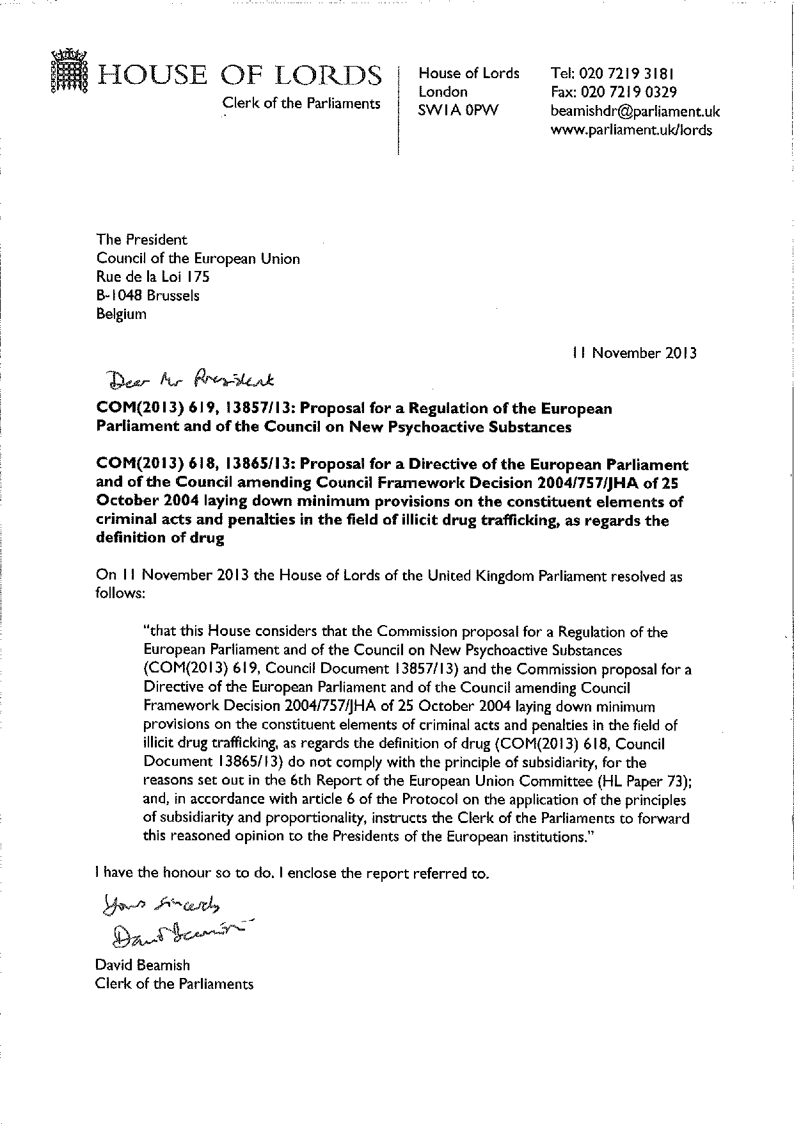
ANNEX

