MERGEFORMAT
Delegations will find attached the Opinion of the Italian Senate on the Proposal for a regulation of the European Parliament and of the Council on new psychoactive substances.
Encl.: Opinion of 20 November 2013
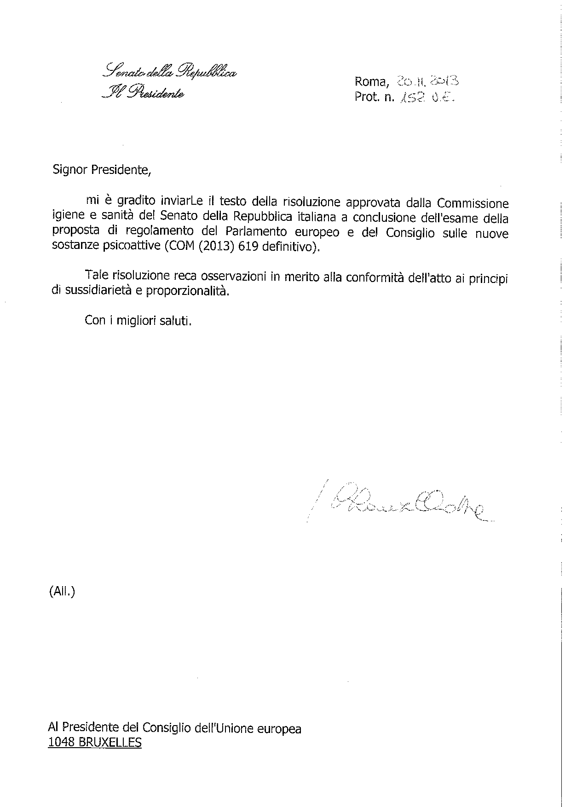
ANNEX

