 | 
COUNCIL OF  THE EUROPEAN UNION |  |  | Brussels, 19 November 2013
 | Interinstitutional File:  2013/0188 (CNS) |  | 16429/13
FISC 222
INST 619
PARLNAT 295

COVER NOTE
from: | The Portuguese Parliament
date of receipt: | 13 November 2013
to: | The President of the Council of the European Union
Subject: | Proposal for a COUNCIL DIRECTIVE amending Directives 2011/16/EU as regards mandatory automatic exchange of information in the field of taxation  [doc. 10243/13 FISC 113 - COM(2013) 348 final]  - Opinion on the application of the Principles of Subsidiarity and Proportionality

Delegations will find attached the abovementioned opinion.

________________________

Encl.

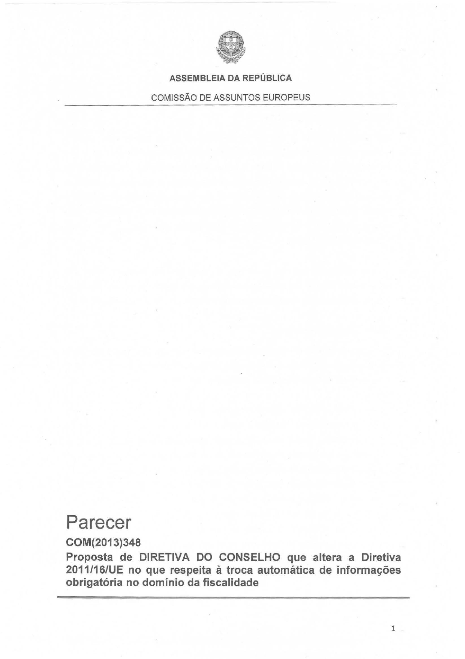
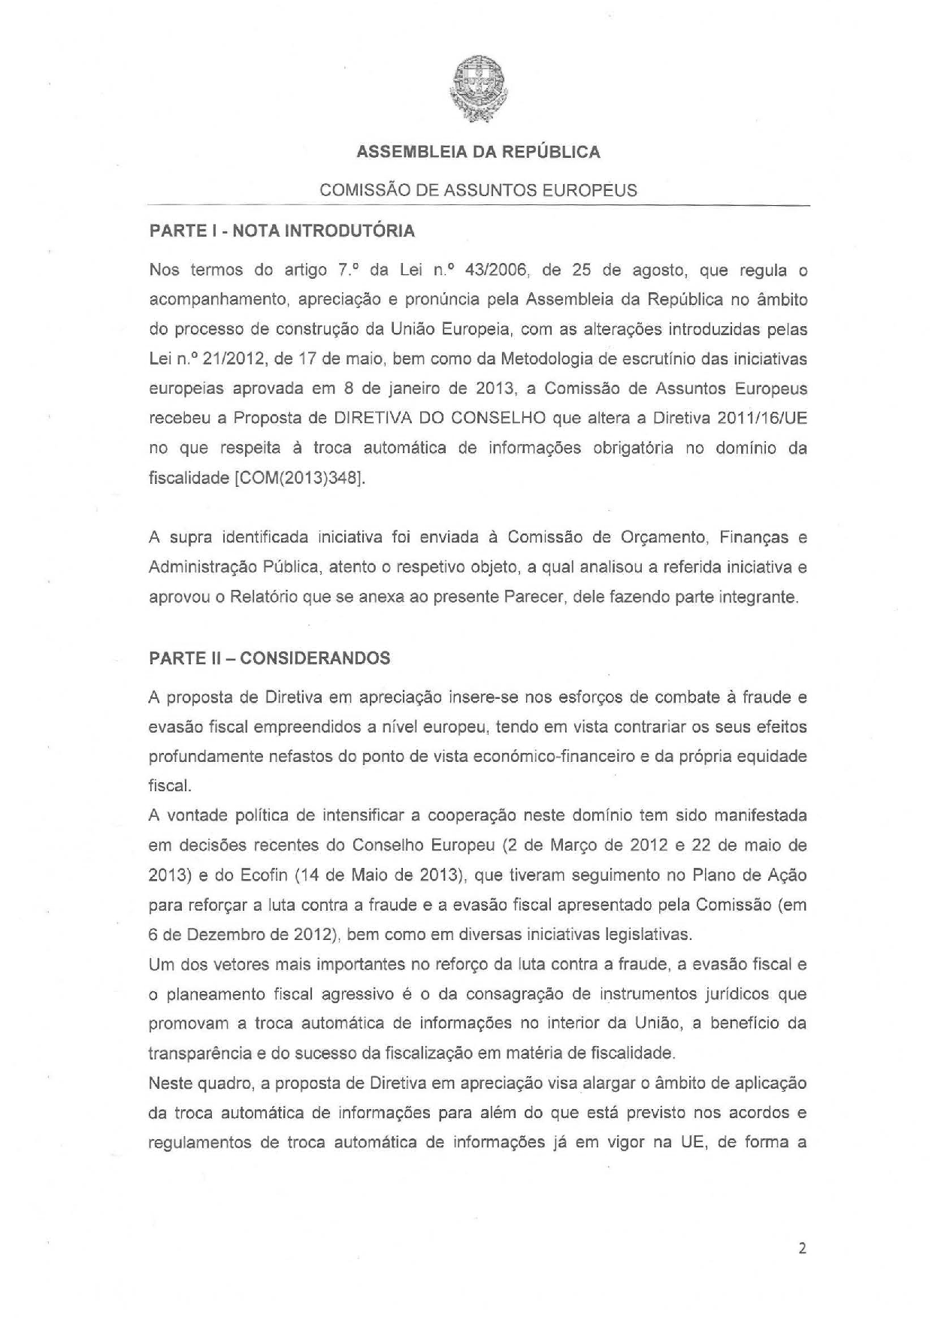

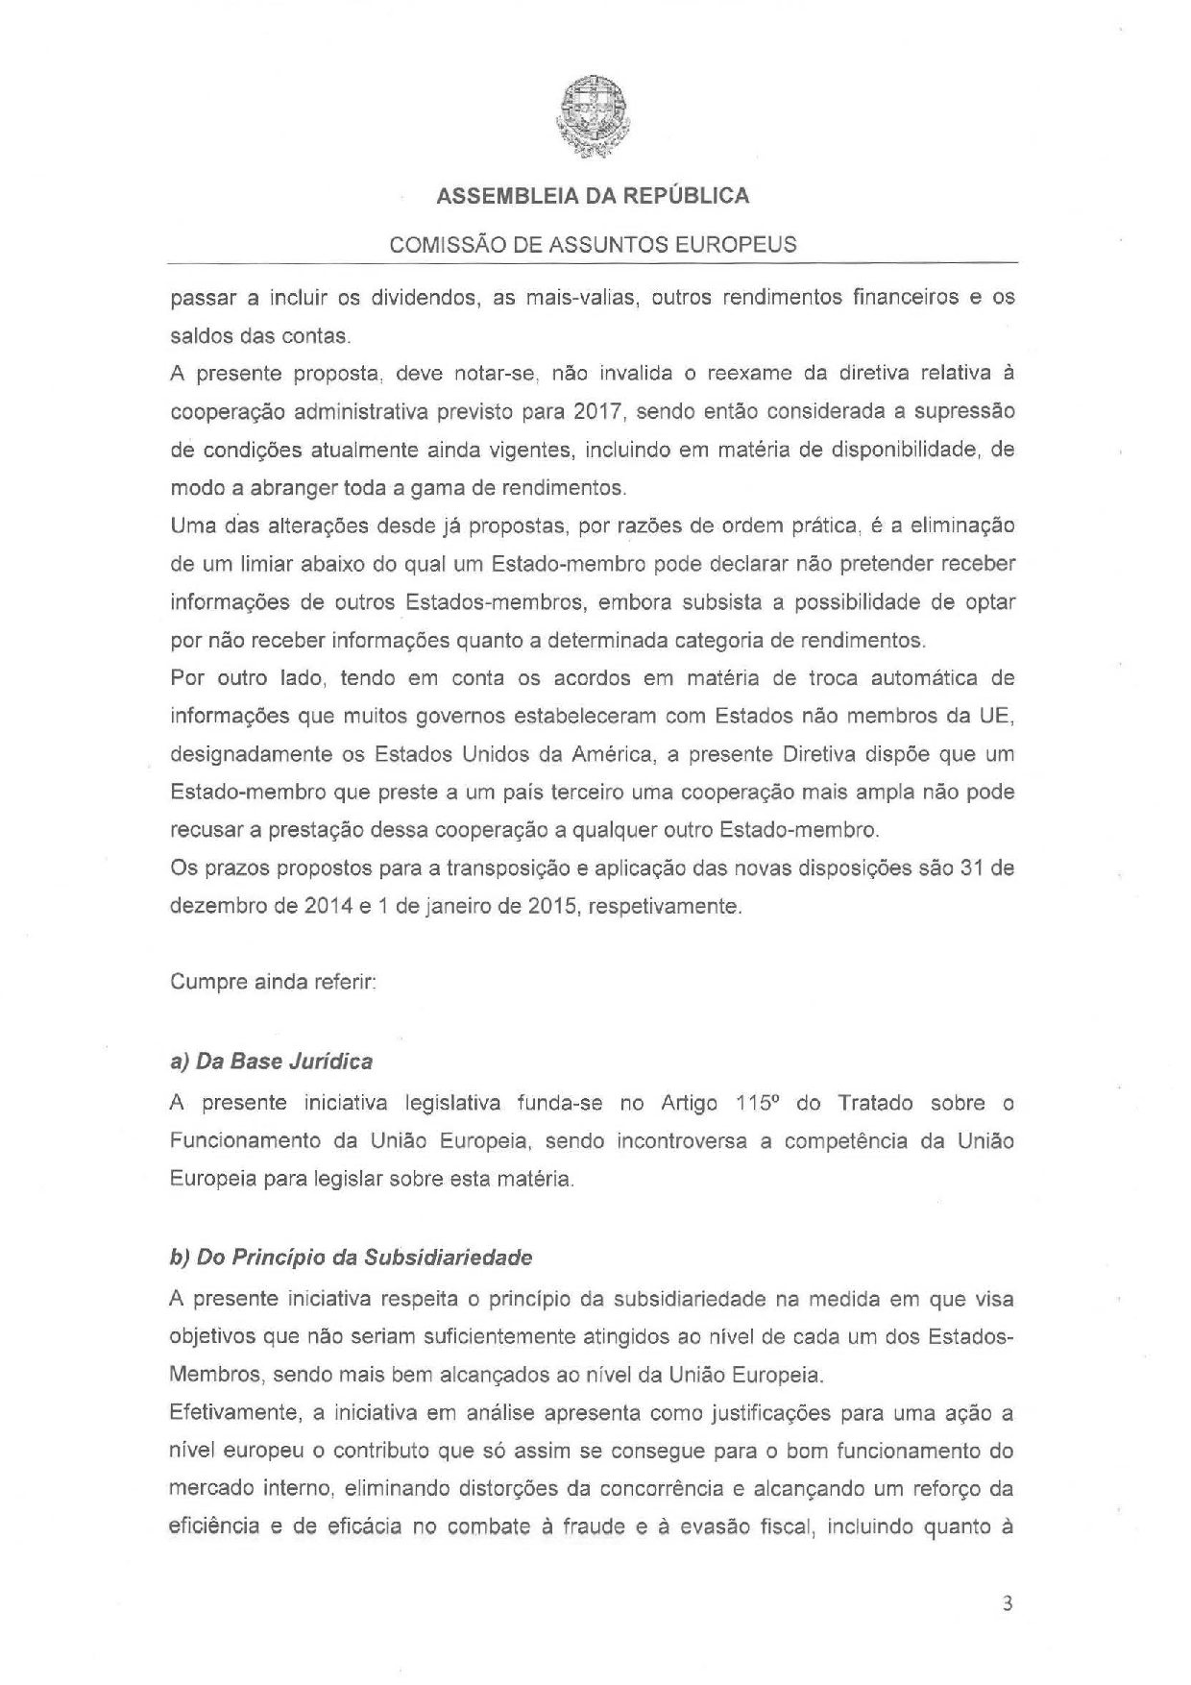

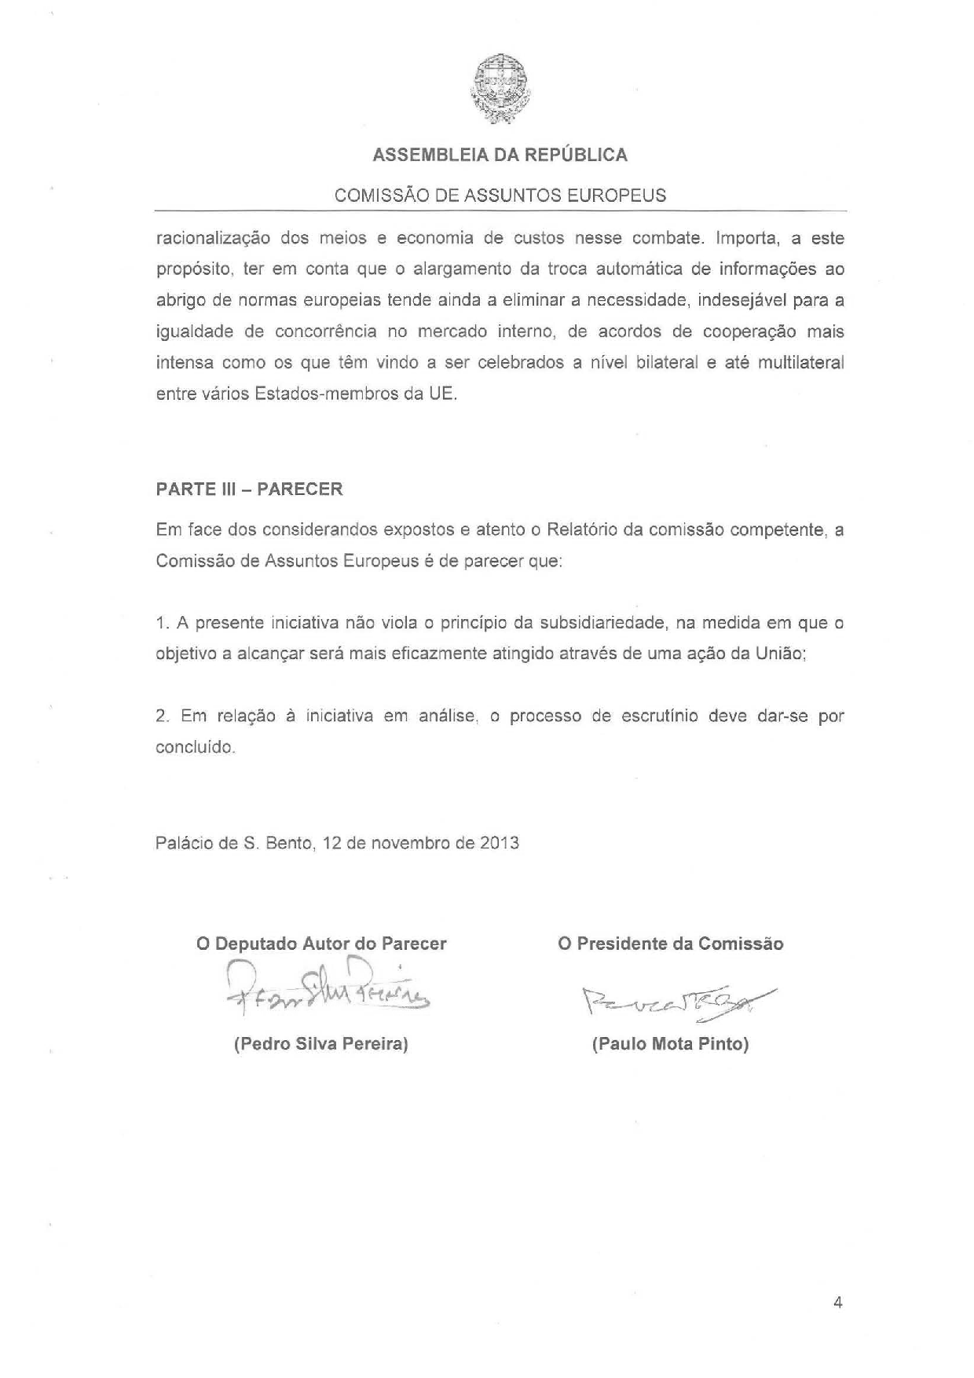



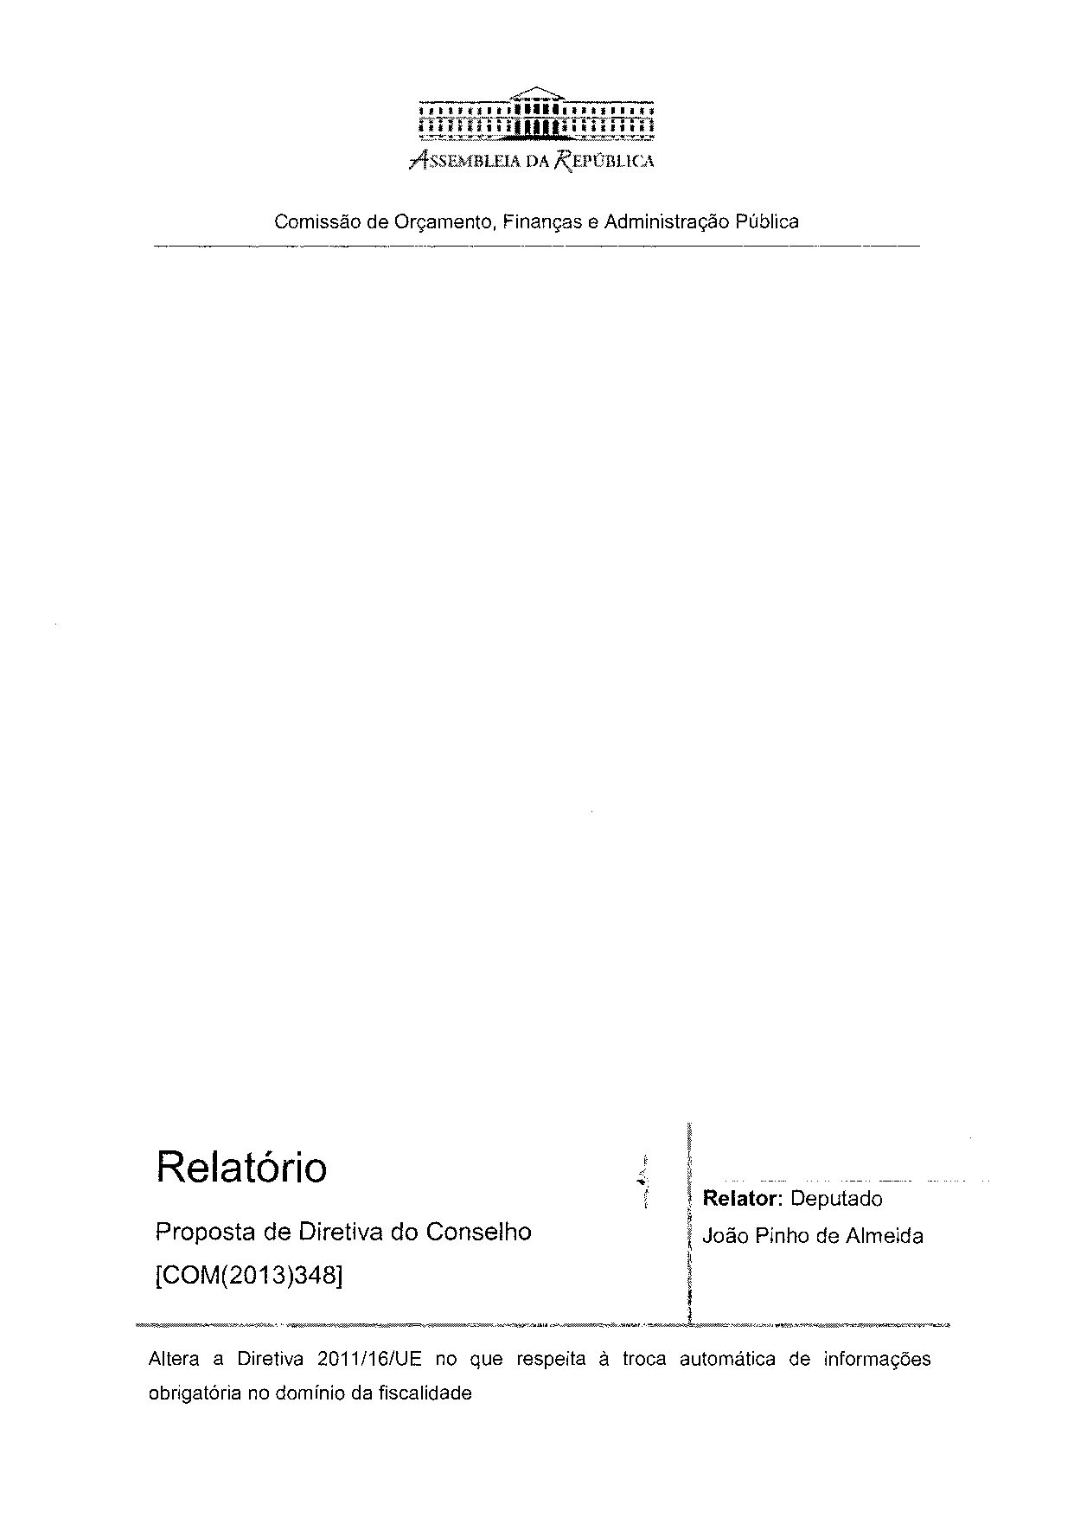

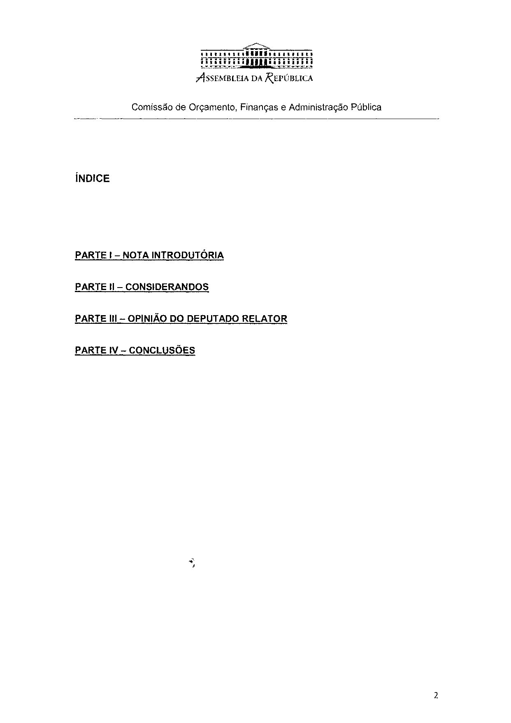

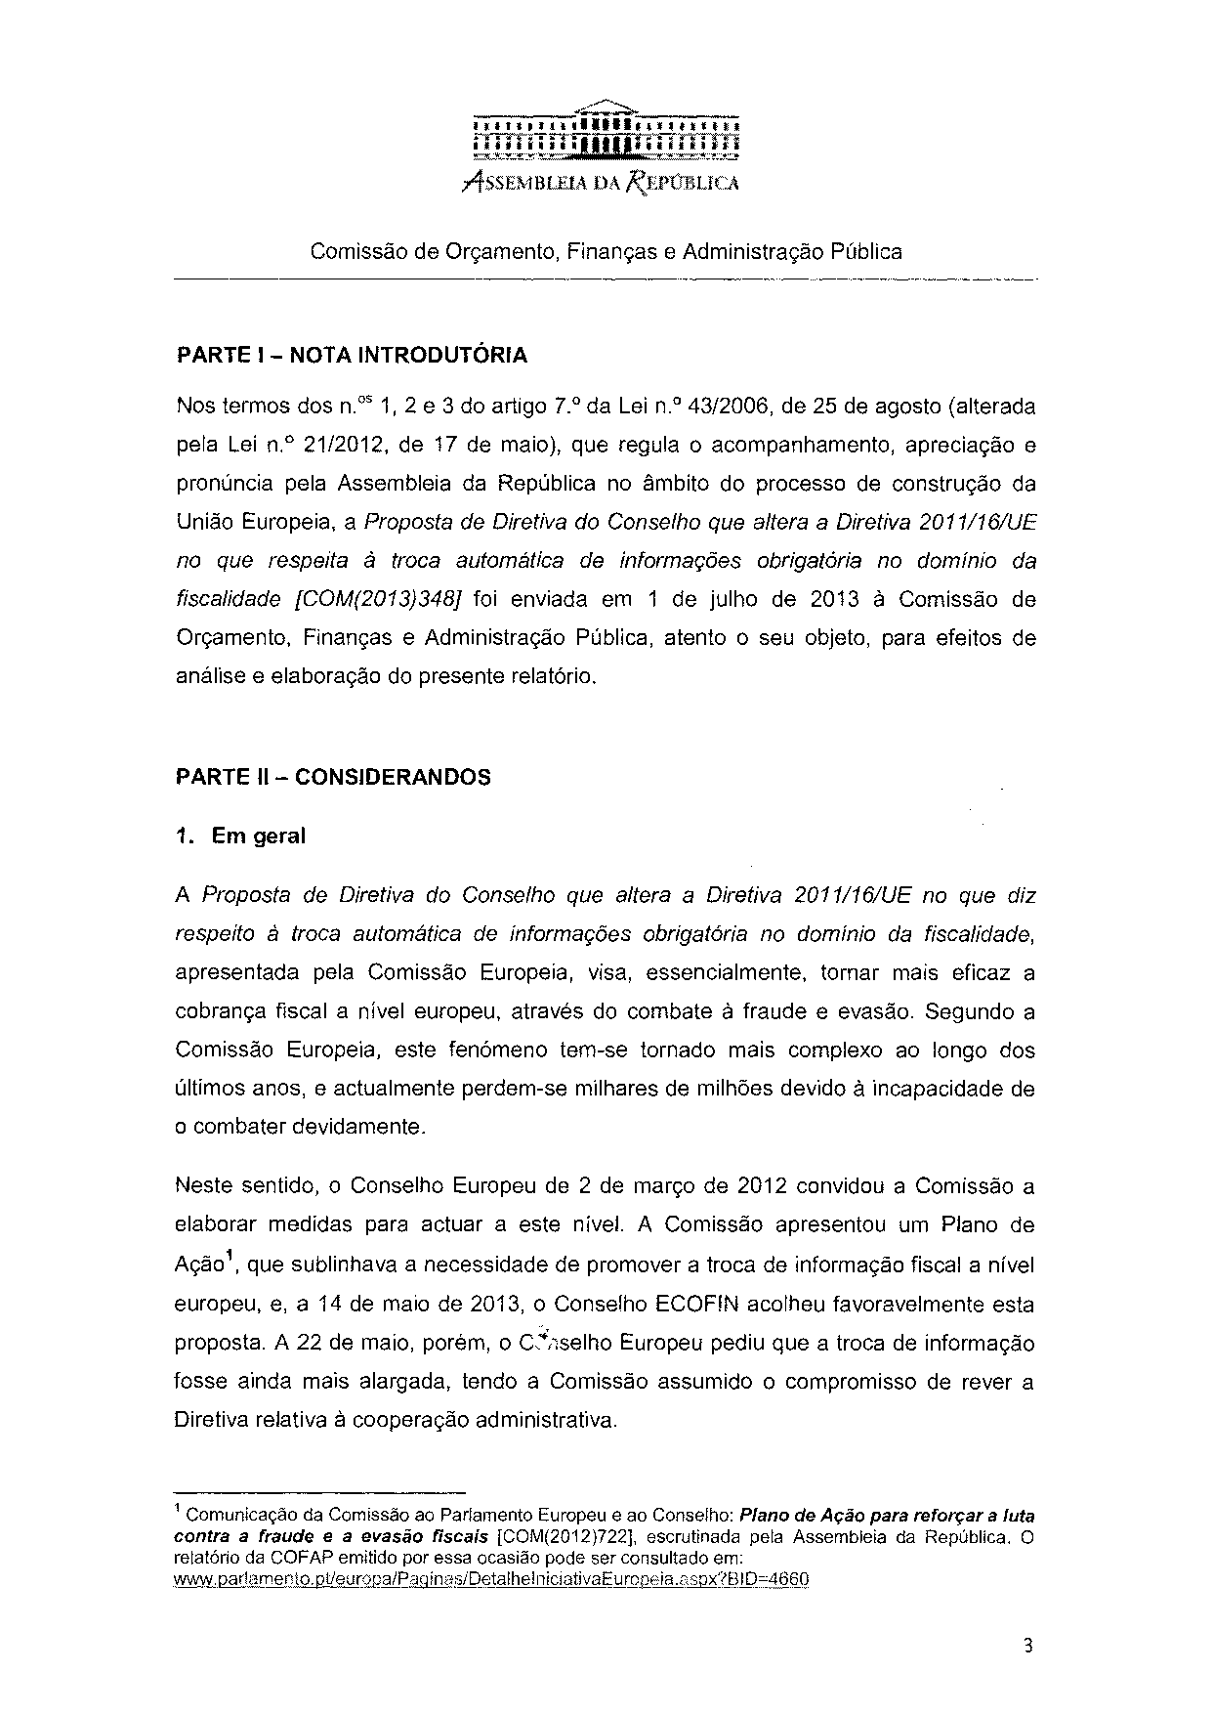

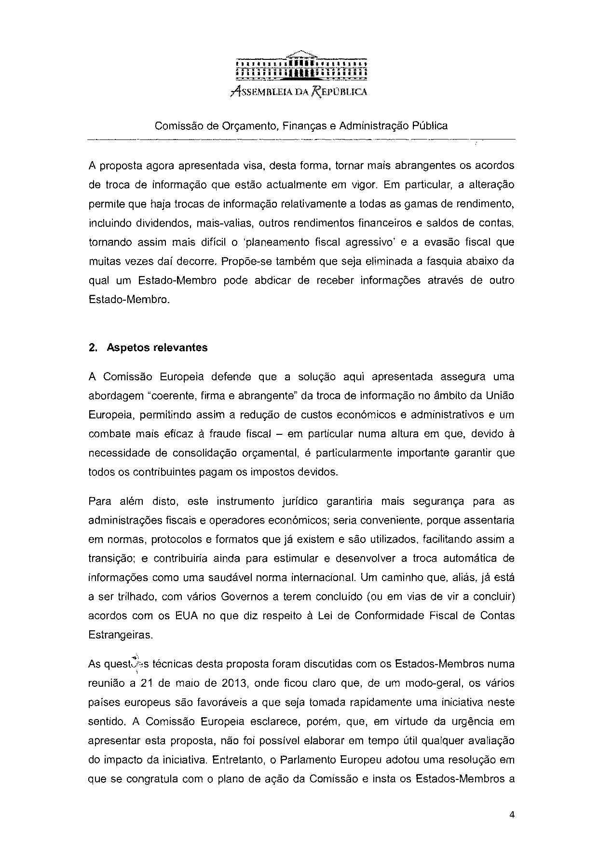

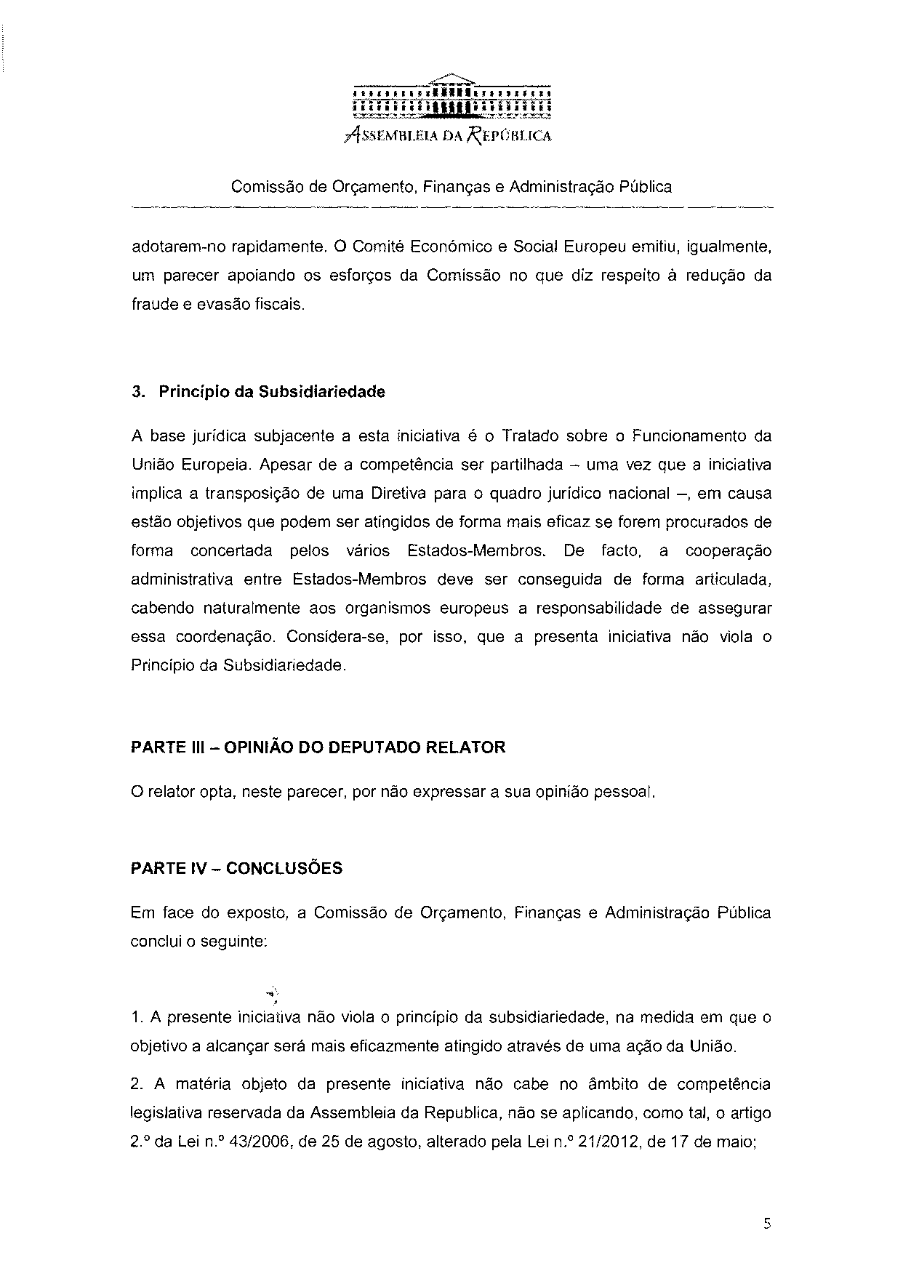
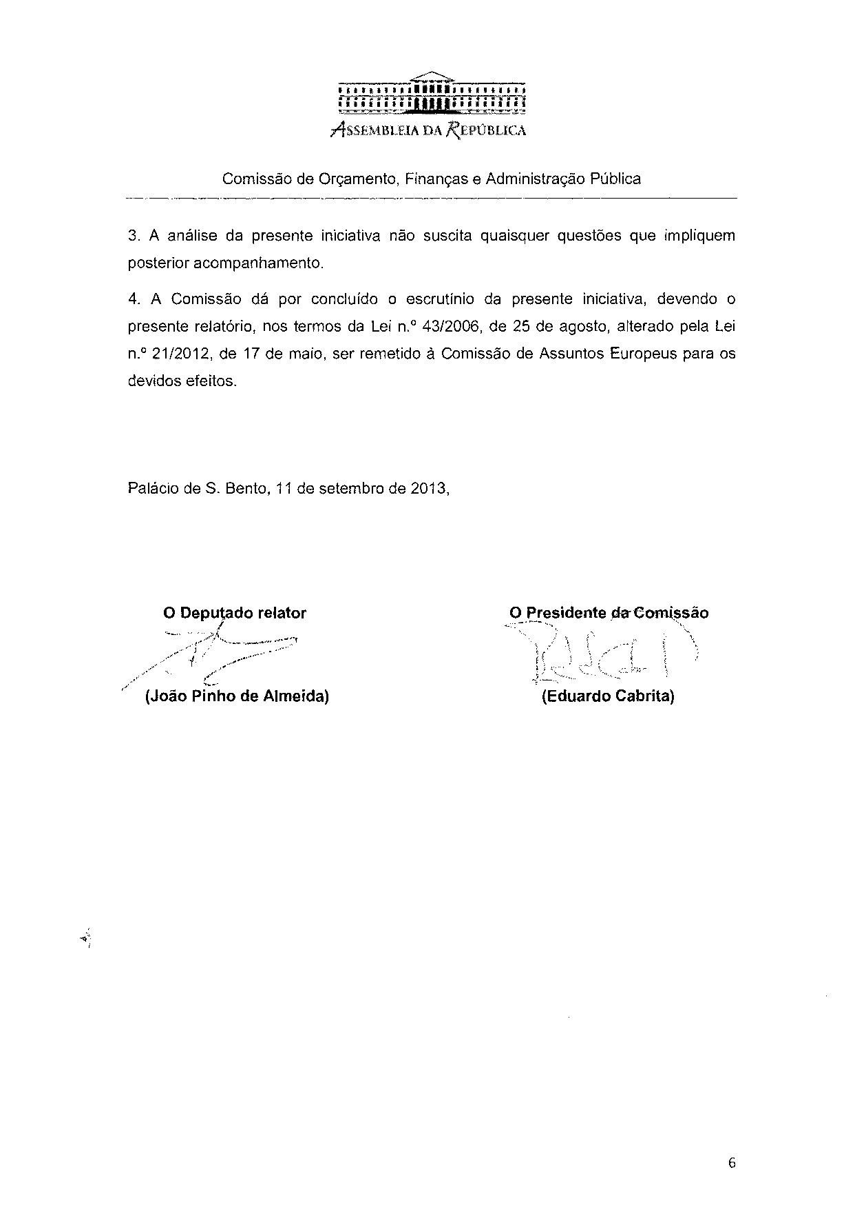

Translation(s) of the opinion may be available on the Interparliamentary EU Information Exchange Site IPEX at the following address: http://www.ipex.eu/IPEXL-WEB/search.do

