- baseline

5.1 Compliance with NO2 limit values
The decline in NO_{x} emissions projected by the baseline should significantly improve future compliance with NO₂ air quality limit values.
A new methodology has been developed to estimate with the GAINS model future NO₂ concentrations at traffic stations (Kiesewetter et al. 2013). This enables the assessment of the impacts of the Europe-wide emission reduction scenarios on compliance with the air quality limit values for each of these stations.
However, due to data gaps, this approach could not be implemented for all monitoring sites in Europe, but is restricted for NO₂ to 2000 sites for which sufficient monitoring data have been provided to AIRBASE, and for PM10 for 1900 sites. Obviously, this sub-set of stations is not necessarily representative, and there are large differences in station numbers across Member States. To facilitate representative conclusions, stations have been allocated to their respective air quality management zones established under the Air Quality Daughter Directive. The analysis presented here determines the compliance status of each zone along the highest concentration modelled at any AIRBASE monitoring site located within the zone.
It has been shown for NO₂ that achievement of the annual limit value of 40 μg/m³ is more demanding than compliance with the hourly limit value of 200 μg/m³. Thus, modelling for NO₂ is restricted to the annual limit value.
To reflect unavoidable uncertainties in monitoring data, modelling techniques and future meteorological conditions, three compliance categories with the annual limit value are distinguished.
Computed annual mean concentrations of NO₂ below 35 μg/m³ indicate likely compliance. If concentrations are computed in the range between 35 and 45 μg/m³, compliance is possible but uncertain due to the factors mentioned above. This is also the range where additional local measures (e.g., traffic management) have a realistic chance to achieve safe compliance, even under unfavourable conditions. In contrast, compliance is unlikely if computed NO₂ concentrations exceed 45 μg/m^{3.}
On this basis, it is estimated that the number of air quality management zones in the EU-28 where compliance with the current limit values is unlikely will decline from about 100 zones (21%) in 2010 to 38 zones (8%) in 2020 under baseline conditions (for this, 500 zones have been considered). However, this estimate is conservative as it does not consider benefits from local measures (e.g., traffic management or low emission zones), which could be quite effective for reducing the large share of NO₂ from near-by emission sources.
Conversely, in 2020 safe compliance will be achieved in 80% of the zones, compared to 63% in 2010 (Table 3). Obviously, by 2020 Europe will not fully reach the ultimate target of bringing all Europe in compliance. However, as shown in Figure A5.2, Europe will be on track towards such a target, with non-compliances rapidly decreasing following fleet renewal. For the baseline projection, which does not consider additional local measures, the number of non-compliance zones is estimated to decline to 13 in 2025 and five in 2030 (Figure A5.3). The additional measures of the MTFR scenario could eliminate 99% of the robust non-compliance cases.

Figure A5.2: Compliance with air quality limit values for NO₂ in the air quality management zones
Figure A5.3: Compliance with air quality limit values for NO₂ in the air quality management zones
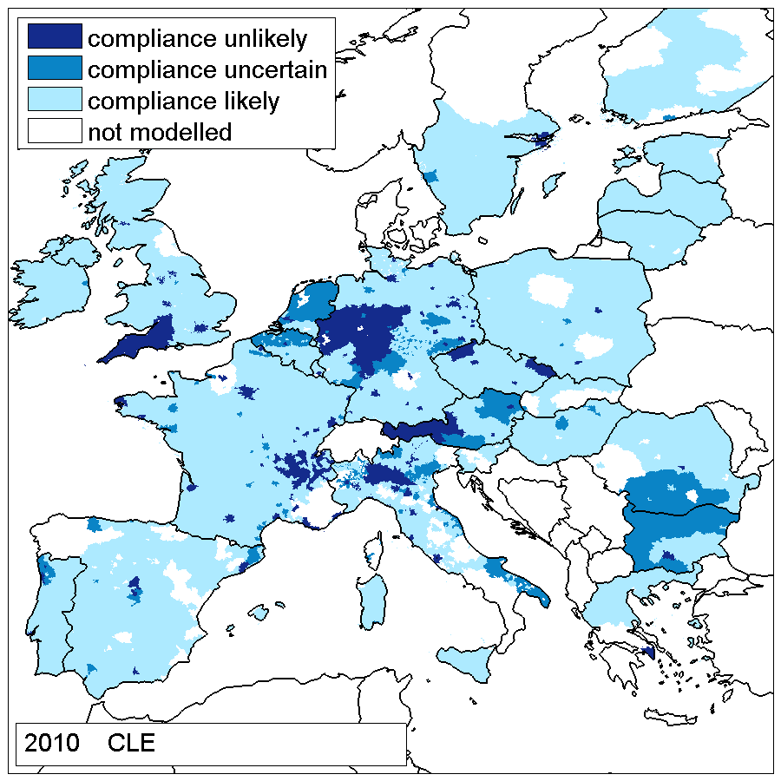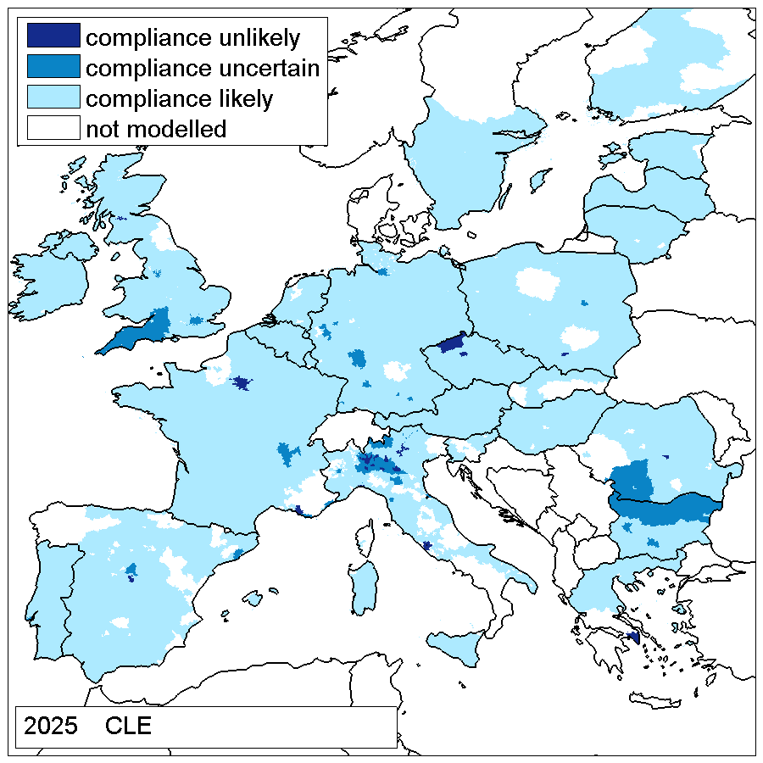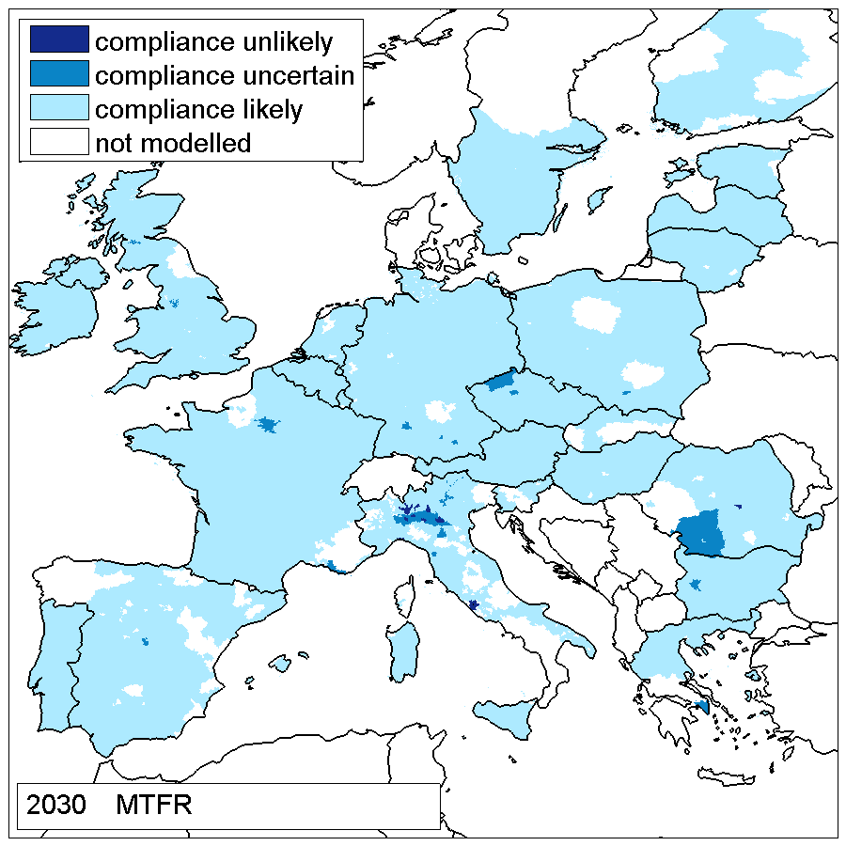

Table A5.7: Compliance with NO₂ limit values (number and % of zones). Note that this calculation does not include effects of additional local policies, such as low-emission zones.
 | Compliance
 | unlikely | uncertain | likely | unlikely | uncertain | Likely
2010 | 103 | 82 | 315 | 21% | 16% | 63%
2020 | 38 | 64 | 398 | 8% | 13% | 80%
2025 | 13 | 39 | 448 | 3% | 8% | 90%
2030 | 5 | 28 | 467 | 1% | 6% | 93%
2030 MTFR | 4 | 22 | 474 | 1% | 4% | 95%

Table A5.8: Population living in air quality management zones with different compliance with the NO₂ limit values (million people, % of European population)
 | Compliance
 | unlikely | uncertain | likely | unlikely | uncertain | likely
2010 | 124.6 | 63.3 | 238.6 | 29% | 15% | 56%
2020 | 68.7 | 55.6 | 302.1 | 16% | 13% | 71%
2025 | 30.8 | 49.7 | 345.9 | 7% | 12% | 81%
2030 | 8.9 | 48.0 | 369.5 | 2% | 11% | 87%
2030 MTFR | 8.1 | 33.5 | 384.7 | 2% | 8% | 90%

5.2 Compliance with PM10 limit values
For PM10, the limit on 35 allowed daily exceedances of 50 μg/m³ is more difficult to attain than the annual mean limit value of 40 μg/m³. However, there is a strong linear correlation between the 36th highest daily values and the annual mean concentrations, both in observations and model results. As an annual mean of 30 μg/m³ corresponds well to the 36th highest daily concentration of 50 μg/m³, this threshold is used as the criteria for the GAINS modelling, which is conducted on an annual mean basis. As for NO₂, uncertainty ranges of ±5 μg/m³ are employed.
For the 516 zones for which sufficient monitoring data are available, it is calculated that in 2010 about 60 zones (12%) did not comply with the PM10 limit value. The decrease in precursor emissions of the TSAP-2013 Baseline should halve this number to about 30 by 2020 (Figure A5.4). As for NO₂, this estimate does not consider additional measures at the urban scale, which could achieve further improvements.
However, in contrast to NO₂, the TSAP-2012 baseline does not suggest additional reductions beyond 2020. Remaining problems will prevail in the new Member States where, due to continued reliance of solid fuels for domestic heating, only little further declines in the emissions from the domestic sector are anticipated.
Technical emission control measures, together with the switch to cleaner fuels and/or to centralized heating systems could bring down PM10 concentrations below the limit value also in urban areas in the new Member States. The third panel in Figure A5.5 illustrates the MTFR case that does not assume additional expansion of central heating systems.

Figure A5.4: Compliance of the air quality management zones with air quality limit values for PM10

Table A5.9: Compliance with PM10 limit values in 2025 (number and % of zones)
 | Compliance
 | unlikely | uncertain | likely | unlikely |  | uncertain | likely
2010 | 62 | 172 | 282 | 12% | 33% |  | 55%
2020 | 31 | 96 | 389 | 6% | 19% |  | 75%
2025 | 26 | 97 | 393 | 5% | 19% |  | 76%
2030 | 25 | 96 | 395 | 5% | 19% |  | 77%
2030 MTFR | 17 | 56 | 443 | 3% | 11% |  | 86%

Table A5.10: Population living in air quality management zone with different compliance with PM10 limit values (million people, % of European population)
 | Compliance
 | unlikely | uncertain | likely | unlikely |  | uncertain | likely
2010 | 81.3 | 132.0 | 213.5 | 19% | 31% |  | 50%
2020 | 48.8 | 85.3 | 292.7 | 11% | 20% |  | 69%
2025 | 39.5 | 92.6 | 294.6 | 9% | 22% |  | 69%
2030 | 40.3 | 86.8 | 299.7 | 9% | 20% |  | 70%
2030 MTFR | 21.4 | 74.1 | 331.3 | 5% | 17% |  | 78%

Figure A5.5: Compliance with the air quality limit values for PM10 in the air quality management zones
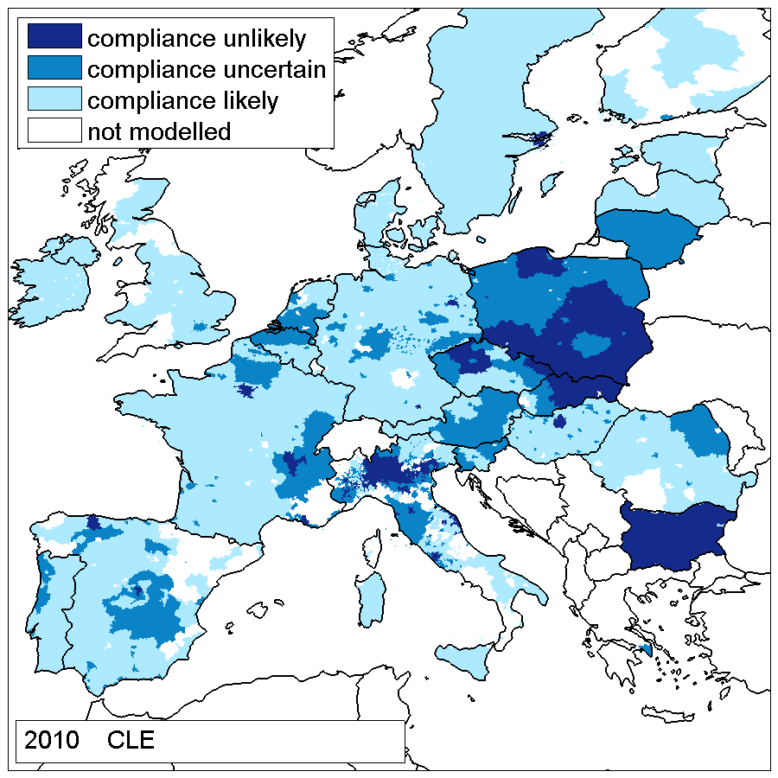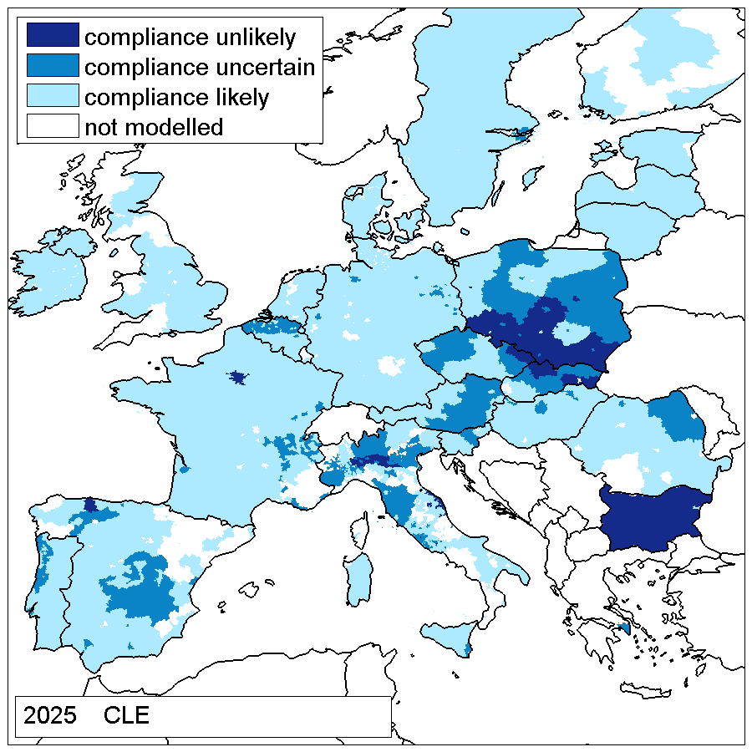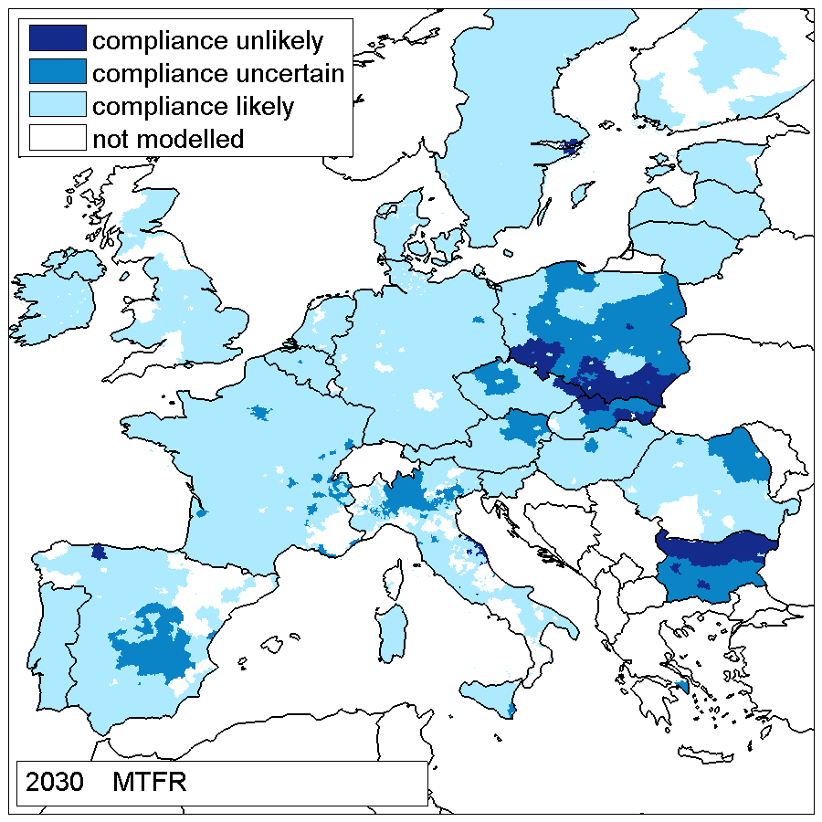
Alternatively to the MTFR, a hypothetical scenario assuming a complete switch of coal and biomass domestic heating to natural gas starting 2020 in four countries: Poland, Czech Republic, Slovakia and Bulgaria, which are the countries with largest projected compliance problems for PM10, where domestic solid fuel combustion plays a significant role.
Figure A5.6 compares the 2030 current legislation baseline (CLE) case with the MTFR and with the domestic solid fuel phase out case in the four countres mentioned. Furthermore, this simulation assumes that 75% of the unexplained PM2,5 component in the four countries is related to domestic solid fuel combustion.
Figure A5.6: Compliance with the air quality limit values for PM10 in the air quality management zones in 2030 for the CLE, MTFR and domestic coal phase-out scenarios. 75% of unexplained component linked to doemstic heating is assumed
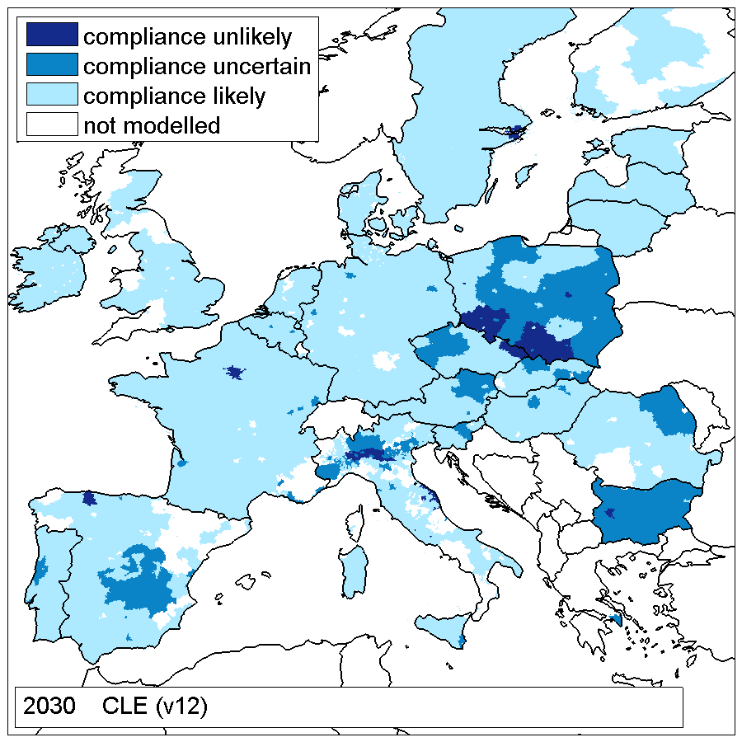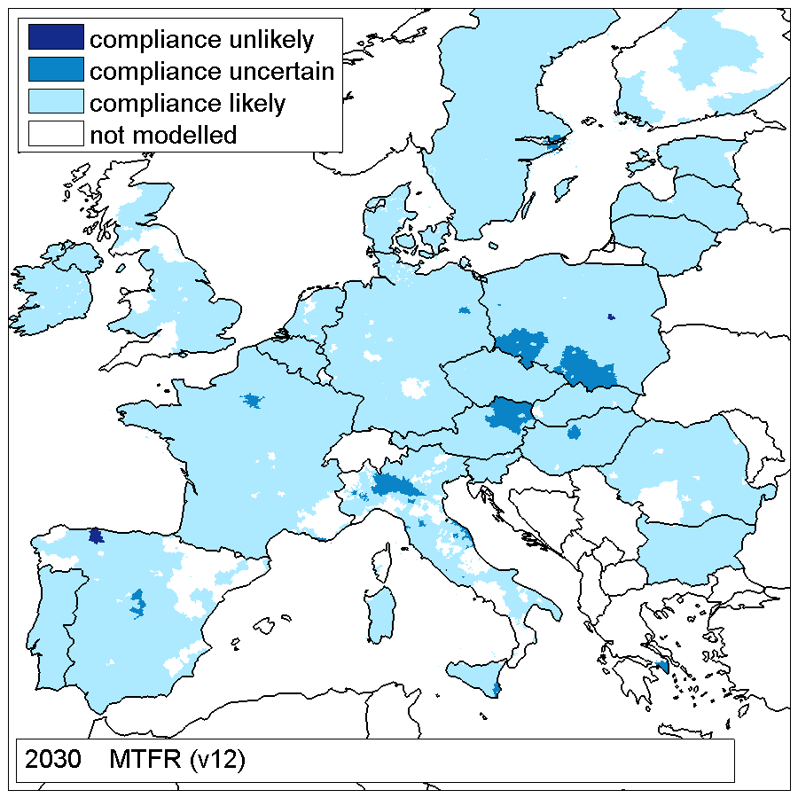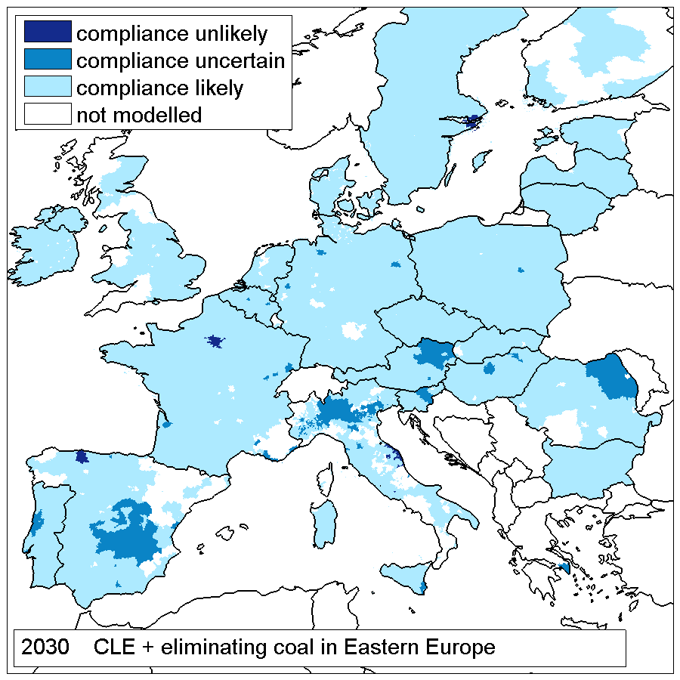
The results confirm that eliminating the most polluting domestic sources would be able to resolve almost entirely the PM non-compliance problems even in the currently most affected areas. Once reasonable assumptions are made for the linkage between domestic heating and the fraction of PM concentrations that models cannot explain with existing emission inventories, it becomes apparent that -even without fuel switching- the application of state-of-the-art solid fuel combustion techniques would be able to resolve the majority of non-compliance situations related to domestic solid fuel use.

5.3 Compliance with PM2,5 standards
For PM2,5, the 25 µg/m³ target value will become a binding limit value. For PM_{2.5} the baseline projections show very high projected compliance in 2015 (Figure A5.7), with around 96% of stations meeting the standard. The AAQD provides for the tightening of the PM_{2,5} LV from 25 to 20 µg/m³ in 2020, subject to feasibility; 99% of stations would comply with the 25 µg standard but only 92% of them with the tighter 20 µg standard. Note that even the 20 µg standard is well above the WHO guideline value of 10µg/m³.
Figure A5.7: Projected compliance with PM 2.5 limit values (2015 and 2020)
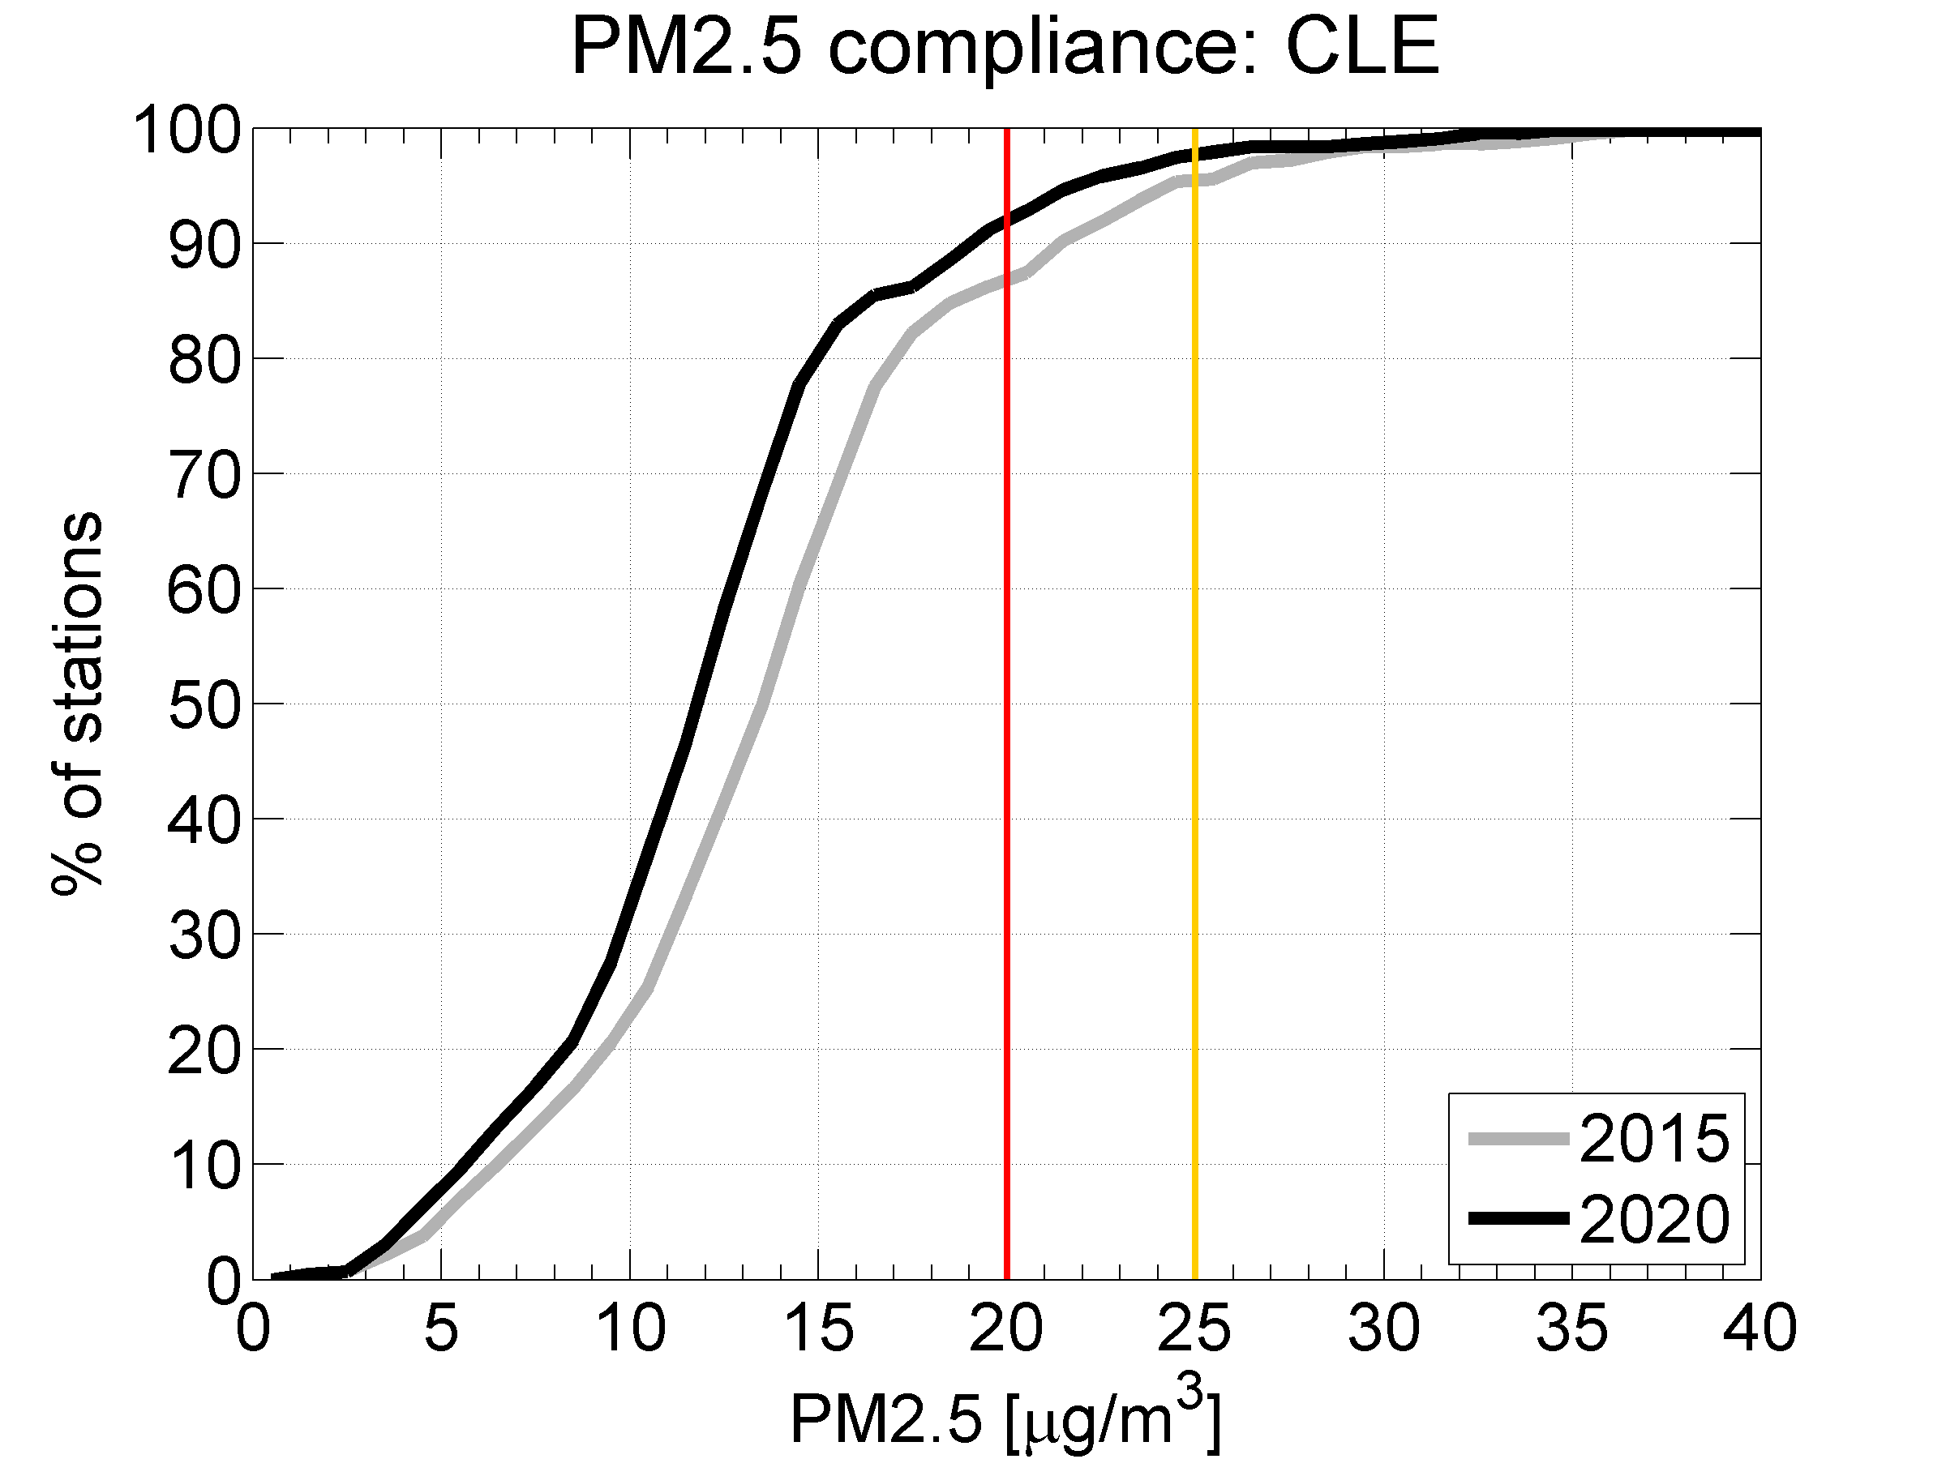
With a view to examining the range of PM2,5 limit values that could be set and ralistically enforced furhter in the future, Figure 0.11 shows the projected compliance picture further in the future; the left panel shows that in 2009 almost 90% of stationswere below 25 µg/m³ and only 10% below the WHO guideline value of 10 µg/m³. The situation is projected to gradually improve up to 2030, when 99% of stations would be below 25 µg/m³ and 35% below the WHO guidance value. The MTFR would be able to bring 60% of stations below the WHO guidance value. The right panel shows the compliance situation projected for policy option 6C, taking into account also the uncertainty range due to possible different assumptions on the fraction of PM2,5 concentration that is not explained by CTM modelling. Under this case, the 25 µg/m³ limit value would be safely met virtually by all stations. A tighter LV of 20 µg/m³ would be complied with by 94-99% of stations. The uncertainty range progressively increases, with 80-96% of stations below 15 µg/m³ and 40-65% below 10 µg/m³.
Figure A5.8: Projected compliance with PM 2.5 limit values in: [LHS] 2009, 2020 (CLE), 2030 (CLE) and 2030 (MTFR); and [RHS] 2025 for option 6C. In the latter case, the uncertainty range is related to assumptions for the component unexplained by CTM modelling
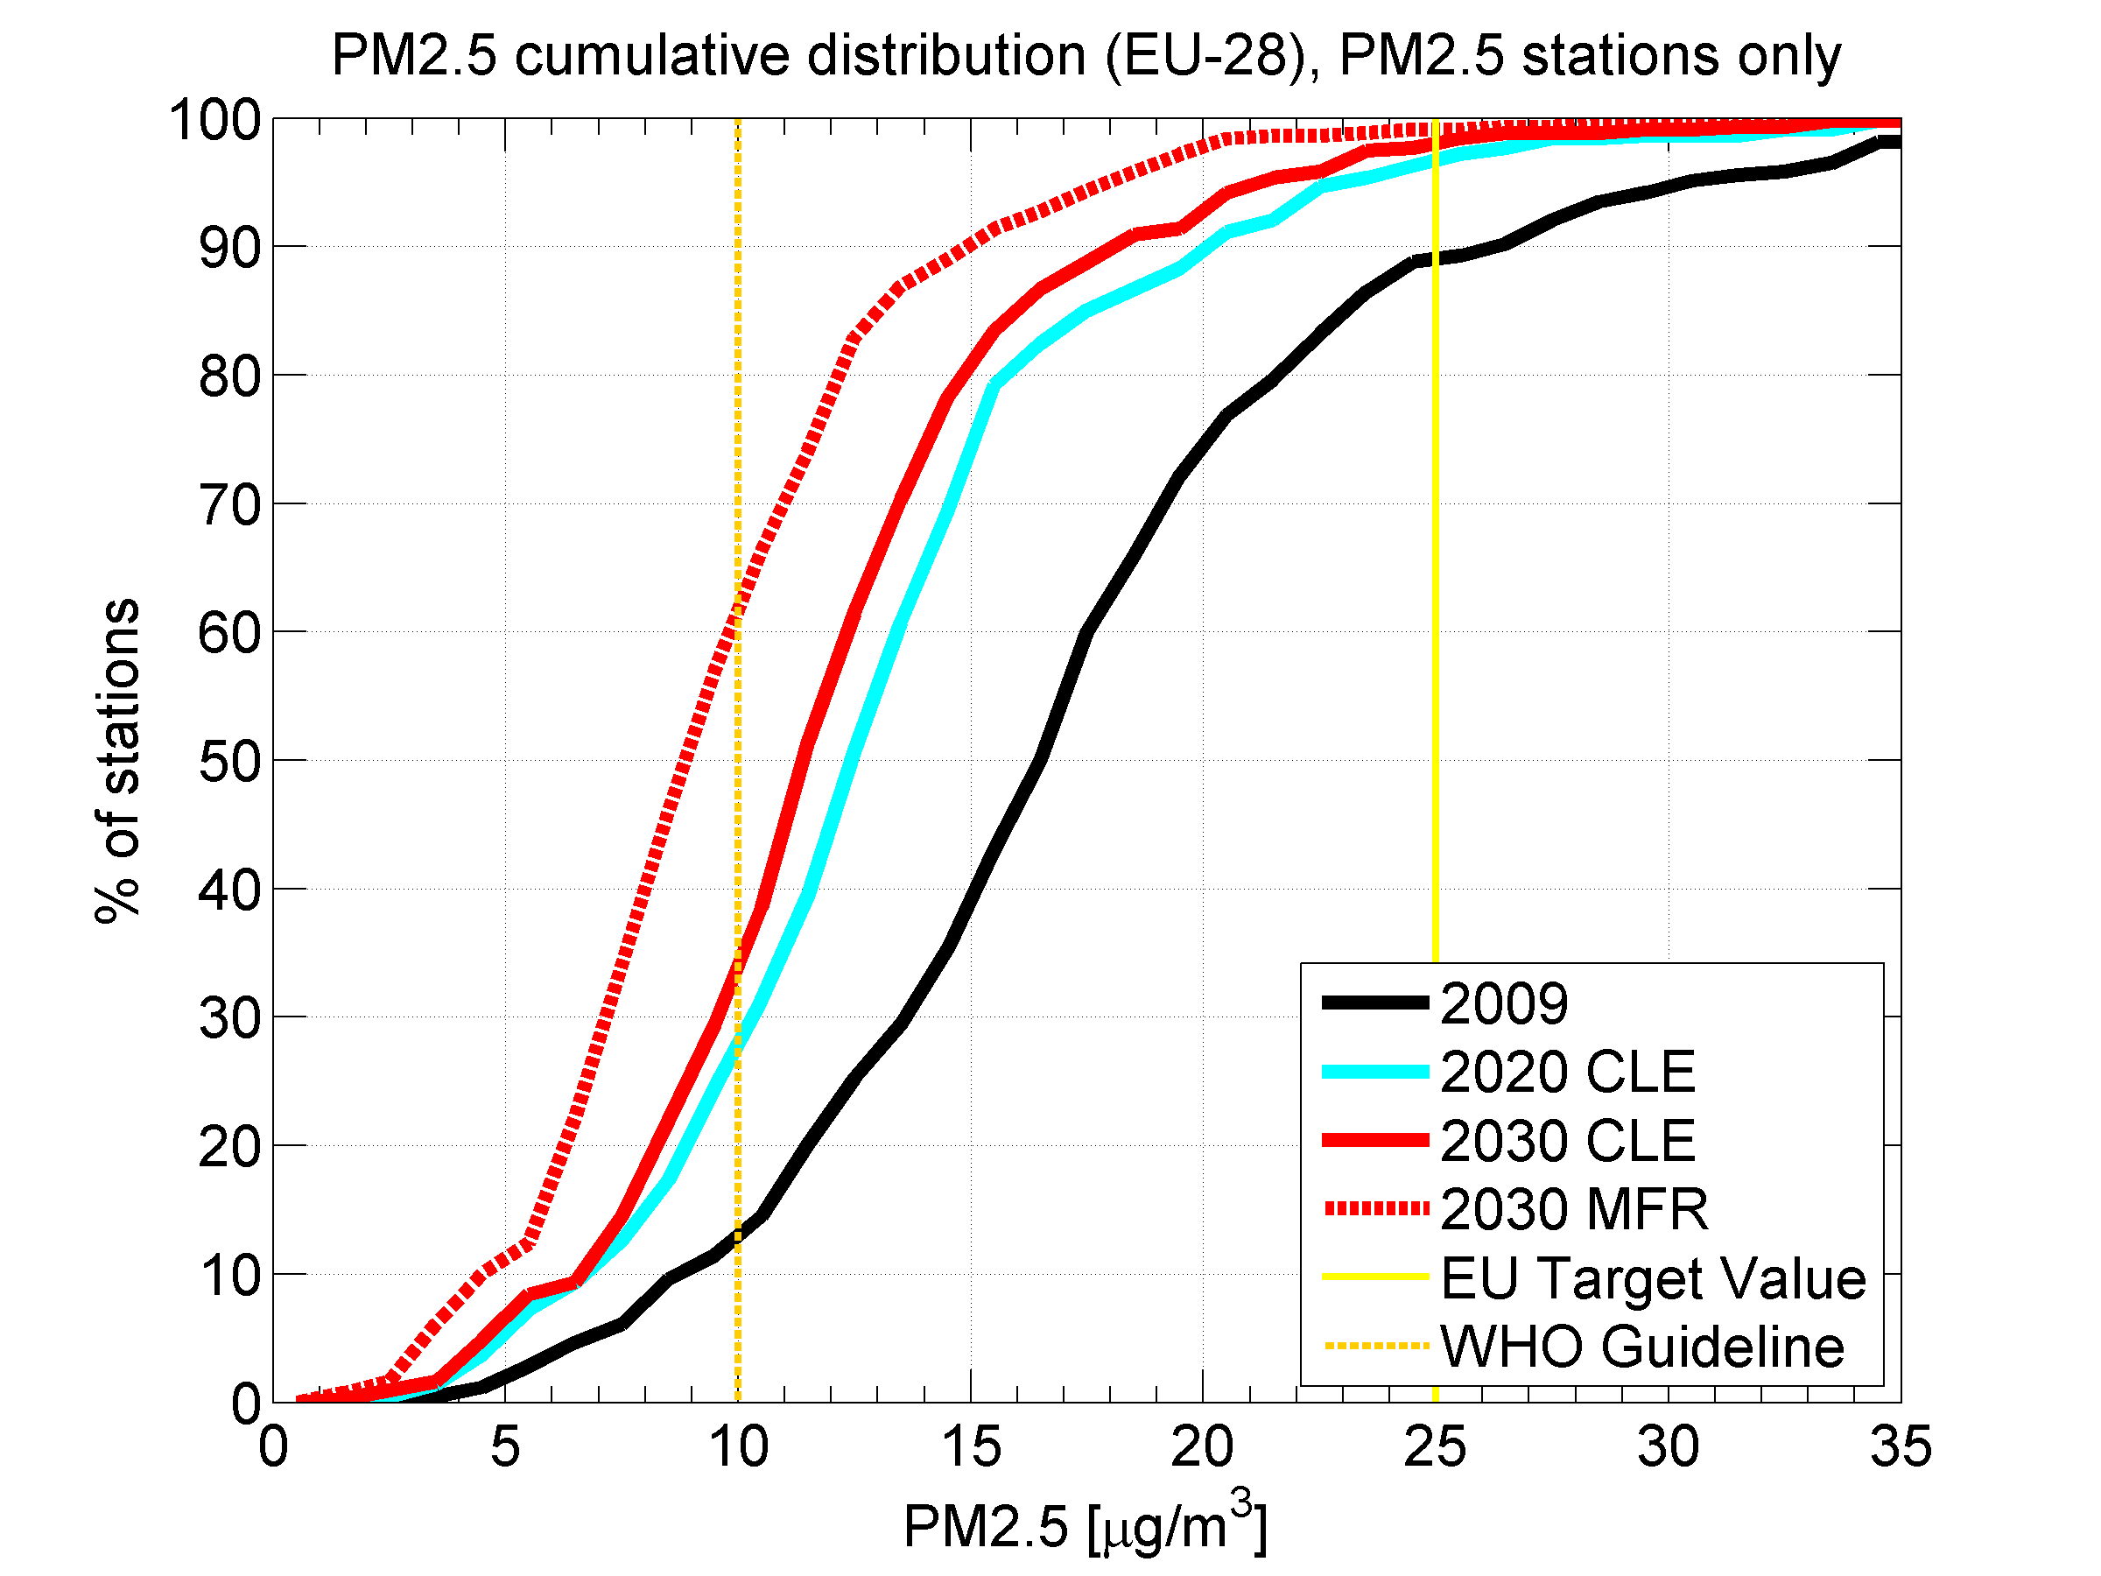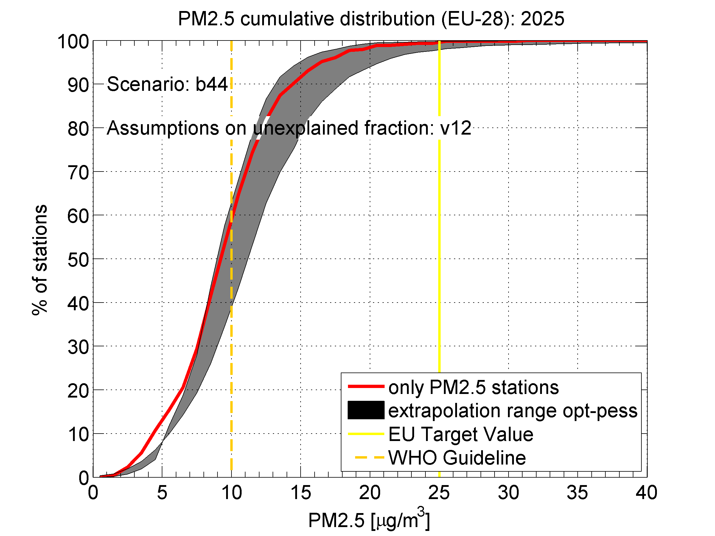

- Future air pollution impacts under the baseline scenario

6.1 Health impacts from PM2,5
The decrease in the precursor emissions of ambient PM2.5 of the TSAP-2013 Baseline projection suggests a decline of the loss of statistical life expectancy attributable to the exposure to fine particulate matter (PM2.5) from 8.5 months in 2005 to 5.3 months in 2025. However, in Belgium, Poland, the Czech Republic, Hungary and Romania people would still lose more than six months even in 2030 (See Annex 7 Appendix).
It is noteworthy that the PRIMES2012-3 baseline results in larger future health impacts compared to the PRIMES2010 baseline, mainly due to higher primary emissions of PM2.5 from expanded biomass combustion in small installations. Thereby, higher primary PM2.5 emissions compensate the benefits from lower precursor emissions of secondary PM2.5, i.e., SO₂, NO_{x}, NH₃ and VOC.
With the additional technical measures that could be implemented within the EU, life shortening could be further reduced by up to 1.4 months, or by 2030 down to about 3.6 months on average.
Overall, despite implementation of current emission control legislation, population in the EU-28 would still lose between 200 and 220 million years of life after 2020 (See Annex 7 Appendix). The additional measures could gain approximately 60-70 million life years.

Figure A5.9: Loss in statistical life expectancy from exposure to PM2.5 from anthropogenic sources; top: 2005, mid: 2025 CLE, bottom: MTFR 2030
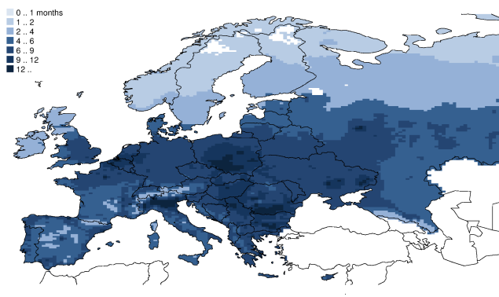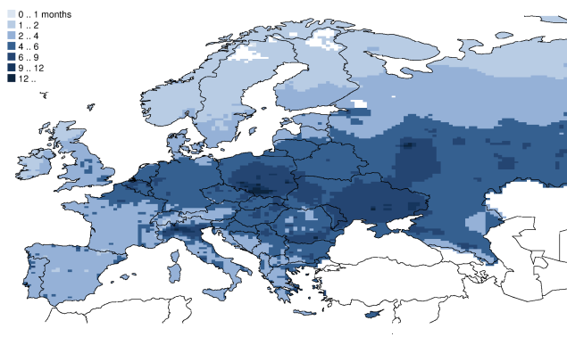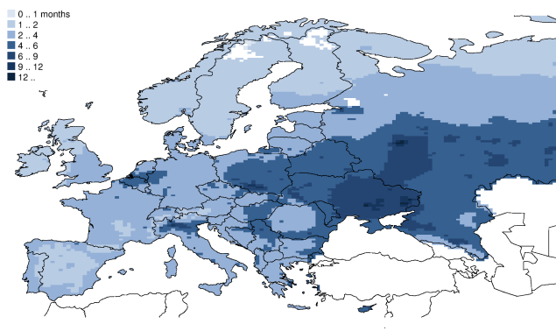
2005
2025 CLE
2030 MTFR

Figure A5.10: Years of life lost (YOLLs) due to exposure to fine particulate matter, EU-28
Despite progress, the TSAP-2013 Baseline would not meet the environmental target for health impacts from PM that has been established in the 2005 Thematic Strategy on Air Pollution for 2020. Instead of the 47% improvement in years of life lost (YOLL) relative to 2000, the current legislation case of the TSAP-2013 would reach only a 45% reduction.

6.2 Health impacts from ground level ozone
The TSAP-2013 Baseline suggests for 2025 approximately 18,000 cases of premature deaths from exposure to ground-level ozone in the EU-28 (Figure A5.11). This is safely below the 10% reduction target (25,000 cases) that was established by the 2005 Thematic Strategy on Air Pollution for 2020 relative to 2000, mainly due to more optimistic expectations on the development of hemispheric background ozone levels.
Additional emission reduction measures within the EU-28 could save another 2,500 cases of premature deaths.
Figure A5.11: Cases of premature deaths due to exposure to ground-level ozone, EU-28
The spatial pattern of the health-relevant SOMO35 indicator, and how this will be influenced by the different emission reduction scenarios, is presented in Figure A5.12
Figure A5.12: The SOMO35 indicator that is related to premature mortality from ground-level ozone
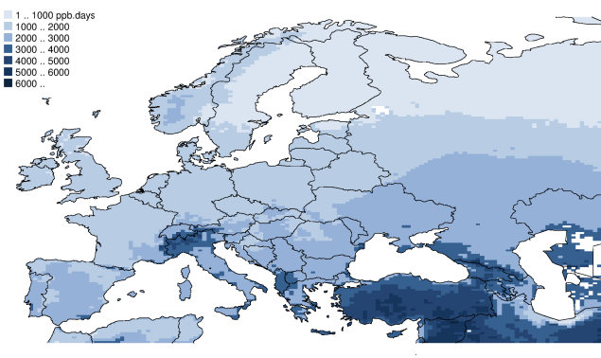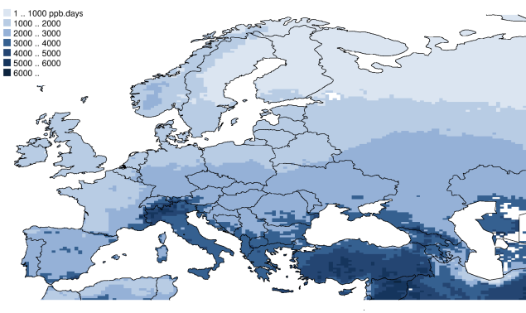
2005
2025 CLE
2030 MTFR
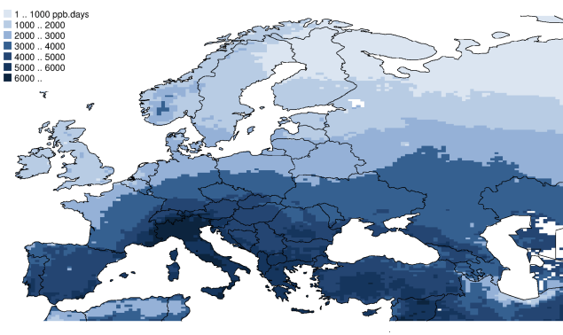

6.3 Eutrophication and biodiversity
Threat to biodiversity of Natura2000 areas
In addition to fragmentation and climate change, excess nitrogen deposition constitutes an important threat to biodiversity in areas that are protected under the Birds Directive and the Habitat Directive (i.e., Natura2000 areas).

Figure A5.13: Percentage of Natura2000 areas with nitrogen deposition above their critical loads for eutrophication. Top: 2005, mid: 2025 CLE, bottom: MTFR 2030
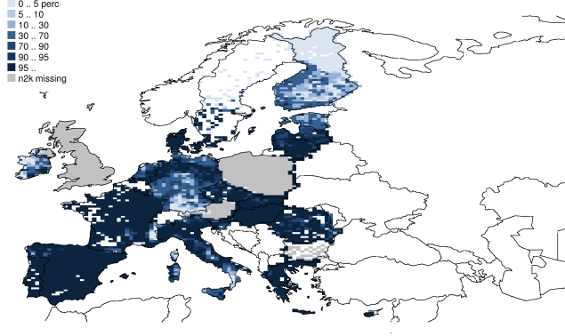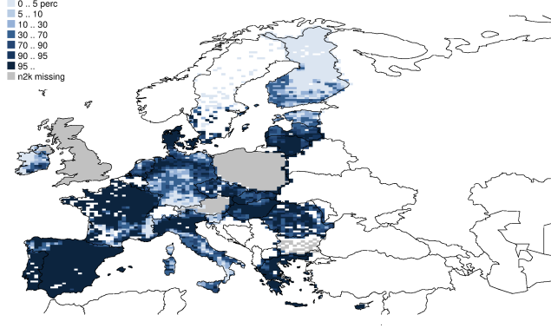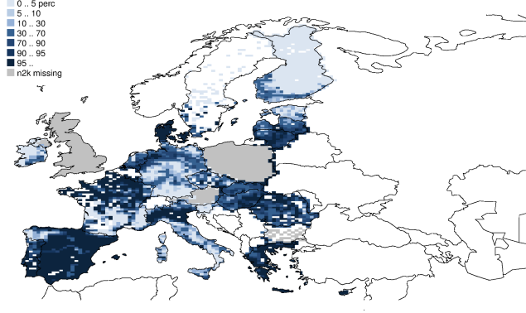
2005
2025 BL
2030 MTFR
For 2005, it is calculated that biodiversity was under threat from excess nitrogen deposition in 77% (423,000 km²) of the protected zones. By 2025, the expected declines in NO_{x} emissions would reduce the threatened area to 62%, leaving 343,000 km² unprotected. By 2030, full application of the available reduction measures, especially for ammonia emissions, could provide protection to another 95,000 km² of the nature protection areas in Europe (See Annex 7 Appendix).
Threat to biodiversity of all ecosystems
In 2005, more than 1.1 million km² (i.e., 66%) of the European ecosystems were exposed to nitrogen deposition that exceeded their critical loads for eutrophication. The future development will be mainly influenced by the fate of NH₃ emissions. In 2025, the TSAP2013 Baseline would reduce the area under threat to about 0.9 million km², while higher NH₃ emissions in the TSAP-2012 Baseline would leave about 0.94 million km² unprotected. The available additional emission reduction measures could safeguard another 180,000 to 200,000 km².
Due to less progress in the reduction of NH₃ emissions than anticipated, the TSAP-2013 Baseline would fail to meet the environmental targets for eutrophication that have been established in the 2005 Thematic Strategy on Air Pollution for 2020. Instead of the 31% improvement in ecosystems area with nitrogen deposition above critical loads for eutrophication relative to 2000, the current legislation case of the TSAP-2013 would achieve only a 24% reduction (Figure A5.14).

Figure A5.14: Ecosystems area with nitrogen deposition in excess of the critical loads for eutrophication, EU-28

Figure A5.15: Percentage of ecosystems area with nitrogen deposition above their critical loads for eutrophication.
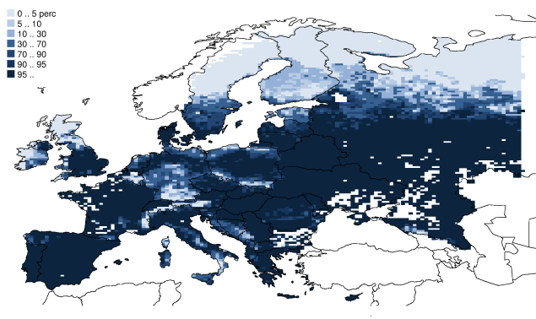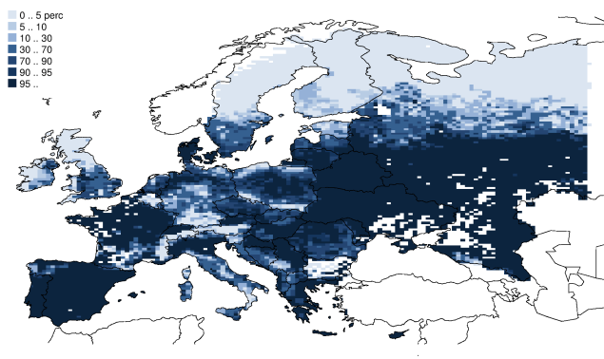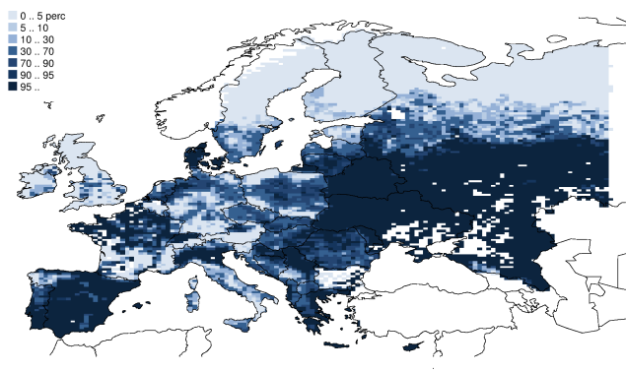
2005
2025 BL
2030 MTFR

6.4 Acidification
Acidification of forest soils
With the 2012 data set on critical loads (Posch et al. 2011), it is calculated that in 2005 critical loads for acidification have been exceeded in a forest area of 160,000 km², i.e., in about 12% of the forests within the EU-28 for which critical loads have been reported.

Figure A5.16: Percentage of forest area with acid deposition above the critical loads for acidification. Top: 2005, mid: 2025 CLE, bottom: MTFR 2030
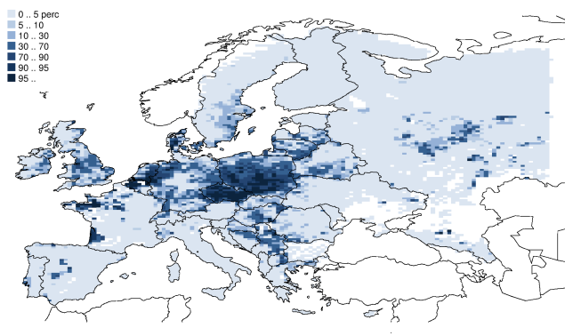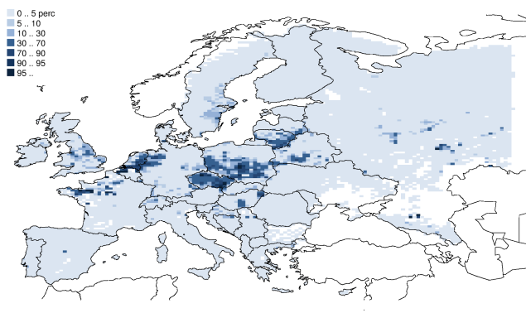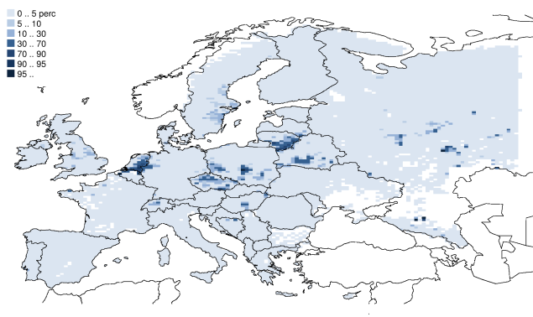
2005
2025 BL
2030 MTFR
Especially the anticipated further decline in SO₂ emissions will resolve the threat for another 110,000 km² up to 2025. Additional measures could provide sustainable conditions for another 30,000 km² up to 2030, and leave only 0.45% of European forests threatened by acidification (See Annex 7 Appendix). These measures would especially benefit the former ‘black triangle’ (i.e., in Poland, Czech Republic and the eastern parts of Germany), while residual problems would remain in the Netherlands due to high ammonia density. Thereby in 2020, the Baseline would achieve the 74% target for acidification of the TSAP 2005 (Figure A5.17).
Figure A5.17: Forest area with acid deposition in excess of the critical loads for acidification, EU-28

ANNEX 6 Elements of a Future European Clean Air Programme to support Member State Action on Reducing Air Pollution
- Introduction
The ex-post analysis of the present EU air quality policy framework assessed in detail the reasons for the outstanding compliance issues with respect to the AAQD and NECD. The analysis is documented in detail in Annex 4 with projections underpinning the compliance prospects further developed in Annex 5. The main conclusions are brought forward in Chapter 3 of the main impact assessment report.
In addition to a number of pollutant specific drivers of the problems, a number of drivers causing the outstanding were attributed to "governance" related issues, including the lack of capacity to effectively assess local air pollution problems and manage them efficiently and the scope for increasing synergies between national and local air pollution management efforts driven respectively by the NECD and the AAQD. The following key areas merited further attention (see in particular the description of options in Chapter 5.1):
- Enhanced capacity building for "local" air quality assessment and management to enable developing and implementing better targeted and cost-effective air pollution reduction strategies and policies for the purpose of reaching compliance and avoiding penalties resulting from ongoing infringement cases;
- Fostering enhanced synergies between local and/or national air quality management and other relevant plans developed and implemented at the national and/or local level (e.g. on climate change mitigation, sustainable energy, mobility, and urban development);
- Broadening the toolbox available to national and local authorities for assessing and managing air pollution and supporting best practice exchange nationally and across the EU (notably related to urban AQ management);
- Fostering enhanced public awareness, participation, and support for national and local action on air pollution, including the marketing and sales of "green" products;

It was suggested in Chapter 5 that the above actions could be usefully grouped into a future European Clean Air Programme also for the purpose of engaging all relevant bodies involved in implementing air quality measures. Considering the specific target groups, these actions are regrouped as follows:
- Action to improve the urban air quality
- Action to abate ammonia emissions
- Action at EU level to promote exchange of good practice and broaden the air quality management tool box
- Action at international level
It is furthermore noted that addressing the governance related issues hampering full compliance by 2020 will also benefit the proper implementation of the policy framework defined for the period beyond 2020 (as described in Chapter 6) inter alia by offering a platform for early action and dedicated stakeholder consultations.
- Action To Improve The Urban Air Quality
Many of the air quality-related problems are related to and concentrated in urban "hotspot areas", i.e. areas with a dense population, high levels of economic activity, and intense traffic. To address the challenges facing these areas, a combination of action is needed at all policy levels.
  - Action better identify and address key air pollution sources in urban areas
Based also on the outcome of the Air Implementation Pilot, and effective urban clean air action programme would include the exchange of good practice and, where appropriate, the development of common guidelines, for the following components:
- High quality and comparable local emission inventories, including enhanced synergies with the national emission inventories;
- High quality monitoring networks, including deriving the maximum information from existing networks;
- Source apportionment, i.e. the identification of key pollutant sources contributing to the air quality exceedances (based on matching emission inventories and monitoring data and using models to map the relative importance and abatement potential)
- Emission and air quality forecasting tools capable also ex-ante cost-effectiveness analysis;
- Air pollution abatement options applied across European (and possibly international) urban areas, including technical and non-technical costs and benefits;
- Integrated cost-benefit analysis integrating national and local conditions based on better understood trends in transboundary air pollution levels;
- Enhanced public information, including the development of harmonized and easy to understand air quality indexes to promote greater public awareness and guiding purchase decisions;
Enhanced capacity in these areas would serve to better integrate (and monitor) air quality consideration in other policy initiatives notably in the field of sustainable mobility and energy at national and local level. It could help assessing the air quality related benefits (or needs) related to upgrading (retrofitting) municipal transport fleets, plans for promoting alternative means of transport including cycling and walking as well as the roll out of e-mobility initiatives. It could furthermore help developing (more) effective low emission zones combined with road pricing schemes or access restrictions, optimized inter-modality plans, etc.
EU level support would be built around the new integrated projects foreseen under the new LIFE regulation which would also offer better access to other EU funds for more targeted action such as fuel switching programmes in certain particularly challenging areas in the EU.
Project-based initiatives would be supported by horizontal services including the regular hosting of EU-wide platforms for reviewing progress, exchange of good practice, and identifying common challenges and solutions. Horizontal services could also deliver common guidelines in other fields than those mentioned above such as guidelines for air-quality-related retrofit programmes (possibly also including certification standards for practitioners); Voluntary programmes identifying and supporting the uptake of "Super Ultra Low Emission Standards" (SULES) to further limit emissions from industrial activities, vehicles, and heating appliances emission heaters, as a voluntary tool for national and local authorities to help achieve compliance with EU air quality legislation, and at the same time promote technical innovation, etc.
  - Action to improve the governance of air quality management at national and EU level
A major cause behind non-compliance has been attributed to poor or lacking co-ordination between the various levels of government whose actions affect air pollution. For example, national vehicle taxation policies have brought about the preponderance of diesels which – emphasized by the real world emissions problem for the Euro standards – has made it more challenging to reach the NO2 air quality standards. For particulates, more than half of concentrations in many locations can be due to pollution from outside the urban borders which makes it challenging to adequately address the situation without effective co-ordination of policies and measures at national level.
Eligibility for EU support of integrated programmes could be made subject to commitments made by the various national governance level in the Member States to tackle air pollution in a more integral and coherent way, including also appropriate arbitrage platforms to ensure that local air quality management needs are taking into account at regional and national level. Such provisions could also be made part of an amended NECD.
- Action to abate agricultural air pollution emissions
One of the main conclusions drawn from the ex-post evaluation of EU air quality policy is the need to give higher priority abating emissions from the agricultural sector, notably related to ammonia where there is a large untapped potential for cost-effective action.
Focal areas would include emission reductions from livestock manures during various stages of the animal production and manure management chains linked to animal feeding, manure management, manure storage systems and manure application to crop land, as well as inorganic fertilizer application (especially from urea-based nitrogen fertilizers).
Advanced ammonia abatement methodologies are available and have been tried and tested for many years, but have yet to be applied at a wider scale. Costs incurred are often offset by the combined benefits to the farmer, such as increased nitrogen use efficiency, whereby nutrients are taken up by the crops rather than emitted to the air, reduced need for costly mineral fertilizers, improved agronomic flexibility, reduced emissions of other environmental pollutants, a healthier working environment for the farmer, and limited odours. While some Member States have taken the lead by developing national standards and good practice, others have done little to address the issue as yet. At EU level, ammonia emissions are largely unregulated, and support measures through the Common Agricultural Policy have so far been limited. To further reduce ammonia emissions in future, the following elements for action will be instrumental.
- Formulation of national emission reduction potential and emission reduction options available (also for the purpose of assisting implementation of the ammonia ceilings contained in a revised NECD);
- Listing cost-effective source control measures to abate ammonia emissions from agriculture and assessing them in a national context, including their impacts on urban air quality challenges. Defaults options could include manure management options (storage, application techniques), feeding strategies, animal housing, fertilizer management (e.g. urea substitution), and balanced fertilization through national nitrogen budgets, extending nitrate vulnerable zones under the Nitrates Directive and/or applying the same rules outside designated nitrate vulnerable zones,
Horizontal support at EU level could entail the hosting of regular sector specific exchange platforms (e.g. a Agriculture Clean Air Forum) that could form the basis for discussing possible regulatory or quasi regulatory option including a review and update of the existing Best Available Techniques (BAT) Reference Document for pigs and poultry under the IED by 2014, including the adoption of new BAT Conclusions, consideration of appropriate labelling provisions as well as requirements for urease inhibitors in the context of the on-going revision of the Fertilizers Regulation, regulation of manure management on the basis of the conclusions and recommendations from a recent study on the collection and analysis of data for the control of emissions from the spreading of manure.
Initiatives would be linked to relevant initiatives and funding opportunities under the new Common Agricultural Policy, notably for those related to food production, sustainable management of natural resources and climate action, and balanced territorial development.
- Action at international level
EU air quality is largely influenced by emission sources outside the EU, and to achieve the long-term air quality objectives to protect human health and the environment, future international cooperation to reduce air pollution outside the EU and to and address short-lived climate pollutants (SLCP) is of crucial importance to limit background and hemispheric air pollution in the EU.
The regional cooperation in Europe and North America on air pollution has a long history, with the 1979 UNECE Convention on Long Range Transboundary Air Pollution (CLRTAP) providing the main framework. Early work was focussing on improving and coordinating air pollution research and monitoring, but over the last few decades a range of legally binding multilateral agreements and protocols have been agreed that set out reduction measures and cap national air pollution emissions. More recently, the CLRTAP has also reached out to other regional initiatives and frameworks, particularly in Asia.
In order to enhance international cooperation to reduce emissions from EU neighbouring countries and regions, future work should focus on the following elements for action.
- Broadening ratification of the (new) amended Gothenburg Protocol and supporting neighbouring countries with the implementation of the new Gothenburg Protocol by enabling targeted technical assistance by the CLRTAP secretariat, subsidiary groups, EMEP, and International Cooperate Programmes and promoting bilateral and multilateral development and cooperation programmes in the EECCA countries, in particular those under development and assistance programmes under EU neighbourhood policy, such as the EU Air Quality Governance Project (http://www.airgovernance.eu).
- Improve the global cooperation on air quality, incuding through information sharing platforms such as Global Atmospheric Pollution Forum (GPF) under the International Union of Air Pollution Associations, the UNEP Climate and Clean Air Coalition (CCAC), the Global Methane Initiative (GMI), the Task Force on Hemispheric Transport of Air Pollution (TF HTAP) under the CLRTAP, and the World Health Organization (WHO)
- Promote further action on air quality within the IMO and the newly established the European Sustainable Shipping Forum focusing in particular on full and rapid implementation of the new sulphur standards in existing and possibly new Sulphur Control Areas, the creation of Nitrogen Emission Control Areas in the EU regional seas, Monitoring, Reporting and Verification of key air pollutants (SOx, NOx and PM), possibly also the establishment of an EU NOx Fund or maritime shipping to promote rapid uptake of abatement technologies.
- Further developing bilateral cooperation on air pollution with key EU trading partners including the United States' Environmental Protection Agency (EPA), Japan, and China.

ANNEX 7 Analysis of Policy Scenarios Related to Targets for the Period up to 2030
- Emission reductions delivered by the respective options
The measures listed in Error: Reference source not found of chapter 6 would reduce pollutant emissions in different proportions in the various options.
Options 6A and 6B would mostly reduce primary PM emissions, SO2 and ammonia and rely only to a lesser extent on measures reducing NOx and VOCs; while deeper cuts in emissions of these two pollutants are delivered by options 6C and 6D.
These qualitative conclusions equally hold for emission reductions in 2025 and 2030.
Table A7.1: Emission reductions by pollutant delivered by the options for post 2020. Percentage changes vs year 2005 and Option 1.
2025 |  |  | 6A |  |  | 6B |  |  | 6C |  |  | 6D
 | 2005 | Option1 | KT | vs 2005 | vs opt1 | KT | vs 2005 | vs opt1 | KT | vs 2005 | vs opt1 | KT | vs 2005 | vs opt1
SO2 | 8172 | 2446 | 2188 | -73% | -11% | 1903 | -77% | -22% | 1694 | -79% | -31% | 1593 | -81% | -35%
NOx | 11538 | 4616 | 4535 | -61% | -2% | 4484 | -61% | -3% | 4096 | -64% | -11% | 3525 | -69% | -24%
PM2,5 | 1647 | 1266 | 1059 | -36% | -16% | 960 | -42% | -24% | 844 | -49% | -33% | 690 | -58% | -46%
NH3 | 3928 | 3658 | 3390 | -14% | -7% | 3122 | -21% | -15% | 2767 | -30% | -24% | 2566 | -35% | -30%
VOC | 9259 | 5604 | 5322 | -43% | -5% | 5157 | -44% | -8% | 4648 | -50% | -17% | 3308 | -64% | -41%
2030 |  |  | 6A |  |  | 6B |  |  | 6C |  |  | 6D
 | 2005 | Option1 | KT | vs 2005 | vs opt1 | KT | vs 2005 | vs opt1 | KT | vs 2005 | vs opt1 | KT | vs 2005 | vs opt1
SO2 | 8172 | 2211 | 1999 | -76% | -10% | 1720 | -79% | -22% | 1510 | -82% | -32% | 1383 | -83% | -37%
NOx | 11538 | 4051 | 3970 | -66% | -2% | 3921 | -66% | -3% | 3544 | -69% | -13% | 2947 | -74% | -27%
PM2,5 | 1647 | 1200 | 994 | -40% | -17% | 904 | -45% | -25% | 802 | -51% | -33% | 607 | -63% | -49%
NH3 | 3928 | 3663 | 3375 | -14% | -8% | 3099 | -21% | -15% | 2762 | -30% | -25% | 2568 | -35% | -30%
VOC | 9259 | 5460 | 5199 | -44% | -5% | 5043 | -46% | -8% | 4569 | -51% | -16% | 3191 | -66% | -42%

For individual Member States, the associated emission reductions per pollutant in 2025 and 2030 are listed in Appendix 7.1. In the Appendix, % emission reductions are expressed against the 2005 benchmark, since this is the benchmark year for emission reduction commitments in the Gothenburg Protocol.
- Impact reductions delivered by the respective options for post 2020 targets

2.1. Health and environmental impacts
The impact indicators summarising the health and environmental improvements delivered by options 6A-D are presented in table A7.3. As described in chapter 3.5, health impacts due to exposure to particulate matter and to ground-level ozone include both mortality and morbidity effects. Table A7.3 is restricted to the headline effects on premature mortality due to chronic PM effects and to acute ozone effects, while the impact on the full range of health effects is provided in Appendix 7.2.
As well as the 2005 level, the health impacts in 2025 under option 1 are indicated. So, option 6A would lead to a reduction in premature deaths of 21,000 due PM2.5 compared to option 1 (308,000 less 287,000) etc.
Table A7.2: Impact indicators of the options for 2025 and 2030, and compared to 2005. [premature deaths, ozone: cases of premature deaths/yr, eutrophication and acidification: 1000 km2 of forests/ecosystems left unprotected]. Changes refer to year 2005 and to Option 1.
2025 |  |  | 6A |  |  | 6B |  |  | 6C |  |  | 6D
 | 2005 | Option1 |  | vs 2005 | vs opt1 |  | vs 2005 | vs opt1 |  | vs 2005 | vs opt1 |  | vs 2005 | vs opt1
PM2,5-chronic-premature deaths | 494000 | 307000 | 287000 | -42% | -7% | 266000 | -46% | -14% | 245000 | -50% | -20% | 225000 | -54% | -27%
Ozone-acute- premature deaths | 24600 | 17800 | 17500 | -29% | -2% | 17300 | -30% | -3% | 16500 | -33% | -7% | 15000 | -39% | -16%
Eutrophication, unprotected '000 sq Km | 1125 | 885 | 850 | -24% | -4% | 814 | -28% | -8% | 747 | -34% | -16% | 684 | -39% | -23%
Acidification, unprotected '000 sq Km | 161 | 47 | 37 | -77% | -21% | 31 | -81% | -30% | 24 | -85% | -45% | 20 | -87% | -52%
2030 |  |  | 6A |  |  | 6B |  |  | 6C |  |  | 6D
 | 2005 | Option1 |  | vs 2005 | vs opt1 |  | vs 2005 | vs opt1 |  | vs 2005 | vs opt1 |  | vs 2005 | vs opt1
PM2,5-chronic-premature deaths | 494000 | 304000 | 284000 | -43% | -7% | 263000 | -47% | -13% | 243000 | -51% | -20% | 216000 | -56% | -28%
Ozone-acute- premature deaths | 24600 | 17200 | 17000 | -31% | -1% | 16800 | -32% | -2% | 16000 | -35% | -7% | 14400 | -41% | -16%
Eutrophication, unprotected '000 sq Km | 1125 | 870 | 832 | -26% | -4% | 794 | -29% | -9% | 726 | -35% | -17% | 665 | -41% | -24%
Acidification, unprotected '000 sq Km | 161 | 42 | 33 | -79% | -21% | 27 | -83% | -36% | 21 | -87% | -50% | 18 | -89% | -57%

Detailed tables of impacts per MS are presented in Appendix 7.3.

2.2. Economic impacts
The economic analysis is undertaken by setting a constraint (a gap closure of 50%, say) and identifying the least-cost combination of available technical measures to achieve it. The modelling of the constraint also identifies the measures that meet it at least cost, which are then identified in Table A7.2.
At first, each percentage point of reduction is relatively cheap. However, the more ambitious the option is, the more expensive each percentage point reduction becomes (in economic terms, this is a standard marginal abatement cost curve).
Those factors are further analysed with the computable general equilibrium (CGE) model GEM-E3 taking into account the interaction between different sectors, the labour and capital markets and foreign trade. This is crucial to understand the full impacts of the direct compliance costs, which are investments as well as operation & maintenance costs, to all parts of the economy. Expenditure on pollution abatement is an economic opportunity for the sectors that produce the required capital goods; on the other hand, higher production costs in the complying sectors are reflected in price increases that reduce the domestic consumption and international competitiveness of the affected products.

2.2.1 Direct compliance costs
The direct cost of policy is the annualised investments required in different sectors to install pollution abatement equipment, as well as operation and maintenance (O&M) of that investment. These costs are presented in Tables A7.3 and A7.4 and are compared to the MTFR costs and to the baseline costs deriving from implementation of current pollution control legislation.

Table A7.3: compliance costs per Member state in 2025 by option, expressed in M€ and in % of GDP.
2025 | Option 1 | GDP% | Opt 6A | GDP% | Opt 6B | GDP% | Opt 6C | GDP% | Opt 6D | GDP%
Country |  |  |  | additional |  | additional |  | additional |  | additional
Austria | 1908 | 0,53% | 2 | 0,00% | 7 | 0,00% | 96 | 0,03% | 1040 | 0,29%
Belgium | 2333 | 0,53% | 7 | 0,00% | 22 | 0,01% | 114 | 0,03% | 759 | 0,17%
Bulgaria | 1310 | 2,73% | 1 | 0,00% | 18 | 0,04% | 76 | 0,16% | 713 | 1,49%
Croatia | 411 | 0,66% | 1 | 0,00% | 7 | 0,01% | 34 | 0,05% | 408 | 0,66%
Cyprus | 140 | 0,65% | 0 | 0,00% | 0 | 0,00% | 1 | 0,00% | 48 | 0,22%
Czech Rep. | 1912 | 0,95% | 5 | 0,00% | 18 | 0,01% | 118 | 0,06% | 1187 | 0,59%
Denmark | 1105 | 0,38% | 0 | 0,00% | 0 | 0,00% | 26 | 0,01% | 774 | 0,26%
Estonia | 298 | 1,38% | 0 | 0,00% | 0 | 0,00% | 5 | 0,02% | 323 | 1,50%
Finland | 1373 | 0,60% | 0 | 0,00% | 0 | 0,00% | 13 | 0,01% | 1006 | 0,44%
France | 11880 | 0,48% | 15 | 0,00% | 59 | 0,00% | 375 | 0,02% | 7675 | 0,31%
Germany | 13741 | 0,47% | 23 | 0,00% | 169 | 0,01% | 835 | 0,03% | 5265 | 0,18%
Greece | 2030 | 0,84% | 1 | 0,00% | 32 | 0,01% | 81 | 0,03% | 1163 | 0,48%
Hungary | 999 | 0,86% | 2 | 0,00% | 19 | 0,02% | 93 | 0,08% | 652 | 0,56%
Ireland | 1044 | 0,46% | 0 | 0,00% | 2 | 0,00% | 22 | 0,01% | 456 | 0,20%
Italy | 10515 | 0,58% | 30 | 0,00% | 261 | 0,01% | 655 | 0,04% | 3841 | 0,21%
Latvia | 373 | 1,41% | 0 | 0,00% | 0 | 0,00% | 19 | 0,07% | 592 | 2,24%
Lithuania | 356 | 0,93% | 0 | 0,00% | 1 | 0,00% | 23 | 0,06% | 601 | 1,58%
Luxembourg | 196 | 0,37% | 0 | 0,00% | 0 | 0,00% | 3 | 0,01% | 41 | 0,08%
Malta | 97 | 1,24% | 0 | 0,00% | 0 | 0,00% | 0 | 0,00% | 18 | 0,23%
Netherlands | 3855 | 0,53% | 1 | 0,00% | 9 | 0,00% | 63 | 0,01% | 913 | 0,13%
Poland | 9864 | 1,90% | 70 | 0,01% | 236 | 0,05% | 715 | 0,14% | 5910 | 1,14%
Portugal | 1353 | 0,68% | 4 | 0,00% | 29 | 0,01% | 82 | 0,04% | 832 | 0,42%
Romania | 2457 | 1,47% | 4 | 0,00% | 41 | 0,02% | 215 | 0,13% | 2905 | 1,73%
Slovakia | 760 | 0,80% | 1 | 0,00% | 15 | 0,02% | 86 | 0,09% | 777 | 0,81%
Slovenia | 447 | 0,99% | 0 | 0,00% | 1 | 0,00% | 48 | 0,11% | 146 | 0,32%
Spain | 7729 | 0,55% | 9 | 0,00% | 68 | 0,00% | 306 | 0,02% | 4747 | 0,34%
Sweden | 1456 | 0,31% | 0 | 0,00% | 0 | 0,00% | 14 | 0,00% | 602 | 0,13%
Un. Kingdom | 7229 | 0,32% | 45 | 0,00% | 187 | 0,01% | 511 | 0,02% | 3610 | 0,16%
EU-28 | 87171 | 0,56% | 221 | 0,00% | 1202 | 0,01% | 4629 | 0,03% | 47007 | 0,30%

Table A7.4: compliance costs per Member state in 2030 by option, expressed in M€ and in % of GDP.
2030 | Option 1 | GDP% | Opt 6A | GDP% | Opt 6B | GDP% | Opt 6C | GDP% | Opt 6D | GDP%
Country |  |  |  | additional |  | additional |  | additional |  | additional
Austria | 1983 | 0,51% | 2 | 0,00% | 7 | 0,00% | 88 | 0,02% | 1099 | 0,29%
Belgium | 2469 | 0,52% | 7 | 0,00% | 29 | 0,01% | 113 | 0,02% | 853 | 0,18%
Bulgaria | 1212 | 2,35% | 1 | 0,00% | 18 | 0,03% | 55 | 0,11% | 752 | 1,46%
Croatia | 423 | 0,63% | 1 | 0,00% | 7 | 0,01% | 33 | 0,05% | 440 | 0,65%
Cyprus | 155 | 0,64% | 0 | 0,00% | 0 | 0,00% | 1 | 0,00% | 49 | 0,20%
Czech Rep. | 1936 | 0,88% | 4 | 0,00% | 18 | 0,01% | 108 | 0,05% | 1269 | 0,58%
Denmark | 1117 | 0,35% | 1 | 0,00% | 1 | 0,00% | 12 | 0,00% | 814 | 0,26%
Estonia | 298 | 1,24% | 0 | 0,00% | 0 | 0,00% | 5 | 0,02% | 363 | 1,51%
Finland | 1422 | 0,58% | 0 | 0,00% | 0 | 0,00% | 13 | 0,01% | 1035 | 0,43%
France | 11905 | 0,44% | 17 | 0,00% | 58 | 0,00% | 351 | 0,01% | 7783 | 0,29%
Germany | 13101 | 0,44% | 34 | 0,00% | 182 | 0,01% | 829 | 0,03% | 5576 | 0,19%
Greece | 2051 | 0,80% | 3 | 0,00% | 18 | 0,01% | 66 | 0,03% | 1241 | 0,48%
Hungary | 1061 | 0,83% | 2 | 0,00% | 19 | 0,01% | 93 | 0,07% | 695 | 0,55%
Ireland | 1177 | 0,45% | 0 | 0,00% | 1 | 0,00% | 19 | 0,01% | 516 | 0,20%
Italy | 11034 | 0,56% | 26 | 0,00% | 181 | 0,01% | 572 | 0,03% | 3950 | 0,20%
Latvia | 408 | 1,37% | 0 | 0,00% | 0 | 0,00% | 3 | 0,01% | 621 | 2,09%
Lithuania | 397 | 0,95% | 0 | 0,00% | 1 | 0,00% | 13 | 0,03% | 664 | 1,59%
Luxembourg | 204 | 0,35% | 0 | 0,00% | 0 | 0,00% | 3 | 0,01% | 45 | 0,08%
Malta | 103 | 1,20% | 0 | 0,00% | 0 | 0,00% | 0 | 0,00% | 17 | 0,20%
Netherlands | 6977 | 0,91% | 1 | 0,00% | 9 | 0,00% | 64 | 0,01% | 1517 | 0,20%
Poland | 9993 | 1,77% | 55 | 0,01% | 173 | 0,03% | 625 | 0,11% | 6849 | 1,21%
Portugal | 1495 | 0,68% | 4 | 0,00% | 16 | 0,01% | 69 | 0,03% | 922 | 0,42%
Romania | 2605 | 1,46% | 4 | 0,00% | 45 | 0,03% | 117 | 0,07% | 3010 | 1,68%
Slovakia | 826 | 0,78% | 1 | 0,00% | 15 | 0,01% | 86 | 0,08% | 852 | 0,81%
Slovenia | 467 | 0,96% | 0 | 0,00% | 1 | 0,00% | 44 | 0,09% | 147 | 0,30%
Spain | 8628 | 0,54% | 13 | 0,00% | 71 | 0,00% | 313 | 0,02% | 5131 | 0,32%
Sweden | 1484 | 0,29% | 0 | 0,00% | 0 | 0,00% | 15 | 0,00% | 635 | 0,13%
Un. Kingdom | 7172 | 0,29% | 36 | 0,00% | 159 | 0,01% | 473 | 0,02% | 3836 | 0,16%
EU-28 | 92103 | 0,55% | 212 | 0,00% | 1032 | 0,01% | 4182 | 0,03% | 50682 | 0,30%

2.2.2. Affected industries and sectorial impacts
Tables A7.5 and A7.6 show the distribution of compliance costs in 2025 and 2030 for air pollution control in the baseline and in the different policy scenarios based on a technology-oriented classification of emission sources controlled.

Table A7.5: effort required per SNAP sector in 2025 by option, expressed in M€ and in % increase compared to option 1.
2025, EU28 | Option 1 |  | Option 6A |  | Option 6B |  | Option 6C |  | Option 6D
Costs by SNAP sector
(million €/yr, increase compared to baseline)
Power generation | 9561 |  | 44 | 0,46% | 125 | 1,31% | 470 | 4,92% | 3519 | 37%
Domestic combustion | 9405 |  | 74 | 0,78% | 497 | 5,29% | 1680 | 18% | 17791 | 189%
Industrial combustion | 2513 |  | 19 | 0,75% | 156 | 6,20% | 641 | 25% | 1796 | 71%
Industrial Processes | 5017 |  | 17 | 0,34% | 125 | 2,49% | 331 | 6,61% | 3964 | 79%
Fuel extraction | 695 |  | 0 | 0,00% | 0 | 0,00% | 6 | 0,81% | 583 | 84%
Solvent use | 1176 |  | 1 | 0,08% | 2 | 0,15% | 56 | 4,76% | 12204 | 1038%
Road transport | 48259 |  | 0 | 0% | 0 | 0% | 0 | 0% | 0 | 0%
Non-road machinery | 8760 |  | 1 | 0,01% | 5 | 0,06% | 145 | 1,66% | 1451 | 17%
Waste | 1 |  | 6 | 786% | 7 | 941% | 9 | 1154% | 9 | 1203%
Agriculture | 1783 |  | 59 | 3,33% | 285 | 16% | 1292 | 72% | 5675 | 318%
Total | 87171 |  | 221 | 0,25% | 1202 | 1,38% | 4629 | 5,31% | 46992 | 54%

Table A7.6: effort required per SNAP sector in 2030 by option, expressed in M€ and in % increase compared to option 1.
2030, EU28 | Option 1 |  | Option 6A |  | Option 6B |  | Option 6C |  | Option 6D
Costs by SNAP sector
(million €/yr, increase compared to baseline)
Power generation | 7122 |  | 36 | 0,50% | 99 | 1,39% | 436 | 6,12% | 3658 | 51%
Domestic combustion | 8928 |  | 52 | 0,59% | 305 | 3,41% | 1217 | 14% | 19622 | 220%
Industrial combustion | 2567 |  | 24 | 0,93% | 175 | 6,81% | 672 | 26% | 1850 | 72%
Industrial Processes | 5032 |  | 17 | 0,34% | 125 | 2,49% | 334 | 6,64% | 4054 | 81%
Fuel extraction | 619 |  | 0 | 0,00% | 0 | 0,00% | 5 | 0,82% | 556 | 90%
Solvent use | 1147 |  | 14 | 1,20% | 15 | 1,28% | 72 | 6,25% | 12214 | 1065%
Road transport | 52633 |  | 0 | 0% | 0 | 0% | 0 | 0% | 0 | 0%
Non-road machinery | 12271 |  | 1 | 0,01% | 5 | 0,04% | 146 | 1,19% | 3007 | 25%
Waste | 1 |  | 6 | 782% | 7 | 938% | 9 | 1148% | 9 | 1196%
Agriculture | 1784 |  | 61 | 3,44% | 300 | 17% | 1292 | 72% | 5711 | 320%
Total | 92103 |  | 212 | 0,23% | 1032 | 1,12% | 4182 | 4,54% | 50682 | 55%

In option 1, the largest share of compliance costs implied by existing legislation is related to pollution control equipment in the transport sector (more than 50% of total costs), followed by the power sector, the domestic sector, non-road machinery and other industries. It is noteworthy that the distribution of additional cost-effective control measures in more stringent pollution control scenarios is very different from the baseline, reflecting the relatively lesser residual potential in sectors that have been more stringently regulated in the past (such as the power sector) and the large untapped potential in other sectors such as agriculture, the domestic sector and solvent applications.
The pollution control expenditure above is expressed in terms of type of activities (combustion, process, etc.) requiring additional investment to abate pollution through technical measures. Further detail on the nature and costs of the technical measures that would be required of individual economic sectors for each of options 6A-6C is provided in Annex 10 (Sectorial impacts and competitiveness proofing).
The costs in tables A7.5 and A7.6 are allocated by type of activity (combustion, solvent use, etc.) but these activities can take place in different economic sectors as defined in national accounts (chemicals, refineries, etc). Table A7.7 presents the costs per economic sector, and Annex 9 provides further analysis of sectorial impacts and their competitiveness implications for each option.
Table A7.7: Effort required per economic sector in 2025 by option, expressed in M€ and in % of sector output. Household expenditure expressed as % of total household consumption. Total cost as % increased compared to option 1 (baseline).
 |  | 6A |  | 6B |  | 6C |  | 6D
Costs by economic sector
(million €/yr, % of sectorial output, % of total household consumption, or % of EU GDP)
Agriculture |  | 64 | 0,01% | 338 | 0,07% | 1425 | 0,27% | 5841 | 1,12%
Chemical Products |  | 12 | 0,00% | 36 | 0,00% | 174 | 0,01% | 9111 | 0,60%
Coal extraction |  | 0 | 0,00% | 0 | 0,00% | 0 | 0,00% | 0 | 0,00%
Construction |  | 0 | 0,00% | 1 | 0,00% | 25 | 0,00% | 43 | 0,00%
Consumer Goods Industries |  | 5 | 0,00% | 15 | 0,00% | 98 | 0,00% | 5360 | 0,22%
Oil extraction |  | 1 | 0,00% | 1 | 0,00% | 1 | 0,00% | 6 | 0,01%
Electricity supply |  | 16 | 0,00% | 76 | 0,02% | 264 | 0,07% | 1572 | 0,44%
Ferrous and non-ferrous metals |  | 11 | 0,00% | 104 | 0,01% | 231 | 0,02% | 861 | 0,08%
Market Services |  | 13 | 0,00% | 24 | 0,00% | 54 | 0,00% | 669 | 0,01%
Non Market Services |  | 2 | 0,00% | 2 | 0,00% | 3 | 0,00% | 9 | 0,00%
Refineries |  | 32 | 0,01% | 103 | 0,04% | 342 | 0,13% | 1221 | 0,48%
Other energy intensive |  | 14 | 0,00% | 83 | 0,01% | 389 | 0,03% | 3854 | 0,34%
Transport |  | 0 | 0,00% | 3 | 0,00% | 19 | 0,00% | 60 | 0,01%
Transport equipment |  | 0 | 0,00% | 0 | 0,00% | 1 | 0,00% | 128 | 0,01%
Water Transport |  | 1 | 0,00% | 1 | 0,00% | 102 | 0,05% | 320 | 0,15%
Households |  | 51 | 0,00% | 416 | 0,01% | 1501 | 0,02% | 17937 | 0,27%
Sum |  | 221 | 0,00% | 1202 | 0,01% | 4629 | 0,03% | 46992 | 0,31%

For a 25% gap closure (option 6A) the additional compliance cost is modest and concentrated in the household sector, agriculture and (to a lesser extent) energy intensive industries; for all sectors the additional effort required is less than or of the order of 0,01% of total output. For the 50% and 75% gap closures (options 6B and 6C), households and agriculture remain prominent, but energy intensive industries progressively contribute more. Option 6C (which delivers 75% of the maximum health benefits) requires additional expenditure of 0,27% of the sectorial output in agriculture, 0,13% for refineries, 0,07% for the power sector and much less for all other industries. The effort required of households is 0,023% of their total consumption, on average ca. €3/year per EU citizen.
Option 6D (MTFR) shows a rather different picture, reflecting the fact that all commercially available technical measures are tapped, irrespective of their cost. Highest additional costs are in the chemicals and consumer goods industries (food, clothing, furniture, etc.), related to relatively expensive VOC abatement measures.

2.2.3. Direct economic benefits due to reduced health and environmental impacts
Reducing air pollution delivers substantial direct economic benefits which are summarised in Tables A7.8 and A7.9.
- Labour productivity gains from reducing the lost working days: Avoided economic loss from improved productivity alone ranges between €0,7bn and almost €3bn. These can offset by more than a factor 2 the direct emission control expenditure on option 6A, fully compensates it on option 6B, and cover about half those on option 6C.
- Savings from reduced damage to the built environment: Benefits due to reduced corrosion and soiling of infrastructure and buildings range between about €53-162M per year in options 6A-6D.
- Savings from reduced crop losses: Ground-level ozone damages plants, hampering the growth of trees as well as food crops. The damage to potato and wheat alone is currently estimated at about €2,6bn per year. Emission reductions can reduce this damage by between €61 and 630M per year (options 6A-D). Timber losses are not included.
- Savings from reduced healthcare costs: These are evaluated where data are available. However, due to the lack of sufficient data for a number of symptoms (including lower respiratory symptoms, restricted activity days and child morbidity), the estimate is not a full account of overall healthcare costs from air pollution. Even so, the benefits delivered by options 6A-D are substantial, ranging between €219 and 886M per year.

Table A7.8: reducing direct economic damage due to air pollution in 2025 options.
2025, EU28 | 2005 | Option 1 | Opt. 6A | Opt.6B | Opt. 6C | Opt. 6D
Lost working days, Million | 136 | 82 | 76 | 71 | 65 | 60
Value of lost working days, M € | 17,629 | 10,651 | 9,925 | 9,230 | 8,514 | 7,820
% of total labour days lost | 0.30% | 0.18% | 0.17% | 0.16% | 0.15% | 0.13%
Damage to built environment, M € | 1,593 | 503 | 450 | 396 | 358 | 340
Crop value losses, M € | 4,867 | 2,176 | 2,114 | 2,074 | 1,897 | 1,545
Respiratory and cardiac hospital admissions | 850 | 641 | 609 | 580 | 542 | 494
Chronic bronchitis | 3,782 | 2,762 | 2,574 | 2,386 | 2,204 | 2,023
Total healthcare where quantified | 4,631 | 3,403 | 3,183 | 2,966 | 2,746 | 2,517
Table A7.9: reducing direct economic damage due to air pollution in 2030 options.
2030, EU28 | 2005 | Option 1 | Opt. 6A | Opt.6B | Opt. 6C | Opt. 6D
Lost working days, Million | 136 | 76 | 71 | 66 | 61 | 55
Value of lost working days, M € | 17,629 | 9,902 | 9,237 | 8,594 | 7,942 | 7,097
% of total labour days lost | 0.30% | 0.17% | 0.16% | 0.15% | 0.14% | 0.12%
Damage to built environment, M € | 1,593 | 452 | 408 | 356 | 317 | 293
Crop value losses, M € | 4,867 | 1,985 | 1,926 | 1,887 | 1,716 | 1,354
Respiratory and cardiac hospital admissions | 850 | 635 | 605 | 577 | 540 | 483
Chronic bronchitis | 3,782 | 2,668 | 2,490 | 2,311 | 2,139 | 1,913
Total healthcare where quantified | 4,631 | 3,303 | 3,094 | 2,888 | 2,679 | 2,396

2.2.4. Broader economic impacts
Direct compliance costs as presented in tables A7.5 and A7.6 are calculated as additional annualised capital and O&M expenditure in the various sectors. Such compliance costs are not to be interpreted as societal costs. This is on the one hand because the investment demand generated represents an economic opportunity for the manufacturers of those investment goods, and on the other hand because the costs of compliance impact production costs and may affect the competitiveness of the affected sectors including at the international level. The analysis needs therefore to take into account:
- Which sectors benefit from expenditure in pollution control by delivering the investment goods, and which other expenditure would be crowded out
- Price effects, and the consequences of price changes for international competitiveness and for consumers.
These aspects were analysed with the CGE model GEM-E3. The required investments and other direct costs per industry were introduced as additional expenditure in the corresponding sectors. Additional benefits in terms of reduced loss of working days are considered and presented separately by proportionately adjusting the labour supply (+0,012 to +0,048% in options 6A to 6D, see table A7.9) in the ‘health’ case in the table below. Other direct economic benefits such as improved crop yields, reduced healthcare expenditure, and damage to utilitarian buildings were not included in this analysis and are to be considered separately. The results in terms of GDP impact, sectorial output and exports by sector are presented in tables A7.10 and A7.11; the exact figures are for 2025 with the results, being calculated as percentage changes, are –considering also the error margin- not significantly different for 2030.
Table A7.10: GDP and sectorial output change in options, the effects of health benefits to labour productivity are presented seprately as “health”case
 | 6A |  | 6B |  |  | 6C
Change in sectorial output in the EU28 (2025), and GDP change; % compared to option 1
 | base | health |  | base | health | base | health
Agriculture | -0,01% | 0,00% |  | -0,06% | -0,04% | -0,22% | -0,20%
Chemical Products | 0,00% | 0,01% |  | 0,01% | 0,03% | 0,03% | 0,05%
Construction | 0,00% | 0,01% |  | 0,02% | 0,03% | 0,07% | 0,08%
Consumer Goods Industries | 0,00% | 0,00% |  | -0,01% | 0,00% | -0,04% | -0,01%
Electric Goods | 0,00% | 0,02% |  | 0,03% | 0,05% | 0,10% | 0,13%
Electricity supply | 0,01% | 0,01% |  | 0,02% | 0,04% | 0,10% | 0,12%
Ferrous and non-ferrous metals | 0,00% | 0,01% |  | -0,01% | 0,02% | 0,00% | 0,03%
Natural Gas | 0,00% | 0,00% |  | 0,00% | 0,00% | 0,01% | 0,02%
Market Services | 0,00% | 0,01% |  | 0,00% | 0,01% | 0,00% | 0,02%
Non Market Services | 0,00% | 0,00% |  | 0,00% | 0,01% | 0,00% | 0,01%
Petroleum Refining | -0,01% | 0,00% |  | -0,03% | -0,02% | -0,10% | -0,08%
Other energy intensive | 0,00% | 0,01% |  | -0,01% | 0,01% | -0,02% | 0,01%
Other Equipment Goods | 0,00% | 0,01% |  | 0,02% | 0,05% | 0,06% | 0,11%
Transport | 0,00% | 0,00% |  | 0,00% | 0,01% | -0,01% | 0,02%
Transport equipment | 0,00% | 0,01% |  | 0,01% | 0,04% | 0,04% | 0,09%
GDP | -0,001% | 0,007% |  | -0,007% | 0,009% | -0,025% | -0,000%
Direct benefits not included | 0.007% | 0.002% |  | 0.013% | 0.004% | 0.020% | 0.007%
indicators calculated as relative changes do not differ significantly for 2025 and 2030. Exact figures reported are for 2025.
Excluding health effects on labour productivity (which, together with the other direct benefits of table 18, would be equivalent to 0,020% of GDP), the estimated aggregate GDP impact is very small even on Option 6C, at 0,025%. Including those productivity gains overturn the direct expenditure effect for options 6A and 6B, and still fully offset the negative impact on GDP making it neutral on option 6C. This is without considering other direct benefits (healthcare, crop yield, infrastructure impacts); as shown in Table A7.8, additional quantifiable direct benefits would amount in option 6C to 1080 M€, equal to 0,007% of GDP, and so option 6C would have an overall small positive effect on GDP.
Several of the sectors that require additional efforts in terms of pollution abatement investment, such as ferrous and non-ferrous metals, chemicals and the power sector, also benefit from additional demand for the delivery of the required investment goods throughout the economy and see a net output increase. The sectors that bear a comparatively larger share of the burden are agriculture and the refinery sector.

2.3. Social impacts of gap-closure options
Table A7.11 summarises the employment impacts of options 6A to 6C by sector. In all cases the effect is essentially neutral (max 2000 jobs in option 6C, which is within the uncertainty range), even without taking labour productivity gains into consideration. When those are considered there is a net employment increase (37-112 thousand jobs). This result is the sum of additional productivity of existing jobs (accounting for around two-thirds of the total) and net creation of new jobs due to increased competitiveness of EU industries.
Table A7.11: Sectorial employment change in options, the effects of health benefits to labour productivity are presented seprately as “health”case. Last row shows the net welfare effect.
 |  | 6A |  | 6B |  |  | 6C
Change in Sector employment in EU28 (2025) in '000 jobs; and welfare change in % compared to option 1
 | base |  | health |  | base | health |  | base | health
Agriculture | -1,697 |  | 0,631 |  | -6,051 | -1,644 |  | -24,574 | -17,589
Chemical Products | 0,055 |  | 0,886 |  | 0,294 | 1,912 |  | 1,264 | 3,711
Construction | 0,826 |  | 3,825 |  | 4,209 | 10,148 |  | 16,237 | 25,043
Consumer Goods Industries | -0,095 |  | 1,668 |  | -0,132 | 3,345 |  | -0,878 | 4,398
Electric Goods | 0,097 |  | 0,487 |  | 0,576 | 1,413 |  | 2,173 | 3,379
Electricity supply | 0,127 |  | 0,355 |  | 0,428 | 0,855 |  | 2,387 | 3,066
Ferrous & non-ferrous metals | 0,057 |  | 1,155 |  | -0,883 | 1,234 |  | 0,697 | 3,947
Natural Gas | 0,000 |  | 0,013 |  | -0,031 | -0,007 |  | 0,043 | 0,085
Market Services | 0,008 |  | 10,299 |  | -0,258 | 19,693 |  | 2,661 | 32,405
Non Market Services | 0,102 |  | 6,268 |  | 0,427 | 12,165 |  | 3,283 | 21,101
Petroleum Refining | -0,013 |  | -0,003 |  | -0,044 | -0,025 |  | -0,111 | -0,082
Other energy intensive | 0,014 |  | 0,785 |  | -0,578 | 0,922 |  | -1,405 | 0,867
Other Equipment Goods | 0,464 |  | 2,727 |  | 2,357 | 6,638 |  | 9,602 | 16,223
Transport | 0,025 |  | 2,400 |  | 0,106 | 4,729 |  | 1,471 | 8,450
Transport equipment | 0,107 |  | 1,004 |  | 0,634 | 2,329 |  | 2,857 | 5,424
TOTAL | -0,069 |  | 37,605 |  | 0,821 | 73,691 |  | 2,119 | 112,256
Impact on aggregate household consumption | -0,002% |  | 0,012% |  | -0,009% | 0,017% |  | -0,030% | 0,008%
indicators do not differ significantly for 2025 and 2030. Exact figures reported are for 2025.

2.4. Monetised impacts of gap-closure options
Following the approach described in chapter 3, the health impacts described in table A7.3 can be translated into economic loss figures based on a well-established literature of contingent valuation studies (Tables A7.12 and A7.13 for 2025 and 2030). The direct health and non-health impact endpoints that are valued in the previous section are also reported.
Table A7.12: Monetised Air Quality impacts in 2005 and in options for the year 2025, in M€/year
 | metric | 2005 | Option 1 | Option 6A | Option 6B | Option 6C | Option 6D
Chronic mortality, low estimate | PM | 268,792 | 160,066 | 149,167 | 138,448 | 127,643 | 117,023
Chronic mortality, high estimate | PM | 916,190 | 685,035 | 638,815 | 592,247 | 546,445 | 501,559
Acute mortality | O3 | 16,121 | 11,774 | 11,057 | 10,247 | 9,460 | 8,732
Chronic Bronchitis | PM | 42,571 | 30,405 | 28,339 | 26,264 | 24,268 | 22,258
Restricted Activity Days (RAD) | PM | 9,341 | 6,656 | 6,391 | 6,143 | 5,793 | 5,279
Other morbidity | PM | 268,792 | 160,066 | 149,167 | 138,448 | 127,643 | 117,023
Total, low estimate |  | 338,479 | 210,217 | 196,250 | 182,383 | 168,390 | 154,402
Total, high estimate |  | 985,877 | 735,186 | 685,898 | 636,182 | 587,191 | 538,938
Value of lost working days, M € |  | 17,629 | 10,651 | 9,925 | 9,230 | 8,514 | 7,820
Healthcare cost (quantified) |  | 4,631 | 3,403 | 3,183 | 2,966 | 2,746 | 2,517
Crop value losses, M € |  | 4,867 | 2,176 | 2,114 | 2,074 | 1,897 | 1,545
Damage to built environment, M € |  | 1,593 | 503 | 450 | 396 | 358 | 340
Note: to avoid any double counting, the value of lsot workind days has been subtracted from the total external cost of RADs; likewise, healthcare costs have been subtracted from the exteranl costs related to illnesses (morbidity)
Table A7.13: Monetised Air Quality impacts in 2005 and in options for the year 2030, in M€/year
 | metric | 2005 | Option 1 | Option 6A | Option 6B | Option 6C | Option 6D
Chronic mortality, low estimate | PM | 268,792 | 149,724 | 139,727 | 129,817 | 119,996 | 107,110
Chronic mortality, high estimate | PM | 916,190 | 678,255 | 633,258 | 587,778 | 543,620 | 485,982
Acute mortality | O3 | 1,654 | 1,322 | 1,302 | 1,288 | 1,232 | 1,109
Chronic Bronchitis | PM | 16,121 | 11,375 | 10,615 | 9,852 | 9,121 | 8,153
Restricted Activity Days (RAD) | PM | 42,571 | 29,508 | 27,540 | 25,562 | 23,674 | 21,157
Other morbidity | PM | 9,341 | 6,456 | 6,206 | 5,971 | 5,638 | 5,062
Total, low estimate |  | 338,479 | 198,387 | 185,390 | 172,490 | 159,661 | 142,592
Total, high estimate |  | 985,877 | 726,917 | 678,920 | 630,451 | 583,285 | 521,464
Value of lost working days, M € |  | 17,629 | 9,902 | 9,237 | 8,594 | 7,942 | 7,097
Healthcare cost (quantified) |  | 4,631 | 3,303 | 3,094 | 2,888 | 2,679 | 2,396
Crop value losses, M € |  | 4,867 | 1,985 | 1,926 | 1,887 | 1,716 | 1,354
Damage to built environment, M € |  | 1,593 | 452 | 408 | 356 | 317 | 293
In 2025, external costs due to air pollution are projected to reduce about 37% compared to 2005, and 40% in 2030. However, in option 1 they would remain in the range between 225 and 760 billion €/year in 2025 and 215-740 in 2030. Additional action beyond option 1 could reduce up to 60-200 billion €/year. Of these, more than 4 billion € could be direct economic savings due to less work absenteeism, healthcare costs, crop damage and deterioration of buildings and infrastructure.
- Policy instruments to achieve the interim targets
The policy measures to deliver options 6A to 6E are set out in Table A7.1. While measures related to product standards (heating appliances in the domestic sector, emission limits for non-road machinery, inorganic fertilizers) are harmonised at EU level to meet the needs of the single market, other measures could in principle either be enacted either at national level or as EU-wide source controls. In practice, we will always look at a combination of both. A range of different sensitivity analysis has been undertaken for the central case Option 6C*, to investigate if and how different choices as regards the main policy instruments adopted may impact the costs of achieving the same overall environmental and health objectives. The analysis compared applying a maximum level of subsidiarity (i.e. NECD ceilings only) to applying various combinations of source controls and NECD ceilings, as well as including emission reductions from international marine shipping in the scope of the NECD.
As a general principle, constraining the range of policy instruments and technical measures that can be used will restrict access to cost-effective measures and so increase the costs of meeting a given set of environmental and health targets. Leaving full flexibility to Member States to decide on which emission sources to control and which technical measures to apply to achieve a national emission ceiling will normally always be the most cost effective option. However, EU source controls may be necessary and useful for levelling the playing field and improving administrative efficiency. In the public consultation, 94% of government respondents advocated more stringent source controls at EU level to support the achievement of emission ceilings. Harmonised measures at EU level would to some extent result in lower cost-effectiveness, but this may be well justified in consideration of these benefits. Several different measures at EU level were analysed, and the additional implementation cost estimated. The results are summarised as follows; details about the specific measures are provided in Annex 8:
Table A7.14: Additional pollution control costs entailed by taking EU-wide harmonised measures in specific sectors
Sector | Control costs (vs base Option 6C*) | Policy instrument
BASE case 6C* | 4680 M€ | NEC Directive only
Agriculture | 51-67 M€ (+ 1,1-1,4%) | Possible specific EU initiative for e.g. integrated manure management,  BREF revision, BAT conclusions
Medium combustion (1-50 MWth) | 162 M€ (+3,4%) | Specific legislative initiative described in detail in Annex 12
Chemicals; Solvents | 2 M€ (+0,05%) | BREF revision, BAT conclusions
Cement&Lime; Glass | 63 M€ (+1,3%) | BREF revision, BAT conclusions
Petroleum Refining | 24 M€ (+0,5%) | BREF revision, BAT conclusions
International marine shipping | Only NECA: 37 M€ (+0,7%)  SECA+NECA: 433-1921 M€ (+9-40%) | Establishment of additional emission control areas for SO2 and NOx under IMO Marpol Annex VI rules
The conclusion is that taking further emission control measures at harmonised EU level in several industrial sectors as well as in agriculture and for medium-scale combustion plants would help the Member States to achieve the emission reductions required to meet their air quality targets in the post-2020 horizon by providing certainty on the emission controls covered by EU legislation and at the same time ensuring a level playfield for businesses across Europe; this would be achieved with relatively minor cost-effectiveness compromises. The EU could deliver the needed source controls with a combination of existing and new policy initiatives: emission limit values for many industrial activities are updated through the periodic revision of sectorial BREFs under the Industrial Emissions Directive (IED) resulting in the adoption of BAT conclusions (as Commission implementing decisions). The Member States, through their vote on the draft Decisions in the IED Article 75 Committee, will eventually have a decisive voice in defining the stringency level of future BAT conclusions. This way Member States will determine the share of emission reductions to be delivered at EU-wide scale and the share to be left for them to deliver with national measures.
Combustion installations below the 50 MWth threshold set in the Large Combustion Plants directive (now merged in the IED) will be addressed by a specific proposal, for which Annex 12 provides details and supporting analysis. The bottom-up analysis shows that, depending on the emission level option chosen, this will reduce emissions of SO2, NOx and total PM (dust) by 127-139, 76-338 and 42-45 kilotons per year. Total annualised compliance costs for implementing the corresponding measures are in the range of 355 M€ - 3296 M€, with the upper end of the range being determined by expensive end-of-pipe measures for NOx abatement on all existing plants. When considering those particular techniques only for specific groups of plants, costs drop to the lower end of the range above, and the cost-effectiveness is in line with the ranges found under options 6A to 6C. In the central case Option 6C* (Error: Reference source not found), pollution abatement expenditure attributed to MCP totals 220 M€ (see Annex 8 for detailed information). Additional costs for the MCP segment beyond those included in Option 6C* are thus 162 M€ in the preferred options (i.e. excluding end-of-pipe NOx controls) described in Annex 12. Administrative costs for regulating these plants may be limited by avoiding an integrated permitting regime.
Ammonia emissions from agriculture are challenging to regulate at EU level, partly because of the structure of the sector, covering a wide range of different farming activities and consisting of many small and medium-sized farms. In addition, ammonia emissions are influenced by several country-specific and local factors, such as soil and climate conditions, properties of different animal manure (linked to type of animal feed, species, age and weight), timing and rate of application of manure to agricultural land, type of housing facilities and manure storage systems, the proportion of time spent indoors or grazing by farm animals, as well as different local farm traditions and practices.
Some abatement measures for ammonia could be addressed in the NECD itself, through appropriate provisions and more detailed guidance for Member States on how to control agricultural activities in order to achieve the national ammonia ceilings. Such an approach would be complemented by strengthened IED BAT provisions at EU level for large pig and poultry installations, which are due for revision in 2014. Moreover, a recent review in accordance with Article 73 (2)(b) of the IED concluded that reducing emissions from the spreading of manure offer the highest benefit-to-cost ratio, and this option will be further explored as a matter of priority. There is also an opportunity to consider appropriate measures in the Fertilizers Regulation, which is to be reviewed in 2013. The regulation is a product regulation designed to harmonize the inorganic fertilizer market in the EU, provide adequate information to farmers about the nutrient content through labelling requirements, and ensure that fertilizers do not harm the environment or human health. Finally, a comprehensive non-legislative Action Plan for Ammonia Abatement will accompany the revised Thematic Strategy.
Further measures in international maritime shipping combining (further) emission control areas both for SO2 and for NOx would not be cost-effective to achieve the targets of the policy options 6A-6C or 6C*, as they would be more expensive than equivalent land-based emission reductions. This conclusion may however be reviewed in future as it depends on a variety of factors including: low-sulphur fuel price premiums; the availability of cost-effective alternative technical solutions (scrubbers, LNG); the fact that only impacts on EU land are considered; and the exact definition of control areas. The current analysis suggests that the designation of NECAs not combined with further SECAs would offer good cost-effectiveness even in the absence of further technical advancements.
Although an EU-level pollution levy has already been rejected as a possible instrument to deliver the EU-wide pollution reduction objectives, taxation at MS level may well remain an effective policy instrument to reduce pollution and at the same time stimulate growth and employment, as part of green tax reforms. As an example, Denmark has introduced several air pollution-related taxation levies; a 1997 2,7€/kg levy on sulphur content of fuels above 500 ppm led to a sharp decline of SO2 emissions, and in 2007 a levy of 3,2€/ per Kg NOx emitted from large and medium-sized point sources was introduced. The potential of fiscal instruments in this context is analysed with macroeconomic modelling.
- Trajectory to achieving the long-term objective by 2050
With a view to understanding whether or not the achievement of the long-term objective of no significant impact from air pollution could be within reach by 2050, a Maximum Control Effort (MCE) scenario was developed for the years 2030 and 2050, combining the effect of further phasing out of the most polluting sources (coal), increased electrification, energy efficiency gains as well as the application of available technical pollution control measures. Table A7.16 shows that the MCE scenario in 2050 would achieve virtually everywhere in the EU (99,5% of locations and 99% of population exposed) background PM2,5 concentrations below the 10 μg/m³ limit recommended by the WHO. Fig. A7.1 shows the concentration map.

Table A7.16: Percentage of EU territory and of EU population exposed to PM2,5 concetration ranges in 2050 in the MCE
PM2.5 range, µg m⁻³ | No. 28km grids | Population | % territory | % population
< 2 | 322 | 511328 | 5.5% | 0.1%
2 - 3 | 1421 | 26628607 | 24.1% | 5.5%
3 - 4 | 1657 | 112866725 | 28.1% | 23.4%
4 - 5 | 1452 | 174130410 | 24.6% | 36.1%
5 - 6 | 645 | 97956199 | 10.9% | 20.3%
6 - 7 | 253 | 35728954 | 4.3% | 7.4%
7 - 8 | 93 | 22420033 | 1.6% | 4.7%
8 - 9 | 17 | 5712484 | 0.3% | 1.2%
9 - 10 | 15 | 1189239 | 0.3% | 0.2%
10 - 11 | 12 | 4556864 | 0.2% | 0.9%
11 - 12 | 14 | 307425 | 0.2% | 0.1%
12 - 13 | 3 | 6795 | 0.1% | 0.0%
13 - 14 | 0 | 0 | 0.0% | 0.0%
14 - 15 | 1 | 1422 | 0.0% | 0.0%
15 - 16 | 1 | 264 | 0.0% | 0.0%
Fig A7.1: Anthropogenic PM2,5 conentrations across Europe in the 2050 MCE scenario
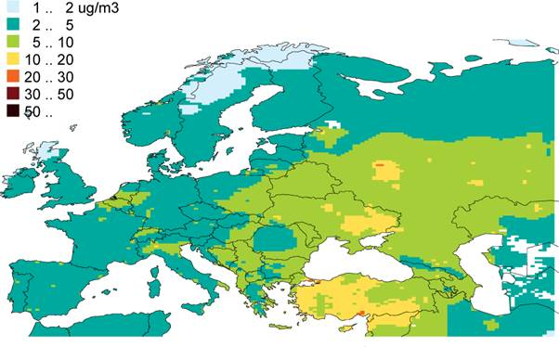
Achieving this level starting in 2025 from the point delivered by the 6C* policy option would require reducing emissions of SO2 16,7% every 5 years; NOx 15%; PM2,5 12,4%; ammonia 6%; and VOC 10%. Table A7.17 reports the pathway to reaching this goal in 2050. Compared to 1990 levels, the 2050 emissions would be 97% lower for SOx, 89% lower for NOx, 84% for VOC, 74% for PM2,5 and 60% for ammonia, with average reduction percentage for the five pollutants of 80%. Whilst these reductions would all be feasible under the MCE assumptions, they could not be cost-effectively achieved by technical measures alone; the trajectory should be considered therefore indicative. Details by Member State are reported in Appendix 7.7.
Table A7.17: Emission reduction trajectory towards achieving the WHO guideline values in 2050; emissions in kilotons, reductions compared with 2005 emissions
EU28 | 2005 | 2025 | 2030 | 2040 | 2050
SO2 | 8172 | -79% | -82% | -87% | -91%
NOx | 11538 | -65% | -70% | -78% | -83%
PM2,5 | 1647 | -48% | -54% | -64% | -72%
NH3 | 3928 | -30% | -34% | -42% | -48%
VOC | 9259 | -50% | -55% | -64% | -71%

Figure A7.2 shows compliance projections for the 2050 MCE scenario. Even at the level of individual monitors, 90% of stations would meet the 10 g/m3 limit. The residual 10% would be addressed by taking proportionate specific local measures to address particular hotspot situations.
Fig A7.2: Porjected distribution of concentrations at existing monitoring stations for PM2,5

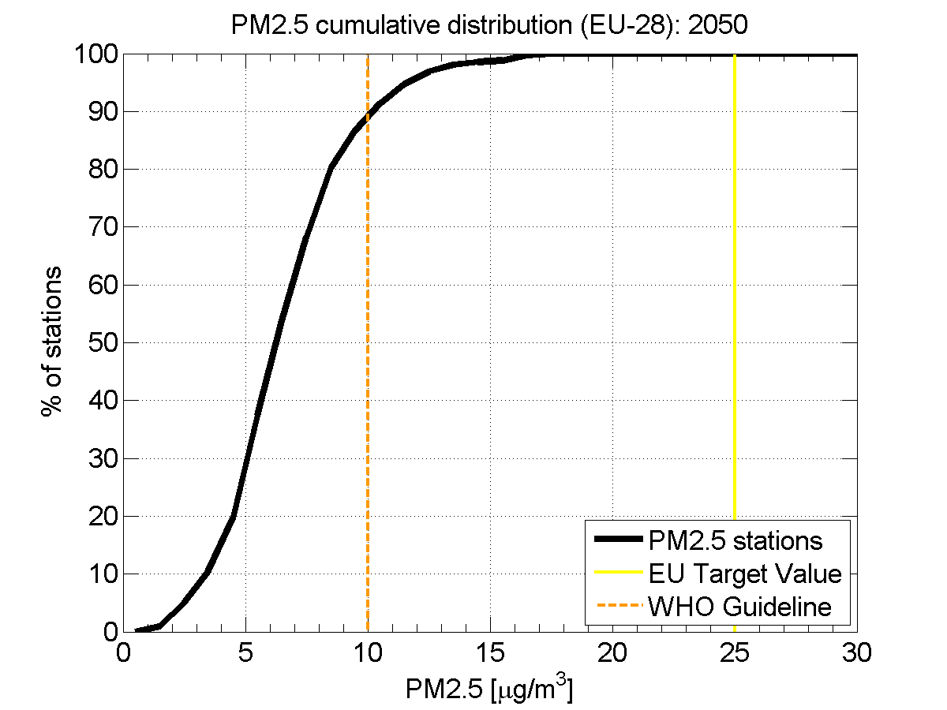

Appendix 7.1 Emission reductions per Member State and per option in 2025 and 2030 (% vs 2005)
SO2 emissions in 2025, baseline and further control options. % reduction vs 2005
Country |  | Option 1 |  | Option 6A |  | Option 6B |  | Option 6C |  | Option 6D
 | 2005 | 2025 | % red | 2025 | % red | 2025 | % red | 2025 | % red | 2025 | % red
Austria | 25 | 14 | -43% | 13 | -46% | 13 | -46% | 12 | -52% | 12 | -53%
Belgium | 140 | 59 | -58% | 54 | -62% | 51 | -63% | 46 | -67% | 46 | -67%
Bulgaria | 890 | 137 | -85% | 135 | -85% | 101 | -89% | 81 | -91% | 80 | -91%
Croatia | 68 | 21 | -70% | 20 | -71% | 11 | -84% | 9 | -86% | 7 | -89%
Cyprus | 38 | 2 | -95% | 2 | -95% | 2 | -95% | 1 | -97% | 1 | -98%
Czech Rep. | 208 | 81 | -61% | 74 | -64% | 68 | -67% | 65 | -68% | 62 | -70%
Denmark | 21 | 10 | -53% | 10 | -53% | 10 | -54% | 9 | -56% | 8 | -60%
Estonia | 66 | 23 | -66% | 23 | -66% | 23 | -66% | 20 | -70% | 18 | -73%
Finland | 90 | 64 | -29% | 63 | -29% | 63 | -29% | 63 | -30% | 59 | -34%
France | 444 | 124 | -72% | 117 | -74% | 108 | -76% | 103 | -77% | 100 | -78%
Germany | 549 | 333 | -39% | 317 | -42% | 308 | -44% | 295 | -46% | 291 | -47%
Greece | 505 | 66 | -87% | 65 | -87% | 65 | -87% | 52 | -90% | 39 | -92%
Hungary | 129 | 28 | -78% | 28 | -79% | 20 | -85% | 17 | -86% | 17 | -87%
Ireland | 71 | 18 | -75% | 17 | -76% | 16 | -77% | 13 | -81% | 13 | -82%
Italy | 382 | 142 | -63% | 119 | -69% | 106 | -72% | 93 | -76% | 75 | -80%
Latvia | 5 | 3 | -39% | 3 | -41% | 3 | -41% | 3 | -47% | 2 | -53%
Lithuania | 42 | 24 | -42% | 24 | -43% | 23 | -45% | 11 | -74% | 9 | -77%
Luxembourg | 2 | 2 | -20% | 2 | -20% | 1 | -25% | 1 | -44% | 1 | -56%
Malta | 11 | 0 | -96% | 0 | -96% | 0 | -96% | 0 | -98% | 0 | -99%
Netherlands | 70 | 34 | -52% | 33 | -52% | 31 | -56% | 30 | -57% | 28 | -60%
Poland | 1256 | 528 | -58% | 414 | -67% | 370 | -70% | 332 | -74% | 319 | -75%
Portugal | 111 | 49 | -56% | 45 | -60% | 33 | -71% | 23 | -79% | 19 | -83%
Romania | 706 | 101 | -86% | 97 | -86% | 63 | -91% | 55 | -92% | 50 | -93%
Slovakia | 92 | 45 | -51% | 44 | -51% | 29 | -68% | 20 | -78% | 19 | -79%
Slovenia | 40 | 6 | -85% | 6 | -85% | 5 | -86% | 5 | -88% | 5 | -88%
Spain | 1328 | 228 | -83% | 222 | -83% | 178 | -87% | 149 | -89% | 133 | -90%
Sweden | 38 | 32 | -15% | 32 | -15% | 32 | -15% | 32 | -16% | 31 | -19%
Un. Kingdom | 850 | 274 | -68% | 210 | -75% | 169 | -80% | 153 | -82% | 150 | -82%
EU-28 | 8172 | 2446 | -70% | 2188 | -73% | 1903 | -77% | 1694 | -79% | 1593 | -81%

SO2 emissions in 2030, baseline and further control options. % reduction vs 2005
Country |  | Option 1 |  | Option 6A |  | Option 6B |  | Option 6C |  | Option 6D
 | 2005 | 2030 | % red | 2030 | % red | 2030 | % red | 2030 | % red | 2030 | % red
Austria | 25 | 13 | -47% | 13 | -49% | 12 | -49% | 11 | -54% | 11 | -55%
Belgium | 140 | 58 | -59% | 52 | -63% | 49 | -65% | 44 | -68% | 44 | -68%
Bulgaria | 890 | 112 | -87% | 109 | -88% | 76 | -92% | 53 | -94% | 52 | -94%
Croatia | 68 | 20 | -70% | 19 | -71% | 11 | -84% | 9 | -87% | 6 | -91%
Cyprus | 38 | 2 | -95% | 2 | -95% | 2 | -95% | 1 | -97% | 1 | -98%
Czech Rep. | 208 | 74 | -64% | 67 | -68% | 61 | -70% | 59 | -72% | 56 | -73%
Denmark | 21 | 9 | -56% | 9 | -56% | 9 | -56% | 9 | -58% | 8 | -63%
Estonia | 66 | 22 | -67% | 22 | -67% | 22 | -67% | 19 | -71% | 15 | -78%
Finland | 90 | 64 | -29% | 63 | -29% | 63 | -29% | 63 | -30% | 59 | -35%
France | 444 | 117 | -74% | 111 | -75% | 103 | -77% | 98 | -78% | 92 | -79%
Germany | 549 | 295 | -46% | 278 | -49% | 269 | -51% | 258 | -53% | 246 | -55%
Greece | 505 | 50 | -90% | 51 | -90% | 50 | -90% | 38 | -92% | 26 | -95%
Hungary | 129 | 27 | -79% | 26 | -80% | 18 | -86% | 16 | -88% | 15 | -88%
Ireland | 71 | 14 | -80% | 14 | -80% | 13 | -81% | 11 | -84% | 11 | -85%
Italy | 382 | 142 | -63% | 119 | -69% | 105 | -72% | 92 | -76% | 73 | -81%
Latvia | 5 | 3 | -40% | 3 | -42% | 3 | -42% | 3 | -47% | 2 | -54%
Lithuania | 42 | 25 | -41% | 24 | -41% | 24 | -43% | 12 | -72% | 10 | -77%
Luxembourg | 2 | 2 | -21% | 2 | -21% | 1 | -25% | 1 | -44% | 1 | -56%
Malta | 11 | 0 | -97% | 0 | -97% | 0 | -97% | 0 | -98% | 0 | -99%
Netherlands | 70 | 32 | -54% | 32 | -54% | 30 | -58% | 28 | -59% | 26 | -63%
Poland | 1256 | 453 | -64% | 362 | -71% | 317 | -75% | 278 | -78% | 261 | -79%
Portugal | 111 | 49 | -56% | 44 | -60% | 33 | -71% | 23 | -79% | 17 | -84%
Romania | 706 | 99 | -86% | 95 | -87% | 60 | -92% | 51 | -93% | 45 | -94%
Slovakia | 92 | 46 | -50% | 45 | -50% | 29 | -68% | 20 | -79% | 19 | -80%
Slovenia | 40 | 6 | -85% | 5 | -86% | 5 | -87% | 5 | -89% | 4 | -89%
Spain | 1328 | 232 | -83% | 226 | -83% | 179 | -87% | 148 | -89% | 130 | -90%
Sweden | 38 | 32 | -16% | 32 | -16% | 32 | -16% | 32 | -16% | 31 | -19%
Un. Kingdom | 850 | 214 | -75% | 173 | -80% | 144 | -83% | 128 | -85% | 124 | -85%
EU-28 | 8172 | 2211 | -73% | 1999 | -76% | 1720 | -79% | 1510 | -82% | 1383 | -83%

NOx emissions in 2025, baseline and further control options. % reduction vs 2005
Country |  | Option 1 |  | Option 6A |  | Option 6B |  | Option 6C |  | Option 6D
 | 2005 | 2025 | % red | 2025 | % red | 2025 | % red | 2025 | % red | 2025 | % red
Austria | 230 | 77 | -67% | 77 | -67% | 77 | -67% | 71 | -69% | 65 | -72%
Belgium | 295 | 146 | -50% | 142 | -52% | 141 | -52% | 123 | -58% | 111 | -62%
Bulgaria | 167 | 68 | -59% | 68 | -59% | 68 | -59% | 65 | -61% | 52 | -69%
Croatia | 76 | 36 | -52% | 36 | -53% | 35 | -53% | 27 | -64% | 17 | -78%
Cyprus | 21 | 7 | -67% | 7 | -67% | 7 | -67% | 7 | -67% | 5 | -78%
Czech Rep. | 296 | 130 | -56% | 129 | -56% | 127 | -57% | 114 | -61% | 98 | -67%
Denmark | 182 | 70 | -62% | 69 | -62% | 69 | -62% | 63 | -65% | 55 | -70%
Estonia | 40 | 18 | -55% | 18 | -55% | 18 | -55% | 18 | -55% | 13 | -69%
Finland | 201 | 110 | -45% | 110 | -45% | 110 | -45% | 110 | -45% | 92 | -54%
France | 1351 | 502 | -63% | 501 | -63% | 486 | -64% | 453 | -66% | 393 | -71%
Germany | 1397 | 608 | -56% | 575 | -59% | 572 | -59% | 522 | -63% | 460 | -67%
Greece | 407 | 150 | -63% | 134 | -67% | 133 | -67% | 133 | -67% | 108 | -74%
Hungary | 155 | 59 | -62% | 59 | -62% | 58 | -62% | 53 | -66% | 42 | -73%
Ireland | 150 | 63 | -58% | 63 | -58% | 63 | -58% | 55 | -64% | 49 | -68%
Italy | 1306 | 514 | -61% | 506 | -61% | 489 | -63% | 447 | -66% | 418 | -68%
Latvia | 36 | 24 | -34% | 23 | -35% | 23 | -35% | 23 | -36% | 19 | -49%
Lithuania | 62 | 31 | -50% | 30 | -51% | 30 | -51% | 30 | -52% | 25 | -60%
Luxembourg | 47 | 13 | -73% | 13 | -73% | 13 | -73% | 13 | -73% | 12 | -75%
Malta | 10 | 1 | -86% | 1 | -86% | 1 | -86% | 1 | -86% | 1 | -89%
Netherlands | 380 | 158 | -58% | 158 | -58% | 155 | -59% | 134 | -65% | 119 | -69%
Poland | 797 | 438 | -45% | 437 | -45% | 435 | -45% | 404 | -49% | 343 | -57%
Portugal | 268 | 103 | -62% | 101 | -62% | 100 | -63% | 85 | -68% | 68 | -75%
Romania | 311 | 140 | -55% | 139 | -55% | 137 | -56% | 112 | -64% | 95 | -69%
Slovakia | 95 | 50 | -47% | 50 | -48% | 48 | -49% | 42 | -55% | 35 | -63%
Slovenia | 50 | 18 | -63% | 18 | -63% | 18 | -63% | 17 | -66% | 15 | -69%
Spain | 1513 | 496 | -67% | 485 | -68% | 485 | -68% | 441 | -71% | 365 | -76%
Sweden | 216 | 82 | -62% | 82 | -62% | 82 | -62% | 82 | -62% | 72 | -67%
Un. Kingdom | 1480 | 504 | -66% | 503 | -66% | 502 | -66% | 450 | -70% | 380 | -74%
EU-28 | 11538 | 4616 | -60% | 4535 | -61% | 4484 | -61% | 4096 | -64% | 3525 | -69%

NOx emissions in 2030, baseline and further control options. % reduction vs 2005
Country |  | Option 1 |  | Option 6A |  | Option 6B |  | Option 6C |  | Option 6D
 | 2005 | 2030 | % red | 2030 | % red | 2030 | % red | 2030 | % red | 2030 | % red
Austria | 230 | 65 | -72% | 65 | -72% | 65 | -72% | 60 | -74% | 54 | -76%
Belgium | 295 | 134 | -55% | 131 | -56% | 130 | -56% | 112 | -62% | 95 | -68%
Bulgaria | 167 | 60 | -64% | 60 | -64% | 60 | -64% | 57 | -66% | 41 | -75%
Croatia | 76 | 33 | -56% | 33 | -56% | 33 | -57% | 25 | -68% | 14 | -81%
Cyprus | 21 | 6 | -70% | 6 | -70% | 6 | -70% | 6 | -70% | 4 | -81%
Czech Rep. | 296 | 112 | -62% | 111 | -62% | 110 | -63% | 99 | -67% | 83 | -72%
Denmark | 182 | 61 | -66% | 60 | -67% | 60 | -67% | 56 | -70% | 46 | -75%
Estonia | 40 | 16 | -61% | 16 | -61% | 16 | -61% | 16 | -61% | 10 | -74%
Finland | 201 | 99 | -51% | 99 | -51% | 99 | -51% | 99 | -51% | 82 | -59%
France | 1351 | 441 | -67% | 440 | -67% | 424 | -69% | 395 | -71% | 332 | -75%
Germany | 1397 | 530 | -62% | 495 | -65% | 491 | -65% | 442 | -68% | 380 | -73%
Greece | 407 | 126 | -69% | 113 | -72% | 112 | -72% | 112 | -72% | 91 | -78%
Hungary | 155 | 52 | -66% | 52 | -67% | 52 | -67% | 46 | -70% | 35 | -77%
Ireland | 150 | 43 | -71% | 43 | -71% | 43 | -71% | 35 | -76% | 28 | -82%
Italy | 1306 | 456 | -65% | 449 | -66% | 432 | -67% | 391 | -70% | 360 | -72%
Latvia | 36 | 20 | -44% | 20 | -44% | 20 | -44% | 20 | -44% | 15 | -58%
Lithuania | 62 | 28 | -54% | 28 | -55% | 28 | -55% | 27 | -56% | 22 | -65%
Luxembourg | 47 | 10 | -79% | 10 | -79% | 10 | -79% | 10 | -79% | 9 | -80%
Malta | 10 | 1 | -89% | 1 | -89% | 1 | -89% | 1 | -89% | 1 | -92%
Netherlands | 380 | 143 | -62% | 143 | -62% | 141 | -63% | 121 | -68% | 105 | -72%
Poland | 797 | 379 | -52% | 378 | -53% | 376 | -53% | 343 | -57% | 280 | -65%
Portugal | 268 | 92 | -65% | 91 | -66% | 90 | -67% | 75 | -72% | 57 | -79%
Romania | 311 | 127 | -59% | 127 | -59% | 124 | -60% | 100 | -68% | 81 | -74%
Slovakia | 95 | 47 | -51% | 46 | -51% | 45 | -52% | 39 | -59% | 31 | -67%
Slovenia | 50 | 16 | -69% | 16 | -69% | 15 | -69% | 14 | -72% | 12 | -75%
Spain | 1513 | 434 | -71% | 422 | -72% | 422 | -72% | 378 | -75% | 300 | -80%
Sweden | 216 | 76 | -65% | 76 | -65% | 76 | -65% | 75 | -65% | 64 | -70%
Un. Kingdom | 1480 | 441 | -70% | 440 | -70% | 439 | -70% | 391 | -74% | 316 | -79%
EU-28 | 11538 | 4051 | -65% | 3970 | -66% | 3921 | -66% | 3544 | -69% | 2947 | -74%

NH3 emissions in 2025, baseline and further control options. % reduction vs 2005
Country |  | Option 1 |  | Option 6A |  | Option 6B |  | Option 6C |  | Option 6D
 | 2005 | 2025 | % red | 2025 | % red | 2025 | % red | 2025 | % red | 2025 | % red
Austria | 63 | 67 | 7% | 59 | -6% | 56 | -11% | 51 | -19% | 46 | -26%
Belgium | 74 | 74 | 0% | 69 | -8% | 66 | -10% | 62 | -16% | 60 | -19%
Bulgaria | 65 | 64 | -2% | 62 | -5% | 61 | -6% | 58 | -11% | 57 | -13%
Croatia | 29 | 29 | 0% | 28 | -5% | 26 | -12% | 21 | -27% | 18 | -38%
Cyprus | 6 | 6 | -6% | 6 | -7% | 5 | -12% | 5 | -21% | 4 | -33%
Czech Rep. | 80 | 63 | -21% | 60 | -25% | 55 | -31% | 52 | -35% | 52 | -35%
Denmark | 73 | 51 | -31% | 49 | -33% | 49 | -34% | 46 | -37% | 39 | -46%
Estonia | 12 | 13 | 7% | 12 | 6% | 12 | -1% | 11 | -10% | 8 | -30%
Finland | 34 | 31 | -8% | 30 | -11% | 30 | -11% | 28 | -17% | 24 | -29%
France | 675 | 638 | -5% | 580 | -14% | 534 | -21% | 463 | -31% | 425 | -37%
Germany | 593 | 570 | -4% | 485 | -18% | 392 | -34% | 318 | -46% | 299 | -50%
Greece | 57 | 47 | -16% | 46 | -19% | 43 | -25% | 41 | -28% | 38 | -32%
Hungary | 78 | 67 | -13% | 62 | -20% | 54 | -31% | 48 | -38% | 48 | -38%
Ireland | 104 | 101 | -4% | 101 | -4% | 98 | -6% | 92 | -11% | 85 | -18%
Italy | 422 | 386 | -9% | 364 | -14% | 330 | -22% | 299 | -29% | 296 | -30%
Latvia | 13 | 15 | 16% | 15 | 14% | 15 | 13% | 13 | 3% | 12 | -5%
Lithuania | 44 | 49 | 12% | 49 | 11% | 48 | 8% | 46 | 4% | 32 | -28%
Luxembourg | 6 | 6 | -10% | 5 | -18% | 5 | -22% | 5 | -25% | 5 | -27%
Malta | 2 | 2 | -7% | 2 | -7% | 1 | -21% | 1 | -25% | 1 | -34%
Netherlands | 146 | 112 | -23% | 112 | -24% | 111 | -24% | 111 | -24% | 110 | -25%
Poland | 344 | 331 | -4% | 300 | -13% | 294 | -14% | 245 | -29% | 227 | -34%
Portugal | 71 | 71 | 0% | 65 | -8% | 62 | -13% | 55 | -22% | 49 | -30%
Romania | 161 | 142 | -12% | 136 | -16% | 134 | -17% | 122 | -24% | 112 | -31%
Slovakia | 28 | 24 | -16% | 21 | -25% | 18 | -35% | 17 | -41% | 17 | -42%
Slovenia | 19 | 17 | -12% | 15 | -18% | 15 | -20% | 14 | -25% | 14 | -28%
Spain | 366 | 352 | -4% | 334 | -9% | 303 | -17% | 258 | -29% | 211 | -42%
Sweden | 54 | 48 | -10% | 48 | -10% | 47 | -13% | 44 | -19% | 39 | -27%
Un. Kingdom | 308 | 282 | -8% | 275 | -11% | 257 | -17% | 240 | -22% | 236 | -23%
EU-28 | 3928 | 3658 | -7% | 3390 | -14% | 3122 | -21% | 2767 | -30% | 2566 | -35%

NH3 emissions in 2030, baseline and further control options. % reduction vs 2005
Country |  | Option 1 |  | Option 6A |  | Option 6B |  | Option 6C |  | Option 6D
 | 2005 | 2030 | % red | 2030 | % red | 2030 | % red | 2030 | % red | 2030 | % red
Austria | 63 | 68 | 8% | 60 | -5% | 56 | -11% | 51 | -19% | 47 | -26%
Belgium | 74 | 73 | -1% | 68 | -9% | 66 | -11% | 62 | -16% | 60 | -19%
Bulgaria | 65 | 64 | -1% | 62 | -4% | 61 | -6% | 59 | -10% | 57 | -12%
Croatia | 29 | 30 | 2% | 28 | -4% | 26 | -12% | 22 | -26% | 19 | -36%
Cyprus | 6 | 6 | -4% | 6 | -5% | 6 | -10% | 5 | -20% | 4 | -31%
Czech Rep. | 80 | 62 | -22% | 59 | -26% | 55 | -32% | 51 | -36% | 51 | -36%
Denmark | 73 | 51 | -31% | 49 | -33% | 48 | -34% | 46 | -38% | 39 | -47%
Estonia | 12 | 13 | 9% | 13 | 7% | 12 | 1% | 11 | -9% | 8 | -29%
Finland | 34 | 31 | -8% | 30 | -11% | 30 | -11% | 28 | -17% | 24 | -29%
France | 675 | 639 | -5% | 574 | -15% | 527 | -22% | 458 | -32% | 424 | -37%
Germany | 593 | 565 | -5% | 472 | -20% | 379 | -36% | 312 | -47% | 294 | -50%
Greece | 57 | 48 | -16% | 46 | -18% | 43 | -25% | 41 | -28% | 39 | -32%
Hungary | 78 | 67 | -13% | 62 | -20% | 54 | -31% | 49 | -37% | 48 | -38%
Ireland | 104 | 101 | -3% | 101 | -3% | 98 | -5% | 93 | -11% | 86 | -18%
Italy | 422 | 389 | -8% | 367 | -13% | 329 | -22% | 302 | -28% | 299 | -29%
Latvia | 13 | 15 | 19% | 15 | 17% | 15 | 15% | 14 | 6% | 13 | -3%
Lithuania | 44 | 51 | 15% | 50 | 13% | 49 | 11% | 47 | 6% | 33 | -26%
Luxembourg | 6 | 6 | -11% | 5 | -19% | 5 | -24% | 5 | -25% | 5 | -27%
Malta | 2 | 2 | -8% | 2 | -8% | 1 | -22% | 1 | -26% | 1 | -35%
Netherlands | 146 | 111 | -24% | 110 | -24% | 110 | -25% | 109 | -25% | 109 | -25%
Poland | 344 | 332 | -3% | 300 | -13% | 294 | -14% | 245 | -29% | 228 | -33%
Portugal | 71 | 73 | 3% | 66 | -7% | 63 | -11% | 57 | -20% | 50 | -29%
Romania | 161 | 141 | -12% | 136 | -16% | 133 | -18% | 121 | -25% | 112 | -31%
Slovakia | 28 | 24 | -16% | 21 | -25% | 18 | -35% | 17 | -41% | 17 | -42%
Slovenia | 19 | 17 | -12% | 15 | -18% | 15 | -20% | 14 | -25% | 14 | -28%
Spain | 366 | 349 | -5% | 330 | -10% | 300 | -18% | 258 | -30% | 209 | -43%
Sweden | 54 | 49 | -9% | 49 | -9% | 47 | -12% | 44 | -18% | 39 | -27%
Un. Kingdom | 308 | 287 | -7% | 279 | -10% | 260 | -16% | 244 | -21% | 239 | -22%
EU-28 | 3928 | 3663 | -7% | 3375 | -14% | 3099 | -21% | 2762 | -30% | 2568 | -35%

VOC emissions in 2025, baseline and further control options. % reduction vs 2005
Country |  | Option 1 |  | Option 6A |  | Option 6B |  | Option 6C |  | Option 6D
 | 2005 | 2025 | % red | 2025 | % red | 2025 | % red | 2025 | % red | 2025 | % red
Austria | 171 | 107 | -38% | 105 | -39% | 104 | -39% | 90 | -47% | 54 | -68%
Belgium | 158 | 99 | -37% | 97 | -39% | 97 | -39% | 89 | -44% | 68 | -57%
Bulgaria | 139 | 73 | -47% | 66 | -52% | 66 | -53% | 56 | -60% | 36 | -74%
Croatia | 79 | 51 | -36% | 47 | -41% | 47 | -41% | 38 | -52% | 27 | -66%
Cyprus | 9 | 4 | -52% | 4 | -53% | 4 | -53% | 4 | -53% | 3 | -68%
Czech Rep. | 251 | 143 | -43% | 137 | -46% | 136 | -46% | 113 | -55% | 73 | -71%
Denmark | 130 | 65 | -50% | 61 | -53% | 61 | -53% | 55 | -58% | 37 | -72%
Estonia | 38 | 29 | -24% | 28 | -27% | 28 | -27% | 26 | -31% | 10 | -73%
Finland | 173 | 102 | -41% | 101 | -41% | 101 | -41% | 96 | -44% | 53 | -69%
France | 1117 | 616 | -45% | 610 | -45% | 606 | -46% | 573 | -49% | 413 | -63%
Germany | 1235 | 850 | -31% | 800 | -35% | 795 | -36% | 720 | -42% | 514 | -58%
Greece | 283 | 121 | -57% | 112 | -60% | 100 | -65% | 93 | -67% | 66 | -77%
Hungary | 144 | 83 | -42% | 82 | -43% | 82 | -43% | 63 | -56% | 47 | -67%
Ireland | 63 | 44 | -31% | 44 | -31% | 44 | -31% | 43 | -32% | 24 | -62%
Italy | 1237 | 667 | -46% | 622 | -50% | 596 | -52% | 568 | -54% | 409 | -67%
Latvia | 69 | 40 | -42% | 39 | -44% | 39 | -44% | 30 | -57% | 16 | -76%
Lithuania | 84 | 43 | -49% | 39 | -54% | 39 | -54% | 34 | -59% | 19 | -78%
Luxembourg | 13 | 6 | -54% | 6 | -54% | 6 | -54% | 5 | -58% | 4 | -66%
Malta | 4 | 3 | -31% | 3 | -32% | 3 | -32% | 3 | -32% | 1 | -64%
Netherlands | 205 | 142 | -31% | 142 | -31% | 139 | -32% | 135 | -34% | 106 | -48%
Poland | 615 | 412 | -33% | 405 | -34% | 340 | -45% | 287 | -53% | 210 | -66%
Portugal | 227 | 137 | -40% | 130 | -43% | 126 | -45% | 122 | -46% | 92 | -60%
Romania | 460 | 256 | -44% | 231 | -50% | 230 | -50% | 171 | -63% | 104 | -77%
Slovakia | 77 | 54 | -30% | 53 | -31% | 53 | -31% | 47 | -39% | 29 | -63%
Slovenia | 41 | 30 | -27% | 30 | -27% | 30 | -28% | 15 | -62% | 11 | -74%
Spain | 934 | 597 | -36% | 518 | -45% | 513 | -45% | 485 | -48% | 363 | -61%
Sweden | 210 | 138 | -34% | 137 | -34% | 137 | -34% | 137 | -35% | 103 | -51%
Un. Kingdom | 1093 | 694 | -37% | 675 | -38% | 638 | -42% | 552 | -50% | 419 | -62%
EU-28 | 9259 | 5604 | -39% | 5322 | -43% | 5157 | -44% | 4648 | -50% | 3308 | -64%

VOC emissions in 2030, baseline and further control options. % reduction vs 2005
Country |  | Option 1 |  | Option 6A |  | Option 6B |  | Option 6C |  | Option 6D
 | 2005 | 2030 | % red | 2030 | % red | 2030 | % red | 2030 | % red | 2030 | % red
Austria | 171 | 102 | -40% | 100 | -41% | 100 | -41% | 89 | -48% | 52 | -70%
Belgium | 158 | 99 | -37% | 98 | -38% | 98 | -38% | 90 | -43% | 67 | -57%
Bulgaria | 139 | 67 | -51% | 60 | -57% | 60 | -57% | 52 | -62% | 32 | -77%
Croatia | 79 | 48 | -39% | 44 | -44% | 44 | -44% | 36 | -54% | 25 | -68%
Cyprus | 9 | 4 | -53% | 4 | -54% | 4 | -54% | 4 | -54% | 3 | -69%
Czech Rep. | 251 | 140 | -44% | 133 | -47% | 133 | -47% | 111 | -56% | 69 | -72%
Denmark | 130 | 63 | -51% | 59 | -55% | 59 | -55% | 54 | -58% | 35 | -73%
Estonia | 38 | 27 | -31% | 25 | -34% | 25 | -34% | 24 | -37% | 9 | -75%
Finland | 173 | 96 | -44% | 98 | -43% | 98 | -43% | 92 | -47% | 48 | -72%
France | 1117 | 591 | -47% | 590 | -47% | 586 | -48% | 560 | -50% | 396 | -65%
Germany | 1235 | 840 | -32% | 788 | -36% | 783 | -37% | 710 | -43% | 502 | -59%
Greece | 283 | 116 | -59% | 108 | -62% | 96 | -66% | 89 | -68% | 60 | -79%
Hungary | 144 | 81 | -44% | 80 | -45% | 79 | -45% | 61 | -58% | 45 | -69%
Ireland | 63 | 43 | -32% | 43 | -32% | 43 | -32% | 43 | -33% | 22 | -65%
Italy | 1237 | 646 | -48% | 610 | -51% | 587 | -53% | 555 | -55% | 400 | -68%
Latvia | 69 | 37 | -46% | 35 | -49% | 35 | -49% | 30 | -56% | 16 | -77%
Lithuania | 84 | 40 | -53% | 36 | -57% | 36 | -57% | 33 | -60% | 18 | -78%
Luxembourg | 13 | 6 | -55% | 6 | -55% | 6 | -55% | 5 | -58% | 4 | -67%
Malta | 4 | 3 | -30% | 3 | -31% | 3 | -31% | 3 | -31% | 1 | -64%
Netherlands | 205 | 141 | -31% | 140 | -32% | 138 | -33% | 133 | -35% | 103 | -50%
Poland | 615 | 403 | -34% | 399 | -35% | 335 | -45% | 281 | -54% | 192 | -69%
Portugal | 227 | 137 | -40% | 130 | -43% | 127 | -44% | 123 | -46% | 92 | -60%
Romania | 460 | 238 | -48% | 213 | -54% | 213 | -54% | 165 | -64% | 96 | -79%
Slovakia | 77 | 53 | -31% | 53 | -32% | 53 | -32% | 47 | -39% | 27 | -65%
Slovenia | 41 | 28 | -33% | 28 | -33% | 27 | -33% | 15 | -63% | 10 | -75%
Spain | 934 | 596 | -36% | 518 | -45% | 513 | -45% | 485 | -48% | 358 | -62%
Sweden | 210 | 132 | -37% | 132 | -37% | 132 | -37% | 131 | -37% | 98 | -53%
Un. Kingdom | 1093 | 684 | -37% | 666 | -39% | 631 | -42% | 546 | -50% | 410 | -62%
EU-28 | 9259 | 5460 | -41% | 5199 | -44% | 5043 | -46% | 4569 | -51% | 3191 | -66%

PM2,5 emissions in 2025, baseline and further control options. % reduction vs 2005
Country |  | Option 1 |  | Option 6A |  | Option 6B |  | Option 6C |  | Option 6D
 | 2005 | 2025 | % red | 2025 | % red | 2025 | % red | 2025 | % red | 2025 | % red
Austria | 24 | 17 | -31% | 16 | -35% | 15 | -39% | 11 | -54% | 10 | -60%
Belgium | 28 | 19 | -33% | 18 | -36% | 16 | -43% | 15 | -46% | 14 | -52%
Bulgaria | 35 | 26 | -24% | 19 | -45% | 18 | -47% | 14 | -60% | 11 | -69%
Croatia | 15 | 11 | -26% | 7 | -56% | 6 | -58% | 5 | -66% | 3 | -78%
Cyprus | 3 | 1 | -70% | 1 | -72% | 1 | -72% | 1 | -73% | 1 | -75%
Czech Rep. | 43 | 34 | -21% | 28 | -34% | 28 | -35% | 23 | -47% | 18 | -59%
Denmark | 28 | 15 | -47% | 14 | -49% | 14 | -49% | 11 | -62% | 8 | -70%
Estonia | 20 | 13 | -36% | 12 | -42% | 12 | -42% | 10 | -48% | 4 | -80%
Finland | 29 | 21 | -25% | 21 | -27% | 21 | -28% | 18 | -37% | 13 | -55%
France | 271 | 184 | -32% | 166 | -39% | 162 | -40% | 154 | -43% | 124 | -54%
Germany | 123 | 87 | -29% | 82 | -33% | 78 | -36% | 73 | -41% | 67 | -45%
Greece | 62 | 32 | -49% | 24 | -61% | 17 | -72% | 16 | -75% | 13 | -79%
Hungary | 29 | 19 | -35% | 16 | -44% | 16 | -46% | 11 | -61% | 9 | -69%
Ireland | 13 | 9 | -29% | 9 | -29% | 9 | -31% | 9 | -32% | 8 | -43%
Italy | 147 | 128 | -12% | 113 | -23% | 86 | -41% | 82 | -44% | 75 | -49%
Latvia | 19 | 14 | -26% | 12 | -34% | 12 | -35% | 9 | -52% | 5 | -74%
Lithuania | 15 | 12 | -23% | 8 | -47% | 8 | -47% | 7 | -55% | 4 | -71%
Luxembourg | 3 | 2 | -42% | 2 | -42% | 2 | -42% | 2 | -47% | 2 | -51%
Malta | 1 | 0 | -75% | 0 | -79% | 0 | -79% | 0 | -79% | 0 | -82%
Netherlands | 24 | 17 | -29% | 16 | -32% | 16 | -35% | 15 | -38% | 14 | -44%
Poland | 225 | 216 | -4% | 197 | -13% | 174 | -22% | 154 | -31% | 124 | -45%
Portugal | 63 | 41 | -34% | 27 | -58% | 22 | -65% | 19 | -69% | 17 | -73%
Romania | 113 | 91 | -19% | 66 | -42% | 58 | -48% | 44 | -61% | 29 | -74%
Slovakia | 32 | 20 | -36% | 19 | -42% | 18 | -44% | 12 | -62% | 8 | -74%
Slovenia | 9 | 6 | -35% | 6 | -39% | 6 | -39% | 2 | -73% | 2 | -75%
Spain | 156 | 124 | -20% | 69 | -56% | 65 | -58% | 60 | -61% | 52 | -67%
Sweden | 31 | 25 | -19% | 25 | -19% | 25 | -19% | 21 | -33% | 14 | -55%
Un. Kingdom | 87 | 82 | -6% | 67 | -23% | 53 | -39% | 46 | -47% | 41 | -52%
EU-28 | 1647 | 1266 | -23% | 1059 | -36% | 960 | -42% | 844 | -49% | 690 | -58%

PM2,5 emissions in 2030, baseline and further control options. % reduction vs 2005
Country |  | Option 1 |  | Option 6A |  | Option 6B |  | Option 6C |  | Option 6D
 | 2005 | 2030 | % red | 2030 | % red | 2030 | % red | 2030 | % red | 2030 | % red
Austria | 24 | 16 | -34% | 15 | -38% | 14 | -42% | 11 | -55% | 9 | -62%
Belgium | 28 | 19 | -33% | 18 | -36% | 16 | -43% | 15 | -46% | 13 | -53%
Bulgaria | 35 | 24 | -30% | 17 | -52% | 16 | -53% | 12 | -64% | 9 | -75%
Croatia | 15 | 11 | -28% | 6 | -59% | 6 | -60% | 5 | -67% | 3 | -82%
Cyprus | 3 | 1 | -70% | 1 | -72% | 1 | -72% | 1 | -73% | 1 | -75%
Czech Rep. | 43 | 32 | -25% | 27 | -37% | 26 | -38% | 22 | -49% | 15 | -65%
Denmark | 28 | 13 | -53% | 13 | -55% | 13 | -55% | 10 | -64% | 7 | -75%
Estonia | 20 | 12 | -41% | 10 | -48% | 10 | -48% | 10 | -52% | 3 | -85%
Finland | 29 | 20 | -30% | 19 | -33% | 19 | -33% | 17 | -41% | 11 | -62%
France | 271 | 169 | -38% | 152 | -44% | 148 | -45% | 141 | -48% | 107 | -61%
Germany | 123 | 84 | -32% | 79 | -36% | 75 | -39% | 70 | -43% | 62 | -49%
Greece | 62 | 30 | -51% | 23 | -63% | 18 | -70% | 17 | -72% | 14 | -78%
Hungary | 29 | 18 | -37% | 16 | -46% | 15 | -48% | 11 | -63% | 8 | -73%
Ireland | 13 | 9 | -33% | 9 | -33% | 9 | -34% | 9 | -35% | 7 | -49%
Italy | 147 | 119 | -19% | 105 | -28% | 83 | -44% | 78 | -47% | 69 | -53%
Latvia | 19 | 12 | -34% | 11 | -42% | 11 | -43% | 8 | -54% | 4 | -80%
Lithuania | 15 | 11 | -28% | 7 | -52% | 7 | -52% | 6 | -57% | 4 | -75%
Luxembourg | 3 | 2 | -43% | 2 | -43% | 2 | -44% | 2 | -48% | 2 | -54%
Malta | 1 | 0 | -76% | 0 | -80% | 0 | -80% | 0 | -80% | 0 | -83%
Netherlands | 24 | 17 | -30% | 16 | -33% | 16 | -36% | 15 | -39% | 13 | -45%
Poland | 225 | 198 | -12% | 181 | -19% | 160 | -29% | 140 | -38% | 98 | -56%
Portugal | 63 | 41 | -35% | 26 | -59% | 22 | -65% | 19 | -69% | 16 | -74%
Romania | 113 | 84 | -25% | 59 | -48% | 52 | -54% | 41 | -64% | 23 | -80%
Slovakia | 32 | 20 | -38% | 18 | -43% | 18 | -45% | 12 | -62% | 7 | -78%
Slovenia | 9 | 6 | -40% | 5 | -44% | 5 | -44% | 2 | -74% | 2 | -76%
Spain | 156 | 125 | -20% | 70 | -55% | 66 | -58% | 61 | -61% | 50 | -68%
Sweden | 31 | 25 | -19% | 25 | -19% | 25 | -20% | 20 | -34% | 14 | -56%
Un. Kingdom | 87 | 82 | -6% | 65 | -26% | 52 | -40% | 46 | -48% | 38 | -56%
EU-28 | 1647 | 1200 | -27% | 994 | -40% | 904 | -45% | 802 | -51% | 607 | -63%

Appendix 7.2 Annual health impacts due to air pollution per option in 2025 and 2030, EU 28
IMPACTS 2025 | EU28 |  | Option 1 | Opt 6A | Opt 6B | Opt 6C | Opt 6D
Acute Mortality (All ages) | Premature deaths | O3 | 17800 | 17500 | 17300 | 16500 | 15000
Respiratory hospital admissions (>64) | Cases | O3 | 19080 | 18775 | 18572 | 17803 | 16168
Cardiovascular hospital admissions (>64) | Cases | O3 | 84028 | 82710 | 81762 | 78162 | 70666
Minor Restricted Activity Days (MRADs all ages) | Days | O3 | 85600047 | 84247689 | 832916 | 79751306 | 72291776
Chronic Mortality (All ages) LYL (1) | Life years lost | PM | 2712818 | 2528130 | 2346405 | 2163449 | 1983531
Chronic Mortality (30yr +) deaths (1) | Premature deaths | PM | 306981 | 286271 | 265399 | 24488 | 224769
Infant Mortality (0-1yr) | Premature deaths | PM | 1062 | 989 | 919 | 845 | 773
Chronic Bronchitis (27yr +) | Cases | PM | 242262 | 225787 | 209296 | 193324 | 177412
Bronchitis in children (aged 6 to 12) | Added cases | PM | 4620688 | 4306510 | 3992889 | 3688243 | 3384315
Respiratory Hospital Admissions (All ages) | Cases | PM | 105003 | 97733 | 91027 | 83753 | 76791
Cardiac Hospital Admissions (>18 years) | Cases | PM | 80583 | 75205 | 69965 | 64399 | 59086
Restricted Activity Days (all ages) | Days | PM | 275871902 | 257139250 | 238147099 | 220117469 | 201831060
Asthma symptom days (children 5-19yr) | Days | PM | 8183267 | 7627288 | 7076647 | 6551034 | 6012666
Lost working days (15-64 years) | Days | PM | 136552072 | 127245001 | 118334181 | 109151738 | 100259715
Note (1) Alternative expressions of the same effect, not additive

IMPACTS 2030 | EU28 |  | Option 1 | Opt 6A | Opt 6B | Opt 6C | Opt 6D
Acute Mortality (All ages) | Premature deaths | O3 | 17200 | 17000 | 16800 | 16000 | 14400
Respiratory hospital admissions (>64) | Cases | O3 | 20061 | 19751 | 19541 | 1874 | 16914
Cardiovascular hospital admissions (>64) | Cases | O3 | 87708 | 86383 | 85409 | 81673 | 73336
Minor Restricted Activity Days (MRADs all ages) | Days | O3 | 83560018 | 82295930 | 81380787 | 77947523 | 70210465
Chronic Mortality (All ages) LYL (1) | Life years lost | PM | 2540459 | 2370845 | 2202668 | 2036090 | 1817522
Chronic Mortality (30yr +) deaths (1) | Premature deaths | PM | 304106 | 283932 | 263538 | 243741 | 217902
Infant Mortality (0-1yr) | Premature deaths | PM | 943 | 880 | 818 | 755 | 673
Chronic Bronchitis (27yr +) | Cases | PM | 234058 | 218409 | 202726 | 187672 | 167765
Bronchitis in children aged 6 to 12 | Added cases | PM | 4459198 | 4161137 | 3863144 | 3576416 | 3196594
Respiratory Hospital Admissions (All ages) | Cases | PM | 100929 | 94054 | 87642 | 8085 | 7213
Cardiac Hospital Admissions (>18 years) | Cases | PM | 77246 | 7216 | 67154 | 61964 | 55314
Restricted Activity Days (all ages) | Days | PM | 269964452 | 251973103 | 233769290 | 216594842 | 193573166
Asthma symptom days (children 5-19yr) | Days | PM | 7733781 | 7218182 | 6707800 | 6222191 | 5568248
Lost working days (15-64 years) | Days | PM | 126944403 | 118424645 | 110185096 | 101818106 | 90984180
Note (1) Alternative expressions of the same effect, not additive

Appendix 7.3 Impact reductions per Member State and per option in 2025 and 2030 (% reductions vs impacts in 2005)
Million Years of life lost (YOLL), calculated with constant 2010 population. 2025
Country |  | Option 1 |  | Option 6A |  | Option 6B |  | Option 6C |  | Option 6D
 | 2005 | 2025 | % red | 2025 | % red | 2025 | % red | 2025 | % red | 2025 | % red
Austria | 5,17 | 3,20 | -38% | 3,03 | -41% | 2,91 | -44% | 2,56 | -50% | 2,37 | -54%
Belgium | 9,11 | 5,47 | -40% | 5,14 | -44% | 4,88 | -46% | 4,55 | -50% | 4,25 | -53%
Bulgaria | 6,92 | 3,64 | -47% | 3,46 | -50% | 3,28 | -53% | 2,98 | -57% | 2,77 | -60%
Croatia | 2,96 | 1,68 | -43% | 1,58 | -47% | 1,50 | -50% | 1,37 | -54% | 1,26 | -57%
Cyprus | 0,59 | 0,53 | -9% | 0,53 | -9% | 0,53 | -10% | 0,52 | -11% | 0,52 | -12%
Czech Rep. | 7,91 | 5,31 | -33% | 4,93 | -38% | 4,68 | -41% | 4,21 | -47% | 3,82 | -52%
Denmark | 2,94 | 1,68 | -43% | 1,61 | -45% | 1,56 | -47% | 1,41 | -52% | 1,30 | -56%
Estonia | 0,53 | 0,43 | -19% | 0,42 | -21% | 0,42 | -22% | 0,40 | -26% | 0,33 | -38%
Finland | 1,68 | 1,28 | -24% | 1,26 | -25% | 1,26 | -25% | 1,19 | -29% | 1,09 | -35%
France | 46,02 | 24,73 | -46% | 23,36 | -49% | 22,44 | -51% | 21,04 | -54% | 18,54 | -60%
Germany | 53,90 | 34,50 | -36% | 32,29 | -40% | 30,47 | -43% | 28,19 | -48% | 26,53 | -51%
Greece | 11,65 | 6,15 | -47% | 5,97 | -49% | 5,33 | -54% | 5,08 | -56% | 4,73 | -59%
Hungary | 8,41 | 5,06 | -40% | 4,76 | -43% | 4,46 | -47% | 3,96 | -53% | 3,66 | -57%
Ireland | 1,34 | 0,86 | -36% | 0,84 | -38% | 0,81 | -39% | 0,78 | -42% | 0,73 | -45%
Italy | 51,51 | 32,52 | -37% | 30,69 | -40% | 26,59 | -48% | 25,08 | -51% | 22,99 | -55%
Latvia | 1,10 | 0,83 | -24% | 0,80 | -27% | 0,79 | -28% | 0,72 | -35% | 0,64 | -42%
Lithuania | 1,76 | 1,37 | -22% | 1,30 | -26% | 1,27 | -28% | 1,17 | -34% | 1,07 | -39%
Luxembourg | 0,39 | 0,23 | -40% | 0,22 | -44% | 0,21 | -46% | 0,19 | -51% | 0,18 | -54%
Malta | 0,25 | 0,13 | -47% | 0,13 | -48% | 0,12 | -50% | 0,12 | -51% | 0,12 | -53%
Netherlands | 12,22 | 7,21 | -41% | 6,83 | -44% | 6,52 | -47% | 6,16 | -50% | 5,82 | -52%
Poland | 36,91 | 28,52 | -23% | 26,21 | -29% | 24,26 | -34% | 21,91 | -41% | 19,61 | -47%
Portugal | 8,21 | 3,67 | -55% | 3,29 | -60% | 2,98 | -64% | 2,73 | -67% | 2,49 | -70%
Romania | 20,18 | 11,62 | -42% | 10,83 | -46% | 10,25 | -49% | 8,97 | -56% | 7,87 | -61%
Slovakia | 3,80 | 2,75 | -28% | 2,58 | -32% | 2,41 | -37% | 2,10 | -45% | 1,89 | -50%
Slovenia | 1,43 | 0,85 | -41% | 0,80 | -44% | 0,76 | -47% | 0,62 | -57% | 0,58 | -59%
Spain | 28,57 | 16,21 | -43% | 14,46 | -49% | 13,63 | -52% | 12,69 | -56% | 11,54 | -60%
Sweden | 2,66 | 1,84 | -31% | 1,80 | -33% | 1,76 | -34% | 1,69 | -37% | 1,58 | -41%
Un. Kingdom | 29,96 | 20,14 | -33% | 18,35 | -39% | 16,45 | -45% | 15,19 | -49% | 14,35 | -52%
EU-28 | 358,09 | 222,38 | -38% | 207,45 | -42% | 192,51 | -46% | 177,58 | -50% | 162,64 | -55%

Million Years of life lost (YOLL), calculated with constant 2010 population. 2030
Country |  | Option 1 |  | Option 6A |  | Option 6B |  | Option 6C |  | Option 6D
 | 2005 | 2025 | % red | 2025 | % red | 2025 | % red | 2025 | % red | 2025 | % red
Austria | 2,22 | 3,05 | -41% | 2,89 | -44% | 2,76 | -47% | 2,45 | -53% | 2,22 | -57%
Belgium | 4,04 | 5,28 | -42% | 4,96 | -46% | 4,70 | -48% | 4,40 | -52% | 4,04 | -56%
Bulgaria | 2,60 | 3,47 | -50% | 3,30 | -52% | 3,12 | -55% | 2,86 | -59% | 2,60 | -62%
Croatia | 1,22 | 1,66 | -44% | 1,56 | -48% | 1,47 | -50% | 1,35 | -54% | 1,22 | -59%
Cyprus | 0,54 | 0,56 | -5% | 0,56 | -5% | 0,55 | -5% | 0,55 | -6% | 0,54 | -7%
Czech Rep. | 3,53 | 5,05 | -36% | 4,69 | -41% | 4,44 | -44% | 4,00 | -49% | 3,53 | -55%
Denmark | 1,24 | 1,60 | -46% | 1,53 | -48% | 1,49 | -49% | 1,37 | -53% | 1,24 | -58%
Estonia | 0,32 | 0,42 | -21% | 0,41 | -23% | 0,41 | -24% | 0,39 | -27% | 0,32 | -40%
Finland | 1,06 | 1,25 | -25% | 1,24 | -26% | 1,23 | -26% | 1,17 | -30% | 1,06 | -37%
France | 16,86 | 23,19 | -50% | 21,85 | -53% | 20,96 | -54% | 19,71 | -57% | 16,86 | -63%
Germany | 24,70 | 32,88 | -39% | 30,67 | -43% | 28,88 | -46% | 26,75 | -50% | 24,70 | -54%
Greece | 4,50 | 5,94 | -49% | 5,77 | -50% | 5,21 | -55% | 4,97 | -57% | 4,50 | -61%
Hungary | 3,50 | 4,93 | -41% | 4,64 | -45% | 4,34 | -48% | 3,86 | -54% | 3,50 | -58%
Ireland | 0,69 | 0,82 | -39% | 0,80 | -41% | 0,77 | -42% | 0,74 | -45% | 0,69 | -49%
Italy | 21,67 | 30,84 | -40% | 29,18 | -43% | 25,53 | -50% | 24,08 | -53% | 21,67 | -58%
Latvia | 0,61 | 0,81 | -27% | 0,78 | -29% | 0,77 | -30% | 0,71 | -36% | 0,61 | -44%
Lithuania | 1,04 | 1,34 | -24% | 1,28 | -27% | 1,25 | -29% | 1,15 | -34% | 1,04 | -41%
Luxembourg | 0,17 | 0,22 | -43% | 0,21 | -46% | 0,20 | -49% | 0,18 | -53% | 0,17 | -57%
Malta | 0,12 | 0,13 | -47% | 0,13 | -48% | 0,12 | -49% | 0,12 | -50% | 0,12 | -52%
Netherlands | 5,53 | 6,93 | -43% | 6,58 | -46% | 6,28 | -49% | 5,94 | -51% | 5,53 | -55%
Poland | 17,51 | 26,78 | -27% | 24,79 | -33% | 22,87 | -38% | 20,58 | -44% | 17,51 | -53%
Portugal | 2,43 | 3,64 | -56% | 3,25 | -60% | 2,97 | -64% | 2,73 | -67% | 2,43 | -70%
Romania | 7,43 | 11,19 | -45% | 10,41 | -48% | 9,82 | -51% | 8,80 | -56% | 7,43 | -63%
Slovakia | 1,79 | 2,67 | -30% | 2,51 | -34% | 2,34 | -38% | 2,04 | -46% | 1,79 | -53%
Slovenia | 0,56 | 0,81 | -43% | 0,77 | -46% | 0,73 | -49% | 0,60 | -58% | 0,56 | -61%
Spain | 11,15 | 16,11 | -44% | 14,39 | -50% | 13,54 | -53% | 12,60 | -56% | 11,15 | -61%
Sweden | 1,56 | 1,81 | -32% | 1,77 | -33% | 1,74 | -35% | 1,67 | -38% | 1,56 | -42%
Un. Kingdom | 13,53 | 19,01 | -37% | 17,47 | -42% | 15,79 | -47% | 14,59 | -51% | 13,53 | -55%
EU-28 | 152,10 | 212,41 | -41% | 198,35 | -45% | 184,27 | -49% | 170,35 | -52% | 152,10 | -58%

Premature deaths from ozone (cases/yr) 2025
Country |  | Option 1 |  | Option 6A |  | Option 6B |  | Option 6C |  | Option 6D
 | 2005 | 2025 | % red | 2025 | % red | 2025 | % red | 2025 | % red | 2025 | % red
Austria | 469 | 312 | -33% | 308 | -34% | 304 | -35% | 288 | -39% | 257 | -45%
Belgium | 316 | 265 | -16% | 262 | -17% | 259 | -18% | 248 | -22% | 221 | -30%
Bulgaria | 814 | 543 | -33% | 537 | -34% | 533 | -35% | 510 | -37% | 468 | -43%
Croatia | 358 | 222 | -38% | 218 | -39% | 215 | -40% | 200 | -44% | 174 | -51%
Cyprus | 51 | 42 | -18% | 42 | -18% | 42 | -18% | 41 | -20% | 39 | -24%
Czech Rep. | 547 | 374 | -32% | 368 | -33% | 364 | -33% | 344 | -37% | 307 | -44%
Denmark | 164 | 127 | -23% | 126 | -23% | 125 | -24% | 120 | -27% | 110 | -33%
Estonia | 38 | 28 | -26% | 28 | -26% | 28 | -26% | 27 | -29% | 25 | -34%
Finland | 99 | 71 | -28% | 71 | -28% | 70 | -29% | 69 | -30% | 63 | -36%
France | 2497 | 1704 | -32% | 1684 | -33% | 1667 | -33% | 1601 | -36% | 1451 | -42%
Germany | 3673 | 2715 | -26% | 2674 | -27% | 2649 | -28% | 2533 | -31% | 2279 | -38%
Greece | 924 | 643 | -30% | 633 | -31% | 624 | -32% | 605 | -35% | 564 | -39%
Hungary | 828 | 533 | -36% | 526 | -36% | 520 | -37% | 488 | -41% | 435 | -47%
Ireland | 56 | 50 | -11% | 49 | -13% | 49 | -13% | 48 | -14% | 46 | -18%
Italy | 5294 | 3674 | -31% | 3591 | -32% | 3530 | -33% | 3377 | -36% | 3007 | -43%
Latvia | 93 | 65 | -30% | 65 | -30% | 64 | -31% | 62 | -33% | 57 | -39%
Lithuania | 144 | 103 | -28% | 102 | -29% | 101 | -30% | 98 | -32% | 91 | -37%
Luxembourg | 15 | 12 | -20% | 12 | -20% | 12 | -20% | 11 | -27% | 10 | -33%
Malta | 26 | 19 | -27% | 19 | -27% | 18 | -31% | 18 | -31% | 16 | -38%
Netherlands | 380 | 338 | -11% | 334 | -12% | 330 | -13% | 316 | -17% | 284 | -25%
Poland | 1669 | 1172 | -30% | 1158 | -31% | 1139 | -32% | 1083 | -35% | 979 | -41%
Portugal | 591 | 449 | -24% | 443 | -25% | 440 | -26% | 428 | -28% | 399 | -32%
Romania | 1597 | 1074 | -33% | 1061 | -34% | 1052 | -34% | 986 | -38% | 903 | -43%
Slovakia | 307 | 203 | -34% | 200 | -35% | 197 | -36% | 185 | -40% | 165 | -46%
Slovenia | 135 | 85 | -37% | 84 | -38% | 83 | -39% | 77 | -43% | 67 | -50%
Spain | 2085 | 1609 | -23% | 1573 | -25% | 1564 | -25% | 1516 | -27% | 1402 | -33%
Sweden | 240 | 172 | -28% | 171 | -29% | 169 | -30% | 164 | -32% | 152 | -37%
Un. Kingdom | 1207 | 1192 | -1% | 1181 | -2% | 1167 | -3% | 1123 | -7% | 1040 | -14%
EU-28 | 24614 | 17794 | -28% | 17517 | -29% | 17318 | -30% | 16566 | -33% | 15009 | -39%

Premature deaths from ozone (cases/yr) 2030
Country |  | Option 1 |  | Option 6A |  | Option 6B |  | Option 6C |  | Option 6D
 | 2005 | 2025 | % red | 2025 | % red | 2025 | % red | 2025 | % red | 2025 | % red
Austria | 469 | 298 | -36% | 294 | -37% | 291 | -38% | 275 | -41% | 243 | -48%
Belgium | 316 | 258 | -18% | 255 | -19% | 252 | -20% | 241 | -24% | 214 | -32%
Bulgaria | 814 | 526 | -35% | 520 | -36% | 516 | -37% | 495 | -39% | 448 | -45%
Croatia | 358 | 212 | -41% | 208 | -42% | 206 | -42% | 191 | -47% | 165 | -54%
Cyprus | 51 | 43 | -16% | 43 | -16% | 43 | -16% | 42 | -18% | 40 | -22%
Czech Rep. | 547 | 359 | -34% | 353 | -35% | 349 | -36% | 330 | -40% | 292 | -47%
Denmark | 164 | 124 | -24% | 122 | -26% | 121 | -26% | 117 | -29% | 106 | -35%
Estonia | 38 | 27 | -29% | 27 | -29% | 27 | -29% | 26 | -32% | 24 | -37%
Finland | 99 | 69 | -30% | 69 | -30% | 68 | -31% | 67 | -32% | 61 | -38%
France | 2497 | 1642 | -34% | 1624 | -35% | 1607 | -36% | 1545 | -38% | 1389 | -44%
Germany | 3673 | 2623 | -29% | 2582 | -30% | 2558 | -30% | 2447 | -33% | 2185 | -41%
Greece | 924 | 632 | -32% | 624 | -32% | 615 | -33% | 597 | -35% | 553 | -40%
Hungary | 828 | 510 | -38% | 504 | -39% | 498 | -40% | 466 | -44% | 412 | -50%
Ireland | 56 | 49 | -13% | 49 | -13% | 49 | -13% | 47 | -16% | 45 | -20%
Italy | 5294 | 3546 | -33% | 3474 | -34% | 3418 | -35% | 3267 | -38% | 2896 | -45%
Latvia | 93 | 64 | -31% | 63 | -32% | 63 | -32% | 61 | -34% | 56 | -40%
Lithuania | 144 | 100 | -31% | 100 | -31% | 99 | -31% | 96 | -33% | 88 | -39%
Luxembourg | 15 | 11 | -27% | 11 | -27% | 11 | -27% | 11 | -27% | 10 | -33%
Malta | 26 | 18 | -31% | 18 | -31% | 18 | -31% | 17 | -35% | 16 | -38%
Netherlands | 380 | 329 | -13% | 325 | -14% | 322 | -15% | 308 | -19% | 274 | -28%
Poland | 1669 | 1130 | -32% | 1117 | -33% | 1099 | -34% | 1044 | -37% | 936 | -44%
Portugal | 591 | 441 | -25% | 435 | -26% | 432 | -27% | 420 | -29% | 390 | -34%
Romania | 1597 | 1041 | -35% | 1029 | -36% | 1020 | -36% | 958 | -40% | 869 | -46%
Slovakia | 307 | 194 | -37% | 192 | -37% | 189 | -38% | 177 | -42% | 156 | -49%
Slovenia | 135 | 81 | -40% | 80 | -41% | 79 | -41% | 73 | -46% | 63 | -53%
Spain | 2085 | 1574 | -25% | 1540 | -26% | 1531 | -27% | 1484 | -29% | 1366 | -34%
Sweden | 240 | 167 | -30% | 165 | -31% | 164 | -32% | 159 | -34% | 146 | -39%
Un. Kingdom | 1207 | 1171 | -3% | 1160 | -4% | 1147 | -5% | 1105 | -8% | 1018 | -16%
EU-28 | 24614 | 17239 | -30% | 16980 | -31% | 16792 | -32% | 16067 | -35% | 14461 | -41%

Square Kilometres of forest area exceeding acidification critical loads. 2025
Country |  | Option 1 |  | Option 6A |  | Option 6B |  | Option 6C |  | Option 6D
 | 2005 | 2025 | % red | 2025 | % red | 2025 | % red | 2025 | % red | 2025 | % red
Austria | 63 | 0 | -100% | 0 | -100% | 0 | -100% | 0 | -100% | 0 | -100%
Belgium | 668 | 29 | -96% | 29 | -96% | 28 | -96% | 19 | -97% | 4 | -99%
Bulgaria | 0 | 0 |  | 0 |  | 0 |  | 0 |  | 0
Croatia | 1333 | 297 | -78% | 252 | -81% | 142 | -89% | 51 | -96% | 21 | -98%
Cyprus | 0 | 0 |  | 0 |  | 0 |  | 0 |  | 0
Czech Rep. | 1902 | 916 | -52% | 704 | -63% | 535 | -72% | 381 | -80% | 281 | -85%
Denmark | 1438 | 37 | -97% | 28 | -98% | 23 | -98% | 11 | -99% | 9 | -99%
Estonia | 119 | 0 | -100% | 0 | -100% | 0 | -100% | 0 | -100% | 0 | -100%
Finland | 25 | 0 | -100% | 0 | -100% | 0 | -100% | 0 | -100% | 0 | -100%
France | 15403 | 3199 | -79% | 1768 | -89% | 958 | -94% | 403 | -97% | 150 | -99%
Germany | 32633 | 4361 | -87% | 2762 | -92% | 1522 | -95% | 867 | -97% | 639 | -98%
Greece | 1217 | 198 | -84% | 149 | -88% | 94 | -92% | 73 | -94% | 73 | -94%
Hungary | 3326 | 1077 | -68% | 926 | -72% | 560 | -83% | 432 | -87% | 330 | -90%
Ireland | 696 | 4 | -99% | 3 | -100% | 3 | -100% | 1 | -100% | 0 | -100%
Italy | 1060 | 60 | -94% | 40 | -96% | 28 | -97% | 2 | -100% | 1 | -100%
Latvia | 5275 | 1066 | -80% | 878 | -83% | 790 | -85% | 614 | -88% | 472 | -91%
Lithuania | 6563 | 5781 | -12% | 5648 | -14% | 5556 | -15% | 5403 | -18% | 5024 | -23%
Luxembourg | 165 | 118 | -29% | 117 | -29% | 96 | -42% | 3 | -98% | 3 | -98%
Malta | 0 | 0 |  | 0 |  | 0 |  | 0 |  | 0
Netherlands | 4785 | 3816 | -20% | 3699 | -23% | 3576 | -25% | 3380 | -29% | 3229 | -33%
Poland | 52295 | 19166 | -63% | 13987 | -73% | 11506 | -78% | 7537 | -86% | 5887 | -89%
Portugal | 1387 | 190 | -86% | 168 | -88% | 140 | -90% | 135 | -90% | 116 | -92%
Romania | 2930 | 80 | -97% | 56 | -98% | 1 | -100% | 0 | -100% | 0 | -100%
Slovakia | 2103 | 523 | -75% | 402 | -81% | 217 | -90% | 47 | -98% | 42 | -98%
Slovenia | 203 | 4 | -98% | 3 | -99% | 3 | -99% | 0 | -100% | 0 | -100%
Spain | 2620 | 48 | -98% | 41 | -98% | 28 | -99% | 4 | -100% | 1 | -100%
Sweden | 19376 | 5243 | -73% | 4867 | -75% | 4572 | -76% | 4216 | -78% | 3836 | -80%
Un. Kingdom | 3315 | 967 | -71% | 760 | -77% | 542 | -84% | 395 | -88% | 309 | -91%
EU-28 | 160900 | 47178 | -71% | 37287 | -77% | 30920 | -81% | 23972 | -85% | 20428 | -87%

Square Kilometres of forest area exceeding acidification critical loads. 2030
Country |  | Option 1 |  | Option 6A |  | Option 6B |  | Option 6C |  | Option 6D
 | 2005 | 2025 | % red | 2025 | % red | 2025 | % red | 2025 | % red | 2025 | % red
Austria | 63 | 0 | -100% | 0 | -100% | 0 | -100% | 0 | -100% | 0 | -100%
Belgium | 668 | 29 | -96% | 28 | -96% | 26 | -96% | 11 | -98% | 2 | -100%
Bulgaria | 0 | 0 |  | 0 |  | 0 |  | 0 |  | 0
Croatia | 1333 | 294 | -78% | 250 | -81% | 133 | -90% | 47 | -96% | 19 | -99%
Cyprus | 0 | 0 |  | 0 |  | 0 |  | 0 |  | 0
Czech Rep. | 1902 | 787 | -59% | 577 | -70% | 439 | -77% | 275 | -86% | 213 | -89%
Denmark | 1438 | 32 | -98% | 27 | -98% | 13 | -99% | 10 | -99% | 9 | -99%
Estonia | 119 | 0 | -100% | 0 | -100% | 0 | -100% | 0 | -100% | 0 | -100%
Finland | 25 | 0 | -100% | 0 | -100% | 0 | -100% | 0 | -100% | 0 | -100%
France | 15403 | 2364 | -85% | 1452 | -91% | 759 | -95% | 216 | -99% | 113 | -99%
Germany | 32633 | 3561 | -89% | 2129 | -93% | 1098 | -97% | 623 | -98% | 434 | -99%
Greece | 1217 | 150 | -88% | 115 | -91% | 94 | -92% | 75 | -94% | 75 | -94%
Hungary | 3326 | 1065 | -68% | 872 | -74% | 524 | -84% | 430 | -87% | 260 | -92%
Ireland | 696 | 3 | -100% | 3 | -100% | 2 | -100% | 0 | -100% | 0 | -100%
Italy | 1060 | 48 | -95% | 40 | -96% | 28 | -97% | 2 | -100% | 1 | -100%
Latvia | 5275 | 1045 | -80% | 865 | -84% | 754 | -86% | 608 | -88% | 451 | -91%
Lithuania | 6563 | 5773 | -12% | 5612 | -14% | 5532 | -16% | 5399 | -18% | 5009 | -24%
Luxembourg | 165 | 118 | -29% | 116 | -29% | 68 | -59% | 3 | -98% | 3 | -98%
Malta | 0 | 0 |  | 0 |  | 0 |  | 0 |  | 0
Netherlands | 4785 | 3731 | -22% | 3612 | -25% | 3460 | -28% | 3219 | -33% | 3035 | -37%
Poland | 52295 | 16483 | -68% | 11756 | -78% | 9346 | -82% | 5765 | -89% | 4334 | -92%
Portugal | 1387 | 190 | -86% | 168 | -88% | 140 | -90% | 135 | -90% | 115 | -92%
Romania | 2930 | 69 | -98% | 56 | -98% | 1 | -100% | 0 | -100% | 0 | -100%
Slovakia | 2103 | 447 | -79% | 309 | -85% | 119 | -94% | 42 | -98% | 40 | -98%
Slovenia | 203 | 4 | -98% | 3 | -99% | 1 | -99% | 0 | -100% | 0 | -100%
Spain | 2620 | 44 | -98% | 35 | -99% | 27 | -99% | 4 | -100% | 1 | -100%
Sweden | 19376 | 4931 | -75% | 4634 | -76% | 4452 | -77% | 4044 | -79% | 3615 | -81%
Un. Kingdom | 3315 | 827 | -75% | 658 | -80% | 481 | -86% | 340 | -90% | 218 | -93%
EU-28 | 160900 | 41995 | -74% | 33317 | -79% | 27496 | -83% | 21247 | -87% | 17948 | -89%

Square Kilometres of ecosystem area exceeding eutrophication critical loads. 2025
Country |  | Option 1 |  | Option 6A |  | Option 6B |  | Option 6C |  |  | Option 6D
 | 2005 | 2025 | % red | 2025 | % red | 2025 | % red | 2025 |  | % red | 2025 |  | % red
Austria | 29569 | 17369 | -41% | 13823 | -53% | 11507 | -61% | 8524 |  | -71% | 6235 |  | -79%
Belgium | 253 | 28 | -89% | 10 | -96% | 5 | -98% | 1 |  | -99% | 1 |  | -100%
Bulgaria | 31978 | 14250 | -55% | 14182 | -56% | 14115 | -56% | 12943 |  | -60% | 11576 |  | -64%
Croatia | 28901 | 24465 | -15% | 23818 | -18% | 23389 | -19% | 21968 |  | -24% | 21038 |  | -27%
Cyprus | 2528 | 2528 | 0% | 2528 | 0% | 2528 | 0% | 2528 |  | 0% | 2528 |  | 0%
Czech Rep. | 2094 | 1702 | -19% | 1583 | -24% | 1423 | -32% | 1213 |  | -42% | 1030 |  | -51%
Denmark | 4275 | 4234 | -1% | 4231 | -1% | 4227 | -1% | 4156 |  | -3% | 4068 |  | -5%
Estonia | 10886 | 4475 | -59% | 4356 | -60% | 4030 | -63% | 3482 |  | -68% | 2647 |  | -76%
Finland | 30047 | 7963 | -73% | 7144 | -76% | 6711 | -78% | 5611 |  | -81% | 4316 |  | -86%
France | 157035 | 121429 | -23% | 113945 | -27% | 104304 | -34% | 88184 |  | -44% | 74833 |  | -52%
Germany | 65668 | 50700 | -23% | 45879 | -30% | 40361 | -39% | 33971 |  | -48% | 31391 |  | -52%
Greece | 57928 | 55006 | -5% | 54533 | -6% | 54292 | -6% | 54121 |  | -7% | 53185 |  | -8%
Hungary | 23844 | 19136 | -20% | 17393 | -27% | 16169 | -32% | 15900 |  | -33% | 15856 |  | -34%
Ireland | 1621 | 615 | -62% | 595 | -63% | 539 | -67% | 443 |  | -73% | 342 |  | -79%
Italy | 98149 | 56516 | -42% | 52093 | -47% | 46273 | -53% | 38668 |  | -61% | 35439 |  | -64%
Latvia | 32738 | 26928 | -18% | 26034 | -20% | 25547 | -22% | 23354 |  | -29% | 20236 |  | -38%
Lithuania | 19343 | 18932 | -2% | 18874 | -2% | 18784 | -3% | 18354 |  | -5% | 16916 |  | -13%
Luxembourg | 1156 | 1117 | -3% | 1116 | -3% | 1106 | -4% | 1084 |  | -6% | 1065 |  | -8%
Malta | 0 | 0 |  | 0 |  | 0 |  | 0 |  |  | 0
Netherlands | 4142 | 3899 | -6% | 3861 | -7% | 3752 | -9% | 3530 |  | -15% | 3506 |  | -15%
Poland | 74127 | 59685 | -19% | 56348 | -24% | 54066 | -27% | 45796 |  | -38% | 40264 |  | -46%
Portugal | 32716 | 32590 | 0% | 32430 | -1% | 32141 | -2% | 30670 |  | -6% | 28729 |  | -12%
Romania | 94774 | 88682 | -6% | 88121 | -7% | 87800 | -7% | 85212 |  | -10% | 81946 |  | -14%
Slovakia | 22184 | 19661 | -11% | 19353 | -13% | 19082 | -14% | 18512 |  | -17% | 17856 |  | -20%
Slovenia | 9716 | 2158 | -78% | 1593 | -84% | 1103 | -89% | 515 |  | -95% | 366 |  | -96%
Spain | 211578 | 202275 | -4% | 201083 | -5% | 198777 | -6% | 192785 |  | -9% | 181272 |  | -14%
Sweden | 91924 | 44863 | -51% | 42207 | -54% | 39439 | -57% | 33551 |  | -64% | 26665 |  | -71%
Un. Kingdom | 8924 | 4054 | -55% | 3624 | -59% | 2795 | -69% | 1755 |  | -80% | 1346 |  | -85%
EU-28 | 1148097 | 885262 | -23% | 850757 | -26% | 814266 | -29% | 746831 |  | -35% | 684651 |  | -40%

Square Kilometres of ecosystem area exceeding eutrophication critical loads. 2030
Country |  | Option 1 |  | Option 6A |  | Option 6B |  | Option 6C |  | Option 6D
 | 2005 | 2025 | % red | 2025 | % red | 2025 | % red | 2025 | % red | 2025 | % red
Austria | 29569 | 16210 | -45% | 12569 | -57% | 10283 | -65% | 7278 | -75% | 5214 | -82%
Belgium | 253 | 25 | -90% | 6 | -98% | 4 | -98% | 1 | -100% | 1 | -100%
Bulgaria | 31978 | 14250 | -55% | 14115 | -56% | 14115 | -56% | 12943 | -60% | 11576 | -64%
Croatia | 28901 | 24105 | -17% | 23566 | -18% | 23080 | -20% | 21785 | -25% | 20617 | -29%
Cyprus | 2528 | 2528 | 0% | 2528 | 0% | 2528 | 0% | 2528 | 0% | 2528 | 0%
Czech Rep. | 2094 | 1659 | -21% | 1508 | -28% | 1356 | -35% | 1071 | -49% | 875 | -58%
Denmark | 4275 | 4231 | -1% | 4230 | -1% | 4214 | -1% | 4140 | -3% | 4013 | -6%
Estonia | 10886 | 4419 | -59% | 4201 | -61% | 3891 | -64% | 3363 | -69% | 2517 | -77%
Finland | 30047 | 7322 | -76% | 6513 | -78% | 6198 | -79% | 5171 | -83% | 4022 | -87%
France | 157035 | 117867 | -25% | 108306 | -31% | 98435 | -37% | 82080 | -48% | 71303 | -55%
Germany | 65668 | 49440 | -25% | 43827 | -33% | 38191 | -42% | 32419 | -51% | 29743 | -55%
Greece | 57928 | 54678 | -6% | 54366 | -6% | 54185 | -6% | 53828 | -7% | 52852 | -9%
Hungary | 23844 | 18452 | -23% | 16611 | -30% | 15997 | -33% | 15884 | -33% | 15848 | -34%
Ireland | 1621 | 586 | -64% | 568 | -65% | 520 | -68% | 428 | -74% | 318 | -80%
Italy | 98149 | 54504 | -44% | 50186 | -49% | 43442 | -56% | 36505 | -63% | 33288 | -66%
Latvia | 32738 | 26468 | -19% | 25754 | -21% | 25048 | -23% | 22982 | -30% | 19959 | -39%
Lithuania | 19343 | 18923 | -2% | 18864 | -2% | 18762 | -3% | 18332 | -5% | 16834 | -13%
Luxembourg | 1156 | 1116 | -3% | 1106 | -4% | 1106 | -4% | 1071 | -7% | 1046 | -9%
Malta | 0 | 0 |  | 0 |  | 0 |  | 0 |  | 0
Netherlands | 4142 | 3886 | -6% | 3829 | -8% | 3683 | -11% | 3508 | -15% | 3439 | -17%
Poland | 74127 | 58839 | -21% | 54771 | -26% | 52450 | -29% | 43737 | -41% | 37690 | -49%
Portugal | 32716 | 32580 | 0% | 32378 | -1% | 32024 | -2% | 30527 | -7% | 28404 | -13%
Romania | 94774 | 88362 | -7% | 87930 | -7% | 87373 | -8% | 84439 | -11% | 80852 | -15%
Slovakia | 22184 | 19416 | -12% | 19228 | -13% | 18923 | -15% | 18283 | -18% | 17336 | -22%
Slovenia | 9716 | 1936 | -80% | 1267 | -87% | 878 | -91% | 460 | -95% | 286 | -97%
Spain | 211578 | 201558 | -5% | 200233 | -5% | 197487 | -7% | 190457 | -10% | 178497 | -16%
Sweden | 91924 | 43196 | -53% | 40343 | -56% | 37594 | -59% | 31698 | -66% | 24834 | -73%
Un. Kingdom | 8924 | 3927 | -56% | 3529 | -60% | 2527 | -72% | 1635 | -82% | 1225 | -86%
EU-28 | 1148097 | 870482 | -24% | 832334 | -28% | 794295 | -31% | 726551 | -37% | 665117 | -42%

Explaining the high observed PM10 concentrations in regions such as Southern Poland poses a considerable challenge to CTM models even with the most recent gridded emission inventory. Concentrations of 50-60µg/m3 annual mean are measured at several background stations in this area, and state of the art models in many cases can only explain less than 50% of these concentrations. From the annual cycles of observed concentrations (closely following temperature-heating cycles) and from evidence provided by local experts to IIASA, it is highly likely that roughly 75% of the unexplained component be linked to combustion of solid fuels not reported in the inventories.
The Partnership Agreements with Member States on priorities for the ‘big five’ EU funding instruments include a strong air quality component. Several Member States with particular air quality problems often have favourable access to structural funds (in terms of co-financing rate), and these funds can have an instrumental role in tackling urban air quality problems, e.g. by promoting fuel switching to reduce pollution from the domestic combustion sector.
www.GEM-E3.net
SNAP: Selected Nomenclature for Air Pollution
The domestic sector includes residential, commercial and institutional activities. The pollution control measures attributed to this sector are improvements to heating appliances. The corresponding expenditure is calculated as the cost premium for the improved appliance compared to the basic type. Note that the pollution abatement costs for private cars (such as the cost of catalytic exhaust systems) are attributed not to the domestic but to the transport sector.
EU27 + CH and NO
Any possible measures with negative costs (i.e. no regret measures that would provide savings for operators at no extra compliance cost) were removed and excluded from the analysis.
Either alone (34%) or in combination with more stringent NEC ceilings (57%)
Note that measures related to product standards are always assumed to be taken at EU-wide scale due to single market provisions. These include: emission standards for road vehicles and non-road machinery; solvent content of consumer products; minimum standards under the Ecodesign directive.
Best Available Techniques (BAT) Reference documents
Regulation 2003/2003/EC

