Disclaimer: This impact assessment commits only the Commission's services involved in its preparation and does not prejudge the final form of any decision to be taken by the Commission.

TABLE OF CONTENTS
1. Introduction 5
1.1. Policy context 5
1.2. Scope of this impact assessment 6
1.3. Procedural issues and consultation of interested parties 8
1.3.1. Impact Assessment Inter-Service Steering Group 8
1.3.2. Review by the Impact Assessment Board 9
1.3.3. Consultation and expertise 9
1.3.4. Results of the stakeholder consultation 10
2. Problem definition 10
2.1. Key challenges in the EU rail sector 10
2.2. The main problems that require action 12
2.3. Problem drivers 14
2.3.1. Fragmentation of R&I efforts 14
2.3.2. Low leverage of EU rail R&D investment 16
2.3.3. Limited and uncoordinated participation of stakeholders along the rail value chain 17
2.3.4. High costs, risks and lead times of R&I investments 19
2.4. Most affected stakeholders and needs assessment 19
2.4.1. The railway community 19
2.4.2. Other industrial sectors 20
2.4.3. The European Commission and the Members States 20
2.4.4. Passengers, users and EU citizens 20
2.4.5. Academia, research community and SMEs 21
2.5. Baseline scenario 21
2.6. Subsidiarity 22
2.6.1. Legal basis 22
2.6.2. Necessity and EU added value 22
3. Objectives 23
3.1. General objectives 23
3.2. Specific objectives and operational objectives 23
4. Policy options 26
4.1. Option 1 – Baseline – Horizon 2020 Collaborative Research Projects 26
4.2. Option 2 – Contractual PPP 26
4.3. Option 3 – Institutional PPP 26
4.4. Option 4 – Coordination within ERA 27
5. Assessing the impacts 27
5.1. General approach to the assessment of impacts 27
5.1.1. Input impacts and cost-effectiveness 28
5.1.2. Economic, social and environmental outcomes 28
5.2. Input impacts and cost-effectiveness 29
5.2.1. Focus and coordination of research efforts 29
5.2.2. Leverage of EU rail R&I funding 30
5.2.3. Broad stakeholder participation and sustained networks 32
5.2.4. Mitigation of innovation risks 34
5.2.5. Operational performance 35
5.2.6. Cost-effectiveness 36
5.3. Economic, social and environmental outcomes 39
5.4. Risk assessment 42
6. Comparing the options 45
6.1. Comparison of the options 45
6.2. Preferred option 47
6.2.1. Proposed governance structure 48
6.2.2. Budget 51
7. Monitoring and evaluation 52
8. Annexes 53
Annex I: Abbreviations 53
Annex II: Key developments in the rail sector 53
Annex III: Overview of existing EU rail R&I projects 53
Annex IV: EU rail R&I objectives and key priorities 53
Annex V: Results of the Public Consultation 53
Annex VI: Schematic comparison of the key governance elements of the options 53
Annex VII: Summary of the cost-effectiveness analysis 53
Annex VIII: Technology Readiness Levels (TRL) 53

Executive Summary Sheet
Impact assessment accompanying the proposal for a Council Regulation establishing a Shift2Rail Joint Undertaking
A. Need for action
Why? What is the problem being addressed? Maximum 11 lines
Innovation throughout the full rail value chain is a strategic enabler both to complete the Single European Railway Area – which is crucial to making rail a more attractive mode and encouraging a modal shift from road and air – and to boost the competitiveness of the European rail sector, confronted with increasing competition from the US and emerging Asian countries. Yet, past rail R&I efforts at EU level have not succeeded in supporting new technologies enabling the further integration of diverse national railway ecosystems and of different rail subsystems. This is namely due to the high level of fragmentation in national standards, the lack of a systems approach to research funding, and the difficulty in ensuring broad and coordinated participation of the different stakeholders along the rail value chain (manufacturers of rolling stock, infrastructure and signalling equipment, railway undertakings and infrastructure managers). Furthermore, the market uptake and impact of EU rail R&I projects under previous framework programmes has been low and slow, due to low operational margins of the rail industry, long product lifecycles, and funding gaps in the innovation cycle.
What is this initiative expected to achieve? Maximum 8 lines
The initiative is expected to accelerate the penetration of technological innovations that will support the creation of a truly integrated and interoperable EU railway market, thereby increasing the competitiveness of the EU rail sector, vis-à-vis both other transport modes and foreign competitors. This will, in turn, contribute to raising the quality, reliability and cost-efficiency of EU rail services. This can be achieved by effective and efficient governance mechanisms better aligning EU rail R&I efforts to support the completion of the SERA. These mechanisms include the development of a common, long-term, innovation-driven R&I agenda, with improved coordination of all key actors from the rail sector across Europe. It should also put in place adequate pathways for a more rapid commercial exploitation of research results.
What is the value added of action at the EU level? Maximum 7 lines
Levels of rail R&I funding have historically been low and what investment does take place suffers from fragmentation and inefficiencies, due to significant differences among national programmes and railway systems. The pooling and coordination of R&I efforts at EU level stands a better chance of success given the transnational nature of the infrastructure and technologies to be developed in support of the SERA, and the need to achieve a sufficient mass of resources. Action at EU level will help to rationalise research programmes and ensure interoperability of the systems developed. This standardisation will open a wider market and promote competition.
B. Solutions
What legislative and non-legislative policy options have been considered? Is there a preferred choice or not? Why? Maximum 14 lines
The present analysis uses H2020 Collaborative Research as a baseline against which the different forms of governance are analysed. The baseline entails a continuation of the FP7 Collaborative Research model, while integrating H2020 improvements, such as simplified monitoring arrangements and more emphasis on demonstration. The contractual PPP (cPPP) option entails the establishment of a flexible contractual agreement between the Commission and private partners to work towards a common programme, based on a roadmap drawn up by the latter, using standard collaborative research and innovation projects. The institutional PPP (iPPP) option involves creating a dedicated administrative structure for coordinating rail R&I, in the form of a Union body under Article 187 of the TFEU, thereby providing a framework for public and private players to work together and take joint decisions. The option of putting the European Railway Agency (ERA) in charge of R&I coordination entails a modification of the Agency's founding Regulation to enable it to undertake R&I activities next to its role as a regulatory authority. The four options are compared along a range of key parameters, such as focus on SERA, leverage, participation, operational performance and cost-effectiveness. The analysis concludes that, despite the longer set-up time, the iPPP option provides the most appropriate governance structure to ensure long-term strategic vision, broad participation and firm commitments.
Who supports which option? Maximum 7 lines
The public consultation reveals that there is strong and broad-based support for the iPPP option, which is judged to be nearly twice as effective as any other option, and emerges as the preferred option regardless of the type of organisation or the field of activity. Only 7.8% of respondents (from different stakeholder groups) believe it would be ineffective against 79% that believe it would be very effective or effective. In contrast, the baseline option was largely considered to be very ineffective or neutral in meeting the stated policy objectives. The cPPP and ERA options score similarly to the baseline scenario. A strong point of the ERA option would nevertheless be its capacity to improve interoperability. One concern regarding the iPPP option is the need to tailor governance arrangements adequately to ensure equal access for all stakeholders.
C. Impacts of the preferred option
What are the benefits of the preferred option (if any, otherwise main ones)? Maximum 12 lines
Under an iPPP, the coordination, programming and execution of rail R&I activities would be the responsibility of a single, dedicated administrative structure, ensuring more continuity and less fragmentation of R&I efforts. The development of a strategic long-term plan and of detailed work programmes, in close cooperation with all market players, will ensure the quality and relevance of future R&I projects in terms of supporting the competitiveness of the rail sector. The leading role played by the Commission will also ensure the alignment of the strategy with SERA objectives of high societal relevance such as standardisation, high safety levels and sustainability of EU railway systems. The stable nature of the iPPP and the firm, legally binding, commitments from the EU and industry partners will ensure a direct leverage effect at least 30% higher than other options. It will also give confidence to private partners, thus stimulating higher indirect investment levels, as well as attracting funding from other sources. The iPPP also ensures broad and balanced stakeholder participation, thanks to a flexible and transparent management of membership conditions and advisory roles.
What are the costs of the preferred option (if any, otherwise main ones)? Maximum 12 lines
A relative disadvantage of the iPPP is that the strong steer of the Commission would mean that the R&I agenda is aligned above all with SERA policy goals and this would reduce the short term industry relevance of the project portfolio. It also takes about 2 years to set up the relevant structures. In terms of cost-effectiveness the administrative costs of iPPP option are higher than other options, but the fact that industry commits to covering half of the running and winding down costs, means operating an iPPP is in fact 17% to 35% less costly for the Commission than other options considered.
How will businesses, SMEs and micro-enterprises be affected? Maximum 8 lines
The proposed initiative will affect all actors in the rail sector (rail supply industry, rail undertakings, rail vehicle leasing companies, rail infrastructure managers and regulatory and safety bodies), by proposing a range of novel business, operational and service solutions that support the search for a "best-in-class" profile for rail. The iPPP option will enable a targeted approach towards SMEs, with different levels of membership and specific, lighter conditions for SME participation.
Will there be significant impacts on national budgets and administrations? Maximum 4 lines
National budgets will not be directly impacted. The operational budget will be provided through H2020 and co-financed by industry. Indirectly, improved organisation of rail R&I efforts will contribute to lower infrastructure and operating costs – thus reducing the scale of subsidies paid out to the sector by national governments. Member States will also gain new possibilities to channel their rail R&I funding in a more efficient manner.
Will there be other significant impacts? Max 6 lines
Boosting and improving rail R&I investments will lead to more effective and efficient rail R&I, which in turn results in economic (competitiveness and operational efficiency of the sector, induced macroeconomic impacts for wider economy), social (employment, safety, security, service quality) and environmental (reduced pollution, noise, congestion) improvements. Given that the exact scope of activities of the future implementing structure is still being defined, the assessment of these impacts is done only at a general level.
D. Follow up
When will the policy be reviewed? Maximum 4 lines
The initiative will take into account the lessons learned with existing iPPPs. An evaluation of the implementation of the Regulation would be carried out by the Commission three years after the start of the activities of the iPPP, aimed at assessing whether the partnership in its setup is efficient and effective. This evaluation would be underpinned with quarterly and annual monitoring processes at project and programme level.

Introduction

Policy context
In its White Paper on a Roadmap to a Single European Transport Area, adopted on 28 March 2011 (hereinafter the 2011 White Paper), the Commission stresses the need to create a Single European Railway Area (SERA) to achieve a more competitive and resource-efficient European transport system, and to address major societal issues such as rising traffic demand, congestion, security of energy supply and climate change.
Consequently, in January 2013, it adopted proposals for a 4th Railway Package aimed at removing remaining administrative, technical and regulatory obstacles holding back the rail sector in terms of market opening and interoperability, so as to increase the efficiency of rail transport and facilitate cross-border activities. In parallel, it has set up a "Connecting Europe Facility" to help complete the European single market by providing funding for high-performing and sustainable transport infrastructure.
The overarching goal of establishing an internal market for rail will necessarily imply the emergence of innovative approaches in business models, services and products, throughout the whole rail value chain. This will, in turn, require a dramatic increase in research and innovation efforts. The EU’s new programme for research and innovation (R&I), Horizon 2020 (H2020), will run from 2014 to 2020 with an estimated total budget of EUR 70.2 billion, of which roughly 8% would go towards support to smart, green and integrated transport. A key objective of H2020 is to improve the efficiency of EU funding and better address societal challenges by pooling together existing R&I efforts and expertise, namely through Public-Private Partnerships (PPPs). Under the current Seventh Framework Programme for Research (FP7), PPPs have already been implemented in the form of:
- institutional PPPs (iPPPs), in the areas of aeronautics (SESAR (Single European Sky ATM Research) and Clean Sky), pharmaceutical research (Innovative Medicines Initiative or IMI), fuel cells and hydrogen (FCH), embedded systems (ARTEMIS) and nanoelectronics (ENIAC) or;
- contractual PPPs (cPPPs), such as the Factory of the Future Energy-efficient Buildings, Green Cars and Future internet partnerships launched under the European Economic Recovery Plan.
H2020 intends to build on this partnering approach in the period 2014-2020. In its Communication of 10 July 2013 on "Public-private partnerships in H2020: a powerful tool to deliver on innovation and growth in Europe", the Commission proposes a "first wave" of 6 iPPPs and 8 cPPPs to be established – or continued – under H2020. Alongside this "first wave", the Commission also calls for a Joint Undertaking in the railway sector, justifying such a move by the scale of R&I efforts required to consolidate EU leadership in rail technologies and the policy need to complete the SERA.

Scope of this impact assessment
This impact assessment seeks to assess how EU R&I investments in the rail sector can be better coordinated to accelerate the penetration of technological innovations required for an integrated, efficient and attractive EU railway market. The present analysis builds on existing studies adapting them to the specific issue of coordinating R&I in rail, namely:
- The impact assessment accompanying the H2020 proposals, which extensively describes the beneficial impacts to Europe's economy and society of better coordinating EU R&I funding. In particular, it highlights the relevance of partnering between the EU and private partners to make the R&I cycle more efficient, to improve coordination between actors and to shorten the time from research to market.
- The impact assessments accompanying the proposals to set up each of the Horizon 2020 "first wave" PPPs, which assess the different partnership approaches that can be implemented to achieve improved coordination.
This proportionate impact assessment builds on the conclusions of the mentioned assessments (see Box 1) and, at this stage, focuses exclusively on the impact of the governance structure that will be set up to implement rail R&I activities. The scope of the activities that will be covered by the future rail R&I implementing structure is not assessed as it is still undecided. In fact, defining this very scope will be the task of the future implementing structure once it is established.
Previous analyses by the Commission identifying potential rail R&I areas (see Annex IV), as well as an industry proposal for a "Shift2Rail" initiative, describing potential R&I activities to be carried out by 2020 in order to preserve the long-term competitiveness of the EU rail sector, will serve as a valuable input when defining the future rail R&I agenda. However, at this stage, they are only indicative and still need to be aligned to the SERA objectives and negotiated with the full range of rail stakeholders.
The reason for presenting this initiative relating to the governance structure for rail R&I, before having a precise R&I agenda, is that it is important to ensure the necessary legislative decisions can be taken in time to launch activities as close to the start of Horizon 2020 as possible. This responds directly to the call from the European Council to prioritise the impact of the Multiannual Financial Framework on growth and jobs. This time pressure means that work on setting up the implementing structure and on defining the concrete rail R&I agenda must be conducted in parallel.
The absence of a concrete rail R&I agenda means the analysis of economic, social and environmental impacts can only be conducted at a general level. The different options, which reflect alternative implementing structures available under the Horizon 2020 regulatory framework (see Box 1), are instead assessed in terms of their ability to effectively and efficiently implement the EU rail R&I agenda and achieve EU rail transport policy goals. For each option, a proportionate cost-effectiveness analysis is provided, quantifying the administrative costs of the dedicated implementing structures.
Box 1 – The Horizon 2020 regulatory framework and lessons learned under FP7
Priorities for transport and rail related research
The proposed regulatory framework for Horizon 2020 identifies a number of research and innovation priorities, under the theme "Societal Challenges" that should be supported through EU funding, including the specific objective of "achieving a European transport system that is resource-efficient, environmentally-friendly, safe and seamless for the benefit of citizens, the economy and society". It argues that "accelerating the development and deployment of new technologies and innovative solutions for vehicles, infrastructures and transport management will be key to achieve a cleaner and more efficient transport system in the Union; to deliver the results necessary to mitigate climate change and improve resource efficiency; to maintain European leadership on the world markets for transport related products and services". It adds that "these objectives cannot be achieved through fragmented national efforts alone" and that activities in this field "will support the implementation of the White Paper on Transport aiming at a Single European Transport Area".
8.23% of the total Horizon 2020 budget, which is estimated at EUR 70.2 billion, would be earmarked for this specific objective. Considering existing commitment appropriations in the aviation, road, waterborne and urban sectors, as well as cross-cutting issues, it is estimated that a budget of around EUR 450-500 million may be available for rail sector research and innovation activities.
Established governance options
Next to collaborative research projects, the proposed regulatory framework for Horizon 2020 allows for the establishment of public-private partnerships to support the development and implementation of research and innovation activities of strategic importance to the Union's competitiveness and industrial leadership or to address specific societal challenges. Such partnerships may take one of the following forms: Joint undertakings established on the basis of Article 187 TFEU or contractual agreements between the Union and private partners.
Article 19 of the Horizon 2020 Regulation sets out a number of criteria that must be met when selecting areas for public-private partnerships, namely:
- the added value of action at Union level;
- the scale of impact on industrial competitiveness, sustainable growth and socio-economic issues;
- the long-term commitment from all partners based on a shared vision and clearly defined objectives;
- the scale of resources involved and the ability to leverage additional investments in research and innovation;
- a clear definition of roles for each of the partners and agreed key performance indicators over the period chosen.
A more detailed description of the two PPP types is provided in Chapter 4.
The legislation also foresees a single set of rules that will apply to all parts of Horizon 2020, including the Joint Undertakings, unless there is a well justified need for a specific derogation (see Box 2 for more information on a summary of simplification measures under Horizon 2020 compared to FP7).
Lessons learnt under FP 7
There is no precedent for a PPP on rail under FP7. As a new initiative, it would have to base itself on the lessons learned from existing PPPs under FP7 (contractual PPPs and institutional PPPs).
An assessment of PPPs under FP7 showed that they can play a significant role in mitigating market failures that are hindering R&I activities necessary for the resolution of technological challenges. In particular the stable and long-term framework of institutional PPPs through the development of strategic R&I agendas succeeds in bringing together key stakeholders from relevant industrial sectors (almost 30% of call participants in all institutional PPPs were SMEs) and to leverage significant private investment (€ 1 EU contribution was matched by about € 1.5 in private investment for all iPPPs taken together).
PPPs under Horizon 2020 will differ from those created under FP7 by the possible extension of their range of activities to demonstration and deployment. They will also address several recommendations formulated for future PPPs:
- The PPP needs to be open to new participants during its implementation;
- The commitment from industry needs to be stronger;
- A stronger focus is needed on generating measurable output and innovation;
- The structures and instruments used for implementation need to become simpler and less bureaucratic, e.g.:
  - Reduced administrative costs for participants;
  - Faster processes for the selection proposals and the management of grants;
  - Decreased financial error rate.

Procedural issues and consultation of interested parties
This impact assessment is prepared by the Directorate-General for Mobility and Transport (DG MOVE), in coordination with the Directorate-General for Research and Innovation (DG RTD) to support the legislative proposal on an EU coordinated approach to Research and Innovation in the rail sector under Horizon 2020 in support to the completion of the Single European Railway Area (Agenda Planning reference 2013/MOVE/040). It also represents the ex-ante evaluation required for legislative proposals occasioning budgetary expenditure of the type which it accompanies.

Impact Assessment Inter-Service Steering Group
DG MOVE was assisted, for the preparation of this IA, by an inter-service Steering Group set up in May 2013, to which the following Directorate Generals were invited to contribute: SG, LS, RTD, BUDG, ECFIN, ENTR, MARKT, COMP, ENV, CLIMA, CNECT, TRADE, REGIO and EAC. The Group met 3 times and SG, RTD, MARKT, ENTR and ENV actively participated in the work of the group. The last meeting took place on 13 September 2013, in view of discussing a draft IA to be submitted to the Impact Assessment Board.

Review by the Impact Assessment Board
This impact assessment was reviewed by the Commission Impact Assessment Board on 16 October 2013. Based on the Board's recommendations, the impact assessment has been revised according to the following lines. The scope of the initiative has been better described, outlining which elements have already been determined under Horizon 2020 (desirable format of coordinating mechanisms, funding, etc.), why action is needed now, and providing more details on how lessons learned and evaluations of existing programmes have been taken into account. In the problem definition, the logical link exists between more R&I efforts and the completion of the Single European Railway Area has been explained. The components that make up the different policy options, particularly as regards governance, have been outlined in more detail, in particular providing an explanation of the different modalities available within the iPPP option, i.e. joint undertaking and joint technology initiative. A clearer assessment of the expected implementation costs for public authorities has been provided. Also, the differences between the categories of stakeholders and specific Member States that might benefit more from this initiative than others have been highlighted. Finally, more references to the views of different stakeholder groups have be provided throughout the report.

Consultation and expertise
A web-based open consultation was launched on 28 June 2013. It was open for 12 weeks, until 19 September 2013, and provided all interested stakeholders with a possibility to express their views. 372 responses were received, including 152 responses from individual citizens and 220 from representatives of organisations or institutions. Responses came from 24 different EU countries and are thus highly representative of the whole EU. 60% of responses came from the five countries that currently receive the largest shares of current EU funding for rail research, namely France, Spain, Italy, Germany and the United Kingdom.
The majority of respondents were private companies (42%), followed by research organisations and universities (21.8%), industry associations and chambers of commerce (11.5%), SMEs (10%) and public authorities (5.5%). The remainder included NGOs, self-employed people or other. Respondents were mostly from the rail supply industry (rolling stock, vehicle components, construction and building), with just 5% of responses coming from infrastructure managers and 4% from railway undertakings. A detailed summary of the results can be found in Annex V.
This online consultation was complemented by individual meetings with sector representatives. As the initiative was initially led by the rail supply industry, it was important to ensure that other segments of the rail sector were sufficiently involved in the process and had the opportunity to express views. Between June and September 2013, the Commission services met, among others, with the following organisations: UNIFE (rail supply industry), CER (incumbent railway undertakings), UIP (wagon keepers), EIM (independent infrastructure managers), UITP (urban transport operators) and EPTO (private passenger transport operators).
A stakeholder hearing was also organised on 12 September 2013, to which 85 stakeholder representatives participated. It follows from the above that the Commission's minimum standards of consultation are respected.

Results of the stakeholder consultation
The vast majority of stakeholders strongly agree with the problems identified by the Commission – that is that current rail R&I efforts focus insufficiently on interoperability issues and standardisation, and fail to lead to the market take-up of innovative solutions. Fragmentation of R&I efforts along the innovation cycle, with insufficient focus on development, prototyping and large-scale demonstration activities is considered to be a major blocking point to developing innovative products that can be taken up by users both in the rail passenger and freight divisions. The current EU R&I framework is seen to have limited capacity in terms of achieving strong leverage of EU funds and a critical mass of stakeholders. Also, long renewal cycles typical to the rail sector are viewed as severely restricting private investment in R&I. On all these issues, the level of disagreement is very low, never exceeding 6.4% of respondents, and it is difficult to highlight specific patterns, although the key trends have been developed in Annex V.
Based on this appraisal of the current situation, a majority of stakeholders (53.5%) considers that the continuation of collaborative research in its current set-up would be largely ineffective in addressing the identified problems. Just 28% of respondents believe a status quo could be effective. Of these, close to half represent research organisations or academia, against just 25% of private companies, 14% of public authorities and 9% of SMEs.
According to stakeholders, key objectives of any future rail R&I initiative should primarily focus on ensuring continuity and a long-term vision for R&I investments, accelerating market take-up, ensuring synchronicity of innovations in the rail value chain, maximising return on investment, promoting interoperability and standardisation, and building sustained partnerships among all relevant stakeholders.

Problem definition

Key challenges in the EU rail sector
Ambitious EU goals on climate change, energy use and environmental protection mean that the railway sector will have to take on a larger share of transport demand in the next decades. The 2011 White Paper aims for 30% of road freight over 300 km to shift to other modes such as rail or waterborne transport by 2030, and more than 50% by 2050. It also aims for a majority of medium-distance passenger transport to go by rail by 2050.
However, rail still finds it difficult to challenge the dominance of road transport. Although there have been positive developments in some markets, such as the UK, Sweden, Denmark, France, Germany, Austria and Belgium, namely thanks to heavy investments in high-speed train infrastructure, the modal share of both freight and passenger rail has fallen significantly in most Eastern and Southern European countries. Overall, the modal share of intra-EU rail freight transport fell from 19.7% in 2000 to 17.1% in 2010, while that of intra-EU passenger rail remained fairly constant at 6.3%. Employment in railways (both passenger and freight) has dropped by 25% from 2000 to 2010 to just over one million people.
Reversing the trend in rail's modal share will thus be crucial to preserving jobs in the sector. However, this will not be easy without a step-change in the level of service as passenger satisfaction continues to lag behind many other sectors, with more than half of respondents to the Eurobarometer 2012 rail survey dissatisfied with their national and regional rail systems.
Revitalising the railways is thus a key goal of the EU’s transport policy. Modernising the sector — notably through the introduction of new technologies — is essential, if rail is to be able to compete successfully with other modes of transport and on potentially profitable markets: in particular, long-distance container transport for freight, and high-speed international services for passengers. Indeed, rail transport continues to rely to a large extent on public subsidies (some EUR 46 billion annually, split more or less evenly between service operations and infrastructure) and will increasingly be faced with governments' spending constraints.
New technologies can do much to help modernise Europe’s railways, while reducing operational and infrastructure costs and creating new business opportunities for the European rail supply industry. ERTMS (European Rail Traffic Management Systems) is a prime example of how to improve the potential of Europe's railways and to help create a unified railway area, while also opening significant business opportunities for the European rail industry, both in and outside the EU. The take-up of ERTMS projects in countries such as Argentina, China, India, South Korea and Taiwan shows the global potential of the technology.
However, although significant investments in high technology products (such as ERTMS, as well as high-speed trains, automated metro systems, etc.) have been made in the EU in past years, the European rail supply industry is coming under pressure. Although it still leads at world level, accounting for more than EUR 49 billion of the EUR 131 billion global rail market, latest available data shows that employment in the rolling stock industry, which employs around 160.000 people, decreased by around 2% from 2004-2008.
A recent Commission study on the competitiveness of the railway supply industry shows that Asia is steadily overtaking Europe as the largest rail supply market, namely thanks to massive investments in R&I. In the past decade, overall R&D expenditure in absolute terms has fallen significantly in the EU (although differences exist between countries – see figure 1 for data on the six main EU countries active in the rail industry), as well as in Japan, while it has surged in China, Korea and the US. Although the study does not provide 2008 data for China, separate data from the EU Industrial R&D Scoreboard shows that the R&D expenditure of China Railway and China Railway Construction alone amounted to close to 1.5 billion USD (in constant 2005 prices) in 2011.
Figure 1: R&D expenditure in railway equipment for selected countries (million USD in constant 2005 prices), 2000 and 2008 (2000 and 2011 for China)
The long-term competitive success of European rail, both vis-à-vis foreign competition and other transport modes, thus depends on continuous product, service and process innovation, which, in turn, requires large-scale and coordinated investments in R&I.

The main problems that require action
As outlined in the 2011 White Paper, innovation throughout the whole of the rail value chain is a strategic enabler to complete the SERA and to boost the competitiveness of the rail sector. Yet, in the past, R&I efforts in the rail sector at EU level have suffered from two main problems.
- Firstly, R&I efforts at EU level have not been sufficiently targeted towards the broader policy goal of completing the SERA despite the fact that creating an internal market for rail will help to strengthen the competitiveness of the EU industry by creating economies of scale. This problem is highlighted in the stakeholder consultation. 89% of respondents agreed that R&I efforts have not succeeded in supporting new technologies enabling the integration of railway ecosystems and their different sub-systems (rail manufacturers, railway undertakings and infrastructure managers), against just 3.4% disagreeing. Numerous respondents to the stakeholder consultation point out that innovation is essential for improving the interoperability of the rail system and for overcoming the technical differences of the different railway systems across Member States, which represent the main barriers to achieving the SERA.
- Secondly, the market uptake and impact of EU rail R&I projects under previous framework programmes has been low and slow. As in other sectors, the commercialisation of publicly-funded research results represents a bottleneck in the innovation process. A study of the impacts of transport research projects in FP5 and FP6 finds that the main outputs produced by transport research were academic outputs and transport modelling tools. Neither technological nor policy-relevant outputs were as prevalent. Furthermore, the report finds that between 30 and 60% of transport research results go entirely unexploited. A report on FP7 implementation also finds that only half of transport projects have led to reported "foreground results". This is relatively low compared to other sectors such as health, nanotechnologies, energy, environment or security (see table 1). Transport projects also produce relatively few publications and Intellectual Property Rights (IPR).
Table 1: Key outcomes of FP7 Cooperation projects
Priority areas  (FP7 Cooperation projects) | Number of processed final reports | Share of projects with at least 1 IPR reported | Average number of publications per project | Average number of reported foregrounds per project
Health | 206 | 26.7% | 23.4 | 0.83
Food & Agriculture | 52 | 15.4% | 11.2 | 0.10
Nanotechnologies | 119 | 39.5% | 12.3 | 1.28
Energy | 36 | 30.6% | 5 | 1.92
Environment | 92 | 7.6% | 13 | 0.84
Transport | 98 | 11.2% | 0.8 | 0.50
Socio-economic sciences | 70 | 0.0% | 4.5 | 0.36
Space | 26 | 3.8% | 4.4 | 0.04
Security | 26 | 11.5% | 1.8 | 0.65
General Activities | 6 | 16.7% | 42 | 0.50
The share of unexploited research is significantly higher if the actual commercialisation of research results is considered. Among the reported foreground results for transport, only 24% concerned commercial exploitation of R&D results (see table 2).
Table 2 – Type of foreground results per sector
Priority areas  (FP7 Cooperation projects) | General advancement of knowledge | Commercial exploitation of R&D results | Exploitation of R&D results via standards | Exploitation of results through EU policies | Exploitation of results through (social) innovation
Health | 62% | 25% | 1% | 4% | 9%
Food & Agriculture | 0% | 20% | 20% | 0% | 60%
Nanotechnologies | 42% | 49% | 4% | 3% | 1%
Energy | 74% | 23% | 0% | 3% | 0%
Environment | 39% | 3% | 3% | 45% | 10%
Transport | 39% | 24% | 0% | 33% | 4%
Socio-economic sciences | 12% | 12% | 0% | 52% | 24%
Space | 0% | 0% | 0% | 100% | 0%
Security | 6% | 53% | 0% | 12% | 29%
General Activities | 0% | 0% | 0% | 100% | 0%
These findings are also confirmed by an assessment of selected rail transport projects funded under Framework Programmes 4, 5 and 6, conducted by the European Rail Research Advisory Council (ERRAC), which finds that only 25% of rail research projects present a strong market uptake, whereas half are qualified as having weak market uptake. Furthermore, 88% of respondents to the stakeholder consultation find that EU rail R&I focuses insufficiently on market uptake (with just 3.1% disagreeing, mainly private companies in various sectors). Many respondents point out that the lack of market uptake is largely due to the fact that EU funding is "estranged" from market needs. Research needs to focus much more on business and end-user needs and include closer-to-market activities, such as demonstration and validation activities. At the same time, uptake of research outcomes will require the rail sector to increase profitability.

Problem drivers
Four important drivers have been identified as contributing to the two main problems discussed above.

Fragmentation of R&I efforts
Fragmentation of funding for R&I is a major issue in the EU, where 90% of R&I budgets are spent nationally, without coordination across countries, thereby negatively affecting the efficiency of public funding of R&I in Europe. As pointed out in the stakeholder consultation, national funds for R&I in the rail sector are largely viewed as closer to market needs than EU funds, causing rail companies to turn primarily to these and thereby hampering a coordinated EU R&I effort, oriented towards achieving the SERA. What's more, coordination of R&I efforts in the rail sector is even further constrained due to fragmentation can be seen among national railway ecosystems, among subsystems of the rail system, and along the innovation life cycle.
- Fragmentation among railway ecosystems:
The fragmentation of R&I efforts among national ecosystems emerges as a key issue with 84% of respondents to the public consultation agreeing or strongly agreeing that this is a problem against just 2.5% disagreeing (mainly rail research organisations, as well as public railway undertakings and infrastructure managers).
The rail industry in Europe is a patchwork of disparate systems and networks, each applying diverse technical and operating standards, within national borders. Contrary to the US, where most rail traffic is freight-oriented, or to Asia, where passenger traffic is predominant, the European railway network mixes passenger and freight rail services, creating challenges in terms of interoperability and traffic management. Also, EU countries have 19 different signaling systems, use different widths of track gauges and operate electrified railway networks at many different voltages.. This makes the construction of pan-European vehicles a challenging task – often ruled out as impractical and too expensive. Instead, the sector develops small series of vehicles, tailored to the inherent constraints of unique infrastructure, electrification or control-command systems in relatively small national markets.
This high level of product customisation and lack of European standardisation not only prevents the creation of single European railway market, it also results in increased production costs and low operational margins. This, in turn, inhibits significant investments into speculative technology-oriented research. Indeed, total R&D investments in the rail sector are relatively low compared to the road and air sectors (see figure 2). Low operational margins also limit market uptake of innovations, leading to slow renewal of vehicle stocks and product ranges, so that the average age for locomotives in Europe is 27 years. Also, the small size of the separate ecosystems makes it difficult to create a critical mass of resources and stakeholders to undertake ambitious innovation programmes.
Figure 2 – Total R&D investments per mode and trends in R&D intensity
That said, advances are being made, with multiple train services operating across borders such as Thalys, Eurostar, EuroCity, TGV and Oresundtrain. Differences in standards are usually bridged with compatible or specially made equipment (e.g. trains capable of running on different gauges, switchable overhead cables). Some differences are also gradually being overcome with the introduction of a unified signaling system, called European Train Controlling System (ETCS), developed as part of the European Rail Traffic Management System (ERTMS) initiative, under the authority of the European Railway Agency (ERA). Similar efforts will have to be pursued in the future, for instance to integrate fragmented rail ticketing systems and broader supply chain systems. This means underlying R&I activities need to be properly coordinated and synchronised to ensure the interoperability of solutions.
- Fragmentation among the subsystems of the rail sector
On top of the segmentation of railway ecosystems, the lack of coordination among different components of the rail system – i.e. manufacturers of infrastructure, rolling stock and signalling equipment, railway undertakings and infrastructure managers – means a large set of disparate and sometimes conflicting technical solutions are developed. In spite of regulatory efforts to adopt technical specifications for increased interoperability, several points remain open due to a lack of technological solutions (e.g. electro-magnetic compatibility between railway vehicles and the network's electrical installations).
Past research projects have mostly focused on just one component of the rail system, rather than on improving the system as a whole and on creating a real EU-wide network. What's more, the complex interactions between rail system components limit the potential of improving one specific segment of the system without touching upon other segments. For instance, the introduction of high-capacity or high-speed trains can only help to increase capacity if accompanied by infrastructure changes, such as removal of loading-gauge limits and switch and crossing constraints.
- Fragmentation along the innovation life cycle
Projects funded under existing EU research programmes have a typical duration of 3-4 years which is often not enough to go through all stages of the innovation cycle, from basic research to the competitive market. The total length of innovation cycle depends on the sector and the type of innovation, but for highly complex technologies, it is often 15 to 20 years long and implies high capital intensity. Hence such technologies require a consistent multiannual programmatic approach.
Previous EU R&I projects have focused primarily on pre-competitive innovation at low Technology Readiness Levels (TRLs) so that projects require follow-up activities to lead to innovation . As a result, a significant part of knowledge generated by EU R&I projects never finds its way to the market. 90.5% of respondents to the public consultation consider that EU R&I efforts are too fragmented along the innovation cycle (against just 0.8% disagreeing), and 85-95% are in favour of more support to development, prototyping and demonstration activities.
These different forms of fragmentation of rail R&I efforts thus make it difficult to develop ambitious, large-scale and long-term innovation programmes capable of proposing breakthrough solutions that have a real impact on the whole system and that can be deployed in the complete SERA.

Low leverage of EU rail R&D investment
For the 47 rail projects funded under the FP7-Transport budget line, the average share of private funding was just 34%, with only three projects obtaining more than 40% private funding. This is partly due to the relatively low participation rates of private companies, which means that the EU has had to contribute higher levels of funding in these projects. Indeed, the average Commission contribution for the participation of academic or research organisations in projects was around 75% to 80%, against around 55% for private companies (see figure 3). By increasing the participation of industry and SMEs, the leverage and effectiveness of EU funding can be increased.
Figure 3: Amount of Commission funding per type of participant in FP7 rail projects
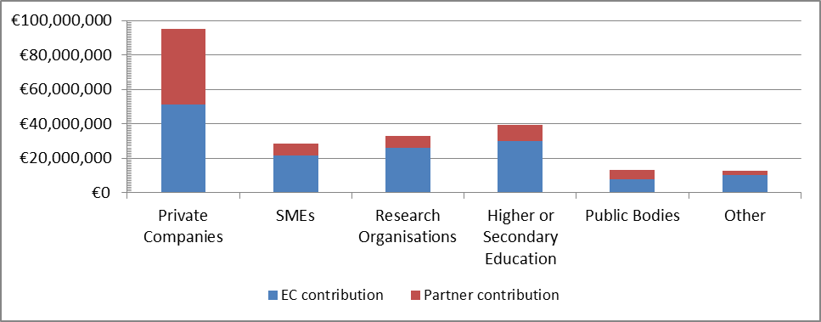
Additionally, enterprises lag behind in project coordination. Only 28% of FP7-Transport rail projects were coordinated by private companies against 43% for university and research organisations. This results in a situation in which most projects target relatively low technology levels, instead of demonstration projects, thereby limiting indirect leverage effects linked to additional private investments after project completion.

Limited and uncoordinated participation of stakeholders along the rail value chain
Under previous framework programmes, annual work programmes elaborated by the Commission in consultation with stakeholders served as the basis for ensuring coherence of rail R&I activities. However, projects were then selected individually through competitive calls for proposals, so that their specific objectives were not necessarily aligned with other projects and with overall EU policy goals. 77% of respondents to the public consultation found that EU R&I activities are not adequately coordinated (only 6% disagreed, half of which were research organisations). Separate calls lead to the formation of ad-hoc consortia, set up according to the specific needs of the project. Such a system hinders continuous collaborations of partners beyond single projects, resulting in reduced confidence and a lack of willingness to share information – two essential factors in projects developing outputs with direct commercial value.
What's more, this system has resulted in projects that do not necessarily represent stakeholders along the whole value chain. As shown in Figure 4, transport and freight operators were involved in less than 10% of all FP5 and FP6 transport projects, despite their participation being essential to achieving integrated rail system solutions that fit with market needs. The various consultation processes made it quite clear how important it was to involve the whole rail value chain in EU-funded projects, and users in particular to ensure R&I efforts correspond to real business needs.
Figure 4: Transport research partnerships (participation in % of partnerships)
In terms of geographical representation, participation of partners from the new Member States remains limited. The Czech Republic was the only new Member State to have partners participate in more than 10 of the 47 rail projects under FP7-Transport (see figure 5). Partners from other new Member States were involved in less than 5 projects.
Figure 5: Frequency of participation in FP7 rail consortia according to nationality (number of projects)
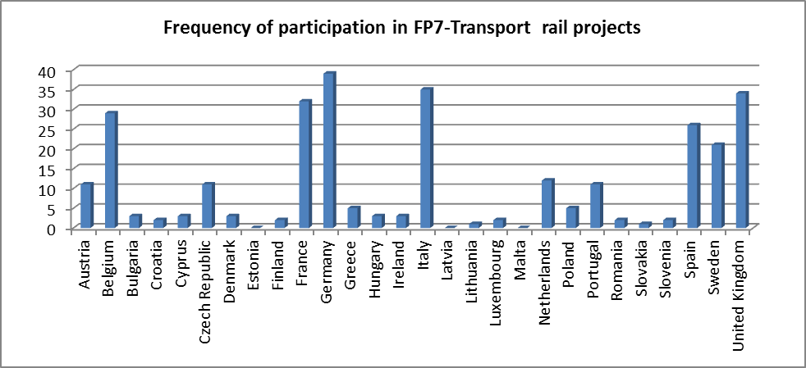
The lack of balanced and coordinated stakeholder participation results in R&I efforts that are not sufficiently oriented towards finding integrated solutions that have a real impact on the whole system, within the entire SERA. This finding is confirmed in the public consultation, where stakeholders agree that a balanced involvement of all actors, ensuring that their interests are properly respected so as to safeguard a “system approach”, is essential. Many stakeholders stress that end users (operators, competent authorities…) are usually not sufficiently involved in EU R&I, which does not favour the market uptake of projects results. It was also considered important to involve all rail market segments in rail R&I, taking local and regional needs into consideration as well. On the other hand, respondents warned that EC requirements to ensure that EU co-funded projects are inclusive of a wide range of stakeholders can lead to weaker proposals, a dilution of efforts and the inability to focus on specific business priorities. It is therefore important to ensure a flexible approach to achieving balanced participation.

High costs, risks and lead times of R&I investments
Innovation is generally characterised by high financial risks. In the rail sector these are further increased by:
- Complex interactions within the system. The interdependency of the different rail segments means that a specific innovation (e.g. a new high-speed locomotive) needs to be accompanied by timely innovation in other segments, such as infrastructure or business models, for it to have an impact on the whole system. Furthermore, an innovation in one segment could have negative impacts on other segments if not coordinated properly. Synchronicity between innovations is crucial.
- Long product lifecycles: A locomotive can be used for 40 years, compared to the typical renewal cycles of 7 years in the automotive industry or 20 years in the airline industry. 87% of respondents to the public consultation agree that this inhibits the rapid deployment of more innovative rail technologies.
- Unequal distribution of innovation benefits: 81% of respondents to the public consultation agree that innovation in the rail sector creates positive externalities that cannot be reaped by the innovator, thus reducing his incentives to invest. Furthermore, effective deployment of innovations can require the participation of stakeholders that have no incentive to invest in these technologies – or even a negative business case and thus needs adequate supporting arrangements.
- Lack of synergies with other innovative sectors: The rail market makes insufficient use of technologies emerging in other industrial sectors, leading to delays in the introduction of new technologies that could provide advanced, customer-focused industrial solutions. For instance, technologies developed in the aerospace and road sectors, such as composite materials, safe wireless communications, collision avoidance systems, positioning systems, could be adapted to the needs of rail.
These risks need to be managed carefully, through effective risk-sharing and funding arrangements, to allow for effective participation in innovation, along the whole value chain, to ensure that innovations can be deployed across the system.

Most affected stakeholders and needs assessment

The railway community
The proposed initiative will affect all actors in the rail sector, by proposing a range of novel business, operational and service solutions that support the search for a "best-in-class" profile for rail. In particular, the following actors will be affected:
- Rail supply industry, which encompasses manufacturers of products and components for railway operation (i.e. rolling stock and locomotives, electrification, signalling, control command, telecommunication and track equipment), as well as their suppliers and service companies. These companies are present in all Member States and their future depends on the competitive edge they can derive from the timely development and deployment of innovative and integrated rail technologies and procedures. Such an initiative will help open new market perspectives, offering significant employment opportunities and reinforcing European leadership.
- Rail Undertakings running passenger and freight services will benefit from innovations enabling increased reliability and quality of services. A more efficient use of resources and optimised operating models will help to reduce operating costs.
- Rail vehicle leasing companies or Rolling stock companies that lease out trains to rail undertakings will benefit from increased interoperability and standardisation of products, enabling them to broaden their client base and increase operational margins.
- Rail infrastructure managers, responsible for the safety, planning, construction, operation, management and maintenance of rail infrastructure, will benefit from innovations in the field of command and control, harmonisation of specifications and increased line capacity, helping to overcome network saturation and ensure better intermodal connections. Innovations in the field of assets, safety and energy management will also help to significantly reduce maintenance costs.
- Rail Regulatory and Safety bodies that are responsible for promoting and/or enforcing competition and health and safety on the railway will benefit from advances in communication (command-control technologies, interoperability across applications, etc.), and surveillance technologies.

Other industrial sectors
The structural transformation of the rail sector thanks to the penetration of technological innovation might also impact on players from other industrial sectors, including actors in economic sectors that could become tiered-suppliers to rail original equipment manufacturers (ICT and telecommunications sectors, composite material manufacturers, etc.) and those that make use of the goods and services provided by the rail supply industry (transportation, public administration, civil engineering, manufacturing, etc.)

The European Commission and the Members States
Improved organisation of rail R&I efforts will help contribute to the EU policy goal of a more integrated, efficient and sustainable transport system. Lower infrastructure and operating costs will help reduce the scale of subsidies paid out to the sector by national governments. Retaining European leadership in the rail sector will also help to create new high quality European jobs in the vehicle technology and project management fields.
It can be expected that the Member States that currently have the highest participation rates in FP7 projects (i.e. Germany, Italy, the United Kingdom, France, Spain, Belgium and Sweden) will be the ones that will benefit most from the initiative in absolute terms, also considering these countries represent 89% of all tonne-km and 70% of all passenger-km in Europe. However, countries with lower participation in FP7 rail research, in particular some Central and Eastern European countries with an important railway industry, such as the Czech Republic, Slovakia and Poland, could in particular benefit from a more inclusive and SERA focused initiative.

Passengers, users and EU citizens
The initiative will indirectly affect passenger and freight rail transport services users as it will ultimately result in improved reliability and quality of services. Also, improved competitiveness of the rail sector, combined with increased capacity, will help it to take on an increased share of transport demand, thereby contributing to reducing traffic congestion and CO2 emissions. Additionally, the introduction of innovative technological solutions will help to improve the performance of rail in terms of noise pollution, thereby having an indirect beneficial effect on citizens' health and wellbeing.

Academia, research community and SMEs
The initiative will provide universities, research centres and innovative SMEs with longer-term organisational and financial stability, generating a better environment for the development of high-value ideas. More than 120 research institutes from 23 Member States are already active in rail research at European level (either as partners or former partners of FP6/FP7 projects and/or as members of the EURNEX association).

Baseline scenario
The baseline scenario implies a continuation of the Collaborative Research model applicable under FP7, integrating improvements foreseen in the Commission's proposals for the next EU research and innovation programme, Horizon 2020. The most notable changes include the stronger focus on innovation and close-to-market actions, including demonstration activities, as well as a significant simplification of procedures (see Box 1).
Box 2 – Simplification (Horizon 2020 compared to FP7): summary
- Single set of simpler and more coherent participation rules, which increases the accessibility and attractiveness of the programmes.
- Moving from differentiated funding rates according to beneficiaries and activities to a simplified system consisting of a single reimbursement rate (maximum of 100 % of the total eligible costs of the research project, with a ceiling of 70 % for close-to-market actions and programme co-funded actions) for all activities and participants.
- Replacing the four methods to calculate overhead or «indirect costs» with a single flat rate
- Major simplification under the forthcoming financial regulation, which introduces more flexible budgetary and procurement procedures.
- Successful applicants to get working more quickly: average time to grant to be reduced to around 250 days (from the current average of around 330 days under FP7).
- Simplification of processes, including time-recording requirements, limited ex-post audits, no declaration on interest on pre-financing.
- Lighter administrative requirements for beneficiaries applying for smaller grants.
- More flexibility in grant rules to facilitate involvement of partners with specific expertise.
The FP will be implemented through (bi-)annual work programmes, based on inputs provided by the technology platform (ERRAC), in consultation with Member States and stakeholders. The work programmes will be subject to approval of Member States in the Programme Committee and will be implemented by the Commission or an Executive Agency. Based on previous experience, the work programmes will cover a broad range of topics, depending Member State policies and stakeholders' interests. They will include the schedule of the "calls for proposals" that will be published during the year. Each call for proposals will cover a specific research area. Specific objectives will be set at the project level, rather than programme level. Proposed projects will be submitted by consortia composed of a range of actors from industry and academia, coming from a minimum of three different Member States or associated countries. The Commission will select the best proposals and award financial support to the projects. The conditions for granting the EU financial support will be governed through grant agreements with each consortium. The Commission or a delegated Agency will manage these grant agreements. Based on previous experience, projects will generally have only a modest demonstration component and limited industrial participation.

Subsidiarity

Legal basis
The EU's right to act in this area is set out in the Treaty on the Functioning of the European Union, which states the overall objectives of EU industrial (Article 173) and research policy (Title XIX). In particular, Article 187 enables the EU to set up joint undertakings or any other structures necessary for the efficient execution of the Union's research, technological development and demonstration programmes. EU action in the field of rail transport is grounded in Articles 58, 90 and 100 setting the basis for internal market in the context of an EU Common Transport Policy.

Necessity and EU added value
Research and innovation in general suffer from important market and systemic failures that justify public intervention, in particular in parts of the innovation life cycle further removed from market implementation. In the rail sector, high risks linked to long product lifecycles, interdependencies between the different rail segments, unequal distribution of innovation benefits and the need for significant investments create additional barriers, on top of generic innovation barriers, which justify additional policy efforts.
The level of funding for rail R&I has historically been low and what investment does take place suffers from fragmentation and inefficiencies, due to significant differences among national programmes. The pooling and coordination of R&I efforts at EU level stands a better chance of success given the transnational nature of the infrastructure and technologies to be developed in support of the SERA, and the need to achieve a sufficient mass of resources. Action at EU level will help to rationalise research programmes and ensure interoperability of the systems developed. This standardisation will open a wider market and promote competition.
Numerous studies point to the added value of EU intervention, namely in helping to efficiently and effectively organise cross-border actions, and in bringing together compartmentalised national research funding so as to achieve the scale needed to tackle societal challenges. Also, ex-post valuation of previous framework programmes has demonstrated that EU funding increases the strategic importance of research projects and has a stronger additionality than national research programmes (e.g. projects without EU funding would have a smaller scale, reduced scope, or not be carried out at all).

Objectives
The 2011 White Paper for Transport emphasised the need to create a Single European Railway Area. This ambitious EU policy goal requires the whole of the rail sector to increase its business performance, providing its customers with the efficiency and quality of services they demand. This cannot be done without the emergence of innovative solutions for delivering enhanced productivity, capacity and reliability.
The present initiative is also linked to one of the Europe 2020 flagship initiatives – the Communication on Innovation Union, which states that given the scale and urgency of the societal challenges and the scarcity of resources, Europe's efforts and expertise on research and innovation must be pooled and a critical mass achieved to accelerate the pace of change leading to new growth and jobs in Europe.

General objectives
Innovation throughout the full rail value chain is a strategic enabler to completing the SERA. The general objective of the proposed initiative is consequently to better align EU rail R&I efforts to support the completion of the SERA, while accelerating the market take-up of innovative solutions, thereby increasing the competitiveness of the EU rail sector, vis-à-vis both other transport modes and foreign competitors. This will, in turn, contribute to raising the quality, reliability and cost-efficiency of EU rail services.

Specific objectives and operational objectives
Table 3 shows how the general objective has been translated into specific and operational objectives.
Table 3: Specific and operational objectives
Specific objectives | Operational objectives
Foster focused, coordinated and long-term investment in EU rail R&I | Develop a long-term strategic vision (e.g. master plan) with detailed multi-annual work programmes and investment plans
 | Ensure the strategic vision, work programmes and projects are aligned with key EU policy objectives of achieving a SERA and industry competitiveness
 | Ensure consistency and coherence between different projects, enabling synchronicity of innovations along the rail value chain
Increase the leverage of EU rail R&I funding | Improve industry involvement to acquire more private co-financing
Increase the leverage of EU rail R&I funding | Ensure strong and long term ex ante commitment from EU and industry as regards financing and participation
Establish sustained networks and knowledge exchange between diverse stakeholders | Ensure balanced participation of diverse stakeholders along the entire value chain, all technical subsystems and all MS.
 | Ensure long-term continuity of partnerships, with enhanced trust and exchanges of knowledge between stakeholders, disciplines and projects
Mitigate risks linked to innovation | Develop close-to-market projects that meet industry's needs, and that include large scale system-level demonstrators to validate research results
Mitigate risks linked to innovation | Establish a strong IPR protection and management framework
Increase the operational performance and effectiveness of rail R&I | Ensure a rapid implementation of improved rail R&I activities
 | Ensure an adequate success rate of proposals that ensures balance between resources and demand
 | Reduce time-to-grant to enable a rapid start-up of project activities
 | Reduce share of administrative costs of fund management

Given the nature of the initiative, which is to identify the optimal governance structure of rail R&I, the operational objectives remain rather generic indicating the scope and direction of intended change. Quantitative targets cannot be set for these objectives; at this stage, however the progress will be measured according to the monitoring indicators outlined in Section 7.
Figure 6 aims to illustrate how the objectives are linked to the problems and drivers identified in Chapter 2.

Figure 6 – Intervention Logic

Policy options
Since R&I activities supporting the rail industry are foreseen under H2020, the options considered for implementing rail R&I activities include the continuation of Collaborative Research, as well as the different forms of PPPs that can be created in accordance with H2020 (contractual and institutional). In addition, the report considers a fourth option, in which R&I activities are coordinated by the European Railway Agency. The different policy options are outlined below and a detailed table providing a systematic description of their content and key components of each option can be found in Annex VI.

Option 1 – Baseline – Horizon 2020 Collaborative Research Projects
As indicated in section 2.4, the baseline implies a continuation of the Collaborative Research (CR) model applicable under FP7, integrating H2020 improvements, such as simplified monitoring arrangements and more emphasis on demonstration.

Option 2 – Contractual PPP
The contractual PPP (cPPP) option aims to implement a common programme through a contractual agreement, following a Commission Decision, between the Commission and private partners. Private partners develop a multi-annual roadmap and set out their own commitments in the contractual agreement. They cover the costs of their own internal governance. Annual or multi annual work programmes are developed by the Commission based on the roadmap drawn up by the private partners. Member States are consulted.
The implementation of the contractual PPP uses Framework Programme collaborative research and innovation projects managed by the Commission services or an Executive Agency. An overall tentative budget for the period 2014-2020 is earmarked, but the cPPP relies on annual budgets subject to an annual decision of the European Parliament and the European Council.

Option 3 – Institutional PPP
The institutional PPP option (iPPP) involves the creation of a dedicated administrative structure for coordinating R&I, in the form of a Joint Undertaking (JU) – a Union body under Article 187 of the TFEU – as foreseen under Article 19 of H2020, when justified by the scope of the objectives pursued and the scale of the resources required.
The iPPP is an independent legal entity with a governance system of its own, as established in its founding regulation. iPPPs have an Administrative Board in charge of strategic decision-making, and an executive director, in charge of day-to-day management, as well as other (advisory) bodies, depending on specific operational and governance needs. Members of the iPPP include the Commission, industry, not-for profit research associations and, sometimes, Member States. Conditions for membership are set out in the founding regulation. Other stakeholders, including non-EU public or private organisations, may participate in the iPPP provided that they fully adhere to its regulations and obligations.
The iPPP has a dedicated budget and staff and provides a framework for public and private players to work together and take joint decisions. The role of public partners is to ensure alignment with public policy goals, while private partners maintain the focus to employability and profit maximisation. The iPPP is in charge of programming and implementing research projects in an integrated way according to an agreed (master) plan. It pulls together funds from different sources (including Commission contributions and legally-binding financial commitments from members), which are jointly managed. It is responsible for the related communication and dissemination activities. The principles applicable under Horizon 2020 should in principle be respected in an iPPP, but derogations may be granted in exceptional and duly justified cases.

Option 4 – Coordination within ERA
Like Option 3, this option would provide a dedicated administrative structure for rail R&I, but within the administrative framework of ERA. ERA would be tasked with the elaboration and implementation of the strategy and work programme for rail R&I under the supervision of its Administrative Board, which unites representatives of the Commission and Member States. The rail sector would be represented on an advisory level.
This option would entail a modification of the ERA Regulation to cater for the following aspects:
- providing ERA with an ad-hoc grant from the H2020 budget, which, under the new Financial Regulations can only be accepted if expressly provided in the relevant sector-specific acts and authorised in ERA's basic act;
- enabling ERA to conduct budget implementation tasks and to actively undertake railway research activities at Union level;
- providing ERA with the necessary human resources to deal with a significantly increased operational budget, assuming an Commission contribution of EUR 64 million per year for rail R&I under H2020, against ERA's current annual budget of roughly EUR 25 million a year.

Assessing the impacts

General approach to the assessment of impacts
The four policy options identified and presented in Chapter 4 have been compared along a range of key parameters selected for their relevance in assessing public intervention in R&I.
The comparison of these parameters was carried out in an evidence-based manner, proportionate to the scope of the impact assessment, which focuses on the impact of the institutional set-up of the implementing structure for rail R&I. A range of qualitative and, where available quantitative, evidence was used, including:
- Findings presented in the Impact Assessments accompanying the H2020 proposals and the proposed first wave of institutional PPP initiatives under H2020
- Monitoring and evaluation results and statistical analyses of previous and on-going Framework Programmes
- Literature review and various external study results
- The results of the online public consultation and various meetings with stakeholders
The four options are compared assuming the EU will contribute to half of industry estimates of total EU rail R&I needs for the period 2014-2020 – i.e. a global allocation of EUR 450 million under H2020. It is assumed that the remainder of these identified financial needs would be covered by industry itself. It is also assumed that the scope of activities that will be undertaken by each of the institutional options will be similar and in line with the H2020 strategic research agenda and the rail technology roadmap.

Input impacts and cost-effectiveness
Given that the scope of this impact assessment is the type of implementing structure that will be put in place to carry out rail R&I activities and that the exact scope of activities is still being defined, the assessment and comparison of the four options focuses mainly on the input impacts – i.e. on the resources invested into delivering the results.
The parameters used are those considered as crucial to enabling major technological advances in the rail sector and are aligned with the specific objectives of the initiative:
- Focus and coordination of research efforts. Limitations in funding mean that EU intervention should focus on areas essential to achieving the EU policy goal of completing the SERA, while also ensuring the long-term competitiveness and growth of the sector. Strong coordination is essential as the fragmentation of R&I efforts among many isolated projects with diverse objectives reduces their capacity to serve a specific European goal.
- Leverage of EU rail R&I funding. High leverage of private and public resources, translated into firm commitments from all parties involved, is a key ingredient for the success of the implementing structure.
- Broad stakeholder participation and sustained networks. The innovation process should gather all key players across Europe in long-term partnerships. The involvement of the full rail value chain, including the users (railways), will help to ensure an approach aimed at improving the system as a whole and a greater uptake of innovations.
- Mitigation of innovation risks. Low profitability, combined with the high financial and technological risks associated with rail research, mean that risk-sharing, IPR protection mechanisms, as well as measures aimed at a more rapid commercial exploitation of research results, are essential to stimulate long-term and large-scale private investment.
- Operational performance and cost-effectiveness. The implementing structure should provide a simple, efficient and cost-effective framework for granting R&I funding, ensuring value-for-money and facilitating industry and SME participation.

Economic, social and environmental outcomes
Improvements in the above-mentioned parameters will lead to more effective and efficient rail R&I, which in turn results in economic (competitiveness and operational efficiency of the sector, induced macroeconomic impacts for wider economy), social (employment, safety, security, service quality) and environmental (reduced pollution, noise, congestion) impacts.
However, given that the scope of this impact assessment is restricted to the incremental impact of the implementing structure and does not consider the scope of the R&I activities, the analysis of economic, social and environmental impacts can only be conducted at a very high level. The four policy options are compared on the basis of the differences in scale, timing and relevance of investments they will enable.

Input impacts and cost-effectiveness

Focus and coordination of research efforts
In the case of a continuation of the CR model, the work programme would be driven by the Commission, with industry and research stakeholders providing input through various consultation mechanisms and platforms, but having no formal decision-making powers on its content. Activities under the work programme would be funded on a project basis. Under FP7, more than 80 rail-related projects have been funded since 2007, with calls funded under different themes. This makes it difficult for the sector to have a clear view of the available types of funding. Also, with such a multitude of non-coordinated individual projects, the risk of overlap and/or of generating uncoordinated technologies or redundant rail projects is significant. "Bottom-up" project initiation does not allow for a comprehensive programmatic approach or a consistent coverage of the agenda and is not suited to ambitious long-term developments requiring a large scale of investment, coordination, synchronisation and ex-ante commitments across different projects. As pointed out by stakeholders in the public consultation, the lack of long term approach and the discontinuity between projects and work programmes under the CR model means the results of previous projects are rarely taken into account and a lot of effort is wasted. To overcome these issues, the Commission would have to develop a substantial management capacity and significant technical expertise to ensure coordination of activities, partnerships and results.
According to an evaluation of existing research PPPs in the European Economic Recovery Plan, the establishment of cPPPs enables improved coordination between the Commission and industry representatives leading to better defined objectives and a stronger focus on a limited number of research sectors than with CR. This is namely thanks to the development of a multi-annual strategy in the form of a roadmap. Indeed, the topics of calls show a strong correlation with objectives established in the roadmap. Also, as cPPPs coordinate research activities across several FP7 themes, projects can be of a larger scale and of a cross-thematic nature, enabling a more coherent approach than with CR. Indeed, average EU funding per project for the three existing cPPPs in 2010 and 2011 was between EUR 3.5 and 4.1 million, which is slightly higher than for FP7-Transport rail projects, where average EU funding per project was around EUR 3.1 million (although similar to overall FP7 funding levels of roughly EUR 4 million per project). The lead role in the PPP is taken by the private partners, who define the multi-annual roadmap. The Commission has the final say on the work programme, which ensures it is aligned with broader EU transport policy objectives. However, given the bottom-up approach for proposals, R&I priorities are steered by industry rather than by the Commission. Also, as the standard rules for calls for proposals would apply, the arguments developed above for CR in terms of results coordination also apply.
Under an iPPP, the coordination, programming and execution of rail R&I activities would be the responsibility of a single, dedicated administrative structure. The development of a strategic long-term plan (covering both the timeframe of the financial framework and beyond), in close cooperation with all market players, would be the first task of the new structure, helping to ensure a stronger relevance and policy coherence of funded projects than in CR. Industry participation ensures that the projects would be linked with the market and support the competitiveness of the rail sector (vis-à-vis other modes and third countries). Co-governance arrangements, with a leading role for the Commission, would ensure that the R&I agenda is fully aligned with the SERA objectives. Furthermore, the strategy would be endorsed by the European Council. The iPPP would act as a single contact point for information on all rail R&I, making it easier for the sector to know what funding is on offer, and ensuring more continuity and less fragmentation of R&I than under CR. R&I programmes would be managed through an Administrative Board in a transparent, coherent and long term manner. As in other options, a substantial management capacity and a high level of technical expertise will be required for the structure to work effectively. Compared to CR, one difficulty may consist of attracting such expertise to an iPPP structure with a limited lifespan.
In the ERA option, the established structures, technical expertise and stakeholder networks of the Agency would theoretically be well geared for taking on a strong coordination role, similar to an iPPP. A strategic long-term plan would be developed in line with EU policy goals. However, although industry would be consulted in defining the strategic plan through existing technology platforms, as in the CR option, its involvement would not be as direct as in the PPP options. This could reduce the industry relevance of the R&I agenda and work programmes. What's more, there is a risk that the strategic agenda would focus on a restricted number of topics, such as standardisation and deployment of interoperable railway systems, given ERA's core mandate and field of expertise. Other areas where the Agency lacks expertise, such as passenger information, ticketing and revenue management systems, could end up excluded from the scope. In fact, a recent evaluation of ERA highlights the tension between ERA's role in standard-setting and any potential role it could play in research and innovation activities. Indeed, the introduction of standards is likely to shift the focus of innovation from the best way to meet a need to the best way to comply with the standard.
These findings are partially reflected in the results of the public consultation. 50-60% of respondents felt that the CR, cPPP and ERA options would be ineffective in developing the required long-term vision for rail R&I or in ensuring the necessary project coordination and synchronicity of innovations. On the other hand, 80% of respondents thought an iPPP would be effective. Also, only 20-25% of respondents felt that the CR and cPPP options could contribute significantly to the EU policy goal of improved interoperability (mainly research organisations and public authorities, as well as some private companies), while 75% believed both the iPPP and ERA options would achieve this.

Leverage of EU rail R&I funding
In the CR option, H2020 rules would apply. This means EU funding would cover up to 100% of project budgets, as well as the Commission's administrative costs and up to 25% of partners' administrative costs. The maximum EU funding rate would be lower for demonstrating activities (70 %), but so far these have not been so frequent. That said, the average share of EU funding for the 47 rail projects under FP7-Transport was 66%. When one looks at FP7-Transport projects in general, the findings are rather similar, with an average share of EU funding of 65% - i.e. a leverage effect of 1.5. One can expect that the leverage of H2020 CR projects will be similar or slightly higher, given the increased support to close-to-market projects, which should attract a higher share of additional funding.
cPPPs allow for a greater industry involvement than CR meaning their potential for leveraging private funds should be greater. However, while the pre-defined budget ensures some continuity, the legal commitment from industry participants is limited to single project grant agreements. Thus, although cPPPs established so far have announced industry funding levels of 50%, in practice, EU grants of 50%, 75% and 100% of costs have been awarded. Therefore the direct private leverage effect has been rather limited and industry co-funding has not reached the 50% target. Average EU funding levels for the combined first calls of existing cPPPs was in fact 66% - i.e. a direct leverage effect of 1.5, similar to CR. Nevertheless, given the strong industry involvement and focus on closer-to-market activities, significant indirect leverage effects can be expected, with additional R&I investments by the private sector in parallel and after programme completion, as technologies that are mature enough to be included in privately funded development programmes are taken up.
The stable nature of iPPPs and the firm commitment from the EU gives confidence to both private and public partners, thus creating the conditions to attract higher levels of financing, and from a wider range of sources, than under CR and cPPP. Furthermore, industry participants are required to commit themselves in a legally-binding manner, for the full duration of the iPPP, to specific financial contributions (in cash or in-kind) and to certain tasks and activities. The scale of the direct leverage effect will depend on the scale of private sector commitments, which will, in turn, depend on the governance arrangements of the iPPP and the assurances provided to private partners in terms of return on investment. Current iPPPs under FP7 must achieve at least 50% co-financing from the industry – i.e. a direct leverage effect of at least 2, while iPPPs under H2020 are likely to be even more ambitious (see table 4). On top of this, the iPPP will trigger even more significant indirect leverage effects than the cPPP thanks to the strong industry commitment.
Table 4: Current and proposed funding of iPPPs
In the ERA option, the leverage impacts would be similar to that of CR and cPPP. Rail R&I would be mainly financed form the EU budget and there would be no formal commitment from industry to participate in the programme (whether in terms of financial contribution or in terms of tasks and activities). Indeed, the structure of ERA would difficultly allow for co-financing for private partners without leaning towards an iPPP model or creating serious conflict of interest issues in light of ERA's role in the fields of vehicle authorisation and certification of railway undertakings. Lastly, given that industry would have only an indirect influence on the work programme, the relevance of the R&I agenda could be less pertinent and therefore assumed to reach lower leverage rates than in the case of a PPP.

Broad stakeholder participation and sustained networks
Under the CR option, industry and research stakeholders would be able to provide their input through various consultation mechanisms and platforms. Rules of participation in the open calls system would favour broad and transnational consortia, with numerous participants, ensuring high representativeness. However, such large consortia can be difficult to drive and some partners are included more for representative purposes than for technical ones, so that commitment is not always very strong. Also, the balance of participation could not be actively managed. As explained in the problem definition, CR projects under previous framework programmes have not achieved balanced engagement among different types of stakeholders or at a regional level. Under FP7, research organisations and universities absorbed on average 65% of EU funding against just 16% for large business enterprises and 16% for SMEs. NGOs, umbrella organisations and foundations, accounted for the remainder. Rail projects under FP7-Transport presented a more balanced picture, with 50% of funding going to business, against 38% for research organisations and academia. Lastly, CR does not enable the continuous collaboration of project partners beyond single projects, resulting in reduced confidence among partners and a lack in the willingness to share information.
There is general consensus that cPPPs, with their system of open calls, bring together a wide range of industrial stakeholders and are inclusive. The participation of organisations not belonging to the Industrial Research Associations, which represent the private side of the partnership, is around 75% and they receive around 70% of the whole Commission funding. On average in the two first calls, large industry absorbed 31% of EU funding across the three existing cPPPs, compared with the FP7 average of 16%, while SMEs represented 22%. This indicates that cPPP programmes are of higher relevance for industry and SMEs than CR programmes. However, the current cPPP setup does not provide for advisory mechanisms enabling all key actors of the value chain to be involved. Given the predominance of large industrial players among the private participants observed in current cPPPs, there is a risk that actors from other segments of the rail value chain (railway undertakings, rail vehicle leasing companies, infrastructure managers, etc.) may be excluded. Also, cPPPs have not reached geographical parity (88% of participations stem from the 15 old Member States, with only 5% from Member States having joined the EU after 2004, 6% from Associated Countries, and even less for third countries).
Within an iPPP, a mix of different governance elements (i.e. different levels of membership and consultative committees) would ensure that stakeholders from the full rail value chain could either be consulted or directly involved in the decision-making process. The principles of shared management by public and private partners would be transparent to all stakeholders. The conditions for membership and advisory roles could be actively managed by the Administrative Board so as to ensure broad stakeholder participation along the full value chain, bringing in partners and advisers with specific expertise, deepening strategic partnerships and building sustained relationships. This would also enable a targeted approach towards SMEs and geographical parity. This flexible partnership can be developed and fine-tuned considering mutual interdependencies and participation capability of different stakeholders. Of course, the governance arrangements of the iPPP will be instrumental in enabling broad participation. If these are not appropriately tailored, there is a risk that some players, with fewer financial or human resources, could be excluded. Experience in the Clean Sky iPPP shows that openness to stakeholders can be a problem when a large share of funding is earmarked for the main private contributors, whereas other iPPPs operating through open and competitive procedures have succeeded in bringing together a large number of partners, including newcomers and SMEs. Budget allocations of existing iPPPs reveal a fairly balanced multidisciplinary participation, with research organisations and universities absorbing on average 44.5% of EU funding whilst industry accounts for 33.5% and SMEs for 20.5% of EU funds, which is higher than in CR. The remainder goes to other organisations, such as NGOs, umbrella organisations and foundations.
In the ERA option, representative organisations of the rail sector would participate in the Management Board, but without voting rights (only the Commission and Member States have voting rights). Although theoretically the existing governance structure could be altered via an amendment of the ERA Regulation, in practice, it would be extremely difficult to grant industry more power without seriously compromising the Agency's role as a regulatory authority. At the same time, the Agency has established working parties with representatives of rail sector organisations and national safety authorities, which provide it with good connections to the relevant market players. However, the network of stakeholders involved would have to be widened to include the urban and light rail market segment, as well as business enterprises, SMEs, the research community and academia. Given that ERA would coordinate projects similarly to the way existing executive agencies do under FP7, one can consider that the participation rates in projects would be broadly similar to the CR option.
In the public consultation, none of the options score particularly well on ensuring equal access for all stakeholders. The CR option scores best (36% considering it to be effective), followed by the iPPP option (30%), with ERA and cPPP scoring just 23% and 19% respectively). The iPPP option is nevertheless considered much more effective at building sustained networks (80% believe it to be effective, against 4% considering it ineffective, compared to only 17-25% of stakeholders believing the three other options could be effective).

Mitigation of innovation risks
In the case of CR, it is likely that R&I projects would be similar to FP7, i.e. at low to medium Technology Readiness Levels. Although H2020 emphasises the need to bring the projects closer to the market, knowledge and technology-related objectives, rather than direct commercialisation-related objectives, tend to prevail in CR. The potential of deployment of projects remains modest. Projects financed would thus be with a modest demonstration component, typically covering TRLs from 2 to 5. IPR policy would be based on the principles set out in the H2020 rules for participation and dissemination and specific clauses would be established within individual grant agreements. This means companies have to put significant efforts into the proposal phase, without having a clear view on the IP rights that will cover the results. Also, there is no IPR framework for multiple projects, which represents a risk for companies wishing to be involved in several projects.
cPPPs have a clear objective of aiming for results nearing market readiness. Although there is not yet any statistically significant data on finished projects to assess the actual market effects of cPPPs, it can nevertheless be said that the participation of commercial entities in projects has been higher. Questioned cPPP stakeholders tend to agree that that cPPPs are more effective in achieving market impact than standard CR projects. At the same time, existing cPPPs tend to focus on short-term actions rather than on a longer-term approach and risk-sharing measures. IPR policy would be based on the principles set out in H2020, with detailed specifications defined within the contractual agreement between the Commission and private partners. Compared to CR, this enables more clarity for companies wishing to get involved.
iPPPs have capability to develop projects in a synchronised manner covering all TRL levels. The inclusion of large scale demonstration activities in the research programme will reduce the risk for private research and innovation investment compared to CR and cPPP. Partners would be required to commit to demonstration activities, while EU co-financing rates would gradually drop as the projects reach market readiness so that the operational risk is transferred to the private sector. IPR policy would be based on the principles set out in the H2020 rules for participation and dissemination. Specific rules would be defined within membership agreements between the iPPP and the private partners, which, like the cPPP, enables more clarity for companies deciding to get involved than in CR. As a basic rule, results generated jointly would be owned by the iPPP while results generated individually would be owned by the iPPP participant generating these results.
In the ERA option, the management of IP rights and the type of research projects funded would likely be similar to the CR option. Some higher TRL projects aimed at deployment of standardised solutions via the Technical specifications for interoperability (TSIs) could be anticipated. However, the Agency's lack of skills and expertise in relation to the commercial aspects of technology development could hinder the development of higher TRL projects.
In the public consultation, neither the CR, nor the cPPP and ERA options score well in terms of mitigating innovation risks and accelerating market uptake (only 13-20% of respondents viewing them as effective). On the other hand, the iPPP option is considered effective by three quarters of respondents, against 5% considering it ineffective. Among these, many are active in the field of railway operations, but also in the rail supply industry).

Operational performance
The assessment of the operational performance of the different options is based on an analysis of the average set-up time, success rates of calls for proposals and time-to-grant.
In CR, no time will be lost in setting up new structures and a new wave of rail R&I calls under H2020 can be launched as of 2014. The average success rate of calls for proposals for CR projects in FP7 is 19%, which is considered to be quite low. On the one hand, this can be a sign of the high attractiveness of the programme and the application of stringent selection criteria (113,508 proposals were submitted for a total of 379 concluded calls over the period 2007-2012, out of which 20,190 were retained for negotiations). On the other hand, low success rates can indicate lack of sufficient funding or overly vague and broad definition of priorities. Reasons differ for each specific programme but over- (or indeed under-)subscription indicates that there is a problem in the balance between resources and demand. Low success rates mean considerable efforts are dissipated in unsuccessful proposals and this acts as a serious deterrent to industry, in particular to SMEs. It can nevertheless be mentioned that success rates of FP7-Transport projects have been higher (25%) and it is also anticipated that the success rate in general may improve under H2020 given the possibility to fine-tune procedures and the larger focus on demonstration and close-to-market activities. The average time-to-grant for CR under FP7 has been improving steadily but remains high, at 320 days in 2012. The Commission expects that time-to-grant will be reduced to 250 days (i.e. 70 days less) under H2020 thanks to simplification measures, enabling successful applicants to get to work more quickly.
Compared with CR, the cPPP will take slightly longer to launch the first series of cross-thematic calls – likely around 9-12 months, based on experience of the first three cPPPs. The outcome of calls in existing cPPPs is slightly higher, with 30% of successful proposals in 2010 (out of 251 submitted proposals), but just 21% in 2011 (out of 400 submitted proposals). Average time-to-grant was also shorter than under FP7, at 280 days. It is likely that, similarly to CR, new rules under H2020 will enable cPPPs to improve success rates and shorten time-to-grant by around 70 days.
The iPPP entails the establishment of a new structure, following the adoption of a Council Regulation, which is likely to take 6-9 months. For past iPPPs the set up time after the adoption of the regulatory framework has been of just over 2 years on average. It is nevertheless assumed that the set-up time for a new iPPP could be reduced quite significantly (to around 1.5 years), both thanks to previous experience and thanks to new provisions under the updated Financial Regulation that allow new structures to share resources with existing iPPPs (including buildings, IT functions, internal control functions, etc.). We therefore assume that the total set-up time of the rail iPPP will be of 2 years. The targeted nature of the calls for proposals, as well as the stronger focus on close-to-market activities, would enable a higher success rate than under CR. Average success rates of existing iPPPs are indeed very high compared to CR at 36% overall (60% for Clean Sky, 37% for FCH, 70% for ENIAC, 22% for ARTEMIS, 23% for IMI). The administrative board would be able to adapt procedures to improve the success rates even further, e.g. by more resort to two-stage calls, where the second stage could have a 30-50% chance of obtaining funding, while also ensuring the conditions for calls are kept broad and inclusive, supporting diverse categories of applicants. Furthermore, the setting up of a dedicated administrative structure would entail a faster time-to-grant. As a means of comparison, the average time-to-grant of the Clean Sky iPPP is 240 days, while the Sesar iPPP's time-to-grant ranges between 160-240 days depending on the type of project. IMI's time-to-grant record has systematically improved for each call, going from over one year to 160 days.
Concentrating all rail R&I within ERA would entail a modification of the ERA Regulation, as the current rules, decision and management processes, and operating structures do not allow it to manage grants. The normal regulatory procedure for such a modification lasts around 2 years. Furthermore, the Agency would also require significant additional resources and would need time to adjust internally to the new tasks assigned to it. One can therefore assume that the total set-up time for ERA would be of close to 3 years. Once up and running, the ERA would likely enable a faster time-to-grant than under the baseline thanks to the existence of a dedicated administrative structure. Furthermore, close involvement of all stakeholders in setting the R&I agenda and the larger focus on demonstration and close-to-market activities could lead to improved success rates.

Cost-effectiveness
This cost-effectiveness analysis focuses exclusively on the costs incurred by the Commission for the implementing structure, which include:
- the establishment cost;
- the running costs (including staff expenditure, meetings, missions and communication expenses, IT expenditure, buildings and installations, and other administrative costs). These costs are considered over the 7-year period covered by the H2020 period;
- winding down/legacy management costs.
A detailed overview of cost calculations summarised in the following paragraphs can be found in Annex VII.
For CR, there would be no establishment or winding down costs as the programmes would be managed within existing structures. Cost calculations are based on the experience of managing the FP7-Transport budget, while including costs to develop an additional management capacity within the Commission to ensure coordination of activities, partnerships and results with a view to achieving its political objective of supporting the completion of the SERA. Including costs relating to managing the legacy of programmes, the total annual equivalent implementation cost of CR is estimated at around EUR 4.71 million.
In case of cPPP, as for CR, there would be no establishment or winding down costs. The overall running costs would be marginally higher than in case of CR, because of the cost of the additional stakeholder consultation process borne by the Commission and external evaluation costs. Including costs relating to managing the legacy of programmes, the total annual equivalent implementation cost of the cPPP option is estimated at around EUR 4.95 million, which is marginally higher than the baseline option.
In the case of an iPPP, quite considerable establishment costs need to be taken into account, linked to the two-year set-up period, during which programmes would be run under the CR approach. Running costs have, in the past, been globally higher in an iPPP than with in-house implementation by the Commission, due to the fact that the Financial Regulation requirements are designed for EU institutions and, as such, are not suited to the needs and size of relatively small structure iPPPs. For instance, under current regulation, each iPPP is expected to have a data protection officer, a local information security officer, an internal control coordinator, an accounting officer (and a back-up), an authorising officer (and back-up), initiating agents (and back-ups), validating agents (and back-ups), an internal auditor and an IT manager. Those requirements are difficult to apply to entities which employ between 13 and 31 staff and lead to situations where on average 50% of the iPPP's staff is dedicated to work on administrative tasks. Moreover, the recruitment rules and public procurement rules are similar to those used by the European Institutions hindering flexibility/responsiveness of the JUs operations. Based on these findings, the Commission is preparing proposals for a delegated regulation applicable to iPPPs under the updated Financial Regulation. These make room for a significant increase in the operational efficiency of iPPPs under H2020, thanks to: the streamlining of reporting requirements, the simplification of budgetary procedures, the sharing of internal audit and internal control functions with the Commission and the pooling of resources between iPPPs.
Given these considerations, one can assume that the internal administrative costs of a future iPPP for rail R&I would represent roughly EUR 24.9 million over its 5-year lifespan. 50% of this will be financed by industry. This corresponds to staffing levels of 20 full-time equivalents. On top of the administrative costs of the iPPP itself, the Commission would incur costs for the supervision of and participation in the iPPP, as well as one-off external evaluation costs. Including costs relating to managing the legacy of programmes and winding down, the total annual equivalent implementation cost of the iPPP option is estimated at around EUR 5.46 million. This is more than for CR or cPPP. However, the higher costs also partly relate to the larger budget that will be managed under the iPPP (roughly EUR 900 million, rather than EUR 690 million, given the stronger direct leverage effect). Also, as industry commits to covering half of the running and winding down costs, the total annual equivalent implementation cost to the Commission is limited to EUR 3.18 million. For the Commission, operating an iPPP is thus less costly than CR or a cPPP.
In the ERA option, rail R&I programmes would only be transferred to the new structure in 2017 given set-up delays. All administrative costs would be covered by EU and Member States. The administrative structure would be linked to the ERA structure, which provides for scale efficiencies, given that existing horizontal functions (e.g. internal audit, accounting, management of human resources) can be used to support the R&I activities, providing for a possibly more cost-effective administrative structure than the cPPP and iPPP options – thereby similar to the baseline option. At the same time, lower costs of Agency staff mean the option is cheaper than the baseline, with a total annual equivalent implementation cost of around EUR 3.83 million per year. However, the Agency would require significant additional resources (estimated at around 15 full-time equivalents) to carry out the coordination and management of the foreseen EU rail R&I budget of EUR 450 million, i.e. EUR 64 million per year – which is 3.5 times ERA's current annual budget. This fact alone hinders feasibility of this option given that according to a Joint Statement of the European Parliament, the Council and the Commission on the future management of decentralised agencies, adopted in July 2012, no additional resources can be allocated to EU agencies.
Table 6 summarises the equivalent annual administrative cost relating to each option.
Table 6 – Equivalent annual implementation costs of the options under assessment (kEUR)
The above table distinguishes between the implementation costs incurred by the Commission and the total implementation costs only in case of iPPP. In reality, of course, industry also bears participation and management-related costs in all other options. However, it is impossible to quantify these costs. The iPPP option therefore offers the advantage that industry has more certainty regarding the costs it will incur for R&I activities in the long term.

Economic, social and environmental outcomes
The ulitmate goal of this initiative are economic, social and environmental benefits induced by more effective rail R&I projects. However, given that this IA does not consider the scope of the R&I activities, but just the implementing structure, the expected economic, social and environmental impacts cannot be assessed in concrete terms. Nevertheless, an overview of some of the major impacts to be achieved through investment in rail R&I can be found in Table 7.
Table 7: Summary table of expected economic, social and environmental impacts of increased investment in rail R&I:
Economic benefits | Competitiveness | Improved competitiveness of EU rail industry on global markets
Economic benefits | Competitiveness | Promotion of innovative enabling technologies
Economic benefits | Economic efficiency | Cost reduction in rail applications through optimised energy use, reduced lifetime infrastructure costs, increased performance and automation
Economic benefits | Economic growth | Increase in line and vehicle capacity to support enhanced freight and passenger volumes
Economic benefits | Economic growth | Expansion of vehicle leasing markets to the benefit of operators and manufacturers
Economic benefits | Infrastructure | Contribution to the Trans-European Network through better intermodal connections and harmonisation of specifications
Economic benefits | Infrastructure | Revitalisation of existing infrastructure
Economic benefits | Infrastructure | Increased utilisation of existing infrastructure and reduction of maintenance costs
Social benefits | Employment | Creation of high-quality jobs in the rail sector
Social benefits | Employment | Creation of high-quality jobs in other related sectors, such as telematics, IT, etc.
Social benefits | Security | New design of stations with very low perceived and actual risk
Social benefits | Security | Secure handling and management of transported goods
Social benefits | Security | Improved surveillance of freight through traceability and tracking innovations
Social benefits | Safety | Self-adjusting and self-reparing infrastructure
Social benefits | Safety | Safer and more reliable vehicles
Social benefits | Safety | Easier and cost-competitive authorisation processes for all railway applications
Social benefits | Safety | Optimisation of signalling systems
Social benefits | Consumer impacts | Reduction of travelling times through optimised trips and increased interoperability of networks
Social benefits | Consumer impacts | Improved punctuality of trains
Social benefits | Consumer impacts | Improved accessibility to passengers with reduced mobility
Social benefits | Consumer impacts | More affordable transport through increased cost-effectiveness of the rail system
Social benefits | Consumer impacts | Real-time traffic information thanks to improved communication systems
Environmental benefits | Air pollution and greenhouse gases, congestion | Modal shift towards cleanest transport mode in Europe leading to reduction of pollutant and CO2 emissions
Environmental benefits | Noise | Reduced noise and vibration railway annoyances
Environmental benefits | Energy efficiency | Reduced final energy consumption through lighter vehicles and energy-efficient infrastructure
The benefits of EU R&I in general have been largely documented in the Impact Assessment accompanying the H2020 proposals, which estimates the long-term macro-economic impact of FP7 at an extra 0.96 percent of GDP.
In the rail sector, one example of the benefits of EU-driven innovation is the ERTMS/CBTC projects. Studies highlight that the market share of ERTMS/CBTC in the global signalling market increased from 14% to almost 22% in the period from 2007 to 2011 and the expectation is for a market share of 25% in 2017, helping to sustain the overall competitiveness of EU industries. Similar effects on a much larger scale can be expected from a large-scale rail R&I programme.
First estimates from industry suggest that a coordinated investment effort of EUR 1 billion in rail R&I in the 2014-2020 period could have the following impacts:
- 100% increase in rail capacity leading to increased user demand;
- 50% increase in reliability leading to improved quality of services;
- 50% reduction in life-cycle costs, leading to enhanced competitiveness.
Economic returns linked to these improvements include:
- An indirect leverage on industry R&I related to the development of industrial products exploiting H2020 innovations, worth EUR up to 9 billion in the period 2017-2023;
- Creation of additional GDP at EU level worth up to EUR 49 billion in the period 2015-2030, and spread among a large number of Member States;
- Creation of up to 140,000 additional jobs in the period 2015-2030;
- Additional exports worth up to EUR 20 billion in the period 2015-2030 thanks to the worldwide commercialisation of new rail technologies developed under H2020;
- Life-cycle cost savings worth around EUR 1 billion in the first 10 years and then, through continued implementation, worth around EUR 150 million per year.
Of course the exact impact of R&I funding will depend on the scope, scale and timing of investments, which vary according to the policy options.
Compared to the baseline option, the cPPP option should entail a similar level of funding (given the similar leverage effect), but with a better focused agenda and a speedier implementation, meaning the first results could be expected several years earlier.
In an iPPP, funding levels are likely to be 30% higher than in the baseline option, given the higher leverage effect. Although the set-up time (roughly 2 years) means results will initially take longer to emerge than under a cPPP, the focus enabled by the iPPP and the fact that partner commitments are binding mean results are still likely to emerge faster than in the baseline option. Compared to cPPP, the scale of impacts should be higher and geared toward step-changes with long term impacts.
With ERA in the lead, funding levels are likely to be similar to the baseline option, but a better focused agenda could speed up implementation. However, the length of time required to modify the ERA structure and to build up the necessary internal expertise, is likely to counterbalance the effect of the better focused agenda.

Risk assessment
The risks associated with the four different options that have been analysed are mapped in Table 8. This table provides an overview of events that may reduce confidence EU rail R&I activities and consequently represent a potential obstacle towards the implementation of the SERA and the competitiveness of the European rail sector. For each risk, potential mitigation actions are presented.
Table 8 – Assessment of risks associated to the rail R&I implementation tool and mitigation measures.
Risk | Description | Most impacted options | Cause | Outcome | Probability | Impact | Mitigation
1 | EU R&I activities are not focused on the goal of completing the SERA | Option 1-CR  Option 2-cPPP | - High degree of R&I fragmentation  - Lack of coordination of R&I activities and results  - No or little involvement of key rail stakeholders in planning and synchronisation of activities  - Limited partnerships between stakeholders. | - Reduced effectiveness of rail R&I activities  - Objective of completing the SERA is delayed or missed altogether | Very High | Very negative: the R&I programme does not contribute to the overall objective | - Establish appropriate governance and leadership of the EU in R&I implementation.  - Enshrine the SERA objective in the strategic master plan.  - Involve all key stakeholders in the decision making process
2 | Conflicting and overlapping EU R&I activities | Option 1-CR  Option 2-cPPP | - Lack of coordination, fragmentation of R&I activities and results  - No involvement of R&I partners in planning or in synchronisation of activities  - No commitment from stakeholders to political objectives | - Reduced effectiveness and efficiency of rail R&I activities  - Objectives of completing the SERA and market uptake of innovations are delayed or missed altogether | High | Negative: delay in performance delivery of the technological innovations necessary to achieve an integrated, efficient and attractive EU railway market;  Loss of confidence in the potential benefit of R&I leads to users' reluctance to buy in. | - Establish appropriate governance and leadership  - Monitor the needs and business plans of all stakeholders and prepare strategic Master Plan accordingly  - Develop partnerships between all actors, develop sustained networks  - Involve all key stakeholders in the decision making process
3 | Limited involvement and uneven stakeholder representation. | All | - Limited accessibility of R&I funding (e.g. low success rate of proposals) and coordination  - Non-transparent and restrictive participation rules | - Scope and uptake of R&I outputs is limited | Very High | Very negative: the SERA objectives are jeopardised. | - Set transparent and flexible participation rules for all key stakeholders in the strategic process  - Ensure advisory mechanisms allow for broad participation of stakeholders  - Avoid trade-off between high leverage and broad participation (for instance by not awarding decision-making powers purely on financial contribution)
4 | Limited investment and lack of long-term financial commitment by EU rail stakeholders. | Option 1-CR  Option 4-ERA | - No way to guarantee long term (financial) commitment of Commission and key industrial stakeholders.  - Innovation risks are not properly mitigated.  - Focus on low TRL projects | - Overall R&I targets cannot be achieved  - Public funding is not used efficiently | Very High | Very negative: competitiveness of rail vis-à-vis international competitors and other modes is reduced | - Set up sound and robust funding mechanisms that stimulate multi-annual commitments by the EU and key stakeholders  - Set up mechanisms to reduce innovation risks (e.g. focus on demonstration projects, IPR management)
5 | R&I management and activities are ineffective and inefficient | All | - Unsuitable coordination structure  - Poor prioritisation of R&I activities leading to ineffective use of funds  - Inability to manage R&I activities to ensure timely delivery of adequate products and solutions  - Projects risk monitoring not systematic and ineffective  - Stakeholders not committed to the R&I programme | - Future European rail system does not deliver the required performance improvements  - European rail supply industry fails to maintain competitiveness vis-à-vis foreign competitors, with a direct impact on European GDP  - Additional costs leading to budgetary issues. | High | Negative: significant impact on achieving the objectives | - Establish processes for coordination of R&I  - Prioritise R&I activities to develop the adequate technologies  - Ensure that the Master Plan and associated R&I initiatives are updated in the event that R&I results do not sufficiently contribute to the performance targets.  - Implementation tool geared towards performance delivery and monitoring achievement of performance targets

Comparing the options

Comparison of the options
The assessment of the four policy options led to the following observations:
Under CR, the changes foreseen under H2020 will lead to a single set of simpler and more coherent participation rules, increasing the accessibility and attractiveness of the programmes, facilitating access to specific expertise, and enabling successful applicants to get working more quickly. There will be more emphasis on innovation and close-to-market activities and a shift to bi-annual work programmes will enable enhanced continuity. However, projects financed are likely to remain at lower TRL levels and the synchronicity and coherence of projects will continue to be hindered by individual calls. Ad-hoc project-level participation will limit the possibility of involving the full value chain of stakeholders and of building sustained networks of cooperation. What's more, the lack of a clear IPR framework for multiple projects and the absence of firm industry commitment mean the leverage of EU funds will remain similar to current levels.
Under a cPPP, contractual arrangements between the Commission and private partners would help to set clear objectives with a focus on a limited number of research sectors and coordination across several research themes. The work programme would be fully aligned to industry needs, containing detailed IPR rules and including demonstration activities, favourable to strong market uptake. This would make the option more coherent with the goals of Horizon 2020. Given the bottom-up approach and the absence of co-governance arrangements with the Commission, R&I priorities would be less geared towards EU policy goals. The pre-defined budget, with pre-determined industry commitment ensures some continuity and increased leverage of EU R&I efforts, although the legal commitment will remain limited to the duration of single projects. The system of individual calls could hinder the synchronicity of projects, as well as the involvement of actors from the full rail value chain.
Under an iPPP, the coordination, programming and execution of rail R&I activities would be the responsibility of a single, dedicated administrative structure, ensuring more continuity and less fragmentation of R&I efforts. The development of a long-term strategy, in close cooperation with all market players, will ensure that R&I projects support the competitiveness of the rail sector. At the same time, the Commission's leading role will ensure the coherence of the R&I agenda with Horizon 2020 and SERA objectives. A relative disadvantage of the iPPP is that the strong steer of the Commission could reduce the short term industry relevance of the project portfolio. Also, the lengthy set-up time (roughly 2 years) means results will initially take longer to emerge. Nevertheless, the stable nature of the iPPP, the clear definition of IPR rules, and the firm commitment from the EU will give confidence to private and pulbic partners, thus stimulating higher investment levels. At the same time, legally binding commitments from industry participants to match EU funding will ensure a direct leverage effect at least 30% higher than other options. As the conditions for membership and advisory roles could be managed by the Administrative Board, in a transparent and flexible manner, the iPPP would be able to ensure broad stakeholder participation and a targeted approach towards SMEs, although there will necessarily be a trade-off between the level of openness of the structure and the leverage effect it can create.
Putting ERA in charge of R&I coordination would ensure that the long-term strategy would be in line with EU policy goals, although it could overly restrict it to standardisation and interoperability issues given ERA's current mandate and lack of commercial expertise. The existence of a dedicated structure, with strong technical expertise and established networks, charged with programme management would ensure strong leadership and coordination. Nevertheless, given the absence of formal commitments from industry the direct leverage effect of EU funds is likely to be relatively low. More importantly, the combination of ERA's role as a regulatory authority with a role of R&I coordination and management could pose a severe conflict of interest. ERA could find itself in a situation where it is charged with collaborating with industry to determine and implement the research agenda, while also being tasked with controlling the very same market players and the outputs produced by this research. The risk will be even greater if ERA's mandate is expanded to the fields of certification of railway undertakings and vehicle authorisation, as proposed under the Fourth Railway Package.Lastly, concentrating all rail R&I within ERA would entail a modification of ERA's governance structures and the hiring of significant additional resources (estimated at around 15 full-time equivalents). This fact alone hinders feasibility of this option and would be incoherent with the current position of the European institutions not to allocate any additional resources to EU agencies. In light of these issues, it is suggested that ERA's involvement in rail R&I activities should be limited to encouraging technical harmonisation or to specifying areas for research, rather than delivering innovation itself.
In terms of cost-effectiveness, although an iPPP would cost marginally more than other options overall, the fact that industry commits to covering half of administrative costs means an iPPP is in fact 17% to 35% less costly for the Commission than other options.
Table 9 presents the assessment of the different policy options compared to the baseline.
Table 9 – Summary of the impact assessment of the alternative policy options
Parameters |  | Baseline | cPPP | iPPP | ERA
Effectiveness
Focus and coordination | Long-term strategy | = | + | + | +
Focus and coordination | Relevance to EU | = | = | + | =
Focus and coordination | Coordination | = | + | ++ | ++
Leverage of EU rail R&I funding | Direct leverage (private co-funding) | 1.5 | =/+  1.5 to 2 | ++  at least 2 | 1.5
Leverage of EU rail R&I funding | Firm commitment | = | + | ++ | =
Broad participation and sustained networks | Representation of the full value chain | = | = | + | =
Broad participation and sustained networks | Sustained partnerships | = | + | ++ | =
Mitigation of innovation risks | Relevance to industry and TRLs | = | ++ | + | -
Mitigation of innovation risks | IPR protection | = | + | ++ | -
Operational performance | Set-up time | No start-up delay | -  9-12 months | --  2 years including legislative procedure | --  3 years including legislative procedure
Operational performance | Success rates | 20% | +  20-30% | ++  30-40% | =  20%
Operational performance | Average time-to-grant | 250 | +  210 | +  160-240 | =  250
Efficiency
Cost-effectiveness | Annual equivalent cost to the Commission | EUR 4.7 million | +  EUR 4.9 million | ++  EUR 3.2 million | ++/--  EUR 3.8 million
Economic, social and environmental outcomes |  | = | + | ++ | =
Coherence |  | = | + | ++ | --
Legend: = : baseline or equivalent to the baseline
+ to ++ : low to high improvement compared to the baseline
- to - - : low to high worsening compared to the baseline

Preferred option
Based on the assessment, it emerges that, despite the longer delays required to implement the structure, the iPPP option would be the most appropriate policy option to achieve the objectives formulated in Chapter 3.
The iPPP option is also the preferred option according to the results of the public consultation. It is judged to be nearly twice as effective as any other option (see Figure 7), with four in five respondents judging it would be effective or very effective in responding to the identified challenges. It is interesting that the iPPP option is the option that receives the strongest support regardless of the type of organisation, although public authorities and research organisations consider it to be equivalent to the continuation of collaborative research. The iPPP also emerges as the favoured option within all activity categories.
Figure 7 –Stakeholder's preferred institutional option
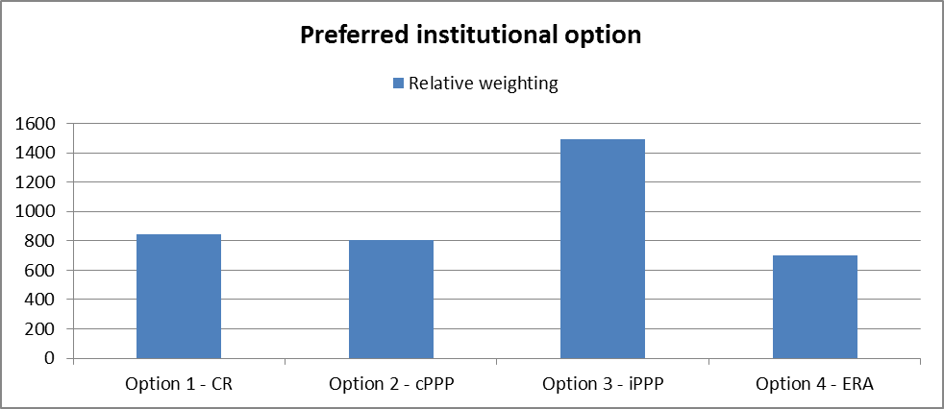
Nevertheless, 7% of respondents fear that the iPPP option could be ineffective. Among these, are mainly representatives of the rail operating community at large (i.e. NGOs, research organisations, public bodies, private companies and SMEs active in railway transport sector, whether as railway undertakings, infrastructure managers, wagon keepers, and other services to the rail transport sector). The key concern voiced by these players is that the governance structure of the iPPP option must be sufficiently open and balanced to ensure that the content is designed to achieve added value for all rail sector stakeholders, and is sufficiently oriented towards business needs and end-user needs, so as to ensure that innovation does not only stem from a "push" approach from the rail supply industry. To overcome these concerns, it is important that railway undertakings, urban rail operators, infrastructure managers, wagon keepers, as well as the final users will be involved in the definition of the strategic orientation of the Joint Undertaking and in the definition of functional requirements of the different projects. This will be ensured via a representative structure of the future Joint Undertaking, as indicated in section 6.2.1 below.
Asides from this concern, roughly one fifth of respondents specified in their open comments that, the creation of a strong managing instrument such as the Joint Undertaking should be coupled with mechanisms ensuring that key investors would have the assurance of obtaining an EU financial contribution for the entire duration of the work programme. It is suggested that this could be done by earmarking funds to named beneficiaries. Among these respondents, the majority represent the rail supply industry in broad terms (rolling stock, infrastructure, equipment and component manufacturers). However, as indicated in section 6.2.1. below, this concern must be balanced with the above concerns relating to broad stakeholder involvement and fair participation.

Proposed governance structure
A carefully designed governance structure is a key factor to ensure that public funds are used in a way that contributes efficiently to EU policy objectives and long-term industry needs. Among existing iPPPs, different governance models have been put in place, which are customised according to context and objectives of each sector.
Box 3 – Variations of the iPPP model
A distinction is traditionally made between iPPPs referred to as "Joint Undertakings" (JUs) and those referred to as "Joint Technology Initiatives" (JTIs). These two types of bodies are in fact both emanate from the same legal basis (Article 187 of the TFEU), although the first are typically considered to be more driven institutionally, while the latter are considered to be led by industry.
An analysis of existing Joint Undertakings and Joint Technology Initiatives shows that the governance structures of each separate body is tailored to the specific needs of the sector, however some differences can be found between those considered as Joint Undertakings (SESAR) and those considered as Joint Technology Initiatives (Clean Sky, FCH, IMI, ENIAC and ARTEMIS), namely:
- the research agenda of the Joint Undertaking is developed by the Joint Undertaking itself, whereas the research agenda of the Joint Technology Initiatives emanates from the European Technology Platforms.
- in the existing Joint Technology Initiatives, the Governing Board is dominated by industry, while the Commission had a leading role in Joint Undertakings.
However, in the proposals for the "first wave" Joint Technology Initiatives under Horizon 2020, the Commission will have 50% of voting rights in the Governing Board. Therefore, industry will no longer dominate the Governing Boards in new Joint Technology Initiatives, making the distinction between the two forms of iPPPs less clear.
Based on this analysis, it was decided not to differentiate between these apparent two forms of iPPPs – and therefore also not to consult stakeholders formally on this question, although a number of questions in the public consultation were indirectly related to the governance set-up and open comments on this subject were also received.
Based on the assessment of impacts in Chapter 5 and on the results of the stakeholder consultation, the following principles should be taken into account when developing the governance structure of the future iPPP for rail R&I:
- Strong link with EU policy: The need to ensure a strong linkage with EU policy and the goal of creating a single market for rail means that the EU must play an important role in the future iPPP, with the capacity to orient the strategic work programme and research activities according to the EU policy goals of integrating the Single European Railway Area, enhancing the competitiveness of the European rail system and promoting a modal shift from road to rail. Decision-making procedures should reflect this predominant role of the EU, while also reflecting the level of public and private financial commitments. This also reflects the fact that the Commission will be held accountable for the quality of programmes implemented by the iPPP.
- Strong strategic framework: To achieve a step-change, research has to be coordinated and synchronised between different rail subsystems, and backed up with long term commitments of all stakeholders. Therefore the first task of the iPPP should be to propose and negotiate a strategic master plan that is agreed with all parties and that tackles the rail system as a whole, rather than its individual sub-systems. This top-down approach will help to deliver a common vision that will ensure greater integration of the rail sector, increased standardisation and stronger market uptake of innovations. Ths plan should be endorsed by the Council to ensure it has the strong backing of the Commission and of Member States.
- Broad stakeholder participation: Membership should be open, enabling all actors of the rail sector to participate, including third country organisations and smaller companies that have fewer human and financial resources to invest in such an undertaking but nevertheless have significant expertise that needs to be leveraged in order to ensure a system approach to innovation, integrating all components of the rail value chain. One way of enabling this is to allow different levels of membership and to establish specific, lighter conditions for SME participation (for instance, enabling in kind contributions only or the pooling of resources through consortia). Broad stakeholder involvement also means that earmarking of funds for major contributors to the iPPP budget should be limited.
- Expertise: Scientific and advisory bodies can be set up to provide relevant technical expertise to the iPPP. Also, the Commission will need to retain sufficient expertise to carry out its own obligations under the PPP agreement and to monitor performance of the private sector and enforce its obligations. Furthermore, even if the ERA in lead option is discarded due to feasibility issues, it will be essential to ensure the involvement of the Agency in the work of the iPPP given its extensive expertise on interoperability issues and integration of the railway system.

Budget
The current industry estimation is that the cost of strategic rail R&I programme is EUR 800 million to EUR 1 billion. The EU would cover 50% of this cost, which would put its contribution to an estimated EUR 450 million. The activities undertaken by the iPPP will mainly be research and innovation activities. Therefore, EU funding should be paid from its Horizon 2020 budget for research and innovation. Nevertheless, funding from other EU instruments, such as the Connecting Europe Facility or the Risk Sharing Funding Facility of the European Investment Bank, for example, could also be considered, namely for later-stage activities, including the deployment of mature outcomes of the iPPP.
Given the expected timeframe for establishing and setting up the Joint Undertaking, an amount of EUR 70 million from within the foreseen EUR 450 million, will be set aside for funding collaborative rail research under the H2020 Transport Work Programme for 2014-2015. Once the iPPP achieves financial autonomy, it will take over these collaborative projects and integrate them into its stategic work programme.
The industrial partners will contribute the remaining budget of EUR 450 million, through in cash and in kind contributions. Private members will also contribute on a 50/50 basis to all administrative costs.
Based on the cost-benefit analysis conducted in this document, it can be estimated that the future structure would require roughly 20 full-time equivalents and that administrative costs would account for roughly 3% of operational expenditure. An indicative estimate of the annual budget of the iPPP can be found in Annex VII.

Monitoring and evaluation
Under existing practices, the focus of monitoring tends to concentrate on verifying if funds are spent correctly rather than on fostering efficiency. Priority has been given to an audit-oriented approach rather than to a managerial, results-based approach. At the same time, audit evaluations are often implemented in a routine manner and do not seek to exploit the findings of these checks, for instance by providing beneficiaries with feedback from audit missions in a way that would enable remedial action and measures for improvement. A possible explanation could be that audit efforts are mainly driven by the obligations towards the Court of Auditors and the Budgetary Authority, rather than by a strategic approach to increase the efficiency of internal (management) procedures.
The future monitoring and evaluation system should maintain a strong focus on the legality and regularity of transactions carried out by the new structure, but it should also be built to keep track of the performance of R&I activities to ensure that these contribute to the strategic work programme.
The detailed framework for monitoring and evaluation will be developed by the iPPP, but the processes should include:
- Project level and work package monitoring and reporting on a regular (quarterly) basis, based on a concise set of reliable key performance indicators (KPIs) defined by the Executive Director and validated by the Administrative Board, including: data relating to financial and effort consumption, achievements made in the last reporting period, completion status of specific tasks, significant issues, risks or gross deficiencies for the successful outcome of the project, with their status and corrective actions. Monitoring of risks will also give specific attention to the research phases (real-time demonstrations with all possible risks attached) and to the research areas. Specific monitoring systems should be established for the large-scale demonstrations. These processes are managed by the project or work package leaders and results are provided to the Executive Director and the Administrative Board.
- Programme level monitoring and reporting, based on project and work package data, and including the monitoring of the quality of deliverables against a set of satisfaction criteria; the monitoring of project management to verify its overall quality and the compliance with the strategic work programme. The objective of the Programme monitoring and reporting is to measure and compare results at different levels, from different viewpoints and for various audiences. This second layer of monitoring includes regular reviews that ensure that, in all projects, risk mitigation action plans are on track and effective and that in case of failure in any projects the relevant adjustments will be made in other linked projects. This process is managed by the Executive Director and his team and results are provided to the Administrative Board.
In addition, evaluations of the implementation of the Regulation should be carried out by the Commission every three years from the start of the activities of the iPPP and at least one year before expiry term of the iPPP, aimed at assessing whether the partnership in its current setup has been efficient and effective. These evaluations have to be underpinned with monitoring processes at project and programme level.
Table 11 identifies key monitoring indicators linked to the operational objectives identified in section 3. As mentioned above, key performance indicators relating to the results achieved by the iPPP will be defined by the Administrative Board once the strategic master plan is defined. An idea of potential KPIs can be found in the section on expected outcomes of rail R&I in Annex IV).
Table 11 – Proposed indicators for monitoring progress towards objectives
Operational objectives | Core indicators
Develop a long-term strategic vision (e.g. master plan) with detailed multi-annual work programmes and investment plans | - Existence of a strategic master plan with a vision covering at least 20 years  - Existence and regular update of multi-annual and annual work programmes  - Existence and regular update of multi-annual and annual investment plans
Ensure the strategic vision, work programmes and projects are aligned with key EU policy objectives of achieving a SERA and industry competitiveness | - Participation of the Commission and the ERA in decision-making procedures relating to the strategic master plan, the work programmes and the calls for proposals  - Endorsement of the master plan by the Council
Ensure consistency and coherence between different projects, enabling synchronicity of innovations along the rail value chain | - Existence and regular update of multi-annual and annual work programmes identifying the links between different projects  - Existence and regular update of a detailed long-term calendar for grants and calls for tenders  - Assessment of alignment between grants and calls for tenders with the work programme and the master plan  - Existence of monitoring processes and information exchanges between project managers within a programme and between programme managers  - Number of projects under initiation, initiated, suspended, cancelled and closed  - Detailed reports on project and programme deliverables
Improve industry involvement to acquire more private co-financing | - Number, size and market share of member companies  - Number, size and market share of associated companies (through strategic partnerships, advisory boards, participation in calls, etc.)
Ensure strong and long term ex ante commitment from EU and industry as regards financing and participation | - Number of signed agreements with private companies (membership and partnership agreements)  - Multi-annual and annual commitments from member companies  - Annual payments made by member companies
Ensure balanced participation of diverse stakeholders along the entire value chain, all technical subsystems and all MS. | - Nationalities of member companies and associated companies  - Types of organisation of member companies and associated companies (private company, SME, research organisation, university, etc.)  - Fields of activity of member companies and associated companies (private company, SME, research organisation, university, etc.)
Ensure long-term continuity of partnerships, with enhanced trust and exchanges of knowledge between stakeholders, disciplines and projects | - Number of signed membership and partnership agreements with all types of stakeholders  - Assessment of stakeholder participation in projects  - Number and frequency of reports from advisory bodies to the Administrative Board  - Existence of data exchange platforms between participants
Develop close-to-market projects that meet industry's needs, and that include large scale system-level demonstrators to validate research results | - Strong participation of private partners in defining the strategic master plan, the work programmes and the calls for proposals  - Number of demonstrators and real-time demonstrations  - Share of projects having tested their outputs in a real-life environment  - Number of project amendments following demonstrations  - Number of validated research results  - Number of commercially exploited IPR  - Assessment of value-for-money of projects undertaken
Establish a strong IPR protection and management framework | - Existence of a general IPR framework  - Existence of IPR clauses in membership and partnership agreements  - Number of IPR generated jointly by the iPPP
Ensure a rapid implementation of improved rail R&I activities | - Time required to determine the composition of the Administrative Board and hold first meeting  - Number of days between regulatory creation of the iPPP and financial autonomy  - Respect of deadlines for the launch of the first calls for proposals  - Level of completion of activities and tasks per programme and project
Ensure an adequate success rate of proposals that ensures balance between resources and demand | - Number of calls for proposals and number of grants  - Number of grants signed  - Success rate of calls for proposals
Reduce time-to-grant to enable a rapid start-up of project activities | - Time-to-grant for projects
Reduce share of administrative costs of fund management | - Number and cost of employees  - Share of administrative expenditure in total expenditure  - Breakdown of administrative costs (staff, IT, buildings, etc.)  - Existence of resource sharing agreements with other organisations
Establish mechanisms for systematic monitoring of project progress and outcomes | - Definition and validation of monitoring and evaluation processes by the Administrative Board  - Existence of monthly, quarterly and annual monitoring reports  - Existence of annual internal evaluations  - Existence of tri-annual external evaluations

Annexes

Annex I: Abbreviations
ARTEMIS | Joint Technology Initiative on embedded systems
CER | Community of European Railway and Infrastructure Companies
cPPP | Contractual public private partnership
CR | Collaborative Research
ENIAC | Joint Technology Initiative on nanoelectronics
ENTR (DG) | European Commission Directorate General for Entreprise and Industry
ENV (DG) | European Commission Directorate General for the Environment
ERRAC | European Rail Research Advisory Council
ERA | European Railway Agency
ERTMS | European Rail Traffic Management Systems
ETCS | European Train Controlling System (a basic component of ERTMS)
EU | European Union
EUR | Euro
EURNEX | European rail Research Network of Excellence
FCH | Fuel Cells and Hydrogen
FP6, FP7 | Sixth and Seventh Framework Programme of the European Community for research, technological development and demonstration activities
GDP | Gross Domestic Product
GSM-R | Global System for Mobile Communications - Railway
H2020 | Horizon 2020 the Framework Programme of the European Community for research and innovation (2014-2020)
IA | Impact Assessment
ICT | Information and Communication Technologies
IMI | Innovative Medicines Initiative
iPPP | Institutional public private partnership
JTI | Joint technology initiative
JU | Joint Undertaking
KPI | Key Performance Indicator
MOVE (DG) | European Commission Directorate General for Mobility and Transport
OECD | Organisation for Economic Development and Cooperation
PPP | Public-Private Partnership
REGIO (DG) | European Commission Directorate General for Regional Policy
R&I | Research and innovation
RSI | Railway Supply industry
RTD | Research and Technological Development
RTO | Research and Technology Organisation
RU | Railway Undertaking
SERA | Single European Rail Area
SESAR | Single European Sky Air Traffic Management Research
SME | Small and Medim-sized Entreprise
TFEU | Treaty of Functioning of the European Union
TRL | Technology readiness level
TSI | Technical Specification for Interoperability
UIC | International Union of Railways
UITP | International Association of Public Transport
UNIFE | Association of the European Rail Manufacturing Industry

Annex II: Key developments in the rail sector
Introduction
In its White Paper "Roadmap to a Single European Transport Area - Towards a competitive and resource efficient transport system" adopted on 28 March 2011 ('2011 White Paper'), the Commission unveiled its vision to establish a genuine Single European Transport Area and it clarified that this objective implies creating the true Single European railway Area. A crucial condition to meet this goal is the removal of all obstacles of administrative, technical or regulatory nature still holding back the rail sector. As announced in the 2011 White Paper, the Commission has prepared a set of proposals, to be adopted sequentially within the Fourth Railway Package.
Additionally, the European Council conclusions of January 2012 highlight the importance of releasing the growth-creating potential of a fully integrated Single Market, including as regards network industries. More precisely, the Commission Communication on Action for Stability, Growth and Jobs adopted on 30 May 2012 stresses the importance of reducing further the regulatory burden and barriers to entry in the rail sector, making therefore country specific recommendations in that direction. In the same vein, the Commission adopted on 6 June 2012 the Communication on strengthening the governance of the single market, which stresses the importance of the transport sector with a special attention to rail.
This Annex gives a brief background of the development of EU railway acquis and clarifies the necessity and objectives of the Fourth Railway Package within this context. It presents all the elements included in the Package (a chapeau communication and seven legislative proposals accompanied by three impact assessments) and explains how different pieces fit together.
In the context of the adoption of the 4th railway package on 30 January 2013 (cf.infra), the Communication "The Fourth Railway Package – Completing the single European railway area to foster European competitiveness and growth" indicates that a more European approach to rail is also intended to provide a single market for rail equipment suppliers with lower costs and explicitly refers to the industry-led Shift2Rail initiative as a means to contribute to developing rail as a transport mode by promoting step-change innovations for passenger rolling stock, freight transport, traffic management systems and rail infrastructure.
Development of EU railways acquis
In the past decade, the European legislator has considerably developed the EU acquis encouraging competitiveness and market opening. The overarching idea has been that greater competition makes for a more efficient and customer-responsive industry. In parallel measures have been taken to improve the interoperability and safety of national networks; and encourage the development of well integrated rail system leading to 'European', rather than 'national', railways.
Rail legislation in the early nineties introduced some limited degree of market opening and prompted the railways to improve efficiency by introducing management independence of railway undertakings from the state and separation of accounts between infrastructure management and transport operations. Since 2000, however, the European Commission has put forward further initiatives in the shape of packages of legislative measures.
The First Railway Package, adopted in 2001, was designed to:
- open the international rail freight market,
- establish a general framework for the development of European railways, and clarify the relationship between (a) the state and the infrastructure manager; (b) the state and railway undertakings and (c) the infrastructure manager and railway undertakings (Directive 2001/12/EC);
- set out the conditions that freight operators must meet in order to be granted a licence to operate services on the European rail network (Directive 2001/13/EC); and
- define policy for capacity allocation and infrastructure charging (Directive 2001/14/EC).
The Second Railway Package was adopted in 2004. Its aim was to determine:
- a common approach to rail safety (Directive 2004/49/EC)
- requirements for interoperability of the European high speed and conventional rail systems (Directive 2004/50/EC)
- the opening of national and international rail freight markets on the entire European network (Directive 2004/51/EC)
- the establishment of the European Railway Agency (Regulation (EC) 881/2004, amended by Regulation 1335/2008).
The Third Railway Package was adopted in 2007, to open up international passenger services to competition. The objective of the package was:
- opening the market for international passenger services to competition (Directive 2007/58/EC)
- setting the conditions and procedures for the certification of train crews operating locomotives and trains (Directive 2007/59/EC); and
- ensuring basic rights for rail passengers (Regulation 1371/2007), for example, with regard to insurance, ticketing, and for passengers with reduced mobility.
The Recast of the First Railway Package was proposed by the Commission in 2010. Following a final vote of approval in the European Parliament on 3 July 2012, the new EU rules should come into force by the end of 2012. The recast aims to simplify and consolidate the rules by merging three directives and their amendments into a single text. Importantly, the Recast also seeks to clarify existing provisions and tackle key problem areas which have been identified in the market over the last ten years. In particular, the new legislation will strengthen the power of national regulators, improve the framework for investment in rail, and ensure fairer access to rail infrastructure and rail related services.
The 4th railway package was adopted by the Commission and is currently being negotiated with the Council and the European Parliament. As explained further ahead, it contains proposals in 3 different domains:
- opening domestic passenger market to competition, including open access lines as well as the routes under PSOs
- improving the infrastructure governance
- establishing a common approach to safety and interoperability rules to remove remaining administrative and technical barriers
Developments in EU rail market
Despite the considerable development of the EU acquis and rail markets, the modal share of passenger rail in intra-EU transport has in average remained more or less constant since 2000, at around 6%. The latest Euro-barometer survey suggests that only 6% of Europeans uses the train at least once per week. It should be noted that there are marked differences between Member States, but in overall rail loses out in terms of modal share compared to other modes, reflecting a (real or perceived) low level of efficiency, service levels and quality compared to other transport modes. In the Consumer Scoreboard 2011, train services score worst of all transport services and four in ten consumers consider the choices in that service category to be inadequate.
Improvements will be necessary in all rail segments
As demonstrated by the EVERIS study, to improve the overall modal split in favour of rail, improvement will be necessary in all rail segments, including conventional long-distance and urban train services.
The 6% modal share for rail in the EU has remained fairly stable in spite of the impressive development of high-speed train networks. The latter have managed to gain some markets at the expense of air transport services, but at the same time air transport has maintained important flows of passenger traffic on routes competing with rail.
Since the mid-nineties, local and regional passenger train services in most Member States that did not open up their market have fallen in a downward spiral of continuous operational losses and subsequent reduced service offer. This decline has been exacerbated in the EU12 Member States by the decay of old infrastructure and rolling stock on the one hand, and wealth driven high-growth of car ownership, on the other hand.
Although commuter transport around urban agglomerations experiences growth in some Member States, cars still secure an important share of urban transport – 59% of Europeans never use suburban trains. This situation contrasts with the 75% urbanisation rate of the EU27 and therefore indicates a huge market development potential for suburban and regional passenger rail transport, especially given the raising congestions on roads.
The rail freight markets within the EU have been opened for a number of years, and the industry’s stagnation cannot therefore be simply explained by the existence of legal barriers of the kind that continue to restrict competition in domestic passenger services. The problem to be addressed therefore also needs to be defined in terms of technical, physical capacity and institutional barriers, which have frustrated action to open markets taken at the EU level.
What are the problems that led to the adoption of the 4th Railway package?
According to available studies, the modest development of the rail sector, as explained above, can be attributed to the presence of several administrative, technical, institutional and legal obstacles, which still hamper market access and operational efficiency of service providers.
Domestic passenger markets are closed
Whereas markets for rail freight services have been fully opened to competition since January 2007 and those for international passenger transport services as of 1 January 2010, national domestic passenger markets, which represent 94% of all passenger-km remain largely closed. However, by removing the legal barrier by allowing open access to infrastructure for domestic passenger services, would have rather limited effects given that major part of the domestic rail market is covered by public service contracts (PSC). The rules on the provision of transport services under public service obligations (PSO) are laid down in Regulation 1370/2007 which gives the possibility to competent authorities to exclude rail transport services from the obligation to award PSCs through an open tendering procedure. This means that most local and regional services, and certain long-distance services, are operated under PSO and attributed to operators through direct award. In addition, the actual impact of market opening depends on the specific requirements imposed for and within PSCs, making the call either attractive or disguisedly non-attractive for new entrants in tendering procedures (e.g. with the aim to protect the incumbent railway undertaking).
Interoperability and safety
Specific EU legislation exists to promote interoperability in order to overcome national historic differences in the field of technical specifications for infrastructure (gauge widths, electrification standards and safety and signalling systems). EU legislation also sets the framework for a harmonised approach to rail safety in the EU. Furthermore, it obliges the Member States to set up the system of national authorities, consisting of national safety authorities, notified bodies, national investigation bodies and regulatory bodies.
The European Railway Agency (ERA), established by the Second Railway Package, plays a central role in promoting interoperability, harmonising technical standards, and developing common approach to safety, all requiring close interaction with the Member States and rail sector stakeholders.
While the level of safety on EU railways has gradually increased, and therefore safety levels as such are not an issue, stakeholders have drawn the Commission's attention to the fact that certain technical and administrative hurdles still persist, creating excessive administrative costs and market access barriers, especially for new entrants. This suggests that the highly decentralised system of railway authorities in place may not have fully coped with the European dimension of the rail services. Firstly, existence of largely non-transparent national technical and safety rules, which overlap and/or are in conflict with the EU legislation, creates unnecessary complexities for RUs. Secondly, there are marked discrepancies in how the national safety authorities (NSAs) conduct vehicle authorisation and safety certifications processes, some NSAs being less efficient and effective than others. This has led to reflections on how to further enhance the role of the ERA in the integration processes.
Infrastructure governance
The First Railway Package established a distinction between infrastructure managers (IM), who run the network, and railway undertakings (RUs), that use it for transporting passengers or goods. The legislation requires that infrastructure charging and capacity allocation, being key factors in opening up the market, must be performed independently of the incumbent RU so as to ensure fair and non-discriminatory access of all operators to infrastructure. Independence of essential functions of infrastructure management has to be ensured in legal, organisational and decision-making terms as to allow for all railway undertakings an equal access to infrastructure and related services. Member States must also have independent regulatory bodies in place to monitor railway markets and to act as an appeal body for rail companies if they believe they have been unfairly treated.
There are, however, problems with the transposition and enforcement of these requirements and the Commission has initiated several infringement procedures, on which it expects the Court of Justice of the EU to express its view by the spring 2013. The interactions between railway undertakings and infrastructure managers, where these independence rules have not been implemented, have created conflicts of interest still resulting in access barriers and market distortions at the expense of new entrants, such as access denials to infrastructure and discriminatory charges.
However, even where the existing legislation has been respected, there remain certain problems related to the use of infrastructure and related services. Partially these issues are expected to be solved through the more precise provisions provided in the Recast of the First Package, especially through the strengthened role of rail regulators. However, certain issues appear to require further legislative intervention. For instance, according to the structure and economics of the railway sector, it could be necessary for the purpose of efficient infrastructure management to keep certain IM functions together, rather than allowing them to be performed by separate (though independent) bodies (e.g. it could be useful to couple traffic management with planning of maintenance works). Furthermore, today the independence requirements apply only to the essential functions (infrastructure charging and capacity allocation), but it might be necessary to extend these requirements also to certain other activities of the IM crucial for competition, such as infrastructure investments planning, financing and maintenance. The optimal governance structure has also led to reflections on the degree of institutional separation between infrastructure management and service provision.
Consequences for the railway equipment manufacturing industry
Railway undertakings and infrastructure managers purchase some 50 billion EUR of goods and services, out of which a substantial part is provided by the railway equipment industry. The closure of domestic passenger markets and the problems of interoperability perpetuate the fragmentation of railway systems along national lines and prevent the emergence of a true internal market of railway equipment. Railway manufacturers are constrained to tailor their goods to each national market, which prevent them from benefitting from economies of scale. This continuous customisation of products weakens incentives for interoperability. The railway manufacturing industry finds itself then in a vicious circle of specialisation along national lines. At the same time, the emergence of large railway markets like China, India and the US expose the EU railway manufacturing industry with new manufacturers from these countries that sell to large single markets with single safety and interoperability requirements and therefore enjoy from substantial economies of scale.
Action taken in the Fourth Railway Package
The main objectives of the Fourth Railway Package is to enhance the quality and efficiency of rail services by removing remaining legal, institutional and technical obstacles, fostering the performance of the railway sector and its competitiveness. As announced by the 2011 White Paper, these issues will be addressed by the different initiatives in three main domains:
- Domestic passenger market opening – opening domestic rail passenger market to competition, including open access lines as well as the routes under PSOs;
- Infrastructure governance - ensuring that the infrastructure manager performs a consistent set of functions that optimises the use of infrastructure capacity, and its organisation guarantees non-discriminatory access to the infrastructure and rail related services.
- Interoperability and safety - removing remaining administrative and technical barriers, in particular by establishing a common approach to safety and interoperability rules to decrease administrative costs, to accelerate procedures, to increase economies of scale for RUs and to avoid disguised discrimination.
What about infrastructure?
Obviously, to contribute to the growth of the modal share of rail, new rail infrastructures need to be built across Europe. The 2011 White Paper calls for completing the European high-speed rail network by 2050, so that it would be fully connected to airports enabling the majority of medium-distance passenger transport to be performed by rail. Future EU strategy for infrastructure development has been already set out in the Commission proposals for Connecting Europe Facility and the new TEN-T Guidelines and therefore remains out of the scope of the Fourth Package..
The technological and research pillar of the 4th railway package
The idea of a package approach in the 4th railway package was that there are synergies to be achieved between its own objectives and the effects of better coordinating research and innovation efforts in the rail sector and the impacts. Some examples of such synergies are provided below.
- Effectiveness of de jure market opening depends on allowing for certain 'framework conditions', such as access to infrastructure, rolling stock, stations, train path allocation, etc. Some of these framework conditions will be addressed within the domestic passenger market opening initiatives, while the others via the proposal on infrastructure governance.
- One way to improve rolling stock availability is to support development of rolling stock leasing market (as considered under in the domestic passenger market opening IA). However, a necessary condition for that is more standardised equipment and the on-going standardisation process is expected to be enhanced by the European "passport" for vehicles, considered within the interoperability and safety initiatives.
- All initiatives would, in their own terms, contribute to a more predictable business models for RUs operating across the borders of EU Member States:
  - interoperability initiative by harmonising approach to safety certification and authorisation of rolling stock,
  - market access initiative by introducing universal licence for provision of passenger services throughout the EU and setting common principles for PSO definition, and
  - infrastructure governance initiative by proposing a more harmonised institutional setup of infrastructure managers in different Member States.
- Better infrastructure governance should improve the operational efficiency of railways and possibly allow to improve the travel times for passengers and freight.
Overall, the different operational gains expected as a result of each initiative should allow a better value for public money, on which the functioning of railways is still heavily reliant.
In this context, the development of specific R&I efforts in the rail sector in support of increased quality of railway services, efficiency of railway systems (including interoperability) and interoperability will be an essential driver in the implementation of the 4th railway package.

Annex III: Overview of existing EU rail R&I projects
During the last decade, R&D investment by the European Commission through the Framework Programmes for Research Development has resulted in outputs that have been and are still being taken up by the market. Under the FP7, funding priorities for rail research projects have largely focused on the following issues:
- Intelligent mobility: Intelligent mobility capabilities now represent one of the most important areas of research in the rail sector. The application of intelligent systems is a powerful means to overcome some of the inherent shortcomings of public and rail transport. Quality of services, both for passengers and freight, would be greatly enhanced if all stakeholders could take on board just some of the new and exciting developments in this area.
- Safety and security: Train accidents result in an average of 100 passenger and crew fatalities per year within the EU. In 2002, the European Commission proposed a new package of measures to revitalise European railways, based on the Transport White Paper. One of these measures is the development a common approach to rail safety. In order to ensure continued improvement in both railway safety and security, an overall systems approach is clearly necessary, including a full analysis of the interrelated elements and determination of risks. The main targets for research activities in this area include hazard reduction. Among other things, hazard reduction is directly linked to improvements in quality. Thus, improving the overall quality management system is also a key priority.
- Environment: Although the rail sector already has a positive image in comparison with other transport modes, the weight of public opinion continues to demand that further improvements be made. One area of particular ongoing concern is noise abatement. Research on improving noise performance in the rail sector is heavily dependent on collaboration between infrastructure managers, train operators, suppliers, national governments and supranational legislators. Others areas of concern include reducing harmful emissions, reducing operational energy consumption and designing for the environment, i.e. designing for easy recycling and reducing the amount of hazardous materials used in construction processes. Finally, emphasis is also placed on further work on emerging technologies, including fuel cells as power sources and levitation technologies that can further reduce the impact of rail transport on the environment.
- Interoperability: The main goals for research on interoperability are to establish, guarantee and continuously improve the conditions for the operational and technical integration of the different national railway systems in the European Union and associated countries. Work focuses primarily on:
  - Finding cost-effective technical and operational solutions for interoperability
  - Creating the conditions for seamless transport and enhancing the capacity of the network
  - Reducing migration times for the implementation of interoperability solutions
  - Developing new interoperable concepts for dedicated freight transport
  - Developing innovative and modular concepts for increasing system simplification
  - Considering intermodality to enhance overall transport system performance.
- Innovative materials and production methods: This research priority sets out to achieve cost reductions for both newly built products and maintenance. Within this framework, a list of future research topics has been established, specifying the expected benefits for rail transport and the milestones for the introduction of innovation.

Although there is no single report presenting the evaluation results of all rail projects funded under FP7 or previous framework programmes, we have used findings presented in the following reports, relating to EU-funded research projects in general or to EU-funded transport research projects, to support our analysis:
- Interim evaluation of EU FP7 Transport research notably within Theme 7 of the cooperation programme “Transport (including aeronautics)”, February 2011
- FP7 Annual Monitoring Reports
- SITPRO Plus: FP7-funded study on the Impacts of the Transport RTD Projects in FP5 and FP6, November 2010
- Market-up : FP7-funded study on transport research market uptake, December 2011
- ERRAC Roadmap: FP-7 funded study on the evaluation of market uptake and lessons learnt from past project results
- JRC report on R&D efforts of the EU automotive and rail industry and the public sector, 2010
We have also used the extensive evidence compiled in the Horizon 2020 impact assessment.
On top of this, we gathered available data relating to projects funded under the FP7-Transport Work Programme that could be attributed to the rail sector. Project data relates to the types of partners in the consortia and their countries of origin, the budget contributions of the Union and of other partners, and the duration of projects. Data concerning the field of activity of the partners was not available meaning that it was not possible to provide evidence pertaining to the participation of the full rail value chain in current framework programme projects.
The following table provides an overview of the 47 rail-only projects funded under the FP7-Transport budget. The total value of these 47 projects so far was EUR 221,615,609, to which the Commission contribution amounted to EUR 146,393,043 – i.e. 66% of total project costs overall.
On top of these projects, various FP7-Transport intermodal projects have covered rail aspects. Some rail projects have also been funded under other budget lines, including FP7-SME, FP7-People, FP7-Security and FP7-ICT.
Project Acronym | Project Title | Project Description | Coordinator's Legal Name | Coordinator's Country | Coordinator's Organisation Type | Project Start Date | Project End Date | Project Total Cost | Project EC Contribution
ACEM RAIL | Automated and cost effective maintenance for railway | Automated and cost effective railway infrastructure maintenance | Centro de Estudios Materiales y Control de Obras S.A. | Spain | SMEs | 01-Dec-2010 | 30-Nov-2013 | 3,849,273 | 2,501,315
ACOUTRAIN | Virtual certification of acoustic performance for freight and passenger trains | Rail system interoperability (regulatory and non-legislative interoperability based on technological innovations | UNION DES INDUSTRIES FERROVIAIRES EUROPEENNES - UNIFE | Belgium | Other | 01-Oct-2011 | 30-Sep-2014 | 3,217,920 | 2,091,220
AEROTRAIN | AEROdynamics  Total Regulatory Acceptance for the Interoperable Network | Interoperable rolling stock | UNION DES INDUSTRIES FERROVIAIRES EUROPEENNES - UNIFE | Belgium | Other | 01-Jun-2009 | 31-May-2012 | 4,042,239 | 2,499,998
ALARP | A railway automatic track warning system based on distributed personal mobile terminals | Human components | ANSALDO STS S.p.A. | Italy | Private Companies | 01-Jan-2010 | 30-Apr-2013 | 3,941,877 | 2,626,610
AUTOMAIN | Augmented Usage of Track by Optimisation of Maintenance, Allocation and Inspection of railway Networks | Automated and cost effective railway infrastructure maintenance | PRORAIL B.V. | Netherlands | Private Companies | 01-Feb-2011 | 31-Jan-2014 | 4,077,603 | 2,499,971
CARGOVIBES | Attenuation of ground-borne vibration affecting residents near freight railway lines | Attenuation of ground-borne vibration affecting residents near railway lines | NEDERLANDSE ORGANISATIE VOOR TOEGEPAST NATUURWETENSCHAPPELIJK ONDERZOEK - TNO | Netherlands | Research Organisations | 01-Apr-2011 | 31-Mar-2014 | 4,909,795 | 3,667,614
CETRRA | Actions to stimulate participation of cooperation partners in surface transport research | Stimulating participation of small and medium size enterprises (SME) | TSB Innovationsagentur Berlin GmbH | Germany | SMEs | 01-Jun-2008 | 30-Sep-2010 | 506,337 | 505,622
CLEANER-D | Clean European Rail - Diesel | Emission reduction technologies for diesel locomotives | UNION DES INDUSTRIES FERROVIAIRES EUROPEENNES - UNIFE | Belgium | Other | 01-Jun-2009 | 31-May-2013 | 13,333,093 | 7,975,574
D-RAIL | Development of the Future Rail Freight System to Reduce the Occurrences and Impact of Derailment | Reducing the occurrences and impacts of freight train derailments | UNIVERSITY OF NEWCASTLE UPON TYNE | United Kingdom | Higher or Secondary Education | 01-Oct-2011 | 30-Sep-2014 | 4,766,522 | 2,998,465
DYNOTRAIN | Railway Vehicle Dynamics and Track Interactions  Total Regulatory Acceptance for the Interoperable Network | Interoperable rolling stock | UNION DES INDUSTRIES FERROVIAIRES EUROPEENNES - UNIFE | Belgium | Other | 01-Jun-2009 | 31-May-2013 | 5,543,718 | 3,258,795
EATS | ETCS Advanced Testing and Smart Train Positioning System | Innovation and standardisation in the field of signalling to accelerate a European Train Control System rollout | CENTRO DE ESTUDIOS E INVESTIGACIONES TECNICAS | Spain | Research Organisations | 01-Oct-2012 | 31-Mar-2016 | 3,902,076 | 2,989,591
ECUC | Eddy CUrrent Brake Compatibility | Rail system interoperability (regulatory and non-legislative interoperability based on technological innovations) | CENTRO DE ESTUDIOS E INVESTIGACIONES TECNICAS | Spain | Research Organisations | 01-Sep-2012 | 31-Aug-2015 | 3,253,188 | 2,050,179
ERRAC ROAD MAP | ERRAC Road Map | Competitive transport operations | UNION INTERNATIONALE DES CHEMINS DE FER | France | Other | 01-Jun-2009 | 31-Jul-2012 | 1,683,513 | 1,540,994
EURAXLES | EURAXLES: Minimizing the risk of fatigue failure of railway axles | Minimizing the risk of fatigue failure of railway axles | UNION DES INDUSTRIES FERROVIAIRES EUROPEENNES - UNIFE | Belgium | Other | 01-Nov-2010 | 31-Oct-2013 | 4,717,900 | 2,899,998
EUREMCO | European Railway Electromagnetic Compatibility | Rail system interoperability (regulatory and non-legislative interoperability based on technological innovations | UNION DES INDUSTRIES FERROVIAIRES EUROPEENNES - UNIFE | Belgium | Other | 01-Oct-2011 | 30-Sep-2014 | 3,686,492 | 2,144,829
FREIGHTVISION | Vision and Action Plans for European Freight Transport until 2050 | Preparatory action on Innovative Transport Networks | AustriaTech - Gesellschaft des Bundes für technologiepolitische Maßnahmen | Austria | Research Organisations | 14-Aug-2008 | 13-Feb-2010 | 2,737,916 | 1,999,623
FUTURAIL | Job Opportunities for the Railway Community of Tomorrow | Raising Awareness of potential job opportunities in the Surface Transport sectors | INSTITUTO SUPERIOR TECNICO | Portugal | Higher or Secondary Education | 01-Jan-2009 | 30-Jun-2010 | 262,080 | 262,080
INESS | INtegrated European Signalling System | Delivering ERTMS-compliant Interlocking Systems | UNION INTERNATIONALE DES CHEMINS DE FER - UIC | France | Other | 01-Oct-2008 | 31-Mar-2012 | 15,734,414 | 10,015,379
INFRAGUIDER | Infrastructure Guidelines for Environmental Railway Performance | The greening of transport-specific industrial processes | CONSORZIO NAZIONALE INTERUNIVERSITARIO PER I TRASPORTI E LA LOGISTICA | Italy | Research Organisations | 01-Jan-2009 | 31-Dec-2010 | 1,138,665 | 1,138,665
INTERAIL | Development of a Novel Integrated Inspection System for the Accurate Evaluation of the Structural Integrity of Rail Tracks | Advanced and cost effective infrastructure construction, maintenance and monitoring | INSTITUTO DE SOLDADURA E QUALIDADE | Portugal | Research Organisations | 01-Oct-2009 | 31-Mar-2013 | 4,991,523 | 3,281,750
LIVINGRAIL | Living in a sustainable world focused on electrified rail | Planning rail towards 2050 | FRAUNHOFER-GESELLSCHAFT ZUR FOERDERUNG DER ANGEWANDTEN FORSCHUNG E.V | Germany | Research Organisations | 01-Dec-2012 | 31-May-2015 | 1,240,912 | 985,259
MAINLINE | MAINtenance, renewaL and Improvement of rail transport iNfrastructure to reduce Economic and environmental impacts | Cost-effective improvement of rail transport infrastructure | UNION INTERNATIONALE DES CHEMINS DE FER - UIC | France | Other | 01-Oct-2011 | 30-Sep-2014 | 4,466,361 | 2,972,953
MARATHON | Make Rail The Hope for protecting Nature | Fast implementation of innovative/effective rail technologies to improve rail freight services | D'APPOLONIA SPA | Italy | Private Companies | 01-Apr-2011 | 31-Mar-2014 | 4,386,346 | 2,699,992
MAXBE | INTEROPERABLE MONITORING, DIAGNOSIS AND MAINTENANCE STRATEGIES FOR AXLE BEARINGS | Rail system interoperability (regulatory and non-legislative interoperability based on technological innovations) | UNIVERSIDADE DO PORTO | Portugal | Higher or Secondary Education | 01-Nov-2012 | 31-Oct-2015 | 4,595,999 | 3,000,000
MERLIN | Sustainable and intelligent management of energy for smarter railway systems in Europe: an integrated optimisation approach | Management of energy in railway systems | UNION DES INDUSTRIES FERROVIAIRES EUROPEENNES - UNIFE | Belgium | Other | 01-Oct-2012 | 30-Sep-2015 | 7,121,486 | 4,499,325
MERLIN | Development of Aero Engine Component Manufacture using Laser Additive Manufacturing | Aerostructures | ROLLS ROYCE PLC | United Kingdom | Private Companies | 01-Jan-2011 | 31-Dec-2014 | 7,122,572 | 4,886,561
MODSAFE | Modular Urban Transport Safety and Security Analysis | Integrated safety and security for urban rail | TUEV RHEINLAND INTERTRAFFIC GMBH | Germany | Private Companies | 01-Sep-2008 | 31-Aug-2012 | 5,180,841 | 3,469,161
NEAR2 | Network of European – Asian Rail Research capacities | Europe to Asia: rail research collaboration | CENTRE FOR RESEARCH AND TECHNOLOGY HELLAS | Greece | Research Organisations | 01-Dec-2012 | 30-Nov-2014 | 962,832 | 887,003
ON-TIME | Optimal Networks for Train Integration Management across Europe | A system approach for railway operations management to increase capacity and decrease delays for railway customers’ satisfaction | D'APPOLONIA SPA | Italy | Private Companies | 01-Nov-2011 | 31-Oct-2014 | 7,970,833 | 5,381,969
OPTIRAIL | Development of a smart framework based on knowledge to support infrastructure maintenance decisions in railway corridors | Next generation tools for optimised infrastructure asset management | VIAS Y CONSTRUCCIONES | Spain | Private Companies | 01-Oct-2012 | 30-Sep-2015 | 3,916,343 | 2,700,000
OSIRIS | Optimal Strategy to Innovate and Reduce energy consumption In urban rail Systems | Energy consumption reduction in urban rail systems | UNION DES INDUSTRIES FERROVIAIRES EUROPEENNES - UNIFE | Belgium | Other | 01-Jan-2012 | 31-Dec-2014 | 7,408,302 | 4,299,951
PANTOTRAIN | PANTOgraph and catenary interaction Total Regulatory Acceptance for the Interoperable Network | Interoperable rolling stock | UNION DES INDUSTRIES FERROVIAIRES EUROPEENNES - UNIFE | Belgium | Other | 01-Jun-2009 | 31-May-2012 | 3,534,167 | 2,166,370
PUBTRANS4ALL | Public Transportation - Accessibility for All | New mobility concepts for passengers ensuring accessibility for all | RODLAUER CONSULTING EU | Austria | SMEs | 01-Sep-2009 | 30-Nov-2012 | 2,750,614 | 1,807,662
RESTRAIL | Reduction of Suicides and Trespasses on RAILway property | Mitigation measures and good practice to reduce human fatalities and disruption of services resulting from suicides and trespasses on railways property | UNION INTERNATIONALE DES CHEMINS DE FER - UIC | France | Other | 01-Oct-2011 | 30-Sep-2014 | 3,868,393 | 2,816,243
RIVAS | Railway Induced Vibration Abatement Solutions | Attenuation of ground-borne vibration affecting residents near railway lines | UNION INTERNATIONALE DES CHEMINS DE FER - UIC | France | Other | 01-Jan-2011 | 31-Dec-2013 | 8,235,633 | 5,199,995
SAFERAIL | Development of Novel Inspection Systems for Railway Wheelsets | Safety and security by design | TWI LIMITED | United Kingdom | Research Organisations | 01-Oct-2008 | 30-Sep-2011 | 4,448,701 | 3,000,000
SECUREMETRO | Inherently secure blast resistant and fire safe metro vehicles | Safety and security by design | UNIVERSITY OF NEWCASTLE UPON TYNE | United Kingdom | Higher or Secondary Education | 01-Jan-2010 | 31-Dec-2012 | 3,769,504 | 2,710,714
SECURESTATION | Passenger station and terminal design for safety, security  and resilience to terrorist attack | Safety and security by design in transport stations and terminals | INGENIERA DE SISTEMAS PARA LA DEFENSA DE ESPANA SA-ISDEFE | Spain | Private Companies | 01-Jun-2011 | 31-May-2014 | 3,119,919 | 2,287,712
SKILLRAIL | Education and Training Actions for high skilled job opportunities in the railway sector | Shaping the New Generation of Sustainable Surface Transport Mobility for Europe | INSTITUTO SUPERIOR TECNICO | Portugal | Higher or Secondary Education | 01-Dec-2009 | 30-Nov-2011 | 483,941 | 454,525
SMART RAIL | Smart Maintenance and Analysis of Transport Infrastructure | Cost-effective improvement of rail transport infrastructure | UNIVERSITY COLLEGE DUBLIN, NATIONAL UNIVERSITY OF IRELAND, DUBLIN | Ireland | Higher or Secondary Education | 01-Sep-2011 | 31-Aug-2014 | 3,823,676 | 2,782,055
SPECTRUM | Solutions and Processes to Enhance the Competitiveness of Transport by Rail in Unexploited Markets | Step changes in rail freight logistics: new technologies and methods to increase freight competitiveness in the emerging low density, high value market | UNIVERSITY OF NEWCASTLE UPON TYNE | United Kingdom | Higher or Secondary Education | 01-May-2011 | 30-Apr-2015 | 4,317,499 | 2,785,539
SPIDER PLUS | Sustainable Plan for Integrated Development through the European Rail network – Projecting Logistics & mobility for Urban Spatial design evolution | Planning rail towards 2050 | Hacon Ingenieurgesellschaft mbH | Germany | SMEs | 01-Dec-2012 | 31-May-2015 | 4,077,187 | 2,969,325
SUSTRAIL | The sustainable freight railway: Designing the freight vehicle – track system for higher delivered tonnage with improved availability at reduced cost | The sustainable freight railway: Designing the freight vehicle – track system for higher delivered tonnage with improved availability at reduced cost | CONSORZIO PER LA RICERCA E LO SVILUPPO DI TECNOLOGIE PER IL TRASPORTO INNOVATIVO | Italy | Research Organisations | 01-Jun-2011 | 31-May-2015 | 9,347,579 | 6,599,933
TIGER | Transit via Innovative Gateway concepts solving European-Intermodal Rail needs | Rail transport in competitive and co-modal freight logistics chains | CONSORZIO PER LA RICERCA E LO SVILUPPO DI TECNOLOGIE PER IL TRASPORTO INNOVATIVO | Italy | Research Organisations | 01-Oct-2009 | 30-Sep-2012 | 17,054,428 | 10,316,063
TREND | Test of Rolling Stock Electromagnetic Compatibility for cross-Domain interoperability | Rail system interoperability (regulatory and non-legislative interoperability based on technological innovations | CENTRO DE ESTUDIOS E INVESTIGACIONES TECNICAS | Spain | Research Organisations | 01-Nov-2011 | 30-Apr-2014 | 2,825,600 | 2,042,026
VEL-WAGON | Versatile, Efficient and Longer Wagon for European Transportation | Fast implementation of innovative/effective rail technologies to improve rail freight services | TECHNISCHE UNIVERSITAT BERLIN | Germany | Higher or Secondary Education | 01-Dec-2010 | 31-Dec-2012 | 1,107,704 | 831,687
VIWAS | Viable Waggonload production Schemes | Tools and conditions for attractive, efficient and competitive single wagonload traffic and its interaction with road and intermodal transports | Hacon Ingenieurgesellschaft mbH | Germany | SMEs | 01-Sep-2012 | 31-Aug-2015 | 4,182,092 | 2,892,748

The analysis of the data from the 47 rail projects funded under FP7-Transport enables us to see that nearly all EU countries have been involved in at least one of these research projects, with the exception of Estonia, Latvia and Malta.
The following graphs provide an overview of the number of project participations per country, as well as the total Commission contribution per country. As can be seen, Germany, the United Kingdom, Italy, France, Spain and Belgium have the highest number of participations, and benefit from the largest share of Commission contributions.
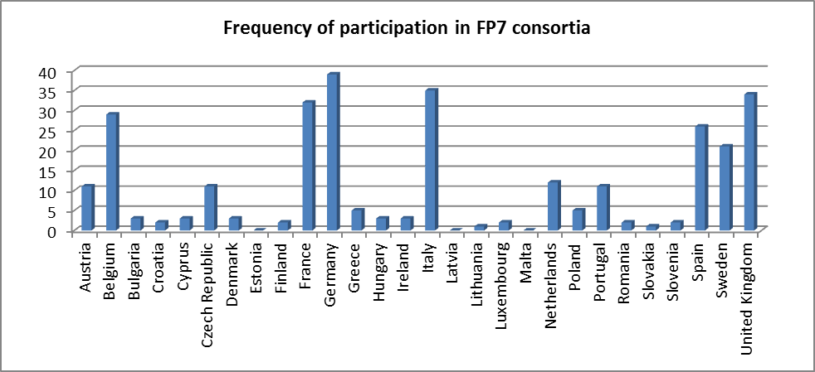
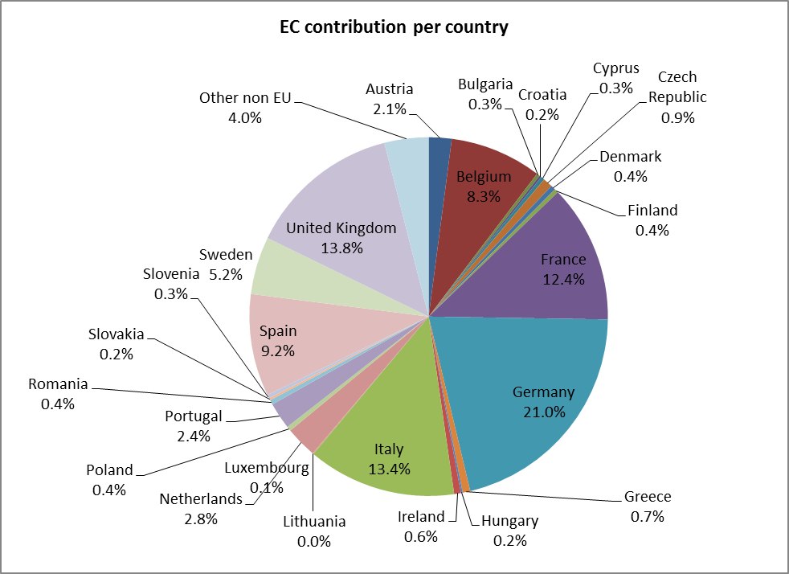
With regard to the types of organisations involved in research, the following table shows that private companies account for 35% of EU funding, against 15% for SMEs, 18% for research organisations, 20% for universities, 5% for public bodies and 7% for other.
Existing evaluations of EU-funded research and innovation projects, in general and in the transport and rail sectors have found that:
- The approach adopted for the FP7 is an improvement compared to the previous FPs (FP7 interim evaluation)
- European Technology Platforms (ETPs) add value to the FP7 Transport programme, help focus the research efforts in the different modes and contribute to gearing public and private research towards common goals. The regularly updated versions of the Strategic Research Agendas (SRAs) are important input for the FP7 Programmes and strongly reinforce the relevance and legitimacy of the FP7 Transport Programme (FP7 interim evaluation)
- The capacity of the FP7 to attract the most important players in research and innovation in transport is uneven among sectors. A significant share of large R&D performers do not participate in FP7. Therefore there is an untapped reservoir of R&D leaders in the field that are potential FP partners. Their relationships with EC-led research should be further investigated in order to find ways to attract them. (FP7 interim evaluation)
- FP7 funds applied mid-term research for projects that will need follow-ups to lead to innovation. Most of the projects are applied research projects with a mid-term horizon. This intermediate positioning of FP research has two strong implications:
  - FP7 research will only marginally lead up to radical innovation. Reflection should be carried out concerning the role of EC research in transport open collaborative research.
  - Many projects will need a phase of technological development before they eventually result in an innovative marketable product or a service. Although it is still a very new initiative, an analysis of Clean Sky suggests that Joint Technology Initiatives are a very promising tool to fill this gap, bringing results up to the demonstration stage. Clean Sky is tackling a major gap through the commitment of a critical mass of public and private resources towards the development of demonstrators (FP7 interim evaluation).
- The role of the Small and Medium Enterprises (SMEs) in the projects is important. Even though the objective of 15% of SME participation has been reached in research funded under the Transport Work Programmes 2007 and 2008, the analysis of the evaluation team shows that only a minor share of EU innovative SMEs are involved in FP projects (5.6% in FP6 and 2.2% in FP7 so far) (FP7 interim evaluation).
- FP7 research and innovation has not contributed sufficiently to tackling societal challenges. If each Member State provides its own response in an uncoordinated way, there is a danger of missing important opportunities for generating scale and interactions. To be successful Europe must stimulate coordinated research aimed at addressing these challenges and improve the way it is transformed into new products and processes. And it must enhance the interaction between research and innovation actions and the sectoral policies related to the challenges (H2020 impact assessment).
- Among the various factors that can explain the efficiency of public support for science and technology, one of them is specific to the EU: the fragmentation of public funding. Almost 90% of public support for civil R&D is decided directly by the Member States without any prior cooperation or even coordination. Only 12% of public funding is allocated through cooperative schemes - such as EU Framework Programmes, Eureka or intergovernmental collaborative measures - which help to avoid duplication between different national and regional funding actions (H2020 impact assessment).
- Applied research targeting industrial applications, often in collaboration with universities, is the standard and mainstream type of research within the transport field unlike in other research areas (SITPRO Plus study).
- There is a gap between the stated and actual use of transport research results by relevant stakeholders or users. Between 30 and 60 percent of research goes unexploited. Exploitation in this context means ‗documented use as through reference or acknowledgement in documents. The degree of lack of exploitation is higher if the actual implementation of research results is considered instead. The fall-out rate of the use of transport research is high not only among policy institutions (such as the EU institutions or national public administrations) but also within the industry—a surprising finding considering that the industry is the main beneficiary of transport research contracts (SITPRO Plus study).
- Transport research continues to produce two main types of outputs: academic outputs such as publications and methods on the one hand; and transport modelling tools and components, on the other. Neither technologies nor policy-relevant outputs are as important, contrary to the rhetoric of some Framework Programme documents on the subject (SITPRO Plus study).
- The policy impact of transport research is often more by name than real. Six out of ten projects consider their results policy-relevant and four out of ten projects think that their research contributes to policy harmonization. However the policy relevance dwindles when specific transport policy objectives such as rail harmonization, road policy or the TEN-T are considered. The gap, which cannot be explained away by the thematic variation of the projects, is the combined result of two factors, namely, the comparatively low specific knowledge of transport policy issues among some project coordinators in conjunction with the transport modelling paradigm still dominant among those in charge of designing the European transport research programme (SITPRO Plus study).
- Projects which are large in terms of partnership (often also involving users and stakeholders in their consortia) and diffused in terms of contents (i.e. having more than one topic and a broad scope) are more likely to consider themselves as policy-relevant. This is in line with the present logic of policy-design which emphasizes cross-sectoral integration. However, insofar as specific policy output is concerned, projects which are more focused in terms of topic and research design are more likely to produce real policy outputs. This is the case for both small and large projects (in terms of number of partners) but more so the case for large projects (SITPRO Plus study).
- A great effort needs to be made to achieve the objective of orienting European R&D investment towards addressing societal challenges. In FP7 there seems to be an unbalanced investment split across modes, in which air transport appears to be benefiting from a high proportion of R&D investment while cross-modal issues, which are critical to achieve “smart, green and integrated transport” seem to be underfinanced (Market Up study).
- The analysis of transport related funding instruments provides evidence for the existence of the “valley of death”, i.e. a funding gap at an intermediate stage of the innovation process, between basic research and commercialization of a new product. It seems easier to find research funding mechanisms for the phases of basic or applied R&D and demonstration than for the market pull phases of commercialization, market accumulation or diffusion. Moreover, most funding schemes analysed showed little focus on financing closer-to-market activities, market analysis and development plans (Market Up study).
- Funding instruments oriented towards engaging industrial partners, research organisations and/or education institutions in collaborative projects and that have specific provisions to ease the involvement of SMEs, present an important mechanism to involve weak players in transport research and can potentially play a prominent role in increasing the market uptake of research results (Market Up study).
- Key blocking mechanisms to market uptake in the transport sector include problems in the area of market formation, lack of legitimation of innovations, negative impacts from alternative technologies already on the market, insufficient resource mobilisation, lack of customer awareness, timing and cost-related issues (Market Up study).
- Key inducement mechanisms to market uptake in the transport sector include government support, usefulness of the innovation to society, lack of opposition to the innovation, and presence of the necessary infrastructure (Market Up study).
- The transport sector is the largest industrial R&D investor in the EU and at global level, and road in particular is the largest investing sector, although all modes show relatively high R&D intensities (JRC study).
- Data problems exist pertaining to rail sector R&D investments which make it difficult to have a proper overview of R&D efforts in the rail sector. (JRC study).
- The uptake of projects funded under FP5 and FP6 is weak in 55% and strong in only 30% of cases. Out of 44 evaluated projects, the13 projects with a strong market uptake are in the domains of Greening of Surface Transport (Design for Environment), Train- Bus Communication Control Systems and Improving Safety and Security. The 24 projects with weak market uptake are mostly in the domain of Railway freight operation relating to modal shift (ERRAC Roadmap).
- Projects will present a better market uptake if they are aimed at solving issues of general acknowledged interest (eg. technical, safety, of harmonisation, business cases), if there has been strong interaction between partners and relevant stakeholders, and if the scope and objectives have been clearly defined at the beginning (ERRAC Roadmap).

Annex IV: EU rail R&I objectives and key priorities
In the context of the goals of the 2011 White paper, the performance of the rail sector compared to other modes is not yet satisfactory. The growth of passenger traffic by rail since the early 2000's has been insufficient to increase its modal share, which has remained fairly stable since the 90s, in comparison to cars and aviation. Railway services perform badly compared to the remaining services in the economy, as shown by the Consumer Scoreboard. It is therefore necessary to improve the quality of rail services by responding to the needs of rail passengers and freight forwarders.
At the same time, the rail sector, which absorbs substantial public funding (some 45 billion EUR annually), needs to adapt to a more competitive and market-driven environment to cope with an era of constrained public finances. In this context, it is necessary to improve the efficiency of railway services by increasing revenues and decreasing operational, as well as the costs of assets like rolling stock and infrastructure - in particular the latter's maintenance, renewal and development.
In line with this, and as explained in Annex II, the rationale of the 4th railway package is to increase the modal share of rail through increases in the:
- Quality of rail services
- Efficiency of railway systems
The structure of costs and revenues of the rail sector
Revenues
Railway undertakings revenues are composed of:
- Revenues from rail passenger services (which represent some 30-35 billion EUR in the EU)
- Revenues from rail freight services (which represent some 10-15 billion EUR in the EU)
- State subsidies to cover the operational costs of public service contracts (which represent some 20 billion EUR in the EU), which are mostly run on regional and suburban rail services
Infrastructure managers’ revenues are composed of:
- Revenues from infrastructure charges (which represent some 15 billion EUR)
- Network grants (which represent some 25 billion EUR)
Operational costs
Railway undertakings operational costs are composed of:
- Labour costs
- Costs of goods and services, in particular energy costs
In addition, railway undertakings have to cope with the costs of rolling stock.
Infrastructure managers’ operational costs are composed of:
- Labour costs
- Costs of goods and services, in particular of enhancement, renewal and upgrade of infrastructure.
The operational costs of railway system amount to some 100 billion EUR yearly.

How can research contribute to the overall competitiveness of the rail sector?
To support the increase of rail modal share, rail research must in particular and inter alia help to:
- Reduce the cost of infrastructure development, maintenance and renewals, in particular through reduced life cycle-cost of infrastructure.
- Reduce the cost of railway services, in particular public service obligations, by reducing the costs of operation and maintenance of rolling stock, lighter and less noisy trains, and savings in energy consumption.
- Optimise traffic management to reduce transaction costs of railway undertakings and infrastructure managers, increase capacity and reduce delays.
- Increase the demand for passenger railway services thanks to reliable rolling stock adapted to consumer needs and easily accessible for persons with reduced mobility, as well as ticketing solutions that facilitate and integrate railway services
- Increase the demand for rail freight services by integrating them into supply chains
Proposed research topics
In order to fulfil its potential of playing a significant role in meeting future transport needs, railways need to radically progress in terms of service, cost, interoperability, capacity, carbon footprint and competiveness. Set against such uphill challenge, crafting the right innovation strategy will require moving well beyond just technology. Novel business, organisational and logistic solutions as well as new partnerships with service and technology providers from more advanced sectors are deemed essential to support new economies of scale and the needed search-for-excellence by rail. The goal will be to rapidly address manifest weaknesses that hamper rail services and operations and to engage in a number of game-changers in rail services and operations.
Analysis undertaken by the Commission recently has served to identify the following priority areas for R&I with a view to achieving a competitive, integrated and interoperable EU railway system.
1. New generation of rolling stock
It is necessary to develop a new generation of rail vehicles that substantially reduces the cost of rail passenger services, drastically improves the capacity of rail to take on a larger modal share and facilitates the use of trains throughout various Member States.
Research in this area must lead to slashing operational costs of rail like energy or life-cycle costs (for instance through improved production and certification processes) as well as to reducing externalities like noise and damage to tracks. This is essential for the continuity of rail services in a context of growingly constrained public budgets – rail services absorb some EUR 20 billion of public subsidies every year.
To improve the modal shift, the quality of rail services – which compete with car and also low-cost airlines – must be irreproachable and it is necessary to boost the reliability of rail vehicles. At the same time, rail vehicles must be able to adapt to an ageing and more urban customer basis, as well as to persons with reduced mobility.
Finally, as long as rolling stock is technically confined to a specific Member State, railway undertakings can't reap the benefits of economies of scale, nor benefit from the cost and finance advantages of a proper leasing market develop (today only 10% of rolling stock is leased), which reduces the entry costs for new entrants and public subsidies. It is essential that research in this area solves some of the critical areas where rolling stock interoperability has not been technically feasible.
2. Cost Efficient-High Capacity Infrastructure
Taking into account the expected growth in transport demand, the need to reduce life-cycle infrastructure costs, and the ever-rising customer expectations in terms of quality of service, research should aim at identifying relevant infrastructure-related challenges and develop solutions that result in reduced investment and recurring operational costs and improve the reliability and availability of rail operations.
Research must focus on new concepts, e.g. for infrastructure condition monitoring and predictive maintenance, with a view to improving reliability, capacity, resilience, cost-effectiveness, accessibility and safety, and minimising noise and vibrations.
3. Intelligent Traffic Management and Control Systems (ERTMS)
There will be a need to step-increase the productivity of the legacy infrastructure assets, requiring the latter to be managed in a more holistic and intelligent way, using lean operational practices and smart technologies that can eventually contribute to improving the reliability and responsiveness of customer service and whole economics of rail transportation.
The ultimate goal of research in this area is to contribute to enhancing the competitiveness of the European rail transport (interoperability, safety, performance, quality, cost, Europe 2020). To this end, the four following objectives should be supported:
- The deployment of ERTMS in Europe on the European Core Network by 2030 (1) by providing time-to-market "plug-and-play" standardised products with standardised interfaces (and closing open points of the Control Command and Signalling Technical Specifications for Interoperability), (2) by matching the management and maintenance of modern safety-critical software based systems with the long life expectancy traditionally associated with the complex and shared railway system, (3) by addressing cross-border issues and facilitating the migration from legacy systems to ERTMS/ETCS, (4) by making ETCS independent from the communication bearer and relying on internet protocol in view of the obsolescence of GSM-R (Global System for Mobile Communications – Railway) in 10-15 years' time.
- Making a positive business case for (small and medium) railway undertakings by decreasing costs of ERTMS related to life-cycle costs in general (in all phase: design, build, placing in service, operation, maintenance), integration with other rail subsystems, retrofitting existing locos, conformity assessment and authorisation procedures of on-board systems, etc.
- Contributing to increase the operational efficiency of the European rail system taking into account a more competitive environment on high speed lines and corridors, and a growing commuter traffic that coexist with rail freight services, fully integrated with European supply chain, that have to deliver goods on time; that includes (1) increasing the performance (capacity, reliability, punctuality, safety, accuracy) of the traffic management, which would contribute to fix the remaining coordination issues between infrastructure managers and RU, (2) improving interaction/integration with other structural and functional subsystems, (3) finding synergies with Galileo to boost the quality of railway services with accurate positioning information, important for urban dense area, and cheap position information for low-density area.
- Contributing to improving the efficiency of energy usage in rail systems, embracing vehicles, infrastructure and operation within a whole-system perspective. This will imply notably the development of smart concepts in intelligent design and management of energy systems for rail applications which should be pursued from a whole-of-life perspective - from concept to implementation through the design, procurement, manufacturing, construction, operations and maintenance phases.
- Contributing to the multimodal smart mobility system, in particular in finding synergies with urban train control systems to make them interoperable and interconnected.
4. Customer Experience Support Systems for seamless travel
Research should contribute to enabling passengers to travel across borders and in travel chains, involving long-distance as well as regional/local trains of different service providers, as well as adjacent modes. Passengers should be able to purchase tickets for such journeys in a single place and single operation in a station or online from an electronic device (PC or smartphone) anywhere in the EU.
Common solutions must be conceived (to be laid down in specifications - TAP TSI) to allow the different stakeholders involved to build the necessary interoperable infrastructure and develop ticket and travel information and selling systems that can provide these services everywhere in the EU.
5. New supply chain concepts for freight
The objective of research in this area is to develop and test innovative solutions enabling rail freight (1) to increase its cost competitiveness, (2) to improve the reliability of freight services in line with market demands and (3) to add new service features to rail freight responding to logistical requirements, in order to secure and strengthen rail's market position in current markets while at the same time enabling it to (re-)enter into new/lost market segments. Freight research shall help to foster new business approaches in rail freight and take into account the specificities of the rail freight sector characterized by medium-sized enterprises.
6. Talent Management Systems
The objective of research in this area is to develop skills and on-the-job training and maintain the high-level technical know-how required for triggering product, service and process innovations, bearing in mind that the sector is confronted with an ageing workforce (some 30% of the rail workforce is expected to retire in the 10 years to come).
Expected outcomes of rail R&I
Research is expected to concur to an indicative surge in the utilisation of capacity within a range 70-90% as well as in a reduction in the recurrent costs of rail operations within a range 25-45%. Part of the latter will evolve from reductions in the power supply operational and maintenance costs (~25%), reductions in transmission and distribution losses (~20%) and increases in reliability of operation (~20%).
This is to be considered, in parallel, with potential savings in investment costs for the delivery of major infrastructure projects and related systems through the adoption of lean design and implementation strategies that may amount up to 30% of total costs.
In freight, research should eventually be aimed at reaching a 98% level in terms of on-time delivery, placing rail amongst the "best-in-class" of the logistic operators. This latter over-arching goal will imply reaching significant gains from a diversification of the freight business, a re-engineering of the production processes towards a leaner and service-focused stance capable of delivering significantly higher levels of productivity – e.g. a doubling of both the revenue per employee and the annual load-runs per wagon, reduction of up to 50% in dwell times and a two-fold increase in the load factor for trains/wagons.
In passenger transport, research should be geared towards increasing passenger train capacity up to 15%, reductions of downtime by increased reliability (~+50%) and reductions of infrastructure charges thanks to lighter trains - whilst delivering superior performance in terms of overall service quality, safety and customer experience in rail transport.

Annex V: Results of the Public Consultation
- Overview of the consultation process
The stakeholder consultation process consisted of the following elements:
- a web-based open consultation, launched on 28 June 2013 and open for 12 weeks, until 19 September 2013, to which 372 responses were received.
- bilateral meetings with sector representatives between June and September 2013, including the following organisations: UNIFE (rail supply industry), CER (incumbent railway undertakings), UIP (wagon keepers), EIM (independent infrastructure managers), UITP (urban transport operators) and EPTO (private passenger transport operators). These meetings provided sector associations with the opportunity to share their views on the type of implementing structure that should be set up, as well as providing some first insights into the scope of activities that might be covered.
- a stakeholder hearing, organised on 12 September 2013, to which 85 stakeholder representatives participated.
- Online consultation
The public consultation was opened on 28 June 2013 and closed on 19 September 2013 (12 weeks). It was held in the form of an electronic questionnaire, with both multiple choice and open questions.
  - Coverage
372 responses were received, including 152 responses from individual citizens and 220 from representatives of organisations or institutions.
While interpreting the consultation results, it needs to be considered that with nearly half of responses coming from individuals, some organisations are represented more than once. Also, it should be noted that a significant share of respondents have collaborated in providing their responses. Of all individual comments, roughly 15-20 % were duplicates or near duplicates and an important number of comments was assigned several times.
Responses came from 24 different EU countries and are thus highly representative of the whole EU. 60.5% of responses came from the five countries that currently receive the largest shares of current EU funding for rail research, namely France, Spain, Italy, Germany and the United Kingdom, which represented 69% of Commission funding for rail research under FP7-Transport.
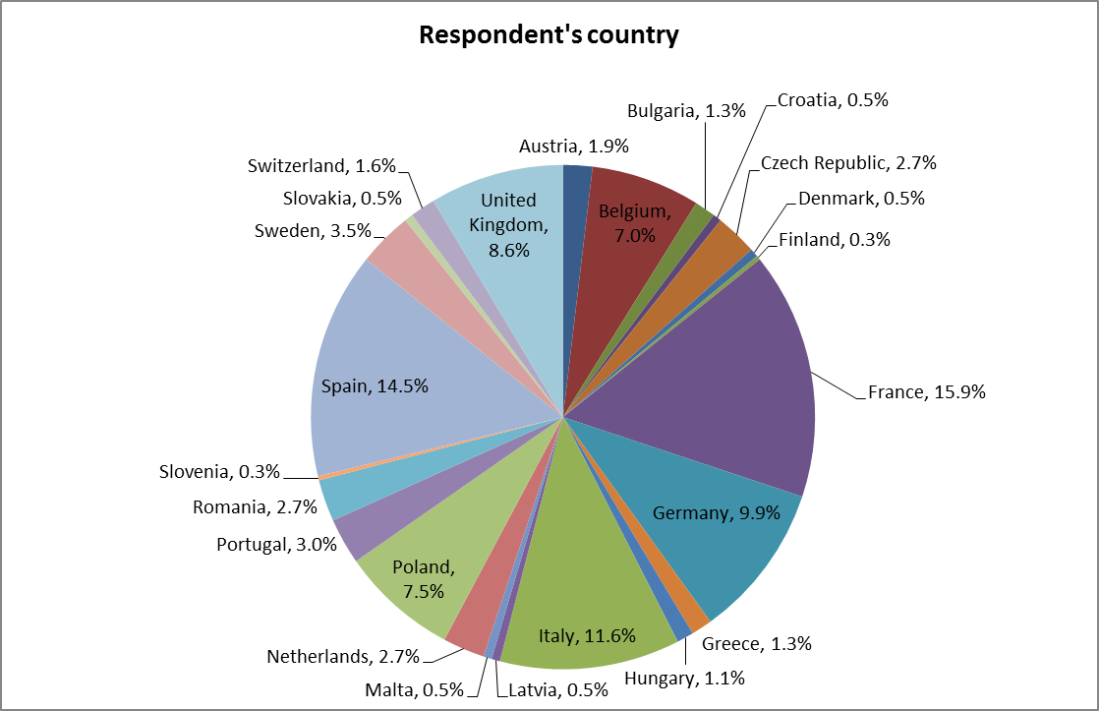
The majority of respondents were private companies (42%), followed by research organisations and universities (22%), industry associations and chambers of commerce (11.5%), SMEs (10%) and public authorities (5.5%). The remainder included NGOs, self-employed people or other.
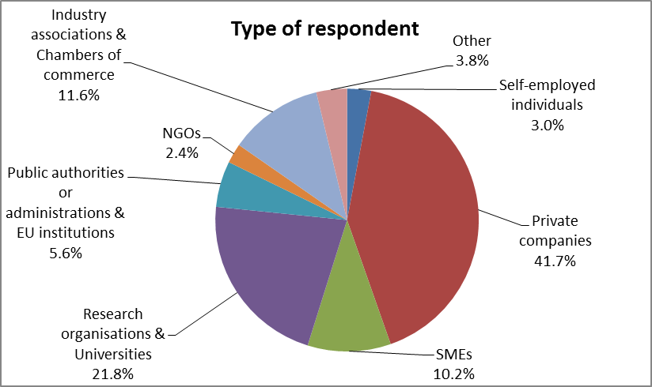
Respondents were mostly from the rail supply industry (rolling stock, vehicle components, construction and building), with just 5% of responses coming from infrastructure managers and 4% from railway undertakings.
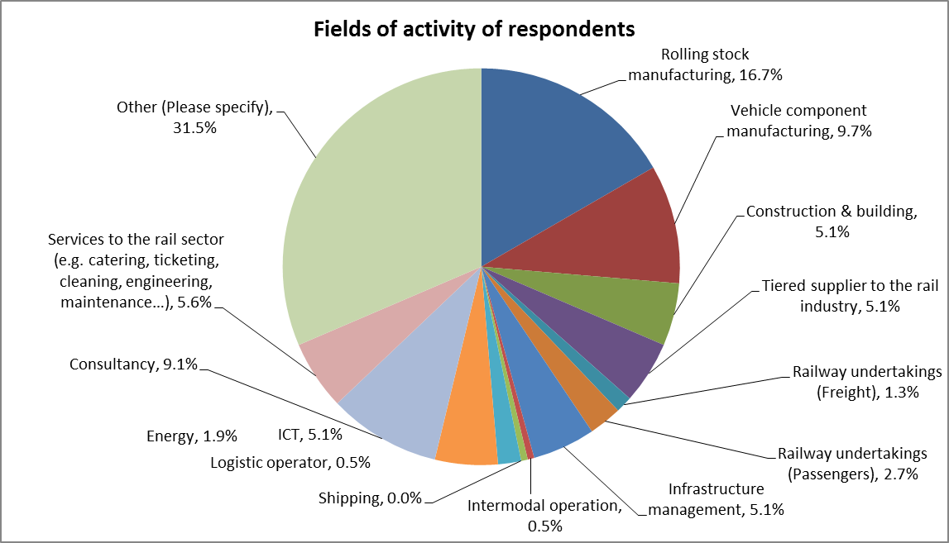
However, it emerges from the large share of respondents classified as "other" (117 respondents) that the categories defined in the questionnaire were too narrow and restrictive.
The majority of respondents in this field were active in a broader scope of activities than those identified in the questionnaire. They included, in particular, broader rail & research activities, the broader rail supply industry, broader railway undertaking and infrastructure management activities, as shown in the following chart.
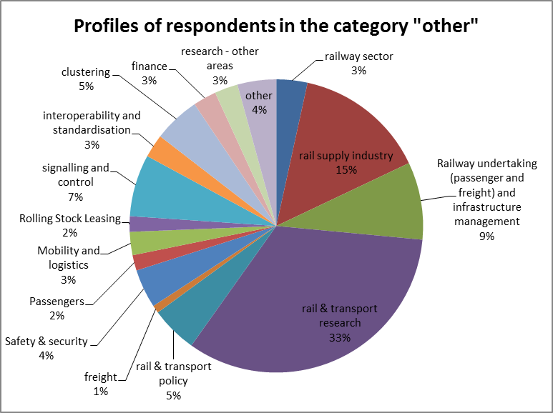
The main rail sector representative bodies at EU level participated: UNIFE (rail supply industry), CER (incumbent railway undertakings), EIM (independent infrastructure managers), UIC (International Union of Railways), UITP (urban transport operators), UIP (wagon keepers), European Passenger Federation, European Federation of Railway Trackworks Contractors, as well as the European Economic Interest Grouping of ERTMS Users (EUG) and EURNEX (European rail Research Network of Excellence).
Many of the leading companies in the rail sector participated, including: Ansaldobreda, Alstom, Bombardier, Siemens, Swedtrain, Talgo, Thales Group, Construcciones y Auxiliar de Ferrocarriles (CAF), Cetest Group, CFD, Actren, Trenasa, VTG, etc.
Also, numerous railway undertakings and infrastructure managers participated, including: ÖBB-Group, SNCF, SBB and SBB Cargo, London Underground, Ferrovie dello Stato Italiane, Network Rail Limited, Polish State Railways (PKP), Portuguese National Rail Infrastructure Manager (REFER), etc.
52% of respondents have been involved in EU co-funded rail research & innovation projects.
  - Results of the public consultation
    - Problems to be addressed
The results of the consultation showed that there is a broad consensus among stakeholders with regard to the core problems affecting rail R&I identified by the Commission.
As seen in the following chart, most stakeholders agreed or strongly agreed that R&I efforts are not sufficiently focused on supporting new technologies oriented towards interoperability or towards further integrating rail operators, infrastructure, rolling stock, signalling and other subsystems and services of the rail system necessary for completion of the SERA. Only 3.4% disagreed with this statement, consisting mainly of private companies active in the rail supply industry as well as some organisations active in the fields of railway operations and infrastructure management.
Participants also broadly felt that the level of standardisation in the European railway area is too low and that this holds back innovation, although 4.5% of respondents disagreed. These were mainly stakeholders active in railway undertakings and infrastructure management or in general railway research.
In addition, stakeholders strongly agreed that R&I efforts are not sufficiently focused on the market take up of innovative solutions. Only 3.1% of respondents disagreed with this statement, consisting mainly of private companies in various sectors (banking, ICT, construction, services to the rail sector, tiered suppliers and vehicle component manufacturing).
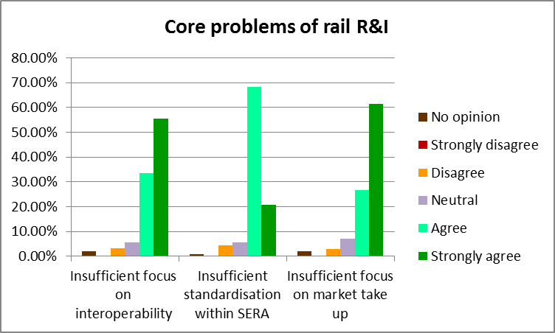
As regards interoperability and standardisation, it was pointed out that the development and introduction of new interoperability systems such as ETCS have been steered by the supply industry rather than the EU or users, which has led to the development of a wide landscape of different ETCS solutions that are, in many cases, non-interoperable. Also, it was highlighted that national technical and operational constraints continue to play a large role in the development and market introduction of new products and that there is still too little harmonisation within the EU. If R&I efforts are to help to bridge these incompatibilities and complete the SERA, a clear EU leadership and vision is required.
As regards market uptake, many respondents pointed out that EU R&I is "estranged" from industrialisation processes and business needs. This results in rail companies turning primarily to national funds, viewed as closer to market needs, which hampers a coordinated EU R&I effort and leads to the development of differentiated national solutions.
In fact, R&I efforts in the EU are considered to be highly fragmented, in particular in terms of their objectives and distribution along the innovation life-cycle, as seen in the following chart, with just a few respondents disagreeing, (mainly organisations conducting rail research, as well as those active in the fields of railway operations and infrastructure management, and those providing services to the rail sector).
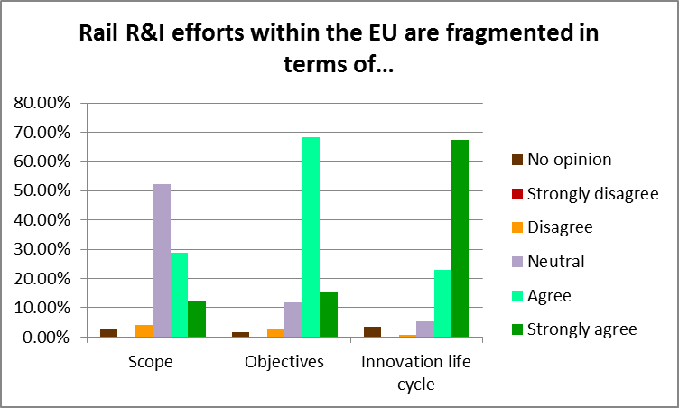
Stakeholders broadly consider research topics to be overly segmented, with too many projects running in parallel, and too many entry points (with open calls for proposals emanating from different research programmes led by different DGs: DG R&I, DG Move, DG Connect, DG Energy, etc.).
In order to overcome this fragmentation, respondents repeatedly stated that a common, long-term vision (10-20 years), based on a clear understanding of the rail sector's market needs is required. This common agenda should be accompanied with clear EU targets (for instance on modal shift, interoperability, accessibility, etc.) to drive the innovation process. Many stakeholders called for a more coordinated approach to EU R&I, with a clear structure and a strong point of reference for the whole sector.
It was further stressed that EU R&I efforts should cover more fully the entire innovation life-cycle. It was felt that there is too much focus on projects that are far from the market and that closer-to-market activities, including development, prototyping and demonstration activities require increased support. The following chart shows the stages of the innovation cycle that respondents feel should receive more support.
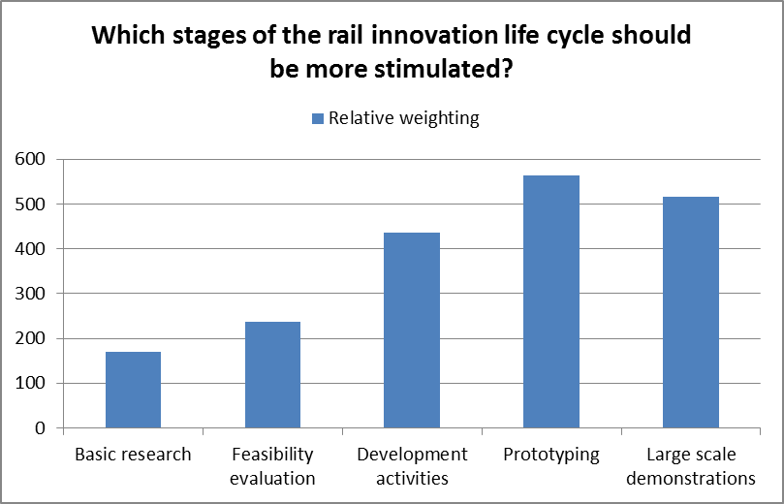
Major barriers to private investment in rail R&I activities were considered to be the long renewal cycles, the limited economies of scale, as well as the low operational margins in the rail sector (see graph below).
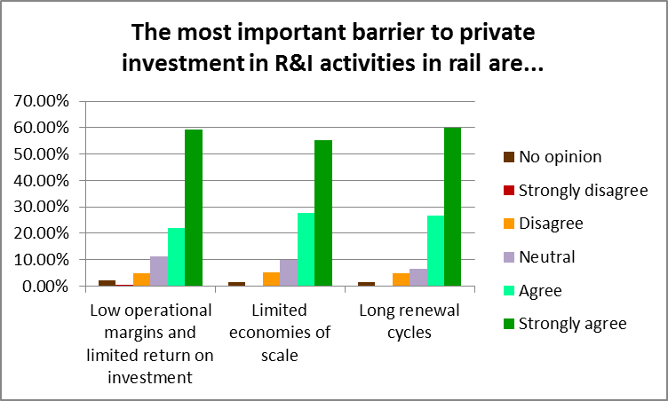
Asides from these barriers, it was also felt that rail-specific innovation constraints (such as the difficulty to share the benefits of innovations among investors and the lack of economies of scale), as well as the current set-up of rail R&I activities, limits the leverage of EU funding (see graph below). Less than 6.5% of respondents disagreed, of which mainly research organisations.
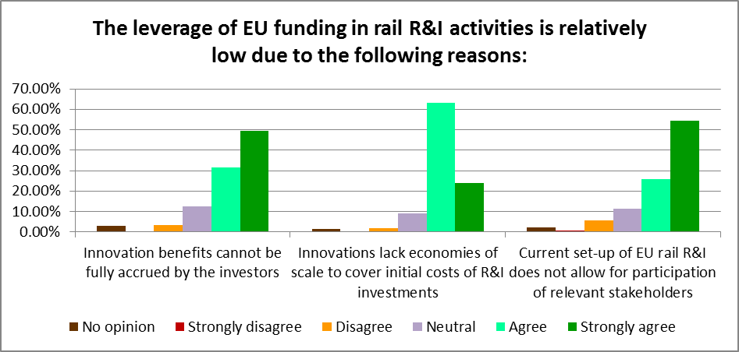
Many stakeholders highlighted the fact that, on the one hand, the uncertainly of the system of open calls for proposals does not allow a company to commit dedicated resources to an EU multiannual and multi-project related framework. On the other, the set-up does not allow for participation of all relevant stakeholders and is insufficiently focused on market needs.
Current R&I partnerships were viewed as restrictive to effective R&I (see graph below), principally because not all stakeholders are adequately committed (less than 3% disagreed, with no particular pattern identifiable), because of a lack of coordination among stakeholders (only 6% disagreed, half of which were research organisations, the rest being mainly representatives of the rail supply industry or of organisations active in railway operations and infrastructure management), and because the H2020 financial and participation rules are inadequate (only 6% disagreed, mainly organisations in charge of research, but also private companies and SMEs active in the rail supply industry).
Many stakeholders highlighted the fact that rules of participation in the open calls system tend to favour very broad and transnational consortia, with a large number of participants. This means that some partners are included more for representative purposes than for technical ones, and that their commitment is not always very strong. Also, such large consortia are difficult to drive and a lot of time and effort needs to be invested in ensuring that all partners have sufficient knowledge of the topics. For a more efficient process, it is felt that more sustained partnerships of key partners are required.
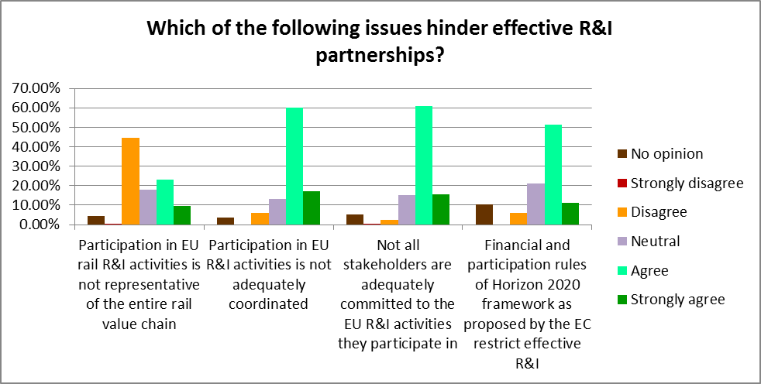
On the other hand, a large number of respondents disagreed that participation in EU rail R&I is not representative of the entire value chain. At the same time, many respondents openly stressed the importance of involving the whole rail value chain in EU funded projects. This includes not only rolling stock and vehicle components manufacturers but also signalling, infrastructure and all construction and maintenance related sub-suppliers and manufacturers, and, in particular the end users – i.e. infrastructure managers and railway undertakings. Indeed, the involvement of end users in defining business needs and validating research results is considered essential to ensure strong market uptake.
Although it is difficult to see a pattern in the responses, it does emerge that it is mainly private companies and rolling stock manufacturing companies (who represent a large share of overall respondents) that consider the rail value chain to be sufficiently represented in current rail R&I activities, while public authorities, research organisations and SMEs, as well as railway undertakings, but also organisations active in construction and services to the railway sector, consultants and tiered suppliers, tend to consider this is not the case, as seen in the following graphs.
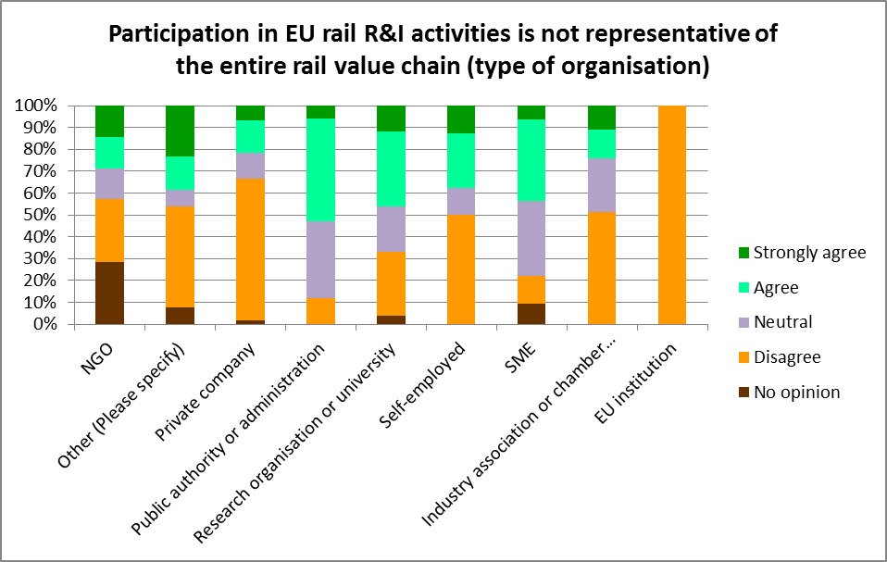
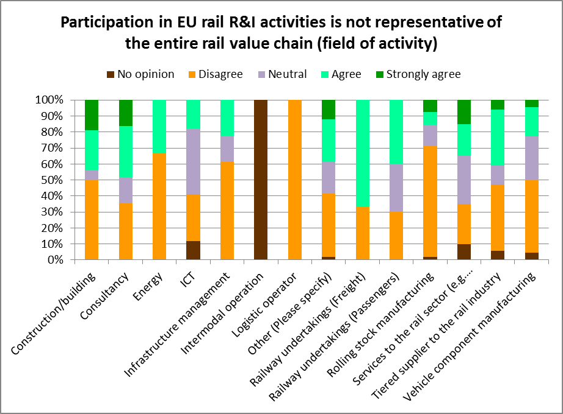
Another key problem highlighted by stakeholders was that the overall level of EU investment in rail R&I is largely insufficient in comparison with the needs and that this low level of funding does not enable the visibility required for significant leverage. Combined with the large size of consortia, this leads to an over dispersion of EU funds and lack of corporate strategy behind the projects.
3. Priority areas
The results of the consultation showed that there is a broad consensus of stakeholders with regard to the core R&I areas that would be best coordinated at EU level. The following chart shows the fields that respondents feel are of most importance.
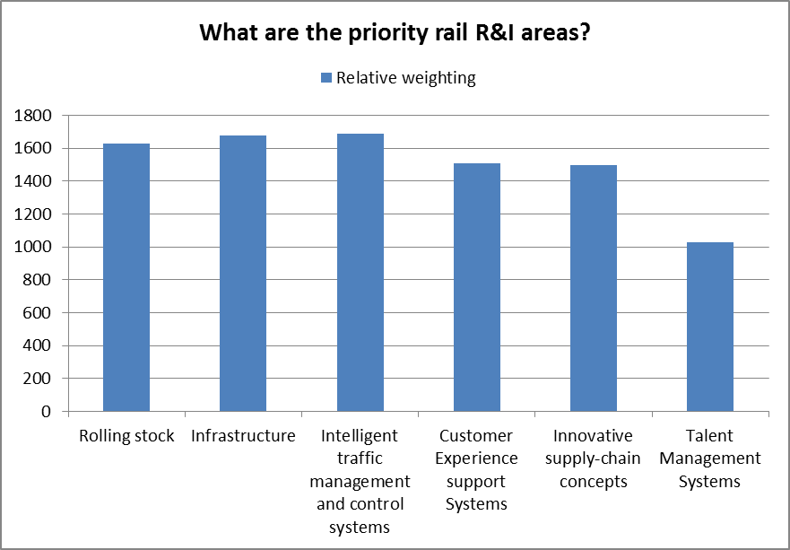
88%-95% of respondents consider the first three topics to be important or very important, while customer experience support systems and new supply chain concepts get strong support from 75% of respondents. Talent management systems are considered less important with just 27% considering them important against 46% considering them irrelevant.
It was also highlighted that these areas needed to be brought together to ensure that the system as a whole is fully effective. This could be ensured by creating a system-wide demonstration platform.
It was further stressed that R&I efforts should focus less on short-term solutions and more on exploring radically new concepts with potential for breakthrough innovation. Synergies with other sectors, such as automotive and aeronautics, should also be sought out.
Respondents also commented that research should take into account the need to raise productivity as much as possible while reducing operating costs. For instance, as regards rolling stock, it was highlighted that research should seek to develop low cost solutions to upgrade existing vehicles and make them interoperable rather than seeking to develop new vehicles as there is not enough money available for renewal of rolling stock. Projects should therefore focus not only on product development, but also take into account aspects of retrofitting, upgrades, maintenance, and impact on the lifecycle, performance, and safety. At the same time, it was stressed that current projects tend to focus on products only, and that future projects should focus also on processes and services.
Another attention point should be that of travellers and users, exploring what options are desirable and feasible from a customer perspective and evaluating the traveller experience of new solutions by prototyping and evaluating them in vivo. For the rail freight sector, the approach should be similar, aimed at integrating the supply chain and providing end-to-end journeys.
Stakeholders also stressed the need to pay attention to ensuring interoperability with other transport modes as the future is multi-modality.
Regarding talent management systems, it was highlighted that these are still too dependent on traditional national operators. The contribution of all actors of the value chain in the academic training process, could make the sector more attractive and enable the emergence of a new generation of workers capable of developing innovative products and solutions.
Lastly, it was pointed out that research activities should also include underlying transport economics, behavioural studies and financial analyses relating to innovative business models, as well as supporting innovation in the fields of legislation and taxation to reduce obstacles to the use of railway.
4. Policy objectives
According to respondents, the most essential objectives for EU rail R&I policy should be to enable the development of a long-term vision, based on the rail sector's business needs, and to ensure market uptake. Other crucial objectives include ensuring synchronicity of innovations and return on investment, as well as interoperability and sustained partnerships. The following chart shows the objectives that respondents feel are of most importance.
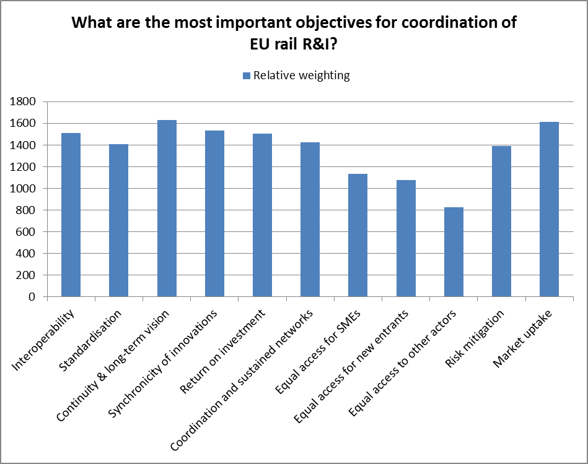
The interoperability of the rail system is considered as essential by most stakeholders, who regard it as one of the main driving forces for both innovation and cost reduction. On the one hand, interoperability should allow closing open points (achieving interoperability as legally defined by the EU directives). On the other hand, R&I should focus on achieving real interoperability in operations through technical harmonisation with a view to reducing barriers for cross-border operations. This will enable significant cost reductions, which is key for the competitiveness of the EU rail industry.
The importance of guaranteeing a systems approach to R&I was also highlighted given the inter-dependency of the rail sub-systems. This means that projects in any given area need to cover the system interface as practically any innovation point will have a system level interaction.
In terms of completing the SERA, respondents felt that rail R&I can be of most use in removing technical obstacles, but also in creating international railway corridors (for freight), in implementing the TEN-T network and harmonising standards, and in simplifying vehicle authorisation processes.
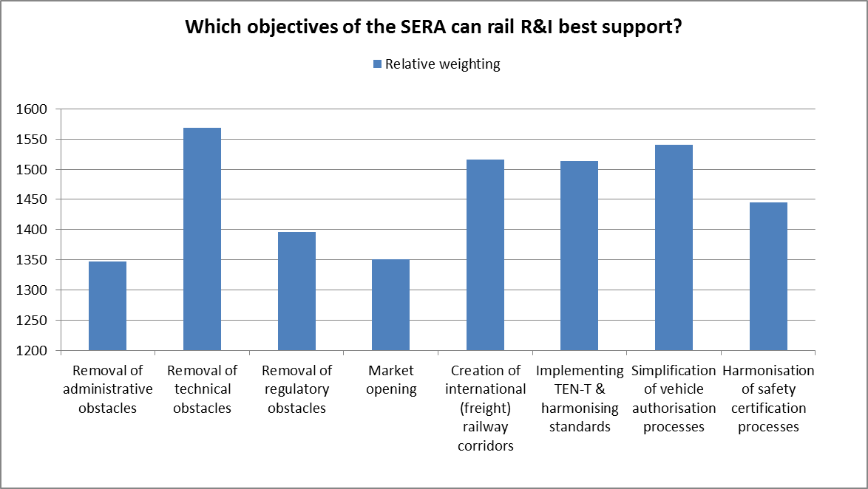
It was also stressed that completing the SERA should not be achieved without also focussing on cost efficiency, meeting customer needs and cross-modal synergies.
5. Policy options and their impacts
Although each of the options received some support from stakeholders, the option that emerged as having, by far, the most backing was the institutional PPP option (see chart below).
79% of respondents judged that this option would be effective or very effective in responding to the identified challenges and it is interesting that the iPPP option is the option that receives the strongest support regardless of the type of organisation with the exception of public authorities and administrations (including public research bodies), who support the baseline CR option.
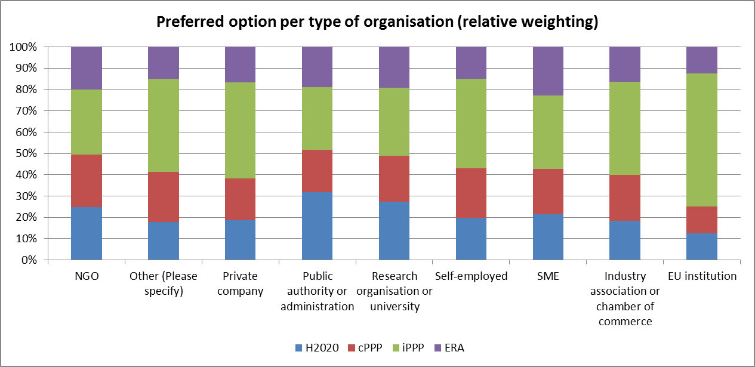
When looking at the different fields of activity, the iPPP is also broadly supported all around, with the exception of intermodal operators (which represent just two respondents) consider ERA to be more relevant.
In the field "other", 8 respondents view the iPPP option as ineffective including organisations representing railway operation and infrastructure management activities, research activities, rolling stock leasing activities, financing and safety activities.
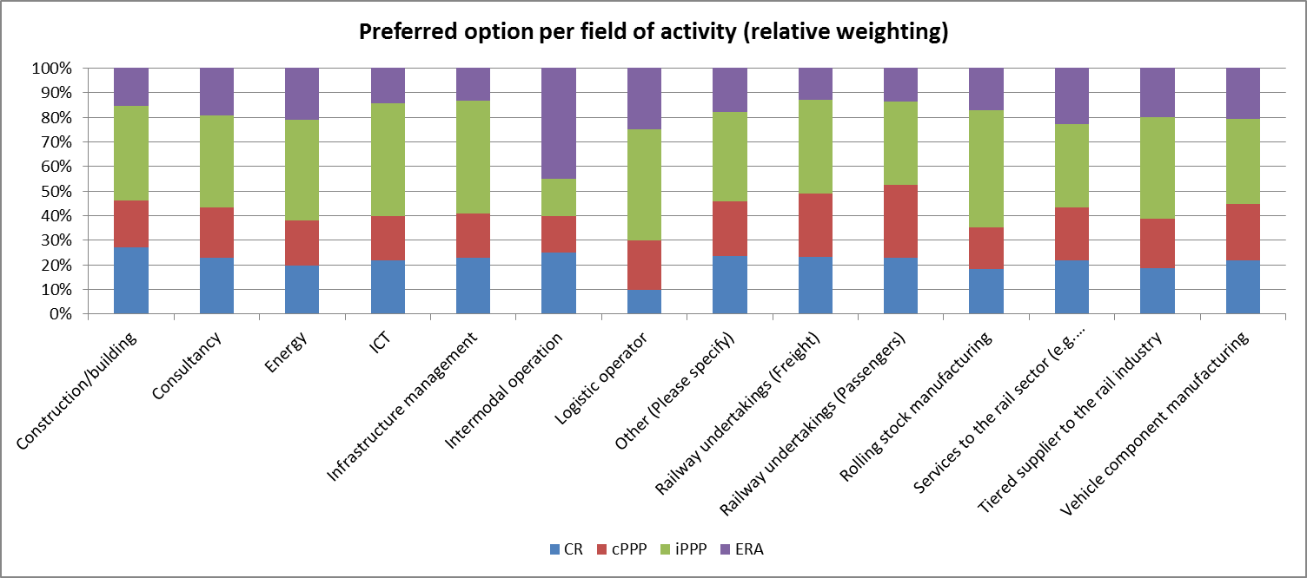
Overall, just 28% of respondents believe the continuation of Collaborative Research could be effective, among which close to half represent research organisations or academia, against just 25% of private companies, 14% of public authorities and 9% of SMEs. The following chart shows how stakeholders consider the CR option could support the main policy objectives identified above. As can be seen, asides from the promotion of standardisation and stakeholder participation, where stakeholders are more reserved, the CR option is considered to be broadly ineffective in meeting all of the stated policy objectives.
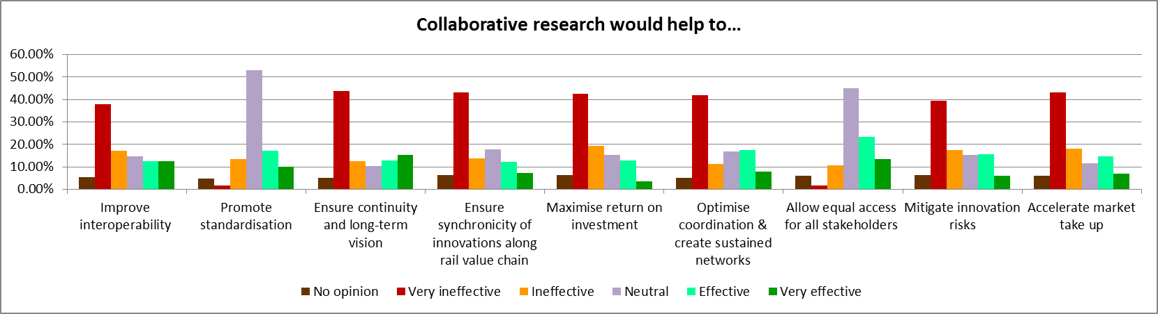
The cPPP option also only gets the support of 26% of respondents. Support comes mainly from public authorities, NGOs and research organisations, although there are no clear trends. The following chart shows how stakeholders consider the cPPP option could support the main policy objectives identified above. As can be seen, asides from the promotion of standardisation and stakeholder participation, where stakeholders are more reserved, the cPPP option is considered to be broadly ineffective in meeting all of the stated policy objectives, similarly to the CR option, although it scores slightly less badly on some areas, such as ensuring synchronicity.
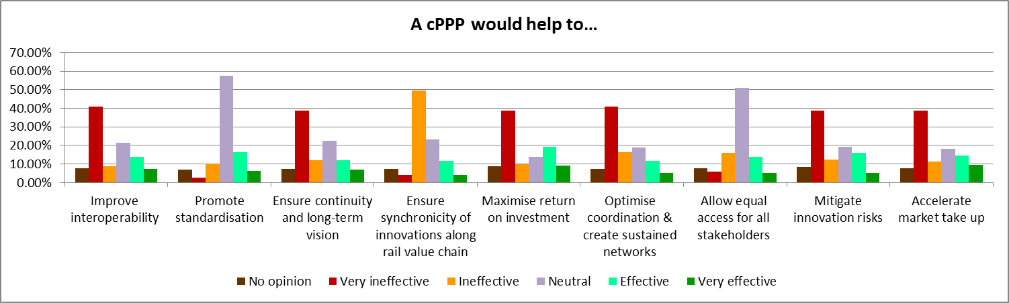
The ERA option gets the support of just 18.5% of respondents. Support comes mainly from public authorities and SMEs. The following chart shows how stakeholders consider the ERA option could support the main policy objectives identified above. As can be seen, asides from the promotion of standardisation and stakeholder participation, where stakeholders are more reserved, the ERA option is considered to be broadly ineffective in meeting all of the stated policy objectives, similarly to the CR option. The only major difference identified is ERA's strong capacity to improve interoperability, where 75% of respondents consider it to be effective, against just 5% disagreeing.
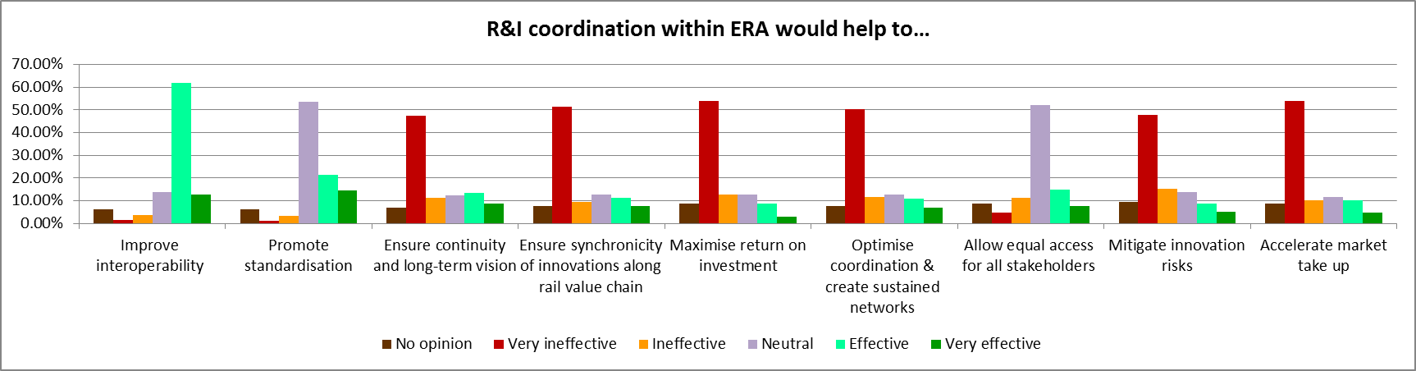
The following chart shows how stakeholders consider the iPPP option could support the main policy objectives identified above. As can be seen, the iPPP option is considered to be effective or very effective in meeting all stated policy objectives. The only weakness that is identified appears to be its capacity to allow equal access for all stakeholders, where respondents are more reserved, although the iPPP option nevertheless scores better than the cPPP and ERA options here, obtaining a score slightly lower than the CR option.
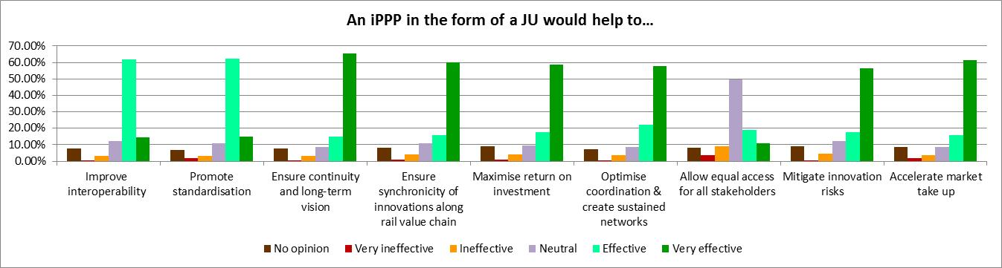
Despite this weakness, many respondents pointed out that an iPPP structure has the capacity to be inclusive towards rail sector actors, as well as towards new entrants, and participants from other sectors, given the critical mass it would create and the commitment of EU rail industry players over an ambitious multiannual R&I programme. For this to be guaranteed, it was highlighted that the governance arrangements would be crucial.
Lastly, roughly one fifth of respondents specified in their open comments that mechanisms should be put in place to ensure that key investors in a rail iPPP would have the assurance of obtaining an EU financial contribution for the entire duration of the work programme, namely thanks to the earmarking of funds to specific beneficiaries. Among these respondents, the majority are large private companies and industry associations. The majority represent the rail supply industry in broad terms (rolling stock, infrastructure, equipment and component manufacturers).
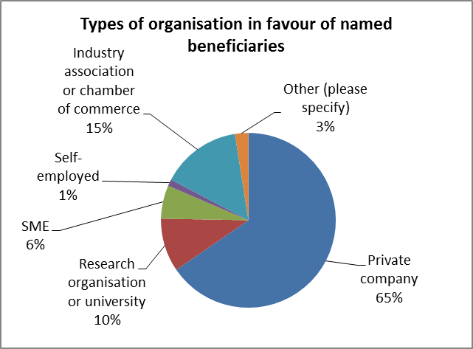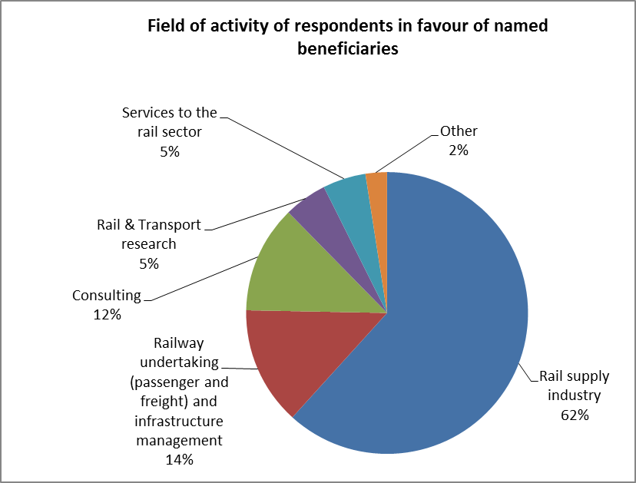
- Stakeholder hearing
A stakeholder hearing was organised on 12 September 2013, to which 85 stakeholder representatives participated. During this meeting, very broad support was voiced in favour of the institutional PPP option, with a strong accent on the need to involve the whole rail sector in an equal, transparent and fair partnership. The minutes of the meeting are transcribed hereafter.
Introduction by the EC – DG MOVE
Mr Jean-Eric PAQUET, Director of DG MOVE/B – European Mobility Network, opened the meeting, underlining that the Commission considers this initiative as absolutely critical to help the sector – in its entire dimension – both to deliver more and better services to citizens and to meet its internal challenges. The initiative will also be crucial in helping to make the Single European Railway Area a reality.
Although there are innovations in the rail sector, if one compares the sector to others, it appears that both the rail industry and the existing frameworks for research and innovation (R&I) at national and EU levels are lagging behind. There is a need to boost efforts in this area and to create a long-term process for driving innovation in the sector. The time horizon considered for this process should go beyond 2020, looking at the longer term – although it will of course be important to reap the opportunities available already from the beginning of the new Horizon 2020 framework programme for research and innovation.
The legislative process launched by the Commission focuses mainly on the instrument that will be created to drive this project. The governance structure is a critical point as it will very much influence the way the rail sector and the EU can interact on the R&I agenda and define priorities together. The proposal presented by UNIFE in July 2012 has been extensively discussed with the Commission over almost two years and has served as valuable input to the Commission work, although the Commission legislative proposal is being developed in parallel to the industry initiative. In terms of substance, the technical proposal is still evolving. The exact scope of the initiative will be defined by all actors when the future governance structure is set up.
There is great interest in this initiative both on the side of the Commission and of the European Parliament – both in the TRAN and ITRE committees. Also, there has been great mobilisation in the Member States, namely thanks to efforts of the rail industry to drive the process. This support should enable an effective handling of Commission proposals so that they can hopefully to be adopted during the Greek Presidency.
Presentation of the Impact Assessment and preliminary key findings
Mr Gerhard TROCHE, DG MOVE/B2 – Single European Rail Area, Ms Bernadette FREDERICK, Acting Head of Unit, DG MOVE/C2 – Research and Innovative Transport Systems, and Ms Rachel SMIT, DG MOVE/ C2 – Research and Innovative Transport Systems gave respective presentations. The key messages presented by the EC can be found in the presentation available online at: http://ec.europa.eu/transport/modes/rail/events/2013-09-12-hearing-rail_en.htm.
Stakeholder presentations
Mr Philippe CITROËN, Director General of the Association of the European Rail Industry (UNIFE) highlighted the fact that for the rail supply industry, the "big issue" is global competition. The good results achieved in FP7 and previous FP in normal R&D collaborative projects need to be taken at a further step to significantly contribute to the Railway overall competitiveness. Research and innovation needs to deliver products, not only concepts and reports, and support increased market uptake.
The structure that can enable this is a Joint Undertaking (institutional PPP) that involves the entire rail sector, as well as the logistics and other sectors (aerospace, ICT, etc.). Rail supply industry, operators, infrastructure managers, urban operators would be involved, as well as research centres and clusters. The structure will also need the support of the European Railway Agency (ERA) – whose role is essential as far as interoperability and ERTMS are concerned. UNIFE has tabled a proposal for the proposed structure. This can be seen in more detail in the online presentation available at: http://ec.europa.eu/transport/modes/rail/events/2013-09-12-hearing-rail_en.htm.
The JU will enable a strong focus on industry needs in co-governance with the EC, to ensure commitment towards creating a Single European Railway Area. Clear targets would be at system level with key performance indicators.
According to UNIFE, the concept of Named Beneficiaries is essential to enable rail stakeholders companies to commit resources from the inception to well identified R&I for 6-7 years (including future exploitation of its results), to create the critical mass for research activities and funds, and to properly cover the industrial risks associated with long term innovation and investment size. Nevertheless, 25% of funds would be reserved for calls targeted at SMEs. With estimated needs estimated at 1.15 billion EUR, this would mean 300 million EUR would be available to SMEs through open calls.
Mr. Citroën further stressed the importance of setting up this instrument very rapidly. In the meantime, the sector will need more information on foreseen lighthouse projects under the Horizon 2020 Work Programme for 2014-2015, to see how the link can be made with the future structure.
Mr Jean-Eric PAQUET responded that the Commission will, when deciding on the future implementing structure and on governance issues, need to take on board the huge amount of work that has already been done by UNIFE, but also draw inspiration from the structure of other initiatives that have already achieved tangible results, such as the SESAR Joint Undertaking.
Mr Enno WIEBE, Senior Advisor on ERA and research-related issues, Community of European Railway and Infrastructure Companies (CER) highlighted that his organisation had not yet responded to the public consultation and that his views were therefore not yet reflected in the preliminary findings presented by the Commission. The CER would respond to the public consultation on September 19th, to present the views of the railway undertakings and infrastructure managers.
He pointed out that the sector has already published a common vision called "Challenge 2050", as well as a common roadmap on how to get there (ERRAC roadmap). The whole sector put a lot of effort into these projects. All these ideas have to be combined to feed into the future R&I agenda.
For the CER, the key goal is to increase attractiveness for customers (passenger and freight) and to cut costs. The focus must be on improving the railway system as a whole. A system view is therefore essential.
The implementing structure would need to provide a very clear vision, with a clear focus on rail business needs. This vision must be developed jointly with all actors, on the basis of an equal, fair and transparent partnership. Operators must play a major role in defining business needs, in defining requirements, validating results, assessing results on life-cycle costs and operations, as ultimately they will be the end users of the research results. Products, processes, standards and concepts developed must fit into the existing system.
Based on this, the CER concludes that:
- Collaborative Research has not always been fully satisfying but there is potential to continue
- The ERA should focus on vehicle authorisation and safety certification and on standardisation. Research should be one part of it, but should not be the heart of it.
- A contractual PPP could be promising but needs further examination
- A Joint Undertaking seems to be the most promising option, with clear programme, clear deliverables, to ensure continuity and market uptake. However, equal partnership is essential. We need the right balance and we need to make sure it focuses on business needs.
The CER's presentation is available online at: http://ec.europa.eu/transport/modes/rail/events/2013-09-12-hearing-rail_en.htm.
Mr Andy DOHERTY, Chairman of the European Infrastructure Managers (EIM) Support Group, represented the view of independent infrastructure managers. He pointed out that railway research has historically been very low in comparison to air and road. Therefore it is maybe not surprising that rail's ability to innovate has been slightly lower. Many FP projects have been conceptual research (Technology Readiness Levels 1-3), i.e. developing result that are far from market ready.
The key goals under Horizon 2020 should be to increase capacity, improve reliability and performance while reducing costs. However this will not be easy as increasing capacity also means reduced access to carry out maintenance.
EIM is very supportive of increasing funding to rail R&I to help the sector to move forward. It believes funding should be channelled through two pathways: Framework Programme projects at Technology Readiness Levels 1-3 and, in parallel, a Joint Undertaking to enable projects at Technology Readiness Levels 4-7, which are much closer to market. Therefore the EIM supports a Shift2Rail Joint Undertaking.
EIM further believes that parallel development of appropriate TSIs and ENs is essential to enable fast take by railway operators.
The involvement of all railways (operators, undertakings, intermodal operators, etc.) is essential and there is a need for an "ERRAC process" to ensure this. Indeed, if the vision meets the railways (users’) needs, then the uptake will be much greater. Therefore the ERRAC represents a good structure for strategic definition of R&I.
The institutional PPP option is essential – it ensures that EIM members can participate, but also allows the structure to branch out to wider sectors that are needed to find innovative solutions
EIM members therefore believe it is essential that an institutional PPP be established, with named beneficiaries, as it must enable collaboration/contracting with partners to deliver. This will allow infrastructure managers to be full members of the initiative.
The EIM's presentation is available online at: http://ec.europa.eu/transport/modes/rail/events/2013-09-12-hearing-rail_en.htm.
Dr. Josef DOPPELBAUER, Chairman of the European Rail Research Advisory Council (ERRAC) pointed out that, from past experience, the two main problems of collaborative research are the lack of investment and the fragmentation of the structure. If both issues are resolved with this initiative, it will result in increased market uptake.
ERRAC represents the entire European rail sector and all forms of rail transport. Therefore, in the context of this initiative, it will be important for ERRAC to push cooperation across the whole sector. ERRAC needs to be strongly involved in a future Shift2Rail Joint Undertaking, with an independent overview of activities, through the strategic council of ERA. There is already a very good alignment between ERRAC objectives and roadmaps and the Shift2Rail Strategic Rail Research Agenda that is currently being developed.
However, the scope of ERRAC goes beyond the Shift2Rail focus on technological innovation. It is therefore important not to forget activities that are outside scope of Shift2Rail. H2020 should provide the instruments from small collaborative research projects to large initiatives like S2R to cover all research needed by all partners. This will require appropriate budgetary resources.
ERRAC will continue to operate on medium and long-term aspects and provide a framework for discussion and coordination of research efforts.
ERRAC's presentation is available online at: http://ec.europa.eu/transport/modes/rail/events/2013-09-12-hearing-rail_en.htm.
Mr. Jean VERRIER, Spokesman of ERCI (European Railway Clusters Initiative) pointed out that there are many cluster initiatives in all Member States, but that there is little or no communication or cross-fertilisation between them. They remain fragmented. They need to work together as not all clusters have critical size to remain sustainable. Also, inter-clustering cooperation can help to avoid redundancy and promote efficiency.
Cooperation has already begun on a large number of topics: energy management, interoperability, standardization, passenger information, intelligent traffic management and control systems, etc. The objective for ERCI is to reach out to research clusters in other European countries.
ERCI has solid experience in involving SMEs in collaborative research projects. This is a difficult feat. Indeed, framework programme projects are hardly affordable for SMEs. There are SMEs involved but most of them are consultants, not industrial SMEs (technology providers, equipment manufacturers, suppliers, etc.). It is essential to boost their cooperation. SMEs cannot afford a stop and go policy. They need continuity and a Joint Undertaking ensures continuity for all stakeholders.
ERCI hopes for a quick decision. It wishes to be involved in the future structure, potentially in visionary advisory groups, but also in the benefits.
ERCI's presentation is available online at: http://ec.europa.eu/transport/modes/rail/events/2013-09-12-hearing-rail_en.htm.
Mr. Giorgio GULIENETTI, Chief Technical Officer, SELEX ES outlined his company's long-standing experience in European R&I. Having participated in the Sesar JU, it is eager to bring this experience into a rail Joint Undertaking.
It is essential to develop our internal market to be able to play on the outside markets: The bigger the “national” market the better for industry.
Developing IT solutions for a seamless attractive railway is essential and can help to provide the Commission with a cockpit for following the various KPIs linked to the work of the future Joint Undertaking.
A holistic, systematic approach is key. The sector must agree on architectures and systems and how it should all come together, not only on a technical level but also in time (synchronicity of innovations).
Preliminary activities ahead of the JU should be devoted to a clearer definition of the strategy and to the approval of all stakeholders. It should not only be led by industry, but also by those that have to implement the systems and run them.
EU direction is also essential, as in the SESAR Joint Undertaking: the EC needs tools to motivate Member States to adhere to legislation.
SELEX ES's presentation is available online at: http://ec.europa.eu/transport/modes/rail/events/2013-09-12-hearing-rail_en.htm.
Open discussion
Imrich KORPANEC of the European Federation of Railway construction companies, representing 162 private contractor companies, ranging from very small, to SMEs, to very large companies (including integrators conduction public works, etc), highlighted the very strong competition from outside of Europe. Therefore, opening of the European markets, standardisation and harmonisation are essential to support the efficiency of construction workers and generate savings in infrastructure costs. We need to make sure that these savings are equally shared and also that there is a risk-sharing. Any innovation should be also on the accounts of the users not only the producers. Participation of infrastructure managers should be balanced with participation of construction companies that produce the infrastructure for them.
It is not only technology development that is important. In parallel, a proper implementation of the technologies in decision-making, planning and processes is required. With this, significant savings of 10 to 30% overall costs can be achieved.
Long-term planning and contracting is essential to ensure that resources are available and committed. If there is no money available in the sector then there will be no market uptake. Innovation will be supported if it contributes to cutting costs, optimisation of operations, more efficient use of infrastructure. Project management, collaboration between managers and contractors, cross-border contracting, are essential.
With this in mind, Mr. Korpanec expressed strong support for a Joint Undertaking, saying he was convinced it would improve market uptake. However, critical mass and balanced involvement of all stakeholders are essential.
Antonella SEMERANO of MERMEC, a supplier to the rail sector, underlined that risk-sharing and IPR protection instruments needed to be appropriate for companies to access innovation. For this, a Joint Undertaking and the concept of Named Beneficiaries are key. In current collaborative research the main problems are:
- During the building phase of a proposal, companies have to bet on some results that are unknown because they have no clear view on multiannual programmes
- During the project phase: if a company wants to make amendments, it is a heavy procedure
- Access to grants: the procedure is too long. Even 250 days is still too long.
The ability to manage IPR in a joint way is an essential point of the Joint Undertaking.
Giovanni BOCCHETTI of Ansaldo STS believed that a funding system with named beneficiaries is the only way to allow industry to plan both the technical and the financial aspects in the long term. He pointed to the Clean Sky initiative which works very well to produce innovation in products that are rapidly marketable. Although one of the weaker points of the Clean Sky was the involvement of all European countries, this is not an issue in the rail sector where many European countries are involved. Named Beneficiaries is not only good for big companies, but also for SMEs. It will enable them to build sustained networks.
Luc ALIADIÈRE of the French Railway Industry Association (FIF) said the Named Beneficiaries system is certainly the most efficient to manage the different subjects that will be addressed by a Shift2Rail Joint Undertaking. He stressed the involvement of SMEs is a major subject to which his association was fully engaged. Although it is true that UNIFE members are mainly large integrating companies, the pull through national associations, which have more and also smaller members, will enable a much broader outreach to companies. The Named Beneficiaries will enable the big companies to drive the process while bringing in the required competences from SMEs, thanks to the intermediary of national federations. All the identified R&I topics are essential to the rail industry.
Dan OTTEBORN of Bombardier commented that the Named Beneficiaries concept already de facto helps to maintain interoperability. Although not presented in this manner, the development of specifications for ERTMS was conducted by groups of supplier companies and railways, with continuous funding from DG MOVE. In a sense this was a form of Named Beneficiaries. If funding had been interrupted each year, interoperability would still not be achieved. Such a system is essential if we want interoperability – especially in signalling.
Bo OLSSON of Trafikverket, commented that the open rail sector in Sweden enabled long-term partnerships with the supply industry. According to him, rail is a system where a weak link can stop innovations and hinder the whole system. Yet, both at national and EU levels, there is a tendency to work in good but fragmented projects. Rail needs sufficient funding up to sufficient Technology readiness levels (6-7). This will also require a sufficient timeframe: 6-7 years is at least what we need.
Named Beneficiaries is the way to do achieve stability, continuity and commitment. The sector cannot take a chance to invest money in the beginning and not have funding all the way through. Nevertheless, open calls should also be a necessary part of the approach to enable other partners to contribute.
Giacomo POTENZA of Ferrovie dello Stato stressed that, as a railway undertaking, it believed the creation of a Shift2Rail Joint Undertaking was essential. The initiative is important in terms of content but also in terms of the structure. The sector needs a strategy, a vision. It is essential to ensure collaboration from all sub-systems of the rail sector to ensure interoperability. Interoperability depends on standards. Some people may feel that we don’t need more standards and it is true that we have too many standards. But what we don’t have is a standardisation process. For this, we need a longer-term view, and therefore we need protection from the risk that a long-term view entails. Therefore a Joint Undertaking with named beneficiaries is the required instrument.
Simon FLETCHER from the UIC expressed the opinion that the initiative should be open to as wide a possible number of UIC members – not only the larger, more affluent companies, also the SMEs that are not able to be involved independently but have important innovation capacity.
José GORTAZAR – CAF said a Shift2Rail Joint undertaking would be an essential instrument for SERA due to its impact on interoperability:
- Innovation is essential to improve interoperability, along with standardisation efforts by ERA
- Cost reduction is a key objective and this will improve interoperability
- R&I within a strong structure will help to move from a fragmented research to a systems approach
Bernard ALIBERT of SNCF expressed strong support to a Shift2Rail Joint undertaking and Named beneficiaries. The link between the rail industry and operators is much stronger than often thought, namely due to the importance of maintenance: This is key to the operators and infrastructure managers. Life-cycle costs are essential. Standardisation is also essential in reducing costs. Therefore, as a large buyer of components and rolling stock, SNCF strongly supports a Shift2Rail Joint undertaking.
Michael MEYER ZU HÖRSTE of DLR said collaboration between industrial partners and research / academic partners is essential and works well in a Joint Undertaking, especially in stages with high Technology Readiness Levels. He therefore fully supports the concept of a Shift2Rail Joint undertaking.
Brigitte Ollier of UITP stressed the need for an attractive R&I programme for mobility, including rail. New technical solutions are important, but also different types of mobility services (integrated mobility services that are attractive to customers that enable them to travel differently but easily and at a lower cost). She pointed out that urban and suburban requirements are quite different from long-distance rail and very different from high-speed rail (no reserved seats, no tickets for specific trains, etc.). Thus, the way UITP looks at technical needs will be a bit different from other rail actors.
Integration with other modes is very, very crucial to UITP. R&I must look at the whole travel chain, which may begin with a bike and end with a train journey. It must be easy to change mode, to find information about those modes, with integrated ticketing. The Shift2Rail Joint undertaking must look into these things and take into account the urban dimension, and UITP will be very attentive that it does.
Yves PERREAL of Thales noted that the main objective of a Shift2Rail Joint undertaking is to increase rail modal share by improving offer, but also by improving the demand. There is a need to boost competition with other transport modes. A Shift2Rail Joint undertaking will help to create a more customer-driven industry and make rail more attractive to people. This includes integration with other modes but also other services (shopping, etc.) A focus on the first and last mile is essential and is one of the aims of the initiative. He stressed that the rail sector is a sector in which EU political and financial support can truly help to reduce fragmentation, which is very important.
Miroslav HALTUF of the Oltis Group stressed that the goal of using innovative approaches to make passenger traffic seamless for all citizens across Europe must absolutely be extended to freight. Freight should receive strong support in a Shift2Rail Joint undertaking.
Nicolas ERB of Alstom expressed strong support for a Shift2Rail Joint undertaking. He asked for industry to be consulted at an early stage of the legislative proposal and asked whether the decision could be taken before the end of the current Parliamentary term.
Sian PROUT of DG MOVE responded saying that the Commission's wish is to go fast, but that we have to be realistic. The last plenary session of the European Parliament would be in April. There is a lot of support in EP thanks to industry's efforts, however all players would have to work very fast if a first reading were to be achieved before the end of the current EP mandate. The Commission intends to present its proposal in December and the consultation would begin thereafter.
Jürgen MEYER of Siemens commented that while a budget for a Shift2Rail Joint undertaking has been guaranteed, there is no communication on the amount. The industry estimate has risen from EUR 800 million to EUR 1.15 billion, mainly due to the fact that the initiative has been opened up to many more stakeholders. Contrary to the Clean Sky initiative, which focuses only on the equivalent of the rolling stock, the Shift2Rail Joint undertaking would have a very ambitious and broad programme, covering infrastructure, traffic management and control systems. He therefore highlighted the need for an ambitious budget.
Maria PRICEof UIP presented the position of wagon leasers. For them, the key problems are those of interoperability, safety, maintenance, certification of vehicles, market-driven approach (also how demand is changing in the supply chain). She noted that the governance structure proposed by UNIFE remained difficult to grasp by many UIP members, who are quite new to EU Framework Programmes. She requested more clarity on the Joint Undertaking's decision-making procedures, on SME involvement and on Named Beneficiaries. How will governance reflect on the distribution of funds? Will there be two budgets: One under H2020 and one under S2R?
Sian PROUT of DG MOVE responded saying that these questions were not yet answered and would be defined following the impact assessment and subsequent negotiations on the legislative proposal. She added that DG MOVE remained available for bilateral sessions if specific questions required clarification.
Manuel PEREIRA of the University of Lisbon stressed the fact that the rail sector also has a lot of positive aspects. High-speed and urban mobility solutions are essential. Rail is eco-friendly, safe, produces reduced externalities, etc.
Nevertheless, innovation is important to maintain progress and performance. There is a need to create an ecosystem with companies, SMEs and excellent research organisations. Scientific robustness is required even in higher Technology Readiness levels. Therefore, there is a need to properly involve the scientific and research community.
With regards to interoperability, he stressed that smaller stakeholders must have a chance to be involved, in the structure but also in deployment across whole of Europe. Openness mechanisms must be set up to ensure proper representation. This will be instrumental in implementing interoperability across Europe.
Sian PROUT of DG MOVE closed the session, reminding those who had not yet done so to participate in the online consultation and inviting all participants to continue their valuable work towards better integrating rail R&I efforts.

Annex VI: Schematic comparison of the key governance elements of the options
This Annex provides details on the essential elements pertaining to each of the four implementing structure options presented in Chapter 4.
Option | Option 1  Collaborative Research | Option 2  Contractual PPP | Option 3  Institutional PPP (Art. 187 TFEU) | Option 4  ERA in lead
Implementing structure | The Commission / Executive Agency | The Commission / Executive Agency | Establishment of a dedicated legal entity composed of both the Union and industry | A new implementing structure is created within the European Railway Agency (Regulatory Agency)
Procedure of establishment | No new body established. Immediately operational | Via a non-legally binding contractual agreement, following a Commission Decision (average time of process 9 months). | Via a Council Regulation after consultation with the European Parliament, and the European Economic and Social Committee (min 6 to 12 months). Set up time following adoption of the Regulation is on average 1.5-2 years. | Amendment of ERA Regulation, review via ordinary legislative procedure (min. 2 years).
Tasks and objectives | - Oversee and manage the implementation of the research programme  - Help mobilise public and private sector funds | - Associate industry to research programme development  - Oversee and manage the implementation of the research programme  - Help mobilise public and private sector funds | - Contribute to the EU policy objectives (integration of the Single European Railway Area, competitiveness)  - Define and launch the research and innovation activities  - Mobilise public and private sector funds  - Oversee the implementation of the research programme
Governance | Horizon 2020 rules. | The mechanism for involving the partners (public or private) in planning and implementation is established in the Memorandum of Understanding.  The Partnership Board is the main mechanism for dialogue. | A specific governance structure, including the respective decision-making powers by private and public partners, is established in the basic act.  Roles of different partners (Commission, market players, Member States) can vary. | A specific governance structure, including the decision-making powers by private and public partners, is established in the amended ERA regulation.  Currently, the Board is composed of Member State, Commission and industry representatives but industry has no voting rights.
Strategy and planning | Commission approves global research strategy based on input from technology platform (ERRAC) and ERA, with an advisory role from MS (programme committee).  Bi-annual operational planning with annual competitive calls conducted by the Commission, possible input from stakeholders, approved by MS. | Private partners develop the multi-annual roadmap and provide inputs to the work programmes. Bi-annual work programmes with annual competitive calls conducted by the Commission, possible input from stakeholders, approved by MS | Decisions on strategic framework and annual work plans are taken by the dedicated legal entity according to its own governance structure. | Strategic framework provided by the Commission setting the high level priorities.  Annual operational planning setting technical framework approved by ERA.
Approach to programming | Stand-alone projects, each having its own objectives.  No predefined budget, commitments at project level.  Large scale projects, but so far mostly pre-competitive research. Deployment stage may be included.  Calls for tenders allowed, but rarely used. | Individual, but larger-scale, cross-thematic projects steered by a wider logic. Aiming at results nearing market readiness. Deployment stage may be included. | Dedicated structure aimed at sound and focused project selection and coordination.  Calls for tenders allowed.  Prioritising long term goals and stability.  Market driven project coordination.  Deployment stage may or may not be included. | Strong project coordination driven exclusively by SERA goals.  Priorities focussed on standardisation and deployment.  Deployment stage included.
Participation | Horizon 2020 rules.  Ad hoc project level participation, based on own initiative. | Standard Horizon 2020 rules.  Ad hoc participation of industry, via non legally -binding Memorandum of Understanding | Derogations to Horizon 2020 are possible, but need to be duly justified. Formalisation of the Commission-industry partnership.  Commitments of members are established on contractual basis and are legally binding. Beyond funding, industry is expected to commit in other terms e.g. to participate in demonstration activities. Possibility to ensure a balanced participation of all market players in the value chain (supply industry, operators, and infrastructure managers). | Possibility to ensure an adequate balance of representativeness.  Industry contributes indirectly via the technology platform (ERRAC)
Financing | Expected €450 M under Horizon 2020 financing  Horizon 2020 general rules apply
Financing | EU contribution to direct costs: up to 70% for demo or 100% for research; 25% for indirect costs.  Max timeframe limited to the period of financial framework. | EU contribution to direct costs: up to 70% for demo or 100% for research; 25% for indirect costs.  Indicative budget for EU contribution and industry commitment is set out in a Memorandum of Understanding, and will be confirmed via work programmes.  Max timeframe limited to the period of financial framework. | Average Commission funding rate of +/- 50%, with a minimum industry contribution to the budget of 50%, in kind or in cash. Possibility to use different funding instruments/co-financing rates depending on Technology Readiness Level  Budget ceiling for EU contribution is set out in the basic act.  Basic act specifies the maximum timeframe can go beyond the period of financial framework. |  | Timeframe can go beyond the period of financial framework. Commitments defined on an annual basis.
Administration costs | The Financial Regulation (Commission Regulation (EC, Euratom) No 2343/2002) applies. | The Financial Regulation applies.  Industry covers the costs of their internal governance and their participation in advisory role. | The financial rules are adopted by the Administrative Board. They should respect the broad principles laid down in the Financial Regulation.  Public and private partners share management and contribute to operational costs. | The financial rules are adopted by the Administrative Board after the Commission has been consulted.  The Financial Regulation applies unless a deviation is specifically required for the Agency’s operation and the Commission has given its prior consent.
Monitoring and follow up | General Horizon 2020 rules. Project level monitoring, formal obligation, limited to contractual procedures. |  | Tailor made rules according to basic act. | ERA in charge of follow up according to its internal rules
Intellectual property rights | Foreground (results) owned by participant generating those results.  Restrictions foreseen for the transfer or licensing of results to third party established in third country. |  | Tailor made rules according to basic act. JU may grant wider access rights to knowledge. | Same as for Options 1 and 2

Annex VII: Summary of the cost-effectiveness analysis
This Annex provides background information relating to the cost-effectiveness analysis presented in section 5.2.6 of the main report. It outlines the core assumptions, alongside the methodology for calculating administrative costs
In the CR option, the following assumptions are made:
- No establishment costs as the programmes are managed within existing structures.
- Running costs:
  - Basic running costs are calculated based on the current costs of the FP7-Transport budget, while factoring in the efficiency gains foreseen under H2020.
  - In the 2007-2013 period, the Commission spent EUR 285 million to cover administrative running costs out of an overall Commission contribution of EUR 4.244 billion. Taking into account the estimated leverage effect of 1.5 of the Commission contribution, the total FP7-Transport budget for the 2007-2013 period (including industry contribution) is estimated at EUR 6.5 billion. Thus, administrative costs of EUR 285 million represent 4% of the total FP7-Transport budget (including industry contribution).
  - Simplification measures introduced in H2020 are likely to lead to efficiency gains within the Commission (single set of participation rules and funding costs, simplified system of indirect cost calculation and reimbursement, more flexible budgetary and procurement procedures, etc.). If we assume this will lead to a 20% cut in administrative costs, this means administrative costs will represent 3.5% of the total budget.
  - If we transpose this 3.5% share of running costs to a rail R&I budget of EUR 690 million (Commission contribution of EUR 450 million, with a leverage effect of 1.5), administrative costs can be estimated at around EUR 24.15 million over 7 years, or an annual equivalent cost of EUR 3.45 million. Running costs will vary from year to year according to the operational expenditure managed within a given year. Budgets are likely to be smaller in the first years and surge in the final years.
  - The additional management capacity developed by the Commission to ensure coordination of activities, partnerships and results with a view to ensure R&I contributes to the completion of the SERA has been estimated at a total of 2 administrator positions and 1 assistant in relevant thematic and horizontal units. This estimate has been obtained as follows: Under FP-7, more than 80 rail-related projects were funded in the period 2007-2013 with an average project duration of 3 years. It can therefore be assumed that a similar number of projects will be funded under H2020, or slightly less (60) if one takes into account pure rail projects. This means that, at any given time, the Commission will be running around 30 projects simultaneously. Assuming that a coordination function requires at least half a man-day per project per week, the coordination function will require 3 Full-time-equivalent staff (1 full-time equivalent per 10 projects running). at an average cost of 128 kEUR per year (=384 kEUR/year over 7 years, or a total of EUR 2.688 million).
  - Spread over the 7-year duration of H2020, this brings total annual equivalent running costs to roughly EUR 3.834 million per year.
- Winding down and legacy management costs:
  - No winding down costs under this option
  - Legacy management of CR projects would be required until 2024.. Costs relating to managing the legacy of programmes are estimated to represent 75% of total annual equivalent running costs in 2021, 50% in 2022, 25% in 2023 and 10% in 2024 – i.e. a total legacy management budget of EUR 6.134 million – or 876 kEUR per year, spread over the 7-year H2020 programming period.
- Total implementation costs: Based on the above calculations, the total annual equivalent implementation cost of the baseline option is EUR 4.71 million (based on the 7 year H2020 programming period).
In the cPPP option, the following assumptions are made:
- No establishment costs as the programmes are managed within existing structures.
- Running costs:
  - Running costs are assumed to be similar to the CR option as projects are managed according to the same rules and procedures, and the Commission will also have to develop additional management capacity to ensure the complementarity and necessary coverage of cPPP projects –i.e. an annual equivalent cost of around EUR 3.834 million.
  - Additional costs related to Commission efforts to manage relations with stakeholders, can be estimated at a total of 1 administrator position and ½ assistant position in relevant thematic and horizontal units – i.e. 1.5 full-time equivalents at an average cost of 128 kEUR per year (=192 kEUR/year). These costs are calculated over the period 2015-2020, given that the cPPP would likely not be operational before 2015.
  - The private partners involved cover the costs of their internal coordination.
  - One-off costs of 200 kEUR (i.e. 28kEUR per year) for external evaluations should also be factored in (based on the assumption of one mid-term and one final evaluation at a cost of 100 kEUR each).
  - Spread over the 7-year duration of H2020, this brings total annual equivalent running costs to roughly EUR 4 million per year.
- Winding down and legacy management costs:
  - No winding down costs under this option
  - Costs relating to managing the legacy of programmes are estimated in the same way as the CR option, resulting in a total legacy management budget of EUR 6.4 million – or 920 kEUR per year, if one spreads this over the 7-year H2020 programming period.
- Total implementation costs: Based on the above calculations, the total annual equivalent implementation cost of the cPPP option is EUR 4.95 million (based on the 7 year H2020 programming period) – or roughly 200kEUR higher than the baseline on an annual basis.
In the iPPP option, the following assumptions are made:
- Establishment costs.
  - Establishment costs relate to the set-up time of the iPPP. For past iPPPs the administrative set up time has been of just over 2 years on average. It is nevertheless assumed that the set-up time for a new iPPP could be reduced quite significantly thanks to previous experience. We therefore assume that the administrative set-up time of the rail iPPP will be of 1.5 years.
  - During this period, it is assumed that the Commission incurs costs related to the coordination and supervision of setting up the iPPP. The needs are estimated at 3 administrator positions and 1/2 assistant position in relevant thematic and horizontal units – thus 3.5 full-time equivalents at a cost of 128kEUR each, or a total annual cost of of 448 kEUR. Over a 1.5 year period, this corresponds to a total set-up budget of 672 kEUR, or, spread over the 7 year H2020 programming period, an annual cost of about 96 kEUR per year.
- Running costs:
  - Running costs of the iPPP are calculated based on the average administrative running costs of existing iPPPs, while factoring in the efficiency gains foreseen under H2020 and the new financial regulation.
  - An analysis of existing iPPPs shows that the average share of administrative expenditure in total expenditure was 3.8%, while the average share of staff expenditure within this administrative expenditure was 56% (see the table on staff and expenditure for existing iPPPs below).
  - Simplification measures introduced in H2020 and the new financial regulation are likely to lead to efficiency gains within iPPPs (simplified budgetary and procurement procedures, sharing of audit functions with the Commission, pooling of resources, etc.). If we assume this will lead to a 20% cut in administrative costs, this means administrative costs will represent 3% of the total budget of iPPPs.
  - If we transpose this 3% share of administrative running costs to a rail R&I budget of EUR 900 million (Commission contribution of EUR 450 million, with a leverage effect of 2), total administrative costs of the iPPP can be estimated at around EUR 27 million. However, as the lifespan of the iPPP will only be 5 years (2016-2020 given setting up time), it can be assumed that some of the rail R&I budget (roughly EUR 70 million for the period 2014-2015) will be managed under CR before being taken over to the iPPP. Therefore, administrative costs in the first 2 years will be similar to CR (3.5% of EUR 70 million, or a total of 2.45 million), while, during its 5 year lifespan, administrative costs of the iPPP will be 3% of EUR 830 million, or EUR 24.9 million, of which 50% will be paid by industry. This brings total administrative costs of the option up to EUR 27.35 million, or an annual equivalent cost (spread over the 7 years of H2020) of EUR 3.907 million.
  - If one assumes that the efficiencies enabled under H2020 and the new Financial Regulation are largely reflected in staff expenditure and that therefore staff expenditure is reduced to an average share of 45% of total administrative costs, the total administrative costs of the iPPP (EUR 4.98 million per year) correspond to staffing levels of 20 full-time equivalents (assuming an average cost per agent of 110 kEUR, rather than 128kEUR in the baseline, given the reduced cost of hiring temporary or contractual staff in an iPPP compared to Commission officials).
  - One can also take a bottom-up approach to staffing levels, based on average operational expenditure per staff member in current iPPPs. In existing iPPPs, average operational expenditure per staff member was around EUR 6.5 million in 2012. Applying this ratio, if one assumes the annual budget of the future rail iPPP will be of roughly EUR 166 million, then the iPPP would require 25 full-time equivalents, at equal productivity levels to current iPPPs. Assuming 20% efficiencies under H2020 and the new Financial Regulation, this figure could be reduced to 20 full-time equivalents, which is similar to results calculated with the means of top-down approach above.
  - On top of the administrative costs of the iPPP itself, the Commission incurs costs of roughly 320 kEUR per year for the supervision of and participation in the iPPP (equivalent to 2.5 full-time equivalents). These costs are incurred over the 5 year lifespan of the iPPP. Furthermore, one-off costs of 200 kEUR for external evaluations must be factored in (based on the assumption of one mid-term and one final evaluation at a cost of 100 kEUR each). Spread over the 7 years lifetime of the iPPP, this leads to an annual cost of about 260 kEUR per year.
- Winding down and legacy management costs:
  - Costs relating to managing the legacy of programmes are estimated in the same way as the CR option, resulting in a total legacy management budget of EUR 6.939 million – or 991kEUR per year, spread over the 7-year H2020 programming period. Half of these costs will be funded by industry.
  - On top of this, the direct cost of winding down is likely to be similar to the setting up costs, i.e. 672 kEUR, or 96 kEUR if one spreads the cost over 7 years, half of which will be funded by industry. These costs will only be relevant if it is decided that the iPPP will cease to exist at the end of the 2014-2020 financial framework.
Staff and expenditure: Overview of key figures of existing iPPPs
- Total implementation costs: Based on the above calculations, the total annual equivalent implementation cost of the iPPP option is EUR 5.457 million (based on the 7 year H2020 programming period) – or roughly 750 kEUR higher than the baseline on an annual basis. However, as industry commits to covering half of the running and winding down costs, the estimated implementation cost to the European Commission is limited to EUR 3.183 million. Operating an iPPP is thus less costly for the Commission compared to CR or the cPPP.
In the ERA option, the following assumptions are made:
- Establishment costs.
  - Although the programmes would be managed within the existing structure, the Agency would have to be significantly remodelled to accommodate the needs of implementing and coordinating a research programme. The regulatory procedure in itself would take 2 years, while the administrative set-up-time, allowing for new staff to be hired and specific decision-making procedures to be established, is estimated at roughly 1 year. During this time, programmes will be run under CR. The human resources required during this period are similar to setting up an iPPP (i.e. 3.5 full-time equivalents) but given that some of these resources (2.5 full-time equivalents) are internal to the Agency, their cost will be lower. Indeed, the average cost per ERA full-time equivalent staff member is 100 kEUR, i.e. 22% cheaper than in the baseline option (128kEUR). The establishment cost is therefore estimated at 350 kEUR.
- Running costs are similar to CR option although slightly lower as the average cost of staff at ERA is lower than at the Commission :
  - Taking into account the 3-year set-up time, running costs in the first 3 years will be similar to CR.
  - For the remaining 4 years, the cost structure is similar to CR (calculated at 3.5% of operational expenditure) but cheaper, due to the 22% lower average cost of ERA staff. The average share of staff expenditure in administrative costs in DG RTD was 67% in 2011 according to internal estimates. Other administrative costs are assumed to remain stable. This means total running costs in the ERA option amount to EUR 21.24 million, or an annual equivalent cost of EUR 3.034 million.
  - No additional costs are required on the Commission side given that it already participates in the ERA structure and that the baseline assumption of increased management capacity is already included in the running costs.
  - Assuming that each staff member can manage an average operational expenditure of EUR 6.5 million (see iPPP scenario), it is estimated that the Agency would need to acquire 15 additional full-time equivalents to manage the H2020 rail R&I annual budget (annual budget of roughly EUR 98 million, given a total budget of EUR 690 million), or slightly less given efficiencies under H2020 and the new Financial Regulation.
- Winding down and legacy management costs:
  - Costs relating to managing the legacy of programmes are similar to the CR option (although slightly cheaper, given the lower staff costs), leading to a total legacy management budget of EUR 4.855 million – or 695 kEUR per year over the 7-year H2020 programming period.
  - On top of this, the direct cost of winding down is likely to be similar to the setting up costs, i.e. 350 kEUR. These costs will only be relevant if it is decided that the iPPP will cease to exist at the end of the 2014-2020 financial framework.
- Total implementation costs: Based on the above calculations, the total annual equivalent implementation cost of the ERA option is EUR 3.83 million (based on the 7 year H2020 programming period) – or roughly 900 kEUR lower than the baseline on an annual basis.
The following table summarises the total costs and the equivalent annual implementation cost relating to each option, based on the 7 year lifecycle of Horizon 2020.
Calculations of implementation costs of the options under assessment (in kEUR)

Annex VIII: Technology Readiness Levels (TRL)
This annex explains the different Technology Readiness Levels that can be attained by research projects and their link with the R&I process.
Technology Readiness Level |  | Description
1 | Basic principles observed and  reported | Lowest level of technology readiness. Scientific research begins with, to be translated into applied research and development. Example might include paper studies of a technology's basic properties.
2 | Technology concept and/or application formulated | Invention begins. Once basic principles are observed, practical applications can be invented. The application is speculative and there is no proof or detailed analysis to support the assumption. Examples are still limited to paper studies.
3 | Analytical and experimental critical function and/or characteristic | Active research and development is initiated. This includes analytical studies and laboratory studies to physically validate analytical predictions of separate elements of the technology. Examples include components that are not yet integrated or representative.
4 | Component and/or breadboard validation in laboratory environment | Basic technological components are integrated to establish that the pieces will work together. This is relatively "low fidelity" compared to the eventual system. Examples include integration of 'ad hoc' hardware in a laboratory.
5 | Component and/or breadboard validation in relevant environment | Fidelity of breadboard technology increases significantly. The basic technological components are integrated with reasonably realistic supporting elements so that the technology can be tested in a simulated environment. Examples include 'high fidelity' laboratory integration of components.
6 | System/subsystem model or prototype demonstration in a relevant environment | Representative model or prototype system, which is well beyond the breadboard tested for TRL 5, is tested in a relevant environment. Represents a major step up in a technology's demonstrated readiness. Examples include testing a prototype in a high fidelity laboratory environment or in simulated operational environment.
7 | System prototype demonstration in an operational environment | Prototype near or at planned operational system.  Represents a major step up from TRL 6, requiring the demonstration of an actual system prototype in an operational environment, such as in a vehicle or on a track.
8 | Actual system completed and qualified through test and demonstration | Technology has been proven to work in its final form and under expected conditions. In almost all cases, this TRL represents the end of true system development. Examples include developmental test and evaluation of the system in its intended system to determine if it meets design specifications.
9 | Actual system proven through successful mission operations | Actual application of the technology in its final form and under mission conditions, such as those encountered in operational test and evaluation. In almost all cases, this is the end of the last "bug fixing" aspects of true system development. Examples include using the system under operational railway conditions.

The following table presents graphically the TRLs and their link with the R&I process as well as the coverage of each TRL by type of project inside the EU framework programme.

White Paper on a Roadmap to a Single European Transport Area – Towards a competitive and resource efficient transport system, COM/2011/0144 final
The Fourth Railway Package – Completing the single European railway area to foster European competitiveness and growth, COM (2013) 25 final
COM (2011) 665 final
Regulation of the European Parliament and of the Council establishing Horizon 2020-The Framework Programme for Research and Innovation (2014-2020), SEC(2011) 1427-Volume 1 and SEC(2011) 1428-Volume 1
These figures are to be confirmed after interinstitutional negotiations.
Decision No 1982/2006/EC of the European Parliament and of the Council of 18 December 2006 concerning the Seventh Framework Programme of the European Community for research, technological development and demonstration activities (2007-2013)
COM(2008) 800
COM(2013) 494 final
Commission Staff Working Paper SEC(2011) 1427 final on an Impact Assessment accompanying the Communication 'Horizon 2020 - The Framework Programme for Research and Innovation'
UNIFE: Shift²Rail – A Flagship Joint Technology Initiative in Horizon 2020, July 2012
Proposal for a Regulation of the European Parliament and of the Council (COM(2011)809 final) establishing Horizon 2020 - The Framework Programme for Research and Innovation (2014-2020) and Proposal for a Council Decision (COM(2011)811 final) establishing the Specific Programme Implementing Horizon 2020 - The Framework Programme for Research and Innovation (2014-2020), 30.11.2011
COM(2011) 572
DG RTD Expert Group (2010) Interim Evaluation of the Seventh Framework Programme
The meetings took place on 22 May, on 4 September and on 13 September 2013. A written consultation was also organised between 26 July and 2 August 2013.
SWD(2013) 10 – Part 1
Eurostat, Modal split of inland freight transport, 2000 and 2010 (% of total inland tkm)
SWD(2013) 10 – Part 3
SWD(2013) 10 – Part 3 and SWD (2012) 246 final/2
SWD(2013) 10 – Part 3
SWD(2013) 10 accompanying the Fourth Railway package proposals – Part 1
EC, Sector Overview and Competitiveness Survey of the Railway Supply Industry, May 2012
EC, Sector Overview and Competitiveness Survey of the Railway Supply Industry, May 2012
EC, Sector Overview and Competitiveness Survey of the Railway Supply Industry, May 2012, p. 100
EC, DG Research and Innovation (JRC): The 2012 EU Industrial R&D Investment Scoreboard, 2013
COM/2011/0144 final, p. 10
SITPRO Plus: Study of the Impacts of the Transport RTD Projects in FP5 and FP6, November 2010
Exploitation is defined as "documented use" through reference or acknowledgement in documents.
Sixth FP7 Monitoring Report – 2012, 7 August 2013
Foreground means the tangible and intangible results, including information and knowledge, whether or not it can be protected, which is generated under the project. Such results include rights related to copyright, design rights, patent rights, plant variety rights, and similar forms of protection.
http://errac.uic.org/IMG/pdf/errac_ewg_wp06_evaluation_of_market_uptake_lessons_learnt_from_past_projects_results.pdf
SEC(2011) 1427 final, p. 11
In this context, the ecosystem is considered as the entirety of institutional, regulatory, operational and technical conditions in which the rail sector operates in a given country
Transport research market uptake (Market-up; Project ID: 265841): D2.1 – Characterisation of the context of RTD initiatives in the Rail Sector, December 2011
See joint UNIFE & UIC study under FP6: Green Info Package for the railway sector)
From a JRC report on R&D efforts of the EU automotive and rail industry and the public sector (2010). The graphs show that overall R&D investments are much larger in the road sector although R&D intensity is not so much lower in the rail sector. Nevertheless, the report highlights data availability issues in the rail sector which hamper the comparison among sectors. Despite data problems, the report highlights stagnating R&D investments in the rail sector.
European Commission, Joint Research Centre: Report of the STTP Stakeholder Workshop on Rail Transport, 18 February 2001
Scale of TRL ranging from 1 to 9: TRL1 expresses the technology readiness of basic principles and observed (exploratory and applied research) up to TRL9 a successful operational experience which is fully tested, validated and demonstrated in its operational environment. Next step would be industrial deployment. See Annex VIII for further explanations.
Based on an analysis of the 47 rail-only projects funded under FP7-Transport, excluding multi-modal projects. For a detailed overview of these projects, see Annex III.
The classification of rail actors derives from the European Commission study by DG Enterprise and Industry: Sector Overview and Competitiveness Survey of the Railway Supply Industry, May 2012
See annex III for further details on R&I activities under FP7.
Austria, Belgium, Bulgaria, Czech Republic, Denmark, Estonia, Finland, France, Germany, Greece, Hungary, Ireland, Italy, Latvia, Lithuania, Netherlands, Poland, Portugal, Romania, Slovakia, Spain, Sweden and the UK
EURNEX: European rail Research Network of Excellence
COM(2011) 808/809/810/811/812
Horizon 2020 - The Framework Programme for Research and Innovation
See Annex 2 of the Horizon 2020 impact assessment (SEC(2011)1427)
See Annex 3 of the Horizon 2020 impact assessment (SEC(2011)1427)
For a detailed assessment of the need for EU intervention in R&I activities, see the Commission Staff Working Paper SEC(2011) 1427 final on an Impact Assessment accompanying the Communication from the Commission 'Horizon 2020 - The Framework Programme for Research and Innovation', in particular p. 13 and Annex 2.
Communication from the Commission to the European Parliament, the Council, the European Economic and Social Committee and the Committee of the Regions, Europe 2020 Flagship Initiative Innovation Union, COM(2010) 546.
Proposals for a "Shift2Rail" initiative presented by UNIFE in July 2012 estimate the necessary budget for rail R&I activities during the period 2014-2020 at a minimum of EUR 800 million to EUR 1 billion in order to preserve the long-term competitiveness of the EU rail sector.
http://www.errac.org/spip.php?article13
Including intermodal projects and cross-cutting issues, under the following themes: Transport, SME, People, Security, ICT, NMP.
European Commission: Interim Assessment of the Research PPPs in the European Economic Recovery Plan, 2011, p. 41
European Commission: Evaluation of Regulation 881/2004, Final Report, April 2011
Interim Assessment of the Research PPPs in the European Economic Recovery Plan, 2011, pp. 27 and 45
SEC(2011) 1427, p.8.
Partnering in Research and Innovation, COM(2011) 572 final.
Interim Assessment of the Research PPPs in the European Economic Recovery Plan, 2011, p. 27
Interim Assessment of the Research PPPs in the European Economic Recovery Plan, 2011
Interim Assessment of the Research PPPs in the European Economic Recovery Plan, 2011, p. 29
Commission Staff Working document: Impact assessment accompanying the proposal for a Council Regulation on the Clean Sky 2 Joint Undertaking
JTI Sherpas’ Group: Final Report: Designing together the ‘ideal house’ for public-private partnerships in European research
SEC(2011) 1427, p.22
? Interim Assessment of the Research PPPs in the European Economic Recovery Plan, 2011, p. 45, 46
European Commission: Sixth FP7 Monitoring Report (2012), 07/08/2013, p. 6.
European Commission: Sixth FP7 Monitoring Report (2012), 07/08/2013, p. 9.
European Commission: Sixth FP7 Monitoring Report (2012), 07/08/2013, p. 41
Interim Assessment of the Research PPPs in the European Economic Recovery Plan, 2011, p. 13
Interim Assessment of the Research PPPs in the European Economic Recovery Plan, 2011, p. 26
Interim Assessment of the Research PPPs in the European Economic Recovery Plan, 2011, p. 27
European Commission, DG RTD: Cost-benefit analysis of the Joint Undertaking (JU) as choice of administrative structure to implement a JTI: Part of the Impact Assessment on the Public Private Partnerships set up on the basis of Article 187 TFEU planned under Horizon 2020, 16/11/2012
Regulation (EU, Euratom) No 966/2012 and Commission delegated Regulation (EU) No 1268/2012 of 29 October 2012 on the rules of application of Regulation (EU, Euratom) No 966/2012
Report from the Commission to the Parliament and the Council: Annual Progress Report on the activities of the Joint Technology Initiatives Joint Undertakings (JTI JUs) in 2011, COM (2012) 758 final, 14 December 2012.
Report from the Commission to the Parliament and the Council: Annual Progress Report on the activities of the Joint Technology Initiatives Joint Undertakings (JTI JUs) in 2010, SWD (2012) 105 final, 27 April 2012
Innovative Medicines Initiative: Annual Activity Report 2012, 28 May 2013, p.23
DG RTD: Cost-benefit analysis of the Joint Undertaking (JU) as choice of administrative structure to implement a JTI
European court of Auditors: Has the Commission ensured efficient implementation of the 7th Framework Programme for research, Special Report No2, 2013
Regulation (EU, Euratom) No 966/2012 and Commission delegated Regulation (EU) No 1268/2012 of 29 October 2012 on the rules of application of Regulation (EU, Euratom) No 966/2012
http://ec.europa.eu/commission_2010-2014/sefcovic/documents/120719_agencies_joint_statement_en.pdf
SEC(2011) 1427 final – Annex document, p. 32
European Rail Traffic Management System and Communications Based Train Control (Urban Rail)
UNIFE commanded World Rail Market Study 2012, Roland Berger
UNIFE: Shift²Rail – A Flagship Joint Technology Initiative in Horizon 2020, July 2012
UNIFE – SEURECO ERASME: Internal note on the evaluation of SHIFT2RAIL project with NEMESIS model, September 2013
Regulation 2013/0014 (COD) on the European Union Agency for Railways and repealing Regulation (EC) No 881/2004
http://ec.europa.eu/commission_2010-2014/sefcovic/documents/120719_agencies_joint_statement_en.pdf
The relative weighting of each option is obtained by calculating the ponderate sum of responses (from 1 to 5 where 1 is not relevant at all and 5 is very relevant)
http://intranet-rtd.rtd.cec.eu.int/int_com/docs/CBA_JU.pdf
http://www.consilium.europa.eu/uedocs/cms_data/docs/pressdata/en/ec/127599.pdf
COM (2012) 299 final.
COM(2012) 259 final
The intention is to add this (identical) background Annex to each of the 3 rail package IAs.
http://ec.europa.eu/public_opinion/flash/fl_326_en.pdf
http://ec.europa.eu/consumers/consumer_research/cms_en.htm
http://ec.europa.eu/transport/rail/studies/doc/2010_09_09_study_on_regulatory_options_on_furt her_market_opening_in_rail_passenger_transport.pdf
27 out of the 40 largest intra-EU air routes in the EU were within the reach of competing long-distance (high-speed) railway services and yet attracted some 50 million passengers a year - i.e. as much as the 4th largest EU airport, Madrid-Barajas.
Directive 2004/51/EC, amending Council Directive 91/440/EEC.
Council Directive 91/440/EEC, as amended inter alia by Directive 2007/58/EC.
Some Member States, such as United Kingdom, Germany, Sweden or Italy, have unilaterally opened their domestic markets.
Regulation (EC) No 1370/2007 of the European Parliament and of the Council of 23 October 2007 on public passenger transport services by rail and by road and repealing Council Regulations (EEC) Nos 1191/69 and 1107/70
Directive 2008/57/EC of the European Parliament and of the Council of 17 June 2008 on the interoperability of the rail system within the Community (Recast)
Directive 2004/49/EC of the European Parliament and of the Council of 29 April 2004on safety on the Community's railways (Railway Safety Directive).
Regulation (EC) No 1335/2008 of the European Parliament and of the Council of 16 December 2008 amending Regulation (EC) No 881/2004 establishing a European Railway Agency (Agency Regulation)
Proposal for a Regulation of the European Parliament and of the Council establishing the Connecting Europe Facility, COM(2011) 665 final – 2011/0302 (COD)
Proposal for a Regulation of the European Parliament and of the Council on union guidelines for the development of the Trans-European Transport network, COM/2011/0650 final/2 - 2011/0294 (COD).
As the result of the changes induced by the Technical Specifications for Interoperability (TSIs) decision.
See the Impact Assessments accompanying the 2001 White Paper, the 4th railway package, as well as JRC Staff Working Documents accompanying the Communication on STTP
European Train Controlling System (a basic component of ERTMS).
The relative weighting of each option is obtained by calculating the ponderate sum of responses (strongly disagree = -2; disagree = -1; neutral and no opinion = 0; agree = 1; strongly agree = 2)
The relative weighting of each option is obtained by calculating the ponderate sum of responses (from 1 to 5 where 1 is not relevant at all and 5 is very relevant)
The relative weighting of each option is obtained by calculating the ponderate sum of responses (from 1 to 5 where 1 is not relevant at all and 5 is very relevant)
Based on the fact that the average share of EU funding for FP7-Transport projects in general and for the 47 rail projects under FP7-Transport in particular was 65% and 66% respectively – i.e. a leverage effect of 1.5
The average cost per full-time equivalent has been calculated in DG Research's "Cost-benefit analysis of the Joint Undertaking (JU) as choice of administrative structure to implement a JTI: Part of the Impact Assessment on the Public Private Partnerships set up on the basis of Article 187 TFEU planned under Horizon 2020", 16/11/2012
Projects under FP7 are expected to run until 2017 – see Research Executive Agency (REA): Externalisation in FP7 and Horizon 2020
Total rail R&I budget of EUR 830 million spread over 5 years – assuming EUR 70 million is managed through CR in years 2014 and 2015.
European Commission: Evaluation of Regulation 881/2004, Final Report, April 2011
Cost-benefit analysis of the Joint Undertaking (JU) as choice of administrative structure to implement a JTI: Part of the Impact Assessment on the Public Private Partnerships set up on the basis of Article 187 TFEU planned under Horizon 2020, 16/11/2012
Assuming a similar leverage effect of the Commission contribution as in the baseline option – i.e. 1.5

