TABLE OF CONTENTS
COMMISSION STAFF WORKING DOCUMENT IMPACT ASSESSMENT
1. Introduction 5
2. Procedural Issues and Consultation of Interested Parties 5
2.1 Organization and timing 5
2.1. Consultation and expertise 5
2.2. Impact Assessment Board 6
3. Policy Context, Problem Definition and Subsidiarity 6
3.1. Policy Context 6
3.2. The ocean energy sector today 9
3.2.1. Ocean energy technologies and state-of-play 9
3.2.2. National policy support overview 11
3.3. The Ocean Energy growth potential 11
3.4. Problem Definition 12
3.4.1. Cost, financial and profitability issues 12
3.4.2. Infrastructure issues 13
3.4.3. Administrative & regulatory issues 14
3.4.4. Environmental issues 15
3.5. Business as usual scenario 16
3.6. EU's right to act 17
3.7. Who is affected? 17
4. Objectives 17
4.1. General objective 17
4.2. Specific objectives 17
4.3. Operational objectives 17
4.4. Consistency with other EU policies 17
5. Policy Options 18
5.1. Option 1: Current Policy Framework ('business as usual') 19
5.2. Option 2: Enhanced political and industry coordination 20
5.3. Option 3: Targeted structural actions 21
6. Analysis of Options 22
6.1. Methodology and limitations 22
6.2. Analysis of individual measures/sub-options 23
6.2.1. Cost reduction, financial and profitability issues 23
6.2.2. Infrastructure 25
6.2.3. Administrative barriers 26
6.2.4. Environmental issues 26
6.3. Economic impacts 27
6.3.1. Levelised cost of electricity (LCoE) 27
6.3.2. Costs for electricity consumers 29
6.3.3. Competitive position of the EU in ocean energy 30
6.3.4. Supply chains and ports, regional economic growth and development of clusters 30
6.3.5. Synergies with other sectors 31
6.3.6. Benefits of energy diversification 32
6.3.7. Administrative burdens 32
6.4. Environmental impacts 32
6.5. Social impacts 34
7. Comparison of Options 36
8. Monitoring and Evaluation 39
9. Annex 1: Acronyms & Glossary 41
10. Annex 2: References 43
11. Annex 3: Results of the Public Consultation 48
12. Annex 4: Overview of Recent EU Funded Ocean Energy Projects 63
13. Annex 5: Detailed Description of Ocean Energy Technologies 73
14. Annex 6: Resource Location 76
15. Annex 7: Current Deployment and Planned Capacity 78
16. Annex 8: Policy Overview 83
17. Annex 9: Support Schemes and their Impact on the Renewable Energy Market 90
18. Annex 10: Scenario Modelling for Economic, Environmental and Social Impacts 94
19. Annex 11: Development of the Offshore Wind Industry 99
20. Annex 12: Overview of Emission Factors 101
21. Annex 13: Environmental Impacts 102
22. Annex 14: Job Creation Estimates 105
23. Annex 15: Supply Chain 106
24. Annex 16: Overview of Marine energy technologies and their European potential 107
COMMISSION STAFF WORKING DOCUMENT
IMPACT ASSESSMENT
Accompanying the document
Communication from the Commission to the European Parliament, the Council, the European Economic and Social Committee and the Committee of the Regions
Ocean Energy
Action needed to deliver on the potential of ocean energy by 2020 and beyond
Disclaimer: This report commits only the Commission's services involved in its preparation and does not prejudge the final form of any decision to be taken by the Commission.

1. Introduction
This Impact Assessment (IA) identifies and assesses the EU policy options available to support the growth of Europe's ocean energy sector. Ocean energy is one of the five pillars of the Blue Growth Strategy that was set forward in the Blue Growth Communication, adopted on 13 September 2012. Marine renewable energy resources not only have a role to play in Europe's energy portfolio but they can also provide the EU with new opportunities to stimulate technological innovation, commercial activity and competitiveness. Furthermore, the deployment of ocean energy could make a meaningful contribution to the EU's drive to become a low-carbon economy. As the EU contemplates its renewable energy and climate change objectives post 2020, it is opportune to explore future avenues that could assist in fulfilling them
Energy from the oceans and the seas can be derived from waves, tides, salinity gradients and thermal gradients. For the purposes of this impact assessment the term "ocean energy" is used to refer to the technologies used to harvest these energy sources. The term "marine renewable energy" is used more broadly to refer collectively to ocean energy and offshore wind energy. Ocean energy is at a much earlier stage of development than offshore wind, itself an offshoot of the onshore wind industry. While representing only a very small portion of the current renewable energy market, ocean energy technologies are getting closer to patented commercialisation. Given the long investment time horizons for new technologies, it makes sense for the EU to already consider now all possible avenues for their support. This impact assessment therefore looks over the horizon at a promising new technology and considers how the EU could usefully support its development.

2. Procedural Issues and Consultation of Interested Parties
Lead DG: DG MARE. Agenda planning/WP reference: 2012/MARE/006.

2.1 Organization and timing
An Impact Assessment Steering Group (IASG) was formed in July 2012 and met on 4 July, 7 November and 10 December 2012 and 31 January 2013. The following Commission services were invited to participate: AGRI, CLIMA, COMP, EACI, EMPL, ENER, ENTR, ENV, JRC, MARKT, MOVE, SG, REGIO, RTD and TAXUD. Various bilateral meetings and consultations were held in particular with DG ENER, DG RTD and the JRC.

2.1. Consultation and expertise
DG MARE held an online public consultation on ocean energy from 14 June to 14 September 2012. Questions related to technical assessment issues, research needs, training and employment, environmental and administrative issues and marine knowledge. 128 submissions from 16 Member States and 4 non-EU states were received. All the Commission's minimum consultation standards were met. The vast majority of submissions (82%) supported the need for a specific policy to support ocean energy at EU level. Annex 3 provides a detailed summary of the findings.
The Commission engaged in consultations with some Member States particularly in the context of the Atlantic Forum, regional representations, industry associations, regional organisations and individual stakeholders. A number of reports and studies by stakeholders and academics were used, including those funded under EU programmes. The JRC prepared a specific report on marine energy technologies and their European potential (see Annex 16) to support this impact assessment. Additionally, the Commission contracted an independent external study to assist specifically with the quantitative analysis of impacts.

2.2. Impact Assessment Board
The draft impact assessment report was presented to the Impact Assessment Board (IAB) on 21 February 2013 and a positive opinion was issued on 22 March 2013. The IAB asked to further strengthen and improve the impact assessment by i) clarifying the initiative's added value and objectives; ii) better presentation of the content of the options and the way in which they address the problems; iii) improving the assessment and comparison of options; and finally iv) better presentation of stakeholders' views.
The impact assessment has been revised to satisfy these requirements in the following way. In section 3.1, the scope of the various initiatives in the renewable energy and maritime policy fields was better defined and the value added of a new initiative, focusing solely on ocean energy as a promising new sector, was highlighted. The presentation of the options in Section 5 was redrafted to better clarify and specify the nature of the measures proposed. To show clearly how the measures were grouped into options, a table was included. This table also links the measures with the corresponding bottlenecks and expected outcomes to further illustrate the intervention logic. In Section 6, the regional impacts were explored in more depth and, where possible, examples given of equivalent measures already implemented and the impacts they had to underpin the analysis (the European Wind Initiative was used as one such example). Section 7, which includes the comparison of options, was redrafted to ensure better coherence with the impact analysis. Finally, references to stakeholders' views were strengthened throughout the text, indicating, where appropriate, which stakeholder groups the particular views pertain to. Complex technical language was avoided and a glossary was included to allow for easier navigation among the specific terms used.

3. Policy Context, Problem Definition and Subsidiarity

3.1. Policy Context
The Blue Growth Communication identified five areas of the blue economy where targeted EU action could stimulate economic growth and jobs in Europe. One of these was the ocean energy sector. The Blue Growth initiative underpins Integrated Maritime Policy (IMP) that aims to address the challenges of globalisation and competitiveness, climate change, energy security and sustainability by harnessing the untapped potential of Europe's oceans, seas and coasts. It also ties in with a number of the flagship initiatives of the Europe 2020 Strategy for smart, sustainable and inclusive growth, notably the Innovation Union, Resource-Efficient Europe, Integrated Industrial Policy for the globalisation era, and Agenda for new skills and jobs.
The blue economy received additional impetus in the 'Limassol Declaration' adopted by the Member States and the Commission on 7 October 2012. A commitment was made to "contribute to the objectives of the Europe 2020 Strategy with respect to carbon emissions and renewable energy, and create new employment opportunities by increasing marine renewable energy production, so as to strengthen the EU's global leadership position". President Barroso reiterated that the Declaration represents a basis on which to develop the blue economy in Europe, which provides a strong maritime pillar to the Europe 2020 strategy.
The development of the ocean energy sector dovetails with the EU's renewable energy policy to achieve a sustainable and secure energy future. This includes various initiatives notably the 2009 Renewable Energy Directive (hereafter "RES Directive"), which sets out legally binding targets for the EU to achieve a 20% share of renewable energy by 2020; the 2008 Strategic Energy Technology (SET) Plan established to accelerate the development and deployment of cost-effective low carbon technologies; the 2011 Energy Roadmap 2050 which investigates possible ways to move towards a low-carbon energy system from 2020 to 2050 and the 2012 Communication on Renewable Energy, which, amongst other things, advocates higher priority to be given to ocean energy research. In 2013, the Commission published a Green Paper to launch a reflection process on the possible contours of a new integrated policy framework for climate and energy policies for the period up to 2030.
A number of European Industrial Initiatives (EIIs) were developed under the SET-Plan, which is the technology pillar of the EU's energy and climate policy. An EII aligns the activities of the industry, the research community, Member States and the Commission in order to strengthen R&D, boost innovation and accelerate technology deployment, bringing added value to the EU. EIIs have been developed for a number of renewable energy technologies but not yet for ocean energy. Nonetheless, ocean energy featured in the 2009 and 2011 Technology Maps of the SET-Plan.
Although ocean energy's contribution to the renewable energy mix up to 2020 is expected to be modest, its potential over the medium to long term has been recognised. The European Parliament and the Council have encouraged the Commission to undertake policy initiatives on ocean energy similar to the 2008 Communication on offshore wind energy , which had sent a signal of political support to the sector which has since grown exponentially. The Atlantic Forum established by the 2011 Atlantic Strategy Communication has highlighted the potential of ocean energy as a source of renewable energy and sustainable growth and jobs in that region. The 2013 Action Plan for the Atlantic recognises the need to consider ways to accelerate the development of marine energy. Lately, the Communication on Energy Technologies and Innovation highlights the need to accelerate innovation in low carbon technologies including emerging ones like ocean energy in the context of the SET-Plan and the proposed Horizon 2020 programme.
The EU is already supporting ocean energy through research and development (R&D) projects, pre-commercial demonstration projects, and market uptake projects notably through its 6th and 7th Framework Research Programmes (FP), the Intelligent Energy Europe programme and the NER-300 programme. Within the EU Cohesion Policy budget significant funding is dedicated to sustainable energy, with a strong focus placed on research and innovation. The mandatory development by Member States or regions of national or regional research and innovation strategies for smart specialisation (RIS3) will represent a major opportunity for Member States and regions to design and implement strategies that include or are largely focused on innovation in the energy sector. Financial support for ocean energy is expected to continue under the Horizon 2020 Programme, for instance under the Societal Challenge 'Secure, clean and efficient energy'. Annex 4 provides an overview of the more recent ocean energy EU-funded projects.
As outlined above, a number of initiatives pertaining to the broader energy and climate policy area are already in place today and some are evolving. Nevertheless, based on stakeholder, industry and Member State input, the Commission believes there is scope to bring the various policy strands together into a sector-specific initiative on ocean energy at EU-level. As this impact assessment shows, the ocean energy sector has the potential to make an important contribution to the EU's long-term decarbonisation and its growth and jobs agenda. Furthermore, decreasing dependence on fossil fuel imports, while increasing the share of indigenous renewable energy sources, will enhance Europe's energy security and stability. While new and indigenous sources of fossil fuels such as shale gas may be increasingly exploited in the future in the EU, this could have an adverse impact on decarbonisation targets. In this context, further diversification and expansion of the EU's renewable energy portfolio clearly has merit.
These are important considerations in view of the Commission's continued evaluation of the possible contours of a 2030 energy and climate change framework. A dedicated and operational ocean energy initiative focusing exclusively on the maritime policy component of a future renewable energy mix will complement the broader remits of other important initiatives such as the ETI Communication and the Atlantic Action Plan. The primary aim of an ocean energy initiative is to tackle the barriers constraining the growth of the sector in a coordinated manner by bringing the main stakeholders i.e., Member States, the industry and the Commission together. While the policy focus of this impact assessment is ocean energy, it is recognised here that offshore wind can also make an important contribution to the EU's overall renewable energy, climate and industrial objectives. There are important lessons that the ocean energy industry can take from offshore wind development as well as potential synergies that can be exploited to enhance blue growth.

3.2. The ocean energy sector today

3.2.1. Ocean energy technologies and state-of-play
A variety of technologies are under development to harvest ocean energy. Wave energy convertors (WECs) vary substantially in design depending on the way energy is absorbed, on water depth and location. The wave resource has most potential along the length of the European Atlantic coast, i.e., France, the UK, Ireland, Portugal and Spain. Tidal stream technologies are similar in principle and design to wind energy turbines. Energy is generated from the flow of water so the technology is best placed in high velocity currents in narrow channels. The UK, Ireland, France, Greece and Italy have high potential. Tidal range technologies (or 'tidal barrages') operate on principles similar to conventional hydro-power installations. Tidal water is captured in a dam across an estuary or a bay and is then forced through a hydro-turbine during low tide.
Ocean thermal energy conversion technologies ('OTEC') generate electricity from the temperature difference between surface and sub-surface water. It has the greatest potential in tropical areas, including the Outermost Regions. Salinity gradient power (or 'osmotic power') relies on the difference in salinity between salt and fresh water, which can be exploited for the production of energy. Favourable locations include the fjords in Norway. OTEC and salinity gradient technologies are much less developed than wave and tidal ones. More details can be found in Annexes 5 and 6. Hybrid solutions present additional potential. Synergies might include offshore wind farms incorporating ocean energy devices, aquaculture facilities co-located with marine energy technologies and sea water desalination coupled with salinity gradient technology.
Over 100 different ocean energy technologies are currently under development in more than 30 countries. Most types of technologies are currently at demonstration stage or the initial stage of commercialisation. SETIS predicts that fully commercial systems could become available between 2015 and 2025. Eight EU countries have included ocean energy in their National Renewable Energy Action Plans (NREAPs) – UK, Ireland, France, Portugal, Spain, Finland, Italy and the Netherlands. In 2020, the installed capacity of these plants is projected to reach 2253MW, representing 0.5% of the total installed electricity capacity in the EU-27 (JRC in Annex 16).
At the moment, the combined operational capacity in Europe is 10 MW, a three-fold increase from 3.5 MW four years ago. The figure below shows the geographical distribution of currently operational installations. EMEC refers to the European Marine Energy Centre in Orkney.
Figure 1: current installed capacity in Europe
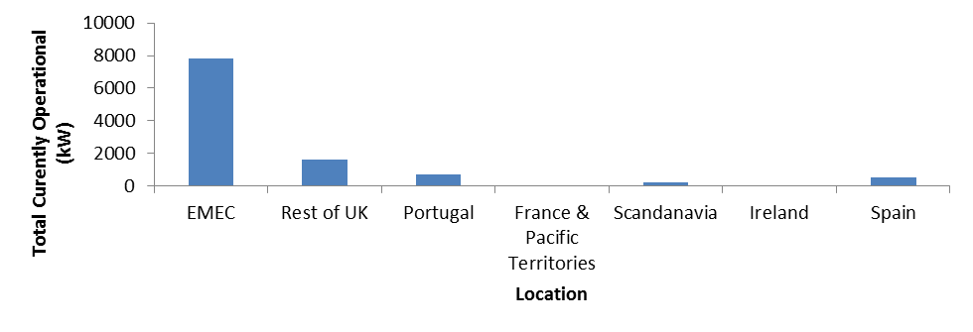
The progress that Member States have made towards achieving the above targets varies substantially. The UK is currently the European and international leader in terms of development and deployment of ocean energy technologies. Other Member States like France and Ireland intend to upscale their ocean energy sectors in the coming years. Over 2GW of ocean energy projects are in the planning pipeline in Europe. Annex 7 provides a more extensive overview of projects in operation including the technologies they deploy.
Test centres are operating or are being developed in the EU. The most advanced is the European Marine Energy Centre (EMEC) in Orkney, in the UK. Others include Wave Hub in Cornwall, UK, the Biscay Marine Energy Platform (BIMEP) in Spain, SEMREV in France, the Atlantic Marine Energy Test Site (AMETS) and the Galway Bay Test Site in Ireland, Ocean Plug in Portugal, the Wave Power Project in Lysekil in Sweden, the Wave Energy Centre (DanWEC) and the Nissum Bredning Test Station for Wave energy in Denmark.
Until recently the ocean energy sector was populated by a large number of independent, entrepreneurial SMEs and university consortia. Recently larger companies such as utilities and manufacturers have become increasingly involved in device development (e.g., EDF, ESBI, Iberdrola, Scottish Power, SSE, Vattenfall, RWE, Alstom, GdF, DCNS, Siemens etc.). Utilities play a key role as they provide financial support for demonstration of ocean energy technologies. Investment from the finance sector has, however, been limited so far.
International initiatives supporting the industry have emerged recently. In 2011, the International Energy Agency launched the Ocean Energy Systems (IEA-OES) technology initiative. Its aim is to coordinate the actors and help industry development. Ten of the 20 members are European (9 EU Member States and Norway). The European Ocean Energy Association (EU OEA) is an industry association which currently has 70 members, including Alstom, Statkraft, DCNS, EDF, GDF Suez and Rexroth. It represents national government agencies, large utilities and industrial companies, national trade associations and universities. A Member States' Ocean Energy Interest Group, comprising the UK, Spain, Ireland, Denmark, France, Belgium, the Netherlands, Portugal and Sweden collaborates with the EU-OEA. Europe's global position in ocean energy is relatively strong. According to the OES its share worldwide in 2011 (including plants under installation) is close to 50%. Europe's share in ocean energy electricity generation is expected to remain very strong in the coming 20 years having a share of more than 55-65% worldwide. This could translate into substantial export opportunities, both for technology and expertise.

3.2.2. National policy support overview
Policy support for ocean energy exists in a variety of forms, the six main categories being (1) capacity and generation targets, (2) capital grants and financial services, (3) market incentives, (4) industry development, (5) research and testing facilities and infrastructure and (6) permitting/space/resource allocation regimes. There appears to be a clear correlation between the strength of the policy support given and the level of progress made in the sector. Compared to other parts of the world, the policy support for ocean energy is relatively strong in Europe. There is a broad agreement, in the literature as well as among the consulted stakeholders, that market-push (e.g. grant support) as well as market pull (i.e. revenue support) policies are needed at this stage. Over a dozen countries currently have dedicated support for ocean energy, with nine EU countries having some kind of a revenue support in place, mostly feed-in-tariffs. Only four countries, however, have differentiated revenue support schemes. For a more detailed account of grant and revenue support in the EU see Annex 8.

3.3. The Ocean Energy growth potential
The global theoretical potential of ocean energy technologies has been estimated to be 7400EJ/year, which well exceeds present and future human energy requirements. In Europe, the theoretical potential of the wave resource alone is estimated to be at least 2800TWh/year (corresponding to about 80% of 2010 EU electricity generation). Ocean energy resources are less variable and predictable to a much larger extent than some other renewable energy resources such as wind and solar. Moreover, the resource fluctuates in different patterns to solar and wind energy, which can help smooth out the electricity supply curve and facilitate network balancing. Another important benefit is the fact that ocean energy installations are likely to face much less severe space constrains for installation compared to onshore RES technologies.
The technical potential of ocean energy is much more modest compared to the theoretical potential predominantly due to current high technology costs. The estimates vary widely; the industrial goal set out by the IEA-OES is 337GW worldwide by 2050; the Carbon Trust estimates approximately 190GW of wave energy and 55GW of tidal energy in the best case scenarios by 2050; and Sims et al. (2007) propose 500GW for wave energy only, without specifying the timescale. In Europe, SETIS (2011) estimate the maximum potential capacity for wave energy to be up to 10GW installed capacity by 2020 and 16GW by 2030, which would equate to 0.8% and 1.1% of EU27 electricity projected consumption respectively for 2020 and 2030. According to industry estimates by 2020 the installed capacity could be 3.6GW and by 2050 100GW, which would satisfy 15% of European electricity demand. Whilst some of these estimates should be viewed with a degree of prudence, the overall picture emerging from independent assessments is that investments into ocean energy are likely to lead to a significant growth of the sector post-2020.
As a capital-intensive and relatively labour-intensive emerging industry, ocean energy has a high economic potential. According to the EU OEA, the industry could create around 314,000 direct jobs. More optimistic academic sources claim 1 million jobs could be created worldwide. The ocean energy industry has so far invested approximately €600 million in Europe over the last seven years and is willing to invest further. On a more global level, the development of a leading EU ocean energy industry can serve an international market that may expand dramatically in the next few years. The Carbon Trust estimated its total value to be approximately €575 billion, cumulative and undiscounted, between 2010 and 2050.

3.4. Problem Definition
The ocean energy sector is currently small but it can grow substantially in the future. A number of technological and non-technological bottlenecks that hamper the sector's development have been identified in various studies and through the Commission's public consultation. These are outlined below. Addressing these bottlenecks may go some way towards enabling the ocean energy sector to move closer to industrialisation and to demonstrate that it is a credible contender in the renewable energy market.

3.4.1. Cost, financial and profitability issues
The cost of electricity generated from ocean energy is currently high compared to that generated from other renewable energy sources or fossil fuels due to high technology costs. At present, the levelised cost of electricity generation from wave devices is around €0.37per kWh and €0.25 per kWh for tidal stream. In comparison, the levelised cost of electricity from offshore wind is €0.18 per kWh, from nuclear technologies €0.067/kWh, combined cycle gas €0.061/kWh, and coal without carbon capture and storage €0.052/KWh. The relatively higher costs can be attributed, among other things, to residual technical uncertainties, lack of know-how and comparatively high operation and maintenance costs. An additional challenge facing the ocean energy sector is to find ways to scale down the high risk of damage to ocean energy devices due to extreme and adverse weather conditions. At this stage both capital (CAPEX) as well as the operational (OPEX) costs need to be reduced.
At the moment, the profitability of modern ocean energy technologies depends on sufficient grant and revenue support, without which ocean energy would be unattractive to investors. Cost reduction can be assisted through various means such as funding through R&D programmes and market-pull policies. The provision of stable revenue support is an effective means of propelling the development of renewable technologies, as is proved by the success of solar energy and onshore and offshore wind. In these cases, the costs of technologies decreased rapidly. See Annex 9 for examples of the link between support schemes and their success in different Member States. Due to the current economic downturn, several governments have substantially scaled back revenue support for renewables. Such developments can erode investors' confidence thus undermining further development of the sector. A long-term political commitment by governments is decisive to helping emerging technologies successfully compete in the market.
Private and public banks play a vital role in financing renewable energy development. The leveraging of funds through venture capital and the European Investment Bank, for example, can ensure financial sustainability for emerging technologies such as ocean energy. When assessing investment choices, however, ocean energy is perceived as 'high risk' by financing entities because of specific characteristics such as the novelty of the technology, small project sizes, high capital costs relative to operating costs, lack of full competitiveness on the market and, by implication, strong dependence on policy. It is only once profitability is established in a longer-term timeframe that private investors will be drawn to the sector. The ocean energy sector has been traditionally dominated by SMEs; utilities are relatively new to the field. For an industrial scale-up, the endorsement of utilities, which are in a better position to raise capital off their balance sheets, will be essential.
Another factor which complicates access to finance is the fact that the industry is characterised by a diverse range of technologies. While a certain degree of variety is desirable as it allows for the exploitation of diverse resources in different locations, the complexity of the technological landscape leads to a dilution of R&D efforts, which slows down the progress toward capital cost reduction for the sector as a whole.

3.4.2. Infrastructure issues
The uncertainty and high cost of grid connection is considered to be a significant constraint on ocean energy development. The resources available to generate power from wave and tidal energy are often located in low population density and peripheral regions. The grid capacity in these locations is limited as is the transmission network, which transfers electricity further to centres of high demand. Investment in grid infrastructure is often undertaken solely based on existing requests without sufficient consideration of future needs. Given the current small scale and low profile of the ocean energy industry, grid connections may not be planned in the areas where they are likely to be needed. As in the case of other renewables, the expansion of deployment of ocean energy would also be facilitated by strengthening grid interconnections in Europe.
Besides the physical constraints, there are also financial and administrative difficulties. The question as to who bears the costs of connection is a particularly important one to clarify, as practices on sharing grid connections as well as access costs differ substantially between Member States. The lead times remain long and the costs borne by project developers tend to be substantial. The developers also have to bear the commercial risk of permits not being granted or not granted on time. The experience of the offshore wind sector shows, for example, that the administrative costs faced by offshore wind park developers can be higher than those involved in the construction of onshore wind projects. From an investor's point of view, reassurance on timely availability of the necessary grid infrastructure is seen as a crucial factor.
Another infrastructural challenge relates to the availability of suitable port services and specialised vessels. These are required for the transportation, assembly, installation and repair of devices and foundations, the installation of underwater cables and connectors, and operations and maintenance (O&M) services. Europe has a number of ports that are already being used for offshore marine energy installations in the Irish Sea and North Sea, while other ports are being remodelled ports to service the offshore marine energy industry. However, suitable port facilities are often lacking in the areas where the potential for ocean energy development is the highest and therefore further investments in port facilities will be needed to underpin growth in the ocean energy sector.

3.4.3. Administrative & regulatory issues
Managing the sustainable use of the marine space requires the implementation of different legal and administrative policies ranging from authorisation procedures, maritime spatial planning as well as environmental regulations and SEA and EIA requirements. Respondents to the Commission’s public consultation highlighted various administrative barriers that hinder the development of ocean energy such as lengthy and complex regulatory and consenting procedures, insufficient coordination amongst public bodies responsible for reviewing applications, as well as a lack of knowledge of ocean energy.
Given that the sector is a relatively new player, Member States tend to deal with projects on a case-by-case basis, using existing regulatory requirements applicable to other sectors such as oil and gas, aquaculture or offshore wind. Some Member States (e.g. Belgium, Germany and Sweden) apply different processes in their territorial seas to those applied in their Exclusive Economic Zones (EEZs). Additionally, multiple consents for a project may be required if the marine and coastal (terrestrial) zones overlap or if they fall under the responsibility of a number of public bodies with different competencies. This patchwork of national administrative and regulatory rules and procedures can be time-consuming and ultimately financially costly for project developers. 'Blue tape', as it is referred to by the IEA-OES, translates into years of delays and millions of euros of additional costs. The recent Windbarriers report, dealing with wind energy, found that the total administrative costs for offshore wind (excluding those related to grid connection) are comparatively much higher than onshore wind, at nearly 14% of total project costs. Similar observations can presumably be applied to the ocean energy sector, which is, relatively speaking, less developed.
It should be noted that a few Member States have already made efforts to simplify procedures, for example, by designating "one-stop-shops" to deal more effectively with consenting processes (e.g. in Scotland and Denmark). Furthermore, in some cases, test sites (e.g. EMEC in Scotland and AMETS in Ireland) are “pre-consented”, which means that developers do not have to go through the full consenting process themselves thereby saving time and reducing costs.
Maritime Spatial Planning (MSP) comes into play when determining offshore site developments for marine renewables. The majority of Member States practice some form of MSP. A few, notably Germany, Portugal, Sweden, the Netherlands and the UK, have quite advanced MSP systems in place while others are in the process of developing MSP regimes e.g. Ireland, Denmark and Italy. Nevertheless, so far there are few MSP regimes that specifically take ocean energy development into account. Indeed, there was broad agreement amongst respondents to the public consultation that ocean energy should be included in national MSP so as to mitigate conflicts over the use of marine space. Taking ocean energy deployment into account would also help to alleviate some of the negative environmental impacts resulting from ocean energy installations. The recently concluded Seanergy 2020 project examined the need to develop MSP instruments to take offshore generation technology and related grid infrastructures into consideration and made policy recommendations to develop such instruments.

3.4.4. Environmental issues
As ocean energy technologies approach commercialisation, the need to take account of their impact on the environment becomes increasingly important. The majority of the negative environmental impacts related to ocean energy deployment are equally relevant for all marine energy technologies, including offshore wind, but also other marine infrastructure installations. The most frequently quoted environmental costs include destruction of habitats, killing of fish through direct 'blade strikes', underwater noise, electromagnetic effects, or the entanglement of diving birds and marine mammals. The uncertainties about the environmental impacts of specific ocean energy technologies combined with the need to apply environmental requirements in an appropriate manner affect the authorisation process.
The data on the environmental impact of ocean energy currently available is limited. A full assessment will only become possible as larger commercial arrays come on stream, and the results of environmental monitoring become available. The lack of information about the marine environment more generally is argued to be an important problem, especially given that the seabed remains relatively unexplored compared to terrestrial ecosystems. Yet, the research is often too expensive for project developers to undertake alone. More R&D and a better flow of information will, therefore, be required to understand and mitigate the adverse environmental impacts of ocean energy installations.
The Habitats Directive and the Birds Directive are key pieces of legislation safeguarding environmental quality in the EU and as such are vital to ensure ocean energy is deployed sustainably. The relatively high environmental quality standards legislated in Europe should therefore, in theory, support the development of this emerging industry. Yet, uncertainties on the application of some EU environmental legislation, given that national authorities prefer to err on the side of caution, can in some instances disproportionally prolong the consenting procedures and place an additional administrative burden on project developers.

3.5. 'Business as usual' scenario
In the absence of a sufficient degree of internal momentum within the industry itself and without political support at national and EU level, the ocean energy share of the renewable energy mix and its contribution to growing electricity demand will likely remain small. The rate of cost reduction will be limited and the potential to contribute to the EU’s 2050 decarbonisation objective will be curtailed. The horizon for full commercialisation of the sector will be long term (2050) rather than medium term (2030). Economic, export and employment opportunities will not be fully exploited.
If no additional action is taken, the ocean energy sector would likely be limited to implementation of ocean energy targets in existing NREAPs. The sector's growthpath will be adversely affected by the current unfavourable economic climate where investors and authorities may prefer to rely on more developed renewable energy technologies and even on unconventional or cheaper 'traditional' fossil fuel generation. Despite this, it can still be assumed that activity in the sector would continue, perhaps in anticipation of more a favourable economic environment as well as increased support at EU level e.g., financial support for R&D projects under current and future research programmes. Efforts to foster consolidated and joint Member State activities and to move to larger projects will be made e.g., through an ERA-NET (European Research Area Network) on ocean energy. Although technology refinement will occur, the path to technological convergence will likely be substantially slower.
Infrastructure improvements such as grid connections will continue at their current rate but the future needs of ocean energy will not necessarily be taken into consideration because the deployment rate is presently too slow to warrant factoring it into the equation. Given that ocean energy uptake is likely to be quite small in the short term, its integration into national planning and management strategies, including MSP, is not likely to be a priority compared to more traditional offshore activities or even of offshore wind. Nonetheless, the adoption of a proposal for a MSP Directive may help the situation to some extent. Similarly, the proposal for a revised EIA Directive could assist in reducing some of the administrative burdens involved in scoping out offshore marine energy sites. At the current deployment rate, however, knowledge of the environmental impacts of ocean energy may not be so readily available or extensive.

3.6. EU's right to act
The EU’s competence in the area of energy is set out in the Treaty on the Functioning of European Union, Article 194 (energy), Article 114 (internal market) and Article 192 (environment). While duly considering their respective competences, action in this area by both the EU and Member States would provide better opportunities to develop ocean energy resources and make best use of R&D budgets. Large scale investments for renewable energy technologies are more feasible and cost-effective in EU-wide markets while large R&D budgets can be mobilised and organised more effectively at European level especially to enable the rapid development of key energy technologies for which barriers, scale of investment and risk can best be addressed collectively.

3.7. Who is affected?
Development of ocean energy will affect the energy industry at all points of the supply chain, including device developers and manufacturers, project developers, service providers and investors; marine industries, including SMEs in areas such as shipbuilding, ports, marine operations, mechanical, electrical and maritime engineering, R&D and logistics; consumers through changes in electricity prices (which will depend on national support and on installed capacity); government bodies through their involvement in the selection of optimal policy to support ocean energy, allocation of research funding, administrative procedures and a broader engagement with stakeholders; and other users of the marine environment.

4. Objectives

4.1. General objective
The general objective is for ocean energy to contribute to sustainable economic growth, jobs and innovation in the EU in line with the Blue Growth Strategy and the Europe 2020 Strategy, to assist in the achievement of the EU's renewable energy and decarbonisation goals in the medium to long term and to increase energy security.

4.2. Specific objectives
This initiative aims to bring together policy makers, technology developers, investors and other stakeholders to foster the competitiveness of the ocean energy sector through coordinated actions to enhance technological innovation, including reliability and efficiency; to facilitate the industry's access to finance and to improve administrative practices and environmental monitoring.

4.3. Operational objectives
The operational objective over the short to medium term is to consolidate R&D activities to enable cost reductions; improve the efficiency of planning and licensing procedures; enhance synergies with other industries, such as offshore wind, including on grid planning matters, and assist with monitoring of environmental impacts as well as the application of environmental protection legislation.

4.4. Consistency with other EU policies
This initiative complements the Europe 2020 flagship initiatives and the Blue Growth initiative that envisaged a follow-up Communication on ocean energy in 2013. It is consistent with and complementary to the Commission’s 2050 Energy Roadmap and to on-going initiatives on renewable energy, including the SET-Plan, energy efficiency and climate change mitigation and adaptation.

5. Policy Options
This section outlines three policy options to tackle the challenges identified in Section 3.4. The table below summarises these options and shows the link between the individual policy measures as a response to the specific bottleneck together with their expected output to help the development of ocean energy. The measures deemed most feasible would be formulated in a Communication in the form of an action plan. Option 1 relies on the current policy framework to support ocean energy while Options 2 and 3 suggest a series of non-legislative measures. Certain sub-options, such as those relating to administrative or environmental guidelines, may be more feasible at a later stage, as argued in the impacts section, but are included here for the sake of completeness. An unambiguous statement of support for an EU policy on ocean energy was called for by numerous stakeholders, including the industry association, utilities and certain regional representations in the Member States (e.g. in the UK and France).
Discarded Option: at the initial stages of the impact assessment preparations, consideration was given to a review of EU energy and environmental legislation in order to examine if there were any specific provisions that hampered the development of ocean energy. Upon further internal reflection and discussions with concerned Commission services, including in the IASG meetings, it was concluded that pursuing this option was not feasible or desirable due to several reasons. Firstly, this option would weaken the stability of the legislative framework, which could be potentially detrimental to the renewable energy sector, including ocean energy. Secondly, a wholesale review of existing legislation to accommodate a particular sector was considered unwarranted and disproportionate. Thirdly, any potential legislative review would have to be accompanied by in-depth consultation and assessment that was beyond the scope of this impact assessment. For these reasons it was decided to discard this option and instead to examine the feasibility of alternatives such as developing guidance on the application of certain directives.

Options  Bottlenecks | Option 1 - Current policy framework | Option 2 - Enhanced political and industry coordination | Option 3 - Targeted structural actions | Expected outcomes
Cost reduction and financial issues | Strengthening research coordination between Member States through an ERA-net on ocean energy  Raising awareness about EU funding opportunities | Industry roundtable with Commission facilitation feeding into a Strategic Roadmap  Reinforced support for ocean energy under EU R&D programmes (Horizon 2020, NER300) and European Investment Bank instruments  Member State guidance on financial incentives | As in option 2  Possible inclusion in the SET-Plan and a European Industrial Initiative | Easier access to research funding and more efficiency in R&D, leading to acceleration of cost reductions  Positive impact on the bankability of projects
Infrastructure | Investment in offshore grid infrastructure through Projects of Common Interest  Continued support for the European Electricity Grid Initiative | Promoting a dialogue between ocean energy industry and grid planning authorities in the context of existing initiatives.  Mapping out needs related to port services and infrastructure and other supply chain issues | As in option 2  Setting up a dedicated sector-specific platform to discuss strategic grid planning needs and non-grid related infrastructure needs (e.g. ports and vessels) | Shorter lead times, with a positive impact on the bankability of projects  Spill-over economic and social benefits
Administrative barriers | Adoption by the Commission of a MSP directive  Continued discussion on the Commission's proposal on a revision of the EIA Directive | Voluntary best practice sharing amongst MS  Identification of the specific needs as regards the integration of ocean energy into MSP.  Promoting results of EU-funded projects. | As in option 2  Guidance document to assist with the implementation of Art. 13 of the RES Directive  Specific guidance on MSP for ocean energy projects | Wider uptake of best practice in Member State planning and market support  Shorter lead times, with a positive impact on the bankability of projects
Environmental issues | Research and monitoring of environmental impact through existing projects e.g., SOWFIA | Encouraging the sharing of environmental monitoring data  Industry exchange of experience and best practice in conducting EIAs | As in option 2  Assessing need for ocean energy guidelines to promote sound implementation of relevant EU environmental legislation | Lower cost of environmental monitoring and facilitated compliance with environmental legislation compliance

5.1. Option 1: Current Policy Framework ('business as usual')
This option entails a continuation of policy initiatives at EU level that are already in place and which affect ocean energy either directly or indirectly. No supplementary EU action in favour of the ocean energy sector is envisaged.
EU funding for R&D projects under the existing FP7 programme as well as the second call under the NER300 programme will continue. An ERA-Net on ocean energy is expected to be established in 2013 which will strengthen research coordination and encourage joint calls for funding amongst Member States thus capitalizing on national and regional research efforts to accelerate ocean energy development. The Commission, Member States and stakeholders will continue discussions on the future priority areas for renewable energy under the new Horizon 2020 programme.
Option 1 sees the continuation of on-going EU projects such as SI Oceans (2012-2014), which is, inter alia, examining policy and other non-technological barriers that impede the growth of the ocean energy sector and developing a market deployment strategy to accelerate the deployment of wave and tidal devices. This activity will interface with the 2013 Industry Vision Paper which outlines a plan to develop a unified strategy to manage technical, project-related and financial risks. Other relevant on-going projects include the SOWFIA project dealing with research and monitoring of environmental impacts. Additionally, the InnoEnergy KIC is expected address ocean energy following its inclusion in the 2012 Strategy and Roadmap for Renewable Energies.
In terms of grid infrastructure developments, the Northern Seas Countries Offshore Grid Initiative provides a framework for regional cooperation to find common solutions to grid infrastructure developments in the North Sea and Baltic. It promotes coordinated planning and grid investment, albeit with a focus on the more advanced offshore wind sector. The technological development needed for realising the offshore grid is programmed in the framework of the European Electricity Grid Initiative, which receives and will continue to receive EU funding support through FP7 and Horizon 2020.
On spatial planning, the Commission's proposal for a Directive aims to establish a framework for MSP and coastal management in the form of a systematic, coordinated and trans-boundary approach to integrated maritime governance. The Commission's proposal amending the EIA Directive aims to strengthen the quality of EIAs as well as to simplify the procedures and reduce unnecessary administrative burdens e.g., it proposes a 'one-stop-shop' allowing for the coordination of procedures under the EIA Directive. Both these proposals are currently going through the legislative process in the Council and the European Parliament so their final contents and potential impacts on the ocean energy sector are not yet known.
This option would not be in line with the views expressed by a majority of respondents to the public consultation; only 4% considered additional action at EU level in support of ocean energy unnecessary mostly because they favour a more holistic approach to energy generation without a support for any particular technology.

5.2. Option 2: Enhanced political and industry coordination
The overarching measure envisaged in Option 2 is the setting up of an industry-led roundtable to promote innovation by bringing together technology developers, researchers, utilities and investors as well as Member States as appropriate. The Commission would play a facilitating role. The objective would be to evaluate viable solutions to the challenges facing the industry by formulating a cost reduction, financing and technical innovation strategy. It would take the form of a strategic roadmap which should also take into account matters relating to infrastructure and administrative challenges and set out industrial development milestones within a clear timeframe (up to and beyond 2020) as well as an indicative implementation plan. The results of the SI Ocean project should provide valuable input into this exercise.
To enable the integration of research priorities identified in the roundtable, Option 2 would include awareness-raising about upcoming funding proposals. This could be carried out, e.g., through information workshops or presentations by the Commission to the roundtable. A more informed and targeted use of EU funding based on specific stakeholder needs will avoid a 'dilution' of efforts. The roundtable would also assess the possibilities for private-public partnerships in R&D projects to share investment risk. Technology developers would also be encouraged to publish performance data as far as this is feasible to help investors make more informed decisions. Implementation of the Atlantic Action Plan could also provide opportunities to enhance cross-border cooperation, in particular through European Territorial Cooperation programmes.
Properly designed revenue support schemes send a strong signal to investors and are an important element in leveraging private investment in renewable energy development. To support diversity in the renewable energy portfolio there is a need for a differentiation in revenue support according to maturity. Yet, differentiated production-based support, taking account of the emerging status of ocean energy technologies, is currently in place in only four Member States. The Commission's formulation of clearer guidance for Member States on how to determine the level of financial incentives for different renewable energy technologies as announced in the 2012 RES Communication is therefore an important component of Option 2. State aid rules, including the guidelines on state aid rules for environmental protection must be taken into account in this context.
As existing initiatives to tackle the grid infrastructure bottleneck do not yet take ocean energy needs into account, a more pro-active dialogue between the ocean energy industry and the parties responsible for grid planning is needed; this would also involve the offshore wind sector. To make its case, the industry must have a clear vision of its needs in the short- as well as in the longer-term. As a first step, option 2 therefore proposes that the industry roundtable includes a thorough assessment of grid-related needs. Other infrastructural needs such as those pertaining to port services and the supply chain would also be identified. Lessons learnt from the results of relevant on-going and recently concluded EU-funded projects should provide valuable input into the process. Particularly relevant here are SI Ocean, ORECCA, Waveplam, SOWFIA, EquiMar and RES Legal. Taking ocean energy into account in grid planning was highlighted as important by several stakeholders in the public consultation, including by Member States' regional representations.
In order to tackle the administrative barriers, option 2 envisages voluntary best practice sharing amongst Member States' authorities to make use of their experience on ocean energy permitting and consenting practices. This would be part of the industry roundtable. Mainstreaming of ocean energy -specific issues in existing fora such as Concerted Action (CA-RES) is also possible. Additionally, as a part of the roundtable discussions the industry could identify its specific constraints and needs in order to encourage improved integration of ocean energy in national MSP. Site selection for ocean energy installations can be optimized through increased research, monitoring, knowledge-sharing and better use of marine spatial planning which will also help to ensure minimal negative effects on the surroundings and ecosystems. The industry could also be encouraged to exchange experiences and best-practices on EIAs.
The individual elements of this option were sourced from consultations with stakeholders; in the public consultation several stakeholders noted that it would be beneficial to emulate successful practices in certain Member States and thus accelerate deployment.

5.3. Option 3: Targeted structural actions
Option 3 builds on option 2 so as to further strengthen industrial cohesion and Member State involvement. To consolidate stakeholder cooperation and give the industry a robust support framework, a European Industrial Initiative (EII) would eventually be set up in agreement between the Member States, the Commission and the industry. This particular instrument was demanded by a wide range of stakeholders including the industry association, concerned regions (e.g. Lower Normandy and Scotland), the Member State ocean energy Interest group, utilities and the academia.
The strategic roadmap outlined in Option 2 would form the basis for the development of an EII which normally requires the elaboration of a technology roadmap and implementation plan. These forward-looking action plans aim to align the efforts of the EU, Member States (in the context of the SET-Plan Steering Group) and industry to achieve common goals and accelerate the development of technologies to enable them achieve larger market share over time. As evidenced by the experience from other sectors, such as wind and solar energy, an EII can deliver progress in research and enhance access to finance through risk-sharing, ultimately helping the technologies to become more competitive. An EII could also provide a forum in which to communicate the benefits of ocean energy as a clean technology and contribute to increased public acceptance.
Regional cooperation on infrastructural developments has a clear cost-cutting potential. Option 3 proposes the setting up of a dedicated grid-planning platform, with the sole purpose of advancing the grid-planning interests of the ocean energy industry. Other infrastructural bottlenecks could be addressed through a sector-specific body or sub-group tasked with identifying and assessing the specific needs and exploring possible synergies with other sectors, notably offshore wind, in a bid to rationalise costs and enhance efficiency.
A guidance document to address administrative barriers could be considered in particular to assist Member States with the implementation of Article 13 of the RES Directive. According to this provision, Member States should ensure that national authorisation and licensing rules applied to RES installations are "proportionate and necessary". Clearer guidance would help Member States strike the right balance between the obligations of public authorities and the interests of the different stakeholders, including the ocean energy industry. As many of the challenges relating to permitting and consenting procedures are ‘structural’, i.e., they derive from specific jurisdictional features, the development of any form of guidelines would have to be deeply rooted in national experience and developed in close collaboration with Member States.
With regard to MSP, it may be beneficial to build on option 2 (identification of specific needs and constraints) and develop sector-specific guidelines for ocean energy in view of the potential development of the sector. Given that the offshore wind sector encounters similar challenges, the scope for coordination between the two industries in identifying common challenges should also be considered.
As shown by the stakeholder consultation, administrative delays can sometimes be linked to sub-optimal implementation of EU environmental directives and overlap with various national administrative procedures on permitting. To mitigate some of these administrative issues, it may be appropriate to develop guidance to promote the sound implementation of the relevant environmental directives such as the Marine Strategy Framework Directive and Habitats Directive.

6. Analysis of Options

6.1. Methodology and limitations
This section analyses the economic, environmental and social impacts of the 3 policy options. The analysis is proportionate to the nature of the policy document proposed i.e., a Communication. This analytical exercise has various limitations: (1) given that all of the measures proposed in this impact assessment are 'soft', their marginal impacts are difficult to assess and quantify; (2) empirical data and evidence-based source material on ocean energy is limited due to its early stage of development and its current low level of deployment; (3) there are many external factors affecting the industry's development which are difficult to predict e.g., development of other RES, the post-2020 RES framework, the evolution of fossil fuel prices, political appetite to support RES in a period of economic downturn and the readiness of the industry to cooperate and coordinate its activities.
Section 6.2 is purely qualitative. It considers how the individual measures help to unlock the four corresponding bottlenecks identified in Section 3. This evaluation will be presented in broad terms; assessing the specific economic, social and environmental impacts of the individual measures or sub-options in isolation is not possible as tackling one bottleneck without addressing the others is not likely to deliver a tangible effect. This qualitative evaluation will nevertheless feed into the final comparison of options in Section 7.
Sections 6.3 to 6.5 will present an additional, partially quantitative, assessment of the possible impacts that a more concerted policy intervention in support of the ocean energy industry can have at the EU level. To allow for this analysis, indicative market uptake scenarios were developed for each policy option in an attempt to show the possible different levels of uptake of ocean energy resulting from different levels of intervention. The possible impacts were then extrapolated. 'Low market uptake' and 'high market uptake' scenarios were established demarcating a range of installed capacity which is theoretically possible to achieve by the measures proposed. Annex 10 provides a full explanation for the scenario modelling. The modelling is to be approached as an illustration, complementary to the qualitative assessment of individual measures. The three options and the market uptake scenarios are tentatively linked based on the general assumption, supported by a wide range of literature, that supportive policy intervention is likely to play an important role in stimulating emerging industries, all other things being equal. It is appreciated, however, that the supportive measures presented here can fail to deliver increase in the uptake of ocean energy, if other landscape factors, such as the price of fossil fuels, are unfavourable.
It should be noted that even the 'high market uptake' scenario is very conservative; the available estimates from the IEA and from certain academic sources present a much more optimistic picture, predicting a steep growth of the industry in the next two decades similar to that experienced by the offshore wind industry from 1990 - 2010. However, founding the scenarios on the development of offshore wind was considered overly optimistic for several reasons, as explained in Annex 11. At the present stage of development a more cautious approach seems appropriate, in line with the assumptions of the 2050 Energy Roadmap.

6.2. Analysis of individual measures/sub-options

6.2.1. Cost reduction, financial and profitability issues
In Option 1, the effect on cost reductions from the just-published Industry Vision Paper 2013 will not be immediately felt but is a tangible step forward to collectively streamline and rationalise industry efforts to accelerate market uptake. Once available, the results of the SI Ocean project on market deployment and resource and technology assessment are expected to pave the way for a more agenda-driven approach to tackle certain bottlenecks, including cost reductions and technological convergence.
R&D efforts will be strengthened through the anticipated ERA-Net on ocean energy that will foster collaboration amongst more Member States. An increased focus of research calls on larger projects, to optimise technologies to increase capacity and improve reliability, could lead to greater convergence and larger-scale pre-commercial deployment of ocean energy arrays with increased capacity. If implemented successfully, the three ocean energy projects under the NER-300 programme are expected to have a positive impact on increasing investor confidence, improving and optimising technological performance and reliability, lowering costs and managing risks. A modest level of direct employment creation (manufacturing, installation and O&M) could be expected as well as some scope for indirect job creation (increase in opportunities for collaborative research).
The industry roundtable set up under Option 2 would be tasked with developing a strategic roadmap to improve competitiveness. Although the precise impacts of this action cannot be quantified, establishing a set of deliverables within a set timeframe will stimulate the industry to tackle common challenges in a coherent way (e.g., through investment commitments and increased R&D coordination) thereby avoiding fragmentation and duplication which should result in cost reductions and increased investment in the longer term. Wider political buy-in and commitment from both Member States and the Commission can help to achieve this objective by mitigating some risk and facilitating the industry’s access to finance. Setting up a roundtable will entail a level of administrative effort for all parties involved. As R&D coordination and awareness-raising about funding opportunities will be strengthened under this option, the expectation is that political, investor and public awareness of the opportunities available will increase as will confidence in the sector.
Issuing Commission guidance for Member States with respect to financial incentives for different RES technologies could reduce uncertainty and enhance project bankability, provide the industry with incentives to become more competitive and help Member States keep overall support costs under control. This is important, as supporting new high cost technologies can lead to higher costs for consumers and/or taxpayers, at least initially, and will therefore impact on public acceptance if not appropriately managed. Guidance on authorisation procedures or MSP and including ocean energy in the debate on strategic grid planning could result in lowering lead times in constructions and enhancing synergies with other sectors which will contribute positively to market uptake and to overall cost reductions and profitability.
Voluntary publication of performance data, particularly when publicly funded, will have a positive impact on investors and developers in that lessons learnt from device performance will contribute to improved innovation, convergence and standard-setting. On the other hand, developers may be reluctant to openly provide such information until device performance and reliability is sufficiently improved or due to a reluctance to share proprietary information.
The evaluation of the Intelligent Energy Europe programme suggests that 'soft' measures similar to those outlined under option 2 can effectively help to pull new energy technologies into the market.
Option 3: According to several stakeholders, an EII would go the furthest in fostering private-public partnerships, enhancing investor confidence and increasing opportunities for collaborative projects between technology developers, utilities and manufactures, all leading up to larger-scale commercial ocean energy deployment. For example, the Wind EII, despite only being launched in 2010, has already yielded a number of achievements including the establishment of the main EU Programme for wind energy R&D and improved allocation of relevant EU and national public funds on priorities identified by the sector (through TPWind). According to the EWEA (2013), the Initiative contributed to technology cost reductions. It seems reasonable to assume, therefore, that cost reductions will be achieved through increased design optimisation, increased economies of scale and lessons learnt from production, constructions, installation, operation and maintenance fostered via the EII. Increased market penetration of ocean energy will bring with it additional economic and employment activity. However, an EII does come at a financial cost to implement as private and public investments are required to support the programmed activities. It is not possible to quantify the amount required for an ocean energy EII at this stage but indicative costs for the wind sector for the period 2010-2020 were estimated at €6 billion. Associated administrative costs to set up, implement and monitor the EII are also expected.
Increased awareness-raising of funding opportunities in the context of the forthcoming Atlantic Action Plan and the industry roundtable will provide a structured framework within which Member States could leverage the benefits of inter-regional cooperation on joint projects.

6.2.2. Infrastructure
A number of initiatives relevant to this bottleneck are already implemented within the current policy framework (Option 1). The Northern Seas Offshore Grid is formally recognized as a one of the priority corridors in the new TEN-E Infrastructure Guidelines. Its development, including finding regulatory solutions for integrated infrastructure, is supported through the cooperation of national governments, regulators, TSOs and the Commission in the framework of the Northern Seas Countries Offshore Grid Initiative. The technological development needed to develop the offshore grid is programmed in the framework of the European Electricity Grid Initiative and supported through the successive EU RTD framework programmes (to be continued in Horizon 2020). Due to early stage of development of the ocean energy industry and lack of visibility on roll-out of commercial scale devices, the main focus of the above fora and initiatives is, however, on the development of offshore wind so the impact on ocean energy is negligible.
Option 2 enables a better engagement of the ocean energy industry in the grid planning process. A thorough assessment by the industry of its needs and its accommodation in existing bodies could be a cost-effective way of addressing the bottleneck. Given the very nature of strategic grid planning it can in any case be assumed that more cost-efficient solutions will emerge if ocean energy producers will consolidate their requirements and feed them into the on-going grid planning process within existing structures. Discussions about appropriate approaches towards anticipatory investments as e.g. planned within the Northern Seas Countries Offshore Grid Initiative may also provide scope to begin to anticipate ocean energy needs.
The proposed dedicated grid-planning platform under Option 3 would send a stronger signal to investors and other market players; the extent of the beneficial impact on supply chains and financiers' interests is nevertheless difficult to predict. This option might, however, not only involve additional substantial administrative costs, but could also be less effective as to its outcome than option 2 as it would risk creating a separate and competing forum. The setting up of dedicated platforms and bodies for the promotion of ocean energy interests in the grid planning procedures, as well as the development of guidance documents to complement certain EU directives (option 3) is likely to increase administrative burden at the EU and possibly also at the national and regional levels. Option 2, which proposes to use existing platforms and initiatives to a highest possible degree, could deliver a better overall result.
In Options 2 and 3 a concrete formulation of the industry's port and supply chain needs coupled with a wide endorsement of the key players could stimulate the supply chain thereby creating job opportunities and more economic activity. Sections 6.3.4 and 6.3.5 provide additional information on economic impacts.

6.2.3. Administrative barriers
The administrative barriers are partially addressed within the Option 1 e.g., the proposed MSP Directive, while sector-neutral does call for a consideration of renewable energy when developing national MSPs. It can be assumed that administrative costs as a proportion of the total project costs would decline over time even without additional intervention as the relevant authorities become better acquainted with the technology; nevertheless, the process could be expected to be relatively slow. In the meantime, administrative hurdles would take their toll in terms of longer construction times and undermining investor confidence.
In option 2 the exchange of best practice in the framework of the roundtable is potentially an effective first step to tackle administrative barriers. National authorities would be given access to information about effective practices from other MS, which could yield improvements over time. A structured exchange of views would in any case be a necessary first step to enlarge the knowledge base before further steps can be taken. Option 3 goes further to tackle some of the issues related to the implementation of Article 13 of the RES Directive by proposing the development of implementation guidelines. However, the current lack of experience on the authorisation process for ocean energy means that the guidance documents could not be developed at this stage but rather once experience is available from several commercial-scale plants. It remains to be seen whether these are indeed necessary and when, if at all, they should be developed.
A similar guidance document could be devised to address the sector-specific issues related to MSP to relieve the institutional risk aversion stemming from limited familiarity with the sector. In the case of MSP it would be necessary to re-evaluate the need for specific guidance once the outcomes of negotiations on the proposed Directive are known. Reducing the bureaucratic burden would facilitate the transition from pilot projects to commercial deployment, provided the other bottlenecks are also addressed. Consideration should be given to a stepped approach whereby a decision on whether or not to provide explicit guidance is made in view of the experience gained under option 2, and for MSP, the outcome of the Directive.

6.2.4. Environmental issues
Under option 1, the lack of data regarding environmental impacts of installations would be partially resolved by the gradual accumulation of data by the industry itself, but this implies a substantial burden on the project developers. Sharing of privately acquired data will likely be limited, and the process slow and inefficient. As for issues relating to implementation of EU directives the revision of the EIA Directive in particular should contribute to a simplification of the EIA process and consequently reduce the costs borne by developers as well as alleviate some of the administrative burden on the Member States authorities. The SOWFIA project is expected to make a contribution by taking the stock of the European experience of consenting processes, EIAs and SIAs relevant for wave energy.
Under Option 2 a more integrated approach at promoting data-sharing and collaborative working between the industry and academia/research organisations could result in an accelerated accumulation of information on the environmental impact of ocean energy devices. The industry would be also encouraged to share experience and best practice in conducting EIAs which would hopefully lead to better outcomes for the responsible authorities as well as for the developers. Yet these actions would be undertaken by the stakeholders on a voluntary basis and therefore their results are uncertain. The evaluation of the Intelligent Energy Europe programme has nevertheless shown that best-practice exchange can be an effective means of tackling non-technological barriers such as this one.
Option 3 proposed the development of implementation guidance documents to complement the relevant environmental directives. This measure was called for by several stakeholders in the public consultation. Whilst these guidelines could potentially alleviate the administrative bottlenecks by giving the authorities targeted information and instructions, they involve a certain degree of additional administrative costs to both Member States and the Commission. In addition, the current lack of data on the environmental impact of ocean energy means that the guidance documents could not be developed at this stage but rather once data is available from several commercial-scale plants. It remains to be seen whether these are indeed necessary and when, if at all, they should be developed. It may be more appropriate to opt for these measures as a second step, following the measures outlined under option 2. The outcome of the discussions on the revised EIA Directive, which ultimately has a higher legal value than guidelines, will also have a bearing on this process.

6.3. Economic impacts

6.3.1. Levelised cost of electricity (LCoE)
This section draws on the market uptake scenarios provided in Annex 10. It is assumed here that additional supportive action could stimulate market uptake, which would lead to accelerated cost reduction through learning effects and economies of scale. A learning curve approach is used to determine the future cost reductions of ocean energy to see how the different policy options would impact on the LCoE of ocean energy over time. Learning curves normally display the relation between costs and production/installed capacity; the modelled market uptake scenarios in this impact assessment will instead link installed capacity to time. Learning rates (LR) range from 0% to 20% in academic sources; at the same time it is noted that the cost of small, modular products tends to decrease more rapidly than the cost of large, non-modular units or plants. Since tidal and wave energy technology cannot be considered particularly small and modular, a learning rate of 5-10% is considered realistic for ocean energy investments. This is comparable to learning rates for the development of the investment costs of offshore wind, ranging from 2.5-10%.
As costs depend strongly on the numbers of devices installed, a practical difficulty in discussing current costs is the present industry status. The most robust evidence of costs and performance comes from large-scale prototypes. 2.2 GW of ocean energy capacity are expected to be installed in European waters by 2020 (based on NREAPs), and the assumptions regarding the lowering costs due to learning experiences will therefore be applied from that basis. The indicative modelling of LCoE reduction over time based on the market uptake scenarios presented in Annex 10 is shown in the figures below for both wave and tidal energy. Two different learning rates were used to derive a range.
Figure 2: Wave Energy Levelised Cost of Electricity, source Ecorys (2013) based on JRC (2013)
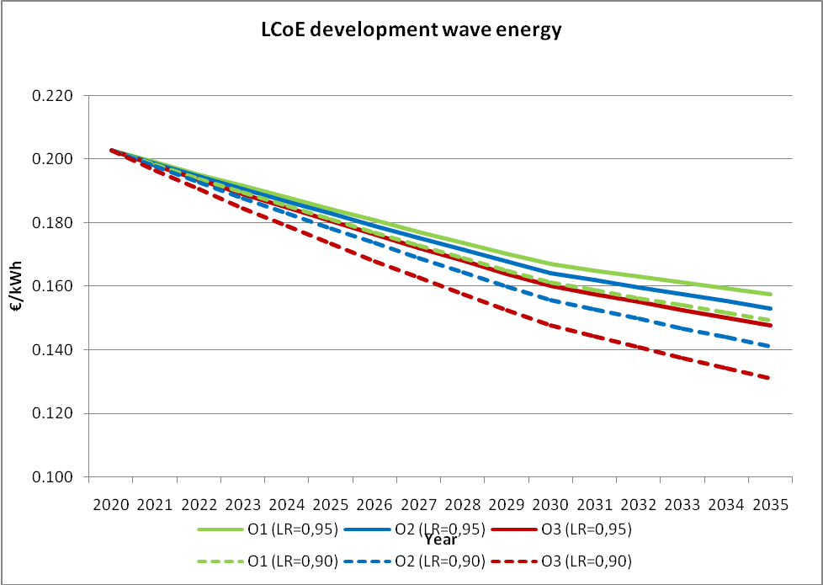

Figure 3: Wave energy estimated cost decrease under options 1, 2 & 3
Wave energy LCoE | Option 1  (€/kWh) | Option 2  (€/kWh) | Option 2 / Option 1 | Option 3  (€/kWh) | Option 3 / Option 1 | Option 3 / Option 2
2020 | 0,208 | 0,208 |  | 0,208
2035 (LR=0,95) | 0,157 | 0.153 | 97% | 0,148 | 94% | 96%
2035 (LR=0,90) | 0,149 | 0.1411 | 94% | 0,131 | 88% | 93%

Figure 4: Tidal Energy Levelised Cost of Electricity, source Ecorys (2013) based on JRC (2013)
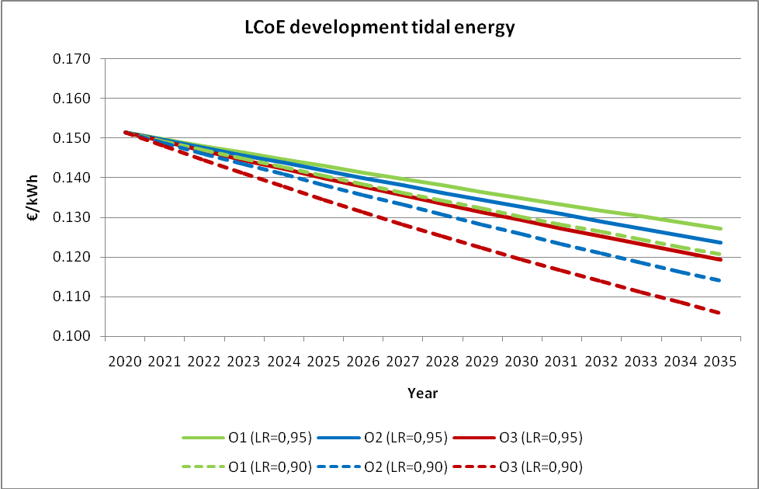

Figure 5: Tidal energy estimated cost reductions under options 1, 2 & 3
Tidal energy LCoE | Option 1  (€/kWh) | Option 2  (€/kWh) | Option 2 / Option 1 | Option 3  (€/kWh) | Option 3 / Option 1 | Option 3 / Option 2
2020 | 0,151 | 0,151 |  | 0,151
2035 (LR=0,95) | 0,127 | 0,123 | 97% | 0,119 | 94% | 96%
2035 (LR=0,90) | 0,120 | 0,114 | 94% | 0,106 | 88% | 93%
Ocean energy technologies are relatively young and therefore their technological development and the related progress in cost reduction can be expected to be faster compared to conventional technologies. Based on increasing fossil fuel cost and decreasing technology costs, it can be assumed that the gap between conventional and new renewable electricity generation technologies will eventually close and a break-even point will be reached. When this will occur depends to a large extent on the policy support provided.
Figure 6: LCoE of Ocean Energy v. Fossil Fuel Technologies: Ecorys (2013) based on JRC (2013)
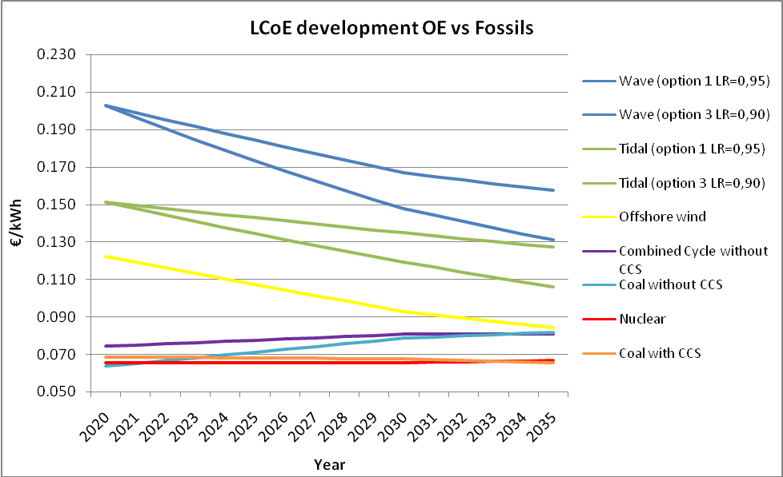
Figure 6 above shows that in 2035 the cost of electricity generated from wave and tidal sources will still be above the electricity costs generated from fossil fuels but there is a converging tendency. No definitive conclusion can be made as to when and how fast ocean energy can be cost competitive with other forms of energy generation. It can be said, however, that option 3 could lead to an accelerated LCoE reduction thus narrowing the gap between wave and tidal with other alternatives such as offshore wind in the period up to 2035. The accelerated cost reduction under option 3 is to be attributed primarily to the establishment of an EII and inclusion of ocean energy in the SET-Plan, as well as to the alleviation of non-technological barriers through other measures. According to the JRC analysis (2010), the SET-Plan does not only play a key role in reducing technology costs but also in ensuring their availability and reliability. Option 1 shows that if there is no additional action, the likelihood of ocean energy becoming cost competitive lies further ahead in the future. As stated earlier, the approach in the impact assessment is conservative compared to some other sources. Esteban and Leary (2011) predict that wave and tidal energy will be cost competitive around 2021, with an LCoE of around 0.06 €/kWh.

6.3.2. Costs for electricity consumers
Increasing the burden on consumers due to development of renewable energies and of the relatively more expensive ocean energy technology in particular is an important concern. Indeed the 'High RES' scenario on which Option 3 scenario is based would entail a rise in electricity prices compared to the 'business as usual' scenario. Only a minor part of this increase would, however, be directly attributable to ocean energy generation as this will only make a relatively small contribution to the energy mix compared to other renewables, even in the most optimistic scenarios. It should also be noted that electricity prices will rise compared to the status quo even under the 'business as usual' scenario due to the need to replace generation infrastructure in the next 20 years. It is cautious to assume, however, that a higher installed capacity of ocean energy (option 3) could be projected in a proportionally higher electricity price than lower installed capacity (options 1 and 2), at least in the short term, all other things being equal.
Whilst the design of revenue support schemes remains within the exclusive competence of Member States, the measures proposed in options 2 and 3 could stimulate a wider uptake of ocean energy under schemes which follow 'best practice in the design, structure and reform'. In theory, such support would be digressive (i.e. reduced with time) to reflect the cost reductions resulting from lessons learnt, avoiding overcompensation. Assuming that the measures proposed under options 2 and 3 are successful in promoting best practice, the cost reductions resulting from accelerated learning would be reflected in a proportional decrease in the support given. This would at least partially offset the price increase caused by growth in installed capacity. In the literature, it is indeed often argued that the increase in electricity prices attributable to renewables is relatively minor, because of the digressive nature of revenue support. According to the Energy Roadmap 2050 "substantial RES penetration does not necessarily mean high electricity prices".
The extent to which a wider uptake of digressive support schemes would offset the rising electricity prices due to increased proliferation of renewables is, however, uncertain. Taking a conservative and precautionary approach, it is assumed, as mentioned previously, that a 'high ocean energy uptake' scenario would lead to an increase in electricity prices for consumers. The negative impact on consumers from higher electricity prices is considered to be proportionally higher under Option 3 than under Options 1 and 2.

6.3.3. Competitive position of the EU in ocean energy
The development of a leading EU ocean energy industry can serve an international market that could be worth up to €575 billion in the period 2010–50, reaching up to €50 billion/year by 2050. The size of the EU's share of this market will depend to some extent on its ability to strengthen the link between the research community and the industry. The EU possesses a strong research basis, as evidenced by the fact that 44% of the marine energy-related publications have been released in the EU between 2001 and 2010. The amount of global ocean energy -related patents has been constantly growing (664% between 2001 and 2010) which is a higher rate than in any other marine sector. Yet, the EU only accounts for a 20% share of the patents registered.
Under Option 1, the EU could be expected to maintain the current low rate of conversion of scientific research into patented technology and could lose its share of the global market. More conscious R&D programming with stronger industry involvement under Options 2 and 3 will allow the EU to move ahead and maintain or even increase its share in the emerging global ocean energy market. This trend would be enhanced through the establishment of an EII which will foster strong relationships between the industry and the research community. The impacts of the proposed measures on export potential cannot be easily quantified but they can reasonably be expected to be relatively larger under Option 3 than under option 2. Enhanced cooperation in R&D activities could potentially lead to competition problems between individual companies, however, as borne out in the public consultation, the majority of stakeholders favour coordinated collective approaches in recognition of the individual gains incurred through increased efficiency of R&D spending.

6.3.4. Supply chains and ports, regional economic growth and development of clusters
The number of dedicated suppliers currently remains limited due to the relatively small scale of the industry and uncertain future growth. Large equipment suppliers can, however, develop their capabilities and change their existing products/services to supply the ocean energy sector provided the market grows in a similar fashion to solar and wind. With a leading position in the high value/high complexity segments of shipbuilding and offshore platform development, European-based equipment manufacturers would benefit from the increased demand for components and specialised ships. The higher the uptake of ocean energy the greater the impetus for strong supply chains to develop. Option 3 offers a relatively more robust support to the sector and therefore could be expected to provide the better opportunities for suppliers, compared to Options 1 and 2.
Provided that options 2 and 3 lead to a faster development of ocean energy, positive consequences for ports in the affected areas can be expected. According to the ORECCA Roadmap, opportunities exist to develop ports on the coasts of Scotland and Ireland. Several ports have already transferred into major hubs for servicing the construction process of offshore wind parks and continue to play a role in providing O&M services. A planned ocean energy project in West Normandy is expected to help revitalize the port of Cherbourg; it is estimated that more than 150 SMEs will provide their expertise and around 17 000 jobs will be created by 2030. Investments are also being made to expand various port facilities in the Orkney Islands to service the needs of the offshore renewable energy sector. There are obvious synergies with the offshore wind sector in this domain as the construction and O&M needs of ocean energy can potentially be met by ports that are geared up for the offshore wind sector.
From consultations with regional representatives it is evident that ocean energy can play a very important role for local economies. The region of Lower Normandy, general council of La Manche and the urban community of Cherbourg, for example, collectively established a dedicated body for the promotion of ocean energy. Whilst the impact on regional and local economies is difficult to predict at this stage, some estimates are available for the contribution of ocean energy into national economies. For instance, it is estimated that if the UK successfully competes in the global market then ocean energy could contribute £1.4 - 4.3bn3 to UK GDP up to 2050. Over time, it can be expected that supply chains become more established, products and components, especially those that are large and heavy, will be sourced regionally or locally to shorten lead times and reduce costs. Local and regional industry can develop on the back of local ocean energy installations, and it may lead to establishment of specific regional clusters of ocean energy industrial and R&D activity as can be observed in offshore wind sector.

6.3.5. Synergies with other sectors
Apart from building supply chains, future developments of the wave and tidal energy sector will be linked with developments in other sectors such as offshore wind energy, oil and gas, and hydropower. There will be significant opportunities for co-location of technologies; e.g., for wave, tidal and offshore wind energy and utilizing common platforms. Mutual learning processes, shared infrastructure and innovations from a shared supply chain will be of great benefit to the future expansion of both the ocean energy sector and related sectors. Industry cooperation initiatives as pursued under options 2 and 3 can also pave the way for increased cross-supply chain cooperation and knowledge sharing with other marine sectors. Initiatives previously taken in the shipbuilding sector, which now acts as a supplier to many marine sectors including offshore energy, are a good example in this regard.

6.3.6. Benefits of energy diversification
Electricity generation from ocean energy sources is less variable and more predictable than other renewable energy sources such as wind and solar. Benefits can especially be expected from combining ocean energy and other variable RES such as wind due to the complementarity of their output. This has the potential to reduce the requirements for backup and reserve capacity, allowing for higher RES production levels with less installed capacity and reducing the amount of "spilled energy". For the UK this effect has been quantified to yield annual cost savings of as much as 3.3% of the annual wholesale cost of electricity under specific assumptions. On a broader level, a more diverse mix of energy at EU level will contribute to the goals of increasing energy security and a better integration of the internal market.

6.3.7. Administrative burdens
The interventions proposed under option 2 and 3 are likely to lead to an overall decrease in administrative burdens compared to the current policy scenario. In particular, the best practice exchange on authorisation and licensing procedures proposed in Options 2 and 3, and the guidance documents to complement the MSP and environmental directives in Option 3 aim to facilitate the implementation of ocean energy project by reducing red tape. This is particularly important for SMEs, which constitute an important part of in sector today. Due to their size and scarce resources, SMEs are badly positioned to deal with long lead times, which substantially increase the costs of projects and threaten their bankability.
Given the non-legislative nature of the measures proposed, the additional administrative costs their implementation imposes on stakeholders are expected to be small. Measures under option 2 and 3 are predominantly voluntary and therefore stakeholders who judge the costs of participation to be higher than the benefits can decide not to take part. Whilst the organisation of roundtables, for instance, entails costs e.g., staff costs, travelling expenses, etc., these are likely to be minimal compared to the potential benefits that can be reaped through increased effectiveness in R&D spending or reductions in financing costs, for example.

6.4. Environmental impacts
Like other renewable energies, ocean energy has the potential to contribute to a reduction in greenhouse gas emissions (GHG). The real extent of ocean energy's contribution to GHG reductions will depend on a variety of factors such as the carbon intensity of the energy mix in a given country. Projected estimates for the CO₂ avoidance potential of ocean energy vary greatly in the literature mainly because they apply different methodologies and carbon intensity factors. These estimates are collated in Annex 12. The potential contribution of ocean energy to GHG reductions until 2035 under the 3 policy options proposed is estimated here using the carbon intensity indicators of the Current Policy Initiatives (CPI) scenario available in the Energy Roadmap 2050.
As shown in Annex 10, the total installed capacity in 2035 is tentatively projected to be 4.3GW (option 1), 6.4GW (option 2) and 10.5GW (option 3). To estimate the CO₂ abatement, assumptions about the capacity factors were made; two different capacity factors of 25% and 35% are used to illustrate the range of possible savings. The lifecycle emissions were not included in the calculation as they are known to be very low; see Annex 12 for more detail.
Figure 7: annual CO₂ reduction in million tons/year using capacity factors of 25% & 35%, source Ecorys (2013)
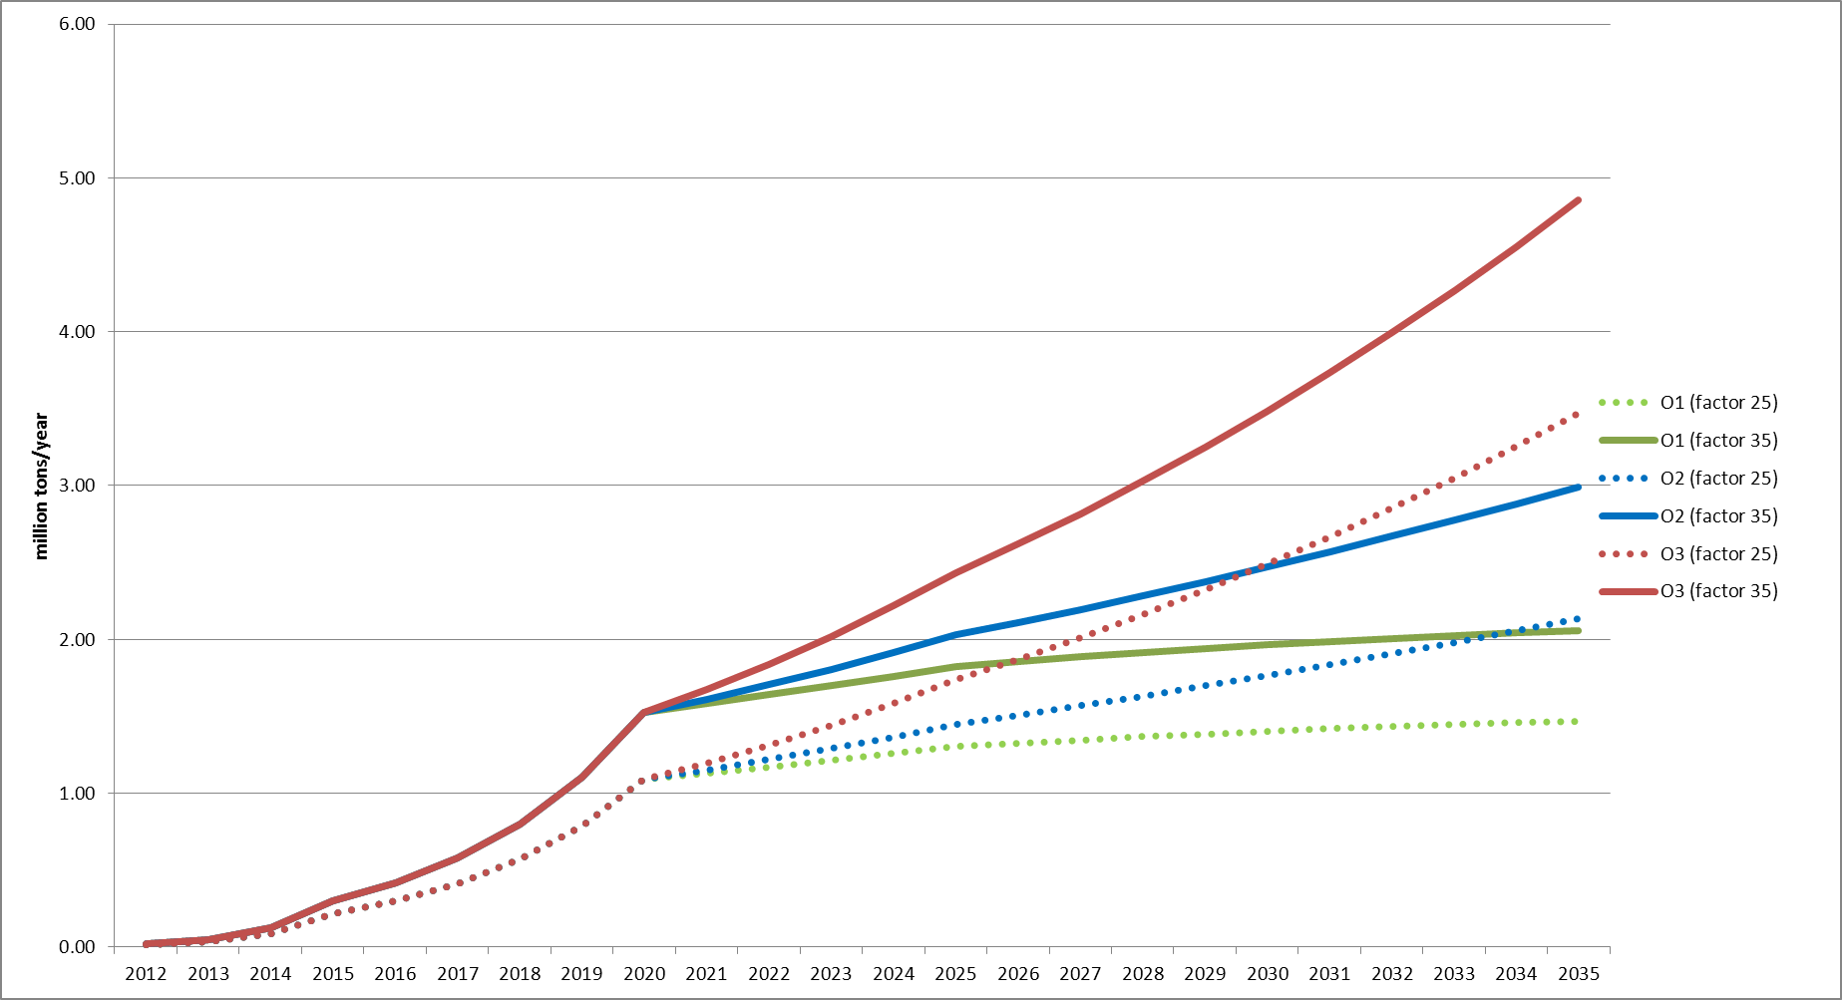
As shown in figure 7 above, the annual range in CO₂ reduction could potentially vary from 0.01-0.02 Mt/year in 2012 to 1.09-1.52 Mt/year in 2020 (for all three options), to 1.47-2.05 Mt/year (option 1), 2.13-2.99 Mt/year (option 2) and 3.47-4.85 Mt/year (option 3) in 2035. The cumulative CO₂ savings are presented in the table below. The figures are derived by adding each of the individual annual reductions expected per option from 2012 to 2035 as plotted in the figure above (lower figure refers to 25% capacity factor; higher figure refers to 35% capacity factor).
Figure 8: CO₂ reduction in million tons 2012 to 2035
 | 2012 | 2020 | 2025 | 2030 | 2035
Option 1 | 0.01 - 0.02 | 3.5 - 4.9 | 9.5 - 13.5 | 16.5 - 23 | 23.5 - 33
Option 2 | 0.01 - 0.02 | 3.5 - 4.9 | 10 - 14 | 18 - 25.5 | 28 - 39
Option 3 | 0.01 - 0.02 | 3.5 - 4.9 | 10.5 - 15 | 21.5 - 30 | 37 - 51.5
Difference 1&2 | 0 | 0 | 0.5 | 1.5 - 2.5 | 4.5 - 6
Difference 1&3 | 0 | 0 | 1 - 1.5 | 5 - 7 | 13.5 - 18.5
Besides contributing to decarbonisation, all 3 policy options will have a proportionally positive effect on air quality as SO_{2,} NO_{x} and particulate matter pollution is progressively decreased through displacement of conventional energy sources. This would have a positive impact on the health of the population.
Long-term monitoring data of the local ecological impacts of ocean energy installations are rather limited as there are few operating installations worldwide. Available information derives mostly from the operation or testing of single devices and is likely to be highly location-specific. A number of projects financed by the EU, such as SOWFIA, Equimar, ORECCA and Mermaid have carried out research in this domain but no definitive conclusions can as yet be drawn. The majority of stakeholders participating in the public consultation argued that the environmental impacts will be limited; it should be noted, however, that a large proportion of these stakeholders have a vested interest in the development of ocean energy.
The effects on sea-bed morphology, sediment transport, species distribution, disturbance through noise and vibration of turbines or the magnetic fields of power cables, entanglement of marine mammals in mooring lines or rotating turbines, and collisions of birds with infrastructure above sea-level should not be discounted. The impacts could grow substantially as ocean energy installed capacity increases progressively under each option. Annex 13 outlines possible specific environmental impacts of individual ocean energy technologies. Environmental impacts may also be beneficial, as voiced in the public consultation. For instance, because ocean energy farms are likely to constitute prohibited areas for commercial fisheries and navigation, they could prevent over-fishing and trawling and thus help the regeneration of certain species as well as provide a bio-diverse refuge around the foundations of the devices (providing 'artificial reefs'). The displacement of GHG emissions will also reduce acidification of the atmosphere and the seas.
In terms of the options proposed, options 2 and 3 will be more effective in tackling the related problems as they provide for a more structured framework in which to exchange information and share knowledge on environmental impacts. At the same time, all options require compliance with existing environmental legislation. Options 2 and 3 will enable a better understanding of how to optimally apply the relevant directives that the ocean energy sector develops in a sustainable manner.

6.5. Social impacts
The development of the ocean energy industry has the potential to generate new commercial activity and create a significant number of jobs in various sectors. Employment opportunities in the ocean energy industry are expected to fall broadly into four categories – project development, component manufacturing, project deployment and operations. The precise impact on employment in the period up to 2035 cannot be projected with absolute certainty; as with any commercial activity real growth depends on a number of economic, political and other factors. Indeed, while the impact of ocean energy on employment is generally assumed to be positive, estimates about the magnitude of job creation provided in the public consultation varied between thousands to tens of thousands.
The differences in the figures may be explained by the approach taken e.g., some sources distinguish between direct and indirect jobs while others do not; others make no distinction between temporary and permanent jobs. Furthermore, the lower jobs/MW ratio for the 2050 timeframe may be explained by the fact that, after an initial rapid growth in (mainly temporary) employment due to capacity build-up, (manufacturing and installation), employment rates (mainly permanent jobs in e.g. operations and maintenance) are expected to increase more slowly as the sector matures. A tentative estimate is made here about the level of permanent employment in operations and maintenance in 2035 under the different policy options. A multiplier of 1.67 and 0.84 for direct and indirect jobs respectively is used based on the figures provided by the EU-OEA, which distinguish between direct and indirect jobs. The multiplier is comparable to that in the Irish and US studies referred to in Annex 14. The results are shown in the table below.
Figure 9: Permanent jobs forecast in 2035 (operations & maintenance)
 | Direct | Indirect | Total
Option 1 | 3.000 – 7.500 | 1.500 – 4.000 | 4.500 – 11.500
Option 2 | 4.500 - 11.000 | 2.000 - 5.500 | 6.500 – 16.500
Option 3 | 7.000 – 17.500 | 3.500 – 9.000 | 10.500 – 26.500
Difference 1&2 | 1.500 – 3.500 | 500 – 1.500 | 2.000 – 5.000
Difference 1&3 | 4.000 – 10.000 | 2.000 – 5.000 | 6.000 – 15.000
This is a rather conservative estimate compared to figures supplied by the industry. The resulting number of permanent jobs in 2035 can be compared with the levels expected by Rutovitz and Atherton who estimate direct jobs at about 10.000-20.000 in a pro-renewable scenario. As for jobs in construction and installation, which are considered to be more temporary and tend to decrease in magnitude due to scaling up of technology and efficiency gains, it is possible to estimate around 2 000 to 3 000 jobs under option 1 and between 10 000 to 14 500 under option 3.
Given the currently limited installed capacity and developing supply chains, the exact regional economic and social impacts are difficult to predict. A positive impact could be expected to take place in those EU Member States with the biggest ocean energy potential such as Spain, Portugal, Ireland, France and the UK, some of which currently suffer from relatively high unemployment. While it is assumed that a large proportion of jobs created will mainly affect coastal regions (port services, installation, operation and maintenance), the regional impacts of job creation and on labour mobility will ultimately depend on the specificities of individual regions, the skill base present and the ability of the ocean energy sector to attract skilled workers. Job growth will not necessarily be limited to the coastal regions; specialised manufacturing including turbines, foundations, spare parts etc. can take place further inland, including in industrialised countries which do not necessarily have a high, or any, ocean energy resource potential. The diagram in Annex 15 clearly shows that the ocean energy supply chains are pan-European. Examples include the manufacture of tidal turbines, hydro-turbines and steel spare parts for power plants in Austria, wave power plants and generators in Germany and wave power attenuators and over-topping devices in Denmark. Manufactures of water turbines, e.g., could increase their commercial activities by expanding their competences to ocean energy power plant spare parts.
Increasing reliance on indigenous ocean energy will have beneficial effects on communities in the more remote parts of Europe such as the Canary Islands (Spain) which relies almost exclusively on fossil fuel imports or the Orkney Islands (UK) where 70% of electricity demand in 2012 derived from indigenous renewable energy and is anticipated to rise to 100% by 2013. The importance of such impacts will vary by region and will also depend on improvements in grid infrastructure.
Overall, higher investments in ocean energy under option 3 in particular and also option 2 can boost economic development and job creation in various regions. Whilst it could be argued that the jobs created in ocean energy will to some extent displace jobs in conventional electricity generation, it could be expected that the overall effect will be positive as relatively labour intensive production of electricity within the EU partially replaces imports of fossil fuels from third countries. However, a quantification of net effects is beyond the scope of this study.
As for education and training, it is useful to differentiate between skills that are transferable between different sectors such as offshore wind (e.g. engineering, naval architecture, financial services) and those that are more ocean energy-specific (e.g., project management, quality assurance, standard-setting, occupational health and safety). Under option 1, demand for both general and specific skills may not be high enough to pose a significant challenge to the more established sectors such as offshore wind. Under Option 2 and especially Option 3 an increase in demand for skilled engineers will tighten the competition with offshore wind and possibly even oil and gas. At the same time, a growth in the ocean energy sector could lead to an orientation of educational curricula for specific renewable energy courses. Ocean energy, as an emerging industry could also absorb the jobs lost in declining sectors such as shipbuilding and fisheries; existing skills which former employees of these sectors possess can be highly relevant for ocean energy.
The offshore energy sectors, conventional and renewable, are regarded as more dangerous than onshore ones due to adverse weather conditions. It is possible to learn from and develop synergies between emerging sectors such as ocean energy and more established ones such as oil and gas on issues relating to health and safety. Whilst potentially more workers will be exposed to risk as the sector grows, this could be offset by the improvement of health and safety standards resulting from accumulation of experience.
The progressive growth of the sector under the three options will affect the level of public acceptance on matters ranging from environmental impacts, competition for marine space as well as concerns about the visual impacts. Early stakeholder engagement will ensure that the impacts of ocean energy farms and potential conflicts arising from the use of marine space will be properly addressed and reduced. Wave and tidal devices, with their smaller profiles, will be less visible and so less likely to provoke an adverse reaction than other onshore and offshore renewable energy installations. Overall, public acceptance can be assumed to decrease with increasing capacity, as the arrays take up more space. If the negative impacts of ocean energy are perceived to be high and acceptance is low, projects could be delayed or stopped altogether whereas if acceptance is high, ocean energy could fully develop its economic potential as well as contribute to overall decarbonisation and climate change mitigation. Option 3 is expected to be more effective at raising awareness in particular as many of the initiatives proposed involve mainstreaming of ocean energy into the policy debate at EU level. Option 2 will also contribute to this process to a lesser extent whereas under option 1, it will mainly be the responsibility of the public authorities in individual MS to secure public acceptance so awareness will possibly remain at a lower level.

7. Comparison of Options
This section will evaluate the options against the objectives identified in section 4. The impacts of the options are summarised in the table below. The scoring of option 1 is informed by the fact that even if no additional action is taken, negative, neutral or positive developments can be expected on the issues under consideration. The cost of electricity, for instance, is expected to increase even if no additional action to support ocean energy is taken.
Figure 10: Comparison of options
 | Option 1 | Option 2 | Option 3
Economic Impacts
Levelised cost of electricity of ocean energy | + | ++ | +++
Consolidate R&D | 0/+ | ++ | +++
Cost for consumers | - | -- | ---
Competitiveness of EU | - | + | ++
Grid developments | 0 | +/0 | +/0
Supply chains and ports | 0 | + | ++
Synergies with other sectors | 0 | + | +
Administrative costs* | - | ++/- | ++/-
Environmental Impacts
Climate change mitigation | + | ++ | +++
'Other' ecological impact** | - | -- | ---
Treatment of uncertainty regarding environmental impact (best practice exchange) | 0 | ++ | +++
Facilitation of implementation of environmental legislation | 0 | 0 | +
Social Impacts
Job creation | + | ++ | +++
Creation of jobs in areas of high unemployment | + | ++ | +++
Education and training | NA | NA | NA
Skills mapping | 0 | ++ | ++
Health and safety | NA | NA | NA
Public acceptance*** | 0 | +/- | +/-
Key: + positive impact, ++ substantially positive impact, - negative impact, -- substantially negative impact, 0 no impact, NA – not applicable/very difficult to assess
* Whilst the proposed measures under options 2 and 3 would reduce the administrative cost over time, there are also costs associated with the administrative effort necessary to implement these measures.
** The nature and extent of other ecological impacts is highly technology specific, but it is prudent to assume that with ocean energy proliferation, the risk of adverse ecological impact would increase.
*** Depends on the level of stakeholder engagement.
Effectiveness
As an emerging industry, the sector requires stable and supportive policy so that it can compete with other energy technologies on a level playing field. The first section of the impact analysis evaluates the effectiveness of individual measures in addressing the specific objectives in more detail. There are clear trends to be observed; whilst certain relevant measures are currently under way under option 1 (e.g. some funding allocated to ocean energy under FP7 and NER300, ocean energy ERA-net, EIA Directive revision, the EU infrastructure package), these address the bottlenecks only partially, and often with no consideration for the specific needs of the industry. ocean energy is, for instance, currently not included in the SET-plan, which implies limited visibility, political endorsement and access to finance.
Option 2 measures seek to tackle the bottlenecks predominantly through the establishment of discussion/collaboration fora and best practice exchange, enhancing industrial cohesion and tapping into the experience already acquired by the industry and regulatory authorities. As argued and evidenced in Section 6, these instruments are likely to promote positive developments relevant to the fulfilment of the objectives. The magnitude of the positive impacts, however, depends to a great extent on the willingness of the parties to cooperate. Option 3 consists of option 2 measures and additional structural interventions. There is substantial evidence to suggest that the inclusion of ocean energy in the SET-plan and the creation of an EII in particular are potent instruments, likely to be effective in fulfilling the first two operational objectives. The development of guidance documents to facilitate the implementation of certain EU directives in the context of ocean energy project development could tackle the administrative issues highlighted in the stakeholder consultation in an effective manner; however, a sufficient amount of accumulated experience and detailed scoping are essential prerequisites for their elaboration.
Given that option 3 contains additional and more robust measures compared to option 1 and 2, it is likely to be most effective in tackling the identified problems. However, due to practical constrains (such as lack of available knowledge), some measures may be best pursued as a second step. The development of guidelines to assist with the implementation of EU environmental law, for example, may be best developed only after the specific issues are known and discussed in the framework of the roundtable. Overall, a stepped approach combining elements of options 2 and 3 may be more effective.
Efficiency
Taking no additional action on the EU level, in option 1, would not involve any additional costs. Whilst the sector would still probably continue to grow at a slow pace, much of its economic potential would be foregone and therefore it cannot be considered the most efficient option. Option 2 measures are likely to entail low costs; whilst the establishment of roundtables and best practice/data sharing platforms requires a certain effort, the associated administrative costs are not likely to be substantial. Although the extent to which these voluntary initiatives will achieve the objectives is uncertain, they are likely to yield some improvements. The cost to effectiveness ratio of this option as a whole is therefore likely to be favourable.
Option 3 includes more robust measures, the inclusion in the SET-plan and the creation of an EII are likely to be instrumental in helping the industry attain greater political saliency and achieve substantial technology cost reductions through collaboration. Weighed up against the administrative costs, this is likely to be a beneficial step to take. It was speculated that, overall, option 3 will lead to a market uptake which is higher than that stimulated by option 2 and option 1 measures in particular because recognition of ocean energy as a strategic energy technology would inspire more confidence in the sector and, as a result, the industry would attract more investment. However, the investment costs related to an EII can be substantial. Whilst a higher market uptake of an emerging, high-cost energy technology may initially have a negative impact on the cost to consumers because of the necessary financial incentives, this may be offset, at least in the medium term, by the systemic savings enabled through the balancing benefits of ocean energy, health benefits and environmental benefits.
From the perspective of efficiency it is beneficial to use existing structures to the highest possible degree. Option 3 proposes to establish a dedicated body to advance the interests of the offshore renewable industry related to grid infrastructure in the North Seas and in the Atlantic. Given that effective bodies with an overlapping remit (such as the Northern Seas Countries Offshore Grid Initiative) already exist, this particular measure is not deemed efficient.
Coherence
Given the non-binding nature of all of the measures assessed in the impact assessment, there are not likely to be any substantial trade-offs between the social, economic and environmental impacts they are likely to deliver. As such, the scope for a negative impact is limited. Although the post-2020 renewable energy and decarbonisation agenda is unknown at this stage, the political commitment to reduce CO₂ emissions by 80% - 95% compared to 1990 levels by 2050 remains in place. The competition for energy commodities is likely to grow as emerging economies develop and their energy demand increases. Energy security and decarbonisation are therefore likely to be important features of the future European energy policy framework. The measures proposed under option 2 and 3 fit well into this context. All of the instruments proposed here are also coherent with the current policy framework.
Feasibility
Whilst some measures, particularly those under option 2, are feasible in the short-term, certain measures from option 3 are only likely to be viable in the longer-term. To enable the establishment of an EII, for example, the industry must have prepared a strategic roadmap including milestones. The development of guidance documents to complement the Habitats and the Birds directives, in turn, requires the availability of a substantial body of knowledge on the environmental impacts of ocean energy. Similar considerations apply to the drafting of guidance documents to complement the provisions of Article 13 of the RES Directive. The sector-specific guidance to complement the MSP would likewise only be possible to conceive once the directive itself is adopted, implemented and its real impacts are known.
Rather than deciding between option 2 and 3, it is recommended that elements of both are adopted with the exception of the establishment of a dedicated strategic grid-planning body due to the reasons stated above. Furthermore, it is recommended that option 2 measures (namely the setting up of roundtables, mapping out of needs related to port services, identification of the specific constraints related to MSP etc.) are adopted as a first step and their results used as a basis for the stronger option 3 measures, which will help the industry to advance further. This could be done by setting out a concrete plan of action in a Commission Communication that will also set out the role that the industry, Member States and the Commission can play to advance the ocean energy sector.

8. Monitoring and Evaluation
It is proposed that the Commission monitors and evaluates the progress of the ocean energy industry on the basis of the following indicators. The data on installations, projects in planning and all the other elements outlined below will be acquired through surveys, which will be distributed to relevant stakeholders including technology developers, project developers, investors and targeted research institutions. The European Ocean Energy Association and the regular reporting by Member States on their progress towards the 20% renewable energy target should provide additional data. A first comprehensive evaluation could take place either within five years of adoption of the Communication on Ocean Energy or at the latest by 2020.
Figure 11: Core indicators to assess ocean energy development
Indicator | Relevance
Installed capacity | Technology commercialisation
Number of projects planned | Investor confidence and political saliency
Magnitude of investment into the sector | Perceived reliability, efficiency and cost-effectiveness of the technologies
Capital cost reduction | R&D efficiency
Capital cost reduction/R&D spending over a given period of time | R&D consolidation and efficiency
Number of collaborative undertakings | Industry cooperation and collaboration, synergies
Amount of Member State financial support for ocean energy, including differentiated revenue support schemes | Political saliency
Lead time length (i.e. the total time taken to get building consent and grid connection permits) | Efficiency of planning and licensing procedures
Proportion of the administrative cost compared to the total project costs | Efficiency of planning and licensing procedures
Availability of relevant baseline environmental data | Monitoring of environmental impacts
Time and resources spent satisfying the requirements of the EIAs | Optimising the application of environmental protection legislation

9. Annex 1: Acronyms & Glossary

Baseload Power Power generation plants which do not change production to match demands and instead operate constant production levels because it is more economical. Baseload generators (e.g. nuclear and coal) tend to have high fixed costs and low marginal costs
CAPEX Capital expenditure
Carbon Intensity Factor Measure of the amount of carbon dioxide (CO2) emitted per megawatt-hour of electricity
Capacity Factor Ratio of an actual output of a device over a period of time to its potential output if it was operated at full nameplate capacity
EIA Environmental impact assessment
EII European Industrial Initiative
EMEC European Marine Energy Centre
ERA-net European Research Area Network
EWEA European Wind Energy Association
EU-OEA European Ocean Energy Association
FP7 EU Seventh Framework Research Program
GHG Greenhouse gas emissions
Grant support Investment incentive
GW Gigawatt (rate of energy output)
GWh Gigawatt hour (unit of energy)
IEA International Energy Agency
IEA-OES International Energy Agency – Ocean Energy Systems
IMP Integrated Maritime Policy
JRC Joint Research Centre (of the European Commission)
KIC Knowledge and Innovation Community
LCoE Levelised cost of electricity
MSP Maritime spatial planning
MW Megawatt
MWh Megawatt hour
NER300 New Entrants Reserve Programme
NREAPs National Renewable Energy Action Plans
O&M Operations and Maintenance
OES-IA Ocean Energy Systems Implementing Agreement
OPEX Operational expenditure
ORECCA Offshore Renewable Energy Conversion Platform Coordination Action
RES Directive Directive on the promotion of the use of energy from renewable
sources
RES Renewable energy sources
Revenue support Production-based financial incentive
SET-Plan European Strategic Energy Technology Plan
SETIS Strategic Energies Technologies Information System
SIA Social Impact Assessment
SI Ocean Strategic Initiative on Ocean Energy Programme
SOWFIA Streamlining of Ocean Wave Farm Impact Assessments
WAVEPLAM Wave Energy Planning and Marketing

10. Annex 2: References
Ascoop J. et al. (2012), 'Stakeholder input into the design of the Atlantic Marine Energy Test Site', presented at the 4th International Conference on Ocean Energy, Dublin, 17-19 October 2012.
Boehlert, J. and T. Gill (2010) 'Environmental and Ecological Effects of Ocean Renewable Energy Development: a Current Analysis, Oceanography, vol. 23/2.
Bonnot-Courtois, M. (1993), 'Comparative study of dredging and flushing effects of sedimentation in the upper part of the Rance estuary', La Houille Blanche, 8, pp. 539-550.
Callaway, E. (2007) "Energy: To Catch a Wave", http://www.nature.com/news/2007/071107/full/450156a.html.
Carbon Trust (2006), 'Future marine energy', at: http://www.oceanrenewable.com/wp-content/uploads/2007/03/futuremarineenergy.pdf.
Carbon Trust (2011), 'Accelerating marine energy'.
Carbon Trust (2011), 'Marine Renewables Green Growth Paper'.
COM (2007) 575, 'An Integrated Maritime Policy for the European Union'.
COM (2007) 72, 'A European Strategic Energy Technology Plan (SET-Plan) - Towards a low carbon future'.
COM (2008) 768 final, 'Offshore Wind Energy: Action needed to deliver on the Energy Policy Objectives for 2020 and beyond'.
COM (2009) 519, 'Investing in the Development of Low Carbon Technologies (SET-Plan)'.
COM (2010) 2020, 'Europe 2020: a strategy for smart, sustainable and inclusive growth'.
COM (2011) 658, Commission proposal for a Regulation on 'Guidelines for trans-European energy infrastructure'.
COM (2011) 665, Commission proposal for a Regulation establishing the Connecting Europe Facility.
COM (2011) 782, 'Developing a Maritime Strategy for the Atlantic ocean Area'.
COM (2011) 885, 'Energy Roadmap 2050'.
COM (2012) 271, 'Renewable Energy: a major player in the European energy market'.
COM (2012) 494, 'Blue Growth: opportunities for marine and maritime growth'.
COM (2012) 663, 'Making the internal energy market work'.
COM (2012) 9432, Implementing Decision of 18.1.2.2012 Award Decision under the first call for proposals of the NER300 funding programme.
COM(2012) 628, Proposal for a Directive amending Directive 2011/92/EU on the assessment of the effects of certain public and private projects on the environment.
Community Guidelines of 1 April 2008 on State aid for environmental protection, OJ C 82 of 1.4.2008.
CSW(2013) 439 final, 'European Commission guidance for the design of renewables support schemes. Accompanying the document Communication from the Commission 'Delivering the internal market in electricity and making the most of public intervention''
Danish Ministry of Climate, Energy and Building, 'Energy report 2012', at: http://www.ens.dk/en-US/policy/danish-climate-and-energy-policy/Documents/Energy%20Policy%20Report%202012.pdf
De Roeck, Y.H. et al, paper presented to the 4th International Conference on Ocean Energy, Dublin, 17-19 October 2012.
DECC (2010) 'Severn tidal power: feasibility study conclusions and summary report' at: http://www.decc.gov.uk/assets/decc/what%20we%20do/uk%20energy%20supply/energy%20mix/renewable%20energy/severn-tp/621-severn-tidal-power-feasibility-study-conclusions-a.pdf.
Directive 2003/87/EC establishing a scheme for greenhouse gas emission allowance trading within the Community and amending Council Directive 96/61/EC, OJ L 275, 25.10.2003.
Directive 2008/56/EC of the European Parliament and of the Council of 17 June 2008 establishing a framework for community action in the field of marine environmental policy (Marine Strategy Framework Directive), OJ L 164, 25.6.2008.
Directive 2009/147/EC of the European Parliament and of the Council of 30 November 2009 on the conservation of wild birds (codified version), OJ L 20, 26.1.2010.
Directive 2009/28/EC of the European Parliament and of the Council of 23 April 2009 on the promotion of the use of energy from renewable sources and amending and subsequently repealing Directives 2001/77/EC and 2003/30/EC. OJ L 140, 5.6.2009.
Directive 92/43/EEC of 21 May 1992 on the conservation of natural habitats and of wild fauna and flora, OJ L 206, 22.7.92.
Ecofys (2011), 'Financing Renewable Energy in the European Energy Market'.
Ecorys (2012) 'Green growth opportunities in the EU shipbuilding sector'.
Ecorys (2013), 'Study in support of impact assessment work for ocean energy'.
Ecorys, Deltares and Océanic Développement (2012), Sub-function report on 'Ocean Renewable Energy Resources' from 'Blue Growth: Scenarios and drivers for Sustainable Growth from the Oceans, Seas and Coasts' .
Energy and Climate Change Committee of the House of Commons (2012): The Future of Marine Renewables in the UK. Eleventh Report of Session 2010-12 Volume II.
Ernst and Young (2012), 'Renewable Energy Country Attractiveness Indices', Issue 33.
Esteban, M. and D. Leary (2012), 'Current developments and future prospects of offshore wind and ocean energy', Applied Energy, Vol. 90.
EU Guidance on wind energy development in accordance with the EU nature legislation http://ec.europa.eu/environment/nature/natura2000/management/docs/Wind_farms.pdf.
EU-OEA (2010), 'Oceans of Energy: European Ocean Energy Roadmap 2010-2050", at: http://www.eu-oea.com/wp-content/uploads/2012/02/EUOEA-Roadmap.pdf.
EU-OEA and the Member States Ocean Energy Interest Group (2011), 'Position Paper: Towards European industrial leadership in Ocean Energy in 2020', at: https://www.gov.uk/government/uploads/system/uploads/attachment_data/file/48233/3610-position-paper-towards-euro-ind-leader.pdf.
EUR 24979 EN (2011), European Commission, JRC/SETIS “Technology Map 2011"
Eurostat Pocketbook on Energy, transport and environment indicators (2012): http://epp.eurostat.ec.europa.eu/cache/ITY_OFFPUB/KS-DK-12-001/EN/KS-DK-12-001-EN.PDF.
EWEA (2012), 'Positive environmental impacts of offshore wind farms', http://www.ewea.org/fileadmin/files/members-area/information-services/offshore/research-notes/120801_Positive_environmental_impacts.pdf
Frankfurt School UNEP Collaborating Centre and Bloomberg New Energy Finance (2012) 'Global Trends in Renewable Energy Investment 2012', at: http://fs-unep-centre.org/sites/default/files/publications/globaltrendsreport2012final.pdf
German Institute for Economic Research, 'German electricity prices: only a modest increase due to renewable energy expected', (2011): http://www.diw.de/documents/publikationen/73/diw_01.c.369430.de/diw_wr_2011-06.pdf
Gross, R., P. Heptonstall and W. Blyth (2007), 'Investment into electricity generation: the role of costs, incentives and risks', UK EREC report.
Halpern B. S. (2003) 'The impact of marine reserves: do reserves work and does reserve size matter?', Ecological Applications, 13, pp. 117–37.
House of Commons 'Science and Technology – 7th Report, House of Commons Science and Technology Committee Publications, UK, (2001).
IEA (2010), Energy Technology Systems Analysis Programme, November 2010 'Technology Brief', www.etsap.org.
IEA (2012), 'World Energy Outlook 2012'.
IEA-OES (2009), 'Annual report', at: http://www.ocean-energy-systems.org/oes_documents/annual_reports/
IEA-OES (2011), 'Annual report 2011', at: http://www.ocean-energy-systems.org/oes_documents/annual_reports/
IEA-OES (2012), 'Market Driver Analysis', at: http://www.ocean-energy-systems.org/ocean_energy/in_depth_articles/market_driver_analysis/; 'Oceans of Energy: European Ocean Energy Roadmap 2010-2050", EU-OEA (2010).
Institution of Mechanical Engineers (undated), 'Marine Energy: More than just a drop in the ocean?' http://www.imeche.org/Libraries/Key_Themes/MarineEnergyReport.sflb.ashx.
Jeffrey, H. et al. (2012), 'Accelerating the development of marine energy: Exploring the prospects, benefits and challenges, Technol. Forecast. Soc. Change (2012), doi:10.1016/j.techfore.2012.03.004.
Junginger et al. (2008), 'Technological learning in the energy sector' (2008): http://www.ecn.nl/docs/library/report/2008/e08034.pdf.
Katofsky, R. (2008) 'Ocean energy: technology basics', Renewable Energy Focus (2008).
Langhamer et al. (2010) 'Wave power—Sustainable energy or environmentally costly? A review with special emphasis on linear wave energy converters Renewable and Sustainable Energy Reviews', 14 (2010) 1329–1335.
Lewis, A., S. Estefen, J. Huckerby, W. Musial, T. Pontes, J. Torres-Martinez, (2011), 'Ocean Energy'. In IPCC Special Report on Renewable Energy Sources and Climate Change Mitigation. [O. Edenhofer, R. Pichs-Madruga, Y. Sokona, K. Seyboth, P. Matschoss, S. Kadner, T. Zwickel, P. Eickemeier, G. Hansen, S. Schlömer, C. von Stechow (eds)]. Cambridge University Press, Cambridge, United Kingdom and New York, NY, USA.
Limassol Declaration (2012), 'A Marine and Maritime Agenda for Growth and Jobs', adopted at the Informal ministerial meeting in Nicosia, Cyprus, on 7 October 2012: http://www.cy2012.eu/index.php/el/file/TphGtH7COdr2nxXo9+AUZw==/
Marine Energy Program Board – Electricity Market Reform Expert Group (2012) 'Catalysing Growth: the Opportunity Presented by Tidal Stream Energy Generation' Response to national Grid call for evidence to support the development of strike prices.
Messinger M. & R. Almon (2009), 'Making Waves on the Ocean Energy Patent Landscape', Clean Tech Law and Business, at: http://www.sternekessler.com/media/pnc/3/media.1053.pdf.
Murray D., C. Carr, J. Jeffers and A. Núñez-Luna(2011, 'Riding the Wave: Confronting Jurisdictional and Regulatory Barriers to Ocean Energy Development', 5 Golden Gate Univ. Env. L. J. 159
National Renewable Energy Laboratory (2009) ' Ocean Energy Technology Overview'.
Navigant Consulting (2009), 'Job Creation Opportunities in Hydropower'.
Neij, L. (2008), ‘Cost development of future technologies for power generation – A study based on experience curves and complementary bottom-up assessments'. Energy Policy 36, pp. 2200-2211.
O’Hagan, A. M., (2011) 'Maritime Spatial Planning (MSP) in the EU and its Application to Marine Renewable Energy' in IEA OES-IA Annual Report 2011.
O'Hagan. A. M, (2012), 'A review of international consenting regimes for marine renewables: are we moving towards better practice?', Hydraulics & Marine Research Centre, University College Cork. Paper presented to the 4th International Conference on Ocean Energy, Dublin, 17-19 October 2012.
Ocean Renewable Energy Coalition (2011). 'U.S. Marine and Hydrokinetic Renewable Energy Roadmap'.
ORECCA (Offshore Renewable Energy Conversion Platform Coordination Action) (2011), 'Investment and Grant Opportunities For Offshore Renewable Energy Projects in Europe', at: http://www.orecca.eu/c/document_library/get_file?uuid=3f2f5122-906a-4b82-9fa2-c626aba62399&groupId=10129.
ORECCA (Offshore Renewable Energy Conversion Platform Coordination Action) (2011), 'European Offshore Renewable Energy Roadmap', at: http://www.orecca.eu/documents.
Post, J. W. (2009) Blue Energy: electricity production from salinity gradients by reverse electrodialysis at http://www.waddenacademie.nl/fileadmin/inhoud/pdf/06-wadweten/Proefschriften/thesis_jan_Post.pdf.
Proposal for a Regulation on guidelines for trans-European energy infrastructure and repealing Decision No 1364/2006/EC, COM (2011) 658.
Redpoint Energy Limited (2009), 'The benefits of marine technologies within a diversified renewables mix: A report for the British Wind Energy Association', at: http://www.oceanrenewable.com/wp-content/uploads/2009/06/redpoint_report.pdf.
Regulation (EC) No 1228/2003 on conditions for access to the network for cross-border exchanges in electricity, OJ L 176, 15.07.2003.
Rutovitz J. and A. Atherton (2009), ' Energy sector jobs to 2030: a global analysis. Final report', Institute for Sustainable Futures. Study conducted on behalf of Greenpeace.
Sanchirico J. N., Malvadkar U., Hastings A., Wilen J. E. (2006) 'When are no-take zones an economically optimal fishery management strategy?', Ecological Applications, 16, pp. 1643–59.
Seanergy 2020 Report (2012), 'Delivering offshore electricity to the EU', at: http://www.seanergy2020.eu/. Project supported by the Intelligent Energy Europe Programme.
SEC(2011)1565 Impact Assessment accompanying the Energy Roadmap 2050.
Simas et al. (2012), 'Understanding the role of stakeholders in the wave energy consenting process: engagement and sensitivities', paper presented to the 4th International Conference on Ocean Energy, Dublin, 17-19 October 2012.
SWD (2012) 149, Impact Assessment on 'Renewable Energy: a major player in the European energy market'.
Thalemann, F. & J. Bard (2012), 'Offshore Supply Chain Requirements for Ocean Energy in Europe – Results from the ORECCA Project', 4th ICOE, Dublin, 17-19 October 2012.
U.S. Department of Energy (2012), 'Water Power for a Clean Energy Future'
UK Energy Research Centre (2010), ‘Great Expectations: the cost of offshore wind in the UK waters – understanding the past and projecting the future', at: www.ukerc.ac.uk/support/tiki-download_file.php?fileId=1164.
WindBarriers Report (2010), 'Administrative and grid access barriers to wind power', at: http://www.windbarriers.eu/fileadmin/WB_docs/documents/WindBarriers_report.pdf

11. Annex 3: Results of the Public Consultation
Introduction
Ocean energy is one of the focus areas identified as a potential source of growth in the European Commission's Blue Growth Communication. It is widely recognised that developing the energy resource in our seas and oceans could benefit European citizens by increasing energy security, enhancing economic growth and job creation, and mitigating the negative impacts of climate change. There are, however, significant investment costs and bottlenecks that would need to be overcome. Ocean energy is believed to be able to supply up to 15% of EU energy demand in 2050 but only 248MW are currently installed equivalent to approximately 0.02%.
This public consultation on ocean energy was carried out in order to gain insight into the development of these energy resources. The responses will serve as a basis for an assessment of the policy options available to support this sector at the EU level. The consultation process took place over two months (14 June – 14 September 2012); as of 9th October 2012, 128 responses were received from a variety of stakeholders. The key findings of the public consultation are reported below.
Section 1: Profile of respondents (Q1-Q4)
i) Occupational profile of respondents
The private sector was well represented among the respondents, with 34%. Electricity companies and technology developers constituted the majority of this group. Civil society was represented predominantly by environmental associations and individuals and the public sector by public authorities at various levels. Research institutes accounted for 23% of the respondents.
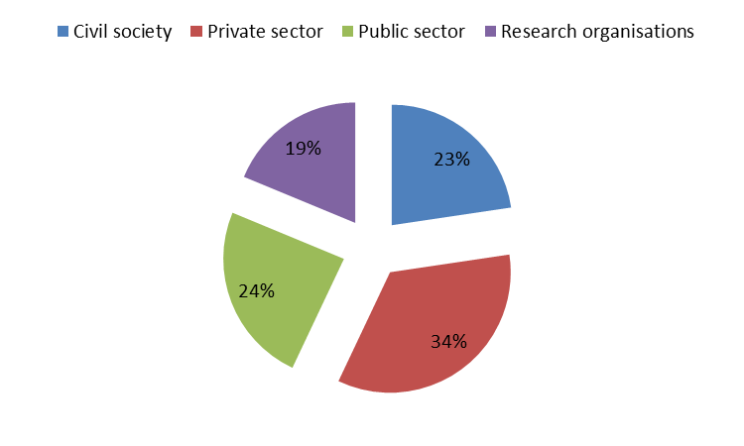
ii) Respondents' place of residence
Stakeholders from 16 EU Member States and 4 non-EU states (Canada, Norway, Channel Islands and Australia) took part in the public consultation. The largest proportion of the respondents (39%) came from France, followed by the United Kingdom (11%) and Spain (10%). With a few exceptions, there is a correlation between the respondents' place of residence and the places where ocean energy has the greatest known potential, i.e. in the countries bordering the Atlantic Ocean.
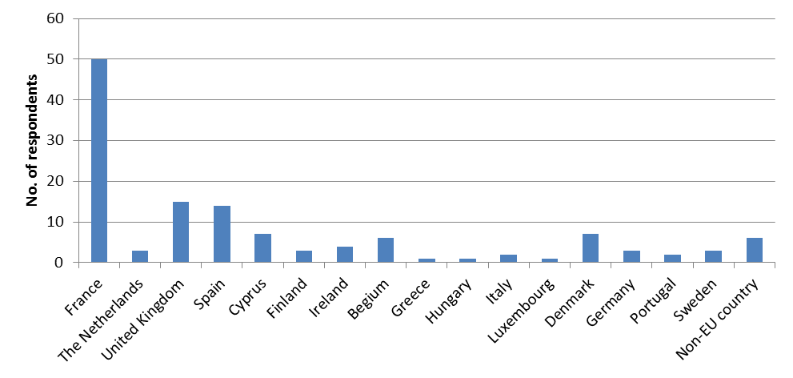
Section 2: Technical Assessment (Q5-Q9)
i) Potential for growth
The responses indicate that there appears to be a strong consensus that ocean energy does have a substantial potential for development. Only 1% of respondents claimed that ocean energy does not have a potential to contribute to the electricity supply mix in a significant way. We have to take into account, however, that a large proportion of the respondents consist of stakeholders, who may have a vested interest to accelerate the development of the sector; it is natural that responses from this group should be rather optimistic. Similar caution may also have to be applied when interpreting other questions.
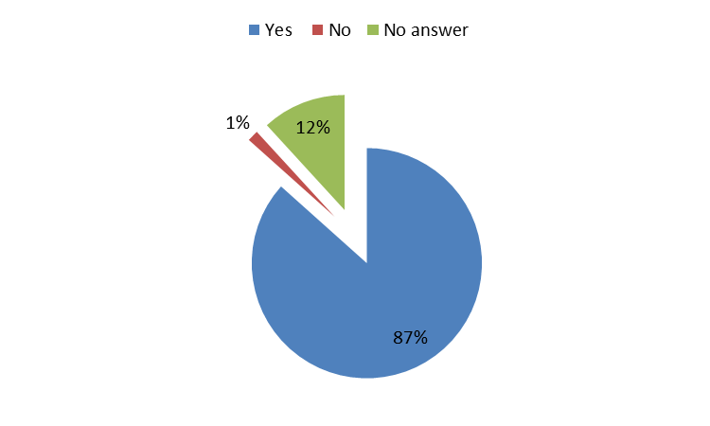
The respondents were asked to assess the magnitude of the potential and the timeline over which they expect it to be developed. Different approaches were adopted – whilst some respondents quoted published studies, others supplied their own estimates. Some only specified the expected timescale, for example stating that that substantial contribution from ocean energy is likely to materialise from 2040 onwards; these are marked in the table below with an 'x'. Predominantly, respondents have made their forecasts in terms of installed capacity or percentage of EU electricity production. The geographical scope also varied, with some giving their assessment for a single country and others for the whole of Europe or the entire world.

2,5-3,5GW -> 5-14 TWh/yr in France |  |  |  | Public sector
0,30% |  |  | 12% | Research institute
 |  | x |  | Environmental association
 |  | x |  | Environmental association
 | 24-70 TWh/yr (<2%) |  |  | Environmental association
 | 5% |  |  | Individual
x |  |  |  | Individual
x |  |  |  | Individual
 |  | 100GW |  | Individual
10-50MW | 100sMW |  |  | Individual
x |  |  |  | Individual
 | x |  |  | Utility
 | 500MW |  | 3GW | Utility
<1% | 3% | 10% | 10% | Utility
30GW |  | 80GW |  | Utility
2,5-3,5GW -> 5-14 TWh/yr |  |  |  | Utility
100MW | 1GW | 10GW |  | Private company
3GW in France |  |  |  | Private company
1,7GW | 5GW |  |  | Utility
x |  |  |  | Private company (ports)
 | x |  |  | Individual
 |  | 5 - 10% |  | Private company (port services)
1GW | 10GW | 50GW | 100GW | Technology developer
 | 20GW |  |  | Technology developer
2GW | Matching offshore wind |  |  | Technology developer
16GW -> 80TWh | 66GW - > 300TWh | 120GW ->600TWh | 240GW -> 960TWh | Technology developer
189GW |  |  |  | Technology developer
1GW | 15GW |  |  | Technology developer
x |  |  |  | Technology developer
300MW | 2500MW | 15GW | 100GW | Technology developer
1GW | 10GW | 50GW | 200GW | Public sector - energy agency
1GW |  |  |  | Research institute
2,5-3,5GW -> 5-14 TWh/yr in France |  |  |  | Public sector
2,5-3,5GW -> 5-14 TWh/yr in France |  |  |  | Public sector
2,5-3,5GW -> 5-14 TWh/yr in France |  |  |  | Private company (shipbuilding)
2,5-3,5GW -> 5-14 TWh/yr in France |  |  |  | Research institute
 | x |  |  | Public authority
2,5-3,5GW -> 5-14 TWh/yr in France |  |  |  | Public authority
300MW |  |  | 2-3GW | Public authority
160-200MW | 1,6GW |  |  | Public authority
 |  | <1% |  | Research institute
30MW | 1GW+ |  |  | Research institute
120GW |  |  |  | Research institute
 | 50GW |  |  | Research institute
5GW | 6GW | 7GW | 8GW | Research institute
 | x |  |  | Research institute
1% | 5% |  | 20% | Research institute
1GW | 10GW | 50GW | 200GW | Research institute/think tank
10MW | 100MW | 1GW | 3GW | Research institute/think tank
 |  |  | 337GW globally | Research institute/think tank
2,1 GW |  |  | 152 GW | Utility
 | 3,6 GW |  | 188 GW | Utility
2,5-3,5GW -> 5-14 TWh/yr in France |  |  |  | Private company

The figure below shows some of the stakeholders' estimates and the trends they forecast until 2050. For the sake of coherence, only the estimates for EU-27 were considered; the estimates where either the timescale or the quantity was not specified were omitted. Responses were converted into the same units, i.e. equivalent installed capacity.
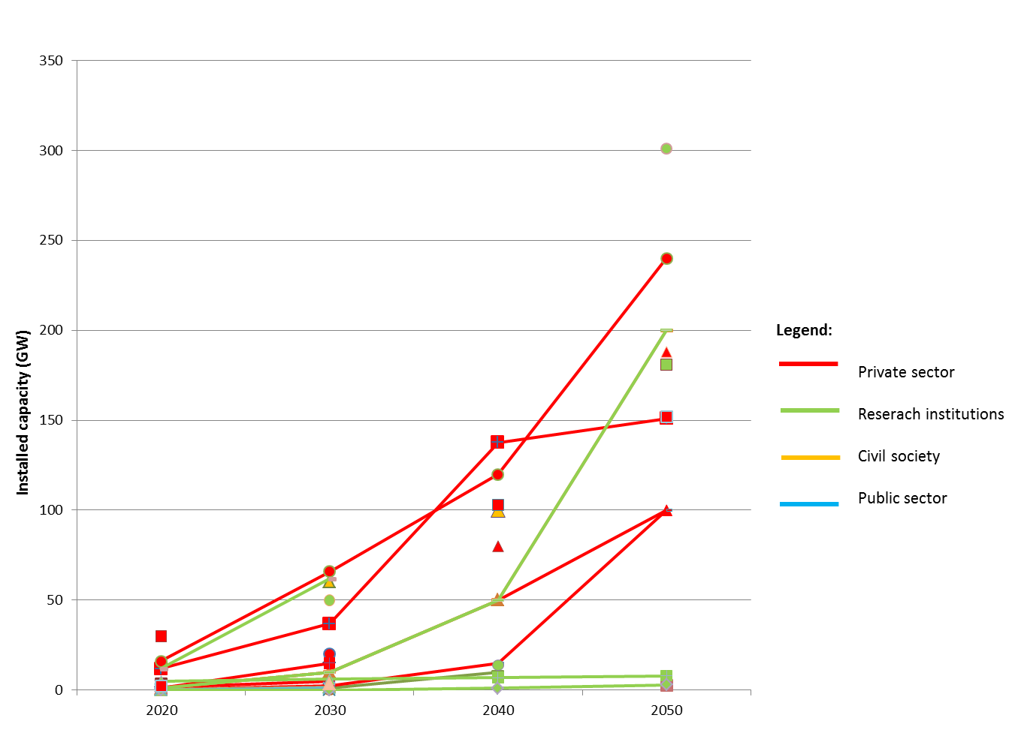
Unfortunately there is not enough data available to make robust claims as to how individual stakeholder groups perceive the potential of ocean energy. Generally speaking, however, private sector actors appear to have a more optimistic outlook on the development of ocean energy potential compared to other stakeholders. The forecast figures provided by research organisations vary widely, with some being conservative and others optimistic. Very few public authorities and civil society actors provided quantified estimates.
On the whole, most stakeholders seem to have a relatively cautious approach as to the potential of ocean energy until 2020; most estimated that the installed capacity would be up to 10GW. For the period after 2020, however, the responses diverge into two directions – one group of respondents believes that the contribution of ocean energy to the energy mix will remain modest but the second group is more optimistic, forecasting a steep growth and estimating that in 2050 energy from seas and oceans could contribute up to 10-12% of projected EU electricity consumption, the equivalent of approximately 150GW of installed capacity. Several respondents stated that the speed at which the technology is taken up by the market will depend on the policy support provided.
ii) Technical barriers
In this section respondents were asked about barriers to the deployment of ocean energy. Specific comments on the stage of technology development as such were solicited in subsequent chapters. Against this background, issues with grid connection were the most frequently quoted barrier to the development of ocean energy overall, with 56% of respondents indicating that this is a problem. 'Other' barriers (46%; viz. table below for more detail), the lack of agreed standards and technical specifications (39%), and lack of construction and installation vessels (31%) followed as the most frequently mentioned barriers.
There appears to be no significant divergence as to the perception of the relative importance of these barriers among the different stakeholder groups. In all groups except the private sector, grid connection issues feature as the most frequently mentioned barrier.
Grid connection issues | Technical | Reliable low-cost connectors, HVDC systems to reduce power losses, prevention of corrosion, active power controllability, need of further R&D for 'intelligent' grid
Grid connection issues | Economic | Long lead times – "financing reinforcements in a timely manner is critical", deficiencies in all parts of the grid infrastructure (nodes, hubs, storage, interconnectors), lack of certainty - negative impact for the sector and sub-sector industries, reinforcements needed, current use of system charges in certain Member States, distribution of costs – "developers alone cannot carry the cost"
Grid connection issues | Administrative | Long and complex planning procedures, lack of experimental data from prototypes

Given the early stage of development of ocean energy, it might perhaps be surprising that grid connection problems are given so much attention. From the detailed responses, however, it becomes apparent that stakeholders are conscious of the grid-related complications that have impeded renewable energy projects, both onshore and offshore, in the past . Even though ocean energy technologies are largely in the pre-commercial stage, the lack of certainty and excessive costs of grid connection are already seen to be a risk, eroding stakeholders' confidence and therefore slowing down the progress of the sector.
According to one technology developer, "having in place a clear and accessible process for guaranteeing grid access to early stage ocean projects is a fundamental step, without which ocean energy projects cannot progress. Experience in a number of Member States has shown the process to gain access to grid can be long and complex and can preclude ocean energy." The relativively small size and, in some instances, remoteness of ocean energy projects make grid connections economically unviable, according to one utility stakeholder who stated that"major transmission projects are only viable at >500MW".
Among 'other' barriers, respondents mentioned a wide variety of issues, some of a technical nature relating to the devices themselves but most of the highlighted problems were administrative and economic. The table belows shows a more detailed breakdown.
Other | Technical | Lack of proven designs, proving reliability and survivability of devices and materials, lack of availability of marine space, technology-related obstacles, variety of designs - lack of convergence, subsea converters and transformers
Other | Economic | Insufficient cable manufacturing capacity, financing and insurance issues, electricity storage, investment security, inappropriate capital grants and revenue support, skill shortages, lack of research funds, weak supply chains, small SMEs in the sector - lack access to finance
Other | Administrative | Public acceptance - problem with co-usage of marine areas e.g. for fishing, aquaculture, agreement between countries over deep sea offshore platforms

iii) Grid planning
Regional cooperation on grid development in sea basins is largely seen as beneficial (77%). While electricity from ocean sources is not expected to be produced at a commercial scale in the short-term, several stakeholders emphasised that integrated grid planning is crucial to provide a basis for long-term industrial plans and that an integrated approach will reduce costs. The North Sea offshore grid development is considered to be a good example of successful cooperation, beneficial for ocean energy development, and also because it facilitates supply and demand balancing.
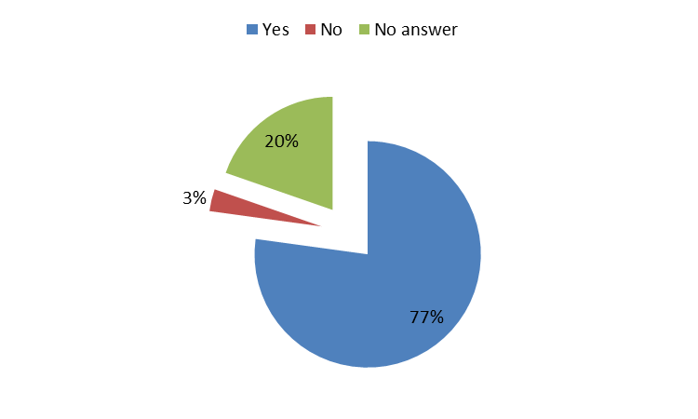

iv) Cost reductions
The vast majority of respondents agreed that there is a clear scope for cost reductions in the installation and maintenance of projects (80%). Only 3% of respondents believe that cost reductions cannot be achieved over time and 17% gave no answer.
Respondents were also asked for their assessment of the magnitude and the timeframe over which cost reductions will take place, and about their drivers. A large proportion of respondents only gave a generic answer, stating that as the technology progresses down the learning curve, and economies of scale materialise, reductions in cost will take place automatically. Several respondents argued that cost reduction is likely to happen at a similar pace to the offshore wind technology, as ocean energy technologies face similar constraints.
Among those respondents who gave a quantified assessment, the average for estimated cost reduction is 50% over the next two decades. The estimates of cost reduction potential, however, vary widely as well as the assumed starting points, which are 250-480EUR/MWh for power from wave technology and 200-330EUR/MWh for power from tidal stream technologies. There is an agreement that costs can be reduced faster if R&D is well supported.
v) Synergies, multi-purpose platforms and multi-use of maritime space
Two distinct issues were under scrutiny – the possibility for synergies in infrastructure use (e.g. multi-purpose platforms) and the synergies in the use of marine space.
The majority of respondents agreed that joint utilisation of infrastructure including multi-purpose platforms presents a considerable opportunity for cost reductions in the longer term, but is not likely to materialise in the short to medium-term. Respondents referred to the risks involved (the development of offshore wind and ocean energy is at different stages, which could imply problems with project financing) and, at large, argued that priority should be given to the optimisation of individual technologies. Many respondents also drew attention to the fact that the scope for combined use of both infrastructure and marine space varies depending on the technology combination considered – whilst wave energy and offshore wind can co-exist, others may not (e.g. this may be more relevant for wave than for tidal energy).
Despite the caveats, there is a broad agreement that cooperation, integration and combined infrastructure use should be actively promoted through policy. Effective Maritime Spatial Planning was often mentioned as key to the selection of appropriate sites for ocean energy, avoiding their interference with other maritime space use and helping to identify synergies. Strategic Environmental Assessment, streamlined consenting and leasing procedures and high-level grid planning are some of the other policy/administrative tools suggested to promote efficient use of marine space.
Funding of multi-purpose platform projects (similar to those which already exist under FP7 energy related and Oceans of Tomorrow programmes such as the MARINA Platform and TROPOS), can, in turn, help to champion infrastructure multi-use. One respondent suggested that multi-purpose platform technologies could also be given priority in the consent/lease round procedures.
Section 3: Research Needs (Q10-Q12)
i) Research needs
There is a strong consensus, across all stakeholder groups, that further research is needed to support the development of ocean energy (81%). Given that the sector is in its infancy, a wide range of issues were identified as deserving of new research. The table below details some of the most often quoted areas and specific issues that need to be targeted by R&D efforts.
Category | Examples
Resource mapping and ambient conditions | Meteorological and oceanographic modelling, impact of climate change, bathymetry, economic value of different marine space usages
Array and multi-device interactions | Wake effect, multi-purpose platforms
Environmental impacts | Baseline state of the environment, vulnerability of bird, fish and marine mammal species to habitat loss, collision risks, entrapment and disturbance/displacement
Technology optimization | Demonstration of prototypes, design optimisation (2nd and 3rd generation concepts), floating devices, mooring and foundations, materials, cost reduction, reliability, control systems
Enabling technologies | Grid connection, vessel design, submarine converters and transformers, storage
O&M improvements | Corrosion resistance, bio-fouling prevention, maintenance systems for osmotic power

ii) Scope for coordination and cooperation
Several respondents mentioned that there is a significant scope for collaborative working in research and development. A common research agenda, whereby a comprehensive, planned programme would converge around ocean energy rather than individual technologies would be welcomed by 69% of respondents, 11% are against it and 20% gave no answer.
Respondents broadly agree that there is a clear opportunity for efficiency gains and accelerated development from cooperation, and it would be especially beneficial in certain domains such as assessing the cumulative impact of ocean energy on the environment, various trans-boundary issues and developing enabling technologies such as vessels etc. Several respondents mentioned that the EU is uniquely positioned to coordinate research in this area. Some, however, also pointed out the risks, including possible competition problems and the danger of 'picking winners' on which research efforts would be focused.
Respondents also called out for adequate funding of research. According to one respondent, for example, EU research spending on ocean energy is "relatively modest", however, "it has the potential to have a disproportionately high impact by increasing coordination, avoiding duplication, and ensuring complementarity across the research already being funded".
International cooperation
The majority of respondents (68%) agree that cooperation with international partners would have a beneficial impact on the development of ocean energy, 12% are against and 20% gave no answer. The most frequently quoted international partners include the USA, Canada, Australia, Japan, South Korea and China. Non-EU European states, Norway and the Channel Islands, were also identified as possible cooperation partners.
The main benefits include knowledge sharing and resource pooling. Stakeholders have pointed out that because of the nature of the sector (highly specialised, technical and capital-intensive) international cooperation is a necessity and will create new opportunities in Europe. One respondent drew attention to the risk of Europe losing its technology lead and argued that Europe must maintain attractive conditions for ocean energy development to maintain its international leadership.
Section 4: Training, Employment, Social Implications (Q13-Q14)
The overwhelming majority of respondents claimed that the impact of ocean energy development on employment will be positive and that jobs will be created in engineering, manufacturing and shipbuilding, as well as in operations and maintenance and other areas. It was mentioned that there may be some loss of jobs in the fishing and tourism sectors due to ocean energy developments but that these are likely to be more than offset by the gains in the new industry. The estimates with respect to the magnitude of job creation vary between thousands to tens of thousands but some have remarked it is too early to assess it at this stage.
Another positive social impact is related to the distribution of the potential employment growth. Several respondents have drawn attention to the fact that jobs are likely to be created in rural coastal areas where opportunities are currently scarce, and would replace the jobs that are disappearing in declining maritime industries. Ocean energy could, therefore, contribute to the revitalisation and diversification of marine economies.
There is a consensus that new technologies will require new skills in the workforce. Whilst it might be possible to recruit workers from shipyards or the offshore oil & gas and wind sectors, new specialised qualification programmes are likely to be needed.
Section 5: Environmental Issues and Climate Change (Q15-Q16)
There appears to be a wide consensus among the respondents that the overall environmental impact will be positive or mostly positive (68%). Only 2% of respondents believe that the net environmental impact will be negative.
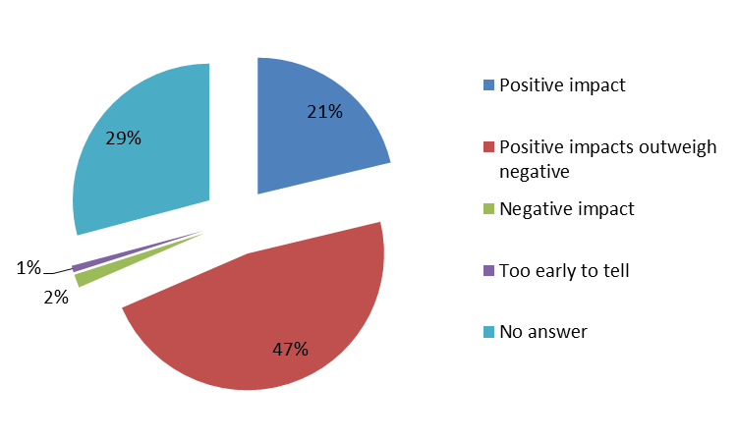
The most commonly held view is that whilst certain short-term local negative impacts on marine wildlife are to be expected, these are likely to be more than offset by the benefits to marine and land-based ecosystems. The geographical distribution of environmental costs and benefits incurred through the development of ocean energy was highlighted – whilst the negative impacts will tend to be local, the most important benefit i.e. climate change mitigation will be global.
Respondents also drew attention to the fact that the most potential for environmental harm exists during the early and final stages of project implementation i.e. when sites are selected, during construction and decommissioning. The underpinning proposition expressed by many is that all forms of energy technology deployment have a negative impact on the environment and ocean energy is superior in this respect compared to alternatives.
The environmental costs and benefits mentioned in the consultation are listed below:
Costs | Benefits
- Habitat change or destruction  - Noise and vibration  - Possible local extinction of fish species when tidal barrages are deployed  - Bird collisions with infrastructure above water  - Rotating turbines can be a risk to fish, marine mammals and diving birds  - Entanglement of marine mammals in mooring lines or floating devices  - Certain species respond to the magnetic field around electricity cables | - Prevention of trawling  - Displacement of greenhouse gas emissions (associated reduction in temperature rise and acidification)  - Artificial reefs locally enhancing biomass and providing a sanctuary for some species  - Better monitoring and understanding of marine ecosystems  - Most severe disruption likely to be short-lived (construction phase)
Several respondents pointed out that the empirical evidence currently available regarding the environmental impacts of ocean energy is limited. Single devices are likely to have negligible environmental impact whilst whole arrays can have a more substantial effect. A more realistic picture of the overall environmental impact ocean energy installations can have will therefore emerge as more data from demonstration sites becomes available.
Thorough monitoring, data availability, more research on the environmental impact of large arrays of devices, and designation of protected areas in Maritime Spatial Planning have been mentioned by respondents as some of the means that should be employed in order to minimise the adverse impacts of ocean energy on the environment and to maximise the benefits.
Climate change
According to 53% of the respondents, climate change will not be a significant impediment to the development of ocean energy. 20% believe it is, and 27% did not respond to this question.
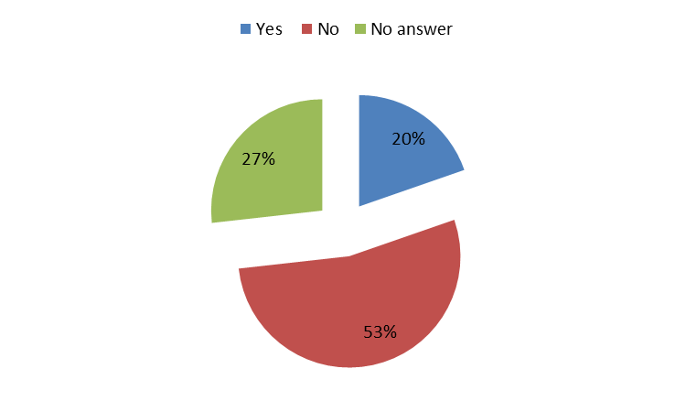
The majority view is that climate change will not have a significant impact on tidal technologies, because the resource is influenced by lunar patterns. Climate change will, however, raise the sea level, which can to a certain extent affect wave height, tidal flow and salinity gradient; glacial melt could also alter the flow of ocean currents. Climate change impacts on weather systems and extreme events may also have important implications on weather windows for deployment, operation and maintenance of devices.
In order to minimise the negative impact of climate change on ocean energy deployments, certain measures can be taken. Respondents mentioned the need for careful planning, on-going monitoring and continual improvement in the design of devices and operational strategies.
Section 6: Administrative Issues and Knowledge (Q17-Q23)
i) Support for Ocean Energy development at EU level
There is a large majority opinion (82%) that there should be a specific policy supporting ocean energy development at EU level. 4% of respondents disagree and 14% gave no answer. There was no significant divergence as to how this issue is perceived by different stakeholder groups.
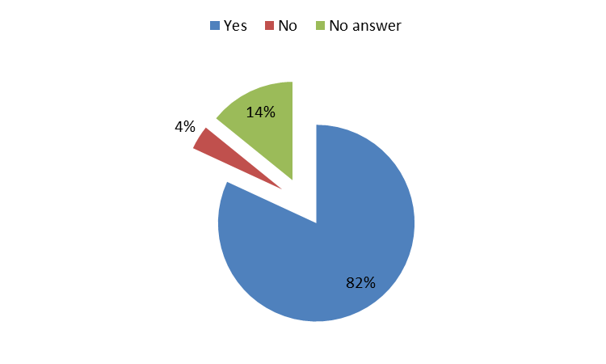
When asked to specify the nature of the initiatives that should be undertaken, many stakeholders only offered general statements, claiming that policy should focus on cost and risk reduction. There is a broad agreement that at this stage of development, the public sector has a key role to play and that a well-designed stable policy will be vital in order to attract private investment.
Below are of the more concrete legislative and non-legislative initiatives suggested by respondents, listed in the order of frequency at which they were mentioned:
- Enhanced and better coordinated research agenda, along with adequate funding (including capital grants; FP7 and NER300 were commended but need to be strengthened)
- Clear declaration of support for ocean energy (possibly including a roadmap) and stability of the policy environment
- Revenue support (e.g. incentives for Member States to support ocean energy, minimum feed-in-tariff guarantee, ensuring support stability, more coherent or harmonised deployment of support schemes to create a larger undistorted market etc.)
- Sharing of best practice
- Streamlining and harmonising of regulatory and licensing procedures and reducing red tape
- Strategic planning of grid infrastructure to facilitate deployment
- A plan to include ocean energy in Maritime Spatial Planning initiatives
- Indicative targets for the amount of energy produced from ocean energy by 2030/2050
By far the greatest number of respondents, across stakeholder groups, called out for enhanced efforts in research. It was often argued that more funds should be made available, but also that research in this domain should be better coordinated. One civil society stakeholder, for example, suggested that "research and development incentives could run on ten year funding cycles to help developers stay with the program over the long haul" and that a "centralised "clearing house" organising and commissioning R&D" could be set up to endure that efforts are coordinated. More specifically, some respondents recommended that ocean energy should be included in the Strategic Energy Technology plan (SET-plan) in the future which would include a European Industrial Initiative for ocean energy.
Private sector actors in particular demanded a clear demonstration of support for the development of ocean energy technologies, as this can help to harness private investment. They also frequently called out for enhanced revenue support. The level of revenue support for renewable energy generation is determined by Member States, in line with the principles of the Renewable Energy Directive, but some respondents nevertheless suggested potential EU-level initiatives such as incentivising stability, or proposing a minimum Feed-In-Tariff guarantee.
The main justification of policy support for the sector at the EU level, quoted in the public consultation, is to accelerate its development. This would bring a variety of benefits to EU citizens, including environmental benefits and strengthening of climate security, enhancement of energy security and would deliver economic benefits including job creation and domestic investment. Potential for technology export and the need to maintain Europe's 'first mover advantage' is often quoted as one of the specific benefits as technologies reach commercialisation.
Of those who disagree (4%, consisting of civil sector stakeholders, a business federation and one technology developer), most claim that whilst the EU should support the development of renewable energy, there should be no specific provisions for particular technologies. One respondent claimed that sufficient policy support is already in place.
ii) Administrative constraints
The most often quoted administrative constraint impeding the development of ocean energy is the length and complexity of authorisation/certification/licensing procedures in individual Member States, regions or areas, with 55% respondents of the total claiming it to be a major obstacle. This is then followed by a lack of qualified staff and the length and complexity of licensing across borders, with 26% and 27% respondents respectively highlighting it.
In the space respondents were given to specify the issues, many have described the licensing procedures as "excessively lengthy, "onerous" and "complex". In many Member States several authorities are involved in the consenting procedures. This slows down and complicates the process and, as a consequence, increases project costs. Stakeholders have drawn attention to the fact that there are issues with interpretation of existing EU legislation. Local authorities can sometimes be cautious in awarding authorisation over possible infringements of environment-related directives. The Environmental Impact Assessment requirements also appear to present a significant challenge for developers. Whilst no transnational ocean energy projects exist at the moment, conflicts might arise in the future if projects have trans-boundary impacts and more coordination will be required.
There is a wide agreement that one-stop-shop licensing (Scotland and Denmark were quoted as successful examples) presents an optimal solution. A clear legal framework, particularly with respect to revenue support is seen as essential. Pre-permitted areas for ocean energy development were also suggested as a possible solution to the licensing problem. Stakeholders also call for a more integrated pan-European planning framework.
The lack of trained qualified personnel is a limitation at both the administrative and technical levels. Insufficient administrative capacity was particularly highlighted as a problem, as it contributes to the delays in the licensing process. According to several stakeholders, civil servants often lack the technical understanding of ocean energy and the capacity to deal with existing EU legislation. Bottlenecks with regards to availability of technical staff are not foreseen in the short-term, nevertheless several respondents called for additional training schemes and for resolution of some of the issues related to compatibility and transferability of national professional qualifications.
Among 'other' issues, respondents often mentioned the following:
- Problems arising from conflicting legislation (the rigorous application of the Habitats Directive was particularly mentioned as an obstacle encountered in the permitting process)
- Problems with project financing and insurance – the administrative requirements are often too stringent for emerging technologies
- Public acceptance
- Excessive administrative requirements and lack of certainty with respect to market support policy
- Length and complexity of authorisation for port infrastructure
- Burdensome Environmental Impact Assessment and Strategic Environmental Assessment requirements
Stakeholders also proposed solutions to some of the aforementioned problems. The issues with project financing and insurance can be partially alleviated through wider availability of data proving performance and reliability of the technology. In order to resolve problems related to public acceptance, it is essential that the permitting procedure is transparent and that stakeholders are properly consulted to ensure acceptance. This is seen as particularly important in the case of the fishing industry.
iii) Spatial planning
The inclusion of ocean energy in national maritime spatial planning is seen as very important (68%). 6% disagree and 26% gave no answer.
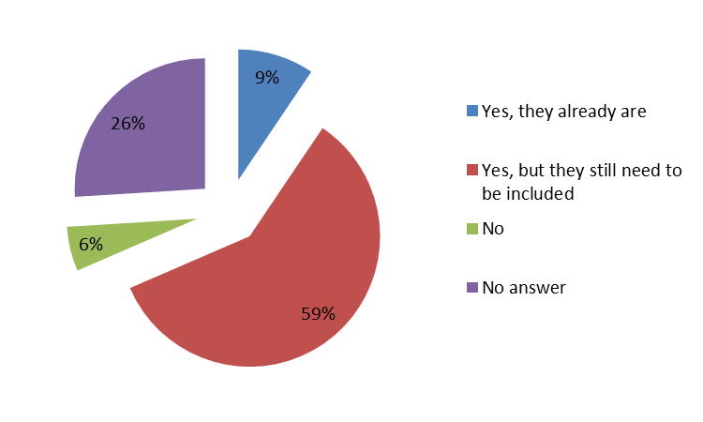
A small group of respondents argued that competition over maritime space will be negligible because it is abundant and various maritime activities can co-exist without impeding one another. The majority of stakeholders, however, were of the opinion that conflicts could occur with other maritime activities, especially with fishing, military uses, shipping and nature conservation.
The suggestions for mitigation of these conflicts primarily included effective Maritime Spatial Planning but also other measures such as long-term planning and transparency in the permitting process, early consultation, awareness and information campaigns, multiplatform solutions, designation of large zones for ocean energy to offer flexibility in array locations and compensation schemes. The potential for conflict with fishermen featured as the most prominent but it was also pointed out that ocean energy developments could offer a career change opportunity for fishermen, whose livelihoods could be in danger as a result of overfishing. The 'sanctuary effect' that ocean energy development could also offset some of the loss of fishing space through faster recovery of fish stocks.
iv) Data
Resource mapping
73% of respondents believe that there is a need for mapping of available resources for different ocean energy technologies, of which 55% think it should be done at high resolution and 18% think it should be done at low resolution. With respect to who should carry out the mapping there is a large consensus (69%) that it should be done by the public sector. Only 17% think it should be done by the private sector.
Other data
66% of respondents believe that other data, such as data about ecosystems, the seabed, environmental impact and climate change are needed to ensure the sustainable development of ocean energy. Bathymetry data and ecosystem data were the two types of information most frequently mentioned. The data is deemed essential in order to inform Marine Spatial Planning and Environmental Impact Assessments. The need for localised climate change scenarios and information on local economic activity was also brought up by respondents.
Several respondents argued that data collection should be undertaken on a large-scale, collective basis – requesting developers to collect detailed environmental data for each project is seen as excessively burdensome and inefficient.
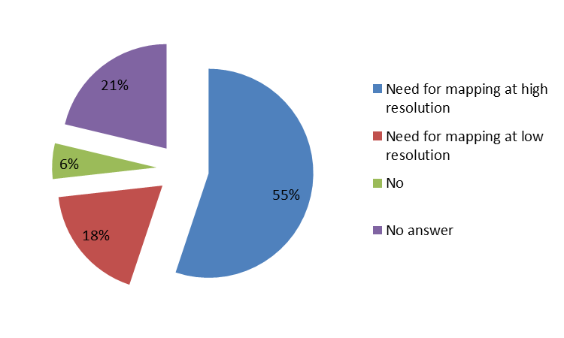

12. Annex 4: Overview of Recent EU Funded Ocean Energy Projects
Over the last twenty years, the EU has injected around €133 million into R&D and pre-commercial demonstration projects for ocean energy. This figure refers to total amounts up to June 2012, including the 'Ocean of Tomorrow' cross-cutting ocean-wind projects but not including projects under negotiation. ocean energy projects have also featured in the Intelligent Energy Europe programme as well as under the more recent NER-300 funding programme.
I. 6th and 7th Research Framework Programmes (FP6 & FP7)
Many of the projects under FP5 (1998-2002) were mainly focused on single devices design for wave and tidal energy. Those under FP6 (2003-2006) moved on to single devices lab tests while the more recent FP7 (2007-2013) projects exhibited a bigger focus on device arrays together with more cases of Member State coordination. An example of the latter is the EQUIMAR project on testing and evaluation of ocean energy extraction devices, which saw collaboration amongst 11 Member States. EquiMar delivered a suite of protocols (general principles to allow fair comparison of marine energy converters testing and evaluation procedures) in order to measure and compare the dozens of tidal and wave energy devices, proposed locations and management systems currently competing for funds, so governments can invest in the best ones and get marine energy on tap fast.
In 2007, one research project was funded on new components and concepts for ocean energy converters and another on pre-normative research. In 2008, 4 demonstration projects on innovative full size systems were supported. The 2012 call supported 2 projects aimed at demonstrating the first ocean energy farms. The 2013 calls target design tools, enabling technologies and underpinning research to facilitate ocean energy converter arrays.
There are also 2 Future Emerging Technology (FET) projects on ocean energy supported by the FP7-ENERGY programme focused on salinity (CAPMIX - funding € 2.4m) and a complete new technology for wave energy conversion (POLYWEC - funding € 2.1m). FET projects refer to those where the time to bring the technologies to market is projected over a much longer time frame.
Ocean Energy RTD and Demo-projects funded under FP6 and FP7
Year | Topic description | Project Names | EC contribution €
2007 | New components and concepts for ocean energy converters | CORES | 3.449.588
2007 | Pre-normative research for ocean energy | EQUIMAR | 3.990.024
2008 | Ocean: demonstration of innovative full size systems | PULSE STREAM 1200  STANDPOINT  SURGE  WAVEPORT | 20.694.439
2010 | Capacitive mixing as a novel principle for generation of clean renewable energy from salinity differences | CAPMIX | 2.400.000
2012 | Demonstration of first ocean energy farms | TIDES  AEGIR | 23.002.736 (under negotiation)
2012 | New mechanisms and concepts for exploiting electro-active Polymers for Wave Energy Conversion | POLYWEC | 2.100.000
2013 | Design tools, enabling technologies and underpinning research to facilitate ocean energy converter arrays | DTOcEAn | 4.100.000  (under negotiation)

The Oceans of Tomorrow Initiative
Joint-calls under "The Ocean of Tomorrow" initiative were also carried out in 2010 and 2011. This is one of the key initiatives regarding the seas and oceans in FP7. It concerns the launch of cross-thematic calls for proposals on major sea-related challenges. Those calls are implemented jointly between different themes of FP7 because they address major cross-cutting issues that require cooperation between various scientific disciplines and sectors. This approach will help deliver sustainable and innovative solutions to fully reap the potential of the oceans. While there was no joint call in 2012, the common effort was pursued with the launch of 9 topics dedicated to support of the Marine Strategy Framework Directive. One project in 2010 covered aspects relating to the impact of marine renewables in the ocean.
In the 2011 call, 3 projects on multi-use platforms (integrating renewable energy) were funded. Although the primary focus of the work in the Ocean of Tomorrow projects is not on ocean energy conversion, the results might be beneficial for the ocean energy sector too. The 3 projects are:
H2OCEAN - development of a wind-wave power open-sea platform equipped for hydrogen generation with support for multiple users of energy - is a project aimed at developing an innovative design for an economically and environmentally sustainable multi-use open-sea platform. Wind and wave power will be harvested and part of the energy will be used for multiple applications on-site, including the conversion of energy into hydrogen that can be stored and shipped to shore as green energy carrier and a multi-trophic aquaculture farm.
MERMAID - Innovative Multi-purpose off-shore platforms: planning, design and operation - will develop concepts for the next generation of offshore platforms which can be used for multiple purposes, including energy extraction, aquaculture and platform related transport. The project does not envisage building new platforms, but will theoretically examine new concepts, such as combining structures and building new structures on representative sites under different conditions.
TROPOS - Modular Multi-use Deep Water Offshore Platform Harnessing and Servicing Mediterranean, Subtropical and Tropical Marine and Maritime Resources - the key objective is the development of a floating modular multi-use platform system for use in deep waters, with an initial geographic focus on the Mediterranean, Tropical and Sub-Tropical regions but designed to be flexible enough not to be limited in geographic scope. The modular TROPOS multi-use platform system is able to integrate a range of functions from the transport, energy, aquaculture and leisure sectors.
Other FP7 projects not exclusively focused on ocean energy
ORECCA - Off-shore Renewable Energy Conversion Platforms Coordination Action – the key objective was to create a framework for knowledge sharing and to develop a roadmap for research activities in the context of offshore renewable energy (wave, tidal and wind). It published a comprehensive European Offshore Renewable Energy Roadmap in September 2011 together with a number of sub-function reports. The Roadmap's objective is to guide policy makers to support the accelerated development of the offshore renewable energy sector in Europe, to identify synergies, to overcome barriers and facilitate significant cost effective commercial scale deployments by 2030.
MARINA Platform - Marine renewable integrated application platform - aims to bring offshore renewable energy applications closer to the market by creating new infrastructures for both offshore wind and ocean energy converters. It addresses the need for creating a cost-efficient technology development basis to kick-start growth of the nascent European marine renewable energy (MRE) industry in the deep offshore a major future global market. It will establish a set of equitable and transparent criteria for the evaluation of multi-purpose platforms for marine renewable energy.
IOWAGA - Interdisciplinary Ocean wave for geophysical and other applications - proposes a systemic investigation of ocean waves for improving the ocean surface wave compartment of Earth system models. The project will integrate existing and new wave-related observations from multiple sources, including remote sensing, seismic records, and in situ measurements, from climate and global scales to coastal scales and single events. This modelling tool will include multiple applications to geophysics at large and will have other practical applications with associated societal benefits (ocean energy planning and management, marine safety, pollution mitigation &).
RTD and Demo-projects not exclusively focused on ocean energy funded under FP7
Duration | Project Name & Website | Acronym | EC Contribution €
2010-2011 | Off-shore Renewable Energy Conversion Platforms Coordination Action  http://www.orecca.eu/home | ORECCA | 1.600.000
2010-2013 | Marine renewable integrated application platform  http://www.marina-platform.info/ | Marina Platform | 8.700.000
2010-2013 | Interdisciplinary Ocean wave for geophysical and other applications  http://wwz.ifremer.fr/iowaga/ | IOWAGA | 1.099.040
 | Joint call "The ocean of tomorrow": Multi-use offshore platforms: |  | 5.000.000  (*14.887.256)
2012-2014 | http://www.h2ocean-project.eu/ | H2OCEAN
2012-2015 | http://www.mermaidproject.eu/ | MERMAID
2012-2015 | http://www.troposplatform.eu/ | TROPOS
* These projects are funded for a total of €14m of which €5 derive from the RTD-Energy budget lines and €9.9m from the RTD-Transport lines.

Supporting projects funded under FP7
FP7 does not only finance research and demonstration projects, but it also supports 'non-technological' projects which can be beneficial for the innovation process in a certain sector, like training of people, opening access to research infrastructure, or stimulating Member States working together via an ERA-NET. Some of these projects are listed below:
An ERA-NET to support the coordination of national research activities is foreseen under FP7 in 2013. The objective of the ERA-NET scheme is to step up the cooperation and coordination of research programmes in the field of ocean energy at national and/or regional level in the Member or Associated States through the networking of organisations involved in the support to ocean energy R&D. The coordination offered by this ERA-NET will allow collaboration and alignment with the work of the EERA Ocean Energy Joint Programme and will enhance synergies and raise the scattered profile of a sector having difficulties to build a mature industrial and commercial status.
WAVETRAIN 2 - the overall objective was to create a pool of specialised wave energy research professionals to support an emerging industry in a field with a very strong anticipated growth and no dedicated existing training curriculum. Although most jobs can be done being a trained engineer in one of the adjacent fields, the existence of interdisciplinary skilled researchers trained in direct connection to the technology development is vital for successful development. In the predecessor, almost all fellows where immediately absorbed by industrial players in the field or continued research in the host institution.
MARINET is an EC-funded network of research centres and organisations that are working together to accelerate the development of marine renewable energy technologies - wave, tidal & offshore-wind - by offering periods of free-of-charge access to their world-class testing facilities and conducting joint activities in parallel to standardise testing, improve testing capabilities and enhance training and networking.
Supporting projects focused on ocean energy funded under FP7
Duration | Project Name | Acronym | EC Contribution €
2008-2012 | Networks for Initial Training for wave energy research professionals: http://www.wavetrain2.eu/ | WAVETRAIN 2 | 3.579.635
2011-2015 | Marine Renewables Infrastructure Network for Emerging Energy Technologieshttp://www.fp7-marinet.eu/ | MARINET | 8.999.997
2013 | ERA-NET: supporting the coordination of national research activities of Member States and Associated States in the field of ocean energy | Call closing on 28/02/2013 | 2.000.000  (maximum funding)

II. Intelligent Energy - Europe Programme
The Intelligent Energy Europe programme, launched in 2003, supports EU energy efficiency and renewable energy policies, with a view to reaching the EU 2020 targets. 8 projects supporting ocean energy and offshore wind energy were funded for a total of €11.3m of which the EC contribute €8.2m. These projects support actions creating favourable market conditions, shaping energy policy development and implementation, and preparing the ground for investment.
SI Ocean, SOWFIA and WAVEPLAM are the 3 ocean energy -specific projects that were funded for a total EC contribution of €2.7m (total eligible costs is € 4m).
SEANERGY 2020 focused on Maritime Spatial Planning and addressed both the offshore wind and wave/tidal energy sectors although with a stronger focus on offshore wind. The EC contribution for this project was €0.9m (total eligible costs €1.2m).
WINDSPEED, GP WIND, OffshoreGrid and NorthSeaGrid are the 4 projects focused on offshore wind for a total EC contribution of €4.6m (total eligible costs for all 4 projects €6.1m).
Projects supported by the Intelligent Energy Europe programme having a maritime dimension
Project title | Strategic Initiative for Ocean Energy
Acronym | SI OCEAN
Website | www.si-ocean.eu
Duration | 2012-2014
Description | Aims to deliver a common strategy for ensuring maximal wave and tidal installed capacity by 2020 – paving the way for exponential market growth in the 2030 and 2050 timeframe.  Identify and develop a wide consensus on the most effective way to tackle the key barriers to delivering a commercial wave and tidal energy sector in Europe.  A key focus will be on increasing participation and input from the commercial sector, namely utilities, large industrials and technology developers.
Expected Results | The project is expected to deliver practical recommendations on removing the barriers to ocean energy. The project is based around three focus areas:  Substantiated Wave and Tidal Energy Production Maps and Projections: the first validated trans-Europe assessment of actual resource production potential using a harmonized methodology and integrating existing resource assessments maps, projections of wave and tidal energy production in 2020, 2030 and 2050. This will underpin the Market Deployment Strategy.  Strategic Technology Agenda: a thorough assessment of the current status of technology development and cost of energy, identifying development priorities and quantifiable scope for future cost and risk reduction.  Market Deployment Strategy: identification of primary barriers to market growth and delivery of recommended policy and strategic initiatives to tackle them. It will cover issues such as how to target financial support and resources to accelerate technology commercialization, using best practice examples from key Member States to improve and standardize regulatory and administrative frameworks across Europe, key recommendations on pan-European strategic supply chain & infrastructure planning.  Stronger and unified network of key stakeholders, by generating new partnership opportunities whilst ensuring accurate and representative results from the project.

Project title | Streamlining of ocean wave farm impact assessments
Acronym | SOWFIA
Website | www.sowfia.eu
Duration | 2010-2013
Description | Aims to facilitate the development of European-wide coordinated, unified and streamlined environmental and socio-economic Impact Assessment (IA) tools for offshore wave energy conversion developments.  Regional coordination via the SOWFIA project collaboration will enable the exchange, sharing and transfer of IA and policy experience and associated knowledge and good practices.
Expected Results | - Compilation of the pan European experience of wave energy development approval process.  - Identification of barriers and accelerators in existing IA processes in EU member states.  - Recommendations for approval process streamlining to help remove legal, environmental and socio-economic barriers to the development of offshore power generation from waves.

Project title | Wave Energy Planning and Marketing
Acronym | WAVEPLAM
Website | www.waveplam.eu
Duration | 2007-2010
Description | To develop tools, establish methods and standards, and create conditions to speed up the introduction of ocean energy onto the European renewable energy market, tackling in advance non-technological barriers and conditioning factors that may arise when these technologies are available for large-scale development.
Main Results | - Detailed picture of the state of the art of wave energy, identifying existing technologies and those that were at demonstration phase.  - Survey of the non-technological barriers and conditioning factors that may hinder the large-scale development of wave energy and recommendations to minimise their effects.  - Methodology for site selection, based not only on the wave resource but also other important issues, such as e.g., conflicts of interests (interaction with competing uses), environmental impact, availability of grid connection points, harbours, shipyards, tidal and currents level, ocean bottom bathymetry and soil, etc.  - Guideline for implementing wave energy projects oriented to the decision makers, promoters and investors will be published, tested and presented to these key actors.  - Networking and dissemination activities

Project title | Delivering Offshore Electricity to the EU: spatial planning of offshore renewable energies and electricity grid infrastructures in an integrated EU maritime policy
Acronym | SEANERGY 2020
Website | www.seanergy2020.eu
Duration | 2010-2012
Description | To formulate concrete policy recommendations on how to best deal with maritime spatial planning (MSP) and remove MSP obstacles that stand against the deployment of offshore power generation.
Main Results | - Selection of good examples of national MSP practices, taking into account (1) policy and legal framework; (2) information management mechanisms; (3) permitting and licensing procedures; (4) stakeholders consultation; (5) sector conflict management practices; (6) cross-border cooperation and (7) MSP implementation and enforcement.  - Analysis of the different international MSP instruments and their compatibility with the implementation of offshore renewable power generation sources.  - Policy recommendations for developing existing, and potentially new, international MSP instruments and for promoting a more integrated and coordinated cross-border MSP, taking into consideration offshore generation technology and related grid infrastructures.  - Case study illustrating the benefits of integrated strategic maritime spatial planning and cross-border coordination.  - Acceptance of the results by the main target groups and stakeholders, including regional and national authorities, EU decision-makers, planners and regulators, offshore generation developers and other users of the sea.  - Communication and dissemination: transfer of best practices towards the countries where MSP has been less developed.

Project title | Spatial Deployment of Offshore Wind Energy in Europe
Acronym | WINDSPEED
Website | www.windspeed.eu
Duration | 2008-2011
Description | To identify a roadmap for the deployment of offshore wind power in the Central and Southern North Sea basin. The roadmap included (a) the definition of an ambitious but realistic medium-term offshore wind energy target, (b) the identification of risks and barriers, and a set of coordinated policy recommendations for the deployment of offshore wind in the above-mentioned sea basin.
Main Results | - Developed an overall integrated approach to assess the realistic deployment potential for offshore wind energy across 5 countries in the Central and Southern North Sea basin, taking into account the spatial, policy and growth as well as market and grid integration constraints.  - Developed a cross-border (planning) tool to assess the potential for deployment of offshore wind energy in relation to other sea use functions and costs for the Central and North Sea countries.  - Provided input to on-going European initiatives with respect to development of RES, in particular offshore wind energy.

Project title | Good practice in reconciling onshore and offshore wind with environmental objectives
Acronym | GP WIND
Website | www.project-gpwind.eu
Duration | 2010-2012
Description | To address barriers to the development of onshore & offshore wind by developing good practice in reconciling objectives on renewable energy with environmental objectives and actively involving local and regional communities.
Main Results | - Building evidence-based support for the design, planning and implementation of projects which are sensitive to environmental and community concerns  - Increasing the consenting rate for on- and offshore wind projects, and reduce the processing period for applications  - Securing endorsement of project outputs by participating partner administrations, and commitment to adopt relevant good practice.

Project title | Regulatory Framework for Offshore Grids and Power Markets in Europe: Techno-economic Assessment of Different Design Options
Acronym | OffshoreGird
Website | www.offshoregrid.eu
Duration | 2009-2011
Description | OffshoreGrid was a strategic project which developed a design for the offshore grid in Northern Europe along with a suited regulatory framework considering technical, economic, policy and regulatory aspects.  OffshoreGrid provided inputs to the preparation of the Commission's "Communication on Energy infrastructure priorities for 2020 and beyond - A Blueprint for an integrated European energy network"- COM (2010) 677 final.
Main Results | - A selection of blueprints for an offshore grid in the Baltic and North Sea taking into account a) the costs of the various options, b) their socio-economic value, c) the regional/ internal power market designs and d) the regulatory framework for the remuneration and operation of the grid, based on:  - Detailed offshore wind power scenarios with generation time series for Northern Europe and high-level renewable energy and grid scenarios for the Mediterranean region.  - Interaction of different design drivers for an offshore grid and the associated costs and interaction of power prices, market design and energy economic parameters in a market comprising the regions around the Baltic and North Sea.  - Discussions and consultations on the clustering of wind farms at hubs versus radial connections to the shore, the possibility of teeing in offshore wind farms to planned interconnectors, and the integration of wind farm hubs with interconnectors in meshed grids.

Project title | Offshore Electricity Grid Implementation in the North Sea
Acronym | NorthSeaGrid
Website | tbd
Duration | 2013-2015
Description : | The lack of development of an offshore grid is due to a variety of barriers including the regulatory frameworks, incompatibility of support schemes, lack of political support, difficulty to attract financing, and uncertainty of risk.  The project will be centred around three case studies for an offshore interconnection integrating offshore wind energy, located in the North Sea. These case studies will be chosen through close cooperation between the consortium, the European Commission and the Northern Seas Countries Offshore Grid Initiative, ensuring they are both relevant to the advancement of development of an offshore grid, and that they support the work being performed by the relevant decision makers.  The barriers investigated will focus on the domains of financing, regulation and risk, areas which have not yet been covered by previous or on-going actions. Conclusions and policy recommendations will be drawn explicitly for the different case studies with the goal to facilitate efficient and timely project implementation.  In a second step the effort will be made to draw some general conclusions that also hold for projects in other areas, such as the Baltic Sea or the English Channel.
Expected results: | - A detailed cost inventory for each concrete case study, for different scenarios, and a calculation of the benefits of the interconnection  - Different models for cost and benefit allocation to different countries and stakeholders, such as project developer, TSO, etc.; including the identification of risk and the financial effects of this risk, with respect to each stakeholder  - Evaluation of the compatibility of support schemes and the regulatory frameworks in the different countries, with the proposed interconnection design  - Discussion surrounding the political barriers identified and solutions to overcome them. The results will be consolidated in specific recommendations for European and regional policy

III. New-Entrants Reserve (NER300)
NER300 is a grant scheme to support carbon capture and storage demonstration projects and renewable energy innovative projects, including ocean energy. It was established by Article 10a(8) of the revised Emissions Trading Directive 2009/29/EC and further developed through Commission Decision 2010/670/EU (NER300 Decision). Managed jointly by the European Commission, the European Investment Bank and Member States, it will use the money raised from the sale on the carbon market of 300 million allowances (rights to emit one tonne of carbon dioxide) in the New Entrants’ Reserve (NER) of the EU Emissions Trading Scheme. NER-300 funding will leverage a considerable amount of private investment and/or national co-funding across the EU. The European Investment Bank plays an important role as it monetises the allowances and manage revenues and provides technical and financial due diligence assessment of the projects.
On 18 December 2012, the Commission awarded over €1.2 billion to 23 innovative renewable energy technology projects, including 3 for ocean energy. The funds were raised from the sale of the first tranche of 200 million allowances. They will help to lower costs, manage risks and tackle knowledge barriers. The chosen projects had to fulfil strict eligibility criteria and show they are financially and technically robust, with the potential to be scaled up and replicated. The deadline for entry into operation of the projects is the end of 2016. Projects will receive funding annually based on proven performance. In the case of the renewable energy projects, this will depend on the amount of clean energy produced each year for the first five years following entry into operation. The three ocean energy projects awarded funding are listed below:

Selected projects funded from stu
Kyle Rhea - United Kingdom
An array of tidal turbines with a nominal capacity of 8 MWe will be built in the narrow strait between the Isle of Skye and the Scottish mainland. The project consists of four tidal energy twin rotor turbines; each one rated at 2MWe, and is based on a significant scaling up of the operational test turbine, which has a three-year track record in Northern Ireland. Maximum NER-300 funding: €18.4m
Sound of Islay - United Kingdom
An array of ten 1 MWe grid-connected tidal current turbines will be installed in deep water in the Sound of Islay off the west coast of Scotland. The tidal turbine technology will have a 3-bladed, seabed mounted design to deliver the overall net capacity of 10 MWe. Maximum NER-300 funding: €20.7m
Ocean West Wave - Ireland
A project located off the west coast of Ireland plans to demonstrate the potential of scaling up wave energy. Six wave energy capture devices will be placed at a depth of 15 metres. A prototype has already been tested at the European Marine Energy Centre (EMEC) in Orkney. The results of recent design changes and tests of an improved 800 kW design will feed into the final design, installation and operation of the project. Maximum NER-300 funding: €19.8m

13. Annex 5: Detailed Description of Ocean Energy Technologies
Wave Energy Converters (WECs)
Wave energy is harnessed from the movement of a WEC device, which can be floating on the surface or moored to the ocean floor. Several different techniques and designs are currently under development.
Attenuators are floating devices that are aligned perpendicular to the waves. These devices capture energy from the relative motion of the two arms as the wave passes them. | 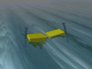
Surface point absorbers are floating structures that can absorb energy from all directions. They covert the motion of the buoyant top relative to the base into electrical power. | 
Oscillating wave surge converters are near-surface collectors, mounted on an arm which pivots near the sea bed. The water particles in the waves cause the arm to oscillate and generate power. | 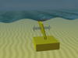
Oscillating water column technologies convert the rise and fall of waves into movements of air flowing past turbines to generate power. | 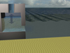
Overtopping devices have a wall over which waves break into a storage reservoir which creates a head of water. The water is released back to the sea through a turbine to generate power. | 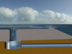
Submerged pressure differential devices capture energy from pressure change as the wave moves over the top of the device causing it to rise and fall. | 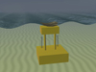
Tidal stream devices
Horizontal axis turbines work in a similar manner to wind turbines. The turbine is placed in the water and the tidal stream causes the rotors to rotate around the horizontal axis and generate power. | 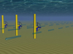
Vertical axis turbines work in a similar manner to horizontal axis turbines but the tidal stream causes the rotors to rotate around the vertical axis and generate power. | 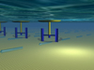
Reciprocating Hydrofoils have a hydrofoil attached to an oscillating arm. The lift caused by the tidal stream causes the arm to oscillate and generate power. | 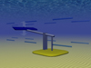
Venturi Effect Devices are devices which funnel the water through a duct, increasing the water velocity. The resultant flow can drive a turbine directly or the induced pressure differential in the system can drive an air turbine. | 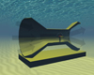
A tidal kite is tethered to the sea bed and carries a turbine below the wing. The kite ‘flies’ in the tidal stream, swooping in a figure-of-eight shape to increase the speed of the water flowing through the turbine. | 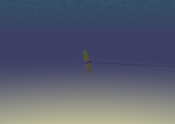
The Archimedes Screw is a helical corkscrew-shaped device (a helical surface surrounding a central cylindrical shaft). The device draws power from the tidal stream as the water moves up/through the spiral turning the turbines. | 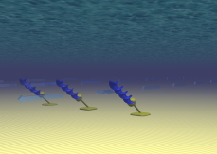

Tidal barrage designs
Tidal Barrages involve building a dam across an estuary with a high tidal range. The tidal barrage plant generates energy by allowing water to flow in and/or out of the estuary through head hydro turbines. | 
Bunded tidal barrages operate in a similar way to conventional tidal barrages but do not fully obstruct an estuary. | 
Single Basin Offshore tidal lagoons would be built on tidal flat in areas with high tidal ranges. | 
Multiple Basin Offshore Tidal lagoons are built on tidal flat in areas with high tidal ranges. | 
OTEC operating principles
These are two main conversion systems – open and closed. In the closed cycle a working fluid is pumped through a heat exchanger and vaporised; the steam then turns a turbine. The cold water in the deep sea then cools the steam back to a liquid state. In an open system, the warm surface water is turned to steam in a pressurised vacuum chamber. The steam is then, again, used to drive a turbine and cooled back to liquid by the cold water below the surface.
Several problems have been encountered in the development of this technology such as biofouling and corrosion. The process can, however, have useful by-products such as hydrogen, lithium and other rare elements which potentially enhance its economic viability.

Salinity gradient operating principles
Two different concepts are under development to exploit the energy from a salinity gradient – reversed electro-dialysis (RED) and pressure-retarded osmosis (PRO). RED uses the chemical potential difference between fresh water and salt water to generate voltage across a membrane. PRO uses naturally occurring osmosis, and exploits the pressure that is exerted by the fluid on the membrane. For seawater and freshwater the osmotic pressure difference tends to be between 2.4 to 2.6 MPa (24 to 26 bar), depending on seawater salinity.

14. Annex 6: Resource Location

European wave energy potential

Wave energy is the result of interaction between wind and ocean surface. The best waves in terms of energy content occur between 30° and 60° latitude. Wave energy availability varies seasonally.

European tidal stream potential
Tidal currents result from the rise and fall of the tide; they are influenced by seabed bathymetry and by the shape of the coastline. Prominent locations in Europe include UK, Ireland, Greece, France and Italy. The best resource tends to be located in channels between islands where the current velocity is the highest. Over 106 promising
locations have been identified, mostly in the UK (CEC, 1996 in IPCC, 2011).

European tidal barrage potential
Tides are generally regular and predictable. They are driven by the graviational forces between the Earth, Moon and the Sun; whilst in some locations only one tide per day occurs, in others there are two high tides and two low tides a day. The timing and magnitude of a tide is dependent on the shape of the shoreline and the seabed but also on the global position. Bays and estuaries are the best locations, the Severn Estuary in the UK, for example, offers a tidal range of 15m. Although the global theoretical potential is significant, only a fraction of the possible locations are suitable for energy exploitation.

Global OTEC potential
Ocean thermal energy is originates as solar energy. It is a relatively low-energy resource compared to waves and tides but it is widely and continuously available, which makes it suitable for base-load power. A minimum temperature difference of 20°C is considered necessary to operate an OTEC power plant, over a distance of less than 1000 m. The resource is available in certain Outermost regions.

European salinity gradient potential
Whilst resource maps are not readily available for this resource, substantial resources in Europe are located in Norway as the fjords alow for exploitation of a steep salinity gradient. Significant potential also exists in the Netherlands. The picture below features the 30-km long Afsluitdijk dam; its salinity-gradient energy potential is comparable to a 221m high Hoover Dam in Nevada.

15. Annex 7: Current deployment and planned capacity

Total Current Installed Capacity in Europe
Location | Total Currently Operational (kW)
EMEC (Orkney, Scotland) | 7800
UK (except EMEC) | 1620
Portugal | 700
France & Pacific Territories | 0
Scandinavia | 200
Ireland | 0
Spain | 500
TOTAL | 1082

UK - European Marine Energy Centre (EMEC):
Type | Name of device | Company | Technology stage | No. of devices installed | Installed capacity (kW) | Year of installation
Wave | Pelamis P2 | E-ON | Pre-commercial (Testing) | 1 | 750 | 2010
Wave | Pelamis P2 | Scottish Power Renewables | Pre-commercial (Testing) | 1 | 750 | 2012
Wave | Penguin | Wello Oy | Pre-commercial (Testing) | 1 | 500 | 2012
Wave | Oyster 800 | Aquamarine Power Ltd | Pre-commercial (Testing) | 1 | 800 | 2011
Wave | Oyster 801 | Aquamarine Power Ltd | Pre-commercial (Testing) | 1 | 1000 | 2015
Tidal | HS1000 | Andritz Hydro Hammerfest | Pre-commercial (Testing) | 1 | 1000 | 2011
Tidal | DeepGen | Tidal Generation Ltd | Pre-commercial (Testing) | 1 | 500 | 2010
Tidal | ReDAPT | Tidal Generation Ltd | Pre-commercial (Testing) | 1 | 1000 | 2013
Tidal | Open Centre Turbine | Open Hydro | Pre-commercial (Testing) | 1 | 250 | 2008
Tidal | AR1000 | Atlantis Resources Corporation | Pre-commercial (Testing) | 1 | 1000 | 2010
Tidal | SR250 | Scotrenewables Tidal Power Ltd | Pre-commercial (Testing) | 1 | 250 | 2011
Wave | Seactricity Float | Seatricity | Pre-commercial (installing) | 1 | 800 | 2012
Tidal | Voith | Voith | Pre-commercial (installing) | 1 | 1000 | 2011
Tidal | Blue TEC | Bluewater | Pre-commercial (Contracted 2013) | 1 | 1000
Tidal | Kawasaki | Kawasaki Heavy Industries Ltd | Pre-commercial (Contracted 2013) | 1 | 1000
Tidal | Alstom | Alstom | Pre-commercial (Testing) | 1 | 1000 | 2014
Wave | AWS lll | AWS | Pre-commercial (Testing) | 1 | 2500 | 2015
Wave | Pelamis P2 | Vattenfall | Pre-commercial (Contacted 2014) | 1 | 750 | 2014
TOTAL (currently installed ) | 7800 | kW
TOTAL (expected) | 8050 | kW

UK (outside EMEC):
Type | Name of device | Company | Technology stage | Installed capacity | Capacity planned | Installation year
Tidal | Technology Neutral | SSE Renewables | Pre-commercial |  | 30 | 2018 onwards
Tidal | Technology Neutral | SSE Renewables | Commercial |  | 170 | 2022 onwards
Tidal | Open Hydro | JV Cantick Head Tidal Development Ltd | Pre-commercial |  | 25 | 2018 onwards
Tidal | Open Hydro | JV Cantick Head Tidal Development Ltd | Commercial |  | 175 | 2022 onwards
Tidal | SeaGen S 2 | SeaGeneration (BroughNess) Ltd | Commercial |  | 100 | 2018 onwards
Tidal | Technology TBC | Scottish Power Renewables | Commercial scale project | 1 | 95 | 2017 onwards
Tidal | SRT 1001 | Scot Renewables Tidal Power | Saltire Lease | 1 | 30 | 2014-15 onwards
Tidal | Technology Neutral | Meygen | Commercial |  | 400 | 2015-16 onwards
Wave | Aquamarine, Oyster | JV Brough Head Wave Farm Ltd | Pre-commercial |  | 40 | 2018 onwards
Wave | Aquamarine, Oyster | JV Brough Head Wave Farm Ltd | Commercial |  | 160 | 2022 onwards
Wave | Pelamis P2 | E.ON | Pre-commercial (Testing) |  | 50 | 2020 (date under review)
Wave | TBD | E.ON | Pre-commercial (Testing) |  | 50 | 2020 (date under review)
Wave | AWS lll | JV Costa Head Wave Company Ltd | Pre-commercial | 2500 | 10 | 2018
Wave | AWS lll | JV Costa Head Wave Company Ltd | Commercial | 2500 | 190 | 2022
Wave | technology TBC | Scottish Power Renewables | Commercial scale project |  | 49,5 | 2017 onwards
Wave | Ocean energy Buoy | OceanEnergy Ltd | Pre-commercial (Testing)
Wave | BOLT Lifesaver | Fred. Olsen Ltd | Pre-commercial (Testing) | 240 |  | 2012
Tidal | Evopod E35-01 | Oceanflow Development Ltd | 1/4 scale mono-turbine demonstrator |  | 0,035 | 2013
Tidal | Evopod TE70-01 | Oceanflow Development Ltd | 1/4 scale twin-turbine demonstrator |  | 0,07 | 2014
Tidal | SeaGen S 1.2 | Marine Current Turbines, A Siemens Busines | Pre-commercial (Testing) | 1200 | 1,2 | 2008
Tidal | SeaGen S 2 | SeaGeneration (Kyle Rhea) Ltd | Demonstration Array |  | 8 | 2015
Tidal | SeaGen S 2 | SeaGeneration (Wales) Ltd | Demonstration Array |  | 10 | 2015
Tidal | Technology Neutral | Bord Gais | Commercial Array |  | 100 | 2017 onwards
Tidal | Technology Neutral | DP Marine Energy | Commercial Array |  | 100 | 2018 onwards
Tidal | Technology Neutral | DP Marine Energy | Saltire Lease |  | 30 | 2016 onwards
Tidal | Minesto | Minesto | 1/4 scale demonstrator | 30 | 0,003 | 2012
Tidal | Swan Turbines Cygnet 300kw | Smith Glaxo Kline | Commercial |  | 4,5 | 2015
Wave | Oyster 1000 | Aquamarine Power Ltd | Pre-commercial |  |  | 2017
Wave | Oyster 1001 | Aquamarine Power Ltd | Commercial |  |  | 2018
Wave | Oyster 1002 | Aquamarine Power Ltd | Commercial |  |  | 2019
Wave | LIMPET | Voith Hydro Wavegen | Pre-commercial (Testing) | 150 | 150 | 2000
TOTAL (currently Installed) |  | kW
TOTAL (expected) |  | kW

Portugal
Type | Name of device | Location | Company | Technology stage | No. of devices | Installed capacity (kW) | Year of installation
Wave | WaveRoller | Peniche | AW-Energy | Demonstration | 3 | 300 | 2012
Wave | Pico (OWC) | Azores, Portugal | WavEC | Pre-commercial | 1 | 400 | 1999
TOTAL | 700 | kW

France and Pacific Territories
Type | Name of device | Location | Company | Technology stage | Capacity planned | Expected capacity | Year of installation
Tidal | Voith HyTide | Voith HyTide | GDF SUEZ Energy France | Pre-commercial |  | 12 | 2016
Tidal | Technology Neutral | Raz Blanchard | GDF SUEZ Energy France | Commercial |  | 100 | 2019
Tidal | Technology Neutral | Fromveur | GDF SUEZ Energy France | Commercial |  | 100 | 2019
Tidal | Open Hydro | Paimpol Bréhat | EDF | Tidal test site | 2 To 4 MW | 2 | 2012-2014
Tidal | Open Hydro | Raz Blanchard | EDF-DCNS | Pre-commercial farm | 8 | 17 | 2015
Tidal | Open Hydro | Alderney | DCNS | Pre-commercial farm | 1 to 2MW | 2 | 2015
Tidal | Sabella | Ouessant | Sabella | Prototype
Tidal | Voith | Raz Blanchard | GDF - Voith | Pilot farm
Tidal (estuary waters) | SEENEOH | Bordeaux | Energie de la Lune - France Energies Marines | Tidal test site in estuary waters | 250KW | 0,25 | 2013
Tidal | Alstom | Raz Blanchard | Alstom | Pre-commercial farm | 200MW plus |  | 2016
Wave | CETO | Reunion island | EDF | Prototype | 200 kW | 0,2 | 2013
Wave | Wave Roller | Baie d'Audierne | DCNS - FORTUM | Pilot farm | 1,5MW | 1,5 | 2015
Wave | SEMREV | Le Croisic | Région Pays de la Loire, France Energies Marines | Test site: Wave and offshore wind | 8MW | 8 | 2013
OTEC | PAT ETM | Réunion Island | DCNS - Région Réunion | OTEC Land Based prototype |  |  | 2012
OTEC |  | Réunion Island | DCNS - Région Réunion | Feasibility study |  |  | 2009-2010
OTEC |  | Tahiti | DCNS- Pacific OTEC | Feasibility study |  |  | 2010-2011
OTEC |  | Martinique | DCNS | Pilot plant project | 10 MW | 10 | 2016
SWAC |  | Saint Denis, Réunion Island | GDF | Bid for commercial application
SWAC |  | Saint Pierre, Réunion Island | EDF | Bid for commercial application
ESTIMATES
Tidal | Open Hydro | Raz Blanchard | EDF-DCNS | Commercial farm | Several hundreds of MW | Several hundreds of MW | From 2018
Wave | Pelamis | Réunion Island | Seawatt

Spain
Technology stage | No. of devices installed | Installed capacity (kW) | Capacity installation planned | Expected capacity | Year of installation | Grid connected? (Y/N)
Demonstration Array | 16 | 300 | 300 | 300 | 2011 | Y
Pre-commercial (Testing) | 1 | 200 |  |  | 2013 | Y
Pre-commercial (Testing) |  |  |  |  | 2012 | Y (2013)
Pre-commercial (Testing) | 1 | 150 |  |  | 2013 | Y
 |  |  |  |  | 2014 | ?
 |  |  |  |  |  | ?
Pre-commercial (Testing) | 1 | 250 |  |  | 2011-12 | Y
TOTAL (currently installed) | 500 | kW

Scandinavia
Company | Technology stage | No. of devices | Installed (kW) | Capacity planned | Expected | Year of installation | Grid connected? (Y/N)
Seabased Industries AB | Pre-commercial/ Commercial |  |  | 10 MW | 10 MW | 2012-2015 | Yes
Fred. Olsen Ltd | Pre-commercial (Testing) | 1 | 30 |  |  | 2009 | Decommissioned?
Wave Star | Pre-commercial (Testing) | 1 | 150 |  |  | 2010
Dexa Wave | Pre-commercial (Testing) | 1 | 50 |  |  | 2011
TOTAL | 200 | kW

Ireland
Technology stage | Expected capacity (MW) | Year of installation | Grid connected? (Y/N)
Pre-commercial | 5,4 | 2016 | y
Prototype test site | 10 |  | y
Commercial demonstration | 5
TOTAL | 20,4 | MW

Source: European Ocean Energy Association (31 January 2013)

16. Annex 8: Policy overview
The policy support instruments for renewables include the following:
- Feed-in tariffs (FIT) are an energy-supply policy greatly reducing project risk. The producer is insulated from energy market prices and receives a fixed amount for the electricity. With Feed-in Premiums, the producer must sell the electricity in the market, and then receive a "green" premium. Thus the producer is, at least partially, exposed to market price risk and is integrated into the market.
- Certificate schemes with quota obligations typically require suppliers to derive a certain percentage of their energy from renewable energy sources and provide "green certificates" as proof. Renewable energy producers operate as normal market players, but receive a green premium from the sale of the green certificates they are issued upon the production of the renewable energy. In this instance, the producer is exposed to market risks.
- Fiscal incentives in the form of tax exemptions or tax reductions generally exempt renewable energy products from certain taxes (e.g. excise duty) in accordance with the Energy Tax Directive. This Directive allows Member States to apply tax exemptions or reductions in order to compensate for the extra costs involved in the manufacture of these products as compared to conventional energy products with external costs. In addition, Member States would be able to provide further tax reductions during a transitional period (until 2023) to compensate for the higher costs involved in the manufacture of sustainable biofuels where the standard system of taxation does not suffice to promote their use.

The most relevant policy instruments adopted in Member States are listed in the table below i.e. predominantly those that apply to the offshore marine or to ocean energy specifically. The list is not exhaustive.

Member State | Policy in place
UK | - The UK has funding schemes which cover almost the entire range of incentives. Most of the funding schemes identified are specifically designed for off-shore energy.  - The Renewable Obligation Certificate (ROC) - provides enhanced revenue support for wave and tidal energy. Each year the electricity suppliers are required to generate a certain amount of power from renewable sources. If they do not meet their target they have to pay a penalty into a fund that is then used to pay the holders of ROCs. ROCs can be earned by any licensed renewable energy generator for each Megawatt hour of power they generate from renewable sources.  - Feed-In-Tariffs - cover all types of electricity generation up to 5 MW by wind power. The tariff applies to any renewable electricity generation installed after 15th July 2009. There is a payment made for all electricity produced, and any excess that is fed back into the power grid attracts an additional payment.  - Harnessing Wave and Tidal Energy (RD&D grant) - to increase the ocean energy deployment in the UK and to reduce electricity costs. The funded activities are: design, development and testing of key sub-systems (including foundations and/or moorings systems) and component technologies optimised for the ocean energy sector; studies to assess practical device and array performance; studies to understand positive and negative environmental impacts, including sediment transfer. Funding rates are up to 100% of the eligible costs.  - Marine Energy Accelerator (RD&D grant) - helps marine energy cost reduction through 3 distinct strands: next generation concepts (new device concepts to reduce costs); device components (research into lowering costs of specific components in existing marine energy devices); and installation, operation & maintenance (development of strategies on how to improve ways marine energy devices can be installed, operated and maintained at a lower cost)  - Marine Renewable Proving Fund – aims to finance demonstration of promising wave and tidal energy devices through demonstration of full scale prototypes. Projects should last up to 2 years.  - Marine Renewable Deployment Fund - the objective is the commercial demonstration of devices and performance monitoring. Manufacturers can apply and get a funding up to £5m per project + £100 per megawatt-hour (MWh) of electricity produced for up to seven years, limited to an overall cap of £9million per project. The MRDF requires that devices have been tested continuously for a minimum of three months before they can enter the scheme
UK (Scotland) | - Renewable Obligation Scotland - mirrored by almost identical Obligations covering suppliers in England and Wales, and in Northern Ireland; between them, these Obligations act to create a UK market for renewable electricity and ROCs. The Scottish Government has introduced higher levels of support for wave and tidal stream generation under the ROS, compared to the UK scheme (currently 2 ROCS per MW) with the enhanced wave band set at 5 ROCs and the enhanced tidal band at 3 ROCs per megawatt hour (MWh) of eligible renewable output generated. Offshore Wind remains at 2 ROCS per MWh as per the UK scheme.  - Wave and Tidal Energy: Research, Development and Demonstration Support fund (WATERS) - supports the development and testing of new wave and tidal stream prototypes in Scottish waters. This includes related infrastructure and the costs of very small arrays. WATERS will also support the development of technologies which increase the effectiveness of the installation, operation and maintenance of marine energy devices. WATERS supported 5 projects for a total of £13 million. £6 million will be provided under WATERS 2.  - The National Renewables Infrastructure Fund (N-RIF) - the N-RIF was established to support the development of port and near-port manufacturing locations for offshore wind turbines and related developments including test and demonstration activity, with the overall aim of stimulating an offshore wind supply chain in Scotland.  - Renewable Investment Energy Fund (REIF) – launched in October 2012, the fund of £103 million aims to promote the use of energy from renewable sources by supporting projects that accelerate the growth of the marine renewable energy sector in Scotland, increase community ownership of renewable energy projects in Scotland and provide for district heating networks that utilise renewable heat technologies.
Ireland | - Sustainable Energy Incubator Programme - aims at fostering business development on the following thematic areas: bioenergy, ocean and wind energy, microgeneration, energy efficiency and demand reduction, fuel cells and hydrogen.  - Prototype Development Fund for demonstration - aims at stimulating industry-led projects for the development and deployment of ocean energy devices and systems. Collaborative development programmes between manufacturers or service companies and research institutions or other centres of learning are actively encouraged. Funding varies according to the type of involved organisations and to the type of activities.  - Renewable Energy RD&D Programme - to stimulate the deployment of renewable energy technologies that are close to market, and assess the development of technologies that have prospects for the future. ocean energy represents one of the priority areas. Funding depends on the type of activities.  - Marine Research Sub-Programme 2007-2013 - is implemented via 3 Research Measures and 2 Supporting Programmes. The Discovery Research Measure, in particular, deals, among the other areas, with renewable ocean energy). Funding can be project based or research based.  - Renewable Energy Feed-in-Tariff (REFIT) - The REFIT scheme currently covers onshore wind (large and small scale), small scale hydro, biomass landfill gas and other biomass. Subject to state aid clearance, REFIT will also be offered for anaerobic digestion/high efficiency Combined Heat and Power, ocean (wave and tidal) energy and offshore wind. Provide subsidies to renewable energy electricity producers based on a per kWh basis.
Spain | - Renewable Energies Bonus (Ocean Energy) - R.D. 661/2007 established an especial regime for electric energy production through renewable energies and introduced an incentive for every kWh produced. A bonus has been outlined for ocean energy. Plant operator can choose among two kinds of bonus: a) Putting all the electricity in the distribution system, through the grid, and cashing a fixed feed-in tariff. b) Selling the electricity in the market and receiving a bonus besides the market price.  - CENIT Programme - CENIT Programme fosters private-public cooperation in all topics of R&D activities, having the off-shore energy theme included in the topic Energy and Environment. CENIT is addressed to large budget projects which last several years (not less than 5). Funding rate can reach up to 100% of eligible costs.  - CONSOLIDER Programme - CONSOLIDER is a Programme financing R&D projects with a high level of innovation and technological advance and fostering the creation of large research teams, composed at least of more than 5 public or private Research centres.  - Integrated Projects – Demonstration loan for experimental projects which should develop an innovative technology and get to the installation of a pilot plant. Projects should last between 2 and 3 years and have a minimum budget of 3 M€ and should have a consortium composed at least by 3 enterprises, of which one must be a large enterprise and one a research centre.
Portugal | - Decree law 225/2007 establishing a feed-in tariff of 26c/kWh for demo projects up to 4MW, feed-in tariff of 16-21c/KWh for pre-commercial devices up to 20MW and a feed-in tariff of 10-16c/kWh for commercial projects.  - National Maritime Spatial Plan in preparation.  - Wave Energy Pilot Zone established.
France | - Feed-In-Tariffs – the obligation to buy the produced energy by the energy distributors, at a fixed price, established in 2000 by the National Ministry of Economics, has been guaranteeing fixed sales price for renewable energy, with 15-year contracts for on-shore wind projects and a 20-year contracts for off-shore wind projects.
Italy | - No funding specifically addressing off-shore renewables is available.  - Green Certificates - The Certificates are issued by the National Authority deputed to the legislation accomplishment and control of the system. GCs can be assigned to any licensed renewable energy producer for each MWh they generate from renewable sources. The GCs can be sold to those energy producers who have to accomplish with the 2% duty. The price of GCs is established in free market conditions. Nowadays (2010), the GCs average value is 84 € per MWh.  - Innovation contracts - aims at supporting large projects able to improve the technological heritage of the country through the development of new products and new industrial processes. Projects shall imply research and development activities.  - Programme Contracts - to support investment and R&TD programmes in several economic sectors in the Convergence regions of Italy. One of the foreseen thematic area concerns the renewable energy production. The Investments projects focused in Energy sector shall concern renewable energy production plants (Ocean Energy and Wind Farm) with no more than 50 MW nominal power.
Netherlands | - No production incentive is available although there are 7 programmes from which offshore energy projects can benefit, the most relevant ones are outlined below.  - Energy Investment Allowance (tax credit) - With the EIA scheme, the Dutch government wants to stimulate energy efficient investments including renewable energy sources by allowing Dutch companies investing in energy efficient equipment and renewable energy sources to deduct a percentage of such investments from their fiscal profit. Only those corporate assets that are placed on the energy list for the specific year of investment are eligible for EIA.  - Fund for Sustainable Energy Technology - the fund objective is to invest in innovative companies actively developing new technologies for the production of clean energy, alternative fuels, CO2 reduction and energy savings. The areas of investments are Energy production and Energy Efficiency. Investments size may range from € 0.5 million to a max of € 5 million over the lifetime of the participation.
Germany | - Feed-in-Tariff - the Renewable Energy Act is an incentive of the federal government that supports the expansion of renewable energy sources in electricity and the electricity production through off-shore wind energy. The fees are paid for electricity generated by wind-powered plants; the minimum fee to be paid for electricity production depends on the wind farm installation site
Denmark | - DKK 25 million fund for installations and demonstration of wave power projects in the period 2014-2015.
Belgium | - Green energy certificates - supports all entities producing green electricity for every MWh of green electricity produced. A contract between the concession holder and the Belgian HV (high voltage) electricity network manager (Elia) is required. Incentives vary according to the MW of installed capacity of the offshore concession. Green certificates are guaranteed until 20 years after the installation has been put into use.  - Tax credit - Investment deduction for energy-reducing investments, including the energy production based on renewable energy sources. Only commercial enterprises can apply. Percentages are evaluated yearly. A certificate needs to be applied for within 3 months after closure of the taxable period when the investments were made.

Changes to Renewable Energy Support schemes

Whilst it is important that Member States reform and improve their support schemes to reflect
decreasing costs of renewables and to encourage greater competitiveness on the part of renewable energy, they also need to avoid creating uncertainty and thereby discouraging investment from occurring. Recently a number of Member States have undertaken reforms that have caused disruption to industry and investors. Without prejudging possible justifications for the reform, such examples include:

- Stopping biofuel blending after only recently having introduced it.
- Avoiding legal constraints in cutting PV tariffs by imposing a levy instead, cutting expected returns to existing investors/producers retroactively.
- Reducing tariffs for most existing energy producers without notice.
- Proposals to apply new lower tariffs in exchange for an existing green certificate scheme, again, retroactively applied to existing producers.
- Ad hoc deferral of direct aid payments for biofuel production.
- Changes to an existing green certificate regime regarding technology eligibility and duration, directly affecting the price of green certificates for existing producers.
- A moratorium on support for new renewable energy production, which has an obvious direct and crushing impact on local renewable energy investment.
- Modifications of feed in tariffs for existing producers, cutting expected returns to investors significantly.
- Changes to timetables applying new, lower tariffs before announced or legally possible.
- Adding complicated project registration procedures to the authorisation process.

On the contrary, best practice in the design, structure and reform of support schemes should strike a balance between certainty and sufficient incentives to invest in new technologies, on the one hand; and avoiding overcompensation on the other. Principles for support schemes need to be established that address transparency and predictability, including greater use of feed in premium schemes, the need for "off budget" financing and common approaches to methods for calculating costs and premiums, scheme structure and technology banding5. If the scheme is flexible and able to adapt to changing market and economic circumstances (cost reductions, fiscal constraints, excess production), forced or unexpected changes are not necessary. Thus schemes with planned forms of automatic tariff digression with clear rules for support evaluation and revision are able to provide revenue stability to producers whilst introducing a quantity constraint on production. The method of tariff calculation and the nature of technology banding are all important determinants of the nature and development of the renewable energy market. Thus consistency between Member States on such issues facilitates creating a single, coherent European market for renewable energy equipment. Applying criteria commonly across Member States could also increase coherence and convergence of approach and thus reduce distortions arising from different national support schemes.

17. Annex 9: Support Schemes and their impact on the renewable energy market
The effect and importance of support schemes on the market uptake of renewable energy has been shown extensively in literature. In the words of IEA (World Energy Outlook 2012): “To foster the deployment of renewable energy, governments use subsidies to lower the costs of renewables or raise their revenues, helping them compete with fossil fuels. The justification is that imperfections in the market fail to factor in externalities (such as environmental costs attributable to other fuels) or deny nascent technologies the opportunity to mature.”
It is not only the level of support but also the stability and continuity of support which is crucial in this respect given payback times of investments in renewable energy. The three examples below illustrate the implementation of renewable energy and the link between support schemes and their success in different Member States.
UK: Success of a green certificate scheme
Currently the UK is ranked as the world’s eighth largest producer of wind power, having increased total installed capacity by 30% in 2012. Since 1990, the two most important support mechanisms for renewable electricity and heat generation are the Non-Fossil Fuel Obligation (NFFO), which ran from 1990 to 2002, and the Renewables Obligation (RO) scheme, which began in 2002. The NFFO programme was designed to allocate money to new renewable projects via a series of bidding rounds whereby renewable energy (RE) projects bid for an inflation-indexed per-kWh price for initially 8 and later 15 years. Onshore wind costs fell from 10 pence/kWh in 1990 to 2.88 pence/kWh in 1998 during the five rounds of NFFO in England and Wales. NFFO did well on cost of the policy, but even though the installed capacity of wind power increased, the overall performance on the quantity of renewables delivered was not that good. Also, the policy failed to deliver actual investment by the winning bidders.
The RO programme is a mechanism designed to incentivise the generation of electricity from renewable energy sources by imposing a certain level of renewable generation obligation on suppliers and creating a market for Renewable Obligation Certificates (ROCs). ROCs are green certificates issued for eligible renewable electricity that is generated within the UK and supplied to customers in the UK. Producers can trade their ROCs on the ROC market and sell their electricity on the normal electricity market. The remuneration they receive is the sum of the ROC price and the market price for electricity. The cost of this policy is relatively high compared to the NFFO, but the policy did better on quantity delivered.

Development of generated wind energy in the UK
Sources: Ecorys, based on Mozelle et al., 2010 and DECC, 2012.

Germany
After some previous experience with feed-in obligations (mainly designed to support existing, especially small hydro, power plants), Germany introduced feed-in tariffs in March 2000. The “Erneuerbare Energien Gesetz” (EEG; Renewable Energies Law) had the clear aim to stimulate the development of electricity generation methods which were immature at the time – especially wind, PV, geothermal and biomass. The scheme follows a fixed price model; it obliges the closest distribution network operator to pay the tariff valid at the time of construction for 20 years, without inflation adjustment; the additional costs are then passed on to the consumers. The tariff for biomass started at 8.7 ct/kWh, while PV electricity was far from market readiness at the time and was granted a tariff of 50.6 ct/kWh. The reduction of PV electricity production cost that came with the massive deployment under the EEG is thus a success story of support policies.
Market uptake really started with the first amendment of the law in 2004 (which increased the rates for PV but also included a yearly degression rate of 5%): between 2003 and 2004, installed capacity increased from 435 MWp to 1105 MWp. In the second amendment of the law in 2009, policymakers already had to take into account the rising costs of the scheme caused by the massive PV deployment, and introduced flexible degression rates depending on deployment rates in order to put a cap on the costs. Another amendment in 2012 brought a one-time decrease of the tariffs for PV by 15% - reflecting the dramatic decrease in costs of solar panels - followed by a monthly degression, again flexible according to deployment rates. As of March 2013, the tariff is between 11.3 and 16.3 ct/kWh (depending on the size of the installation) and installed capacity is at 32,875 MWp. The feed-in tariff is valid for 20 years for an installation built in the respective year.

Development of PV in Germany following the "EEG" (renewable energies law)
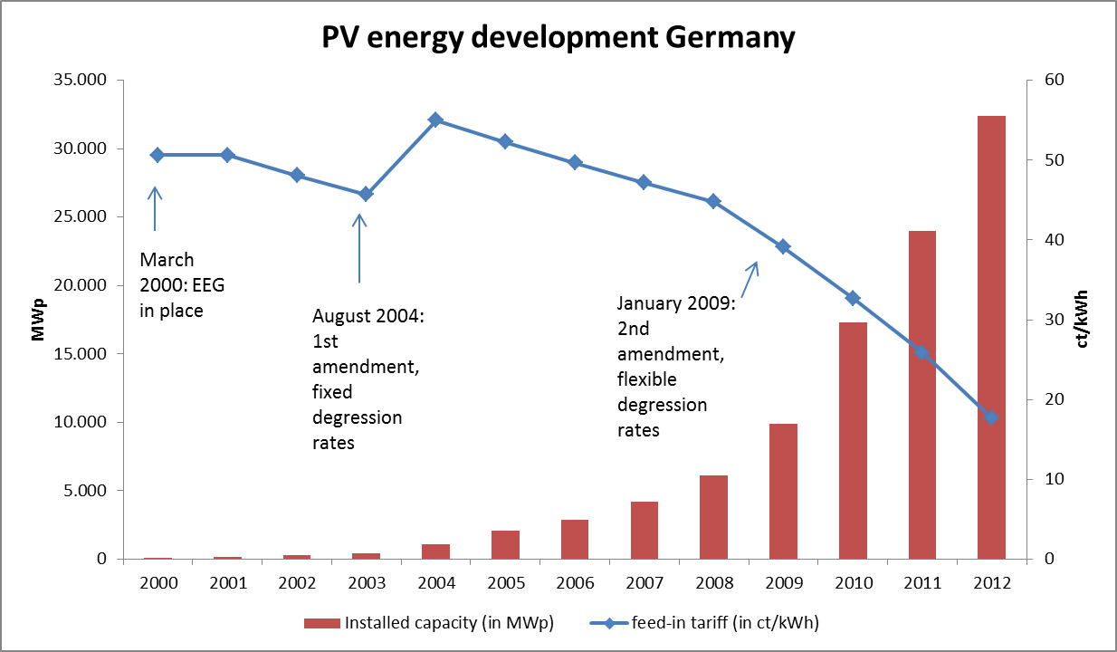
Sources: Ecorys based on BDEW, 2013; BMU, 2004; BMU, 2011 and SFV, 2013

Spain
Spain is the world’s third biggest producer of wind power. In 2008, more than 11% of Spain’s electricity came from wind power. For more than a decade renewable energy promotion has been a national energy priority, resulting in a detailed renewable energy plan, a feed-in tariff system for electricity from renewable energy sources (starting in 1998) and a commitment by all political parties to maintain the system and avoid discontinuities in support, which negatively affects investment in renewables. It has been shown that an absolute negative correlation exists between wind electricity promotion and the wholesale market price, leading to a reduction of retail electricity prices.

18. Annex 10: Scenario Modelling for Economic, Environmental and Social Impacts

Methodology and approach
This this section will outline the likely market uptake scenarios for ocean energy under each of the three policy options. A speculative link between the instruments/actions proposed under each option to tackle the identified bottlenecks and the potential market uptake scenario is necessary in order to assess the economic, environmental and social impacts.

The most recent estimates regarding the installed capacity of ocean energy will be used to develop market uptake in the short term while the medium to longer term will be based on existing scenarios. Option ('business as usual') is considered to be the baseline scenario; it is linked to a continuation of current policy initiatives and realisation of current commitments with no additional measures. Option 2 and 3 will be set against this baseline scenario to assess the incremental effect on ocean energy market deployment in Europe. The scenario for option 2 will be assessed relatively to the baseline option 1 and the targeted structural actions option 3; hence the market uptake scenario for Option 3 is presented first, followed by the scenario for option 2.

Market-uptake scenarios
Scenarios looking at a long term future are inevitably bound with uncertainties as external factors (e.g. changing government policies, energy price developments etc.), which may influence the actual market uptake. In that sense scenarios are projections rather than forecasts. Nevertheless these market uptake scenarios are a useful tool enabling a comparison between the different policy options.
The market-uptake scenarios and the subsequent analysis of impacts will refer to the periods 2012-2020-2035. Beyond 2035, the uncertainty surrounding the development of ocean energy, together with other factors affecting its development is believed to be too indeterminate to derive reliable forecasts. Installed ocean energy capacity for all scenarios has been assessed for the years 2011, 2020 and 2035. For the period 2011-2020, no distinction between the scenarios is applied as it is not expected that differences will occur in terms of installed capacity before 2020. After 2020, the scenarios start to differentiate.

Ocean energy installed capacity under Option 1
The current installed capacity of modern wave and tidal installations amounts to approximately 10 MW. For the development up to 2035 the 'business as usual' scenario predominantly follows the Current Policy Initiatives (CPI) reference scenario in the Commission's Energy Roadmap 2050. This scenario reflects the impacts of the policies that are already in place. In the CPI scenario, installed capacity increases to 1.6 GW in 2020, and 4.3 GW in 2035. This is slightly more conservative than the latest IEA World Energy Outlook which foresees an installed capacity of 6 GW in 2035 under their reference scenario.

For the short term, up to 2020, the scenario is refined with recent plans from the Member States in their NREAPs. As mentioned in Section 3.3.4, six countries plan to have wave and tidal plants operating by 2020. In 2020, the installed capacity of these plants is projected to reach 2243MW, representing 0.5% of the total installed electricity capacity in the EU-27. This projection up to 2020 is in line with other sources that point to a strong growth of ocean energy over the coming years.

The figure below shows the resulting development of ocean energy installed capacity for electricity generation in the EU until the year 2035 under policy option 1. In line with the above assumptions ocean energy installed capacity will grow to 2.2 GW in 2020 and 4.3 GW in 2035.

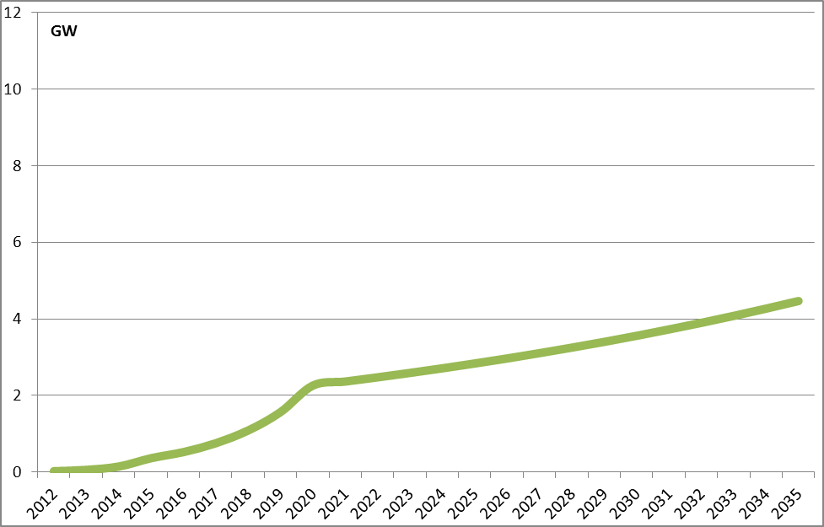

Data source: Ecorys study (2013), based on JRC (2012) and Energy Roadmap 2050 (2011)

The market uptake scenario for Option 3 is based on the "High RES” scenario in the Energy Roadmap 2050 as the types of measures proposed in this scenario are seen to be broadly comparable to the actions undertaken in Option 3. The High RES scenario aims at a high RES share in overall power generation in 2050 together with strong support and facilitation of RES in general. Despite the fact that it does not require the setting of post-2020 renewable energy targets, it does imply an overall decarbonisation goal of reducing EU GHG emissions along the line of the Low Carbon Economy Roadmap.

Option 3 relies on a series of policy measures related to the objective of enhancing R&D for low carbon energy technologies, including the mainstreaming of ocean energy in existing and future funding instruments (e.g., Horizon2020, NER300 and structural funds) as well as the eventual setting up of a European Industrial Initiative. These measures would enable the exploration of new co-operation opportunities, lead research programmes through dedicated joint calls and encourage demonstration programmes of full-scale projects. Similar policy requirements are also accounted in the high RES scenario, in which the enhancement of the European capacity for innovation, appropriate R&D investments and education and training are considered to be instrumental for an effective transition to a low carbon economy. For instance, the scenario includes support to early demonstration and first of a kind commercial plants for all low-carbon technologies, including renewables.

Concerning infrastructure, policy option 3 implies that, for renewable energy production to increase, additional measures could be needed beyond current policy initiatives. Tackling this specific issue is fundamental, if one considers that infrastructural needs have been identified as one of the specific bottlenecks hindering the potential growth of the ocean energy sector. In this regard, the response brought by the High RES scenario is consistent with such needs, since it assumes that stronger growth of interconnection capacity will be key preconditions for higher RES-based electricity trade to occur. On this matter, a dense DC interconnection system is foreseen to develop mainly offshore. Moreover, the high RES scenario also expects the facilitation of power flows through the de-congestion of specific grid links, the reinforcement of DC lines and additional grid development coordination.

The sustainable development and market uptake of ocean energy also depend on knowledge and best practice sharing across EU Member States. This is included in Option 3 which consists of policy initiatives similar to those in the High RES scenario and originates mainly from the full implementation of the RES Directive. The latter, for instance, establishes a transparency platform to facilitate and promote cooperation among Member States. In addition to this, the High RES scenario refers to the use of cooperation mechanisms or convergent support schemes for the promotion of market integration allowing for more RES trade.

The figure below reflects the expected development of ocean energy installed capacity in the EU until 2035 under policy option 1 (the baseline scenario) and option 3 (targeted structural actions). Under the Option 3 scenario installed ocean energy capacity is expected to increase to 10.5 GW in 2035.
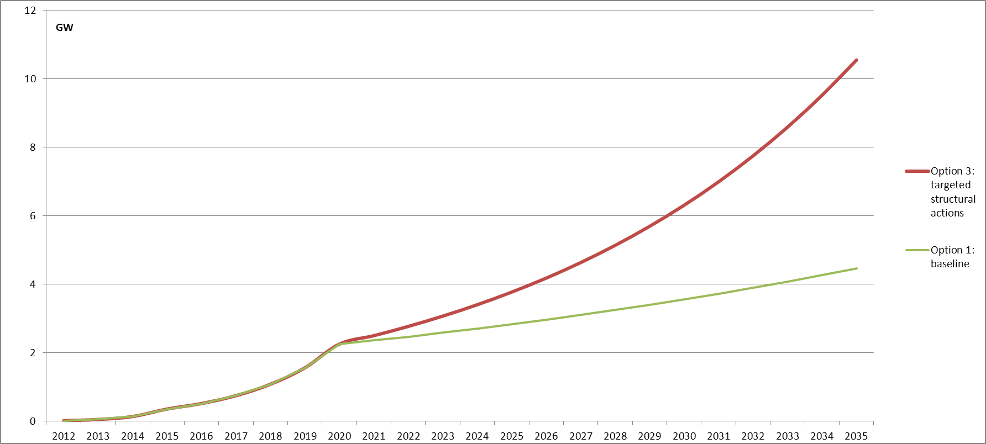
Source: Ecorys study (2013) based on Energy Roadmap 2050 (2011)

Ocean energy installed capacity under option 2
Option 2 consists of a set of soft measures that support the creation of a receptive climate towards ocean energy and accelerate the exchange of information and best practices both among and within industry, research institutes, NGOs and relevant governmental organisation within Members States. It thus creates a more favourable attitude towards ocean energy and increases awareness of its potential hence lowering thresholds in various fields which are now seen as a bottleneck in the market uptake of ocean energy, including access to finance, unknown environmental impacts of ocean energy etc. As such it is giving a positive impulse to its market uptake which places it above the baseline scenario (Option 1).

Since Option 2 is less tangible in its actions, the outcomes and impacts will dependent strongly on the interaction between government and industry stakeholders, but no robust statement can be made on its effectiveness. Consequently, no firm market uptake scenario has been developed for this option. Instead, an assessment of a plausible potential impact vis-à-vis the other two options is made. This is shown in figure below where the market uptake for Option 2 in terms of installed capacity is higher than Option 1, but significantly less than Option 3. This shows a market uptake level at one-third of the difference in development between Options 1 and 3. In 2035 this would mean an installed capacity of 6.4 GW under Option 2. This number is merely illustrative, used for the facilitation of assessment.

Ocean energy installed capacity in scenario Option 2, in comparison with Option 1 and Option 3

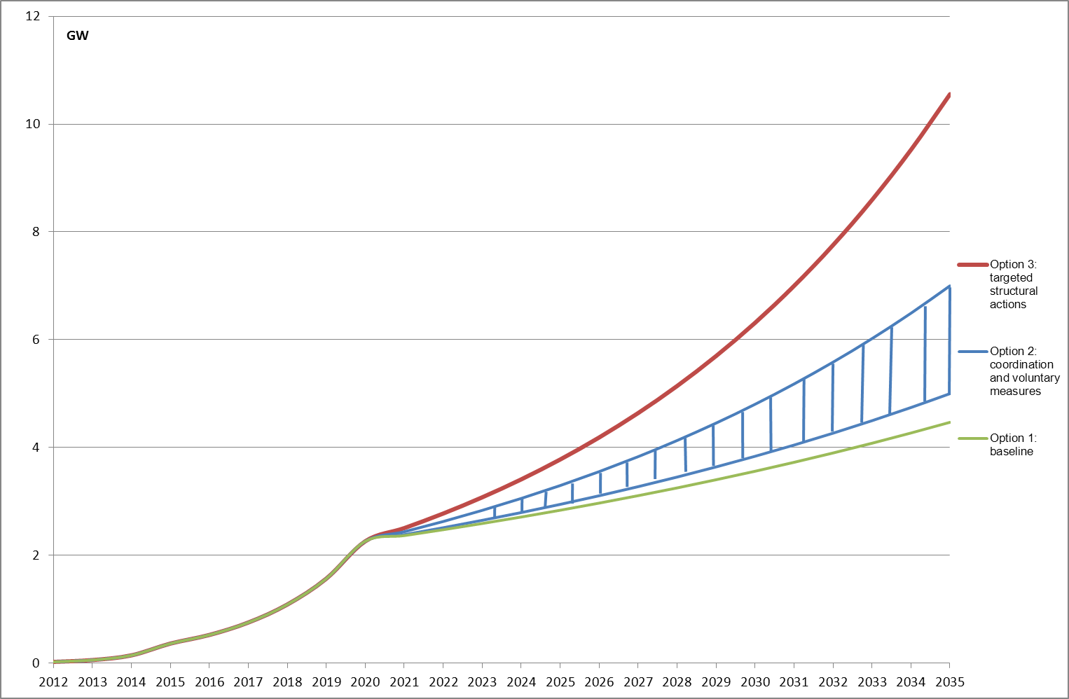
Source: Ecorys study (2013)

19. Annex 11: Development of the offshore wind industry

A recent study argues that the current situation in ocean energy technology is comparable to the position of offshore wind in the beginning of the 1990s. If the historical development of offshore wind is plotted on ocean energy (the situation for ocean energy in 2008 is assumed equal to offshore wind energy in 1991) we can see that it could be expected to take off dramatically after 2025 reaching roughly 23 GW in 2035. The green line represents the option 1 baseline scenario.

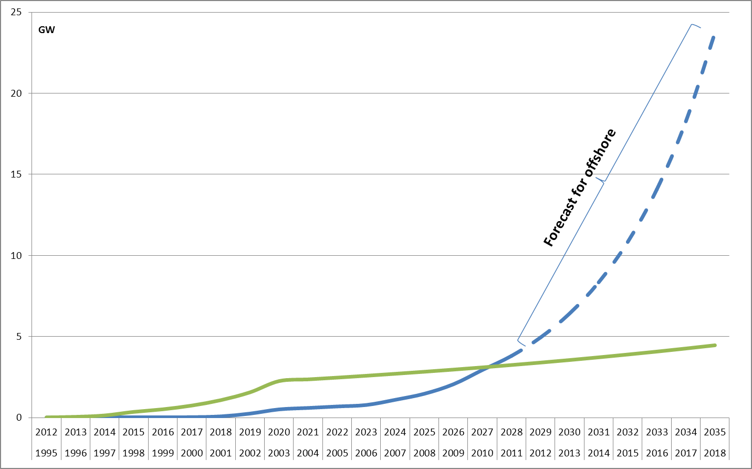
Source: Ecorys (2013) based on Esteban & Leary (2012)

Offshore wind and modern ocean energy share similarities in technology, installation & operation techniques, regulatory environment (Maritime Spatial Planning, support schemes) and the two sectors seem to have a substantial potential for synergies. However, modelling the development of ocean energy based on offshore wind deployment would be inaccurate and unrealistic for several reasons.
Firstly, the measures proposed under this impact assessment are of a soft, non-binding nature. In contrast, the European offshore wind industry enjoyed strong legal interventions in several Member States such as the 2006 German Infrastructure Planning Acceleration Act for offshore wind grid connections. The figure below shows additional detail.
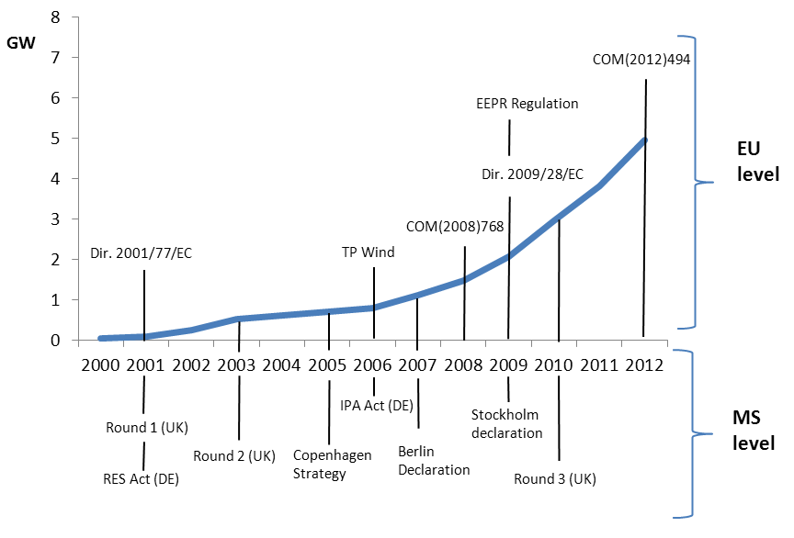
Source: Ecorys (2013)

Secondly, the political and economic climate has changed. During the past two decades, there has been a strong focus on increasing the share of renewables in the European energy mix. The wind energy industry (both onshore and offshore) was stimulated by ambitious environmental policy in Member States and EU targets. The policy framework provided a strong impetus to the development of renewable energy technologies more generally, with on- and offshore perceived to have a strong potential to contribute to the targets at the time. The situation has changed; however, with the economic crisis substantially diminishing the amount of investment into the renewable energy industry. The current policy landscape is focused on the period up to 2020 may not provide a substantial impulse to ocean energy, especially given the competition from more mature renewable energy technologies and the limited extent to which ocean energy can contribute to the 2020 targets. Specific policy to support ocean energy is therefore deemed necessary.
Thirdly, there are substantial techno-economic differences between the ocean energy and offshore wind energy; not only is ocean energy characterised by a more diverse array of designs and technologies, but the offshore wind industry could readily establish itself on the existing onshore wind industry so, e.g., there was only a need for incremental advances in R&D and the technological risks were perceived to be lower. Nevertheless, even though ocean energy is presently still at an early stage of development, significant changes could realistically occur in the future provided that the appropriate policy context is created, addressing the identified bottlenecks.

20. Annex 12: Overview of Emission Factors

Comparison of avoided GHG emissions expected by various literature sources.

Source | Total emissions from ocean energy | Kg CO2 per MW/h | Assumptions
Valuation offshore | 100 million tonnes from 2010 to 2050 | 430 (2010-2030)  20 (2030-2050) | Technologies considered:  Tidal and wave  DECC 2010 GHG appraisal guidance
Carbon trust | 1 to 3.3 million tonnes a year for 1 to 2.5 GW
JRC EU OEA | 2.61 million tonnes per year in 2020  136.3 million tonnes per year in 2050 | 300 Kg | Technologies considered:  Tidal and wave  An estimation of NOx and SOx is proposed

Source: Ecorys (2013)

21. Annex 13: Environmental Impacts
Infrastructure projects affect the environment by definition. As ocean energy technologies approach commercialisation, the concern over the impact of their deployment on the environment becomes increasingly important. At the same time, however, available data is limited and too many unknowns remain for a full assessment of the environmental costs and benefits of ocean energy.
Although some are specific, the majority of the negative environmental impacts related to ocean energy deployment are equally relevant for all of the technologies, including offshore wind, but also other marine infrastructure installations unrelated to renewable energy. The most frequently quoted environmental costs include destruction of habitats, killing of fish through direct 'blade strikes', underwater noise, electromagnetic effects, or the entanglement of diving water birds and marine mammals. Potentially, negative impacts can also be expected with the construction of access roads, channels and connections to the electricity grid, as natural habitats can be damaged, disturbed or lost in the process. Whilst in most cases the harm to the concerned populations is temporary, extreme cases could result in a local extinction of a given species. Mitigating measures and further research are therefore essential to prevent such irreversible damage.
According to numerous studies, the adverse environmental impacts ofocean energy deployment are expected to be far lower than those for conventional sources of energy (e.g. coal mining, shale fracturing), which also exacerbate global environmental problems such as climate change.
Wave and Tidal stream

The lack of deployment experience currently precludes a full assessment of the environmental impact of wave and tidal stream technologies.

Tidal stream turbines are considered to be more environmental benign than tidal barrages as they do not block channels or estuarine mouths, interrupt fish migration or alter hydrology. Noise and vibration during installation and decommissioning, disruption of habitats, and entanglement of birds and marine mammals are, however, some of the most important adverse impacts. Chemical leakage of paints and anti-fouling chemicals could have an adverse impact on water quality. The visual impact is likely to be limited because devices are normally partially or entirely submerged. Bird migratory routes, feeding and nesting are likely to be largely unaffected.

Tidal Barrage

Estuaries are highly complex and unique habitats. Tidal range or tidal barrage plants sited at the mouths of estuaries pose many of the same environmental threats as large dams as they alter the flow of saltwater into and out of estuaries which could affect the hydrology and salinity of these sensitive environments.

There is a broad agreement in the literature, that damning estuaries tends to have a very substantial impact on the environment resulting from the change in the amplitude and timing of tides in the basin, which alters water salinity and sediment movements in the estuary. By consequence, these changes alter the local habitat and can lead to a loss of biodiversity. Environmental concerns have, for example, blocked the development Severn estuary in south west England.

Salinity gradient and OTEC

Water temperature and salinity are among are two key water quality factors, decisive for the composition of species in a given aquatic environment. The main waste product of salinity gradient technology is brackish water, its discharge in large quantities into the surrounding waters can substantially alter the aquatic environment. OTEC technology can alter the biodiversity through the intake of warm water and alteration of the nutrient characteristics. There is a risk of chemical spills for both technologies if the fluids used during the process spill.
The deployment of ocean energy technologies can, however, also have a wide range of positive impacts on the environment. It could, for example, result in the exclusion of fishing and trawling in the areas concerned. This was found to be highly beneficial for fish population recovery, the diversity levels in these areas could even be comparable to marine protected areas.
The public consultation on ocean energy showed that directly engaged stakeholders are generally aware of the double-edged nature of the effect of ocean energy on the environment and of the possibilities for mitigation of some of the adverse effects. For instance, because ocean energy farms are likely to constitute prohibited areas for commercial fisheries and navigation, they could locally prevent over-fishing and trawling and thus help the regeneration of certain species as well as provide a bio-diverse refuge around the foundations of the devices (providing 'artificial reefs'). The displacement of GHG emissions will also reduce acidification of the atmosphere and the seas. Many of the negative impacts can also be successfully mitigated, for example by installing sensors which detect approaching seals etc. Site selection for ocean energy installations can be optimized through increased research, monitoring, knowledge-sharing and better use of marine spatial planning.
Lifecycle emissions of ocean energy technologies

While ocean energy is generally considered to be a 'zero carbon' technology, some carbon emissions will inevitably be produced throughout the device life-cycle during the manufacturing, construction, transportation, installation, maintenance and decommissioning. Only a limited number of lifecycle assessment studies are available for ocean energy but these show that when compared to fossil fuel technologies, the lifecycle GHG emissions are very low. For instance, the largest contribution in the energy balance of wave converters is the energy needed for the materials used (usually steel) but the energy needed for transport assembling and decommissioning is low.
Source: IPCC, 2011

22. Annex 14: Job Creation Estimates

Geographic area | Total jobs created | Capacity created in MW | Time horizon | Jobs/MW
Europe | 40.000 (26.000 direct) | 3.600 | 2020 | 11.1 (7.2 direct)
Europe | 471.320 (314.213 direct) | 188.000 | 2050 | 2.5 (1.67 direct)
Ireland | 70.000 | 29.000 | 2050 | 2.4
United Kingdom | 2.500 | 2.300 | 2030 | 1.08
United Kingdom | 68.000 | 70.000 | 2050 | 0.97
U.S. | 36.000 | 15.000 | 2030 | 2.4
U.S. Department of Energy | 1.400.000 | n/a | 2025 | 14

23. Annex 15: Supply Chain
The diagram below shows the manufacturing capacity supporting the ocean energy sector (represented by dark blue circles) across Europe. The industry can support economic growth even in countries which do not have the resource potential for deployment.

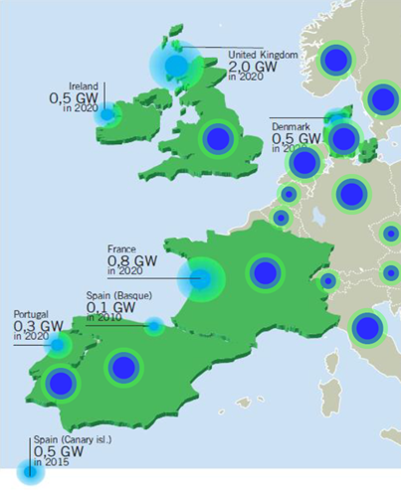

24. Annex 16: Overview of marine energy technologies and their European potential

1. Preamble
The resource potential of marine energy (wave, tidal, offshore wind and other forms of energy such as saline gradient and thermal energy conversion) is undeniable. Still, the marine environment remains Europe’s last, untapped renewable energy source, despite its potentially significant role in the decarbonisation of the European economy and the security of the European energy supply. Moreover, marine energy can have a positive impact on economy and stimulate job creation. The manufacturing, transportation, installation, operation and maintenance of marine energy facilities are expected to offer employment opportunities to communities often in remote coastal areas with low and/or decreasing employment rates; thus actively supporting communities and local economies across Europe.
Reducing the cost of marine energy technologies and improving and expanding the electricity grid infrastructure to more readily integrate these new technologies with the European energy system are key challenges for harvesting the marine energy potential. Simpler planning and licensing processes in compliance with environmental regulations, along with increased public awareness and acceptance, will also facilitate the large scale deployment of marine energy technologies.
In the context of this Annex, marine energy refers to:
- Wave energy
- Tidal stream energy
- Offshore wind energy
- Other forms such as tidal barrage, saline gradient and thermal energy conversion, which are not treated in detail herein.
The most developed marine energy technology is offshore wind. Offshore wind in Europe is expected to grow from 2.9 GW in 2010 to almost 42 GW by 2020. Reaching this target will require massive investments, hence, it is of utmost importance that costs are reduced by designing bigger, smarter and more reliable turbines; and by stream-lining the supply chain, installation, operation and maintenance processes. In contrast, wave and tidal energy technologies are still in their infancy. The key issue with these technologies is to achieving the transition from early demonstration of single projects to deployment of the first arrays of multiple devices, allowing the industry to pursue the commercialization of such technologies. Synergies between offshore wind and wave and tidal energies can be found in the necessity to develop design concepts, dedicated ports and fleets of installation vessels as well as access to grid and maintenance. Other forms of marine energy, such as thermal energy conversion and saline gradient are expected to be of limited relevance for the European energy system in the short to medium term (up to 2030), hence they are not considered in this report.
Europe is currently a world leader in marine energy, both in terms of wave and tidal technology demonstration and offshore wind farm deployment. Europe is very active in developing wave and tidal energy conversion concepts, in system design and engineering, and in single- and multiple-device testing aiming at demonstrating the commercial viability of technologies. The European test centres, e.g. the European Marine Energy Centre (EMEC), the Wave Hub, the Biscay Marine Energy Platform (BiMEP) and the Danish Wave Energy Centre (DanWEC), are state-of-the-art facilities. Developments in offshore wind have mainly centred in the North Sea with the UK representing the largest individual market while major projects are also under development in Germany, Denmark, Sweden and Belgium.
2. Current market status and future potential
2.1 Current situation
2.1.1 Wave and new tidal
Currently, there is only one commercial tidal energy plant in Europe, located in France, the La Rance tidal barrage power station. Its capacity is 240 MW and generated 476 GWh of electricity in 2010. The potential of tidal barrage technology is limited to few favourable geographic locations. Furthermore, such projects require intensive civil work: the La Rance plant has a 750 meter long barrage. As such, this Annex does not address tidal barrage technology; it focuses on ‘new’ tidal stream technologies, which convert tidal energy to electricity in favourable tidal stream areas with high flow speeds. With regards to wave energy, existing facilities are concentrated in the UK, where the installed capacity reached 2.6 MW in 2010, generating 1.8 GWh.
Wave and "new" tidal energy technologies are still in their infancy and a number of devices are currently being tested in real environmental conditions. The 1.2 MW Marine Current Turbines tidal device in Northern Ireland leads the market in terms of power generated on a continuous basis by a utility-scale tidal or wave machine. The second largest installation is the 500 kW Wavegen Limpet device at Islay (UK), which has also been generating electricity on a continuous basis. This installation uses the oscillating water column (OWC) technology. A similar plant with a nominal power of 300 kW has been built in Mutiku, Spain. Wave energy manufacturers include also Aquamarine with its 315kW Oyster devices installed in 2009 in Orkney islands and 800 kW in 2011; Pelamis Wave Power, which presented the 750 kW Pelamis module in 2008 and a second generation device (P2) in 2010; Carnegie Wave Energy, Wave Dragon and Eneolica. In Norway, Langlee Wave power is expected to make major steps when presenting its 28 MW and 24MW wave demonstration projects in 2013. Table 1 shows examples of wave and tidal energy converter designs that have been installed in European waters. Intensive testing and demonstration activities have been carried out in recent years by EMEC in the UK, including Pelamis machines, one Aquamarine installation and a Wavegen plant.
Finally, it is noted that three new projects will receive funding from the NER300 programme: the Kyle Rhea 8 MW tidal energy project in the UK, which will receive EUR 18.4 million; the Sound of Islay 10 MW tidal energy project in the UK, which will receive EUR 20.7 million; and the West Wave 5 MW wave energy project in Ireland, which will receive EUR 19.8 million.

Table 1: Examples of wave and tidal energy technologies installed in European waters
Developer | Country of Origin | Nominal power [kW] | Projects to date
Pelamis Wave Power | UK | 750 | 2 units at EMEC, UK
Ocean Power Technologies | USA | 40 / 150 | 2 units of 40 kW in the USA, one 150 kW unit in Scotland
Seabased | Sweden | 30 | Many 30 kW units in Sweden
Aquamarine Power Oyster | UK | 315 / 800 | 315 and 800 kW units at EMEC, UK
AW Energy WaveRoller | Finland | 300 | 1 unit in Portugal
Voith Hydro Wavegen | UK / Germany | 300 / 500 | One 300 kW unit in UK and one 500 kW unit in Spain
WavEC | Spain | 400 | 1 plant in Portugal
Wave Dragon | Denmark | 20 | 1 unit in Denmark
Wello Oy | Finland | 500 | 1 unit in the UK

2.1.2 Offshore wind energy
According to the Renewable Energy Progress Reports of the EU Member States, the installed capacity of offshore wind energy in the EU27 reached 2925 MW in 2010 (Table 4); 87% of which was located in the UK, Denmark, Netherlands and Belgium. In the same year, the offshore wind energy production in EU27 was 6226.6 GWh (22.4 PJ) (Table 4), which corresponds to 0.4% of the total EU renewables (total RES) energy generation and approximately 0.26% of total electricity generation in that year (Table 5). According to industrial sources, the installed capacity of offshore wind energy in the EU reached 4950 MW by the end of 2012.
There were approximately 70 offshore wind farms in operation in Europe in 2012. The average wind farm capacity was 90 MW whereas the maximum capacity was 630 MW. These farms have been erected relatively close to the shore (at a distance less than 50km) and in shallow-to-medium water depths (less than 50m). However, although most future wind farms will remain at a maximum depth of 50m, there are a significant number of projects planned for deeper waters, at 50-350 m depth. By 2012, three wind energy projects have been built on floating substructures, in waters deeper than 50m: a 2.3 MW turbine at a depth of 220 meters, off the coast of Norway (Hywind); a 2 MW turbine at a depth of 50m off the coast of Portugal (WindFloat); and an 80 kW turbine at a depth of 113 meters off the coast of Brindisi in Italy (Blue H). The latter was decommissioned after 6 months of research.
Figure 1 shows the mean depth of existing and planned European wind farms based on the 4COffshore wind farms database. Denmark, the Netherlands and Sweden were the first European countries to build demonstration offshore wind farms starting in the 1990s. However, the timeline starts only at year 2000 to give more space in the graph for the major cluster of offshore wind developments, starting around 2005. For the same reason, the wind farms developed or planned for waters deeper than 150 m have been omitted in the graph. Those include one wind farm in Norway in 2012 and two wind farms each for Croatia, Estonia and Spain planned for the period 2015-2020. Currently Germany and the UK have the largest numbers of planned wind farms.
Figure 1: Mean depth of existing and planned European offshore wind farms

However, as the figure shows, the majority of future wind farms are still planned to be erected at a distance of less than 50km from the shore: both Germany and the UK have consistently placed all of their planned wind farms in maximum 50m deep waters.
Norway, on the other hand, plans to go deeper with wind farms at depths of several hundred meters, while staying relatively close to the shore. Also Spain has some wind farms planned for deep waters but only around 2020.
A general trend of erecting farms at deeper waters – especially where shallow waters are not available – has been observed but this trend is counter-balanced by the related increased technical demands. According to Deloitte this leads to an upward trend in offshore project costs during the next 10 years.

2.2 Future potential
2.2.1 Wave and tidal
According to the National Renewable Energy Action Plans (NREAPs) prepared by the EU Member States, six countries plan to have wave and tidal plants operating in their territories by 2020: UK, France, Portugal Ireland, Spain and Italy. The installed capacity of these plants is projected to reach 2253 MW in 2020 (Table 2), representing 0.5% of the total RES electricity in EU27 that year (Table 3). This implies an approximately 10-fold increase from 2010 levels (Figure 2). These plants are expected to generate 6506 GWh (21.6 PJ) in 2020, see Table 2.
The largest amount of wave and tidal energy in 2020 will be generated in the UK and France: 3950 GWh (14.2 PJ) and 1150 GWh (4.1 PJ), respectively (Table 2). Their aggregated energy generation will represent 85.1% of the total wave and tidal energy production in EU27, with UK alone providing 65.9%. In 2020, the total amount of wave and tidal energy generated in the EU-27 will represent 0.2% of the renewable energy mix of that year (Table 3). Hence, between 2010 and 2020, the amount of wave and tidal electricity is projected to increase by a factor of 13 with a compound annual growth rate (CAGR) of 29.2%. The UK, Ireland and Portugal will have the highest wave and tidal energy share in domestic renewable electricity generation, with 3.4%, 1.7% and 1.2 %, respectively. The UK and Ireland will also have the highest domestic share of wave and tidal energy in the total renewable energy in 2020, with 1.7% and 0.9%, respectively (Table 3). The highest growth in wave and tidal energy in 2020 compared to 2010 is expected to be in the United Kingdom (Figure 3a).

Table 2: Wave and tidal energy installed capacity and generated energy by Member State up to 2020, as described in the EU Renewable Energy Progress Reports and NREAPs (National Renewable Energy Action Plans). Countries not shown in the Table below have not planned for wave and tidal energy for the period to 2020

 | Installed Capacity (MW) |  |  |  | Generation Potential (GWh)
 | 2005 | 2010 | 2015 | 2020 | 2005 | 2010 | 2015 | 2020
IE | 0 | 0 | 0 | 75 | 0 | 0 | 0 | 230
ES | 0 | 0 | 0 | 100 | 0 | 0 | 0 | 220
FR | 240 | 240 | 302 | 380 | 535 | 476 | 789 | 1150
IT | 0 | 0 | 0 | 3 | 0 | 0 | 0 | 5
NL | 0 | 0 | 0 | 135 | 0 | 0 | 0 | 514
PT | 0 | 0 | 60 | 250 | 0 | 0 | 75 | 437
FI | 0 | 0 | 10 | 10 | 0 | 0 | 0 | 0
UK | 0 | 2.6 | 0 | 1300 | 0 | 1.8 | 0 | 3950
EU | 240 | 242.6 | 372 | 2253 | 535 | 477.8 | 864 | 6506

Table 3: Share of wave and tidal energy in total RES and renewable electricity in each Member State in 2020. Source: EU Renewable Energy Progress Reports and NREAPs

 | Share in total RES energy (%) |  | Share in RES electricity (%)
 | 2010 | 2020 | 2010 | 2020
IE | n.a | 0.9 | 0 | 1.7
ES | n.a | 0.1 | 0 | 0.2
FR | 0,2 | 0.3 | 0.6 | 0.7
NL | n.a | 0.6 | 0 | 1
PT | n.a | 0.6 | 0 | 1.2
UK | n.a | 1.6 | 0 | 3.4
EU 27 | 0,03 | 0.2 | 0.08 | 0.5

Figure 2: Wave and tidal energy installed capacity and energy generation in EU27, according to EU 27 Renewable Energy Progress Reports and NREAPs

Figure 3. (a) Wave and tidal energy and (b) offshore wind energy development according to EU 27 Renewable Energy Progress Reports and NREAPs

2.2.2 Offshore wind
According to NREAPs, the installed offshore wind capacity is projected to reach 42 GW in 2020 (Table 4, Figure 4) representing about 20% of installed wind. Although, as stated above, in 2010, the UK, Denmark, the Netherlands and Belgium hosted about 87% of the total offshore wind installed capacity in the EU, in 2020 these countries are projected to host 70% to the total offshore wind installed capacity in EU27, indicating a wider spread of offshore wind power among the Member States.
The offshore wind energy production in 2020, reported by Member States in the NREAPs, is expected to reach 137 TWh (492 PJ) (Table 4) in EU27, meeting 4.8% of the total renewable energy generation (Table 5). In 2020 offshore wind will represent 3.6% of the total electricity generation in the EU27.
The highest offshore wind domestic share in renewable electricity will be in Malta, the Netherlands and the UK with 46.1%, 37.8% and 37.7% respectively, followed by Estonia and Belgium with 29.4% and 26.8%. Malta will also have the highest offshore wind domestic share in the total renewable energy generation in 2020, i.e. 31.9%, followed by the Netherlands (24%), the UK (18.3%), Belgium (9.8%) and Denmark (9%), see Table 5.
The largest offshore wind energy development in 2020 from 2010 levels will be in the United Kingdom and Germany, followed by the Netherlands and France (Figure 3b).

Table 4: Offshore wind installed capacity and generation potential by Member State up to 2020, as described in the EU Renewable Energy Progress Reports and NREAPs

 | Installed capacity (MW) |  |  | Generated electricity (GWh)
 | 2005 | 2010 | 2020 | 2005 | 2010 | 2020
BE | 0 | 196.5 | 2000 | 0 | 189.6 | 6200
DK | 423 | 765 | 1339 | 1456 | 1622 | 5322
DE | 0 | 180 | 10000 | 0 | 210 | 31771
EE | 0 | 0 | 250 | 0 | 0 | 563
IE | 25 | 25 | 555 | 0 | 70* | 1742
GR | 0 | 0 | 300 | 0 | 0 | 672
ES | 0 | 0 | 750 | 0 | 0 | 1822
FI | 0 | 26 | 900 | 0 | 73* | 2500
FR | 0 | 0 | 6000 | 0 | 0 | 18000
IT | 0 | 0 | 680 | 0 | 0 | 2000
LV | 0 | 0 | 180 | 0 | 0 | 391
MT | 0 | 0 | 95 | 0 | 0 | 216
NL | 0 | 228 | 5178 | 0 | 765 | 19036
PL | 0 | 0 | 500 | 0 | 0 | 1500
PT | 0 | 0 | 75 | 0 | 0 | 180
SE | 23 | 163 | 182 | 62 | 450 | 500
UK | 213.8 | 1341 | 12990 | 403 | 2847 | 44120
EU | 685 | 2925 | 41974 | 1921 | 6226.6 | 136535
* Values estimated by the JRC-SETIS based on capacity factor values derived from the NREAPs.

Figure 4: Offshore wind installed capacity and generated energy in EU27, according to EU 27 Renewable Energy Progress Reports and NREAPs.

Table 5: Share of offshore wind electricity production in total RES energy, total RES electricity, total electricity production and gross final energy consumption (GFEC).
 | Share in total RES energy (%) |  | Share in RES electricity (%) |  | Share in total electricity production (%) |  | Share in GFEC (%)
 | 2010 | 2020 | 2010 | 2020 | 2010 | 2020 | 2010 | 2020
BE | 0.8 | 9.8 | 2.7 | 26.8 | 0.17 | 5.34 | 0.04 | 1.3
DK | 3.8 | 9.0 | 13.1 | 25.8 | 6.75 | 12.84 | 0.86 | 2.8
DE | 0.1 | 7.0 | 0.2 | 14.6 | 0.05 | 5.19 | 0.01 | 1.4
EST | 0 | 5.6 | 0.0 | 29.4 | 0.00 | 5.09 | 0.00 | 1.4
IE | 0.9 | 6.5 | 1.6 | 12.5 | 0.25 | 5.10 | 0.04 | 1.1
GR | 0.0 | 1.2 | 0.0 | 2.3 | 0.00 | 0.94 | 0.00 | 0.2
ES | 0.0 | 0.8 | 0.0 | 1.3 | 0.00 | 0.44 | 0.00 | 0.2
FI | 0.1 | 2.0 | 0.3 | 7.5 | 0.00 | 2.46 | 0.02 | 0.8
FR | 0.0 | 4.2 | 0.0 | 11.6 | 0.00 | 3.01 | 0.00 | 1.0
IT | 0.0 | 0.8 | 0.0 | 2.0 | 0.00 | 0.49 | 0.00 | 0.1
LV | 0.0 | 1.7 | 0.0 | 7.5 | 0.00 | 3.91 | 0.00 | 0.7
MT | 0.0 | 31.9 | 0.0 | 46.1 | 0.00 | 6.39 | 0.00 | 3.5
NL | 3.2 | 24.0 | 6.5 | 37.8 | 0.70 | 14.01 | 0.13 | 3.2
PL | 0.0 | 1.2 | 0.0 | 4.7 | 0.00 | 0.74 | 0.00 | 0.2
PT | 0.0 | 0.3 | 0.0 | 0.5 | 0.00 | 0.27 | 0.00 | 0.1
SE | 0.2 | 0.2 | 0.5 | 0.5 | 0.14 | 0.29 | 0.11 | 0.1
UK | 5.2 | 18.3 | 10.2 | 37.7 | 1.27 | 11.09 | 0.18 | 2.8
EU | 0.4 | 4.8 | 1.0 | 11.3 | 0.26 | 3.57 | 0.05 | 1.0

Bulgaria, Cyprus, Latvia, Poland, Romania and Slovenia have no plans to introduce offshore wind before 2020. Italy has planned to introduce offshore wind in 2013 whereas Estonia, Greece, Spain, Latvia, Malta, Portugal and Spain will not introduce offshore wind before 2015. The largest growth in offshore wind energy from the 2010 levels is expected in the United Kingdom and Germany, followed by the Netherlands and France (Figure 3, right).
For the period 2013-2015, a number of sources estimate that the annual global wind energy market (onshore and offshore combined) could reach between 43 GW and 58 GW, increasing afterwards mainly due to growth of offshore installations. JRC-SETIS estimates that in 2020 the European wind energy installed capacity could reach 215 GW of which 33 GW offshore, reflecting on the latest delays in materialising grid infrastructure projects. Global capacity of wind energy could reach 715 GW in the same year, of which 50 GW will be offshore.
In Europe, the 2020 projections based on the NREAPs suggest that offshore installations will increase significantly, from 2.9 GW today to 42 GW, demonstrating a 15-fold increase. The industry expects that the installed capacity in 2020 in Europe will reach 230 GW, of which 40 GW will be offshore, and 400 GW by 2030 of which 150 GW offshore.
Table 6 shows the JRC-SETIS estimates on likely deployment of wind energy for the European Union and the world as a whole.

Table 6: Estimated installed capacity of wind energy up to 2050, in GW. Source JRC-SETIS
 | EU |  |  | World |  |  |  | EU share of World capacity
 | Total | Onshore | Offshore | Total | Onshore | Offshore | Offshore
Cumulative capacity 2011 | 94 | 90 | 3.7 | 240 | 236.1 | 3.9 | 95%
Installed 2012-2015 | 51 | 43.7 | 7.3 | 175 | 162.9 | 12.2 | 60%
Annual installation rate | 12,8 | 10,9 | 1.8 | 43.8 | 40.7 | 3 | 60%
Installations 2016-2020 | 70 | 48 | 22 | 300 | 266 | 34 | 65%
Annual installation rate | 14 | 9.6 | 4.4 | 60 | 53.2 | 6.8 | 65%
Cumulative by 2020 | 215 | 182 | 33 | 715 | 665 | 50 | 66%
Installations 2021-2030 | 135 | 50 | 85 | 750 | 550 | 200 | 43%
Annual installation rate | 13.5 | 5 | 8.5 | 75 | 55 | 20 | 43%
Cumulative by 2030 | 350 | 232 | 118 | 1465 | 1215 | 250 | 47%
Installations 2031-2050 | 200 | 40 | 160 | 1075 | 725 | 350 | 46%
Annual installation rate | 10 | 2 | 8 | 54 | 36 | 18 | 44%
Cumulative by 2050 | 550 | 272 | 278 | 2540 | 1940 | 600 | 46%

3. The cost of marine energy
The successful penetration of marine energy in the European energy system will depend by and large on the future trajectory of costs, for both marine energy technologies and their established technological ‘competitors’. Data are not available on actual costs of electricity per generating technology and Member State; nevertheless, useful conclusions about the competitiveness of marine energy technologies can be drawn based on calculations by the JRC-SETIS of the levelised cost of electricity (LCoE) for the main power generating technologies. The following section presents the results of this analysis. This is followed by a section that addresses the main barriers to marine energy cost reductions. This chapter is concluded by a brief overview of indirect costs that may affect the competitiveness of marine energy and in particular those of electricity networks and of electricity storage.
3.1 Average electricity generation cost from conventional technologies
The LCoE for a number of power generating technologies has been calculated using the most updated set of energy technology operational and performance indicators available to the JRC-SETIS. Table 7 below shows the input data used for natural gas, nuclear, oil and coal (both conventional and carbon capture and storage –CCS- options) technologies and the calculated LCoE for the period 2010 - 2050. The fuel and carbon costs assumed in this analysis are those considered in the 2050 Energy Roadmap. It is noted that no carbon cost was considered for the year 2010.

Table 7a: LCoE of nuclear energy technologies
LCoE, Nuclear energy
 | 2010 | 2020 | 2030 | 2040 | 2050
Specific investment [€/kW] | 4803 | 4337 | 4061 | 3938 | 3938
Economic lifetime [yr] | 40 | 40 | 40 | 40 | 40
Discount rate [%] | 7 | 7 | 7 | 7 | 7
Load factor [%] | 90 | 85 | 80 | 75 | 75
Fixed O&M cost [%] | 2 | 2 | 2 | 2 | 2
Variable O&M costs [c€/kWh] | 0.22 | 0.23 | 0.24 | 0.24 | 0.24
Fuel cost [c€/kWhe] | 1 | 1 | 1 | 1 | 1
Direct GHG emissions [tCO₂/GWh] | 0 | 0 | 0 | 0 | 0
Carbon cost [€/tCO₂] |  | 19 | 42 | 54 | 52
LCoE [c€/kWh] (2010 €) | 6.72 | 6.53 | 6.55 | 6.77 | 6.77
Note: The construction cost of the reactor does not vary much between today and 2050, but a learning factor is considered based on the reduction in the construction time from 8 years at present down to 5 years on the longer run. A decrease in the load factor is assumed in the future due to higher penetration of wind and solar power in the power mix. The fixed operating and maintenance (O&M) costs are expressed as a share of the reactor construction cost.
Table 7b: LCoE natural gas combined cycle energy technologies without CCS
LCoE, Natural Gas Combined Cycle power plants without carbon capture and storage
 | 2010 | 2020 | 2030 | 2040 | 2050
Specific investment [€/kW] | 855 | 820 | 761 | 750 | 740
Economic lifetime [yr] | 25 | 25 | 25 | 25 | 25
Discount rate [%] | 5 | 5 | 5 | 5 | 5
Load factor [%] | 80 | 70 | 60 | 60 | 60
Fixed O&M cost [%] | 2.4 | 2.4 | 2.4 | 2.4 | 2.4
Variable O&M costs [c€/kWh] | 0.23 | 0.23 | 0.23 | 0.23 | 0.23
Fuel cost [c€/kWh] | 2.61 | 3.05 | 3 | 2.8 | 2.41
Average annual efficiency [%] | 56 | 57 | 58 | 58 | 58
Direct GHG emissions [tCO2/GWh] | 308 | 308 | 308 | 308 | 308
Carbon cost [€/tCO2] |  | 19 | 42 | 54 | 52
LCoE [c€/kWh] (2010 €) | 6.05 | 7.44 | 8.07 | 8.08 | 7.32
Note: A decrease in the load factor is assumed in the future due to higher penetration of wind and solar energy in the power mix. The fixed O&M costs are expressed as a share of the investment.

Table 7c: LCoE for natural gas combined cycle energy technologies with CCS
LCoE, Combined Cycle power plants with carbon capture and storage
 | 2010 | 2020 | 2030 | 2040 | 2050
Specific investment [€/kW] |  | 1244 | 1155 | 1124 | 1093
Economic lifetime [yr] |  | 25 | 25 | 25 | 25
Discount rate [%] |  | 5 | 5 | 5 | 5
Load factor [%] |  | 85 | 85 | 85 | 85
Fixed O&M cost [%] |  | 2.9 | 2.9 | 2.9 | 2.9
Variable O&M costs [c€/kWh] |  | 0.09 | 0.09 | 0.09 | 0.09
Fuel cost [c€/kWh] |  | 3.05 | 3 | 2.8 | 2.41
Average annual efficiency [%] |  | 50 | 53 | 55 | 58
Direct GHG emissions [tCO2/GWh] |  | 54 | 50 | 47 | 45
Carbon cost [€/tCO2] |  | 19 | 42 | 54 | 52
LCoE [c€/kWh] (2010 €) |  | 7.96 | 7.51 | 6.94 | 5.95

Table 7d: LCoE for coal energy technologies without CCS
LCoE, Coal power plants without carbon capture and storage
 | 2010 | 2020 | 2030 | 2040 | 2050
Specific investment [€/kW] | 1620 | 1500 | 1350 | 1300 | 1300
Economic lifetime [yr] | 25 | 25 | 25 | 25 | 25
Discount rate [%] | 5 | 5 | 5 | 5 | 5
Load factor [%] | 90 | 85 | 85 | 80 | 80
Fixed O&M cost [%] | 4 | 4 | 4 | 4 | 4
Variable O&M costs [c€/kWh] | 0.25 | 0.25 | 0.25 | 0.25 | 0.25
Fuel cost [c€/kWh] | 1.13 | 1.23 | 1.28 | 1.18 | 1.03
Average annual efficiency [%] | 43 | 48 | 48 | 48 | 48
Direct GHG emissions [tCO2/GWh] | 695 | 695 | 695 | 695 | 695
Carbon cost [€/tCO2] |  | 19 | 42 | 54 | 52
LCoE [c€/kWh] (2010 €) | 5.16 | 6.37 | 7.85 | 8.52 | 8.07
Note: A decrease in the load factor is assumed in the future for coal power plants without CCS due to higher penetration of wind and solar energy in the power mix. The fixed O&M costs are expressed as a share of the investment.

Table 7e: LCoE for coal energy technologies with CCS
LCoE, Coal power plants with carbon capture and storage
 | 2010 | 2020 | 2030 | 2040 | 2050
Specific investment [€/kW] |  | 2456 | 2356 | 2315 | 2275
Economic lifetime [yr] |  | 40 | 40 | 40 | 40
Discount rate [%] |  | 5 | 5 | 5 | 5
Load factor [%] |  | 85 | 85 | 85 | 85
Fixed O&M cost [%] |  | 3 | 3 | 3 | 3
Variable O&M costs [c€/kWh] |  | 0.29 | 0.29 | 0.29 | 0.29
Fuel cost [c€/kWh] |  | 1.23 | 1.28 | 1.18 | 1.03
Average annual efficiency [%] |  | 36 | 40 | 43 | 46
Direct GHG emissions [tCO2/GWh] |  | 126 | 114 | 107 | 100
Carbon cost [€/tCO2] |  | 19 | 42 | 54 | 52
LCoE [c€/kWh] (2010 €) |  | 6.86 | 6.76 | 6.36 | 5.75

The required inputs to calculate the LCoE for wave and tidal energy are the capital costs and the discount rate, the amortization period, equivalent annual utilization time (load factor) and the fixed and variable O&M costs. There are no fuel and carbon emission costs, since life cycle-based carbon emissions are not included in the calculations. In practice, the variable O&M costs are minor. Capital costs take into account the capital and the accumulated interest until the start of operation of the plant. Load factors have been assumed based on a conservative approach; nevertheless these should be addressed with caution in view of the uncertainty of performance of any non-commercialised technology. For example, the average load factor calculated from the Member States’ estimates of energy production in the NREAPs is 33%, while the present analysis assumes values less than 30%. The discount rate for wave energy is assumed to be relatively high on the short term, reflecting a high-risk investment (10%). On the long term, a discount rate of 5% is considered. Tidal energy is a more proven technology, hence capital costs at any time before 2050 are lower than those of wave energy technologies.
The assumed economic performance indicators for offshore wind for the calculation of LCoE are mainly adopted from the JRC wind status report. Capital expenditure and fixed O&M costs are decreasing with time, which is supported by the general trend within the industry, e.g. expected reduction in raw material costs, current manufacturing overcapacity and increasing competition. The somewhat high discount rate reflects the high perception of risk related to offshore wind projects by investors. Regarding the load factor, at European level there are two counteracting trends: increased reliability will generally increase the load factors whereas the geographic spread of offshore wind farms to sites with lower mean wind speeds than in the North Sea will lead to lower average load factors. Thus, a conservative increase in load factor has been assumed.
The results of the calculation of LCoE for marine technologies for the years 2010 to 2050 is presented in Tables 8 (wave and tidal) and 9 (offshore wind). The cost breakdown for both wave and tidal energy technologies in 2050 is shown in Figure 5 and similarly for offshore wind in Figure 6. The capital costs have by far the highest share in the wave and tidal electricity cost. The fixed O&M costs are also significant. All other costs are minor. Similarly, for offshore wind, the highest share in the LCoE in 2050 comes from the capital costs, followed by the fixed O&M costs. However in this case, the variable O&M costs play a more significant role than for tidal and wave energy.

Table 8: Input data and calculated LCoE for wave energy and for tidal energy
LCoE, Wave energy
 | 2010 | 2020 | 2030 | 2040 | 2050
Specific investment [€/kW] | 5650 | 4070 | 3350 | 3062 | 2200
Economic lifetime [yr] | 25 | 30 | 30 | 30 | 30
Discount rate [%] | 10 | 8 | 6 | 5 | 5
Load factor [%] | 22 | 23 | 24 | 25 | 26
Fixed O&M cost [%] | 2 | 2 | 2 | 2 | 2
Variable O&M costs [c€/kWh] | 0.05 | 0.05 | 0.05 | 0.05 | 0.05
Direct GHG emissions [tCO2/GWh] | 0 | 0 | 0 | 0 | 0
LCoE [c€/kWh] (2010 €) | 37.3 | 21.9 | 14.8 | 11.7 | 8.3
LCoE, Tidal energy
 | 2010 | 2020 | 2030 | 2040 | 2050
Specific investment [€/kW] | 4340 | 3285 | 2960 | 2700 | 2200
Economic lifetime [yr] | 25 | 30 | 30 | 30 | 30
Discount rate [%] | 8 | 7 | 6 | 5 | 5
Load factor [%] | 22 | 23 | 24 | 25 | 26
Fixed O&M cost [%] | 2 | 2 | 2 | 2 | 2
Variable O&M costs [c€/kWh] | 0.05 | 0.05 | 0.05 | 0.05 | 0.05
Direct GHG emissions [tCO2/GWh] | 0 | 0 | 0 | 0 | 0
LCoE [c€/kWh] (2010 €) | 24.9 | 16.4 | 13.1 | 10.3 | 8.3
Note: The fixed O&M costs are expressed as a share of the investment.

Table 9: Input data and calculated LCoE for offshore wind
LCoE, Offshore wind
 | 2010 | 2020 | 2030 | 2040 | 2050
Specific investment [€/kW] | 3500 | 3000 | 2560 | 2290 | 2060
Economic lifetime [yr] | 20 | 25 | 25 | 25 | 25
Discount rate [%] | 10 | 9 | 8 | 7 | 6
Load factor [%] | 36 | 39 | 41 | 42 | 43
Fixed O&M cost [%] | 3.4 | 2.8 | 2.8 | 2.8 | 2.8
Variable O&M costs [c€/kWh] | 1 | 0.8 | 0.6 | 0.55 | 0.5
Direct GHG emissions [tCO2/GWh] | 0 | 0 | 0 | 0 | 0
LCoE [c€/kWh] (2010 €) | 17.81 | 12.21 | 9.27 | 7.62 | 6.3
Note: Increased load factor due to design upgrades is assumed. The fixed O&M costs are expressed as a share of the investment.

The LCoE for all the technologies is presented in Table 10 and in Figure 7 below.

Figure 5: Cost breakdown of LCoE in 2050 for wave and tidal energy
Figure 6: Cost breakdown of LCoE for 2050 for offshore wind energy

Table 10: Summary of LCoE for all power generation technologies
LCoE, all technologies [c€/kWh] (2010 €)
 | 2010 | 2020 | 2030 | 2040 | 2050
Nuclear | 6.7 | 6.5 | 6.6 | 6.8 | 6.8
Combined Cycle | 6.1 | 7.4 | 7.5 | 6.9 | 6.0
Coal | 5.2 | 6.4 | 6.8 | 6.4 | 5.8
Offshore Wind | 17.8 | 12.2 | 9.3 | 7.6 | 6.3
Tidal | 24.9 | 16.4 | 13.1 | 10.3 | 8.3
Wave | 37.3 | 21.9 | 14.8 | 11.7 | 8.3
Note: The LCoE for combined cycle and coal power plants considers conventional plants until 2020 and the lowest cost option between conventional and CCS plants for 2030 onwards.
The analysis shows that offshore wind can be competitive with other mainstream power generation technologies from about 2030 onwards. However, wave and tidal energy technologies at the current rate of development will only become marginally competitive at around 2050, based on the assumptions made above. Therefore, to make wave and tidal competitive with other mainstream technologies sooner, for example by 2030, their capital costs need to be reduced more rapidly and their load factors need to increase, implying the necessity for intensified RD&D investments.

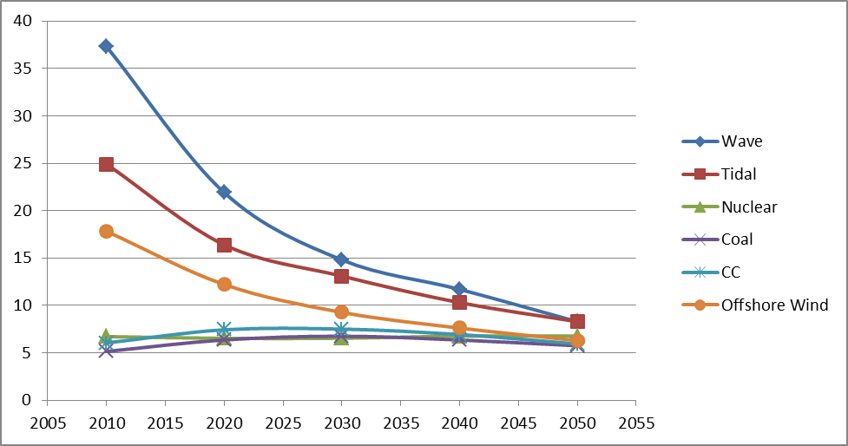
Figure 7: LCoE projections for the main power generation technologies

3.2 Cost reductions for marine energy technologies
The current costs of both wave and tidal energy are considerably higher than these of conventional and other renewable energy generation technologies, as described in the previous section, given the early stage of their technological maturity, particularly since projects are constrained to demonstration of individual devices and thus there are very limited economies of scale.
According to CarbonTrust, the current costs reflect the high uncertainties and lack of know how. The cost of devices decreases through deployment at choice sites or dedicated test sites. Reduction cost efforts are focused on new generation devices by means of increasing the energy yield in deeper waters and greater swept area per unit of support structure and foundation and per unit of capital costs and O&M costs.
Cost reduction in wave and tidal energy will be achieved through design improvement, optimizations in applied materials and mass production. These factors will lead to significant reductions in investment costs, increase of the capacity factor, higher reliability and extended lifetime.
At the current early stage, wave and tidal technologies are based on a wide variety of different designs. For instance, current wave energy converter technologies include the following types: attenuator, point absorber, oscillating wave surge converter, oscillating water column, overtopping, pressure differential, bulge wave and the rotating mass type, among others. Tidal energy converts include, among others: horizontal and vertical axis turbines, oscillating hydrofoil, enclosed tips, helical screw and tidal kite. In the future, it is expected that the current technological diversity on the RD&D level will crystallize to standard solutions with strong synergies so that significant cost reduction through the learning rate would be achieved with the increase in the cumulative installed capacity.
Figure 8 presents the cost reduction curve for wave and tidal energy during the period 2010 to 2050, based on JRC-SETIS estimates.

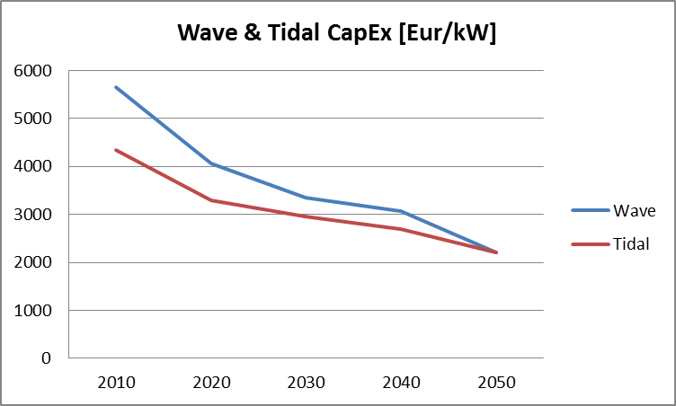
Figure 8: Capital cost reductions in wave and tidal energy technologies

The offshore wind industry experienced a period of fierce internal competition between 2000 and 2004, resulting in capital cost reductions. However, since 2005, capital costs have shown a continuous increase. During the last six years, R&D in offshore wind technology has focused on increasing the reliability of turbines which also has caused an increase in capital cost. Increased reliability should, however, be reflected on a reduced cost of energy, albeit with a lag.
Therefore, the two key issues for offshore wind are increasing reliability and reducing costs. Increasing reliability will have an impact on a number of current challenges in offshore wind farms. For example, increasing reliability reduces maintenance stops, which in turn translates to reducing the need to access the wind farm, which is currently a costly activity. Therefore, reduction of costs is partly met by increasing reliability, but also by improving the design of the whole system, e.g. the coupling between the foundation and the installation vessels in order to reduce installation time; more cost-effective foundations and installation for sites in deeper waters and farther away; and by reducing the cost of interconnections, currently representing about 20–25 % of the capital expenses.
In fact, the design of foundations and cable connection has become as important as that of turbines. Currently, monopiles are the most popular foundations, followed by gravity-based foundations for shallow-to-medium water depths. Jacket foundations are more expensive than monopiles but they have become more common mainly because of their less steep cost increase with increased turbine size, in particular above 4 MW and in increased water depths of beyond 40 m.
Much less common and, in fact, nearly experimental, are tripod, tripile and floating foundations. The latter are being explored in order to capture the very large resource available in deep-water areas. The first deep-water wind farm is envisaged in Japan in 2020. In Europe the projects VertiMED and Wind float aim to install floating wind farms of 26-27 MW around the same year.
The trend towards ever larger wind turbines, which slowed in recent years, has resumed. The largest wind turbine now in commercial operation has a capacity of 7.5 MW, and most manufacturers have introduced designs of turbines in the 4.5 – 10 MW range (up to a total of 42 different designs) mostly for offshore use. Both industry and academia see even larger turbines (10 – 20 MW) as the future of offshore machines.
The market uptake of innovative offshore foundations is affected by the long time that it takes for a new foundation to become commercially established. Public support for full-size tests of new foundations and/or first-of-a-kind use in a new wind farm would help accelerate this process. Initiatives such as the European Energy Programme for Recovery (Offshore Wind Energy) did just this at Thornton Bank offshore wind farm and others.
Monopiles, caissons or tripods, all have very different port requirements, and it has been hard to justify the development of dedicated port facilities until uncertainties are reduced. Over the past year the situation has become much clearer and as the wind farms have gone from 30 turbines each to several hundred, it is now possible to foresee dedicated port facilities being built. It is very likely that two or three such facilities will be built along the European littoral to supply European needs.
Synergies exist between the marine energy sector and the oil and gas (O&G) industry in areas such as the manufacture of installation vessels. The O&G sector can bring in experience and knowhow to the marine energy sector, in particular on substructure installations and on operation and maintenance issues.
However, the logistics of offshore wind energy are less efficient than in the O&G industry. For example, with new wind farms being built further offshore, vessels will need to carry more wind turbines in order to do less trips and to better use weather windows. In addition, they should be able to install both turbines and foundations. Certain new standards are needed: the wind industry is working with standards designed for the O&G industry, and sometimes these are not optimal.
In summary, offshore wind is expected to maintain high costs until 2015 but it has room for actions that can reduce costs, including technology improvements (e.g. to reduce foundation and installation costs), learning-by-doing, improved supply chain and more competition, which could lead to a reduction of approximately 30% by 2020, based on an average from various estimates from the industry. The industry values range from 40% cost reduction by 2015 to 20% cost reduction by 2020.
Public bodies could possibly have the largest impact on cost reduction if they focus on reducing the risks and uncertainties existing in the different phases of a wind farm project. Examples include the identification and reduction in the uncertainty of wind energy yield calculations (which would result in lower risks for financial institutions providing debt); and the reduction of the risks of the permit process, e.g. through streamlining the permit schemes, public planning of preferred wind deployment areas, etc.
Many of the issues mentioned above for offshore wind are likely to become applicable to wave and tidal energy technologies, once they reach a similar revel of maturity.
Figure 9 presents the cost reduction curve for offshore wind, for the period 2010 - 2050.

Figure 9: Cost reduction curve for offshore wind power

3.3 Connecting marine energy to the European grid
The integration of large amounts of marine energy, especially of variable offshore wind, with the power system can be a challenge for the current transmission system in a liberalised background. It is noted that tidal and wave energy is predictable to a large extent, hence less challenging for the reliability of the power grid. This makes wave and tidal energy suitable for hybrid systems with balancing power from pumped storage or gas. To address this potential bottleneck, a more flexible transmission grid would be needed as well as the large scale deployment of electricity storage devices. An overview of the power grid technology options, which could be explored to integrate marine (and other RES) energy in the power system are presented next, followed by an overview of costs for the transmission grid and electricity storage.

3.3.1 Power grid technology options for the integration of marine energy
The on-going energy market liberalisation process in Europe causes a steady rise of power exchange between Member States, generally increasing transmission network congestion. The solution of enhancing power transmission capacity, traditionally realised by adding new high voltage alternating current (HVAC) lines, is nowadays seriously hampered by economic, social and environmental constraints. Thus, a need emerges in Europe for the evolution in the design and operation of transmission networks, which will necessitate re-engineering of the system. The different options to support such a process include advanced power transmission devices like FACTS (flexible alternating current transmission system) and HVDC (high voltage direct current) technologies.
FACTS and HVDC may play a significant role towards the development of the future pan-European transmission system. These devices could help to increase transmission network capacity and flexibility and generally enhance system reliability and controllability with a limited environmental impact. These properties are especially important in a deregulated environment, where, in the presence of more frequent and severe corridor congestions, fast-reacting FACTS and HVDC elements can efficiently avoid or relieve network constraints. This can then lead to a reduced need for building new HVAC lines with consequent environmental and economic benefits. Thus, FACTS and HVDC elements may provide European transmission system operators (TSOs) with effective solutions to the several criticalities they encounter nowadays in their grid planning processes. Particular attention should be paid to different specific technical, economic and environmental features of FACTS and HVDC that have to be taken into account in a transmission expansion plan. Finally, it has to be noted that in a highly meshed network, as the European one, if HVDC and FACTS become extensively deployed, they will deliver real benefits only when subjected to a coordinated and hierarchical control.
3.3.2 The cost of electricity transmission
The investment costs for an undersea transmission system, as calculated by the FP7 REALISEGRID project, are illustrated in Figure 10. These costs refer to transmission lines connecting offshore wind farms with capacity close to 1000 MW and include costs for equipment, project engineering and installation. Each transmission type (AC and DC) in Figure 10 is represented by two lines showing minimum and maximum costs. The minimum value refers to installation costs in European countries with low labour costs, while the maximum value refers to installation costs in European countries with high labour costs, e.g. Germany, The Netherlands and France.

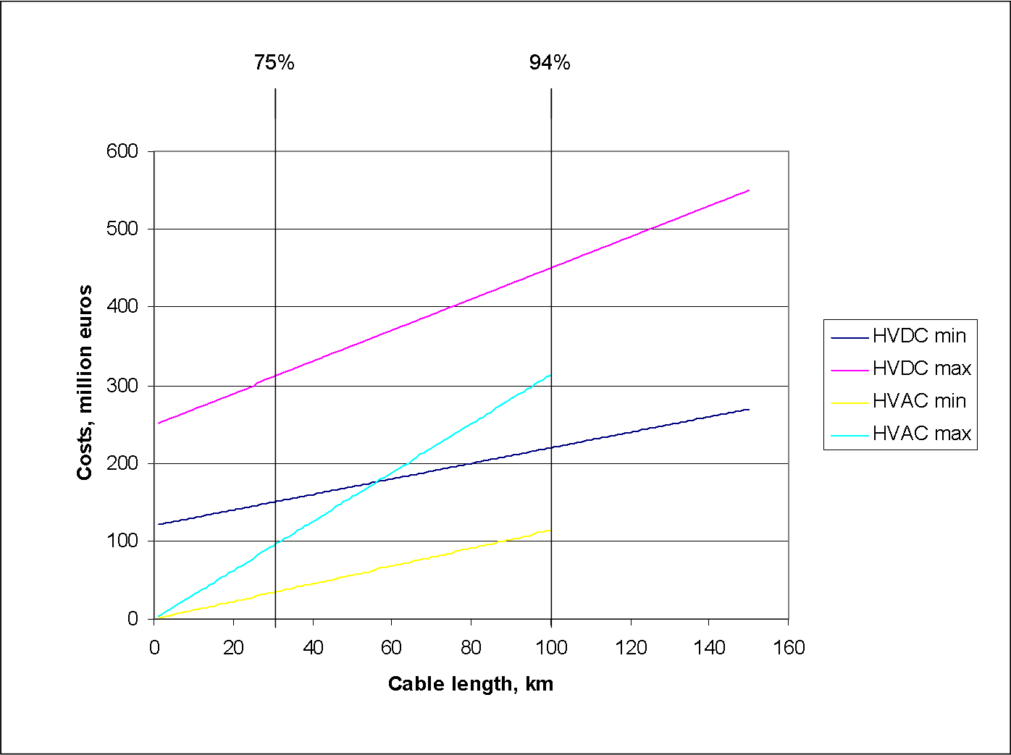
Figure 10: HVAC and HVDC undersea cable costs for a 1000 MW wind farm. The vertical lines give the percentages of existing and planned offshore wind farms at a distance less or equal to the corresponding value in km from shore.

It can be noticed in Figure 10 that HVAC transmission cables have lower costs for power transfer of 1000 MW. However, the costs presented here are the investment costs only; therefore, it is very important that maintenance costs are also included in any assessment. Maintenance costs would represent a significant part in the total costs for AC cables, since the AC power transmission is associated with the presence of reactive power. The reactive power in the cable does not do any useful work, but increases the current in the cable. So, the losses and loading increase as well. These results indicate that for short distances (until 100 km) the HVAC option could be more efficient for offshore cabling purposes. However, for offshore cabling for long distances (200 km and more) HVDC is the only feasible solution. This discussion is also relevant to wave and tidal energy transmission, where a good approach would be to consider connection costs similar to offshore wind cabling costs.
3.3.3 The cost of electricity storage
Electricity storage has attracted significant political and commercial attention in the light of development of renewables and distributed generation, as a way to improve grid stability and to control fluctuations of variable resources, such as offshore wind, and to a lesser extent, of wave and tidal energy. There are many storage technologies commercially available or under development, such as pumped hydro storage (PHS), compressed air energy storage (CAES), hydrogen, flywheels, super-capacitors, superconducting magnetic energy storage (SMES) and conventional/advanced/flow batteries. Figure 11 gives an overview of power storage technologies, as a function of their commercial maturity stage and the power investment cost.
Pumped storage schemes currently provide the most commercially viable means of large scale electricity storage, and it is expected to maintain this position in the short / medium term. The main technical and economic features of PHS are summarized in Table 11 below. In Europe, the installed capacity of pure PHS is approximately 40 GW. It is estimated that by 2030, about 50 % of the current PHS will have to be refurbished due to ageing. Some of these projects have already started to increase their generation capacity, for example, in the Alpine region, where new and larger converter units have been added to existing storage basins. The capacity of planned or on-going projects in Europe is estimated to be about 7 GW to be built by 2020 mainly in Switzerland, Austria, Portugal, Germany and Spain. Additionally, the large PHS potential of Norway, estimated to be 10-25 GW of new projects, could be further exploited, triggered by the large deployment of wind power in the North Sea.
Main barriers to the installation of new PHS plants are the environmental concern and the public acceptability when projects might affect the resource availability and inundate the ecosystem. New PHS plants usually require large electricity transmission infrastructure in their vicinity, which might raise political, social and regulatory issues. The initial investment costs are high, and the construction time can be long, up to 15 years taking into account the time needed for obtaining the approval for concession rights and connection to the grid. Non-technological issues include market uncertainty, the need to further develop regulatory aspects on power quality at the European level and to contribute to the integration of storage while defining grid extension planning and renewable integration targets, and unfavourable economics. A detailed treatment of these barriers can be found in the 2011 Technology Map of the European Strategic Energy Technology Plan, prepared by SETIS.
Overall, an increase in European PHS installed capacity would allow for more system flexibility. More reservoir-hydro capacity would contribute to grid support and this would enable the large scale deployment of marine and other renewables into the system.

Table 11: Main features of PHS
PHS
Power rating, MW | 100-5000
Energy rating | 1-24h+
Response time | Seconds to minutes
Round-trip efficiency | 75-85
Lifetime (years) | 50-100
Power cost (Euros/kW) | 500-3600
Power cost (Euros/kWh) | 60-150

Figure 11: Power storage technologies as function of their costs and development stage (JRC-SETIS)

4. Coastal, marine and maritime activities in synergy with marine energy
The future development of the wave and tidal energy sector will be linked with developments in offshore wind energy, exploiting positive synergies in technological progress (e.g., components), infrastructure, supply chain and policies. There will be significant opportunities for co-location of technologies; for example for wave, tidal and offshore wind energy, utilising common platforms for wind/wave or wind/tidal hybrid systems. Mutual learning processes, shared infrastructure and innovations from a shared supply chain will be of great benefit to the future expansion of the marine energy sector.
As mentioned earlier, synergies also exist between the marine energy sector and the oil and gas industry in areas such as the manufacture of installation vessels. The oil and gas sector can bring in experience and knowhow to the marine energy sector on substructure installations, health and safety and other operation and maintenance issues.
Wave and tidal energy projects share grid-related issues with offshore wind and even with onshore wind at a lower level. Other sectors that have possible synergies with wind are the grid components, in particular for offshore installations, and electricity storage sectors. The latter, along with the automotive industry for electric cars, and with the support of smart grids/metering, would create a demand-management scenario able to adapt and assimilate mainly surplus offshore wind electricity.

5. Social impact of marine energy
5.1 Employment
The estimated employment in the wave and tidal energy sector, according to the European Ocean Energy association (EU-OEA), in 2020 may reach 26000 direct jobs (and 40000 in total, both direct and indirect). The number of new jobs that will be created depends by and large on the actual penetration level of these technologies.
A significant increase is also foreseen for employment in offshore wind. A study by Cambridge Econometrics for RenewableUK examines three scenarios for employment growth in the offshore wind sector by 2020: 31 GW of installed offshore wind would create 42400 direct full time employees (FTEs) and 25300 indirect FTEs; 23 GW would create 29700 direct FTEs and 17500 indirect FTEs; and finally, 13 GW would create 1800 direct FTEs and 6400 indirect FTEs.
However, projections of growth in wind-related employment should be re-interpreted in the context of the ongoing process of delocalisation. Delocalisation causes a reduction of the production capacity in Europe with important consequences on wind energy employment. New wind markets do not necessarily involve employment growth in Europe as some of these markets (e.g. Canada, South Africa) impose local content, which aims to create local jobs. In addition, new markets without local content requirements, but away from Europe, will be supplied by European manufacturers from their factories located nearer to those markets.

5.2 Reduction in greenhouse gas (GHG) emissions
Assuming that marine energy technologies get dispatch priority in the European energy system, each MWh of marine energy fed to the grid would dispatch an equal amount of electricity generated from the power generation infrastructure in place (at least as long as the amount of marine energy is still small compared to the total amount of power generation). This implies that marine energy technologies ‘displace’ fossil fuel power plants, which leads to reduction of CO₂ emissions. The amount of CO₂ avoided by the introduction of marine energies is directly linked to the carbon intensity of electricity production. Based on the 2050 Energy Roadmap, the carbon intensity of the European energy system in 2010 is 320 kg of CO₂ per MWh, hence the generation of 1 MWh of marine energy could lead to CO₂ reductions of 320 kg. The amount of CO₂ avoided in the future depends on the future technology mix. The carbon intensity in 2020 is 230 kg/MWh in the Reference scenario, and 200 kg/MWh in the ‘diversified supply technologies’ and the ‘High RES’ scenarios of the 2050 Energy Roadmap. It is apparent that the total CO₂ emissions which could be avoided by the deployment of marine energy technologies will depend on the installed capacities of marine energy technologies and the portfolio of power generation technologies already in place at any time. The EU-OEA estimated that 2.61 Mt CO₂ /year in 2020 and 136.3 Mt/year by 2050 could be avoided by the envisaged deployment of wave and tidal energy. Similarly, in 2021, offshore wind power is estimated to avoid the emissions of 104 Mt CO₂, a figure that will rise to 315 Mt CO₂ in the year 2030. Cumulatively, this corresponds to over 2.3 Gt CO₂ avoided by 2030.

6. Marine energy technology innovation in Europe and international competition
6.1. European capacities for innovation
In 2010, the European R&D investments (public and corporate initiatives) in marine energy (Table 12) amounted to EUR 214 million (EUR 360 million if the effective payments of the European Energy Programme for Recovery –EEPR- are included). The aggregated R&D investments in the wave and tidal energy technologies concentrate in four European countries: the United Kingdom, Germany, Sweden and Norway (that account for 86% of all investments). In the United Kingdom and Sweden the public participation to relevant projects is more evident than in other countries (around 40% of national R&D investments). Offshore wind energy R&D investments concentrate in 2 countries (the United Kingdom and Germany) which together account for 70% of total offshore wind investments. The contribution of Germany would be larger when adding the funding from EEPR. Until March 2012, 92 % of the total effective payments of EEPR funding for offshore turbines and structures were made to 4 German projects (BARD Offshore, Global Tech I, Nordsee Ost and Borkum West II).
The regional distribution of public and corporate R&D investments is sensitive to market size; the correlation coefficient between aggregated (public and corporate) R&D investment and GDP is 0.76. Therefore, larger economies tend to invest more in marine energy R&D technologies than smaller countries. Long coastline countries, such as the United Kingdom, France, and Sweden, together with Germany account for 73% of these investments.

Table 12: Public and corporate R&D investment in marine energy across the European Member States in 2010 (amounts are presented in millions of euro)
 | Offshore wind energy projects | Wave and tidal energy projects
EEPR effective payment in 2010 | 146
Member State R&D investment (from IEA RD&D Statistics database) | 5.6 | 44
Corporate R&D investment (JRC-SETIS calculations) | 62.4 | 102

Table 12 presents the R&D investments in marine energy in 2010, using the methodology described hereafter. For corporate R&D investment it was assumed that the distribution of patents across the relevant technologies is a proxy for the distribution of R&D expenditures, as there is evidence of significant correlation between patents and R&D spending.
Data on public RD&D investments in wave and tidal and offshore wind energy, for many (but not all) EU Member States are collected using the IEA RD&D Statistics database.

6.1.1 R&D investment in wave and tidal energy in 2010
Based on an analysis of WIPO patent applications, Asian countries such as Japan (early investor) and Korea show large interest in the development wave and tidal energy technologies. The intensity of their research displayed a different pattern: from 2003 to 2011, a declining trend is observed for the share of patent applications from Japan and increasing one for Korea(Figure 12).These countries account together for approximately 50% of WIPO patent applications.

Figure 12: Wave and tidal energy patent applications by the main patent offices around the world during the period 2003 to 2011

Compared to the above mentioned countries, European research efforts seem to be low in the early 2000s, but significantly increasing after 2007. European patents, based on data from the European Patent Office (EPO), show an annual average increase of 16 patents during the period 2002 – 2011, rising to an annual increase of 50 to 70 after 2007. Most of the patent applications originated in the United Kingdom and Germany.
Using the share of wave and tidal energy patents in the total applications of main corporations as intensity of research in marine energy) the present assessment has estimated that EUR 102 million were invested in 2010 by the European industry in related projects. Corporate investments in wave and tidal energy are higher than public investments and account for 70% of total wave and tidal investments in 2010. Such high corporate share for RD&D investment turns out to be in line with the Lisbon strategy, according to which two thirds of R&D expenditure should be financed by the business enterprise sector. Despite the high commitment to marine energy technology development exhibited by corporate initiatives, their efforts remains limited with respect to the considerable efforts made for other energy technologies. For example, the corporate R&D in wave and tidal energy investments represent barely 5% of investments in non–nuclear energy technologies addressed by the European Strategic Energy Technology Plan (wind, solar, bioenergy, carbon capture and storage and electricity grids), and about 22% of corporate R&D investments in wind energy (onshore and offshore).
Figure 13: Estimate of corporate RD&D investments in wave and tidal energy projects by European country for the year 2010

An examination of the regional distribution of corporate R&D investments in wave and tidal energy projects reveals that countries such as The United Kingdom and Germany account for an important share of total corporate initiatives (Figure 13). The regional distribution of corporate R&D investments seem however to be less concentrated than the public investments. The public R&D investments in wave and tidal are highly concentrated in Europe, with the United Kingdom, Sweden, France and Denmark accounting for more than 90 % of public R&D investments (Figure 14).
Figure 14: Estimate of public RD&D investment in wave and tidal energy projects by European country for the year 2010. Data was collected from IEA RD&D database

With a total installed wave and tidal energy capacity in 2010 reaching 2 MW, the United Kingdom is one of the countries that show an early commitment to this technology. Public RD&D investment in the United Kingdom shows an annual average increase of EUR 3.3 million during the period 2001 to 2010. In order to improve current technology market gaps, governmental spending complements and reinforces private investments, which according to RenewableUK had been around GBP 41 million in 2009. The National Renewable Energy Centre, the European Marine Energy Centre, Wave Hub and QinetiQ support industrial initiatives. Public funding is targeting early technological stages such as first and next generation prototypes, up to 1MW.
In Sweden, the realization of the tidal energy potential is encouraged through public funding, in particular in the case of large scale projects: benefitting from public support, companies such as Seabased AB and Fortum had announced in 2010 the start of the construction of a wave power plant at the coast of Smögen in Sotenäs, with a capacity of around 10 MW. The Swedish Energy Agency has announced a special fund for the demonstration and commercialisation of new technologies with a budget of 101.4 million euro (SEK 875 million) to be distributed from 2009 to 2011. Through this fund, 16.11 million euro were used to finance wave power plants at the coast of Smögen.
A long term commitment towards marine energy technologies is also made by Denmark. Public RD&D investment in Denmark shows EUR 1 million annual average increase from 2001 to 2010. In contrast, Germany is one of the countries that started investing only recently, but significantly in marine energy projects (2.77 million euro in 2009). German investments might increase in the future, as wave and tidal initiatives are highly correlated with offshore wind projects, an area in which Germany has recently intensified its efforts.
Surprisingly, the continental country of Austria has also developed small marine initiatives in the last three years; in 2009 Austria invested 246000 euro on related projects.
Overall, from 2001 to 2010 the number of European countries involved in wave and tidal RD&D projects has increased from 5 to 11 and the public investment in wave and tidal related projects has increased tenfold (from EUR 4.2 million euro in 2001 to 44 million euro in 2010).

6.1.2 R&D investment in offshore wind energy in 2010
The recent years are characterized by an increase in public investments in offshore wind projects. Apart from national initiatives, one of the main support actions has been the European Energy Programme for Recovery (EEPR), a specific funding programme designed to stimulate Europe's economic recovery and to promote offshore wind initiatives. By the end of 2010, EUR 146 million was disbursed through EEPR for offshore wind projects in Germany, United Kingdom, Netherlands and Belgium. Five out of the 9 offshore wind projects involve German partners that received for offshore turbines and structures EUR 136 million by March 2012. Such public initiatives have been set in place to reinforce and complement private investments that might be suboptimal in the presence of uncertainty related to the market potential of the technology and in the presence of uncertainty related to future benefits from investment in the new technology.
To some extent, the intensification of public and private efforts has been correlated. The intensification of corporate research efforts for offshore wind energy technology is reflected through the patent applications at WIPO (Figure 15).
Figure 15: Offshore wind patent applications at WIPO between 2002 and 2011

From 2008 to 2012, WIPO patent applications have been increasing with an average rate of 17 patents per year. During the same period, Germany shows an annual average of 6 patent applications in offshore wind; Denmark and Netherlands an annual average of 3; while other European countries (France, Italy) follow with 1 patent application. The number of Asian and American applicants increases constantly during the same period. The regional distribution of patent applications among the Member States in 2010 for offshore wind technology is shown in Figure 16.
Figure 16: Offshore wind patent applications at WIPO by European country for the year 2010

A further examination of offshore wind patents reveals that many of them are owned by established wind manufacturers, such as Vestas, Siemens and Gamesa. The research intensity related to offshore wind of the main wind turbine manufacturers during the period 2002-2012 remains constant (1-2 patents per year). For the year 2010, offshore wind applications of the main wind turbine manufacturers represented 2.5-3% of total wind patent applications of the main wind manufacturers. Having as goal a monetary assessment of research efforts for offshore wind projects, the present assessment includes both research efforts of the main wind manufacturers, as well as new entrants in offshore wind industry (AREVA, Siemens and Alstom). These new entrants show a higher intensity in offshore wind research activities (measured by their number of patent applications) than the established wind turbine manufacturers. A high commitment for offshore wind projects is also noted for wind energy developers, such as Dong Energy and Acciona Energy. Using a patent analysis to distribute offshore wind R&D investments, JRC-SETIS has estimated that EUR 62.39 million was invested by the European private sector in offshore wind in 2010. The spatial distribution of the corporate offshore wind R&D expenditure is shown in Figure 17.
Figure 17: Estimate of corporate RD&D investment in wind offshore energy projects by European country for the year 2010

Public expenditure in offshore wind related projects (according to IEA database) remains limited: in 2010 only 5.62 million euro were invested in offshore wind in Denmark and France. However, a patent analysis from 2010 to 2012 reveals additional public investments in offshore wind in Norway and Germany (see Figure 18).
Figure 18: Estimate of public R&D for wind offshore energy projects by European country for the year 2010

In conclusion, countries such as Germany, Denmark, the UK and France demonstrate a particular commitment to the development of marine energy projects.

6.2 Assessment of the European offshore wind innovation ecosystem
The assessment and monitoring of the marine energy innovation ecosystem is an important step to increase the chance of the successful development and deployment of the European marine energy sector. Through this effort one can evaluate how the innovation system functions and identify the problems that need to be addressed by policy. The JRC in a recent study assessed the offshore wind innovation ecosystem following the “Technological Innovation System Approach (TIS)” methodology, in a number of countries along the Atlantic arc; all together they accounted for 93% of the total offshore wind installed capacity in the EU in 2010.
The study identified the system weaknesses that hinder the proper functioning of the offshore wind innovation system in the focus countries. All studied countries have both specific and common barriers that hinder the innovation process, which are summarised below. It is noted that although this study was specifically focused on the offshore wind energy sector, useful conclusions can also be drawn for the wave and tidal energy sectors, due to their similarity.
Entrepreneurial activities are most hindered by limited domestic offshore wind markets. Changing regulatory regimes for renewables and ineffective support programmes also have negative impact on support of technology deployment. Entrepreneurial activities can be held up by the underdeveloped value chain, in particular lack of any manufacturing capacity and poor availability of skilled labour. This causes a quite significant presence of large foreign incumbent companies in the value chain and little space for national new entrants. In countries where the government is committed and the feed-in tariff is effective, entrepreneurial activities are not hindered by any specific factor.
Slow knowledge development, another barrier to innovation, is due to the lack of cross-fertilisation between knowledge produced at universities and by industrial parties. Limited public commitment results in a poor domestic market and unfavourable R&D conditions, as well as funding cuts for higher education. Lack of specialisation in any of the offshore wind areas and shortage of manufacturing capacity in a country may be both the outcome of and the reason for the poor knowledge base in that country.
Knowledge diffusion is mainly hindered by the dominance of the tacit/technological type of knowledge and the problematic transfer of university knowledge to a specific context of application. In countries where wind industry sector employs great numbers of people, there are large and informal industry-university networks, hence diffusion of technology is comparatively good. In countries with a small domestic market there is limited feedback from the industry to university; while other countries quite strongly depend on the knowledge transferred from abroad. In the situation when the offshore wind innovation system is driven by the tacit /technological type of knowledge, companies are not very eager to share their know-how in fear of losing their competitive advantage.
Guidance of the search is in all studied countries hindered by the uncertainties around wind turbine technology, vessels, cables supply (especially high voltage cables), increasing energy costs and a protracted permitting procedure. Also, since offshore wind is a young technology it strongly depends on political support and commitments. Lack of clear grid strategy and of a truly European market, as well as long consenting procedures, are issues that hold up the guidance of the search.
Market formation barriers include: connection to the existing grid, high costs, shortage of experts and of funds, and poor support schemes. Resource mobilisation is mostly hindered by the financial crisis and growing risks, lack of skilled labour and of regulations and strategies on grid improvement, and the availability of interconnector cables. Legitimacy creation is hindered by competition with other renewables, competition for space in the North Sea, lack of targets beyond 2020, uncertainties around grid connection, and social acceptance of the technology applied. These barriers for the above-mentioned three processes (market formation, resources mobilisation and creation of legitimacy) in all four studied countries are in common, which require particular policy attention for improvement from an innovation perspective.
The functioning of the innovation system can be enhanced by policy intervention through structural elements. Clear institutional challenges are differing national policies, instruments and regulatory framework. Most importantly, offshore wind requires stable and long-term political support. Another systemic challenge is the absence of specific actors in the value chain. Particular countries specialise in specific aspects/phases of the value chain and in specific aspects of knowledge. Policy supporting the creation of a complete and highly competent European value chain would be very beneficial to the offshore wind system in general and to the European strategic position in the field in particular. Another, urgent challenge is the shortage of skilled labour. The third systemic challenge concerns infrastructural aspects. Knowledge infrastructure is needed on both technical and non-technical issues of offshore wind energy (cost-effectiveness of technology). Physical infrastructure challenges concern mainly the need to enhance harbour infrastructure and grid enhancements. Regarding financial infrastructure, the availability of finance to both R&D and the capital costs of wind farm installation are essential. Lastly, the connectivity between some actors could be enhanced such as between science and industry. In particular, industry is reluctant to share their technological knowledge while knowledge institutes not always produce knowledge that industry finds useful and applicable.

6.3 The international scene
The global installed capacity of wave and tidal energy more than doubled in 2011 due to the commissioning of the 254 MW Sihwa Lake Tidal Power Plant, near Seoul, South Korea, in August 2011. Although the rate of growth of wave and tidal energy is otherwise relatively slow at present, it may experience similar rates of rapid growth between 2030 and 2050 as offshore wind has achieved in the last 20 years .
Beyond Europe, wave and tidal activities have been developed mainly in Australia, Canada, China, Korea, Mexico, New Zealand and the USA. Japan, with a high potential for marine energy, such as waves, tidal range and tidal currents, ocean thermal energy, etc. has launched many research projects on the development and optimization of various marine energy systems.
In 2011, the federal government of Canada launched the ecoENERGY Innovation Initiative programme with a budget of 97 million Canadian dollars to support research, development and demonstration projects, including marine technologies. 2011 was the year in which the concept of the Fundy Ocean Research Centre for Energy (FORCE), in Nova Scotia, was recognised as a model for incubation of this industry, its collaborative agreement with the European Marine Energy Centre being part of this. 2011 also saw the development of a river-current energy project with the RER TREK demonstration in Montreal and prototype testing by Clean Current, MAVI and Sabella Energie. In the USA, open-water tests of wave and current energy devices have been performed. Environmental research for marine energy systems began to show results as resource assessments are reaching completion and databases are being launched. The marine energy arena is also very active in Australia and Korea, with a number of projects moving from R&D, through demonstration and towards commercialization. In China, the first survey of marine renewable energy resources, the project of “National survey and utilization evaluation of offshore ocean energy in China”, has been successfully completed. The national project of a pilot zone and testing sites construction, which will serve for the sea trial of wave and tidal current devices, has been initiated. A hybrid power system of 100 kW with wind, solar and wave energy has been constructed and operated by the National Ocean Technology Centre.
Although UK and Germany are likely to maintain their dominance in the offshore wind market for the next years, competition is rising mainly from China. Over 51 billion euro of capital expenditure is expected for projects coming online between 2012 and 2016, according to the World Offshore Wind Market Forecast 2012-2016. The UK and Germany are expected to invest roughly 34 billion euro in offshore wind projects, while China could invest about 6 billion in the same period.
Offshore wind deployment plans for China grow from 2 GW by 2015 to 6 GW by 2020 and to a total capacity of 12.6 GW by 2030. Another country with significant plans for offshore wind is Taiwan, aiming at 600 MW installed capacity by 2020 and 3 GW by 2030. In addition, South Korea has entered the offshore wind market with two pilot installations and plans to build a 84 MW offshore wind farm by 2015.

Table 13: Annual installations of offshore wind, in MW. Intertidal wind farms included but not shoreline. Source: JRC database
Country | < 2003 | 2003 | 2004 | 2005 | 2006 | 2007 | 2008 | 2009 | 2010 | 2011 | 2012 | Total
Belgium |  |  |  |  |  |  | 30 |  | 165 |  | 185 | 380
China |  |  |  |  |  | 1.5 |  | 71 | 270 | 66 | 103 | 512
Denmark | 210 | 210 |  |  |  |  |  | 230 | 207 |  | 50 | 908
Finland | 0.5 |  |  |  |  |  | 18 |  | 2.3 |  |  | 21
Germany |  |  |  |  |  |  | 5 | 60 | 40 | 88 | 80 | 273
Ireland |  |  | 25 |  |  |  |  |  |  |  |  | 25
Netherlands | 19 |  |  |  | 108 |  | 120 |  |  |  |  | 247
Norway |  |  |  |  |  |  |  | 2.3 |  |  |  | 2.3
Portugal |  |  |  |  |  |  |  |  |  | 2 |  | 2
South Korea |  |  |  |  |  |  |  |  |  | 2 | 3 | 5
Sweden | 23 |  |  |  |  | 110 |  | 30 |  |  | 4.1 | 168
UK | 4 | 60 | 60 | 90 | 90 | 100 |  | 382 | 556 | 667 | 940 | 2948
Vietnam |  |  |  |  |  |  |  |  |  |  | 16 | 16
Total | 160 | 270 | 85 | 90 | 198 | 212 | 173 | 775 | 1240 | 825 | 1381 | 5506

COM(2012) 494.
See e.g. Messinger & Almon (2009).
http://ec.europa.eu/dgs/maritimeaffairs_fisheries/consultations/ocean_energy/index_en.htm
Ecorys, 'Study in support of impact assessment work for ocean energy', (2013).
The others are biotechnology, deep-sea mining, tourism and aquaculture.
COM(2007) 575.
COM(2010) 2020.
COM(2010) 546, COM(2011) 21, COM(2010) 614 and COM(2010) 682 respectively.
The 20-plus point Limassol Declaration or 'A Marine and Maritime Agenda for Growth and Jobs' refers to a broad agenda of promising maritime sectors, including the five sectors highlighted in the Blue Growth Communication: http://www.cy2012.eu/index.php/el/file/TphGtH7COdr2nxXo9+AUZw==/
Limassol Declaration, paragraph 13.
http://europa.eu/rapid/press-release_SPEECH-12-696_en.htm
Directive 2009/28/EC.
COM(2007) 72 and COM (2009) 519.
COM(2011) 885.
COM (2012) 271.
COM(2013) 169.
European Industrial Initiatives include those on bioenergy, solar energy, wind energy, carbon capture and storage, energy efficiency, electricity grids, fuel cells and hydrogen and nuclear energy.
Technology Roadmaps are produced by the Commission's SET-Plan Information System, SETIS, and provide an assessment of the state of development of various low-carbon energy technologies, including their market penetration potential and the barriers to their large-scale deployment. http://setis.ec.europa.eu/about-setis/technology-map/2011_Technology_Map1.pdf/view.
COM(2008) 768.
The Council stressed the importance of the offshore production of renewable energy, including tidal power: IMP Conclusions, 8 December 2008, document 16862/08; European Parliament Resolution on IMP of 21 October 2010 P7_TA (2010)0386. See also European Parliament Resolution of 9 March 2011 on the European Strategy for the Atlantic Region, P7_TA (2011)0089.
http://ec.europa.eu/maritimeaffairs/policy/sea_basins/atlantic_ocean/atlanticforum/index_en.htm
COM(2011) 782.
COM(2013) 279.
COM(2013) 253.
Horizon 2020 is the financial instrument proposed by the Commission for the 2014-2020 Multiannual Financial Framework. It aims to combine all research and innovation funding currently provided through the Framework Programmes for Research and Technical Development, the innovation-related activities of the Competitiveness and Innovation Framework Programme and the European Institute of Innovation and Technology.
Examples of projects supported include the Wave Hub in South West England, aiming to create the world’s largest test site for devices that generate electricity from the power of waves, supporting large-scale deployment of devices in the final stage before full commercialisation, and the Great Tank of Maritime and Coastal Engineering in Cantabria, Spain, designed to simulate wave conditions using any type of stream or wind.
The EU's dependency on energy imports increased from 46.7 % in 2000 to 52.7 % in 2010, an increase of 6 percentage points: Eurostat Pocketbook on Energy, transport and environment indicators (2012). Between 2000 and 2010, EU-27 dependency on oil imports grew by 8.6 percentage points. From 2000 to 2010, EU-27 dependency on natural gas grew by 13 percentage points (from 48.9 % in 2000 to 62.4 % in 2010).
The Commission (DG Environment) commissioned a number of studies on shale gas including one on the 'Potential Risks for the Environment and Human Health Arising from Hydrocarbons Operations Involving Hydraulic Fracturing in Europe' (September 2012). In December 2012, it launched a public consultation on the future development of unconventional fossil fuels such as shale gas in Europe.
The only large scale commercial tidal power station in Europe is at La Rance, in Brittany, France. In operation since 1996, it currently generates 240MW of power. Tidal barrage technologies are included here for completeness but they are out of the scope of this study for the following reasons: (1) the technology is mature and therefore it would not substantially benefit from the measures outlined below; (2) despite the significant global potential, the number of locations which could be exploited for energy use is limited (IPCC 2011);and (3) the environmental impacts of building barrages tend to be judged as high which also sets limits to possible expansion (e.g. Boehlert and Gill, 2010).
See e.g., the ORECCA European Offshore Renewable Energy Roadmap, September (project financed under FP7 See Annex 4).
E.g., the Wavestar project which is evaluating the possibility of combining wind and wave technologies: http://wavestarenergy.com/.
IEA-OES (2009).
Esteban and Leary (2012).
EUR 24979 EN – 2011.
Data from EU-OEA (see Annex 7). This figure is 250MW if the 240MW generated by La Rance is factored in.
European Ocean Energy Association (2013).
Ocean energy is a focus area in Ireland's 2012 Integrated Marine Plan, "Harnessing our Ocean Wealth".
France is developing five sea-trial sites for all marine renewable energies (wave, tidal and offshore wind). See e.g., De Roeck et al. (2012).
Jeffrey et al. (2012).
EUR 24979 EN – 2011.
Lewis et al. (2011).
http://www.ocean-energy-systems.org/
http://www.eu-oea.com/
IEA-OES 2011.
This is strongly influenced by the large tidal barrage in La Rance, France (240 MW) and the Sihwa Tidal barrage in Korea (254 MW). When these two are excluded Europe share is reduced to 30%.
IEA (2012).
Lewis et al. (2011).
Ibid.
Katofsky (2008).
IEA-OES (2009).
EU-OEA and the Member States Ocean Energy Interest Group Position Paper (2011).
Lewis et al. (2011).
The global electricity supply was approximately 1800TWh or 54EJ in 2008. 1 Exajoule [EJ] is equivalent to 278 Terawatt hour (TWh) rounded off to 3 significant figures.
EUR 24979 EN – 2011.
EU-OEA (2010).
EU-OEA (2010).
Esteban and Leary (2012).
EU OEA (2013).
Ecorys (2012).
Carbon Trust (2011).
Figures come from JRC Study in Annex 16.
IEA-OES (2012), EU-OEA (2010).
Gross et al. (2007).
UNEP Collaborating Centre and Bloomberg New Energy Finance (2012).
SEC(2012) 146 provides a list of examples, p.7. See Annex 8 of this IA.
Ecofys (2011).
Ibid.
IEA-OES (2012).
Lewis et al. (2011).
In the wave energy converter domain, hundreds of prototypes exist in several different categories. Compared to the wave sector, tidal stream technologies exhibit a relatively higher degree of technological convergence, although even here some 50 innovative designs have been reported.
Barriers relating to grid planning were highlighted in the Commission's OE public consultation. The ORECCA Roadmap examines this issue in some detail for wave, tidal and offshore wind energy.
Institution of Mechanical Engineers (2013).
SWD (2012) 149. One of the industrial initiatives under the SET-Plan is the European Electricity Grid Initiative (EEGI) which deals with accelerating innovation and technological deployment in European electricity grids: http://www.smartgrids.eu/node/20. Upgrading and modernising Europe’s grid infrastructure to meet increasing consumer demand is a crucial element in the continued integration of the EU’s energy markets.
E.g., a significant issue for developers in Scotland is said to be the underwriting of liability costs as well as current transmission charges, which are unfavourable to generators that are furthest away: Scotland Marine Energy Group, 'Marine Energy Action Plan', June 2012.
The total time it takes to get the building consent and grid connection permits.
WindBarriers report (2010).
The requirements for port facilities depend on the type of structure involved (fixed or floating), its size and weight and the type of foundations used (which also depends on the type of energy devices - wave, tidal, wind). These factors also have a bearing on the types and size of the vessels needed to transport the devices and spare parts or carry out operations and maintenance.
ORECCA Roadmap (2011).
E.g. DCNS has been remodelling the port infrastructure at Cherbourg, France, and has a new building dedicated to ocean energy equipment. The Scottish Government is making significant investment in pier and shore-side developments in the Orkney Islands to support and encourage the development of the marine renewables industry.
Administrative barriers to ocean energy development were cited in the Blue Growth Study and the Waveplam Report. See also Simas et al. (2012), Murray et al. (2011).
O'Hagan (2012).
IEA-OES (2011).
WindBarriers Report (2010).
O'Hagan (2012).
Ibid.
Germany, e.g., has developed a Maritime Spatial Plan for the EEZ of both the North Sea and the Baltic Sea which prescribes priority areas for wind energy development.
O’Hagan (2012), in IEA OES-IA (2011).
Seanergy Report (2012).
Public consultation; Langhamer et al. (2010).
Public consultation.
92/43/EEC.
2009/147/EC.
COM(2013) 133.
COM(2012) 628.
KICs bring together the 'knowledge triangle' made up of the research, higher education, and innovation-entrepreneurship-business communities. KIC InnoEnergy was designated in 2009 by the EIT as a one of the first three KICs. It addresses sustainable energy as its priority area and aims to foster the integration of education, technology, business and entrepreneurship and strengthening the culture of innovation: http://www.kic-innoenergy.com/.
Scotland/UK, Italy, Portugal and Ireland have production-based incentives (PBI) in place for OE which is significantly higher than the PBI for offshore wind in the same country. In Denmark, France and the UK (excluding Scotland), the ocean energy PBI is comparable to the offshore wind PBI: ORECCA Roadmap, p.51.
Community Guidelines of 1 April 2008 on State aid for environmental protection, OJ C 82 of 1.4.2008.
See Annex 4 for a description of these. RES Legal provides information on important legislation related to support schemes, grid issues and policies for energy from renewable sources. The scope of the database covers all the EU 27 Member States, the EFTA Countries and some EU Accession Countries.
The "Concerted Action supporting the transposition and implementation of the RES Directive" is a project supported by Intelligent Energy Europe. It is coordinated by the Austrian Energy Agency (AEA): http://www.ca-res.eu/.
The SET Plan Steering Group, composed of EU Member States, is mandated to conceive joint actions and make resources available to implement the SET-Plan.
2008/56/EC.
See e.g., EU Guidance on wind energy development in accordance with the EU nature legislation http://ec.europa.eu/environment/nature/natura2000/management/docs/Wind_farms.pdf.
Esteban and Leary (2012) argue that the year 2008 for OE is comparable to the year 1991 in offshore wind.
Deloitte (2009).
Information provided to the Commission by the EWEA (2013).
It is, however, naturally difficult to determine the extent to which the Initiative contributed to cost reductions relative to other factors including the wider EU policy framework and private investment.
Deloitte (2009).
A learning curve expresses the decrease in costs of a product or technology by a constant fraction with each doubling of the total number of units produced.
The levelised cost of electricity (LCoE) is the cost of a kWh produced by a certain technology. Several variables come into play including efficiency, lifetime of the technology, load factor etc.
In the case of option 2, a range for the predicted future market uptake is used and the average of the boundary values is used to determine the development of costs for this option.
Neij (2008).
UK Energy Research Centre (2010).
Carbon Trust (2006).
Junginger et al. (2008).
Wiesenthal et al. (2010).
Esteban and Leary (2012).
SEC(2011) 1565.
SWD(2012)164, p. 7.
German Institute for Economic Research (2011).
Carbon Trust (2011).
Ecorys (2012).
Ibid.
Ibid.
See e.g., the case study on Oostende presented in the Blue Growth study (Ecorys, 2012).
Information provided to DG MARE by West Normandy Marine Energy: 'Le potential de production d'énergie hydrolienne en Basse-Normandie' (2013).
Thalemann and Bard (2012). It is argued that OE operations have much lower port requirements than the offshore wind industry mainly because of the smaller size and weight of the OE devices.
Technology Innovation Needs Assessment (2012).
E.g., the projects TROPOS http://www.troposplatform.eu/ and Marina http://www.marina-platform.info/
Redpoint (2009).
Ibid.
Under the CPI scenario the carbon intensity levels start at 330 kg per MWh in 2010 and then continuously decrease over time to reach a level of 150 kg/MWh in 2035 , reflecting the progressive decarbonisation of the European energy mix.
According to SETIS, marine technologies may be able to provide capacity factors of 30-45%.
The more optimistic 35% capacity factor is in line with recent studies in the UK e.g., 'Cost of and financial support for wave, tidal stream and tidal range generation in the UK', Black and Veatch Ernst and Young (October 2010).
Similar observations have been made by the EWEA: http://www.ewea.org/fileadmin/files/members-area/information-services/offshore/research-notes/120801_Positive_environmental_impacts.pdf
Navigant Consulting (2009).
Several estimates on potential job creation derived from various studies are presented in Annex 12.
E.g. Esteban and Leary (2011).
The results have been further compared with the UK scenarios using a multiplier of 1.025 permanent jobs/MW (derived from the average of UK jobs/MW in 2030 and 2050) and assuming a ratio similar to that of the EU-OEA i.e. two-thirds direct to one-third indirect permanent employment. The lower ends of the ranges shown in the table are the result of using the UK multiplier while the higher ends are estimates using the OEA multiplier.
The EU-OEA estimates around 314 000 direct jobs and 470 000 (direct and indirect) in 2050: Oceans of Energy Roadmap (2010).
Rutovitz and A. Atherton (undated).
The Blue Growth Study (2012) shows that the blue economy value chain includes the closest direct and indirect supporting activities necessary for the functioning of those economic sectors; these can be located anywhere, including in landlocked countries.
E.g. the International Centre for Island Technology (ICIT) in the Orkney Islands, UK, which is part of Heriot-Watt University's Institute of Petroleum Engineering, provides Masters Courses in Marine Renewable Energy.
See e.g. http://www.windplatform.eu/events/
See e.g. Simas et al. (2012) and Ascoop et al. (2012).
SEC(2011) 1565.
COM (2012) 494
European Ocean Energy Agency (undated) 'Towards European Industrial Leadership in Ocean Energy in 2020'
Ocean Energy Systems (2011) 'Annual Report'
Estimation based on the assumption of gross EU electricity generation of 3410 TWh (SEC(2011) 1565) and capacity factor of 35%.
Directive 2009/28/EC of the European Parliament and of the Council of 23 April 2009 on the promotion of the use of energy from renewable sources and amending and subsequently repealing Directives 2001/77/EC and 2003/30/EC. OJ L 140, 5.6.2009
http://ec.europa.eu/energy/intelligent/about/index_en.htm
Commission Implementing Decision of 18.1.2.2012 Award Decision under the first call for proposals of the NER300 funding programme, COM(2012) 9432 final.
All pictures and information sourced from aquaret.com; IPCC, 2011; NREL (2009)
Pictures and information sourced from aquaret.com and IPCC, 2011
Jan Wilem Post (2009) Blue Energy: electricity production from salinity gradients by reverse electrodialysis at http://www.waddenacademie.nl/fileadmin/inhoud/pdf/06-wadweten/Proefschriften/thesis_jan_Post.pdf.
Excerpt taken from Commission Staff Working Document SWD(2012)164, pg. 6.
Information was predominantly sourced from ORECCA, 2011; but additionally from Danish Ministry of Climate, Energy and Building (2012) for Denmark and Jeffrey et al. (2012) for the UK.
Excerpt taken from Commission Staff Working Document SWD(2012)164, pg. 7.
Sourced from Ecorys (2013)
See for example: European Commission (2008), ‘The support of electricity from renewable energy sources’, SEC(2008)57 http://ec.europa.eu/energy/climate_actions/doc/2008_res_working_document_en.pdf; OPTRES (2007). ‘Assessment and optimisation of renewable energy support schemes in the European electricity market – Final report’. http://www.optres.fhg.de/OPTRES_FINAL_REPORT.pdf; Couture, T., and Y. Gagnon (2010). ‘An analysis of feed-in tariff remuneration models: Implications for renewable energy investment’. Energy Policy 38 (2010) 955–965; Ecofys (2011). ‘RE-Shaping: Shaping an effective and efficient European renewable energy market’. http://www.ecofys.com/files/files/re-shaping%20d17_report_update%202011.pdf;
Mozelle, B., J. Padilla and R. Schmalensee (2010). ‘Harnessing Renewable Energy in Electric Power Systems – Theory, Practice, Policy’. Published by RFF Press, an imprint of Earthscan, London, UK.
Hiroux, C. and M. Saguan (2010). ‘Large-scale wind power in European electricity markets: Time for revisiting support schemes and market designs?’. Energy Policy 38, 3135-3145.
Mozelle et al., 2010
Department of Energy and Climate Change (2012). ‘Digest of United Kingdom Energy Statistics. Internet Booklet’. https://www.gov.uk/government/uploads/system/uploads/attachment_data/file/82879/5950-dukes-2012-internet.pdf.
Couture & Gagnon, 2010
BNetzA – Bundesnetzagentur / Federal Network Agency (2013). ‘Photovoltaikanlagen: Datenmeldungen sowie EEG-Vergütungssätze‘. Webpage last visited at: 3 April 2013. http://www.bundesnetzagentur.de/cln_1912/DE/Sachgebiete/ElektrizitaetGas/ErneuerbareEnergienGesetz/VerguetungssaetzePVAnlagen/VerguetungssaetzePhotovoltaik_node.html;jsessionid=5FB37E783D1B53708E11C751A0177C13#doc149586bodyText4
BDEW – Bundesverband der Energie- und Wasserwirtschaft e.V. (2013). ‘Erneuerbare Energien und das EEG: Zahlen, Fakten, Grafiken - Anlagen, installierte Leistung, Stromerzeugung, EEG-Auszahlungen, Marktintegration der Erneuerbaren Energien und regionale Verteilung der EEG-induzierten Zahlungsströme’. http://www.bdew.de/internet.nsf/id/17DF3FA36BF264EBC1257B0A003EE8B8/$file/Energieinfo_EE-und-das-EEG-Januar-2013.pdf; BMU - Bundesministerium für Umwelt, Naturschutz und Reaktorsicherheit (2004). ‘Mindestvergütungssätze nach dem neuen Erneuerbare-Energien-Gesetz (EEG). http://www.dlr.de/Portaldata/1/Resources/portal_news/newsarchiv2011_2/ee_in_zahlen_2010_bf.pdf; BMU - Bundesministerium für Umwelt, Naturschutz und Reaktorsicherheit (2011). ‘Erneuerbare Energien 2010’. Publication can be found at: http://www.dlr.de/Portaldata/1/Resources/portal_news/newsarchiv2011_2/ee_in_zahlen_2010_bf.pdf; SDV - Solarenergie-Förderverein Deutschland e.V (2013). ‘Solarstrom-Vergütungen im Überblick’. Webpage last visited: 3 March 2013. http://www.sfv.de/lokal/mails/sj/verguetu.htm.
Sáenz de Miera, G., P. del Río González and I. Vizcaíno (2008). ‘Analysing the impact of renewable electricity support schemes on power prices: The case of wind electricity in Spain’. Energy Policy 36, 3345– 3359.
IEA World Energy Outlook 2012
See also SEC(2011)1565/2 Impact Assessment accompanying the Energy Roadmap 2050.
IAE OES (2011), with another 5.7 MW under construction. This excludes the old tidal barrage built in La Rance, France in 1966 that has a capacity of 240 MW.
SEC(2011)1565 Impact Assessment accompanying the Energy Roadmap 2050.
SEC(2011)1565, p 67. For wave and tidal the heading “other renewables (tidal etc.)” is used.
Corresponding with an electricity generation of 20 TWh. See IEA (2012) World Energy Outlook 2012. For 2030 they assess a total installed capacity of 2 GW.
JRC (2012)
See Blue Growth Study, DG MARE( 2012), Marine Energy in the UK State of the Industry Report, RenewableUK2012, Implementing Agreement on Ocean Energy Systems, IEA, 2010 and The World Wave and Tidal Market Report 2011-2015, Douglas-Westwood, 2010.
SEC(2011)1565
This is clearly lower than the mirrored offshore wind development path described earlier, but also slightly more conservative than the strong RES scenario adopted by IEA in their latest World Energy Outlook (the 450 ppm scenario which assumes the adoption of policies that put the world on a pathway that is consistent with having a 50% chance of limiting the global increase of average temperature to 2 degrees Celsius in the long term). Under this scenario installed capacity in the European Union is expected to grow to 14 GW in 2035. For consistency reasons we rather adopt the High RES scenario as explained earlier.
Esteban, Miguel and Leary, David (2012): “Current developments and future prospects of offshore wind and ocean energy”, In Applied Energy (90) 2012. They argue that the year 2008 of ocean energy is comparable to the year 1991 in offshore wind.
Financing Renewable Energy in the European Energy Market, Ecofys (2011); commissioned by European Commission, DG Energy
Langhamer et al. (2010) 'Wave power—Sustainable energy or environmentally costly? A review with special emphasis on linear wave energy converters Renewable and Sustainable Energy Reviews', 14 (2010) 1329–1335, Boehlert and Gill (2010) 'Environmental and Ecological Effects of Ocean Renewable Energy Development: a Current Analysis, Oceanography, vol. 23/2
Boehlert and Gill (2010) 'Environmental and Ecological Effects of Ocean Renewable Energy Development: a Current Analysis, Oceanography, vol. 23/2
E.g. House of Commons 'Science and Technology – 7th Report, House of Commons Science and Technology Committee Publications, UK, (2001); Lewis, A., S. Estefen, J. Huckerby, W. Musial, T. Pontes, J. Torres-Martinez, 2011: Ocean Energy. In IPCC Special Report on Renewable Energy Sources and Climate Change Mitigation.
Ibid.
Bonnot-Courtois (1993) Comparative study of dredging and flushing effects of sedimentation in the upper part of the Rance estuary, La Houille Blanche, 8, pp. 539-550
DECC (2010) 'Severn tidal power: feasibility study conclusions and summary report' at: http://www.decc.gov.uk/assets/decc/what%20we%20do/uk%20energy%20supply/energy%20mix/renewable%20energy/severn-tp/621-severn-tidal-power-feasibility-study-conclusions-a.pdf
Lewis, A., S. Estefen, J. Huckerby, W. Musial, T. Pontes, J. Torres-Martinez, 2011: Ocean Energy. In IPCC Special Report on Renewable Energy Sources and Climate Change Mitigation.
Boehlert and Gill (2010) 'Environmental and Ecological Effects of Ocean Renewable Energy Development: a Current Analysis, Oceanography, vol. 23/2
Sanchirico J. N., Malvadkar U., Hastings A., Wilen J. E. (2006) 'When are no-take zones an economically optimal fishery management strategy?', Ecological Applications, 16, pp. 1643–59.
Halpern B. S. (2003) 'The impact of marine reserves: do reserves work and does reserve size matter?', Ecological Applications, 13, pp. 117–37
Douglas (2007), University of Edinburgh.
Lewis, A., S. Estefen, J. Huckerby, W. Musial, T. Pontes, J. Torres-Martinez, 2011: Ocean Energy. In IPCC Special Report on Renewable Energy Sources and Climate Change Mitigation.
Ecorys 2013
Ocean Energy Association (2011): Position Paper Towards European industrial leadership in Ocean Energy in 2020
Sustainable Energy Authority of Ireland: Ocean Energy Roadmap
Energy and Climate Change Committee of the House of Commons (2012): The Future of Marine Renewables in the UK. Eleventh Report of Session 2010-12 Volume II
Includes offshore wind
Ocean Renewable Energy Coalition (2011): U.S. Marine and Hydrokinetic Renewable Energy Roadmap
U.S. Department of Energy (2012): Water Power for a Clean Energy Future
Cumulative number
Presentation of European Ocean Energy Association
Prepared by the Joint Research Centre (JRC-Petten) of the European Commission.
EU 27 Renewable Energy Progress Reports: http://ec.europa.eu/energy/renewables/reports/2011_en.html
UK Department of Energy and Climate Change, 2011 - "Digest of UK Energy Statistics 2011" –http://webarchive.nationalarchives.gov.uk/20130109092117/ - http://decc.gov.uk/assets/decc/11/stats/publications/dukes/2312-dukes-2011--full-document-excluding-cover-pages.pdf
See footnote 243.
According to EU 27 Member State Renewable Energy Progress Reports the total RES in 2010 was 147.9 Mtoe (6190 PJ), RES electricity 55.9 Mtoe (2340 PJ) and gross final energy consumption 1175.1 Mtoe (49197 PJ) – The Czech Republic has not submitted the first renewable energy progress report
JRC 2012, JRC wind status report – Technology, market and economic aspects of wind energy in Europe, JRC Technical Reports, Report EUR 25647 EN
Mean depth is calculated from the minimum and maximum depths estimated from nautical charts.
Data up to 2011 can be considered as existing wind farms whereas data from 2012 onwards reflect planned wind farms, with increasing uncertainty especially beyond 2020.
4COffshore: database of offshore wind farms. Available at www.4coffshore.com, accessed August 2012.
JRC, based on 4COffshore database of offshore wind farms. Available at www.4coffshore.com, accessed August 2012.
Deloitte ,2011, Analysis on the furthering of competition in relation to the establishment of large offshore wind farms in Denmark. Report for the Danish Ministry of Climate and Energy, 2011. Available at www.ens.dk/en-US/supply/Renewable-energy/WindPower/offshore-Wind-Power/Future-offshore-wind-parks/Documents/Deloitte%20-Summary.pdf, accessed 15.11.12.
EWEA Datasheet offshore wind energy 2010, http://www.ewea.org/fileadmin/ewea_documents/documents/statistics/Data_sheet_offshore2010.pdf
JRC 2012, JRC wind status report – Technology, market and economic aspects of wind energy in Europe, JRC Technical Reports, Report EUR 25647 EN
EWEA 2011, Pure Power – Wind energy targets for 2020 and 2030, A report by the European Wind Energy Association.
European Commission, Energy Roadmap 2050, COM(2011)885.
JRC 2012, JRC wind status report – Technology, market and economic aspects of wind energy in Europe, JRC Technical Reports, Report EUR 25647 EN
Carbon Trust 2011, “Accelerating marine energy”, July 2011, http://www.carbontrust.co.uk/publications/pages/publicationdetail.aspx?id=CTC797
Both projects are funded by the New Entrant Reserve 300 (NER300) programme.
European Wind Technology Platform (TPWind), 2010. Wind European Industrial Initiative Team, 2010-2012 Implementation Plan, May 2010. Available at setis.ec.europa.eu/implementation/eii/implementation-plans/Wind_EII_Implementation_Plan_final.pdf/
European Commission (2012): European Energy Programme for Recovery. Information available at ec.europa.eu/energy/eepr/index_en.htm, accessed 15.11.12.
JRC 2012, JRC wind status report – Technology, market and economic aspects of wind energy in Europe, JRC Technical Reports, Report EUR 25647 EN
Bloomberg 2011, New energy finance. Marine research note. 4 May 2011
REALISEGRID 2010, http://realisegrid.rse-web.it/content/files/File/Publications%20and%20results/Deliverable_REALISEGRID_1.2.1.pdf.
European Commission, JRC, 2011 Technology Map of the European Strategic Energy Technology Plan (SET-Plan), Technology Descriptions, EUR 24979 EN – 2011.
Research Reports International, 2008. Enhancing the value of wind power with energy storage, USA.
Deane, J.P., O´ Gallacho´ir, B.P., McKeogh, E.J., 2010. Techno-economic review of existing and new pumped hydro energy storage plant, Renewable and Sustainable Energy Reviews, 14, 1293–1302.
Haaheim, J.U., 2010. Balancing North Sea wind power. Utilizing Norwegian reservoirs for energy storage and regulating capacity, in Proc. of Energy Storage Forum, Barcelona.
Energy Technology Systems Analysis Program (ETSAP), 2010. Technology Brief E12. http://www.etsap.org/E-techDS/PDF/E07-hydropower-GS-gct.pdf
See footnote 23
OES, IEA, An International Vision for Ocean Energy 2012.
EU-OEA 2010, “Ocean of energy – European ocean energy roadmap 2010 -2050”: http://www.eu-oea.com/index.asp?bid=436
RenewableUK, 2011: Working for a greater Britain, Volume 2. Available at www.renewableuk.com
EWEA, 2011, “Wind in our Sails - The coming of Europe’s offshore wind energy industry”, A report by the European Wind Energy Association, 2011.
No previous detailed data of effective payments by project is available before march 2012
IEA RD&D Statistics, http://www.iea.org/stats/rd.asp
The amount was obtained using information related to offshore patent applications gathered from WIPO database. The WIPO search codes for offshore wind applications include a combination of keywords “offshore” “wind” “turbine” and IPC codes such F03D, B60L 8/00.
The amount was obtained using relevant information related to wave and tidal patent applications gathered from WIPO database. The WIPO search codes for wave and tidal applications includes IPC codes such as E02B9, F03B13, F03B 15/00 - F03B 15/20, F03B17/02 , F03G7/00 F03G-7/05
An important source for information on marine energy corporate R&D investments is WIPO – the World Intellectual Property Organization. WIPO patent applicants comprise both public and private companies, as well as universities and non-profit organizations that seek exclusive property rights for an invention. Patent applications of large multi-technology companies were used to estimate the amount dedicated to R&D investment in marine energy technology: in order to assess the intensity of R&D expenditure for marine energy in such companies, the share of marine energy related patent applications in the total patent applications of a company was used as a proxy. A lag structure of one year was used to take into account the delay between the time when research takes place and its impact on innovation. The availability of data for the overall R&D budget of corporations is crucial for such an analysis. Large companies listed in the stock exchange have the obligation to disclose some financial information, while small companies can opt for not revealing this kind of information. In order to deal with this limitation, for smaller companies, R&D investment was approximated using the average R&D investment per marine energy patent, which was previously calculated for companies who make public their overall R&D expenditures.
Griliches, Z., 1990. Patent Statistics as Economic Indicators: A Survey, Journal of Economic Literature 28(4), 1661-1707
IEA RD&D Statistics
Patent applications from 2002 to 2011 increase at Korean Patent Office and Japan with an annual average of 36 patents and 8 patents respectively.
Renewable UK 2010, Channelling the Energy A Way Forward for the UK Wave & Tidal Industry Towards 2020, http://www.renewableuk.com/en/publications/reports.cfm/Wave-and-Tidal-Channelling-the-Energy
Swedish Energy Agency is financing 56% of the project
United kingdom, Denmark, Norway, Netherland and Portugal
Arrow K.J.(1962) The Economic Implications of Learning by Doing. Review of Economic Studies 29 (The Review of Economic Studies, Vol. 29, No. 3) 29 (3): 155–73.
Hekkert, M.P., Suurs, R.A.A., Negro, S.O., Kuhlmann, S., Smits, R. E. H. M., 2007. Functions of innovation systems: A new approach for analysing technological change. Technological Forecasting and Social Change 74, 413-432.
European Commission, JRC, A systemic assessment of the European offshore wind innovation: insights from the Netherlands, Denmark, Germany and the United Kingdom., EUR 25410 EN, 2012.
OES IEA 2011, OES Implementing agreement Annual Report 2011.
OES EIA 2011
Wright, Frank, 2012, What's In Store for Offshore Wind in the Next Five Years?, Renewable Energy World, http://www.renewableenergyworld.com/rea/news/article/2012/09/the-next-five-years-for-offshore-wind, viewed in December 2012.
Douglas & Westwood, 2011, World Offshore Wind Market Forecast 2012-2016 LEAFLET http://www.douglas-westwood.com/news/info.php?refnum=662#.UO1J5eS7NA8

