COMMUNICATION FROM THE COMMISSION TO THE EUROPEAN PARLIAMENT, THE COUNCIL, THE EUROPEAN ECONOMIC AND SOCIAL COMMITTEE AND THE COMMITTEE OF THE REGIONS
Energy prices and costs in Europe
Introduction
Energy price rises are a major political concern. They create additional cost burdens on hard-pressed households and industry and affect Europe's global competitiveness. The European Commission, in response to a European Council request, has prepared an in-depth analysis of energy prices and costs in Europe, to help policy makers understand the background context, the impact of recent price rises on consumers and the political implications.
The report provides extensive and detailed data drawn from a wide range of sources. It assesses trends in energy prices and energy costs and explores their possible causes, as well as drawing conclusions to help inform decisions on the policy measures needed to address this issue. The report is attached to this Communication.
The focus of the report is electricity and gas prices. In the global markets for oil and coal, energy consumers across the globe pay broadly the same price. So price differentials - that can raise costs to consumers and generate competitive advantages or disadvantages – are less of a concern. That is why these two fuels and the transport sector are not covered extensively in the report.
Energy commodity prices, particularly for fossil fuels, have increased in recent years. Rising energy prices and costs are not new. For centuries, Europe has faced a constant struggle for adequate and affordable energy. The difference today is that Europe's energy sector is in the midst of a major shift away from imported fossil fuels and needs high levels of investment, even at a time of economic uncertainty. Furthermore, the energy price gap between the EU and major economic partners has widened for a number of reasons, many of which Europe has little influence over. Moves to decarbonise electricity generation have led to strong growth in wind and solar power in particular, which has had a major impact on grids and energy production costs. Alternative gas supplies, such as shale gas or Caspian gas, are also being developed, requiring further investment. At the same time, Europe's gas and electricity sectors are moving from public monopolies to liberalised markets made up of competitive private companies, where users, rather than tax-payers, bear the cost of new energy investments.
There are different ways to interpret and anticipate the impact all these changes have on one another. The liberalisation of the market is expected to deliver more competition and therefore more efficient and cheaper energy. Environment and climate policy and decarbonisation are designed to ensure a sustainable energy sector in the long run, with acknowledged higher costs in the short term, particularly from investment. Governments expect these changes to deliver short term benefits to consumers – jobs and quality of life - as well as longer term sustainability objectives. The energy industry itself needs to adapt to very different environmental, commercial, regulatory and technology norms. What was not anticipated was a major and prolonged downturn in economic confidence.
To ensure that Europe can manage all these changes, while continuing to assure its citizens access to sustainable and affordable energy and maintaining industrial competitiveness, efforts are needed at both the European and national policy levels, as well as action by industry and by individual consumers.
To understand which measures will be most effective, the following sections provide an insight into how energy prices and costs are evolving, and what is driving these changes. Subsequently, the impact on EU global competitiveness and future price and cost trends are considered.
In conclusion, the Commission proposes a number of courses of action with a view to ensuring that Europe's citizens and industry can deal effectively with the energy price challenge and that the EU can maintain its competitiveness, today, to 2030 and beyond.

What makes up our energy bill?
As a preface to the economic analysis below, it is important to understand what is meant by energy prices and costs. Our energy bills are partly driven by the quantity of energy we consume – so energy costs can be reduced by using more energy efficient products or other energy saving practices. But the price element of energy bills is often seen as more critical and difficult to understand. The price that consumers pay for electricity and gas reflects various elements, influenced by both market forces and government policy.
The energy element of the bill consists of two parts. First, the wholesale element of prices. This normally reflects the costs incurred by companies in delivering energy to the grid. These include fuel purchase or production and shipping and processing, as well as the costs of constructing, operating and decommissioning power stations. Second, the retail element covers costs related to the sale of energy to final consumers. Network costs reflect transmission and distribution infrastructure costs related to the maintenance and expansion of grids, system services and network losses. Charges are often added to network tariffs to cover other costs such as those related to public service obligations and technology support. Finally, taxes and levies are applied; these may be part of general taxation (VAT, excise duties) or specific levies to support targeted energy and/or climate policies.
Elements of consumer prices 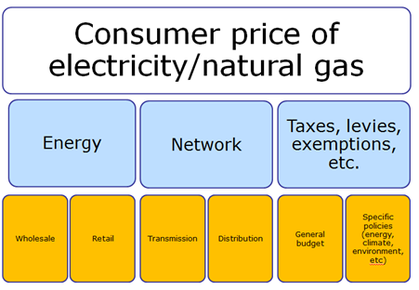
1. Energy prices in Europe
In gas and electricity markets, despite a degree of global tradability of fuels and equipment (such as LNG vessels, wind turbines, etc.), there are at best regional prices, and more often national or sub national prices, which affect retail costs and prices for consumers and can undermine the single market.
European consumers' electricity and gas prices have risen and are still rising. Whilst almost all Member States have seen a consistent rise in consumer prices of electricity and gas, the differences between different national prices remain large: consumers in the highest priced Member States are paying 2.5 to 4 times as much as those in the lowest priced Member States. The gap between the highest and lowest prices paid for electricity and gas by consumers across Member States has widened over time, especially in the case of household gas prices. So rather than European prices converging and markets becoming more efficient, differences at national level persist.
Households retail price evolution
In the EU on average, household electricity prices have risen 4% a year for the last five years (2008-2012). In most Member States, this is an increase above inflation. For gas, household prices have risen 3% a year, again above inflation for most Member States. That said, behind these averages there are significant national variations in how prices have changed over time:
Household electricity prices (€c/kWh inc. taxes)
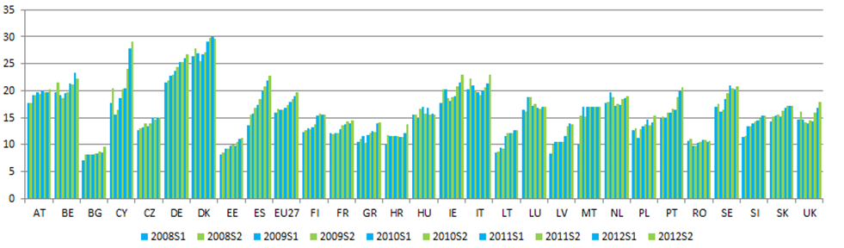
Source: Eurostat energy statistics
Household natural gas prices (€c/kWh inc. taxes)
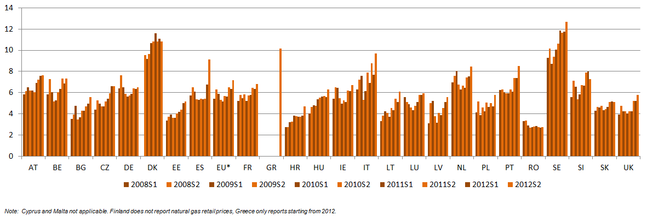
Source: Eurostat energy statistics
Industry retail price evolution
For industry, retail electricity prices rose by approximately 3.5% a year in the same period – above inflation in half of Member States; and gas prices by less than 1% a year over the same period - below inflation in most Member States.
Industry electricity prices (€c/kWh excl. VAT & recoverable taxes and levies but also any exemptions)
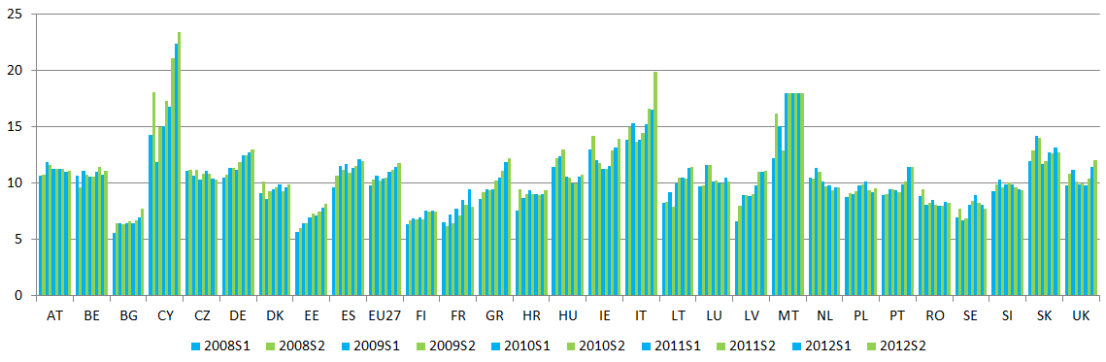
Source: Eurostat energy statistics
Industry gas prices (€c/kWh excl. VAT & recoverable taxes and levies but also any exemptions)
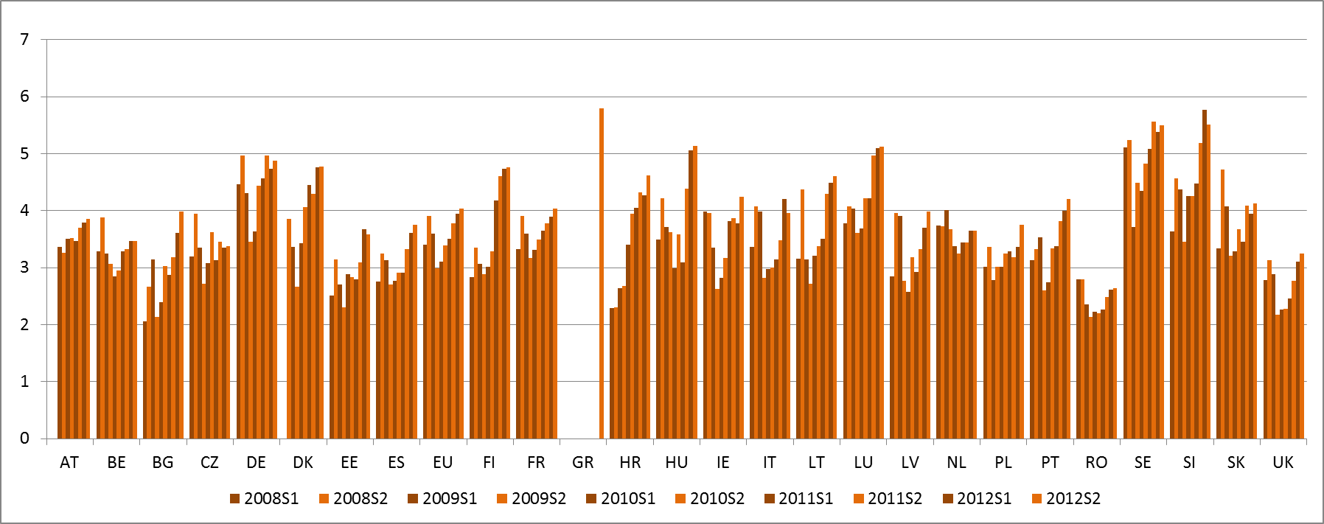
Source: Eurostat energy statistics

Wholesale prices
In contrast to these retail developments, in the period 2008-2012 wholesale electricity prices declined by between 35% and 45% on the major European wholesale electricity benchmarks. Wholesale gas prices have fluctuated, falling and then returning to earlier levels, so no price increases were evident over the whole period.
Breakdown of prices by component
These average European price increases hide significant variation between Member States, between different industries and over time. Some sectors have experienced much greater price volatility. e.g. national increases in household electricity prices range from -34% to +55%; whilst EU average industrial gas prices rose by less than 1% a year in 2008-2012, certain energy intensive industries reported gas price rises of between 27% and 40% in the period 2010-2012. The accompanying report explores these differences, especially between industrial sectors, and highlights that prices and the impacts of policies differ for different users. In order to better understand the relationship between energy prices and policy, it is useful to disaggregate prices into their various elements:
Evolution of retail electricity price by component
The relative share of the energy element in the retail price of electricity has generally diminished over time. This is because since 2008 it is the tax/levy component which has seen the greatest increase and energy cost elements have seen the smallest increase. Since 2008 electricity network costs went up by 18.5% for households and 30% industrial consumers; taxes and levies rose by 36% for households and 127% for industry, before exemptions. Whilst consistent national data on exemptions is not available, a number of Member States provide significant tax and levy exemptions for some energy intensive industries which substantially mitigate the tax/levy price rises.
Electricity price evolution by component 2008-1012
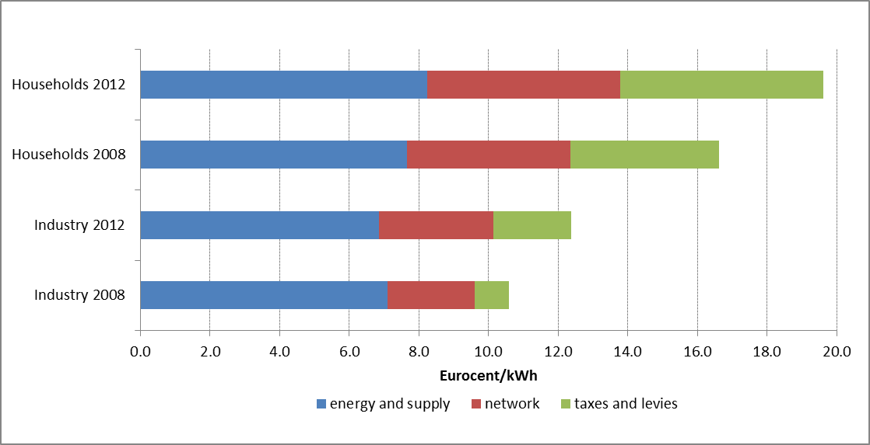

Source: Eurostat. Includes taxes in the case of households; excludes VAT and other recoverable taxes in the case of industry but other industry exemptions are not included (not available).
Evolution of retail gas price by component
In the case of retail prices for natural gas, since 2008 the energy component has also stayed stable, while on average for the EU the network component has risen by 17% for households and 14% for industry; taxation went up by 12-14% for households and 12% for industry.
Gas price evolution by component 2008-1012
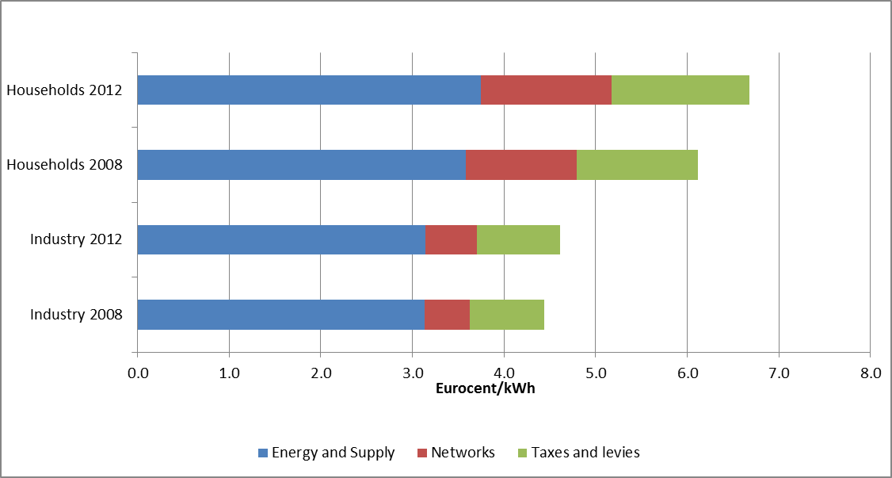
Source: EC, Metadata Member States. Includes taxes in the case of households; excludes VAT and other recoverable taxes in the case of industry.
Drivers of the "energy" element of price
Of the three elements of energy prices (energy, network costs and taxes and levies), the energy cost element is generally the largest, though its share is diminishing. As mentioned above, in contrast to the energy element of retail prices, there has been a convergence and fall in wholesale electricity prices. This can be linked to EU energy policies: the increase in competition following market coupling, the unbundling of electricity generation from system operation, the fall in EU ETS carbon prices and the growth of power generation capacity with low operating costs (such as wind and solar power, in addition to existing nuclear and hydro power).
However the fall in wholesale prices has not translated into a reduction in the energy element of retail prices, even though this is the part of the energy bill where energy suppliers should be able to compete. The result may imply that price competition in a number of retail markets is weak, allowing suppliers to avoid passing on wholesale price reductions to retail prices.
The relationship between wholesale and retail prices can be cut by high levels of market concentration. Moreover, universal retail price regulation applied in some Member States tends to be detrimental to competition in the retail markets, as it discourages competitors from market entry and investment. It might therefore contribute to reducing the responsiveness of retail prices. In addition, Member States should explore other policy measures to address the concerns for vulnerable households or industries.
In the gas market, in addition to market concentration and price regulation, there is still often a supply constraint (with low numbers of suppliers and competition) and gas prices are still often indexed to oil prices. This practice disconnects wholesale gas prices from actual supply and demand for gas, constraining energy suppliers from responding flexibly to changing market conditions or passing true costs on to consumers. In these cases, the rise in oil prices in recent years has directly contributed to rising gas prices for selected, limited markets, to the detriment of consumers and industry in those regions.
Drivers of the "tax/levy" element of price
Within this element it is important to distinguish between general energy tax measures and energy-system related costs financed by levies. Taxes and levies for financing energy and climate policies are generally the smallest element in most Member States but the levies in particular have increased significantly more than others. This element has caught up with or overtaken the share of network costs and now constitutes the largest part of the household electricity price in three Member States, whereas in some others it remains marginal. In most Member States, taxation and levies finance energy and climate policy measures, including promotion of energy efficiency and renewable energy production. Indeed the cost of renewable energy added to retail prices constitutes 6% of the average EU household electricity price and approximately 8% of the industrial electricity price before taking exemptions into account. Here too, there is a wide range of costs, with Spanish and German shares reaching 15.5% and 16% of household electricity prices, in contrast to less than 1% in Ireland, Poland and Sweden.
Whilst some national energy and climate policies are financed via levies, the EU ETS costs are reflected in the wholesale element of energy price. National levies, at whichever point in the chain they are applied, will alter prices and so cause differences between different national markets. To minimise such distortions, it is important that government interventions in the energy sector (financing infrastructure or generation, e.g. renewables, nuclear costs or flexible fossil fuel capacity) are as cost effective as possible.
The European framework for energy taxation does not provide for a full harmonisation, so Member States may change their taxes and tax rates individually, going beyond the core elements or minimum levels contained in EU law. Again, using electricity as the example, significant national differences are evident in the relative shares and in absolute values of the tax/levy component of energy prices illustrated above. Member States use taxes and levies for a wide variety of purposes. These include general revenue-raising (e.g. for health and education), but also for internalising the external costs of energy production and consumption and financing energy specific policies such as climate and energy policies or fossil fuel sectoral adjustment.
Data on the tax exemptions and other subsidies offered by Member States, particularly to energy intensive industries is currently patchy and lacks consistency. For this reason, the Commission is preparing an in-depth study to gather consistent and complete data on the full costs of and subsidies to the various technologies in the electricity sector.
Drivers of the "network" element of price
The relative share of transmission and distribution costs, as well as the absolute levels, vary greatly across Member States, for reasons that are not always easy to understand; data on the drivers of these shares and their evolution is scarce, in particular for gas. The following therefore relates to electricity only.
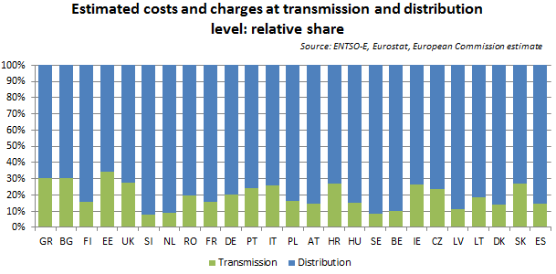
note: certain Member States add non network costs to network
charges, which are not distinguished in these data.
Since 2008 electricity network costs went up by 18.5% and 30% for industrial and household consumers respectively. The sustained increase in network costs, in particular for households, is not unexpected in the context of energy sector transformation, but could be mitigated through better network governance.
With absolute values ranging from 2€c/kWh to 7€c/kWh, it is clear that such costs can have a significant impact on total electricity prices and thus the total energy price differentials across Member States and with trading partners. Such differentials are also partly driven by widely differing national practices regarding network tariff regulation and cost allocation practices, as well as by physical differences in the networks and the efficiency of their operations.
2. The cost of energy in Europe
Whilst energy price levels receive most attention, energy costs are in practice more important for households and for industry, since they reflect actual bills paid. Price rises can encourage, to some extent be compensated by energy efficiency gains and reduced consumption. This occurs as a result of improvements in process, product or household energy efficiency or through reductions in sectoral or even overall energy intensity of industry. However, price decreases can also be outweighed by increased consumption, for example because a higher number of electric goods are being used.
In the household sector, significant improvements in energy efficiency have been seen across all energy uses, but perhaps most visibly in household heating:
Energy consumption trend for household heating (koe/m²).
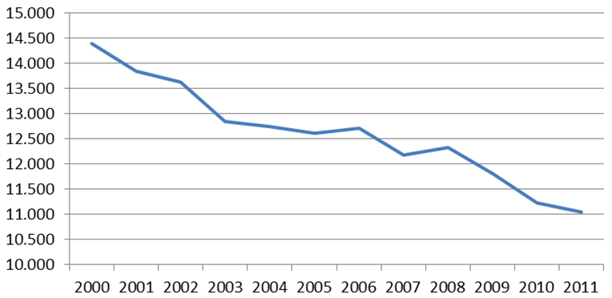 Source: Odyssee
Overall, household electricity consumption declined by 1% in the period 2008-2011 and gas consumption by 15%. Despite this, household energy costs have increased, for example because of low refurbishment rates of inefficient housing and replacement rates of inefficient equipment have not been sufficient to offset rising prices. Data for all Member States shows that the energy share of household consumption has risen 15% over the period 2008-2012, from 5.6% to 6.4% of total consumption. As energy costs often form a larger part of poorer households' costs, such an increase has further negative distributional consequences on "vulnerable" households.
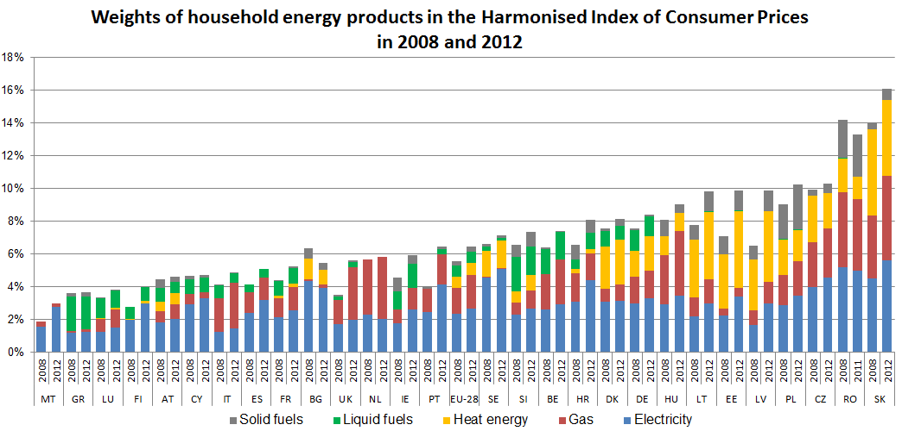
Source: Eurostat
Over the period 2008-2011, continued improvements in European industry's energy efficiency and falls in production due to the economic crisis and international competition led to a reduction in electricity consumption of 4%. However, increases in electricity prices have outweighed these improvements and caused cost increases of about 4% for industry overall, before taking tax and levy exemptions into account. In contrast, gas, for which industrial consumption declined by 5.3%, costs over 2008-2011 declined by 6.8% overall.
European industry overall is a global frontrunner in efficiency. However, there is still potential for further efficiency measures (partly already under way with the EU's implementation of the new energy efficiency directive and on-going improvements in energy products) particularly given the large differences among and within Member States. Access to standardised data on energy costs is not easy. The figures available suggest a highly divergent range of performance when looking at the share of energy costs in production costs. For this reason it is worth looking at energy intensive industries in detail, including manufacturing sectors such as paper and printing, chemical products, non-metallic minerals, iron and steel and non-ferrous metals, which all have a high share of energy costs compared to production costs. EU companies taking part in in-depth case studies in energy intensive sectors reported that their electricity and gas prices after exemptions, were on the rise between 2010 and 2012.
The share of energy costs in production costs in energy intensive industries
(Different bars are sub sectors, with lowest, highest Member State values and EU averages, 2010)
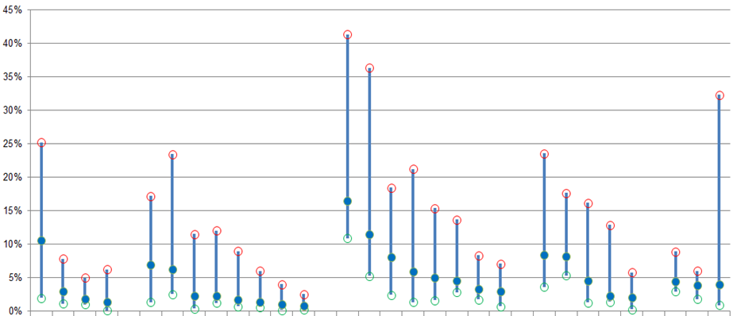
Source: Eurostat, Structural Business Statistics
3. Energy and Europe's international competitiveness
While Europe has never been a cheap energy location, in recent years the energy price gap between the EU and major economic partners has further increased: on average, EU industry gas prices are now three to four times more expensive than comparable US, Indian and Russian prices, 12% more than China's, comparable to those of Brazil and less than those of Japan.
Cheaper regional prices resulting from, for example, the shale gas boom in the US and progressive increase in LNG trade, have not yet translated into cheaper prices on the European market. This is due to domestic subsidies in certain producer countries, trade restrictions and/or infrastructure limitations and the effects of oil indexation. Moreover, rising demand in Asia, particularly Japan after the Fukushima nuclear accident, has also widened the gap between EU and US prices.
For electricity, wholesale prices in Europe declined over the period, are relatively low and are of a roughly comparable level to wholesale electricity prices in the US. At present exchange rates however, EU industrial retail electricity prices are more than twice those in the US and Russia, 20% more than China's but 20% less than those in Japan. Here again, lower US and Russian gas prices (and subsequent lower coal prices) have helped bring down those countries' electricity prices. Yet, in the majority of Member States the supply of electricity (based on interruptions/fluctuations) is more reliable than that of the US and Japan, China and Russia. These interruptions also have costs. International data on network costs is not readily available to validate the hypothesis that EU networks are more expensive but more reliable than elsewhere in the world. Taxation data is somewhat more available and demonstrates that EU electricity and gas taxation is on average higher than in other regions of the world.
To assess the impact on industrial competitiveness of this increasing energy price gap two indicators are key: exports and European production by energy intensive companies.
- EU energy-intensive goods still dominate global export markets despite the widening disparities in energy prices since 2008. But in recent years the EU has significantly reduced the energy intensity of its exports, whilst emerging economies such as Brazil, Russia and China are becoming increasingly important sources of energy intensive intermediate components. According to the IEA, the growing disparity in the EU and other regions' energy prices and costs is expected to reduce the EU's share in global export markets for energy intensive goods.
- Production levels in energy intensive industries have been in decline since 2008 and the overall share of energy intensive industries in European GDP is falling. However, it is not possible to attribute this to energy prices alone at this stage, as tax and levy exemptions for energy intensive industries, recession, structural changes in the world economy and corresponding global shifts in consumer demand are also important factors. Manufacturing in the EU has indeed been restructuring towards lower energy intensity and higher value added production for decades and this has partially mitigated rising energy prices. Moreover, many other factors have played a role, including labour costs and the attractiveness of markets outside the EU, driving investments to those markets.
There is a link between these two dimensions. In recent years, some European energy intensive industries have turned to global markets to compensate for the recession and the related fall in demand in Europe through exports or international investments, even in such local industries as bricks and roof tiles. As such, they are further subject to international competition and must decide whether to invest in Europe or abroad, in countries with much more promising market dynamics. As competitors in other countries seek to improve their energy efficiency, energy price differentials have more impact on investment decisions and companies' ability to compete and develop.
4. Future price and cost trends
The Commission's 2030 energy and climate policy framework reflects a wide range of work to understand future expectations of energy costs and final prices, taking into account the dynamics of global and European markets, government policies and consumer and industry behaviour. The Commission's analysis confirms the findings of the 2050 Energy Roadmap that fossil fuel prices are expected to continue to rise and to drive energy costs. Specifically for electricity, costs are likely to increase up to 2020, due to rising fossil fuel costs coupled with necessary investment in infrastructure and generation capacity. Beyond 2020, costs are expected stabilise and then slightly decrease as fossil fuels are replaced by renewable energy. Capital costs, however, decrease only slightly while tax/ETS auction payments rise.
5. Conclusions: actions to reduce energy costs
Looking at trends in energy prices since 2008, the following main conclusions can be drawn:
Electricity prices, but even more importantly, costs, continued to rise overall for both households and industry, despite falling or stable levels of consumption. Gas prices have fluctuated but did not significantly increase over the period 2008-2012;
This rise in prices is driven mainly by increases in taxes/levies and network costs. The evolution of the energy component of prices was uneven; in countries with high penetration of wind and solar power there has been downward pressure on wholesale power prices, but not in other. Progress made in the functioning of the internal energy market should have had a positive impact by ensuring that wholesale market prices converged across Europe. This was not the case for retail prices, where network distribution systems, uncoordinated national energy and climate policies, taxes, levies and network tariff regulations differ, fragmenting the internal market.
EU trends disguise significant disparities across Member States and across industry sectors. This points to weaknesses in the internal energy market, with wide differences between Member States' policies on network costs and taxes/levies.
Both for electricity and gas, the price differential with external competitors (with the main exceptions of Japan and Korea) is increasing. The sharp fall in gas prices in the US contrasts with the stable level in Europe over the period.
The EU has until now retained the lead in exports of energy intensive goods. But European industry's efforts to compensate for higher energy costs through constant energy efficiency improvements may need to go even further, bearing in mind physical limits, as competitors also increase their efficiency and as European industry decides to invest abroad to be closer to expanding markets.
There is a serious lack of credible, comparable and verifiable information on certain aspects of prices and costs, in particular on the drivers of transmission and distribution costs, on the exact impact of energy on costs at the level of production facilities and on the levels of taxation and subsidy, in particular for industry.
Based on the above, the Commission believes it is important to maintain our commitment to completing the internal energy market in 2014 and further develop energy infrastructure. Thanks to EU market liberalisation, industry (particularly SMEs) and household consumers can already reduce their prices by changing to better tariff regimes with existing suppliers or by switching to cheaper energy suppliers, where suppliers are sufficiently numerous. Further effort is still needed to liberalise the market, to increase investment and competition and generate efficiencies which can bring price reductions. At the same time, dynamic pricing and smart metering technology remains out of reach of most European households. This limits consumers' ability to control their energy bills. To address these issues, the Commission intends to launch a Communication on retail markets before the summer of 2014.
Where fuel prices are global (e.g. oil and coal) and difficult to influence, EU policies of diversifying energy supplies and supply routes, negotiating with major energy partners with one European voice, and promoting energy efficiency internationally, all help strengthen the EU's influence. In addition, increasing renewable energy production and energy efficiency helps to reduce the fossil fuel import bill.
For the energy policy levy and tax component of prices, which has seen the greatest rise in recent years, it is important to reflect on the value of such measures and ensure that the policies financed by such measures are applied as cost effectively as possible. It is therefore important that Member States review their different national practices and follow best practice, including the Commission's guidance regarding government interventions in the energy sector, to minimise negative consequences for energy prices. A cost effective approach to 2030 climate change, renewable energy and energy efficiency policies will be critical in this respect, as in other policy areas.
The network element of prices has grown in most Member States, with great variations between countries, particularly in distribution costs. This suggests that further work is needed to benchmark network costs and practices to ensure that European convergence in network practices improves the efficiency of the distribution and retail markets and so reduces the network cost element of prices.
To keep energy costs in check, households and industry in Europe can improve their energy efficiency and adopt demand response and other novel energy technologies and innovations to save energy and money. The ongoing financial and economic crisis makes addressing energy poverty and/or vulnerability more important today, given that energy cost rises are hitting poor households harder. For households, fiscal transfers can be considered to provide protection, bearing in mind that it is generally more efficient to protect such vulnerable consumers through social policy measures (such as fiscal transfers) rather than through energy pricing.
For industry, the EU should continue its efforts to ensure a level playing field for energy prices. In particular, energy subsidies to local industries and export restrictions related to energy goods should be addressed with its international partners, both bilaterally as well as at WTO level. These measures will also help European industry to improve its international competitiveness, despite recent rises in Europe's relative energy prices and the growing cost of paying for necessary investment. Where such measures are inadequate, fiscal transfers, exemptions and reductions in taxes and levies could be means of protecting certain industrial consumers from higher energy costs, provided they are compatible with state aid rules and the internal energy market rules. The existing guidelines on state aid measures in the context of the ETS allow for state aid for undertakings in certain energy intensive sectors to compensate indirect ETS emission costs. In addition, the proposed text for the revised State aid guidelines in the field of energy and the environment (currently in public consultation) foresees that Member States may wish to grant partial compensation for additional costs for financing renewable energy support so as to facilitate the overall funding of support to energy from renewable sources and avoid carbon leakage. This is particularly relevant for energy intensive industry. However, it should be remembered that targeted subsidies must be financed by other consumers or by taxpayers. They also reduce the direct incentive for taking efficiency measures and, as they are generally applied nationally, they further distort competition within the single energy market.
Europe must confront the energy cost challenges of the energy transformation through the tripartite efforts of the EU, Member States and European households and industry. With flexible energy systems, responsive consumers, competitive markets and cost effective government instruments, Europe will be better equipped to contain price rises, pay for investments and minimise cost increases. It can thus set a practical example of how a competitive economy can be built on a sustainable and affordable energy system.

"Industry" and industry data in the report broadly covers commercial activity and is not just manufacturing or heavy industry sectors.
EUCO 75/1/13 REV1, 23 May 2013
The collection of consistent and complete data in the energy sector is a challenge and constrains analytical efforts to assess the state of play and the impacts of policy. The data presented here and in the accompanying report contains the most consistent and latest available data from across the EU.
Industrial prices reported in line with Directive 2008/92/EC on industrial electricity and gas price data collection and may include other non-residential user. In the case of gas all industrial uses are considered. However, the system excludes consumers who use gas for electricity generation in power plants or in CHP plants, in non-energy uses (e.g. in the chemical industry), above 4,000,000 GJ/y.
The ratio is similar for all energy products (electricity or gas); consumer types (domestic or industrial), consumer bands (modest, median or big consumers), time periods (2008 - 2012) and monetary units (Euro, national currency or purchasing power standards). For this last element, the ratio does not change significantly, but the ranking of different Member States does change significantly: a country with a low nominal price may end up with a comparatively high price in PPS terms.
This time period is used extensively throughout the report because Eurostat energy retail price data methodology changed considerably at this point and is not consistent with earlier data or complete for all Member States.
For both households and industry (+36.5% and +127%) for the EU weighted average electricity price. For industry, this percentage change excludes VAT and other recoverable taxes. This percentage does not take account of industry exemptions.
Carbon prices constitute part of the wholesale price and have fallen from 14-29 €/t in 2008 to 6-9 €/t in 2012. It is not clear however, to what extent this price reduction is passed on to the wholesale price, or relevant, in light of the merit order effect of low operating cost technologies.
The combination of weak demand and wholesale power price dynamics (stable or falling when hydrocarbon prices were on the rise) has put pressure on conventional generation assets. In many cases both the profit margins from the generation business and company share prices were affected negatively, and access to finance has been more difficult. As a rule, EU utilities need to adapt to this new business environment and have done so by focusing more on downstream services, including decentralized generation and energy efficiency and by gradually divesting their conventional power generation assets.
In liberalised markets, easier market entry increases competition which should increase incentives to reduce costs and pass on lower prices to consumers. This is illustrated in the lower retail industrial electirity prices in the UK, BE and NL.
51% of gas consumption in Europe was still oil-indexed in 2012, as opposed to 44% that was priced on a gas-on-gas competition basis (IGU 2012 annual survey). The share of gas-on-gas priced volumes has increased by a factor of 3 since 2005, but strong regional differences persist in wholesale price formation mechanisms with about 70% of gas in North-West Europe (UK, Ireland, France, Belgium, Netherlands, Germany, Denmark) priced on a gas-on-gas basis in 2012, compared to less than 40% in Central Europe (Austria, Czech Republic, Hungary, Poland, Slovakia and Switzerland). Some Member States have their total gas imports on oil-indexation basis.
Renewable energy taxes and levies as a share of household electricity prices range from less than 1% to 15.5% in Spain and 16% in Germany. The share is increasing due to rising renewable energy shares and falling wholesale prices (which increase the gap between wholesale price and renewable energy support). However when the merit order effect (hydro, wind and solar power lowering wholesale prices) is also taken into account, the net effect of renewable energy on retail prices can be to reduce, not raise prices. This appears to be the case in Spain and Ireland but not in Germany. (See Annex of the report). The decreased wholesale prices should pass through to final consumers in the form of lower costs of the energy supply component.
See Communication C(2013) 7243 Delivering the internal electricity market and making the most of public intervention
See Directive 2003/96/EC
See section 1.1.1.3. of the associated report for details.
Industrial consumers network costs. For households the range is 2.2 cents/kWh (MT) - 9.7 cents/kWh (ES).
As measured by the harmonised index of consumer prices.
See report, Figure 90.
Not taking account of tax or levy exemptions for energy intensive industries, and noting the difficulty in finding comparable international data on electricity prices
See chapter 3 of the Staff Working Document
IEA WEO 2013, Fig. 8.17
Gross value added (2008-2011) and volume index of production (2008-2012) for paper and printing, chemicals, other non-metallic mineral products (incl. building materials, glass, ceramics), basic metals (incl. iron and steel), non-ferrous metals (aluminium).
Competitiveness "proofing" of all EU policies

