COMMUNICATION FROM THE COMMISSION TO THE EUROPEAN PARLIAMENT, THE COUNCIL AND THE EUROPEAN ECONOMIC AND SOCIAL COMMITTEE
A vision for the internal market for industrial products
(Text with EEA relevance)

1. Introduction
In 2012, the Union celebrated the 20th anniversary of the single market ensuring the free movement of goods, services, people and capital within the European Union (EU). The objective of this Communication is to formulate a number of recommendations for the legislation on the internal market for industrial products and to set out a broader vision for the next decade. It will be transmitted to the European Council, as requested in its meeting of 14 and 15 March 2013.
Strengthening the effectiveness of the internal market for industrial products was identified as a priority in the October 2012 update on an Integrated Industrial Policy. This proposed the re-industrialisation of the EU, based on a four-pillar strategy, one of which is improving access to markets.
The European Commission therefore carried out an evaluation of EU law in the area of industrial products to assess the regulatory framework’s overall coherence and ‘fitness for purpose’ and to develop an evidence base on the cumulative regulatory effects from an industry perspective. In parallel, the Commission organised a public consultation of stakeholders. This Communication builds on the results of the evaluation and the public consultation and analyses the regulatory environment of the internal market for industrial products. The detailed results of the evaluation, the public consultation and a number of case-studies are set out in the accompanying Commission Staff Working Document.
The internal market for products has been a frontrunner in EU economic integration. Regulatory obstacles within the Union are prevented by Directive 98/34/EC or eliminated through the principle of mutual recognition, or through Union harmonisation legislation. The objective of this legislation is twofold, first ensuring that products placed on the European market guarantee high levels of protection for health and safety and the environment and secondly, ensuring the free movement of products by replacing national rules with a single harmonised set of conditions for placing products on the internal market so that these can circulate freely.
The focus of this Communication is on industrial products i.e. non-food products manufactured through an industrial process. It covers a wide range of products such as different types of machines, radio equipment, electrical and electronic devices, toys and many others. The EU acquis for industrial products has gradually expanded, and today there are more than 30 directives and regulations; both those covering specific industrial products (e.g. pressure equipment, gas appliances) and those that apply horizontally across many different product groups, such as REACH (chemicals) and the Ecodesign Directive.
Union legislation that has recently been subject to major revision, in particular the legislation on medical devices, cosmetics, construction products and on consumer product safety and market surveillance is not addressed by this Communication. Chemical products and motor vehicles are also outside the scope of the analysis since the Union legislation in these sectors has recently been evaluated or subjected to a regulatory fitness check. Finally, pharmaceuticals are left aside because of their very specific nature.

2. What are the benefits of the internal market for industrial products?
Since the Single Market became a reality in 1993, intra-EU trade in goods has grown as a share of GDP by around 5 percentage points. Intra-EU trade represented around 17% of EU GDP in 1999 and close to 22% in 2011. Furthermore, intra-EU trade represents a very high percentage of GDP in most Member States.
Figure 1 – Evolution of intra-EU trade in goods as share of EU GDP, 1999-2011 (average of export and import) - Source: Eurostat
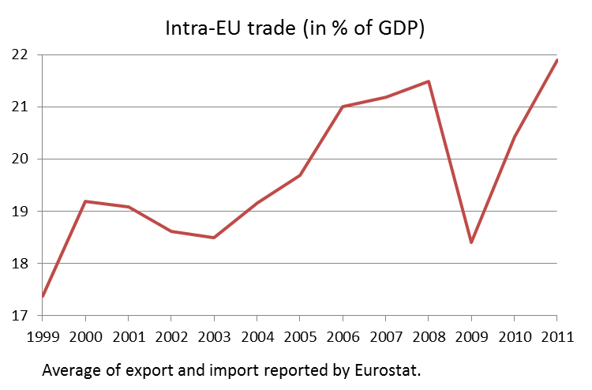
The evolution of intra-EU trade in the three broad categories of industrial products according to the SITC classification (Machinery and transport equipment, manufactured products classified by material and other manufactured products) has exceeded the growth rate of total EU manufacturing value added between 2000 and 2012 (see chart below).
Figure 2 - Evolution of intra-EU trade (exports, 2000=100) in selected manufacturing sectors in relation to manufacturing gross value added - Source: Eurostat
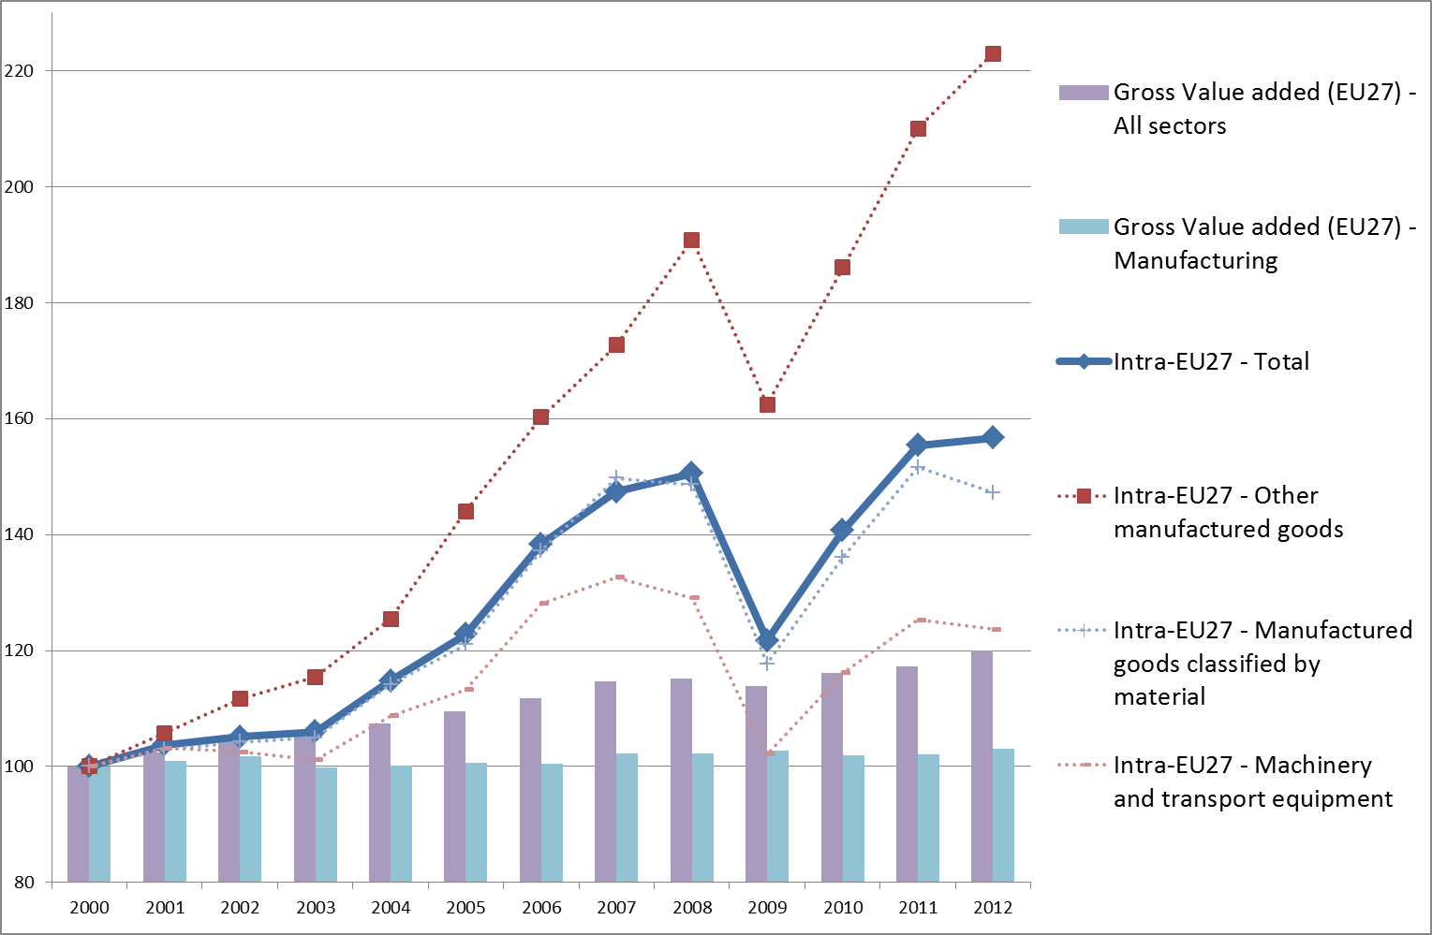

While there are significant differences between the sectors covered by Union harmonisation legislation on industrial products, most have experienced an increase in the level of intra-EU trade, particularly between 2003 and 2008. Although three sectors have shown a fall in the level of intra-EU trade since 1999 (i.e. office machines and automatic data processing, metalworking machinery and photographic apparatus), much of this can probably be attributed to the onset of the economic and financial crisis in 2008, but also to other dynamics linked, for example, to the emergence of smartphones and tablets.
Figure 3 - Evolution of intra-EU trade in selected manufacturing sectors (value of imports; 1999=100) - Source: Eurostat
Source: Eurostat
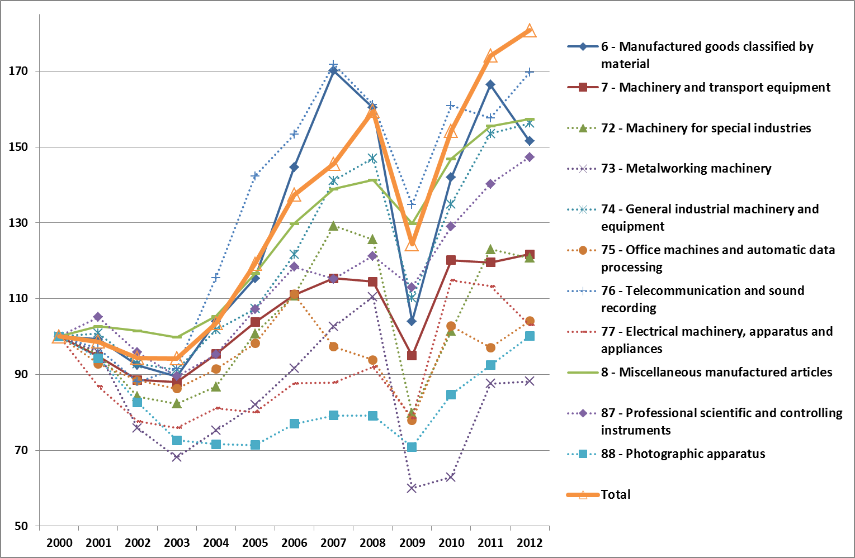
Better access to the internal market and global markets has led to greater economies of scale and scope and thus enhanced firm-level competitiveness and cost-efficiencies through regulatory and product convergence at European level and, to some extent, also globally. Prior to the establishment of the single market, each EU Member State imposed obligations on business in the interests of safety, health and consumer protection. This meant that there were considerable regulatory barriers to trade in products because of the different rules and requirements, meaning that businesses had to treat each EU Member State as a separate market and offer different products.
Doing business on a cross-border basis in this operating environment imposed considerable regulatory compliance costs on businesses. The adoption of successive vertical and horizontal Union harmonisation legislation therefore directly addressed the needs of European industry.
In some instances, no national rules were in place prior to the adoption of EU legislation which addressed regulatory gaps, thereby enabling businesses to develop a larger market for their products, while ensuring high levels of product safety and protection. For instance, until the adoption of the Machinery Directive in 1989, many national legal frameworks did not adequately regulate the safety and usage of electrical and mechanical machinery, despite the high level of risk involved for those operating such machinery. In these sectors, EU legislation largely preceded the development of national legislation thus preventing the emergence of different national regulations which would otherwise have led to market fragmentation, obstacles to the free movement of products and to higher administrative burdens for regulatory compliance.
The approximation of product legislation through internal market legislation has been relevant in promoting industrial competitiveness because regulatory convergence at EU level supported by voluntary technical standards, has promoted access to new markets within the internal market and led to fairer competition and a level playing field among economic operators. Union harmonisation legislation also strengthens competitiveness in other ways, e.g. through effects on global regulatory and product convergence, enhanced take-up of innovation and RTD results (through a technology-neutral approach), the promotion of industry consolidation leading to even greater economies of scale with manufacturing firms capable of operating across the internal market and beyond.

3. The evolution of Union Law on industrial products

3.1. The EU only regulates the essential elements…
Since 1985, the Union has applied a unique mechanism for harmonised product legislation: the Union legislator lays down the “essential requirements” in respect of safety, health and other public interests that businesses must comply with when putting products on the Union market. The fundamental principle is that businesses need to demonstrate that they have complied with the essential requirements set out in Union harmonisation legislation, possibly with the help of harmonised standards developed by the European standardisation organisations. The products could then be sold everywhere in the internal market.
The so-called ‘new approach’ to product regulation has considerably reduced divergence in national technical regulations on products and has brought about a single, borderless market for harmonised industrial products. It lowered market access barriers for industry and made it easier for businesses to operate in pan-European markets. The internal market in industrial products has brought about economic and employment benefits, through its contribution to increased EU-trade. As such, it is widely recognised as one of the EU’s major success stories.

3.2. …with and for people, businesses and Member States…
The European rules on industrial products rely on the invaluable input of several important groups of actors:
- Manufacturers and other businesses in the supply chain are expected to take the necessary steps to make their products comply with the legal requirements. Manufacturers must follow the various conformity assessment procedures while at the same time – mainly through the industry associations – they can participate in the development of technical standards and monitor the implementation of the legislation. Other relevant stakeholders – e.g. consumer, environmental groups and trade unions – also participate very actively in this process.
- A number of mechanisms and structures that underpin the implementation of Union harmonisation legislation are the responsibility of the Member States. Member States are responsible for the development of national implementing rules and for designating competent conformity assessment bodies, the so-called ‘notified bodies’ – including determining whether accreditation mechanisms are required and for monitoring the operation of notified bodies. They also support and guide businesses to ensure effective implementation, market surveillance and enforcement.
- At EU level, the Commission has an important overarching role in monitoring and evaluating the implementation of Union harmonisation legislation on industrial products, in assessing the scope for possible regulatory changes and pursuing possible breaches of EU law. The Commission is also responsible for requesting EU standardisation bodies to develop technical standards in support of legislation, in accordance with the priorities identified in the Union’s Annual Work Programme on standardisation. Successive European Research framework programmes have contributed to the development of standards for technologies and products which will be continued in the Horizon 2020 Programme.

3.3. …but does not shy away from profound reforms where needed
The Union legislation on industrial products sets out the main requirements for businesses. Examples of these are the CE marking indicating product compliance with EU legislation and the obligatory steps to be taken before a product can bear CE marking, such as producing a declaration of conformity.
Although in principle the administrative requirements for businesses are clear (CE marking, declaration of conformity, self-certification or third party conformity assessment depending on the type of Directive or Regulation and level of safety or other risk involved), in practice, anomalies and differences between EU legal texts have emerged. This is partly due to the fact that the overall volume of legislation has increased, and the fact that individual pieces of legislation have evolved independently. For instance, the requirements for declarations of conformity varied between Directives, both in relation to the information that had to be provided, and whether the declarations of conformity had to be placed together with the product or could be in the accompanying manual alone.
There was therefore an urgent need to standardise and ensure greater consistency in terms of requirements for businesses and national authorities. Since 2009, the Union legislation on industrial products underwent sweeping reforms to eliminate unnecessary inconsistencies between various pieces of Union harmonisation legislation and help minimise the burdens placed on businesses:
- More than fifteen different proposals for the revision of directives on a wide range of industrial products, varying from toys to cableway installations, will have been proposed and/or adopted during the period 2009-2013. Most of these new directives and regulations will have to be transposed or applied by 2015, at the latest.
- The Construction Products Regulation was adopted in 2011 and started applying in 2013.
- The Standardisation Regulation was adopted in 2012 and started applying in 2013.
- In addition, two horizontal legislative proposals for regulations on market surveillance and consumer product safety were tabled and are expected to be adopted by the European Parliament and the Council in 2014.
- Preliminary analysis indicates that stakeholders seem to be satisfied with the current Union rules on machinery and toys. The Commission will however launch an evaluation of the Machinery Directive in 2015 and, on the basis of input from Member States and all interested parties in 2014, will examine if the rules on toy safety should be made more effective.
- The principle of mutual recognition is one of the pillars of the internal market and is, in the field of industrial products, organised in the ‘Mutual Recognition Regulation’. In line with the Council’s conclusions from December 2013, the Commission will launch an evaluation of the functioning of the principle of mutual recognition and report back to the Council in 2015.

4. Review of Union Legislation on industrial products
A thorough and independent assessment of the day-to-day functioning of the Union legislation on industrial products looked at its impact on businesses, national administrations and other stakeholders. The overall conclusions is that internal market legislation is relevant to meeting EU objectives relating to the need for technical harmonisation measures with high levels of protection for health and safety and consumers and, to the environment. The Internal Market legislative framework has also in built responsiveness to adapt to change.
However, the assessment and the public consultation identified a series of problems or points for improvement and led to a number of recommendations. These recommendations synthesising the views of the stakeholders and the independent evaluation of the legislation are the following:

4.1. Improving the architecture of Union harmonisation legislation
    - Regulations rather than directives should be the preferred instrument for implementing Union harmonisation legislation. This would eliminate differences in the timing of national legislation entering into force across the Union, and reduce the risk of divergent transposition, interpretation and application. The feasibility of this approach should however be confirmed on a case-by-case assessment taking into account the objectives of better regulation as well as the principle of subsidiarity. After a positive analysis, the Commission has for instance proposed a regulation in the field of radio equipment.
    - Periodic reviews should be undertaken of Union harmonisation legislation for industrial products to ensure that the regulatory framework is consistent, and that there are no major gaps, inconsistencies, regulatory burden that could be reduced or duplication either in the legislation itself or between different pieces of Union harmonisation legislation for industrial products. Such reviews should take place regularly to ensure that legislation remains up to date, is sufficiently achieving its objectives and reflects industry developments and product innovation.
    - A horizontal regulation based on Decision 768/2008/EC should be considered, setting out common definitions and other common elements that apply across Union harmonisation legislation. Such a regulation would bring additional coherence to Union harmonisation legislation.
    - Regular update of non-binding guidance on complying with Union harmonisation legislation such as “The ‘Blue Guide’ on the implementation of EU product rules” should be carried out. Where possible, the guidance should give insight into the rationale for particular requirements or standards.
    - In a number of areas within professional products, the legislation applicable at the use phase (e.g. installations, maintenance) laid down at national level imposes additional barriers that reduce the benefits of harmonised legislation. While such aspects are outside the scope of Union harmonisation legislation for industrial products itself, the development and provisions of this legislation should take such aspects into consideration aiming to minimise any obstacles to the extent possible.

4.2. Strengthening the effectiveness of the regulatory framework
    - The Commission should give further consideration to ways of strengthening the participation of SMEs and civil society stakeholders (e.g. consumer associations and associations of professional users) in the preparation of initiatives for EU legislative action and in standardisation processes. One possibility would be to ensure that SME-focused industry associations are better represented in working groups on specific Union harmonisation legislation for industrial products, with support provided for their participation costs where possible.
    - National standards organisations should be encouraged to make abstracts of harmonised standards available free of charge on their websites. Manufacturers, particularly SMEs, may not necessarily know in advance precisely which standards they require. Making abstracts freely available would reduce time and costs incurred in purchasing inappropriate standards.
    - There should be a faster transition towards “e-market surveillance” in which economic operators make compliance information available online as far as possible. More sensitive technical documentation and data requested by market surveillance authorities could be transferred electronically via secure data transmission. This would promote more efficient ways of ensuring transparency and two-way provision of compliance information and data between market surveillance authorities and businesses.
    - In order to facilitate the transition towards a paperless future for market surveillance, market surveillance authorities (and, where appropriate, customs authorities) should be equipped with scanning equipment or smart phone readers that would link through to the compliance section of the economic operators’ website or to a dedicated standalone website. This is subject to resources being identified and requires joint investment by industry and market surveillance authorities.
    - Businesses should be given greater flexibility on meeting traceability requirements in order to promote greater use of e-labelling. This would help to alleviate the major concerns that businesses have with regard to current traceability requirements for products and packaging to provide full addressee information. These are seen as unnecessary, as well as detracting from product aesthetics and industrial design. E-labelling provides a viable alternative route to meeting the same requirements.
    - When a currently non-harmonised product group becomes part of a harmonised product group, consideration should be given as to whether it is possible to integrate new product groups in existing pieces of Union harmonisation legislation for industrial products, rather than proposing new legislation. A good example in this regard was agricultural machinery for spreading pesticides, which was incorporated into the Machinery Directive.

4.3. Strengthening the implementation regime for Union harmonisation legislation
    - The mechanisms to facilitate cooperation and the exchange of information between market surveillance authorities and the Commission such as RAPEX and ICSMS should continue to be supported. EU coordination and support actions relating to market surveillance through the ‘Product Safety and Market Surveillance Package’ are critical and should be maintained in coordination with market surveillance authorities aiming for the most efficient use of resources.
    - The use of accreditation should be further strengthened through a consistent approach in the regulated area in line with Regulation (EC) No 765/2008.
    - Synergies should be fully exploited between different structures in the implementation regime of the Union harmonisation legislation for industrial products. Greater synergies are needed between SOLVIT which solves general problems relating to the non-functioning of the internal market, the Enterprise Europe Network, helping SME to benefit from opportunities in the internal market and Product Contact Points, which have more specialised knowledge about non-harmonised product legislation. For instance, there could be referrals of cases between SOLVIT, Enterprise Europe Network and Product Contact Points. The possibility of using the Internal Market Information System for linking up national Product Contact Points should also be investigated. Staff working at the different structures could be made better aware of coordination mechanisms and contact points for industry that specialise in issues relating to the internal market in industrial products.
    - The role of the Product Contact Points set up by the Mutual Recognition Regulation should be expanded to harmonised products to provide a first point of contact for firms. Many firms don’t know who to turn to and there is a low level of knowledge among some smaller firms and micro enterprises about internal market legislation, and even whether harmonised or non-harmonised legislation applies to their product. This would both strengthen the visibility of Product Contact Points and provide SMEs with a clear information source.

4.4. Reducing administrative burdens for businesses
    - As all products need to meet the legal requirements concerning safety, health and other public interests, there is only limited scope for SME exemptions from the legal provisions in Union harmonisation legislation for industrial products. Nevertheless, the SME Test should always be applied to ensure that administrative requirements do not impose disproportionate burdens on SMEs while ensuring that the legislation achieves its objectives.
    - A single reference source on changes made to Union harmonisation legislation for industrial products and updates to standards and when these come into force should be available for firms. Such information would save time and resources for industry, particularly SMEs. Businesses signing up to the service could then receive email updates outlining upcoming changes and informing them when these will take place. Moving from a legislative-based to a product-based approach to informing economic operators about applicable Union harmonisation legislation for industrial products and voluntary standards would however be a technically demanding and resource-intensive exercise. It would also require strong cooperation and support of industry associations and European standardisation organisations, some of which already do relevant work in this area.
    - Business should be allowed to continue to choose between producing a single declaration of conformity and a different declaration of conformity for each piece of applicable Union harmonisation legislation for products.
    - It is crucial that industry is not over-burdened with too frequent legislative changes, since there have been many changes in the past decade, with others due to come into effect in the near future. Regulatory action/measures should continue to be subject to public consultation and supported by impact assessments.

4.5. Extending the reach of Union harmonisation legislation on products
    - The Commission should promote international convergence in legislation and technical standards for industrial products, since this could help to lower compliance costs for industry, thereby strengthening industrial competitiveness. The Trade and Investment Partnership (TTIP) being negotiated between the EU and the US is an important step in the right direction and further cooperation with regulators and standards bodies in other third countries that are key European export markets should be explored, especially in countries which often base standards either on European or international ISO and IEC standards.

5. A vision for the future
The importance of addressing regulatory barriers will only increase with the pace of technological change and as the world, and global supply chains, become ever more integrated. Against this background and bearing in mind the overriding need to minimise administrative burdens, especially for SMEs, the following areas appear to be those where attention should be focused.

5.1. A well-functioning internal market for products needs strong enforcement mechanisms
Beefing up market surveillance and ensuring that Member States invest the necessary human and financial resources in market surveillance is key for strengthening enforcement mechanisms. The challenge is twofold. On the one hand, authorities must ensure legislation is enforced as a tool to safeguard important public interests such as health and safety, the protection of the environment and security, and the protection of consumers. On the other hand, enforcement mechanisms help eliminate unfair competition and create a level playing field for economic operators. Coordination and cooperation between enforcement authorities in the internal market are also essential.
Almost all business organisations welcomed the Commission’s new ‘Market Surveillance Package’ but regretted that sanctions for non-compliance with harmonised rules were not applied coherently. These sanctions are not, as such, part of market surveillance but are rather a consequence of it. Some stakeholders argue that a disaggregated, scattered system of economic sanctions results in non-compliance with EU law always shifting to the area where the sanctions are most lenient at a given time. This situation might be prevented if the economic penalties of the different Member States were streamlined or harmonised at least in a way that avoids large discrepancies and treats all of infringements of product legislation in a similar way throughout the EU.
Therefore, the Commission will consider elaborating a legislative proposal on how to streamline and harmonise economic sanctions of an administrative or civil nature for non-compliance with Union harmonisation legislation to ensure equal treatment of all businesses throughout the internal market for industrial products. A Platform of enforcement authorities facilitating their work and mutual cooperation will be of added value.

5.2. ‘Horizontal’ legislation on products
Many stakeholders pleaded for less sector rules and more horizontal rules across industrial product sectors to avoid overlapping or conflicting requirements. A legally-binding horizontal “umbrella” legislation setting out common elements across sectors was advocated by many stakeholders. However, there were also differing views on this point, with some stakeholders preferring all the relevant text to be included in each Directive. Several competent authorities, market surveillance authorities and industry associations were in favour of transforming Decision 768/2008/EC into a Regulation since such a horizontal Regulation would reduce the volume of the current legislation, which is often considered to be duplicative and not SME-friendly. Unlike Decision 768/2008/EC which only contains reference provisions, the horizontal “umbrella” regulation would also be legally binding and directly applicable.
An example at national level exists in the horizontal national regulation adopted in Germany based on Decision 768/2008/EC. This provides a regulatory umbrella and overall framework under which sectoral legislation at national level stemming from European product legislation is structured.
The proposal on how to streamline and harmonise economic sanctions of an administrative or civil nature for non-compliance with Union harmonisation legislation should also take a new step in streamlining and making simpler the existing common legal framework for the marketing of industrial products, including their maintenance and after-sales.

5.3. Innovation and the digital future
The digital society evolves at an increasing pace. For example, future robotics and new manufacturing technologies such as additive manufacturing, also known as “3-D printing” could bring a significant amount of today’s production back to a local, and perhaps more sustainable dimension. 3-D printing has the potential to level the playing field between SMEs and large industry in reducing development costs and in allowing firms to develop prototypes and initial designs in-house rather than having to outsource them, which may be at a prohibitive cost. At the same time, the mobile revolution is set to continue, branching into a whole class of new smart, wearable devices such as smart watches or glasses, smart textiles etc.
In short, the world is rapidly moving towards the 'internet of things' in which all objects will be equipped with minuscule identifying devices. If all objects in daily life were equipped with radio tags, they could be identified and inventoried by computers. Software will handle everything needed to allow products to be tracked and counted, and waste, loss and cost to be greatly reduced. It will inform users when things need replacing, repairing or recalling, and whether they are fresh or past their best.
However, when most of the Union harmonisation legislation was adopted, there were hardly any electronic tools available. Compliance with the rules still involves paperwork for businesses and market surveillance authorities.
In order to remain competitive, the European market for industrial products needs a regulatory framework that facilitates innovation and does not create unnecessary barriers for the timely take-up of new technologies and market introduction of innovations. EU legislation and standards need to allow new products and technologies to be made available on the market rapidly so that Europe can avail itself of a first mover advantage in the global marketplace. At the same time, novel challenges brought about by new technologies will also increasingly have to be taken into account, such as the risk of unregulated production of dangerous goods by 3-D printers or the impact of potentially concealed audio-visual recording equipment in smart devices becoming more and more pervasive.
The Commission will take into account innovation and technological developments in the elaboration of any new proposals in the internal market for products sphere. It will also launch an initiative on e-Compliance whereby compliance with Union harmonisation legislation can be demonstrated electronically and in several languages, for example through e-labelling, digital market surveillance and electronic declarations of conformity in all official Union languages.

5.4. The blurring distinction between products and their connected services (installation, maintenance, etc.)
Manufacturing firms are increasingly offering services along with their traditional products. The interaction between manufacturing and services has become more complex. Services and manufactured products are used as intermediary inputs to produce a larger number of final products and services. The service content of manufacturing has been growing in the EU and elsewhere in the world. In 2011, more than a third of value added embodied in manufacturing final output was accounted for by services.
Although manufacturing products are also used for producing services, the manufacturing content of services is about three times smaller than the service content of manufacturing and has increased much less over time. The average manufacturing content of services produced in the EU is around 10%.
There is a high degree of complementarity between manufacturing products and services. Services such as maintenance and training are very important elements in the delivery of complex manufactured products. Other services such as transport are essential to the completion of manufactured products, but are still subject to certain market restrictions. At the same time the importance of specialised services such as financial intermediation, communications, insurance and specialised knowledge-intensive business services (KIBS) are becoming important inputs in the production of sophisticated manufacturing output. This process is one of several explanations for the increasing contribution of services to the overall output of an economy.
The issue of complementarity of products and services has an increasing importance for the economy. The Commission will examine how to improve the interface between manufacturing products and services within the internal market.

5.5. More Regulations, less Directives…
Directives have been the preferred instruments for harmonisation of product legislation and have made the internal market for industrial products a reality. Today however considering the high level of market integration, the challenges are new and the policy objectives even more ambitious.
In an increasingly complex world access to information on rules for products is very important. The costs associated with finding the right information can be considerable. This is true not least for cross-border trade. Access to information can still be a problem in the single market for products in which Directives are binding on the result to be achieved, but leave to Member States the choice of form and methods. As a result of this flexibility, the transposition of EU provisions and their implementation may vary from one country to another and endanger the coherence of the overall regulatory framework for products. The risk is particularly high where concepts are vague or provisions imprecise, as often results from conciliating the interests of 28 or more countries. As a matter of fact, lack of information or regulatory differences can constitute a very significant trade barrier within the EU, and this is, of course, mostly the case for SMEs. It does not become easier if businesses need to communicate with a large number of government authorities in several different languages.
Switching from Directives to Regulations leads to less red tape and more certainty for businesses. Subject to a case-by-case assessment, the Commission will henceforth give priority to the form of a Regulation as the main source of Union law for businesses and authorities so that there would be no gold plating and the number of infringement cases would be reduced to a minimum.

5.6. …and a business friendly approach to product rules
More should be done to help businesses comply with EU law on industrial products. It is essential to keep the right balance between the costs of regulation and the objectives it pursues. At the moment, businesses are confronted with multiple legislative acts applying to the same products/manufacturers and the boundaries between many of these acts are sometimes unclear. The internal market law is spread over hundreds of Directives that might have different scopes, procedures, approaches, etc. and require additional transposition measures.
Therefore, simplification and clarification of the product rules is at the heart of Commission’s priorities. A deeper regulatory integration of the internal market for products is needed. Ideally, the regulatory approach whereby products are subject to several Directives pursuing similar or different public interests and transposed differently in the Member States, could be reduced by creating legislative “one stop shops” for manufacturers of a given category of products. Such an approach would mean that several requirements applicable to one product group could be covered by a single and coherent legislative approach. Major regulatory simplifications should be a medium- to long-term objective. They should be subject to thorough impact assessments and synchronised with the periodic reviews of legislation. The Commission thus acknowledges the cumulative effects of the frequency of changes to European legislation, as well as the express request of industry for periods of regulatory stability with incremental change, rather than frequent major overhaul of the harmonised legislation on products.
Besides business friendly rules, it is also important that standards do not create market fragmentation. Given the limited possibility for the Commission to intervene in the standardisation process, Member State authorities are encouraged to be actively involved in the standards development in order to avoid instances where standards are only challenged at the end of the process.
When a periodic review of sectoral legislation is carried out, the Commission will consider whether it is feasible to regroup it with other legislation applicable to the same category of products.

5.7. The global market
The importance of addressing regulatory barriers will only increase as the world becomes more multipolar and as new centres for economic development and trade, with their regulatory environment, emerge in fast-growing developing countries.
Previously, the EU could rest assured of the attractiveness of its regulatory model, since complying with EU regulation meant that trading partners gained access to the world’s largest importer of goods. By virtue of the size of the internal market the EU was a “standard setter” in the international arena. However, to remain competitive and ensure that EU companies have the best opportunities, the EU needs to recognise that this situation is changing and to adapt to the new reality. The international competitiveness of EU business needs to play a stronger role in the evaluation of existing EU regulation and the consideration of options for new initiatives.
The EU’s approach towards its trading partners varies. On the one hand, the goal vis-à-vis countries aspiring accession to the EU and other neighbouring partners is to achieve full alignment to the EU regulatory model. On the other hand, although the approach towards more distant partners cannot be as ambitious, it is still targeted at regulatory convergence. From the point of view of economic operators, regulatory convergence presents major advantages compared to mutual recognition agreements, in particular in terms of legal certainty.
In an increasingly low-tariff global environment, regulatory or “behind the border” barriers are responsible for relatively higher administrative and substantive compliance costs for industry. The EU should upgrade its strategic dialogues with key third countries as a means of building mutual trust and improving the predictability of regulatory developments. This is an essential tool for industry to plan ahead.
The EU is already negotiating free trade agreements with important industrialised countries. These negotiations open up opportunities to reduce regulatory obstacles between key trading partners while ensuring a high level of protection of public interests. They contribute to a broader reflection about common, global rules on products. For the EU this means greater access to key emerging markets where there is high economic growth and demand.
A transatlantic trade agreement that eliminates traditional trade barriers to products and services would be a major step towards such global rules. It could reduce regulatory compliance costs for companies across the economy. Adopting common transatlantic regulations for new technologies could save millions and help define open global standards and regulations for the industries of the future.
The EU should continue to promote international convergence in legislation and technical standards for industrial products while ensuring a high level of protection of public interests. The Commission should ensure a stronger focus on the impact of EU regulation on the international competitiveness of EU business.

6. Conclusion
Despite its stage of development and advanced integration, the internal market for products needs to continue evolving in order to keep up with the pace of technological and societal challenges of the 21 century. However, this needs to be balanced with the request of industrial stakeholders for periods of regulatory stability without major overhaul of the rules. Therefore, in the short term, the Commission will focus its efforts on the consolidation of legislation and the strengthening of enforcement mechanisms without furthering burdening the industry. The Commission will work on a proposal consisting of a harmonised approach to economic sanctions and a common framework for the marketing of industrial products based on Decision 768/2008/EC.

COM (2012) 582 final “A Stronger European Industry for Growth and Economic Recovery - Industrial Policy Communication Update”.
Directive 98/34/EC sets up a procedure which imposes an obligation upon Member States to notify to the Commission and to each other all the draft technical regulations concerning products and soon Information Society Services before they are adopted in national law.
The notion of 'industrial products' should not be seen in opposition to 'consumer products'. Whereas the former definition is based on the production process, the latter is based on the end-use. Many industrial products are therefore also consumer products, although not all (some are for professional use only).
An indicative list of Union harmonisation acts is available at: http://ec.europa.eu/enterprise/policies/single-market-goods/documents/internal-market-for-products/new-legislative-framework/index_en.htm#h2-2
OJ L 157/24 of 9.6.2006.
COM(2013) 561 final.
Directive 2013/29/EU on pyrotechnic articles has been already adopted and the legislator has also reached an agreement on the Recreational crafts directive. The proposals on radio equipment, electromagnetic compatibility, low voltage products, lifts, equipment used in explosive atmospheres (ATEX), civil explosives, measuring instruments, non-automatic measuring instruments, simple pressure vessels, pressure equipment, personal protective equipment, cableways, and gas appliances are still pending.
OJ L 88/5 of 4.4.2011.
OJ L 316/12 of 14.11.2012.
Regulation (EC) No 764/2008 of the European Parliament and of the Council of 9 July 2008 laying down procedures relating to the application of certain national technical rules to products lawfully marketed in another Member State and repealing Decision No 3052/95/EC.
Council Conclusions on Single Market Policy (16443/13).
COM(2012) 584 final.
http://ec.europa.eu/enterprise/policies/single-market-goods/documents/internal-market-for-products/new-legislative-framework/index_en.htm#h2-3
Rapid Alert System for non-food dangerous products. More information on RAPEX is available at: http://ec.europa.eu/consumers/safety/rapex/index_en.htm
Information and Communication System on Market Surveillance. More information on ICSMS is available at: http://ec.europa.eu/enterprise/policies/single-market-goods/internal-market-for-products/icsms/index_en.htm
http://ec.europa.eu/enterprise/policies/single-market-goods/internal-market-for-products/market-surveillance/index_en.htm#h2-1
L 218/30 of 13.8.2008.
Find out more about the Internal Market Information System here: http://ec.europa.eu/imi-net
OJ L 218/21 of 13.8.2008.
An analysis of the effects of a legislative proposal on SMEs. More information is available at: http://ec.europa.eu/enterprise/policies/sme/small-business-act/sme-test/
The High Level group on Business Services proposed in the Commission Communication "Towards a Single Market Act" (COM (2010) 608) discusses the complementarity between products and services. Their final report is expected in Spring 2014.
European Competitiveness Report 2013.

