Contents
1. Procedural issues and consultation of interested parties 4
1.1. Organisation and timing 4
1.2. Consultation and expertise 4
1.3. Subsidiarity 6
1.4. Opinion of the Impact Assessment Board 6
2. Policy context 7
3. Lessons learnt from the functioning of the EU ETS 7
4. Problem definition 8
4.1. Interaction with possible measures in the context of the 2030 framework 10
5. Objectives 11
5.1. General objective 11
5.2. Specific objective 11
5.3. Operational objective 11
6. Policy options 12
6.1. Option 1: Retiring a number of allowances in phase 3 14
6.2. Option 2: Market stability reserve 14
6.2.1. Potential sources of supply flexibility 15
6.2.2. Functioning of the mechanism 16
6.2.3. Triggers for feeding allowances into the reserve and releasing them 17
6.2.4. Size of the adjustment 23
6.2.5. Timing 24
6.2.6. Other design aspects and characteristics of a market stability reserve 25
6.3. Option 3: Combination of a market stability reserve with permanent retirement 26
7. Analysis of impacts 26
7.1. Market balance 26
7.1.1. Baseline scenario – Option 0 29
7.1.2. Permanent retirement options: Options 1a and 1b 30
7.1.3. Options for the market stability reserve 31
7.1.4. Option for a combination of a market stability reserve with permanent retirement: Option 3 45
7.2. Potential impact on carbon price formation 45
7.2.1. Baseline option 46
7.2.2. Permanent retirement 46
7.2.3. Market stability reserve 46
7.2.4. Combination of a permanent retirement and a market stability reserve 47
7.3. Auction revenues 48
7.4. EU competitiveness considerations 48
7.4.1. Potential direct cost for energy-intensive sectors covered by the EU ETS 50
7.4.2. Potential indirect cost 52
7.5. Social impacts 52
7.6. Environmental impacts 54
8. Comparison of options and conclusions 54
9. Monitoring and evaluation 55
10. Annexes 58
10.1. Sensitivity analysis 58
10.1.1. Baseline scenario 58
10.1.2. 40% GHG emission reduction by 2030 60
10.2. Summary of the results of the stakeholder consultation 63
10.2.1. Process 63
10.2.2. Distribution of replies to the online consultation 64
10.2.3. EU remains the best instrument for achieving the EU objective of an economy-wide 80-95% reduction 66
10.2.4. Option (a): Increasing the EU reduction target to 30% in 2020 67
10.2.5. Option (b): Retiring a number of allowances in phase 3 67
10.2.6. Option (c): Early revision of the annual linear reduction factor 67
10.2.7. Option (d): Extension of the scope of the EU ETS to other sectors 67
10.2.8. Option (e): Use of access to international credits 68
10.2.9. Option (f): Discretionary price management mechanisms 68
10.2.10. Other proposals 69

COMMISSION STAFF WORKING DOCUMENT
IMPACT ASSESSMENT
Accompanying the document
Proposal for a Decision of the European Parliament and of the Council
concerning the establishment and operation of a market stability reserve for the Union greenhouse gas emission trading scheme and amending Directive 2003/87/EC

1. Procedural issues and consultation of interested parties

1.1. Organisation and timing
The preparation of the Impact Assessment (IA) for the structural measures to strengthen the EU Emissions Trading System (ETS) formally started in November 2012 with the adoption of a Report on the State of the European Carbon Market in 2012 (from here on referred to as the Carbon Market Report). As the work on the 2030 climate and energy framework plays a role in the assessment of several options for the structural measures , the preparation of this IA was combined with the preparation of the IA for the 2030 framework (from here on referred to as the 2030 IA).
An interservice group for the 2030 framework was established in February 2013 in view of preparing a Green Paper on the matter. It continued to meet to steer the work on the IAs after the paper's adoption. Also in relation to the options for structural measures, the group met three times:
- On 16 July 2013 to discuss the first outline of the 2030 IA, including the chapter on the EU ETS, and the lessons learnt;
- On 23 September 2013 to discuss the results and analysis of the information submitted by stakeholders on the options for structural measures, first outline of this IA and the progress on the 2030 IA;
- On 21 October 2013 to discuss the progress on both IAs.
The final draft IA was submitted to the group on 13 January 2014.
Directorate-General for Climate Action (DG CLIMA) took the lead on this IA. The following services were invited to the steering group: Secretariat-General; Legal Service; DG Competition; DG Economic and Financial Affairs; DG Employment, Social Affairs and Inclusion; DG Energy; DG Enterprise and Industry; DG Environment; DG Internal Market and Services; DG Mobility and Transport; DG Research and Innovation; DG Taxation and Customs Union and DG Trade.

1.2. Consultation and expertise
The Carbon Market Report served as a consultation document. It presents the adverse effects of the severe supply-demand imbalance in the EU ETS and sets out a range of possible structural measures to address it in a sustainable manner.
The Commission launched an online stakeholder consultation, which lasted until 28 February 2013. It did its best to accept late submissions also. The consultation sought input on the expected impacts of individual options, including on emission reductions, ability of the EU ETS to meet the EU long-term target of an 80-95% reduction by 2050 in a cost-effective manner, stakeholders' activities, and employment and households. 232 contributions from a broad spectrum of stakeholders were received. The Commission's minimum consultation standards were met. In addition, two dedicated full-day consultation meetings were organised on 1 March and 19 April 2013. As there appeared to be a growing view among stakeholders that the EU ETS needs some kind of objective and rule-based mechanism to strengthen market stability and increase the resilience to large-scale demand shocks, the Commission organised on 2 October 2013 an expert meeting on this additional option. The main findings of the public consultation are found in Box 1 and a comprehensive summary report in section 10.2.
Box 1: Main findings of the public consultation
The public consultation showed that a large majority of stakeholders continued to hold the view that the EU ETS is the best instrument for achieving the EU objective of an economy-wide 80-95% reduction in greenhouse gas (GHG) emissions by 2050 within an internal market. Most stakeholders recognise that there is a large and growing surplus in the carbon market. Some thought that the Carbon Market Report puts forward the options because the carbon price signal does not generate enough revenue for Member States. Many regretted that the options set out in the Carbon Market Report were not explicitly linked to a clear process on the 2030 framework. Some stakeholders felt that the options appeared to concentrate on the short-term action and did not sufficiently address the underlying issues. According to some, there are significant differences between the economies of Central Europe and the rest of the EU.
Functioning of the EU ETS: Stakeholders have mixed views on the extent to which the success of the EU ETS depends on a robust carbon price signal. Many argue that a significant carbon price is necessary so that the low-carbon investment results in a positive business case. Others emphasised that a low carbon price simply indicates that there is little need for additional abatement to meet the current target. Accordingly, views differ on the need for measures in the short-term.
Preferred options: Most energy-intensive industries prefer no action before phase 4 (2021-2028). Other stakeholders supporting measures to be taken in phase 3 generally favour:
- Option (c) for an early revision of the linear reduction factor consistent with a 2030 target, if necessary accompanied by option (b) for a permanent retirement preceeding the application of a new factor (in phase 4 of the EU ETS) in order to swiftly implement the new factor and address the market imbalance well before 2020;
- Additional option that has emerged from the consultation for a rule-based reserve mechanism to render the auction supply more flexible. A volume-based mechanism based on verified emission data seems to be seen as the preferred choice.
Other options: Member States and stakeholders highlighted that other options are not expected to be implemented and thus not have a material impact much before 2020. Hence, they are seen to be considered more in the context of the 2030 framework. Some believed that the options offered in the Carbon Market Report were incomplete. However, apart from the flexible auction supply, hardly any tangible options relevant for addressing the market imbalance were proposed. Most other proposals rather concerned measures for addressing the risk of carbon leakage.
The European Parliament has noted in a number of documents that further improvement of the EU ETS is necessary. In its Resolution on the Roadmap for moving to competitive low carbon economy in 2050, the European Parliament called on the Commission to adopt measures to correct the failings of the EU ETS and allow it to function as originally envisaged, which it reiterated in the Resolution on the Energy Roadmap 2050. Also in the context of the agreement on the Energy Efficiency Directive, it called on the Commission to examine options for action with a view to adopting as soon as possible appropriate structural measures during phase 3 (2013-2020).
The European Council of 22 May 2013 underlined the importance of a well-functioning carbon market in the context of the challenges for Europe's energy policy.
In terms of external expertise, the Commission contracted the National Technical University of Athens, International Institute for Applied System Analysis and EuroCare to model scenarios underpinning the sectoral analysis for the 2030 IA, some which are also behind the analysis for this IA.

1.3. Subsidiarity
The EU ETS is an EU policy instrument. Structural measures can only be implemented through proposals by the Commission to amend the Directive. Moreover, the EU ETS is a climate policy instrument. Articles 191 to 193 of the Treaty on the Functioning of the EU (TFEU) confirm and further specify EU competencies in the area of climate change.

1.4. Opinion of the Impact Assessment Board
The Impact Assessment Board of the Commission assessed a draft version of the IA and issued its opinion on 6 December 2013. The Board issued a positive opinion and made several recommendations and, in the light of them, the final IA:
- Explains better in sections 2 and 4.1 how this initiative fits within the overall improvements/revisions foreseen to the EU ETS in the longer-term (after 2020) and its general coherence with the 2030 climate and energy framework;
- Explains in section 3 the lessons learnt from the functioning of the EU ETS so far;
- Explains in section 2 the role of the EU ETS in the future climate policy mix;
- Clarifies in section 5.3 the objectives that this initiative aims to achieve and how they take into account the need for simplicity and predictability of the EU ETS legal framework;
- Explains better in sections 4.1 and 6 why an early revision of the linear reduction factor was discarded from further analysis in this impact assessment;
- In terms of impacts, it amends section 7.2 giving more context on the limitations to the assessment of impacts on the carbon price. It also amends sections 7.4.2 and 7.5 giving more context on the magnitude of impact on energy prices. It adds a new section 7.3 on auctioning revenue and explains in section 6.2.3.2 whether any of the sub-options entail administrative burden requiring additional information and data to be collected.

2. Policy context
The GHG emission reduction target for 2020 for the sectors covered by the EU ETS is expected to be met. However, the economic recession and the accelerated inflow of international credits have created a surplus of more than 2 billion allowances since beginning of phase 2 (2008-2012).
The Commission in July 2012 undertook steps to consider changes to strengthen the EU ETS based on a two-step approach. As a first step, the EU should slow down the increase in the supply-demand imbalance by postponing (back-loading) part of the auction supply. Back-loading has received a favourable opinion from Member States in the Climate Change Committee in the comitology process. While the measure is now under scrutiny by the European Parliament and the Council, this Impact Assessment takes back-loading for a fact.
The structural measures should be identified as a second step, to enable the EU ETS to address the imbalance in a sustainable manner. With this in mind, the Commission proposed six options for structural measures in the Carbon Market Report.
As outlined by stakeholders, as well as in the Carbon Market Report, a properly functioning EU ETS plays a critical role in driving investments in a wide range of low carbon technologies. If unaddressed, the large imbalance in the EU ETS will impact its ability to do so in the mid- and longer-term. The 2020 framework is but an intermediate step towards a competitive and secure low carbon economy. As a preparatory step for the 2030 framework, the Commission adopted the Green Paper on 27 March 2013. The Green Paper highlights the need to assess the 2030 architecture for EU ETS on a number of elements: the level of the target and potential revision of the linear reduction factor, the extension of the scope of the EU ETS, access to international credits and how to continue avoiding the risk of carbon leakage. Accordingly, the 2030 IA also assesses the options for structural measures and the relevant components form the basis for this IA specifically on the structural measures to address the large supply-demand imbalance in the EU ETS rather than determine the ambition level for 2030. The options considered in this report are not included in the baseline option for the 2030 impact assessment.
This IA also complements the assessments already undertaken in the context of these steps: Staff Working Document on the functioning of the EU ETS, Impact Assessment on backloading and the Carbon Market Report.

3. Lessons learnt from the functioning of the EU ETS
The EU ETS regulatory framework has been largely unchanged for the first eight years of the functioning of the system. However, with the start of phase 3 a significant number of architectural and regulatory changes have kicked in 2013, as outlined in the 2012 Staff Working Document. The EU ETS has produced since its start an EU-wide carbon price signal to incentivise daily operational and strategic investment decisions delivering emissions reductions across parts of the EU economy that are responsible for half the EU's GHG emissions.
On the demand side, verified emissions have varied materially over the years. At the start of phase 2, it was expected that the EU ETS cap would be ambitious. However, emissions experienced a very large decrease, with the economic crisis having a considerable impact on industrial production and electricity consumption. In contrast, on the supply side, the annual use of international credits in the EU ETS has actually experienced a significant increase. In 2008 only around 82 million international credits were used for compliance, while this increased to over 500 million credits in 2012. The effect of these two elements has been a strong driver for the large imbalance. The drivers of the surplus and of carbon prices have been analysed in the report Energy Economic Developments in Europe.
There is clearly an interaction between the EU ETS, and renewables and energy efficiency policies. However, this was anticipated and taken into account when the 2020 package was prepared and adopted. Specific measures to promote renewable electricity or lower electricity consumption can reduce the carbon price. But they are also expected to deliver additional benefits beyond GHG emission reductions, e.g. concerning synergies with resource efficiency.
The current imbalance is aggravated by this mismatch between the supply of emission allowances, which is fixed due the nature of the EU ETS as a cap-and-trade system (and was decided in more favourable economic circumstances), and demand for them, which is flexible and impacted by economic cycles, fossil fuel prices and other drivers.

4. Problem definition
At the start of phase 3, the EU ETS was characterised by a surplus of around 2 billion allowances. In the baseline scenario, this surplus is expected to be at the same level at the end of phase 3 in 2020 and around 1.5 billion at the end of the phase in 2028. In the reference scenario, it is expected to grow to more than 2.6 billion allowances by 2020 and gradually decrease to around 2.1 billion by 2028, which means compared to today the surplus at the end of phase 4 would be largely unchanged. If adopted, the recent proposal to change the coverage of aviation under the EU ETS, limiting it to European regional airspace and exempting certain flights from lower income countries with small shares in global aviation, would be expected only to further increase this overall surplus.
The IA examines the issues related to the magnitude of the existing structural surplus expected to remain in place for many years and definitely beyond the end of phase 3. The aforementioned 2012 Staff Working Document and backloading Impact Assessment include an analysis of the surplus that materialised in phase 2 and how the transition from phase 2 to phase 3 was expected to impact it. This IA therefore complements these earlier analysis related to the exceptionally rapid build-up by the end of phase 2, due to the transition into phase 3. Figure 1 provides an illustration of the historical and expected growth of the surplus up to 2028 assuming an emission profile of the reference scenario projections.
Figure 1: Historical and projected future profile of supply and demand up to 2028
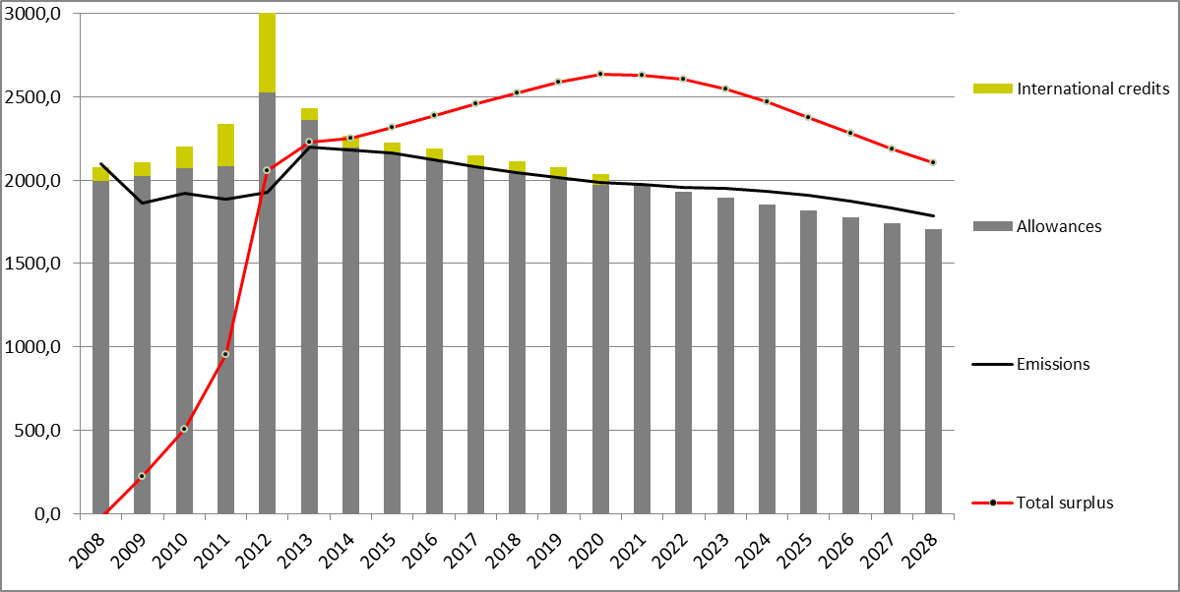
Costs of emission reductions are expected to be the lower, the earlier the necessary long-term investments take place. Although in a cap-and-trade system, such as the EU ETS, the agreed environmental objective expressed in the cap, limiting total emissions for a given period, is guaranteed, the cost-efficiency objective expressed in the total cost is also of central importance. In principle a market functions well with a certain level of surplus, as it provides a buffer to deal with factors leading to normal fluctuations in the supply-demand balance. For this reason rational economic behaviour results in stock-keeping. However, a large surplus is likely to result in a prolonged downward pressure on the carbon price signal. This may be good for the short-term competitiveness of some sectors but not for the EU at large. The resulting carbon price signal is increasingly distorted and no longer in line with the trend necessary to achieve the long-term decarbonisation target in a cost-effective manner.
A large surplus hence strongly confounds the signal for investments, which are necessary for the transition towards a low-carbon economy, including energy supply. It is a problem as it is expected to result in locking the EU into high carbon capital and investment, in particular considering the currently high gas to coal price ratio.
The latest survey of EU ETS operators in early 2013 by Thomson Reuters Point Carbon reconfirmed that the EU carbon price has become less important for investment decisions. 20% of the operators surveyed said that EU ETS no longer has a significant impact on emission reductions. Because of the risk of carbon lock-in, the large surplus in turn risks putting the EU on a more expensive path to meeting the long term targets. That is bad for the longer term competitiveness of the EU. Put differently, the presence of a large surplus reduces the dynamic efficiency of the market-based outcome and thus increases overall costs when considered over the longer periods that are relevant for the climate change challenge.
As a short term measure to mitigate the effects of this problem in the context of additional temporary imbalances caused by regulatory changes linked to the transition to Phase 3, the Commission proposed to back-load the auctioning of 900 million allowances in the beginning of phase 3. Figure 2 provides an illustration of the supply and demand balance up to 2020 with back-loading. The analytical assumption generally used in this Impact Assessment is that back-loading reduces the auctioning amounts by 400, 300 and 200 million allowances in 2014, 2015 and 2016 respectively. The return of these allowances to the market remains the same as initially proposed, increasing the auctioning amounts by 300 and 600 million allowances in 2019 and 2020 respectively. It should be emphasised, however, that back-loading and the measures considered in this Impact Assessment pursue complementary objectives.
Figure 2 demonstrates that to an extent back-loading can rebalance supply and demand in the EU ETS in the transition into phase 3 compared to a situation without back-loading. As already highlighted in the Carbon Market Report, however, back-loading leads to a rebound in the surplus in 2019 and 2020 and hence does not affect the average size of the structural surplus of around 2 billion allowances in phase 3 and 4, peaking at 2.6 billion in 2020. It is the structural surplus, and solutions for addressing it in a sustainable way and preventing from it accumulating again in the future that are the focus of this Impact Assessment.
Figure 2: Historical and projected future profile of supply and demand up to 2028 with back-loading
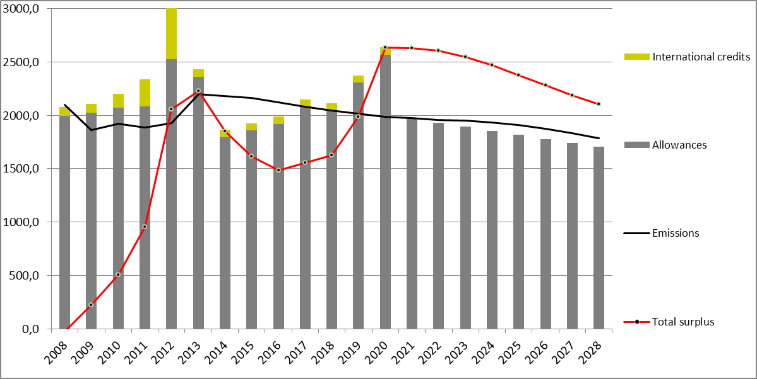

4.1. Interaction with possible measures in the context of the 2030 framework
According to stakeholders, the linear reduction factor should be strengthened after 2020 consistently with the GHG emission reduction target for 2030. This target is still to be decided. If the target is decided fast enough to allow for an early revision of the linear reduction factor ahead of 2020, this should lead to a decline in the surplus. Nevertheless, the decline would only happen gradually. For this reason, an early revision of the linear reduction factor is also discarded from further analysis as an option that can address the large imbalance in the short-term.
If, as of phase 4, the linear reduction factor would be increased to a level consistent with a 40% GHG emission reduction by 2030, all scenarios leading to such a reduction still result in a surplus of around 2.3 billion allowances or more by the end of phase 4 (see Figure 3) and even 2030. Under this target, there is also no demand in the EU ETS for international credits as of 2021, given that they would only add to the already very large surplus of allowances. This is also consistent with the current legislation that provides for no additional entitlements created after 2020. If it was allowed to meet a part of the effort through international credits, this would be combined with a higher conditional target. Hence, this is not likely to have a considerable effect on the surplus.
Figure 3: historical and projected future profile of supply and demand up to 2028 with back-loading and a 40% GHG target for 2030
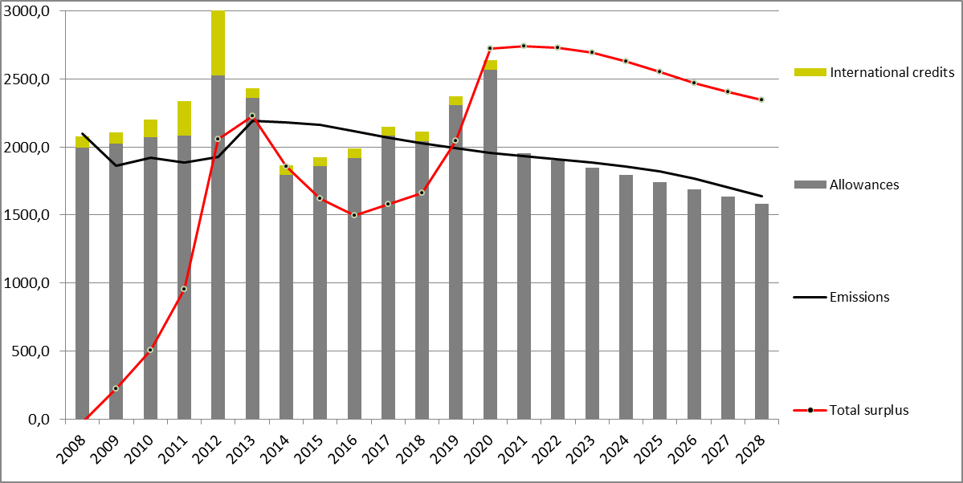
Concerning possible revision of the EU ETS after 2020 to include additional sectors, it still requires further assessment. A first qualitative analysis is taken up in the 2030 impact assessment. It shows that the degree of impact on the market balance will depend on the overall cap under the enlarged scope. In any case, however, an extension of the scope may, like the revision of the linear reduction factor, lead only to a very gradual decline in the surplus.

5. Objectives

5.1. General objective
The general objective of the EU is to achieve the climate objective of limiting global average temperature increase to not more than 2 degrees Celsius above pre-industrial level. The EU ETS, as the main policy instrument at the EU level to reduce GHG emissions, has a central role to achieve the needed emissions reductions up to 2050 in a cost-effective and economically efficient manner.

5.2. Specific objective
The specific objective is to restore the functioning of the European carbon market in the short-term (and beyond) in a context where auctioning of allowances has gained a significant role as of phase 3 in bringing allowances in circulation.

5.3. Operational objective
The operational objective is to ensure inter-temporal efficiency of the carbon market in the short-term and beyond in a market setting characterised by large-scale auctioning, taking into account the need for simplicity and predictability. This requires addressing the structural surplus expected to remain in place even with other possible measures after 2020 in the context of the 2030 framework (i.e. revision of the linear reduction factor, use of international credits, extension of the scope). It also requires increasing the resilience of the EU ETS in the light of the severe economic recession and other potential future large-scale events that may severely disturb the supply-demand balance.

6. Policy options
The baseline option (option 0) includes back-loading of 900 million allowances as outlined in section 4 and the so-called reference scenario concerning the expected emissions. Consistently with the 2030 impact assessment, the reference scenario is assumed as this is the one that sees the fulfilment of all legally binding targets for 2020. A detailed description of the policies and measures includes in the reference scenario is available in the 2030 impact assessment.

In terms of structural measures, the Carbon Market Report outlined a shortlist of six options listed in Table 1. The report acknowledged that some of the options would require considerably more analytical work, time to decide upon and subsequently implement. This was also one of the considerations that stakeholders took into account in their choice of preferred options. Out of those, who supported action in phase 3, the preferred options seem to be: c) early revision of the linear reduction factor to maintain the credibility of the EU ETS in the long-term, ideally combined with b) retirement of allowances to maintain the credibility of the EU ETS in the short term; a variant of option f), which would not focus on the price for allowances but rather on the supply of (auctioned) allowances.
The 2030 IA includes a general assessment of the impacts of those options that can only be implemented and have an impact in the context of a 2030 framework ((c) early revision of the linear reduction factor, (d) extension of the scope of the EU ETS to other sectors and (e) using access to international credits). It confirms that, although all options may be relevant as of phase 4, only a few have the potential to achieve the objective of this IA, to improve the functioning of the EU ETS in the short-term. Option a) of increasing the target is excluded from the focus of the 2030 IA based on the clear stakeholder feedback. Option c) for a revision of the linear reduction factor would be best implemented only after the decision on the 2030 GHG emission reduction target. Even if revised before 2020, it would only create scarcity and restore better aggregate balance in a gradual manner and is not expected to significantly impact the surplus in the short-term. As regards option d), the main limiting factor is the fact that the option requires further analysis and would not directly affect the surplus. In relation to option e), this would only impact the availability of international credits in phase 4. It would not sufficiently change the availability of international credits in the short-term, as more than two thirds of the amount allowed until 2020 is already used up. For more information, see the 2030 IA.
Based on the screening of the six options in terms of stakeholder views and assessment in the 2030 IA, the focus of this more detailed assessment is on the options that could realistically be implemented, and already restore the orderly functioning of the EU ETS in the short-term:
- Option 1: Retirement of a number of allowances in phase 3 (option b) in the Carbon Market Report);
- Option 2: More flexible auction supply in the form of a market stability reserve (additional option building on a variant of option f) in the Carbon Market Report);
- Option 3: Combination of a market stability reserve with retirement of a limited number of allowances in phase 3
Table 1: Comparison of the options from the Carbon Market Report
 | Stakeholder views* | Potential effectiveness in improving the functioning of the European carbon market in phase 3
a) Increasing the EU reduction target to 30% in 2020 | Very limited support | Not focus of the assessment  Would have been accompanied by a reduction of auction supply over phase 3 by some 1.4 bn allowances. This might have the potential to improve market functioning in the short-term  Reference emission projections for 2020 actually already come very close to levels associated with a 30% reduction target. This means that while the EU might not be ready to increase its target to 30%, the full achievement of other agreed targets can reduce emissions in the EU to the level in line with what would be required to achieve a step up to a 30% target
b) Retiring a number of allowances in phase 3 | Medium support | Retiring a number of allowances early on has the potential to create scarcity and improve market functioning in the short-term
c) Early revision of the annual linear reduction factor | Medium support | Limited potential to improve market functioning in the short-term  But expected to have a positive impact in the mid- and long-term
d) Extension of the scope of the EU ETS to other sectors | Limited support (for phase 3) | Limited potential to improve market functioning in the short-term  Assessment of administrative challenges and potential to improve market functioning as of phase 4 needs to be further investigated  But potential other benefits, e.g. in terms of technology-neutral incentives across sectors
e) Use access to international credits | Limited support (for phase 3) | Very limited potential to sufficiently improve market functioning in the short-term  Aggregate surrender of international credits has already used up more than two thirds of the amount allowed until 2020
f) Discretionary price management mechanisms | Very limited support for a mechanism focused on price | Not focus of the assessment  EU ETS is an instrument based on volume not price
Additional option | Medium support for a mechanism focused on (auction) supply to address market imbalance | Potential to improve market functioning in the short-term  Most useful and simplest mechanism expected to be a reserve of allowances
* Out of those supporting any measures in phase 3

6.1. Option 1: Retiring a number of allowances in phase 3
The market imbalance can be reduced by retiring some of the phase 3 allowances on a permanent basis. A permanent retirement would indirectly increase the reduction target for 2020 and in turn (partially) restore the ambition level of the 2008 climate and energy package. However, as a self-contained measure, it would not directly impact the framework after 2020.
A retirement of a number of allowances would reduce the auction supply, but unlike with backloading this auction supply would not return to market and the allowances would be cancelled. It would not affect the amount of free allocation on the basis of the National Implementation Measures (NIMs) for phase 3.
This option would address the impact of the economic crisis and complementary policies on the demand side, as well as of the supply side drivers, notably the large inflow of international credits.
For the purpose of this assessment, an upper limit is put on the number of retired allowances that is equal to the number required for the step up to a 30% overall GHG reduction target in 2020, i.e. 1400 million allowances. However, under this option the primary aim is not to increase the target to 30%, but rather to address the market imbalance. This sub-option assumes that the permanent retirement starts in 2014 and ends in 2020, with high amounts at the beginning (similar to backloading) to correct the large existing surplus and low amounts of 100 million annually as of 2016.
Of course other amounts of retired allowances could be conceived. As a sensitivity analysis, another sub-option with a lower amount of 500 million allowances is assessed. This sub-option assumes that first 900 million allowances are temporarily withdrawn from the market through backloading, 500 million of these are permanently retired, while the remaining 400 million allowances are returned at the end of phase 2.

6.2. Option 2: Market stability reserve
Contrary to a one-off measure to improve the functioning of the market in light of the current severe economic recession, such as a retirement of allowances, the objective of a permanent mechanism is to increase the efficiency of the EU ETS and its resilience of in the light of any future severe demand shocks. A discretionary price management mechanism was among the options for structural measures to strengthen the EU ETS. Two variations have been put forward in the Carbon Market Report: a price floor and a price management reserve. Neither drew much support in the consultation on the options by stakeholders, who generally highlighted that the EU ETS is an instrument based on volume not on price. Price management would go against the central EU ETS principles and is therefore opposed by most stakeholders. It can also be expected that agreeing on the "right" price thresholds would be very contentious, if not impossible.
However, there is a broad agreement among stakeholders that instead possible measures to be assessed should be i) non-discretionary and rule-based to remove the need for future ad hoc intervention, and ii) volume-based to allow for continued price discovery by the market, and neutral to the overall cap. A mechanism to adjust auction supply aims to address the mismatch between the fixed auction supply and flexible demand by introducing flexibility also on the supply-side in the short-term, without affecting the total long-term supply in place. Keeping the supply flexibility within the cap is essential for a mechanism design that is environmentally viable. Hence, some stakeholders are proposing an idea of a reserve of allowances.
Such a measure may also allow improving the interaction with renewables and energy efficiency policies, and even reduce uncertainty from international negotiations, by playing a helpful role in the 2030 framework and move between an unconditional and possible conditional GHG target.

6.2.1. Potential sources of supply flexibility
Although supply on the carbon market stems from three sources – auctions, free allocation and international credits – the main cause of supply rigidity is the auction supply.
Contrary to the allowance allocated for free, auctioned allowances translate immediately into supply on the market. The Auctioning Regulation provides for a rigid time profile. The volume to be auctioned in each year should be equal to the difference between the total amount of allowances under the cap (which declines in a linear manner) and the amount of allowances handed out for free in that year (in line with the benchmarks), i.e. cap minus free allocation for each year. This time profile was decided back in 2010.
The point in time when free allocation translates into actual supply in the secondary market, on the other hand, depends on the operators’ incentives to sell the allowances they have received. If demand falls, so does the price and the operators are not incentivised to sell allowances received, and may prefer to bank them into subsequent trading periods, reacting in a flexible manner to changes in demand. The rules for free allocation when there are capacity extensions and reductions as well as new entrants and closures provide additional flexibility responding to changes in economic activity. Some stakeholders advocate going further to full ex-post corrections to free allocation based on actual output. While this may be relevant for the discussion on addressing the risk of carbon leakage, it is not relevant in relation to the large supply-demand imbalance. It should be noted that moving to ex-post allocation would change the incentives for industry and in particular would undermine the incentives for emissions reductions for products and sectors with no specific product benchmarks and covered by so-called fall-back allocation approaches.
In relation to international credits, a distinction needs to be made between the overall amount of credits allowed and the annual distribution of this amount over the relevant period (currently for 2008-2020 combined). The annual inflows of international credits are in principle able to react to changes in demand, but in 2011 and 2012 this was rather counteracted by increased inflow of credits in reaction to a regulatory change (disallowing the compliance use of industrial gas credits) that was decided in early 2011 for implementation as of May 2013. The overall amount, on the other hand, is fully fixed. Following the recession, the overall limit has turned out to be rather generous. The combination of these two factors meant that the use of international credits was one of the major drivers of the surplus. As of phase 4, the default situation is that no additional entitlements are created. Any further use of international credits in a 2030 framework needs to address how many could be used (quantity) and what type could be used (quality). In terms of quantity, various solutions could be envisaged to avoid large inflows in the future:
- To ensure a more stable flow of international credits and avoid excessive inflows in an individual year triggered by events like the forthcoming ban of some credit categories, an option would be to break down the overall amount into annual amounts, which would act as annual limits on the use of the international credits. At the same time, if that annual amount was not used up to the full, the remaining amount would be lost, i.e. it could not be added to the amounts for the subsequent years. Although it expected that this may create an incentive to use up the annual amount, it would create a more stable inflow of international credits and avoid circumvention of any additional credit bans by increased use of international credits in preceding years.
- Another option to align the supply / inflow of international credits with demand is to define the allowed use in relation to emissions rather than (free) allocations. This would allow for a higher amount of inflows in times of higher emissions and vice versa.
- To align the use of international credits with its original purpose – cost containment – and prevent the overall amount being too generous, another option would be to make the overall amount subject to demonstrated need. For example, the default amount could start at zero or a low level, but could be increased depending on a price trigger. This could be an absolute trigger or a relative one, like the mechanism in Article 29a of the EU ETS Directive.
However, as by the end of phase 2 the aggregate surrender of international credits has used around two thirds of the amount allowed over 2008-2020, changes to the remaining allowed supply for phase 3 would not have sufficient impact. Curtailing the remaining credit entitlements would furthermore disadvantage those installations that have so far made a disproportionally limited use of the possibility to surrender international credits with the intention to consume the entitlement in later years. More flexibility could rather be considered for phase 4 and beyond, in case it should be decided to allow for the use of more international credits after 2020. The option therefore discussed and assessed in the 2030 IA.

6.2.2. Functioning of the mechanism
As the purpose of the mechanism is to make supply more flexible without affecting the cap, the most obvious mechanism is establishing a reserve of auctioned allowances. The auction supply and the size of the reserve would vary over time by:
- Adding allowances to the reserve by deducting them from future auction volumes with the aim of mitigating market instability due to a large temporary surplus in the EU ETS;
- Releasing allowances from the reserve and adding them to future auction volumes with the aim of mitigating market instability due to a large temporary deficit in the EU ETS.
To ensure that the cap is not affected, an increase in the auction volume would only be possible, if there were allowances in the reserve. A market stability reserve would work across trading period boundaries. Allowances that would be in the reserve at the end of a trading period would remain there for the following period. Key design aspects that need to be decided for the establishment of a workable reserve are rules on when to feed allowances into the reserve and when to release them (triggers), how many allowances to feed into it and how many to release (size of the adjustment) and over what time period any adjustment should be made (timing).
The design of such a reserve would need to take careful account of the already accumulated large surplus in the EU ETS and the proposed back-loading of part of the auction volumes from the beginning of phase 3. Experience with implementing back-loading could also provide valuable insight into the operational design and / or review of a reserve with regard the impacts of withholding an amount of allowances from the market on the behaviour of market participants.
Given that a market stability reserve would be purely rule-based and non-discretionary, existing institutional arrangements for auctions (e.g. tasks performed by the Commission and auction platforms) could most cost-effectively be used for implementation purposes.

6.2.3. Triggers for feeding allowances into the reserve and releasing them
Potential triggers can be grouped into external indicator-based, price-based and volume-based. In terms of their level, the basis for the adjustment should be expressed in a range rather than one specific value, which should be continuously targeted, to ensure that the rules kick in only in exceptional circumstances due to large demand shocks and not on frequent basis in normal circumstances.
The mechanism could also be devised as a combination of these triggers, e.g. a volume-based trigger for putting the allowances into the reserve, but a price-based trigger for releasing allowances from the reserve.

6.2.3.1. External indicator-based triggers
Triggers based on external economic activity indicators, such as gross domestic product (GDP) and industrial production, would be most directly related to the underlying causes of decreased demand for emission allowances due to economic shocks. There are limitations in the suitability of macroeconomic indicators, such as the GDP, as the trends in the EU ETS sectors may be prone to different cyclical swings than the wider economy. So more targeted indicators related to industrial or electricity production may be more appropriate. Changes to the size of the reserve could be made if the indicators considerably deviated from a certain range or possibly based on multi-year averages, e.g. if the GDP in year x deviates by 0.5 % from the average GDP over the preceding three years or less.
One could use actual data from the previous year as soon as they become available, or forecasts. In case of the latter, the more forward looking the forecast, the less accurate it is likely to be. Hence, it may be advisable to use forecast for only one year ahead. Still, any trigger based on forecasts will inherently suffer from the disadvantage that forecasts can turn out to be inaccurate, as was the case with the growth forecasts used for the Impact Assessment for the 2008 climate and energy package. However, a trigger based on forecasts will have the advantage of potentially kicking-in before the changes in the economic activity driving demand shocks have happened, while an indicator based on actual data, which is available with a time lag, will only kick-in after the event. The expert meeting on flexible auction supply on 2 October 2013 showed an almost universal preference for the use of actual verified data over forecasts.
A major limitation of external indicator-based triggers is that they are only able to capture changes in the demand for emission allowances due to changes in the economic activity. They are not able to capture changes in the demand due to possible other factors, such as impact of complementary policies, such as the renewables and energy-efficiency policies, which can reduce EU ETS emissions and demand for allowances. They are also not able to capture changes on the supply side, such as occurred in the transition from phase 2 and 3, and any big changes in the inflow of international credits.

6.2.3.2. Volume-based triggers
As the issue the measure aims to address is market imbalance, which is expressed in cumulative surplus, a volume-based trigger would be best designed having either a certain stock of surplus (cumulative surplus) or flow of surplus (changes in cumulative surplus) as a basis. A surplus-based mechanism would aim to maintain the surplus within a pre-defined target range. A market may normally build up some surplus to act as a buffer by providing sufficient liquidity in times of higher demand. This liquidity is absorbed by hedging demand, currently mostly in relation to forward electricity sales. However, too large a surplus affects the stability of the carbon market and impedes the effectiveness of the system in incentivising both short-term abatement, such as fuel switching from coal to natural gas, as well as mid- and long-term investments in low carbon technology.
The most useful data source related to the evolution of the surplus is actual data on verified emissions and the use of international credits in the previous year. The use of forecasts is arguable less appropriate here. The expert meeting showed a general agreement on this point, that historical data should be used.
Such a range could be expressed as an absolute range or in relation to the auction quantities or the cap. As an example for the relative range, the levels proposed by stakeholders so far are in the order of magnitude of 40-50% of the annual cap. This means that allowances should be added to auctions when the surplus falls below 40% of the annual cap; and they should be deducted when the surplus exceeds 50% of the annual cap. As the cap decreases, the absolute numbers would change year on year with a band that tapers over time. This may have the disadvantage of going against the possibly increasing trend in hedging needs by also sectors other than the power sector as the amount of free allocation declines. The band could also be determined in absolute levels, e.g. that allowances should be added to the auctions when surplus falls below 400 million allowances and deducted from the auctions, when it exceeds 1000 million allowances. Also in the case of a band expressed as a share of the auctioning amount, the absolute numbers would change year on year, but with a band that would increase over time. However, such a band may be exposed to possible structural breaks in the transition from phase 3 into phase 4, if there were any changes in the free allocation rules, in particular in terms allocation to sectors deemed to be exposed to a significant risk of carbon leakage.
Another aspect to consider is whether to have a constant band or one where the upper level either increases or decreases over time. One possibility would be a band that increases over time so that the surplus is reduced faster at the beginning to restore market balance. Such an approach may be better if an amount of auction supply is not already temporarily removed from the market through back-loading. However, back-loading already acts in a similar way, quickly reducing the market imbalance from the start, so a lower band in the early years may not be needed. The alternative would be a band that decreases over time so that the surplus shrinks or grows in a step-wise and gradual way to prevent big changes in the auction supply and possible large price effects. A band that is relative to the cap already declines in line with the cap, however bigger differences in the level of the band over time would probably be needed to avoid shock-therapy in a situation where a large surplus has already built up.
In terms of the width of the band, a narrower band is expected to lead to more need for intervention than a broader band. As a result, it is likely to lead to a higher number and frequency of adjustments and in turn in less predictability as regards the auction volumes. A broader band would result in a lower number and frequency of adjustments.
Figure 4: Illustration of a supply-based adjustment
An alternative to cumulative surplus as a basis for the trigger could be an annual change in the surplus. For example, allowances could be put into the reserve if the annual change in the surplus (increase or reduction) would exceed a certain amount. Such an approach is expected to react quicker than an approach based on the cumulative surplus, which may take a number of years of large annual changes to reach it.
An advantage of surplus-based triggers is that they would not only address the impact of the economic crisis, but also take into account the complementarity between the EU ETS and renewables and energy efficiency policies, which in the future may trigger an additional increase in the surplus in the EU ETS, as well as supply-side drivers, such as large inflow of international credits.
Choosing values for a volume-based trigger
A crucial issue is determining the upper and lower ends of a volume-based target range, which would trigger putting allowances into a reserve and releasing them. This warrants considering several approaches to establish appropriate values for the target range. These are:
- An analysis of typical hedging needs: Given the primary purpose of a market surplus, typical hedging needs in relation to emission allowances to cover forward sales should guide the decisions about the appropriate level of the band. The hedging needs are for the time being mainly related to the electricity sector, but to the extent that industry (e.g. industry sectors not deemed to be exposed to a significant risk of carbon leakage) may increasingly need to buy allowances on the market rather than having their compliance needs covered by free allocation, total hedging needs may grow too. Hence, a relative band expressed in relation to the cap, which would decrease over time, may have the disadvantage of going against the possible increasing trend in hedging needs. However, only a part of the power sector's hedging behaviour is understood and published data on it far from complete. No legal mandate is in place for power companies to regularly disclose hedging positions beyond certain transactions. Moreover, hedging behaviour may change over time. An option would be to put in place a reporting requirement in terms of hedging data. However, experts acknowledged that there is a risk of strategic behaviour by the reporting companies and little possibility to verify the data. Apart from that, none of the options for a market stability reserve requires additional information and data to be collected.
- An analysis of the average stocks of allowances in phase 2 and 3: Figure 5 compares the average monthly stocks of emission allowances in phases 2 and 3. In phase 2, the majority of emission allowances (around 96%) was allocated for free in one go at the end of February and was not surrendered until April the following year. This means that for two months, there were twice as many allowances in the market as "needed" in a year. In phase 3, with the increasing role of auctioning, which gradually brings allowances in circulation over the year, the average monthly stock of allowances is considerably lower. The difference between the average stock of allowances in circulation in phase 2 and 3 could provide insights about the magnitude of the needed allowances in circulation that still allows for orderly functioning of the market. This difference is around 800 million allowances.
Figure 5: Comparison of monthly stocks of allowances in phase 2 and phase 3
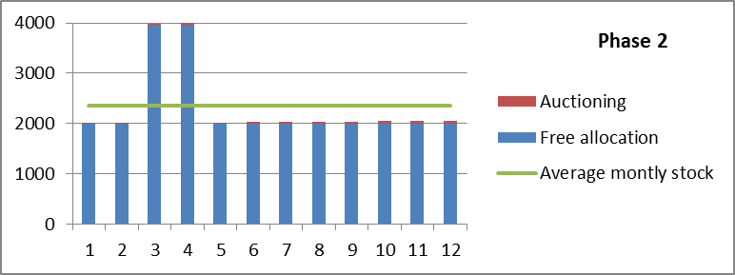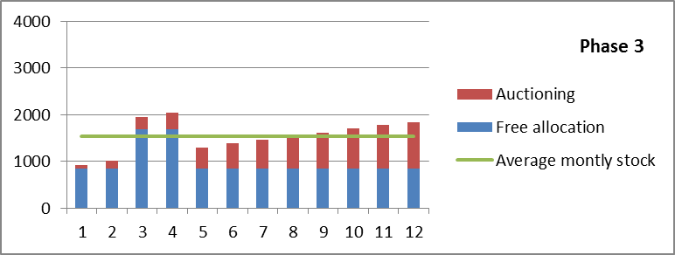
Some stakeholders and experts have submitted estimates of the amount of allowances covering power sectors forward sales and an appropriate range, which show diverging views on the order of magnitude:
- In the expert meeting, a representative of Bloomberg New Energy Finance mentioned a range of 1.2-1.3 billion allowances;
- In the same meeting, a representative of ENEL, proposed a surplus range of 762-956 million allowances;
- Fortum proposes a range between 40-50% of the following years cap (i.e. 810-1013 allowances at the start of phase 3 declining to 704-880 allowances at the start of phase 4).
There are mixed views on the whether there exists a "right" range in the first place and whether the values matter. Some experts argued that the values are essential, while others that they do not matter that much because market participants may adjust their behaviour anticipating the impact of the reserve. In any case, the risk of setting the triggers at inappropriate levels could be mitigated by setting a broader range or a declining range, with a higher upper level at the beginning, to allow for a gradual reduction in the market imbalance and learning about the market impacts along the way, which could inform a possible review of the trigger levels. Putting a limit on the size of the annual adjustment can also prevent possible risks of setting the triggers at unsuitable levels, such as responding too strongly to changes in the demand. Furthermore, any excessive price increases due to a too low range would be addressed by the existing safeguard in article 29a of the Directive.

6.2.3.3. Price-based triggers
Price based triggers could be expressed in absolute or relative terms. Absolute thresholds would act as a price corridor with a price floor and price ceiling. A relative approach could function as the existing mechanism in Article 29a of the EU ETS Directive. This provides for the option to advance auction supply, if for more than six months the carbon price is more than three times the average price during the two preceding years. As this is about excessively high prices, the article could serve as the basis for the return of allowances from the reserve to the market, with another trigger determined for feeding the allowances into the reserve.
Price-triggers are a theoretical possibility, but obviously, this would be a price-focused mechanism with all the aforementioned drawbacks, which elicited little interest and support among stakeholders. They frequently pointed out that any price management mechanism would fundamentally modify the EU ETS, as the system would no longer be a quantity-based, market-based instrument for achieving emission reductions in a cost-effective way. One of the main implications of the decision for a quantity-based instrument over a price-based one is that the carbon price signal is not fixed by policy-makers but revealed by the market. In the EU ETS, the carbon price reflects the quantity of allowances and their relative scarcity and not the other way around. With this in mind, stakeholders are asking for a mechanism that complements and enhances the market, and preserves this price discovery. In contrast, a mechanism prescribing a certain price corridor runs counter to a market logic and even substitutes it, by distorting the carbon price level that would otherwise be revealed by the market.
Price-base triggers also suffer from the drawback of being more at risk of manipulation and gaming. There are indications that this risk is not material for volume- and in particular GDP-based triggers, as low concentration of the carbon market considerably mitigates the risk of gaming with a company attempting to influence the annual emissions, let alone the GDP. However, given that the European carbon market is dominated by derivatives (namely futures) a reserve with price triggers may be more prone to cross-market gaming behaviour by market participants influencing price-setting.
As the external indicator-based triggers, it would also require an additional step to determine how many allowances would be deducted or added to the auctions if the price fell outside a certain price range.
Price-base triggers would be able to address the impact of the economic crisis and complementary policies on the demand side, as well as of the supply side drivers, notably the large inflow of international credits.

6.2.3.4. Review of triggers
The appropriateness of the triggers and their levels, the size of the adjustment and the timing could be reviewed on a regular basis. There seems to be a broad consensus among experts on the need for a periodic review of the triggers, which should be well-signalled in advance.
In case of surplus-based triggers the review could include the latest trends in hedging and in case of external indicator-based triggers latest trends in production, sector shares in the GDP and emission intensity. The triggers could be automatically updated by basing them on rolling averages of related data, or they can be revised on a more ad-hoc basis via the comitology process (e.g. once per trading period or every 4 years).
There is a trade-off between certainty for market operators and flexibility to incorporate "learning" by the decision makers. The advantage of the review would be that there would be a smaller regulatory risk of setting the triggers at the wrong levels and that it would allow for learning. The review would also allow for responding to any changes in the market structure, notably continued transition from free allocation for industrial sectors not deemed to be exposed to a significant risk of carbon leakage. On the other hand, it has the drawback of potentially reducing certainty.
One possibility would be to create two different types of trigger: the first type of trigger to determine when allowances go into or out of the reserve, the second type of trigger to launch a review of the first trigger for (moving allowances in or out of the reserve). For example, a surplus-based trigger could determine whether allowances are put into or taken out of the reserve, whereas price trends could be used as a secondary check or second trigger to launch a review. In this case, if excessive price changes occur even with a reserve, they could automatically result in (or trigger) a review of trigger levels based on the cumulative surplus. This second, review trigger could for example be along the lines of the formula in the existing rule in article 29a of the ETS Directive.
The Commission will monitor and evaluate the functioning of the carbon market in its annual report as foreseen under Article 10(5) of the EU ETS Directive. Any need for review of the triggers could be evaluated and signalled in the context of this report.

6.2.4. Size of the adjustment
As the external indicator-based triggers and price-based triggers would not be directly expressed in a number of emission allowances, another aspect to be decided is the amount of allowances put into the reserve or taken out of it, once a trigger is reached. A number of options exist, which are outlined and discussed in the following sections.

6.2.4.1. Function of the distance from the trigger levels
The amounts could be determined as a function of the difference between the upper / lower limit of the band. For example, in the case of external indicator-based triggers the amount could be expressed as X million allowances to be deducted from auction volumes for each percentage point below the band, or X million allowances added for each percentage point above the band. For a price-based system, the amount could be expressed as X million allowances to be deducted from auction volumes for each € below a certain price, or X million allowances to be added for each € above a certain price. The main challenge that this approach poses is that without a perfect knowledge of the emission intensity in case of external indicator-based triggers, and price elasticity in the case of price-based triggers, which would be required to determine such amounts, it is uncertain that the adjustments in amounts of allowances auctioned would actually correspond to the changes in economic activity or bring the price within a desired price corridor.
As the surplus-based triggers and related band would be expressed directly in a number emission allowances, there would in principle be no need for this additional step to determine the size of the necessary adjustment. This could be automatically determined by the difference between the size of the surplus and upper or lower limit of the band.
The advantage of the size of the adjustment depending on the distance from the triggers is in its flexibility in responding to different levels of demand shocks. However, this model may act as shock-therapy in terms of changes in supply. It would also provide less predictability in terms of the size of the adjustment and the final auction volumes. Hence, the adjustment could possibly be determined as a percentage of (as opposed to 100% of) the distance to the trigger level.

6.2.4.2. Fixed independently of the distance from the trigger levels
Alternatively, for all three types of triggers, the amount could also be determined simply as a certain fixed amount to be deducted from the auction volumes or added to them, as soon as the relevant triggers were reached, independent of the distance from the band. For example, allowances should be put into the reserve or taken in instalments of 100 million allowances or X% of the annual auction supply, each time the trigger to feed the reserve is reached.
The adjustment could also be determined as a percentage of the cumulative surplus (e.g. 10%). In absence of further demand shocks, the imbalance and the absolute amount of the adjustment would decline with every preceding adjustment. This would combine the ability of the reserve to respond proportionally to the magnitude of the imbalance, and at the same time to avoid the risk of unwanted impacts due to too large annual adjustments. In this case, the upper level of the trigger could also implicitly be expressed as minimum amount of adjustment. I.e. an adjustment putting allowances into the reserve would happen unless the adjustment, determined as a percentage of the cumulative surplus would fall under a certain absolute amount (e.g. 100 million allowances). In this example, the implicit upper limit would be 1 billion allowances.
The advantage of pre-determined amounts is a high degree of predictability in terms of changes to the expected auction volumes and simplicity. The disadvantage is that the size of adjustments may not immediately correspond to the size of the changes in demand. For example, the size of such an adjustment may not be sufficient. However, the difference could decline by additional adjustments in the same instalments over the following years, building the reserve or depleting it in a gradual manner.

6.2.4.3. Limits on the size of the adjustment and the reserve
If the size of the individual adjustments is not fixed, it may be considered to put an upper limit on them in order to ensure more gradual changes to the supply profile and for transparency reasons. There was general agreement among the experts that limits on the size of the annual adjustment are warranted.
An upper limit may be less needed if the triggers would start with a high surplus band to avoid large changes in the auction supply in the situation when a large surplus has already built-up. The auction supply available acts as an ultimate limit on the maximum adjustment that can be done in the period in question. However, for example, it could also be decided that the magnitude of the annual adjustment cannot exceed a certain amount, for example 100 million allowances or tenth of the auction volume in the relevant period. This would ensure that majority of the expected auction volume would come to the market, in case the rules would lead to deductions from the auction volumes. The benefit would be increased predictability of the minimum and maximum levels of annual auction supply. The drawback would be that the adjustments may not be sufficient to fully react adequately and timely to very large demand shocks.
A limit could be put on the maximum size of the reserve, e.g. that it shall never be higher than a certain percentage of the annual cap (this would be a different number every year) or a certain absolute amount (this could remain constant). If the maximum size of the reserve was reached, there could be two possible consequences. Either the auction volumes would remain untouched in line with the default annual volumes or the allowances exceeding the maximum limit (for a prolonged period) would be cancelled. The advantage of the former is that it would ensure predictability of the system in relation to the absolute cap, but the mechanism may no longer be able to achieve its objective of making the EU ETS more resilient to shocks. Conversely, cancelling any excess allowances in the reserve may undermine principle of neutrality of a market stability reserve in terms of the overall cap and the predictability of the system in relation to the absolute cap, but it would still maintain the ability of the mechanism to cope with prolonged periods of surplus accumulation. Reducing the cap would improve the environmental outcome of the EU ETS and ensure predictability in terms of relevant ambition. It could also play a helpful role in the context of the international negotiations and move to the more ambitious conditional target. Reaching the maximum limit could lead to an automatic cancellation of allowances or initiate a review of the cap through ordinary legislative procedure.

6.2.5. Timing
Another design aspect concerns the timing of any adjustments to the auction volumes. A number of alternatives could be contemplated, to a degree also depending on the triggers chosen.
The most obvious would be an annual exercise, with the total volume deducted or added to the auction volumes to be spread over 12 months. In any case, the period over which the adjustment is spread should not exceed the length of the period of the exercise to avoid accumulation of adjustments. I.e. if this was an annual exercise, and the volumes were spread over more than 12 months, the adjustments in month 13 and onwards could already overlap with possible adjustments stemming from following year's exercise.
If the trigger was surplus-based, the necessary data for the previous year (year t-1) - verified emissions and use of international credits - would become available in May of the current year (year t). So the earliest possible timing of the adjustment could be the 2nd half of the current year. This means that the initial auction calendar, which determines in detail the dates and volumes of auctions throughout a year, for year t would be determined without taking into account the possible adjustments. Following the annual compliance period, the auction calendar(s) for year t would be updated, reducing or increasing the volume for the remainder of the year. Another possibility would be to adapt the period of the auction calendar(s) so it more aligned with the compliance year, and runs from May of year t until April of t+1, or 2nd half of year t until 1st half of year t+1.
Alternatively, the adjustment could be done in the following year (year t+1). This way the auction calendar for year t would not require any updates and the auction calendar for year t+1 could already take into account the necessary adjustment from the start. However, adjustments in supply would have a longer delay than in the case of adjustment in the current year. On the other hand, they may provide more predictability to the market as the size of the adjustment would be known several months in advance before it is implemented.
Similar timing options and considerations apply also for the external indicator-based triggers, given the industrial and production indicators for year t-1, would only be available in year t. As mentioned, also forecasts could be used. For example, using the European Economic Forecasts – autumn editions (published in November), the auction calendar for the following year could already take into account the forecast for that year. Currently, according to the Auctioning Regulation, knowing the auction calendar for a year in advance has been decided as appropriate to ensure the necessarily level of predictability.
The calculations to check whether a trigger has been reached and the adjustments could also be done on a less frequent basis, e.g. every two years or half way through the trading period (i.e. every four years). In general a more frequent exercise has the benefit of being able to react more quickly to any significant changes in circumstances, but the drawback of providing less predictability in terms of volumes to be auctioned. A less frequent exercise risks requiring larger adjustments but the volumes for the adjustment can be spread over a longer period.

6.2.6. Other design aspects and characteristics of a market stability reserve
The model of a market stability reserve has a number of other possible advantages and aspects that could be conceived. One is in terms of the use of allowances in the reserve. Some stakeholders proposed ideas that could be relevant in this regards. For example, European Chemical Industry Council (CEFIC) proposes that the new entrants reserve be transformed into an "EU central reserve bank for efficient growth" – that e.g. during the times of economic crisis, unused allowances can be put into a reserve and dynamically reallocated to ETS sectors and the market in times of economic recovery and growth according to agreed rules. Their recommendation seems to be also about additional ex-post adjustments to the free allocation, but some elements could be considered also for a reserve of only auctioned allowances. The Confederation of European Paper Industries (CEPI) recommends using the revenues from the EU ETS to help drive innovation. Taking into account this input, possible uses of the allowances in the reserve could be
- To replenish the new entrants reserve if it were to be depleted based on the existing free allocation rules for significant capacity extensions and new entrants;
- To use some of the auction revenue from the allowances released from the reserve to support the development of breakthrough technologies for the sectors covered by the EU ETS.
The latter could be based on the principles laid down in the NER300 programme. In terms of governance, the European Investment Bank (EIB) could act as a reserve-keeper.
The market stability reserve could also have benefits in the context of international negotiations. A market stability reserve could also allow predictable but quick changes to the EU ambition to match more ambitious commitments by other regions and countries, by committing to permanently retire an amount of allowances in the reserve. This way the EU could credibly signal a possible higher ambition level to the international community and this help advance the international negotiations.

6.3. Option 3: Combination of a market stability reserve with permanent retirement
The market imbalance can also be reduced with a combined approach, both establishing a market stability reserve and permanently retiring a limited number of allowances. This would appear to be consistent with the dual nature of the problem, which is on the one hand the large surplus that the market is experiencing today (a "corrective" element) and on the other hand possible re-emergence of imbalances in the future due to large demand shocks (a "preventive" element).
Contrary to the baseline option, one possible way to implement a combined approach is to permanently retire allowances towards the end of phase 3. Technically this could be done by means of some back-loaded auction supply not being returned to the market. The analytical assumption used is that 500 million allowances are permanently retired. Regarding the design of the market stability reserve part, this option will be based on the central option(s) that will appear from the pre-assessment of different market stability reserve sub-options. The market stability reserve applies as of 2017. This option would be able to address the impact of the economic crisis and complementary policies on the demand side, as well as of the supply side drivers, notably the large inflow of international credits.

7. Analysis of impacts

7.1. Market balance
Table 2 represents two sub-options for the permanent retirement in terms of the numbers of allowances to be permanently retired, which will be assessed in relation to the their impact on the market balance and expected price development. It illustrates changes in the annual auction volumes compared to the baseline option 0, and for ease of comparison also the combined net change due to back-loading and a permanent retirement compared to the initial auction volumes.
Table 2: Sub-options for a permanent retirement – changes in auction volumes
[mio allowances] |  | Total | 2013 | 2014 | 2015 | 2016 | 2017 | 2018 | 2019 | 2020
Large retirement  Option 1a | Change compared to option 0 | -1400 | 0 | 0 | 0 | 0 | -125 | -125 | -425 | -725
Large retirement  Option 1a | Net change compared to initial auction volumes before back-loading | -1400 | 0 | -400 | -300 | -200 | -125 | -125 | -125 | -125
Small retirement  Option 1b | Change compared to option 0 | -500 | 0 | 0 | 0 | 0 | 0 | 0 | -167 | -333
Small retirement  Option 1b | Net change compared to initial auction volumes before back-loading | -500 | 0 | -400 | -300 | -200 | 0 | 0 | 133 | 267
Table 3 below represents 7 sub-options for the market stability reserve in terms of when and how many allowances to put into the reserve and when and how many to release, which will be assessed in relation to their impact on the market balance. All sub-options for a market stability reserve include rules for the return of the allowances to the market and are therefore cap-neutral. The options assume that the adjustment is done on an annual basis. The options were chosen to assess the differences in functioning of the reserve with different design elements. Other combinations of elements would be possible, too.
The first set of options focuses on the surplus-based triggers (options 2a-2f), either in relation to the cumulative surplus or change in the surplus. Different levels of the band are chosen in a way to allow a sensitivity analysis in terms of impacts of different levels and widths of the band. The majority of the options are focused on the surplus-based triggers as they have the important benefit of being able to account for the impact of complementary policies, such as renewables and energy efficiency measures. As explained before, price-based triggers are not the focus of this assessment.
In general, two variants are assessed, one where there is some kind of a safeguard to avoid large changes in the auction supply:
- Under option 2b, an upper limit is put on the size of the annual adjustment.
- Under option 2d the adjustment putting allowances into the reserve is calculated as a 10% share of the cumulative surplus, unless the adjustment would fall under 100 million allowances. Adjustments releasing allowances from the reserve are determined as instalments of 100 million allowances.
- Under option 2f the adjustment is limited to 50% of the distance from the band.
The limits at the same time de facto mimic the impact of a fixed amount of the adjustment. For the purpose of this analysis, two different levels of 100 million (limit and instalment in options 2b and 2d) and 200 million (instalment in option 2g) allowances are assessed, as well as an adjustment at the level of 50% of the distance from the band.
One option (option 2g) looks at a reserve with an external indicator-based trigger, more specifically based on the GDP growth forecasts published in the European Economic Forecast – autumn editions. As the band is not directly expressed in emission allowances, external indicator-based triggers in any case require an additional step of determining the amount of allowances placed into / released from the reserve. Given the difficulties of precisely translating the relation between the unit of GDP growth into a number of allowances, the external-based trigger is only assessed in combination with pre-determined adjustment amounts of 200 million allowances.
Table 3: Sub-options for a market stability reserve
 | Option | Trigger | Adjustment amount
Relative narrow band & unlimited | 2a | Total surplus outside 40-50% of the cap | Distance from the band/unlimited
Relative narrow band & limited | 2b | Total surplus outside 40-50% of the cap | Distance from the band/limit of 100 mio allowances
Absolute broad band & unlimited | 2c | Total surplus outside 400-1000 mio allowances | Distance from the band/unlimited
Absolute broad band & limited | 2d | Total surplus outside 400-1000 mio allowances | 10% of cumulative surplus/instalment of 100 mio allowances
Annual change & unlimited | 2e | Annual change in surplus >100 mio allowances | Unlimited/ surplus change above 100 mio allowances
Annual change & 50% | 2f | Annual change in surplus >100 mio allowances | 50% of the surplus change above 100 mio allowances
GDP | 2g | GDP growth forecast outside 2-3% | Instalments of 200 mio allowances
Different impacts of a market stability reserve on the market balance can be expected when the market is faced with a growing imbalance and when the market balance has been restored. Therefore, the assessment is done in steps. Firstly, it assesses the impact of the reserve on the supply-demand balance with a demand shock resulting from a severe recession, using actual phase 2 data as a proxy. Obviously, only a very small amount of allowances was auctioned in phase 2, but for the purpose of this illustration, it is assumed that a similar share of auctioning would be available for any adjustments as in phase 3. The relevant time period for this step is primarily phase 2, but the assessment is extended to show residual impacts on phase 3. This part of the analysis assesses whether a market stability reserve would have prevented the large imbalance that the EU ETS is experiencing today.
In a second step, the assessment will examine what the impact of different options would be in the current situation, after back-loading has been implemented and has to a certain extent already restored market balance in 2014-2016. The reserve would apply as of 2017. Backloaded allowances then return in 2019 and 2020. The relevant period for this step is primarily phase 3. However, analysis is also extended to show impacts in phase 4. Obviously, for the permanent retirement options we only perform the second step of the assessment. This part of the analysis assesses whether the options would correct the large imbalance that the EU ETS is experiencing today.
In a third step, the assessment will examine what the impact of different options would be if they applied as of phase 4, with the first adjustment in 2021. This follows the preference by a number of stakeholders to implement structural measures as of phase 4, as after back-loading this would otherwise result in multiple measures in the space of few years and could impair certainty. So contrary to a permanent retirement, these stakeholders could support flexible supply as of phase 4.
Table 4 represents an option for the combination of a market stability reserve with permanent retirement. The choice of design features for the market stability reserve is informed by the pre-assessment and comparisons of the market stability reserve sub-options in section 7.1.3.4.
Table 4: Sub-option for the combination of a market stability reserve with permanent retirement
 |  | Amount of permanent retirement | Reserve triggers | Reserve adjustment amount
Retirement & reserve limited | 3 | 500 mio allowances | Total surplus outside 400-1000 mio allowances | 10% of cumulative surplus/Minimum limit or instalment of 100 mio allowances
The scheduled changes in the auction volumes related to the permanent retirement follow the profile set out in Table 5.
Table 5: Changes in auction volumes related to the permanent retirement
[mio allowances] | Total | 2013 | 2014 | 2015 | 2016 | 2017 | 2018 | 2019 | 2020
Change compared to option 0 | -500 | 0 | 0 | 0 | 0 | 0 | 0 | -167 | -333
Net change compared to initial auction volumes before back-loading | -500 | 0 | -400 | -300 | -200 | 0 | 0 | 133 | 267

7.1.1. Baseline scenario – Option 0
Figure 6 represents the annual deficit or surplus and the total cumulative surplus up in the current situation without a reserve being put in place. It will serve as the basis for comparison with options where a market stability reserve would have been implemented as of 2008. Hence, for the purpose of this particular simulation, it assumes no back-loading, as the market stability reserve would have already been in place and able to address the intended aim of that measure too. As there was only limited auctioning in phase 2, the illustrations show the total annual volume of issued allowances, rather than only auction supply.
Figure 6: Option 0 – Evolution of the surplus in phase 2 (and 3) without a market stability reserve and without back-loading
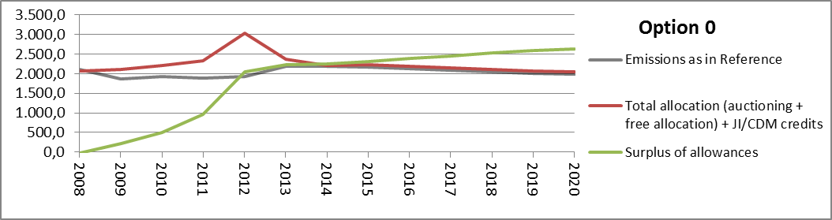
Figure 7 represents the annual deficit and surplus and total cumulative surplus in the situation without a market stability reserve, but where back-loading has been implemented. It will serve as the basis for the second part of the analysis, comparing the impact of the market stability reserve if it was to be implemented as of 2017.
All figures in this section use the same data as Figure 1.
Figure 7: Option 0 – Evolution of the surplus in phase 3 (and 4) without a market stability reserve, but with back-loading
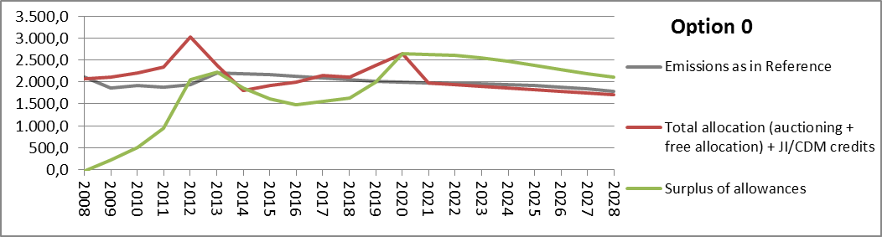

7.1.2. Permanent retirement options: Options 1a and 1b
Figure 8 provides a graphical presentation of the impacts in terms of market balance of a permanent retirement in two different amounts. Option 1 in the total amount of 1.4 billion allowances would mean that all 900 million allowances foreseen to be back-loaded are permanently retired plus an additional 500 million permanently retired afterwards. Option 2 in the total amount of 500 million allowances would mean that only that amount of back-loaded allowances are permanently retired, with 400 million returned to the market.
Figure 8: Evolution of the surplus in phase 3 and 4 with a retirement -options 1a and 1b
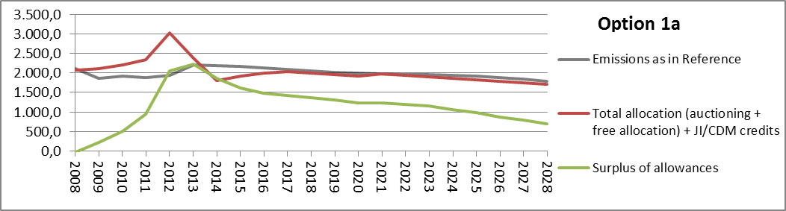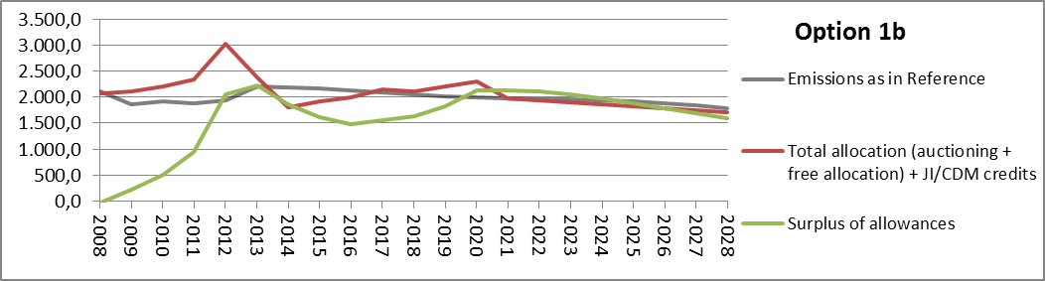
The following observations can be made:
- Both options are expected to reduce the surplus early on. This seems to be more consistent with the objective of inter-temporal efficiency than the baseline option 0.
- The core difference between the two options emerges in the second half of the period. A lower amount of permanent retirement decreases the stabilising effect of the measure. The option with a large retirement (1a) continues to reduce the surplus until 2020 and is likely to support the price in that period. Option with a small retirement (1b), however, results in a rebound in the surplus as of 2016 and an additional expansion of the surplus in 2020 when the back-loaded allowances, which were not permanently retired, are returned to the market. This may result in a renewed downward pressure on the carbon price signal.

7.1.3. Options for the market stability reserve

7.1.3.1. Options with volume triggers based on the cumulative surplus: Options 2a-2d
Impact of a market stability reserve if implemented in phase 2
Figure 9 gives a graphical presentation of the impacts in terms of market balance of a market stability reserve with volume triggers based on the cumulative surplus if it was already in place as of 2008.
Options 2a and 2b assume a relative and narrow band. Option 2a assumes a band with the total surplus within 40-50% of the cap with an adjustment depending on the distance from the band (unlimited adjustment). Option 2b assumes the same band, but limits the amount of the annual adjustment to maximum 200 million allowances. Options 2c and 2d are based on an absolute and broader band of 400 to 1000 million allowances, former with an unlimited adjustment defined as the distance from the band. Option 2d has an annual adjustment putting allowances into the reserve defined as 10% of the cumulative surplus in the preceding year, unless the adjustment would fall below 100 million allowances. Adjustments releasing allowances from the reserve are defined as instalments of 100 million allowances.
The following observations can be made:
- None of the options would have prevented the rapid accumulation of the surplus in 2011 and 2012;
- However, they would have avoided a continued growth of the surplus and reduced the market imbalance substantially and in most cases early in phase 3 compared to the baseline option 0. Hence, they appear to be more effective in ensuring the inter-temporal efficiency;
- Impact of the size of the adjustment:
- As they provide more flexibility in responding to the shocks, options with variable adjustments (2a and 2c) lead to an early and significant reduction in the market imbalance. However, they also lead to significant changes to the initial auction volumes.
- Options with a limit on the adjustment or the adjustment defined as a percentage of the cumulative surplus (2b and 2d) lead to a more gradual and predictable but smaller reduction in the market imbalance. They lead to similar results in phase 3. Of course, the speed of the reduction in the overall surplus will depend on the maximum amount of the adjustment and the percentage of the cumulative surplus, respectively. The higher the values, the quicker the reduction in the surplus would have been. In this particular case, these options do not manage to bring the surplus within the band until 2020 and adjustments reducing the annual auction amounts continue to be needed until the early years of phase 4.
- As for the impact of the levels of the band, in general, the narrower the band, the greater the need for interventions. While there is little difference in the number of interventions putting allowances into the reserve in phase 3, options with a narrower band (2a and 2b) would require more interventions in different directions in phase 4 (first still putting the allowances into reserve and shortly later releasing them from it). Options with a narrower band (2a and 2b) result in higher reserve levels by 2020.
Figure 9: Evolution of the surplus in phase 2 and 3 under options 2a-2d if already implemented in phase 2
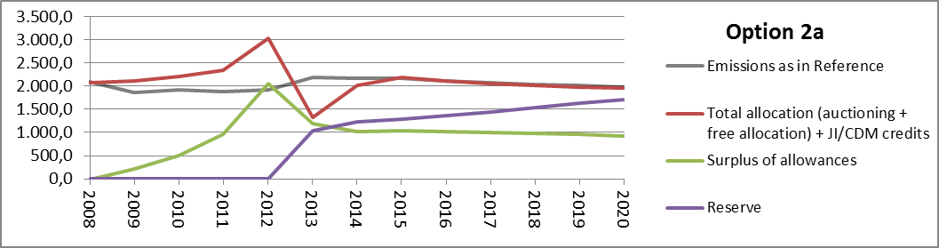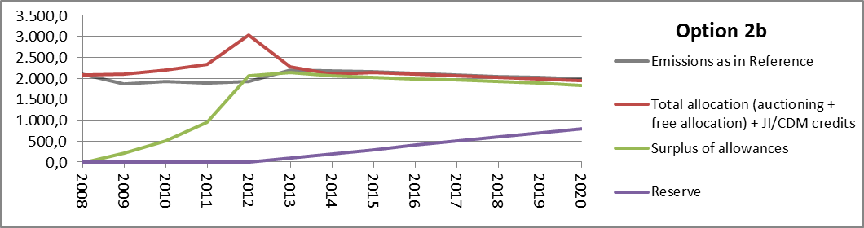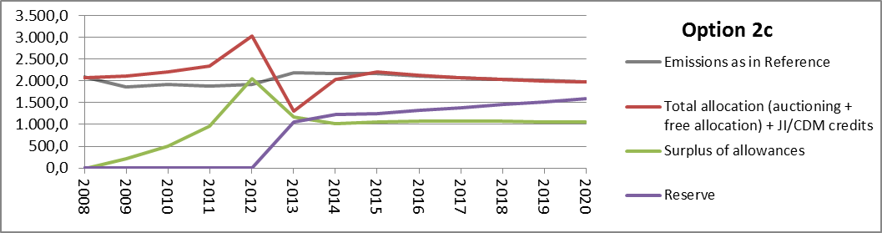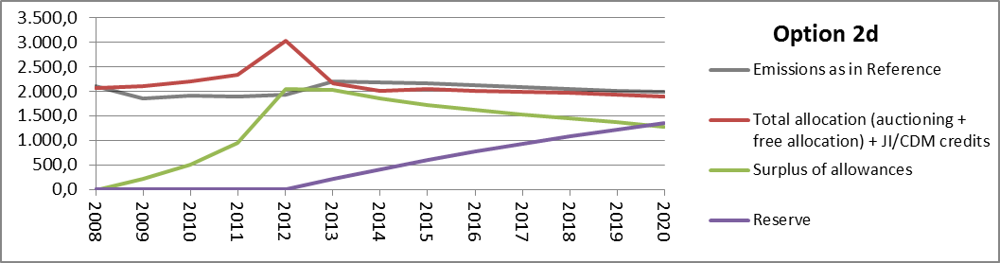
Impact of a market stability reserve if implemented in phase 3
Figure 10 provides an illustration of the impacts of the same options, if they were implemented as of 2017, after backloading, and the backloaded allowances would be returned to the market in 2019 and 2020 as scheduled. The following observations can be made:
- While the options are expected to lead to a rebound in the surplus at the end of phase 3, they would result in a gradual decrease as of phase 4. The pattern of a decrease in the market imbalance, followed by an increase and then a more gradual decrease may be inconsistent with the objective of better inter-temporal efficiency.
- Levels of the band: A narrow band (2a and 2b) leads to a higher number of adjustments, first putting allowances into the reserve, followed by adjustments releasing them only a few years later.
- Size of the adjustment: Options without a limit (2a and 2c) reduce the surplus faster as of phase 4. However, they result in quite high variability in auction supply and surplus in the transition into phase 4, with a spike at the end of phase 3 followed by a rapid drop early in phase 4. The options with some kind of a limit (2b and 2d) are slower in reducing the surplus as of phase 4, but results in most stable auction supply and more gradual reduction in the surplus. However, option 2b does not manage to bring the surplus within the band in phase 4 and requires an adjustment putting allowances into the reserve from 2017 throughout phase 4.
Figure 10: Evolution of the surplus in phase 3 and 4 under options 2a-2d if implemented as of phase 3
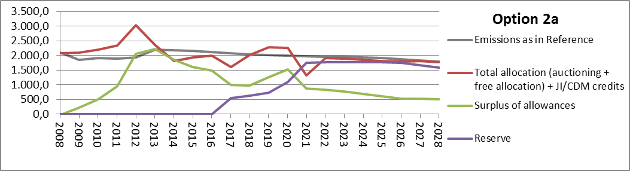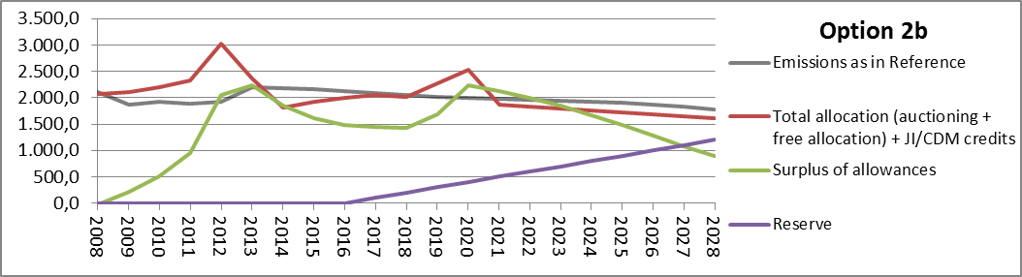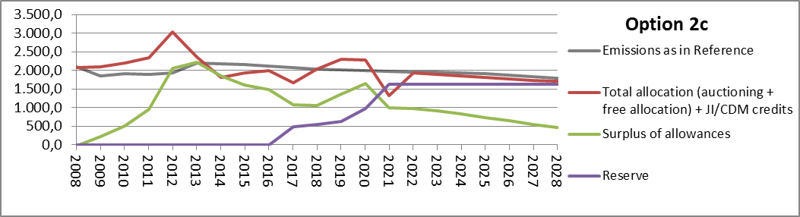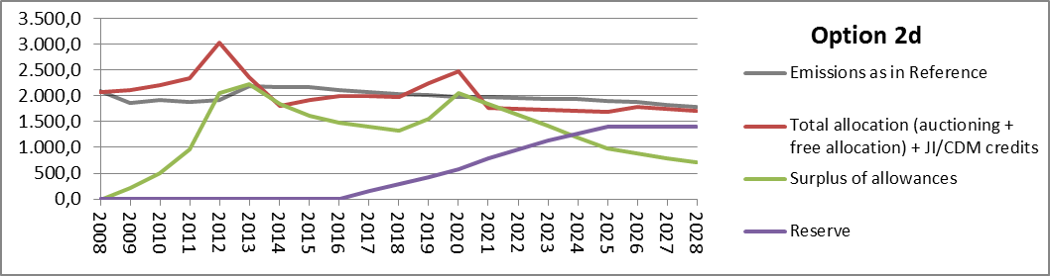

Impact of a market stability reserve if implemented in phase 4
Figure 11 provides an illustration of the impacts of the same options if they were to apply as of phase 4. The following observations can be made:
- Clearly, none of the options prevent the rebound in the surplus following the return of the back-loaded allowances. Compared to a situation where a reserve would be implemented as of 2017, the surplus in 2020 at the end of phase 3 is always higher.
- However, the options do correct for the expansion of the surplus as of phase 4. As the surplus is higher by then, so are the needed corrections.
- Levels of the band: Without a limit on the size of the adjustment, a narrow band (2a) results in more interventions in opposite directions, first putting allowances into the reserve and releasing them towards the end of the phase.
- Size of the adjustment: Options without any limit (2a and 2c) lead to very high adjustments at the beginning of phase 4, resulting in no auction volumes for 2021 and nothing (2a) or very little (2c) to be auctioned in 2022. However, they bring the surplus within the band in two years. Options with limited adjustments (2b and 2d) result in a slower but much more gradual reduction in the surplus, and ensure continuity of material auction supply throughout the phase. However option 2b is not able to bring the surplus within the band in phase 4 and requires adjustments putting allowances into the reserve every year of phase 4.
Figure 11: Evolution of the surplus in phase 3 and 4 under options 2a-2d if implemented as of phase 4
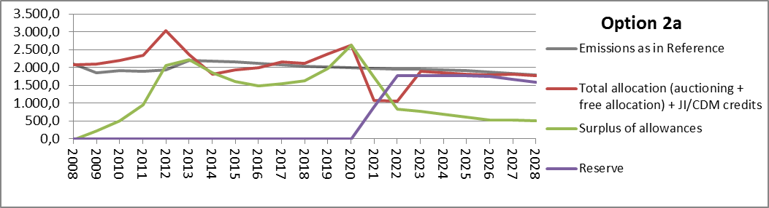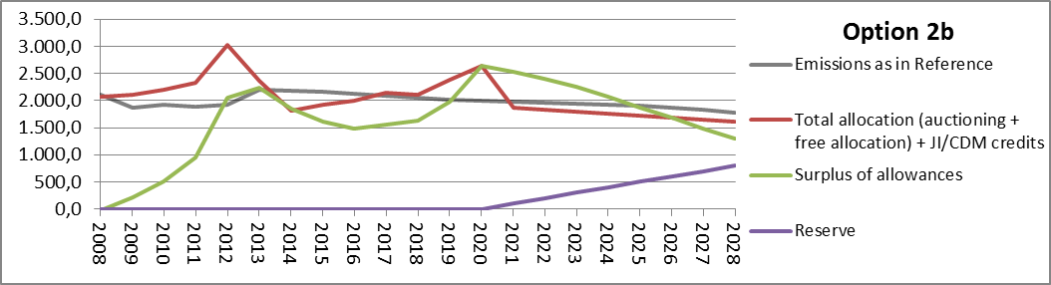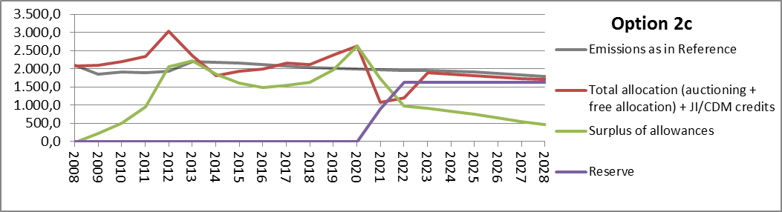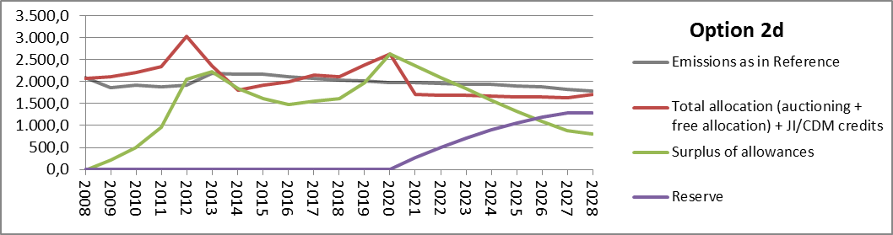

7.1.3.2. Options with volume triggers based on the change in surplus: Options 2e and 2f
Impact of a market stability reserve if implemented in phase 2
Figure 12 provides a graphical presentation of the impacts of the options with a trigger based on annual changes in the surplus. Both options assume that allowances are put into the market stability reserve if the cumulative surplus grows by at least 100 million allowances in a year and released from it if the cumulative surplus contracts by at least 100 million allowances. Again, the adjustment is determined as the full annual change in surplus above 100 million allowances (2e) or 50% of that amount (2f).
Screening both options leads to the following observations:
- These options start reacting somewhat faster to the accumulation of the surplus and therefore result in a lower expansion of the surplus in 2012 than in the baseline option 0. However, they do little to reduce the surplus further as the market is more in balance, not triggering the rules, which would require putting additional allowances into the market stability reserve. So they are effective in improving the inter-temporal efficiency only to a limited extent.
- Impact of the size of the adjustment: Option with an unlimited adjustment (2e) would have led to a significant reduction in the build-up of the surplus. Option with a lower adjustment at 50% of the distance from the band would have resulted in a proportionately smaller reduction in the size of the surplus.
Figure 12: Evolution of the surplus in phase 2 and 3 under options 2e and 2f if already implemented in phase 2
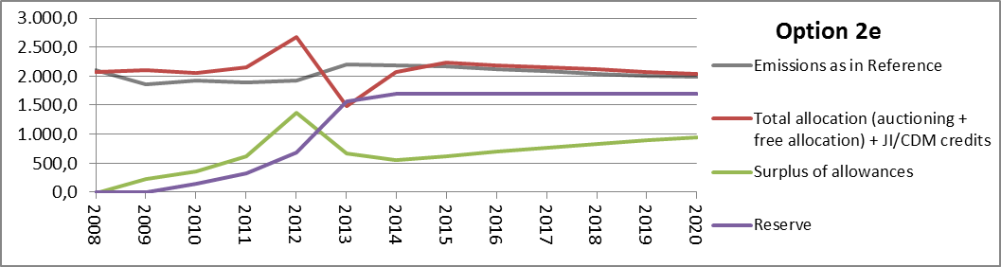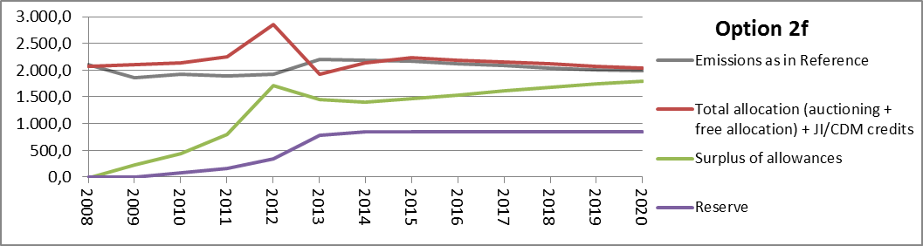
Impact of a market stability reserve if implemented in phase 3
While both options would not yet address the surplus in a lasting manner in phase 3, they would to a certain extent reduce the surplus shortly after its rebound at the end of phase 3. However, no subsequent adjustment is expected to follow if no unexpected rapid annual changes in the surplus would happen. Again, this means that the options lead to only limited improvements in inter-temporal efficiency.
The option without a limit on the size of the annual adjustment (2e) would lead to double the reduction in the surplus than the one with an adjustment at 50% of the distance from the band (2f). However, it would lead to higher variability in the auction supply and surplus in the transition to phase 4.
Figure 13: Evolution of the surplus in phase 3 and 4 under options 2e and 2f if implemented as of phase 3
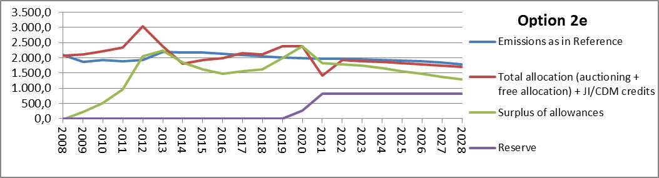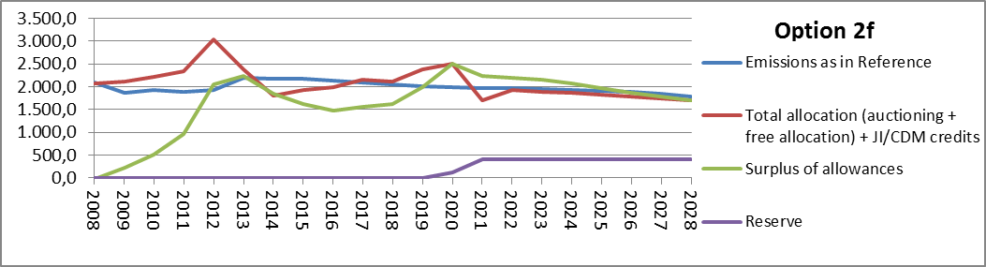
Impact of a market stability reserve if implemented in phase 4
Figure 14 provides an illustration of the impact of the same options if they started to apply as of 2021. They would be able to reduce the surplus, but to a lesser extent than if they were implemented in 2017. While the options would be able to respond to further shocks, they would not lead to any additional improvement in the total structural surplus.
Figure 14: Evolution of the surplus in phase 3 and 4 under options 2e and 2f if implemented as of phase 4
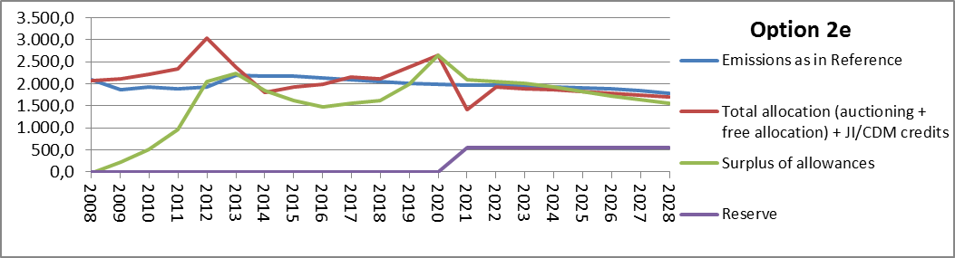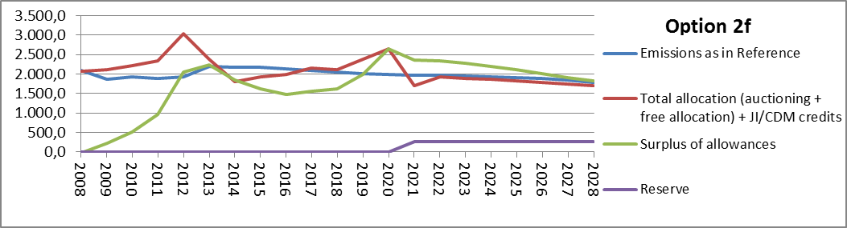

7.1.3.3. Option with a trigger based on the GDP growth forecasts
Figure 15 provides an illustration of the impact in terms of market balance of the option using GDP growth as the external trigger. Where the GDP growth forecast is outside a band of 2-3%, allowances would be put in the reserve in instalments of 100 million allowances. The figure shows how the market stability reserve would have worked in the time of the crisis, until today, and assuming GDP growth rates would stay within the band as of 2013.
Figure 15: Evolution of the surplus in phase 3 under option 2g if already implemented in phase 2
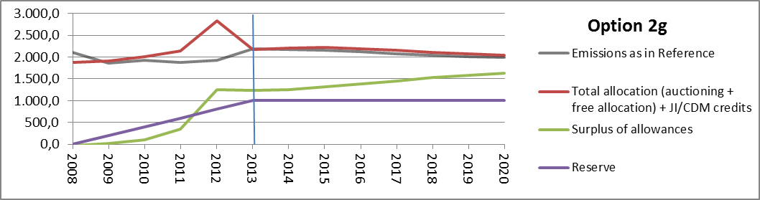
The following observations can be made:
By relying on forecasts for GDP growth, this option would have anticipated the major changes in the economic activity, which have been in part responsible for the surplus. The adjustment could already be made in the year for which the forecast applies, and hence their timing aligned with timing of the forecasted drop in demand. However, this kind of approach would not have been able to react to changes in the market balance due to other factors, such as the increased supply of allowances in the transition into phase 3 and due to return of back-loading, and record inflow of international credits due to regulatory changes. Hence, the option would have improved the inter-temporal efficiency, but to a limited extent. These options may be able to react to changes in demand due to impacts of complementary policies, if production trends in terms of overall output as well as fuel input in power generation can be adequately captured.

7.1.3.4. Comparison of sub-options for the market stability reserve
There are many possible combinations of design elements and trigger levels for a market stability reserve. In this section we compare the sub-options and define the most interesting option to be assessed further in the next sections of the impact assessment, based on the assessment of the design parameters in terms of their effectiveness in addressing the market imbalance and other related criteria. Figure 16 provides a comparison of the impacts of the various sub-options for a market stability reserve on the surplus and the size of the reserve if they were already in place in phase 2.
Figure 16: Comparison of the evolution of the surplus and reserve under various sub-options for market stability reserve if already implemented in phase 2
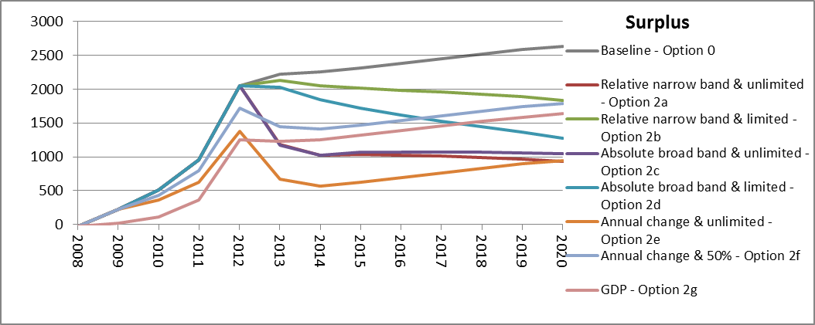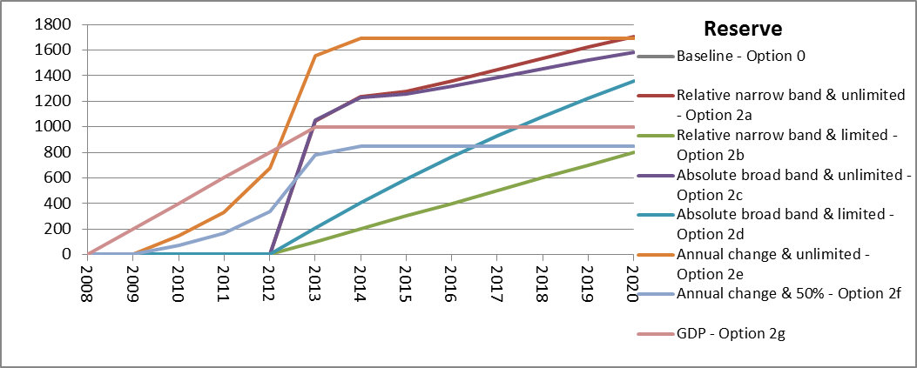
Figure 17 compares the impacts of various sub-options if a market stability reserve was implemented in phase 3. The comparison in terms of the surplus also included the two permanent retirement options (1a and 2b) and two combined options (3a and 3b).
Figure 17: Comparison of the evolution of the surplus and reserve under various sub-options for market stability reserve if implemented as of phase 3
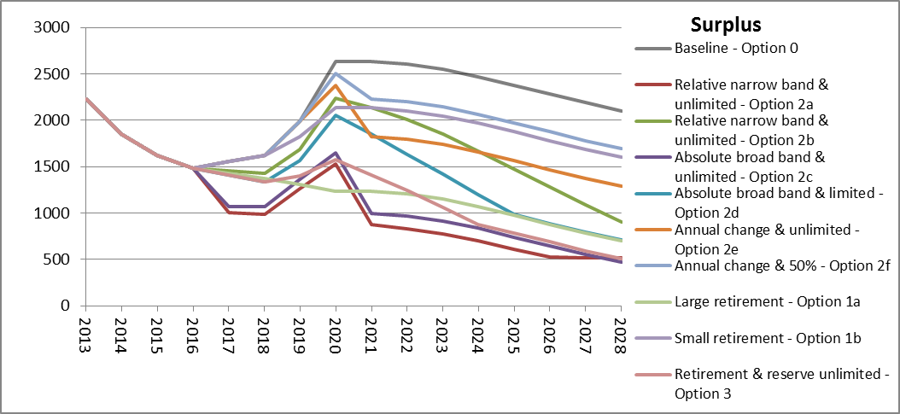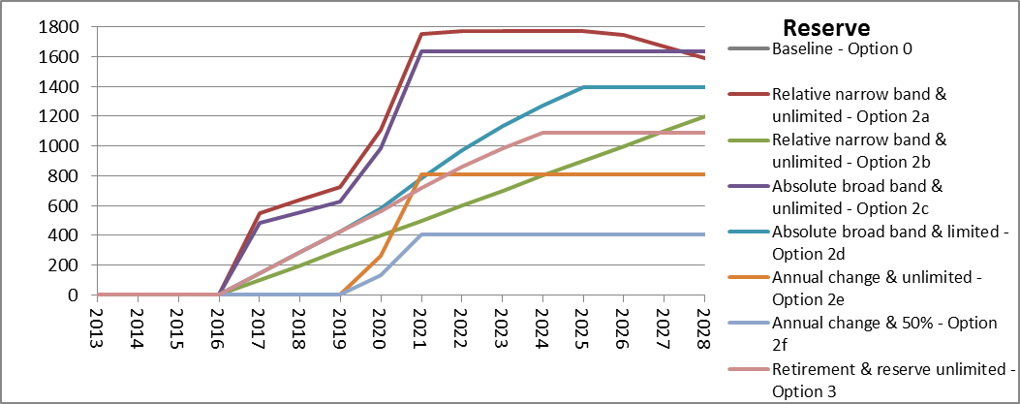
Figure 17 compares the impact of various sub-options if they were implemented in phase 3. The comparison of the impacts on the surplus also includes the two permanent retirement options (1a and 1b). However, they are by definition not relevant for the comparison in terms of the size of the reserve, as a permanent retirement would not lead to one.
Figure 18 compares the impact of various sub-options if they were implemented in phase 4. For ease of comparison the figure depicting the evolution of the surplus also include the two permanent retirement options. However, they are not included in the figure on the reserve, as they do no lead to any allowances being put into a reserve.
Figure 18: Comparison of the evolution of the surplus and reserve under various sub-options for market stability reserve if implemented as of phase 4 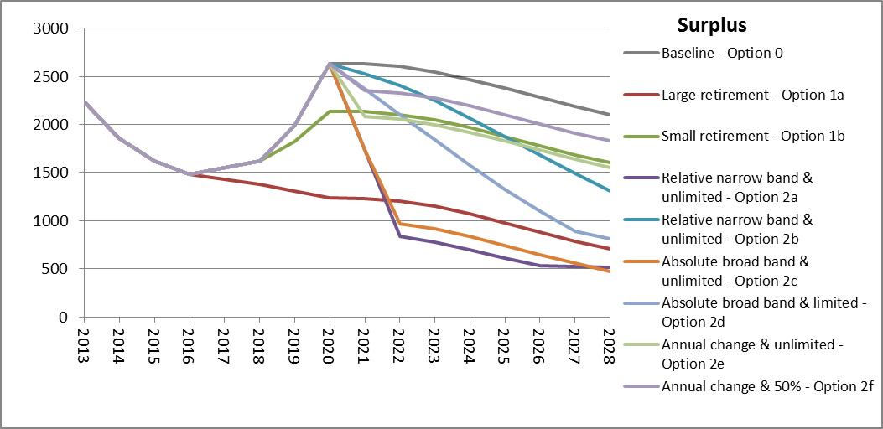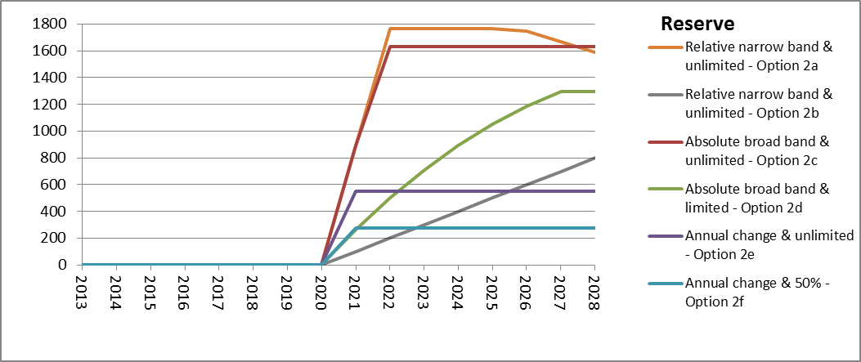
The results of the assessment are shown in Table 6. The following summary explanation can be given with respect to the scores given:
- The surplus-based triggers get a better score as regards their ability to capture changes in demand not only due to macroeconomic changes, but also other factors such as impact of complementary policies, as well as supply side factors such as changes in inflow of international credits.
- Out of surplus-based triggers, those based on a cumulative surplus are expected to perform better that those based on annual changes in correcting the surplus. While triggers based on changes in the balance may be more effective in preventing a market imbalance, they do not lead to further reduction of the surplus after the market is more in balance.
- Those surplus-based triggers with an absolute band score better in relation to simplicity. Moreover, a relative band which tapers off in line with the decreasing cap may perform poorly with an increasing trend in hedging needs.
- A broader band gets a better score in terms of number of needed adjustments. Such a reserve rule is expected to lead to lower amounts and frequency of adjustments as well as lower variability in auction volumes. In contrast, a narrower band is likely to lead to higher number of interventions and in different directions, i.e. a number of adjustments putting allowances into the market stability reserve only to be followed by release of those allowances shortly after.
- Limited adjustments, either with an explicit limit on the amount of adjustment or determined as a certain percentage of the cumulative surplus, get a better score in terms of predictability. They also lead to more continuity in terms of auctions, and gradual changes to the surplus and market stability reserve. Unlimited adjustments get a better score in terms of flexibility in addressing large and rapid fluctuations in the market balance and generally restore the market balance more swiftly. However, in situations with a large surplus, as the market is expected to experience by the end of phase 3, they may lead to no auction supply coming to the market for several years.
For ease of comparison, a choice needs to be made on the option(s) for a market stability reserve to be taken forward for further analysis. Considering a combination of criteria, it is proposed to take option 2d (with volume triggers, with a broad absolute surplus range between 400 and 1000 million allowances and an adjustment putting allowances into reserve at the level of 10% of the surplus) as the central options for the market stability reserve to be assessed further in terms of impacts other than on market balance and compare to the permanent retirement options. This option has an important advantage in terms of correcting the market imbalance in a gradual way, predictability and simplicity. While it may not fully address the market imbalance in phase 3, they start doing so soon after, at the beginning of phase 4.
Table 6: Comparison of various sub-options for a market stability reserve
Option |  | Effectiveness in ensuring inter-temporal efficiency |  |  |  |  | Size of the reserve |  |  |  |  | Market stability |  | Capturing impact of other policies, supply shocks | Simplicity | Predictability
 |  | Preventing market imbalance: size of surplus (if in phase 2) | Restoring market balance: size of surplus |  |  |  | If in phase 2 | If in phase 3 |  | If in phase 4 |  | Number of adjustments* |  | Capturing impact of other policies, supply shocks | Simplicity | Predictability
 |  | Preventing market imbalance: size of surplus (if in phase 2) | If in phase 3 |  | If in phase 4 |  | If in phase 2 |  |  |  |  | If in phase 3 | If in phase 4 | Capturing impact of other policies, supply shocks | Simplicity | Predictability
 |  | 2013 | 2021 | 2028 | 2021 | 2028 | 2013 | 2021 | 2028 | 2021 | 2028 | 2017-2028 | 2021-2028 | Capturing impact of other policies, supply shocks | Simplicity | Predictability
Relative narrow band & unlimited | 2a | 1.2 bn  + | 900 mio  ++ | 500 mio  ++ | 1.7 bn  + | 500 mio  ++ | 1 bn | 1.8 bn | 1.6 bn | 900 mio | 1.6 bn | 9  (6↑/3↓)  -- | 5  (2↑/3↓)  - | + | - | --
Relative narrow band & limited | 2b | 2.1 bn  0 | 2.1 bn  0 | 900 mio  ++ | 2.5bn  0 | 1.3 bn  + | 100 mio | 500 mio | 1.2 bn | 100 mio | 800 mio | 12(12↑)  -- | 8(8↑)  - | + | - | +
Absolute broad band & unlimited | 2c | 1.2 bn  + | 1bn  ++ | 500 mio  ++ | 1.7 bn  + | 500 mio  ++ | 1.1 bn | 1.6 bn | 1.6 bn | 900 mio | 1.6 bn | 5(5↑)  - | 2(2↑)  0 | + | + | --
Absolute broad band & limited | 2d | 2 bn  0 | 1.8 bn  + | 700 mio  ++ | 2.4 bn  0 | 800 mio  ++ | 200 mio | 800 mio | 1.4 bn | 300 mio | 1.3 bn | 9(9↑)  - | 7(7↑)  - | + | + | +
Annual change & unlimited | 2e | 700 mio  ++ | 1.8 bn  + | 1.3 bn  + | 2.1 bn  0 | 1.6 bn  0 | 1.6 bn | 800 mio | 800 mio | 500 mio | 500 mio | 2(2↑)  0 | 1(1↑)  0 | + | + | -
Annual change & 50% | 2f | 1.4 bn  + | 2.2 bn  0 | 1.7 bn  0 | 2.4 bn  0 | 1.8 bn  0 | 800 mio | 400 mio | 400 mio | 300 mio | 300 mio | 2(2↑)  0 | 1(1↑)  0 | + | + | +
GDP | 2g | 1.2 bn  + | n.a. | n.a. | n.a. | n.a. | 1 bn | n.a. | n.a. | n.a. | n.a. | n.a. | n.a. | - | - | +
Key: ++ (very positive/ decrease in surplus > 1bn), + (positive / decrease in surplus > 500 mio), - (negative), -- (very negative), 0 (neutral/decrease in surplus < 500 mio)
*Means annual adjustments. E.g. back-loading as proposed equates to 5 adjustments (3deducting allowances from auction volumes and 2 adding them). ↑(adjustment putting allowances into the reserve), ↓ ( adjustment releasing allowances from the reserve)

7.1.4. Option for a combination of a market stability reserve with permanent retirement: Option 3
Figure 19 shows the impacts of the option for a combination of a permanent retirement of 500 million allowances and market stability reserve with a broad band with an adjustment putting allowances into a reserve defined as 10% of the surplus and releasing them in instalments of 100 million allowances. The following observations can be made:
- While the option leads to a rebound in the surplus at the end of phase 3, it does reduce it compared to the baseline option 0. It also keeps gradually decreasing the surplus in phase 4. This seems to be more consistent with the objective of inter-temporal efficiency than the baseline option 0.
Figure 19: Evolution of the surplus in phase 3 and 4 with combined option 3
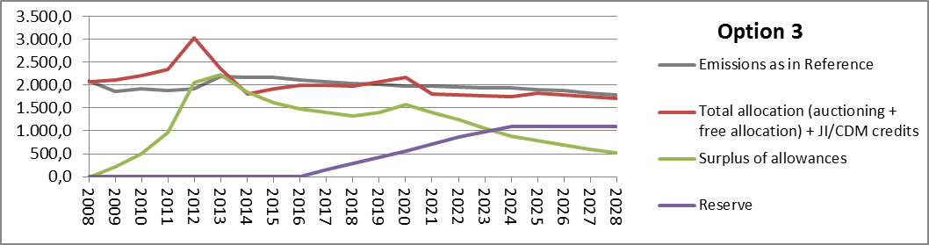

7.2. Potential impact on carbon price formation
One of the central issues is the price impact. Modelling tools typically used by the Commission to assess the impact of certain targets, be it GHG target or specific energy targets, are better able to assess mid to longer term scarcities and price formation on the market, and are less well equipped to look at interaction of the drivers and uncertainties within short periods of time. A detailed assessment of the annual magnitude of the price impacts, in particularly of options with a market stability reserve element, cannot be made for a number of reasons (similar as for back-loading). Their impact is hard to forecast as by definition it is very uncertain when a mechanism built to apply in cases of large-demand shocks only will apply. This assessment uses actual data from the period of the economic crisis as a proxy because economic models are not good in capturing such unexpected large shocks. Furthermore, if a measure reduces auction supply to such an extent that those entities that are short of allowances (such as the power sector that as of phase 3 no longer receives any free allocation) cannot buy sufficient amount of allowances in auctions, then prices will be driven to an extent by the financing needs of the entities that are holding surplus allowances (such as industry sectors) and the price levels that incite industry or other surplus owners to sell allowances. Prices will furthermore be influenced by the changes in hedging-driven demand. A further uncertainty relates to the extent that the market participants may adapt their behaviour to anticipate the impact of a reserve.
The exact impacts of a market stability reserve will depend on how such a mechanism is designed. As this impact assessment shows, there are many ways to do so. Obviously, this is probably one of the reasons why there are hardly any analyses quantifying the price impacts of a market stability reserve by stakeholders or private market analysts available at time of the writing of this assessment.
Complementing the EU ETS rule set with a market stability reserve is furthermore expected to increase confidence of market operators that the market is more resilient to major shocks. This should extend the time horizon and/or lower the discount rates of market operators when taking investments and entering positions in the carbon market. Such impacts on carbon price formation are not measurable with conventional economic models used for impact assessments.
Acknowledging the issue of uncertainties concerning the exact price impacts, a safeguard trigger for a release of allowances from the reserve based on article 29a of the ETS Directive could be added as an appropriate response to mitigate any risk of excessive upward price fluctuations.

7.2.1. Baseline option
In a situation without back-loading and any structural measures, the carbon price in the reference scenario is expected to be €5 in 2015 and €10 in 2020, while the surplus of allowances is projected to continue growing to some 2.6 billion allowances in 2020 and only gradually decrease afterwards. In case Member States would not take on additional policies to achieve their renewables targets and not fully implement latest adopted policies, emissions might be a bit higher, but baseline projections still project a surplus of more than 2 billion allowances by 2020.
With back-loading of 900 million allowances (baseline option 0), the market balance profile changes considerably, decreasing the surplus early in phase 3. This is likely to support the carbon price at the beginning of the phase compared to the situation without back-loading. But if the remaining surplus is large enough, prices should in principle not increase significantly beyond projections mentioned above. By 2019 at the latest, when back-loaded allowances start returning to the market, this supporting effect would be lost again.

7.2.2. Permanent retirement
The larger permanent retirement of 1.4 billion allowances (option 1a) would result in at least a similar price support as back-loading in the early years of phase 3, but without a price rebound as of 2019. The lower amount of a permanent retirement of 500 million allowances (option 1b) would significantly reduce the price support effect of the measure, with an expected repeated decline in the price at the end of phase 3. Impacts on prices should be limited if a permanent retirement only decreased this projected surplus to a limited extent. Even if a permanent retirement reduced the surplus by 1.4 billion allowances, impacts should be lower than those assessed in the 2010 Communication in the context of an increase in the EU target to 30%.

7.2.3. Market stability reserve
Prices can increase when a market stability reserve builds up. Once the market stability reserve has built up, and the surplus is more in line with the orderly functioning of the market, prices should be more strongly driven by the actual cap and the extent to which emissions are below or above the supply in a given time period. Any market stability reserve that reduces the surplus to a level that supports the functioning of the market would thus rather support the price signal and the gradual transition to lower emissions, also in case of a higher ambition in the EU ETS as of phase 4 in the context of a 2030 framework. This would in turn reduce the risk of too much carbon intensive investment (or too little low-carbon investments) in the short term, which increases costs and prices in the longer term.
A market stability reserve is likely to smooth out the price pattern over time avoiding extremes. A market that is not perfectly forward looking is expected to experience upward price pressures when the supply and surplus decrease, and downward pressures when supply and surplus increase.
In such a market setting, the impact of a market stability reserve that would temporarily be built-up, would in the short-term be similar and not higher than that of a permanent retirement of allowances of a similar amount than the amount in the reserve. Not higher because, the market participants are nevertheless expected to take into account that allowances will return to the market at a later point in time.
At the end of phase 3, the price support of the market stability reserve would be significantly lower than of a large permanent retirement. Over the mid- and long-run, a market stability reserve would by definition allow for more flexibility in the supply and lead to a relative decline in the carbon price when allowances are released from the reserve.
All in all, the price impact of the reserve should allow for a market to function better and reduce emissions in line with the gradually decreasing long-term target. Price evolution may depend on the expectations by market participants about whether the allowances are returned into the market or cancelled after a certain period of time or if the reserve exceeds a certain size.
To be noted is that even if the linear reduction factor was to be increased in order to achieve a 40% GHG reduction by 2030, the overall surplus remains large up to 2030 if emissions effectively reduce by -40%, with a remaining surplus of around 2 billion or more by 2030 (see IA 2030). This represents a situation where the market would have to continue to operate with rather high surpluses, be it shrinking ones, strongly driven by longer term considerations with respect to scarcity and costs. If long term considerations are not sufficient to create short-term demand and market certainty, short-term carbon prices may actually be lower than projected, mid- and long-term emissions higher and surplus lower than projected in the scenarios with 40% GHG reductions, putting the achievement of a 40% 2030 GHG reduction target at risk and resulting later on in the need for steeper reductions. Thus also in the context of such an increased ambition level, a market stability reserve that reduces the surplus to a level that supports the functioning of the market, would thus rather support price development consistent with the gradual transition to lower emissions.

7.2.4. Combination of a permanent retirement and a market stability reserve
Prices are expected to increase in relative terms towards the end of phase 3 due to a combined effect of a permanent retirement of limited number of allowances and the market stability reserve being built up. Hence, this is expected to provide more support than solely a permanent retirement of the same amount would (option 1b). It is also likely to have a higher impact than a similar market stability reserve alone would (e.g. option 2d). However, the options would still result in some rebound of the surplus at the end of phase 3 and hence have less of a price impact than the large permanent retirement (option 1a).
In the mid- and long-term, the relative price impacts compared to the baseline option are expected to be reversed due to two effects. Directly, because prices may decline in relative terms when allowances are released from the reserve. It is also expected to prevent unnecessarily higher prices in the mid- and long-term as reducing the surplus to a level that allows orderly functioning of the market and brings the price more in line with a price signal consistent with achieving the necessary emission reductions in the mid- and long-term, would reduce the risk of carbon lock-in in the short-term.
Among the options assessed, the option with a larger amount of permanent retirement is expected to result in the highest prices over phase 3 and 4.
If there were any excessive price increases, they would be addressed by the existing mechanism in Article 29a of the EU ETS Directive, which could also be combined with triggers for a release of allowances from a reserve in case of concerns about excessive price movements.

7.3. Auction revenues
Given the uncertainties concerning exact price impacts, in particular of options including a market stability reserve, it is also difficult to assess with certainty the impacts on the auction revenues. What is clear is that even with back-loading, with an average weak carbon price signal in phase 3 and beyond, the EU ETS auction revenues for Member States would continue to be considerably lower than anticipated. This adds pressure on public finances and reduces another potential source of funds available for climate purposes. Furthermore, weaker carbon price also means that there is materially less auction revenue for distributional and solidarity purposes for certain Member States.
A quantitative analysis of a large permanent retirement of 1.4 billion allowances has been taken up for the 2010 Communication on the option to move beyond a 20% reduction target. It suggested that auction revenues might increase by around a third, because the carbon price was expected to increase more than the reduction of allowances auctioned. The detailed results by Member States can be found in the follow-up 2012 Staff Working Document. Member States opting for a temporary derogation from full auctioning for the modernisation of the power sector may forego some of the revenue increase. However, as half of the permanent retirement, as assumed in this impact assessment, would happen in the same years as the return of back-loading allowances the absolute changes compared to an average annual auction volume may not be considerable. This risk is also mitigated by the fact that free allocation for the power sector declines over the period, reaching zero in 2020. But of course, an increase in the carbon price would still increase the value of the free allocation given to the electricity generators for those Member States.
Similar considerations concerning the free allocation for the power sector apply also for other options. However, this is no longer relevant in phase 4, and not at all relevant for a market stability reserve, if it was to be implemented after 2020 only.

7.4. EU competitiveness considerations
Energy and climate policies have the potential to drive demand and growth in the low carbon economy. But by not rewarding investments and innovation flowing from deploying low-carbon technologies clearly and early enough, the EU is expected to lose a competitive advantage in those technologies. Instead, an unrepresentatively weak carbon price that the EU ETS has experienced recently and that may remain at a fairly low level well into phase 4, is expected to incentivise carbon lock-in, which refers to construction of carbon-intensive capital, such as fossil fuel plants. It is failing to encourage investment in new low-carbon capacity, e.g. renewable power capacity. This would lead to higher costs in the mid- and long-term and higher negative competitiveness impacts in the mid- and long-term.
Furthermore, not strengthening the EU ETS is expected to lead to a disintegrated EU energy and climate policy, and a fragmented internal market. Member States may increasingly pursue national solutions to compensate for the weak carbon price signal, which would distort the EU-wide carbon price signal, undermine the efficiency of Europe's climate policy and create additional costs for the sectors covered by the EU ETS.
In terms of the short-term impacts on the sectors covered by the EU ETS, a distinction needs to be made between the impacts on the energy-intensive industries and the electricity sector. A stronger carbon price in the short-term, as a result of a structural measure, is expected to decrease the uncertainty in the electricity sector, decreasing the risk of insufficient investment. In addition to a positive impact on the penetration of low carbon technologies, this would also have a positive impact on the security of energy supply and hence overall competitiveness.
For the energy-intensive industry, however, a stronger carbon price in the short-term would mean higher direct and indirect cost, possibly negatively affecting certain energy-intensive sectors, deemed to be exposed to significant international competition and thus risk of carbon leakage. Some energy-intensive industries note that this is the wrong moment to explore measures that may increase the cost for these industries over the next years.
The impacts of a permanent retirement or a market stability reserve up to a level of 1.4 billion allowances in 2020 are likely to remain within the carbon price levels and production changes already assessed in the context of the 2010 Communication on the options to move beyond 20% reductions. Even with a market stability reserve of that size, the carbon price and production changes are expected to be lower in the mid- and long-term as allowances return to the market. Furthermore, the current reference scenario projects lower prices than this analysis from 2010, even though the latter already took into account the impact of the crisis. The impact of a permanent retirement of 1.4 billion allowances on the output of the EU energy-intensive industry by 2020 was assessed to be limited, as long as special measures already taken for energy-intensive industry stayed in place.
Neither of the permanent retirement options (1a and 1b) would exceed the amount of 1.4 billion allowances. Although a market stability reserve would affect the supply in a similar manner by 2020, the allowances would be released back to the market later on. The amount in the reserve in the central market stability reserve option (2d), and all other sub-options, is within the amounts of the permanent retirement assessed.
The carbon price signal also has an impact on the sectors outside the EU ETS. For example, the EU currently holds a technological advantage in wind energy. A robust carbon price signal is expected to give an equally robust signal to investors and maintain this advantage. This is particularly important, as sectors with such a competitive advantage are typically exporting sectors positively impact the EU trade balance. Despite the current recession, the European wind power sector is estimated to have exported €8.8 billion worth of goods and services in 2010, while the EU’s trade deficit was €150 billion.
Furthermore, a robust carbon price signal is also expected to provide trade balance benefits by reducing the imports of fossil fuel energy. Additional diversification of energy supply routes could improve competition on energy markets and deliver significant mid- and long-term savings by investments in renewables and energy efficiency. This reduces the vulnerability to growing energy prices. This is of particular concern to energy-intensive industries.
By having an impact on the carbon price signal, a structural measure would also have an impact on the cost of achievement of other targets, notably the renewables target. Increasing the carbon price signal would lower the cost of renewables support schemes.

7.4.1. Potential direct cost for energy-intensive sectors covered by the EU ETS
The options considered in this impact assessment would affect the auction supply, not the level of free allocation. However, they are expected to affect also the price signal and therefore the value of allowances that an installation holds or needs to buy.
Similar to backloading, the market stability reserve option is expected to impact the distribution of cost over time, probably increasing the carbon price when allowances are put into a reserve and decreasing it when they are released. In contrast, the permanent retirement option is likely to lead to an increase in the carbon price, without being followed by a relative decrease in the mid-term. In the longer-time still, both options may decrease carbon prices in relative terms by avoiding or reducing underinvestment in low carbon capacity in the short term. The magnitude of the impact depends on the amount of the permanent retirement or allowances put into a reserve, the higher the amounts, the bigger the expected price impacts.
This means that in the short-term, a market stability reserve and a permanent retirement would increase the cost for those installations that need to purchase allowances on the market but increase the benefits for those that hold extra allowances. Given the continued free allocation to industry and the existing large surplus of allowances allocated for free in phase 2, installations are more likely to be net sellers of allowances in the short-term.
In terms of the extent of industrial surpluses accumulating in phase 2, the verified emissions data show in aggregate a surplus of free allowances in relation to emissions from industrial sectors (excluding the power sector) reported of more than 34% or around 895 million allowances. Some of this surplus may have already been sold by industry, in which case the value of those allowances for industry would not be lost but now arise in the form of money. Moreover, these are all estimates for industry as a whole, with potential variations between sectors and individual installations.
For phase 3, a total of some 6 billion allowances will be allocated for free to industry or on average around 740 million annually. Table 7 gives an overview of the estimates of potential emissions for industrial sectors that receive free allocation using reported historical emissions in each year of phase 2 and 2005 as an example of a year with higher emissions as the basis for an estimate of emissions in phase 3. It also lists the consequent estimates of deficits or surpluses of free allowances on average annually and in total over phase 3. The table shows that under most emission assumptions the expected financial impact on industry is quite moderate.
Table 7: Estimated amount of allowances that industrial sectors would need to buy assuming various emission levels (in million allowances)
Based on historical emissions of year | 2005 | 2008 | 2009 | 2010 | 2011 | 2012
Estimated annual emissions | 885 | 873 | 755 | 790 | 778 | 754
Estimated annual deficit (-) or surplus (+) | -146 | -133 | -16 | -51 | -39 | -15
Estimated total deficit (-) or surplus (+) in phase 3 | -1.168 | -1.067 | -128 | -407 | -312 | -121
Estimated total deficit (-) or surplus (+) in phase 3 with existing surplus | -273 | -172 | 767 | 488 | 583 | 774
Note: Takes into account the impact of the cross-sectoral correction factor
Due to the continued impact of the crisis, emission estimates for phase 3 based on the latest 2012 data are the lowest and based on 2005 data the highest. Further free allocation will be available to new entrants and for significant capacity extensions, while free allocation may be reduced in the case of closures and significant capacity decreases. However, the amounts are difficult to predict at this stage.
If emissions in phase 3 were similar to those in any year of phase 2, except for 2008, then continued free allocation is still expected to result in a surplus over phase 3 taking into account the existing surplus from phase 2. As mentioned, some of the industry surplus has already been sold, but not all. But in this case, industry as a whole could see benefits in phase 3 from a structural measure in the form of increased value of their surplus.
If emissions were to be similar as in 2005 or 2008, then continued free allocation in addition to the existing surplus would not be sufficient to cover all industry needs, which would partly need to be covered by buying extra allowances on the market. In this case, industry as a whole could see increased cost in phase 3 due to a structural measure in the form of increased cost for purchasing allowances.
As of phase 4, any deficit may actually become cheaper to buy under the options with a market stability reserve, which would see allowances being released from the reserve (by 2028 this would happen under option 2a).
Assuming that emissions were at the top end of the range, industry would need to purchase 273 million allowances over phase 3. Every €1 increase in the carbon price would translate into a cost increase of € 273 million. Assuming that emissions remained at the level of 2012, industry would still have 774 million allowances allocated for free to sell on the market or use for future compliance needs. Every €1 increase in the carbon price would translate into a benefit of €774 million in the form of increased value of the industry surplus.
Table 8: Estimated amount of allowances that individual sectors would need to buy in phase 3
 | Estimated annual surplus (+) or deficit (-) in phase 3
 | in million allowances | % compared to NIMs emissions
Extraction of crude petroleum and natural gas; service activities | -15 | -40%
Manufacture of pulp, paper and paper products | -2 | -6%
Manufacture of coke, refined petroleum products and nuclear fuel | -48 | -30%
Manufacture of chemicals, chemical products and man-made fibres | -79 | -38%
Manufacture of other non-metallic mineral products | -33 | -14%
Manufacture of basic metals | -8 | -4%
Notes: The table assumes emissions in phase 3 are similar to the emissions in the years chosen by installations for the free allocation. Obviously, the emissions figures from the period chosen for the National Implementation Measures (NIMs) are expected to be the highest among the possible reference years, in some cases even higher than 2005 figures, which are typically the highest emission figures, as shown in Table 7. Since the production of the majority of European industrial installations is currently lower than in the reference years chosen by installations, in comparison to most recent production and emissions data, this is a very conservative estimate. Actual allocation is expected to be less constraining as the table may suggest. Classification according to 2-digit NACE codes. Includes sectors with emissions above 30 million tCO₂ per year.
This assessment does not take into account national policies, which complement the carbon price signal, and could therefore in aggregate have the same cost impact as an increase in the carbon price.
Depending on the degree of pass-through of carbon cost to consumers, impacts on industries may be (significantly) lower. Changes in the carbon price signal have very different impacts on profitability and in turn competitiveness depending on the level of the cost-pass through, which among others depends on climate action taken by third countries. So unsurprisingly, impacts on the energy-intensive sectors are responsive to the assumptions on the ambition of climate policies in third countries, with impact lowest in case of global action. The EU is working on getting an international agreement to cut emissions signed by 2015. Meanwhile, many countries already have national measures in place to reduce emissions over the next decade and beyond.

7.4.2. Potential indirect cost
The report Energy Economic Developments in Europe has found no statistically significant impact of the carbon price on electricity retail prices. But this may be due to the fairly weak carbon price observed over the recent years and may change if the carbon price was to increase. The Commission adopted State aid Guidelines which set the conditions under which Member States may compensate part of the increased electricity costs due to the EU ETS. They list the maximum regional CO₂ emission factors for electricity production in different geographic areas from 0.56 tCO₂/MWh and 1.12 tCO₂/MWh. With conservative assumptions, i.e. 100% carbon cost pass through into electricity price, every €1 increase in the carbon price would then translate into an increase in the electricity price between 0.56 €/MWh and 1.12€/MWh. These figures do not take into account expected lower cost pass through in the Member States applying the derogation allowing transitional free allocation for the modernisation of electricity generation. In addition to the emission factor, the relative change in the electricity cost depends on the existing cost of electricity for EU industry. On average, this represents an increase in the electricity cost of 0.8% for EU industry.
These estimates are based on current emission factors of price-setting power plants. A robust carbon price signal is expected to reduce fossil fuel combustion and the importance of fossil fuel-based plants in electricity price setting. Hence, it is likely to reduce the incremental cost of the EU ETS in the electricity price in the mid- and long-term.

7.5. Social impacts
The carbon price level has been far lower than what was anticipated when the climate and energy package was adopted in 2008. In relation to the electricity cost, a €1 increase in the carbon price may on average translate into an increase of 0.5% compared to the current price for households, if the carbon price reached a level where it would start having a noticeable impact on the electricity retail prices. Any increases in the electricity cost may be mitigated by more efficient appliances. For lower and middle income households, possible negative impacts could be alleviated, if part of the ETS auction revenue is used for measures intended to increase energy efficiency and insulation or to provide financial support in order to address social aspects in these households, as specified in article 10(3) of the ETS Directive. Decarbonisation policies also reduce emissions of PM_{2.5}, SO₂ and NO_{x}. So through the carbon price signal, a carbon market can have positive health impacts by in short-term by improving air quality through encouraging fuel switching from coal to gas and in the mid- and long-term by discouraging financing new coal facilities. While several factors have driven the EU to use more coal, the weak carbon price signal in the EU has contributed to many consumers opting for coal over natural gas. A stronger carbon price signal is therefore expected to discourage fuel combustion, in particular coal, and have positive health impacts as well as broader economic benefits.
In terms of employment, the carbon market can have impacts through changes in production and related jobs, and through the possible use of auction revenue to reduce labour taxes. On the one hand, environment and climate policies in general are expected to contribute to creating jobs through investment in typically labour intensive sectors, such as energy efficiency and renewable energy. Figures from the Communication "Towards a job-rich recovery" indicate that, despite economic downturn, the green economy has seen a rise in employment and remains strong. The 2030 impact assessment shows that when auction revenue are recycled and if carbon pricing extended to all sectors, decarbonisation policies can lead to an increase in employment of 0.2% or 430.000 net jobs created by 2030. The United Nation Environment Program (UNEP) estimates that compared to fossil-fuel power plants, renewable energy generates more jobs per unit of installed capacity, per unit of power generated and per dollar invested. The stronger the carbon price signal, the higher the employment benefits in the green economy are expected to be.
On the other hand, if leading to possible production losses in certain energy-intensive industries deemed to be exposed to a significant risk of carbon leakage, a carbon price signal can have impacts on the jobs in those sectors. In this case, the stronger the carbon price, the higher the risk of carbon leakage and possible job losses.
Furthermore, there is still a large scope to shift the tax burden away from labour especially on the low skilled workers. Lowering tax burden on labour will create new jobs, as well as improve cost-competitiveness and encourage entrepreneurship. EU ETS auction revenue can be used for reducing the labour cost. However, there are limits on the amount of auction revenues and hence possible trade-offs between the use of the revenues for different purposes, depending on the overall amount. In case of the market stability reserve option, there would be a trade-off between government auction revenue that could be used for reducing labour cost and the use of allowances released from the reserve, in case it was decided to use them for financing low-carbon investment (e.g. along the lines of the NER300 programme). In that respect, the more allowances were put into a reserve, the lower the possible government revenue that could counteract a decrease in the labour cost could be. However, increased financing of low-carbon investment could have positive second order effects on employment in the sectors concerned.

7.6. Environmental impacts
The environmental impact of the EU ETS in terms of emissions in the sectors covered over a certain period of time is determined by the cap. The options that entail a permanent retirement (1a,1b and 3) would therefore lead to more positive impacts in terms of emission reductions that the market stability reserve options (2a-2g), unless it was decided that the reserve is used to facilitate the step-up to a more ambitious EU GHG target.
In addition to the direct impacts on emission reductions, a more stable and stronger carbon price signal should also allow the ETS to better support the achievement of the renewables targets and the further improvement of energy efficiency by 2020.
As mentioned, decarbonisation policies also reduce emissions of PM_{2.5}, SO₂ and NO_{x}. Hence, a structural measure would also have positive impacts on air quality by incentivising in fuel-switching from coal in power plants. The stronger the carbon price signal, the more it drives energy efficiency and low-carbon energy sources, reducing also the need for fuel combustion in the mid- and long-term.

8. Comparison of options and conclusions
Table 9 compares the options for a permanent retirement (1a and 1b), a market stability reserve (specifically option 2d) and combination of a market stability reserve with permanent retirement (3) to the baseline option 0 in terms of their effectiveness in achieving the objective and coherence with other policy goals. The assessment has identified important advantages of a structural measure being taken in the short-term. At the start of phase 3, the EU ETS was characterised by a surplus of around 2 billion allowances, which is expected to grow further. Not addressing the surplus is expected to result in a prolonged downward pressure on the carbon price signal, which is expected to lead to carbon lock-in and raise the cost of emission cuts needed in the future, reducing inter-temporal efficiency.
A permanent retirement or a market stability reserve will improve the market balance by addressing the surplus in a more lasting manner than back-loading and, if implemented as of 2017, avoiding another increase as of 2019, although a small retirement (option 1b) alleviates a further surplus increase to a very limited, probably insufficient extent. This option is expected to be only marginally more effective in addressing the market imbalance and in turn improving the efficiency of the EU ETS in the mid- and long-term than the baseline option.
A large retirement and a market stability reserve are more likely to be effective in addressing the market balance in a lasting manner. However, a permanent retirement does not increase the resilience of the EU ETS to potential future large-scale events that may severely disturb the market balance, while a market stability reserve does. Similarly, a permanent retirement is able to capture the impacts of complementary policies, such as energy-efficiency and renewables measures, on the demand for emission allowances so far, but not any future impacts. A combination of the two measures (options 3) - a market stability reserve and permanent retirement - may both correct the existing market imbalance and prevent it from happening again in the future. If the reserve is combined with a fairly low permanent retirement it will still lead to a rebound in the surplus at the end of phase 3, however it will decrease it in the years that follow. However, this option implies a measure taken in phase 3 and a permanent retirement.
By changing the auction volumes, the free allocation given to the industry will not be affected. A structural measure is likely to increase the carbon price signal in relative terms in the second half of phase 3 compared to the baseline option. However, it may not necessarily increase the carbon price in absolute terms, but rather prevent a price decline when backloaded allowances would otherwise return to the market. The price impact is expected to be the strongest for the large permanent retirement (1a), probably followed by the combination of a market stability reserve with a limited permanent retirement (3a and 3b) and market stability reserve alone (2d) and only very limited and short-lived impact of the small retirement (1b). Accordingly, the impacts on individual companies will be the strongest in case of a large permanent retirement, both in terms of benefits for companies covered by the EU ETS, which are net sellers of allowances in phase 3, and companies relying on low-carbon investment, and cost in terms of net buyers of allowances in phase 3.
Similar considerations apply to other impacts. The social impacts are also two-pronged. On the one hand, a stronger carbon price can lead to additional jobs in sectors associated with green economy. On the other hand, a stronger carbon price increases the risk of carbon leakage and hence job losses in the sectors deemed to be exposed to this risk. A stronger carbon price is also expected to lead to highest increase in electricity prices in the short-term, as well as highest benefits in terms of air quality and associated health impacts.
A permanent retirement has a clear advantage over options that include a market stability reserve in terms of simplicity, as also acknowledged by most stakeholders.

9. Monitoring and evaluation
The Commission will continue to monitor and evaluate the functioning of the carbon market in its annual Carbon Market Report, as foreseen under Article 10(5) of the EU ETS Directive. This annual report foresees the explicit monitoring of the functioning of the EU ETS including the implementation of the auctions and would implicitly also cover the impacts of any structural measures. This may be particularly relevant in case of a market stability reserve and its review.

Table 9: Comparison with baseline option 0 in terms of effectiveness and coherence
 |  | Effectiveness in improving the inter-temporal efficiency and resilience of the EU ETS | Coherence with other policy goals |  |  |  | Simplicity
 |  |  | Renewables and energy efficiency policies | Competitiveness | Social impacts | Environment | Simplicity
Large retirement | 1a | Considerable continued decline in the surplus, continued carbon price support and no rebound in the surplus and no decline in the carbon price signal in 2019-2020.  But no improvement in market imbalance in case of future large-scale events.  + | Captures impact complementary policies had so far, but not additional future impacts  + | Strong signal against the fragmentation of EU energy and climate policy.  No decline and possible limited increase in the value of allowances for surplus holders and in cost for net buyers. No decline and possible limited increase in electricity cost. Opposite effects in the long-term.  Strong signal for low-carbon investment  +/- | No decline and possible limited increase in electricity cost  Limited employment impacts  Strong signal against carbon-intensive fuel use and for health benefits  +/- | Strong signal against high-carbon fuel use  ++ | +
Small retirement | 1b | Considerable rebound in the surplus and decline in the carbon price signal in 2019-2020.  No improvement in market imbalance in case of future large-scale events.  0 | Only partly captures impact of complementary policies had so far, no additional future impacts.  0 | Weak signal against the fragmentation of EU energy and climate policy.  No reversal in the decline of value of allowances for surplus holders and no increase in cost for net buyers. No increase in electricity cost. Opposite effects in the long-term.  Weak signal for low-carbon investment  0 | Decline in electricity cost  Limited employment impacts  Weak signal against carbon-intensive fuel use and for health benefits  0 | Weak signal against carbon-intensive fuel use  0 | +
Market stability reserve | 2(d) | If implemented in phase 3, continued decline in the surplus, followed by a partial rebound in 2019-2020.  If implemented in phase 4, considerable rebound in surplus and limited support of the carbon price signal in 2019-2020, followed by decline in the surplus and price support as of phase 4.  Increase in auction supply in the mid-term.  Improvement in market-balance in case of future large-scale demand shocks  + | Captures impact complementary policies had so far, as well as additional future impacts  ++ | Moderate signal against the fragmentation of EU energy and climate policy  Short-term decline or possible limited increase in the value of allowances for surplus holders and in cost for net buyers. Short-term decline or possible limited increase in electricity cost. Opposite effects in the mid-and long-term.  Improved certainty and moderate signal for low-carbon investment  +/- | Short-term decline or possible limited increase in electricity cost.  Limited employment impacts  Moderate signal against carbon-intensive fuel use and for health benefits  +/- | Moderate signal against carbon-intensive fuel use  + | -
Combination of a market stability reserve and permanent retirement | 3 | Partial rebound in the surplus and decline in the carbon price signal in 2019-2020, followed by decline in the surplus and price support as of phase 4  Increase in auction supply in the mid-term  Improvement in market balance in case of future large-scale shocks  + | Captures impact complementary policies had so far, as well as additional future impacts  ++ | Moderate signal against the fragmentation of EU energy and climate policy  Possible limited increase in the value of allowances for surplus holders and in cost for net buyers. Possible limited increase in electricity cost in the short-term. Opposite effects in the mid-and long-term.  Improved certainty and moderate signal for low-carbon investment  +/- | Possible limited increase in electricity cost.  Limited employment impacts  Moderate signal against carbon-intensive fuel use and for health benefits  +/- | Moderate signal against carbon-intensive fuel use  + | -

10. Annexes

10.1. Sensitivity analysis

10.1.1. Baseline scenario
Baseline projections only project already implemented policies, and do not achieve in all Member States all targets, for example the renewables targets. Forecasted EU ETS emissions remain flat by 2020 and start slowly decreasing in phase 4. With higher emissions than in the reference scenario, the expected surplus is lower but still around 2 billion in 2020 without any measures (option 0).
Impact of options implemented in phase 3
Figure 20 illustrates the impact of various sub-options on the evolution of the surplus based on baseline scenario emissions profile, if implemented in phase 3.
Figure 20: Evolution of the surplus assuming baseline scenario emissions with options implemented in phase 3
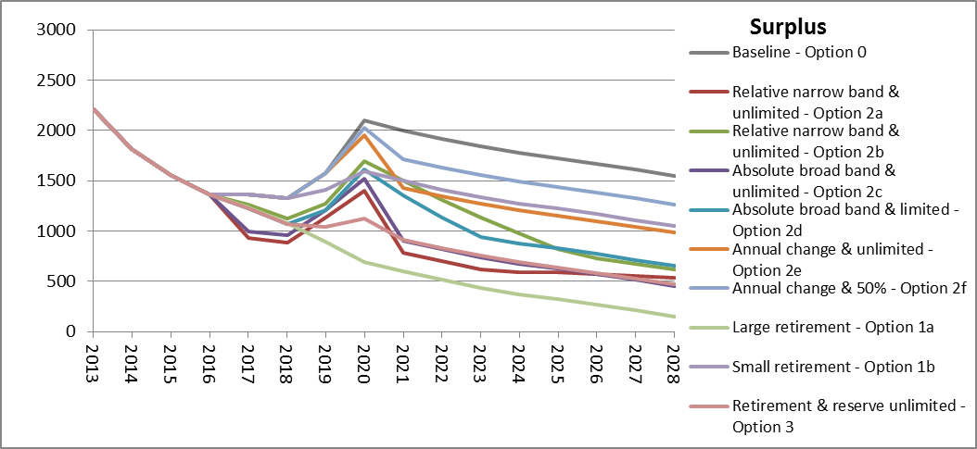
Figure 21 illustrates the impact of the various market stability reserve sub-options in terms of size of the reserve based on the baseline scenario emissions. Given the smaller surplus, there is less need for adjustments putting allowances into the reserve, resulting in an earlier stop to adjustments putting allowances into the reserve and a smaller size of the reserve at its peak and to possible earlier adjustments in the other direction, taking allowances from the reserve.
Figure 21: Evolution of the reserve under sub-options with a market stability reserve implemented in phase 3 assuming baseline scenario emissions
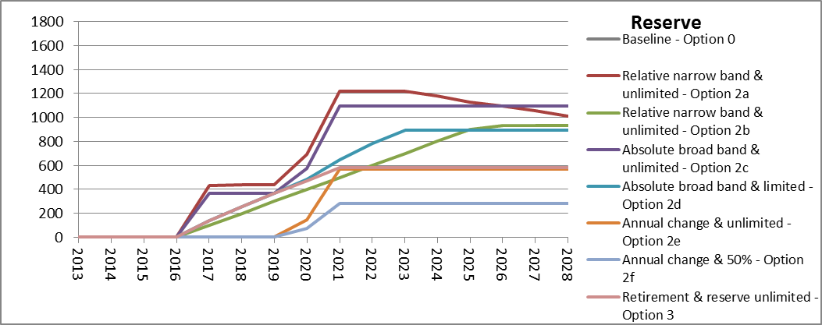
Impact of a options implemented in phase 4
Figure 22 and Figure 23 depict the impact of various sub-options implemented in phase 4, assuming baseline scenario emissions. Again the surplus is lower than with reference scenario emissions, however, still at the level that requires some adjustments putting allowances into the reserve at least at the beginning of phase 4. However, these adjustments are generally lower and stop earlier.
Figure 22: Evolution of the surplus assuming baseline scenario emissions with options implemented in phase 4
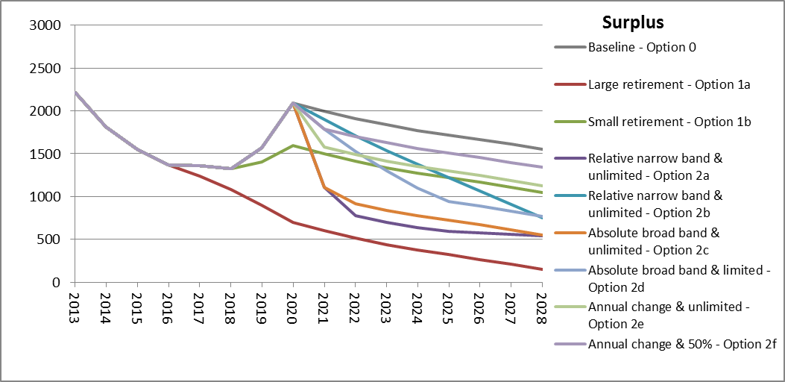
Figure 23: Evolution of the reserve under sub-options with a market stability reserve implemented in phase 4 assuming baseline scenario emissions
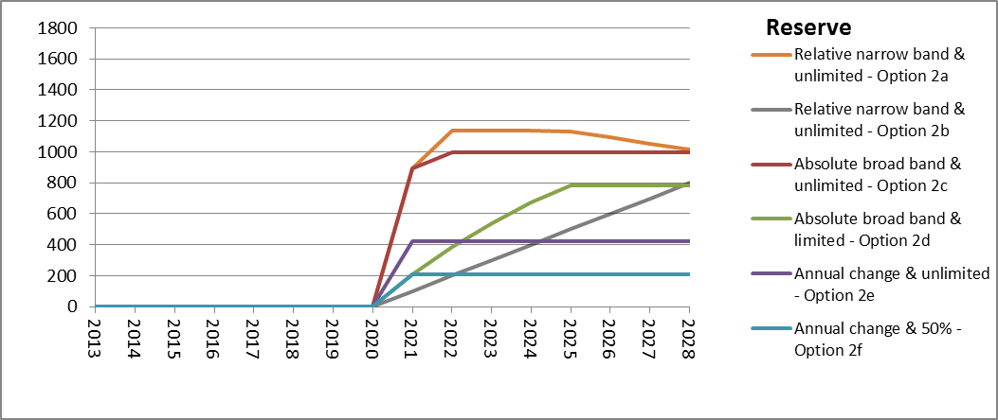

10.1.2. 40% GHG emission reduction by 2030
According the ETS Directive, the ETS cap for stationary sources decreases linearly, with an annual amount equal to 1.74% of the average annual allocation during phase 2 (excluding aviation), referred to as the linear reduction factor. The scenario with 40% GHG reductions and moderate energy-efficiency and renewables policies up to 2030 achieves emission reductions in the ETS of 43% by 2030 compared to 2005. Setting a cap at this 2030 emission level would require a change of the linear reduction factor.
Impact of options implemented in phase 3
Figure 24 shows the impact of various sub-options, implemented in phase 3, on the evolution of the surplus using the GHG 40% emission projections. Even if, as of phase 4, the linear reduction factor would be increased to a level consistent with a 40% GHG emission reduction by 2030, it would still result in a surplus well above 2 billion allowances by the end of phase 4 and even 2030.
Figure 24: Evolution of the surplus assuming 40% GHG reduction emissions profile with options implemented in phase 3
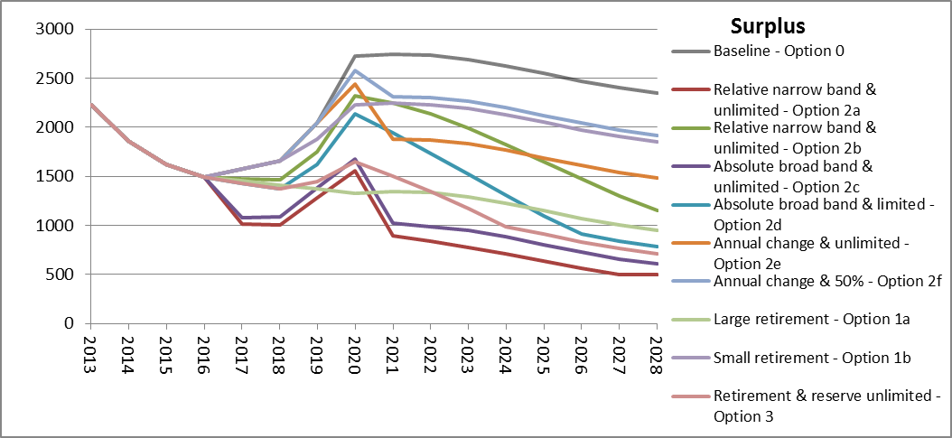
Figure 25 shows the impact of various sub-options with a market stability reserve implemented in phase 3 in terms of the size of the reserve using the GHG 40% emission projections.
Figure 25: Evolution of the reserve under sub-options with a market stability reserve implemented in phase 3 assuming 40% GHG reduction emissions profile
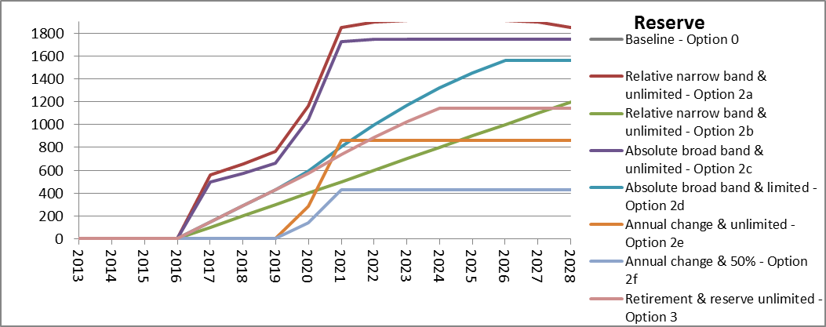
Impact of options implemented in phase 4
Figure 26 and Figure 27 show that even if the linear reduction factor would be increased to a level consistent with a 40% reduction target by 2030, it would still require adjustments putting allowances into a reserve in order to reduce the surplus, otherwise still staying well above 2 billion by end of phase 4.
Figure 26: Evolution of the surplus assuming 40% GHG reduction emissions profile with options implemented in phase 4
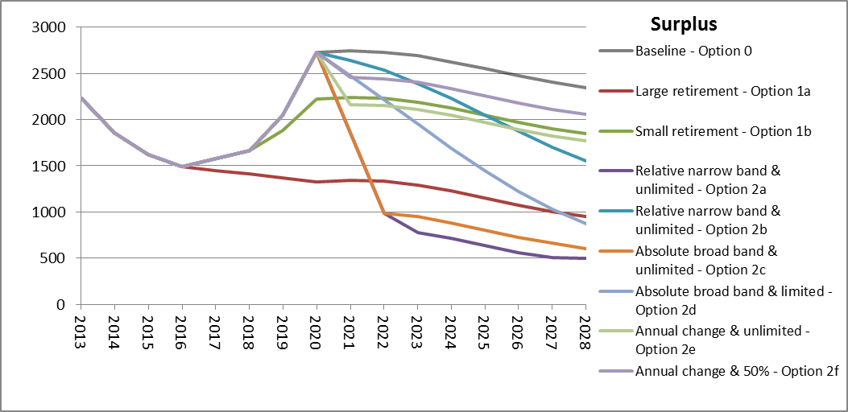
Figure 27: Evolution of the reserve under sub-options with a market stability reserve implemented in phase 4 assuming 40% GHG reduction emissions profile 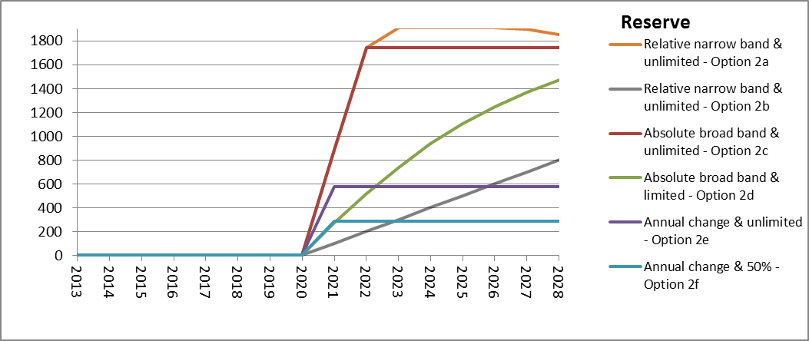

10.2. Summary of the results of the stakeholder consultation
On 14 November 2012, the European Commission adopted a Report on the State of the European Carbon Market in 2012 (Carbon Market Report). This document served as a consultation document for a twelve-week online consultation on the options for structural measures to strengthen the EU Emissions Trading System (ETS, which lasted until the end of February 2013, allowing stakeholders, Member States and other EU institutions to express their views.
The Carbon Market Report gave an overview of the current functioning of the market with a large and growing supply-demand imbalance of emissions allowances in the EU ETS, followed by a non-exhaustive list of six options for structural measures:
  - Increasing the EU reduction target to 30% in 2020;
  - Retiring a number of allowances in phase 3;
  - Early revision of the annual linear reduction factor;
  - Extension of the scope of the EU ETS to other sectors;
  - Use of access to international credits;
  - Discretionary price management mechanisms.
The information submitted to the consultation is a fundamental part of the impact assessment and has been taken into due account in the Commission's preparations of more concrete proposals for a structural measure.
This document summarises the responses to the consultation. It is available on the webpage of the online consultation, together with the individual contributions received.

10.2.1. Process
The online consultation lasted from 7 December 2012 to 28 February 2013. A dedicated webpage including the link to the Carbon Market Report was created and announced on the centralised "Your Voice in Europe" page.
The following general groups replied to the consultation:
- Organisations consisting of business associations; trade unions; representatives of civil society; such as non-governmental organisations (NGOs); organisations representing other stakeholders groups; and individual companies;
- Public authorities consisting of national and sub-national authorities;
- Citizens;
- Stakeholders, who identified themselves as organisations representing certain interests but could not be verified in the EU Transparency Register.
In addition, two dedicated full-day consultation meetings were organised on 1 March and 19 April 2013 in Brussels. An expert meeting on an additional option, which emerged from the consultation, of a reserve mechanism to render the auction supply more flexible was organised on 2 October 2013. The results of all meetings were taken into due consideration together with the results of the online consultation in preparing this summary.
Box 2: Consultation meetings
The Commission organised two full-day consultation meetings to examine with the stakeholder community in detail the merits and drawbacks of the six options set out in the Carbon Market Report. The agenda was defined in a way to move forward the reflection on three options in each meeting. In addition, the second meeting looked at possible additional options supported by several stakeholders in the online consultation.
1st meeting on 1 March 2013
Welcome and introductory remarks were given by the Commission and the Irish Government. The Commission also presented a summary of the results of the online consultation.
The first session was dedicated to option (b) of retiring a number of allowances in phase 3. The panel was composed of a representative of Centre for European Policy Studies (CEPS) acting as a lead discussant, followed by representatives of BusinessEurope and International Emissions Trading Association (IETA).
The second session was dedicated to option (f) of discretionary price management mechanisms. The panel was composed of a representative of Bloomberg New Energy Finance (BNEF) acting as a lead discussant, followed by representatives of Glass for Europe and Eurelectric.
The third session was dedicated to option (a) of increasing the EU reduction target to 30% of 2020. The panel was composed of a representative of University College Dublin acting as a lead discussant, followed by representatives of Cembureau and The Prince of Wales's EU Corporate Leaders Group on Climate Change.
A video recording is available at the following webpage:
https://scic.ec.europa.eu/streaming/index.php?es=2&sessionno=4ecb679fd35dcfd0f0894c399590be1a
2nd meeting on 19 April 2013
Welcome and introductory remarks were given by the Commission.
The first session was dedicated to option (c) of early revision of the linear reduction factor. The panel consisted of a representative of Tschach Solutions acting as a lead discussant, followed by representatives of Confederation of European Paper Industries (CEPI) and Climate Action Network Europe (CAN-Europe).
The second session was dedicated to option (d) of extension of the scope of the Eu ETS to other sectors. The panel consisted of a representative of Öko-Institute acting as a lead discussant, followed by representatives of Europia and Department of Climate Change and Energy Efficiency, Australia.
The third session was dedicated to option (e) of use of access to international credits. The panel consisted of a representative of Center for Clean Air Policy Europe (CCAP Europe) acting as a lead discussant, followed by representatives of Eurofer and European Trade Union Confederation (ETUC).
The fourth session was dedicated to additional options supported by stakeholders. The panel consisted of representatives of Thomson Reuters Point Carbon and European Chemical Industry Council (CEFIC).
The meeting also included an item on competitiveness and risk of carbon leakage presented by the Commission.
A video recording is available at the following webpage:
https://scic.ec.europa.eu/streaming/index.php?es=2&sessionno=b607ba543ad05417b8507ee86c54fcb7

10.2.2. Distribution of replies to the online consultation
In total 232 responses were received. One stakeholder requested that their submission remains confidential.
The consultation registered a strong participation by organisations, with around 66% of overall replies from registered organisations and 23% from non-registered organisations. 8% replies came from citizens and 3% from Member States and other public authorities (see Figure 28).
Figure 28: Replies per affiliation
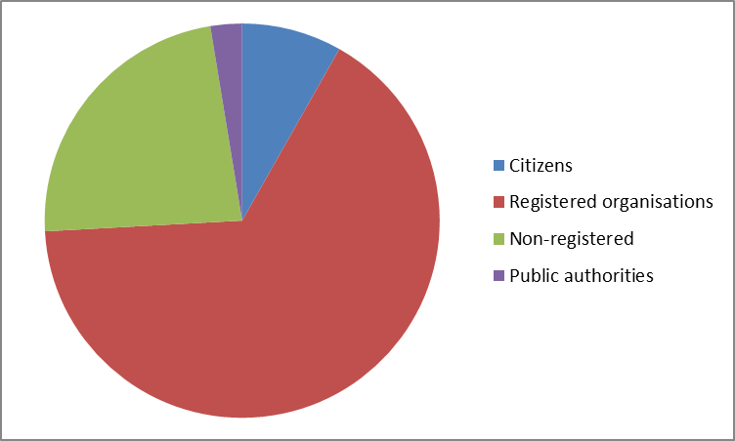
Concerning the geographical distribution, European level organisations represent the highest share of responses (22% of all replies). At Member State level, stakeholders from the biggest Member States are also generally best represented: Poland (11%), France (7%), United Kingdom (7%), Germany (6%) and The Netherlands (6%). Among non-European countries, Norway represents the highest participation (3%). Equally strong participation can also be noted from international organisations with members from both EU and third countries (3%).
Figure 29: Geographical distribution of replies
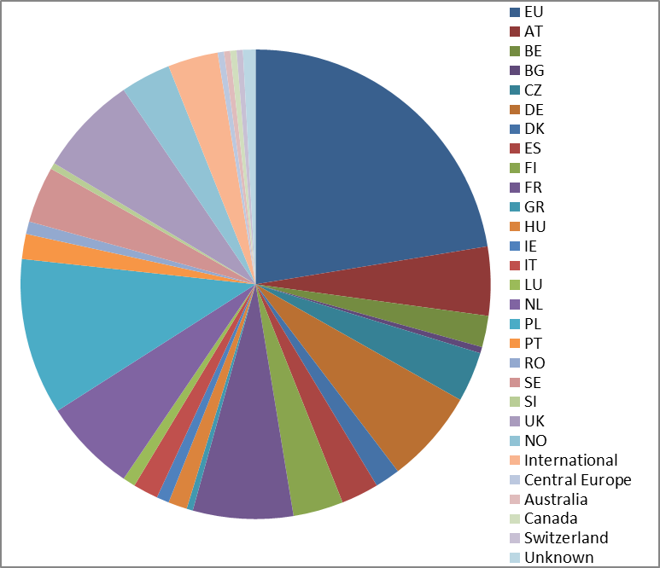

10.2.3. EU remains the best instrument for achieving the EU objective of an economy-wide 80-95% reduction
The public consultation showed that a large majority of stakeholders continued to hold the view that the EU ETS is the best instrument for the covered sectors to contribute to achieving the EU objective of an economy-wide 80-95% reduction in greenhouse gas emissions by 2050 within an internal market.
Stakeholders are asking for a stable, predictable legislative framework, which they believe necessary for business investment. Utilities, gas companies, organisations in the renewables sector, non-energy intensive companies, NGOs, academia, think thanks and some Member States think that because of a large surplus of allowances, the market does not work in every aspect in a satisfactory way. Some energy-intensive industry organisations feel a structural reform of the EU ETS first needs to bring a structural solution to EU's competitive position. Nevertheless, stakeholders, including most industrial organisations, recognise that there is a large and growing surplus in the carbon market.
Some energy-intensive industry organisations thought that the Carbon Market Report puts forward the options because the carbon price signal does not generate enough revenue for Member States. Many regretted that the options set out in the Carbon Market Report were not explicitly linked to a clear process on the 2030 framework. Some stakeholders felt that the options appeared to concentrate on the short-term action and did not sufficiently address the underlying issues. According to some, there are significant differences between the economies of Central Europe and the rest of the EU.
Stakeholders have mixed views on the extent to which the success of the EU ETS depends on a robust carbon price signal. Many argue that a significant carbon price is necessary so that the low-carbon investment results in a positive business case. Others emphasised that a low carbon price simply indicates that there is little need for additional abatement to meet the current target. Accordingly, views differ on the need for measures in phase 3.

10.2.4. Option (a): Increasing the EU reduction target to 30% in 2020
It is frequently pointed out that this option is not deployable fast enough and would hence have too little impact in order to address quickly enough the surplus in the market. Although the energy-intensive industry organisations support the conditional position to increase the target in case other industrialised countries commit to comparable emission reductions, they emphasise that only the EU, Australia, Norway and Switzerland and a few other countries agreed to binding emission reductions.
Others, including the organisations from the renewables sector, see the increase of the target not only as a solution to the climate challange, ensuring that the EU policy complies with the 25-40% domestic reductions needed in the industrialised nations to keep global warming below 2°C, but also as a solution to economic and energy crises. However, throughout the second consultation meeting, there was a strong acknowledgement by the proponents of more ambitious action that pursuing this option may use up all political capital for the negotiations on the 2030 framework.

10.2.5. Option (b): Retiring a number of allowances in phase 3
Throughout the consultation, there was a strong support by those advocating a measure in phase 3, for a permanent retirement of a number of allowances. Electricity companies support this option as it addresses the problem in a direct manner. Similarly, gas companies support a permanent retirement (of at least 1.2 billion allowances) to reinforce the effect of back-loading, as the definition of a emission reduction target for 2030 and consistent revision of the linear reduction factor take time. The option is also seen as the simplest.
The options also seems attractive to the academia, however they highlight the possibly difficult political process the option may require. Part of the some energy-intensive industry representatives see it as only addressing the symptom – the surplus in the EU ETS – but not the underlying problem.

10.2.6. Option (c): Early revision of the annual linear reduction factor
By some of the energy-intensive industry organisations, this option is seen as having a double negative effect on its competitiveness by higher scarcity of allowances leading to higher carbon prices and by reducing the free allocation to industry. But otherwise there is a broad consensus among other stakeholders that the revision of the factor should be accelerated (to as early as 2014).
Non energy-intensive companies support the increase of the factor from 1.74% to 2.5%. The NGOs agree that the current factor is not consistent with the EU agreed long-term objective of 80-95% reduction by 2050. However, most stakeholders believe that even an early revision of the factor would not have a material impact on the imbalance in the market much before 2020. Hence, many stakeholders believe that the factor should be revised early consistently with a 2030 GHG reduction target, and if necessary accompanied by a permanent retirement to swiftly address the surplus.

10.2.7. Option (d): Extension of the scope of the EU ETS to other sectors
Some stakeholders note that extension to sectors, such as transport, including perhaps maritime, and households would increase liquidity in the market. It is considered by many as consistent with the goal of cost-effective economy-wide reductions.

But specifically in terms of road transport, part of the NGOs oppose its inclusion in the system, as would not deliver economic benefits. There is also a general agreement that this option will take longer to implement and is thus only relevant for post 2020. Many replies also suggest that a thorough impact assessment must be made.

10.2.8. Option (e): Use of access to international credits
Some stakeholders see this option as not having a significant impact on the ability of the EU ETS to meet the EU long-term target of 80-95% reduction in a cost-effective manner. Other stakeholders oppose limiting the access to international credits.
On the other hand, some NGOs and citizens emphasise many concerns regarding their use in the EU ETS. Some feel access to international credits should not only be limited but not allowed altogether. Outcome of the international negotiations is seen as one of the principle considerations in terms of this option.

10.2.9. Option (f): Discretionary price management mechanisms
The vast majority of stakeholders highlight that the process for determining the true economic cost of abating greenhouse gas emissions is best determined through market principles and not via discretionary price management. Still, a few stakeholders, including project developers for international credits, would be supportive of a creation of a mechanism, which creates a reserve to buy allowances under a defined policy. A preferred choice that clearly emerges from the online consultation to address part of the surplus due to the economic crisis is to establish, not a price-based, but rather a volume-based supply-management mechanism.
Building on this, an additional option of a reserve mechanism to render the auction supply more flexible appeared at the 1st consultation meeting. Hence, the Commission organised an expert meeting to explore this option further (see Box 3).
Box 3: Expert meeting on flexible auction supply
The Commission hosted a panel of experts on 2 October 2013 to discuss technical aspects related to the possible creation of a reserve mechanism to render auction supply in the EU ETS more flexible. The agenda was focused five questions, which were defined in a way to encourage a structured debate. Welcome remarks were given by the Commission and an introductory presentation by a representative of Tschach Solutions/ICIS. The panel of experts was comprised of experts from industry, power generation, finance, research, market analysis, non-governmental organisations and Member States. They participated in their personal capacity.
The conclusions were as follows:
A rule-based approach that makes auction supply more flexible is seen as part of the necessary structural reform of the EU ETS. The general view was that the objective behind more flexible auction supply is to improve efficiency in the market. More precisely, the participants often referred to inter-temporal efficiency, to address the current situation where the diluted short-term carbon price signal is expected to be followed by an unnecessarily higher price in the mid- and long-term, and possible higher cost in total. There was some hesitation about the mechanism, primarily because of possible data constraints to set the triggers at appropriate levels.
Three types of triggers were discussed: volume-based (e.g. based on surplus), output-based (e.g. based on GDP) or price-based. There seems to be a clear preference for volume-based triggers, specifically based on thresholds related to the cumulative surplus of allowances. Unlike output-based triggers, they can capture changes both in output as well as due to impact of other policies delivering abatement (renewables and energy-efficiency). The triggers should not be based on the carbon price.
In terms of data, the mechanism should be based on actual historical data, such as verified emissions, and not on forecasts.
Another important conclusion was that the mechanism should not be overly complicated in general.
What is clear is that the trigger values should ensure that the mechanism applies in cases of large market imbalances only, and not whenever there is a minor surplus in the market.
Regular review of the triggers is needed, but not too often to ensure market certainty. Two concrete periods that were mentioned were every 5 years or once per 8-year trading period.
The mechanism should avoid unnecessarily further destabilising the market by following large changes in the demand by large changes in the supply. Hence, there should be limits on the amount of adjustment that is possible in a year.
There seems to be a general preference for having the same "mirror" rules apply for putting allowances into the reserve and releasing them from the reserve. Nevertheless, some participants acknowledged that there may also be good alternative approaches.

10.2.10. Other proposals
By some energy-intensive industry organisations, the options referred to in the report were perceived as incomplete. However, apart from the additional option of flexible auction supply, there were hardly any suitable options proposed to address the supply-demand imbalance. Instead, most other proposals concerned measures to address the risk of carbon leakage. Business organisations called for:
- Supporting industry with recycling of auction revenue;
- Adequate evidence-based support to sectors deemed to be exposed;
- Maintaining a stable carbon leakage status;
- Forward looking industrial policy giving priority to boosting research and innovation;
- Indirect free allocation for electro-intensive sector;
- More achievable benchmarks, e.g. based on weighted average of performance of EU installations;
- Redesigning the EU ETS from a static to a dynamic one, allocation to operators based on actual production.

COM(2012) 652
COM(2013) 169
For additional information see Impact Assessment for a 2030 climate and energy policy framework
COM(2012) 416 and draft Commission Regulation: http://ec.europa.eu/clima/policies/ets/reform/docs/2013_07_08_en.pdf
SWD(2012) 234
http://ec.europa.eu/clima/policies/ets/cap/auctioning/docs/swd_2012_xx2_en.pdf
Energy Economic Developments in Europe, European Economy 1, 2014. European Commission
Surplus is defined as the difference between the cumulative amount of allowances available for compliance at the end of a given year, and the cumulative amount of allowances effectively used for compliance with the emissions up to that given year.
Baseline scenario assumes full implementation of existing policies without additional policies that would for instance still be required to achieve the renewable energy targets for 2020.
Reference scenario assumes full implementation of existing policies, including the achievement of the renewable energy and greenhouse gas reduction targets for 2020 and implementation of the Energy Efficiency Directive. For additional information see Impact Assessment for a 2030 climate and energy policy framework
COM(2013) 722 final
In line with the 2030 IA, the calculations assume an emissions profile of the reference scenario.
E.g. see Energie-Nederland response to the consultation on the options for structural measures
shows the surplus in a scenario with 40% GHG reductions and moderate energy efficiency and renewables policies up to 2030. For additional information see Impact Assessment for the 2030 climate and energy policy framework.
In the context of carbon markets, this refers to the optimal balance between the carbon price signal and low-carbon investment that is needed now, and those that will be needed in the future.
E.g. see Eurelectric's and AFEP's responses to the consultation on the options for structural measures
E.g. see Businesseurope recommendations for a 2030 framework for energy and climate policy, June 2013
International Emissions Trading Association (IETA). Initial IETA reflections on the concept of an "Automatic Adjustment of Auction Volumes" in the EU ETS. 2013
E.g. CEFIC, Enel and Fortum responses to the consultation on the options for structural measures
Commission Regulation (EU) No 1031/2010
E.g. see CEFIC and IFIEC contributions to the consultation on the options for structural measures
Presentation by Point Carbon and ensuing discussion at the consultation meeting of 19 April 2013
SEC(2008) 85/3
Hedging is making an investment to decrease a risk of an adverse price movement in an asset. It is widely used by companies in various sectors and markets for instance in sectors heavily dependent on oil prices or exposed to foreign currency risks. Typically power companies need to cover at least to some extent their forward sales of electricity with allowances.
Based on 80-100% % of the expected 2014 auction volume
http://www.fortum.com/SiteCollectionDocuments/Media/Fortum_ASAM_Pöyry_report_%20summary.pdf
E.g. see consultation contribution by Fertilisers Europe
International Emissions Trading Association (IETA). Initial IETA reflections on the concept of an "Automatic Adjustment of Auction Volumes" in the EU ETS. 2013
Some of this behaviour may be captured and prohibited by the market abuse rules applying to financial instruments.
If 10% of cumulative surplus is above 100 million, this means the 100% of cumulative surplus is at least 1 billion allowances.
http://ec.europa.eu/economy_finance/publications/european_economy/forecasts/index_en.htm
Auctioning Regulation allows for subsequent changes to a published auction calendar in a number of prescribed situations, most of which are technical of nature (Article 14 of Auctioning Regulation).
The assumption on how the remaining allowances return to the market is aligned with the envisaged back-loading profile, with a third of the amount returning in 2019 and the remaining two thirds in 2020.
If the adjustments releasing allowances from the reserve (meaning the cumulative surplus is below 400 million) were also defined as a percentage of the cumulative surplus, they would by definition always be lower than the minimum limit on the adjustment of 100 million allowances (as they would always be lower than 10% of 400 million=40 million). Hence, the limit needs be lifted on the adjustment releasing allowances from the reserve or adjustment determined as a fixed instalment.
Back-loading would have translated into reduced annual auction volume in 2014-2016.
E.g. see consultation contribution by Cembureau
Although back-loading will translate into reduced annual auction volumes and t in principle lead to annual changes in surplus above the thresholds, those amounts are considered as foreseen adjustments that are not counted in the calculations of next year's surplus. Otherwise, each adjustment reducing auction volumes could potentially necessitate an adjustment in the opposite direction the following year and so on.
For more information see chapter 4.1 of the impact assessment on backloading: http://ec.europa.eu/clima/policies/ets/cap/auctioning/docs/swd_2012_xx2_en.pdf
SEC(2010) 650
SWD(2012) 5 final
E.g. see response by Finnish Energy Industries to the public consultation on the options for structural measures
E.g. see response by European Tyre and Rubber Manufacturers' Association (ETRMA) to be public consultation on the options for structural measures
SEC(2010) 650
Response by European Wind Energy Association (EWEA) to the public consultation on the options for structural measures
All stationary installations reported in the European Union Transaction Log (EUTL) that do not have as activity code "combustion".
All installations not identified as "electricity generators". Therefore, this does not include free allocation to electricity generators pursuant the application of the derogation allowed under article 10c of the EU ETS Directive. It also does not include free allocation for heat to electricity generators. However, it does include free allocation for cross-boundary heat flows that may not correspond to emissions in the industrial sectors themselves. For those installations that have not yet reported emissions in the EU ETS, estimates have been made based on other reporting installations.
Energy Economic Developments in Europe, European Economy 1, 2014. European Commission
Ranging from 0.4%-1.7% at Member State level. Based on a simple average of increases for EU Member States, hence not weighted average. Source of electricity prices: http://www.energy.eu/, reference month May 2013
Ranging from 0.2%-1.3% at Member State level. Based on a simple average of increases for EU Member States, hence not weighted average. Source of electricity prices: http://www.energy.eu/, reference month May 2013
COM(2012) 173 Final
Impacts of a market stability reserve will depend on its design. As explained earlier, for the purpose of this comparison the central options for a market stability reserve is based on sub-options 2c and 2d.
To determine 2013 allocation, the linear factor is applied starting from 2010 onwards.
For additional information see Impact Assessment for the 2030 climate and energy policy framework.
COM(2012) 652
http://ec.europa.eu/clima/consultations/articles/0017_en.htm
In the interests of transparency, the Commission asks organisations who wish to submit comments in the context of public consultations to provide the Commission and the public at large with information about whom and what they represent by registering in the Transparency Register and subscribing to its Code of Conduct.

