COMMISSION STAFF WORKING DOCUMENT
EXECUTIVE SUMMARY OF THE IMPACT ASSESSMENT
Accompanying the document
Proposal for a Decision of the European Parliament and of the Council
concerning the establishment and operation of a market stability reserve for the Union greenhouse gas emission trading scheme and amending Directive 2003/87/EC

1. Problem definition
At the start of the third trading period (2013-2020), the EU Emissions Trading System (ETS) was characterised by a surplus of around 2 billion allowances. Over the coming years, this surplus is expected to grow and to reach more than 2.6 billion allowances by 2020, to only gradually decrease to around 2.1 billion by 2028 (reference scenario).
The current imbalance in the EU ETS is primarily due to the economic crisis and a large inflow of international credits at the end of phase 2 in view of restrictions on the use of certain credits introduced in phase 3. There is a mismatch between the auction supply of emission allowances, which is fixed in a very rigid manner, and demand for them, which is flexible and impacted by economic cycles, fossil fuel prices as well as complementary policies delivering abatement.
Although in a cap-and-trade system, such as the EU ETS, the agreed environmental objective expressed by the cap, limiting total emissions for a given period, is guaranteed, the cost-efficiency objective expressed in the total cost is also of central importance. The presence of a large surplus is a problem as it is expected to lock the EU into high carbon capital and investment. It reduces the dynamic efficiency of the market-based outcome and thus increases overall costs when considered over the mid- and long-term that are relevant for the climate change challenge.
As a short term measure to mitigate the effects of this problem in the context of additional temporary imbalances caused by regulatory changes linked to the transition to phase 3, the Commission proposed to back-load the auctioning of 900 million allowances in the beginning of phase 3. Back-loading has received a favourable opinion from Member States in the Climate Change Committee in the comitology process. While the measure is now under scrutiny by the European Parliament and the Council, this Impact Assessment takes back-loading for a fact. Back-loading and the measures considered in this Impact Assessment pursue complementary objectives.
As already highlighted in the Report on the State of the European Carbon Market in 2012 (Carbon Market Report), however, back-loading leads to a rebound in the surplus in 2019 and 2020 and hence does not affect the average size of the structural surplus of over 1.8 billion allowances in phase 3, peaking at 2.6 billion allowances in 2020 (see Figure 1). It is the structural surplus (and solutions for addressing it in a sustainable way) that is the focus of this Impact Assessment.
Figure 1: Historical and projected future profile of supply and demand up to 2028 with back-loading
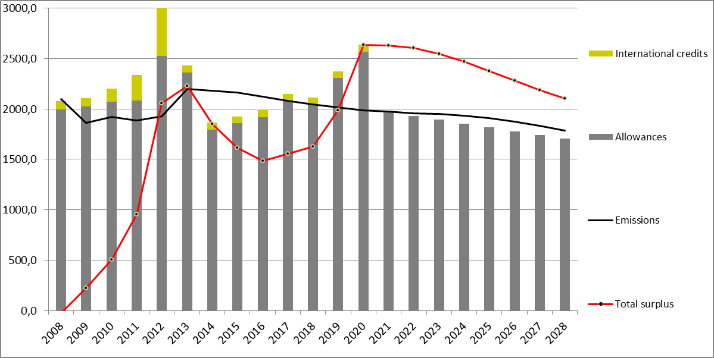

2. Objective
The operational objective is to ensure inter-temporal efficiency of the carbon market in the short-term and beyond in a market setting characterised by large-scale auctioning, taking into account the need for simplicity and predictability. This requires addressing the structural surplus expected to remain in place even with other possible measures after 2020 in the context of the 2030 framework (i.e. revision of the linear reduction factor, use of international credits, extension of the scope). It also requires increasing the resilience of the EU ETS in the light of large-scale events that may severely disturb the supply-demand balance.

3. Options
In November 2012, the Commission set out a non-exhaustive list of six options for structural measures in the Carbon Market Report. The impact assessment on the 2030 climate and energy framework includes a general assessment of the impacts of those options that realistically do not have the potential to restore the balance between supply and demand in the short-term, but would only have an impact in the context of the 2030 framework (early revision of the linear reduction factor, extension of the scope of the EU ETS to other sectors and using access to international credits). The option of increasing the target is excluded from the focus of the 2030 impact assessment based on stakeholder feedback. During the public consultation on the structural measures, an additional option – to establish a reserve mechanism to render the auction supply of emission allowances more flexible – has emerged from the discussion.
Table 1: Comparison of the options from the Carbon Market Report
 | Stakeholder views* | Potential effectiveness in improving the functioning of the European carbon market in phase 3
a) Increasing the EU reduction target to 30% in 2020 | Very limited support | Not focus of the assessment  Would have been accompanied by a reduction of auction supply over phase 3 by some 1.4 bn allowances. This might have the potential to improve market functioning in the short-term  Reference emission projections for 2020 actually already come very close to levels associated with a 30% reduction target. This means that while the EU might not be ready to increase its target to 30%, the full achievement of other agreed targets can reduce emissions in the EU to the level in line with what would be required to achieve a step up to a 30% target
b) Retiring a number of allowances in phase 3 | Medium support | Retiring a number of allowances early on has the potential to create scarcity and improve market functioning in the short-term
c) Early revision of the annual linear reduction factor | Medium support | Limited potential to improve market functioning the short-term  But expected to have a positive impact in the mid- and long-term
d) Extension of the scope of the EU ETS to other sectors | Limited support (for phase 3) | Limited potential to improve market functioning in phase the short-term  Assessment of administrative challenges and potential to improve market functioning as of phase 4 needs to be further investigated  But potential other benefits, e.g. in terms of technology-neutral incentives across sectors
e) Use access to international credits | Limited support (for phase 3) | Very limited potential to sufficiently improve market functioning in the short-term  Aggregate surrender of international credits has already used up more than two thirds of the amount allowed until 2020
f) Discretionary price management mechanisms | Very limited support for a mechanism focused on price | Not focus of the assessment  EU ETS is an instrument based on volume not price
Additional option | Medium support for a mechanism focused on (auction) supply to address market imbalance | Potential to improve market functioning in the short-term  Most useful and simplest mechanism expected to be a reserve of allowances
Accordingly, the focus of this assessment is on the three options, and several sub-options, that could realistically be implemented, and already restore the orderly functioning of the EU ETS in the short-term:
- Option 1: Retirement of a number of allowances in phase 3;
- Option 2: More flexible auction supply in the form of a market stability reserve (additional option building on a variant of option of discretionary price management mechanisms from the Carbon Market Report).
- Option 3: Combination of a market stability reserve with the retirement of a number of allowances in phase 3

3.1. Sub-options for a permanent retirement
For the purpose of this assessment, in the light of the current surplus and its expected evolution, a larger upper limit of 1400 million allowances is put on the number of retired allowances.
Of course other amounts of retired allowances could be conceived. As a sensitivity analysis, another sub-option with a lower amount of 500 million allowances is assessed (option 1b).

3.2. Sub-options for a market stability reserve
A market stability reserve would, in principle, function by:
- Adding allowances to the reserve by deducting them from future auction volumes with the aim of mitigating market instability due to a large temporary surplus in the EU ETS;
- Releasing allowances from the reserve and adding them to future auction volumes with the aim of mitigating market instability due to a large temporary deficit in the EU ETS.
A market stability reserve, as a rule-based mechanism, would only change the timing of auction volumes. It would not affect the level or timing of free allocation. It would furthermore be "cap-neutral" and not lead to a change of the environmental ambition level.
Based on the pre-assessment of the various design aspects, several sub-options relating to the decisive factors for adding to or releasing allowances from the reserve (triggers) as well as the size of the adjustment are assessed in terms of impact on the market imbalance. Other combinations of elements would also be possible.
Table 2: Sub-options for a market stability reserve
Description | Option | Trigger | Adjustment amount
Relative narrow band & unlimited | 2a | Total surplus outside 40-50% of the cap | Distance from the band/unlimited
Relative narrow band & limited | 2b | Total surplus outside 40-50% of the cap | Limit of 100 mio allowances
Absolute broad band & unlimited | 2c | Total surplus outside 400-1000 mio allowances | Distance from the band/unlimited
Absolute broad band & limited | 2d | Total surplus outside 400-1000 mio allowances | 10% of cumulative surplus/instalment of 100 mio allowances
Annual change & unlimited | 2e | Annual change in surplus >100 mio allowances | Unlimited/ surplus change above 100 mio allowances
Annual change & limited | 2f | Annual change in surplus >100 mio allowances | 50% of the surplus change above 100 mio allowances
GDP | 2g | GDP growth forecast outside 2-3% | Instalments of 200 mio allowances
The majority of the sub-options focus on surplus-based triggers. They have the important benefit of being able to account for the impact of complementary policies, such as renewables and energy efficiency measures. Considering stakeholder views on the importance to maintain the nature of the EU ETS as a quantity-based instrument, where the carbon price signal is not fixed by policy-makers but revealed by the market, price-based triggers are not in the focus of this assessment.
The first set of sub-options focuses on the surplus-based triggers (options 2a-2f), either in relation to the cumulative surplus or change in the surplus. The mechanism would aim to maintain the surplus within a pre-defined target range (band). As views on the optimal values for the triggers are not yet conclusive, different levels of the surplus band are chosen in a way to allow for sensitivity analysis in terms of impacts of different levels and widths of the band. In general, two variants are assessed, one where there is some kind of a safeguard to avoid large changes in the auction supply (either in form of a limit on the size of the adjustment or the adjustment defined as a percentage of the cumulative surplus), and one with unlimited adjustments.
One option looks at a reserve with an external indicator-based trigger, more specifically based on the GDP growth forecasts published in the European Economic Forecast – autumn editions. As the band is not directly expressed in emission allowances, external indicator-based triggers in any case require an additional step of determining the amount of allowances placed into / released from the reserve. Given the difficulties of precisely translating the relation between the unit of GDP growth into a number of allowances, the external-based indicator trigger is only assessed in combination with pre-determined adjustment amounts of 200 million allowances.

3.3. Sub-options for a combination of a market stability reserve and permanent retirement
For ease of comparison, the same amount is used for the permanent retirement part as under option 1b – 500 million allowances. Regarding the design of the market stability reserve part, there it is based on the central option(s) that appears from the pre-assessment of different market stability reserve sub-options, i.e. one without a broad absolute band and the annual adjustment putting allowances into the reserve defined as a share of the cumulative surplus.

4. Analysis of impacts

4.1. Market balance
It is assessed whether the permanent retirement and market stability reserve options address the existing problem of the large market imbalance. In case of the market stability reserve, it is also assessed, using phase 2 (2008-2012) data, whether the various options would have prevented the problem if they had already been implemented in phase 2.
Permanent retirement:
- The large permanent retirement (option 1a) is expected to reduce the market imbalance early on, without a rebound in the surplus later on in phase 3. This appears to be more consistent with the objective of inter-temporal efficiency than the baseline option 0.
- Lowering the amount of permanent retirement to 500 million allowances (option 1b) would correspondingly decrease the stabilising impact of the measure, with a rebound in the surplus later on in phase 3, with a more limited improvement in inter-temporal efficiency than a large retirement.
Market stability reserve:
- There is a difference between the ability of various sub-options to prevent a large surplus from accumulating and to address it once it has already built-up (see Error: Reference source not found). Certain sub-options would have prevented the problem to a different degree than others. However, all sub-options are expected to address the problem, albeit with different speeds.
- Surplus-based triggers are more efficient than GDP-based ones as regards capturing changes in demand not only due to macroeconomic changes, but also due to other factors that may affect demand, such as the impact of complementary policies. They also better capture supply side factors such as changes in the inflow of international credits.
- Comparing the different surplus-based triggers, those based on a cumulative surplus are expected to perform better than those based on annual changes in the surplus in the situation where the market balance has already been improved by back-loading. While triggers based on changes in the balance may be more effective in avoiding a market imbalance, they do not lead to further reductions in the surplus after the market is no longer in balance.
- Surplus-based triggers with an absolute band score better in relation to simplicity. Moreover, a relative band which tapers off in line with the decreasing cap may perform badly if the trend in hedging needs increased.
- A broader band is expected to lead to lower amounts and frequency of adjustments as well as lower variability in auction volumes. In contrast, a narrower band is likely to lead to a larger number of interventions and in both directions, i.e. a number of adjustments putting allowances into the market stability reserve only to be followed by release of those allowances shortly thereafter.
- Limited adjustments, either with an explicit limit on the amount of adjustment or determined as a certain percentage of the cumulative surplus, get a better score in terms of predictability. They also lead to more continuity in terms of auctions, and gradual changes to both the surplus and market stability reserve. However, unlimited adjustments get a better score in terms of flexibility in addressing large and rapid fluctuations in the market balance and generally restore the market balance more swiftly. However, in situations with a large surplus, as the market is expected to experience by the end of phase 3, they may lead to no auction supply coming to the market for several years.
Figure 2: Evolution of the surplus under various sub-options for a permanent retirement and market stability reserve if implemented in phase 4
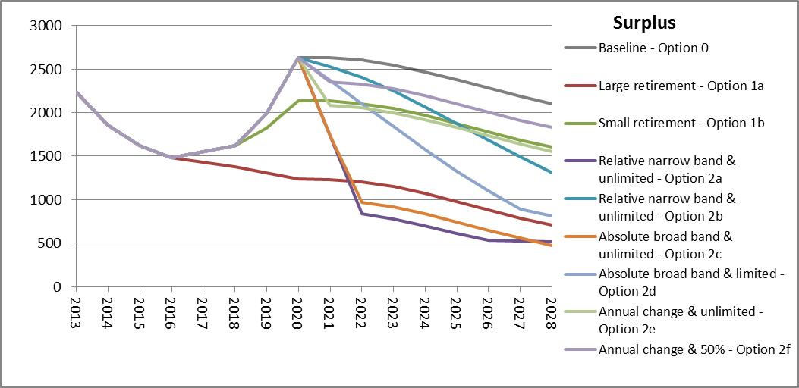
For ease of comparison, not all the options for a market stability reserve are taken forward for further analysis. Considering a combination of criteria, it is proposed to take option 2d (with volume triggers, with a broad absolute surplus range between 400 and 1000 million allowances and annual adjustment putting allowances into a reserve defined as 10% of the cumulative surplus) as the central option for the market stability reserve to be assessed further in terms of impacts other than on market balance and compared to the permanent retirement options. This option has an important advantage in terms of simplicity. While it may not fully address the market imbalance in phase 3, it starts doing so at the beginning of phase 4.
This sub-option also forms the market stability reserve part for the option for a combination of a market stability reserve with permanent retirement:
- While the option leads to a rebound in the surplus at the end of phase 3, it does reduce it compared to the baseline option 0. It also keeps gradually decreasing the surplus in phase 4. It seems to be more consistent with the objective of inter-temporal efficiency than the baseline option 0.

4.2. Potential impact on carbon price formation
In a situation without back-loading and any structural measures, the carbon price in the reference scenario used for the impact assessment of the 2030 climate and energy policy framework is expected to be €5 in 2015 and €10 in 2020, while the surplus of allowances is projected to continue to grow to above 2.5 billion allowances in 2020 and only gradually decrease afterwards. With back-loading of 900 million allowances (baseline option 0) being implemented in phase 3, prices should in principle not increase significantly above these projections, if the remaining surplus in the relevant period is large enough.
In terms of a large retirement (option 1a), the impact on the carbon price would be at least similar to back-loading in the early years of phase 3, but without a price rebound as of 2019. If a permanent retirement only reduced the projected surplus to a limited extent, by 500 million allowances (option 1b), impacts on prices are expected to be correspondingly limited.
Prices can increase when a market stability reserve builds up. Once it is in place and the market is more balanced, prices should be more strongly driven by the decreasing mid- and long-term cap. When allowances are released from the reserve, prices can decline in relative terms. Any reserve that reduces the surplus to a level that supports the orderly functioning of the carbon market, would thus rather support the gradual transition to lower emissions, also in case of a higher ambition in the EU ETS in the context of a 2030 framework. This is expected to reduce the risk of too little low-carbon investment in the short term which increases costs in the mid- and long-term. However, a detailed assessment of the annual magnitude of the price impacts of a market stability reserve cannot be made for a number of reasons.
Prices are expected to increase in relative terms towards the end of phase 3 due to a combined effect of a market stability reserve complemented with the permanent retirement of 500 million allowances. Hence, this is expected to provide more support than solely a permanent retirement of the same amount would (option 1b). It is also likely to have a higher impact than a similar market stability reserve alone would (e.g. option 2d). However, the option would still result in some rebound of the surplus at the end of phase 3 and hence have less of a price impact than the large permanent retirement (option 1a).

4.3. Competitiveness impacts
Not strengthening the EU ETS in the short-term would in the longer term have an impact on the EU’s competitiveness. The unrepresentatively weak carbon price signal that the EU ETS has provided recently and that may remain at a fairly low level well into phase 4, would have adverse effects on investment and innovation of low-carbon technologies. It would also lead to a disintegrated EU energy and climate policy, and an increasingly fragmented internal market. The stronger the carbon price signal in the short term, the smaller these negative consequences should be.
In terms of possible short-term direct cost for the energy-intensive sectors deemed to be exposed to a risk of carbon leakage, it is to be noted that the verified emissions data for phase 2 show in aggregate a surplus of free allowances in relation to emissions reported from industrial sectors (excluding the power sector) of more than 34% or around 895 million allowances. This is an estimate for industry as a whole, obviously with potential variations between sectors and installations. If emissions in phase 3 were similar to those in any year of phase 2, except for 2008, then continued free allocation is still expected to result in a surplus over phase 3 taking into account the existing surplus from phase 2.
If emissions were to be similar as in 2005 or 2008, then continued free allocation in addition to the existing surplus would not be sufficient to cover all industry needs, which would partly need to be covered by buying extra allowances on the market. In this case, industry could see increased cost in phase 3 due to a structural measure for purchasing allowances.
In relation to possible short-term increases in electricity cost due to the EU ETS (indirect cost) every €1 increase in the carbon price may on average translate into an increase of 0.8% compared to the current price for industry. These figures do not take into account the expected lower cost pass-through in the Member States applying the derogation allowing transitional free allocation for the modernisation of electricity generation, or the decreasing importance of fossil fuel-based plants in electricity price setting due to a robust carbon price.

4.4. Social impacts
A €1 increase in the carbon price could on average translate into an increase of 0.5% compared to the current price for households. Decarbonisation policies also reduce emissions of PM_{2.5}, SO₂ and NO_{x}. Through a more stable carbon price signal, a carbon market can have positive health impacts by in short-term by improving air quality through encouraging fuel switching from coal to gas and in the mid- and long-term by discouraging financing new coal facilities. Revenues from the auctions may increase and can be used to cushion adverse social impacts. The 2030 impact assessment shows that when auction revenue are recycled and if carbon pricing extended to all sectors, decarbonisation policies can lead to an increase in employment of 0.2% or 430.000 net jobs created by 2030. The higher the impact on the carbon price signal, the higher these impacts are expected to be.

4.5. Environmental impacts
The environmental impact of the EU ETS in terms of emissions in the sectors covered over a certain period of time is determined by the cap. As the options that entail a permanent retirement (1a, 1b, 3a and 3b) would imply a change of the cap for phase 3, they have more positive impacts in terms of emission reductions than the market stability reserve options.

Surplus is defined as the difference between the cumulative amount of allowances available for compliance at the end of a given year, and the cumulative amount of allowances effectively used for compliance with the emissions up to that given year.
The reference scenario assumes full implementation of existing policies, including the achievement of the renewable energy and greenhouse gas reduction targets for 2020 and implementation of the Energy Efficiency Directive. The baseline scenario assumes only already implemented policies, and does not achieve in all Member States all targets, for example the renewables targets. In the baseline scenario, the surplus is expected to stay at 2 billion in 2020.
COM(2012) 652
In the context of carbon markets, this refers to the optimal balance between the carbon price signal and low-carbon investment that is needed now, and those that will be needed in the future.
For more information see chapter 4.1 of the impact assessment on backloading: http://ec.europa.eu/clima/policies/ets/cap/auctioning/docs/swd_2012_xx2_en.pdf
Some of this surplus may have already been sold by industry, in which case the value of those allowances for industry would not be lost but now arise in the form of money. Data includes all stationary installations reported in the European Union Transaction Log (EUTL) that do not have as activity code "combustion".
Ranging from 0.4%-1.7% at Member State level. Based on a simple average of increases for EU Member States, hence not weighted average.
Ranging from 0.2%-1.3% at Member State level. Based on a simple average of increases for EU Member States, hence not weighted average.

