REPORT FROM THE COMMISSION TO THE EUROPEAN PARLIAMENT AND THE COUNCIL
ON FOOD INGREDIENTS TREATED WITH IONISING RADIATION FOR THE YEAR 2012
1. Introduction
The current report, as requested by Article 7(4) of Directive 1999/2/EC, covers the period from 1 January 2012 to 31 December 2012. It contains a compilation of the information forwarded to the Commission by 27 Member States.
2. Legal basis and background
Article 7(3) of Directive 1999/2/EC of the European Parliament and of the Council of 22 February 1999 on the approximation of the laws of the Member States concerning foods and food ingredients treated with ionising radiation, requires Member States to forward to the Commission every year:
- the results of checks carried out in irradiation facilities, in particular regarding the categories and quantities of food and food ingredients treated and the doses administered
and
- the results of checks carried out at the product marketing stage and the methods used to detect treatment with ionising radiation.
Article 7(4) of the Directive requires the Commission to publish in the Official Journal of the European Union
- the details of the approved irradiation facilities in the Member States as well as any changes in their status;
- a report on the information provided by the national supervisory authorities.
Information on general aspects of food irradiation is available on the website of the European Commission’s Directorate-General for Health and Consumer.
2.1. Irradiation facilities
According to Article 3(2) of Directive 1999/2/EC, food and food ingredients may be irradiated only in approved irradiation facilities. For facilities in the EU, approval is given by the competent authorities of the Member States. Article 7(3) requires Member States to inform the Commission on the list of their approved irradiation facilities.
Irradiation of food and food ingredients may only be carried out by means of the following sources:
- Gamma rays from radionuclides ⁶⁰Co or ¹³⁷Cs;
- X-rays generated from machine sources operated at or below a nominal energy (maximum quantum energy) level of 5 MeV;
- Electrons generated from machine sources operated at or below a nominal energy (maximum quantum energy) level of 10 MeV.
The list of approved irradiation facilities in Member States is publicly available as it was published by the Commission.
2.2. Irradiated food and food ingredients
The irradiation of dried aromatic herbs, spices and vegetable seasonings is authorised at EU level by Directive 1999/3/EC of the European Parliament and of the Council of 22 February 1999 on the establishment of a Community list of food and food ingredients treated with ionising radiation. In addition, seven Member States have notified to the Commission that they maintain national authorisations for certain food and food ingredients in accordance with Article 4(4) of Directive 1999/2/EC. The list of national authorisations has been published by the Commission.
Any irradiated foodstuff containing one or more irradiated food ingredient must be labelled with the words “irradiated” or “treated with ionising radiation”. If an irradiated product is used as an ingredient in a compound food, the same words shall accompany its designation in the list of ingredients. In the case of products sold in bulk, these words shall appear together with the name of the product on a display or notice above or beside the container in which the products are placed.
To enforce correct labelling or to detect non-authorised products, several analytical methods have been standardised by the European Committee for Standardisation (CEN), following a mandate given by the European Commission.
3. Results of checks carried out in irradiation facilities and doses administered
This section of the report deals with the results of the checks carried out in irradiation facilities, in particular regarding categories and quantities of products treated and doses administered. According to the information submitted by the Member States, the controls carried out by the competent authorities confirmed the compliance of the approved irradiation facilities with the requirements of Directive 1999/2/EC.
The following tables and figures show the results of checks carried out in the approved irradiation facilities in EU Member States in 2012, in particular regarding the categories and quantities of food and food ingredients treated and the doses administered.
3.1. Summary for the EU
The following table summarises the quantities of foodstuffs (in tonnes) treated by ionising radiation in the approved irradiation facilities within the European Union:
Member State | Number of approved facilities | Treated quantity (tonnes)
Belgium | 1 | 5157,7
Bulgaria | 2 | No food irradiated
Czech Republic | 1 | 23.8
Germany | 4 | 125.8
Estonia | 1 | 33.7
Spain | 2* | 326.6
France | 5 | 612.9
Italy | 1 | No food irradiated
Hungary | 1 | 124.9
Netherlands | 2 | 1476.0
Poland | 2 | 89.0
Romania | 1 | 1.6
United Kingdom | 1 | No food irradiated
Total: | 24 | 7972.1
* No food was irradiated in one of these facilities.
The following figure summarises the quantities of foodstuffs (in tonnes) treated by ionising radiation in approved irradiation facilities within the European Union in 2012:
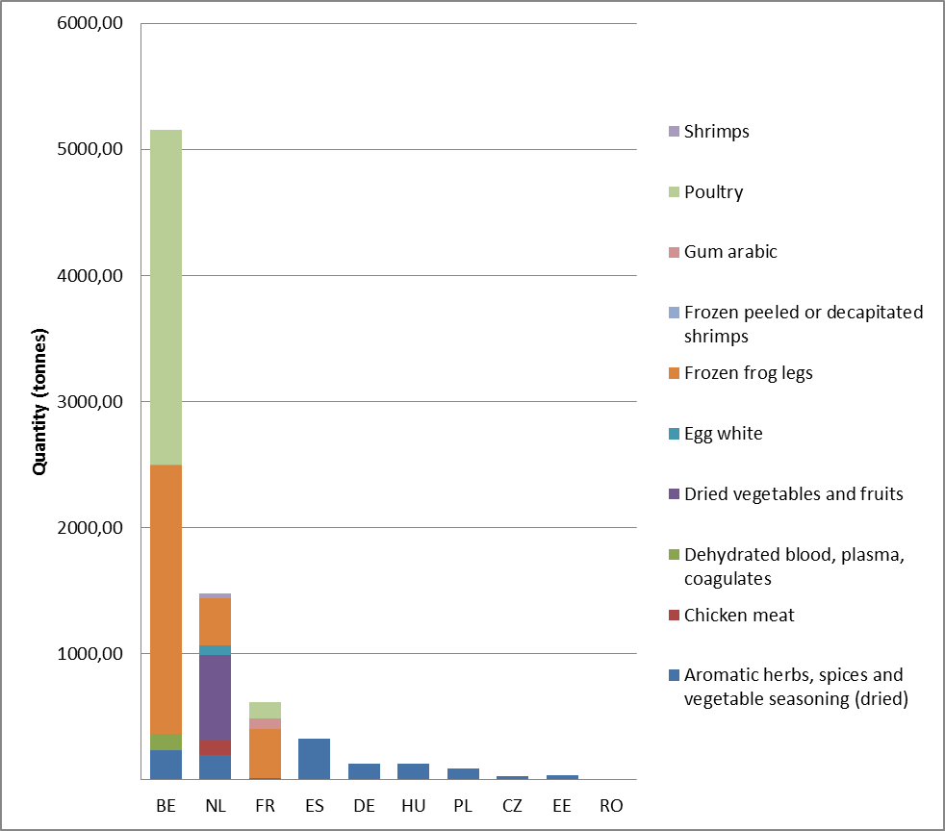
There are no approved facilities in the following Member States: Denmark, Ireland, Greece, Cyprus, Latvia, Lithuania, Luxembourg, Malta, Austria, Slovenia, Slovakia, Finland, Sweden, Portugal.
3.2. Belgium
Foodstuffs | Absorbed dose (kGy)
Aromatic herbs, spices and vegetable seasoning (dried) | 5 - 9
Dehydrated blood, plasma, coagulates | 2 - 4
Frozen frog legs | 2.7 - 5.5
Frozen peeled or decapitated shrimps | 2 - 7
Poultry | 2 - 6.1
3.3. Czech Republic
Foodstuffs | Absorbed dose (kGy)
Aromatic herbs, spices and vegetable seasoning (dried) | 5.77 - 9.82
Dried vegetables and fruits | 5.66 - 6.55
3.4. Germany
Foodstuffs | Absorbed dose (kGy)
Aromatic herbs, spices and vegetables seasoning (dried) | <10
3.5. Estonia
Foodstuffs | Absorbed dose (kGy)
Aromatic herbs, spices and vegetable seasoning (dried) | 10
3.6. Spain
Foodstuffs | Absorbed dose (kGy)
Aromatic herbs, spices and vegetable seasoning (dried) | 9.09
3.7. France
Foodstuffs | Absorbed dose (kGy)
Aromatic herbs, spices and vegetable seasoning (dried) | 10
Frozen frog legs | 5
Gum arabic | 3
Poultry | 5
3.8. Hungary
Foodstuffs | Absorbed dose (kGy)
Aromatic herbs, spices and vegetable seasoning (dried) | 2 - 10
3.9. Netherlands
Foodstuffs | Absorbed dose (kGy)
Aromatic herbs, spices and vegetable seasoning (dried) | 6.9
Chicken meat | 3.8
Dried vegetables and fruits | 3
Egg white | 1
Frozen frog legs | 4
Shrimps | 3.2
3.10. Poland
Foodstuffs | Absorbed dose (kGy)
Aromatic herbs, spices and vegetable seasoning (dried) | 5 - 10
3.11. Romania
Foodstuffs | Absorbed dose (kGy)
Aromatic herbs, spices and vegetable seasoning (dried) | 8
4. Results of checks carried out at the product marketing stage and methods used to detect irradiated foods
The following tables show the results of the checks carried out at the product marketing stage and the methods used to detect treatment with ionising radiation.
4.1. Summary for the EU
The following table summarises the samples analysed and the results obtained for the European Union as a whole:
Member State | Compliant | Inconclusive | Non-compliant | Total samples | % Versus EU total samples
BE | 89 | 18 | 3 | 110 | 2,1%
BG | 47 | 0 | 2 | 49 | 0,9%
CZ | 23 | 7 | 0 | 30 | 0,6%
DK | NCP | NCP | NCP | NCP
DE | 2676 | 27 | 13 | 2716 | 52,4%
EE | NCP | NCP | NCP | NCP
IE | 78 | 0 | 0 | 78 | 1,5%
EL | NCP | NCP | NCP | NCP
ES | 139 | 1 | 0 | 140 | 2,7%
FR | 46 | 5 | 3 | 54 | 1,0%
IT | 281 | 3 | 7 | 291 | 5,6%
CY | NCP | NCP | NCP | NCP
LV | 6 | 0 | 5 | 11 | 0,2%
LT | 63 | 0 | 20 | 83 | 1,6%
LU | 12 | 0 | 0 | 12 | 0,2%
HU | 60 | 0 | 0 | 60 | 1,2%
MT | 20 | 0 | 0 | 20 | 0,4%
NL | 362 | 0 | 11 | 373 | 7,2%
AT | 132 | 0 | 2 | 134 | 2,6%
PL | 241 | 1 | 4 | 246 | 4,7%
PT | 47 | 0 | 2 | 49 | 0,9%
RO | 104 | 0 | 1 | 105 | 2,0%
SI | 21 | 0 | 0 | 21 | 0,4%
SK | 22 | 1 | 0 | 23 | 0,4%
FI | 219 | 4 | 31 | 254 | 4,9%
SE | NCP | NCP | NCP | NCP
UK | 291 | 13 | 19 | 323 | 6,2%
Total EU | 4979 | 80 | 123 | 5182 | 100,0%
Total EU | 96,1% | 1,5% | 2,4% | 100,0%
NDS: No data submitted
NCP: No check performed
The following figure summarises the samples analysed and the results obtained for the European Union as a whole:
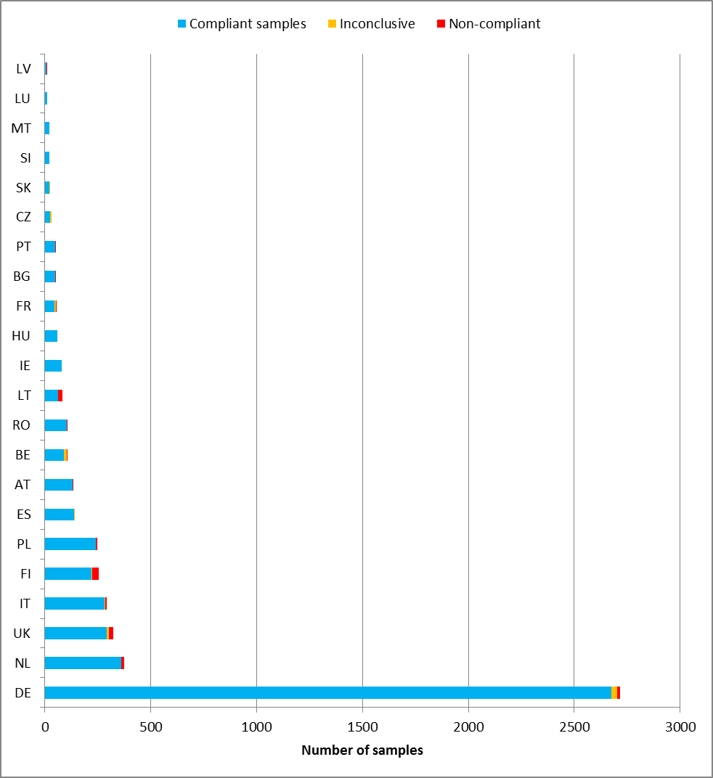
4.2. Belgium
Foodstuffs analysed at product marketing stage | Number of Samples: 107 |  |  | CEN method used
Foodstuffs analysed at product marketing stage | Compliant | Inconclusive | Non-Compliant | CEN method used
Aromatic herbs, spices and vegetable seasoning (dried) | 24 | 1 | 0 | EN 1788
Cereal products | 8 | 8 | 0 | EN 1788
Food supplements | 14 | 2 | 2* | EN 1788
Fruit (dried) | 6 | 3 | 0 | EN 1788
Molluscs | 16 | 3 | 1* | EN 1788
Mushrooms or mushrooms products (dried) | 2 | 0 | 0 | EN 1788
Pulses | 2 | 0 | 0 | EN 1788
Tea | 16 | 1 | 0 | EN 1788
Vegetables and vegetable products (dried) | 1 | 0 | 0 | EN 1788
Total: | 89 | 18 | 3
Total % of analysed samples: | 83% | 17% | 3%
* erroneously labelled
4.3. Bulgaria
Foodstuffs analysed at product marketing stage | Number of Samples: 49 |  |  | CEN method used
Foodstuffs analysed at product marketing stage | Compliant | Inconclusive | Non-Compliant | CEN method used
Aromatic herbs, spices and vegetable seasoning (dried) | 19 | 0 | 0 | EN 1788;EN 1787
Fish and fish products | 2 | 0 | 0 | EN 1786
Fruit (dried) | 5 | 0 | 0 | EN 13708
Herbal teas / Infusions | 8 | 0 | 2* | EN 1788;EN 13751;EN 1787
Meals and dishes (prepared) | 3 | 0 | 0 | EN 1788;EN 1787
nuts | 3 | 0 | 0 | EN 1788;EN 1787
Poultry meat | 5 | 0 | 0 | EN 1786
Shrimps | 2 | 0 | 0 | EN 1786
Total: | 47 | 0 | 2
Total % of analysed samples: | 96% | 0% | 4%
* erroneously labelled
4.4. Czech Republic
Foodstuffs analysed at product marketing stage | Number of Samples: 30 |  |  | CEN method used
Foodstuffs analysed at product marketing stage | Compliant | Inconclusive | Non-Compliant | CEN method used
Aromatic herbs, spices and vegetable seasoning (dried) | 7 | 2 | 0 | EN 1788
Food supplements | 2 | 0 | 0 | EN 1788
Garlic | 3 | 0 | 0 | EN 1788
Herbal teas / Infusions | 3 | 1 | 0 | EN 1788
Instant noodles | 6 | 3 | 0 | EN 1788
Mushrooms or mushrooms products (dried) | 2 | 1 | 0 | EN 1788
Total: | 23 | 7 | 0
Total % of analysed samples: | 77% | 23% | 0%
4.5. Denmark
Due to limited financial resources no checks were carried out at product marketing stage in 2012.
4.6. Germany
Foodstuffs analysed at product marketing stage | Number of Samples: 2716 |  |  | CEN method used
Foodstuffs analysed at product marketing stage | Compliant | Inconclusive | Non-Compliant | CEN method used
Aromatic herbs, spices and vegetable seasoning (dried) | 1285 | 15 | 4* | EN 1788;EN 13751; EN 1787
Butter (seasoned) | 1 | 0 | 0 | EN 1788;L12.01-1; EN 13751;EN 1787
Cereals, seed, vegetables and fruit | 94 | 0 | 0 | EN 1786
Cheese (containing spices/herbs) | 41 | 0 | 0 | EN 1788; EN 1787
Cheese (preparations without herbs and spices) | 1 | 0 | 0 | EN 1788; EN 1787
Coffee | 64 | 0 | 0 | EN 1786
Crustaceans, shellfish, mussels and other aquatic animals (including their products) | 83 | 1 | 2* | EN 1788; EN 13751
Fish and fish products | 121 | 0 | 3** | EN 1788; EN 13751; EN 1786
Food supplements | 97 | 9 | 2** | EN 1786
Fruit (dried) | 63 | 1 | 1 | EN 1788; L12.01-1; EN 13751
Fruits (fresh) | 88 | 0 | 0 | EN 13751; EN 1787; EN 13708
Meals and dishes (prepared) | 64 | 1 | 2** | EN 1788; EN 13751; EN 1787
Meat | 41 | 0 | 0 | EN 13751
Meat (except poultry and game) | 61 | 0 | 0 | EN 1788; EN 1786
Meat products (except sausages) | 30 | 0 | 0 | EN 1786
Mushrooms (fresh) | 51 | 0 | 0 | EN 1784; EN 1786
Mushrooms or mushrooms products (dried) | 111 | 0 | 0 | EN 1788; EN 1785;ESR; EN 13751
Other | 21 | 0 | 0 | EN 1788; EN 13751; EN 1787
Egg and egg products | 16 | 0 | 0 | EN 1788; EN 13751
Pulses, oil seeds, nuts | 15 | 0 | 0 | EN 1784
Tea, tea like products | 73 | 0 | 0 | EN 1788; EN 13751; EN 1787
Potatoes | 30 | 0 | 0 | EN 1788; EN 13751; EN 1787
Poultry meat | 40 | 0 | 0 | EN 1788; EN 13751
Sauces and soups (dehydrated) | 83 | 0 | 1* | EN 1784; EN 1786
Sausage products | 9 | 0 | 0 | EN 1788; EN 13751
Vegetables and vegetable products (dried) | 46 | 0 | 0 | EN 1784; EN 1786
Vegetables (fresh) | 47 | 0 | 0 | EN 1788; EN 13751; EN 1787
Total: | 2676 | 27 | 13
Total % of analysed samples: | 98% | 1% | 1%
* erroneously labelled
** irradiation not allowed
4.7 Estonia
No checks were carried out at product marketing stage in 2012.
4.8 Ireland
Foodstuffs analysed at product marketing stage | Number of Samples: 78 |  |  | CEN method used
Foodstuffs analysed at product marketing stage | Compliant | Inconclusive | Non-Compliant | CEN method used
Aromatic herbs, spices and vegetable seasoning (dried) | 1 | 0 | 0 | EN 1788; EN 13751
Food supplements | 4 | 0 | 0 | EN 1788; EN 13751
Instant noodles | 9 | 0 | 0 | EN 1788; EN 13751
Breadcrumbs | 1 | 0 | 0 | EN 1788; EN 13751
Herbs and spices | 29 | 0 | 0 | EN 1788; EN 13751
Sauces and soups (dehydrated) | 1 | 0 | 0 | EN 1788; EN 13751
Seeds | 6 | 0 | 0 | EN 1788; EN 13751
Tea | 27 | 0 | 0 | EN 1788; EN 13751
Total: | 78 | 0 | 0
Total % of analysed samples: | 100% | 0% | 0%
4.9. Greece
No checks were carried out at product marketing stage in 2012.
4.10. Spain
Foodstuffs analysed at product marketing stage | Number of Samples: 140 |  |  | CEN method used
Foodstuffs analysed at product marketing stage | Compliant | Inconclusive | Non-Compliant | CEN method used
Aromatic herbs, spices and vegetable seasoning (dried) | 76 | 1 | 0 | EN 1788;EN 13751;EN 1787
Fish and fish products | 30 | 0 | 0 | EN 13751
Herbal teas / Infusions | 8 | 0 | 0 | EN 1787
Meat and meat products | 2 | 0 | 0 | EN 13751;EN 1787
Mushrooms or mushrooms products (dried) | 9 | 0 | 0 | EN 1788;EN 13751
Nuts | 6 | 0 | 0 | EN 1786
Vegetables (fresh) | 8 | 0 | 0 | EN 1786
Total: | 139 | 1 | 0
Total % of analysed samples: | 99% | 1% | 0%
4.11. France
Foodstuffs analysed at product marketing stage | Number of Samples: 54 |  |  | CEN method used
Foodstuffs analysed at product marketing stage | Compliant | Inconclusive | Non-Compliant | CEN method used
Aromatic herbs, spices and vegetable seasoning (dried) | 5 | 0 | 0 | EN 1788
Crustaceans or molluscs (frozen) | 2 | 0 | 0 | EN 1788
Food supplements | 6 | 3 | 0 | EN 1788
Frog legs | 9 | 0 | 0 | EN 1788
Fruit (dried) | 5 | 0 | 0 | EN 1788
Herbal teas / Infusions | 5 | 0 | 0 | EN 1788
Instant noodles | 1 | 0 | 0 | EN 1788
Mushrooms or mushrooms products (dried) | 1 | 0 | 0 | EN 1784
Avocado | 2 | 1 | 0 | EN 1788
Poultry meat | 2 | 0 | 0 | EN 1786
Sauces and soups (dehydrated) | 4 | 1 | 3* | EN 1788
Vegetables and vegetable products (dried) | 4 | 0 | 0 | EN 1784
Total: | 46 | 5 | 3
Total % of analysed samples: | 85% | 9% | 6%
* erroneously labelled
4.12. Italy
Foodstuffs analysed at product marketing stage | Number of Samples: 291 |  |  | CEN method used
Foodstuffs analysed at product marketing stage | Compliant | Inconclusive | Non-Compliant | CEN method used
Aromatic herbs and spices | 96 | 0 | 0 | EN 1788;EN 13751
Fish and fish products | 5 | 2 | 0 | EN 13751
Food supplements | 1 | 0 | 0 | EN 13783;EN 1788;EN 13751;EN 1787
Food supplements | 9 | 1 | 2 | EN 13784;EN 1788;EN 1785;EN 13751;EN 1786
Frog legs | 4 | 0 | 5 | EN 13751
Fruits (fresh) | 3 | 0 | 0 | EN 13783;EN 13751;EN 1787
Garlic and Onion | 14 | 0 | 0 | EN 1787;EN 13708
Herbal teas / Infusions | 9 | 0 | 0 | EN 13751
Land snail | 1 | 0 | 0 | EN 1788;EN 13751
Meat | 67 | 0 | 0 | EN 13783;EN 13751;EN 1787
Mushrooms or mushrooms products (dried) | 7 | 0 | 0 | EN 13751;EN 1785;EN 1786
Nuts and dried fruit | 14 | 0 | 0 | EN 13783;EN 13751;EN 1787
Oil seeds | 6 | 0 | 0 | EN 13783;EN 1788;EN 13751
Potatoes | 7 | 0 | 0 | EN 13751;EN 1787
Pulses | 13 | 0 | 0 | EN 1788;EN 1786
Vegetable seasonings | 9 | 0 | 0 | EN 13751
Vegetables (fresh) | 15 | 0 | 0 | EN 1787;EN 13708
Wheat | 1 | 0 | 0 | EN 1788
Total: | 281 | 3 | 7
Total % of analysed samples: | 97% | 1% | 2%
4.13. Cyprus
In 2012 no checks were carried out at the product marketing stage. There is no laboratory in Cyprus carrying out analyses for ionising radiation. Due to the limited financial resources, samples were not sent abroad for analysis.
4.14. Latvia
Foodstuffs analysed at product marketing stage | Number of Samples: 11 |  |  | CEN method used
Foodstuffs analysed at product marketing stage | Compliant | Inconclusive | Non-Compliant | CEN method used
Food supplements | 6 | 0 | 5* | EN 1788
Total: | 6 | 0 | 5
Total % of analysed samples: | 55% | 0% | 45%
* irradiation in facilities not approved by the EU
4.15. Lithuania
Foodstuffs analysed at product marketing stage | Number of Samples: 83 |  |  | CEN method used
Foodstuffs analysed at product marketing stage | Compliant | Inconclusive | Non-Compliant | CEN method used
Aromatic herbs, spices and vegetable seasoning (dried) | 50 | 0 | 0 | EN 13783
Food supplements | 13 | 0 | 20 | EN 13783
Total: | 63 | 0 | 20
Total % of analysed samples: | 76% | 0% | 24%
4.16. Luxembourg
Foodstuffs analysed at product marketing stage | Number of Samples: 12 |  |  | CEN method used
Foodstuffs analysed at product marketing stage | Compliant | Inconclusive | Non-Compliant | CEN method used
Aromatic herbs, spices and vegetable seasoning (dried) | 2 | 0 | 0 | EN 1788
Cereals, seed, vegetables and fruit | 1 | 0 | 0 | EN 1788
Fruit (dried) | 1 | 0 | 0 | EN 1788
Herbal teas / Infusions | 3 | 0 | 0 | EN 1788
Mushrooms or mushrooms products (dried) | 1 | 0 | 0 | EN 1788
Tea | 1 | 0 | 0 | EN 1788
Vegetables and vegetable products (dried) | 2 | 0 | 0 | EN 1787
Yeast products | 1 | 0 | 0 | EN 1788
Total: | 12 | 0 | 0
Total % of analysed samples: | 100% | 0% | 0%
4.17. Hungary
Foodstuffs analysed at product marketing stage | Number of Samples: 60 |  |  | CEN method used
Foodstuffs analysed at product marketing stage | Compliant | Inconclusive | Non-Compliant | CEN method used
Aromatic herbs, spices and vegetable seasoning (dried), tea | 60 | 0 | 0 | EN 1788
Total: | 60 | 0 | 0
Total % of analysed samples: | 100% | 0% | 0%
4.18. Malta
Foodstuffs analysed at product marketing stage | Number of Samples: 20 |  |  | CEN method used
Foodstuffs analysed at product marketing stage | Compliant | Inconclusive | Non-Compliant | CEN method used
Coffee | 2 | 0 | 0 | EN 13751
Fish and fish products | 2 | 0 | 0 | EN 13751
Frog legs | 1 | 0 | 0 | EN 13751
Garlic | 1 | 0 | 0 | EN 13751
Herbal teas / Infusions | 2 | 0 | 0 | EN 13751
Honey and other bee products | 1 | 0 | 0 | EN 13751
Instant noodles | 2 | 0 | 0 | EN 13751
Mushrooms or mushrooms products (dried) | 1 | 0 | 0 | EN 13751
Poultry meat | 3 | 0 | 0 | EN 13751
Prawns and snacks (fried) | 1 | 0 | 0 | EN 13751
Sausage products | 1 | 0 | 0 | EN 13751
Soup | 1 | 0 | 0 | EN 13751
Tea | 2 | 0 | 0 | EN 13751
Total: | 20 | 0 | 0
Total % of analysed samples: | 100% | 0% | 0%
4.19. Netherlands
Foodstuffs analysed at product marketing stage | Number of Samples: 373 |  |  | CEN method used
Foodstuffs analysed at product marketing stage | Compliant | Inconclusive | Non-Compliant | CEN method used
Cereal products | 34 | 0 | 0 | EN 1788;EN 13751
Fish and fish products | 19 | 0 | 0 | EN 1788;EN 13751
Food supplements | 52 | 0 | 9* | EN 1788;EN 13751
Fruit (dried) | 36 | 0 | 0 | EN 1788;EN 13751
Other | 6 | 0 | 0 | EN 1788;EN 13751
Poultry meat | 23 | 0 | 0 | EN 1788;EN 13751
Salads, pasta and soup etc. | 40 | 0 | 0 | EN 1788;EN 13751
Seeds | 35 | 0 | 0 | EN 1788;EN 13751
Special herb mixtures | 57 | 0 | 2* | EN 1788;EN 13751
Spices/flavours | 34 | 0 | 0 | EN 1788;EN 13751
Vegetables and vegetable products (dried) | 22 | 0 | 0 | EN 1788;EN 13751
Vitamin preparations | 4 | 0 | 0 | EN 1788;EN 13751
Total: | 362 | 0 | 11
Total % of analysed samples: | 97% | 0% | 3%
* non compliance either for irradiation in a unapproved facility or lack of labelling
4.20. Austria
Foodstuffs analysed at product marketing stage | Number of Samples: 134 |  |  | CEN method used
Foodstuffs analysed at product marketing stage | Compliant | Inconclusive | Non-Compliant | CEN method used
Aromatic herbs, spices and vegetable seasoning (dried) | 46 | 0 | 0 | EN 1788;EN 13751
Poultry meat | 62 | 0 | 0 | EN 1786
Sauces and soups (dehydrated) | 24 | 0 | 2* | EN 1788;EN 13751
Total: | 132 | 0 | 2
Total % of analysed samples: | 99% | 0% | 1%
* erroneously labelled
4.21. Poland
Foodstuffs analysed at product marketing stage | Number of Samples: 246 |  |  | CEN method used
Foodstuffs analysed at product marketing stage | Compliant | Inconclusive | Non-Compliant | CEN method used
Aromatic herbs, spices and vegetable seasoning (dried) | 9 | 0 | 0 | EN 13751
Aromatic herbs, spices and vegetable seasoning (dried) | 1 | 0 | 0 | EN 1786
Aromatic herbs, spices and vegetable seasoning (dried) | 57 | 0 | 0 | EN 1788
Berries | 1 | 0 | 0 | EN 1787
Cheese containing spices/herbs | 7 | 0 | 0 | EN 1788
Cheese (cottage) | 1 | 0 | 0 | EN 1788
Coffee | 1 | 0 | 0 | EN 1788
Crustaceans or molluscs (frozen) | 2 | 0 | 0 | EN 1788
Crustaceans, shellfish, mussels and other aquatic animals (including their products) | 1 | 0 | 0 | EN 1788
Dried fruit | 17 | 0 | 0 | EN 13708
Dried fruit | 2 | 0 | 0 | EN 1788
Fish and fish products | 9 | 0 | 0 | EN 1786
Fish and seafood (dried) | 2 | 0 | 0 | EN 1788
Food for particular nutritional uses | 1 | 0 | 0 | EN 13751
Food for particular nutritional uses | 1 | 0 | 2 | EN 1788
Food supplements | 5 | 0 | 0 | EN 13751
Food supplements | 6 | 1 | 0 | EN 1788
Frog legs | 1 | 0 | 2 | EN 1786
Fruits (fresh) | 1 | 0 | 0 | EN 1784
Fruits (fresh) | 3 | 0 | 0 | EN 1788
Fruit (tropical) | 3 | 0 | 0 | EN 1784
Fruit (tropical) | 1 | 0 | 0 | EN 1787
Fruit (tropical) | 8 | 0 | 0 | EN 1788
Garlic | 1 | 0 | 0 | EN 13751
Garlic | 1 | 0 | 0 | EN 1787
Garlic | 10 | 0 | 0 | EN 1788
Herbal teas/Infusions | 7 | 0 | 0 | EN 13751
Meat | 2 | 0 | 0 | EN 1784
Meat and meat products | 1 | 0 | 0 | EN 1784
Meat (except poultry and game) | 1 | 0 | 0 | EN 1784
Meat (except poultry and game) | 1 | 0 | 0 | EN 1786
Meat from different birds, kangaroo, hare) | 1 | 0 | 0 | EN 1784
Meat from different birds, kangaroo, hare) | 4 | 0 | 0 | EN 1786
Meat products (except sausages) | 1 | 0 | 0 | EN 1786
Milk and milk products | 1 | 0 | 0 | EN 1788
Nuts | 2 | 0 | 0 | EN 1786
Nuts | 20 | 0 | 0 | EN 1787
Other | 1 | 0 | 0 | EN 13708
Other | 1 | 0 | 0 | EN 13751
Other | 5 | 0 | 0 | EN 1788
Pulses | 3 | 0 | 0 | EN 1788
Red Pepper | 1 | 0 | 0 | EN 1788
Sauces and soups (dehydrated) | 11 | 0 | 0 | EN 1788
Shrimps | 7 | 0 | 0 | EN 1788
Soups | 5 | 0 | 0 | EN 1788
Tea | 11 | 0 | 0 | EN 13751
Vegetables and vegetable products (dried) | 1 | 0 | 0 | EN 1788
Vegetables (fresh) | 2 | 0 | 0 | EN 1788
Total: | 241 | 1 | 4
Total % of analysed samples: | 98% | 0% | 2%
4.22. Portugal
Foodstuffs analysed at product marketing stage | Number of Samples: 49 |  |  | CEN method used
Foodstuffs analysed at product marketing stage | Compliant | Inconclusive | Non-Compliant | CEN method used
Aromatic herbs, spices and vegetable seasoning (dried) | 4 | 0 | 0 | EN 13751
Food supplements | 18 | 0 | 2 | EN 13751
Tea | 4 | 0 | 0 | EN 13751
Vegetable extracts (dried) | 7 | 0 | 0 | EN 13751
Plant parts (roots, bay leaves) | 7 | 0 | 0 | EN 13751
Frozen clam (with shell) | 7 | 0 | 0 | EN 13751
Total: | 47 | 0 | 2
Total % of analysed samples: | 96% | 0% | 4%
4.23 Romania
Foodstuffs analysed at product marketing stage | Number of Samples: 105 |  |  | CEN method used
Foodstuffs analysed at product marketing stage | Compliant | Inconclusive | Non-Compliant | CEN method used
Aromatic herbs, spices and vegetable seasoning (dried) | 68 | 0 | 1* | EN 1788;EN 13751
Food supplements | 4 | 0 | 0 | EN 13751
Herbal teas / Infusions | 10 | 0 | 0 | EN 13751
Seeds | 6 | 0 | 0 | EN 13751
Tea | 11 | 0 | 0 | EN 13751
Vegetables and vegetable products (dried) | 5 | 0 | 0 | EN 13751
Total: | 104 | 0 | 1
Total % of analysed samples: | 99% | 0% | 1%
* irradiation in facilities not approved by the EU
4.24. Slovenia
Foodstuffs analysed at product marketing stage | Number of Samples: 21 |  |  | CEN method used
Foodstuffs analysed at product marketing stage | Compliant | Inconclusive | Non-Compliant | CEN method used
Aromatic herbs, spices and vegetable seasoning (dried) | 14 | 0 | 0 | EN 1788;EN 13751
Tea | 7 | 0 | 0 | EN 13751
Total: | 21 | 0 | 0
Total % of analysed samples: | 100% | 0% | 0%
4.25. Slovakia
Foodstuffs analysed at product marketing stage | Number of Samples: 23 |  |  | CEN method used
Foodstuffs analysed at product marketing stage | Compliant | Inconclusive | Non-Compliant | CEN method used
Aromatic herbs, spices and vegetable seasoning (dried) | 15 | 1 | 0 | EN 1784;EN 1788
Cheese (ripened) | 2 | 0 | 0 | EN 1784
Nuts | 5 | 0 | 0 | EN 1784
Total: | 22 | 1 | 0
Total % of analysed samples: | 96% | 4% | 0%
4.26. Finland
Foodstuffs analysed at product marketing stage | Number of Samples: 254 |  |  | CEN method used
Foodstuffs analysed at product marketing stage | Compliant | Inconclusive | Non-Compliant | CEN method used
Aromatic herbs, spices and vegetable seasoning (dried) | 119 | 3 | 8* | EN 1788 for confirmation; EN 13751
Berries | 6 | 0 | 0 | EN 13751
Food for particular nutritional uses | 4 | 0 | 2** | EN 1788 for confirmation; EN 13751
Food supplements | 35 | 0 | 13** | EN 1788 for confirmation; EN 13751
Herbal teas / Infusions | 11 | 1 | 1** | EN 1788 for confirmation; EN 13751
Other (sauce ingredients, food ingredients etc.) | 26 | 0 | 7** | EN 1788 for confirmation; EN 13751
Tea | 17 | 0 | 0 | EN 13751
Vegetables and vegetable products (dried) | 1 | 0 | 0 | EN 13751
Total: | 219 | 4 | 31
Total % of analysed samples: | 86% | 2% | 12%
* erroneously labelled, irradiation in facilities not approved by the EU
** irradiation not allowed
4.27. Sweden
In 2012 no checks were carried out at the product marketing stage.
4.28. United Kingdom
Foodstuffs analysed at product marketing stage | Number of Samples: 323 |  |  | CEN method used
Foodstuffs analysed at product marketing stage | Compliant | Inconclusive | Non-Compliant | CEN method used
Aromatic herbs, spices and vegetable seasoning (dried) | 156 | 5 | 3* | EN 1788;EN 13751
Cereal products | 3 | 0 | 0 | EN 13751
Cereals, seed, vegetables and fruit | 2 | 0 | 0 | EN 13751
Crustaceans, shellfish, mussels and other aquatic animals (including their products) | 1 | 0 | 0 | EN 13751
Flavoured couscous | 1 | 0 | 0 | EN 13751
Flavoured icing sugar | 1 | 0 | 0 | EN 13751
Food supplements | 26 | 3 | 1** | EN 1788;EN 13751
Fruit (dried) | 2 | 0 | 0 | EN 13751
Fruit Juice | 1 | 0 | 0 | EN 13751
Fruits (fresh) | 1 | 0 | 0 | EN 13751
Garlic | 13 | 0 | 0 | EN 13751
Herbal teas / Infusions | 5 | 0 | 0 | EN 13751
Herb and spice pastes | 7 | 0 | 0 | EN 13751
Herbs and spices (fresh) | 4 | 0 | 0 | EN 13751
Instant noodles | 40 | 4 | 7* | EN 1788;EN 13751
Meals and dishes (prepared) | 3 | 0 | 0 | EN 13751
Nuts | 1 | 0 | 0 | EN 13751
Rice | 1 | 0 | 0 | EN 1788;EN 13751
Sauces and soups (dehydrated) | 21 | 1 | 7** | EN 1788;EN 13751
Seeds | 1 | 0 | 0 | EN 13751
Vegetables and vegetable products (dried) | 0 | 0 | 1* | EN 1788;EN 13751
Vegetables (fresh) | 1 | 0 | 0 | EN 13751
Total: | 291 | 13 | 19
Total % of analysed samples: | 90% | 4% | 6%
* erroneously labelled and/or irradiation in facilities not approved by the EU
** irradiation not allowed, erroneously labelled, irradiation in facilities not approved by the EU
5. Summary
The current report covers the period from 1 January 2012 to 31 December 2012. It contains a compilation of the information forwarded to the Commission by the 27 Member States.
In 2012, 24 approved irradiation facilities were operational in 13 Member States in accordance with Article 7(2) of Directive 1999/2/EC. No new irradiation facilities have been approved. No approved irradiation facilities have been closed. Five irradiation facilities did not irradiate any food during 2012.
A total quantity of 7972 tonnes of products were treated with ionising irradiation in EU Member States, 91% of which were irradiated mainly in three Member States: Belgium (64.7%), Netherlands (18.5%) and France (7.7%). The three biggest commodities within the irradiated categories are: frog legs (36%), poultry (35%) and dried aromatic herbs and spices (15%). There has been a slight decrease in the total quantity of products irradiated in the EU compared to the previous year 2011 (8.067,5 tonnes).
27 Member States submitted information regarding the checks carried out at the product marketing stage. Five Member States did not perform any analytical checks in official control and inspection in 2012.
A total of 5.182 samples have been analysed by 22 Member States, three Member States accounted for 66% of the samples (Germany 52,4.0%, the Netherlands 7.2%, and United Kingdom 6.2%). 4.979 samples (96.1%) were compliant with the provisions of the Directive, 123 samples (2.4%) were non-compliant, 80 samples (1.5%) gave inconclusive results. The two main reasons for non-compliance of tested samples were incorrect labelling and forbidden irradiation; non-compliance was also due to irradiation in facilities not approved by the EU. Reasons for non-compliance are given in each table reporting the tests carried out in each Member State.

OJ L 66, 13.3.1999, p. 16.
http://ec.europa.eu/food/food/biosafety/irradiation/index_en.htm
OJ C 265, 1.9.2012, p. 3.
OJ L 66, 13.3.1999, p. 24.
OJ C 283, 24.11.2009, p. 5.

