Contents
Annex 5. The environmental problems and their causes 4
5.1. Risks of surface and ground water contamination 4
5.2. Risks of air pollution and GHG emissions 6
5.3. Risks of water resource depletion 7
5.4. Land related impacts, community disruption and cumulative impacts 8
5.5. Environmental problems and their causes 8
5.6. Overlap between water stressed regions and shale gas resources in Europe 10
5.7. Shale gas resources in Europe over trans-boundary groundwater bodies 11
Annex 6. Elements of comparison between conventional and unconventional fossil fuels extraction practices 12
Annex 7. Matrix of potential environmental impacts and risks from high volume hydraulic fracturing 17
Annex 8. Summary of EU legislation applying to unconventional fossil fuels, in particular shale gas activities 25
8.1. EU treaties 25
8.2. General EU legislation 25
8.3. EU environmental legislation 26
8.4. Main applicable EU legislation 28
8.5. Guidance 31
Annex 9. Main ambiguities/uncertainties and gaps in the EU acquis 32
9.1. Water 32
9.2. Waste from high volume hydraulic fracturing operations 32
9.3. Industrial emissions 33
9.4. Environmental Impact Assessment (EIA) 33
9.5. Strategic environmental assessment (SEA) 34
9.6. Chemicals 34
Annex 10. Examples of North American regulatory and non-regulatory developments 36
Annex 11. Shale gas related developments in Member States 39
Annex 12. Foreseen developments of relevant pieces of EU legislation 44
Annex 13. Summary of advantages and disadvantages for identified techniques alternative to slickwater fracturing 45
Annex 14. Summary table of the baseline and remaining gaps 51
Annex 15. Areas for best practices 57
15.1. IEA "Golden Rules" 57
15.2. Areas for actions according to the identified environmental problems 58
Annex 16. Measures and options 59
16.1. Measures groups 59
16.2. Subgroups and possible tools for implementation under options A-D 61
16.3. Summary comparison of measures and options 67
Annex 17. Assessment of the Effectiveness of the Options 72
17.1. Effectiveness of the options in addressing the need for appropriate site selection and strategic planning 72
17.2. Effectiveness of the options in addressing the need for environmental impact assessments 73
17.3. Effectiveness of the options in addressing underground risk characterisation and assessment 74
17.4. Effectiveness of the options in addressing the risk of well failure 77
17.5. Effectiveness of the options in addressing the use of chemicals (which may be hazardous) 79
17.6. Effectiveness of the options in addressing asymmetry and lack of information 81
17.7. Effectiveness of the options in addressing risks of water depletion 84
17.8. Effectiveness of the options in addressing the management of large volumes of contaminated waste at the surface 85
17.9. Effectiveness of the options in addressing risk related to surface water quality 87
17.10. Effectiveness of the options in addressing the need for baseline reporting and monitoring 88
17.11. Effectiveness of the options in addressing the need for appropriate permitting and inspections 90
17.12. Effectiveness of the options in minimising / controlling air emissions, including methane emissions 91
Annex 18. Illustrative concession 95
Annex 19. Main shale gas operators active in Europe 98
Annex 20. Methodology and main results from the macro-economic study undertaken for this IA 101
20.1. Methodology 101
20.2. Main results 102
Annex 21. Share of energy costs in some sectors of the economy in some MS 103
Annex 22. EU-US comparison in terms of economic structure 111

The environmental problems and their causes

Risks of surface and ground water contamination
Risk of water contamination can happen via several channels, notably linked to the chemicals used in the high volume hydraulic fracturing process that can contaminate the groundwater and the surface waters.
The chemicals used in hydraulic fracturing consist of a mixture of typically 6-12 different chemicals that are adjusted to the properties of the geology to ensure propagation of the factures, their stabilisation and the subsequent flow of gas. Chemicals used include acids to improve permeability, scale inhibitors and biocides to maintain permeability of the gas. Some of these chemicals have hazardous properties: Of the 260 substances that have been used in fracturing fluids in America, Broderick et al. (2011) identified 58 that could pose a risk, depending on the amount and concentrations used, the fate of the substances and the way in which people and the environment are exposed. Eight substances were classified as cancer-causing agents, 17 as toxic to freshwater organisms, and two (naphthalene and benzene) as priority substances requiring action to reduce pollution under the European Union’s Water Framework Directive. Although most chemicals are used in rather high dilutions, the large volume of fracking fluids used can lead to several hundred cubic meters of chemicals injected per fractured well. JRC IES notes that chemicals potentially emitted via operational or accidental release as a result of shale gas development activities could lead to pollution of water, air and soil and may ultimately affect human health (see Annex 19 for details).
In case of insufficient underground characterisation and well integrity, there is a risk of groundwater contamination via chemicals: Indeed, a fraction of the additives injected with the fracking fluids remains underground (typically between 25 to 85%, depending on the geology) and may leak outside the well, via wellbore, induced fractures (if the fractures created by hydraulic fracturing accidentally reach groundwater reservoirs) abandoned wells and existing faults, and possibly contaminate groundwater. A MIT study reviewing 43 US publicly reported incidents from 2004 onwards (selected on the basis of US reports in various shale gas plays and aimed at providing a broad picture of the type of incidents and their frequency) found out that about half of these incidents were related to groundwater contamination as a result of drilling operations (a third was linked to on-site surface spills and about 10% to off-site disposal issues). In Canada (Alberta), 21 inter-well bore events occurred since 2009, essentially due to over pressuring and horizontal wells being too close to other wells. Studies finding no evidence of impact on groundwater at a specific location nevertheless highlight the risk and need for monitoring of the situation. A peer-reviewed study published in July 2013 in Environmental Science and Technology found an increased presence of heavy metals (arsenic, selenium, barium, above safe concentrations) in wells close to shale gas wells (100 water wells examined in and near the Barnett area). Researchers believe that the causes of contamination are likely to be faulty well casing, vibrations from drilling, lowering of water tables through eg water used for Hydraulic Fracturing.
Surface waters contamination could occur via the high volume of wastewaters produced: This wastewater is typically contaminated by the injected fracturing chemical additives, highly saline water and possibly naturally occurring heavy metals and radioactive materials (target shale formations often contain those elements), depending on the geology. As the injection of wastewater from high volume hydraulic fracturing underground for disposal in geological formations is not allowed in Europe, this wastewater needs to be treated and would require specialised waste treatment facilities (industrial or hazardous ones), which are much less widespread than municipal wastewater treatments facilities, generally unable to handle these types of waters due to their contents. If not adequately handled, this wastewater may affect the quality of soil and surface waters. In the US, wastewaters from hydraulic fracturing activities have often been stored in open ponds, leading to air emissions, biodiversity impacts and risks of spills (in case of heavy rains, floods eg) that could contaminate soils and surface waters. Improper well design, leading to wastewater spill, caused a massive fish kill in Kentucky in August 2013.
Water can also be contaminated by gas leaking into drinking water reservoirs: Evidence of methane contamination of drinking water associated with shale gas extraction was documented in the USA: Osborn et al. (2011) found methane in 85% of the shallow drinking water wells above the Marcellus and Utica shale formations of north-eastern Pennsylvania and upstate New York, but concentrations were about 17 times higher in wells where active drilling and extraction was taking place compared with neighbouring non-active areas. The most likely pathway is the escape of methane gas from leaky gas well casings, possibly hundreds of metres underground, which migrates through naturally occurring faults and fractures to the drinking water wells. A recent study found that, on average, methane concentrations were 6 times higher and ethane concentrations were 23 times higher at homes within a km of a shale gas well. Propane was detected in 10 samples, all of them from homes within a km of drilling. Distance to gas well was identified by the study as the most significant factor influencing gases in the drinking water sampled. Although evidence of contamination exits, precise causes and exposure routes are not well understood.

Risks of air pollution and GHG emissions
Unless properly mitigated, the GHG emissions per unit of electricity generated from shale gas would be around 4% to 8% higher than for electricity generated by conventional pipeline gas from within Europe, according to a hypothetical analysis of potential lifecycle GHG emissions that may arise from shale gas exploitation within Europe.
These additional emissions arise in the pre-combustion stage, predominantly in the well completion phase when the fracturing fluid is brought back to the surface together with released methane. The figure below compares the life cycle emissions of electricity generation from shale gas, with conventional fossil fuels.
Lifecycle emissions from coal and gas fired electricity generation

The final GHG balance of shale gas will be strongly affected not only by the techniques used for its exploration and production, but also by its impact on the whole energy mix, i.e. which parts of the current energy mix shale gas replaces. The figure above compares the life cycle emissions of electricity generation from shale gas, with conventional fossil fuels. The figure below brings these calculations into perspective with other sources of energy.

The June 2013 IEA report "Redrawing the Energy climate map" identifies, among the 4 measures that could stop the growth in global energy-related emissions by the end of this decade at no net economic cost, the reduction of methane releases from upstream oil and gas industry, which could provide 18% of the GHG savings in 2020. Increased traffic and machinery work also leads to emissions of NOx, SOx, and particulate matter. In the US, the oil and gas industry is the largest industrial source of VOC emissions and certain US States have experienced regional ozone pollution linked to unconventional oil and gas activities (e.g Wyoming, Utah, Colorado, Texas).

Risks of water resource depletion
High volume hydraulic fracturing necessitates large quantities of water (about 15 000 m3 / well on average), a large part of it (up to 90 % in some places) remains underground and being therefore "a consumptive loss and is no longer part of the hydrologic cycle".
Transporting water by lorry for shale gas development is expensive and, in North America, companies often use local sources of water, such as groundwater reservoirs, rivers and lakes, competing for demand with other users. In areas with limited water availability, increased demand could affect drinking water supplies, streamflow, and damage freshwater ecosystems and wildlife habitats. Pollution may also become concentrated as there is less water to dilute contamination.
A case studies modelling undertaken by JRC IES finds that water use for shale gas development would account for 0.15% of total water use for all sectors in Poland, and 0.1% in Germany (average impact scenario). The Polish case study shows that the share of abstracted water in total available surface water increases by 7.8% in an average shale gas development scenario as compared to a baseline scenario without shale gas development. For Germany, the same share increases by 3.1% under similar scenarios. This may trigger larger pressures locally.

Land related impacts, community disruption and cumulative impacts
Shale gas developments require large-scale road transport of equipment, materials and vehicles. "Transportation of water from its source and to disposal locations can be a large-scale activity. If the hydraulic fracturing of a well requires 15 000 cubic metres, this amounts to 500 truck-loads of water […]. Such transportation congests local roads, increases wear and tear to roads and bridges and, if not managed safely, can increase road accidents". It is estimated that commercial extraction of shale gas in the UK could lead to 7,000 to 11,000 truck visits during the development of a well pad with 10 wells, hence having an impact on road networks, especially areas around the gas wells.
In addition, the pipeline infrastructure needed to transport the extracted gas and, in some cases, wastewater can be extensive.
According to a modelling exercise conducted by JRC IES on possible future large scale shale gas production in Germany and Poland, the land taken for shale gas development represents 2% of the total land converted to industrial purposes within each country in the period 2006-2028.

Environmental problems and their causes
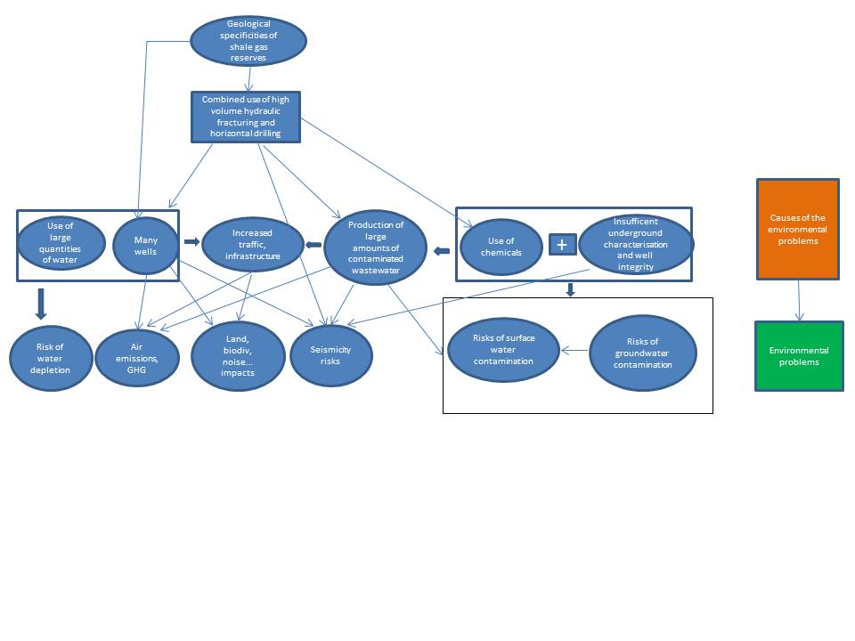

Overlap between water stressed regions and shale gas resources in Europe

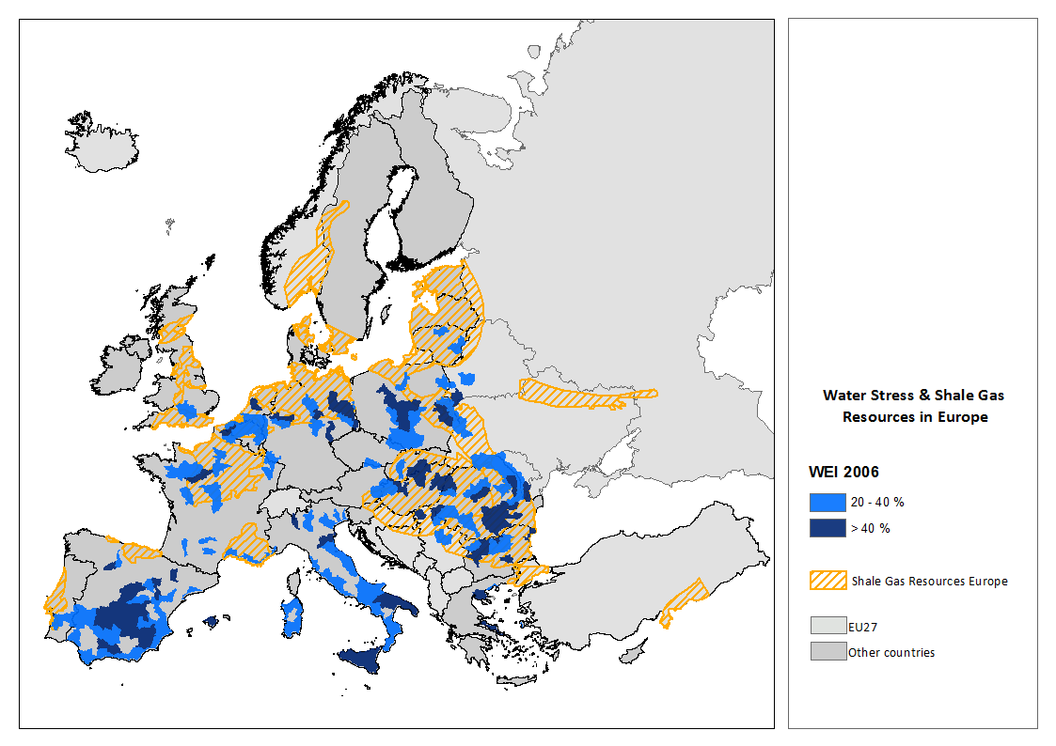

Source: JRC IES
Data used: IEA, Golden Rules 2012 report for the shale plays and Water Exploitation Index (WEI) computed using the LISQUAL model, IES, JRC, for the Water Stressed regions

Shale gas resources in Europe over trans-boundary groundwater bodies

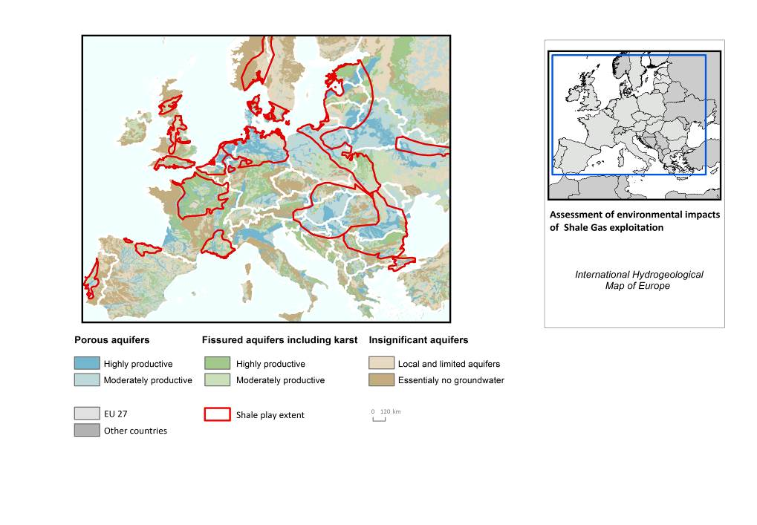

Source: JRC IES
Data sources used:
- Shale plays: IEA, Golden Rules 2012 report
- Groundwater resources: Hydrogeological map for Europe (compiled by BGR and UNESCO). Aquifers are distinguished by the texture of the rock (porous versus fissured) and by the potential groundwater storage in volume (productivity)

Elements of comparison between conventional and unconventional fossil fuels extraction practices

According to the International Energy Agency, "producing unconventional gas is an intensive industrial process, generally imposing a larger environmental footprint than conventional gas development".
A risk assessment conducted by independent experts in the framework of a 2012 study sponsored by Exxon-Mobil in Germany concluded that hydraulic fracturing used in unconventional gas extraction “entails the following new risk dimension that does not arise in connection with conventional gas production (in Germany)”: "most (of Germany's) unconventional gas reservoirs are located closer to the surface, closer to usable groundwater, and closer to ecosystems that depend for their survival on groundwater. Exploiting unconventional gas reservoirs (a) entails the realization of numerous wells and hydrofracking operations; and (b) involves the following additional elements and risks relative to conventional gas production: A greater amount of land is needed […], more trucks and pipelines, as well as greater numbers of chemical, wastewater and natural gas filling, cleaning and storage cycles; and this of course translates into a greater risk of accidents".
Diverging views are raised by the oil and gas industry, claiming that there are no scientifically objective criteria to single out shale resource development activities, with associated environmental risks being very similar to those of conventional activities.

The table below presents the amount of water used for gas (conventional and unconventional) and oil

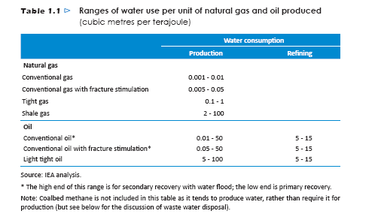

The table below (source: AEA 2012) presents the main differences between conventional and unconventional hydrocarbon extraction:

Development & Production Stage | Step | Decision factors | Differences from Conventional Hydrocarbon practices
Site Selection and Preparation | Site identification | Production yield versus development cost | None
Site Selection and Preparation | Site selection | Number of wells required | Many more shale gas wells are required for recovery of a given volume of gas than for recovery of the same volume of gas from conventional reservoirs. Of the order of 50 shale gas wells might be needed to recover the same volume of gas as a typical North Sea well
Site Selection and Preparation | Site selection | Proximity to buildings / other infrastructure  Geologic considerations  Proximity to natural gas pipelines  Feasibility of installing new pipelines | None  None  None  None
Site Selection and Preparation | Site selection | Site area (around 3 hectares/well needed during fracturing) | More space required during hydraulic fracturing for tanks / pits for water / other materials required for fracturing process (New York State 2011 PR p5-6)
Site Selection and Preparation | Site selection | Access roads / requirement improvements | More lorry movements during hydraulic fracturing than conventional production sites due to need to transport additional water, fracturing material (including sand/ceramic beads) and wastes
Site Selection and Preparation | Site selection | Availability and cost of water supply and wastewater disposal | Obtaining large volumes of water (10,000 to 25,000 m³ per well)  Disposing of large volumes of contaminated water (up to19,000 m³flowback water per well assuming up to 75% recovery, together with produced water) (Derived from Broderick et al 2011 NPR)
Site Selection and Preparation | Site selection | Availability of space to store make up water and wastewater | Storage of large volumes of water (10,000 to 25,000 m³ per well) Will require sufficient trucks / tanks onsite to manage flowback (e.g. 250 – 625 trucks at 40 m³ per truck) (derived from New York State DEC 2011 PR p6-302)
Site Selection and Preparation | Site preparation | Number of wellheads per pad and per hectare  Well pad design to control run off and spills and contain leaks  Amount of water / proppant needed for production activities | Installation of additional tanks / pits sufficient to accommodate up to 25,000 m³ of make-up water  6-10 wells/pad (New York State 2011 PR p3-3) whereas 1 well/pad has been more common for conventional production  Fewer wellpads/hectare: 1 multi-well horizontal well pad can access c. 250 hectares, compared to c.15 hectares for a vertical well pad (New York State 2011 PR p5-17)
Well Design, drilling, casing and cementing | Selection of horizontal vs vertical well  Well drilling | Separation of aquifer from hydrocarbon bearing formation by impermeable layers  Existence of fault / fracture zones  Maximising access to hydrocarbon in strata | Both conventional and unconventional wells may be drilled through water bearing strata and need to achieve the same performance standards. The hydraulic fracturing process places additional stresses on the well casing, which may require changes to the well design and/or additional monitoring
Well Design, drilling, casing and cementing | Selection of horizontal vs vertical well  Well drilling | Depth to target formation (vertical or horizontal) | Horizontal drilling produces longer well bore (vertical depth plus horizontal leg) requires more mud and produces more cuttings/well. Typically 40% more mud and cuttings for horizontal well compared to a vertical well, depending on depth and lateral extent ( New York State 2011 PR p5-34). However, horizontal wells allow access to a greater extent of shale gas formation, and are more effective for exploitation of a given shale gas formation.  Horizontal drilling requires specialist equipment: larger diesel engine for the drill rig uses more fuel and produces more emissions. Equipment is on site for a longer time (typically 25days for horizontal well compared to 13days for vertical well; New York State DEC 2011 PR p6-192).  However, horizontal wells have a smaller land surface footprint than conventional vertical wells(USEPA 2011a PR 3.2.1). Consequently, horizontal drilling from a limited number of well heads would in principle be preferable to vertical drilling from a larger number of well heads. In practice, horizontal drilling techniques are normally used to open up reservoirs which would not otherwise be viable with vertical drilling techniques, and so this comparison is not directly relevant.
Well Design, drilling, casing and cementing | Casing | Casing required or open hole construction (competent conditions only):casing would normally be required  Conductor (for wellhead)  Surface (to isolate near-surface aquifer from production)  Intermediate (to provide further isolation)  Production (in target formation)  Centred casing to enable cementing | Casing material must be compatible with fracturing chemicals (e.g., acids)  Casing material must also withstand the higher pressure from fracturing multiple stages
Well Design, drilling, casing and cementing | Cementing | Correct cement for conditions in well (e.g. geology and groundwater) and fracturing pressure | Hydraulic fracturing has the potential to damage cement: may pose a higher risk during re-fracturing, although unclear at present (EPA 2011 NPR p82)
Well Completion | Hydraulic Fracturing: Water sourcing | Quantity of water required for hydraulic fracturing  Quality of water required for hydraulic fracturing  Source and availability of water  Impact on water resources and surface water flows  Intensity of activity in watersheds / geologic basins | Requirement to abstract and transport water to wellhead for storage prior to hydraulic fracturing operations
Well Completion | Hydraulic Fracturing: Chemical Selection | Tailoring of fracturing fluid to properties of the formation / project needs  Tailoring chemicals to make up water quality (e.g., highly saline flowback, acid mine drainage) | Current information indicates that the composition of chemicals used in high volume fracturing is similar to that used in conventional fracturing (New York State DEC 2011 PR p5-54). Less harmful additives are being developed and used at lower concentrations in both conventional and unconventional applications (King 2011 PR p39). Record-keeping and disclosure of chemicals is also improving (e.g. see www.fracfocus.org).
Well Completion | Chemical Transportation |  | Transport of large volumes of water, chemicals and proppant to well pad (up to 25,000 m³ water per well, together with a further 8-15% proppant and 0.5-2% chemical additives; New York State DEC 2011 PR p5-51)
Well Completion | Chemical storage | Size, type, and material of tanks or other containers | More chemical storage required for high volume hydraulic fracturing (as for transportation above)
Well Completion | Chemical Mixing | Quality control on site to ensure correct mixture and avoidance of potentially harmful spills | Mixing of water with chemicals and propping agent (proppant)
Well Completion | Hydraulic Fracturing: Perforating casing | Use and type of explosive (not required if open-hole drilling is carried out) | Conventional wells are hydraulically fractured in North America, although this is uncommon in Europe. The amount and extent of perforations may be greater for high volume HF
Well Completion | Hydraulic Fracturing: Well injection of hydraulic fracturing fluid | Number of stages required  Need to inject small amount of fluid before fracturing occurs to determine reservoir properties and enable better fracture design  Pressure required to initiate fracturing with fracturing fluid without proppant dependent on depth and mechanical properties of formation  Monitoring and control of hydraulic fracturing process.  Number, size, timing and concentration of delivery slugs of fracturing fluid and proppant | Monitoring requirements and interaction of fracturing fluid with formation also occur in conventional wells but more extensive in high volume fracturing due to longer well length in contact with formation (up to 2,000 metres for HVHF compared to up to a few hundred metres for conventional well depending on formation thickness)  More equipment required: series of pump trucks, fracturing fluid tanks, much greater intensity of activity.
Well Completion | Hydraulic Fracturing: Pressure reduction in well / to reverse fluid flow recovering flowback and produced water | Chemical additions to break fracturing gels (if used)  Planning for storage and management of flowback recovered before the well starts gassing (varies from 0%-75% but strongly formation dependent).  Planning for storage and management of smaller volumes of wastewater generated during production (decreasing flow rates and increasing salt concentrations) | “Flowback” of fracturing fluid and produced water containing residual fracturing chemicals, together with materials of natural origin: brine (e.g., sodium chloride), gases (e.g., methane, ethane, carbon dioxide, hydrogen sulphide, nitrogen, helium), trace elements (e.g. mercury, lead, arsenic), naturally occurring radioactive material (e.g. radium, thorium, uranium), and organic material (e.g. acids, polycyclic aromatic hydrocarbons, volatile and semi-volatile organic compounds) (USEPA 2011a PR Table 5)
Well completion (continued) | Connection of well pipe to production pipeline | During exploration phase, natural gas is likely to be flared  Wells should be connected to production pipeline immediately in production phase. | In principle, no difference to conventional wells. However, potential for impacts in areas which would not otherwise be commercially viable
Well completion (continued) | Reduced Emission Completion | Capture gas produced during completion and route to production pipeline or flare it if pipeline is not available | Larger volume of flowback and sand to manage than conventional wells (10,000 to 25,000 m³ per well) (Derived from Broderick et al 2011 NPR)
Well completion (continued) | Well pad removal | Amount of wastewater storage equipment to keep on site  Remove unneeded equipment and storage ponds  Regrade and re-vegetate well pad | Larger well pad (with more wells/pad) with more ponds and infrastructure to be removed, as described above
Well Production | Construction of pipeline | May need to construct a pipeline to link new wells to gas network | Exploitation of unconventional resources may result in a requirement for gas pipelines in areas where this infrastructure was not previously needed
Well Production | Production | May need to refracture the well to increase recovery. This could take place up to four times over a 40 years well lifetime.  Wastewater management (e.g. discharge to surface water bodies, reuse or disposal via underground injection including transport to disposal site) | Produced water will contain decreasing levels of fracturing fluid as well as hydrocarbons  Conventional wells are often in wet formations that require dewatering to maintain production. In these wells, produced water flow rates increase with time. In shale and other unconventional formations, produced water flow rates tend to decrease with time.
Well Site Abandonment | Remove pumps and downhole equipment  Plugging to seal well | Need to install surface plug to stop surface water seepage into wellbore and migrating into ground water resources  Need to install cement plug at base of lowermost underground source of drinking water  Need to install cement plugs to isolate hydrocarbon, injection/disposal intervals | Abandonment of unconventional wells is similar to abandonment of conventional wells.
Post-abandonment | Potential for methane seepage to occur in the long-term if seals or liners break down | Proper design and construction of well plugs and liners.  Long-term monitoring programme of abandoned wells | Abandonment of unconventional wells is similar to abandonment of conventional wells.

Matrix of potential environmental impacts and risks from high volume hydraulic fracturing
(source: AEA 2012: summary of the potential environmental impacts and risks of shale gas extraction using high-volume hydraulic fracturing

Impacts and risks for groundwater, surface water and water resources (Impacts and risks specific to HVHF/Unconventional gas extraction are underlined )
Development & Production Stage | Step | Groundwater contamination and other risks and impacts | Surface water contamination risks and impacts | Water resource depletion
Site Selection and Preparation | Site identific-ation
Site Selection and Preparation | Site selection
Site Selection and Preparation | Site preparation |  | Runoff and erosion during site construction may lead to silt accumulation in surface waters (greater potential risk in HVHF because of larger well pads and storage impoundment construction)
Well Design | Deep well (directional)  Shallow vertical | Inadequate design could result in aquifer pollution. Risk of pollution via casing of inadequate depth and/or quality
Well drilling, casing and cementing | Drilling | Inadequate control of drilling process and associated wastes could result in groundwater or surface water pollution. | Leaks/spills of drilling mud and cuttings could result in SW pollution
Well drilling, casing and cementing | Casing | Inadequate casing quality or depth could result in pollution of groundwater during hydraulic fracturing, flowback, and gas production
Well drilling, casing and cementing | Cementing | Inadequate quality of cementation could result in pollution of groundwater during hydraulic fracturing, flowback, and gas production
Hydraulic Fracturing | Water sourcing: surface water and ground water withdrawals | Surface water abstraction could affect groundwater flow pathways, or quantity or quality | Temporary structures (hoses and pipes) used to remove source water from surface stream could cause bank erosion, potential for silt contamination of the stream. | Withdrawal from ground water resources may have the following impacts:  - Lowering of water table  - Dewatering drinking water aquifers  - Changes in water quality resultant from water use:  - Changes to salinity of water  - Chemical contamination resulting from mineral exposure to aerobic environment  - Lowering of water table may result in bacterial growth, taste or odour problems  - Lowering of water table may lead to release of biogenic methane into superficial aquifers  - Aquifer depletion may lead to upwelling of lower quality water or other substances (e.g. methane – shallow deposits) from deeper and subsidence or destabilization of geology  - Withdrawal from surface water resources (streams , ponds and lakes) can affect hydrology and hydrodynamics altering flow regime (depth, velocity and temperature), can reduce dilution and increase contaminants
Hydraulic Fracturing | Water sourcing:  Reuse of flowback and produced water | Flowback stored in surface impoundments prior to reuse can leak and cause GW contamination.  Risk of indirect effects following spillage and contamination of surface waters | Surface impoundments that store flowback prior to reuse can fail and cause SW contamination.  Flowback transported to another location: Accidents and spillages in transit can result in surface and/or ground water contamination.
Hydraulic Fracturing | Chemical additive transportation and storage; mixing of chemicals with water and proppant | Accidents and spillages on site can result in surface and/or ground water contamination, e.g. as a result of:  - Tank ruptures  - Equipment / surface impoundment failures  - Overfills  - Vandalism  - Accidents  - Fires  - Improper operations  If storage arrangements are inappropriate, rainfall can transfer materials offsite in run-off
Hydraulic Fracturing | Perforating casing | Inappropriate charge used to perforate casing could affect well integrity (e.g., crack cement and casing)
Hydraulic Fracturing | Well injection of hydraulic fracturing fluid | Fluid contaminants could be transferred to aquifers:  - via induced fractures extending beyond target formation to aquifer as a result of hydraulic fracturing operations and/or  - through complex biogeochemical reactions with chemical additives in fracturing fluid and/or  - via pre-existing fracture or fault zones and/or  - via pre-existing man-made structures where these intersect an injection zone or in vicinity of hydraulically fractured well serving as conduits  Sites close to, or hydraulically linked to water resources pose a greater risk | Risk of indirect impacts via groundwater contamination. Risks may result from HF fluid chemicals, contaminants in produced water, and/or gas migration. Sites close to, or hydraulically linked to water resources pose a greater risk
Hydraulic Fracturing | Pressure reduction in well to reverse fluid flow, recovering flowback and produced water | Risk of pollution due to spillage of flowback and produced water via  - Tank ruptures  - Equipment or surface impoundment failures  - Overfills  - Improper operations  These waters contain HF fluid, naturally occurring materials, as well as potentially reaction and degradation products including radioactive materials.  Risk of disruption to groundwater flows | Risk of direct impacts via spillage of flowback water; indirect impacts via groundwater contamination. Risks may result from HF fluid chemicals, contaminants in produced water, and/or gas migration. Sites close to, or hydraulically linked to water resources pose a greater risk
Well Completion | Handling of waste water during completion (planned management) |  | If permitted, direct discharge to surface streams can affect water quality, particularly from the high salt content (this practice is banned in the U.S.)  Treatment in municipal sewage treatment plant can affect the plant due to slugs of saline wastewater which can pass through the plant untreated.  Treatment in Centralized Waste Treatment facility: risks depend on the treatment process.
Well Completion | Handling of waste water during completion (accident risks) | Risk of pollution due to spillage of flowback and produced water via  - Tank ruptures  - Equipment or surface impoundment failures  - Overfills  - Vandalism  - Fires  - Improper operations  Risk of pollution if wastewater is re-used or disposed inappropriately  If flowback water is used to make up fracturing fluid, this would increase the risk of introducing naturally occurring chemical contaminants and radioactive materials to groundwater. Relevant naturally occurring substances could include:  - Salt  - Trace elements (mercury, lead, arsenic)  - NORM (radium, thorium and uranium)  - Organic material (organic acids, polycyclic aromatic hydrocarbons)
Well Completion | Connection of well pipe to production pipeline
Well Completion | Well pad removal |  | Improper grading may cause runoff and erosion and lead to silt accumulation in surface waters.  Drainage and removal of impoundment facilities could potentially result in accidental discharge to surface waters.
Well Production | Production  (including produced water management) | Risks posed by failure or inadequate design of well casing leading to potential aquifer contamination  Surface spills or release of produced water during storage on site could affect groundwater and surface waters, as for “Hydraulic Fracturing” above. At the beginning of the production phase, flowback will comprise mainly fracturing fluid, changing to produced water after a few days, with increased salt concentration.  Risk of pollution if wastewater is re-used or disposed inappropriately, as for “Hydraulic Fracturing” above
Well Production | Pipeline construction and operation | Risks due to spillage of materials during construction of pipeline
Well Production | Re-fracturing | Similar to “Hydraulic Fracturing” above | Similar to “Hydraulic Fracturing” above | Similar to “Hydraulic Fracturing” above
Well / Site Abandonment | Remove pumps and downhole equipment
Well / Site Abandonment | Plugging to seal well | Inadequate sealing of well could result in subsurface pathways for contaminant migration leading to groundwater pollution, and potentially surface water pollution  Existence of well could result in increased risks of pollution associated with future subsurface activity.

Impacts and risks for air emissions, land take and biodiversity (Impacts and risks specific to HVHF/Unconventional gas extraction are underlined)

Development & Production Stage | Step | Release to air of HAPs/ O₃ precursors/ odours | Land take | Biodiversity risks and impacts
Site Selection and Preparation | Site identification
Site Selection and Preparation | Site selection
Site Selection and Preparation | Site preparation | Diesel emissions from site construction equipment. Minor risk due to fugitive emissions in the event of equipment fuel or oil spillage | Typical well head would remove an area of approx. 3ha from other uses (eg agriculture, natural habitat) for the duration of exploration and production (US Department of Energy 2009 NPR). It may not be possible to restore a sensitive habitat following operational phase | Risk of impacts on sensitive species during site preparation due to removal of habitat, introduction of invasive species; noise, disturbance, particularly in sensitive areas  Emissions, noise, human activity, traffic, land-take, habitat degradation, introduction of invasive species etc. could result in disturbance to natural ecosystems, particularly in sensitive areas
Well Design | Deep well (directional)  Shallow vertical
Well drilling, casing and cementing | Drilling | Diesel emissions from well drilling equipment. Minor risk due to fugitive emissions in the event of equipment fuel or oil spillage |  | Noise or plant movement during drilling could affect wildlife, particularly in sensitive areas
Well drilling, casing and cementing | Casing
Well drilling, casing and cementing | Cementing
Hydraulic Fracturing | Water sourcing: surface water and ground water withdrawals |  | On-site storage of water for hydraulic fracturing requires land-take | On-site storage and transportation of water can affect biodiversity due to land take, disturbance and/or by the introduction of non-native invasive species
Hydraulic Fracturing | Reuse of flowback and produced water | Risk of emissions to air of HAPs/ozone precursors/ odours, from inadequate control of gas leakage during completion, or from release of gases dissolved in liquids Possible fugitive emissions of methane or HAPs from flowback or produced water. Direct effects more severe in the vicinity of residential locations. Indirect effects may be more severe in rural areas
Hydraulic Fracturing | Chemical additive transportation and storage; mixing of chemicals with water and proppant |  |  | Accidents and spillages can result in harmful effects on natural ecosystems
Hydraulic Fracturing | Perforating casing (where present)
Hydraulic Fracturing | Well injection of hydraulic fracturing fluid | Diesel emissions from fracturing fluid pumps.  Risks posed by movement of naturally occurring substances to groundwater as described for groundwater contamination.  Relevant naturally occurring substances could include:  - Gases (natural gas (methane, ethane), carbon dioxide, hydrogen sulphide, nitrogen and helium)  - Organic material (volatile and semi-volatile organic compounds)
Hydraulic Fracturing | Pressure reduction in well to reverse fluid flow, recovering flowback and produced water | Volatile and semi-volatile chemicals may be released from flowback and produced waters during recovery (EPA, 2011b NPR). Direct effects more severe in the vicinity of residential locations. Indirect effects may be more severe in rural areas  Fugitive emissions may take place from routeing gas generated during completion to the sales pipeline. This is likely to be more severe from exploratory pre-pipeline wells than from developmental wells (pipeline in place) | Storage of flowback water and produced water requires land take
Well Completion | Handling of waste water during completion (planned management)
Well Completion | Handling of waste water during completion (accident risks) |  |  | Spillages of waste water could result in pollution or other disruption to habitats
Well Completion | Connection of well pipe to production pipeline
Well Completion | Well pad removal |  | (Return of land used for well pad to prior use or other uses)
Well Production | Production (including produced water management) | Fugitive losses could occur during production phase via valve leakage etc  Collect and treat gases dissolved in produced water along with methane | (After fracturing, the well pad may be removed or made smaller, reducing the footprint.) | Slight potential for disturbance to natural ecosystems during production phase due to human activity, traffic, land-take, habitat degradation, introduction of invasive species etc., particularly in sensitive areas
Well Production | Pipeline construction and operation | Risk of fugitive losses during production phase via valve or flange leakage | Pipeline requires land-take during construction and operation | Construction of new linear feature could adversely affect biodiversity, particularly in sensitive ecosystems
Well Production | Re-fracturing  Re-fracturing | Similar to “Hydraulic Fracturing” above, but should be possible to route emissions to the pipeline | Similar to “Hydraulic Fracturing” above | Similar to “Hydraulic Fracturing” above
Well / Site Abandonment | Plugging to seal well | Inadequate sealing of well could result in fugitive emissions following site abandonment | It may not be possible to return the entire site to beneficial use following abandonment, e.g. due to concerns regarding public safety | It may not be possible to return the site and any other affected areas to its previous state, which could be particularly significant for sites located in sensitive areas

Risks and impacts for noise, seismicity, visual impacts and traffic (Impacts and risks specific to HVHF/Unconventional gas extraction are underlined)
Development & Production Stage | Step | Noise | Seismicity | Visual impacts | Traffic
Site Selection and Preparation | Site identification
Site Selection and Preparation | Site selection
Site Selection and Preparation | Site preparation | Noise from excavation, earth moving, other plant and vehicle transport could affect residential amenity and wildlife, particularly in sensitive areas |  | Heavy plant, stockpiles, fencing, site buildings etc could result in adverse visual intrusion during site preparation | Transportation to/from well heads during site preparation can have significant adverse effects as above. Impact likely to be more severe on unsuitable roads and for longer haulage distances
Well Design | Deep well (directional)  Shallow vertical | Noise emissions from wellhead could affect residential amenity and wildlife, particularly in sensitive areas |  | Well heads constitute a potentially significant visual intrusion, particularly in non-industrial settings as above
Well drilling, casing and cementing | Drilling | Noise emissions from drilling or associated activity could affect residential amenity and wildlife, particularly in sensitive areas |  | Drilling activity and associated plant could constitute a potentially significant visual intrusion, particularly in non-industrial settings as above
Well drilling, casing and cementing | Casing
Well drilling, casing and cementing | Cementing
Hydraulic Fracturing  Reuse of flowback and produced water  Chemical additive transportation and storage; mixing of chemicals with water and proppant  Perforating casing (where present)  Well injection of hydraulic fracturing fluid  Pressure reduction in well to reverse fluid flow, recovering flowback and produced water | Water sourcing: surface water and ground water withdrawals | Noise from use of pumps to handle water for hydraulic fracturing could affect residential amenity and wildlife, particularly in sensitive areas |  |  | Transportation of water to the site can have significant adverse effects due to noise, community severance, air emissions, accident/spillage risk etc. Impact likely to be more severe on unsuitable roads and for longer haulage distances
 | Reuse of flowback and produced water | Noise from use of pumps to handle water for hydraulic fracturing could affect residential amenity and wildlife, particularly in sensitive areas
 | Chemical additive transportation and storage; mixing of chemicals with water and proppant |  |  | Chemicals storage tanks and related plant could constitute a potentially significant visual intrusion, particularly in non-industrial settings as above | Transportation of chemicals to the site can have significant adverse effects due to noise, community severance, air emissions, accident/spillage risk etc. Impact likely to be more severe on unsuitable roads and for longer haulage distances
 | Perforating casing (where present)
 | Well injection of hydraulic fracturing fluid |  | Hydraulic fracturing could be associated with minor earth tremors up to 4.0 on Richter scale | Hydraulic fracturing plant could constitute a potentially significant visual intrusion, particularly in non-industrial settings as above
 | Pressure reduction in well to reverse fluid flow, recovering flowback and produced water | Noise emissions associated with operation of well and associated equipment could affect residential amenity and wildlife, particularly in sensitive areas
Well Completion | Handling of waste water during completion (planned management) |  | Injection of waste water could potentially be associated with minor earth tremors | Waste water tanks and related plant could constitute a potentially significant visual intrusion, particularly in non-industrial settings as above | Transportation of waste water to treatment/disposal facility can have significant adverse effects due to noise, community severance, air emissions etc. Impact likely to be more severe on unsuitable roads and for longer haulage distances
Well Completion | Handling of waste water during completion (accident risks) |  |  |  | Transportation of waste water to treatment/disposal facility can have significant adverse effects due to accident/spillage risk. Impact likely to be more severe on unsuitable roads and for longer haulage distances
Well Completion | Connection of well pipe to production pipeline
Well Completion | Well pad removal | Noise from construction/demolition machinery |  | (Benefit from removal of site infrastructure)
Well Production | Production |  |  | Site plant and equipment could have a visual impact, particularly in residential areas or high landscape value areas, but much less than during fracturing
Well Production | Pipeline construction and operation | Noise from pipeline construction could affect residential amenity and wildlife, particularly in sensitive areas |  | Pipeline could have a significant visual impact, particularly in residential areas or high landscape value areas | Transportation of materials and equipment could have adverse effects due to noise, community severance etc during construction phase
Well Production | Re-fracturing | Similar to “Hydraulic Fracturing” above | Similar to “Hydraulic Fracturing” above | Similar to “Hydraulic Fracturing” above | Similar to “Hydraulic Fracturing” above
Well / Site Abandonment | Plugging to seal well |  |  | It may not be possible to remove all wellhead equipment from site

Summary of EU legislation applying to unconventional fossil fuels, in particular shale gas activities

EU treaties
According to Article 194(2) of the Treaty on the Functioning of the European Union (TFEU), Member States have the right to determine the conditions for exploiting their energy resources.
With due regard to the need to preserve and improve the environment (Article 194(1) TFEU), each Member State has the responsibility to decide whether it will allow prospection, exploration and/or production of unconventional gas resources within its jurisdiction. This provision is without prejudice to Article 192(2)(c) of the TFEU, according to which measures significantly affecting a Member State’s choice between different energy sources and the general structure of its energy supply can be adopted but they require a unanimous decision of the Council in accordance with a special legislative procedure.
Member States must ensure – via appropriate assessment, licensing and permitting regimes as well as through monitoring and inspection activities – that any exploration or exploitation of energy sources, including those using hydraulic fracturing practices, complies with the requirements of the existing legal framework in the EU, including provisions on the protection of human health and the environment. The precautionary and prevention principles are part of the guiding principles for the development of the EU's environmental policy, as set out in Article 191 of the TFEU.

General EU legislation
The Hydrocarbons Directive (94/22/EC) sets provisions on granting and using authorisations for the prospection, exploration and production of hydrocarbons. This Directive focuses on ensuring competition in national licensing procedures and equal access to national bidding rounds.
The EU legislation on the health and safety of workers, and in particular Directive 92/91/EEC on the safety and health protection of workers in the mineral extracting industries through drilling, applies to unconventional fossil fuels. Provisions on well control focus on the protection of workers against blowouts. Although they can be complementary, the requirements do not address environmental aspects.
The recently adopted Directive on safety of offshore oil and gas operations (2013/30/EU) will apply to offshore oil and gas activities at the latest by July 2015 as far as prevention of major accidents and limiting the consequences thereof is concerned.
There is also EU legislation applicable to equipment, transport, noise, radiation (please refer to the table in annex 8.4 for reference)

EU environmental legislation
A Commission services guidance on the applicable environmental legislation to activities involving horizontal drilling and high volume hydraulic fracturing was published in 2011. The main relevant pieces of legislation relate to the following:
- The REACH regulation on the registration, evaluation, authorisation and restriction of chemicals (1907/2006/EC) and the Directive on the placing of biocidal products on the market (1998/8/EC) apply to the use of chemicals and biocidal products;
- The Environmental Impact Assessment (EIA) Directive (2011/92/EU) requires an EIA for projects involving the extraction of natural gas where the amount of gas extracted exceeds 500.000 m3 per day as well as a screening for deep drilling projects. A guidance on the application of the EIA Directive to unconventional fossil fuels projects was published in 2011. A guidance also exists on the application of the EIA for large scale transboundary projects.
- The SEA (Strategic Environmental Assessment) Directive (2001/42/EC) makes a strategic environmental assessment compulsory for plans and programmes prepared for i.a. energy, industry, waste management, water management, transport or land use and which set the framework for future development consent of projects covered by the EIA Directive or for which an assessment is required under the Habitats Directive.
- The Mining Waste Directive (MWD) (2006/21/EC) requires notably a waste management plan, monitoring of the waste facility, and a financial guarantee covering the obligations under the mining waste permit. It does not apply to waste from offshore operations.
- The Industrial Emissions Directive (2010/75/EU) would be applicable to shale gas exploration and exploitation under certain conditions.
- The Water Framework Directive (2000/60/EC) requires the operator to obtain an authorisation for water abstraction (unless it is considered that the abstraction will not cause any significant impact) and prohibits the discharge of pollutants into groundwater. The Groundwater Directive (2006/118/EC) is also applicable.
- The Environmental Liability Directive (ELD) (2004/35/EC) at least partly applies to shale gas related activities: a strict liability regime (no need to prove fault) applies for dangerous activities listed under Annex III, encompassing related activities such as the management of waste. It requires operators to prevent and remedy environmental damage caused by activity and to bear the cost of the associated prevention or remediation measures.
- Directive on the control of major-accident hazards involving dangerous substances (Seveso II and III) would apply depending on whether the threshold related to the storage of gas or of dangerous substances on-site are met.
- Directive on the conservation of natural habitats and of wild fauna and flora (Habitats Directive 92/43/EC) requires an assessment of the effects of a plan or project on a protected site.
- Effort sharing decision (406/2009/EC) on the effort of Member States to reduce their GHG emissions up to 2020 applies to fugitive methane emissions, provided the latter are correctly reported in the GHG inventories.

Main applicable EU legislation
(source: AMEC 2013)
Regulation (EC) No 595/2009 of the European Parliament and of the Council of 18 June 2009 on type-approval of motor vehicles and engines with respect to emissions from heavy duty vehicles (Euro VI) and on access to vehicle repair and maintenance information and amending Regulation (EC) No 715/2007 and Directive 2007/46/EC and repealing Directives 80/1269/EEC, 2005/55/EC and 2005/78/EC (OJ L 188, 18.7.2009, p. 1–13)
Directive 2008/50/EC of the European Parliament and of the Council of 21 May 2008 on ambient air quality and cleaner air for Europe (OJ L 152, 11.6.2008, p. 1–44)
Regulation (EU) No 528/2012 of the European Parliament and of the Council of 22 May 2012 concerning the making available on the market and use of biocidal products (OJ L 167, 27.6.2012, p. 1–123)
Directive 98/8/EC of the European Parliament and of the Council of 16 February 1998 concerning the placing of biocidal products on the market (OJ L 123, 24.4.1998, p. 1–63)
Directive 2011/92/EU of the European Parliament and of the Council of 13 December 2011 on the assessment of the effects of certain public and private projects on the environment (OJ L 26, 28.1.2012, p. 1–21)
Directive 2004/35/CE of the European Parliament and of the Council of 21 April 2004 on environmental liability with regard to the prevention and remedying of environmental damage (OJ L 143, 30.4.2004, p. 56–75)
Directive 2002/49/EC of the European Parliament and of the Council of 25 June 2002 relating to the assessment and management of environmental noise - Declaration by the Commission in the Conciliation Committee on the Directive relating to the assessment and management of environmental noise (OJ L 189, 18.7.2002, p. 12–25)
Council Directive 80/68/EEC of 17 December 1979 on the protection of groundwater against pollution caused by certain dangerous substances (OJ L 20, 26.1.1980, p. 43–48)
Directive 2006/118/EC of the European Parliament and of the Council of 12 December 2006 on the protection of groundwater against pollution and deterioration (OJ L 372, 27.12.2006, p. 19–31)
Directive 2010/75/EU of the European Parliament and of the Council of 24 November 2010 on industrial emissions (integrated pollution prevention and control) (OJ L 334, 17.12.2010, p. 17–119)
Directive 2006/21/EC of the European Parliament and of the Council of 15 March 2006 on the management of waste from extractive industries and amending Directive 2004/35/EC (OJ L 102, 11.4.2006, p. 15–34)
Council Directive 92/43/EEC of 21 May 1992 on the conservation of natural habitats and of wild fauna and flora (OJ L 206, 22.7.1992, p. 7–50)
Directive 2009/147/EC of the European Parliament and of the Council of 30 November 2009 on the conservation of wild birds (OJ L 20, 26.1.2010, p. 7–25)
Council Directive 96/29/Euratom of 13 May 1996 laying down basic safety standards for the protection of the health of workers and the general public against the dangers arising from ionizing radiation (OJ L 159, 29.6.1996, p. 1–114)
Directive 97/68/EC of the European Parliament and of the Council of 16 December 1997 on the approximation of the laws of the Member States relating to measures against the emission of gaseous and particulate pollutants from internal combustion engines to be installed in non-road mobile machinery (OJ L 59, 27.2.1998, p. 1–86)
Directive 2000/14/EC of the European Parliament and of the Council of 8 May 2000 on the approximation of the laws of the Member States relating to the noise emission in the environment by equipment for use outdoors (OJ L 162, 3.7.2000, p. 1–78)
Directive 2003/4/EC of the European Parliament and of the Council of 28 January 2003 on public access to environmental information and repealing Council Directive 90/313/EEC (OJ L 41, 14.2.2003, p. 26-32)
Regulation (EC) No 1907/2006 of the European Parliament and of the Council of 18 December 2006 concerning the Registration, Evaluation, Authorisation and Restriction of Chemicals (REACH), establishing a European Chemicals Agency, amending Directive 1999/45/EC and repealing Council Regulation (EEC) No 793/93 and Commission Regulation (EC) No 1488/94 as well as Council Directive 76/769/EEC and Commission Directives 91/155/EEC, 93/67/EEC, 93/105/EC and 2000/21/EC (OJ L 396, 30.12.2006, p. 1–849)
Directive 2001/42/EC of the European Parliament and of the Council of 27 June 2001 on the assessment of the effects of certain plans and programmes on the environment (OJ L 197, 21.7.2001, p. 30-37)
Council Directive 96/82/EC of 9 December 1996 on the control of major-accident hazards involving dangerous substances (OJ L 10, 14.1.1997, p. 13–33)
Directive 2012/18/EU of the European Parliament and of the Council of 4 July 2012 on the control of major-accident hazards involving dangerous substances, amending and subsequently repealing Council Directive 96/82/EC (OJ L 197, 24.7.2012, p. 1–37)
Council Directive 92/91/EEC of 3 November 1992 concerning the minimum requirements for improving the safety and health protection of workers in the mineral- extracting industries through drilling (eleventh individual Directive within the meaning of Article 16 (1) of Directive 89/391/EEC) (OJ L 348, 28.11.1992, p. 9-24)
Council Directive 91/271/EEC of 21 May 1991 concerning urban waste-water treatment (OJ L 135, 30.5.1991, p. 40–52)
Directive 2008/98/EC of the European Parliament and of the Council of 19 November 2008 on waste and repealing certain Directives (OJ L 312, 22.11.2008, p. 3–30)
Directive 2000/60/EC of the European Parliament and of the Council of 23 October 2000 establishing a framework for Community action in the field of water policy (OJ L 327, 22.12.2000, p. 1–73)
Regulation (EC) N° 1013/2006 of the European Parliament and of the Council of 14 June 2006 on shipments of waste (OJ L 190, 12.7.2006, p. 1-98)

Guidance
In 2011, Commission services released guidance summarizing the existing EU environmental framework applicable to unconventional fossil fuels projects involving the use of horizontal drilling and HVHF, such as shale gas. It concluded that the existing EU environmental acquis applies to such activities. Yet more information was needed to determine whether or not the level of health and environmental protection provided under the current EU legal framework is appropriate.
The draft note was submitted to the Legal Service of the Commission, which clearly stipulated that it was not possible to conclude at this stage that the framework is "adequate and sufficient", in the absence of sufficient information on the fracturing process itself and the environmental risks and impacts of such projects. To this end, DG ENV commissioned external studies, so as to be able to compare the identified impacts and risks with the existing legislation applicable both at EU and national level, hence allowing concluding on whether or not such legislation is sufficient.
The enforcement of such guidance is generally weak and was not sufficient to clarify the situation (see Milieu study 2013 on the regulatory framework applicable in 8 Member States).

.

Main ambiguities/uncertainties and gaps in the EU acquis

Water
The main ambiguities in the current EU acquis relate to the interpretation of art. 11.3 (j) of the Water Framework Directive which prohibits the direct discharge or input of pollutants into groundwater.
Identifying whether or not hydraulic fracturing may lead to a direct discharge of pollutants into groundwater would require a site-specific hydrogeological risk assessment. There are no criteria for such assessment within the Water Framework Directive. The site-specific hydrogeological risk assessment is at the discretion of Member States and may or may not be conducted. In the latter case, it could put groundwater at risk.
There is also uncertainty at national level as to what constitutes a direct discharge vs. indirect discharge in the context of hydraulic fracturing, i.e whether a possible groundwater contamination following an unexpected extension of the fractures beyond the shale formation would qualify as direct or indirect discharge of pollutants.
The Water Framework Directive requires Member States to control abstraction of freshwater and to conduct monitoring for abstraction of water from drinking water areas above certain volumes of water abstracted per day. The Water Framework Directive, as a horizontal instrument to ensure water protection, requires baseline water monitoring at river basin level but not specifically at the project site. It may result in the absence of systematic baseline monitoring prior to operations, which would then make it difficult to assess possible impacts to water.

Waste from high volume hydraulic fracturing operations
The Mining Waste Directive (MWD) (art. 11) provides for requirements for the "suitable location" of the "waste facility", taking into account "geological, hydrological, hydrogeological, seismic and geotechnical factors". Commission Decision 2009/360/EC on waste characterisation includes an analysis of the geological background of the deposit to be exploited.
Such general geological requirements would apply to the underground structure of a shale gas installation, should it qualify as a "waste facility". A "waste facility" is defined as "any area designated for the accumulation or deposit of extractive waste, whether in a solid or liquid state or in solution or suspension", whether on the ground or underground. The boundaries of such "waste facility" are uncertain in the case of a shale gas well as the horizontal leg of the well is perforated to enable access to widely dispersed pores of gas. A number of Member States have called for clarification as to the scope of application of the MWD, especially as to whether the MWD applies to both surface and sub-surface and whether it applies from the start or only after closure of the well.
There are also divergent interpretations at national level as to whether the injection of wastewater from high volume hydraulic fracturing activities underground for disposal is allowed under the Water Framework Directive.

Industrial emissions
There have been requests for clarification as to which extent the Industrial Emissions (IED) Directive would apply to unconventional fossil fuels exploration and extraction. Such application would inter alia depend on whether the injected fracturing fluids remaining underground qualify as “underground storage of hazardous waste of 50 tonnes or more”. This would require a characterisation of the likely composition of the waste prior to starting hydraulic fracturing operations.
Among the eight Member States examined by Milieu in a study for DG ENV, as of March 2013, one Member State (LT) requires an IPPC/IED permit for unconventional fossil fuels projects.

Environmental Impact Assessment (EIA)
Under the current EIA Directive, a screening is required prior to giving consent to shale gas exploratory projects, as the latter fall under "deep drilling projects" covered by the EIA Directive (Annex II). A large discretion is left to Member States to decide whether or not to conduct a full EIA, which has raised public concerns.
An EIA is mandatory for projects involving the extraction of natural gas where the amount of gas extracted exceeds 500.000 m3 per day. The volume of gas produced per shale gas well very much varies within one play and in different shale gas plays. Although the EIA Directive applies to the well pad and not per individual well, this implies that in certain shale gas plays with low productivity rates, the 500 000 m3 threshold under Annex I of the EIA may not necessarily be reached, even at the production stage. It is therefore not guaranteed that shale gas production projects would fall systematically under the Annex I of the existing EIA Directive.
EIA related requirements for unconventional gas exploration and/or extraction differ amongst Member States, as illustrated by the study conducted by Milieu for DG ENV. While certain Member States require a mandatory EIA for both exploration and extraction of unconventional hydrocarbons (BG), or for drilling projects involving the use of hydraulic fracturing at both phases (DK; LT), other Member States transposed the EIA Directive without a specific reference to unconventional gas activities or hydraulic fracturing, leaving the authorities decide on a case by case basis. There is also no common understanding amongst the selected Member States as to the scope of the EIA and when it is required, in particular, whether or not it covers the concession area/well pad or wells individually.
The identification of possible underground impact pathways (e.g existing geological faults, abandoned wells; seismic prone areas) and the sub-surface dimension of projects are not explicitly mentioned in the existing EIA Directive and may therefore not be fully taken into account in the impact assessment. The EIA directive is currently under revision and may provide for a general clarification on this aspect. However it is a horizontal tool that cannot provide for underground risk assessment measures specific to activities involving the use of high volume hydraulic fracturing.

Strategic environmental assessment (SEA)
An environmental assessment must be carried out for all plans and programmes which are prepared for energy, industry, transport, waste management, water management, (…) or land use and which set the framework for future development consent of projects listed in the EIA Directive or which, in view of the likely effect on sites, have been determined to require an assessment under the Habitats Directive. Plans and programmes which determine the use of small areas at local level and minor modifications to plans and programmes must require an environmental assessment only where the Member States determine that they are likely to have significant environmental effects.
Strategic planning at the level of the shale gas play appears essential to anticipate cumulative environmental impacts over wide areas and optimise site selection. (i.e in terms of access to infrastructure, wastewater treatment facilities, water resources etc.).
There is already a Commission services guidance recommending the use of a strategic environmental assessment which did not lead to a significant uptake of strategic environmental assessment across Member States.

At present, only a few Member States (e.g UK and Lithuania) are developing plans or programmes setting the framework for shale gas projects. Without such plans or programmes, there is no obligation to conduct a strategic environmental assessment. There is therefore no systematic consideration given to the possible impacts of multiple activities on very wide areas (e.g certain shale gas plays reach more than 33 000 km2). This may lead to a sub-optimal allocation of resources such as water (and lead to possible conflicts of use), infrastructure, wastewater treatment plants, which would lead to increased costs for operators and public authorities.

Chemicals
The REACH regulation covers the registration, evaluation, authorisation and restriction of chemicals in the EU. This regulation is applicable to chemicals used for hydraulic fracturing and requires manufacturers and importers of substances to submit a registration for each substance manufactured or imported in quantities of 1 tonne or above per year. Exemptions apply i.a. to polymers, substances that are adequately registered under other legislation (i.e. biocides) and upon request, may apply to substances for product and process oriented research and development, and. As of 1 June 2018 all substances produced in volumes of more than 1 tonne per year have to be registered under REACH. Exposure scenarios for chemicals used under REACH cover realistic and foreseeable accidental release of substances.
In addition, REACH requires manufacturers and downstream users to apply for authorisation to be able to use substances of very high concern (e.g., substances classified as carcinogen, mutagen, or toxic for reproduction) that are placed on Annex XIV by submitting a dossier containing information on exposure, risks and alternatives. Such authorisations are subject to time-limited reviews. REACH also foresees a restriction process to regulate the manufacture, placing on the market or use of certain substances, if they pose an unacceptable risk to health or the environment. Such process can be initiated on a case by case basis if such risk arises. There are currently no restrictions on chemicals applicable specifically for hydraulic fracturing purposes under REACH.
Information on chemical substances, on their own or in mixtures, which have been registered under REACH and for which registration dossiers have been submitted to the European Chemicals Agency (ECHA) are made electronically available to the public pursuant to Article 119 of REACH.
At present, it is not possible to easily identify chemicals registered for use in hydraulic fracturing in the ECHA database due to a lack of specific use category in the Use Descriptor System, which is the reference for the industry in defining the use for which the registration is to be made. (no specific "Sector of Use" category nor specific "identified use name") A search in the ECHA database based on "uses" is presently not possible, although this should be made possible as of the end of 2013. Non confidential information accessible through the ECHA database is available per registered substance and not on a well per well basis. Consequently it does not allow academia nor the general public to know precisely which substances have been used for individual shale gas projects.
Article 118(2) of REACH provides a list with information, which is generally considered to undermine the protection of the commercial interests of the concerned parties. In practice this means that when ECHA is subject to an access to documents request, the following information will be considered confidential and will in principle not be publicly disclosed: e.g. details on the full composition of a mixture or the precise tonnage of a substance or mixture manufactured or placed on the market. Only in cases where urgent action is essential to protect human health, safety or the environment ECHA may disclose the information referred to under Article 118(2).

Examples of North American regulatory and non-regulatory developments
- US EPA regulatory action at federal level
- Underground Injection Control requirements (covering disposal of O&G waste underground and use of diesel in hydraulic fracturing): provides for consideration of the geology, confining zones, formation fracture pressure, distance to drinking water operating procedures (e.g injection pressures), monitoring and regular testing and inspection, reporting, record-keeping and closure requirements
- Air rules : mandatory capture of gas ("reduced emissions completion") as of 2015
- US Greenhouse Gas Reporting Rule: requires onshore natural gas operators to report CO₂, CH₄ and N₂0 emissions from 18 emission sources on each well-pad. From 2014 onwards operators will have to comply with the required methods of measurement, leak detection and sampling, which should increase accuracy of the data.
- The New Source Performance Standards (NSPS): regulates volatile organic compound (VOC) emissions (and GHG emissions as a co-benefit) in the crude oil and natural gas sector. Under this rule gas venting from hydraulically fractured gas well completions is no longer allowed. Producers are expected to either install combustion devices (flaring) or use Reduced Emissions Completions (RECs) when hydraulically fracturing new gas wells. As of 1 January 2015, RECs will be mandatory, with the exception of low pressure gas wells and exploration wells. Furthermore, the rule also sets cost-effective performance standards for gas wells, storage vessels, certain controllers and certain compressors. The NSPS regulation requires annual reporting for each affected facility, all emission data and reporting requirements are not entitled to confidential treatment and shall be made available to the public.

- US Bureau of land management (BLM) : draft fracking rules applicable to public land
Aims at modernising 30 years old rules not fitting « modern hydraulic fracturing activities» to "improve public awareness and strengthen oversight of hydraulic fracturing" by providing i.a for:
- proposal for hydraulic fracturing or re-fracturing must be approved by BLM (incl. geological information, depths of occurrence of all usable water, depth of operations, pressure used)
- mandatory disclosure by operators to disclose the chemicals they use in fracturing activities on public lands;
- need to ensure well integrity
- need to ensure operators prepare a wastewater management plan
- As a complement to state regulations on hydraulic fracturing (such as Colorado, Wyoming, North Dakota, and Texas).

- Center for sustainable development of shale gas
Voluntary agreement between environmental organizations (incl. Environmental Defense Fund), philanthropic foundations, energy companies (incl. Chevron, Shell) and other stakeholders along 15 principles including notably:
- comprehensive characterization of subsurface geology, including a risk analysis, that demonstrates the presence of an adequate confining layer, thorough investigation of any active or abandoned wellbores within such area of review or other geologic vulnerabilities (e.g., faults) that penetrate the confining layer and adequately address identified risks.
- baseline and periodic water monitoring
- maximize water recycling (90% recycling target in areas in which an operator is a net water user)
- no venting for production wells; any gas not capture must be flared; limitations on flaring
- ban on the use of open pits to store wastewater within 2 years (use closed tanks instead)
- disclosure of chemicals and use reduced toxicity fracturing fluid

- British Columbia
Had to modernize its legislation following the development of unconventional fossil fuels
- Mandatory disclosure of fracturing fluids
- Goal to “eliminate all routine flaring at oil and gas producing wells and production facilities by 2016 with an interim goal to reduce routine flaring by half (50 per cent) by 2011."
- Looking into multi-activity permitting over large shale gas areas (at full shale gas basin).
- Companies need to report contamination incidents and non-compliance issues are publicly disclosed.

- Alberta
- subsurface reservoir management and wellbore integrity among key challenges identified
- regulations are in place with regard to groundwater, wellbore casing and cementing, fracking fluid handling, and reinjection into deep water wells, water use allocation approvals, flaring and venting, well completion (especially for shallow fracking), facilities design and operations and waste management.
- currently developing a regulatory framework for unconventional resources, discussing in particular on how to regulate on an areal basis (to manage water access, water use, community disruption) (to be completed by 2015)

- US Natural Gas STAR program
Natural Gas STAR program is a voluntary instrument set up to reduce non-CO₂ GHG emissions in the oil and natural gas sector. Natural Gas STAR program partners represent 59 percent of the U.S. natural gas industry, spanning the production, gathering and boosting, transmission and the distribution sectors (although not all in shale gas). The program does not contain any reduction targets, it merely recommends to operators cost-effective technologies that would reduce methane emissions. The partners have allegedly reduced emissions by over 400 million metric tonnes of CO₂ equivalent since the program’s inception in 1993. However, this figure cannot be verified, as the program contains no monitoring requirements.

Shale gas related developments in Member States
(based on official information collected between Oct. 2012 and October 2013) HF= hydraulic fracturing
 |  | Shale gas activities | Legislative developments
AT |  | No application received for shale gas projects | Obligatory EIA for HF since Aug. 2012
BE |  | Flemish Region: one concession for the exploration of coal bed methane in parts of the Campine Basin (363 km2). If the desk study is successful, at least one vertical drilling is foreseen, possibly followed by horizontal drillings. No hydraulic fracturing foreseen.  Several operators are considering concession applications for shale gas, tight gas and coalbed methane in Flanders (Campine Basin).  Walloon Region: no concessions granted, although potential for coal bed methane. | The Flemish Minister for Natural Resources and Environment stated in the Flemish Parliament (14 May 2013) that no concession applications that imply hydraulic fracturing will be considered prior to the conclusion of the EU initiative.
BG |  | Use of HF prohibited for exploration and exploitation of oil and gas since Jan. 2012 (amendment June 2012) | Obligatory EIA for exploration and exploitation of unconventional hydrocarbons, incl. shale gas; further possible changes in the Bulgarian Underground Resources Act and/or related legislation may be foreseen
CZ |  | No concessions have been granted for shale gas; priority given to environment and health protection over prospection and exploration of unconventional gas (Decision of Czech Government of Feb 20th, 2013) | The Ministry for Environment was requested to prepare proposals for changes in the CZ legislation to reflect technologies used for shale gas.
DK |  | 2 concessions granted for exploration and production (2010); 1-2 exploration wells foreseen with fracturing in the next few years | Mandatory EIA for exploration and extraction of shale gas since July 2012.
DE |  | 30 permits granted in 6 Laender for shale gas exploration; 1 well drilled and fracked; moratorium on HF in North Rhine Westphalia | Draft law proposed by Ministries for Environment and Economy prior to the Sept 2013 elections to ban fracking in water protection areas and provide for a mandatory EIA for deep wells involving HF (but this law has not yet been adopted)
EE |  | Mainly involved in oil shale at present. | The Ministry of the Environment has begun the preparation of a National Development Plan for the Use of Oil Shale for 2016–2030, which will be subject to a Strategic Environmental Assessment (SEA).
ES |  | 7 concessions granted (475 000 ha) under central state responsibility (some further concessions may have been granted at regional level); Several licensing areas in Gran Enara region; 14 exploration wells foreseen (none drilled); moratorium/ban on hydraulic fracturing in Cantabria region and La Rioja regions | Government proposal sent to Parliament proposing a mandatory EIA for all wells involving HF.  The research body “Instituto Geologico y Minero de España” is currently preparing a report for the Ministry of Environment, with recommendations on prevention and mitigation measures for unconventional hydrocarbon exploration.
FR |  | Prohibition of HF for exploration and exploitation of liquid and gaseous hydrocarbons, July 2011 (expected to remain in place until at least 2017).  The French constitutional court confirmed the validity of the law in October 2013.  No new permit for hydrocarbons exploration will be granted before the review of the French mining code in 2014. | Mining code under review, notably to align it to environmental regulations and to strengthen public participation
HU |  | Mainly involved in tight gas activities; 6 concessions granted for shale gas and tight gas; on-going shale gas tendering process | The Mining Act introduced the term “unconventional hydrocarbons” in 2008 for specific license area and royalty provisions
IE |  | No exploration licences yet granted.  Research study expected to be commissioned soon by the Environmental Agency of Ireland (in cooperation with Northern Ireland) on environmental impacts of shale gas and best practices. | Applications for exploration licences would be subject to an EIA.
LV |  | On-going assessment of existing geological information (with US Geological Survey)
LT |  | A tender for shale gas exploration and exploitation concessions was awarded to Chevron, which however then withdrew from the bid.  As Chevron was the only participant, it was decided to declare the tender void on 29 Oct. 2013. The Lithuanian Geological Service is currently evaluating the Lithuanian legal and tax environment, prior to the organisation of a new tender. | As of 30 May 2013, the following changes have been made in national law:  - Mandatory EIA for exploration and exploitation of unconventional hydrocarbons wells, particularly shale gas and shale oil  - Prohibitions of unconventional hydrocarbons exploration and (or) exploitation in protected areas, drinking water bodies protection zones, as well as consumers of drinking water supply systems (wells) areas.  - Mandatory information to be provided to the competent authority on the composition and amount of substances used.  - Mandatory complex (air, water, soil) environmental monitoring from the beginning of the exploration phase.
NL | 3 shale gas concessions have been granted; On-going moratorium.  It was decided in Sept. 2013 to carry out a study ("structural plan") over 1 year and a half to identify possible locations for test drilling over roughly 25% of the Dutch territory. This period will also be used to optimize drilling techniques. In the meantime, no further exploration licences will be granted.  5-10 exploratory wells could be drilled depending on whether or not the moratorium is lifted |  | On-going moratorium
PL | 108 concessions granted for shale gas prospection and exploration (total 87 138 km2, approx. 27% of PL territory); 46 shale gas exploration wells were completed as of April 2013 (3 wells are in the process of drilling) (out of which 10 vertical wells were hydraulically fractured; 6 horizontal or directional wells were hydraulically fractured; 3 wells with Diagnostic Fracture Injection Test or micro- hydraulically fractured.) As of 1st June 2013, companies are obliged to drill 122 exploration wells by 2021 (with the option to drill 223 more - depending on the results of the work carried out by investors). |  | On 12 June 2013, new draft provisions amending the Geological and Mining Law Act, as well as environmental legislation were presented with a focus on the extraction of hydrocarbons from conventional and unconventional sources. A draft ordinance on projects having a significant impact on the environment was adopted on 26th June 2013 with entry into force within two weeks. Shale gas exploratory projects located above 5kms deep would not be subject to a screening nor a full EIA. Changes in the national legislation applicable to shale gas are expected by the end of 2013.
PT | 5 onshore exploration and exploitation concessions granted. (prospecting phase, no wells drilled yet).  If the results are positive, several wells may be drilled. |  | Several scientific studies are being analysed in order to evaluate the environmental aspects and the procedures/regulations already applied in other countries.  A working group was set up (competent authority, geoscientists and environment representatives), to develop recommended practices to be followed during shale gas exploration/exploitation activities.
RO | Following parliamentary elections of Dec. 2012, the moratorium is lifted and the new government programme for 2013-2016 now specifically states that ‘exploration activities for the identification of exploitable unconventional resources’ is a priority activity. RO unconventional gas potential is currently being explored as part of a National Geological Programme.  Permits granted (Chevron) but public opposition took place in October 2013 at the first site of shale gas exploration
SI | No shale gas reservoir; tight gas reservoirs HF (at least 26 HF between 1973-1997 and 1 recent in 2011)
SE | 5 concessions (one of which abandoned); no HF yet (proposed in 2 concessions)
UK | Licensing areas granted; 4 shale gas exploratory wells drilled (1 with HF); activities suspended following two minor earthquakes; moratorium lifted since Jan. 2013; re-permitting procedures on-going (subject to seismic monitoring requirements). Next licensing round foreseen in 2014. A Strategic Environmental Assessment (SEA) will be conducted.  20-40 exploratory wells are foreseen in the next 2-3 years. Production expected to start from 2017.  The broad areas where operators are showing interest in exploring for unconventional gas are in North West England, South Wales, South West England, South East England and North East England. The exploration for shale gas in Scotland is also expected to increase in the coming years. Extensive development of well pads across the current licensed area in Northern Ireland is expected, should the commercial viability of the resource be proven by current exploratory works. |  | UK set up a new office of unconventional gas and oil to promote their safe extraction. A new tax regime for shale gas was proposed, subject to a consultation until Sept. 2013. Possible tax legislation foreseen in Finance Bill 2014.  Scotland Environment Agency published permitting guidance on CBM and shale gas in 2012.  England Environment Agency drafted permitting guidance on on-shore oil and gas exploration, subject to public comments until 23rd October 2013.  Standard rules are being drafted (especially on waste streams) by the England Environment Agency to be completed by February 2014. The objective is to speed up the permitting procedure.  Operators will be required to disclose chemicals used on a well-by-well basis in England and Wales.  Separate environmental regulatory framework for applications involving hydraulic fracturing in Northern Ireland.

Foreseen developments of relevant pieces of EU legislation
- On-going revision of the Environmental Impact Assessment (EIA) Directive (2011/92/EU): A proposal for a revised EIA Directive was put forward by the Commission on 26th October 2012, which is currently being discussed with the European Parliament and Member States.
      - A second evaluation report on the application and effectiveness of the SEA (2001/42/EC) Directive is foreseen in 2016 (first one adopted in 2009), which may or may not lead to a revision of the Directive.
- A review of the REACH Regulation (1907/2006/EC) focusing on polymers is on-going, which may or may not lead to a revision.
- A review by Member States of biocidal active substances has been launched in 2004 and is expected to be completed in 2024.
- A review of the Environmental Liability Directive (2004/35/EC) is foreseen in 2014. This will include a report, and may or may not lead to a revision of the directive in 2015.
- A review is foreseen in the Water Framework Directive (2000/60/EC) (article 19) at the latest by 22 December 2019 and may or may not lead to a revision of the directive.
- The Environmental Quality Standards Directive (Priority Substances) (2008/105/EC) has recently been revised; 12 new substances with corresponding Environmental Quality Standards to be met have been added to the priority substances list (the review was not aimed at substances used for high volume hydraulic fracturing). The next review is foreseen in 2017 at the earliest.
- There is an on-going review of the Annexes I and II of the Groundwater Directive (GWD) (2006/118/EC) on environmental quality standards and threshold values for groundwater pollutants. This review does not plan to look into substances used in high volume hydraulic fracturing. The next review will take place in six years.
- A review of the existing BREF under the Mining Waste Directive (2006/21/EC) is foreseen to start in December 2013 and is expected to take three years before completion. The review would aim at encompassing waste from shale gas and shale oil activities, allowing for the development of best available techniques (BAT); however, as such, there would be no obligation to use such BAT as reference when setting permit conditions.
    - An initial review of the implementation of the Industrial Emissions Directive (2010/75/EU) is foreseen by January 2016 on the basis of the first Member States implementation reports. A more thorough review will follow by January 2019 on the basis of the second Member States reports.

    - A review of the National Emission Ceilings Directive (2001/81/EC) is on-going.

Summary of advantages and disadvantages for identified techniques alternative to slickwater fracturing
Source: JRC IET (forthcoming) NB: HF=high-volume Hydraulic Fracturing

echnique |  | Potential advantages | Potential disadvantages | Status of application  for shale gas production
Hydraulic Fracturing | Foam-based fracturing fluids | - Water usage reduced (or completely eliminated in case of CO2-based foams).  - Reduced amount of chemical additives.  - Reduction of formation damage.  - Better clean-up of the residual fluid. | - Low proppant concentration in fluid, hence decreased fracture conductivity.  - Higher costs.  - Difficult rheological characterization of foams, i.e. flow behaviour difficult to predict.  - Higher surface pumping pressure required. | Commercially applied to fracture shale formations.
Hydraulic Fracturing | Oil-based fracturing fluids  (→ LPG) | - Water usage much reduced or completely eliminated.  - Fewer (or no) chemical additives are required.  - Flaring reduced.  - Truck traffic reduced.  - Abundant by-product of the natural gas industry. Increased the productivity of the well.  - Lower viscosity, density and surface tension of the fluid, which results in lower energy consumption during fracturing.  - Full fluid compatibility with shale reservoirs (phase trapping virtually eliminated).  - No fluid loss.  - Recovery rates (up to 100%) possible.  - Very rapid clean up (often within 24 hours). | - Explosion risk  - Involves the manipulation of large amounts of flammable propane, hence potentially riskier than other fluids and more suitable in environments with low population density.  - Higher investment costs.  - Success relies on the formation ability to return most of the propane back to surface to reduce the overall cost. | Commercially applied to fracture unconventional reservoirs (not clear if this include shales).
Hydraulic Fracturing | Acid-based fracturing fluids | The application of acid fracturing seems to be confined to carbonate reservoirs. Not used to stimulate sandstone, shale, or coal-seam reservoirs.
Hydraulic Fracturing | Alcohol-based fracturing fluids  (→ Methanol) | - Water usage much reduced or completely eliminated.  - Methanol is not persistent in the environment.  - Excellent fluid properties: high solubility in water, low surface tension and high vapour pressure.  - Very good fluid for water-sensitive formations. | - Methanol is a dangerous substance to handle:  - Low flash point, hence easier to ignite.  - Large range of explosive limits.  - High vapour density.  - Invisibility of the flame. | Methanol-based fluids have been used on low permeability reservoirs, but it is not clear if their application has been extended to shales.

Technique |  |  | Potential advantages | Potential disadvantages | Status of application  for shale gas production
Hydraulic Fracturing | Emulsion-based fluids |  | - Depending on the type of components used to formulate the emulsion, these fluids can have potential advantages such as:  - Water usage much reduced or completely eliminated.  - Fewer (or no) chemical additives are required.  - Increased the productivity of the well; better rheological properties (i.e. better flow behaviour); fluid compatibility with shale reservoirs. | - Potentially higher costs. | Emulsion-based fluids have been used on unconventional (low permeability) formations, but no direct usage for shale gas stimulation could be found as a part of the present study.
Hydraulic Fracturing | Cryogenic fluids | Liquid CO₂ | - Potential environmental advantages:  - Water usage much reduced or completely eliminated.  - Fewer (or no) chemical additives are required.  - Some level of CO₂ sequestration achieved.  - Reduction of formation damage.  - Form more complex micro-fractures.  - Enhance gas recovery by displacing the methane adsorbed in the shale formations.  - Evaluation of a fracture zone is almost immediate because of rapid clean-up. Better clean-up of the residual fluid, so smaller mesh proppant can be used. More controlled proppant placement and higher proppant placement within the created fracture width. | - Proppant concentration must necessarily be lower and proppant sizes smaller, hence decreased fracture conductivity.  - CO₂ must be transported and stored under pressure (typically 2 MPa, -30°C).  - Corrosive nature of CO₂ in presence of H₂O.  - Unclear (potentially high) treatment costs. | Liquid CO₂ as fracturing fluid is commercially used in unconventional applications (most notably, tight gas) in Canada and the US. Devonian shale formations in Kentucky (USA) have been stimulated with liquid CO₂ as early as 1993.  Super-critical CO₂ usage appears to be at the concept stage.
Hydraulic Fracturing | Cryogenic fluids | Liquid N₂ | - Potential environmental advantages:  - Water usage much reduced or completely eliminated.  - Fewer (or no) chemical additives are required.  - Reduction of formation damage.  - Self-propping fractures can be created by the thermal shock, hence need for proppant reduced or eliminated. | - Special equipment required to safely handle liquid N₂, due to the very low temperature of the fluid.  - Higher costs. | Nitrogen as a component (in mists, foams or other energised fluids) of the fracturing medium is common. The use of liquid nitrogen is less typical. The technique is commercially available and has been applied for fracturing shale formations but its usage appears limited.

Technique |  |  | Potential advantages | Potential disadvantages | Status of application  for shale gas production
Hydraulic Fracturing | Cryogenic fluids | Liquid He | - Potential environmental advantages:  - Water usage much reduced or completely eliminated.  - No chemical additives are required.  - No formation damage. | - Could be expensive.  - Problems with procurement.  - Does not allow the use of proppants, hence decreased fracture conductivity. | It is unclear what the status of the technique is. Very little information could be found to assess its viability.
Hydraulic Fracturing | Cryogenic fluids | Liquid LPG | Very little information available. See section 2.8.4
Pneumatic Fracturing | (→Air)  (→N₂) |  | - Potential environmental advantages:  - Water usage completely eliminated.  - No chemical additives are required.  - Potential for higher permeabilities due to open, self-propped fractures that are capable of transmitting significant amounts of fluid flow. | - Limited possibility to operate at depth.  - Limited capability to transport proppants. | Shallow shale formations have been fractured with pneumatic fracturing (EPA 1993) with the purpose of facilitating the removal of volatile organic contaminants.  Pneumatic fracturing with gaseous nitrogen is applied to shale gas production, but limited information on the scale is available.
Dynamic loading | Explosive fracturing  (→ solid propellants) |  | - Potential environmental advantages:  - Water usage completely eliminated.  - No chemical additives are required.  - Minimal vertical growth outside the producing formation.  - Multiple fractures.  - Selected zones stimulated without the need to activate packers .  - Minimal formation damage from incompatible fluids.  - Homogeneous permeability for injection wells.  - Minimal on-site equipment needed.  - Lower cost when compared to hydraulic fracturing.  - Can be used as a pre-fracturing treatment (to reduce pressure losses by friction in the near wellbore). | - Can replace hydraulic fracturing only for small to medium treatments, i.e. the fracture penetration is somewhat limited.  - Proppant is not carried into the fracture. Instead, propellant fracturing relies upon shear slippage to prevent the fracture from fully closing back on itself.  - The energy released underground, albeit relatively low, could potentially induce seismic events. | Techniques based on explosive fracturing seem to have been largely superseded.  On the other hand, techniques based on propellant fracturing are commercially available and have been used on shale formations, but very limited information on the scale is available.  New techniques are currently being developed (for instance, Dry Fracturing EPS).
Technique |  |  | Potential advantages | Potential disadvantages | Status of application  for shale gas production
Dynamic loading | Electric fracturing |  | - Potential environmental advantages:  - Water usage much reduced or completely eliminated.  - Few or no chemical additives are required. | - Limited capability of increase rock permeability away from the wellbore.  - Proppant not carried into the fracture.  - Can only replace hydraulic fracturing only for small to medium treatments, i.e. the fracture penetration is somewhat limited. | Both identified technologies (see section 4.2.1 and 4.2.2) are at the concept stage.  Plasma stimulation (4.2.2) is reported as ready for being tested in the field.
Other methods | Thermal (cryogenic) fracturing |  | - Potential environmental advantages:  - Water usage much reduced or completely eliminated.  - No chemical additives are required.  - Could be used in conjunction with CO₂ sequestration schemes.  - Reduction of formation damage.  - Enhance gas recovery by displacing the methane adsorbed in the shale formations. | - Large quantities of liquid CO₂ would be needed.  - Long times required: CO₂ injection would need to occur for several years, and gas production would only start after two years from the beginning of the treatment. | The concept idea has been proposed for tight formations.
Other methods | Mechanical cutting of the shale formation |  | - Potential environmental advantages:  - Water usage much reduced or completely eliminated.  - No chemical additives are required.  - Possibly enhanced recovery of total gas in place, accelerated rates of production, and development of reserves in fields that would not otherwise be produced. | - None identified. | This is a technique specifically thought for shale formations.  The technique is at the concept stage.
Other methods | Enhanced bacterial methanogenesis |  | - Potential to tap into vast hydrocarbon resources of immature source rock.  - Potential environmental advantages: no usage of water nor chemical additives, etc. | - None identified. | Enhanced bacterial methanogenesis appears to be at the concept stage.  The technique has been successfully applied in laboratory specimen.
Other methods | Heating of the rock mass |  | - Water usage much reduced or completely eliminated.  - No chemical additives are required. | - None identified. | The technique is applied for producing oil shale. No information on the extent of the use.  It is at the concept stage concerning application for other unconventional hydrocarbons such as shale gas.

Summary table of the baseline and remaining issues and gaps
Environmental problems | Causes of the problems / drivers | EU, industry and MS measures already in place to tackle the problems | Remaining gaps / uncertainties / issues
Risks of water pollution (surface and groundwater) and seismicity risks | Lack of underground risk characterization  .  Well integrity failure | - General geological requirements applicable to conventional gas at MS level (but rarely focus on specific risks in the context of hydraulic fracturing)  - Standards would exist only on the manufacture of components of wells such as casing, tubing and wellheads  - Operators tend to rely on their corporate well integrity standards  - Independent verification of safety conducted in certain MS (e.g UK) although may not focus on environmental protection | - No specific provisions for underground risk characterisation and assessment prior to operations and lack of criteria for that purpose (i.e no criteria for hydrogeological risk assessment under the Water Framework Directive)  - Unclarity at MS level on how to interpret the Water FD (art.11.3 (j)) i.e to which extent hydraulic fracturing is allowed and under which conditions  - If the well is qualified as “waste facility”, requirements on geology for waste characterisation under Decision 2009/360/EC not specific/comprehensive enough  - Unclarity at MS level as to which extent the MWD applies to the underground  - Lack of EU standards for the design and construction of oil and gas wells
 | Use of chemical additives which may be hazardous | - REACH regulates the registration, evaluation, authorisation and restriction of chemical substances  - Biocidal Products Regulation (as of Sept. 2013)/ Biocides Directive applies to biocides that may be used for fracturing purposes.  - Seveso: major accident prevention provided relevant thresholds are reached for storage/processing of gas on-site or other listed dangerous substances  - On-going research into alternatives fracturing techniques  - One MS allows only the use of non-hasardous substances for groundwater (UK) | - No restrictions currently under REACH on the use of specific substances for hydraulic fracturing  - The current Use Descriptor System from the European Chemicals Agency does not include a specific entry for hydraulic fracturing nor for unconventional fossil fuels (neither under "identified use name" nor under "sector of use" categories)  - Unlikely that Seveso thresholds would apply  - Alternatives not likely to be commercially viable in the near future (apart from propane, which has not been widely applied so far, possibly due to its cost and risks in handling it)
 | Production of large volumes of wastewater contaminated by the injected chemicals (and naturally occurring materials) | - Water legislation: WFD prohibits deep underground injection of waste water from HVHF for disposal unless it is free of pollutants  - MWD: generic requirements for waste management plan; waste characterisation; treatment; emergency plan if waste facility qualifies as category A; site selection and construction requirements for waste facility; monitoring during and after closure of the waste facility; encourages recycling/re-use  - IED: would apply e.g if the installation is qualified as "underground storage of hazardous waste of 50 tonnes or more"  - Industry trend towards increased use of recycling  - UK has specific surface storage requirements for wastewater (closed tanks; no open ponds) | - Diverging interpretations of art. 11. 3 (j) of the WFD across Member States as to which extent it would allow or prohibit the injection underground of wastewater for disposal (application of the derogation clause)  - Divergence in Member States as to the legal status of the fracturing fluids remaining underground and whether the well should be considered as a waste facility under MWD and at which phase of the project.  - The qualification as "underground storage of hazardous waste" under IED is unlikely to be systematic  - No Best available techniques (BAT) covering waste management from shale gas under the existing BREF under the MWD
Air pollution and GHG impacts | Well completion flowback typically releases a high volume of methane, VOC and other air pollutants  Unsuitability of gas production equipment to handle flowback | - IED would apply e.g if the installation is qualified as "underground storage of hazardous waste of 50 tonnes or more" or if shale gas project technically connected with any activity listed under Annex I  - Air Quality Directive (not project specific)  - Possible venting and flaring limitations are at the discretion of MS  - No widespread uptake of equipment to capture gas from well completion | - Uncertainty as to the application of the IED  - No baseline reporting on e.g air, surface water under IED, limited post-closure requirements  - The qualification as "underground storage of hazardous waste" under IED is unlikely to be systematic.  - No obligation to capture fugitive GHG emissions.  - Methodological uncertainty regarding reporting of fugitive emissions (currently discussed at IPCC level)
Horizontal environmental impacts (land take, biodiversity issues, noise, cumulative effects…) |  | - Screening for deep drilling projects under the EIA; mandatory EIA if above 500 000 m3 gas/ day  - SEA if MS have plans setting the framework for shale gas projects (not a majority of MS; e.g UK and LT)  - Habitats and Birds Directives (assessment under art. 6.3 of Habitats Dir.)  - Trend in a number of MS towards mandatory EIA at exploration and/or exploitation; | - Lack of strategic planning (no systematic SEA)  - Large discretion left to MS to decide whether or not an EIA should be conducted; uncertainties as to the scope of the EIA at national level (well/wellpad/concession)  - Uncertainty in MS at to which legislation applies to HF (e.g water and/or industrial installations and/or mining waste permit)  - Insufficient requirements for site characterisation, setting of baseline conditions, operational monitoring at EU level
Risk of water depletion | - Relative scarcity of water compared to its demand by all sectors in a region  - Use of high volume hydraulic fracturing induces the use of large volumes of water, a significant part of which is lost in the process  - Cumulative use of water in many wells across a wide shale gas play (thousands km2)  - No systematic re-use of the waste water | - WFD (River Basin Management Plans, water pricing)  - MWD encourages recycling/re-use  - SEA, if MS have plans setting the framework for shale gas projects  - EIA/Screening  - Permit typically required at MS level for water abstraction, on the basis of general water legislation  - Industry would be able to recycle 70-90% of waste water recovered (see voluntary agreement in the US for a 90% recycling target where operator is a net water user) | No Best Available Technique on recycling/re-use under the existing BREF on mining waste  No systematic SEA is conducted, which does not ensure that cumulative impacts and risks are addressed
All environmental issues | Asymmetry/lack of information | - Aarhus Convention regulates public access to environmental information unless business confidentiality is claimed  - A few MS are asking for disclosure of chemicals as part of EIA or permitting procedure; PL to propose mandatory disclosure  - Non-confidential information on registered substances under REACH are disseminated on ECHA website. All information available to ECHA can be made accessible to REACH enforcement authorities in MS.  - Voluntary industry register for disclosure of chemicals in the EU launched in June 2013 | - No specific provisions related to the disclosure of the chemicals used for fracking on a well by well basis Issue of protection of industry confidential business information and IP rights
All environmental issues | Uncertainty and gaps in EU acquis, in particular as regards liability, financial security and post closure monitoring issues | - Financial guarantee required under the MWD for waste management  - Generic post-closure monitoring provision under the MWD  - MS generally require a financial guarantee prior to the start of hydrocarbons activities but requirements vary greatly (e.g type of damage covered, calculation methods, evaluation procedure, timeframe) | - Differing interpretations/uncertainty as regards the coverage of annex III of the ELD for shale gas activities  - Differing interpretation by MS as to the scope of MWD application.  - Financial guarantee requirement under the MWD only covers activities under the scope of the MWD, and their related environmental risks/impacts  - No specific requirements with respect to post closure survey (e.g no minimum period or specific parameters for monitoring)  - Lack of provisions preventing the abandonment of a well through its sale to a company that is not financially viable

Areas for best practices

IEA "Golden Rules"
(Special report on unconventional gas, 2012- Summary of Main recommendations)

1. Robust and appropriate regulatory regime

2. Careful site selection (e.g. geological surveys prior to drilling; micro-seismic measurements prior to fracturing; considerations of population density; natural areas; infrastructure, water availability and disposal options)

3. Adequate project planning (e.g. considerations of cumulative and regional impacts of traffic, land and water use, noise)

4. Robust rules for well design (e.g. on quality and thickness of cementing to isolate the wells and prevent leaks; considerations of minimum depths limitations on fracturing)

5. Transparency on operations and monitoring of associated impacts (e.g baseline measurements for groundwater quality before and during operations to be made publicly available; disclosure of chemicals used for fracturing operations and of waste water characteristics; dialogue between industry, authorities and citizens)

6. Sound water management (e.g. efficient use of water; maximise the re-use and recycling of waste water)

7. Mitigation of Air and GHG emissions (e.g. via targets for 0 venting and regulatory restrictions to reduce flaring of gas to the minimum during well completion)

Areas for actions according to the identified environmental problems

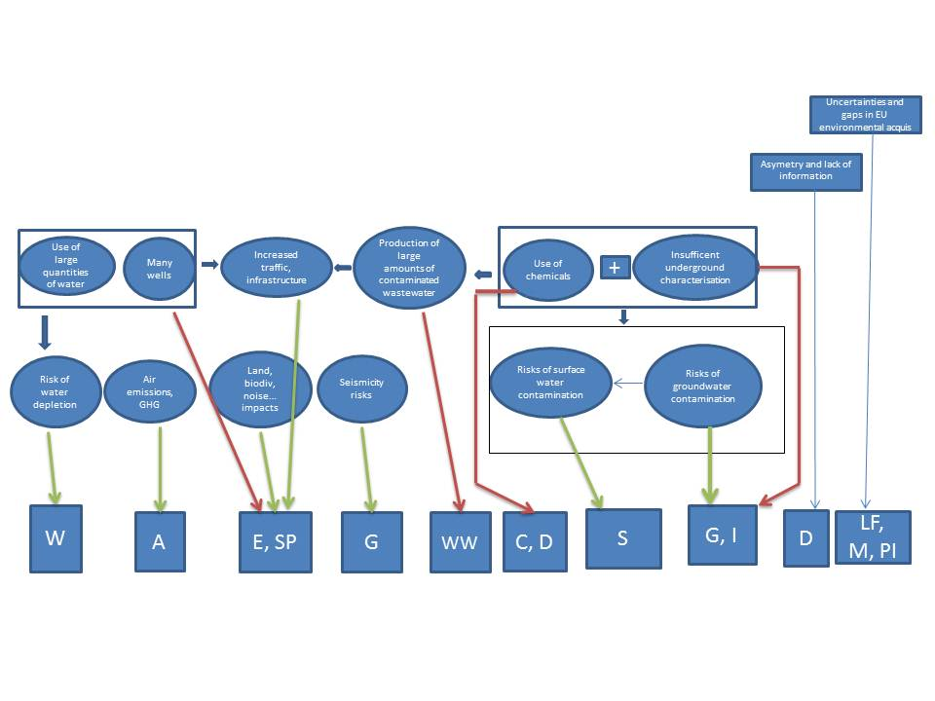
W= water management
A= Air emissions (control of)
E= Environmental assessment
SP= Site selection and Planning
G= Underground risk (coverage of)
WW= wastewater treatment
C= chemicals (minimise / control of)
D= disclosure of information
S= surface water (prevention of pollution)
I= Well integrity
LF= Liability, financial security
M= Monitoring and baseline reporting
PI= permitting, inspections, enforcement

Measures and options

Measures groups

Name of the measures group | Description of the measures group | Description of subgroups and examples of measures (in italics). A comprehensive list of measures that could be applied for the implementation of each element is provided in the next section of this annex. This list was developed to assess costs of groups of measures and policy options and is of illustrative nature.
SP | Site Selection and Planning  to optimise well site selection (taking into account water and infrastructure needs, waste water treatment facilities, protected and sensitive areas) and to anticipate cumulative environmental impacts (e.g water abstraction and contamination; air pollution) as well as transboundary effects (e.g cross-border shale gas plays in UK/IE; PL/Baltic states); | SP1: Buffer zones from sensitive and protected areas  SP2: Mandatory development of plans and programmes setting the frame for shale gas projects before concessions are granted  Strategic environment assessment (SEA) and monitoring of significant effects at the shale gas play
G | Ensure underGround risk characterisation and assessment:  a thorough understanding of the geological system is needed to identify potential contamination pathways such as abandoned wells, faults (also responsible for induced seismicity) and to avoid drilling too close to aquifers; | G1: Basic risk characterisation based on available data  demonstration of existence of geological barriers between the shale formation and potential aquifers  G2: Collection and assessment of specific geological and hydrogeological data  2D survey; 3D seismic in geological complex areas  G3: Modelling of operations and their impacts  Development of a conceptual and dynamic model of the geosystem (geology, hydrogeology, seismicity; monitoring of extent of fracturing and effects thereof (induced seismicity)
I | Ensure proper Well Integrity (e.g casing and cementing quality; independent evaluation and verification) | I1: Appropriate well design and construction  Specific provisions for well integrity (e.g casing & cementing quality, cement log)  I2: Testing of well integrity and independent verification  pressure tests; operational monitoring of well integrity; independent verification of well safety and environmental critical elements
C | Minimise/Control the use of Chemicals | C1: Information exchange on environmentally safer technologies and practices, including on safe handling of substances used  Stakeholder platform  C2: Hazardous chemicals management Minimise use, substitute by less hazardous substances; monitoring and reporting of chemicals used such as volumes and concentrations  C3: Restrictions on the use of certain substances or substance categories (hazard based negative list)  C4: Allow only use of substances or substance categories identified on a positive list (risk based)  List of allowed substances
WW | WasteWater management, handling and treating large volumes of contaminated wastewater and residuals from waste treatment in appropriate facilities; | WW1: Reduce waste water volumes and toxicity  Selection of substances that minimise need for treatment  WW2: Monitoring, reporting and tracing of waste streams  WW3: Reduce risk of spills of waste water and chemicals;  Storage of waste water in closed tanks  (+ measures SP on strategic planning)
S | Prevention of Surface water pollution | S 1: Use of surface pipes for the transport of liquids (e.g water and wastewater)  S 2: sealing of pad  (+ measures C on the use of chemicals and SP on strategic planning)
W | Water management: taking into account water scarcity where applicable (conflicts of use) and multiple drilling (cumulative effects); | W1: Encourage the use of alternatives to fresh water  use of industrial, saline water  W2: Waste water recycling target  W3: Management plan to coordinate water abstraction at level of play/concession  (+ measures SP on strategic planning)
A | Control of Air emissions: esp. Volatile Organic Compounds (VOCs) and fugitive methane emissions; | A1: Monitoring, reporting and verification of emissions of GHG and other pollutants  A2: Mitigation of emissions from the well completion phase Reduced Emissions Completions (i.e. mandatory capture of gas), minimization of flaring where capture is not feasible  A3: Mitigation of emissions from other phases  Installation of vapour recovery units on storage tanks  A4: Require transport management plan and site planning aiming at reducing environmental impact Transport management plan and site planning aiming at emission prevention; low emission power supply; limit number of rigs operating on a concession site
E | Environmental assessments | E1: Mandatory environmental impact assessment (EIA) for exploitation (without a threshold or with a reduced threshold)  E2: Mandatory EIA for exploration and exploitation (with or without a threshold; with or without a reference to certain criteria such as the technology used/use of hydraulic fracturing and locational criteria)
D | Disclosure of information and reporting | D 1: Improving the current use descriptor system in ECHA database + voluntary agreement on disclosure of fracking chemicals on a well by well basis and notification of incidents/accidents  cut-off date in case agreement does not deliver; notification on incidents/accidents to authorities and the general public.  D 2: Improving the current use descriptor system in ECHA database + mandatory disclosure of fracking chemicals on a well by well basis and notification of incidents/accidents  EU-wide register for incidents/accidents
LF | Liability, Financial security and capacity of the operator  To ensure possible liabilities from the operations are addressed, roles and responsibilities are clear, and financial capacity of the operator is checked | L 1: Clarification that environmental liability provisions apply to shale gas activities  L 2: Ensure that environmental liability provisions apply explicitly to shale gas extraction  L 3: Clarification of operator/licensee/sub-contractors responsibilities  Identification of a liable person prior to the start of operations; technical competence; financial capacity; financial guarantee
M | Baseline reporting and Monitoring (before, during, after operations) | M 1: Baseline reporting  surface and groundwater, soil, air; seismicity  M 2: Monitoring and reporting of environmental parameters during and after closure of the well  monitoring of water use and quality, soil, air, traffic, integrity of surface infrastructure;
PI | Enforcement, Permitting, Inspections | PI 1: Exchange on good inspection practice  Exchange under IMPEL  PI 2: Minimum requirements for inspections  Frequency of inspections  PI 3: Integrated approach to permitting

Subgroups and possible tools for implementation under options A-D
Environmental problems | Causes of the problems / drivers | Areas of action and measures aiming at preventing the problems | Option D  Directive  +  Guidance | Option C  Framework Directive +  (incl. Amendments) +  Guidance | Option B  Amendments to existing legislation + Guidance + Recommendation | Option A  Guidance+ Recommendation+Voluntary approaches
Overarching environmental risks and impacts (land take, biodiversity issues, noise, cumulative effects…) | Site selection and planning | SP1: Buffer zones from sensitive and protected areas  SP2: Mandatory development of plans and programmes setting the frame for shale gas projects before concessions are granted | Directive  Directive | Recommendation  Framework Directive | Recommendation  Recommendation | Recommendation  Recommendation
 | Assessment of environmental impacts | E1: Mandatory environmental impact assessment (EIA) for exploitation (without a threshold or with a reduced threshold)  E2: Mandatory EIA for exploration and exploitation (with or without a threshold; with or without a reference to certain criteria such as the technology used/use of hydraulic fracturing and locational criteria) | E1-E3:  Directive amending EIA D | E1-E3:  Framework Directive amending EIA D | E1-E3:  Amendment of EIA Directive | E1-E3:  Interpretative guidance note
Risks of water pollution (surface and groundwater) and seismicity | Lack of underground risk characterization | G1: Basic risk characterisation based on available data  G2: Collection and assessment of specific geological and hydrogeological data  G3: Modelling of operations and their impacts | Part of G3  Directive  as above | Part of G3  Framework Directive – principle + amendment of MWD to give BREF a legal effect  as above | Part of G3  Amendment of MWD to give a legal effect to BREF  As above | G1-G3:  CIS guidance note under WFD  BREF under MWD
 | Well integrity | I1: Appropriate pad and well design and construction  I2: Testing of well integrity | Directive  as above | Framework Directive amending MWD  as above | Amendment of MWD strengthening BREF  as above | Recommendation  as above
 | Use of chemical additives which may be hazardous | C1: Information exchange on environmentally safer technologies and practices, including safe handling of chemicals  C2: Hazardous chemicals management  C3: Restrictions on the use of certain substances or substance categories (negative list)  C4: Allow only use of substances or substance categories identified on a positive list | Voluntary stakeholder platform  Specific provisions in Directive  As above  n/a | Voluntary stakeholder platform  Framework Directive - principle  Framework Directive - principle  n/a | Voluntary stakeholder platform  Guidance  As above  n/a | Voluntary stakeholder platform  Recommendation to MS/ Guidance/Voluntary commitment of the sector  Recommendation to MS / Guidance/  n/a
 | Production of large volumes of wastewater contaminated by the injected chemicals (and naturally occurring materials) | WW1: Reduce waste water volumes and toxicity  WW2: Managing, monitoring, reporting and tracing of waste streams  WW3: Reduce risk of spills of waste water and chemicals; | Directive  as above  as above | Framework Directive amending MWD strengthening BREF  as above  as above | Amendment of MWD strengthening BREF  as above  as above | Voluntary stakeholder platform  Recommendation  Recommendation
 | Surface water contamination and cumulative effects of multiple drilling | S1: Use of surface pipes for the transport liquids  S2: sealing of pad | Directive  As above | Framework Directive amending MWD/IED with BREF  As above | Amendment of MWD/IED with BREF  As above | Recommandation  Recommandation
Risk of water depletion | - Use of high volume hydraulic fracturing induces the use of large volumes of freshwater,  - Cumulative use of water | W1: Use of alternatives to fresh water  W2: Monitoring of water use and water recycling target  W3: Management plan to coordinate water abstraction at level of play/concession | W1-W3: Directive | W1-W3: Framework Directive amending MWD | W1-W3:  Amendment of MWD strengthening BREF | Voluntary agreement  Recommendation  Recommendation
Air pollution and GHG impacts | Well completion flowback typically release a high volume of methane, VOC and other air pollutants  Unsuitability of gas production equipment to handle flowback | A1: Monitoring, reporting and verification of emissions of GHG and other pollutants  A2: Mitigation of emissions from the well completion phase  A3: Mitigation of emissions from other phases  A4: Require transport management plan and site planning aiming at reducing environmental impact | A1-A4:  Directive | A1-A4:  Framework Directive amending IED with BREF | A1-A4:  Amendment of IED with BREF | A1-A3:  Voluntary agreement by Industry + Recommendation  Recommendation
Risk resulting from insufficient enforcement | Asymmetry of information | D 1: Voluntary agreement on disclosure of chemicals  D 2: Mandatory disclosure of the substances used in hydraulic fracturing and notification on incidents/accidents | Superseded by D2  Directive (specific content of the disclosure tool) | Superseded by D2  Framework Directive (content of disclosure tool to be discussed with stakeholders) | Voluntary agreement between industry and other stakeholders  n/a | Voluntary agreement between industry and other stakeholders  n/a
Risk resulting from insufficient enforcement | Enforcement, Permitting, Inspections | PI 1: Harmonised inspection practice  PI 2: Minimum requirements for inspections  PI 3: Integrated permitting based on BAT | Recommendation  Directive  Directive | Recommendation  Framework Directiveamending IED  As above | Recommendation  Recommendation  Amendment of IED | Recommendation  Recommendation  Recommendation
Risk resulting from insufficient enforcement | Liability, Financial security and capacity of operator | L1: Clarification that shale gas activities are covered by Annex III of the ELD  L2: Ensure that Annex III of the ELD applies to shale gas extraction  L3: Operator/licensee's requirements  L4: Transfer of responsibility to Member State | Superseded by L2  Directive  As above  As above | Superseded by L2  Framework Directive amending IED  As above  As above | Superseded by L2  Amendment of IED  As above  Recommendation | Guidance  n/a  Recommendation  Recommendation
Risk resulting from insufficient enforcement | Baseline reporting and Monitoring (before, during, after operations) | M1: Baseline reporting  M2: Monitoring and reporting of environ-mental parameters during and after closure of the well | Directive – provisions on baseline reporting  Directive – provisions on monitoring and reporting | Framework Directive – principles on baseline reporting and amending MWD/IED with BREF  As above | Amendment of MWD/IED with BREF  As above | Recommendation  Recommendation

Summary comparison of measures and options

Measures ensuring | No action | Option A  Recommendation, Guidance and voluntary action | Option B  Amendment to acquis | Option C  Obligation for MS to adopt measures | Option D  Dedicated legislation
Underground risk management | - Operators are likely to restrict collection of geological data to those data necessary to optimise production and not for environmental protection purposes  - No EU-wide criteria for hydrogeological assessment | - Recommendation to carry out an underground risk characterisation  - recommendation for criteria to assess hydrogeological risks | - BAT for underground risk characterisation via BREF under MWD (note: this measure implies development of a BREF and amendment of MWD that makes the BREF compulsory reference for permitting)  - No criteria to assess risks | - to protect groundwater by a thorough characterisation of the underground and by carrying out a proper risk assessment;  - MS would be supported by BAT for underground risk characterisation and by a recommendation for criteria to assess risks | - Specific and obligatory provisions for underground risk characterisation and  - assessment setting EU-wide criteria (MS remain free to take into account local geological specificities)
Well integrity (construction and operation of a well) | Operators rely on their own corporate standards | Recommendation on well integrity testing and independent verification  Mandate to CEN to develop an EU standards on well integrity | BAT for well construction and testing via BREF under MWD  BAT for monitoring and operation under IED  + CEN standard | to protect ground water by ensuring well integrity;  MS would be supported by BAT for well construction and testing and by CEN standard | Require well integrity testing and independent verification of well design, construction and testing  + CEN standard
Safety of installation (pad) to avoid spills | US practice of use of open ponds for storage of flowback and use of gravel for the surface lining of the pad would prevail | Recommendations for technical measures to avoid or mitigate spills (sealing of the pad, tanks) | BAT for pad safety via BREF under MWD | to protect surface water by avoiding and mitigating spills  MS would be supported by BAT for pad safety | Provisions for technical measures to avoid or mitigate spills
Waste management (flowback) | MS specific approach. Case law by EJC may harmonise practices. | Recommendation to monitor waste streams and to treat flowback adequately | BAT for waste management via BREF under MWD | To minimise env impacts by adequate management of waste streams  MS would be supported by BAT for waste management | Provision to monitor waste streams and to treat flowback adequately
Reduction of emissions of methane and other VOC | US experience suggests that venting and flaring continues even when capture would result in a net revenues | Recommendation for capture of gas during all phases of well construction | BAT for capture of gas via BREF under IED | to minimise emissions to air  MS would be supported by a recommendation | Provisions for capture of gas during all phases of well construction  Ban for venting and limitation of flaring to emergencies
Safe use of additives | REACH and Biocides legislation apply.  Techniques alternative to high volume water-based fracturing or minimising the use of hazardous chemical additives are being explored and/or tested. Water-based fracturing is expected to remain the dominant technology for the next few years. | a) Voluntary agreement of the industry to minimise the use of chemical additives and substitute hazardous ones  b) Recommendation to MS (general principles for the use of chemicals; priorities in the review programme of biocidal active substances)  c) EC proposal to ECHA to complement the Use descriptor system | n/a | on the use of chemicals (e.g minimise, substitute) with a cut-off date for legal action if industry voluntary agreement does not deliver.  Compatible with c) under option A. | Requirements on specific categories of substances that cannot be used/ could be used for hydraulic fracturing  Compatible with c) under option A.
Disclosure of information, incl. on chemicals used in fracking and on accidents and incidents to the public | ECHA is providing access to information collected under REACH to enforcement authorities in Member States.  ECHA is expected to make it possible to filter information by "uses" in the on-line database of registered substances under REACH by end 2013  Chemical substances used for fracking on a well-by-well basis may be made available on a voluntary basis by certain operators; public disclosure on a well by well basis may be required at permitting level in certain Member States and not in others. | a) Recommendation to industry to refer explicitly to the use in "hydraulic fracturing" when registering substances under REACH; Recommendation to ECHA to update the Use Descriptor System and associated ECHA guidance; b) recommendation to operators to set a voluntary sectorial agreement to disclose chemicals used on a well-by-well basis;  c) Recommendation to comp. authorities to disclose information, notably on accidents and incidents | As under option A | for the disclosure of information notably on chemicals used in fracking on a well by well basis and on accidents and incidents to the public  Supplemented by a) under option A. | Provisions for mandatory disclosure of chemicals used on a well-by-well basis and for informing the public, notably on accidents and incidents and their causes.  Supplemented by a) under option A.
Baseline determination and monitoring and reporting of environmental parameters | Generic but inadequate monitoring requirements under water legislation and under MWD apply. | Recommendation for a monitoring plan | Amendment of IED would allow baseline determination (shallow and deep groundwater, soil and subsoill) and emissions monitoring (to water, air, land).  Review of EIA D may provide for generic baseline and monitoring requirements | for baseline determination, and monitoring and reporting of env impacts  MS would be supported by a recommendation | Specific and obligatory provisions for baseline determination and monitoring of air, water and deep ground parameters
Liability and financial security | Applicability of the ELD to incidents related to waste but not to other operational activities  Financial guarantee required under the MWD for waste management  Some MS require a financial guarantee prior to the start of hydrocarbons activities | Recommendation to apply the provisions of the ELD to shale gas activities  Recommendation for a financial guarantee and a financial mechanism | Amendment of IED to cover shale gas would bring this activity under the scope of the ELD | to prevent and remedy environmental damage  MS would be supported by a recommendation | Provisions on env liability and financial guarantee and mechanism
Site planning and area wide permitting | MS specific practice likely to continue: a few MS carry out SEAs before granting licences (e.g UK, LT) while other MS do not | Recommendation to take into account environ-mental considerations during licensing and to anticipate the development of a licence area to full production | No possibility to introduce site planning and area wide permitting under this option | to take into account environmental considerations during licensing and to anticipate the development of a licence area to full production  MS would be supported by a recommendation | Require Member States to take into account environ-mental considerations during licensing and to anticipate the development of a licence area to full production
Safety after well closure | MS provisions for conventional wells apply. Most MS require a well abandonment plan and require the operator to instigate post closure measures to maintain the integrity of the well. | Recommendation for abandonnement survey and post-closure monitoring and possible corrective measures | Amendment of IED to cover explicitly shale gas would introduce general provisions for closure and MWD for post-closure monitoring | to ensure that no significant risk is caused by a closed well  MS would be supported by a recommendation | Provisions for abandonnement survey and post-closure monitoring and possible corrective measures

Assessment of the Effectiveness of the Options

Effectiveness of the options in addressing the need for appropriate site selection and strategic planning

Business as usual:
- Only a few Member States request a strategic environmental assessment (SEA) prior to granting concessions (e.g UK and Lithuania). This is due to the fact that the SEA Directive does not introduce an obligation to make plans, but it applies only if MS legislation foresees plans. There is therefore no systematic consideration given to the possible impacts of multiple activities on very wide areas (e.g certain shale gas plays reach more than 33 000 km2). This may lead to a sub-optimal allocation of resources such as water (and lead to possible conflicts of use), infrastructure, wastewater treatment plants, which would lead to increased costs for operators and public authorities.
- There is already a Commission services guidance on the Environmental Impact Assessment (EIA) / SEA which did not lead to a significant uptake of strategic environmental assessment across Member States.
- The Habitats and Birds Directives require an assessment of the effects of the projects on protected sites (art. 6.3 of Habitats Directive)
- Certain Member States (e.g DE) have proposed banning drilling e.g in water protected areas.

Option A: Recommendation to Member States (MS) on planning, zoning (e.g buffer zones from sensitive/protected areas, drinking water areas, aquifers), noise and traffic management (e.g use pipes to transport water and wastewater instead of trucks). It could build on good practice and foster Member States initiatives.

Option B: amendments to existing EU legislation addressing site selection and strategic planning could not be identified.

Option C:
Overarching goals would be set regarding site selection and minimisation of community impacts (e.g land take, noise, traffic, biodiversity). Member States would develop plans and programmes setting the frame for HVHFHD projects, thus triggering a strategic environmental assessment. This would allow addressing locational/design alternatives, cumulative and transboundary effects, as well as providing for public information and consultation at an early stage, prior to development consent (also ensuring compliance with the Aarhus Convention). It would also provide generic environmental information that may then facilitate the subsequent development of EIAs, as well as social acceptance.

Option D:
This option would set specific requirements in terms of site selection (incl. zoning, setbacks/buffer zones from sensitive/protected areas) and minimisation of community impacts (e.g land take, noise, traffic, biodiversity). It would also foresee the development by Member States of plans and programmes setting the framework for HVHFHD projects, thus triggering a strategic environmental assessment. (as under C)

Timeliness:
- Recommendation: 2013/2014
- A regulatory instrument (option C -which would provide for consolidated amendments of existing EU pieces of legislation- and option D) could be transposed and implemented as of 2017.

Summary: While option A may be the fastest to develop, a wide uptake of site selection measures and of strategic environmental assessment prior to licensing rounds is dependent on the extent to which competent authorities and operators follow the recommendation. It is therefore not expected to fully allay public concerns, as no systematic public consultation would be foreseen prior to licensing rounds at the level of the shale gas play and cumulative effects of extraction over wide areas may not be sufficiently taken into account. To ensure the latter, it is expected that options C and D would be more effective compared to baseline and would ensure legal predictability. Options C or D could be combined with the development in parallel of option A, so as to cater for the need for urgent action. Option D would go one step further than C in terms of coverage of the environmental risks and legal certainty by providing for requirements on site selection.

Effectiveness of the options in addressing the need for environmental impact assessments

Business as usual
- A screening for deep drilling projects is required under the EIA to verify likely significant effects on the environment and a full EIA is needed for exploitation projects above 500 000 m3 of gas extracted per day and 500 tonnes per day in the case of petroleum.
- A diversity of EIA provisions apply across Member States and uncertainties as to their application have been raising public concerns (subject of numerous parliamentary requests, citizens letters and petitions) and entails possible risks of litigation for projects.
- A revision of the EIA Directive is currently on-going in the frame of which amendments have been put forward in the European Parliament to provide for a mandatory EIA both at exploration (without reference to hydraulic fracturing) and production phases and independently from the amount extracted, which would trigger public consultation prior to development consent.

Option A is not considered relevant as a Commission services guidance focused on the application of the EIA Directive to unconventional fossil fuels using high volume hydraulic fracturing already exists

Option B: This option depends on the on-going co-decision procedure in the framework of the revision of the EIA Directive. There could be various possibilities such as the inclusion of an explicit insertion of HVHFHD projects within Annex I for exploitation (without a threshold), for exploration and exploitation (with or without a threshold; with or without a reference to certain criteria such as the technology used/use of hydraulic fracturing and locational criteria).

Option C and D: There are no separate C and D options on this subject, because the EIA does not set standards but only procedures and criteria to reach decisions. However, an environmental impact assessment (as under B) can be part of broader options C and D.

Timeliness:
- Amendment of EIA: implementation at the earliest in 2016
- A regulatory instrument (option C -which would provide for consolidated amendments of existing EU pieces of legislation- and option D) could be transposed and implemented as of 2017.

Summary: The existing 2011 Commission services guidance on the application of the EIA to unconventional fossil fuels such as shale gas did not allay public concerns and uncertainties remain at national level as to the scope of its application. Conducting a full EIA for both exploration and exploitation and/or in connection with the use of hydraulic fracturing operations, is already prescribed in several Member States in order to reinforce the knowledge basis of decisions and to contribute to increased social acceptance. The Commission did not propose to amend Annexes I and II of the EIA Directive as part of the on-going revision process. However should co-legislators foresee such amendments, the Commission will consider those.

Effectiveness of the options in addressing underground risk characterisation and assessment

Business as usual
  - The Mining Waste Directive (MWD) (art. 11) provides for requirements for the "suitable location" of the "waste facility", taking into account "geological, hydrological, hydrogeological, seismic and geotechnical factors". Commission Decision 2009/360/EC on waste characterisation includes an analysis of the geological background of the deposit to be exploited. Such general geological requirements would apply to the well, should it qualify as a "waste facility". A "waste facility" is defined as "any area designated for the accumulation or deposit of extractive waste, whether in a solid or liquid state or in solution or suspension", whether on the ground or underground. The boundaries of such "waste facility" are uncertain in the case of a shale gas well as the horizontal leg of the well is perforated to enable access to widely dispersed pores of gas. Nevertheless, ensuring a proper well management might be considered as one of the measures needed to meet the objectives of the MWD (e.g prevention of water and soil pollution). A number of Member States have called for clarification as to the scope of application of the MWD, especially with regard to the underground.

  - The review of the existing best available techniques reference document (BREF) on mining waste under the Mining Waste Directive is already foreseen. It is aimed at addressing notably waste resulting from the prospecting, extraction, treatment and storage of shale gas, which is currently not covered. Based on the interpretation that a well is considered a "waste facility" under the MWD, and on the fact that waste will be deposited or accumulated underground, the BREF may then be able to identify best available techniques on site selection and underground risk characterisation. Such a BREF would however have a limited legal effect as the use of best available techniques (BAT) is only a general requirement of the Directive (no BAT conclusions are foreseen that would serve as reference for setting the permit conditions).
  - The Water Framework Directive (WFD) prohibits the direct discharge/inputs of pollutants into groundwater. Pollutants are defined as any substance liable to cause pollution. The WFD environmental objectives for groundwater aim at protecting current and potential future uses and at protecting connected surface water and terrestrial ecosystems. The depth of groundwater that needs to be protected and, where necessary, enhanced through its inclusion in a body of groundwater depends on the risks to the Directive’s objectives. This is a matter for Member States to decide based on their assessments of groundwater characteristics. It should be noted that all groundwater is subject to the ‘prevent or limit’ objective whether or not it is identified as being part of a body of groundwater. There is no specific risk assessment guidance or parameters under the Water Framework Directive that would help determine on a case by case basis whether or not high volume hydraulic fracturing would occur in groundwater. It therefore relies on the permitting authorities to require such site specific risk assessments on an ad hoc basis, which may not necessarily be conducted or be improperly conducted and result in risks of water pollution.
  - The Environment Impact Assessment (EIA) Directive (2011/92/EU) requires an EIA for projects involving the extraction of natural gas where the amount of gas extracted exceeds 500.000 m3 per day as well as a screening for deep drilling projects. The existing EIA Directive does not provide for an explicit identification of underground impact pathways as part of the environmental impact assessment/screening (e.g existing geological faults, abandoned wells; seismic prone areas; deep aquifers). The sub-surface dimension of projects may therefore be insufficiently taken into account. The EIA directive is currently under revision and may provide for a general clarification on this aspect. However it is a horizontal tool that cannot provide for underground risk assessment measures specific to activities involving the use of high volume hydraulic fracturing.
  - There are typically general geological requirements applicable to both conventional and unconventional gas projects at Member State level but they rarely focus on specific risks in the context of high volume hydraulic fracturing (e.g identification of faults, abandoned wells, seismicity). They are also diverging interpretations at national level of the applicability of both the EU water and mining waste legislation in relation to high volume hydraulic fracturing.

Option A:
- Recommendation, Guidance note under the Common Implementation Strategy (CIS) or guidelines developed under comitology under the Water Framework Directive

This guidance would provide in a combined manner:
- technical guidance on risk assessment helping Member States in ensuring that a site-specific hydro/geological risk assessment is systematically and properly conducted prior to granting authorisations for projects using high volume hydraulic fracturing. This would help identifying risks to water quality.

- clarification of the interpretation of relevant aspects of the existing EU water legislation in the context of such activities.
It could for instance explain further the interpretation of art. 11.3 (j) under the WFD and its concrete implications for permitting authorities (e.g need to conduct a site specific hydro/geological risk assessment prior to any high volume hydraulic fracturing operations; concept of direct discharge vs. indirect discharge in groundwater in the context of high volume hydraulic fracturing; prohibition of injection of waste water from high volume hydraulic fracturing operations underground for disposal unless it is free of pollutants; legal status of waste water that is aimed at being re-used in other fracturing operations).

The existing CIS process is a participative process involving Member States, the European Commission and stakeholders, working on the basis of consensus.

b) Interpretative guidance note on the application of the Mining Waste Directive (MWD)

This would explain how the MWD requirements apply in practice to HVHFHD projects, in particular with regard to the geological and hydrogeological factors that need to be taken into account prior to locating the "waste facility". The latter would encompass the well considered as “waste facility” due to the fracturing fluids remaining underground.

Option B:

Individual amendment of the MWD: a BREF/BAT conclusions developped under the MWD would be given a legal effect and clarification would be provided as to the scope of application of the MWD.
This would imply that Best Available Techniques (BAT) may be identified on site selection and underground risk characterisation and serve as reference for setting permit conditions. Flexibility would remain at the level of permitting of the installations concerned.

This would be combined with an interpretative guidance note on the application of water legislation. The latter could make reference to BAT developed under the MWD which would be relevant for conducting a hydrogeological assessment under the Water Framework Directive. (see option A)

Option C:
A legal instrument would provide overarching goals on underground risk characterisation and assessment. It would also set the frame for an amendment of the MWD (as under option B).
This would build on existing EU legislation and can be accompanied by option A (interpretative guidance note on water legislation).

Option D:
A legal instrument would set in law criteria for geological and hydrogeological risk assessment at EU level.
Such requirements could support data collection on geology and geophysics, hydrogeology, geochemistry, geomechanics, seismicity, presence of natural and man-made leakage pathways (e.g active faults; abandoned wells), interaction with other underground activities (e.g. CO2 storage; geothermal energy production; water abstraction wells), and feed into modelling, so as to characterise and assess specific underground risks prior to any high volume hydraulic fracturing activity.

Summary: Option A would present the advantage of providing for a consultative process to establish hydro/geological risk assessment technical parameters/principles. However although guidance notes or guidelines may have persuasive influence in proceedings before the European Court of Justice (ECJ), they are not recognized as legally binding. A wide uptake of underground risk characterisation and assessment measures may therefore depend on the willingness of competent authorities and operators to follow such guidance as well as on whether or not there is public pressure in Member States. Taken alone, this option may be insufficient to respond to strong public concerns regarding protection of water resources. Options B and C would address better the risks than under the baseline. The characterisation and assessment of underground risks would however rely on the development of BAT, the level of ambition of which depends on a participative process, which may be less predictable than underground risk characterisation requirements set in law (option D). The latter would further assist permitting authorities and reassure the general public.

Timeliness:
- A CIS guidance note could be developed from 2016 (this subject is not included in the CIS Work Programme agreed for 2013-2015).
- The development of a guidance note on waste legislation would take at least a year.
- An individual amendment of the MWD would take at least three years before transposition and implementation. The development of an associated BREF under MWD would take 3 years to be developed.
- A regulatory instrument (option C -which would provide for consolidated amendments of existing EU pieces of legislation- and option D) could be transposed and implemented as of 2017.

Effectiveness of the options in addressing the risk of well failure
Business as usual
  - The Workers Health and Safety Directive (92/91/EC) focuses on well blowout and gaps have been identified in the recent review of the Directive in terms of requirements applicable to well design and well control procedures. The risk evaluation aims at workers health and safety and although it could be complementary, it does not aim at addressing environmental risks. In addition, independent verification of the wells is not provided for in the Directive and was highlighted in the review as an area for further improvement. The review of all EU health and safety legislation is foreseen until the end of 2015, which may or may not lead to a revision of this particular Directive.
  - Standards would exist only on the manufacture of components of wells such as casing, tubing and wellheads and operators tend to rely on their corporate well integrity standards.
  - With the exception of an EU harmonised standard on pressure equipment, no EU harmonised standards relate specifically to the mineral extractive industries.
  - Independent verification of critical safety elements (but not necessarily of environmental aspects) is conducted in certain Member States (e.g UK).

Option A:
Development of standards on well integrity (e.g design and construction of the well; casing; cementing; testing)
The Commission could issue a formal mandate to the European Committee for standardisation (CEN). The latter would then be submitted to a committee of Member States that would decide whether or not to issue standards on well integrity.

Option B:
Individual amendment of the MWD: a BREF/BAT conclusions under the MWD would be given a legal effect and clarification would be provided as to the scope of application of the MWD, encompassing the well as a “waste facility”. Best available techniques may then be developed on well integrity. This could be accompanied by the development of EU standards (see option A).

Option C:
This option would set the frame for general provisions on well integrity and verification thereof while providing for an amendment of the MWD in a consolidated manner. (same content as option B). This could be accompanied by the development of EU standards (see option A).

Option D: A legal instrument would set specific requirements at EU level on well integrity, encompassing well design, well construction (casing; cementing), testing, independent evaluation and verification.

Timeliness:
- The development of standards (e.g on well integrity) via CEN would typically require at least three years and would unlikely be able to start before 2016 as the standardisation programme has already been agreed until 2015.
- An individual amendment of the MWD would take at least three years before transposition and implementation. The development of an associated BREF under MWD would take 3 years to be developed.
- A piece of legislation (option C which could provide for consolidated amendments of existing EU pieces of legislation and option D) could be transposed and implemented as of 2017.

Summary: Option A - taken alone- may not allay public concerns considering the time needed for its implementation. Option B would lead to more effects than the baseline given that BAT conclusions on well integrity would then be the reference for setting permit conditions. Flexibility would however remain at the level of permitting of the installations concerned and the level of ambition of the BAT depends on a participative process. The same is valid for Option C, although the latter would also provide for framework principles on well integrity and the need for verification. It would build on the existing EU acquis and could be combined with option A (development of standards). Option D would be the only option providing for specific requirements in law, which may provide further clarification to permitting authorities.

Effectiveness of the options in addressing the use of chemicals (which may be hazardous)
Business as usual:
- REACH requires the registration, evaluation and in some cases, authorization or restriction of chemical substances placed on the market. If an operator of a project uses hazardous registered substances, his suppliers have to provide him with an extended safety data sheet that includes exposure scenarios. The latter should give information about the conditions of safe use relevant to operators and cover realistic and foreseeable accidental release of substances. Manufacturers and downstream users must apply for authorization to be able to use substances of very high concern. Such authorization is subject to time-limited reviews. REACH also foresees a restriction process to regulate the manufacture, placing on the market or use of certain substances if they pose an unacceptable risk to health or the environment. This process can be initiated on a case-by-case basis in case such a risk can be demonstrated based on the dangerous properties of the substances and the specific relevant exposure scenario (no generic exposure scenario yet exists for hydraulic fracturing, see below). REACH does not set at present restrictions on substances used specifically for fracking purposes.
- Polymers (which may be used for hydraulic fracturing) are currently exempted from REACH registration requirements. Monomers in polymers have to be registered (article 6.3). A review process is on-going to evaluate if practicable and cost-efficient ways of selecting polymers for registration can be established. Subject to the outcome of the review, an amendment of the REACH Regulation will be proposed.
- As per the study conducted by JRC IHCP, neither hydraulic fracturing nor shale gas was explicitly mentioned in the REACH registration dossiers examined for 16 substances that may be connected with the use in hydraulic fracturing of shale gas reservoirs. Although it could be covered implicitly under certain identified uses (e.g use in oil industry or in mining operations), hydraulic fracturing of shale gas reservoirs was not identified as a specific use for any of the substances and a dedicated Exposure Scenario was not developed by any registrant.
- The development of a generic exposure scenario for substances typically used for high volume hydraulic fracturing may be expected at OECD level in the coming years.
- The Biocides Directive (Biocidal Products Regulation as of Sept. 2013) apply to the use of biocides for hydraulic fracturing purposes. It requires EU-level evaluation and approval of all biocidal active substances, and subsequent authorisation of all biocidal products for their intended uses. A review programme of biocidal active substances by Member States started in 2004, with the objective to be completed by 2024. Biocidal active substances used in oil and gas operations are not among the priorities identified for the review in the coming years.
- The Seveso Directives provide for major accident prevention if relevant thresholds are reached for storage/processing of gas on-site or other listed dangerous substances.
- Techniques alternative to high volume water-based fracturing are being explored and/or tested. Some have reached a commercial stage in North America (e.g. LPG fracturing) but are not common practice (see details in annex 20). Depending on the applicability of the alternative techniques to European geological conditions, those could provide an alternative in the future, while slickwater fracturing is expected to remain the dominant technology for the next few years (5 to 10 years).

Option A:
- Formal voluntary agreement of the industry to minimise the use of chemical additives and substitute hazardous ones (accompanied with a cut off clause to make it mandatory if the agreement does not deliver). Its effectiveness would depend notably on whether the industry could be well circumscribed to ensure the agreement is made on behalf of the entire sector.
- Recommendation to Member States establishing general principles for the use of chemicals (e.g minimise use, substitute by less hazardous substances) in high volume hydraulic fracturing.
- Recommendation to Member States for the setting of priorities in the evaluation of the review programme of biocidal active substances, so as to examine active substances that might be used for HVHFHD activities
- Commission proposal to the European Chemicals Agency (ECHA) to complement the Use descriptor System by one additional Environmental Release Category (ERC) (covering the case of a substance that is intentionally introduced into the environment to carry out its technical function), and to update the existing ECHA guidance on use descriptor accordingly.

Option B: No amendment of existing EU legislation could be identified to address specifically the use of chemicals (which may be hazardous) for high volume hydraulic fracturing.

Option C:
This option could set general principles on the use of chemicals (e.g minimise, substitute) in a framework directive covering HVHFHD activities and refer in an article to a voluntary agreement by the industry with a cut-off date for further legal action if the agreement does not deliver. (same content as option A)

Option D:
A regulatory instrument could provide for requirements at EU level on specific substances or categories of substances that cannot be used/ could be used for high volume hydraulic fracturing (e.g negative list of substances/categories of substances or positive list), taking into account existing requirements under REACH and EU legislation applicable to biocides, where relevant. Such an instrument could set for instance general restrictions (hazard-based) on the use of certain categories of substances in high volume hydraulic fracturing such as:
- Non-use of any (non-biocidal) substances with classification for any health or environmental effects; non-use in biocidal products of any substances with classification for any health or environmental effects;
- Or non-use of carcinogenic, mutagenic and reprotoxic (CMR), aquatic acute/chronic toxic specific substances categories;
- Or non-use of non-biodegradable/persistent chemicals

Summary: Taken alone, option A may provide incentives to the industry to accelerate the phasing out/substitution of hazardous chemical additives used for high volume hydraulic fracturing but may not be sufficient to allay strong public concerns on the health and environmental impacts and risks of the use of chemicals. Option C would provide for general requirements on the use of chemicals that could be combined with a voluntary agreement (as under option A). This would better respond to public concerns than option A while allowing the industry to work on a voluntary basis towards the phasing out/substitution of hazardous substances. Option D is more stringent as it would provide for specific restrictions on the use of certain categories of chemicals. The reduced availability of chemicals may lead to a reduced well productivity and may result in a possible reduction of income/profit for operators compared to the baseline, although it may be more effective than other options to address public concerns and provide increased environmental protection.
Options B, C and D are compatible with the proposal to be made to ECHA to complement the Use descriptor system and modify the associated ECHA guidance accordingly (featured under Option A).

Timeliness of the options:
- Recommendation to ECHA to modify the Use Descriptor System and the associated guidance (option A): 1 year (this involves a proposal of the Commission to ECHA which is then discussed with stakeholders)
- Formal voluntary agreement of the industry to minimise the use of chemical additives and substitute hazardous ones (option A): this could take some two years on average, although this would very much depend on whether or not a consensus within the sector can be achieved rapidly.
- Recommendation to Member States (option A): 1-2 years
- A regulatory instrument (option C -which would include consolidated amendments of existing EU pieces of legislation- and option D) could be transposed and implemented as of 2017.

Effectiveness of the options in addressing asymmetry and lack of information

Business as usual:
- Information on substances registered under REACH is made electronically available on the website of the European Chemicals Agency (ECHA) unless considered confidential. A search function filtering information by "uses" should be made possible by ECHA by the end of 2013. The current Use Descriptor System does not provide for specific "identified use" or "sector of use" allowing to identify substances registered for hydraulic fracturing purposes. REACH provides for the possibility of disclosure of business confidential information on substances used only in case of health, safety or environmental emergency. It does not provide for a specific disclosure tool -on a well by well basis- of substances used for the extraction of unconventional fossil fuels such as shale gas.
- The Aarhus Convention regulates public access to environmental information unless business confidentiality is claimed.
- The mandatory disclosure of chemicals is a request from citizens, environmental NGOs, academic experts as well as a recommendation from the International Energy Agency. In addition, the US Bureau of Land Management has recently put forward a proposal requiring mandatory disclosure on US public lands and a number of states and provinces in North America already provide for mandatory disclosure.
  - A voluntary disclosure scheme of chemicals used for hydraulic fracturing aimed at the general public was launched by the international association of oil and gas producers (OGP) on 18th June 2013. The register so far provides information on 10 exploratory wells in Poland which have been hydraulically fractured since the first January 2011. This register mentions inter alia the product trade names (if applicable), purpose, supplier and date of the fracturing operation. Service companies and operators are responsible for providing and verifying data collected on this register. Supporting organisations include 21 companies and four organisations / sectoral federations (http://www.ngsfacts.org/participants/)
  - The OECD secretariat is also considering setting up a disclosure tool on a global level in the short term, which seems to be supported by the industry.
  - A few Member States are asking for disclosure of chemicals as part of the Environmental Impact Assessment (EIA) or permitting procedures. Poland would plan to require mandatory disclosure of chemicals used to the general public.
  - Reporting of incidents/accidents at national level is being requested in certain Member States (e.g UK; ES)

Option A:
- Voluntary agreement by the industry to disclose chemicals intended to be used/used for hydraulic fracturing to the general public (with a cut-off date if the voluntary register does not deliver) combined with a recommendation to Member States to include public disclosure as a permitting requirement. The effectiveness of such a voluntary agreement would depend notably if the industry can be well circumscribed to ensure the agreement is made on behalf of the entire sector. It would formalise and extend the existing voluntary on-line disclosure tool launched by the oil and gas federation OGP in June 2013, so as to encompass all operators. Interconnection between this industry tool and the ECHA database could be explored.
- Guidance advising companies that register substances under REACH to specify "hydraulic fracturing" as use name for substances which can be used for this purpose. This would then facilitate the search for information on registered substances in the existing ECHA database, once a search by "uses" is made possible by ECHA by the end of 2013.
- Commission's proposal to ECHA to adapt the Use Descriptor system (and associated ECHA guidance) so as to allow for the definition of a more specific "sector of use" (SU) category (e.g unconventional hydrocarbons extraction). Such proposal is subject to a stakeholders' consultation.

Option B: no particular amendments to existing EU pieces of legislation could be identified.

Option C:
The principle of a mandatory disclosure of chemicals (intended to be used and used for high volume hydraulic fracturing) -while respecting IP rights- to both the general public and competent authorities would be inserted in a regulatory instrument, while providing flexibility as to its precise content. The latter could be defined for instance in the framework of a stakeholder platform involving operators, service companies, workers unions, water authorities, wastewater treatment industry, environmental non-governmental organisations.
A general principle on reporting of incidents/ accidents to public authorities also be featured under this option.

Option D: Such an instrument would require a mandatory disclosure to both public authorities and the general public of chemicals intended to be used and subsequently used for high volume hydraulic fracturing, with specific requirements in terms of content.
An EU wide incident/accident reporting mechanism may also be foreseen (a precedent is set with the Offshore Safety Directive major accident reporting tool- see Annex VI- "Sharing of information and transparency" which provides for common data reporting on incidents and accidents)

Summary:
There are strong public concerns on chemicals used for high volume hydraulic fracturing and overall a perceived lack of transparency on operations. The industry is generally in favour of public disclosure of chemicals to increase public acceptance and has set up a voluntary tool in North America and the EU. Such a voluntary tool may also be set up on a global level via the OECD secretariat. However concerns have been raised by environmental NGOs as to the comprehensiveness of voluntary tools. Subject to stakeholders' agreement, option A would provide for an improved ECHA dissemination portal (for substances registered under REACH). It would rely on a voluntary disclosure tool (for information on a well by well basis), building on the already available industry register (NGSfacts). Options C and D may appear more effective than option A in terms of responding to the strong call for transparency and systematic information. A regulatory instrument (as under C or D) would be the only tool available to provide for mandatory disclosure on a well by well basis, as this cannot be featured under REACH, which is focused on individual substances and legal entities. Although providing less flexibility on the content of the disclosed information and less scope for discussion between stakeholders, Option D may be more comprehensive than C and therefore respond even further to the call for transparency. Options B, C and D are compatible with the recommendation to companies to specify "hydraulic fracturing" when registering substances for this purpose under REACH, and are also compatible with a recommendation to ECHA to adapt the current Use Descriptor System (featured under Option A).

Timeliness:
- Formal voluntary agreement of the whole sector to disclose chemicals: this may take some two years on average or less, depending on whether or not a consensus within the entire sector can be achieved rapidly.
- Recommendation to companies to specify "hydraulic fracturing" when registering substances under REACH: a few months
- Recommendation to ECHA to modify the Use Descriptor System and the associated ECHA guidance (option A): 1 year (this involves a proposal of the Commission to ECHA which is then discussed with stakeholders)
A regulatory instrument (option C -which could also provide for consolidated amendments of existing EU pieces of legislation- and option D) could be transposed and implemented as of 2017.

Effectiveness of the options in addressing risks of water depletion
Business as usual
- The Water Framework Directive (WFD) applies and requires the development of river basin management plans and their review every six years.
- Under the WFD, the operator would have to obtain an authorisation from the competent authority before undertaking any abstraction, unless it is considered that the abstraction will not cause any significant impact upon the status of the water body concerned. Yet, in case where the status of the water body from which the water is abstracted will or may be deteriorated or significantly affected, the authority could still authorise water abstractions by having recourse to the derogation foreseen. However, reliance upon a derogation must meet several conditions (for instance, it would have to be demonstrated, among others, that the shale gas activity would constitute an "overriding public interest" or that there is no significantly better environmental option that would achieve the same objective).
- In any event, the abstraction of surface or groundwater would qualify as a water service within the context of the WFD. Consequently, Member States should adopt a water pricing policy, applicable to shale gas extraction and exploration, which takes account of the principle of cost recovery and provides adequate incentives for the efficient use of water resources.
- The Mining Waste Directive encourages recycling and re-use. A BREF under the MWD may identify among best practices the re-use/recycling of wastewater into other fracturing operations or other uses.
- Should a strategic environmental assessment (SEA) be conducted, Member States may take account of cumulative effects of water abstraction. However so far, it appears that only very few Member States (e.g Lithuania and United Kingdom) are conducting a SEA prior to granting shale gas licences.
  - A screening for deep drilling projects is required under the EIA Directive and mandatory EIA if the amount of gas extracted is above 500 000 m3 per day. Such screening and EIA take account of the "use of natural resources".
  - A permit is typically required at Member State level for water abstraction, on the basis of general water legislation.
  - Industry would be able to recycle 70-90% of waste water recovered (see Annex with the example of a voluntary agreement in the US including a 90% recycling target where the operator is a net water user).

Option A: A voluntary industry agreement to recycle/re-use waste water up to a certain target and seek alternatives to freshwater (with cut-off date for legal action if it does not deliver) may help reducing public concerns, provided the industry can be well circumscribed so as to ensure the agreement is made on behalf of the entire sector.

Option B: an amended Mining Waste Directive (MWD) would give the associated BREF a legal effect. BREF/BAT conclusions may identify re-use/recycling of wastewater into other fracturing operations among best available techniques. This option would lead to more effects than the baseline given that BAT conclusions would be the reference for setting permit conditions. Flexibility would remain at the level of permitting of the installations concerned.

Option C:
A piece of legislation would provide for general goals such as ensuring proper water management. Member States would prepare plans or programmes setting the frame for shale gas projects, hence triggering a strategic environmental assessment (SEA) which should take account of cumulative effects of water abstraction over wide areas. Option C would also provide for an amendment of the MWD to give the associated BREF/BAT conclusions a legal effect. (as under B)

Option D: As under C. It could also provide for more specific requirements for instance on recycling of wastewater.

Summary
The current legislation applicable at national level generally provides for water abstraction permits as part of the permitting process. A voluntary agreement of the industry (on re-use/recycling, use of alternatives to freshwater) could help reducing public concerns related to the risk of water depletion, although it is likely that a BREF/ BAT conclusions (option B) may be more effective in this regard, as they would be used as reference when setting permit conditions. Option C would present the advantage to tackle cumulative aspects, while building on a BREF/BAT conclusions under the MWD to foster recycling. Option D would provide more specific requirements in law which from an environmental and public acceptance perspectives may be more effective than C.

Effectiveness of the options in addressing the management of large volumes of contaminated waste at the surface
Business as usual
- According to the Water Framework Directive (art. 11.3 (j)), the underground injection of wastewater resulting from high volume hydraulic fracturing activities for disposal purposes is prohibited unless it is free of pollutants. Waste must be treated according to the provisions of the Mining Waste Directive (MWD).
- The MWD provides for requirements i.a on waste management plan, waste characterisation, financial guarantee covering requirements under the permit, as well as an emergency plan (if the waste facility qualifies as category A). It also provides for site selection and construction requirements for the “waste facility”, monitoring during and after closure of the waste facility and encourages recycling/re-use. The review of the existing BREF on mining waste under the Mining Waste Directive is already foreseen. It is aimed at addressing notably waste resulting from the prospecting, extraction, treatment and storage of shale gas. Such a BREF would not ensure that best available techniques serve as reference for setting permit conditions. A wide uptake of waste management best practices is not guaranteed, which may leave risks of water contamination insufficiently addressed.
- The Industrial Emissions Directive (IED) and associated requirements to minimise emissions would apply if the installation is qualified as "underground storage of hazardous waste of 50 tonnes or more" or if an unconventional fossil fuel such as shale gas project is technically connected with any activity listed under Annex I. Such application is uncertain at present and lead to diverging interpretations at national level, leading to differentiated treatments of projects across Member States and legal uncertainty for operators and competent authorities. Based on the study conducted by Milieu for DG ENV, as of March 2013, only one MS out of 8 examined would require an IPPC (/IED) permit for shale gas projects. There is at present no BREF applicable to waste management from unconventional fossil fuels such as shale gas under the IED.
- The industry is likely to pursue its efforts towards increased use of recycling provided this is more affordable than using freshwater or sending wastewater to treatment facilities.
- Only a few Member States (e.g UK) may have specific surface storage requirements for wastewater (e.g closed tanks; prohibition of open ponds). Specific requirements may (or may not) be taken on an ad hoc basis as part of the permitting.
- The oil and gas industry is calling for clarification as to whether or not wastewater recovered after hydraulic fracturing is to be considered as waste if it is aimed at being recycled/re-used.

Option A:
a) A voluntary industry agreement could be set e.g to recycle/re-use waste water up to a certain target (with cut-off date for legal action if does not deliver), use closed tanks (instead of open ponds) for wastewater storage and ensure appropriate treatment. Such agreement could be put in place until (in parallel to the development of) a revised BREF under the MWD (see option B). The effectiveness of such an agreement would depend on whether the industry can be well circumscribed to ensure the agreement is made on behalf of the entire sector.

b) Interpretative guidance note on the application of the Waste Framework Directive (e.g regarding gaseous effluents), MWD and of the IED to shale gas activities as far as waste management is concerned.
Such guidance note would not have a legally binding effect and could therefore be contested by Member States and challenged by economic operators at the permitting stage.

Option B:
a) Amendment of the MWD: a BREF/BAT conclusions under the MWD would be given a legal effect and clarification would be provided as to the scope of application of the MWD. This option would lead to more effects than the baseline given that Best Available Techniques (BAT) conclusions would then be the reference for setting permit conditions on waste management, treatment and storage. Flexibility would remain at the level of permitting of the installations concerned.

b) Amendment of the European List of Waste (Commission Decision 2000/532/EC) [possibly under category 01- Waste resulting from exploration, mining, dressing and further treatment of minerals and quarry] This would be done by comitology with the addition of two new categories of waste (e.g a) waste from unconventional fossil fuels/shale gas activities containing hasardous substances or preparations, b) waste from unconventional fossil fuels/shale gas other than those mentioned under a) Implementation of these options would imply the option to classify these wastes either as hazardous (a) or non-hasardous (b), hence providing the legal obligation for waste owners to assess the waste to determine whether it is hazardous or not.

Option C:
This option would provide for a general goal to ensure proper waste management and would also provide for an amendment of the MWD to give the associated BREF/BAT conclusions a legal effect (as under Ba) and provide legal clarification of the scope of application of the MWD and IED.

Option D :
A regulatory instrument could provide for requirements on specific waste management practices. (e.g requiring re-use/recycling of waste water up to a certain target and prohibiting the use of open ponds (or requiring the use of closed wastewater storage tanks)

Summary: A review of the existing BREF under the Mining Waste Directive is already scheduled and is expected to address waste resulting from the prospecting, extraction, treatment and storage of shale gas operations. The best available techniques developed would however not have a legal effect, i.e would not necessarily serve as reference when setting the permit conditions. Public concerns related to water contamination due to poor waste management are unlikely to be alleviated in the baseline situation and the request for legal certainty from both competent authorities and economic operators would be insufficiently addressed. An amendment to the Mining Waste Directive to give a legal effect to the associated BREF/BAT conclusions and clarify the scope of the MWD (options B and C) is considered more effective than option A as they would provide more legal certainty. Option Ba could be accompanied by an amendment of the European List of Waste (option Bb) to ensure that the characteristics of waste from shale gas activities are systematically checked; its adoption would depend on the outcome of a discussion in comitology with Member States. Option D would provide for specific requirements in law instead of relying on the development of best available techniques (under B and C), the level of ambition of which depends on a participative process.

Timeliness:
- An individual amendment of the MWD would take at least three years before transposition and implementation. The development of an associated BREF under MWD would take 3 years to be developed.
- The inclusion of new waste codes within the European List of Waste (Commission Decision 2000/532/EC) cannot be expected until 2015 at the earliest.

Effectiveness of the options in addressing risk related to surface water quality
Business as usual

Option A:
- Stakeholder platform exchanging good practices on spills and leaks prevention; use of closed tanks for waste water storage instead of
- Voluntary agreement by the sector

Option B:
- Individual amendment of MWD to give a legal effect to the BREF / BAT conclusions (which could provide the basis for identifying the use of closed storage tanks as BAT and/or the use of open ponds as non-BAT)
- Individual amendment of the IED providing for emissions limits to water (which could provide the basis for identifying BAT as well as non BAT on prevention of leaks and spills and site construction and deconstruction)

Option C:
- Principle on baseline reporting and monitoring of surface water quality combined with amendments of the MWD and IED (as above)
- Principle to avoid leaks and spills at the surface

Option D:
- Requirement to conduct site specific baseline reporting prior to operations and monitoring of drinking water bodies, surface water quality during and after operations; use of closed tanks for storage of waste water

Summary:
Following good practice for site construction and deconstruction and avoidance of leaks and spills at the site is generally considered as measures that might be adopted under normal practice by industry. Fostering a stakeholder exchange on measures to mitigate the risk to surface water would be valuable to encourage exchange of knowledge between operators, provided the latter see a business advantage in doing so (possible issues of confidentiality). A voluntary agreement would formalise the commitment of the sector, which may provide more reassurance to the public than a stakeholder exchange platform, although the level of ambition of such agreement is uncertain, would require that the sector can be well circumscribed to ensure full buy-in. Its non-binding nature would not necessarily lead to a wide uptake of the measures. Options C would provide for goals to be achieved while leaving Member States as to the best measures to implement such goals. Option D would go one step further in the level of stringency by providing for specific requirements, which would on the one hand provide more precision and clarity as to the measures, while at the same time possibly meeting more reluctance from Member States and operators than C.

Effectiveness of the options in addressing the need for baseline reporting and monitoring

Business as usual:
- No project specific baseline monitoring requested under the Water Framework Directive (monitoring at the level of river basin management plan)
- The MWD foresees that post-closure monitoring of waste facilities will take place "as long as may be required by the competent authority", without fixing a minimum time after closure. In addition, the requirements for monitoring are generic, and do not include specific requirements to e.g. monitor the quality of groundwater, the well integrity, etc. The reporting requirements cover notification to the competent authority "of any event or developments likely to affect the stability of the waste facility, and any significant adverse environmental effects revealed by the relevant control and monitoring procedures", but do not include regular reporting eg on well integrity or methane leakage.
- Therefore, the specific long term risks associated with shale gas activities (in particular linked to well integrity, e.g possible degradation of cementing) are not specifically addressed through monitoring requirements.

Option A:
- Recommendation to EU Member States listing key principles for baseline reporting and operational monitoring
- Develop good practice guidance on baseline reporting, operational monitoring, requirements
- Develop good practice guidance on post-closure monitoring and reporting requirements
Under option A, the Commission would develop a guidance documents for Member States with indication of good practice requirements for monitoring and reporting in terms of time scale and specific requirements.
This option would not have a legal effect, thus leaving uncertainty as to the application of these good practices.

Option B:
- Amendment of the IED to include explicitly shale gas but may imply only partial baseline reporting and monitoring
- Baseline report only for groundwater and soil (e.g not for air, surface water)
- Periodic monitoring of soil and groundwater in relation to relevant hazardous substances ; not likely to include monitoring of the fracturing process itself
- Uncertain level of ambition of BAT conclusions under IED

BAT conclusions adopted in the form of a Commission implementing decision are binding and must serve as the reference for setting permit conditions. Flexibility would remain at the level of permitting of the installations concerned. The operator remains free to define what techniques to use, provided that it is BAT (either the ones identified in the BREF- BAT Conclusions or other techniques identified by the operator as BAT in the light of the criteria set in Annex III of the IED. A specific technique may however be explicitly identified as non-BAT: in such a case, the operator would not be entitled to make use of this technique. Competent authorities must ensure that the permit sets emission control measures that lead to compliance with the BAT-associated emission levels (AELs).
Note: the application of the MWD and IED is complementary and could lead to complementary BREFs.

- Amendment of the EIA Directive, providing generic requirements for baseline description (as part of the on-going review):
- EC proposal for EIA review proposes to have a "description of the existing state of the environment and likely evolution without implementation of the project" and measures to "monitor the significant adverse environmental effects" (in case a full EIA is conducted)
- Horizontal tool that cannot provide for specific requirements (e.g monitoring of the fracturing process)

Option C:
Integrated requirements on baseline reporting, monitoring of environmental parameters during and after operations and operational monitoring (incl. of the hydraulic fracturing process)
- Baseline monitoring of surface and groundwater, air, seismicity
- Operational monitoring: incl. of the fracturing process itself (e.g extent of the fractures, not to go beyond the shale gas layer)
- Post-closure monitoring (e.g monitoring of casing and cementing which may degrade with time and repeated fracturing treatments)
Option C would appear the most effective to ensure systematic and consistent baseline reporting, operational monitoring and post-closure monitoring provisions are in place, hence allowing for an early identification of the risks and impacts and remediation action if needed.

Option D

Include post-closure monitoring and reporting requirements under a Directive. This option would ensure that long term risks that could be tackled through adequate post-closure monitoring (eg risks linked with well failure) would be addressed.
Implementing this option through a review clause would be weaker than addressing it upfront in the standalone instrument.

Effectiveness of the options in addressing the need for appropriate permitting and inspections

Business as usual:
- Member States (MS) tend to rely on their current mining and hydrocarbon legislation for the permitting of HVHFHD activities and the permitting system does not differ from the one for conventional gas activities. Some MS require separate licences for the exploration and the exploitation phase while e.g. the UK issues a single "Petroleum Exploration and Development License". As a general rule, the start of operational works (e.g. drillings, extraction phase and closure) must be authorised. In some MS operators must provide operational plans that detail how mining works are carried out to the national authorities for approval. Permits may be issued per well or per pad. Typically more than one permit is issued. Several mining, environment and/or energy authorities at local, regional and state level may be involved in the permitting and core activities regulated by these individual permits may include mining activities, radioactive substances and ground water activities.

- Little information on the inspection practice in MS is available. UK requires from the operator to submit weekly reports, so called well notification schemes in order to verify the safety of the well since on-site inspections are limited. In Lithuania, the new draft law would require that the inspection programme of technical conditions of the well casing includes a description of a pressure test of the well casing and its thickness to be carried out by geophysical methods. In Spain Law 21/92 on Industry establishes industrial safety rules that are applicable the exploration and exploitation of mineral or geological resources. It covers not only general aspects related to health and safety, but also certain environmental matters. In case where inspections would identify deficiencies, which cause a risk of serious and imminent damage to people or the environment, the competent authority can request the temporary suspension (total or partial) of the activity until these deficiencies are corrected.

Option A: Recommendations for integrated permitting of HVHFHD activities and inspections based on Recommendation 2001/331/EC providing for minimum criteria for environmental inspections in the Member States. Gathering of information on best practice and guidance on inspection (e.g. inspection frequency) under the European Union Network for the Implementation and Enforcement of Environmental Law (IMPEL).

Option B: Amendment of the IED Activities listed in Annex I require integrated approach to permitting.

Option C: Framework Directive amending IED by including HVHFHD activities in Annex I and outlining principles on inspections.

Option D: Directive specifying inspection requirements.

Summary: An integrated approach to permitting would ensure a high level of protection of the environment as a whole while allowing the licensing authorities, in determining permit conditions, to take into account the technical characteristics of the installation, its geographical location and the local environmental conditions. In most MS permitting for HVHFHD activities are carried out by different agencies at local regional and state level. Although option A may be the easiest to develop, it would not trigger the necessary coordination between the various authorities.
The measures proposed by Recommendation 2001/331/EC and stimulating a more harmonized inspection practice in MS via IMPEL guidance provides minimum standards for inspections that could be applied for inspections of HVHFHD installations. A large variety of practices exists in frequency of inspections for individual industrial installations in the EU and principles and guidance on inspection frequency would improve inspection practice.

Timeliness:
- The development of a guidance note for integrated permitting would take at least a year.
- IMPEL guidance note could be developed from 2015.
- An individual amendment of the IED would take at least 3 years would take some three years before transposition and implementation; the development of an associated BREF takes some 3-4 years on average.
- A regulatory instrument (option C -which could also provide for consolidated amendments of existing EU pieces of legislation- and option D) could be transposed and implemented as of 2017.

Effectiveness of the options in minimising / controlling air emissions, including methane emissions

Business as usual
- IED requirements to minimise air emissions would apply if the installation is qualified as "underground storage of hazardous waste of 50 tonnes or more" or if the project is technically connected with any activity listed under Annex I. Such application is uncertain at present and lead to diverging interpretations at national level, leading to differentiated treatments of projects across Member States (MS) and legal uncertainty for operators and competent authorities. Based on the study conducted by Milieu for DG ENV, as of March 2013, only one MS out of 8 examined would require an IPPC (/IED) permit for shale gas projects.
- The Air Quality Directive (2008/50/EC) and the National Emissions Ceilings Directive (2001/81/EC) do not provide for project specific air emissions control requirements. The ETS does not apply specifically to such activities.
- Fugitive methane emissions, provided the latter are correctly reported in the GHG inventories, should be covered by the Effort Sharing Decision.
- Possible venting and flaring limitations are at the discretion of MS and may be required as part of the permitting requirements in certain Member States.
- Even though most measures for mitigation of fugitive methane emissions are cost-effective (due to resulting revenues from the sale of the captured methane and a relatively short pay-back period), and part of the operators may deploy some of the mitigation technologies, experience from the US has shown that many producers would rather focus their investment capital into drilling of new wells.

Option A:

Voluntary agreement by the industry to limit flaring and capture gas, accompanied by an announcement of EU legal action in case the voluntary approach is not robust enough to lead to emissions reductions by a certain cut-off date. The effectiveness of such a voluntary agreement would depend notably on whether the industry can be well circumscribed to ensure the agreement is made on behalf of the entire sector. Industry seems to prefer this approach, while the civil society could be concerned that an industry-led approach may not lead to best practices being adopted. This option is estimated to result by 2020, as well as by 2030, in reductions of EU fugitive methane emissions from shale gas extraction and production by 24%, compared to BAU emissions. It is likely to have co-benefits of reductions in air pollutants, such as benzene, toluene, or hydrogen sulphide of a similar extent. However, it will be hardly possible to credibly assess the effectiveness of this option, unless this is accompanied by option B, C or D for monitoring and reporting.

Option B: Explicit inclusion of HVHFHD activities within the IED Directive and clarification as to its scope of application.

Associated Best Available Techniques (BAT) conclusions could then address air emissions. BAT conclusions adopted in the form of a Commission implementing decision are binding and must serve as the reference for setting permit conditions. The operator remains free to define what techniques to use, provided that it is BAT (either the ones identified in the BREF- BAT Conclusions or other techniques identified by the operator as BAT in the light of the criteria set in Annex III of the IED). A specific technique may however be explicitly identified as non-BAT: in such a case, the operator would not be entitled to make use of this technique. Competent authorities must ensure that the permit sets emission control measures that lead to compliance with the BAT-associated emission levels (AELs). The BREF document can be reviewed, so as to encompass new technological developments. This option would lead to more emission reductions than option A given that the emission limit values would be set based on BAT conclusions. It is estimated to result by 2020, as well as by 2030, in reductions of EU fugitive methane emissions from shale gas extraction and production by 40%, compared to BAU emissions. Flexibility would however remain at the level of permitting of the installations concerned.

Option C:

A piece of legislation (Framework Directive) would provide the frame for the control of air emissions by setting overarching goals such as the capture of methane emissions, avoidance of venting and minimisation of flaring. This would build on the existing EU legislation by providing for an amendment of the IED (as under B). Option C is estimated to result by 2020, as well as by 2030, in reductions of EU fugitive methane emissions from shale gas extraction and production by 40%, compared to BAU emissions. It is likely to have co-benefits of reductions in air pollutants, such as benzene, toluene, or hydrogen sulphide of a similar extent.

Option D: A piece of legislation (Directive) would provide for a legally binding requirement to use mitigation technologies, such as Reduced Emissions Completions (RECs) when using high volume hydraulic fracturing to extract gas from new gas wells. Option D is estimated to result by 2020, as well as by 2030, in reductions of EU fugitive methane emissions from shale gas extraction and production by 40%, compared to BAU emissions. It is likely to have co-benefits of reductions in air pollutants, such as benzene, toluene, or hydrogen sulphide of a similar extent. These reductions would be achieved with a higher degree of certainty than in options B and C, as a specific Directive would provide for requirements set in law rather than relying on the development of best available techniques and associated emissions levels.

Summary: Option A would leave it up to the industry to voluntarily minimise air emissions from its activities, where practical, which would leave a margin for interpretation to operators. Although this option may be relatively easy to implement (provided the sector can be well circumscribed and abides to the same agreement), it may not fully allay public concerns as regards the environmental and climate integrity of the activities. This would also not enable a credible assessment of the emissions reductions without being accompanied by clear requirements for monitoring and reporting. Considering the fact that "reduced emissions completion" equipment actually provides a net benefit to the operator (as the captured gas can be sold), options B, C or D would be more effective from a climate and public acceptance perspective than option A, while at the same time, being beneficial to the industry. Option B and C present the advantage of establishing best available techniques as part of a participative process, including operators, on the basis of an existing piece of EU legislation and would allow for updates in the light of new technological developments. Option C would in addition to the amendment of the IED (as under B) provide for overarching goals setting the overall framework for the control of air emissions. Option D may be easier to enforce by permitting authorities and may provide higher legal predictability to the operators as well as increased certainty that air emissions will be indeed reduced, as it would provide for more specific requirements. According to a hypothetical analysis of potential lifecycle GHG emissions from shale gas exploitation in the EU, mandatory use of RECs (as proposed under option D) would reduce the emissions from shale gas based electricity generation by nearly 14g CO2/ kwh electricity, i.e by 3.2% of the lifecycle emissions.

Timeliness:
- The set-up of a voluntary agreement by the sector is expected to take several months to a couple of years, depending on how fast the sector can reach a consensus.
- An individual amendment of the IED would take some three years before transposition and implementation; the development of an associated BREF takes some 3-4 years on average.
- A piece of legislation (option C which could provide for consolidated amendments of existing EU pieces of legislation and option D) could be transposed and implemented as of 2017.

Illustrative concession

Parameter |  | Type | Value | Unit | Notes | Reference
1 | Length of horizontal well | Physical | 1350 | metres |  | AEAT (2012)
2 | Depth of vertical well | Physical | 3000 | metres |  | JRC (2013)
3 | Area (overground) covered by well pad during construction | Physical | 6 | hectares |  | JRC (2013)
4 | Area (overground) covered by well pad during operation | Physical | 2.24 | hectares |  | JRC (2013)
5 | Area (underground = shale gas formation) covered by well pad | Physical | 320 | hectares |  | JRC (2013)
6 | Area per concession | Physical | 800 | km^2 | Assumed gas saturation of entire area | Based on data provided by MS
7 | # of well pad sites per concession | Physical | 250 | units | Calculated: overground area cover by well pad divided by area per concession
8 | Distance between well pad sites | Physical | 1.5 | km |  | JRC (2013)
9 | Area occupied by well installations | Physical | 0.3% | % of the land area (concession) | Calculated based on pad size / area per concession
10 | # of well heads per well pad | Physical | 8 | units per well pad |  | JRC (2013)
11 | Vertical drilling per day | Physical | 110 | metres / day |  | JRC (2013)
12 | Horizontal drilling per day | Physical | 55 | metres / day | JRC p108 horizontal drilling takes twice longer than vertical | JRC (2013)
13 | Days required for vertical drilling | Time | 27 | days / well | Calculated: depth of well divided by drilling length per day
14 | Days required for horizontal drilling | Time | 25 | days / well | Calculated: depth of well divided by drilling length per day
15 | Duration of the drilling stage | Time | 52 | days / well | Sum of days required for vertical drilling and horizontal drilling
16 | Rate of mud generation from drilling | Waste | 0.47 to 0.63 | m^3 per metre drilled | Original assumptions are: 0.9 to 1.2 barrels of mud generated per foot drilled. Converted to metric units. | AMEC expert knowledge based on shale gas development sites in North America.
17 | Mud generated from drilling | Waste | 1,650 | m^3 | Calculated from depth of well drilled and rate of mud generation (average is used)
18 | Expected # of wells developed in the EU | Physical | Depends | units per year | use figures on "JRC data on Land Use" | JRC (2013)
19 | Expected # of well pads developed in the EU | Physical | Depends | units per year | use figures on "JRC data on Land Use" | JRC (2013)
20 | Required vol. of fracturing fluid in hydraulic fracturing | Resource | 15000 | m^3 per fracturing |  | JRC (2013)
21 | Number of fracturing per well during lifetime | Physical | 2 | times |  | JRC (2013)
22 | % Flowback, out of total vol. of fracturing fluid used per fracturing | Waste | 50% | % |  | JRC (2013)
23 | Flowback from fracturing fluid (volume) per fracturing | Waste | 7500 | m^3 per fracturing | Calculated based on volume of fracturing fluid used and % flowback
24 | Flowback from fracturing fluid (volume) per well lifetime | Waste | 15000 | m^3 per well | Calculated based on volume of flowback and number of fracturing per well lifetime
25 | % Recycling, out of total vol. of fracturing fluid used per fracturing | Waste | 35% | % |  | JRC (2013)
26 | Volume of recycled fracturing fluid, to be used for further fracturing (volume) | Waste | 5250 | m^3 per fracturing | Calculated based on volume of fracturing fluid used and % recycling
27 | Fracturing fluid - water content | Resource | 90% | % of total volume |  | API (2010)
28 | Volume of water (fresh or recycled) in fracturing fluid per fracturing | Resource | 13,500 | m^3 per fracturing | Calculated based on volume of fracturing fluid and proportion of water in fracturing fluid
29 | Volume of water (fresh or recycled) in fracturing fluid per well lifetime | Resource | 27,000 | m^3 per well | Calculated based on volume of water and number of fracturing during well lifetime
30 | Volume of freshwater required in fracturing fluid per well lifetime | Resource | 22,275 | m^3 per well | Calculated assuming that the first fracturing fluid is 100% freshwater and the second fracturing fluid is composed of recycled fracturing fluid and freshwater.
31 | Proppant content in fracturing fluid | Resource | 9.50% | % |  | API (2010)
32 | Density of proppant | Resource | 1.95 | tonnes/m^3 | assumed to be equal to density of wet sand | COM
33 | Quantity of proppant in fracturing fluid per fracturing | Resource | 2,779 | tonnes | Calculated based on volume of fracturing fluid, proportion of proppant in fracturing fluid and density of proppant
34 | Quantity of proppant in fracturing fluid per well lifetime | Resource | 5,558 | tonnes | Calculated based on volume of proppant and number of fracturing during well lifetime
35 | Fracturing fluid - additives | Resource | 0.50% | % of total volume |  | API (2010)
36 | Volume of additives in fracturing fluid per fracturing | Resource | 75 | m^3 | Calculated based on volume of fracturing fluid and proportion of additives in fracturing fluid
37 | Volume of additives in fracturing fluid per well lifetime | Resource | 150 | m^3 | Calculated based on volume of additives and number of fracturing during well lifetime
38 | Required water storage availability | Resource | 13,500 | m^3 | Equivalent to required volume for one fracking
39 | Required proppant storage availability | Resource | 2,779 | tonnes | Equivalent to required volume for one fracking
40 | Required additive storage availability | Resource | 75 | m^3 | Equivalent to required volume for one fracking
41 | Storage capacity per truck | Resource | 40 | m^3 |  | AEAT (2012)
42 | # of truck movements to manage freshwater in 2 hydraulic fracturing | Resource | 557 | trucks | Calculated: required water storage divided by storage capacity per truck
43 | # of truck movements to manage flowback in 2 hydraulic fracturing | Resource | 375 | trucks | Calculated: required water storage divided by storage capacity per truck
44 | # of site construction truck movements | Resource | 135 | trucks | Assume 10 t truck. Duration 4 weeks | AEAT (2012)
45 | # drilling stage truck movements | Resource | 515 | trucks | Assume 10 t truck. Duration 4 weeks, extending to 5 months for multiple wellheads | AEAT (2012)
46 | Cuttings volume from a horizontal well compared to a vertical well | Resource | 40% | greater compared to a vertical well | Horizontal drilling penetrates a greater linear distance of rock and therefore produces a larger volume of drill cuttings than does a well drilled vertically to the same depth below the ground surface | NYSDES (2011)
47 | Salinity of produced water | Waste |  | ppm |  | AEAT (2012)
48 | Types and levels of contaminants in flowback water | Waste |  |  |  | Table 2 of AEAT (2012)
49 | Gas production (URR) | Output |  | mcm per well | These figures are based on 30 year lifetime. These are not used in calculation of costs for individual measures. | JRC (2013)
50 | Re-fracturing (occurrence) | Time | 1 | over a 10 year period |  | AEAT (2012)
51 | Well lifetime | Time | 10 | years |  | JRC (2013)
52 | Fuel/energy demand | Resource |  | kW | Drilling and fracturing operations | AMEC expert knowledge based on shale gas development sites in North America.

Main shale gas operators active in Europe
It is often stated that the U.S. shale gas revolution was made possible by "small" companies whereas the majors followed the trend later on. However, while indeed the major international oil and gas companies (e.g. Exxon or Chevron) initially saw shale gas as a less attractive investment choice compared to conventional oil and gas (e.g. offshore), a recent assessment on the origins of U.S. shale gas development concluded that shale gas exploitation as a highly capital intensive industry exceeds the financial and technical capacity of small natural gas firms. In contrast, the shale gas boom was started by large, independent (from the majors) oil and gas companies like Mitchell Energy.
This is also reflected by the holders of licenses for the prospection and exploration of hydrocarbons which are assumed to aiming at shale gas in the two countries with ongoing exploration activities: Poland and the UK.
As regards the UK, the licensee Cuadrilla Resources announced on 13 June 2013 that Centrica becomes a 25% investment partner in the Cuadrilla Resources operated Lancashire Bowland shale gas licenses area.
Holders of the overall 108 shale gas licenses in Poland
(Shown are the mother companies in case they have a more than 25% share in the legal entity holding the license)

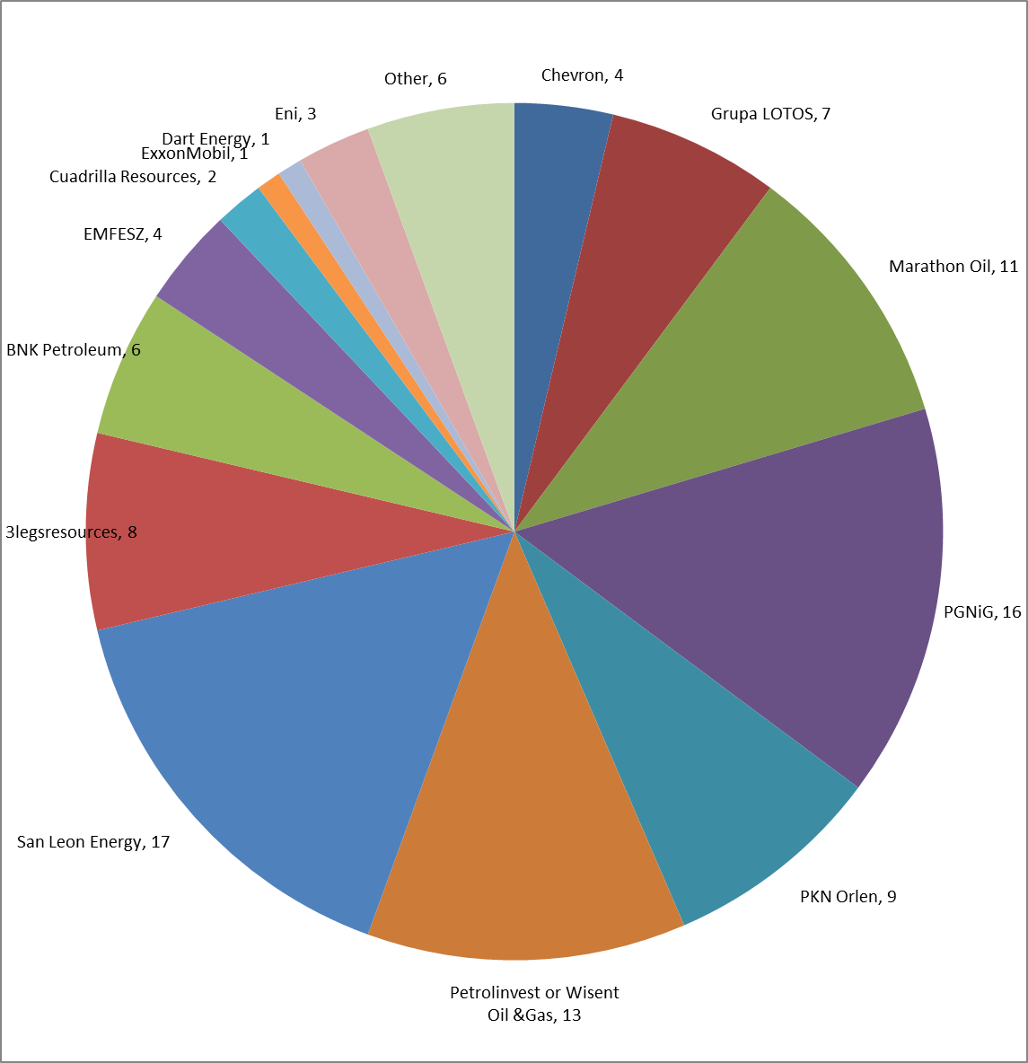
Source: Official information from Polish government and DG ENER own research
In Poland 41 out of 108 shale gas licenses were granted to large international oil and gas companies (San Leon Energy, Marathon Oil, BNK Petroleum, Eni, ExxonMobil, Dart Energy). 32 licenses are in the hand of large oil and gas companies which are largely or partially (>25%) owned by the Polish government (PGNiG, PKN Orlen, Grupa LOTOS). 14 licenses are controlled by large oil & gas companies active in several European countries (Cuadrilla, EMFESZ, 3legsresources) and 13 by large oil & gas companies with a clear focus in Poland (Petrolinvest and their daughter company Wisent Oil & Gas). For 3 licensees with together 6 licenses no clear information could easily be found from public sources.

Characteristics of licensees in Poland
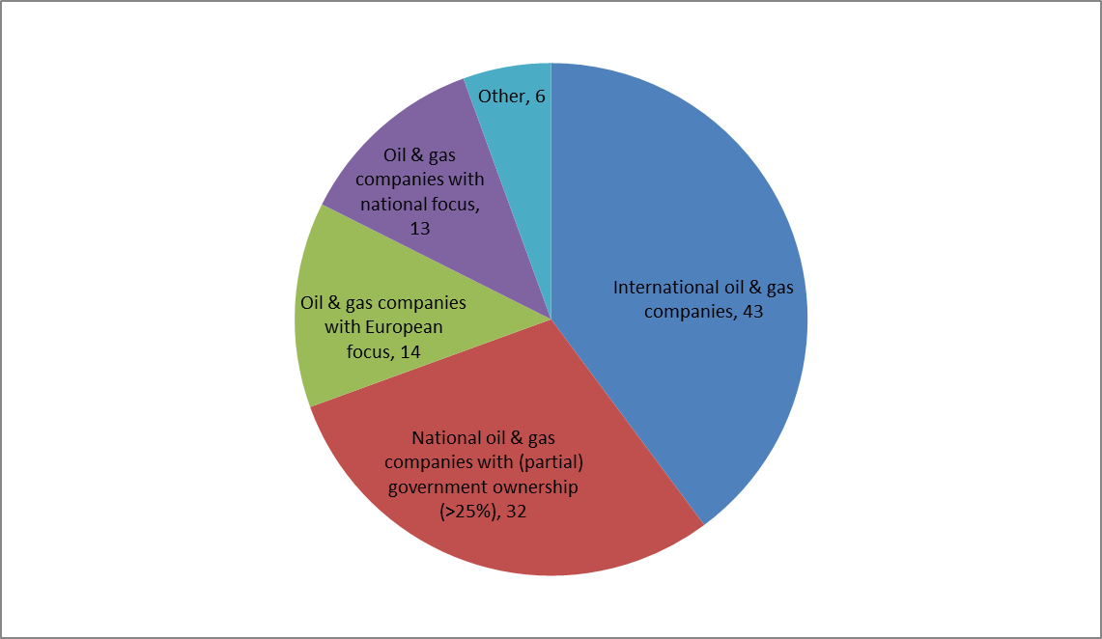
Source: DG ENER own research

Methodology and main results from the macro-economic study undertaken for this IA
(ICF 2013, forthcoming)

Methodology
The study assesses the macro-economic impacts of the BAU, option A and option D.
Options B and C were not analysed as it was assumed that their macro-economic impacts would be in-between the ones of options A and D. In case the results for A and D would have been much different, we would have run the model also for B and C, but it was not deemed necessary.

In order to assess macro-economic impacts, the study followed the following steps:
1. Develop estimates of the accessible shale gas resource base in each Member State for both the baseline (i.e., best resource base estimates) and ‘high’ resource base scenarios; (accessible resource is estimated as a share of recoverable resource taking into account population density and protected area).
2. Develop supply curves to model the costs for shale gas extraction at play level; apply these supply curves to Member States, scaling the resource base to the estimated actual (mean) shale gas resource for each Member State; Develop supply curves by Member State representing the regulatory scenarios: Costs for gas producers to comply with the risk management policy options are translated into additional costs (in €/bcm) necessary to adopt a certain technology or to comply with a given policy or regulation.
3. Run POLES model in order to model EU shale gas production and gas prices under BAU and different policy scenarios for years 2020 and 2030; The POLES model simulates demand and supply dynamically and gas prices are an endogenous result of the annual demand/supply equilibrium. As a result, different shale gas production and production costs will result in different gas prices overall; in turn, this will change the competitiveness of gas as a fuel to energy consumers. Thus, forecasts of shale gas production levels associated with variants on technology costs or policies in producing countries will also be associated with corresponding forecasts of gas prices and gas demand levels by sectors in consuming countries.
4. Based on the supply curves and outputs from POLES, estimate impacts of policy scenarios (and sensitivities) on EU energy consumption, sources of energy, energy prices and investment by the energy sector.
5. The E3ME macroeconomic model converts key outputs from the POLES model (energy consumption (by fuel and sector), source of energy (i.e. domestic or imported), energy prices (by fuel) and investment by the energy sector into impacts on GDP, Employment by sector, Unemployment, Household incomes, Consumption, Investment, Government expenditure, Inflation. The model is based on Eurostat data, with a historical database covering the period 1970-2010 (1995-2010 for CEE countries). Energy balances are obtained from the IEA. To ensure that the analysis is carried out on a consistent basis, E3ME has been calibrated to the same baseline forecast as the POLES model. The labour market baseline forecast in E3ME has been calibrated to be consistent with the most recent version of the EU projections published by CEDEFOP.
Sensitivity analysis was undertaken for resource estimates and GDP growth. As for well lifetime, 10 and 30 years were checked and did not lead to any significant differences.

Although detailed quantitative results are subject to uncertainties, the report considers that the direction of the results and the qualitative conclusions are robust.

Main results

Shale gas production levels differ relatively little (8%) between risk management policy options, so do imports
In the model, production levels depend on shale gas resources, production costs and possible moratoria in place. They do not depend on the clarity of the regulatory framework nor the public perception.
The model shows that, in the most stringent option (D), with production costs about 8% higher than in the BAU in 2030 (due to more requirements), production is 8% lower than in the BAU. In option A, production is 5% lower than in BAU.
Impacts of the different options are significantly smaller compared to the impacts of different assumptions on economic growth and shale gas resources available.
Since production does not change much, imports also do not change much: In both options A and D, the contribution of shale gas gradually reaches around 10% of consumption 15 years after start of production.

Sectoral impacts
Even with the most stringent option (D), sector output decreases by less than 1% across nearly all the sectors in comparison to BAU. In case of "high resource and stringent requirements", sector output increases, most importantly in the "Utilities and Mining" sector (+4.1%) as a direct result of the net increase in shale gas production. This sector also sees increases in employment, but because it is relatively energy and capital intensive, the employment increase is small. The sectors that are most affected are those that both provide inputs to the mining sector and are also energy (gas) intensive:
- metals (1.09%)
- non-metallic minerals (0.52%)
- construction (0.52%)

Negligible Impacts on GDP:
The policy options A and D have a negligible economic impact compared to the reference case, because the policies have almost no impact on energy production, energy prices or energy demand. The highest impact is reached in the "high resources AND stringent requirements" scenario which leads to a 0.34% increase in EU-27 GDP as compared to BAU. This positive impact is more pronounced for Member States that have a large difference between shale gas production in the reference case and in the high resource base relative to the overall size of a Member States economy.

Negligible impacts on Employment:
The policy options A and D have a negligible employment impact compared to the reference case. The highest impact is reached in the "high resources AND stringent requirements" scenario which leads to 0.15% employment impact, which translates to around 350,000 jobs (measured in full-time equivalence) across Europe. The impact is modest because the sectors most affected (the gas extraction sector) have a low-intensity of labour.

Share of energy costs in some sectors of the economy in some MS

(source of the graphs unless otherwise mentioned: DG ENTR)

On average, the share of energy in the production costs, in 2010, was around 2% in the manufacturing sector in Germany, France, Italy and UK (and around 5% in Bulgaria and Romania). This hides a wide diversity of situations, with this share ranging between 5 and 9 % in the chemicals sectors in these countries, between 5 and 13% in the basic iron and steel manufacturing and between 14 and 23% in the cement sector. However, this large range between some the most industrial EU countries also shows that, in some countries and sectors, there are significant possibilities for improving energy efficiency with necessary investments.

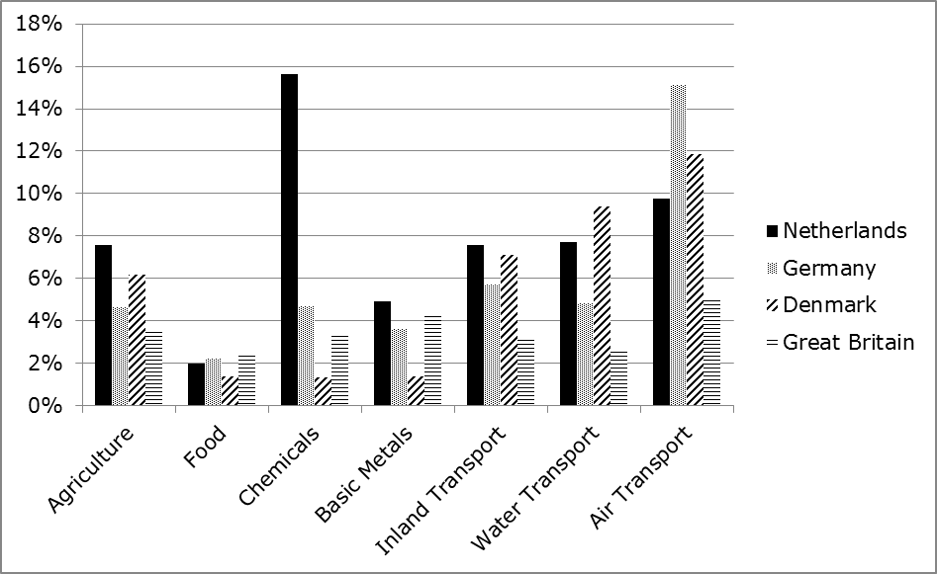Energy cost share in some industrial sectors for some EU countries in 2009
Source: World Input-Output Database

source: Enerdata, Global energy statistical yearbook 2012

Share of EU gas consumption covered by different sources
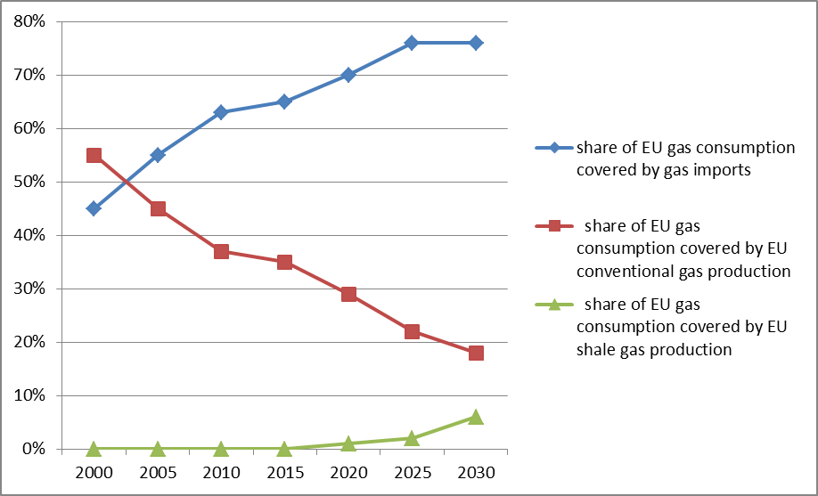
Source: ICF 2013, baseline scenario

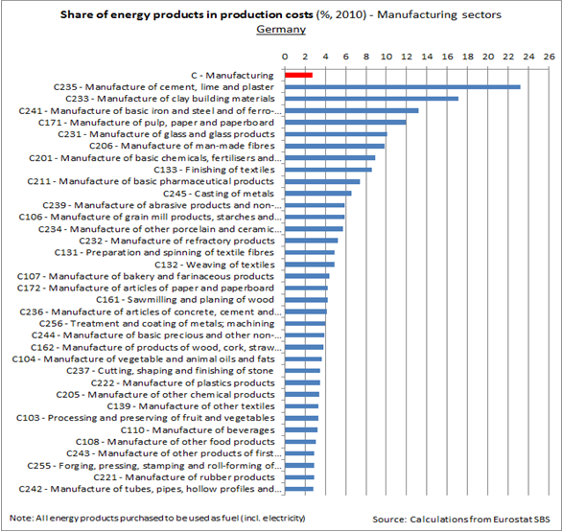
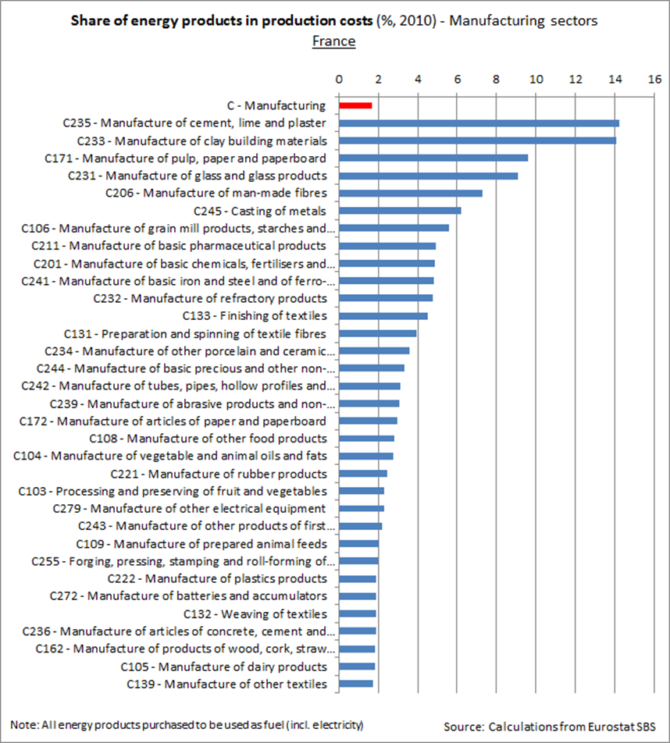
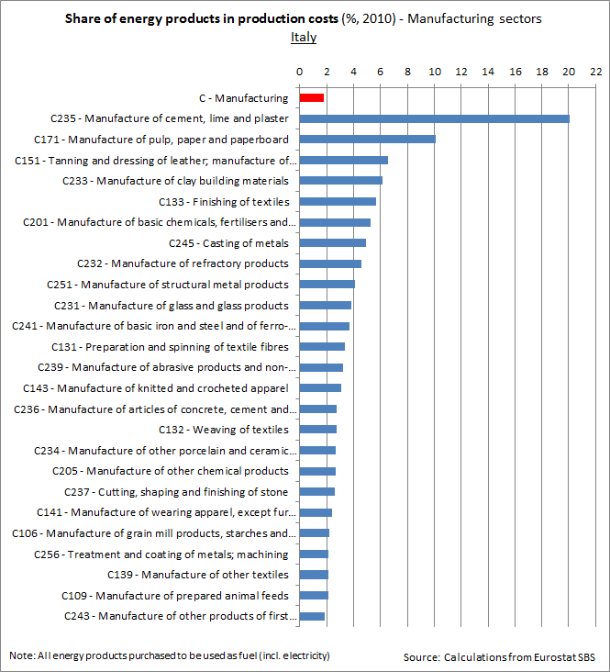
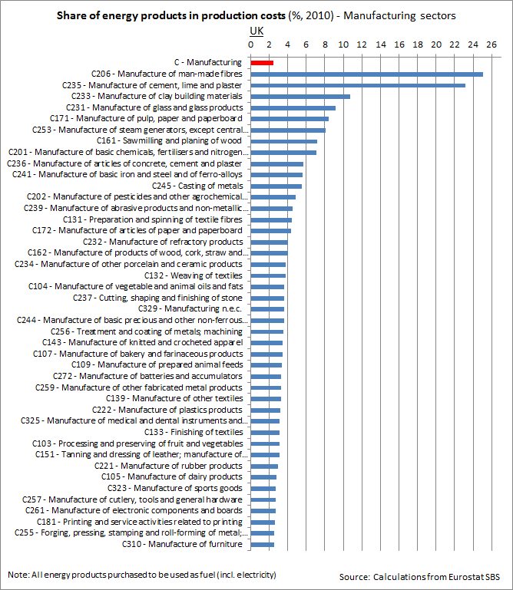

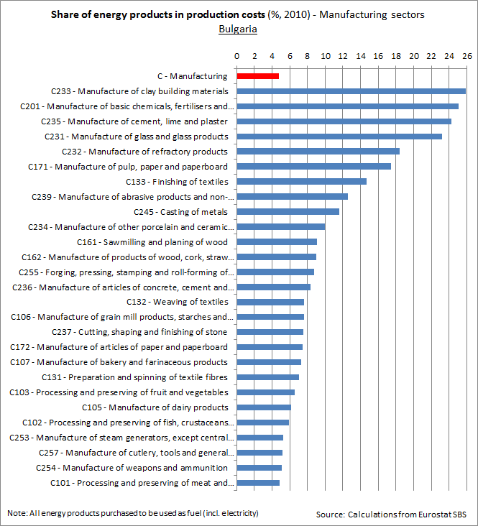
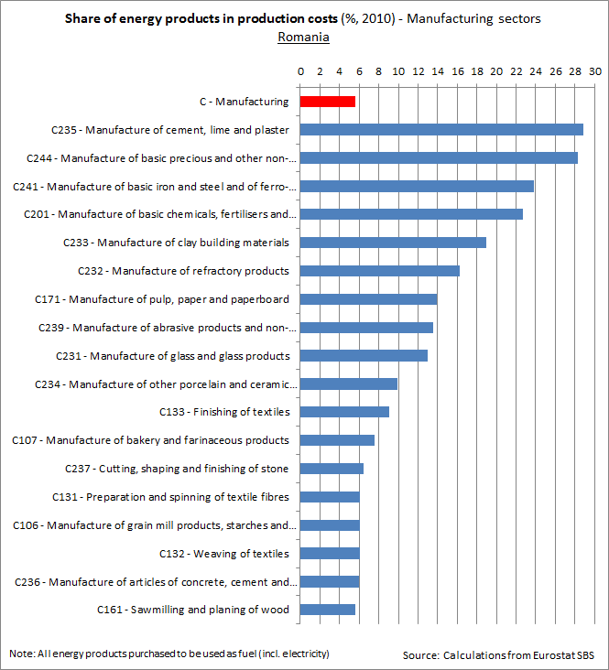

EU-US comparison in terms of economic structure
Sources: Energy Economic Developments in Europe, DG ECFIN, forthcoming publication

Share of some Energy Intensive Sectors (EIS) and share of Manufacturing in total
Gross Value Added in EU and USA, 2001-2011

Source for the EU: EUROSTAT
EIS for the EU are: Mining and Quarrying, Manufacturing of Chemicals and chemical products, Manufacturing of Paper and paper products, Manufacture of coke and refined petroleum products, Manufacture of basic pharmaceutical products and pharmaceutical preparations, Manufacture of rubber and plastic products, Manufacture of other non-metallic mineral products, Manufacture of basic metals, Manufacture of fabricated metal products, except machinery and equipment. Data for 2011 for some sectors are estimated.
Source for the US: Value Added by Industry [Billions of dollars], Bureau of Economic Analysis, Release Date: April 25, 2013
EIS for the US are: Mining, Nonmetallic mineral products, Primary metals, Fabricated metal products, Paper products, Petroleum and coal products, Chemical products, Plastics and rubber products.
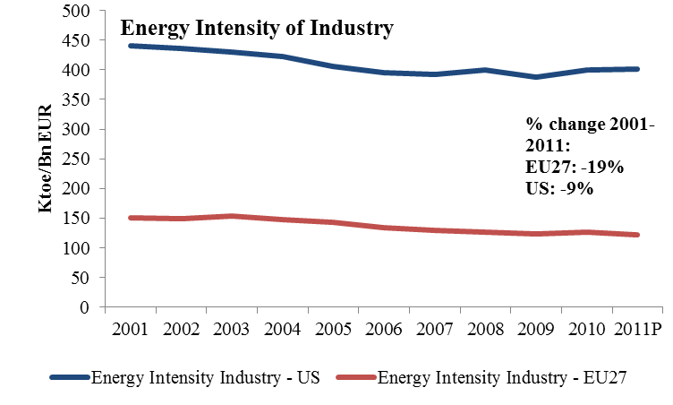
The EU industry's energy intensity has been substantially lower than its US counterpart. In addition it has improved by almost 19% between 2001 and 2011 while in the US the improvement over the same period was only 9%.

Bilateral trade balance for goods, US – EU27, 2001-2011, % of respective GDPs.

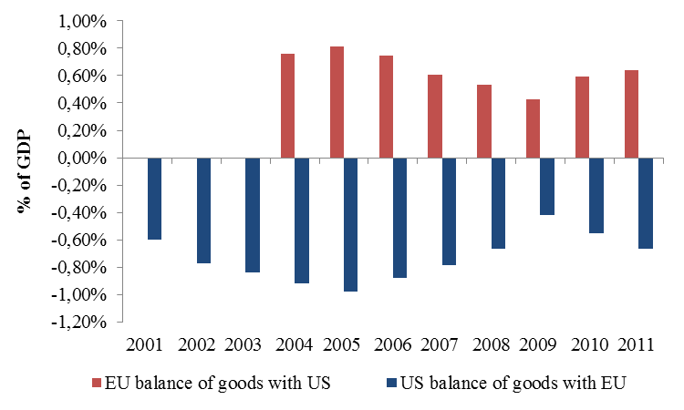
Source: Commission services on Eurostat and US Bureau of Economic Analysis

The graphs above show that "the EU-US goods balance has shown a persistent surplus for the EU without any clear sign of deterioration. Since the direct trade in goods constitutes one of the key indicators for assessing (changes in) competitiveness, one can tentatively conclude that the widening EU-US energy price gap has so far not visibly affected the EU industry's market performance vis-a-vis their US counterpart, at least on the EU and US markets".

See for instance: 'The Energy-Water Nexus: Potential Groundwater-Quality Degradation Associated with Production of Shale Gas", from Procedia Earth and Planetary Science, Volume 7, 2013, available at: http://www.sciencedirect.com/science/article/pii/S1878522013002130 and 'The Effects of Shale Gas Exploration and Hydraulic Fracturing on the Quality of Water Resources in the United States', from Procedia Earth and Planetary Science, Volume 7, 2013, available at: http://www.sciencedirect.com/science/article/pii/S1878522013002944
Umweltauswirkungen von Fracking bei der Aufsuchung und Gewinnung von Erdgas aud konventionellen LagerstaettenUBA study
Broderick, J., Anderson, K., Wood, R. Gilbert, P., Sharmina, M., Footitt, A.,Glynn, S.,Nicholls, F. (2011) Shale gas: an updated assessment of environmental and climate change impacts. Manchester: The Tyndall Centre for Climate Change Research. Available at: http://www.tyndall.ac.uk/sites/default/files/coop_shale_gas_report_update_v3.10.pdf [accessed August 2013].
At the exploratory well in Lebien, Poland, 462.09 m3 of various chemical additives (representing about 2.5% of volume of the fracturing fluid) were used. (PGI 2012)
Spatially-resolved Assessment of Land and Water Use Scenarios for Shale Gas Development: Poland and Germany, JRC
US EPA 2011 Study Plan mentions 25-75% of flowback waters; Lebien exploratory project in Poland refers to some 15% flowback; Cuadrilla in the UK (public website) refers to 20-40% returned waters. http://www.cuadrillaresources.com/protecting-our-environment/water/water-disposal/. Hence the complementary figures relate to fracking fluids remaining underground.
The Future of Natural Gas, June 2011 http://mitei.mit.edu/system/files/NaturalGas_Report.pdf p. 39 and Appendix 2E http://mitei.mit.edu/system/files/NaturalGas_Appendix2E.pdf - this study does not aim at a comprehensive analysis of all known incidents nor conduct a detailed analysis of all state reported incidents. It has to be noted that drinking water wells in Europe are often not privately owned and differently regulated than in USA.
Alberta official information, Jan. 2013. An inter-well bore event relates to the impact of hydraulic fracturing conducted at one well on a nearby well, hence potentially challenging its integrity.
For instance, in http://www.nicholas.duke.edu/news/study-finds-no-evidence-of-water-contamination-from-shale-gas-drilling-in-arkansas?utm_source=click&utm_medium=web&utm_campaign=hpbanners: "Variations in local and regional geology play major roles in determining the possible risk of groundwater impacts from shale gas development" and "systematic monitoring of geochemical and isotopic tracers is necessary for assessing possible groundwater contamination".
Fontenot et al (2013): Environ. Sci. Technol., 2013, 47 (17), pp 10032–10040
For instance, Cuadrilla application in the UK indicates that the "returned waters become contaminated with Naturally Occurring Radioactive Material (NORM) at levels that exceed 1 Becquerel per litre (>1Bq/l) (…) which means that the returned waters are defined as radioactive waste" in accordance with UK legislation. See http://www.cuadrillaresources.com/wp-content/uploads/2012/02/MWD_WMP_AR_082012-FINAL-Waste-Management-Plan-UPDATED.pdf
Unless it is free of "pollutants" or it is authorised under the derogation laid down in Article 6 § 3b of the Groundwater Directive (2006/118/EC). A pollutant is defined as "any substance liable to cause pollution, in particular those listed in Annex VIII of the Water Framework Directive".
following the requirements of the Mining Waste Directive
A peer-reviewed study examined the water quality and isotopic compositions of discharged effluents, surface waters, and stream sediments associated with a treatment facility site in western Pennsylvania where water from shale gas wells was treated. It found levels of Radium 226 in stream that were about 200 times greater than upstream and background sediments and above radioactive waste disposal threshold regulations ("Impacts of Shale Gas Wastewater Disposal on Water Quality in Western Pennsylvania", N.R. Warner et al, 2013, Environmental Science and Technology). See also Journal of Environmental Management, Volume 120, 15 May 2013, Pages 105–113: 'Wastewater management and Marcellus Shale gas development: Trends, drivers, and planning implications', B.G. Rahm and al.
Ceteris paribus, the damages caused by the uncontrolled spill of waste water containing cyanide and heavy metals in Romania in 2000 caused an interruption in the water supply in 24 localities, inconvenience to citizens, and supplementary costs in the sanitary field and in industry by interruption of the production process (official Romanian sources). For more info, see UNEP report: http://reliefweb.int/sites/reliefweb.int/files/resources/43CD1D010F030359C12568CD00635880-baiamare.pdf)
U.S. Department of the Interior, U.S. Geological Survey: Hydraulic Fracturing Fluids Likely Harmed Threatened Kentucky Fish Species, available at: http://www.usgs.gov/newsroom/article.asp?ID=3677&from=rss_home (accessed Sept 2013)
Osborn, S.G., Vengosh, A., Warner, N.R., Jackson, R.B. (2011a) Methane contamination of drinking water accompanying gas-well drilling and hydraulic fracturing. Proceedings of the National Academy of Sciences of the U.S.A. 108 (20): 8172–8176. Doi/10.1073/pnas.1100682108
Jackson and al, 2013, Duke University, Proceeding of the National Academy of Sciences: Higher levels of stray gases found in water wells near shale gas sites. ScienceDaily. Retrieved June 28, 2013, from http://www.sciencedaily.com /releases/2013/06/130624152607.htm
"Climate impact of potential shale gas production in the EU" – a study conducted for DG CLIMA in 2012.
IPCC Special Report on Renewable Energy Sources and Climate Change Mitigation, 2012, Cambridge University Press.
http://iea.org/newsroomandevents/pressreleases/2013/june/name,38773,en.html
US Department of Energy 90 days report; Electric Power Research Institute (EPRI) (2012) Program on Technology Innovation: Literature Review of Issues Related to the Atmospheric Impacts of Natural Gas Power Plants. EPRI, Palo Alto, CA: 2012. 1025018. Available at: www.epri.com/abstracts/Pages/ProductAbstract.aspx?ProductId=000000000001026597 [accessed August 2013]; Professor Rob Field, University of Wyoming,
Kappel et al, 2013, US Geological Survey: http://pubs.usgs.gov/of/2013/1137/pdf/ofr2013-1137.pdf
Rahm, B.G., Riha, S.J. (2012) Toward strategic management of shale gas development:Regional, collective impacts on water resources. Environmental Science & Policy. 17: 12-23. Doi:10.1016/j. envsci.2011.12.004.
Entrekin, S., Evans-White, M., Johnson, B., and Hagenbuch, E. (2011) Rapid expansion of natural gas development poses a threat to surface waters. Frontiers in Ecology and the Environment. 9(9): 503–511. Doi:10.1890/110053.
see annex 20
IEA Golden rules report, p.31
Broderick et al.(2011) Shale gas: an updated assessment of environmental and climate change impacts. Manchester: The Tyndall Centre for Climate Change Research. Available at: http://www.tyndall.ac.uk/sites/default/files/coop_shale_gas_report_update_v3.10.pdf [accessed August 2013].
Spatially-resolved Assessment of Land and Water Use Scenarios for Shale Gas Development: Poland and Germany", JRC IES, forthcoming
IEA Golden Rules Report 2012
http://dialog-erdgasundfrac.de/sites/dialog-erdgasundfrac.de/files/Ex_HydrofrackingRiskAssessment_120611.pdf, p.56
OGP Position paper July 2013
World Energy Outlook Special Report on Unconventional Gas: Golden Rules for a Golden Age of Gas © OECD/IEA, 2012, table 1.1 p.31
Directive 2013/30/EU needs to be transposed into national legislation as of 19 July 2015. According to available information, (PGI 2012 and BGS 2012-2013), there would be potential for offshore shale gas resources for instance in the North/Baltic sea and under the East Irish sea. The suitability of the Offshore oil and gas Directive could be reassessed, should there be indication of concrete offshore shale gas projects, which is not the case in the short term.
DG ENV note endorsed by the Commission legal service: http://ec.europa.eu/environment/integration/energy/pdf/legal_assessment.pdf
Will be repealed by Regulation 2012/528/EU concerning the placing on the market and use of biocidal products
http://ec.europa.eu/environment/integration/energy/pdf/guidance_note.pdf
Guidance on the Application of the Environmental Impact Assessment Procedure for Large-scale Transboundary Projects (http://ec.europa.eu/environment/eia/eia-support.htm, (16/05/2013)
If an activity listed in Annex I of the Industrial Emissions Directive (IED) (i) would be directly associated to shale gas exploration and exploitation, (ii) would have a technical connection with shale gas exploration and exploitation and (iii) would be operated in situ . Hence the IED could apply, should the injected fracturing fluids qualify as “underground storage of hazardous waste of 50 tonnes or more”. Should it apply, emissions limits e.g to surface water would apply, groundwater and soil baseline reporting would be foreseen as well as monitoring of emissions to water, air or land. The IED repeals the IPPC Directive (2008/1/EC) and entered into force on 6th January 2011. It had to be transposed into national legislation by Member States by 7th January 2013.
Member States have to transpose and implement the Seveso III Directive by 1st June 2015.
The Directive would apply only to the chemical and thermal processing operations and storage related to those operations which involve listed dangerous substances in the Directive. Indeed the Directive exempts from its scope the exploitation, namely the exploration, extraction and processing, of minerals in mines and quarries, including by means of boreholes.
This decision requires each Member State, by 2020, to limit its greenhouse gas emissions at least by the percentage set for that Member State in Annex II to this Decision in relation to its emissions in 2005.
The Commission proposal for a revised EIA Directive proposes that the screening criteria and the information to be included in the EIA report refer to the sub-surface dimension of the projects and take into account hydromorphological changes.
Commission services guidance on the applicability of the EIA and SEA to unconventional fossil fuels such as shale gas available at: http://ec.europa.eu/environment/integration/energy/pdf/guidance_note.pdf
Milieu study conducted for DG ENV, 2013
Under REACH, all information available to ECHA can be shared with competent authorities in charge of REACH enforcement.
'Mitigation of climate impacts of possible future shale gas extraction in the EU' – study performed for DG CLIMA in 2013
The study 'Measurement of methane emissions at natural gas production sites in the US' by Allen et al (2013) demonstrated, on a limited sample of 27 well completions, that RECs are able to significantly reduce emissions and that they are gradually being phased in. Out of the 27 well completions, 67% of the wells used RECs, which resulted for these wells in capturing 99% of potential emissions. However, some doubts have been raised about the representativeness of the sampled sites.
Defined as 500 pounds per square inch absolute (psia), i.e. 3.45 MPa.
'Mitigation of climate impacts of possible future shale gas extraction in the EU' – study performed for DG CLIMA in 2013
Routine associated gas flaring is defined as the continuous flaring of solution gas that is economical to conserve. Associated (solution) gas is gas produced from a well during oil production.
'Mitigation of climate impacts of possible future shale gas extraction in the EU' – study performed for DG CLIMA in 2013
The Commission proposal did not propose to review Annexes I and II of the EIA Directive.
Directive 98/8/EC, to be replaced by Regulation (EU) No 528/2012 as of 1 September 2013.
The content of these measures depend on the on-going co-decision procedure in the framework of the revision of the EIA Directive
Milieu study conducted for DG ENV, 2013
Commission services guidance on the applicability of the EIA and SEA to unconventional fossil fuels such as shale gas available at: http://ec.europa.eu/environment/integration/energy/pdf/guidance_note.pdf
e.g draft proposal in Germany not yet adopted pending elections in the autumn 2013
Milieu study for DG ENV, 2013
Opinion of the ENVI Committee adopted on 11th July 2013. A plenary adoption is foreseen in the autumn 2013.
Commission services guidance on the application of Directive 85/337/EEC (now codified by Directive 2011/92/EU) to projects related to the exploration and exploitation of unconventional hydrocarbons: http://ec.europa.eu/environment/integration/energy/pdf/guidance_note.pdf.
Review foreseen to take account not only of shale gas but also the red mud accident in Hungary in 2010 as well as techniques/processes used in certain specific mining sectors such as cyanide gold mining.
Article 4.1(b)(i) of the WFD:" Member States shall implement the measures necessary to prevent or limit the input of pollutants into groundwater and to prevent the deterioration of the status of all bodies of groundwater, subject to the application of paragraphs 6 and 7 and without prejudice to paragraph 8 of this Article and subject to the application of Article 11(3)(j)
The Commission proposal for a revised EIA Directive proposes that the screening criteria and the information to be included in the EIA report refer to the sub-surface dimension of the projects and take into account hydromorphological changes.
see Annex Main findings from Milieu study, 2013
DNV study conducted for DG EMPL
AEA study on well integrity, 2012
DNV study for DG EMPL, 2013
Milieu report for DG ENV, 2013
Manufacturers and importers of substances used for high volume hydraulic fracturing were obliged to register the substances by December 2010 if produced/imported above 1000 t/y or with a lower tonnage for specific hazardous substances (with further phase-in of substances due in 2013 and 2018).
Assessment of the use of substances in hydraulic fracturing of shale gas reservoirs under REACH, JRC IHCP, 2013.
It is therefore suggested in this report that the possibility of defining a more specific use name that addresses hydraulic fracturing is explored by the industry. The current use descriptor system under REACH may also be complemented by one additional Environmental Release Category (ERC) covering the case of a substance that is intentionally introduced into the environment to carry out its technical function. It is furthermore noted that the environmental exposure assessment may benefit from the development of a model that covers the direct introduction of substances into the underground and possible migration upwards.
Propane was used for fracturing gas wells in North America but according to service companies and industry, such use would not be a common practice and would typically be 20-40% more costly according to AEA 2012 than slickwater fracturing.
whereas the REACH restriction process is per substance, on a case by case basis and after a risk arises.
Milieu report for DG ENV, 2013
Milieu report for DG ENV, 2013
http://www.ngsfacts.org/findawell/list/
subject to certain possible exceptions
Milieu study for DG ENV, 2013
Milieu study, DG ENV, 2013
Be it flowback or produced water
Would qualify as category A a waste facility fulfilling Annex III criteria of the Mining Waste Directive (i.e a failure or incorrect operation could give rise to a major accident, on the basis of a risk assessment taking into account factors such as the present or future size, the location and the environmental impact of the waste facility; or it contains waste classified as hazardous under Directive 91/689/EEC above a certain threshold; or it contains substances or preparations classified as dangerous under Directives 67/548/EEC or 1999/45/EC above a certain threshold)
Review foreseen to take account not only of shale gas but also the red mud accident in Hungary in 2010 as well as techniques/processes used in certain specific mining sectors such as cyanide gold mining.
http://ec.europa.eu/environment/air/pollutants/stationary/ippc/pdf/recast/ia_en.pdf
Ranging from several days for the Reduced Emissions Completions to over a year for installation of vapour recovery units on storage tanks, according to the study "Mitigation of climate impacts of possible future shale gas extraction in the EU' – study performed for DG CLIMA in 2013
In the United States the uptake of the Natural Gas STAR program is relatively high (59 % of the US natural gas industry) also due to the fact that some US states require proof of participation in the program as part of permitting regulations (e.g. New York State GHG Emissions Impacts Mitigation Plan draft). ('Mitigation of climate impacts of possible future shale gas extraction in the EU' – study performed for DG CLIMA in 2013)
E.g. the International Association of Oil & Gas Producers (OGP) stated in their Policy Recommendations in July 2013 that OGP members intend to use 'green completion' where practical; while venting and flaring would still be used during the exploration phase and when needed for operational safety reasons.
'Mitigation of climate impacts of possible future shale gas extraction in the EU' – study performed for DG CLIMA in 2013. The estimates of impacts on shale gas emissions and production costs can be affected by uncertainties in emissions factors; abatement efficiencies of mitigation measures; capital and operating costs of mitigation measures; gas prices; uptake of measures under BAU; requirements for additional uptake of measures under policy scenarios; projections of numbers of wells per MS and their characteristics and scale up of emissions per well to emissions per MS. Further sources of uncertainty relate to the energy and economic modelling, which can be affected by uncertainties in the data and assumptions, simulation methods and modelling relationships, baseline forecasts and model/scenario assumptions. However, when comparing the differential impacts between the policy scenarios and BAU, uncertainties will tend to cancel out and become less important.
'Mitigation of climate impacts of possible future shale gas extraction in the EU' – study performed for DG CLIMA in 2013.
'Mitigation of climate impacts of possible future shale gas extraction in the EU' – study performed for DG CLIMA in 2013.
RECs involve temporary installation of equipment designed to handle the high initial flow of water, sand and gas. A sand trap is used to remove the solids, and is followed by a three phase separator which separates the water from the condensate (liquid hydrocarbons) and gas. The gas is then sent to a sales pipeline (or to other processing facilities where needed). Where the pipeline infrastructure is not yet in place to receive saleable gas, the gas stream may be routed to suitable storage before treatment and transfer offsite or a temporary flare.
'Mitigation of climate impacts of possible future shale gas extraction in the EU' – study performed for DG CLIMA in 2013. The estimates of impacts on shale gas emissions and production costs can be affected by uncertainties in emissions factors; abatement efficiencies of mitigation measures; capital and operating costs of mitigation measures; gas prices; uptake of measures under BAU; requirements for additional uptake of measures under policy scenarios; projections of numbers of wells per MS and their characteristics and scale up of emissions per well to emissions per MS. Further sources of uncertainty relate to the energy and economic modelling, which can be affected by uncertainties in the data and assumptions, simulation methods and modelling relationships, baseline forecasts and model/scenario assumptions. However, when comparing the differential impacts between the policy scenarios and BAU, uncertainties will tend to cancel out and become less important.
"Climate impact of potential shale gas production in the EU", study conducted for DG CLIMA, Sept. 2012
Wang, Zhongmin/Krupnick, Alan: US Shale Gas Development. What Led to the Boom? Resources for the Future Issue Brief 13-04, May 2013
In the UK a Petroleum, Exploration and Development License covers any hydrocarbons so shale gas could be explored under any existing license. However, Cuadrilla is the company who drilled the up to now only four shale gas wells in the UK.
http://www.cuadrillaresources.com/news/cuadrilla-news/article/cuadrilla-welcomes-centrica-as-new-investment-partner-in-lancashire/
Centrica has around 40,000 employees and as at 31 January 2013 a market capitalisation of GBP 18.21 billion (http://www.centrica.co.uk/files/pdf/at_a_glance.pdf)
Hutton Energy Plc as mother company of licensee Strzelecki Energia Sp with 3 licenses is next to Poland active in Ukraine, France and the Netherlands. The focus of Canadian International Oil, who has 2 licenses in Poland, is in the Canadian province of Alberta. The remaining license is held by Mac Oil (Poland) Sp. z.o.o.

