Contents
Annex 4. Environmental Impact pathways
4.1. General impacts pathways
4.2. Chemicals' pathways
4.3. RFF risks pathways

Annex 4. Environmental Impact pathways

4.1 General impacts pathways

Source: Pollutant pathways associated with hydraulic fracturing. Source: Adapted from Environment Agency (England) (2013) © Environment Agency right

4.2 Chemicals' pathways
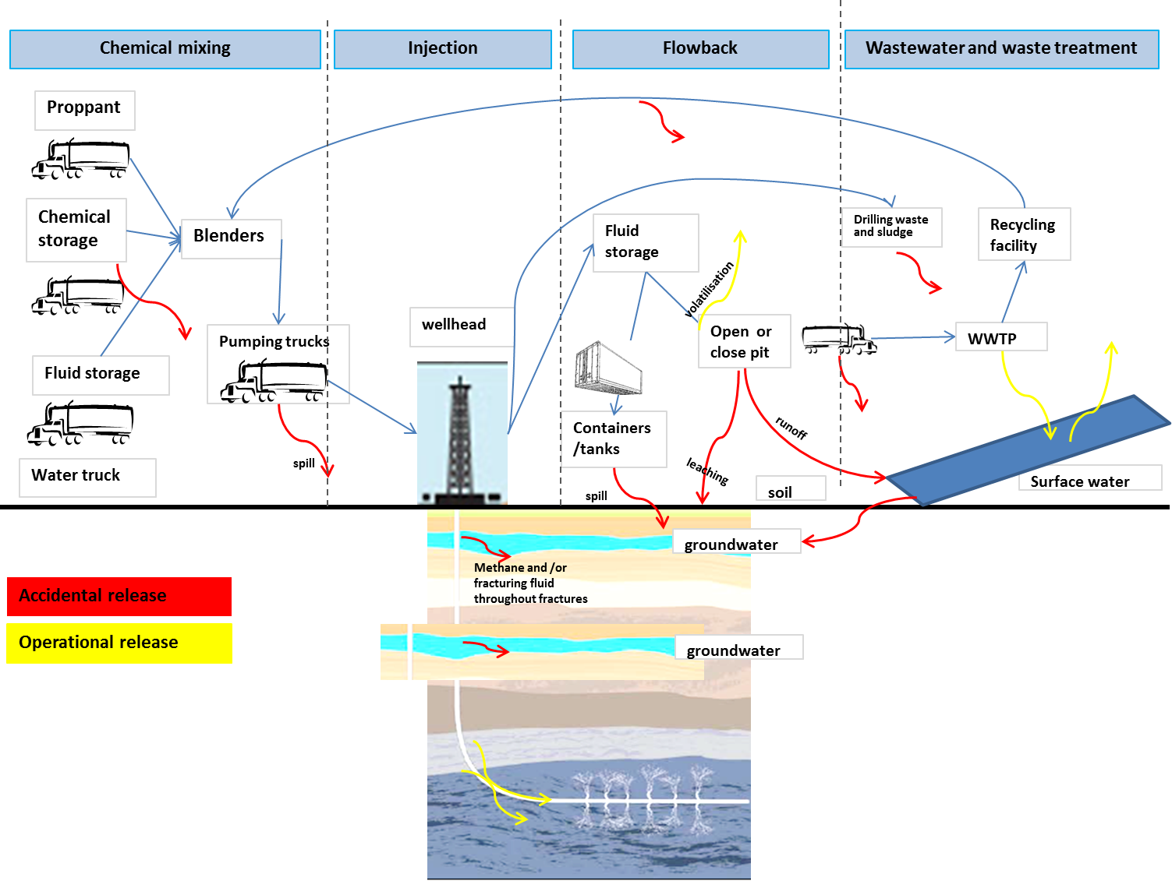

Source: "Spatially-resolved Assessment of Land and Water Use Scenarios for Shale Gas Development: Poland and Germany", JRC IES, forthcoming

4.3. RFF risks pathways
Source: RFF report, Pathways to Dialogue What the Experts Say about the Environmental Risks of Shale Gas Development, Alan Krupnick, Hal Gordon, and Sheila Olmstead, 2013 (accessible at: http://www.rff.org/Documents/RFF-Rpt-PathwaystoDialogue_FullReport.pdf)- RFF retains copyright on this figure.

