Contents
Annex 1. Main sources used in this IA 3
Annex 2. Main meetings hold with stakeholders 6
Annex 3. Gas market information 7
3.1. Gas demand in the EU 7
3.2. Natural gas production in the EU (in toe) 8
3.3. Gas imports in the EU 9
3.4. Natural gas prices 10

Annex 1. Main sources used in this IA

Studies commissioned / undertaken by the European Commission
- Potential Risks for the Environment and Human Health Arising from Hydrocarbons Operations Involving Hydraulic Fracturing in Europe, AEA 2012
- Climate Impact of Potential Shale Gas Production in the EU, AEA 2012
- Unconventional Gas: Potential Energy Market Impacts in the European Union, JRC IET 2012
- The analysis and evaluation of the effects of the practical application of national legislation related to safety and health at work in mineral extraction through drilling", Det Norske Veritas (DNV), 2013
- Regulatory provisions governing key aspects of unconventional gas extraction in selected Member States, MILIEU 2013
- Technical support for assessing the need for a risk management framework for unconventional gas extraction, AMEC 2013
- Analysis and presentation of the results of the public consultation "Unconventional fossil fuels (e.g. shale gas) in Europe", BioIS 2013
- Macroeconomic Impacts of Shale Gas Extraction in the EU, ICF GHK, 2013
- Mitigation of climate impacts of possible future shale gas extraction in the EU: available technologies, best practices and options for policy makers, ICF 2013
- Assessment of the use of substances in hydraulic fracturing of shale gas reservoirs under REACH, JRC IHCP, 2013
- An overview of alternative technologies to hydraulic fracturing for shale gas production, JRC IET, forthcoming
- Spatially-resolved Assessment of Land and Water Use Scenarios for Shale Gas Development: Poland and Germany", JRC IES, forthcoming
- European Economy Publication on energy, DG ECFIN, forthcoming

Studies commissioned by the European Parliament
- Impacts of shale gas extraction on the environment and on human health, 2011, commissioned by the Environment Committee of the European Parliament
- Impacts of shale gas extraction on the environment and on human health –2012 update, commissioned by the Petitions Committee of the European Parliament, October 2012

Institutional documents
- European Parliament resolution of 21 November 2012 on the environmental impacts of shale gas and shale oil extraction activities
- European Parliament resolution of 21 November 2012 on industrial, energy and other aspects of shale gas and oil

Studies commissioned by Member States
- Risk study on Exploration and Exploitation of unconventional gas in North-Rine-Westphalia and the impacts to the ecosystem, in particular the impacts on drinking water resources, 2012
- Fracking and its environmental impacts, in particular to groundwater, German Federal Environment Agency (UBA), 2012
- Environmental Aspects of Hydraulic Fracturing Treatment Performed on the Łebień LE‐2H Well, Poland, 2011
- Polish Geological Institute, Assessment of shale gas and shale oil resources of the lower Paleozoic Baltic podlasie Lublin basin in Poland, 2012
- Shale gas extraction in the UK: a review of hydraulic fracturing , UK Royal society, 2012
- The Impact of Shale Gas on Energy Markets, written evidence submitted by the British Geological Survey, Session 2012-2013
- UK House of Commons Energy and Climate Change Committee report on shale gas, 2011
- Preese Hall Shale gas fracturing review and recommendations for induced seismicity mitigation, UK, April 2012
- Umweltbundesministerium report on shale gas, Germany, 2011
- Les hydrocarbures de roche-mère en France, Conseil général de l'économie, de l'industrie, de l'énergie et des technologies; Conseil général de l'environnement et du développement durable, 2012
- French Senate feasibility plan study on alternatives to hydraulic fracturing techniques for shale gas exploration and exploitation, Parliamentary office of evaluation of scientific and technological choices, 2013
- German Advisory Council on the Environment (SRU), "Fracking for shale gas production – A contribution to its appraisal in the context of energy and environment policy", 2013
- UK Department of Energy & Climate Change, About shale gas and hydraulic fracturing (fracking), 2013
- UK Environment Agency, An Environmental Risk Assessment for shale gas exploratory operations in England, 2013
- Public Health England, 2013, Review of potential public health impacts of exposures to chemical and radioactive pollutants as a result of shale gas extraction: draft for comment

Studies from North American institutions
- US Energy Information Administration official information (eg World Shale Gas Resources: An Initial Assessment. April 2011; Technically Recoverable Shale Oil and Shale Gas Resources: An Assessment of 137 Shale Formations in 41 Countries Outside the United States. June 2013)
- US EPA public information and reports; US EPA. Final Plan to Study the Potential Impacts of Hydraulic Fracturing on Drinking Water Resources, 2011
- US Bureau of Land Management: Oil and Gas; Hydraulic fracturing on Federal and Indian Lands, March 2013
- US Department of Energy, Shale Gas Subcommittee 90-Day Report, 2011
- US Department of Energy, Office of Fossil Energy and National Energy Technology Laboratory, Modern Shale Gas Development in the United States: A Primer, 2009
- New York State Department of Environmental Conservation (NYDEC), 2011: Supplemental Generic Environmental Impact Statement On The Oil, Gas and Solution Mining Regulatory Program; Well Permit Issuance for Horizontal Drilling And High-Volume Hydraulic Fracturing to Develop the Marcellus Shale and Other Low-Permeability Gas Reservoirs
- US House of Representatives, Committee on energy and commerce, Minority staff, 2011, Chemicals used in Hydraulic fracturing
- U.S. Geological Survey, 2013, Kappel, W.M., Williams, J.H., Szabo, Zoltan, Water resources and shale gas/oil production in the Appalachian Basin; critical issues and evolving developments.
- Alberta and British Columbia official information
- Sustainable Development of the Shale Gas Industry in Québec, Bureau d’audiences publiques sur l’environnement, Québec, 2011
- Analyse du cycle de vie et bilan des gaz à effet de serre prospectifs du gaz de schiste au Québec, 2013, CIRAIG, rapport pour le Ministère du Développement Durable, Québec
- Détermination des externalités associées au développement de la filière du gaz de schiste ainsi que des mesures susceptibles de les réduire, Ministère du Développement Durable, de l'Environnement, de la Faune et des Parcs, Québec, 2013

Studies by international organisations
- International Energy Agency, Golden Rules report 2012
- International Energy Agency, Gas: Medium Term Market Report, 2013
- Intergovernmental Panel on Climate Change, Renewable Energy Sources and Climate
Change Mitigation, Special Report, Cambridge Univ Press 2012

Other studies
- Resources For the Future: Survey on risks and reports, 2013
- Hydrofracking risk assessment, Exxon-Mobil Informations und Dialogprozess; 2012
- The Tyndall Centre for Climate Change Research, 2011, Shale gas: an updated assessment of environmental and climate change impacts
- Worldwatch Institute report on environmental risks from shale gas, 2010
- Osborn SG et al, Methane contamination of drinking water accompanying gas well drilling and hydraulic fracturing, PNAS ( 2011), 108, p. 8172
- Jackson et al, Increased stray gas abundance in a subset of drinking water wells near Marcellus shale gas extraction, PNAS (2013), 110, p.11250
- Several scientific reviews articles (see exact references in the text)

Annex 2. Main meetings held with stakeholders

Non-exhaustive list of meetings held since January 2012 between DG ENV representatives and representatives of companies or NGOs:

  - 25 Jan. 2012: meeting with ExxonMobil
  - 02 February 2012: meeting with Talisman Energy
  - 07 February 2012: meeting with Shell
  - 15 February 2012: meeting with Statoil
  - 22 February 2012: meeting with FTI Consulting representing Halliburton
  - 02 March meeting with Food & Water Europe
  - 25 April 2012: meeting with FTI Consulting representing Halliburton
  - 25 April 2012: meeting with ExxonMobil
  - 31 May 2012: meeting with Chevron
  - 17 August 2012: meeting with GDF Suez
  - 17August 2012: meeting with OGP
  - 17th August2012: Health and Environment
  - 05 October 2012: Meeting with Food & Water Europe; Friends of the Earth Europe; WWF; Greenpeace, HEAL
  - 08 October 2012: meeting with Halliburton
  - 05 November 2012: meeting with Chevron and Aberdeen Global Technology Centre
  - 26 November 2012: meeting with Friends of Earth and Food and Water
  - 27 November 2012: meeting with Dow Chemical
  - 19 February 2013: meeting with Halliburton
  - 27 February 2013: meeting with Shell International B.V.
  - 04 March 2013: meeting with ExxonMobil
  - 21 March 2013: meeting with Chevron
  - 22 March 2013: meeting with Chevron
  - 26 March 2013: meeting with PGNiG (Polish Oil & Gas Company)
  - 9 April 2013: meeting with eCORP International
  - 22 April 2013: meeting with Food & Water Europe
  - 22 April 2013: meeting with WWF
  - 26 April 2013: meeting with CEFIC
  - 08 May 2013: meeting with BHP Billiton
  - 27 May 2013: meeting with OGP, International Association of Oil and Gas Producers
  - 18 June 2013: meeting with OGP Europe
  - 18 June 2013: meeting with Nexen
  - 26 June 2013: meeting with Business Europe
  - 04 July 2013: meeting with Business Europe
  - 10 July 2013: meeting with Dow Chemicals

Meetings of the Technical Working Group of Member States on environmental aspects of unconventional fossil fuels, in particular shale gas
- 27 January 2012
- 4th October 2012
- 6th December 2012 – expert workshop on geological aspects
- 8th April 2013
- 24th June 2013

Annex 3. Gas market information

Gas demand in the EU

Source: Gas medium term market report, © OECD/IEA, 2013, fig.10 p.33

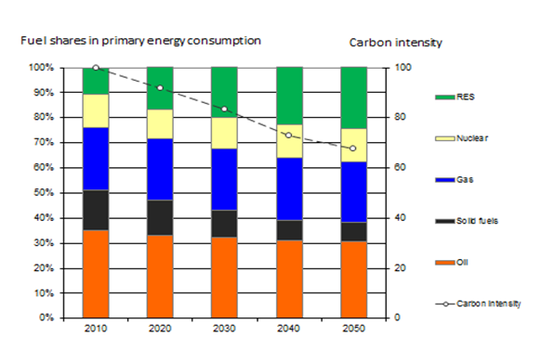
Source: Reference scenario used for the 2030 Climate Energy Framework

Natural gas production in the EU (in toe)

Source: Eurostat (2013)

In the EU, most of natural gas is produced in UK, the Netherlands and Germany.
EU production is in decline in the recent years.

Gas imports in the EU
EU 27 natural gas import dependency (%) (Eurostat)
 | 2000 | 2005 | 2010 | 2011
Gas Energy dependence | 48.9 | 57.7 | 62.39 | 66.98

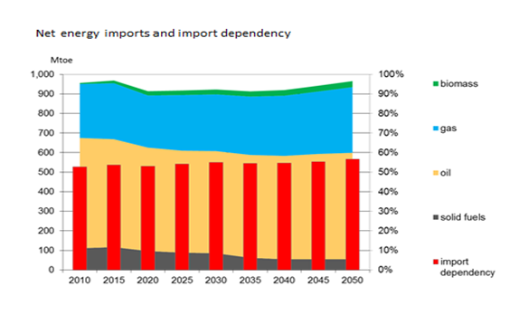
Source: Reference scenario used for the 2030 Climate Energy Framework
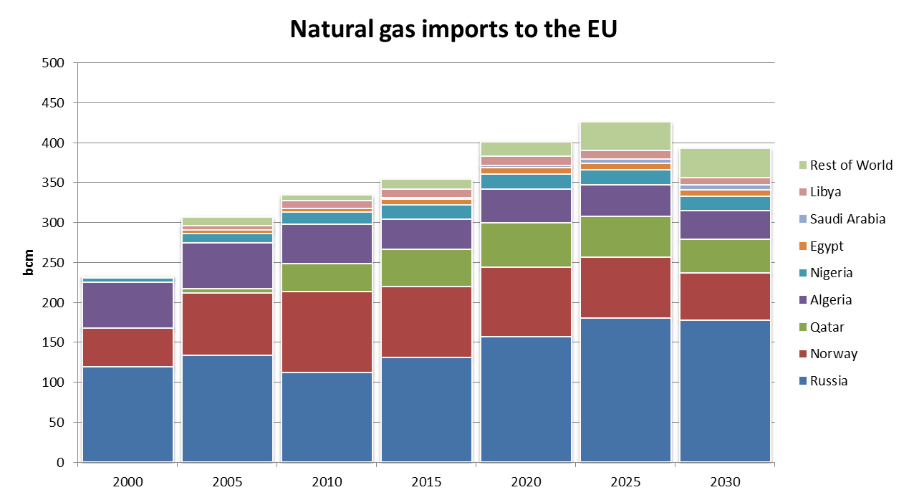
Rest of World (9% of imports) includes the United States, United Arab Emirates, Trinidad & Tobago and Central Asian countries (Kazakhstan, Uzbekistan, Azerbaijan, Turkmenistan).
Source: ICF 2013, study reference scenario

Natural gas prices

Natural Gas and LNG prices 1960-2012 (in real US$ 2005 per mmbtu)
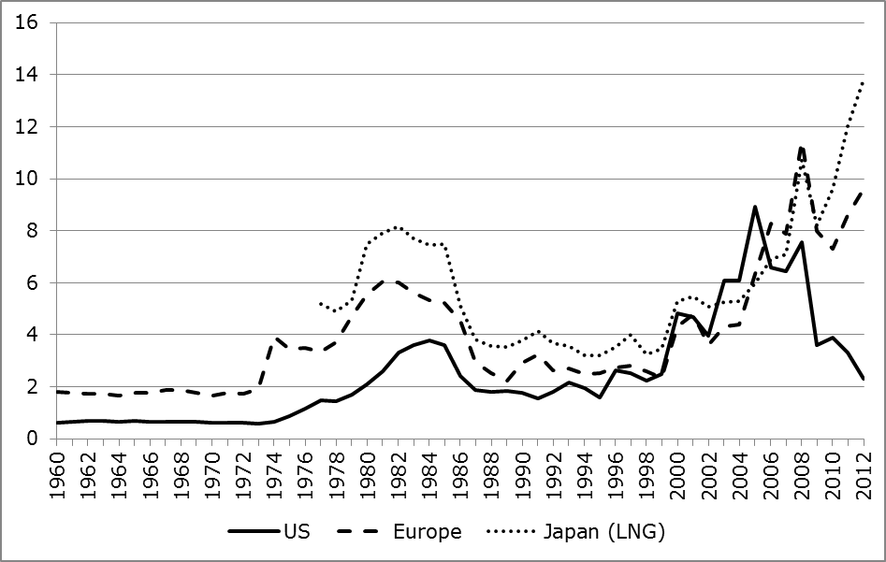
Source: World Bank Commodity Prices
Natural gas prices were much lower in the EU compared to the US in 2003, but this is now completely the other way around. Gas prices are threefold compared to the US.

Natural Gas and LNG prices since 2009 (nominal in $ per mmbtu)
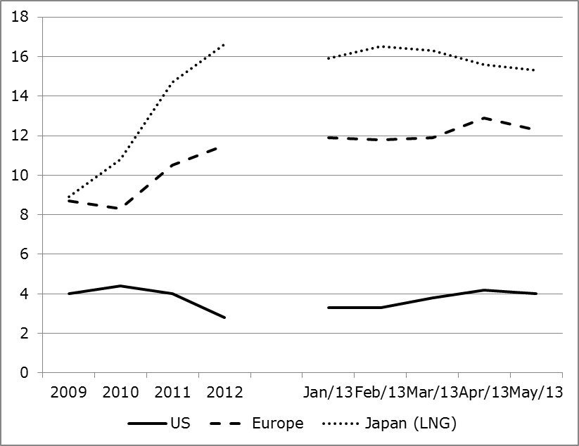
Source: World Bank Commodity Prices

