TABLE OF CONTENTS
1. Introduction 3
2. State of the Industry - 2013 5
2.1. Introduction 5
2.2. Production 6
2.3. Investment 9
2.4. Access to finance 10
2.5. Productivity 13
2.6. Employment 14
2.7. Skills 15
2.8. Innovation 16
2.9. Internal market 19
2.10. Exports and FDI 21
2.11. Energy issues 23
3. Industrial Policy - Sectoral Issues 30
3.1. Chemical sector 30
3.2. Automotive sector 32
3.3. Machinery (mechanical engineering) 33
3.4. Forest-based industries 34
3.5. Steel 36
3.6. Non-ferrous metals 37
3.7. Textiles, fashion and high-end 38
3.8. Defence 40
3.9. Space 42
3.10. Agri-food industries 44
3.11. Pharmaceutical sector 46
3.12. Bio-Based Products Sector 48
3.13. Cement.. 50
3.14. Ceramics 50
3.15. Glass...... .50
3.16. Construction 50
3.17. Tourism.. 50
3.18. Standardisation 50
4. Implementation of the 2012 Industrial Policy Communication 50
5. Contribution of EU Policies to Industrial Competitiveness 50
5.1. Internal market for good and services 50
5.2. Internal Market - Access to finance 50
5.3. Regional and urban policy 50
5.4. Digital agenda 50
5.5. Employment, labour market and social policies 50
5.6. Education and culture policy 50
5.7. Research and innovation policy - horizon 2020 50
5.8. Competition policy 50
5.9. Trade policy 50
5.10. Transport policy 50
5.11. Environmental policy and resource efficiency 50
5.12. Climate action 50
5.13. Justice.... 50

Introduction
In 2010, the Commission adopted the Europe 2020 flagship initiative on “An Integrated Industrial Policy for the Globalisation Era” in the context of the Europe 2020 strategy for smart, sustainable and inclusive growth'. Good progress has been made in the implementation of the 70 key actions of this flagship.
In October 2012 the Commission adopted an update of the flagship communication with the title "A Stronger European Industry for growth and Recovery". The underlying theme of the 2012 Communication was the need to accelerate the reforms initiated already in previous industrial policy developments. To this end, the Commission focused on establishing a broad partnership between the EU, its Member States and industry to dramatically step up investments in new technologies. The Commission remains convinced that Europe’s capacity to take up new technologies will determine the speed of the recovery and the strength of the EU economy in the coming decades.
The Commission has been pursuing an integrated industrial policy approach as outlined in the Industrial Policy Communications of 2010 and 2012 and has issued growth-enhancing recommendations to Member States in the context of the European Semester. Full, effective implementation of this policy approach at European and national levels is critical to ensure EU future competitiveness and to increase its growth potential. To be effective, policy actions must be well articulated and consistent from regional efforts to the EU-level. For these reasons, the new communication calls on Member States to recognise the central importance of industry for boosting competitiveness and growth in Europe and calls for a systematic mainstreaming of competitiveness concerns across all policy areas. They are also invited to endorse the objectives of revitalization of the EU economy, the road-map for achieving this aim and the reindustrialisation efforts to raise the contribution of industry to GDP to as much as 20% by 2020.
This staff working document presents firstly the current state of European manufacturing. In particular it illustrates trends and the impact of the crisis on production, investment, productivity, employment, skills and innovation. It also describes the EU performance in the international arena and considers possible benefits from improvements in the internal market regulations. The aim is to take a snapshot of the manufacturing sector's competitiveness, which could provide elements for improving the design and implementation of EU policies.
Chapter three provides a brief overview of current challenges and relevant policy measures in different sectors. As the EU industrial structure is multi-faceted, the various sectors face different conditions, which should be reflected in European, national and regional competitiveness policy. This section therefore provides an overview of the Commission’s policies on Enterprise and Industry in some of the most relevant sectors. The list of sectors presented hereafter is not exhaustive but focuses on relevant policy areas of the 2012 Industrial Policy Communication. In addition, the importance of standardisation in the European Economy is emphasised by looking at the European Standardisation System of tomorrow.
Chapter four presents the state of play of policy implementation in the form of a summary table. The state of play of the six task forces in place for each priority action line, the accompanying measures and other related initiatives are grouped according to the main themes identified in the 2012 Communication: i) technologies and innovation, ii) access to markets, iii) access to finance and iv) human capital and skills.
The final chapter presents a collection of policies currently implemented at EU level; special attention is put in pointing out their contribution to industrial competitiveness. There are numerous pieces of legislation across the different domains of the European framework that may have an impact on industry. The collection illustrated in this chapter is thus not to be considered fully exhaustive.

State of the Industry - 2013

Introduction
This chapter presents the current state of European manufacturing industry. In particular it illustrates trends and the impact of the crisis on production, investment, productivity, employment, skills and innovation. It also describes the EU performance in the international arena and considers possible benefits from improvements in the internal market regulations. The aim is to take a snapshot of the manufacturing sector's competitiveness, which could provide elements for improving the design and implementation of EU policies.
The recovery from the recession has been slow and partial in the EU, with significant differences across Member States and across sectors. The persistently sluggish behaviour of investment in the EU, and in particular the collapse in the construction related sectors are among the key reasons for this unsatisfactory performance. Economic recovery requires investment to pick up , but EU investment has stayed well below long-term values remaining unresponsive to policy actions. It is very difficult to identify when investment will rebound and one can speculate about the reasons for the delay, but input costs and macroeconomic uncertainties have been identified as influencing factors. Difficulties in financing investments seem also to be of relevance in most vulnerable Member States.
A recurrent theme in the policy discussion is whether the decline in bank loans as observed during the economic crisis is driven by reduced demand or by the tightening of supply, or as is more plausible, by both factors simultaneously. Although there is not a clear answer to this question, the Commission identified the countries where those factors behind low aggregate demand and tightening of supply acquire more importance.
Labour productivity growth has been higher in manufacturing than in services, albeit with significant variation across sectors. Manufacturing industries have also outperformed services industries in total factor productivity (TFP) growth, which measures the efficiency by which companies convert inputs into output. Growth in total factor productivity is higher in the manufacturing sector than in the services sector and in the economy as a whole for almost all EU Member States.
The crisis created a sharp fall in employment from 2008 to 2010 but employment in manufacturing was already falling due to two structural drivers. The higher-than-average productivity growth in manufacturing and the falling share of labour intensive manufacturing in favour of more capital-intensive high value added activities are both contributing to a secular fall in industrial employment. Expanding manufacturing industries increasingly need more skilled employees to keep up with technological change and remain competitive and more and more sustainable, on the basis of a circular economy approach. Skills mismatch is an issue with several high-growth sectors struggling to find trained specialists. This is the case in a variety of sectors such as pharmaceuticals, coke and refined petroleum, and computers, electronic and optical equipment.
There has been a steady growth of the body of internal market legislation since the establishment of the internal market in 1992. The available data for the period 1999-2011 show a concomitant increase in the share of trade in goods as a percentage of EU GDP, from around 17% of EU GDP in 1999 to close to 21.5% in 2012. Further steps in simplifying internal market legislation continue to be an avenue for strengthening competitiveness of firms by facilitating scale and productivity gains.
Since the onset of the recession, extra-EU exports have been the main driver of EU growth and industrial activity. In a very depressed economic context, net exports have been the most dynamic component of GDP growth in the EU since 2010 and the only growing component of GDP both in 2012 and 2013. Although EU growth in 2014 and 2015 should become less export-dependent, partly because of a slowing down of emerging economies, the fact remains that growth prospects in other regions of the world, and notably Asia, should continue providing important business opportunities for the EU industry.
Foreign direct investments greatly contribute to growth and employment in the EU, but while Europe still attracts very important FDI flows estimated at USD 230 billion in 2012, the EU is becoming a less attractive destination of FDI. Its share of world FDI declined from 30% in 2008 to 16.8% in 2012. In the same period, the share of China increased from less than 10% to more than 18% and emerging economies are playing an increasingly large role as FDI partners.
Energy issues have gained relevance in the discussions on how to maintain and further develop a solid and competitive industrial base in the EU. Evidence over the last decade highlights the uneven developments of energy prices across regions and markets and points to an increase of energy price pressure affecting the EU economy as a whole and energy intensive industry players in particular.

Production
- EU manufacturing recovery from recession has been slow and partial, while in the US manufacturing has rebounded faster.
- Several Member States, notably in central and Eastern Europe, have seen a quicker recovery in manufacturing than most old Member States.
Manufacturing output fell sharply in 2009 and despite a partial recovery still remains well below its pre-crisis peak. Manufacturing employment also fell sharply after the crisis but has since returned to its long-term gradual declining trend (figure 1).
The US manufacturing sector has recovered more quickly. Japanese manufacturing output on the other hand has been more volatile and has struggled to maintain momentum since 2010 (figure 2). This is partly due to the negative impact of the Great East Japan earthquake and tsunami, but also to the strength of the yen, which made Japanese exports more expensive.

Figure 1: EU manufacturing production and employment (2010=100) | Figure 2: Manufacturing production in the EU, Japan and USA (2010=100)
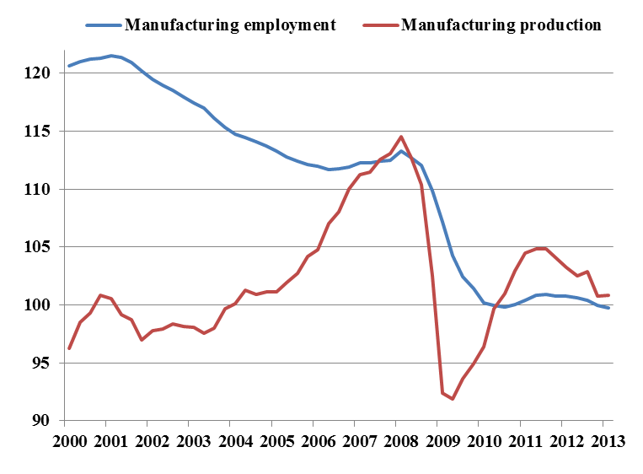  Source: European Competitiveness Report 2013 | 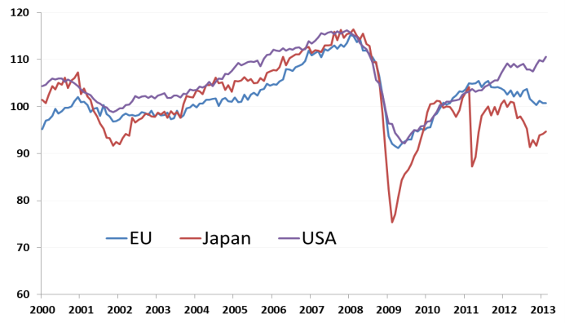  Source: European Competitiveness Report 2013 based on data from Eurostat and OECD
There have been significant variations in the performance of Member States’ manufacturing since the peak in 2008. Manufacturing in several Member States has surpassed its pre-crisis peak whereas in others it is still well below that level. In general, manufacturing has rebounded more quickly in those new Member States with a relatively large industrial sector compared to the EU average. Growth in this group of countries, particularly the Baltics, has been partly helped by export demand from outside the EU, including the CIS. Manufacturing output still lags well behind the pre-crisis peak in several Member States where domestic demand has been weak and the size of the manufacturing sector is smaller than the EU average. This is the case of Spain, Greece, and Cyprus (figure 3). The relatively large manufacturing sector in Finland has been negatively affected by structural changes, notably in the electronics industry.
Figure 3:
Recovery in manufacturing production since the 2008 peak by Member State to Q1 2013
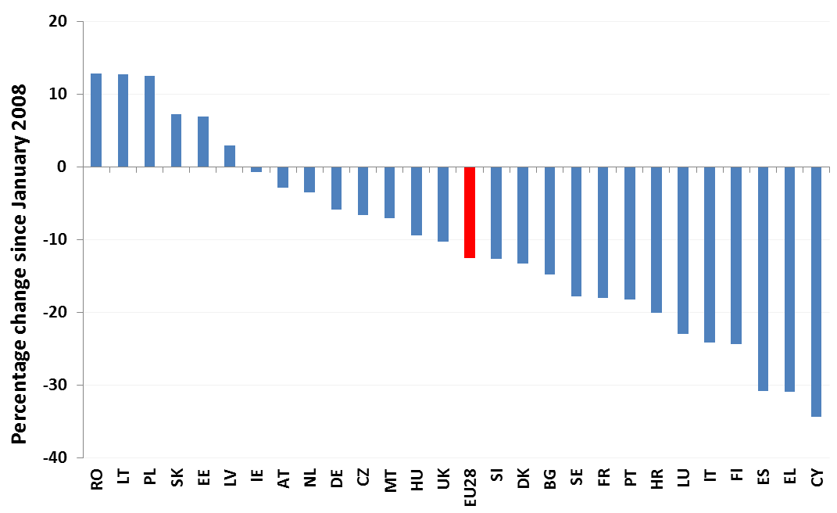
Source: European Competitiveness Report 2013 based on data from Eurostat
Only a few industrial sectors (e.g. pharmaceuticals and other transport equipment) have recovered their pre-crisis level of production. High-tech (HT) industries have generally been more resilient than those lower down the technology ladder (high-to-medium tech – HMT; low-to-medium tech (LMT); low-tech (LT)). Industries producing consumer staples, such as food and beverages, have fared relatively better than those producing more durable consumer goods such as furniture, clothing and motor vehicles, which are more sensitive to income. Sectors linked closely to the business cycle, such as those producing intermediate goods and capital goods have fared poorly, as well as sectors related to the extraction and manufacturing of raw materials such as mining and quarrying, metal and wood products (figure 4).
Figure 4: Manufacturing recovery by manufacturing sector since the 2008 peak to Q1 2013
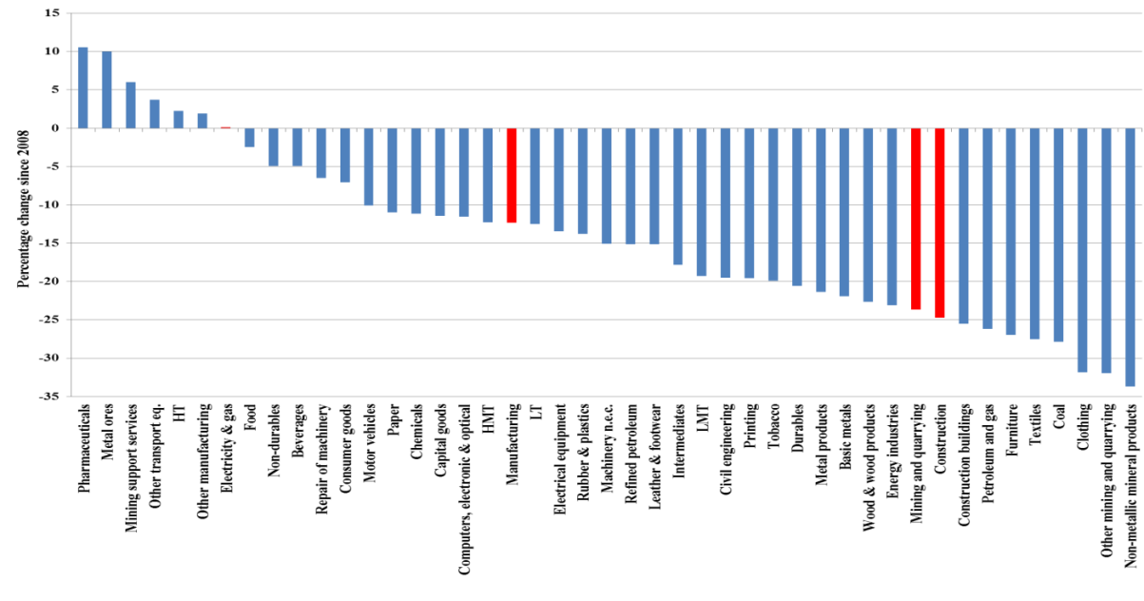
Source: European Competitiveness Report 2013 based on data from Eurostat
Figure 5: Share of EU manufacturing production to total VA by member state (2000-2012)
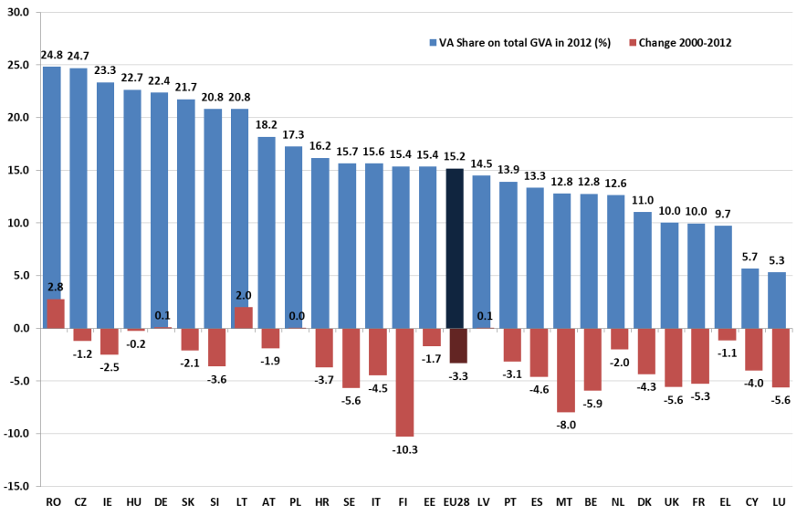
Source: Eurostat
In general, manufacturing sectors have been hit more severely than service industries during the crisis, with the share of manufacturing as a percentage of GDP falling in many Member States, except Germany, Poland, Romania and Latvia. In 2013, EU manufacturing value added is 15.1 % of GDP (annualised value in the second quarter of 2013). The declining share of manufacturing output and employment is part of a long-term trend driven by a shift in domestic demand towards services and a trend for higher productivity growth in the manufacturing sector that lowers relative prices of manufactured goods.

Investment
- The evolution in gross capital formation is heavily influenced by the collapse in construction related investment; investments in equipment, metal products and machinery have recovered faster during the crisis.
- It is difficult to identify when investment will recover, but access to finance, input cost conditions and weak business confidence have been identified as major factors delaying the recovery.
Gross fixed capital formation as a whole has fallen since 2008 from just over 21 % of GDP to 17.9 % of GDP in 2012. This trend has continued during 2013 with the level of investment falling to 17.5% of GDP (annualised) in the second quarter of 2013. The sharp deterioration of gross capital formation is the reflection of the collapse in construction related investment. Investment in equipment, metal products and machinery recovered faster after the crisis, at least until 2011 (figure 6).
Economic recovery requires investment to pick up and, in particular, investment in construction that has a strategic importance in the EU as it delivers the buildings and infrastructures needed by the rest of the economy.
Figure 6: Evolution of the investment components in the euro area (2005 =100) | Figure 7: GDP growth and gross fixed capital formation (EU, current prices in euro)
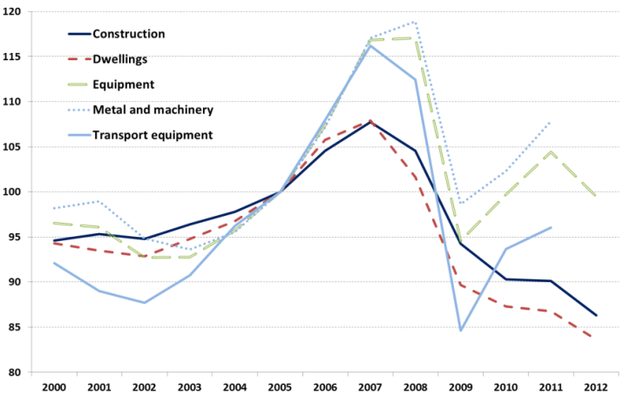  Source: Ameco database | 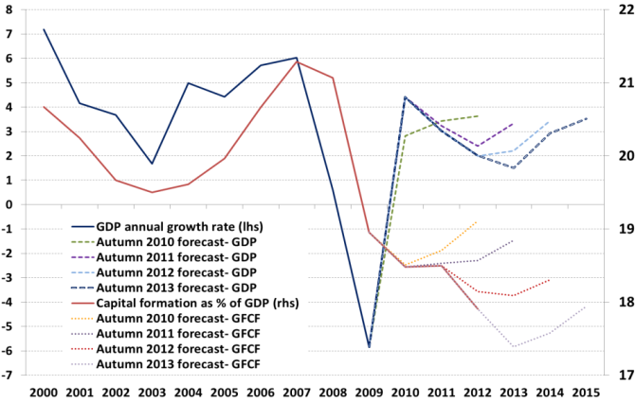  Source: Ameco database and European Commission economic forecasts
Until now, investment has stayed low since 2009 and seems to be unresponsive to policy actions. There is considerable variance in the official forecasts of the future evolution of investment in the EU. While Commission forecasts in November expected a recovery in gross fixed capital formation of 2.5 % in 2014 for the EU and of 1.9 % for the Euro Area (figure 7), the IMF and the OECD predicted a mere 1.3 % for the euro area. Until now, the expectations of the Commission for a recovery of gross fixed capital formation have been contradicted by actual (lower) figures. It is very difficult to identify when investment will recover but cost conditions and macro uncertainties have been identified as major factors delaying this recovery.
An additional obstacle to investment is the difficult access to finance, both in the form of high financing costs or quantity rationing. In relation to the former, borrowing has been much more expensive in countries facing greater financial and economic difficulties (e.g. Spain, Italy) compared to others (figure 8).
The low rate of investment rates is examined in detail in the Product Market Review. Results showed that in most vulnerable Member States firms' investment rates are lower than what is expected based on fundamentals. Put differently, it could be seen that two firms in the same sector, of similar performance, size and indebtedness, invest significantly differently depending on whether they are based in a vulnerable Member State (e.g. Italy, Spain, and to some extent Portugal) or not.
Figure 8: Interest rates of new loans to non-financial corporations
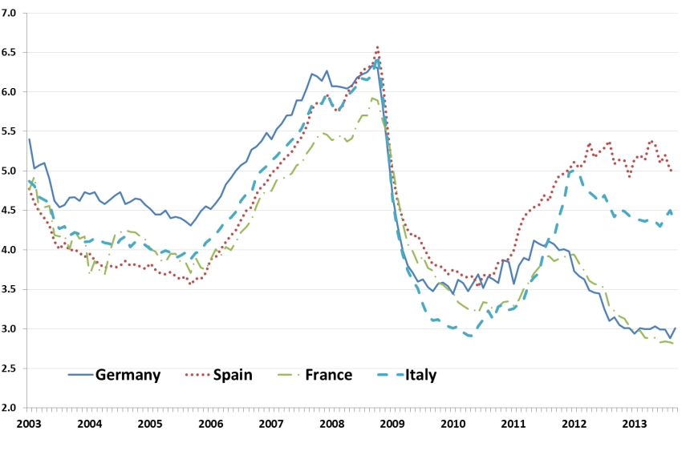
Note: Annualised agreed rate (AAR) / Narrowly defined effective rate (NDER); Up to and including EUR 1 million
Source: ECB

Access to finance
- Loans to non-financial corporations have not yet recovered from the crisis and lending activity continues to decrease in the euro area.
- The firm's age, size and its growth performance are important explanatory variables of perceived bank lending difficulties.
The availability of external financing has become a serious threat to the survival of significant parts of Europe’s industry. Lending to non-financial corporations has not yet recovered from the crisis and lending activity continues to decrease in the euro area (figure 9).
According to the latest SAFE survey, approximately one fourth of the SMEs in the euro area applied for a bank loan. While 65% of these firms had received the full amount they applied for, 12% of them reported that their bank loan application had been rejected. On the other side, 47% of the SMEs did not apply because they could count on sufficient internal funds, the percentage of firms not applying for fear of rejection stayed around 7%; and firms not applying or "other reasons" reached almost 21%. It is worth noting that there is a wide regional disparity, the percentage of SMEs applying for a bank loan was higher in France (30%), Italy (29%) and Spain (27%), whereas it was lowest in Ireland (12%). More than half of the SMEs in Belgium, the Netherlands, Ireland, Germany Austria and Finland reported that they did not applied due to sufficient internal funds. By contrast, these shares were considerably lower in Greece (28%), and Portugal (33%). The situation is also very uneven across firm sizes. Larger European firms have been able to tap into the bonds markets in the past few years while SMEs have had a harder time diversifying their financing sources.
The constrained bank lending in the EU is in contrast to the US, where there was a 30 % fall in lending at the height of the crisis, but a growth of 10 % year-on-year since 2011. At the same time, the rate of non-performing loans in some EU countries is much higher compared to the US (figure 10).
Figure 9 – Year-on-year growth of loans to non-financial corporations | Figure 10 - Non-performing loans as a share of total loans
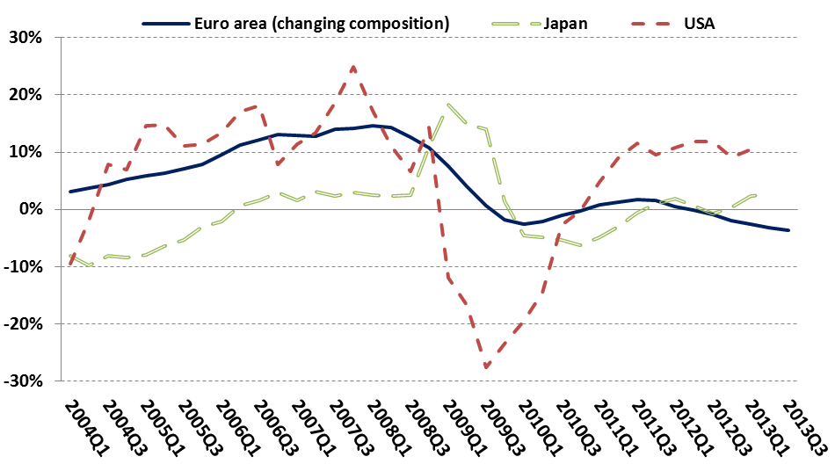  Source: ECB, US Federal Reserve, Bank of Japan | 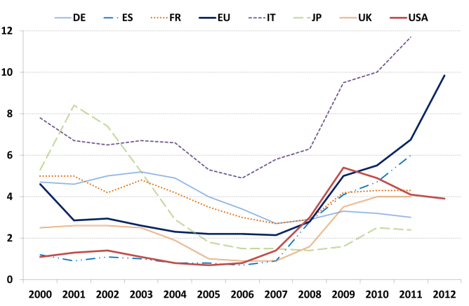  Source: World Development indicators, October 2013
To estimate the likelihood of rejection after a loan request a synthetic index of financing difficulties was constructed using data from the Survey on access to finance of SMEs. The index was a statistically and economically significant predictor of underinvestment, even controlling for factors affecting both growth and financing constraints (age and size) and controlling expected profitability developments over the next two years. The increase of loan rejection probability for SMEs by 30 percentage points leads to an average underinvestment by any given firm of up to 0.5 percentage points (as a share of total assets). These results show that the bank lending channel seems to be currently difficult in most vulnerable Member States, including in Greece, Spain, Portugal, and to some extent Slovenia. Intermediate cases are France, Czech Republic, Germany, Poland and Belgium, while in Finland the rejection probability of a loan request is well below average.
A recurrent theme in the policy discussion is whether the decline in bank loans as observed during the economic crisis is driven by reduced demand or by a tightening of supply (a so-called credit crunch), or perhaps by both factors simultaneously. In order to answer this question, firms' perceptions on access to bank loans in the EU have been examined using the results from the SAFE survey by the Directorate for Economic Affairs and Finance in the Product Market Review 2013. The report points out that data allow for a distinction between demand-side (e.g. the firms' needs for bank loans) and supply-side (e.g. the banks' willingness to provide loans) indicators (table 1). The SAFE survey allows for cross-country comparisons of the relative importance of supply and demand factors, but not within each country. According to the report, firms in Estonia, Finland and Slovakia report most frequently reductions in the need for bank loans or discouragement to apply for a loan without signalling strong supply reductions (e.g. Luxembourg). A tightening of supply conditions (also without reporting strong demand-side reductions) is perceived by firms in Spain, Portugal and Slovenia. These countries show symptoms of a credit crunch. A third group of countries include the Netherlands, Greece, and Ireland, where firms most often indicate both reduced demand as well as squeezed credit supply.
Table 1: Access to loans drivers
Reduced demand | Tightening of supply
Decreased needs of firms for bank loans  Top 4: EE, FI, NL, SK | Firms indicating access to finance as the most pressing problem  Top 4: ES, EL, IE, SI
Discouraged borrowers  Top 4: EL, IE, LU, NL | Decreased availability of bank loans  Top 4: EL, IE, PT, SI
Discouraged borrowers  Top 4: EL, IE, LU, NL | Decreased willingness of banks to provide a loan  Top 4: ES, EL, PT, SI
Discouraged borrowers  Top 4: EL, IE, LU, NL | Received not all the financing requested  Top 4: ES, EL, IE, NL
Source: Product Market Review 2013 using data from SAFE survey
An econometric analysis has been performed using the SAFE survey in the Product Market Review. The analysis looks at the characteristics of the company, e.g. age of the firm, firm size, sector, ownership structure, and determines their importance in explaining perceived access to finance. Country-level data on the general economic conditions and structural and financial indicators on the banking sector have been also included as control variables. Some of the control variables are of a structural nature (firm's characteristics and market structure of the financial sector) and do not change in response to cyclical conditions. Other control variables (notably financial health of the banking sector, growth prospects of firms and macroeconomic conditions) are cyclical.
Conclusions based on results of the econometric analysis highlight that firm characteristics, in particular the firm's age, size and its growth performance are relevant explanatory variables. The phenomenon of the discouraged borrower is indicated as predominantly observed among young, small firms with negative recent growth of their turnover. Cyclical conditions are reported also as drivers of lending difficulties, with firms in countries with higher unemployment rates often reporting financing difficulties. However, the report indicates also that a weak and positive impact of the unemployment rate on the change in the needs for a bank loan, can flag that firms rely more heavily on bank loans in times of economic hardship for their working capital and to finance inventories. The report illustrates also a third group of factors related to the market structure of the banking sector. Among them, the presence of foreign banks is perceived by firms as increasing the banks’ willingness to give credit. Finally, the relationship between firms' perceptions of accessibility of loans and the financial health of the banking sector is examined. In particular the return on equity of the banking sector was examined, which turned out to be a relevant explanatory factor.

Productivity
- Labour productivity growth in EU manufacturing is lower than in US manufacturing, mainly due to a more dynamic labour market in the US.
- In the EU and the US alike, manufacturing has higher labour productivity growth and higher total factor productivity growth than services.
EU manufacturing has lagged behind US manufacturing in productivity growth. Since 2000, average labour productivity growth (in terms of value added per hour worked) in manufacturing was 3.5 % in US compared to 2.4 % in EU (figure 11). A large part of the difference materialized in the period after the dotcom recession whilst there was also a larger decline in EU manufacturing labour productivity between 2008 and 2010. These differences can be partly linked to a more dynamic labour market in the US that sheds labour more quickly during recessions. Employment and hours worked declined more in the US than in the EU during recessions because labour was made redundant to a higher extent than in the EU.
Figure 11: Manufacturing labour productivity in the EU versus the US (quarterly, year-on-year) | Figure 12: Comparison of total factor productivity (TFP) growth (1995-2007)
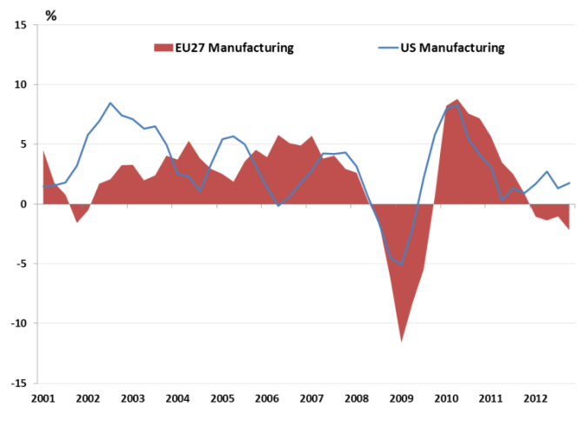  Source: European Competitiveness Report 2013 based on data from Eurostat and OECD | Source: European Competitiveness Report 2013 based on EU Klems
In general, labour productivity growth has been higher in manufacturing than in services, although there has been significant variation across sectors. Between 2000 and 2011, labour productivity, measured as value added per employee, grew faster in high-tech manufacturing sectors and the knowledge-intensive ICT sector. Some low-tech and medium low-tech industries such as textiles, rubber and plastics also performed relatively well and above the average for manufacturing sectors. The lowest productivity growth rates were in labour intensive services. Wages have remained relatively stable across sectors. Consequently, changes in labour cost competitiveness, measured in unit labour costs, have been largely driven by changes in productivity. Consequently, those industries with higher productivity gains have gained the most in competitiveness.
Like in labour productivity, manufacturing industries have, in general, outperformed services industries in total factor productivity growth. Total factor productivity (TFP) measures the efficiency by which companies convert inputs into output. Growth in total factor productivity is higher in the manufacturing sector than in the services sector and the economy as a whole, for all EU Member States for which data is available except for Italy, which recorded negative TFP growth over the period in the Italian economy as a whole. Within the EU, the TFP growth differential between the manufacturing sector and the total economy is particularly large in Austria and Germany (figure 12). If the share of manufacturing continues to fall, it may have a negative impact on TFP growth for the whole economy and on long-term growth potential. The decline in investment expenditure may also have a negative impact on TFP growth with manufacturing but also in other sectors of the economy.

Employment
- EU employment in manufacturing is going down, as it has done for decades, although this trend is partly counterbalanced by employment creation in the inter-linked services sector.
- An important structural reason for the decline is that productivity growth is higher in manufacturing than in the rest of the economy.
Employment in EU manufacturing has been falling for several decades and is now about 20 % lower than at the start of the century (see Section 2, figure 1). The sharp fall in employment from 2008 to 2010 was caused by the crisis. But there are two structural drivers of falling employment in manufacturing: manufacturing’s higher-than-average productivity growth and the falling share of manufacturing sectors in the economy (from more than 20 % of EU GDP in 1995 to just over 15 % in 2012).
However, in parallel, the increasing inter-linkage between manufacturing and services has created new jobs. The importance of business services of manufacturing and service industries in value chains has grown rapidly since the last decade of the last century. Growth of employment in Europe illustrates this, in particular the business service sector (14.6 % of total EU employment in 2011) accounts for about half of the employment growth and the non-market services (23.1 % of EU employment in 2011).
The fall in employment has affected not only manufacturing but also other sectors such as mining and quarrying, agriculture and forestry, public administration, telecommunications, electricity and gas, that are characterised by sustained labour productivity growth. On the other hand, sectors such as construction, trade, education and administration saw increasing employment from 2000 to 2010 (cf. Annex). The only manufacturing sector with higher employment in 2010 than in 2000 was pharmaceuticals, but it represents a very small fraction of total employment in manufacturing. Employment in this sector increased by 15 % from 2000 to 2010, driven in particular by new jobs in Ireland, Denmark and the Czech Republic.

Skills
- The supply of numeracy and literacy skills differs widely across Member States, from very poor on average to among the highest in the world.
- EU manufacturing increasingly needs better educated employees, particularly in industries such as pharmaceuticals, coke and refined petroleum, and computers, electronic and optical equipment.
The OECD Skills Outlook 2013 revealed considerable differences across Member States concerning adult (16–65 years) skills, notably numeracy and literacy. At the top end, the skills of Finnish adults in literacy and numeracy are very high, second only to Japanese adults. At the opposite end, the literacy and numeracy skills of Spanish and Italian adults are far behind those of adults in other OECD countries: the distance to the next Member State in the ranking, France, is more than ten points in literacy and more than eight points in numeracy. Given their importance to the EU economy and the current state of their economies, that the situation of skills in Spain and Italy is particularly worrying: in reading, more than one in four adults in Italy (27.7 %) and Spain (27.5 %) perform at or below the most basic level, compared with one in twenty Japanese adults (4.9 %) and one in ten Finns (10.6 %); in numeracy, almost one in three adults in Italy (31.7 %) and Spain (30.6 %) perform at or below the most basic level, compared to around one in twelve in Japan (8.2 %) and one in eight in Finland (12.8 %) and the Czech Republic (12.8 %).
Figure 13: Mean literacy and mean numeracy proficiency scores in selected Member States
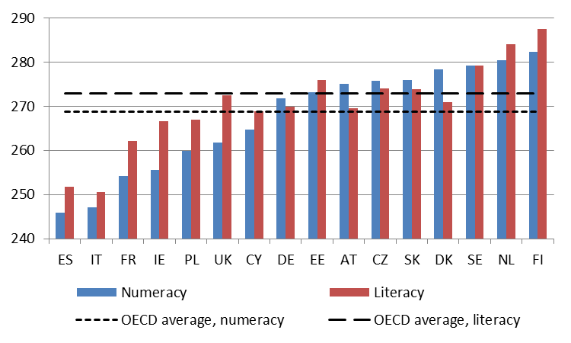
Source: OECD Skills Outlook 2013 (UK data do not include Scotland and Wales; Cypriot data refer to the area under the effective control of the Government of the Republic of Cyprus)
It is also remarkable that the mean literacy score exceeds the OECD average only in the Czech Republic, Estonia, Netherlands, Slovakia, Finland and Sweden, whereas in several other Member States (Denmark, Germany, Austria and others) the average literacy score falls short of the OECD average (figure 13).
At the same time, EU manufacturing industries need highly skilled employees in order to compete. In 2011, the pharmaceuticals sector was the sector with the highest share of highly skilled employees, followed by coke and refined petroleum. The manufacturing sector with the lowest share of high skills and the sector with the highest share of low skills was leather and footwear (figure 14).
Figure 14: Composition of EU labour force by sector (%), 2011
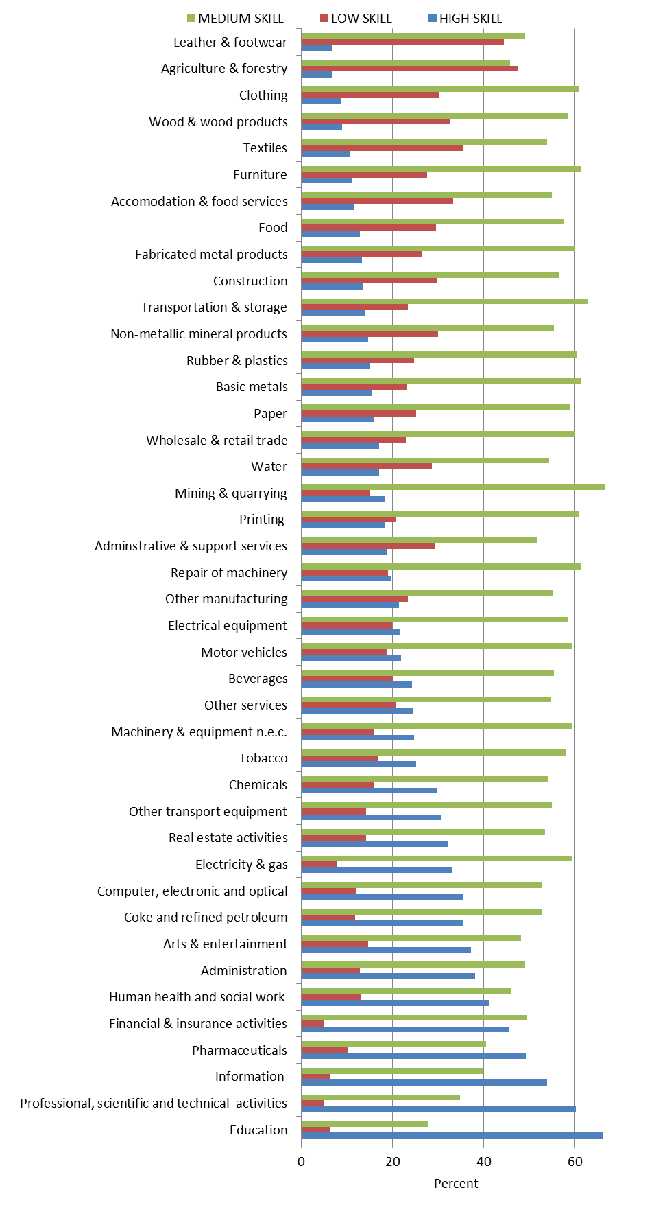
Source: European Competitiveness Report 2013
Skills shortages and mismatches may occur in the future in some of the most dynamic sectors if growing demand for increasingly skilled employees cannot be matched. On the other hand, low skill and high labour intensive service activities may be the only opportunity for the unskilled labour force migrating from shrinking labour intensive manufacturing industries. This fact would call for further liberalisation of the services sector particularly pertinent, in particular insofar as low-skilled activities are concerned (e.g. retail trade, road and freight transport, etc.).

Innovation
- Public R&D spending in the EU grew in the early years of the crisis, however, recent data point to a potential reversal of this trend.
- The innovation divide between the Member States is widening. The leading innovators are becoming even stronger while moderate and modest innovators fail to catch up.
- In pharmaceuticals, computer/electronic/optical products, chemicals and beverages, rapid innovation cycles mean that two-thirds or more of all companies report innovative activities. But these firms are facing greater difficulties in accessing to credit.
Public R&D spending in the EU grew throughout the crisis as governments strived to keep up their R&D investments and thus incentivise businesses to do likewise. However, recent data point to a potential reversal of this trend. Public R&D budgets decreased in 2011 for the first time since the beginning of the crisis, with more pronounced effects in the Member States suffering most from sovereign debt crisis. There are also signs of increasing disparities in the performance of Member States. The less innovative countries might no longer be catching-up with the most innovative countries, as illustrated by the Innovation Union Scoreboard.
In parallel, the EU is lagging behind its Europe 2020 target of spending 3% of GDP on research & development (R&D).
Business R&D expenditure in the EU is far below that of our main competitors: the EU businesses spent 1.29% of GDP on R&D in 2011, less than South Korea (2.8% in 2010), Japan (2.49% in 2010), the US (1.83%), and China (1.39%). These differences are in part due to different sectoral compositions across countries and regions.
However, during the 2008-2013 period the EU has increased its innovation performance (figure 15), according to the Summary Innovation Index of the Innovation Union Scoreboard, at an annual average rate of 1.6% and has closed almost half of the innovation gap towards the US and Japan. The EU has a strong lead over China and other BRICS countries, although China and South Korea are growing faster than the EU. Notwithstanding the EU improvement in innovation performance, the same index points to a widening in the innovation divide between the Member States, with the leading innovating Member States becoming even stronger while moderate and modest innovators fail to catch up. Estonia is the innovation growth leader (7.1%), albeit from a low starting point, while the five Member States with the least performance change (less than 1%) are Cyprus and Greece (with negative values), Poland, Bulgaria, and Sweden.
Figure 15: Growth in innovation performance 2008-2012 | Figure 16 – Funding ratios to basic and applied research in 2010
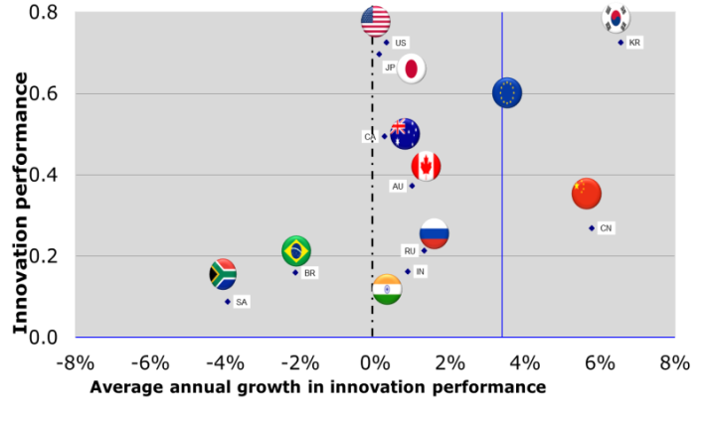  Source: Innovation Union Scoreboard 2013  Note: Average performance, going from 0 to 1, is measured using a composite indicator building on data for 24 indicators in 2010-2011. Growth in innovation corresponds to yearly growth. | 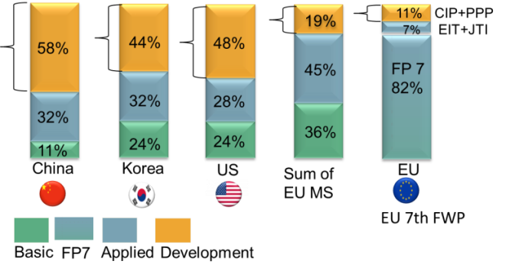  Source: Key Science and Engineering Indicators, National Science Board, 2010 Digest, NSF, OECD "Research and Development Statistics “, DG ENTR analysis

International comparison of funding ratios related to basic research, applied research and R&D show that 19% of EU funding focused on applied developments, against 54 % in China, 48% in the US and 44% in Korea (figure 16). Reasons for this commercialisation gap range from difficulties in accessing finance over excessive red tape to inadequate intellectual property rights regimes.
Figure 17: Share of innovating EU firms by sector in 2010 (%)
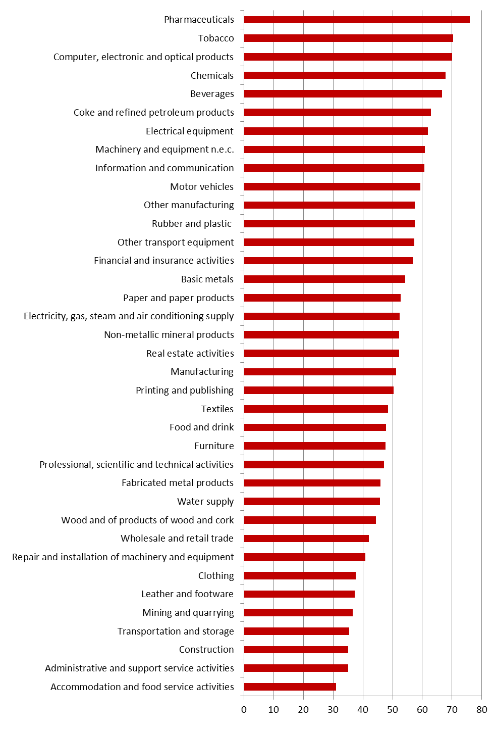
Source: European Competitiveness Report 2013 using CIS data
Innovation patterns differ across different sectors of the EU economy. In manufacturing sectors such as pharmaceuticals, tobacco, computer/electronic/optical products, chemicals and beverages, rapid innovation cycles mean that two-thirds or more of all companies report having undertaken product or process innovation in the previous year, while most companies in the clothing, leather and footwear sectors are not involved in innovation on a regular basis (figure 17). On average, across all sectors, manufacturing firms are considerably more innovative than firms in services, and they engage relatively more in product innovation than firms in the services sector.
An important aspect to mention is that that access to finance can be more difficult in the case of innovative firms due to the inherent uncertainty of innovative projects, the difficulties innovators face in appropriating their benefits, and asymmetric information permeating the relationships between lenders, borrowers and equity investors. These difficulties may imply that innovation is delayed inhibiting the process of creative destruction in which young innovative firms replace inefficient firms.

Internal market
- Overall benefits from further simplification of the internal market regulatory framework could reach 12% of compliance costs.
- Empirical analysis highlighted potential positive impacts on labour productivity and value added, leading to improvements in employment.
Since the establishment of the internal market in 1992 there has been a steady growth of the body of internal market legislation, and the existing evidence suggests that this has been accompanied by a sizeable increase of exchanges between Member States. Other factors and processes that have also played an important role are the introduction of the Euro currency, the EU enlargement, the emergence of broader globalisation processes, improvements in transport infrastructure, the reduction of transport costs, and development of e-commerce. Nevertheless, administrative obstacles and an incomplete enforcement of internal market rules leave the potential of the internal market only partially exploited. Additional improvements of the internal market rules, including the removal of administrative obstacles and further enforcement of the internal market legislation would allow the internal market to express its full potential as an engine of growth.
Available data for the period 1999-2011 show a clear increase in the general level of total trade as a share of EU GDP. However, factors other than internal market legislation might have contributed to this performance. Over the 20 years since the internal market’s launch in 1992, intra-EU trade in goods has grown as a share of GDP from around 17% of EU GDP in 1999 to 21.5% in 2012. Furthermore, input from stakeholders and the analysis of the role of specific pieces of legislation affecting specific sectors also provides supportive evidence of the positive effect of the internal market on trade.
Intra-EU trade growth rates in three broad categories of manufactured goods - machinery and transport equipment, manufactured goods classified by material and other manufactured goods – have exceeded the growth rate of the total manufacturing value added in the EU between 2000 and 2012 (figure 18). Whilst there are differences between different sectors, most of them have experienced an increase in the level of intra-EU trade, particularly during the first half of the 2000s. Only “Office machine and automatic data processing” has shown a fall in the level of intra-EU trade since 1999 and this coincided with the economic and financial crisis of 2008.
In most sectors, there has been a reduction in the share of intra-EU trade in the total level of world trade. This reflects the globalisation of markets, the increasing presence of non-European manufacturers in the EU market and the delocalisation of segments of the value chain outside the EU.
Figure 18: Intra-EU trade in selected sectors (2000=100) and GVA growth in the EU
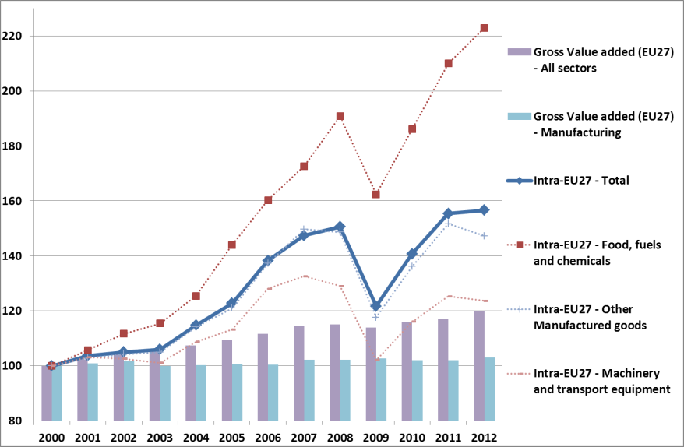
Source: Eurostat

Although an Action Programme for Reducing Administrative burdens in the EU has been launched by the Commission in 2010s, additional steps in simplifying internal market legislation appear necessary for strengthening competitiveness of firms through higher productivity.
A recent study commissioned by DG ENTR to CESS looked at the benefits deriving from simplification of the internal market regulatory framework, based on empirical analysis (cases studies) in eight sectors. The assessment of the benefits of simplification, based on assumptions on the potential costs saving for firms, showed that the highest savings (20% total cost reduction) could be attained through greater coordination in timing and updating of directives and regulations. E-labelling and a wider provision of compliance information electronically would allow a 3% cost reduction through lower printing and labour costs and more efficient access to specific regulatory compliance information. Cost savings of eliminating inconsistencies across EU harmonisation rules on CE marking across all relevant directives and regulations, and saving of eliminating inconsistencies in requirements for the demand of compliance were estimated in 0.2% of total costs. At the same time, the study underlined the need that any simplification must be strongly evidence-based and supported by extensive industry consultation in order to take into account potential downside risks and unintended effects.
The basic assumptions of the study are that any cost reduction from simplification would be translated into savings of firms’ operational costs via improved labour productivity, which is then passed into lower prices of products. As a consequence, external competitiveness would improve boosting exports. Ultimately, this dynamic would have a positive impact on Gross Domestic Product, and thus on (increased) employment.
The broader benefits to the economy from simplification have been estimated using a macro-sectoral and a world input-output model, comparing medium term economic developments with and without simplification of the internal market regulation. The assessment has been made for a sample of firms in the metallurgical sector. The current internal market compliance cost was estimated in €430 million for the EU, with a potential labour cost reduction of €50 million following internal market simplification, this implying an increase in value added of €10 million euros (0.001%). The assessed impact of this cost reduction on macroeconomic variables (final demand categories, excluding government consumption, exports, imports and GDP) at EU level is low. The GDP increase caused by the improvement in labour productivity is estimated in €63 million (0.0004%), employment would remain mainly unaffected (a small job loss is expected in metallurgical industry), while in other sectors the number of jobs created would increase. Results should be treated with considerable caution, not only because they are based on cost reductions in one sector only, but also because the model used to produce the figures was based on a Netherlands national model extrapolated to the EU with the inherent inaccuracies this could entail.

Exports and FDI
- Exports, mostly to the rest of the world, have been the main driver of industrial activity, while aggregate internal demand has remained subdued.
- A few sectors and Member States account for a large share of the very significant trade surplus of the EU in manufactured products.
- On FDI, while the EU remains the main global recipient, its share has been significantly reduced these last few years. Emerging economies play an increasingly large role as FDI partners.
Since the beginning of the crisis, extra-EU exports have been the main driver of EU growth and of industrial activity. In a very depressed economic context, net exports have been the most dynamic component of EU GDP growth since 2010 and in fact the only positive one both in 2012 and this year. Although EU growth in 2014 and 2015 should become less export-dependent, also in view of a slowing down of emerging economies, the fact remains that growth prospects in other regions of the world, and notably Asia, should remain more dynamic in the foreseeable future therefore providing important business opportunities for the EU industry.
While before the great recession of 2008-2009, intra-EU and extra-EU trade were evolving broadly in parallel, since then a gap has become apparent with extra-EU trade growing at a much steeper pace than intra-EU-trade.
When looking only at manufactured products (figure 19), intra-EU trade recovered well in chemicals and food although in machinery and transport equipment the pre-crisis levels have not yet been reached. Overall, manufactured products represent more than 80 % of exports in goods and generate a massive trade surplus for the EU (€365 billion in 2012 compared to €125 billion in 2006, nearly a threefold increase), an essential counterweight to the trade deficit in energy and raw materials. This trend appears to continue in 2013, as in the period from January to July, the EU has achieved a trade surplus in manufactured products of €233 billion, compared to €200 billion in the same period of 2012).
A few sectors account for a sizeable share of the large trade surplus. These include road vehicles (an approx. €120 billion surplus in 2012), industrial machinery and equipment (€70 billion), pharmaceutical products (€57 billion), aircrafts (€28 billion), beverages (€20 billion) and paper (€14 billion). Conversely, large trade deficits are sustained by the EU in a minority of industrial products such as clothing (€ 47 billion.), office machines (€ 48 billion), telecommunications equipment (€ 40 billion) or non-ferrous metals (€ 11 billion).
Figure 19: Intra-EU exports (million EUR) for selected manufactured products’ categories – 1999-2012
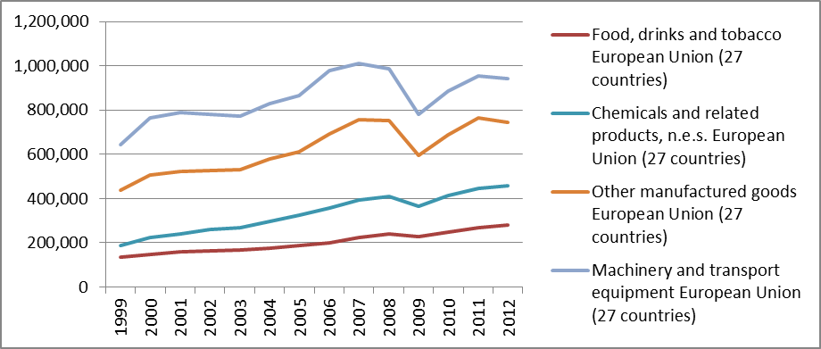
Source: EUROSTAT
The EU industry remains the dominant actor in a wide range of manufacturing sectors. Excluding intra-EU trade, the EU share of world markets in 2011 was as high as 49.4% for beverages and 43.3% for pharmaceuticals and remarkable results were registered for sectors as diverse as printing (41.1%), machinery (30.7%), motor vehicles (27%) or rubber and plastics (17.9%). China has become the dominating force only in a limited number of sectors (textile, clothing, footwear, computers) while other emerging economies still maintain a rather marginal role (with some exceptions, like that of Russia in refined petroleum or India in the “other manufacturing” category) (table 2).
A very large share of the overall EU trade surplus recorded in 2012 is based on the performance of a few Member States, notably Germany but also Italy, especially in machinery, or Ireland, especially in organic chemicals.
Foreign direct investments greatly contribute to growth and employment in the EU. While Europe still attracts very important FDI flows, estimated at USD 230 billion in 2012, the share of the world total is decreasing steeply, from more than 30% in 2008 to 16.8% in 2012; in the same period the share of China increased from less than 10% to more than 18% .
While the United States and Switzerland remain the main FDI partners both for inward and for outward stocks, some emerging economies play an increasingly large role, such as Russia, Brazil and China (table 3).
Table 2: Share of EU and main trade partners in world markets by sectors in 2011
Source: DG ENTR calculations using COMTRADE data
Table 3: Main FDI partners with the EU (stocks)
 | Inward |  | Outward
 | 2004 | 2011 | 2004 | 2011
United States | 15.87% | 13.28% | 14.18 | 11.92%
Switzerland | 4.63% | 4.62% | 4.75 | 5.17%
Japan | 1.69% | 1.42% | 1.47 | 0.72%
Canada | 1.31% | 1.36% | 1.46 | 1.86%
Russia | 0.11% | 0.53% | 0.40 | 1.40%
South Africa | 0.09% | 0.08% | 0.72 | 0.67%
Brazil | 0.07% | 0.77% | 1.36 | 2.00%
China (excl. HK) | 0.04% | 0.15% | 0.41 | 0.85%
Hong Kong | 0.27% | 0.63% | 1.67 | 1.04%
Singapore | 0.35% | 0.67% | 0.81 | 1.03%
Australia | 0.56% | 0.34% | 1.00 | 1.05%
Source: Eurostat, DG ENTR calculations

Energy issues
- Widening gaps in electricity and gas prices compared to main competitors worldwide have been observed and are expected to stay in the medium-to-long term – in particular following the so-called shale gas “revolution” in the US.
- Uneven developments of energy prices across regions and markets have determined huge energy costs differential across regions and countries.
Implementing the adopted 2050 climate and energy roadmaps as well as the intermediate 2030 climate and energy framework - currently under definition – will require a deep transformation of the energy systems as well as of the entire economy of the EU. Increased investment in adequate infrastructure and technologies will be necessary, including infrastructure resilient to the impact of disasters. The total investment needed to transition to a secure, competitive low carbon energy in the EU by 2050 is predicted at about 1.5% of GDP on an annual basis. By 2020, is it estimated that about one trillion euros of investment is needed in the EU to "ensure security of supply, diversification of sources, cleaner energies and competitive prices within an integrated energy market" . But investment in the EU has slowed down with the crisis.
Implementing solutions to climate, energy and environmental challenges must be compatible with keeping the EU an attractive place for investment, but also with maintaining or even increasing EU competitiveness. By and large, energy inputs and energy policies play a critical role in reversing this trend. As a key production input, energy is a core driver of productivity growth, along with other measurable inputs such as of capital, labour, material and service inputs. The inputs that matter vary according to the industries, segments or sub-segments of the global value chain. The price and the availability of energy inputs are critical for activities such as manufacturing, distribution or logistics, while low-cost labour and qualifications of the labour force determine the competitiveness of most services activities.
The issue of energy prices and costs is unquestionably crucial for maintaining and developing a solid and competitive industrial base in the EU. Energy costs are obviously particularly important for Energy Intensive Industries (EIIs) that, in addition, are often exposed to international competition and have a strategic positioning alongside the economic value chain (figure 20).
In the context of a fast-changing global energy system, relative positions of countries and regions are shifting, redefining the foundations of today and tomorrow’s international competitiveness. Evidence over the last decade is clear about the uneven developments of energy prices across regions and markets and, in particular, about the comparative disadvantages the EU economy and industry players are confronted with (figure 21).
Striking price differences are certainly more evident with regard to two fundamental energy inputs, that is, electricity and gas, for both of them widening gaps compared to most of EU direct competitors worldwide have been observed and are expected to stay in the medium-to-long term – in particular following the so-called shale gas “revolution” in the US (figure 22).
Macroeconomic evidence on the recent trends associated to energy prices in the EU as well as with regard to the high variability of conditions in different EU Member States, is further supported by an analysis conducted by the Commission. The main purpose is to assess the evolution and composition of energy prices and costs, by individual industry sectors and by plant, based on real-life cases. Cases are not meant to be exhaustive but they can give important insights about the variability of operating conditions across the EU. Case studies have been carried out for bricks and roof tiles, wall and floor tiles, ammonia, chlorine, ethylene, aluminium, steel.
Figure 20: Share of energy in total production cost worldwide, 2011 | Figure 21: Weighted average industrial energy prices (including tax) by economy
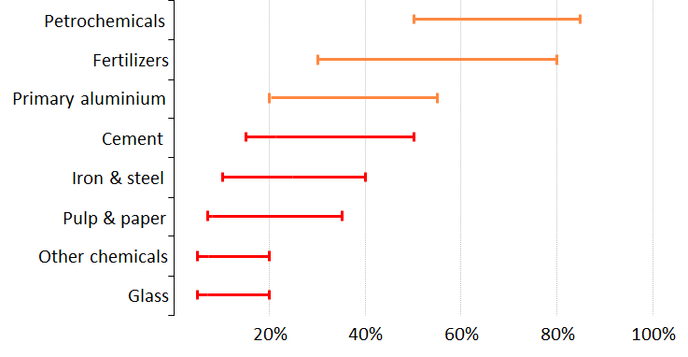  Source: IEA 2013 | 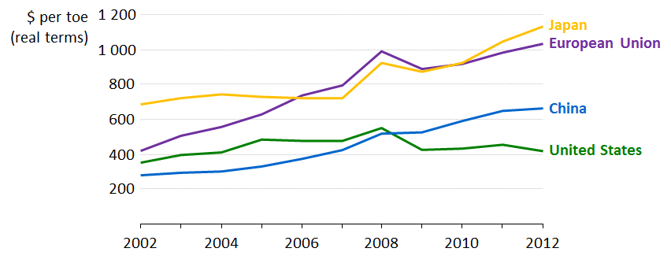  Source: IEA 2013
Results from these studies suggest the trend already visible at macro level of a significant increase between 2010 and 2012 in the level of gas and electricity prices paid, on average, by industry operators in each sector or sub-sector assessed. Moreover, there are highly differentiated price dynamics by region leading to widening differentials across Europe in prices paid by operators of the same sector or sub-sector.
Figure 22: Ratio of industrial energy prices relative to the United States
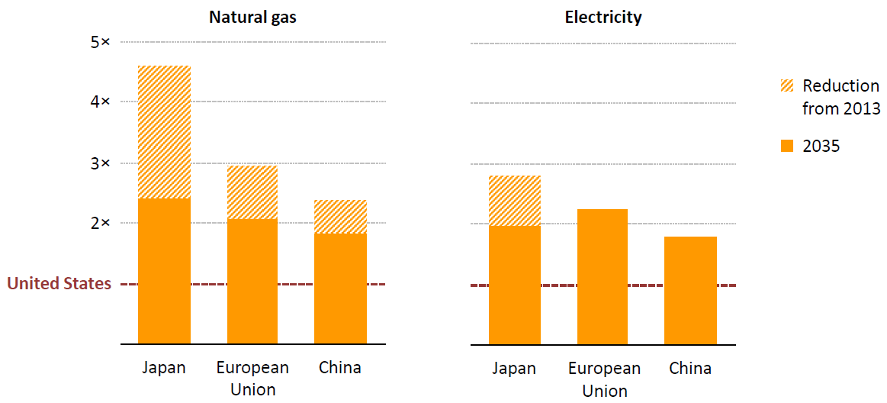
Source: World Energy Outlook 2013
According to the study, gas prices are indeed dominated by the cost of the energy component which, based on the sector and regions assessed, varies between 80% and 97% of the final price. The registered increase in gas prices mainly derives from increased commodity price and indexation of gas to oil price.
As for the electricity price, for which the energy component compared to other parts of the world remains roughly stable and more or less similar between EU Member States, the main driver of the evolution of electricity prices is the increase, in recent years of network fees, taxes and levies, including support schemes for renewable energies. While progress in the functioning of the internal market for electricity has had a positive effect in the convergence of wholesale electricity prices across Europe, national policies, taxes, levies and network distribution costs have more than offset the impact of the internal market. These costs may cumulatively represent, depending on the sector and region observed, between 30% and 45% of the overall electricity price.
Electricity and gas prices paid by EU operators are much higher than prices faced by competitors in many third countries or plants belonging to the same company established abroad, in particular the US and Russia. Over the last few years, these spreads have been increasing. This has been observed for all the sectors and subsectors for which evidence was collected both on average (i.e. steel, aluminium) and at plant level (i.e. bricks and roof tiles, wall and floor tiles).
Information available from some case studies, in particular for aluminium, suggests that producers benefiting from long-term contracts have been able to limit the impact of increasing energy prices over the last years compared to EU producers buying on the wholesale market.
Energy efficiency is rightly considered as the most effective way to respond to increasing energy prices. The EU manufacturing sector still enjoys an ample advantage in terms of energy intensity compared to their US counterparts, not only in absolute levels (more than 3 times lower) but also in terms of trends. Between 2001 and 2011 the EU industry went from an energy intensity of 150 to 121 ktoe/Bn€, a decline of 19%; over the same period the US industry went from 440 to 400 ktoe/Bn€, a decline of 9%. The situation is similar with regards to EIIs where the gap is less pronounced but it has been growing over the past decade. For instance the EU chemicals and paper sectors have about half the energy intensity of their US competitors while the non-metallic minerals and the basic metals sectors are about one third less energy intensive than their US counterparts. Case studies may not provide conclusive evidence on average efficiency trends across sectors or on the link with energy price evolution, but they provide some useful insights by comparing prices paid by the least and most efficient plants in some sectors and subsectors. For example, a sharp increase in the energy input costs may not always be followed (or anticipated) by technical improvements and further reduction in consumption. This holds especially true over a short time period as the one assessed and in cases where efficiency levels are already high as it is the case for many EU industrial operators and in times of reduced or negative profitability margins. Moreover, it seems logical to think that investment decisions with regard to energy efficiency, when involving either expensive solutions ‘at the margin’ or large-scale replacement projects directly compete with somehow easier options of relocation.
The Commission has studied the interactions of energy prices and energy intensity in determining the different overall energy costs of manufacturing companies in a global comparison. Using the World Input-Output Database (WIOD), the concept of Real Unit Energy Costs (RUEC) has been developed. Similarly to Unit Labour Costs, the RUEC indicator measures the amount of money spent on energy sources to obtain 1 unit of value added. The levels and trends of RUECs for the manufacturing sector are presented below in Figure 23.
In 2011, the EU presents a level of RUEC which is much below that of China, Russia and India. It is above that of Japan and essentially the same as the US. In terms of trend it is to note that all countries have experienced a slow increase in RUEC over the years with the partial exception of India after 2002. The comparison of the EU with the US is particularly important: so far, the persistent energy price gap in favour of the US has not led to diverging RUEC levels. This is an indication that energy intensity improvements may have helped the EU industry to offset the price disadvantage.
Figure 23: Real Unit Energy Costs – Manufacturing Sector, selected countries.
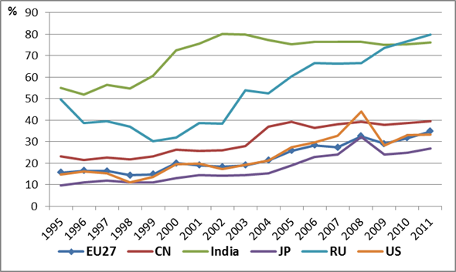
Source: Commission calculation on WIOD figures.
Finally, the estimation of the impact of CO2 indirect costs has been carried out in parallel to the assessment of the evolution in electricity prices. In this respect, the main result shown by case studies is the high variability of impacts across sectors, regions and plants. This is mainly due to highly differentiated sectoral electricity intensities as well as highly varied regional CO2 emission factors for electricity production. The choice of instruments used at Member State level in the pursuit of different policy objectives seems to play also an important part in these differences. It can be noted that, as the price of CO2 allowances has remained low over the last years, it cannot be considered as one of the key drivers for the upward trend observed in electricity prices. However this might change in the future as a result of the recovery of economic activity levels in the medium term and the investments which will be required for renewing and decarbonising the EU energy system. CO2 allowance price may therefore become an additional significant driver in the future.
ANNEX
Distribution of EU employment across sectors (%), 2000 and 2010
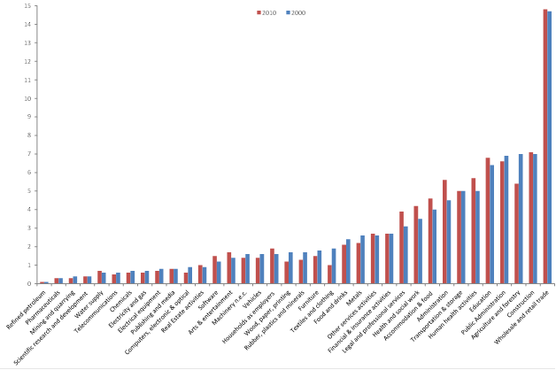
Source: Eurostat’s labour force survey (data unavailable for Bulgaria and the UK)
Employment changes by sector and Member State (%), 2000–2010
Source: Own calculations based on Eurostat’s labour force survey (data unavailable for BG, HR, PL, RO and UK)

Industrial Policy - Sectoral Issues
EU industrial policy focuses mainly on framework conditions and horizontal issues. It seeks to provide enterprises and other actors with the environment and resources needed to make the most of their creative capacity.
Nevertheless, Europe’s industrial structure is multi-faceted and many sectors face particular conditions and challenges, which must be reflected in an efficient competitiveness policy, at EU as well as national and regional level. An overview of EU industrial policy would not be complete without a brief account of particular sectoral conditions. This section therefore provides an overview of some of the sectors most relevant for the Commission’s policies on Enterprise and Industry. For each sector, a brief and non-exhaustive overview of the situation is presented below focusing on current challenges and of relevant policy measures.

Chemical sector

Overview
The European chemical sector is an essential industry as it is involved in different stages of multiple value added chains and also supplies final consumers. The chemical industry represents 1.1% of EU GDP and offers 1.2 million jobs. The EU chemical industry is a mature and rather stable industry, which recovered relatively well from the economic crisis of 2008/2009. The production level in 2012 was still nonetheless 9 % below the 2008 peak and EU chemicals production decreased by 1.4 % during the first seven months of 2013 compared with the same period in 2012. European chemicals represent 20% of the global market, compared to 29.8% in 2001. During the same time China’s share increased from 8.2% to 26.8%.
The confidence indicator (CCI) has stabilized for the chemical sector showing improvements in August 2013 in comparison with July 2013. Capacity utilization in the EU chemicals industry increased from 77.9 % in first quarter 2013 to 78.1 % in the second quarter. Given the diversity of the different subsectors of this industry, it is difficult to draw general conclusions applicable to all of them. Nevertheless, thanks to the positive evolution of the external markets and a certain recovery of some Member States, reasonable expectations are being created.
The EU chemical trade surplus in 2012 was € 49.5 billion, 76% of which resulted from the Specialty and Consumer Chemicals subsectors. The most important trade partners outside the EU are the rest of Europe (non-EU), followed by the NAFTA region (North American Free Trade Agreement market) and Asia (excluding China and Japan) accounting for about 85% of total trade flows with countries outside the EU.
For 2013, the EU chemicals trade surplus reached €25.4 billion during the first six months – a €1.2 billion improvement on the same period last year. EU chemical prices in July 2013 were 0.4 per cent higher than in July 2012. January-June sales were 4.1 per cent lower compared with the first six months of the previous year.
Despite the overall increasing trade surplus of the chemical industry and the historically strong trading position of the chemical industry as a whole, the trade position of intensive energy chemicals subsectors such as petrochemicals, basic inorganic products and polymers has weakened in recent years.

Challenges
Sectoral reports suggest that the main challenges for the chemicals industry in the short and medium term are:
- High energy costs
- Access to raw material
- Innovation and structural change
- Legal and regulatory complexity

Policies
- The cumulative impact of different strands of EU and national regulations should not create insurmountable competitiveness disadvantages for EU firms operating in this sector and exposed to open global competition.
- Better access to all forms of feedstock for chemical production at competitive prices is a challenge to be addressed as a matter of priority. This includes the application of the “cascading use principle” with regard to the biomass as raw material in different legislative acts, the review of current incentives for biofuels, the use and development of sustainability criteria, assessment approaches for different types of biomass and bio based products, and supply issues related to tariffs and trade agreements, especially those related to ethanol. Innovation is key for the future competitiveness of the sector. The chemical sector will play an essential role in Public-Private Partnerships such as SPIRE (energy efficiency) and BBI (bio based products). Of particular importance for the sector are also cluster policies and initiatives (e.g. SILC II for demonstration projects) as well as the further implementation of smart specialization strategies in the regions that facilitate infrastructure investments in the chemical sector, such as bio-refineries, the reuse of CO2 as chemical feedstock and import terminals for gas.
- A stable and predictable regulatory environment for the chemical sector is another key requirement for future competitiveness. In relation to the chemicals sector, REACH has been reviewed and a cumulative cost assessment study is to start in 2014. The study will take into account different framework conditions in which the sub-sectors operate, identify relevant policies and regulation for each subsector, quantify them and conclude how supportive or hampering the policy/regulatory environment is. It will collect relevant qualitative (opportunity costs of disinvestment, low innovation, cross-sectorial linkages etc.) and quantitative information (costs generated by the compliance with existing EU legislation, its implementation and application) in cooperation with the industry community, following as widely as possible a value chain approach. The study will identify costs and also consider benefits and highlight possibilities to decrease unnecessary costs and strengthen the sector's competitive position. In the same vein, in 2014 a regulatory fitness check will be conducted on the most relevant chemicals legislation not covered by REACH as well as related aspects of legislation applied to downstream industries.

Automotive sector

Overview
The automotive industry is of strategic importance to the European economy. The sector, that represents around 12 million direct and indirect jobs, is going through a difficult situation in the EU but continues to generate almost one third of the EU trade surplus. While the results in sales and production of light and commercial vehicles in 2012 have not been positive, sector analysts estimate that the ailing European car market has finally bottomed out at the end of 2013. It is expected that growth will follow a recovery trajectory, with an average annual growth rate of 3.1% by 2019 driven primarily by a high replacement demand. Six months into 2013 the total car production decreased by 5.5% on a year-to-year basis.

Challenges
Production overcapacity continues to weigh heavily on the balance sheet of European car manufacturers and is momentarily concentrated in peripheral Western Europe. Despite the announced structural measures by European OEMs and suppliers, industry analysts predict that these are not sufficient and the manufacturers with a particular European exposure will continue to be most at risk from global industry pressures in the absence of further market rationalisation. Production levels in 2014 are forecasted to grow by 3.7% compared with 2013. In the long run, analysts predict a rate of growth of 2.8% on average, but the growth rates will not recover its 2011 level before 2015 (2007 levels will not be re-established till 2017) while the localization of production capacity in Eastern Europe (Turkey, Russia), Asia, North America and North Africa continues.

Policies
Continuous investment efforts in research, development and innovation ensure future competitiveness in this sector. Considering that Europe’s competitors on the global markets have set up massive R&D support programmes for green vehicle development, Europe cannot have limited ambitions nor reduce the efficiency of action in this field. The new Multiannual Financial Framework for the 2014-2020 reserves a quite large budget allocation for transport research, i.e. some €5.8bn or 8.23% of the total Horizon 2020 envelope. This, alongside with the COSME, programme and the EIB support are the main sources of financing for SMEs at European level. In addition, other sources of financing might be available at national level.
Dealing with industrial adjustment and investment in human capital remains a major issue. The industry, employees and public authorities should all make more progress in this sense as this is vital for the future competitiveness of the EU automotive industry. As suggested in the accompanying communication, promoting an anticipative approach in restructuring and the diffusion of good practices can contribute to anticipate and facilitate industrial adjustment and restructuring. The European Automobile Skills Council offers an appropriate framework for that purpose. The Commission also launched an inter-service task force Ford Genk in April 2013.
Liberalisation of trade remains of strategic importance for the sustainable growth of the EU automobile industry as the sector continues exporting an ever-increasing portfolio of high-quality and high-technology vehicles to third markets. With this aim, the EU is currently negotiating a range of ambitious free trade agreements (FTAs) with key partners. Yet ensuring an open global market place remains a challenge. For example, regarding the implementation of the FTA with Korea in force since 2011, the Commission has noted a number of regulatory measures that create new Non-Tariff Barriers for EU industry.
In addition to Trans-Atlantic Trade and Investment Partnership negotiations with the US and the Free Trade Agreement negotiations with Japan, there is an ongoing bilateral regulatory cooperation with Russia and China with a view to contributing to a high level of regulatory approximation and therefore helping EU companies to export. The Commission is also continuing efforts to modernise 1958 UNECE agreement to accommodate the needs of the emerging economies.
The Commission is streamlining existing rules and conducting competitiveness proofing of new major future initiatives to reduce administrative burden and provide certainty which will in turn lead to more investment in the sector.

Machinery (mechanical engineering)

Overview
After a negative start of the year, there are signs of the beginning of a turnaround since the end of the third quarter of 2013. However, it is expected that the production of the European engineering industry has contracted by around 1.7% on average in real terms during 2013.
Order stocks are now better than in the first quarter of 2013, but, for many companies, they are still below normal levels. Nevertheless a positive trend is now building up judging by some business cycle indicators for this industry. For example, the business climate index indicator has risen to around 100, indicating a more optimistic perspective for 2014. Moreover, consumer confidence is on the rise in most countries, suggesting a positive impetus for machinery sectors producing consumer goods.
Financial problems are limiting companies’ investment. With production capacity utilisation in EU manufacturing industry at a low level, demand for mechanical and industrial machinery has been below normal during the past year. Only a few export-oriented countries have shown stronger demand. Nevertheless, this has not proved enough to compensate for the contraction in fixed capital formation in the EU.
However, a number of factors point to an improvement in the EU investment cycle in the coming year. The machinery and equipment industry is, as a result, expected to grow by 3% in 2014. With few businesses willing to invest in new capacity for the moment, demand in the EU will therefore come mainly from investments on the replacement of equipment.

Challenges
Main challenges for the sector are:
- Ensuring regulatory predictability and stability.
- Strengthening market surveillance. It appears than in most Member States, the focus tends to be on the surveillance of consumer goods while industrial goods are not given sufficient importance.
- Mobilising more funding for R&D for nanosciences, nanotechnologies, materials and new production technologies (NMP) programmes. Transaction costs of the 7th RTD Framework Programme implementation need to be reduced for SMEs.
- Combating protectionism and opening up markets through EU trade policy.
- Developing lifelong learning for education of skilled young workers in the engineering sector.
- Promoting measures to improve market access for SMEs.
- Facilitating access to finance.

Policies
The vast majority of the challenges mentioned above were addressed in the October 2012 Industrial Policy Communication following a consultation with industry stakeholders in follow-up to the 2012 study on the Competitiveness of the Mechanical Engineering industry. A conference on the engineering industries will also be organised during the second half of 2014.

Forest-based industries

Overview
The EU Forest-based Industries (F-BI) include woodworking, furniture, pulp & paper manufacturing and converting and printing industries. They represent in total about 7% of EU manufacturing GDP and nearly 3.5 million jobs. They all use common raw material – wood, which is a natural, renewable, reusable and recyclable raw material, creating an opportunity for the F-BI to become a key actor in the bio-based economy.
The F-BI was severely hit by the recent crises, which have led to a significant reduction in number of jobs and turnover estimated to have fallen by 19% and 13% respectively in the period 2007-2011 and they have still not recovered pre-crisis levels in 2013.

Challenges
The EU F-BI competitiveness is also negatively impacted by the following challenges:
- increasing competition from countries having low production costs, combined with a decline in demand for F-BI products as a result of structural changes and slowdown in construction sector
- availability of raw materials at affordable prices mainly due to the growing demand for wood from often subsidised bio-energy sector and increasing exports of secondary raw materials outside the EU.
- protectionist measures in international markets creating market distortions, both for import of input materials and export of final products.
- increasing energy prices and gas prices difference compared to North America and pressure to reduce greenhouse gases, in particular impacting energy-intensive industries of F-BI (pulp & paper and wood panels producers).
- the need of a coherent and predictable regulatory framework providing an enabling conditions for investment decisions and creation of growth and jobs in the EU.
- structural problems of ageing workforce combined with difficulties to attract young workers and securing access to finance for research and innovation, in particular to SMEs, which often lack financial capacity.

Policies
In September 2013, the Commission adopted a Communication “A new Forest Strategy: for forests and the forest-based sector”, accompanied by the Staff Working Document “A Blueprint for the EU forest-based industries”. This Blueprint seeks to address the challenges faced by these industries with the objective of helping to improve their global competitiveness.
Sustainable supply of wood and wood fibre materials, including the need for increased sustainable mobilisation and promoting the cascading use of wood principle, are objectives also supported in the European Innovation Partnership on Raw Materials. While the Bio-based Industries Public-Private Partnership and EU strategy for the construction sector will provide opportunities to stimulate demand and market growth for F-BI products.

Steel

Overview
Europe is the second largest steel producer in the world and it has a strategic importance for several major European industries such as terrestrial and naval transport, construction, machinery, energy and defence.
The EU steel industry is an important employer with 350 000 direct jobs and several millions of workers in related industries.
The EU’s share in global steel production halved during the last ten years with China now producing almost 50% of global steel production. While the EU is a successful world leader in many forms of high quality steel, the competitive situation for higher volume lower quality steel is more challenging.

Challenges
Domestic demand is not expected to recover in the short term and the global share of European companies is shrinking. The European steel industry is suffering from the loss of competitiveness as a combined result of a series of factors:
- the demand for steel has dropped substantially due the financial and economic crisis,
- the operational costs are high compared to many competitors that face lower energy costs,
- there is a fierce competition from third countries operating in different domestic environments.
The outlook for employment in the steel sector is of serious concern since more than 65 000 jobs have been lost in Europe during the past few years due to capacity reduction or plant closures.

Policies
In June 2013, an action plan for the European Steel Industry was presented to help this sector confront today’s challenges and lay the foundations for future competitiveness by fostering innovation, creating growth and jobs in the sector.
In parallel, the Commission finished the cumulative cost assessment on the steel sector, one of the measures of the proposed action plan. The results of this cumulative cost assessment were published on the date of adoption the action plan.
The Commission has formally created a High-Level expert Group on steel to continue the dialogue among major stakeholders and follow the implementation of the action plan in this strategic industrial sector.

Non-ferrous metals

Overview
The main non-ferrous metals (NFM) included in this sector are aluminium, copper, nickel, zinc, lead, tin, silver, gold and platinum.
The EU NFM industry accounts for one fifth of the world’s refined metal production and at least one third of the world’s output of semi-manufactured metal products. It contributes 2% to EU GDP and directly employs 450 000 people.
EU energy-intensive sectors such as aluminium are increasingly under strong competitive pressures, mainly due to high-energy prices. In 2013, the EU imported more aluminium than it produced domestically.

Challenges
The global NFM industry is open and highly competitive. Whilst prices for NFM are set globally in international commodity exchanges, cost factors other than raw material inputs are usually determined locally, making them important determinants of competitiveness, especially for upstream segments. Challenges include the following:
- High energy prices and ensuring global competitiveness. The drivers of competitiveness of the NFM industry are conditioned by i capital, resource and energy-intensity of the sector. The latter makes the it very sensitive to high-energy prices (especially electricity prices) for primary production. In order to ensure investment predictability the sector needs long-term price predictability.
- Access to raw materials. The EU NFM industry is highly dependent on imported raw materials (especially primary) due to the lack of appropriate ores in the EU. EU access is further restricted by export restrictions, tariffs and taxes in place in important raw material producing countries like China and Russia, which creates an unequal international playing field. At the same time, the EU is exporting significant amounts of valuable scrap to third countries.

Policies
Actions that have been or are being implemented include:
- In 2008 the Commission launched the Raw Materials Initiative, an integrated strategy aimed at responding to different challenges related to access to non-energy and non-agricultural raw materials. Since then the Commission has focussed its actions on increased international cooperation (Pillar 1), the fostering of sustainable supply from European sources (Pillar 2) and reducing the EU's consumption of primary raw materials (Pillar 3).
- In 2012 the Commission launched a European Innovation Partnership (EIP) on Raw Materials, with the following objectives: to extract more efficiently and safely, to re-use and recycle more, to find alternatives/substitutes for critical raw materials and to be more resource efficient by decoupling resource use from economic growth. In September 2013, the EIP's high-level steering group adopted the Strategic Implementation Plan, which includes 10 concrete targets.
- In November 2013 the Commission published a study that focused on the Cumulative Cost Assessment of EU regulation on the aluminium industry. Findings of the study include that regulatory costs related to climate and energy policies are estimated to be between 16% and 40% of the industry's profitability. These regulatory costs reduce profitability and the attractiveness of the EU as a production area for this industry.
- An appropriate framework that could allow for long-term energy supply contracts in a framework of strict and full respect of competition and internal market rules could enhance efficiency in this sector by limiting the impact of high-energy prices. This could take the form of a guidance letter on long-term electricity supply contracts provided that a request for such letter is made and the respective conditions for issuing a guidance letter are met.

Textiles, fashion and high-end industries

Overview
The European fashion industry value chain employs over 5 million persons, which is equivalent to 3.7% of the total non-financial business economy (2009), representing nearly 3% of the EU GDP. With 70% of world market share, high-end industry adds further to this important contribution; its annual turnover amounts to € 400 billion, with employment reaching 1 million.
European high-end products amount to 10% of all EU exports. 62 % of all goods manufactured by European high-end brands are sold outside Europe, with the value of European exports by the high-end industries estimated at € 260 billion.
The fashion industries still face a deficit in extra EU trade; however in 2011 and 2012, they increased exports to third countries, in particular to China, Russia, India and Brazil and thus improved the trade balance.
The EU has become one of the world leaders in non-clothing applications of textiles. The technical textiles sub-sector is strongly linked to other sectors such as cars and the transport industry, medical applications, protective clothing and construction, and therefore dependent on the performances of these sectors. Technical textiles are intensive in R&D and innovation. That is why a Technology Platform was set-up notably to meet the requirements of FP7. Higher value added new fibres also constitute drivers of export.

Challenges
Due to various pressures for change as a result of trade liberalisation and increasing external competition, consumer developments, technological advances, changes in production costs, and environmental issues, the EU fashion industry is characterised by permanent restructuring and modernisation. The crisis has accentuated the process of restructuring towards the high value added range of the market and niche products. As to the high-end industries, they showed stable growth over the past decade, with remarkable years in 2010 and 2011 with yearly growth of over 10 %. Current challenges include:
- Benefiting from a smart legislative and regulatory framework to develop creative and high-end products manufactured in the EU;
- Competing on price level with the emerging economies has become difficult, if not impossible. The industry has to continue its move towards innovative, high-added value products.
- Continuing globalisation of value chains implies further delocalisation outside the EU and further exposure of the value chain to reputational risks. Putting an emphasis on technological progress, creativity and innovation can reverse this trend.
- Attracting young talents with adequate skills is difficult. There is a risk of losing traditional skills and know-how and this would have an impact on the long-term competitiveness of these industries.
- The sector has to fully benefit from market liberalisation, notably via Free Trade Agreements and by exploring opportunities created by the demographic expansion and increase of revenues in third countries such as Brazil, China, India, Indonesia, Japan and the USA.
- SMEs in the fashion sector are suffering from longer financial cycles vs. production cycles.
- Counterfeiting and other IPR violations undermine the creative efforts of European fashion and high-end companies.
- Lack of legal certainty and consequently decreasing consumers trust online shopping.

On 3 December 2013, industry associations endorsed an Action Plan for the fashion and high-end industries presented by the Commission along these lines in London.

Policies
The 2012 Communication ‘Promoting cultural and creative sectors for growth and jobs in the EU’ was the Commission’s first recognition of the economic, social and cultural significance of these specific industries. The Communication is accompanied by two Staff Working Documents, one on fashion and the other on high-end industries, which assess the current situation and prospects for the fashion and high-end industries and setting out policy options to strengthen their competitiveness, in particular in the following areas:
- International trade: the current demand drop in the internal market and the growth opportunities outside the EU, are driving the trade agenda of the fashion industry to more offensive positions as exports are considered as an engine for growth. Trade policy, including preferential trade agreements, is used to access international markets, which has become a key priority for the industry especially in emerging economies. Creating and maintaining a level-playing field in international trade is crucial. Trade policy will continue contributing to open international markets addressing both tariffs and non-tariff barriers that have proliferated, in particular in emerging economies. Preferential Agreements are useful. Rules of origin within preferential trade agreements need to be negotiated cautiously because they impact directly on specific processes where competitive advantages exist in Europe.
- Adequate skills both more sophisticated ones (researchers, ICT technicians, product developers, global marketing, etc.) as well as traditional skills and crafts are needed.
- As the sector takes a quality shift moving up towards more sophisticated production activities, the need for finance becomes increasingly important. The banking system could be better used to finance innovation in the textiles sector (especially for SMEs). The current EIB Group scheme to increase lending for SMEs is useful but limited.
- This globalized sector also could benefit from the reinforcement of Intellectual Property Rights protection (both awareness raising and enforcement action and duty of care for Online Service Providers), to protect EU brands, know-how and expertise both in the physical world and online. Whilst already regulated, it is worth mentioning the strategic value of selective distribution for these industries.

Defence

Overview
With a turnover of 96 billion € in 2012, the European defence industry brings a major contribution to the growth of the wider economy. It provides thousands of highly skilled jobs, as it directly employs about 400 000 people. Moreover, driven by a multiplier effect of between 2.2 and 2.4, it generates up to another 960,000 indirect jobs.
The defence sector consists of three main sub-sectors:
- The aeronautics sector represents around 50% of Europe’s defence, with a turnover of 46.7 billion € in 2010 (43% of this is generated from exports), and employs around 200 000 people.
- In 2010 the land defence sector had a turnover of around 30 billion € and employed 128 700 people. It has the capability for delivering and sustaining key military capabilities in areas such as main battle tanks and armoured fighting vehicles, as well as for sustaining and upgrading platforms.
- The naval sector had a turnover of around 17 billion € in 2010 and employed 83 200 people. The sector provides full services across the entire life cycle of a complex warship from design and construction to integration of systems and support.

Challenges
Member States encounter difficulties to equip their armed forces adequately. Defence budgets are falling, and the cost of modern capabilities is rising. This is aggravated by the persisting fragmentation of European markets which leads to unnecessary duplication of capabilities, organisations and expenditures. It is increasingly unlikely that Member States can bear the cost of defence equipment development in isolation, as new equipment is often technologically complex and expensive. Cooperation and EU-wide competition still remains the exception, with more than 80% of investment in defence equipment being spent nationally, and with relatively high dependency on imports from third countries. The US alone spends seven times more on defence R&D than all 28 EU Member States together.
Furthermore, the EU is at a risk of losing critical technological competences with scarce resources devoted to R&D. Without robust actions to redress the current market situation, the competitiveness of the European Defence Industrial Sector may continue to decline, with an obvious impact on Europe’s strategic autonomy.

Policies
As announced in the Commission Communication “Towards a more competitive and efficient defence and security sector”, the Commission’s strategy focuses on action in the following strands:
- Further deepen the internal market for defence and security. This means first of all to ensure the full application of the two existing Directives. Based on this acquis, the Commission will also tackle market distortions and contribute to improving security of supply between Member States;
- Strengthen the competitiveness of the European Defence Technological and Industrial Base. To this end, the Commission will develop a defence industrial policy based on two key approaches:
– Support for competitiveness – including developing 'hybrid standards' to benefit security and defence markets and examining the ways to develop a European certification system for military airworthiness.
– Support for SMEs – including development of a European Strategic Cluster Partnership to provide links with other clusters and support defence-related SMEs in global competition, while recognising the traction and catalyser effect played by large integrators on the whole supply chain.
- Exploit civilian military synergies to the maximum extent possible in order to ensure the most efficient use of European tax payers' resources. In particular by:
– concentrating its efforts on possible cross-fertilisation between civil and military research and the dual-use potential of space;
– helping armed forces reduce their energy consumption and thereby contribute to the Union’s 20/20/20 targets.
- In addition, the Commission suggests actions which aim at exploring new avenues, driving the strategic debate in Europe forward and preparing the ground for more and deeper European co-operation. In particular by:
– assessing the possibility of EU-owned dual-use capabilities, which may in certain security areas complement national capabilities and become effective and cost-efficient force multipliers;
– considering launching a preparatory action for research related to Common Security and Defence Policy, focusing on those areas where EU defence capabilities are most needed.

Space

Overview
Space is a key sector for Europe’s economy, and space activities require and generate innovation, scientific, technological and organisational excellence. For this reason, the space sector is an essential pillar of Europe’s strategy to enhance industrial competitiveness, generate growth and create jobs. Both the EU and the Member States are devoting considerable amounts of taxpayers’ money to space activities. It is therefore essential to ensure the most efficient possible use of such investments in order to maximise the benefit that our economies and citizens get out them.

Challenges
Coordination is important and EU Member States have come to the conclusion that most space projects are unaffordable for any single Member State and therefore, it is more efficient to pool resources that ultimately serve to fulfil both national and EU policy objectives. The EU policy measures have to be commensurate to the public budgets at stake and the need to foster an industry capable of delivering on the objectives and competing worldwide.

Policies
As stated in the Communication on EU Space Industrial Policy and the Communication on Defence and Security, six actions are essential for a business-oriented space industrial policy:
A. Technological leadership and non-dependence: Europe’s ability to pursue strategic policy initiatives and provide key services for citizens' benefit requires an independent access to space. This can only be achieved if European industry further develops its technological non-dependence, especially in critical technologies, to ensure its capability to deliver products and services necessary for economic growth and citizens' well-being. R&D efforts, including through the space strand of Horizon 2020, should therefore focus, as a matter of highest priority, on technological non-dependence starting from the low levels of technological readiness up to in orbit demonstration and validation of components and market readiness.
SMEs constitute a crucial element in the value-chain and are often at the innovation forefront. The EU’s role should be to ensure an environment with the right mix between large EU companies able to compete worldwide and agile SMEs delivering on innovation. Horizon 2020 will contribute to that.
B. Maximizing institutional investment: The industry has also often stated the need to have a clearer view of medium to long-term intentions regarding space institutional expenditure as this would help to better organise themselves, keep engineering teams in place. Europe should also avoid duplication of efforts, particularly in space research. Past experience has shown that establishing a long-term planning of space activities based upon good will to exchange information with Member States is not fruitful. Therefore, the Commission will examine the possibility of a EU legislative instrument for compulsory reporting on space activities across the EU.
Particularly in procurement, preparatory work is underway to explore the potential proposal of legislation specific for space procurement if it is concluded that current EU procurement and defence procurement Directives do not sufficiently cater for space specificities.
C. Maintaining and enhancing competitiveness in global markets: International cooperation should serve as a market opener for the promotion of European space technologies and services. At the same time, EU trade negotiations should take into account the specificities of the space sector. The Commission will therefore undertake a sector-specific risk/benefit analyses on relevant issues, such as the strategic export controls and reciprocity in areas, regarding notably public procurement of launchers and satellites. On the basis of this analysis, the Commission will assess the pertinence of developing an international trade strategy and policy vision and ensuring the necessary technical expertise in trade negotiations.
D. Market take-up: The EU space industrial policy supports the worldwide competitiveness of our industry and the market development for space applications and services. This includes not only the development of new capacities within existing industry but also the adoption of coherent set of EU measures, including GNSS Action Plan to foster the development and adoption of satellite navigation applications using EGNOS and Galileo and similar measures to boost the emerging Earth observation market, for creation and stimulation of an environment allowing the market take-up of new satellites technologies and the emergence of new operators with particular focus on small businesses.
E. Sustainability of space activities and space business environment: The sustainability of European space activities is also at stake. This means not only improving environmental aspects of space activities and ensuring non-proliferation of space debris, but also setting the right EU-regulatory framework in areas, such as the regulatory obligations of insurance, registration and authorisation of space activities and services and sanctions. The Commission will explore possible legislative initiatives in these areas to provide a more consistent legal framework favouring the emergence of a European market for space products and services.
F. Exploiting the dual use aspect of space: As stated in the 2013 Communication on Defence and Security, whilst most space technologies, space infrastructures and space services can serve both civilian and defence objectives, in the EU there is no structural link between civil and military space activities. The EU needs therefore to push for increased synergies between civil and military capabilities in space. The Communication has identified areas such as space surveillance and tracking, pooling of military satellite communications demand and development of an EU high-resolution imagery capacity. In this particular context, Horizon 2020 shall support the development of the necessary dual use technologies to prepare the next generation of both civil and military space systems.

Agri-food industries

Overview
With an annual turnover over EUR 1 trillion and around 4 million employees, the agri-food industry is part of a complex supply chain, which encompasses also agriculture and distributive trade. Taken as a whole, this value chain generates a total value added of € 715 billion per year — almost 6% of the EU Gross Domestic Product. On average, 15% of household expenditure is on food and drink. The sector not only feeds people, it also responds to cultural, health, ethical demands and many other qualities that consumers demand from their food, including convenience.
Moreover, the EU is the world’s biggest exporter and importer of agricultural and food products and accounts for about 19% of total global export flows.

Challenges
The food sector legislation is highly harmonised in the European Union. The sector enjoys significant benefits from the opportunities that the internal market offers. Cross-border trade between the Member States has risen by 72% in value over the last decade (at constant geographic scope), and currently accounts for about 20% of EU food and beverage production. However, businesses still report market fragmentation and diverging implementation of EU law in some specific domains. Further integration of the internal market would open up new opportunities for growth. Several Member States are developing national measures in non-harmonised areas, such as fiscal measures on food taxes, which may impact on the competitive position of the sector. At the same time, Member States initiatives to introduce public procurement rules fostering healthy and sustainable food choices may contribute to ensure more consumer-orientated food systems.
Generally speaking, the European food and drink market involves using and managing the EU’s natural resources with impacts on consumer welfare, public health and the environment.
The economic crisis and consolidation in some parts of the value chain have contributed to change market power relationships over the past years. In the framework of the High Level Forum for a Better Functioning Food Supply Chain, European trade associations have agreed on the need to eliminate unfair behaviour. To this end, a self-regulatory initiative called 'The Supply Chain Initiative' was launched on 16 September 2013. Self-regulatory and regulatory initiatives are also developing at national level.
As a relatively labour-intensive industry, many companies in the food and beverages sector encounter difficulties in finding skilled workers that match their needs, especially in some subsectors.
While EU exports in foodstuffs are increasing in absolute terms, this is not the case of export shares and the EU agri-food sector’s competitive leadership is increasingly being challenged by established trade partners (USA, Australia, New Zealand) and by emerging economies (Brazil, China). European high food safety standards continue providing a comparative advantage in exports markets. EU exports are high value added products while imports are mainly commodities.
Stakeholders report that the protection of intellectual property rights is becoming increasingly challenging as counterfeiting and illegal trade seem to increase, notably with regard to high value foodstuffs and beverages. If confirmed, such tendency could also harm the safety of products available on the market and harm the sector’s image.

Policies
By the end 2014, the High Level Forum on a Better Functioning Food Supply Chain will report on its achievements. The Forum is expected to promote fairer business-to-business relationships within the sector and improve price transparency. It will also review the results of a study on food taxes and the relevant parts of the SME cumulative costs study.
By end 2013, the Regulatory Fitness check of the Food sector will be launched, supported by an evaluation of the general Food law. Results can be expected for 2015 of this comprehensive assessment exercise.
The Commission supports the Structured Social Dialogue Committee that was established in 2012 upon the request of the social partners.
To open new growth opportunities in non-EU markets, the Commission takes an ambitious approach in trade negotiations to improve market access in particular for processed agricultural products.
The Commission actively works with Member States and stakeholders to prepare its participation to the world exhibition EXPO Milano 2015 ‘Feeding the Planet. “Energy for Life”. The event will offer a unique opportunity to showcase the high quality of European foodstuffs, to promote EU policies and in particular the industrial policy, including food crafts, and to improve the image of the agri-food sector as a whole. It should also contribute to develop synergies between the agri-food industry and other key economic sectors of the Union such as tourism or space.

Pharmaceutical sector

Overview
Europe has traditionally been a world leader in the pharmaceutical sector. This high-tech industry presents an excellent overall performance and has been particularly resilient to the crisis and therefore, it can be considered as one of the gems of the European economy. The reasons why a viable European pharmaceutical industry is of the utmost importance are four-fold:
- Firstly, it contributes to the health and the quality of life of our citizens by providing remedies to an ever-increasing number of patients. As the burden of disease is likely to increase as a consequence of the ageing European population it is to be expected that the 9.5% GDP spending on healthcare costs, including pharmaceutical treatment, on average across OECD countries in 2010 will increase significantly in the coming years.
- Secondly, the healthcare sector and in particular the pharmaceutical industry is of economic significance, as demonstrated by €157 billion in annual turnover and 660,000 employees (of whom 110,000 are researchers).
- Thirdly, the European pharmaceutical industry serves as a major contributor to the EU’s position as a successful trading power. In fact, the European Union is the world’s major trader in medicinal and pharmaceutical products enjoying a trade surplus of EUR 56 billion in 2012.
- Fourthly, the world market of medical products is a growth market, i.e. global spending on medicines will grow to nearly $1.2 trillion by 2016. While the developed markets are expected to grow slowly due to the sustained impact of the global economic crisis, emerging markets will become the major sources of demand.

Challenges
The European pharmaceutical sector is subject to many challenges which are likely to impede its development and future perspectives, for example:
- Tighter public budgets as a consequence of sluggish growth rates in the EU suffering from the aftermath of the financial/economic crisis and consequently, reduced social security contributions;
- The short-term orientation of measures taken to address the financial constraints in public health budgets in response to the ongoing budgetary crisis in some EU Member States and the subsequent lack of a predictable business environment;
- Diverging policy responses (in particular with regard to pricing/reimbursement of medicines in Member States) and spill-over effects of national cost austerity from one Member State to another, irrespective of the socio-economic conditions;
- Globalisation and the emergence of new competitors that target life sciences as future engines of growth while impairing the market access of non-domestic manufacturers through (non)-tariff barriers and the lack of a sufficient level of intellectual property protection.

Policies
Commission policies in the field of pharmaceuticals aim to secure the competitiveness and long-term viability of the industry. Such a policy aims at reaping the sector’s full potential for growth and employment while ensuring better and timely access to medicinal products for European citizens and maintaining the sustainability of the healthcare systems.
Given that the industry faces numerous barriers to trade and an increasing competition in world markets, assuring fair market access in third countries is of utmost importance.
A European response to the challenges should build on the lessons learned over the recent years (including the results of the Process of Corporate Responsibility in the Field of Pharmaceuticals which was concluded last October).
Given the complexity of the subject matters and the different policies affected at EU and Member States’ level, a comprehensive response is required. As announced in the Communication on Industrial Policy of October 2012, the Commission is committed to addressing the challenges by launching a new Strategic Initiative for the Pharmaceutical Sector. The comprehensive nature of such an exercise would require covering a wide scope of areas ranging from finding a consensus on the value of medical innovation, up-stream measures on R&D to down-stream measures on improving patients’ access to medicines, including issues related to pricing/reimbursement of medicinal products. This would also need to include global competition and effective IP protection and enforcement, which are key for Europe’s innovation and international competitiveness, while fully respecting the 2001 Doha Declaration on the TRIPS Agreement and Public Health, especially in the field of generic medicines and public health.
The Innovative Medicines Initiative, a Joint technology Initiative set up under the 7th RTD Framework Programme, is proposed to continue under Horizon 2020. It will aim at improving the drug development to bring new medicines more rapidly to the patients, through multi-stakeholder collaboration in an open-innovation framework.

Major efforts are also made to speed up the development of orphan drugs through the better coordination of research and innovation efforts across the globe via the International Rare Diseases Research Consortium (IRDiRC) that has been supported via FP7 and will be continue to be supported throughout Horizon 2020.

Bio-Based Products Sector

Overview
Estimates suggest that in 2010 bio-based products accounted for 10% of sales within the global chemical industry, representing 125 billion dollars in value. However, the share could rise to as much as 20% depending on the development of technologies, feedstock prices and policy framework.
Based on an assessment presented in the 2012 Commission Communication on the bio-economy strategy, the segment of bio-based industries in the EU currently represents approximately 57 billion € in annual turnover with 300,000 jobs involved. Bio-based industries encompass the following main categories: Bio-based lubricants, polymers, surfactants, solvents and chemical building blocks; Enzymes and Biofuels, estimated respectively at 50 billion, 0.8 billion and 6 billion € annual turnover.
Europe is technologically well positioned to spearhead the switch to a low carbon society with strong agricultural, agro-food and forestry sectors and world-leading companies in the plant breeding, biotech and chemical/biochemical, engineering and energy industries.
Although the EU industry has already started to make significant investments in bio-refineries - e.g. in France, Germany, Finland, Netherlands, Denmark, Italy, Spain – this has so far been done in a fragmented manner. Europe needs to maintain its competitive edge by consolidating and capitalizing its prominent knowledge base and creating the necessary framework conditions for industry to increase its investments in Europe.

Challenges
The ongoing work of the task force created after the 2012 Industrial Policy Communication has led to the identification of the following challenges:

- Sustainable access to raw materials / feedstock in sufficient quantities at a suitable and guaranteed quality and at competitive prices.
- Uncertainty with regard to the measurement and communication of environmental benefits and product properties.
- Scaling up from pilot to industrial scale production.

Policies
In order to foster the bio-based products sector and its competitiveness it is necessary to review the market entry barriers identified by the task force.
With regard of the biomass supply it is essential to generate general recognition of the cascading use of biomass at EU level. The Commission’s recently published Renewable Energy Progress Report recognizes a need for coherence of policies, since there is currently a significant detrimental impact from the use of biomass for biofuels and bioenergy rather than for high value-added products.
With regard to the measurement and communication of environmental benefits and product properties, it is important to continue developing and applying clear and unambiguous European and international standards and to promote and use harmonized certification and labelling schemes for bio-based products. Standardisation is in progress for the development of a standard for measuring the “bio-based content”. Separate standardisation mandates were issued and are on-going, among others, for the elaboration of a standardisation program for bio-based products, for bio-based polymers, lubricants, solvents and surfactants and for the development of horizontal standards for bio-based products.
The design and implementation of a communication strategy involving all partners in the value chain and all other stakeholders to achieve coherent messages on bio-based products would also be conducive to the development of the sector.
A compilation of product lists and databases of available bio-based products linked with awareness-raising among of contracting authorities in all EU Member States on the availability and capabilities of bio-based products would create a pull effect for the bio-based products industries.
With regard to the up-scaling from pilot to industrial scale production, the Commission contributes to the set-up of the Bio-Based Industry Public Private Partnership (BBI PPP) in the framework of Horizon 2020, a Joint Technology Initiative (JTI). This includes an effective link with the SPIRE PPP as a contractual PPP and the SILC II initiative on demonstration projects.

Cement

Overview
The cement industry is amongst those sectors most heavily hit by the economic crisis. 2012 cement production fell by 20% year-on-year, compared to a 2.8% decrease in overall industrial output in Europe. Compared to pre-crisis levels, cement production has fallen by 40%. The sector gives direct employment to 45,000 people in the EU.
The cement sector's turnover to GDP ratio is 0.14%. The value of production to GDP ratio is 0.61% and the value added to GDP is 0.18%.
China represents 59% of global production (in 2012), whilst the EU represents 6.1 %.
The average return on capital employed within the European cement industry in Europe during the 2009-2012 period has been 3.1%, which is 3-5% below the industry’s cost of capital, making it very difficult for the sector to invest in growth and jobs.

Challenges
Main challenges for the cement industry are:
- Investment, labour and energy costs are high in Europe. Nevertheless, Europe needs to compete with the US (which faces high labour and investment costs but low energy costs) and China (which has high energy costs but low labour and investment costs. Energy costs still represent 30% of the overall production cost with electricity amounting to 19% of overall production costs.
- A coherent and predictable regulatory framework is needed to create the conditions necessary for investment.
- Driven by the crisis and by especially harsh construction crises in a number of Member States, the demand for construction related cement has dropped substantially.

Policies
According to the Global Cement Report (2013), in 2012 six out of the ten world's largest cement producers were Chinese companies, and four were European. This compares with the situation in 2005, when seven out of the top ten were European. Policy instruments to different policy objectives must not introduce disproportionate modifications of the relative prices of inputs or distortions that might imply significant disadvantages in the production conditions faced by EU producers compared to those faced by their international competitors.
The choice of policy instruments to achieve environment-related objectives requires significant investments that may not be feasible in times of economic hardship. According to industry, the return on investment ratio is not sufficient at present to financially justify these investments in those periods.
- The cement industry needs to be competitive within an international level playing field.
- Over the past 20 years, the European cement industry has reduced its CO2 emissions per ton of cement from 719 kg in 1990 to 660 kg in 2010. For example, the cement industry has replaced part of its traditional fuel sources with biomass and waste with alternative fuels accounting for 34.2% of the fuels employed by the cement industry, with the aim of increasing this share to 60% by 2050. In addition, the unique properties of concrete can contribute to significant energy savings and can help build the energy efficient houses of tomorrow.

Ceramics

Overview
The ceramics sector encompasses a wide range of products including construction products (wall and floor tiles, bricks and roof tiles, vitrified clay pipes, sanitary ware), table and ornamental ware, refractory products, technical ceramics and abrasives.
The European ceramic industry today employs more than 200,000 people in the EU-28, around 80% of them in SMEs.
The European ceramics sector has been severly affected by the crisis. Following a slight recovery in 2011, stagnation was recorded in 2012; while waiting for final figures, expected production value in 2013 is around 30% less than in pre-crisis years.
The leading Member States producing ceramics are Italy, Germany, Spain, France, the UK, Poland, Portugal and Austria. Ceramic manufacturing is present in virtually every EU Member States.

Challenges
Domestic demand is slowly recovering but it has not yet reached the pre-crisis levels. The European ceramics industry is suffering from the loss of competitiveness as a combined result of a series of factors:

- the demand for construction related ceramics has dropped substantially due the financial and economic crisis,
- the operational costs are very high compared to international competitors (especially energy costs),
- there is a strong competition from third countries not always complying with the same level-playing field.

Policies
- Two ceramic sub-sectors (wall and floor tiles and bricks & roof tiles) are part of the Study on energy prices and costs of Energy Intensive Industries (EII). This study is a follow up of the Energy Council of 03/2013 and has provided input to the Commission report adopted in December 2013.
- Antidumping duties. Two measures have been adopted in the last years against China imposing definitive anti-dumping duties on imports of ceramic tableware and kitchenware in China.
- Origin Marking. The EC proposal for a new Regulation on Consumer Product Safety (part of a broader “Product Safety and Market Surveillance Package”) includes a proposal for Origin Marking, which is supported by a good number of ceramics sub-sectors (certain reluctance by the construction sub-sectors though).
- Horizon 2020 and SPIRE PPP and SILC II initiative. SPIRE calls published on 11/12/2013; SILC II call to be published later in 2014.
- In 2012 the Commission launched a European Innovation Partnership (EIP) on Raw Materials, with the following objectives: to extract more and efficiently and safely, to re-use and recycle more, to find alternatives/substitutes for critical raw materials and to be more resource efficient by decoupling resource use from economic growth. In September 2013 the EIP's high-level steering group adopted the Strategic Implementation Plan, which includes 10 concrete targets.

Glass

Overview
The glass sector includes the following different glass products: container glass, flat glass, domestic glass, special glass and reinforcement glass fibres. The sector directly employed some 100,000 people in 2012.
In 2012, EU-27 glass production covered by Glass Alliance Europe reached a volume of more than 30 million tonnes, making the EU the largest glass producer in the world with a market share of around one-third of the total world market. However this production decreased by 5.7% in 2012 compared to 2011, the international economic and financial crisis has hit the EU glass market as well. Customers from the car industry, the construction sector, domestic, leisure and other industries drastically reduced their orders in 2012. Overcapacity even led to several plant closures.
Germany remains the EU’s biggest producer with about one fifth of the volume, closely followed by France, Spain, Italy and the UK.
The evolution of production and employment, as well as the origin of imports into the EU, are very different across glass sectors. Generally speaking however, after the slightly better conditions in 2011, recession has severely hit all sectors in 2012 and no positive trend was detected in 2013.

Challenges
Main challenges for the sector are:
- The need of a coherent and predictable regulatory framework enabling conditions for investment decisions and creation of growth and jobs in the EU.
- Investments in alternative locations - cumulative effects of rising production costs, growing legislative burdens and uncertainties, and a strong Euro, lead to the increase in capacity investments outside the EU, rather than in Europe.
- Face foreign trade from third countries and fight unfair trade practices - imports from Asian countries, and in particular China, remain big competitors with an increasing number of new plants set up in neighbour countries (e,g, East EU and Mediterranean borders).
- Low demand due to the crisis.
- Increasing energy prices in the EU combined with increasing difference in gas prices compared to North America and pressure to reduce greenhouse gases, in particular impacting energy-intensive industries
- Promoting measures to improve market access for SMEs.
- Facilitating access to finance.

Policies
As other energy-intensive industries, policy challenges in the sector are linked to the impact energy prices to the competitiveness of the sector. The flat glass sector is included in the Study on energy prices and costs of Energy Intensive Industries (EII). This study is a follow up of the Energy Council of 03/2013 and has provided input to the Commission report adopted in December 2013
The sector will also be very much affected by the outcome of discussion on Binding Occupational Exposure Limit Value (BOELV) for Respirable Crystalline Silica (RCS) under Directive 2004/37/EC (the so-called Carcinogens and Mutagens Directive) or under Directive 98/24/EC (the so-called Chemical Agents Directive).

Construction

Overview
The construction industry is a major economic operator. Overall, it generates almost 10 % of GDP, provides 20 million direct jobs, mainly in micro and small enterprises, and contributes to more than 50 % in fixed capital formation of all economic agents.
This sector has been hit particularly hard by the financial and economic crisis. The production index of construction for both building and infrastructure works fell by 8.5 % between 2009 and 2012 across the EU-28. Activity fell sharply in building works, in particular in the new residential segment, with a decline in the production index of nearly 9% between 2009 and 2012 for all EU-28. Infrastructure works also experienced a downturn in activity of 6%.
However, the situation varies enormously from one country to another. Countries with the highest decreases of performance are those that had the highest growth rates up to 2008. Another reason for the different impacts of the crisis at national levels could be the nature and impact of planned construction work as well as varying effects of national stimulus packages. Several Member States were adversely affected by the financial crisis to a different degree extent, including those where there was no “construction bubble” prior to 2008.

Challenges
The demand and the activity in construction are influenced by the general economic context in the EU. If recent figures suggest that the European economy is gradually gathering momentum, the growth rates remain low and the tentative signs of recovery are still fragile. A number of Member States still have significantly high unemployment rates and the implementation of essential but difficult reforms across the EU is still in its early stages.
The latest business confidence and economic sentiment indicators suggest an improvement among consumers and managers in industry, services and retail trade. Only in the construction sector confidence indicators have weakened. Credit conditions remain tight but expectations for the near future point to a further ease in credit conditions on loans to non-financial corporations.
Important policy measures adopted since summer 2012 have reduced the sovereign- debt crisis and the risk of a possible rapid worsening of the crisis. Measures notably comprise structural and fiscal reforms at the Member States level. Despite the ongoing fiscal consolidation, debt-to-GDP ratios are expected to have increased in 2013 due to the more negative contribution of real GDP growth and to persistent primary deficits. This is putting some constraints in public investment in construction works.
The high energy needs of buildings and resource requirements for construction exert significant pressure on EU energy consumption and trade balance, and contribute significantly to global CO2 emissions. Though energy efficiency improvements in the existing building stock represents the most promising driver for regaining growth in this sector, due to the high intensity of investment need, this potential is not being realised yet.
Competition within both EU and non-EU construction markets is becoming tougher and tougher for EU construction enterprises. Non-EU companies are often subject to less stringent social and environmental requirements and benefit from state aid. In international markets, they are confronted to more and more stringent access conditions.

Policies
Given the importance of the construction sector for the EU economy, as well as its role in the achievement of some critical climate, environmental and energy-related objectives, the Commission adopted in July 2012 a Communication and the “Construction 2020” Action Plan. The Action Plan proposes measures to stimulate investment in building renovation, especially for energy efficiency improvements, as well as in the maintenance of existing infrastructure. Moreover, it suggests actions to address the significant shortfall of qualified workers, the poor attractiveness of the sector to young people and the ageing of the workforce. In addition, a number of measures are proposed to improve the functioning of the Internal Market of construction products and services, in particular regarding the conciliation of the requirements of environmental sustainability with EU product and services legislation related to the sector. Finally, the Action Plan looks at fostering the global competitiveness position of EU construction enterprises.
In order to create synergies and maximise the impact of various actions at EU, national and sectorial levels, the Commission has set up at the beginning of 2013 a High Level Tripartite Strategic Forum (HLF) consisting of Commission, Member States and sectorial organisations, as well as five Thematic Groups addressing specific aspects of the Action Plan. The High Level Forum met on 29 November 2013 to monitor progress on the Action Plan and to make specific recommendations for future action. They represent a number of steps forward, which, if properly implemented, will bring concrete results with a significant impact on the medium term.
In addition, the EC Task Force on “Sustainable industrial policy, construction and raw materials” brings together different EC services to ensure the contribution of the construction sector to policy development on innovation, disaster resilience, job creation, social cohesion, energy efficiency, environmental goals and international growth. Its main focus is on possible synergies and elimination of overlaps and of inefficiencies, as well as on other coordination issues linked to the contribution of the construction sector to the EU 2020 strategy, long-term Industrial Policy and other relevant EU goals.

Tourism

Overview
Tourism is an important sector in terms of jobs and growth. With about 1.8 million enterprises, primarily SMEs and employing about 5.2% of the total labour force (10 million jobs) tourism represents the third largest socio-economic activity in the EU. Taking into account the sectors linked to it, its indirect contribution is even greater. Total employment is estimated at 17 million jobs and its contribution to EU economy at around 10% of the GDP. With over 400 million international tourist arrivals per year, the EU is the world's first touristic destination.
Despite the past years' economic downturn, EU tourism has been experiencing continuous growth, showing its resilience to the crisis and proving its capacity to generate economic growth and jobs.

Challenges
Europe’s pole position should not be taken for granted, nor should the potential impact of globalization and the attraction of new emerging destinations be underestimated.
The EU tourism sector is dominated by micro enterprises that are likely to face difficulties in terms of financial and human resources. Furthermore, climate change, seasonality and demographic changes call upon investments in sustainable and responsible tourism and represent new trends to be followed by the tourism sector.
The tourism industry should also keep up with the challenges of innovation and the digital economy, drawing its maximum advantage integrated in tourism services. The sector should present an upgraded 'brand' image and improve its attractiveness as a career choice, particularly for the young.

Policies
The Commission adopted in 2010 a new framework for tourism in Europe, responding to the new competences of the EU granted by the Lisbon Treaty and to the need for new measures to stimulate EU growth. This framework outlines an ambitious set of 21 actions aiming at enhancing competitiveness and promoting the development of the European tourism sector, as well as consolidating the image and profile of Europe as home to sustainable, responsible and high-quality destinations.
The implementation of these actions since 2010 has already showed significant results, such as an international communication campaign to promote Europe as a destination as well as the co-financing of a high number of projects aiming at the diversification the EU tourism offer, improving low season tourism flows and promoting non-traditional destinations. The Commission is also working on improving the uptake of ICT by small businesses, on the improvement of skills and competences in the sector and on accessibility of tourism services for people with special access needs. EU policy actions are being implemented to improve the socio-economic knowledge base on tourism as well as the quality of life and business processes and to strengthen cooperation with international bodies and third countries.
In order to support the competitiveness of the EU tourism sector and its SMEs, under the multi-annual financial framework of 2014-2020, transnational tourism-related initiatives will be co-financed under the Programme for the Competitiveness of Enterprises and SMEs (COSME).
These initiatives are to be developed in close cooperation with the national and regional tourism public authorities, private stakeholders, clusters and European networks involved in tourism activities. Such initiatives have a direct impact on the sustainability of the sector, they stimulate the competing edge of Europe as a touristic destination and should thus be supported to enable higher quality tourism to thrive during the years to come.

Standardisation

Context
Standardisation is the voluntary process of developing technical specifications based on consensus among all interested parties and associated stakeholders. It is carried out by independent standardisation bodies, acting at national, European and international level.
While the use of standards remains voluntary, the European Union has, since the mid-1980s, made an increasing use of standards in support of its policies and legislation. The system however, has remained almost unchanged since then.
The Commission adopted a Standardisation Package on 1 June 2011 [COM(2011)311], setting out a vision for European Standards. The Package comprises a Commission Communication outlining the future strategy and political direction for standardisation and a Proposal for a Regulation detailing the legislative changes necessary.
In 2013, a new Regulation (EU) No 1025/2012 on European standardisation entered into force strengthening the role of European standardisation as a policy tool to support Union legislation and policies, both for goods and services. The Regulation establishes requirements on transparency and inclusiveness of different stakeholders to the standardisation work; it enables to reference ICT technical specifications developed outside the European Standardisation System for use in public procurement, and it sets revised rules to finance European standardisation including stakeholder organisations at European level. At the same time, through the comitology procedure, it gives the European Parliament and the Council the possibility to take part in the standardisation process.
This Regulation foresees the publication of an Annual Union Work Programme allowing improved transparency and anticipation. It better connects European standardisation with the European Industrial Policy. On their part, both interconnect with the National Standardisation Organisations implementing National Industrial Policy. And this has to match together.
At the same time, the Regulation sets up a reporting system allowing monitoring how the European level is linked with the national level.
The new Commission framework programme for Research fully recognised the added value and the role of standardisation in order to nurture the innovation process and make it effective. With the regulation on standardisation the research component has now been embedded in the standardisation system and both, the framework programme and the research in standardisation need now to amplify each other.
Along with standards for products, service standards can also play an important role as a facilitator of cross-border trade. While standards for goods have been playing their role in strengthening the internal market for a long time already, the focus on standards for services is quite recent. These standards can improve compatibility between services, information to the recipient and the quality of service provision. They can also foster the development of new markets and high quality segments of existing markets, enhancing economic growth.
Based on current trends and the importance of services in the overall European economy, the general expectation is that the role of service standards will grow.
Therefore, the Commission has mandated CEN to come up with proposals for horizontal service standards (such as information provision to the customer, billing, or complaints and redress procedure) that would facilitate compatibility between services supplied by providers in different Member States. The objectives of this mandate are twofold: (i) to establish a clear programme for the development of horizontal European service standards; and (ii) to develop a number of voluntary horizontal European service standards, which would correspond to market (and societal) needs and raise the quality of services offered in the EU.

Challenges
Confronted with a rapidly changing industrial and international environment, the increasing fusion of services with products, the economic crisis and the upcoming actors on the global market, the European standardisation system has to follow the evolution of needs, trends and integration in different domains.
The European standardisation system has a good reputation on the global scene, however the competition is increasing. Therefore, the European standardisation system needs to evolve and address the challenges ahead if it wants to remain an important global player able to foster competitiveness of European business. It is doing so, for example, by being involved in the Transatlantic Trade and Investment Partnership (TTIP) negotiations with USA and the debate regarding the Technical Barriers to Trade.
Also internally, in the European internal market, the rules of the game need to be respected. Standards should help improving competitiveness of European business and should avoid negative effects on the internal market. The well-functioning of the European internal market could be improved by making sure that the adverse effects of some standards on the internal market are removed.
The current European standardisation system does not yet provide for a synergy-effect in the context of innovation. Young researchers and technicians should be provided with tools enabling “to think in Standards” rather than patents. The interaction between protecting Intellectual Property (IP) in patents and sharing IP in standards is insufficiently understood and seen as complementary tools that need to be balanced against each other in a harmonious and coherent way.

Policies
In order to look at the way forward, an independent review has been launched at the end of 2013, to assess progress against strategic objectives and evaluate the performance of the current governance in the European standardisation system. It will consider measures to make standard setting faster, more inclusive and more efficient while maintaining the EU’s strategic position vis-à-vis our main trade partners. The Commission will also secure the alignment with the 2014-2020 Multiannual Financial Framework and the provisions of the Financial Regulation.
In a fact-finding effort, strengths and deficiencies will be brought to the surface, triggering a debate allowing to start a process for change. In a first instance, the independent review will indicate areas where further and deeper research and analysis is needed in order to complete the picture.
From the debate triggered by the results and findings of the independent review, concrete suggestions will be formulated correcting the highlighted shortcomings in a prompt and profound way.
A combination of constant foresight analysis with improvement cycling will allow keeping the European standardisation competitive on the global scene.
Concrete direct interaction between the R&D, industrial policy and standardisation will create a forward looking dynamics, providing the efficient working environment to deliver. A task force has started working bringing R&D Commission services together with academia, business and the standardisation community in order to start working in this sense.
As far as the complementarity between IP for sharing and protecting is concerned, concrete initiatives will be considered bringing the patents-world together with the standards world, both listening to industry and research and development. A special role will be given to the Patent organisations and the Standards organisations.

Implementation of the 2012 Industrial Policy Communication

Theme | Sub-theme | Action | Deliverable | State of play
Facilitating investment in technologies and innovation | Priority action lines | Advanced manufacturing technologies for clean production | Task Force | Task Force adopted Roadmap and is preparing its Report (expected first quarter of 2014). Priorities include support for pre-competitive research in manufacturing via Public-Private Partnerships (e.g. “SPIRE”), support for demonstration projects (e.g. SILC II), measures to foster market uptake of advanced manufacturing and on skills and professional training. A set of public hearings and workshops with stakeholders took place in 2013.A Staff Working Document will be published in early 2014 identifying 16 actions for implementation in the short term.
Facilitating investment in technologies and innovation | Priority action lines | Key Enabling Technologies | Task Force | Task Force adopted Roadmap. High-Level Group and a Member States' group established. Commission reviewing recommendations HLG. Actions include (1) implementation of instruments in support of KETs deployment as Horizon 2020, structural funds under smart specialisation and European Investment Bank. A Memorandum of Understanding has been signed with the EIB on 27 February 2013 already resulting in improved access to finance for investments in KETs; (2) Support for multi-KETs pilot lines of high industrial interest in four priority areas; (3) Support for SME innovation capacity through KETs technological platforms; (4) skills strategy for KETs.
Facilitating investment in technologies and innovation | Priority action lines | Bio-based products | Task Force | Task Force adopted Roadmap, priorities include standardisation programme for bio-based products; communication strategy about the availability of standardisation documents, and information to public procurers. An Expert Group for Bio-based Products has been established and has started its activity
Facilitating investment in technologies and innovation | Priority action lines | Sustainable industrial policy, construction and raw materials | Task Force | Task Force adopted Roadmap, priorities include screening of national buildings regulations in order to elaborate an interpretative document on requirements for a sustainable use of natural resources, and mapping of skills needs for energy efficiency in building renovation.
Facilitating investment in technologies and innovation | Priority action lines | Clean vehicles and vessels | Task Force | Task Force adopted Roadmap, priorities include follow-up of the PPP European Green Cars Initiative, which will leverage public funding in order to increase the investment in clean technologies. Adoption of the Clean Power for Transport Package with an alternative fuels strategy. Cooperation with the EIB to ensure financing for automotive research and innovation projects, in particular for SME's. Development of UNECE Regulations for electric and fuel cell vehicles to achieve harmonisation at EU and international level. Publication of guidelines on financial incentives, to increase demand for low emission vehicles.
Facilitating investment in technologies and innovation | Priority action lines | Smart grids | Task Force | Task Force adopted Roadmap. Priorities include determining concrete needs of EU technology providers, and actions to promote investment in smart appliances.
Facilitating investment in technologies and innovation | Accompanying measures | Promote demand-led innovation | Action plan to boost the demand for innovative goods/services | The Commission will provide support for the completion of targeted market-specific roadmaps starting in 2014 and has launched in January 2014 an innovation demand-side monitoring system (to be finalised in 2016) to spread the knowledge about demand-side innovation policies and to facilitate the streamlining of these policies into EU research and industrial policy.
Facilitating investment in technologies and innovation | Accompanying measures | Skills promotion | Establishment of learning network on workplace innovation | European Workplace Innovation Network launched on 10 April 2013
Facilitating investment in technologies and innovation | Accompanying measures | Coordination of R&I efforts across the EU | Adoption of a set of legislation on Public Private Partnerships and Public-Public Partnerships referred to as the Innovation Investment Package | Set of legislation adopted on 10 July 2013. The inter-institutional process is on-going on those legislations; the process should be completed by the end of the first quarter of 2014.
Facilitating investment in technologies and innovation | Accompanying measures | Wider use of design, as well as other non-technological innovations | Implementation of action plan for accelerating the take-up of design in innovation policy | Building on the recommendations of the European Design Leadership Board, an Action Plan for Design-Driven Innovation has been presented in September 2013 (SWD (2013) 380). European Design Innovation Platform has been launched in January 2014 to accelerate the take-up of design in innovation policies at European, national and regional levels and to promote the increased use of design in European industry as well as in the public sector to promote value creation, competitiveness and efficient use of resource.
Facilitating investment in technologies and innovation | Accompanying measures | Creative industries | Implementation of proposals on fashion industries and high-end industries | Implementation of the Communication on Promoting cultural and creative sectors for growth and jobs in the EU – COM(2012)537 – ongoing and Staff Working Documents (2012)284 and 286 on fashion and high-end industries.
Access to markets | Improving the Internal market for goods | Fitness checks | New generation of “horizontal” fitness checks and cumulative cost assessments for specific industrial sectors | Fitness check for petroleum refining sector: mandate discussed with stakeholders and quantitative assessment launched. Final results in Q3 2014.  Cumulative cost assessments for the steel (already completed) and aluminium sector (Completed in 2013).
Access to markets | Improving the Internal market for goods | Better functioning of the internal market for products | Evaluation of the functioning and analysis of the Internal Market for industrial products | A public consultation took place. The Commission has conducted a Review of the internal market for industrial products to be submitted to the Commission in January 2014.
Access to markets | Improving the Internal market for goods | Improve the EU framework for Market surveillance | Adoption of a Product Safety and Market Surveillance Package | Package adopted on 13 February 2013. Includes proposed revision of the General Product Safety Directive and proposal for Regulation on market surveillance of products as well as multi-annual action plan for market surveillance -COM(2013)75, COM(2013) 76, COM(2013)78
Access to markets | Improving the Internal market for goods | Full internal market integration of  security and space sectors | Implementation of the actions foreseen in the security industrial policy communication and in the space industrial policy communication | Space:  Communication on space industrial policy adopted on 28 February 2013 – COM(2013)108.  Security:  Following the adoption of the Security Industrial Policy Communication (COM (2012) 417) several actions have been launched:  - Two Impact Assessments are on-going for the creation of regulations for harmonised certification procedures for alarm systems and airport screening equipment. Public consultations took place during the first half of 2013.  - Standardisation mandates have been issued to CEN/CENELEC/ETSI, including the preparation of civilian-military “hybrid standards”.  - A Pre Commercial Procurement topic on “secure communications” has been included in the Horizon 2020 “Secure Societies“ Work Programme.
Access to markets | Improving the Internal market for goods | Enhancing the efficiency of the defence market. | Communication on a comprehensive strategy to strengthen Europe's defence sector | Communication on a comprehensive strategy to strengthen Europe's defence sector adopted on 24 July 2013 (COM(2013) 542), (SWD(2013) 279 final).
Access to markets | Improving the Internal market for goods | Encourage MS to introduce impact assessments and competitiveness proofing | Exploiting the potential of the 98/34 procedure to help guide EU legislative priorities | Discussions with Member States took place. New elements to be included in the procedure.
Access to markets | Improving the Internal market for goods | Coordination on methodologies for pricing/reimbursement of medicinal products | Launch of policy strategy agenda to strengthen the competitiveness of the  pharmaceuticals industry | Possible Action Plan on the competitiveness of the pharmaceutical sector being considered.
Access to markets | Improving the Internal market for goods | Improve the internal market in Business services | High Level Group on Business services | HLG launched on 14 March 2013. A Third meeting took place on 14 November. The Group is focusing on innovation, internationalisation, skills, internal market and other regulatory instruments. The final report will be delivered in March 2014.
Access to markets | Fostering entrepreneurship to render the Internal Market more dynamic | Foster growth of start-ups and provide support for early-stage businesses, transfer of businesses and efficient bankruptcy procedures. | Entrepreneurship action plan | Action plan adopted on 9 January 2013 – COM(2012)795.
Access to markets |  | Stimulating uptake of digital technologies and e-commerce | Revision of legislation on cross-border online sales | On 23 April 2013, the Commission published a report outlining the state of play on the implementation of the e-commerce action plan 2012-2015. On 24 July the Commission adopted legislative package in the field of the EU payments framework. This package proposes a revised Payments Services Directive (PSD2) and a Regulation on Multilateral Interchange Fees (MIFs). On 16 December 2013 the Commission also adopted a Roadmap on cross-border parcel delivery, which lays down a comprehensive action plan in view of further facilitating cross-border e-commerce through innovative and demand driven parcel delivery services. Proposal for a Directive on electronic invoicing in public procurement adopted on 26 June 2013.  Digital Entrepreneurship Monitor started in January 2013.  The European Multi-stakeholder Forum on e-Invoicing issued reports in October 2013.
Access to markets | Internal Market for technology, the unitary patent and protection of IPR | Creation of a uniform, EU-wide patent protection | European patent with unitary effect | The unitary patent protection regulations were adopted in December 2012 in the framework of enhanced cooperation and will apply from the date of entry into force of the Agreement on a Unified Patent Court. Preparatory measures for the unitary patent are being taken by the participating Member States in the select committee in the framework of the European patent office.
Access to markets |  | Explore accounting methods to value patents | Expert group conclusions | An expert group for Intellectual Property Valuation will prepare a report.
Access to markets |  | Optimising the use and protection of trade secrets | Examination of legal framework for trade secrets protection | In July 2013 the Commission published the results of a public consultation on trade secrets as well as a study on the economic and legal aspects of trade secrets in the Internal Market, which includes a survey to more than 500 companies. Both the survey and the consultation show a strong support from the industry for an EU initiative on trade secrets.  Commission Proposal for a “Directive on the protection of undisclosed know-how and business information (trade secrets) against their unlawful acquisition, and disclosure” adopted by the Commission on 28 November 2013. This directive introduces new rules to protect businesses when confidential information is stolen or misused.
Access to markets |  | Improving incorporation of IPR in standards | Measures increasing transparency and improving the treatment of IPR in standardisation | The Commission has initiated in 2012 a wide-ranging fact finding exercise, aimed at identifying further areas of possible improvement of the current framework governing IPR in standardisation. A study has been completed and will be published in January 2014. This work will feed into the independent review of the European standardisation system which the Commission launched by the end of 2013.
Access to markets |  | Improving protection of IPR in third countries | Revised Strategy on Protection and Enforcement of IPR in Third Countries | The Commission is revising the approach adopted in 2004 for the enforcement of IPRs in third countries and is setting out a revised strategy, and specific action lines, to promote IPR and combat IPR infringements abroad.
Access to markets |  | Developing the "raw materials diplomacy" / Promoting international regulatory cooperation and convergence | Missions for growth in third countries  Promoting international regulatory cooperation and convergence | Since October 2012, VP Tajani led Missions for Growth to Morocco, Tunisia, Egypt, Peru, Russia and China, with in some cases the signature of letters of intent to reinforce bilateral cooperation and dialogue. Before the end of the year, new missions foreseen to Vietnam/Myanmar/ Thailand and to Israel. Follow-up missions by DG Calleja to Mexico and Colombia.
Access to markets |  | Support the enforcement of IPR in third countries | SME IPR Helpdesks in ASEAN and Mercosur | ASEAN IPR SME Helpdesk established. The Mercosur Helpdesk will be operational as of January 2014.
Access to finance and capital markets | Public sector support to facilitate access to capital | Facilitate access to EU finance | Launch a single portal providing information on how to access finance from the different EU programmes | Single portal on EU finance launched and expanded in June 2013 to cover Structural Funds.
Access to finance and capital markets | Public sector support to facilitate access to capital | Improve access to finance for SMEs | New initiatives to restore access to finance for SMEs | In June 2013, the EIB and the Commission presented a joint report to the European Council setting out 3 options to better support SMEs, notably by better combing resources under the 2014-2020 MFF. Also, The EIB, the Commission and the European Central Bank are analysing the best ways of enhancing funding to SMEs and revitalising the securitisation market.
Access to finance and capital markets | Access to capital markets | Improve financing framework conditions | Green Paper on long-term financing of the economy | Green Paper adopted on 20 March 2013 – COM(2013)150, launching a public consultation. To be followed by a Communication.
Access to finance and capital markets | Access to capital markets | Create a Single Market for Venture Capital funds | Review of the operating environment of venture capital markets  Complete the examination of tax obstacles to cross border VC investments | Regulation 345/2013 on European venture capital funds was adopted by the European Parliament and the Council in April 2013 and applies from 22 July 2013.  The public consultation on tax problems linked to cross-border venture capital investment was closed in November 2012. The Commission is considering possible initiatives.
The crucial role of human capital | Job creation | Reform of the network of European employment services | Transforming EURES into a European placement and recruitment tool | Decision to reform and modernise EURES adopted on 26 November 2012 and due to be implemented by 1 January 2014.
The crucial role of human capital | Job creation | Promoting traineeships | Providing a Quality Framework for Traineeships | Communication with second-stage consultation adopted on 5 December 2012. Commission will adopt Quality Framework early in 2014.
The crucial role of human capital | Investment in skills and training to accompany structural change | Improve the matching of skills and jobs | Develop a European classification of Skills/ Competences, Qualifications and Occupations (ESCO)  Development of multi-stakeholders partnerships in the ICT sector to address the skills shortage in that sector | The Commission is developing ESCO in collaboration with stakeholders, as a semantic asset to support applications on the labour market and in education/training (e.g. tools for competence-based online job matching, career guidance applications). It will become available in October 2013.  .  EU Skills Panorama launched on December 2012.  Sector Skills Alliances launched in Jan. 2013 (covering Automotive industry, Health-care, Sustainable construction, and Tourism).  “Grand Coalition for Digital Jobs” launched by the Commission on 4 March 2013.  The ‘EURAXESS – Researchers in Motion’ jobs portal is further developed to improve the matching of skills and jobs for researchers.
The crucial role of human capital |  | Providing better skills supply | Communication on implementing efficient reforms and effective education and training systems | “Rethinking education” strategy adopted on 20 November 2012 – COM(2012)669.  To improve the quality and supply of apprenticeships in Europe, the European Alliance for Apprenticeships was launched by the Commission on 2 July 2013.  The "Erasmus +" programme, which fosters cross-border vocational training, will be fully operational by January 2014

Contribution of EU Policies to Industrial Competitiveness
European Commission policies in many areas contribute to the competitiveness of the European economy. This section highlights many actions in different fields aiming at facilitating efficient economic activity including directly or indirectly the growth of a strong industry.

Internal market for good and services
The work being done in the European Union to promote the integration of the European Market is one of the principal pillars of the policy to promote European Competitiveness. Access to 500 million consumers and to hundreds of thousands possible partnering SMEs is one of the biggest advantages that can be handed to European producers. Besides ongoing enforcement, the focus is now being put on public procurement, intellectual property rights regime, services and retail.
For the internal market to play its role in achieving a healthy and growing industrial sector, the demand side is also taken into account. Against the background of the importance of private consumption expenditure for economic growth,^{[2]} the Commission published in 2012 a Communication on "A European Consumer Agenda - Boosting confidence and growth"^{[3]}, setting out its policies to ensure confident consumers, and a sustainable and rising demand for products and services. The Commission will continue to implement the outstanding initiatives, and will report on progress in spring 2014.

Public Procurement
Simplified public procurement procedures, as one of the main objectives of the new legislative package on Public Procurement to be adopted in 2014, will facilitate the access to public purchasing. Together with the encouragement to public purchasers to divide public contracts into lots, the simplified procedures will be beneficial to SMEs who are the substantial bearers of innovation in Europe. The new legislative package allows for more negotiation in public procurement through the 'competitive procedure with negotiation', which will favour more innovative solutions; it also introduces a completely new specific innovation oriented procedure: the innovation partnership which aims at the development of an innovative product, service or works and the subsequent purchase of the resulting supplies, services or works.
E-procurement serves to conduct public procurement electronically. The use of e-procurement makes life easier for companies, and particularly for SMEs, facilitating their access to public procurement markets and reducing the cost of such participation. This stimulates cross-border competition, innovation and growth in the internal market. Its use is expected to generate significant savings for European companies and public buyers (100 billion euros/year).
The new Public Procurement Directives foresee a gradual transition to e-procurement, by mid-2018.
The International Procurement Instrument (IPI) aims to strengthen the position of the EU when negotiating the access of EU businesses to the public procurement markets of third countries and to clarify the legal situation for foreign bidders, goods and services participating in the EU market. The proposal includes mechanisms to encourage the EU’s trading partners to start market access discussions by allowing measures to temporarily limit the access of goods and services not covered by the EU's international commitments in certain well-defined cases, notably where EU operators suffer from serious and recurring discriminations in the third country concerned. Once in force, the instrument will provide the EU with a number of tools to gain leverage in negotiating market access with third countries, which in turn will enable European companies to get better access to these countries' procurement markets and to ensure that they are competing on a level playing field with non-EU actors.
The instrument is currently being discussed in the European Parliament and the Council.

Intellectual Property Rights
The European Union already has a well-functioning and balanced system of Intellectual Property (IP). However, in a modern economy defined by globalisation the IP should not only guarantee innovators their due reward but should also be able to stimulate the competitiveness in general. The IP system in Europe therefore needs to adapt to the future challenges.
The most obvious gap in the current IP framework in Europe is the lack of a patent ensuring uniform protection for an invention across the Union. In December 2012, two regulations creating a unitary patent in the framework of enhanced cooperation of 25 Member States were adopted. However, in order for this unitary patent to become a reality, a number of conditions still need to be fulfilled. Firstly, the availability of a unitary patent is dependent on the entry into force of the Agreement on a Unified Patent Court (UPC). This Agreement concluded under international law was signed in February 2013 but needs to be ratified by at least 13 Member States. So far, only one Member State has done so. The ratification process must therefore pick up pace in 2014. Secondly, an amendment of the “Brussels I” Regulation is also necessary in order to allow the entry into force of the UPC Agreement and to ensure coherence between both instruments. The Commission proposed the necessary amendments in July 2013. Finally, the creation of a new legal title and a specialised patent court common to the Member States requires complex implementation. Intense work by the Member States is taking place with a view of the entire package coming into force in 2015.
While trade mark framework in Europe is complete with the availability of a Community trade mark, the current Union legislation needs to be streamlined and modernised in order to make the trade mark registration systems more accessible and efficient. For this reason, in March 2013 the Commission presented a package of proposals.
The Proposed Directive on Trade Secrets aims at ensuring an equal and adequate level of legal protection of trade secrets against misappropriation throughout the Internal Market, including effective means of redress against such dishonest practices. European companies and researchers risk losing potential competitive advantages which result from their research and innovation if the results of these efforts cannot be protected against misappropriation. If confidential business information is being misappropriated and subsequently used by competitors, EU companies face unfair competition. Under such conditions both researchers and companies have less incentive to do R&D as they might not be able to benefit from their investments and the competitiveness of the European economy would suffer.

Business to business services
Business Services play a crucial role in the European economy. They account for 11.7% of the EU economy and provide jobs for 24 million people, across more than 5 million enterprises. It is a dynamic, rapidly growing sector with significant opportunities for further development. Business Services drive innovation, growth and create high quality employment. Despite the dynamics of the sector, its productivity performance is lagging behind compared to manufacturing. Also, micro and small companies of this sector show limited growth compared to the large ones and middle-sized companies are underrepresented. In this context it is also crucial to further improve the general regulatory environment for services
To analyse the sector's potential the Commission has set up in the beginning of 2013 a High Level Group on Business Services (HLG), bringing together representatives of four business services sectors ( private security services; technical and engineering services; design and marketing and advertising). The HLG is expected to come up by spring 2014 with policy recommendations that would help improve the performance of the sector.
The HLG decided to set up five working groups (Internal Market, innovation, instruments (standardisation), skills and internationalisation). The groups worked between May and September and each of them presented in the autumn of 2013 its draft report and a set of recommendations. The final recommendations of the HLG are expected in the spring 2014.
In answer to the call of the European Council of 25th October and the conclusions of the Competitiveness Council, the Commission intends to carry out further analysis of the remaining obstacles to a Single Market for services. The findings of this analysis will be presented by mid-2015. Given the new business models in the economy and the fact that the services and manufacturing sectors are becoming more and more integrated providing highly complex interdependent goods and services, it is necessary to identify obstacles not only in the services sector but also in the goods markets in the areas which might impact on the services sector. It should be done with the objective of creating better and less burdensome framework for businesses to operate in and grow.

In the area of public services, the Points of Single Contact (PSC) bring the benefits of e-government to entrepreneurs. They provide them with comprehensive information on applicable requirement and allow them to complete administrative procedures online, be it in their own country or in any other EU Member State. They simplify the setting up and expansion of businesses in the internal market. The current scope of the PSCs as well as their functionalities is not yet completely satisfactory to businesses, which expect to be able to complete all administrative formalities via the PSCs (and not only to serve the purposes identified by the Services Directive). Further work is necessary to make sure that the businesses can complete all procedures also on a cross-border basis. This requires increased interoperability of national technical solutions and smart use of key enabling technologies (eIDs, esignatures etc.). Better functioning PSCs will support businesses in accessing new markets and should also support industrial sectors by creating better conditions for services companies to thrive.
In order to tackle current deficiencies, the Commission has agreed on the PSC Charter with the Member States that sets out the key features of successful PSCs. In the course of 2014 the Commission will assess progress towards more comprehensive PSCs.

Retail services
Retail and wholesale services, also known as distributive trades, represent 11 % of EU GDP and account for almost 15 % of the EU’s total employment. More than 6 million companies, i.e. 29% of all EU undertakings, are active in this sector. The retail sector is characterised by a very high share of SMEs, particularly micro companies (more than 95%). Retail and wholesale are closely linked to each other, and to other economic sectors such as agriculture, manufacturing, IT services, energy, logistics and transport. These sectors are becoming more and more integrated, and the distinction among them is increasingly blurred, as some retailers are now acting also as wholesalers, or even manufacturers.
The retail and wholesale sectors have therefore an essential role to play in stimulating growth and job creation under the Europe 2020 strategy: they are among the key sectors that can drive the transition to both a more sustainable economy and consumption patterns. Efficiency in this sector has implications for competition, innovation, price trends and competitiveness.
The 2013 Commission Communication "setting up a European Retail Action Plan" sets out a coherent and holistic strategy for achieving a well-functioning internal market in retail through improved access to more sustainable and competitive retail services through proposing 11 actions addressing five key priorities:
- Consumer empowerment - through, inter alia, more transparent, more reliable and more directly comparable information on the price and quality of products.
- Improved access to more sustainable and competitive retail services - both ‘bricks and mortar’ and e-commerce retail could benefit from improved market access, in particular through clearer and more transparent establishment rules.
- Fairer and more sustainable trading relationships along the retail supply chain - stakeholders would benefit from a framework effectively tackling unfair trading practices.
- More innovative solutions - stakeholders would benefit if research results were brought more rapidly to market.
- Better working environment - both employees and employers will benefit from creating better working conditions and addressing mismatches between skills required and those available.
Even though efforts are made by retailers to provide an ever growing array of additional services, retail is still very much dependent on the manufacturing industry. But retail can also bring significant benefits to manufacturers by providing efficient distribution with wide coverage. Adopting measures that aim at improving the retail sector can lead to significant benefits for the supply chain. Retail helps bring innovative products on the market faster, stimulating research and rewarding innovative manufacturers.
The implementation of all actions set out in the European Retail Action Plan is on-going and should be completed by end 2014. The Commission will monitor developments and report on the progress in implementing this Action Plan by issuing a report in 2015.

Internal Market - Access to finance
The 2012 Industrial Policy Communication paid special attention to the diversification of potential sources of finance to the real economy and to industry in particular. Diversified financing could come from the public sector (EIB and Structural Funds), but also from alternative private sources, private equity, project bonds, venture capital and facilitating cross-border operations for SMEs and mid-caps. The ultimate objective is to facilitate access to capital for investments to adopt new technologies and equipment.
The following initiatives are relevant in the domain of access to finance.
Green Paper on long term investment: In March 2013 the European Commission adopted a Green Paper that launched a public consultation on how to foster the supply for long-term investment and how to improve and diversify the system of financial intermediation for long-term investment in Europe. The paper contains a dedicated section on SME access to bank and non-bank financing. The section examines whether additional steps should be considered to be developed: venture capital markets further, dedicated markets and networks, new securitisation instruments, standards for credit scoring assessments, and to develop and promote other "non-traditional" sources of finance, such as leasing; supply chain finance; internet-based sources of funding like crowd-funding, etc. .The Green Paper will be followed-up by a Communication on the results of the consultation in early 2014.
Agreement on Basel III: The legislation that translates Basel III into EU law is in force since July 2013 and will be applied as from January 2014. The new more restrictive capital requirements will not apply to loans granted to SMEs up to an amount of 1,500,000 euro since the new rules will introduce a reduction in the capital charges for exposures to SMEs through the application of a supporting factor equal to 0.76. This will provide credit institutions with an appropriate incentive to increase the available credit to SMEs.
European Venture Capital Passport: The new EU venture capital framework creates a genuine internal market for venture capital funds. This legislation enables venture capitals to operate more efficiently within the European Union. Fund managers can now have a European passport and market their funds across the EU.
Better access to equity markets: In order to make SMEs markets and listed SMEs more visible, the Commission had proposed: i) an SME growth market label in the EU capital markets legislation (MiFID, still under negotiation), and ii) the modification of the Accounting and of the Transparency Directives, already approved. The first one simplifies and improves accounting rules for SMEs whilst the latter reduces the regulatory burden for small issuers
Late Payments Directive: The 2011 Directive on combating late payment in commercial transactions has to be transposed into national legislation by March 2013. The aim of this directive is to reduce late payments through setting maximum delay periods. Given the stronger weight of accounts receivable, SMEs are more vulnerable to late payments. Thus, measures designed to reduce this vulnerability will result in a better financial position for SMEs.

Regional and urban policy
European Regional and Urban Policy represents the main investment arm for the EU growth agenda. It supports the sustainable development and structural adjustment of regional economies, including the conversion of declining industrial regions and regions lagging behind. Its related investments are focused on creating the right framework conditions and eco-systems for growth as well as providing direct support to economic operators, mainly SMEs.
There are € 360 bn planned European Structural and Investment Funds investments that are to be deployed between 2014 and 2020 to support regional development. Out of those, close to € 90bn have been earmarked for investments into four main drivers of industrial competitiveness and innovation-driven growth, namely research and innovation, SME competitiveness, ICT, energy efficiency and renewable energy.
Other thematic objectives that are not part of the thematic concentration such as sustainable transport and network infrastructures as well as employment, education and skills are also potentially contributing to industrial competitiveness.
As policy delivery is based on shared management with EU Member States and regions - whereby programmes are developed by Member States following strategic guidelines set at the EU level - the extent to which these possibilities will be used depends ultimately on the choices of the Member States and regions as expressed in their Operational Programmes (OPs) and on the quality of the implementation thereof.
ERDF thematic objectives directly related to industrial competitiveness
(1) strengthening research, technological development and innovation through:
(a) enhancing research and innovation (R&I) infrastructure and capacities to develop R&I excellence and promoting centres of competence, in particular those of European interest;
(b) promoting business investment in innovation and research, and developing links and synergies between enterprises, R&D centres and higher education. Support, in particular product and service development, technology transfer, social innovation, eco-innovation, public service applications, demand stimulation, networking, clusters and open innovation, technological and applied research, pilot lines, early product validation actions, advanced manufacturing capabilities and first production, in particular in Key Enabling Technologies and diffusion of general purpose technologies;
(2) enhancing access to and use and quality of ICT through:
(a) extending broadband deployment and the roll-out of high-speed networks and supporting the adoption of emerging technologies and networks for the digital economy;
(b) developing ICT products and services, e-commerce and enhancing demand for ICT;
(c) strengthening ICT applications for e-government, e-learning, e-inclusion, e-culture and e-health;
(3) enhancing the competitiveness of SMEs through:
(a) promoting entrepreneurship, in particular by facilitating the economic exploitation of new ideas and fostering the creation of new firms, including through business incubators;
(b) developing and implementing new business models for SMEs, in particular for internationalisation;
(c) supporting the creation and the extension of advanced capacities for product and service development;
(d) supporting the capacity of SMEs to engage in growth in regional, national and international markets, and in innovation processes;
(4) supporting the shift towards a low-carbon economy in all sectors through:
(a) promoting the production and distribution of energy derived from renewable sources;
(b) promoting energy efficiency and renewable energy use in enterprises;
(c) supporting energy efficiency, smart energy management and renewable energy use in public infrastructures;
(d) developing and implementing smart distribution systems at low and medium voltage levels;
(e) promoting low-carbon strategies for all types of territories, in particular for urban areas, including the promotion of sustainable multi-modal urban mobility and mitigation of relevant adaptation measures;
(f) promoting research in, innovation in and adoption of low-carbon technologies;
(g) promoting the use of high-efficiency co-generation of heat and power based on useful heat demand;
To make sure that R&I investments co-financed by the ERDF (European Regional Development Fund) are focused on realistic regional growth opportunities and fit into the overall EU framework for research and innovation and industrial competitiveness, the development of national/regional innovation strategies for smart specialisation has been set as an ex-ante conditionality.
Thereby countries and regions are asked to engage with knowledge providers and industry and other private sector into a process of 'entrepreneurial discovery' to determine a limited set of priority areas for research and innovation investments linked to inherent strengths and comparative advantages to fuel economic transformation towards higher value added activities.
These will then determine the allocation of funds under the Research and Innovation priority of the relevant Operational Programmes in the Member States and regions. But they will also potentially leverage other EU, national, regional, public and private funds. Part of the fulfilment criteria for the smart specialisation ex-ante conditionality is to adopt a framework outlining available budgetary resources for R&I. Member States and regions are also strongly encouraged to look across borders and at the entire value chains in their areas of smart specialization to enhance knowledge flows, maximize synergies and complementarities and build critical mass.
Asking each Member State or regions to define their priority areas for knowledge based investments through the smart specialisation process opens up important opportunities for matching industrial and innovation roadmaps, exploiting complementarities at European scale, and building more world-class clusters.
This coordination potential of smart specialisation for constructing competitive industries and world-class clusters should be systematically developed. The challenge therefore is not only to make sure that well-developed smart specialisation strategies are being adopted in the Member States and regions but also to make sure that synergies are being developed in practice and that the emerging bottom-up dynamics generated by smart specialisation are interlocking with other EU-wide platforms and initiatives.

Digital agenda
Global best practices show that the latest wave of industrial innovation is stemming from the digital revolution. The enabling effects of ICT and service integration can have lasting effects on smart and sustainable growth, and contribute to the emergence out of the last economic crisis.
Digital technologies have a strong positive effect on agile industrial operations from design through to logistics and manufacturing, down to maintenance and support throughout the product life cycle.
Public authorities, notably at European level can help markets to reap the transformative potential from digital technologies; which requires acting on those regulatory and policy aspects most relevant to maximise the industrial impact from digital technologies, such as legal aspects relating to cloud computing, IPR, data protection, open data, public procurement or standards.
Moreover, the digital transformation is creating new opportunities and new sectors where Europe must not fall behind. A good example is big data. In the health sector, for example, new data collection and analysis capability can significantly facilitate and lead to powerful new research in disease prevention and treatment, with impacts on the pharmaceutical industry. The data market could contribute billions of euro to the economy. However, out of the top 20 data companies in the world 17 are from the US and only two from Europe.
The on-going digital transformation has been widely recognized and a number of Member States have modernised their industrial policies to give a central place to the digital economy. The European Council of 25th October 2013 set out an ambitious framework for completing the digital single market. The digital dimension also has a place at the centre of European industrial policy.
The challenge for EU industry, however, is that it has yet to tap into the potential of digital and high-tech revolution which will directly affect their competitiveness by modernising its production capacities for agile response to demand, and cost reduction, and the provision of product and service bundles. The challenge is also to create added value and business competitive advantage with embedded intelligence in all sorts of industrial artefacts and products.
A number of key enabling factors are needed to seize these opportunities. Efficient physical infrastructure is required for connecting businesses and consumers. In particular, the roll out of fast broadband, should be promoted.
However, any future industrial policy cannot only be focused around building digital infrastructure - "build it and they will come" principle - but also about its transformative potential. This will require significant capacity building in terms of soft (managerial) skills and business processes in our economies. As shown in other areas of the world, e.g. Japan, the mere deployment of networks does not inexorably lead to their use by a variety of sectors where different regulations but also variations in industry dynamics enter into play
Failing to adopt digital technologies and transform Europe's industry accordingly would miss out on the potential of the digital single market which is just emerging, as other world regions are already harvesting the first benefits and improving their competitiveness against European players.
To fully profit from digital technologies, Europe needs to match high tech investment with complementary developments of managerial and technical skills (organizational capital in the firms), which will require: better use of public sector tools; promotion of cooperation across industry, academia, and public services though smart specialisation; and better prioritising regional funds on digitally enabled industrial product and manufacturing innovation.
Concretely Europe could benefit from:
- Modern and secure high speed networks which allow industry to reap the productivity gains from new applications and services such as cloud, machine-to-machine and virtualisation.
- A number of key legislative initiatives that will drive the productivity gains such as the proposed regulation on electronic identification and trust services and the Connected Continent initiative that will enable the pan-European provision of connectivity, resulting in an environment that is conducive to private investment helping the EU regain its leadership in ICT.
- Sufficient ICT security : As part of the European Strategy for Cyber-security, the European Commission is hosting the Network and Information Security (NIS) Platform that will provide the groundwork for the implementation of the proposed NIS Directive to achieve cyber-resilience in the EU and develop industrial and technological own resources for cyber-security.
- A necessary level of digital skills for all Europeans;
- Strengthening of the Grand Coalition for Digital Jobs to address skills mismatches by supporting targeted labour mobility schemes and the use of the newly developed classification of European Skills/Competences, Qualifications and Occupations (ESCO);
- Capacity and an appropriate regulatory framework to fully exploit the benefits of big and open data supported by innovative technologies such as cloud high performance computing.
The value of data is at the centre of the future knowledge economy. The sector around data is estimated to grow at an annual 40% rate. It affects all sectors and it is estimated that hundreds of thousands of new data-related jobs will become available in Europe in the coming decade. To this effect, the Commission is working on a 'Data Value Chain Strategy' that will aim to develop a healthy data-ecosystem in Europe.
Cloud computing is a key enabler of economic growth, competitiveness and job creation allowing SMEs to reach out to ever larger markets and increase firms' productivity.
In the context of the European Cloud Partnership, Member States public administrations and the EU Institutions, as lead users, are expected to support the establishment of secure and efficient public sector cloud services and adopt cloud computing as the default mode of delivery of government IT (i.e. "Cloud First Policy").
- Dedicated public-private partnerships (PPPs) initiatives to support cutting-edge R&D and commercialisation in strategic industry sectors.
At the end of 2013, the European Commission has launched eight (PPPs) which collectively will implement major elements of the Innovation Union and EU Industrial Policy in key enabling technologies.
The areas covered by the PPPs are: Robotics; Photonics; High Performance Computing; 5G network infrastructures; Factories of the Future; Energy-efficient Buildings; Green Vehicles; and Sustainable Process Industry. These contractual public-private partnerships join the already launched Joint Technology Initiatives in the areas Innovative Medicines, Fuel Cells and Hydrogen, Clean Sky, Bio-based Industries, Electronic components and systems. In particular the ''European Electronic strategy'' aims to double the economic value of the semiconductor components production in Europe by 2020, by reinforcing areas where Europe has strengths (automotive, energy, industrial automation), investing in the emerging high growth areas, and regaining a leading position into mobile communications.
These areas are crucial for the re-industrialisation of Europe and have significant spill-over effects into other sectors. In particular, the role of ICT as an enabler for intelligent manufacturing has been recognized and the Commission has prepared guidelines with key features of ICT Innovation for the "Manufacturing SMEs" initiative in order to be replicated by Member States and their regions.

Employment, labour market and social policies
Recovery means finding new sources of growth and competitiveness for the longer term, notably in knowledge-intensive and high-productivity activities. This cannot be achieved without a properly managed process of restructuring of the EU industrial base and of the economy more generally. The Annual Growth Survey 2014 equally emphasises the need for a strategic governance of skills for addressing mismatches in knowledge intensive sectors in order to foster job creation. The 2013 European Company Survey shows that a staggering 40% of European employers have difficulties finding workers with the right skills. The trend towards smart specialisation in research investment needs to be accompanied by better alignment of skills to future labour market needs and by smoother occupational transitions based on more efficient matching of demand and supply on the labour market.
An important priority of the new industrial policy is to support reallocation of labour from declining sectors and activities to those that are growing. Better anticipation and management of restructuring would help employees as well as companies to better adapt to transitions imposed by excess capacities, and innovation needs ensuing from economic change and structural adjustment.
A competitive and efficient industrial policy relies on dynamic labour markets. Boosting the job creation potential of key markets through new synergies with relevant EU policies, and dealing with the labour market challenges related to structural change in the framework of social dialogue are therefore deemed key elements of a competitive and efficient industrial policy. Moreover, increasing EU labour force mobility in growth industries can provide an expedient solution to skills bottlenecks.
Structural change and innovation are a force of both job destruction and of job creation. Proactive strategies can only, notably through innovation, facilitate socially inclusive transitions and allow us to better address the issues of growing unemployment and social exclusion.
There are a number of key areas in which concrete actions are being taken forward:
1. Developing a EU Quality Framework for Anticipation of Change and Restructuring: On 10 December 2013, the Commission adopted a Communication presenting an EU Quality Framework for Anticipation of Change and Restructuring (QFR). The QFR requires certain principles and good practices of anticipation of change and management of restructuring activities within companies, as well as by public authorities, to be better identified, applied and monitored. These should, in particular, facilitate investment in human capital and the reallocation of human resources to activities with high growth potential and quality jobs, while increasing the quality of working conditions. The QFR is a non-binding instrument. The Commission will monitor the way in which the QFR is applied and consider the need to revise it by 2016.
2. Employee involvement in processes of change and restructuring. The EU Directives on information and consultation of workers provide mainly for the involvement of workers’ representatives in the restructuring process. Timely information and consultation of workers is of particular importance in anticipating change and duly preparing for and managing restructuring. Moreover, it can help diminish job losses, whilst also maintaining employability levels and lowering adjustment costs through the use of internal flexibility. The Commission has undertaken to look into the possibility of consolidating the information and consultation Directives .
3. Anticipation and matching of skills. A range of Commission initiatives aim to improve skills based matching. ESCO, the recently launched European classification of Skills, Competences, Qualifications and Occupations will provide a common language for jobseeker's CVs and for the employers' vacancies, allowing matching across borders. The EU Skills Panorama, integrating the results of Cedefop skills forecasts and of the European Vacancy Monitor aims to provide an overview of existing skills intelligence instruments in the Member States and increase their use. The reform of the network of European Public Services EURES, will transform it into a more effective employment instrument that enables offering mobility services in a flexible demand-driven way, in line with the needs of labour markets. A reformed EURES will integrate targeted mobility schemes, potentially addressing the specific needs of sectors facing skills shortages, providing a support to enhanced EU mobility. Enhancing skills governance, or bringing skills closer to the needs of the labour market, requires stronger partnerships between business and education providers. The European Sector Skills Councils provide a platform to better coordinate activities of social partners and education and training sector. Strong business-education cooperation is also important for the European Alliance for Apprenticeships launched in the summer 2013.
4. Support to industrial change and restructuring by the ESF and the EGF. The European Social Fund (ESF) is the main EU financial tool that is used to invest in improving the skills of the workforce and its capacity to adapt to change. ESF's interventions not only enhance the opportunities of individuals on the labour market but also help employers to have access to employees with the right skills and the capacity to adapt to changes, with a positive impact on competitiveness.
Complementing the ESF, the European Globalisation Adjustment Fund (EGF) provides one-off, time-limited individual support to help workers made redundant as part of mass lay-offs. The EGF helps workers cope with the negative consequences of restructuring by financing measures such as job-search assistance, career advice, tailor-made training and re-training, and promotion of entrepreneurship, as well as individual allowances for participating in various re-skilling and training activities.
In the next programming period 2014-2020, both the ESF and the EGF will continue to finance human capital investments. The latter will co-finance measures supporting workers made redundant not only as a result of globalisation but also because of global financial and economic crises.

Education and culture policy
The pivotal role of skills in fostering growth and innovation, and the benefits expected from reinforced cooperation between business and education and training have repeatedly been emphasised in policy documents adopted in the framework of the Europe2020 Strategy. These include the Commission Communication 'Rethinking Education' (COM (2012)669) and the subsequent Council Conclusions on 'Investing in Education and training – a response to Rethinking Education', the 2013 Annual Growth Survey, as well as the more recent communication on 'Opening Up Education through New Technologies'.
Education and training are key mechanisms to support industrial competitiveness and address the very current economic problems faced in Europe such as youth unemployment. The economic impact of education must be recognised and fully exploited, as outlined in the 2012 Rethinking Education communication. This calls on Member States to engage the power of their education and training systems to ensure that education provides the right skills for the economy and develops strong partnerships between industry and education to ensure the best possible match.
There are two key areas in which concrete actions are being taken forward:
1. Strategic partnerships to support delivery of specific skills needs: Partnerships are effective in developing closer collaboration between business and education. It is vital that education and training delivers the specific skills needed by industry by enabling business to inform the curriculum and ensure it aligns to the needs of the labour market.
o The Commission is mainstreaming new partnership models into the Erasmus+ funding programme, such as the Knowledge Alliances to introduce more relevant curricula in higher education by engaging in a two-way knowledge transfer with business with the aim to bring more innovation to the market but equally to equip students with up to date entrepreneurial skills and Sector Skills Alliances to support the design and delivery of joint vocational training curricula, teaching and training methodologies, drawing on evidence of trends and skills needed in a specific economic or professional fields.
o The Commission will ensure the smooth and timely implementation of the KIC on Added-Value Manufacturing, as a way to foster the development of skills which may support KET related areas;
o The Marie Skłodowska-Curie Actions will continue to fund European Industrial Doctorates, , a doctoral programme that brings the researchers to the non-academic sector for at least 50% of the duration of their PhD.
o The European Alliance for Apprenticeships will drive forward action by bringing together key partners with a view to coordinating and up-scaling different initiatives for successful apprenticeship. The contribution of apprenticeships to supporting industrial competitiveness is widely recognised, while strong partnerships between employment and education are pivotal for successful apprenticeship schemes.
2. Anticipating and understanding skills needs through the provision of skills intelligence is vital for providing a quicker reaction to emerging skills shortages.
o The EU Skills Panorama [EUSP] will strengthen its role as a provider of skills intelligence – namely on skills supply, demand and mismatches – supporting more informed decisions to be taken by organisations or policy bodies. The EUSP will also gradually improve the way its information is structured in order to provide advice to job- seekers and citizens in the context of individual decisions for careers and skills development.
o ESCO (European Skills, Competences, Qualifications and Occupations) will help overcome and prevent skills mismatches and shortages in the EU, through practical dialogue between the labour market and the education/training sector resulting in a multilingual classification of occupations, skills/competences and qualifications.

Research and innovation policy - horizon 2020
Horizon 2020 is the European Union's financial instrument in support of the Innovation Union, the Europe 2020 flagship initiative aimed at securing Europe's global competitiveness. It aims at making Europe more attractive for businesses, large and small, to invest and to carry out research and innovation (R&I) actions with market potential and strong societal impact.
A key driving force under Horizon 2020 is its focus on 'Industrial leadership and competitive frameworks', with a budget of € 17.01 billion and wide-ranging actions in support of business activities in R&I. However, companies are also expected to play a major role in the third axes of Horizon 2020, ’Societal challenges’, with a dedicated budget of € 29.67 billion aimed at tackling societal challenges by helping innovative enterprise to develop their technological breakthroughs into viable products with real commercial potential. This market-driven approach will include creating partnerships with the private sector and Member States to bring together the resources needed.
At the same time, Horizon 2020 will facilitate the participation of small- and medium-sized enterprises across (SME) the whole programme. SME can engage in collaborative projects as part of a consortium and they will also be supported through a new dedicated SME instrument specifically for highly innovative small companies. The integrated approach and the simplification efforts of Horizon 2020 should lead to a minimum of 20%, or about € 8.65 billion, of the total combined budgets of the specific objectives 'Leadership in enabling and industrial technologies' and ‘Societal Challenges’ going to SME. The SME instrument will be crucial in achieving this target. At least € 3 billion will be allocated to the SME instrument.
The eight activities of Horizon 2020 selected below illustrate the programme's contribution in support of Europe's industrial competitiveness through business research and innovation actions.
- A dedicated axis targeting 'Leadership in enabling and industrial technologies'. It will support the development of technologies underpinning innovation across a range of sectors, including ICT and space. Horizon 2020 will have a strong focus on developing European capabilities in Key Enabling Technologies (KETs) with a budget of €5.96 billion. These include micro- and nano-electronics; photonics; nanotechnologies; advanced materials; biotechnology; and advanced manufacturing and processing, including the SILC II initiative for technology demonstration. The development of KET requires a multi-disciplinary, knowledge and capital-intensive approach.

- New instruments to facilitate access to risk finance. Greater use of financial instruments helps leverage further private R&I investments, including venture capital investments for innovative, fast-growing and high-tech companies, notably SME. A total amount of € 2.84 billion is budgeted for financial instrument facilities, and accompanying measures, for R&I. At least one-third of this amount is expected to be absorbed by SME and small mid-caps. A leverage of up to 5 is envisaged, meaning that for every Euro provided through the financial instruments, additional finance of up to 5 Euro is foreseen to be generated. Two facilities will be available. First, a debt facility providing loans, guarantees and other forms of debt finance to entities of all forms and sizes, including research and innovation-driven SME. Second, an equity facility providing finance for early- and growth-stage investments, with a particular focus on early-stage SME with the potential to carry out innovation and grow rapidly. These facilities will be implemented via a partnership with the European Investment Bank Group (EIB, EIF) and/or other international financial institutions and national intermediaries. They will be operated in conjunction with the COSME programme, which allocates €1.38 billion to debt and equity financing fir SME.

- Public-Private Partnerships (PPPs). Horizon 2020 supports public-private partnerships in the form of Joint Technology Initiatives (JTIs) implemented through Joint Undertakings. JTIs allow businesses and stakeholders to join forces to set and organise their own research and innovation agendas around a series of strategic goals. The Commission has proposed an investment of €17.5 billion, with under €10 billion coming from industry, under the €22 billion Innovation Investment Package into five JTIs. The Commission will strengthen industrial engagement in Horizon 2020 through further PPPs based on contractual agreements, such as in the areas of Green Cars, Energy Efficient Buildings, Factories of the Future, Sustainable Process Industries, Robotics and Photonics.

- A new dedicated SME instrument. This new instrument will fill in the gaps in funding for early-stage, high-risk research and innovation by SME as well as stimulate most innovative breakthrough innovations with an EU dimension. It provides easy access with simple rules and will be used across all societal challenges and the enabling and industrial technologies specific objective of Horizon 2020. It targets highly innovative SME showing a strong ambition to develop, grow and internationalise, regardless of whether they are high-tech and research-driven or non-research conducting, social or service companies. Even single company support will be possible. The instrument covers the possibility to outsource research and development critical to the innovation projects of non-research intensive SME, as previously supported under 'Research for the Benefit of SME' in FP7. Support is provided in three stages covering the whole innovation cycle. First, feasibility to allow for an assessment of the technological and commercial potential of a project ('proof of concept'), with lump sum funding. Second, a grant in support of an innovation project focusing on activities such as demonstration, testing, prototyping, pilot lines, scale-up studies, miniaturisation, design, performance verification and market replication. Third, facilitated access to debt and equity financial instruments and IPR protection in support of the commercialisation phase. Each stage is open to all SME. In addition, a coaching and mentoring scheme is provided by business practitioners and made accessible through the Enterprise Europe Network.

- Support for research intensive SME. The Eurostars Joint Programme (2014-2024) undertaken by several Member States and Associated countries in the framework of Eureka, with the participation of the Union, will promote market-oriented transnational research activities of research performing SME in any field. The budget will be significantly higher than its predecessor (the first Eurostars Joint Programme). By pooling together national resources, Eurostars also aims at strengthening integration and synchronization of national research programmes contributing to the achievement of the European Research Area.

- The fast-track to innovation pilot action (FTI). It will be implemented in the form of a full scale pilot action to be launched in a call foreseen in 2015. 100 proposals with an expected budget of around €200 million are expected to be funded. FTI will support innovation actions under the specific objective 'Leadership enabling and industrial technologies' and under the 'Societal Challenges', relating to any technology field, on the basis of a continuously open call, and time to grant not exceeding six months. Proposals may be submitted at any time. Any legal entity may apply, with a minimum of 3 up to a maximum of 5 in any action.

- Future and Emerging Technologies (FET). Under the objective 'Excellent Science’, € 2.69 billion will be allocated to FET in support of collaborative research across scientific and engineering disciplines with a clear final goal or purpose. Researchers may be investigating the foundations for radically new technologies, or working towards a breakthrough, which could then transfer new ideas from science into high-tech technological markets, which involve fast-growing SME in innovative sectors. Under Horizon 2020, FET is an integral part of this objective and open to collaborative projects in any technological area (for example material science or health).

- Knowledge Innovation Communities (KICs). The funding for the European Institute of Innovation and Technology (EIT) amounts to €2.71 billion. The EIT concentrates on creating KICs across the EU which bring together top-level academic and business partners around major innovation challenges. KICs are highly integrated partnerships, joining excellent universities, research centres, SME and other actors on a long-term basis around specific societal challenges. At the core of each KIC there is a small number of interconnected co-location centres in the various Member State of the EU, where partners work closely together on a daily basis and with an unprecedented degree of common strategic objectives. Those centres build on existing centres of excellence, developing them further into local innovation ecosystems and linking them together into a network of innovation nodes across the EU. Through KICs, the EIT creates environments where innovation is more likely to thrive and to generate breakthroughs in the way higher education, research and business collaborate.
In addition, two crucial policy issues are worth being underlined:
- First, the remarkable progress with the 2010 Innovation Union agenda, resulting in the fulfillment of a very substantial share of its 34 commitments (around 80%). This includes:

  - Progress with the European Research Area reforms to achieve a single EU market for knowledge with higher quality and efficiency in national R&I investments and systems. ERA is now an integral part of the 2014 priorities in the Annual Growth Survey of the Commission, providing the guidance to assess National Reform Programmes within the European Semester of economic policy coordination.

  - The EU business environment is more innovation-friendly thanks to a set of internal market measures addressed by the Innovation Union, including the unitary patent, faster standard setting, modernised EU procurement rules and a European passport for venture capital funds. As an example, once fully in function, the unitary patent will ensure protection in 24 Member States on a ‘one-stop-shop’ basis, expecting to reduce costs by up to 80%. Moreover, the European Venture Capital Fund entered into force in April 2013 to facilitate fundraising and allow venture capitalists to market their funds across the EU with a single set of rules. Moreover, the European Innovation Partnerships are pooling resources and concentrating demand and supply-side measures around the pressing societal challenges to bring down barriers to commercialization of knowledge-intensive goods and services. Demand-side measures to stimulate innovation include policies that target R&I clusters, which together with the Smart Specialisation Strategies exploit the advantages of proximity to promote economic growth and competitiveness.

- Second, the Commission-s Work Programme foresees a Commission Communication 'Research and Innovation as new sources of growth' to be adopted in 2014. Building on the Innovation Union, the Commission onservices are considering how knowledge-based innovation can best contribute to the new phase of growth in the EU building on the return of the EU to positive GDP growth and contributing to making the EU economy more resilient. This work will draw on an analytical basis for the assessment of the quality of public spending in R&I, providing an evidence-base for country-specific reforms built around the concept of smart fiscal consolidation.

Competition policy
EU competition policy – a cornerstone of the internal market – contributes significantly to the conditions necessary for the competitiveness of the European Union's industry. Absent enforcement of the EU antitrust rules and merger control, there would be nothing to prevent firm-induced barriers to trade and competition from replacing the regulatory barriers that free movement rules have painstakingly dismantled over more than half a century. Nor would Member States be prevented from distorting trade and competition between manufacturers across the internal Market through a myriad of subsidies, a scenario which would naturally favour the fiscally stronger Member States.
A growing body of empirical research as well as individual case studies have found that competition is a fundamental driver of innovation. Competition and competition policy are an integral part of the framework conditions required for innovation to thrive in the manufacturing sectors. EU competition policy provides legal certainty for potential investors and operators in the internal market in particular through the European Competition Network of national competition authorities, which enforce the same rules on anticompetitive conduct across the whole EU.

Antitrust, cartels and merger control
The current focus of EU competition policy – in particular in the antitrust area - is on sectors of systemic and cross-cutting importance to the EU economy, including the manufacturing sector; key network industries such as energy, telecoms and postal services; financial services as well as knowledge-intensive markets such as mobility services. Enforcing EU competition rules in these areas pushes these sectors to provide services and products which are cheaper, of higher quality and more innovative. The Commission´s actions against cartels and abuses of dominant positions are particularly beneficial to European manufacturing and basic industries since such enforcement actions deter and sanction collusion to charge excessive input prices. Indeed, he Commission's track record in anti-cartel enforcement demonstrates that cartels often concern input and intermediate products (e.g. airfreight, car parts, metals, chemicals etc.), and are likely to make EU-produced goods less competitive internationally. The same is true of merger control which often addresses concentrations in sectors producing such input goods. The impact of competition enforcement through antitrust and merger control can often be direct and immediate, through remedial action on opening up markets or preserving opportunities for innovation.

State aid control
In the context of its State Aid Modernisation (SAM) initiative, the Commission is currently reviewing different State aid Frameworks in order to provide Member States with additional support possibilities in line with the Europe 2020 Strategy. SAM will, among other things, further improve access to finance and the investment climate in the internal market. State aid rules on risk finance will be made more attractive for investors through changes of the current Guidelines on state aid to promote risk capital investments in SMEs and the General Block Exemption Regulation. This will be achieved by widening the scope in terms of eligible undertakings, in particular by including firms in their later growth stages. The new rules will also be made more flexible so as to reflect the actual dimension of the market failure and so as to capture the most common funding structures which are currently used by the venture capital industry and the Member States. The maximum aid amount will be increased. Overall, the new risk finance rules will provide greater regulatory certainty, a factor which is particularly conducive to investment. Moreover, the future Research & Development & Innovation (R&D&I) State aid rules will be a flexible tool to enable public support to address those market failures which may hamper the financing of R&D&I in Europe. The new guidelines on Risk Finance will provide a framework for ensuring that start-up and young innovative enterprises have proper access to finance.

Trade policy
The economic crisis has highlighted that international trade can contribute to increase economic growth without drawing on severely constrained public finances. However, efficient investment and trade flows that generate growth are dependent on open markets and a level playing field for businesses. The EU has signed a series of Free Trade Agreement (FTA) with important international partners with a view of opening markets to EU firms. Negotiations are on-going with notably India, Malaysia, Vietnam, Thailand, the United States, and Japan. Many key issues, including investment, public procurement, competition, regulatory issues and intellectual property rights (IPR) enforcement, which are currently not fully covered by WTO disciplines, are being addressed through FTAs. WTO accession negotiations are also being currently pursued notably with Kazakhstan, Afghanistan and Azerbaijan.
Although our market shares have been diminishing as a result of the crisis, the EU remains the world's largest exporter, importer, foreign direct investor and the second largest recipient of foreign direct investment. Some EU industrial sectors of strategic importance, such as the automotive or engineering sectors, contribute to this high trade surplus. Moreover, by concluding on-going FTA negotiations including those with Japan and the US, two-thirds of EU external trade would be covered by FTAs. These FTAs have the potential of boosting EU GDP by more than 2% (€250bn).
Around 30 million jobs in the EU depend on sales to the rest of the world, which represents an increase of 10 million jobs since 1995. On average, each additional €1 billion of exports supports 15.000 additional jobs across the EU. Long-term evidence from EU countries shows that a 1 % increase in the openness of the economy leads to an increase of 0.6 % in labour productivity. These figures illustrate the contribution of trade to the overall economic well-being. Moreover, the contribution of external demand to economic growth is bound to increase in the future, as 90 % of global economic growth in the next 10-15 years is expected to be generated outside Europe, a third of it in China alone.
EU trade policy is also contributing to increase the access to international markets by EU firms (for both purchases and sales) through commitments on services and investment as well as by working on mutually beneficial regulatory convergence with international partners. A decrease of complex behind-the-border obstacles to trade with such important partners as the US or Japan would significantly enhance EU competitiveness, while strengthening Europe’s position in global supply chains. For example, a significant amount of the value of a Chinese export is often produced in Europe. Even an iPhone, designed in California and manufactured in Guangdong (China), has a European contribution of 12%. The same pattern is repeated in other production processes, from children’s toys to passenger jets.
Today, services represent about 40% of the EU value added in exported manufactured products. About a third of the jobs generated by exports of manufactured goods are actually located in companies that supply the exporters of goods with auxiliary services. Therefore, better and cheaper services are a key variable in the industrial competitiveness equation. In addition to removing the remaining barriers within the internal market, liberalising and facilitating international trade in services would increase European competitiveness of industrial firms while at the same time provide opportunities for European service providers to expand globally.
In a knowledge society, intangible assets are a crucial component of many goods and services. Europe needs innovation to secure comparative advantage against competitors with lower labour, energy and raw materials costs. EU investments in creativity, research, design and quality are a unique asset of the European economy, but are also particularly vulnerable to poor enforcement of IPR in other jurisdictions. Effective protection of IPR is therefore essential to fully harness the potential of European added value.
Europe's industry is dependent on the supply of raw materials from international markets. To ensure sustainable supply of primary and secondary raw materials, the EU implements a trade strategy based on three pillars, negotiations, monitoring and enforcement, and outreach. The European Commission negotiates and concludes trade agreements at multilateral and bilateral level which include disciplines on export restrictions. To ensure a level playing field for all actors participating in the trade of raw material commodities, the EU monitors trade barriers in raw materials and when necessary, takes action to challenge measures which violate WTO or bilateral commitments, including by resorting to dispute settlement procedures. Outreach activities towards third countries to intensify cooperation in the field of access to raw materials, are pursued with strategic partners such as the US and Japan, as well as emerging economies such as Russia, China and India. The EU continues to contribute actively to work in the G20 and OECD to this end.
Given the concerns about the competitiveness of EU industry in terms of rising energy costs, EU trade policy in this area may contribute to increase and diversify supply, and thus reducing prices or limiting further price increases and enhance energy security The EU will continue to develop and negotiate trade disciplines specific to the energy sector with a view to ensuring unrestricted, market-based and non-discriminatory access to energy resources worldwide.
While trade negotiations are essential to prepare for the future, the EU also needs to ensure the robust enforcement of the EU’s rights under current rules. The EU commitment to open markets is upheld by our capacity to act against anti-competitive trade practices, using anti-dumping and anti-subsidy measures to do so. The EU is a moderate user of trade defence instruments, allowing its partners to make full use of comparative advantages. However, it does not hesitate to take action where an un-level playing field is created through unfair practices such as anti-competitive pricing behaviours, subsidies or other state-induced distortions. Furthermore, the Commission will continue to make full use of its Market Access Strategy to monitor, and take appropriate action to challenge measures that violate WTO or bilateral commitments. When all other interventions fail, the EU will not hesitate in claiming its right by means of WTO dispute settlement.

Transport policy
Transport policy in the European Union is taking concrete steps in a large range of areas to foster innovation and the competitiveness of European industry.
The European Commission is working towards the deployment of alternative fuels and electric vehicles infrastructure with common EU standards as a necessary step to foster innovative mobility solutions. To secure a leading position at global level, it is essential to develop as soon as possible common European standards that will facilitate market growth and allow EU producers to exploit their economies of scale on an non-fragmented home market.
Currently, most stakeholders assume a realistic market share for new electrically chargeable vehicles in the range of 3 to 10% by 2020 to 2025, or between 450,000 and 1,500,000 units based on today’s market depending on how quick some of the challenges can be addressed. Today the United States is the biggest market with 19.000 sales in 2011 and Japan and even more so China are growing steadily. The proposed Directive on the deployment of alternative fuels infrastructure (COM(2013) 18) will stimulate innovation in this sector by mandating Member States to secure a minimum coverage of alternative fuel infrastructure, including electric recharging stations with Common EU interface standards. A timely adoption by the Council and the European Parliament would be support this effort in competitiveness 2014.
It is recognised that innovation partnerships are powerful tools to develop strategic technologies, overcome fragmentation in research and innovation, and accelerate market take-up of innovative solutions. They provide efficiencies by pooling financial, human and infrastructure resources and are particularly useful for developing large-scale, longer-term and high risk/ reward research. The Commission will then propose innovation partnerships in the following sectors:
Rail: The Shift2Rail Joint Undertaking, which the Commission intends to establish in 2014, will accelerate the integration of advanced new market- driven technologies and solutions into the rail system. The necessary technology will be created to help complete the Single European Railway Area, thereby increasing the competitiveness, attractiveness and the long-term sustainability of the rail sector.
Aviation: The SESAR Joint Undertaking has helped develop since 2007 operational and technological improvements to the European and global air traffic management system reducing the costs of air traffic management. SESAR Joint Undertaking is the technological pillar of the Union's Single European Sky policy. Under Horizon2020, the European Union will contribute
EUR 600 million to this programme have been budgeted for this project, which is one of the most ambitious research and development projects ever launched by the European Union. Eurocontrol and private partners will contribute a further EUR 500 million each.
Maritime: The European Commission adopted on 8th July 2013 a Communication, creating a policy framework for the future “Blue Belt” environment. In the Blue Belt area, ships will be able to operate freely with a minimum of administrative formalities to fulfil.
Looking at vessels carrying both EU and non-EU goods and calling also at non-EU ports, the Commission is undertaking the development of an electronic harmonised cargo document (the “eManifest”) would allow for facilitation and speeding up of customs procedures for EU cargo by enabling customs to distinguish between Union and non-Union goods. Currently, all goods arriving in EU ports are considered to be non-Union goods, even if they come from a previous EU port without having called in a third country port.
Commission services presented in November 2013 a two-step approach for developing the eManifest. The eManifest should be accepted by Member States in replacement of manifests existing in national legislations. They should accept it in the administrative Single Window they are establishing to comply with Directive 2010/65/EU on reporting formalities, which will be used as from 1st June 2015 to collect information needed by Customs, maritime and other authorities.
Improving the efficiency and quality of ship operations through training on quality management would bring benefits to continuing innovation and cost reduction. Therefore, the Commission intends to foster the integration of experience at sea gained by European seafarers with advanced training including forms of certifying/labelling such as advanced skills matching the introduction of new technologies or alternative fuels in the shipping industry.
Infrastructure: In light of the resource constraints likely to prevail for infrastructure investments in the coming years, the Commission will propose an innovation partnership in the course of 2014 that will coordinate research and innovation in the field of infrastructure. This Innovation Partnership will aim at accelerating the market take up of innovative solutions for products, processes and services for the next generation transport infrastructure. Logistics needs to be seen not only in the limited sense of goods transport and warehousing but as a main factor in helping deliver a competitive European industrial value chain. In 2010, EU-27 freight transport was close to 3.9 trillion tonne-kilometres (tkm), of which 45.8% was on the road and about 40% on the sea. The transport services sector in the EU-27 employed around 10.5 million persons in 2010. Therefore, the Commission is considering proposing in the course of 2015 an innovation partnership that will coordinate research and innovation in the field of infrastructure. It would foster Europe's competitive advantage in customer intimacy, operational efficiency and market competitiveness.
The non-discriminatory access to travel and traffic data and their improved availability will lead to more innovative cross-border services and applications that would ultimately result in economic growth, job-creation and tax revenues. It will bring new market opportunities, not only for big companies but also for SMEs and microenterprises. Therefore, the Commission may adopt in 2014 a proposal on opening the access to travel and traffic data.
The large scale deployment of Cooperative Systems (C-ITS) will contribute to the further development of all the sectors along the value chain in such a way that the European ITS industry can continue to play a leading role in global markets. In view of that, the European Commission is planning to set up in 2014 a stakeholders platform to drive the large scale deployment of Cooperative systems in Europe.
Today, this tremendous asset of the EU is endangered by increasing underinvestment in roads, railways and inland waterways. Public budgets cannot provide the funding stability required for efficient life-cycle management of transport infrastructures. A greater application of the user-pays and polluter-pays principle is needed, where money collected from transport users in the form of charges is reinvested, in a closed circle, into the infrastructure they use.
The first and important step towards a more sustainable financing of transport infrastructure should be the general application of efficient distance-based charges for Heavy-Good Vehicles with a common tariff structure and cost components, including the recovery of wear and tear, noise and local pollution. Such tolls should be collected electronically to cause as little hindrance as possible to the free movement of goods. Revenues should be strictly earmarked to infrastructure maintenance and reconstruction.
Although efforts are on-going to open transport markets to competition, this has not been achieved across the board. Opening markets to competition has shown to significantly increase loading factors. Completing the Single Market for road transport would therefore constitute an important step in achieving the EU's aims of restoring competitiveness and growth. The opening of road transport markets should go hand in hand with better enforcement of existing rules. Market access and social provisions should be implemented in a simple and harmonised way to ensure compliance throughout the transport chain. A legislative initiative has been announced in the REFIT Communication that will aim to clarify and simplify the existing framework. In so doing, it will also prevent the adoption of protectionist national initiatives to implement the existing legislation, which go against the spirit of the Internal Market.
Maximum weights and dimensions of trucks are regulated by EU legislation. Maximum dimensions, however, are constraining possible aerodynamic improvements to trucks, such as rounded cabins and flaps at the rear; as such improvements would exceed maximum allowable dimensions. This is why the Commission has proposed to amend Directive 96/53/EC to allow for additional length for the purpose of designing more aerodynamic cabins and installing aerodynamic devices on trucks. The society as a whole would benefit from improved safety performance from rounded cabins as well as from lower emissions of CO2 and of harmful pollutants. And very importantly, European truck manufacturers, who currently are among world market leaders, would have the opportunity to design and markets new models and thus maintains and possibly strengthen their global positions.

Environmental policy and resource efficiency
European environmental policy calls for an industrial competitiveness policy that fosters a transition to increased resource efficiency and to a circular economy model that would entail economic, strategic, business and environmental advantages. Increasing resource efficiency and moving towards a circular economy model in European industry can make a significant contribution to improving competitiveness.
The Commission flagship initiative on Transition to a Resource Efficient Europe provided a framework for policies and actions in this area. The implementation of the Roadmap to a Resource Efficient Europe has been on-going and the Commission is planning to put together a new "resource efficiency package" that will highlight the progress made and other envisaged subsequent policy actions. This package will build on the conclusions of the European Resource Efficiency Platform, and include the results of the work on resource efficiency indicators and targets, the waste policy and targets review, as well as incentives to business to improve their resource efficiency.
In a world with growing pressures on natural resources, we are witnessing rising costs, price volatility and scarcity of certain resource types. Under these conditions promoting efficient use of resources and circular business and production models that reduces dependence on finite and costly resources makes a lot of business sense and should help boost companies competitiveness and profitability. According to a recent estimate, the EU could realistically reduce the total material requirements of its economy by 17% to 24%, boosting GDP and creating between 1.4 and 2.8 million jobs.
Reducing the material and energy use through better design, eco-innovation and reuse and recycling would generate direct cost savings and cost avoidance, and, therefore, increased profitability for industry. Resulting efficiencies could be a key factor for competitiveness for companies at the EU and also at global markets and facilitate the transition towards a circular economy. The concept of circular economy has as its core a restorative industrial system, which maximises the use of resources in the economy by making use of maintenance, reuse, refurbishment and recycling..
Green product and production methods, and goods and services generated in the eco- industries sector are also certain to benefit from increased global demand in the future and the European industry can build on its first mover advantage to benefit from these global trends.
The 2012 Industrial Policy Communication stated that "Green products and services" represent a dynamic, innovative and growing market. However, the development in parallel of different and often inconsistent technical rules and labelling schemes in Member States and through private initiatives might lead to confusion of consumers, and obstacles to the free movements of these products and services across the internal market. The Commission is studying the best possible ways to integrate "green products and services" in the Internal Market, including environmental footprinting"
In April 2012, the Commission adopted the Single Market for Green Products initiative. Through this initiative the Commission puts forward two methods to measure environmental performance throughout the lifecycle, the Product Environmental Footprint (PEF) and the Organisation Environmental Footprint (OEF) and recommends the voluntary use of these methods to Member States, companies, private organisations and the financial community. These methodologies help to ensure that the most resource-efficient and environmentally- friendly products on the market are known and recognisable for consumers. The widespread application of these methods would reduce the need for companies to comply with multiple requirements existing across different markets in the EU. The Commission has started in November 2013 a three years testing period of the PEF/OEF methodologies on 15 selected product groups and sectors with active stakeholder participation.
The Ecodesign Directive sets legally binding minimum environmental and energy performance requirements for products across the EU. It aims to lead companies to switch to more resource efficient products that reduce costs for producers and provides savings for the users of these products. The policy also ensures free-movement of products, while delivering a level playing field for businesses, therefore means a concrete steps towards the creation of a real 'Green Single Market'. So far, the Ecodesign Directive has been successfully used to improve energy efficiency of 13 categories of products on the EU market. Other 15+ product categories are in the pipeline.
Eco-innovation is one of the enabling factors to move towards a green economy with opportunities for resource efficiency, growth and job creation. The European Research budget allocate a global envelope of 70 billion € over 7 years to develop and diffuse innovative solutions addressing societal challenges. Recent studies reveal that companies could save around €200,000 annually for implementing innovative solutions in the manufacturing sector alone. Still only around 15% of companies in the EU eco-innovate. The main Commission vehicle for eco-innovation is the Eco-innovation Action Plan that was adopted In December 2011. The Eco-innovation Action Plan is not a financial instrument. It is a set of initiatives implemented through programmes such as LIFE+, the Competitiveness and Innovation Programme, FP7 and, from 2014 onwards, Horizon 2020. One common objective of these programmes is to help SMEs throughout Europe to successfully enter markets with their green products, processes and services which are innovative, highly replicable and have a strong European added value.
A variety of actions are pursued in the area of waste policy with the aim to further reducing waste, encouraging high-quality waste management and increasing recycling. The Commission is currently working on a Waste Policy Review with the following objective: improving the implementation of the EU Waste legislation; adapting waste legislation to the evolution of the waste management strategies; simplifying waste legislation and ensuring increased consistency
The Commission is also pursuing work to improve the operation of extended producer responsibility schemes in Member States.
Commission services are working on actions for green entrepreneurship.

Climate action
EU Climate Action policy develops and implements cost effective international and domestic climate change policies and strategies in order for the EU to meet its targets for 2020 and beyond, especially with regard to reducing its greenhouse gas emissions. This policy includes the development and implementation of the EU Emissions Trading System ("EU ETS") and promotes its links with other carbon trading systems with the ultimate aim of building an international carbon trading market.
In this context, it also promotes the development and demonstration of low carbon and adaptation technologies, especially through the development and implementation of cost effective regulatory frameworks for their deployment (e.g. carbon capture and storage, fluorinated gases, ozone depleting substances, vehicle efficiency standards and fuel quality standards) as well as through the development of appropriate financial support schemes.
Development of new less energy intensive breakthrough technologies will be a key for the European industrial sustainability on a longer term while also helping to address Europe's energy cost disadvantage in the medium term. As one possible mean of achieving this, some of the revenues from the auctioning of emissions allowances under the EU ETS could be earmarked by the Member States to help financing low energy and climate-related objectives, possibly including the development of new low-carbon technologies across the industries concerned.
Considering linkages between the Key Enabling Technologies and Climate policies, current work is also considering the optimal framework for the development of the bio-economy. There is a strong possibility that by 2050 some European industrial sectors, headed probably by the forest fibre industry and by the chemical industry, may have shifted a substantial part of their business to bio-economy. For the forest fibre industry for example this means using the know-how of the industry to establish a second area of core business, by building on the expertise of the industry in wood chemistry, fibre processing and recycling. This will simultaneously reduce the greenhouse gas emissions up to 80%, and improve competitiveness of the industry. Gradually decreasing the subsidies for burning biomass will create more and cheaper bio economy feedstock and value added for the industry.
For the chemical industry the challenge will be to replace its feedstock to the extent possible by bio-based material, with far-reaching implications for the industry competitiveness and reduced greenhouse gas emissions. For this to succeed, it will be crucial to ensure a right policy framework that supports innovation and is conducive for development of the breakthrough technologies that will be necessary to achieve these aims, on which we need joint EU and Member States support. This also applies in a wider context for the EU energy efficient technologies as a whole.
The EU's climate policy for post-2020 will consider how technological limits, barriers and opportunities, the effects of associated costs on competitiveness as well as the commitments and level of ambitions of non-EU countries, can best be taken into account. The Commission will ensure in its proposal transparency and stability of the regulatory framework in order to make for a environment conducive to long-term investments.

Justice
As recalled by the last Annual Growth Survey, the quality, independence and efficiency of national justice systems play a key role in restoring confidence of investors and in the return to growth. An efficient and independent justice system contributes to trust and stability. Predictable, timely and enforceable justice decisions are important structural components of an attractive business environment. They maintain the confidence for starting a business, enforcing a contract, settling private debt or protecting property and other rights. For this reason, the improvement of the quality, independence and efficiency of judicial systems is a priority in the European Semester, By providing data on these parameters, the EU Justice Scoreboard, which is part of the European Semester, contributes to this objective.
In addition, work continues to achieve a regulatory framework which would help companies recover their cross-border claims more efficiently and at lower cost, and address their financial difficulties with their creditors at an early stage in order to avoid their insolvency would increase legal certainty and create the conditions for a more business-friendly environment. Several concrete actions are currently being taken by the Commission:
1. Proposed Regulation of the European Parliament and of the Council creating a European Account Preservation Order to facilitate cross-border debt recovery in civil and commercial matters: the creation of a European Account Preservation Order will facilitate the recovery of cross-border claims for businesses by making it easier to obtain a preservation order securing the recovery of cross-border debt.
2. Revision of the European Small Claims Regulation: the revision would allow cross-border claims of up to €10,000 (up from €2,000) to benefit from the simplified procedure established by that Regulation. This amendment is expected to benefit companies, since the new threshold will cover an additional 30% of business claims.
3. Revision of the Insolvency Regulation
4. Follow-up to the 2012 Communication on A new approach to business failure and insolvency: minimum standards for a preventive procedure which would allow companies in financial difficulties to restructure efficiently their debts and avoid their insolvency would have a positive impact in terms of keeping companies operating, saving jobs and preserving the supply and client networks of the company.

The 2012 Industrial Policy Communication introduced a focus on six priority action lines, which are not sectors in a strict sense. For an overview of challenges and policies in those priority areas, cf. the 2013 Staff working document on Member States’ Competitiveness Performance and Implementation of EU Industrial Policy.
OECD FDI in figures, October 2013.
Based on figures from Eurostat, the REER rose by over 10% at the start of 2009 and remained at that level until a change in monetary policy in 2013.
The construction sector has been hit particularly hard by the financial and economic crisis, and in some Member States a recovery is not expected in the short run. However, the situation varies enormously from one country to another.
International Monetary Fund, World Economic Outlook, October 2013 and OECD Economic Outlook, Volume 2013, Issue 1, May 2013.
European Commission, Directorate General for Economic and Financial Affairs, Product Market Review 2013, Financing the real economy. European Economy, 8, December 2013, chapter 3.
ECB "Survey on the access to finance of Small and Medium-sized Enterprises in the euro area", November 2013.
Cfr footnote 6.
See Product Market Review 2013, Part II, Chapter 4 "Financing the real economy: Perceived access to bank loans for EU firms in times of crisis", page 94.
Data refer to the period April 2011-September 2011 (covering all EU countries) and October 2012-March 2013 (for a selection of euro area countries).
Cfr. page 104.
Based on OECD figures, the unemployment rates from the start of 2008 show different developments for the US and the EU. In the US, the increase in unemployment peaked by the end of 2009, rising from 5% to 10%; while in the EU unemployment rose from just under 7% to 9.5% over the same period but continued rising afterwards.
European Commission, 2013 Competitiveness Report.
European Commission, Directorate General for Economic and Financial Affairs, Product Market Review 2013 – Financing the real economy. European Economy, 8, December 2.
See details on sectors and legislation in CSES-Panteia, "Evaluation of the Internal Market Legislation for Industrial Products". Final report.
“Other manufactured goods” includes SITC 6 (Manufactured goods classified chiefly by material) as well as SITC 8 (Miscellaneous manufactured articles).
http://ec.europa.eu/dgs/secretariat_general/admin_burden/index_en.htm
Evaluation of the Internal Market Legislation for Industrial Products , CESS, November 2013 .
Belonging to the food, metallurgical and chemical industry, other manufacturing, and wholesale trade sectors.
PRISMA, a macro-sectoral model developed by Panteia for medium/long- term scenario analysis in the Netherlands. Results were then extrapolated at the EU level, and a World Input-Output model used.
Comprised in NACE codes 24, 25, 26, 27, 28, 29, 30, 33.
European Commission, DG ECFIN, European Economic Forecast, Autumn 2013, table I.2.
Looking more closely at the industrial sub-sector generating the largest surplus, road vehicles, it is remarkable to see that that extra-EU exports in 2012 have doubled in the last ten years earlier whereas imports in theis sub-sector increased by only a third.
OECD FDI in figures, October 2013
“Energy challenges and policy", Commission contribution to the European Council of 22 May 2013.
In addition to the Communication on “Energy Prices and Costs in Europe” see the accompanying “Energy Price and Costs Report”.
Comparisons with other emerging countries might give a more balanced picture.
Energy intensity is calculated dividing the final energy consumption by the gross value added in constant prices. It can be understood as the amount of energy sources neede. d to obtain one unit of value added.
DG ECFIN "Energy Economics Development in the EU" Forthcoming publication.
In a formula, the RUECs can be interpreted as the real energy prices multiplied by the quantities of each energy input consumed by a given sector or aggregation thereof and then divided by the corresponding value added.
For additional details: DG ECFIN "Energy Economics Development in the EU" Forthcoming publication.
Despite low CO2 price, the indirect cost may still result to be particularly sensitive for those industrial processes which use electricity as a key input, e.g. in the case of aluminium electricity is used for electrolysis which represents 30% of total energy costs, which implies that even a marginal variation of CO2 allowances price may have significant impacts in the energy sector.
The 2012 Industrial Policy Communication introduced a focus on six priority action lines, which are not sectors in a strict sense. For an overview of challenges and policies in those priority areas, cf. the 2013 Staff working document on Member States’ Competitiveness Performance and Implementation of EU Industrial Policy.
Source: CEFIC Chemicals Trends Report
IHS Chemical sector reports and CEFIC “Chemicals Industry Profile”.
COM(2013)659.
SWD(2013)343.
For a more detailed analysis of the sector, see CEPS, Assessment of Cumulative Cost Impact for the Steel and the Aluminium Industry, March 2013, at http://ec.europa.eu/enterprise/sectors/metals-minerals/files/final-report-aluminium_en.pdf
COM (2013) 407.
See COM(2013) 442 'On the implementation of the Raw Materials Initiative' http://ec.europa.eu/enterprise/newsroom/cf/_getdocument.cfm?doc_id=8056
http://ec.europa.eu/enterprise/policies/raw-materials/innovation-partnership/
http://ec.europa.eu/enterprise/policies/raw-materials/files/docs/eip-sip-part1_en.pdf
This figure includes employment in high-end fashion
COM(2012) 537 final
SWD(2012) 284 final/2 and SWD(2012) 286
COM(2013) 142 final. « Towards a more competitive and efficient defence and security sector », of 24.7.2013.
COM(2013) 142 final.
COM(2014) 108 final EU Space Industrial Policy - Releasing the Potential for Economic Growth in the Space Sector.
Council Regulation (EU) 917/2011 of 12/09/2011 and Council Regulation (EU) 412/2013
http://ec.europa.eu/enterprise/policies/raw-materials/innovation-partnership/
http://ec.europa.eu/enterprise/policies/raw-materials/files/docs/eip-sip-part1_en.pdf
ECORYS (March 2011), Study on the Sustainable Competitiveness of the Construction sector, final report, available at: http://ec.europa.eu/enterprise/sectors/construction/files/compet/sustainable_competitiveness/ecorys-final-report_en.pdf
Source: EUROSTAT Structural Business Statistics and Short Term Statistics and own calculations
Ibid
Ibid
COM(2012) 433 final of 31.07.2012 – “Strategy for the sustainable competitiveness of the construction sector and its enterprises”
Traditional suppliers of travel and tourism services (hotels, restaurants, travel agencies, car hire, charter airlines, tourist coaches, cruise vessels, etc.) offering goods and services directly to visitors.
See European statistics on tourism http://epp.eurostat.ec.europa.eu/portal/page/portal/tourism/introduction
In particular distribution, construction, transport companies in general (air, rail, maritime, bus/coach, etc.) and the cultural sector (including cultural and creative industries).
Tourism Satellite Accounts (TSAs) in Europe - 2013 edition http://epp.eurostat.ec.europa.eu/cache/ITY_OFFPUB/KS-TC-13-006/EN/KS-TC-13-006-EN.PDF.
Provisional data for 2012 - UNWTO World Tourism Barometer http://mkt.unwto.org/en/barometer
COM(2010) 352 final.
According to Article 6(d) and TFEU Article 195 the Union shall have competence to support, coordinate or supplement the actions of the Member States in the tourism sector, by promoting the competitiveness of the sector through (a) encouraging the creation of a favourable environment for the development of this sector; (b) promoting the exchange of good practice between the Member States.
COM(2013) 547 final
COM(2013) 550 final
COM(2013) 886 final
[ 2] Private consumption expenditure makes up 58,4% of GDP (EU28).
[ 3] COM(2012) 225 final
Proposal for a Regulation of the European Parliament and of the Council on the access of third-country goods and services to the Union’s internal market in public procurement and procedures supporting negotiations on access of Union goods and services to the public procurement markets of third countries
Proposal for a Directive of the European Parliament and of the Council on the protection of undisclosed know-how and business information (trade secrets) against their unlawful acquisition, use and disclosure. Adopted by the Commission on 28 November 2013.
ICT through direct investment in ICT and through its contribution to Total Factor Productivity accounted for more than 70% of US labour productivity growth from 2000 to 2007. EU countries clearly lag behind. Source: "Capturing the ICT dividend", Oxford Economics.
In that context, the Commission proposed a Regulation of the European Parliament and of the Council on the protection of individuals with regard to the processing of personal data and on the free movement of such data (General Data Protection Regulation) on 25 January 2012. It forms a part of the Data Protection reform package.
See "Industrial Policy Reconsidered in a Digital World", Kenji E. Kushida & John Zysman
COM(2013) 494 and COM(2012) 582
COM(2013)298, "A European Strategy for Micro- and Nanoelectronic Components and Systems"
Directive 2010/65/EU of the European Parliament and the Council of 20 October 2010 on reporting formalities for ships arriving in and/or departing from ports of the Member States and repealing Directive 2002/6/EC
Task Force on Maritime Employment and Competitiveness and Policy, 2011 (http://ec.europa.eu/transport/modes/maritime/seafarers/doc/2011-06-09-tfmec.pdf)
Regulatory Fitness and Performance (REFIT): Results and Next Steps, COM(2013) 685 final.
A Stronger European Industry for Growth and Economic recovery, COM (2012) 582 final.
http://ec.europa.eu/justice/effective-justice/files/justice_scoreboard_communication_en.pdf

