 | 
COUNCIL OF  THE EUROPEAN UNION |  |  | Brussels, 14 January 2013
 | Interinstitutional File:  2012/0099 (NLE) |  | 5283/13
ECO 3
ENT 11
MI 15
UNECE 1
PARLNAT 22

COVER NOTE
from: | The Assembly of the Republic of Portugal
date of receipt: | 10 January 2013
to: | General Secretariat of the Council of the European Union
No Cion doc.: | 10074/12 ECO 67 ENT 130 MI 349 UNECE 2 - COM (2012) 202 final
Subject: | Proposal for a Regulation of The European Parliament and of The Council simplifying the transfer of motor vehicles registered in another Member State within the Single Market  - Opinion on the application of the Principles of Subsidiarity and Proportionality

Delegations will find attached for information a copy of the above opinion.

________________________

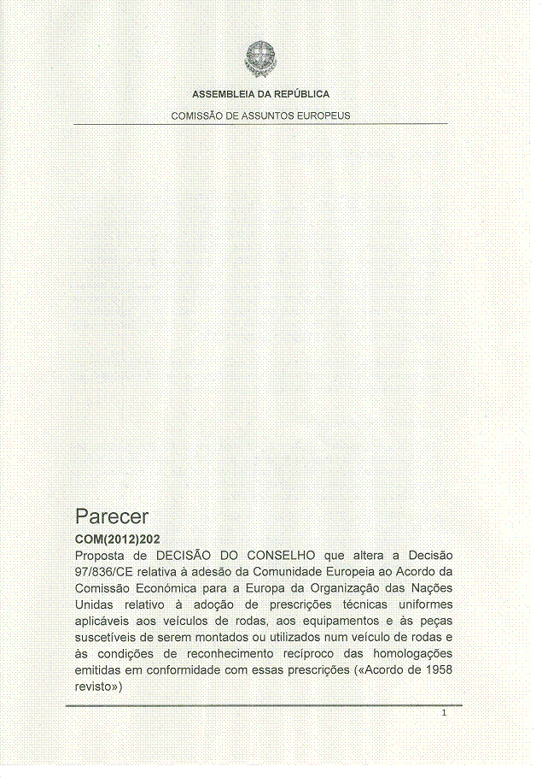
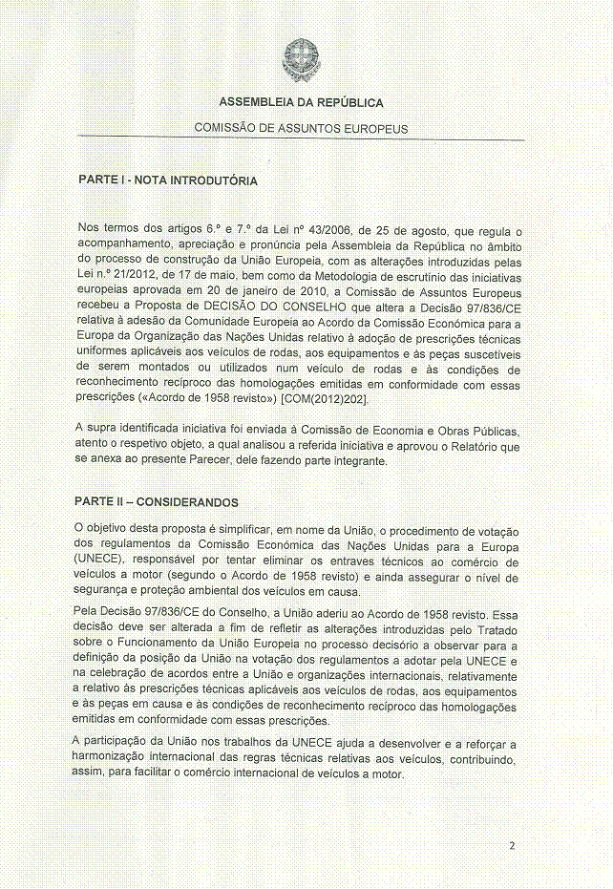
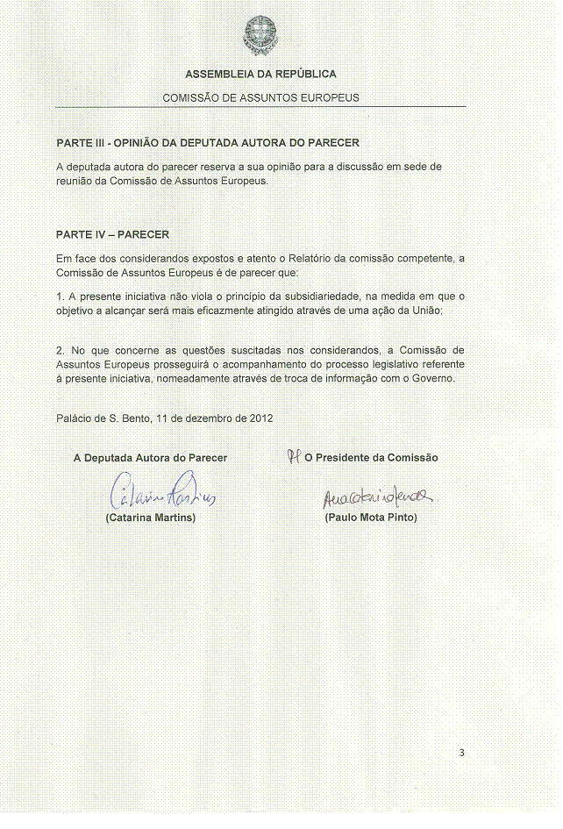
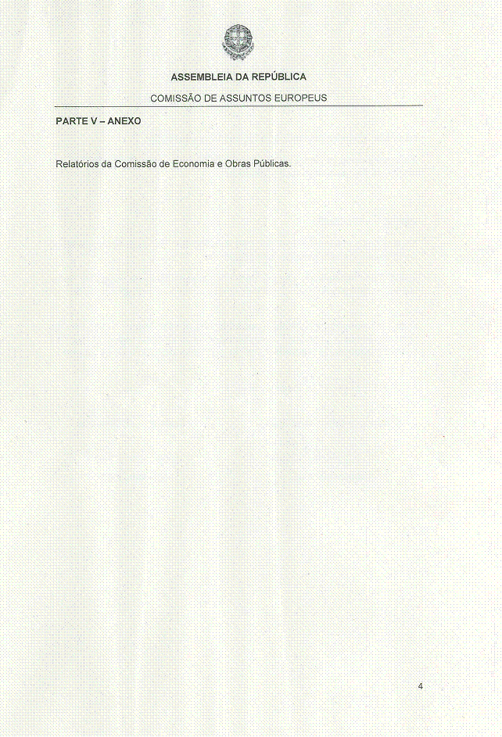
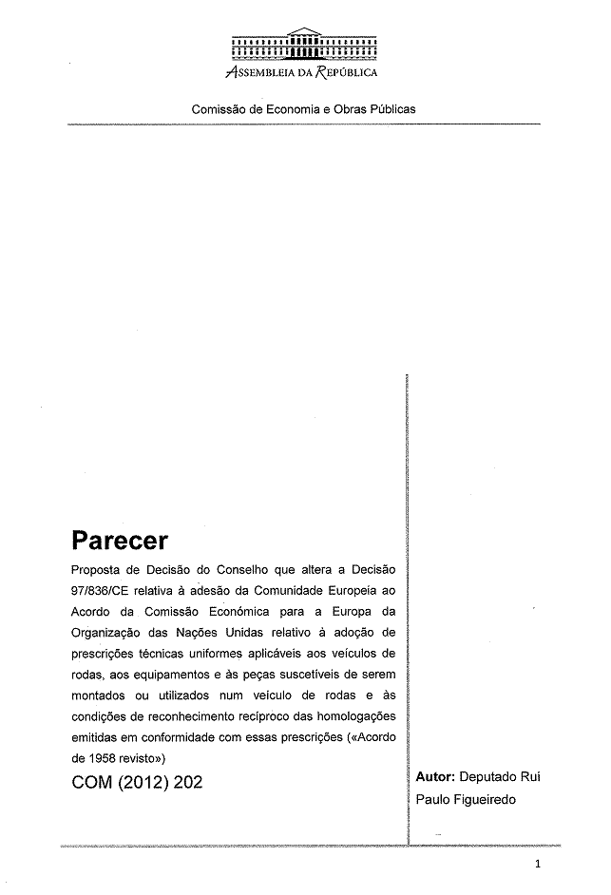
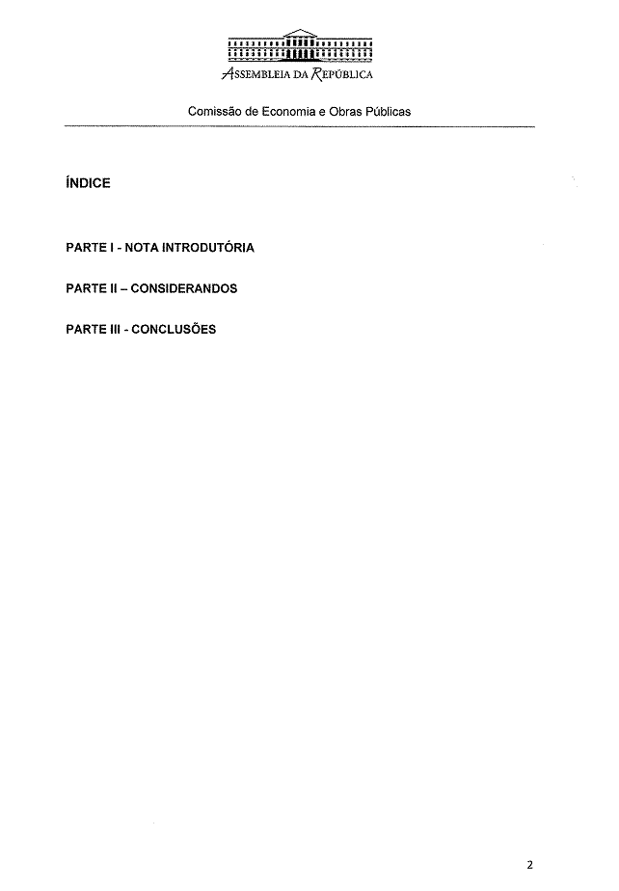
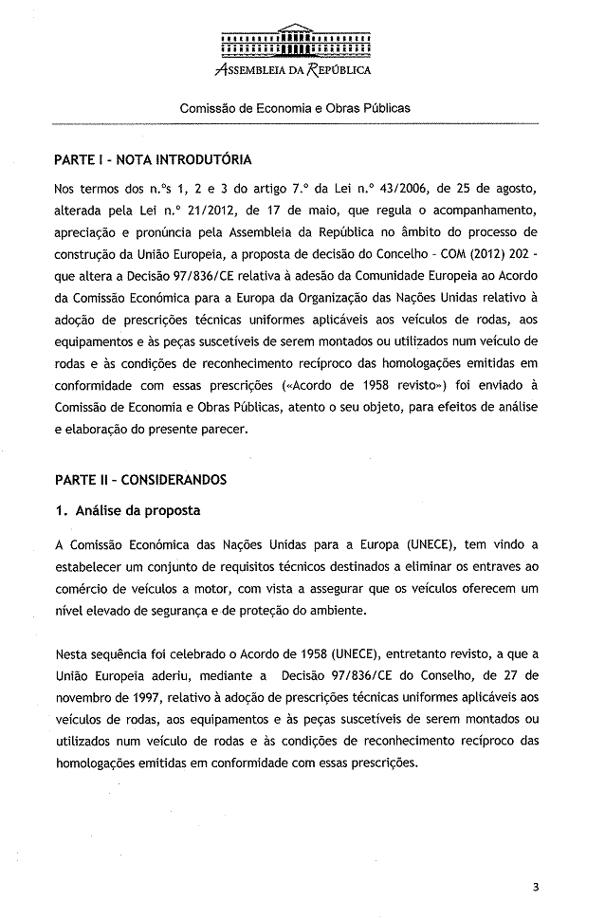
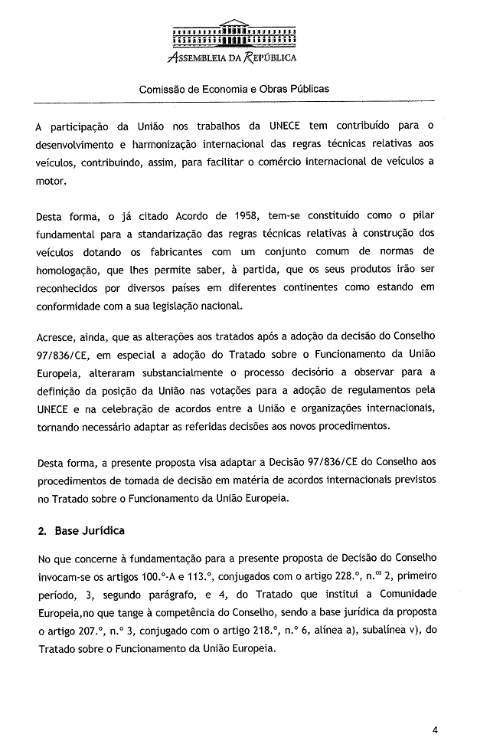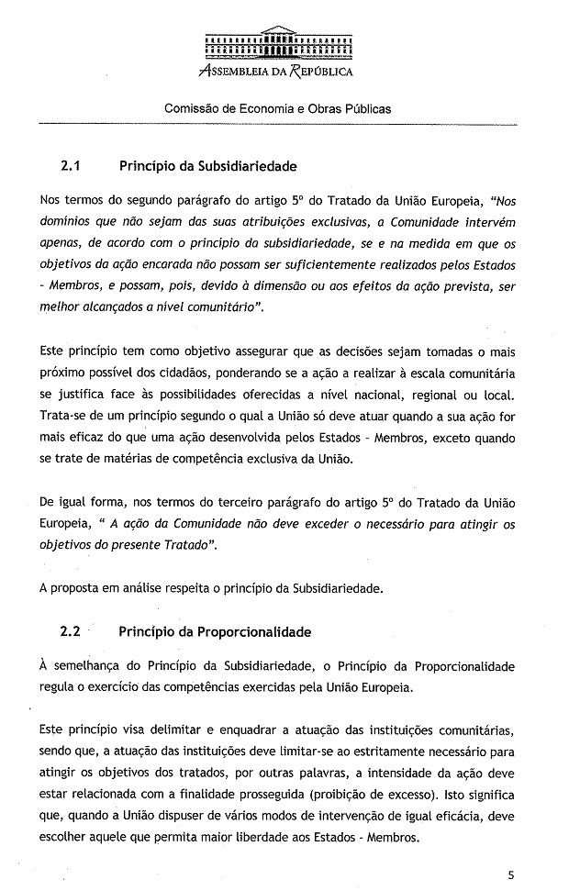_
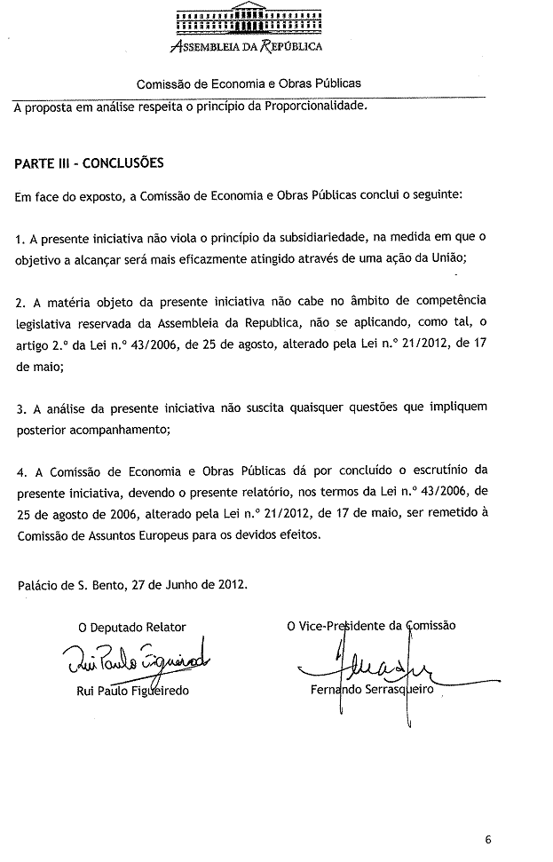

The translation(s) of the opinion may be available on the Interparliamentary EU Information Exchange site IPEX at the following address: http://www.ipex.eu/IPEXL-WEB/search.do

