 | 
COUNCIL OF  THE EUROPEAN UNION |  |  | Brussels, 14 February 2014
 | Interinstitutional File:  2013/0435 (COD) |  | 6509/14
DENLEG 31
AGRI 101
CODEC 422
INST 100
PARLNAT 51

COVER NOTE
from: | Portuguese Parliament
date of receipt: | 12 February 2013
to: | The President of the Council of the European Union
No Cion doc.: | 18171/13 DENLEG 164 AGRI 881 CODEC 3090 - COM(2013) 894 final
Subject: | Proposal for a REGULATION OF THE EUROPEAN PARLIAMENT AND OF THE COUNCIL on novel foods (Text with EEA relevance)  - Opinion on the application of the Principles of Subsidiarity and Proportionality

Delegations will find attached for information a copy of the above opinion.

________________________

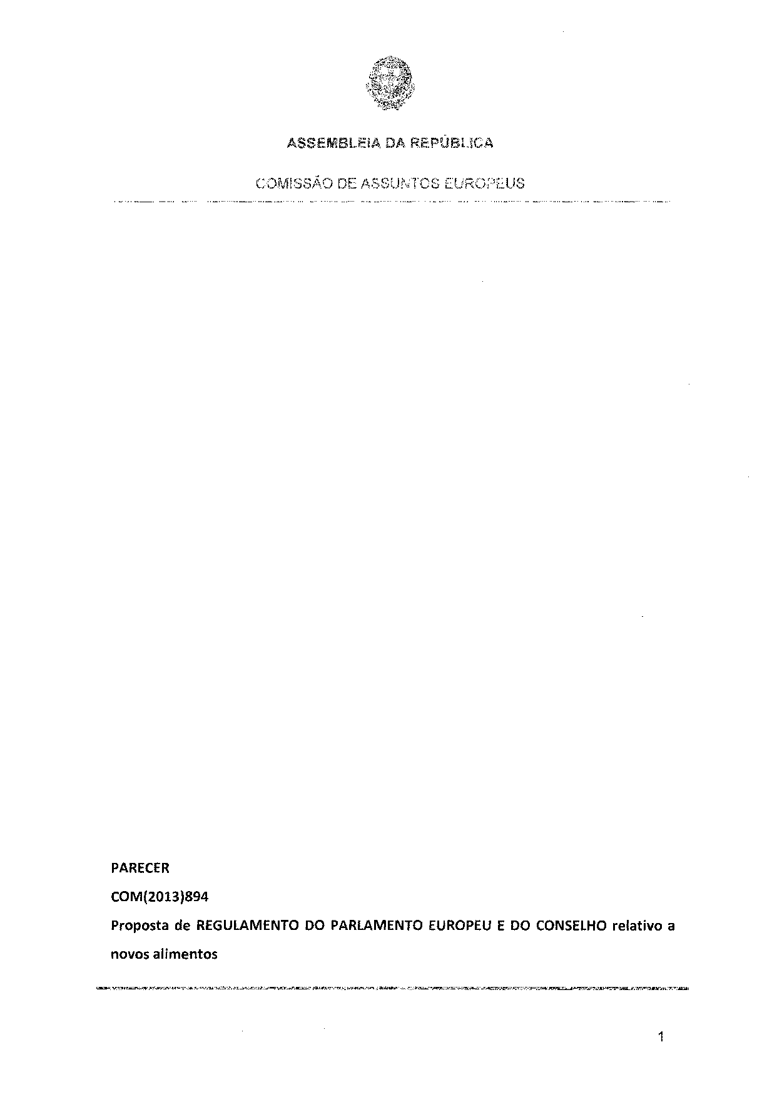
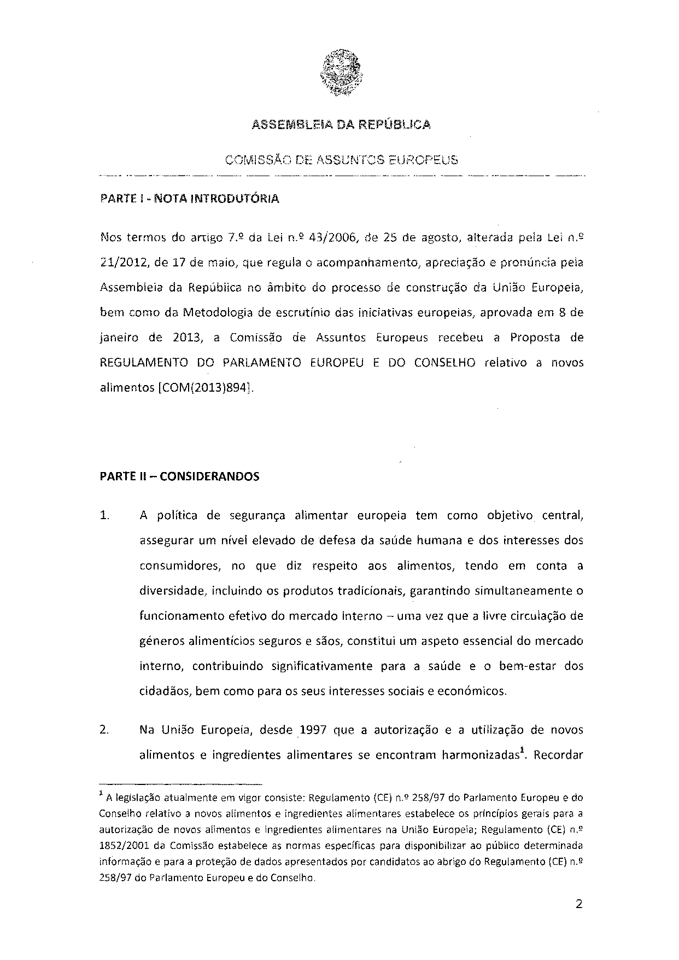
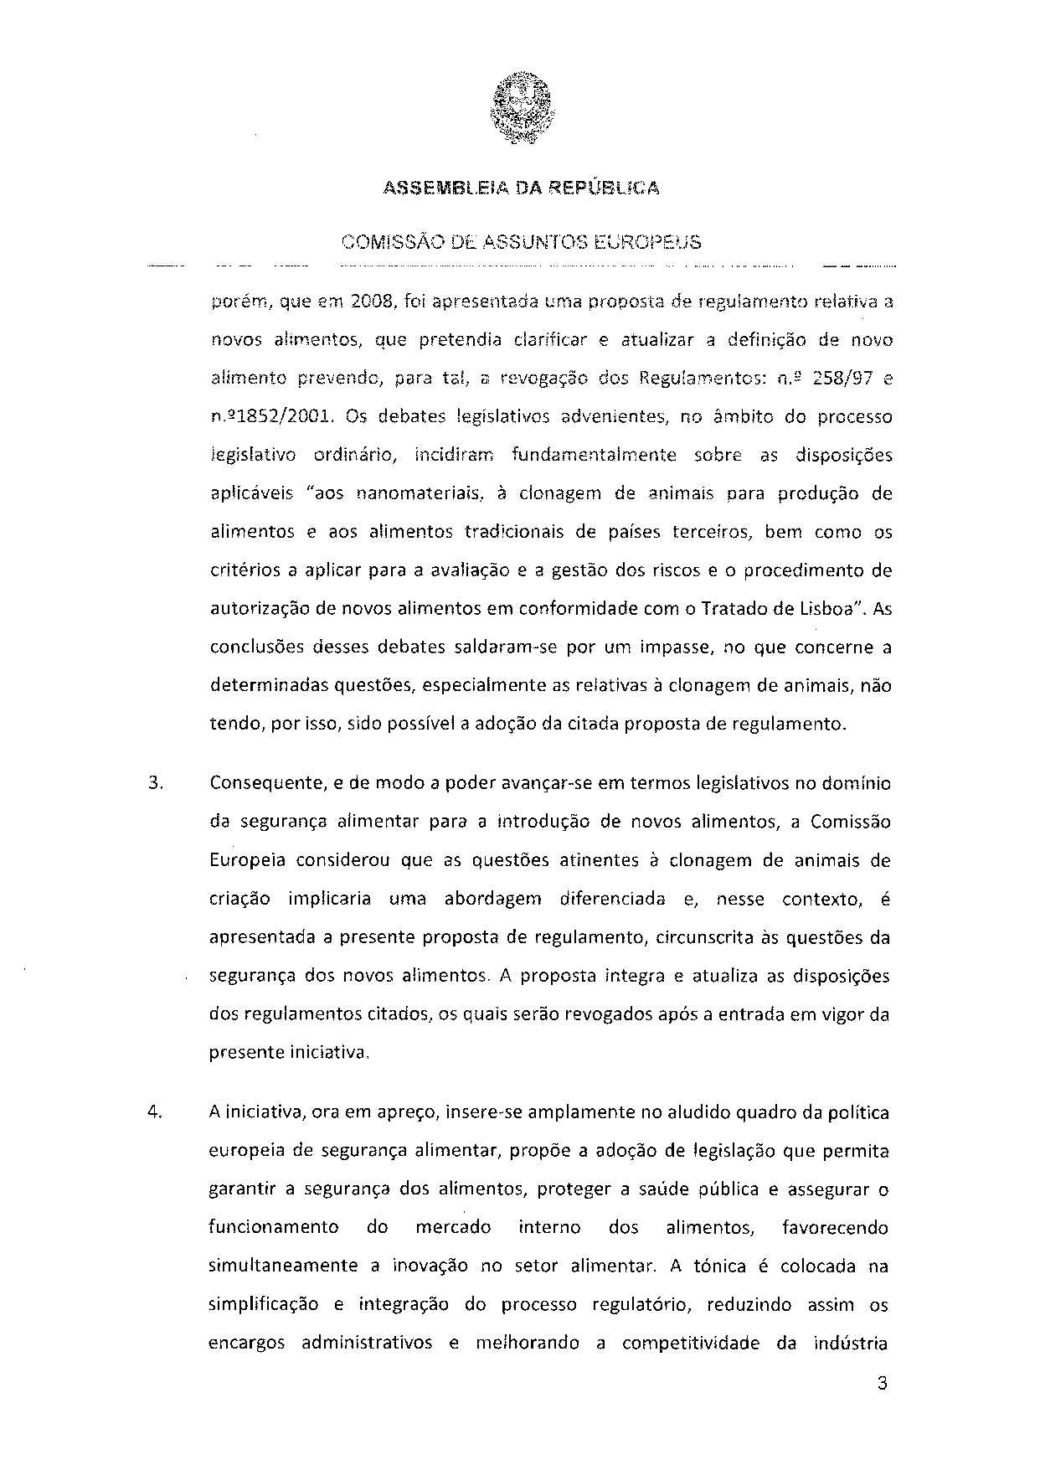
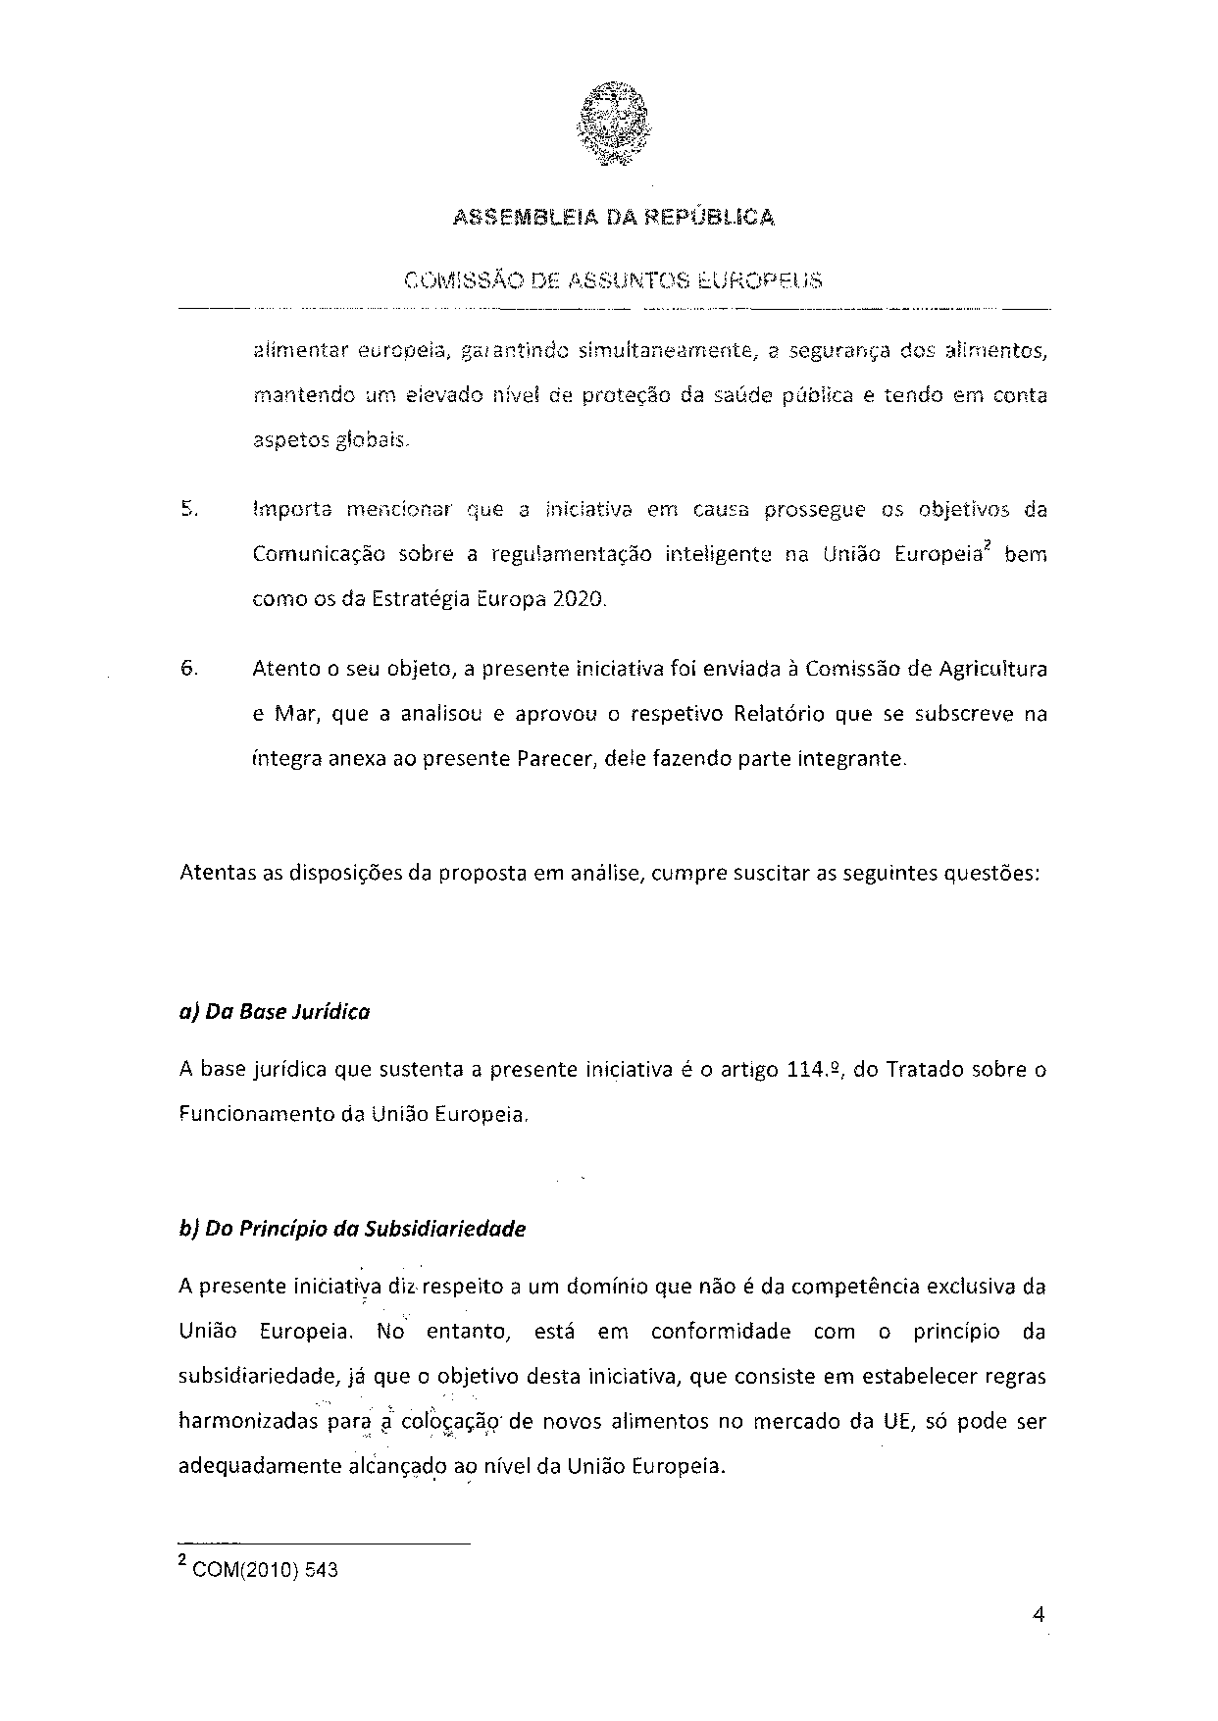
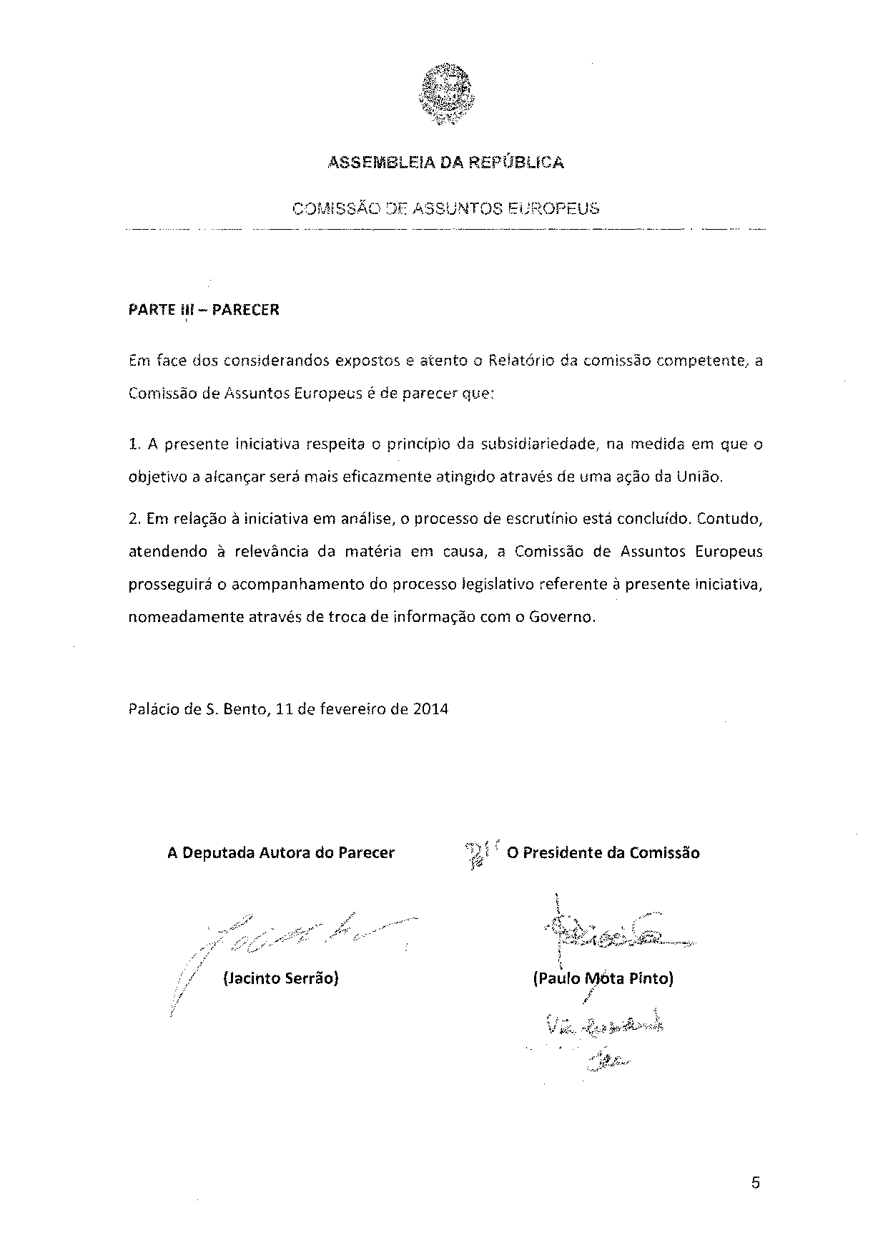
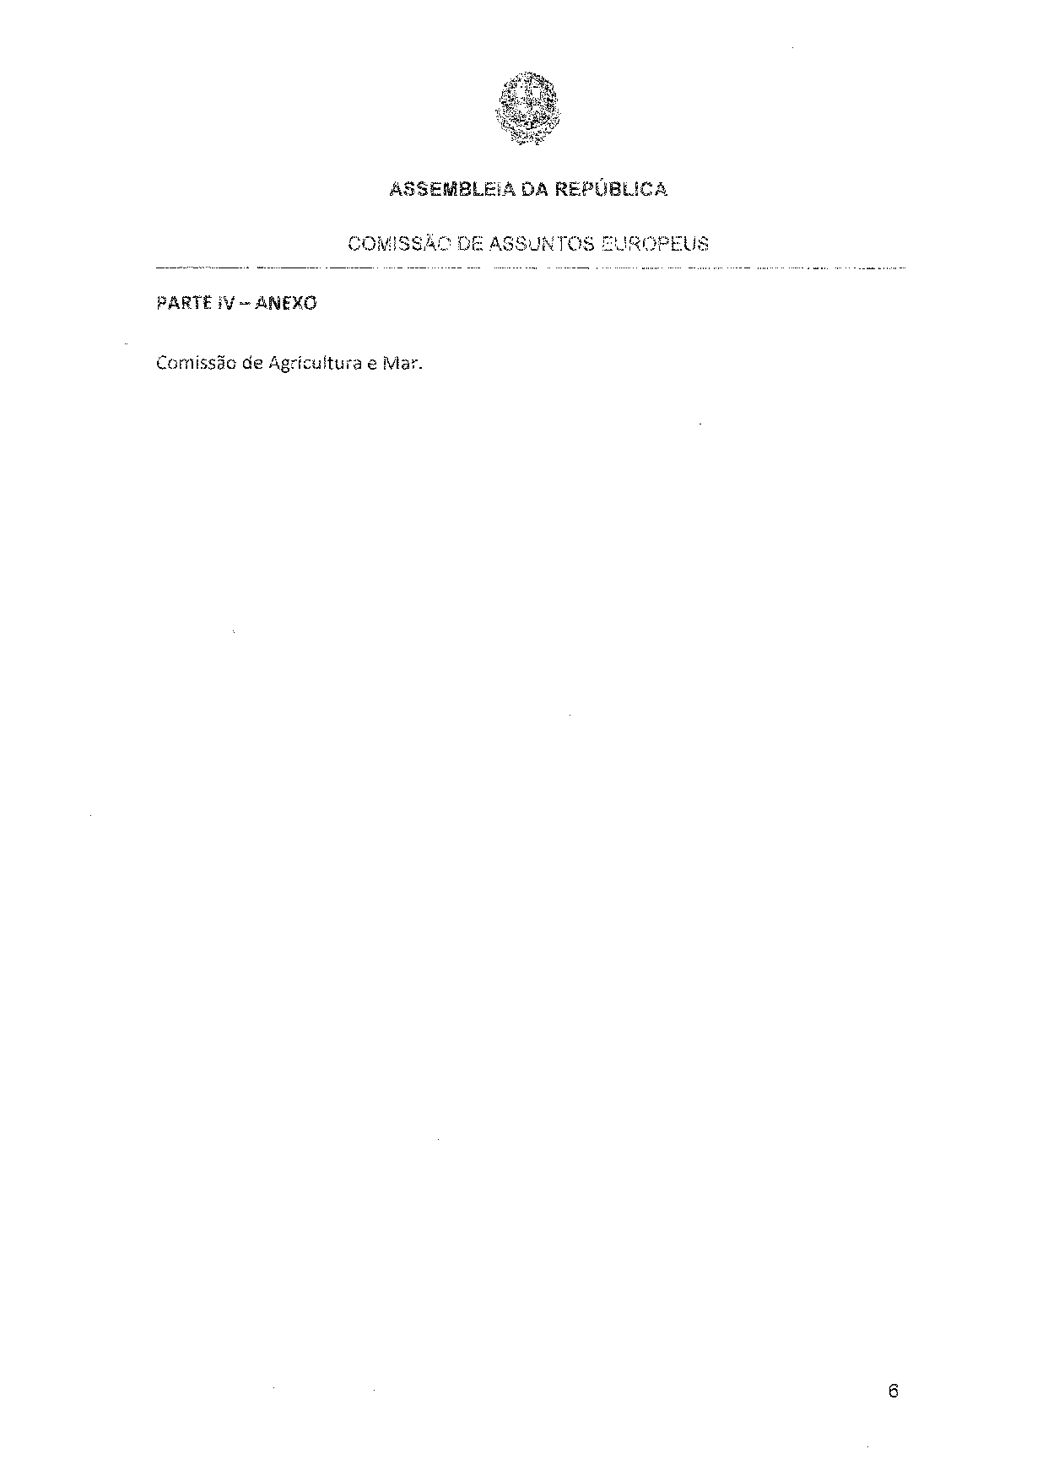
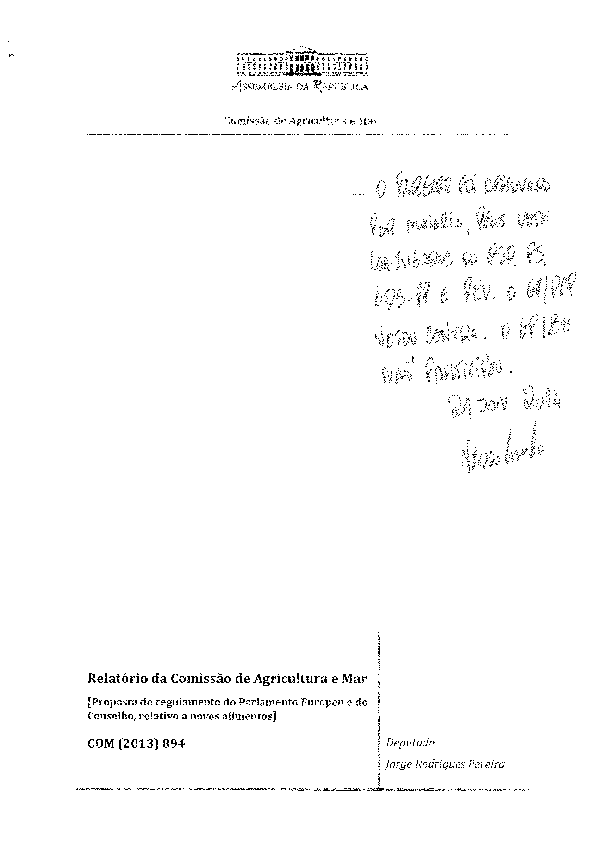
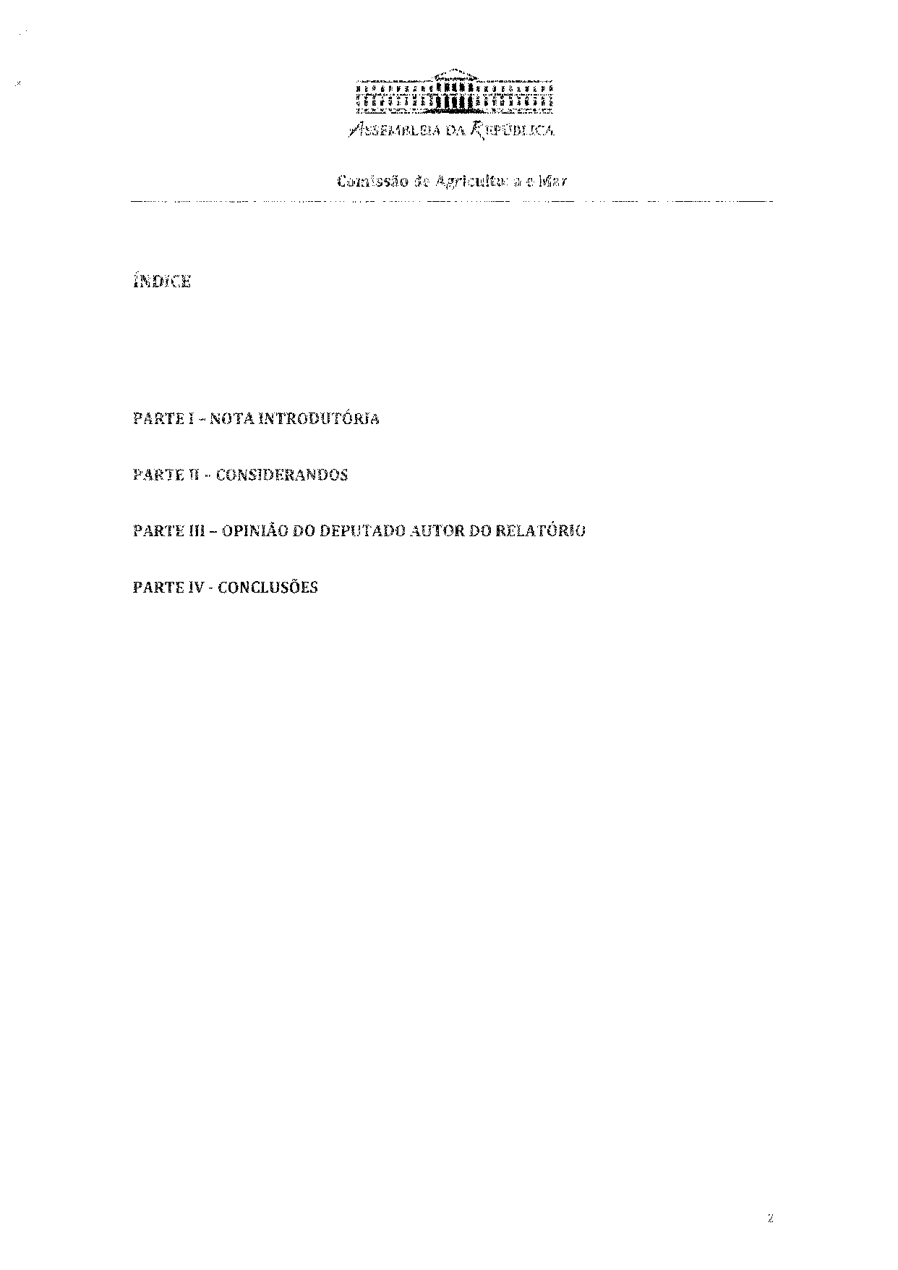
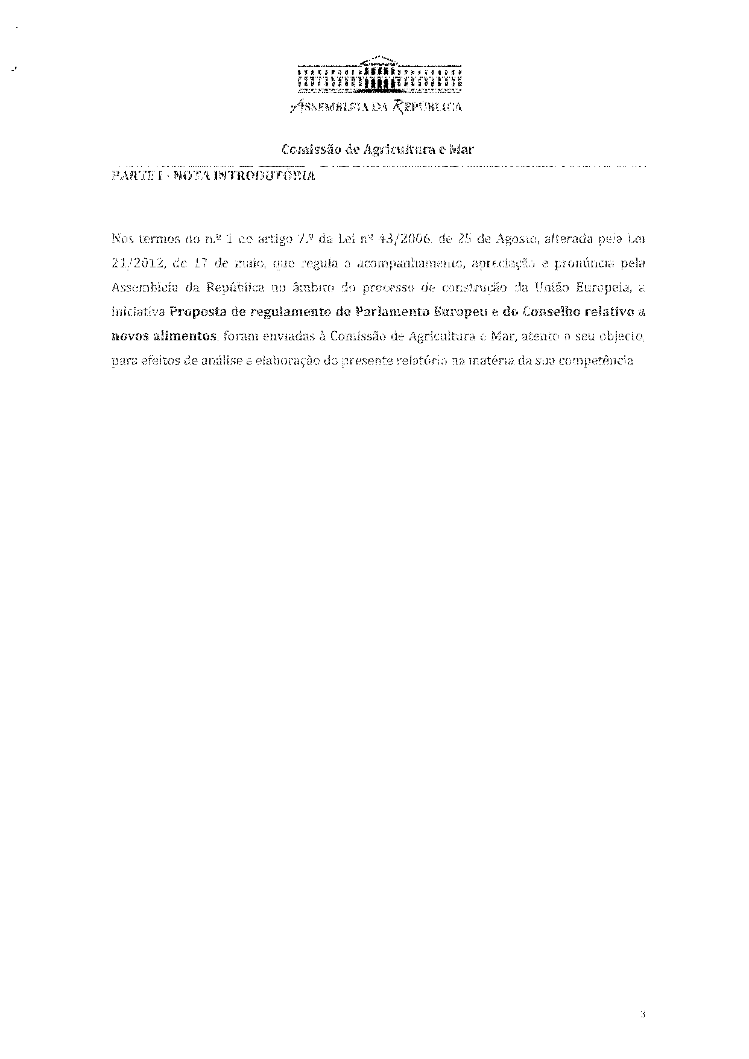
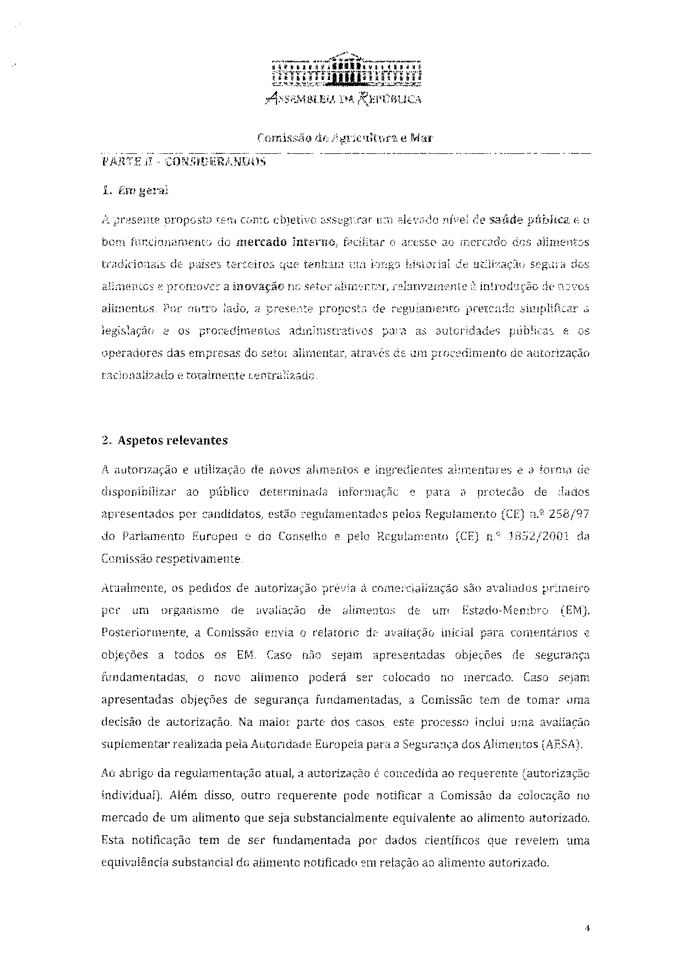
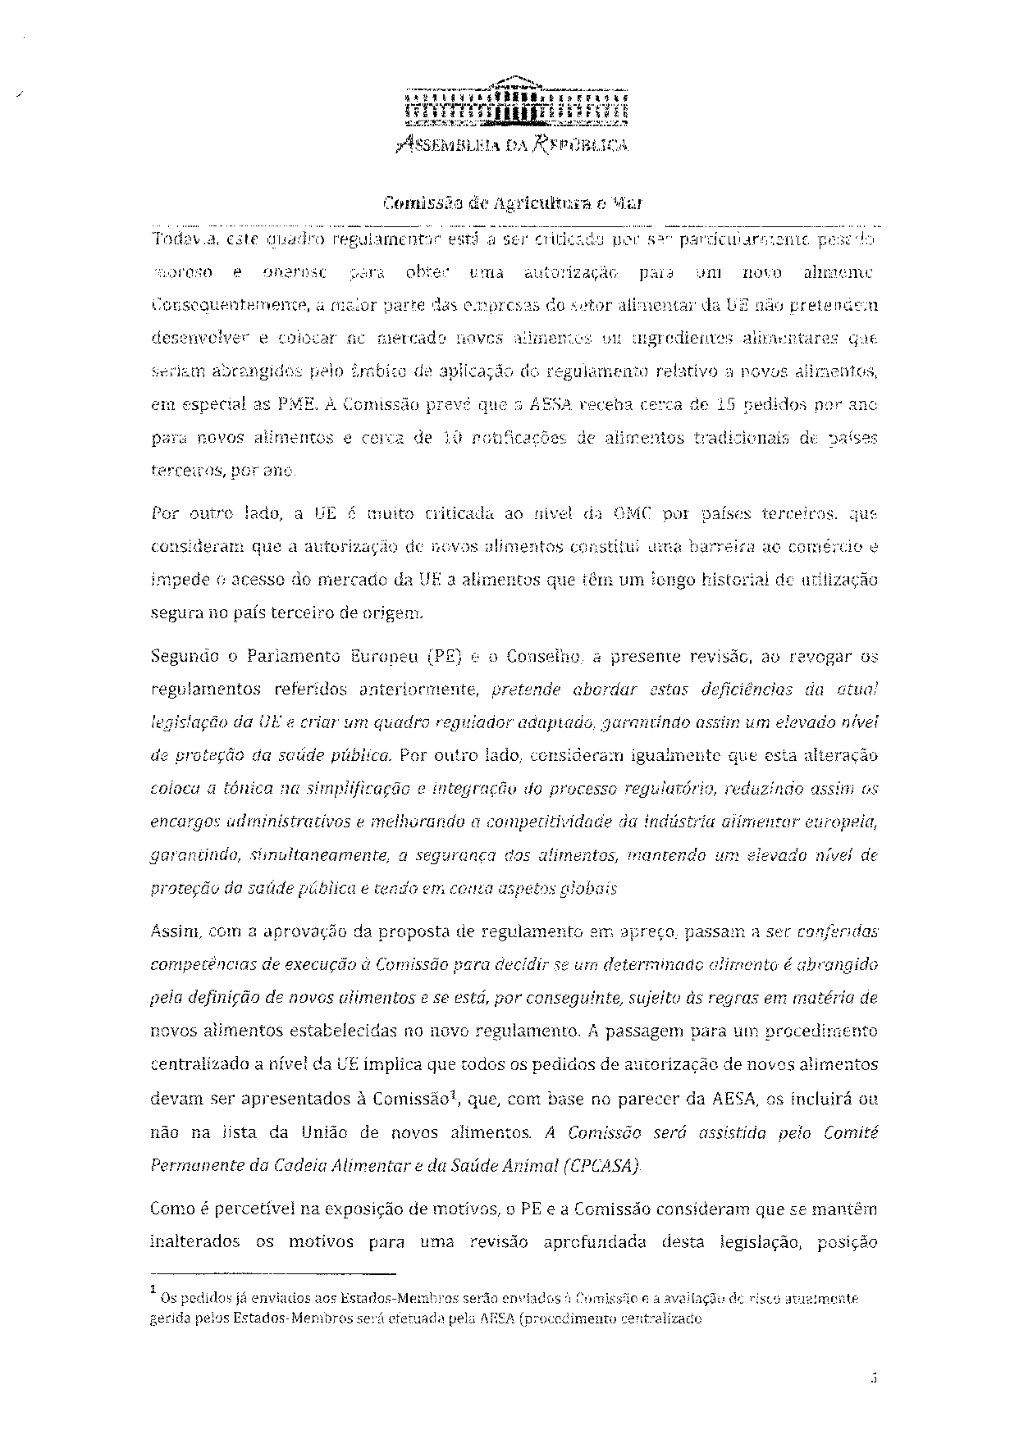
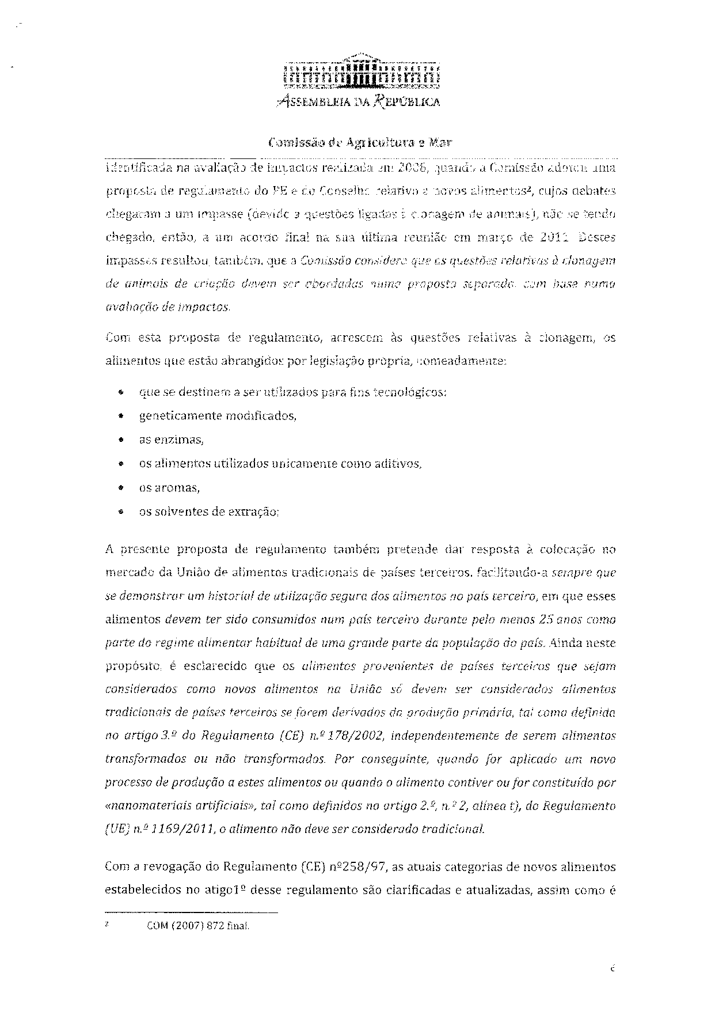
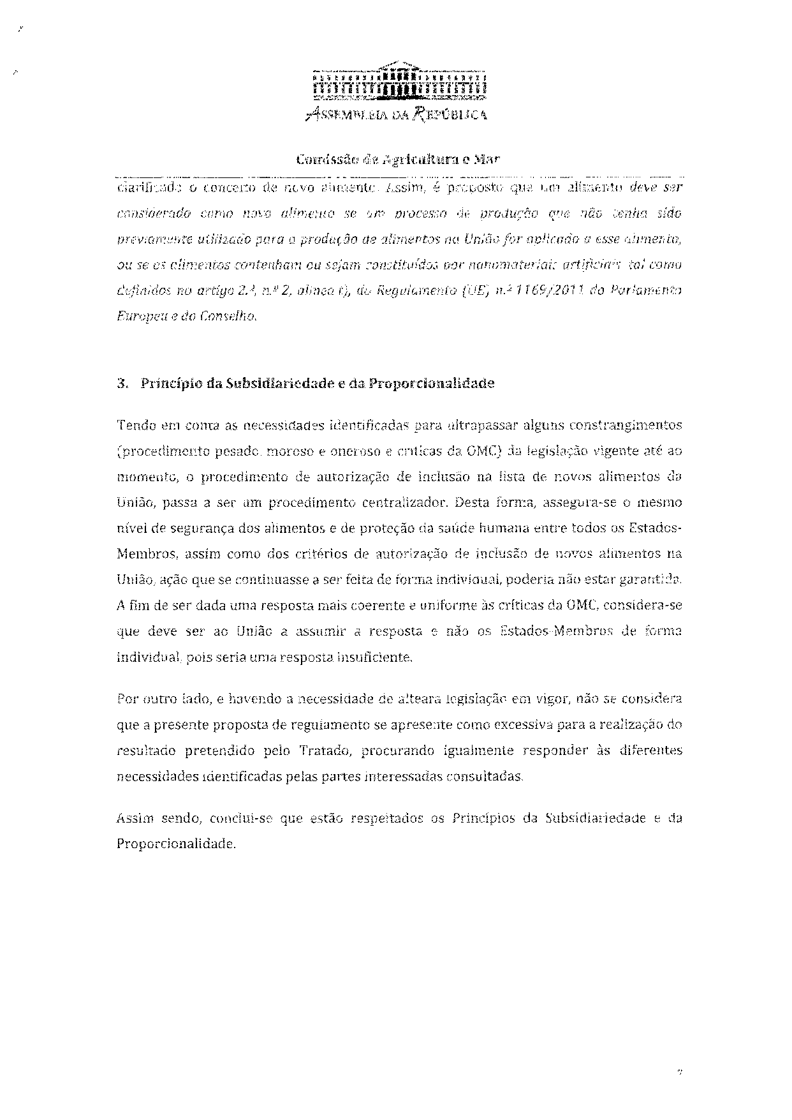
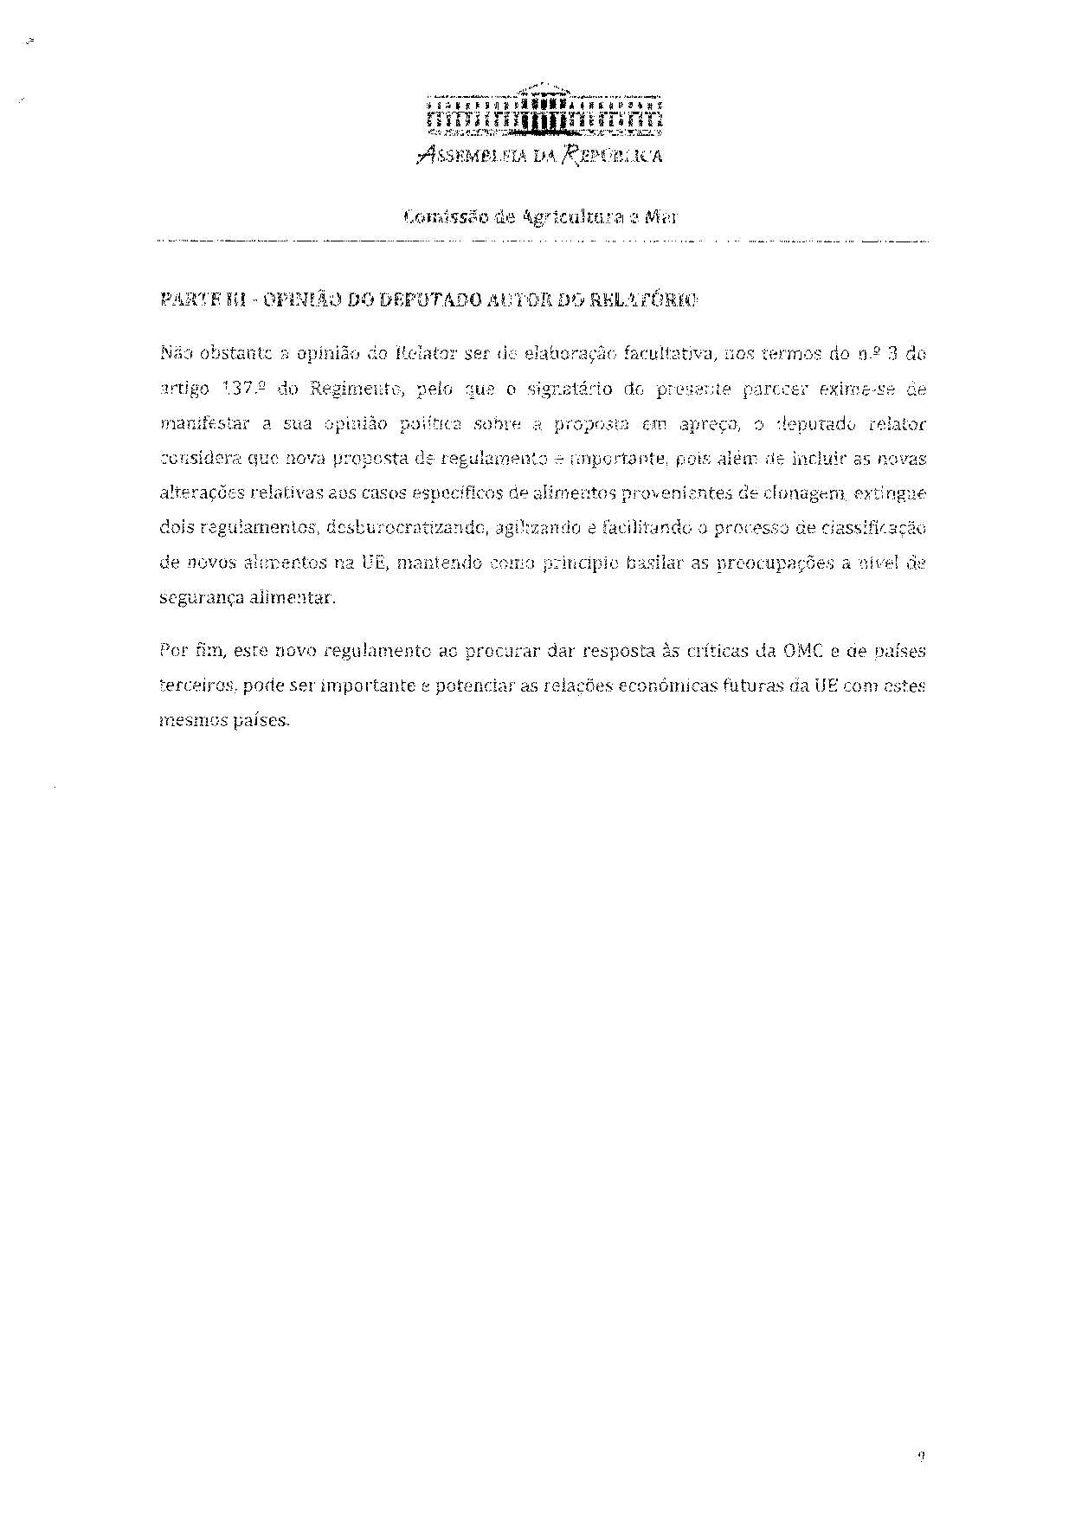
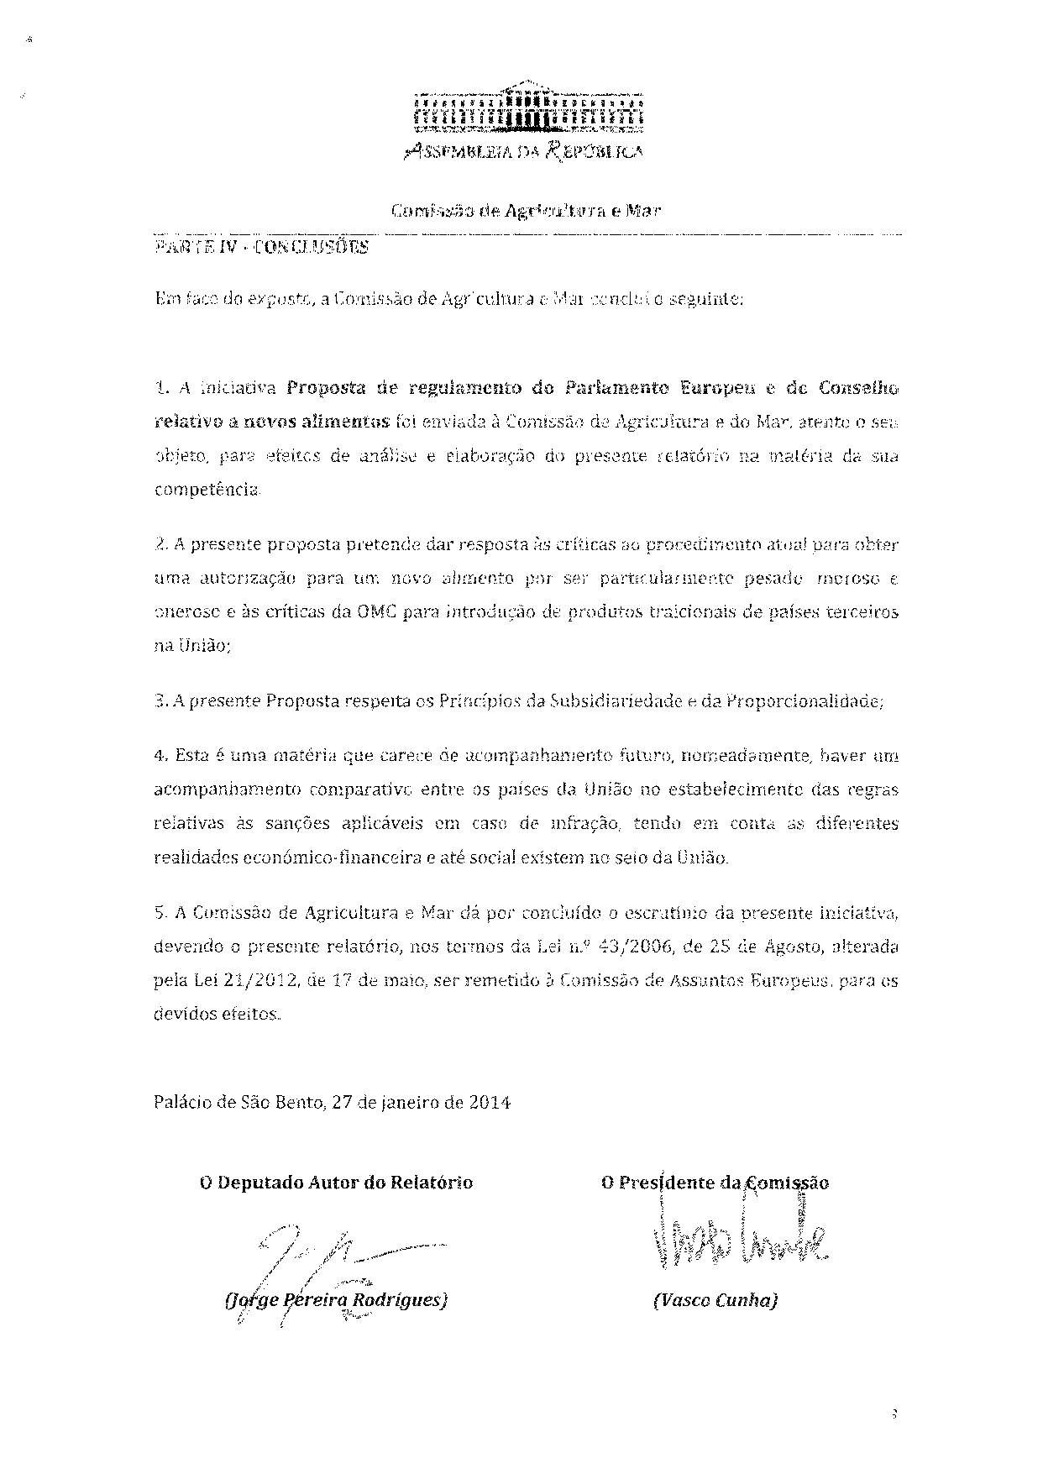

The translation may be available at the Interparliamentary EU information exchange site IPEX at the following address: http://www.ipex.eu/IPEXL-WEB/dossier/document/COM20120788.do#dossier-COD20120366

