 | 
COUNCIL OF  THE EUROPEAN UNION |  |  | Brussels, 5 February 2014
 | Interinstitutional File:  2013/0400 (CNS) |  | 6130/14
FISC 22
INST 86
PARLNAT 43

COVER NOTE
from: | The Portuguese Parliament
date of receipt: | 29 January 2014
to: | The President of the Council of the European Union
Subject: | Proposal for a COUNCIL DIRECTIVE amending Directive 2011/96/EU on the common system of taxation applicable in the case of parent companies and subsidiaries of different Member States  [doc. 16918/13 FISC 237 - COM(2013) 814 final]  - Opinion on the application of the Principles of Subsidiarity and Proportionality

Delegations will find attached the abovementioned opinion.

________________________

Encl.

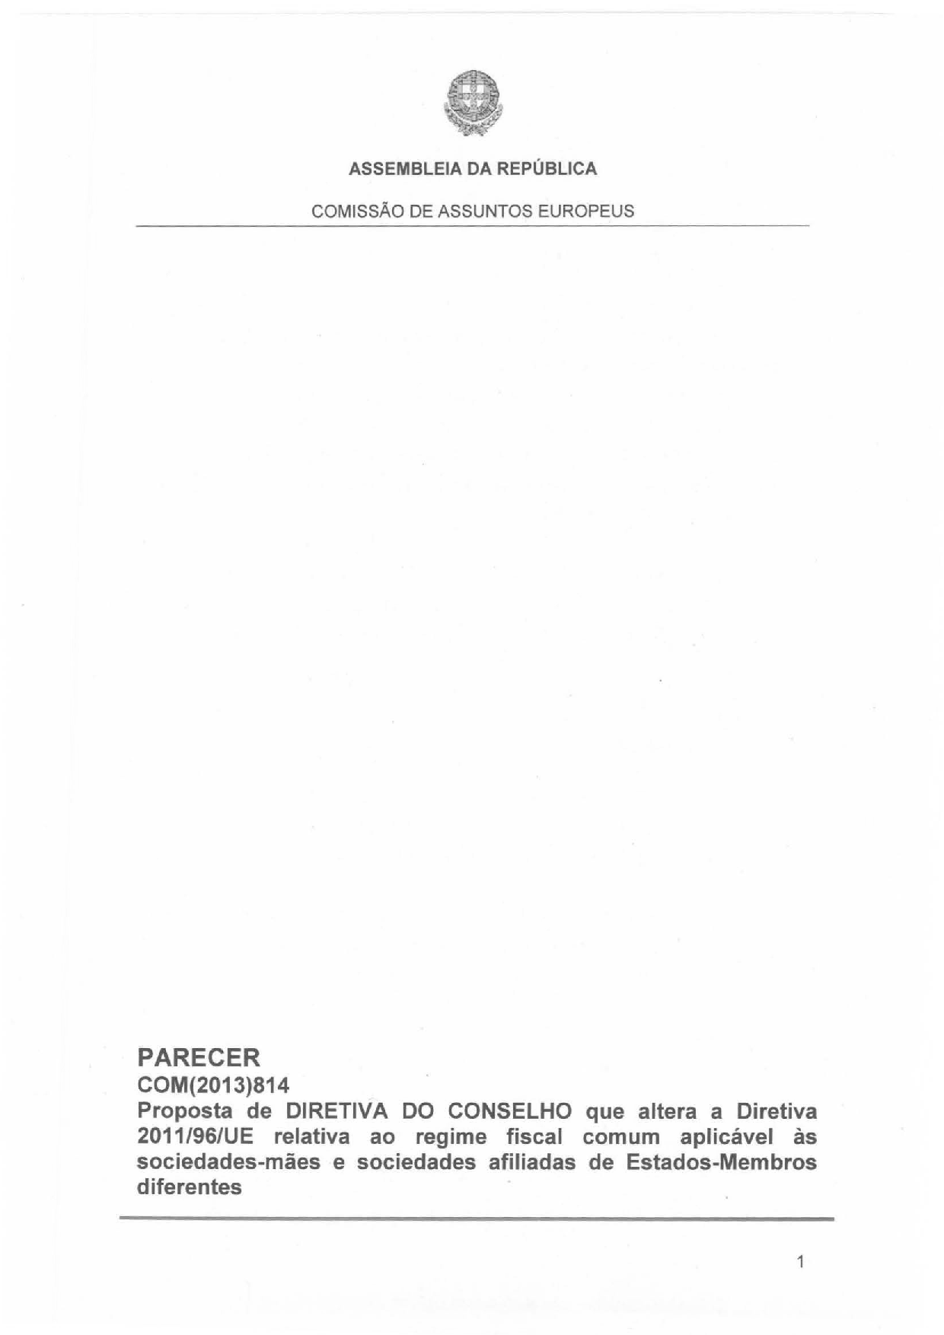

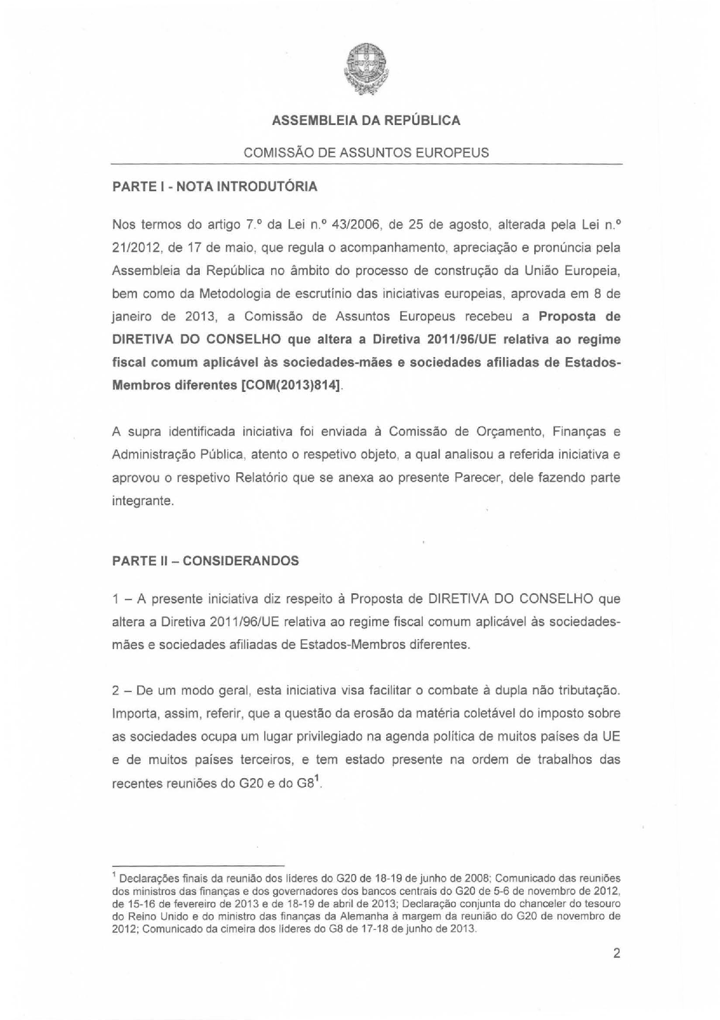

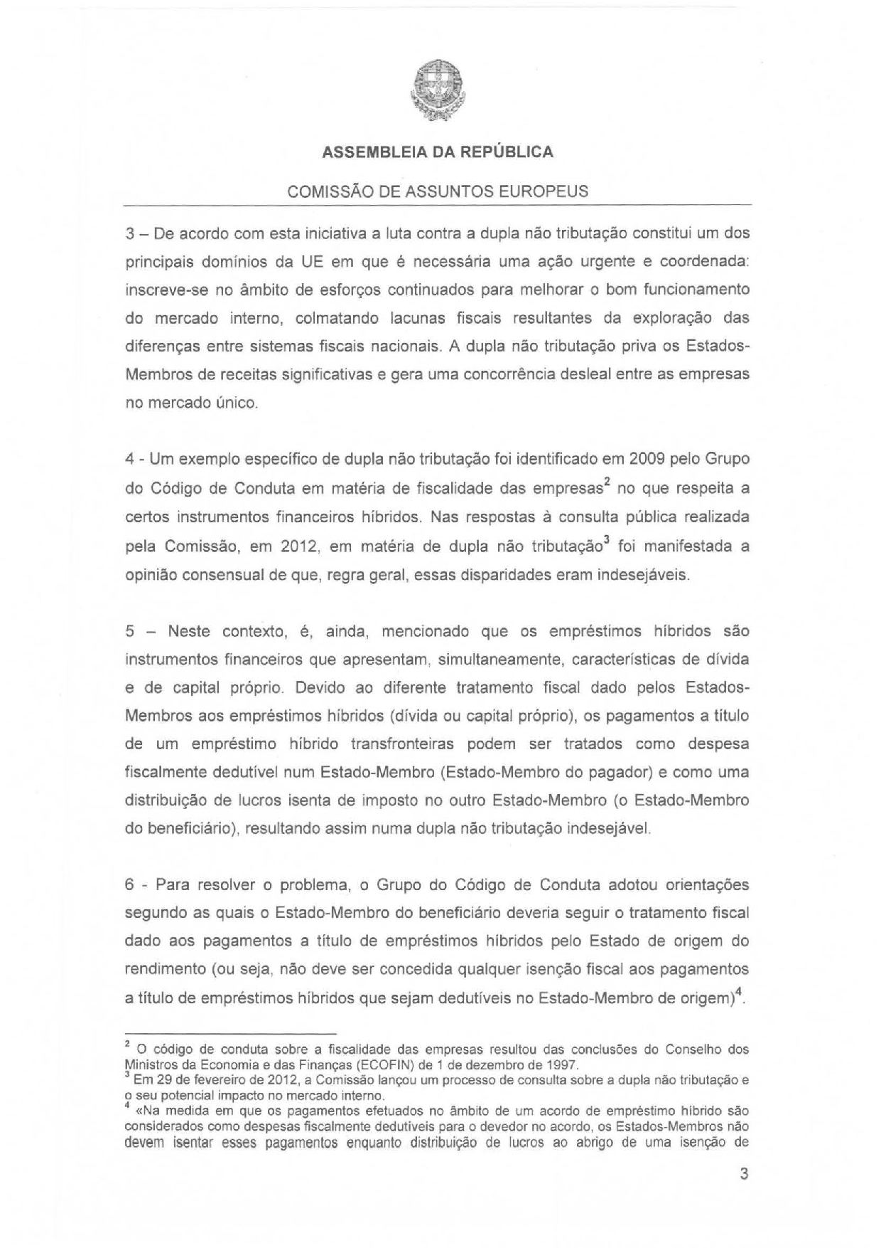

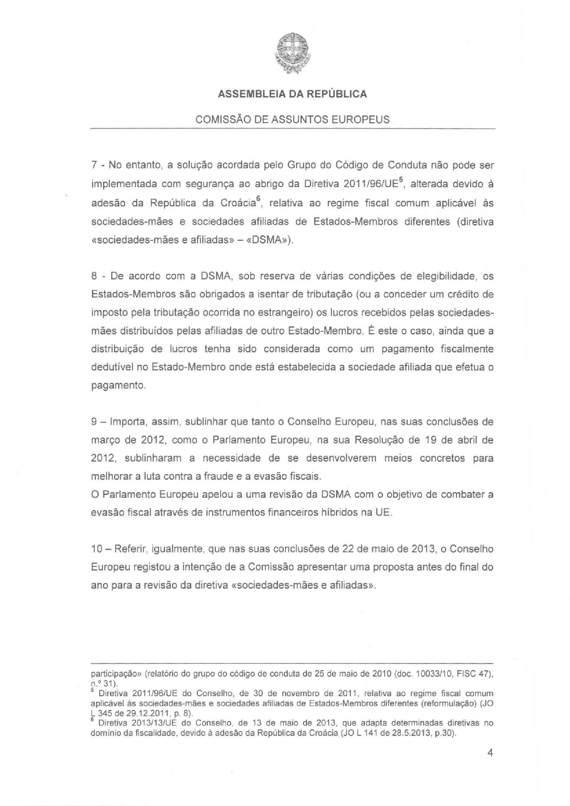

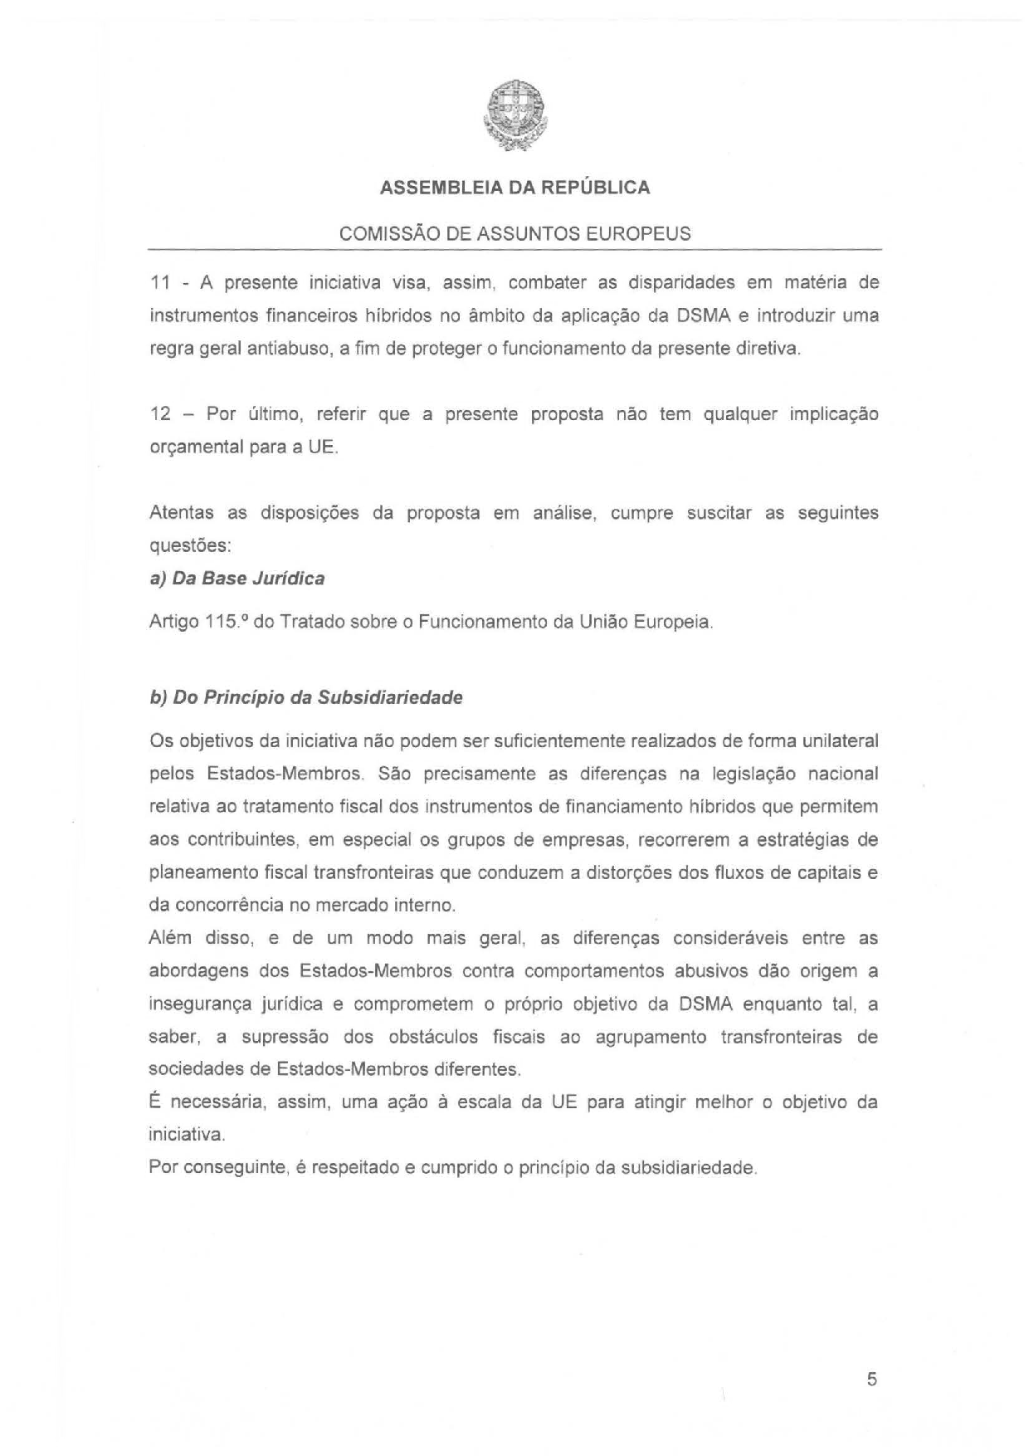

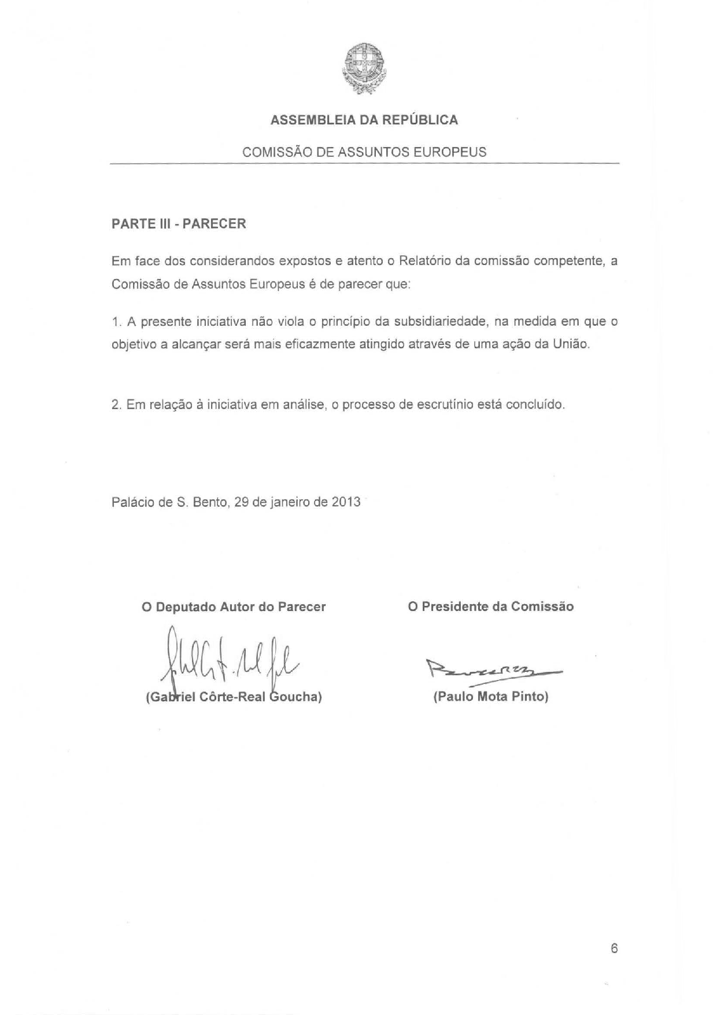



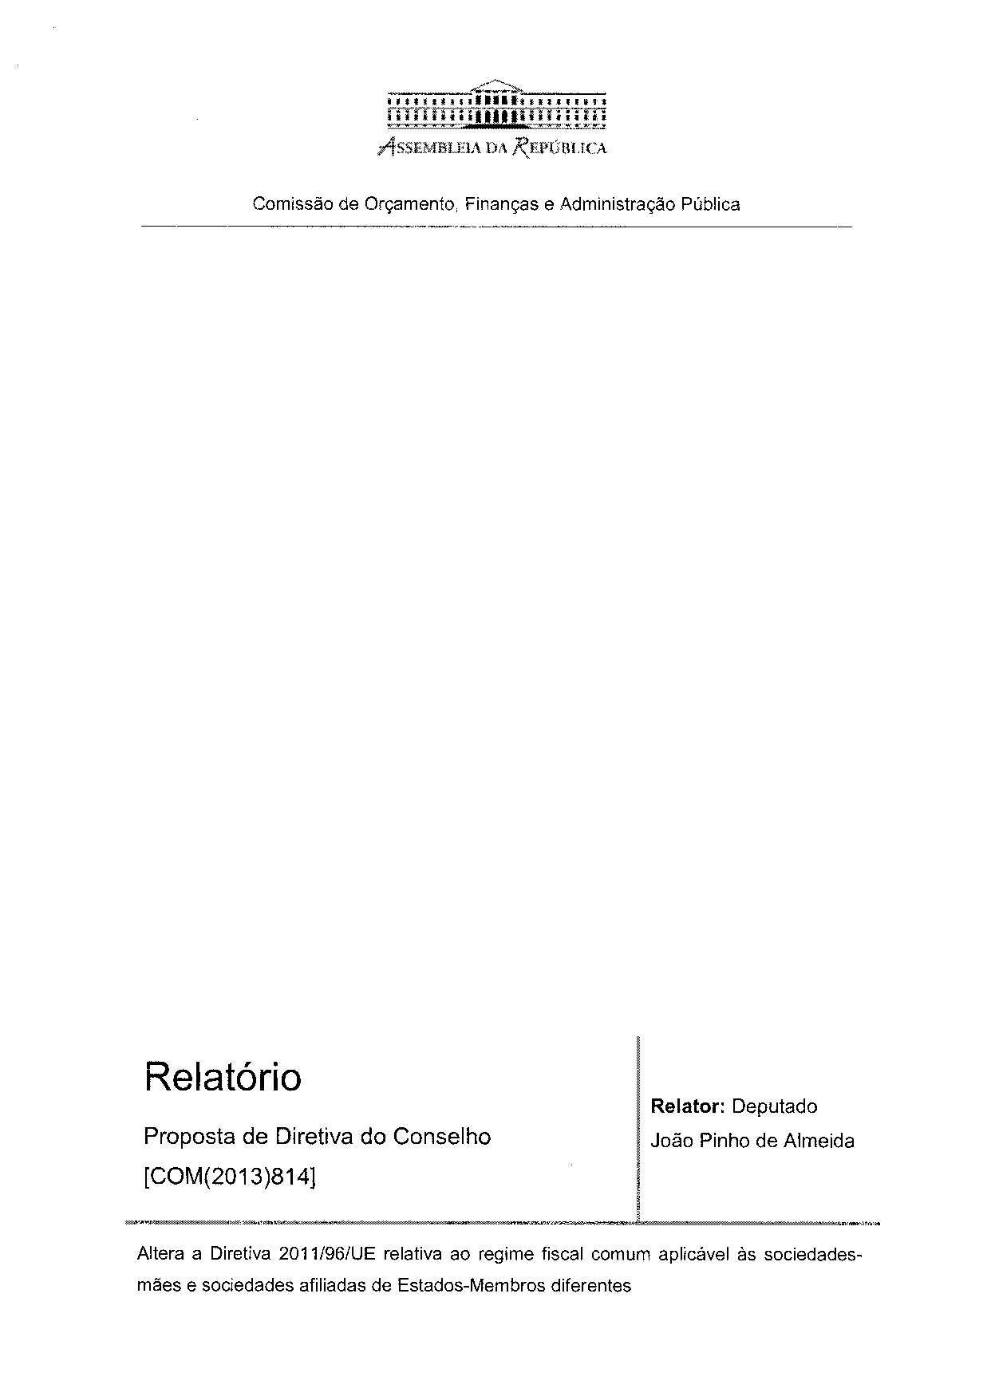

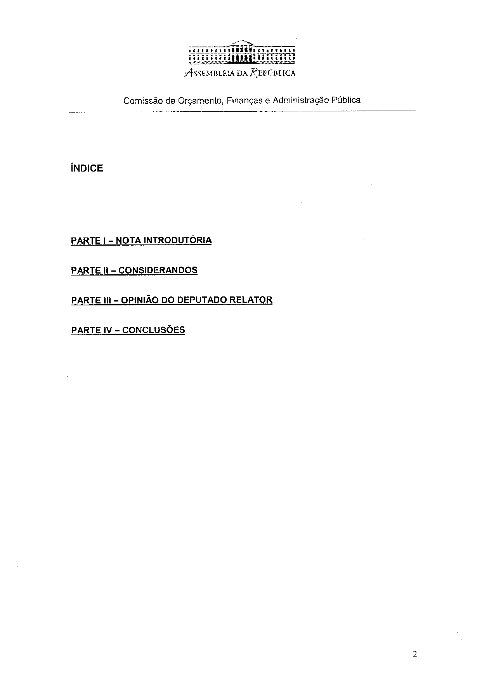

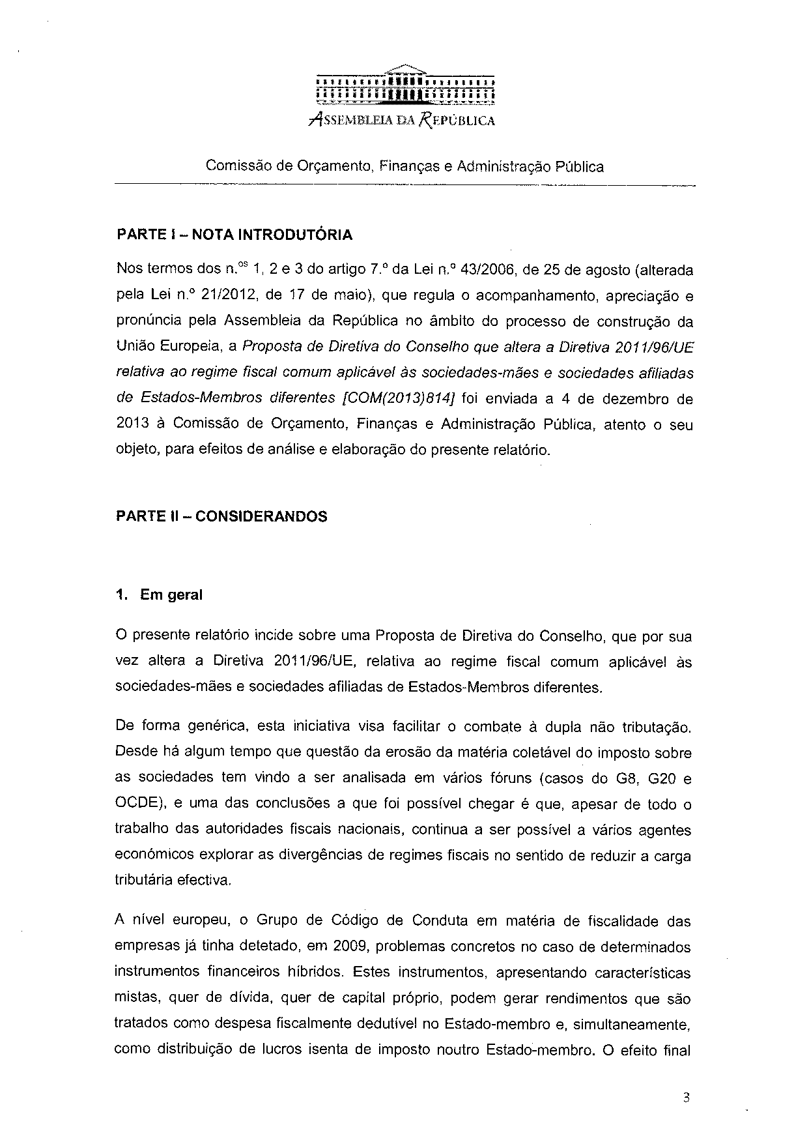

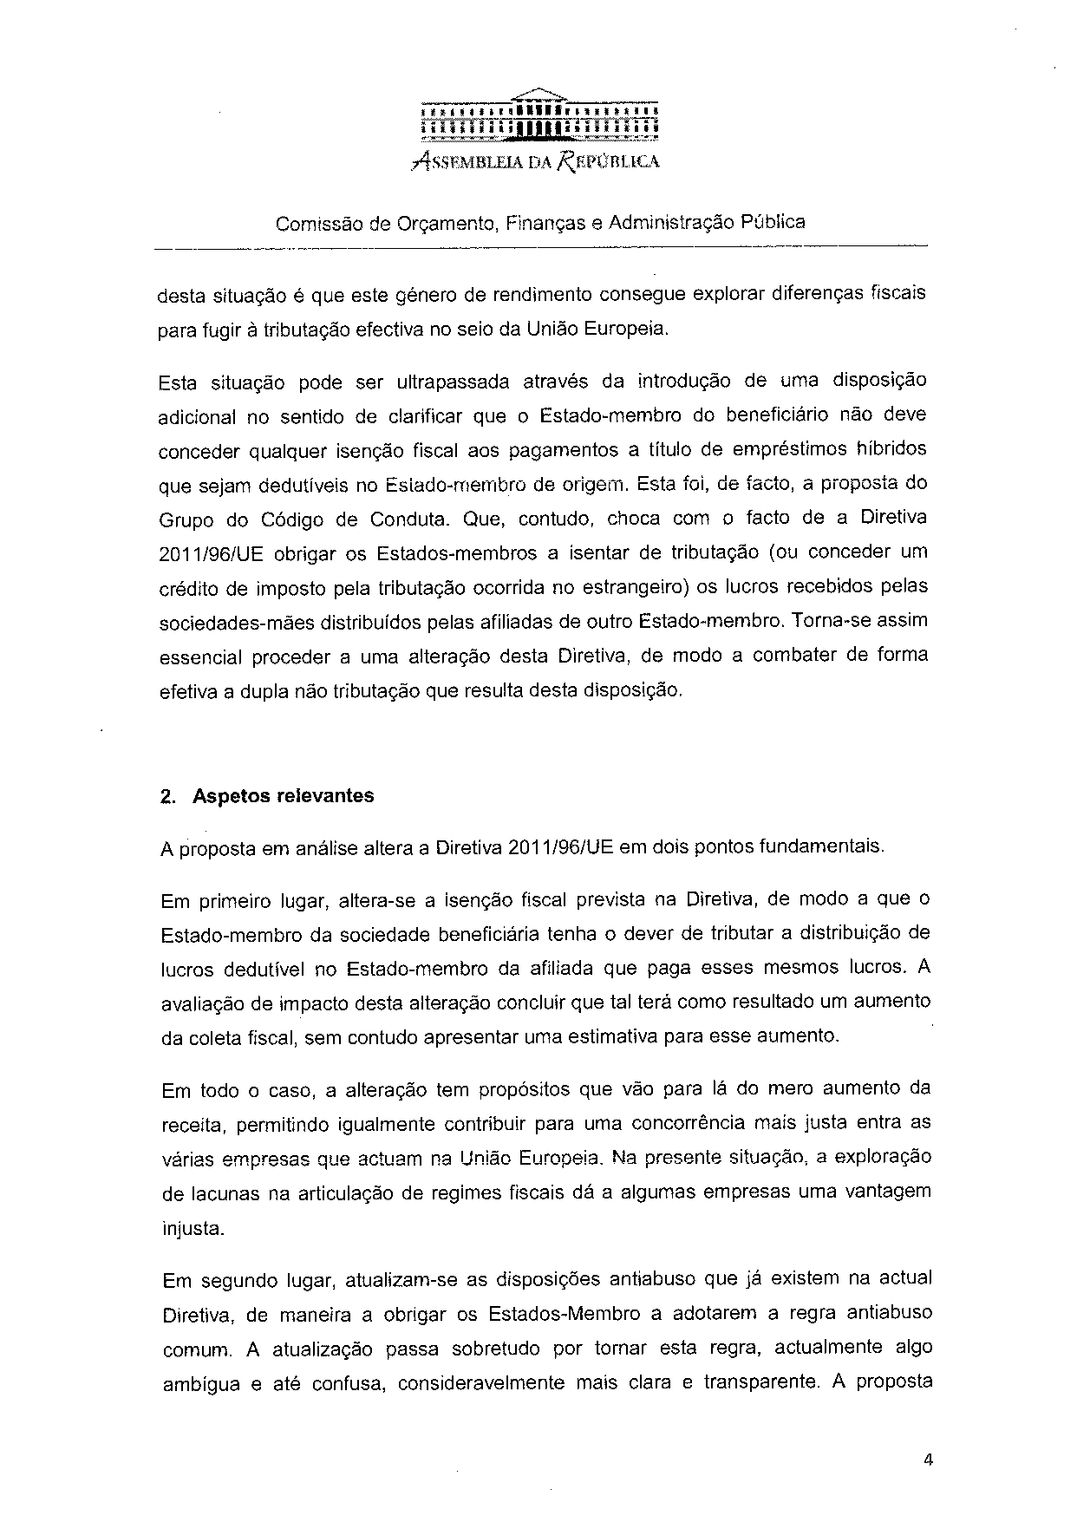

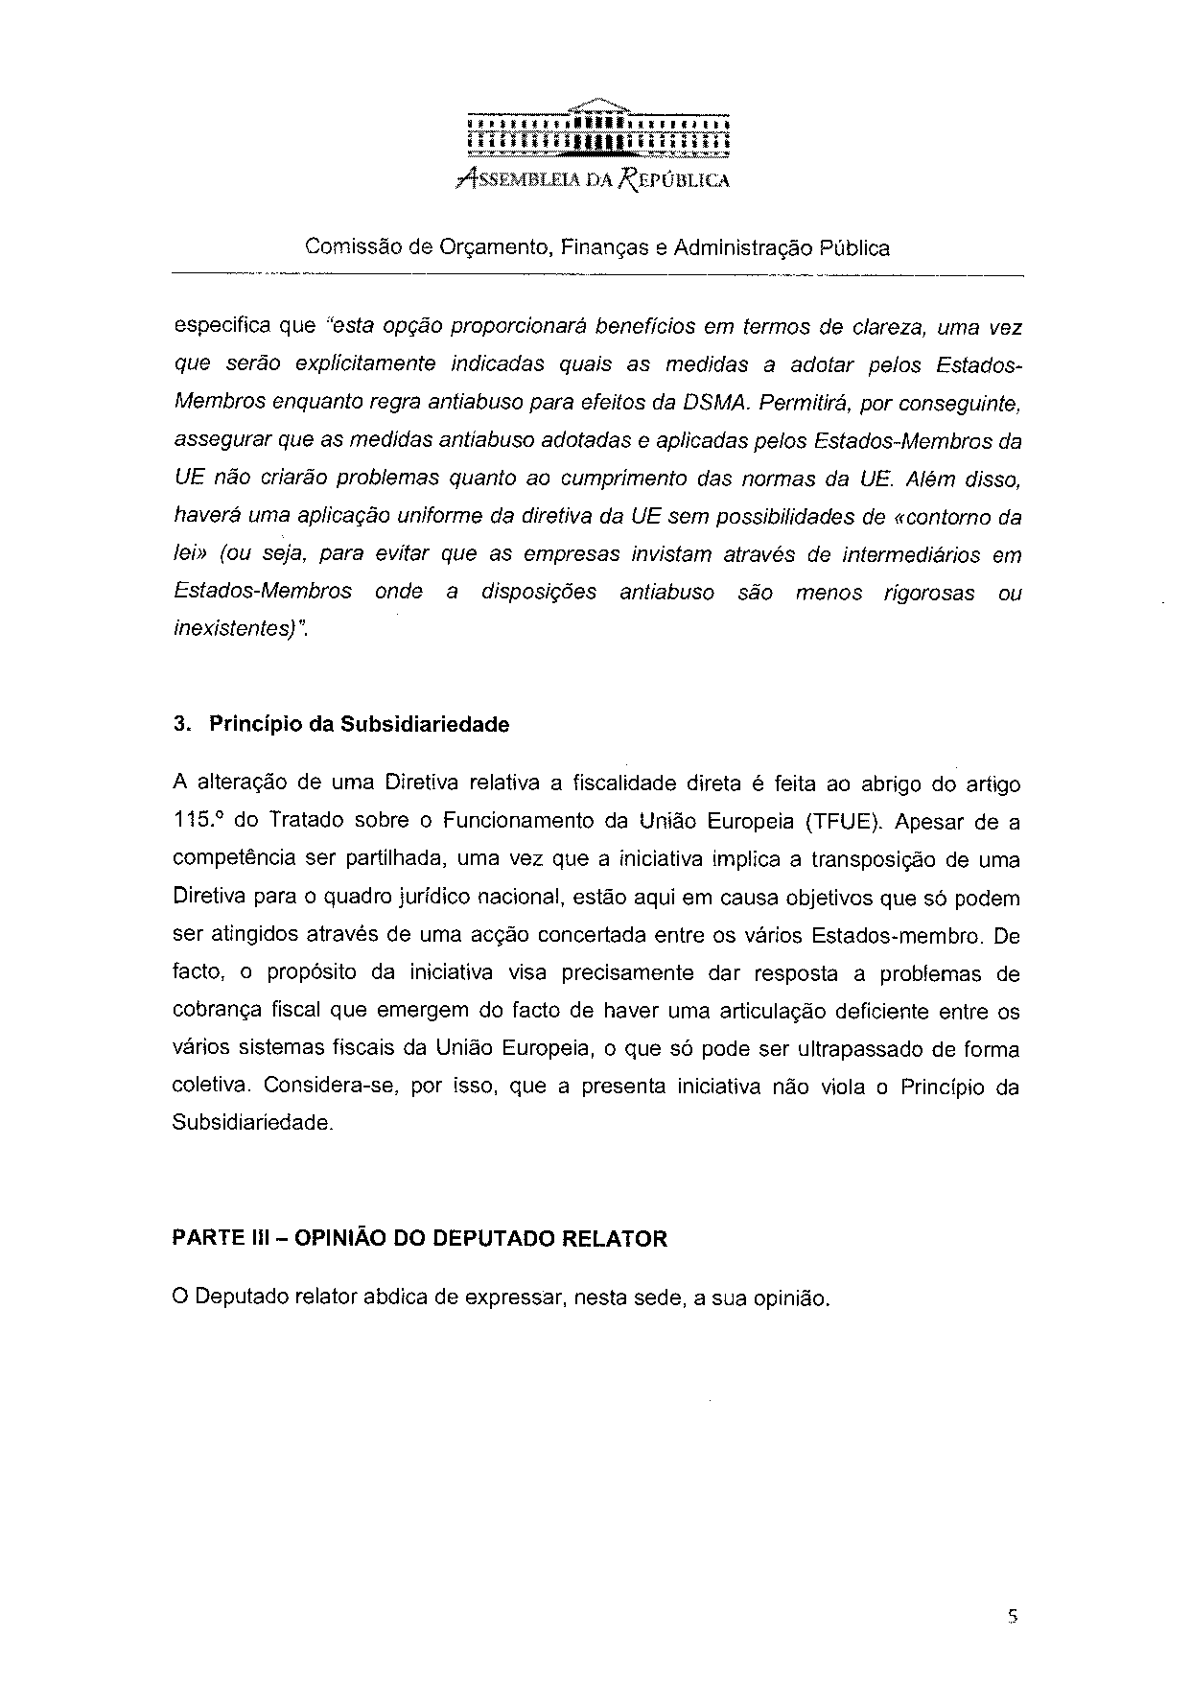

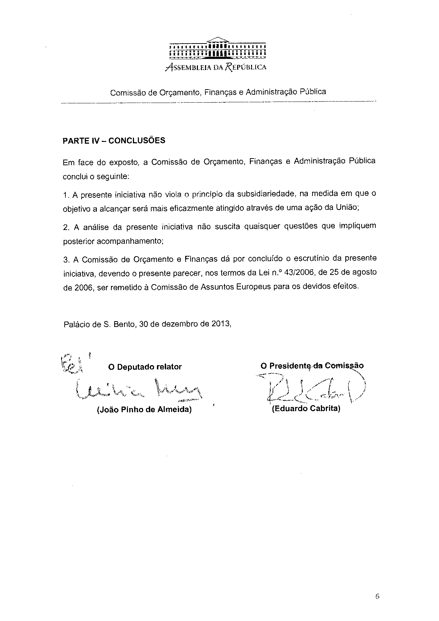

Translation(s) of the opinion may be available on the Interparliamentary EU Information Exchange Site IPEX at the following address: http://www.ipex.eu/IPEXL-WEB/search.do

