 | 
COUNCIL OF  THE EUROPEAN UNION |  |  | Brussels, 3 February 2014
 | Interinstitutional File:  2013/0403(COD) |  | 6039/14
JUSTCIV 26
EJUSTICE 11
INST 78
PARLNAT 37
CODEC 288

COVER NOTE
from: | the Spanish Congress of Deputies
Date of receipt: | 28 January 2014
to: | Antonis Samara, President of the Council of the European Union
Subject: | Proposal for a Regulation of the European Parliament and of the Council amending Regulation (EC) No 861/2007 of the European Parliament and the Council of 11 July 2007 establishing a European Small Claims Procedure and Regulation (EC) No 1896/2006 of the European Parliament and of the Council of 12 December 2006 creating a European order for payment procedure  [doc. 16749/13 JUSTCIV 278 EJUSTICE 114 CODEC 2695 - COM(2013) 794 final]  - Opinion on the application of the Principles of Subsidiarity and Proportionality

Delegations will find attached a copy of the above mentioned opinion.

_______________________

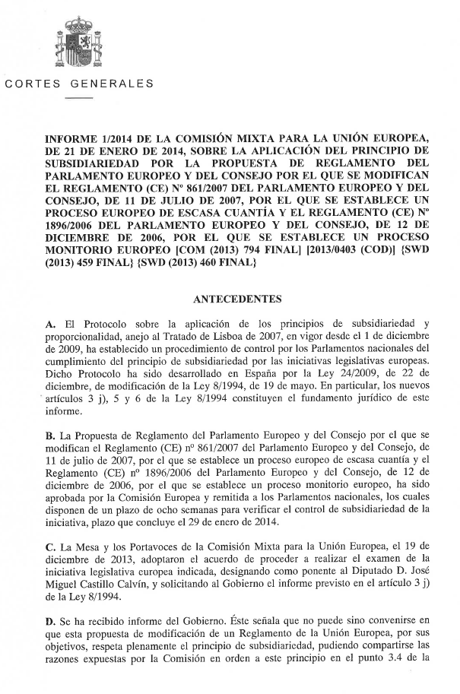

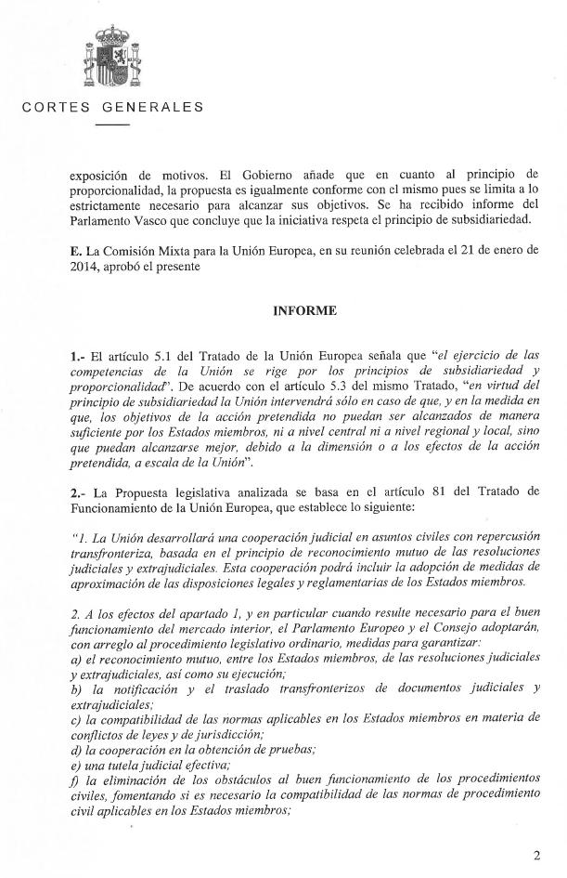
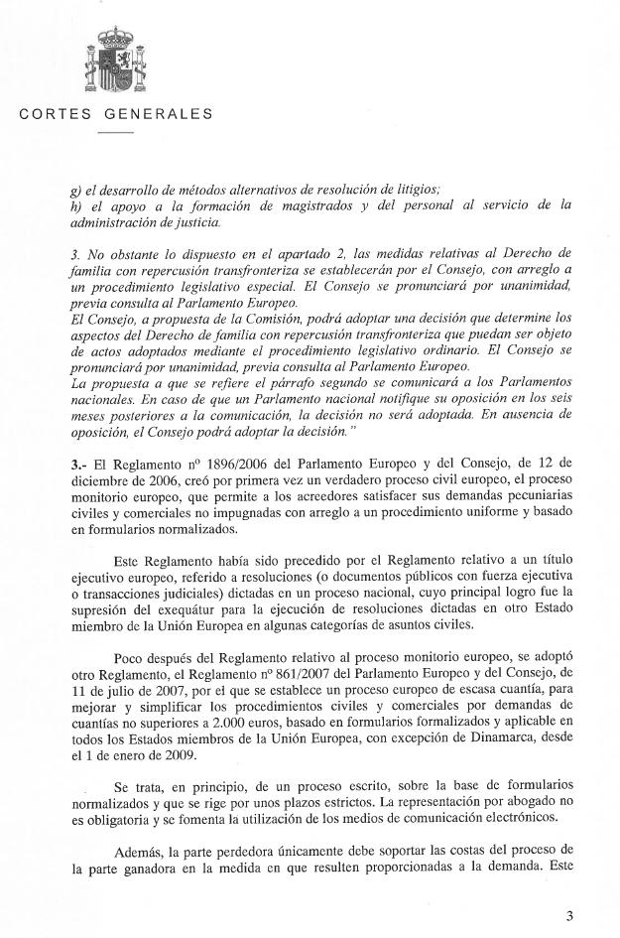
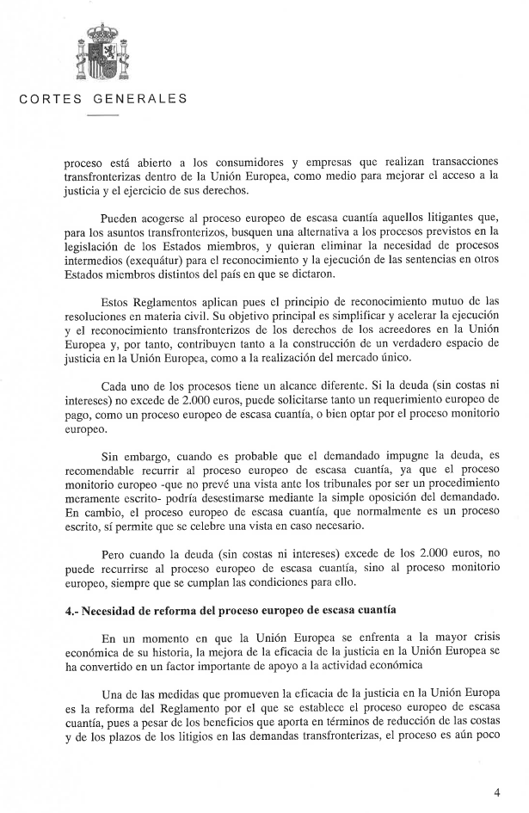
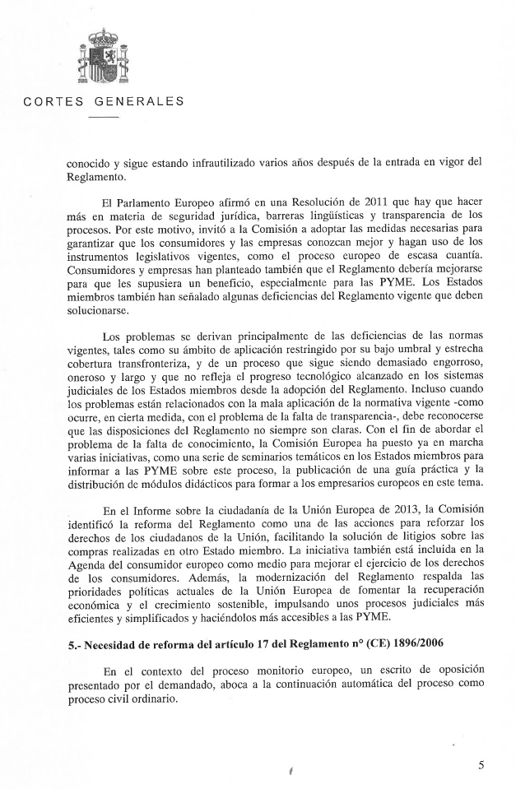
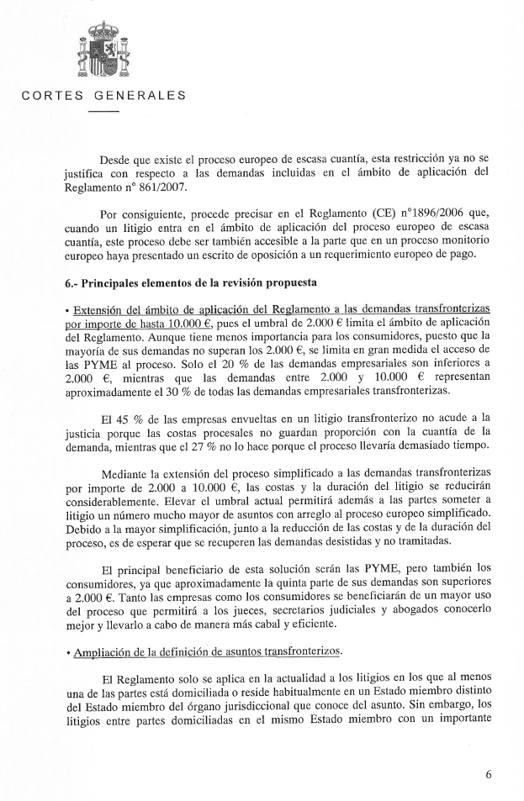
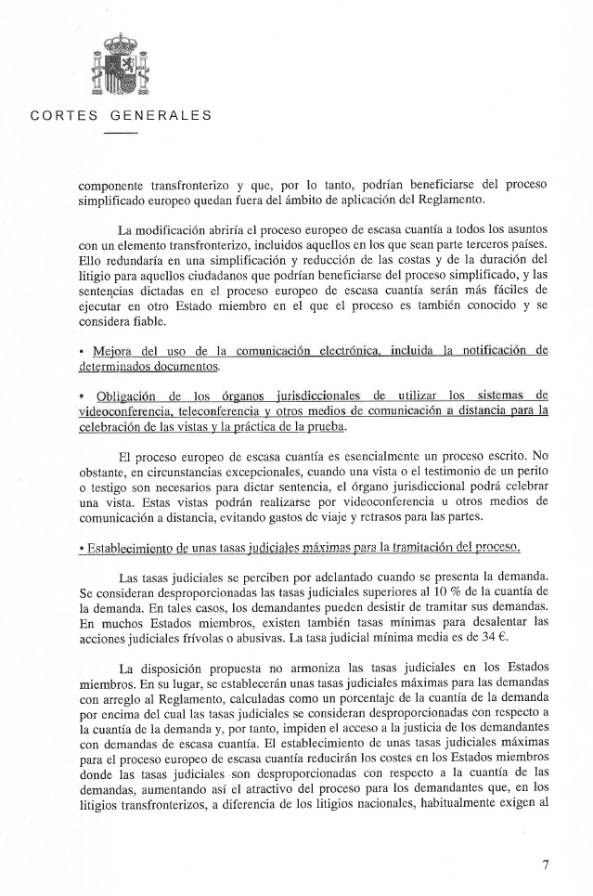
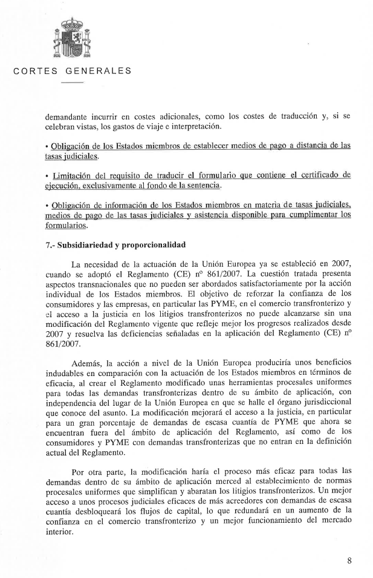
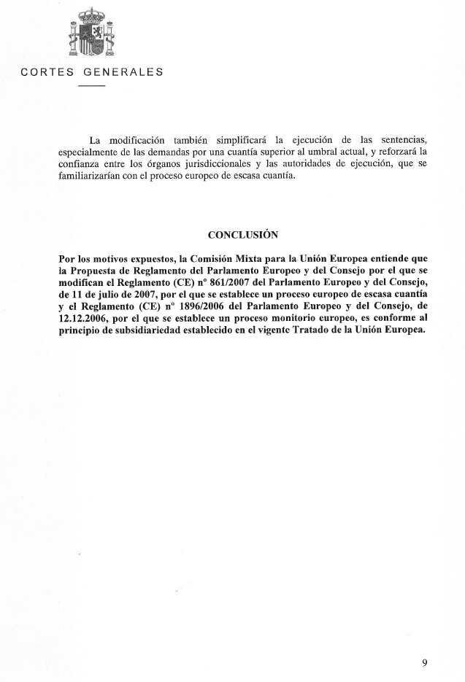

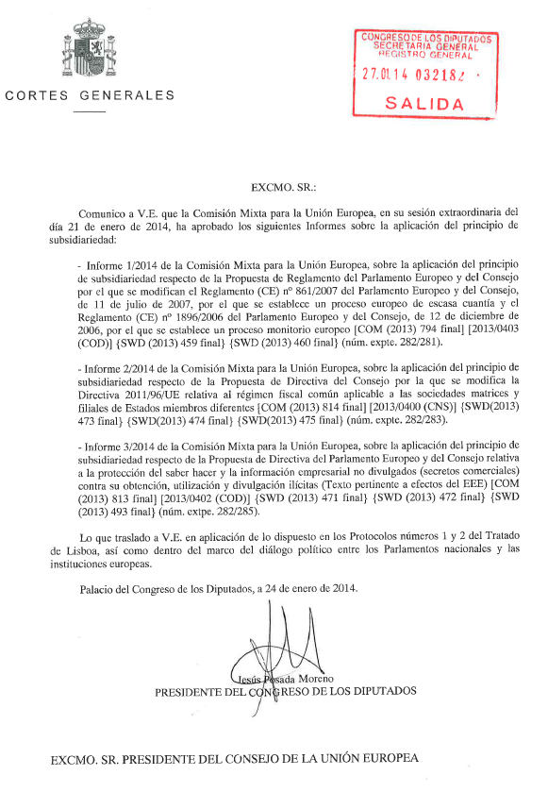
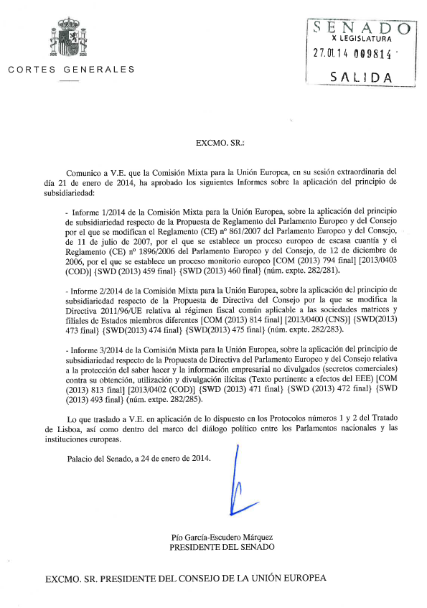____________________

For other available language versions of the opinion, reference is made to the Interparliamentary EU information exchange Internet site (IPEX) at the following address: http://www.ipex.eu/IPEXL-WEB/search.do

