COMMISSION STAFF WORKING DOCUMENT
Accompanying the document
REPORT FROM THE COMMISSION TO THE COUNCIL AND THE EUROPEAN PARLIAMENT
Seventh report under Article 12 of Regulation (EEC, Euratom) n° 1553/89 on VAT collection and control procedures

Contents
Contents 3
I. INTRODUCTION 4
II. ANALYSIS 6
CHAPTER 1: Selected Issues on Organisation of Tax Administrations 6
CHAPTER 2: VAT Identification, Registration and Deregistration 10
A. Threshold and Stratification of VAT Registrations 10
B. VAT Registration Procedures 13
CHAPTER 3: Customs Procedure 42 19
CHAPTER 4: Submitting VAT Returns (Filing) and Payment 22
CHAPTER 5: VAT Collection and Recovery 29
CHAPTER 6: VAT Audit and Investigation 36
CHAPTER 7: Tax Dispute Resolution System 43
CHAPTER 8: VAT Compliance 50
III. RECOMMENDATIONS 54

- INTRODUCTION
- In 2011 the total amount of VAT revenue collected in the EU was around € 901 billion, which represented 7.1 per cent of GDP-EU-27 and 18.4 per cent of total tax revenue, including social contributions. The EU VAT system embraced around 26.5 million VAT taxable persons. The VAT-gap, which is the difference between the amount of VAT actually collected and the theoretically collectable amount of VAT, is estimated at 18.4 per cent of GDP-EU-26.
- In 2011, the VAT own resource represented 11 per cent of the EU revenue, being around € 14 billion. For the calculation of the VAT own resource, as a rule, a uniform rate of 0.30% is levied on the harmonised VAT base of each Member State. However, this VAT base is capped at 50% of GNI for each Member State. In addition, for the period 2007-2013, 4 Member States have reduced VAT call rates: 0.225% for Austria, 0.15% for Germany and 0.10% for the Netherlands and Sweden. Some other corrections exist, in particular the UK rebate. The efficiency of VAT collection and control in the Member States may impact the amount of VAT own resources due by the Member State concerned as well as the relative share in total own resources of other Member States.
- Article 12 of Council Regulation 1553/89 on the definitive uniform arrangements for the collection of own resources accruing from VAT requires the Commission to submit a report to Parliament and Council every three years on the procedures applied in the Member States for registering taxable persons and determining and collecting VAT, as well as on the modalities and results of their VAT control systems. This report should enable Member States to assess risks and identify opportunities to improve VAT control and collection systems. Six reports have been made since 1989.
- The current report, building on the recommendations of previous reports and taking into account progress already made at EU and national level, aims at measuring improvements in VAT administration in Member States within the framework of Article 12 of the above mentioned Regulation. It takes into account recent developments in tax administration with increased emphasis on preventive measures and promoting voluntary compliance. It aims to identify good practices in the various steps of an effective tax collection, measured against common benchmarks.
- In order to prepare this report, a questionnaire on selected issues has been submitted to all Member States to pool the information needed for the report. The data submitted were discussed on several occasions with the Member States. Generally, the data included in the report reflect the situation up to 31 December 2011, unless otherwise indicated. Later developments are covered only if information was made available by a Member State.
- ANALYSIS

CHAPTER 1: Selected Issues on Organisation of Tax Administrations
- In around half of the Member States the tax administration functions as a semi-autonomous body. Autonomy is essential to a good performance of a tax administration. Over the last decades, tax administrations have been faced with the need to deliver services more effectively and at a lower cost to citizens and to address deficiencies in traditional procedures and structures seen as too rigid to respond to the challenges confronted by government in modern society. As a basic principle, autonomy can lead to better performance by removing impediments to effective and efficient management while maintaining appropriate accountability and transparency. As a result, there has been a tendency for governments to increase the autonomy of its departments and agencies. The OECD has identified a number of different categories of institutional arrangements for tax administrations: (i) a single or multiple directorate(s) within the Ministry of Finance; (ii) a unified semi-autonomous body, the head of which reports to a Minister and (iii) a unified semi-autonomous body with a board, the head of which reports to a Minister. Table 1 gives an overview of the Member States tax administrations' position in this field and compares the degree of autonomy in what concerns the: (i) budget; (ii) management of human resources and (iii) organisational structure.
Table 1 - Autonomy of tax administration
 | AT | BE | BG | CY | CZ | DK | EE | FI | FR | DE | EL | HU | IE | LT | LV | LT | LU | MT | NL | PL | PT | RO | SK | SI | ES | SE | UK
1.The tax administration is:
a) A department of the MoF | Y | Y |  | Y |  |  | Y | Y | Y |  | Y |  |  |  |  | Y | Y | Y | Y | Y | Y
b) A semi-autonomous body |  |  |  |  | Y |  |  |  |  |  |  |  | Y |  |  |  |  |  |  |  |  |  |  |  | Y
c) A semi-autonomous. body with a board |  |  | Y |  |  | Y |  |  |  |  |  | Y |  | Y | Y |  |  |  |  |  |  | Y | Y | Y |  | Y | Y
2.Can the tax administration:
a) Design its' own organisational structure? | Y | Y | Y | Y | Y | N | Y | Y | Y |  | N | N | Y | Y | Y | Y | Y | N | Y | N | Y | y | Y | Y | N | Y | Y
b) Set the remuneration levels? | N | N | Y | N | Y | N | Y | Y | N |  | N | N | N | N | Y | Y | N | N | N | Y | N | N | Y | N | Y | Y | Y
c) Set its staffing levels? | N | Y | Y | Y | Y | N | Y | Y | Y |  | N | N | N | Y | Y | Y | Y | N | N | Y | N | N | Y | Y | N | Y | Y
d) Hire and fire staff? | Y | N | Y | N | Y | Y | Y | Y | N |  | N | Y | Y | Y | Y | Y | N | N | N | Y | N | Y | Y | Y | Y | Y | Y
e) Discretion over operating expenditure? | Y | Y | Y | Y | Y | Y | Y | N | Y |  | N | Y | Y | Y | Y | N | Y | Y | N | N | Y | Y | N | Y | Y | Y | N
f) Discretion over capital expenditure? | N | N | Y | Y | Y | Y | Y | N | Y |  | N | Y | N | Y | N | N | N | N | N | N | N | Y | N | N | Y | Y | N
- The organisational structure of tax administrations and the position of the VAT administration differ across Member States. Over the last decades, the organisational structure of many tax administrations has been subject to major reforms. There is a trend to aggregate direct taxes, indirect taxes and customs. Customs is under the same management structure as VAT in several Member States (AT, BE, CY, DK, EE, ES, IE, LV, MT, NL, PT, SI and UK). There is also a trend to create distinct units devoted to VAT fraud. Currently, eight Member States do not have a specialised VAT fraud unit. Generally speaking, there is an evolution from structures based largely on "tax or legislation type" criteria, to a process- or function-based organisation. A number of administrations have evolved towards a "taxpayer type" approach. The taxpayer approach embraces, inter alia, the creation of specific units for large taxpayers, high wealth individuals and self-employed. Risk management units support the tax payer approach. Table 2 gives an overview of the position of the tax administrations of Member States in this field.
Table 2 - Selected issues on organisation of tax administration
Country | Structure of tax administration | Large taxpayer unit | Enforced debt collection unit | VAT fraud unit | High wealth individduals unit | Risk management unit
AT | T, TP | Y | N | N | N | Y
BE | ALL | Y | Y | Y | N | Y
BG | F | Y | Y | Y | N | Y
CY | T | N | Y | Y | N | N
CZ | T,F | Y | Y | Y | N | Y
DK | ALL | Y | Y | Y | N | Y
DE | T, TP | Y | Y | Y | N | Y
EE | ALL | Y | Y | N | N | N
ES | ALL | Y | Y | Y | N | N
FI | MATRIX | Y | Y | Y | N | Y
FR | TP | Y | Y | Y | Y | N
EL | ALL | N | Y | N | Y | N
HU | F | Y | Y | Y | N | N
IE | TP | Y | Y | Y | Y | Y
IT | F | Y | Y | Y | N | N
LT | F | Y | Y | Y | N | Y
LV | F | Y | Y | N | N | N
LU | T,F | N | Y | Y | N | N
MT | ALL | N | Y | Y | N | N
NL | F | Y | N | Y | N | Y
PL | ALL | Y | Y | Y | N | N
PT | F | Y | Y | Y | N | N
RO | ALL | N | Y | N | N | N
SE | ALL | Y | Y | Y | Y | N
SI | F,TP | Y | Y | N | N | N
SK | F | Y | Y | Y | N | Y
UK | ALL | Y | Y | Y | Y | Y

Conclusion
- Although autonomy is essential to a good performance by a tax administration, in many countries there are still significant constraints on management. There is a trend towards the creation of autonomous agencies (around 50 per cent of Member States). This institutional arrangement offers, in general, more budgetary autonomy as well as autonomy in the management of human resources and the design of the organisational structure. However, there is no silver bullet solution to this question, as some countries have granted a high level of autonomy to the tax administration within the Ministry of Finance.
- There is a trend from a tax-type towards a taxpayers-type organisational structure. Most Member States have a large taxpayers function; however, very often it is merely an audit centre and does not embrace filing, payment, enforced collection or taxpayer services. Ten Member States have a distinct risk management unit, supporting a holistic compliance approach. Very few countries have a distinct function responsible for the compliance management of high wealth individuals and self-employed.

CHAPTER 2: VAT Identification, Registration and Deregistration
- Threshold and Stratification of VAT Registrations
- Within the EU, on average in 2011, taxpayers are required to register for VAT when total turnover exceeds threshold of € 30.611. Businesses below the threshold may voluntarily register to participate in the VAT system. DE, ES, IT, MT, NL and SE do not apply a threshold for VAT registration of their small businesses. In other Member States, thresholds vary greatly from a minimum of € 5.000 (EL) to a maximum of € 83.802 (UK). Furthermore, some Member States apply specific thresholds and options depending on the sector of activity on the basis of Directive 2006/112/EC of 28 November 2006 on the common system of value added tax (hereinafter "Directive 2006/112").
Graph 1 – Overview of VAT registration thresholds
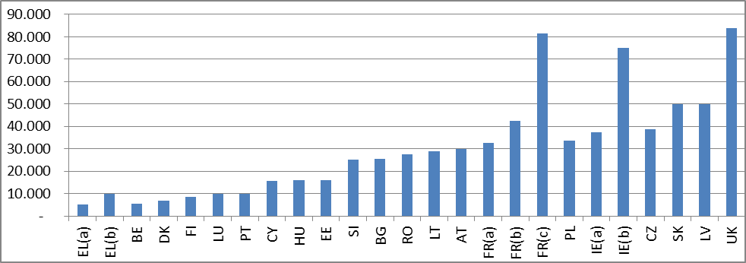
Note: EL(a) threshold for provision of services; EL(b) threshold for provision of goods. FR(a) threshold for provision of services and hotels; FR(b) threshold for lawyers authors and artists; FR(c) threshold for sales; IE(a) threshold for services; IE(b) threshold for goods.
- Around 22 per cent of VAT taxpayers are below the threshold for mandatory registration and have a net VAT liability close to nil. This may indicate a loss-making activity in the segment or a compliance problem resulting from overvaluation of deductible VAT (embracing private expenditure) or undervaluation of turnover.
- The vast majority (around 65%) of the registered VAT taxable persons, have a turnover not exceeding €100.000 and contribute little to VAT revenue. Graph 2 shows the distribution of registered businesses by turnover and contribution in terms of net VAT declared liability and compares it to the typical segmentation of Taxpayers and Revenue Collections. It is generally admitted that a small number of large enterprises (typically less than 1 percent) are responsible for 60–70 percent of domestic tax collections, while a very large number of smaller enterprises account for less than 5–10 percent of domestic tax collections. Within the EU, most of the taxpayers (65 per cent) are in the segment of micro firms but with a turnover even not exceeding € 100.000 and contribute only 2 percent of net VAT liabilities. Given the design of the VAT system, it is possible that these small firms will take more from the VAT system than what they pay in output tax (as part of the output tax will be deducted by larger firms).
Graph 2 – Segmentation of Tax Payers and Revenue Collection: 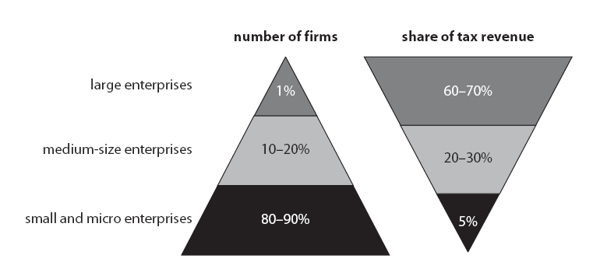
68%
2%
6
Source: World Bank quoted in Risk-Based Tax Audits Approaches and Country Experiences World Bank report 2011 – Simon York p. 40.
- The stratification suggests a compliance problem in voluntary registrations. As said, the extremely low net VAT liability in this segment may indicate a loss-making activity in the segment or result from overvaluation of deductible VAT or undervaluation of turnover. The detailed analysis of negative VAT liability for a selected number of Member States shows that deductible VAT compared to declared turnover is relatively high for voluntary registrations. It even results in a negative net VAT liability in a number of Member States (CY, DK, EE, EL, FR, HU, LT, LU, LV, SI, SK and UK) (See Graph 3 below) as it amounts to a direct VAT subsidy to micro-firms. This may indicate a compliance problem. Additionally, having a higher registration threshold increases the risk that a significant number of taxpayers will choose to opt out of the VAT system, not for business reasons, but solely because they find themselves in a recurring VAT credit position. This risk is illustrated in Graph 3 below, which shows a trend of negative net VAT payable position for Member States where a threshold is in place (CY, DK, EE, EL, FR, HU, LT, LU, LV, SI, SK and UK). As a consequence, a drop in revenue may occur in case of higher registration threshold, with little possibility for the Member States to anticipate it, track it in a population with a wider range of turnovers and monitor it.
Graph 3 - Number of voluntary registrations and contribution to the revenue for Member States with thresholds
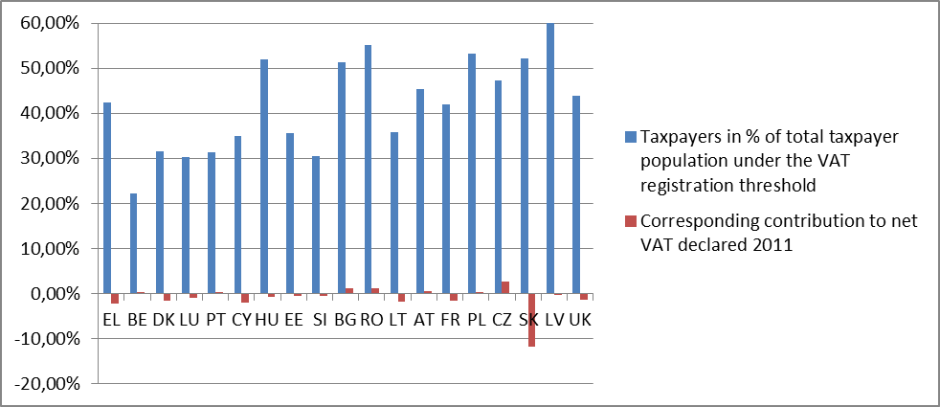
- A higher registration threshold does not significantly reduce the number of voluntary registrations, but may contribute to a drop in VAT revenue and to less visibility. There is no perfect correlation between the level of the threshold and the number of voluntary registrations, as depicted in Graph 4 below. On average, the segment of taxpayers whose declared turnover is below € 100.000 contributes 2 per cent more to the total VAT revenue, compared to Member States with a threshold.
Graph 4 – Correlation between number of volunteer registrations and the threshold
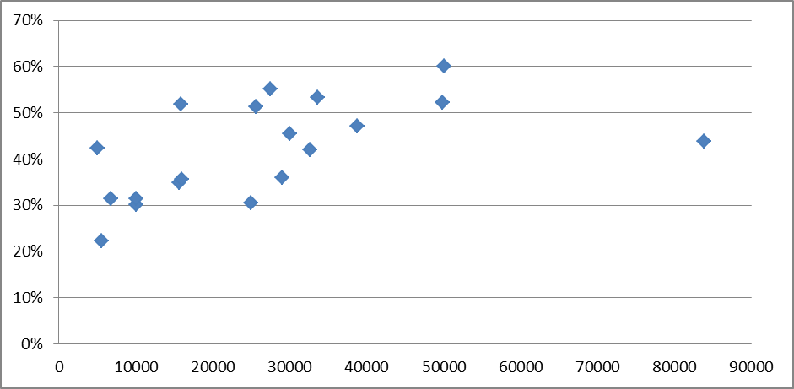
Conclusion
- In the EU, small and micro firms contribute only around 2% of VAT revenue. In particular, voluntary registrations below the registration threshold seems to indicate a compliance problem. It can even result in a negative net VAT liability in a number of Member States (DK, EE, EL, FR, HU, LT, SI, SK and UK).
- Member States should consider the desired threshold for mandatory registration and the VAT treatment of micro businesses need to be further examined. In setting a threshold for mandatory VAT registration, policy makers have to take into account the fact that businesses below the threshold may decide to register voluntarily to participate in the VAT system.
- VAT Registration Procedures
Overall Benchmarks
- Registration is transparent and taxpayers are well-informed about how, when and where they can register for VAT. Accurate and up to date information is available. There is access to services for taxpayers through helpdesks, online systems and/or call centres. Non-established taxpayers can easily get access to information through a website or a web portal and there is an exclusive contact point for these taxpayers. Requests for registration are dealt with one week. The registration process collects information enabling the tax administration to detect and stop fraud and consequently to limit substantially the level of fraud. From the start, the tax administration monitors VAT filing and payment compliance in connection with risky registrations, embracing early and on-going post-registration on-site visits. Deregistration procedures are effective to deregister immediately missing traders from the VAT system and to prevent VAT fraud at an early stage. The register is kept up to date and measures are taken to ensure the quality and reliability of the data in VIES. Tax Authorities and economic operators can rely on the validity of the VAT identification numbers in the VIES system. In cases of suspicious fraudulent intentions and when registration cannot be refused, the tax administrations take precautionary and additional security measures as a pre-requisite for registration.
Current Situation
- In most countries the registration process is transparent and taxpayers – including the non-established taxpayers - are well-informed about how, when and where they can register for VAT. In fact, only 3 Member States (BE, EL and LU) do not provide specific information on national and VIES registration to non-establish taxpayers. Almost all Member States (AT, BG, CY, CZ, DE, DK, EE, ES, FI, HU, IE, IT, LT, LV, MT, NL, PL, PT, RO, SE, SI, SK and UK) provide information (by means of a webpage, through a leaflet, etc.) on VAT registration and specify the requirement in foreign languages, English is the most common foreign language used. Nevertheless, a more user-friendly approach could be taken when information is provided in the language of neighbouring countries or to countries with which the country in question establish a more active economic partnership (for example, in the cases of FI and IT). A lot of efforts have been made in many Members States to provide information on their VAT system to non-established operators in English (AT, BG, CZ, DK, EE, ES, FR, HU, IT, LT, LU, LV, MT, NL, PL, SK, SE and UK). Nonetheless, when more specific and business-related issues emerge, the information given becomes scarcer and the person is re-directed at the existing webpages in their national language. Some Members States have specific offices dealing with non-established companies, where the staff is proficient in different languages. Still, and despite noticeable efforts made by many Member States on their website, it remains difficult to know whether certain businesses need to be registered or not and what the relevant obligations concerning it are..
- The registration process seeks a balance between facilitating trade and controlling the VAT system. Very few Member States have long deadlines for registration of taxable persons (weekly - BE, ES and PT; monthly – EL). The deadlines vary from immediate registration to a maximum of 30 days. In most cases, the registration process takes less than 10 days. This means that most Tax Authorities have a very tight deadline to perform pre-registration checks.
- The majority of Member States systematically cross-check the registration application against other sources of data. In addition to verifying the information provided in the application form, it is essential that supplementary information is collected from a range of accessible data bases. Generally, tax administrations verify information included in an application form through the national register of companies, as well as information available in internal databases, such as income tax returns, the social security register and customs declarations. EL, FR, IT and PT do not cross-check registration data. These checks are occasionally made in BE, CZ and PL.
- Most Member States focus on the identification of potential fictitious businesses at the pre-registration stage. A registration process under which the intended activity and the identity of the taxpayer are verified is essential to prevent frauds associated with fictitious businesses (also called “missing traders”). The registration process should collect information to enable the tax administration to detect and stop frauds associated with fictitious businesses at an early stage. This would limit substantially the level of fraud. Most Member States systematically rely on risk indicators in a pre-registration phase. On-site visits are not frequent. Few Member States systematically carry out pre-registration visits. Nevertheless, they do take place occasionally in the great majority of the Member States. FR, IT, LT and PT have limited or no pre-registration checks in place.
- Registration procedures rarely result in a rejection of the registration. In fact, a large number of Member States do not have available data in this respect. For the remaining Member States, in general, over the period 2009-2011, very few applications have been rejected, when compared to their respective total number of taxpayers (average of 0.16per cent and maximum of 1.2per cent over this period). Graph 5 depicts the number of rejected registrations. More than half of the Member States (BE, BG, DE, DK, EE, ES, FR, HU, IE, LT, MT, PL, SE, SI and UK) keep a record of applicants for whom registration has been refused either for a national identification number or VIES identification number. These records are not always directly available to all registration offices.
Graph 5 – Rejected registrations
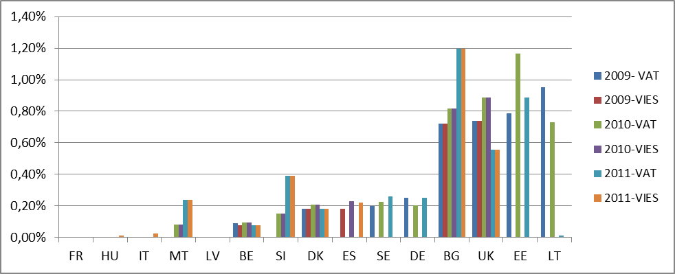
- Post-registration monitoring programs for risky traders are implemented in half of the Member States. Modern Administrations monitor from the start VAT filing and payment compliance for risky registrations, including early analysis of the VAT returns and on-going post-registration on-site visits where needed. Some Administrations even set-up monitoring and visiting programs for a wider range of traders, which include intermediaries, brokers, main dealers, exporters and freight forwarders in high risk sectors. The main purpose of such programs is to gather as much information as possible on new players in the arena. Around half of the Member States systematically analyse the VAT return of new registrations. Not surprisingly, most of those Member States having put in place automatic cross checks of data in the initial phase of registration are also the ones proceeding to cross checks of the VAT returns with available data bases. Also half of the Members States, occasionally visit and audit companies at their premises. Only a few Member States (AT, LU and SK) have a systematic, albeit risk-based, visiting programme in place.
- There is often little information available on deregistration. Almost half of the Members States are not able to quantify the number of deregistrations following post registration checks, at least at central level. Moreover, around half of the Members States do not have data available on the percentage of deregistrations from VIES. For the others, the percentage varies from 0,1 per cent (IT) to 11,5 per cent (LV). The trend over the three previous years seems rather constant.
- In many Member States, deregistration procedures are too slow to stop VAT fraud at an early stage and are not very efficient as regards deregistering missing traders quickly from the VAT system. It is important to react quickly on detected frauds, in order to put an end to VAT fraud. Therefore, a short and rapid procedure should be in place to deregister or to cancel the VAT number. In case of suspicion of fraud, the minimum time required to deregister from a VIES number varies greatly from 1 day to 134 days, the average being 13,4 days. Despite recent and real progress, quick deregistration still seems to be a problem in many Members States. The differences between the Member States are significant and often adequate legislation and administrative processes supporting deregistration are lacking.
- The interaction between registration for national purposes and for intra community trade differs across Member States. The vast majority of Member States provide identification for intra community trade together with the national registration for VAT purposes. The other Member States have separate registers. The percentage of registered taxpayers for intra community transactions goes from 6 per cent (BG) to almost 100 per cent (BE), with significant variations over the years in certain Member States, due to changes in the registration system (BE, IT and RO).
- Keeping the information available in the VIES system up-to-date, complete and accurate, can be improved for some Member States. Keeping proper and up-to-date records in VIES, as well as in the VIES Web version is a prerequisite to enhance legal certainty for legitimate business activities and mutual trust between tax authorities in the EU. As to the updating of the VIES data base, 5 Member States operate in real time (EE, IT, LU, PL and SI); the gross majority (18) update the VIES system daily; 3 weekly (BE, ES and PT) and only 1 monthly (EL). Most Members States have a hotline where taxpayers can report errors in VIES. Nevertheless, 3 Member States (ES, IT and PT) don’t have this facility.
- A total of 9 Member States use retroactive deregistration (CY, DK, EL, FR, IE, PL, PT, RO and UK). Nonetheless, only 6 ensure that the effective date of deletion from the system is visible (EL, FR, IE, PL, PT and RO) .
Conclusions
- In most countries the registration process is transparent and taxpayers – including the non-established taxpayers - are well-informed of how, when and where they can register for VAT. Accurate and up-to-date information is available. Non-established taxpayers can easily get access to information. However, on more specific issues, the information given becomes scarcer in foreign languages.
- The focus on the pre-registration and deregistration process has increased significantly with the implementation of the Council Regulation 904/2010, however not all Member States have developed end-to-end processes for registration. An end-to-end process embraces not only pre-registration checks, but also a regular follow-up on the activities of the taxable person and deregistration as soon as the conditions for registration fail to be complied with, thus making VIES a more reliable database.
- The number of deregistrations ex officio remains low and in many countries the deregistration procedures are slow. Quick deregistration still seems to be a problem due to the absence of adequate legislation and supporting administrative processes.
- Keeping the information available in the VIES system up-to-date, complete and accurate, may be improved for some Member States. In particular the long timeframes for updating the system and the retro-active deregistration in certain Member States may be problematic. In the latter case, according to the principle of transparency and legal certainty, the real date of deletion of the VAT number should be made visible to users in the VIES web version.

CHAPTER 3: Customs Procedure 42
Overall Benchmarks
- Member States have put in place a system to enable checking of VAT identification numbers at the time of importation. This embraces an online access to the VIES database containing all valid VAT identification numbers in the EU database. Customs authorities systematically transmit data concerning importations using the Customs Procedure 42 to the tax administration for an efficient exchange of data. Importations using the Customs Procedure 42 are identified as an additional risk in the tax administration's risk analysis system. Results of this risk analysis are exchanged through Eurofisc working field number 3 "Customs Procedure 4200".
Box 1. Customs 42 procedure
CUSTOMS PROCEDURE 42 is the regime an importer uses in order to obtain a VAT exemption when the imported goods will be transported to another Member State. The VAT is due in the Member State of destination.
This procedure is commonly known as customs procedure 42 because in such cases the importer of the goods must indicate in box 37 of the Single Administrative Document (SAD) a code starting with the digits 42. When goods are re-imported, code 63 should be indicated instead. For the purposes of this report, references to customs procedure 42 include customs procedure 63.

Current Situation
- A significant number of Member States fail to systematically check both the VAT identification number of the importers and the VAT identification number of the customers. Although 24 Member States check the VAT identification numbers of the importers at the time of importation, only 17 systematically also check the VAT identification numbers of customers acquiring the goods in the Member State of destination. As a result, a total of 9 Member States do not systematically check both of the above mentioned VAT identification numbers - the number of the importers and those of the customers (BE, BG, FR, HU, IE, LU, NL, PT and UK).
- In a number of Member States there is no system for exchanges of information between the Customs and the tax administration. Once the information is made available to the Customs administration through box 44 of the SAD, it should be transmitted to the tax administration of the Member State of importation. At that time the tax administration can monitor whether the recapitulative statement has been filed by the importer or his fiscal representative and the transactions can be further monitored using the tools put at the disposal of Member States through the Regulation (EU) No 904/2010. In EE and IE this exchange of information can be easily achieved, since these countries have a merged Customs and tax administration. In ES the information is also ensured since both Customs and tax administrations have one integrated database. There are still, however, at least 5 Member States where such system for the exchange of information is lacking (EL, IT, NL, PL and SK).
- Despite the high loss of VAT revenue due to abuse of the Customs 42 procedure at least five Member States indicated that they do not identify these imports as an additional risk in their domestic risk analysis system. Since 2011, a specific working field within Eurofisc has been set up to exchange rapidly information on possible fraudulent transactions or traders misusing the Customs Procedure 42. The information exchanged within this working field relates to suspicious transactions identified and resulting from a domestic risk analysis of these transactions. Currently, despite the high amount of VAT revenue that is lost following the misuse of the above mentioned Procedure (see Special Report of the ECA), 4 Member States (EE, FI, LU and MT) are not participating in this working field, whereas 2 Member States (DE and PL) participate only as an observer.
- Several Member States use specific tools to avoid the misuse of the Customs Procedure 42. In several Member States specific tools, such as licenses (LU, MT, NL and SK) or guarantees (AT, DK, EE, ES, HU, IT, LU, MT, NL, RO and SK) are used in order to prevent the misuse of the Customs Procedure 42. For example, in AT, an electronic system automatically generates a recapitulative statement from the data contained in the SAD. In PL the use of the Customs Procedure 42 is dependent on the filing of the recapitulative statement. MT only releases the guarantee once the recapitulative statement is filed. Those Member States that use a guarantee only impose this in exceptional or limited cases.
Conclusions
- Not all Member States ensure that the validity of the VAT identification numbers listed in box 44 of the SAD are systematically checked at the time of importation. Those Member States that do not have yet done so - at least half of the Member States (BE, BG, DE, EE, HU, IE, IT, LU, LV, NL, PL, PT, RO, SE and SK) - should apply the necessary resources in order to guarantee automatic access to VIES to the customs administration. Moreover, not all Member States guarantee that all the information on importations using the Customs Procedure 42 is transmitted domestically to the tax administrations in order to ensure a proper follow up of the goods movement within the EU. This situation seems to persist despite previous recommendations on the matter – i.e. in FPG 29 of 2008, echoed by the European Court of Auditors in its Special Report No 13 of 2011, and also supported by the European Parliament and the Council.
- Member States should identify these transactions as additional risks in their domestic risk analysis systems. It is crucial that transactions misusing the Customs Procedure 42 are identified rapidly by all Member States and that the information is passed on quickly between them. Furthermore, in order to alert other Member States rapidly of fraudulent transactions discovered or traders systematically misusing the Customs Procedure 42, all Member States should actively participate in Eurofisc working field 3.
- The use of a license or guarantee may prove useful to prevent the misuse of the Customs Procedure 42, However, imposing an overall guarantee or license on all traders or fiscal representatives that intend to use the Customs Procedure 42 would be a disproportionate burden on honest business and jeopardise the smooth functioning of the internal market, taking away the flexibility and attraction of the simplification provide for by this procedure. Therefore, Member States imposing such a license or guarantee system should only target risky traders.

CHAPTER 4: Submitting VAT Returns (Filing) and Payment
Overall Benchmarks
- Filing VAT returns is the first step (after registration) in the end-to-end process of establishing VAT liabilities. A disciplined and systematic approach is in place to monitor and enforce filing obligations and ensure on-time filing of returns. Highly automated business processes, embracing electronic filing of VAT returns and recapitulative VIES statements, are supported by taxpayer profiling tools to determine the most appropriate follow-up action for stop-filers (e.g., phone call, e-mail, text messages, demand notice, personal visit, default assessment or prosecution). VAT due and VAT refunds are paid timely. Interest is charged or paid automatically for late payments and refunds. Reasonable penalties support compliance with filing and payment obligations.
Current Situation
- There are significant differences in the filing ratio (the number of returns received compared to the number of returns expected), across Member States. The median filing ratio for 25 Member States is around 96 per cent. The best performing Member States have a ratio of VAT returns submitted reaching almost 100 per cent (DK, EE, NL, SE and SI). The lower end quartile is around 90 per cent. The filing ratio will depend, inter alia, on the efficiency of an automated and end-to-end filing and payment system, the interest and penalties schemes and the accuracy of the taxpayers register. In this context, IT is significantly under-performing (47.5 per cent) as many "active" VAT numbers are "dormant" and do not correspond to entities carrying out an economic activity and do not submit VAT returns.
- On average, the results in terms of timely filing of the VAT returns could be improved. However, on average, those Member States with the best filing ratio have also the highest delays in filing time, which reflects the efforts made to collect the returns. Graph 6 depicts the delays and timely filing of VAT returns. VAT returns are filed for more than 97 per cent within the deadline in a minority of Member States (more specifically 5 Member States: BG, EL, IT, PT and SK).
Graph 6 – Delays and timely filing of VAT returns
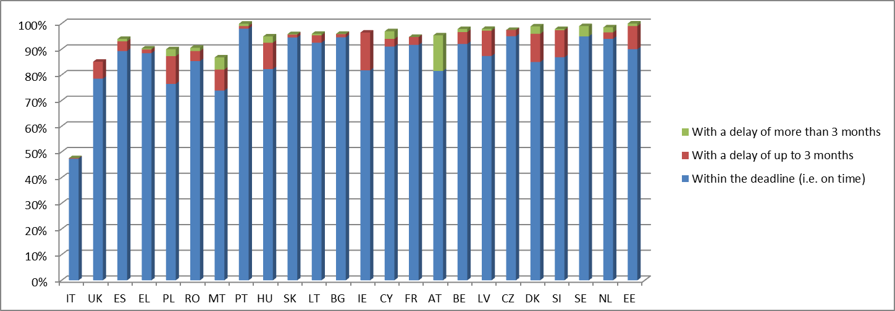
- Electronic filing is increasing, but not in line with reasonable expectations. Only a small majority of the Member States (see Graph 7 below) have appropriate legislation in place providing for a compulsory electronic filing of VAT returns. For the remaining Member States, so far, an option-based system is applicable. There is a positive trend in this respect: a significant increase in the effective percentage of electronic filing can be noted over the period 2009-2011 (average progression for 2009/2010 of 49 per cent and of 22 per cent for 2010/2011). Nevertheless, the current figures are not satisfying since, in countries where the electronic filing is compulsory, the effective electronic filing reaches only 87 per cent on average.
Graph 7 – E-filing of VAT returns
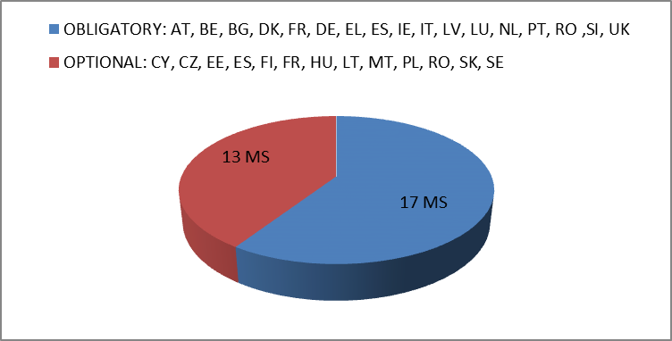

- Progress could be made in 7 Member States on the development of an automatically filing and payment system for VAT returns. A central monitoring of the deadlines for filing and payment is in place in most Member States (See Graph 8). However, modern and automated follow-up systems are lacking in a significant number of Member States. Automatic reminders are still not in place in 7 Member States (BG, ES, IT, LV, NL, PL and SK). Moreover, in 17 Member States (AT, BE, CY, CZ, DE, DK, FI, FR, HU, IE, LT, LU, MT, PT, RO, SE and SI) reminders are sent out through a written notification letter instead of more modern means of communication, such as an e-mails or a SMS. Only a few Member States have taxpayer profiling tools to determine the most appropriate action for stop-filers.
Graph 8 – Automated monitoring of deadlines for filing and payment by an electronic system
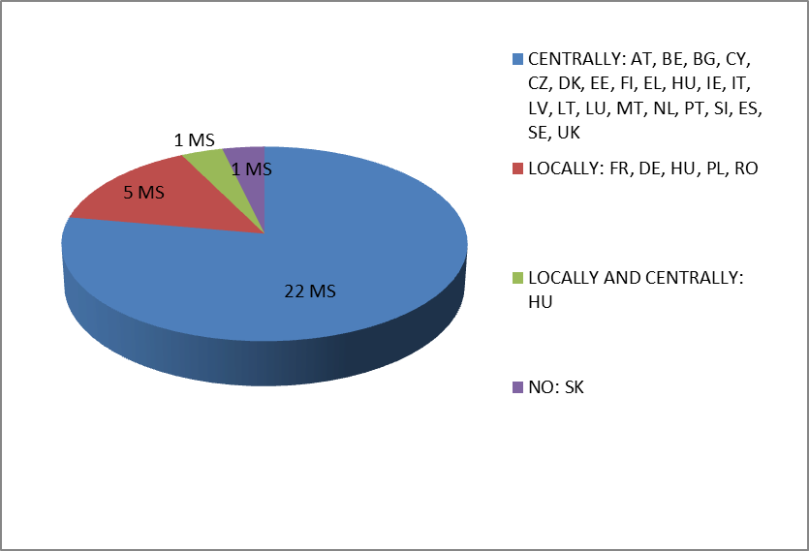
- Interest and penalties for late filing and payment vary significantly across Member States and their efficiency remains to be proven. All Member States apply sanctions for late or non-filing. Most sanctions are for late payments -17 Member States-(AT, CZ, DE, EE, EL, ES, FI, HU, IE, IT, LU, MT, NL, PT, SE, SK and UK). The range of penalty rate applicable appears to be broad, takes different forms (monthly fixed, yearly or periodic rate) and is not directly linked to the financial market rate. The current data do not provide any guarantee that the sanctions effectively impact and penalize the tax payers with overall cost that is higher than what would have been incurred as part of third-party financing
- Systematic and immediate estimated assessment in case of non-filing is not a common standard. 10 Member States (BG, EE, ES, HU, LT, LV, PL, RO, SI and SK) do not calculate any estimated assessment in case of late filing and, for the remaining Member States, only 6 Member States (DE, FR, IE, MT, SE and UK) apply this assessment immediately. Graph 9 depicts the timeframe for assessment in case of late filing.
Graph 9 – Timeframe for assessment in case of late filing
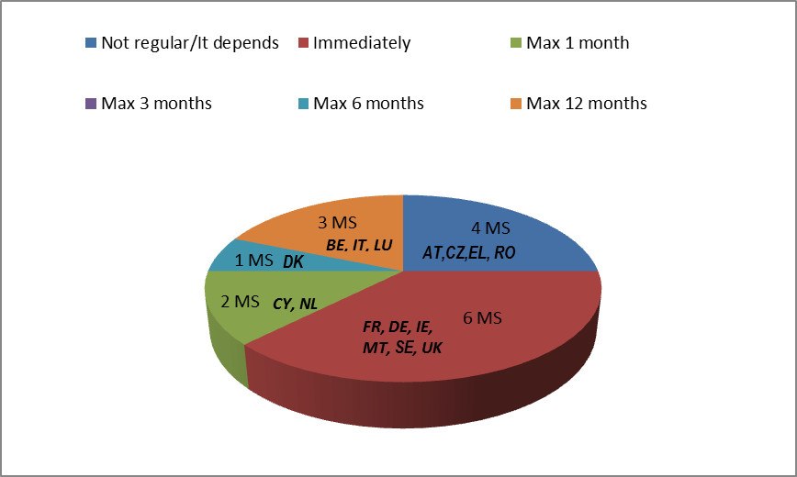
- The timeliness of VAT refunds has improved over the period 2009-2011 with some exceptions below 98 per cent (FR, HU, IE, IT, MT, RO and SI). In most Member States, the refund of VAT claim requests is subject to a deadline (22 Member States – AT, BE, BG, CZ, DE, DK, EE, EL, ES, FR, HU, IE, IT, LT, LV, MT, NL, PL, RO, SI, SK and UK), the standard effective period being between 30-45 days (please refer to Graph 10 and 11 below). The deadlines, if applicable, are generally respected, up to at least 95 per cent in all Member States in 2011, except FR, IT, LV, MT and RO. Moreover, the VAT refund process can be suspended in case of suspicion of fraud for an undetermined period in a vast majority of the Member States (18 Member States – AT, BE, CZ, DE, DK, EE, ES, FI, FR, HU, IT, LT, LU, NL, PL, PT, SI and UK). There is little information on the amount of postponed refunds, but these amounts seems to be stable or improving, over the period 2009-2011, for those Member States that disclosed the information (except for EL, FR, IT, NL and RO).
Graph 10 –Percentage of VAT refund claim paid within the deadline
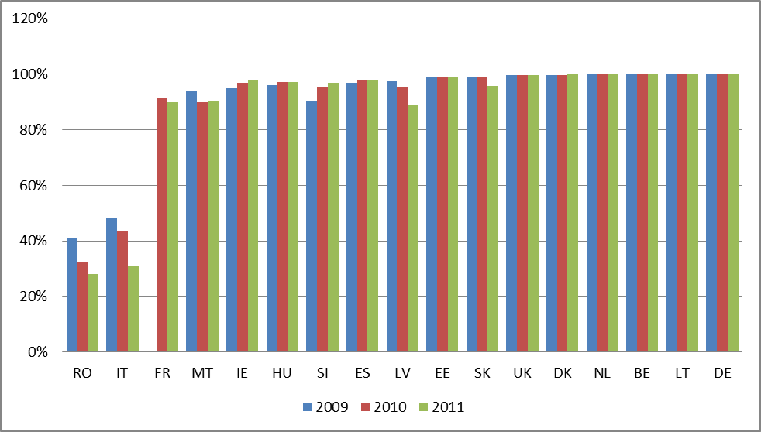

Graph 11 – Deadline for payment of VAT refund claims under national law or procedures
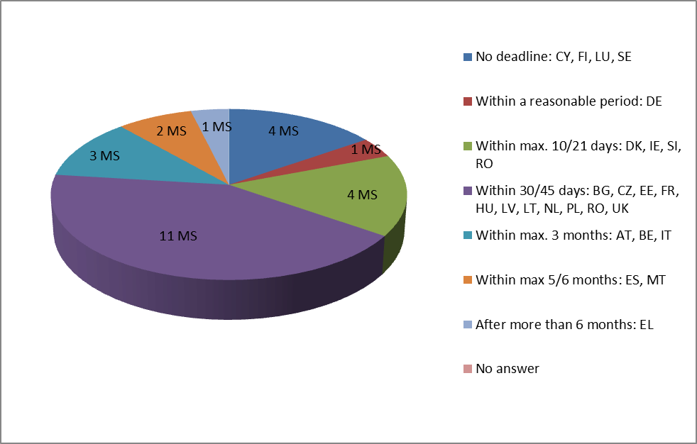
- A majority of Member States do not automatically pay interest in case of late refunds. The number of Member States automatically paying interest in case of payment of VAT refunds after the deadline is unsatisfactory (12 Member States-CZ, DE, DK, EE, ES, FI, FR, HU, MT, PL, SI and SK), with 5 Member States per cent not applying interest (AT, CY, LU, NL and UK).
Graph 12– Payment of interest in case of late VAT refund
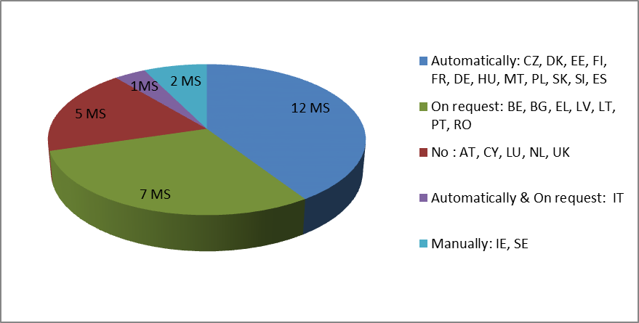
- Filing compliance is decreasing for recapitulative VIES statements. The overall percentage of recapitulative statements filed in time has decreased significantly between the period of 2009 and 2010 (-6 per cent) and has become stable since then to reach an average of 84 per cent which remains low.
Graph 13 – Percentage of VIES recapitulative statements filed in time
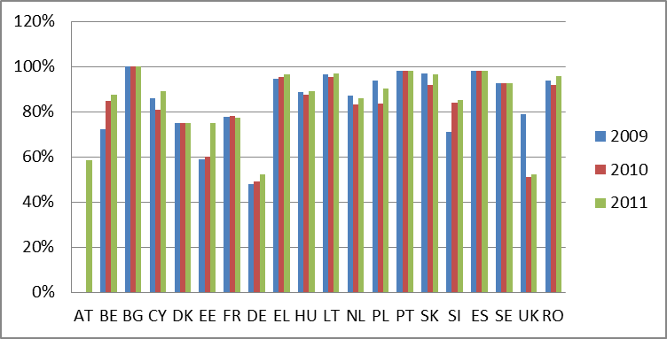
Conclusions
- Although the median filing ratio in the EU is around 96 per cent, it can be significantly improved in a number of Member States. Modern and automatic end-to-end processes are often missing. A systematic and immediate estimated assessment in case of non-filing would contribute to a better filing ratio. The efficiency of interest and penalties schemes for late filing and payment needs further examination. The register of taxable persons is not being kept up to date may be another factor contributing to a low filing ratio. Electronic filing is increasing, but not in line with reasonable expectations.
- The timeliness of VAT refund of VAT claims has improved over the period 2009-2011. The standard effective period is between 30-45 days. However, there are some Member States where timely VAT refunds remain problematic. And the majority of Member States do not pay automatically interest in case of late refunds.
- Filing compliance is decreasing for recapitulative VIES statements, The forthcoming Commission report on administrative cooperation in the field of VAT will examine this issue in further detail.

CHAPTER 5: VAT Collection and Recovery
Overall Benchmarks
- The stock of tax debt is stable at less than 10 per cent of annual tax revenues. The backlogs of old debts are regularly reviewed for collectability and appropriate write-off policies are in place. A strong headquarters develops debt collection policies and strategies and monitors national debt collection performance. Debt collection operations are consolidated into a small number of offices and conducted by a full time work force of specialized collection staff. The function is highly automated and includes: (i) computer generated notifications, reminders and warrants; (ii) automatic identification of assets based on third party information and (iii) automatic offsetting of tax credit entitlements against outstanding debts. Debtor profiling tools assist in targeting the most effective means of collecting overdue payments. Out-bound telephone call centres make early contact with new debtors. The administration has a structured and transparent approach for instalments schemes and there is an automatic identification system of assets based on third party information and debtor profiling tools. A holistic government approach is taken to coordinating collection of tax and social security contribution debts.
Current Situation
- The stock of arrears is high and increasing in most Member States. The median for the stock of debts is 11 to 13 per cent of annual tax revenues. However, the stock of VAT debt at the end of the year in terms of percentage of annual revenue is reaching 19 to 23 per cent on average over the period of 2009-2011. Considering the current financial and economic crisis, the stock of VAT debt has increased in most of the Member States by an average of 9 per cent. Only 6 Member States have reduced their stock by more than 4 per cent (AT, BE, HU, LU, SE and UK). This has not offset the position of a few Member States which have significantly increased the same stock by 19 per cent or more, particularly CY and MT (19 per cent), EL (21 per cent), LV (27 per cent), SK (31 per cent) and SI (91 per cent). The growth in VAT arrears is of concern, but can at least be partly explained by the recession. Graphs 14 and 15 depict the situation and evolution of the arrears inventory from 2009 onwards.

Graph 14 – Stock of VAT debt at the end of the year
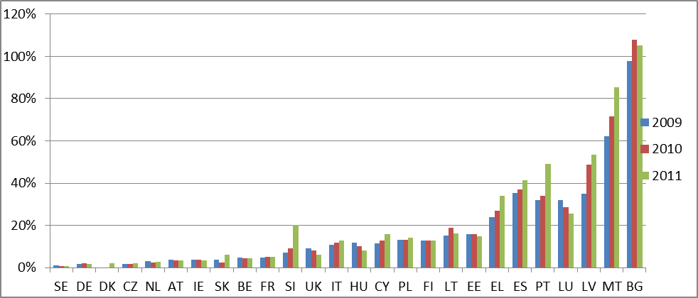
Graph 15 – Stock of VAT debt at the end of the year (growth)
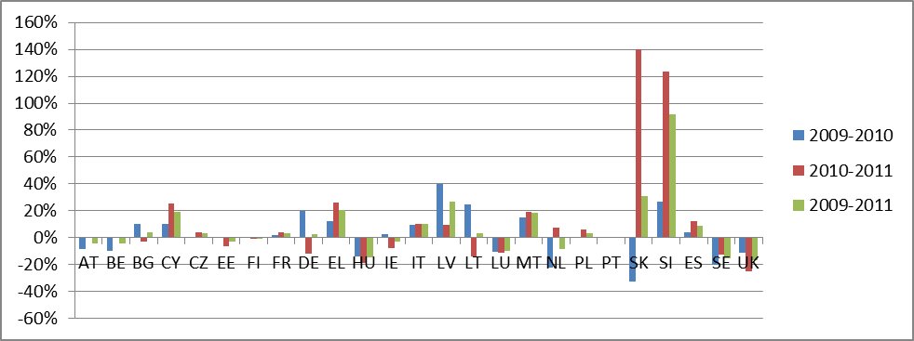
- The absence of debt write-off in a number of Member States gives a distorted picture of the stock of tax debts that are truly collectible. The level of write-offs is low and even close to zero in BG, CY, EL, FI and MT. Without an on-going write-off programme, the tax administration risks wasting valuable resources pursuing uncollectible amounts as attention is diverted from collectible debt. Debts proven uncollectible at a reasonable cost should be subject to a flexible write off procedure. Graph 16 depicts the position of the VAT write-offs in most Member States over the period 2009-2011.
Graph 16 – Value of the VAT write-offs in percentage of vat revenue
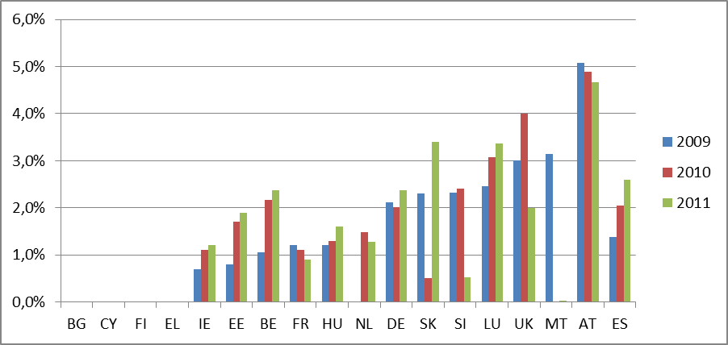
- In a significant number of Member States the debt collection function is not managed from an end-to-end perspective. A coherent approach is required which manages the debt collection process from the time the debt is established until it is extinguished. Many Member States do not have a central or local real-time system to report on the stock of VAT debts (5 Member States –DE, EL, PL, SK, UK- as regards a per-debtor reporting and 7 Member States –DE, EL, HU, PL, SE, SK, UK as a whole). Only 3 Member States (ES, IT and PT) have a fully integrated recovery process which is supported by an automatic identification of assets based on internal or third party information. While 10 Member States (BE, BG, CZ, DK, FI, HU, IE, LT, SE and SI) have partially integrated such a process.
Graph 17 – Automated identification of asset system supporting the recovery process and based on third party information
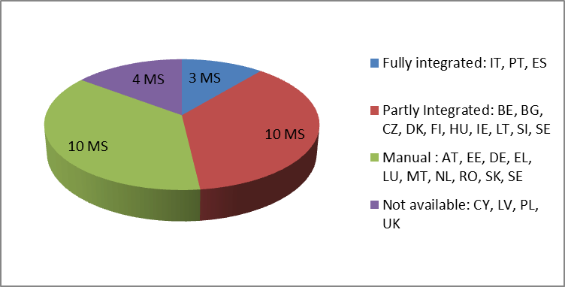
- There is a clear trend towards non-sequential debt collection processes. About half of all Member States use automatic debtors profiling tools in order to differentiate the recovery process between low, medium and high risk debts (AT, BE, BG, DE, ES, FR, HU, IE, LT, LU, LV, PT, SE and UK). Moreover, in 19 Member States (AT, BG, CY, DE, DK, EE, EL, FI, HU, IE, LT, LU, LV, MT, NL, PL, PT, SE and SI) there is systematic special procedure for new debtors, involving in many cases outbound call centres. Graph 18 depicts the use of non-sequential debt collection processes.
Graph 18 – Distinction between low, medium and high risk debts
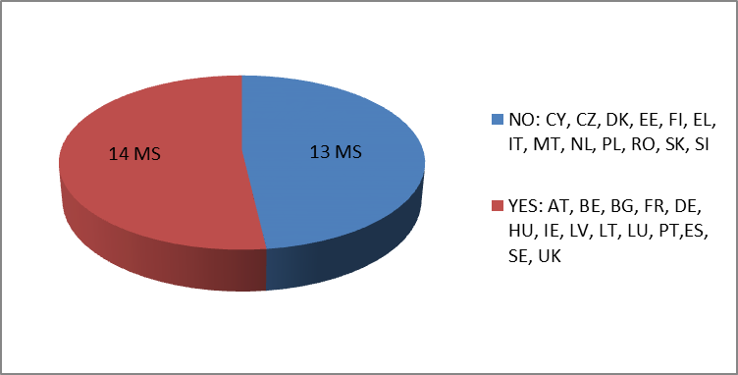
- The policy on instalments schemes is diverse. A small number of Member States do not apply instalments schemes for VAT. 4 Member States most frequently apply settlement arrangements for periods of less than 6 months (CY, LU, SK and UK). 12 Member States apply settlement arrangements for 6 to 12 months (BE, CZ, DK, EE, ES, HU, LV, MT, NL, PT, SE and SI) and 5 Member States for 12 to 24 months (AT, FI, FR, IE and LT). Within the scope of this exercise, the correlation with the performances of the Member States in terms of management of the VAT debt is difficult to establish. Nevertheless, the Member States who perform well in this respect have generally a 6 month deadline with a maximum of 12 months (HU, NL and SI). Table 3 below depicts the four categories in which the Member States can be ranked when considering the value of their instalment arrangements compared to their outstanding VAT debts and can be correlated with the Graph 19 describing the length of the instalment periods.
Table 3 - Value of instalment arrangements in percentage of total outstanding VAT debts at year end – average performance of Member States group over 2009-2011
1st Group | CY, CZ, DK, ES | 21%
2nd Group | NL, IE, HU, SI | 9%
3rd Group | AT, BE, EE, PL, LV, LT, MT | 4%
4th Group | BG, DE, UK | 0.21%

Graph 19 – Possible instalment procedures
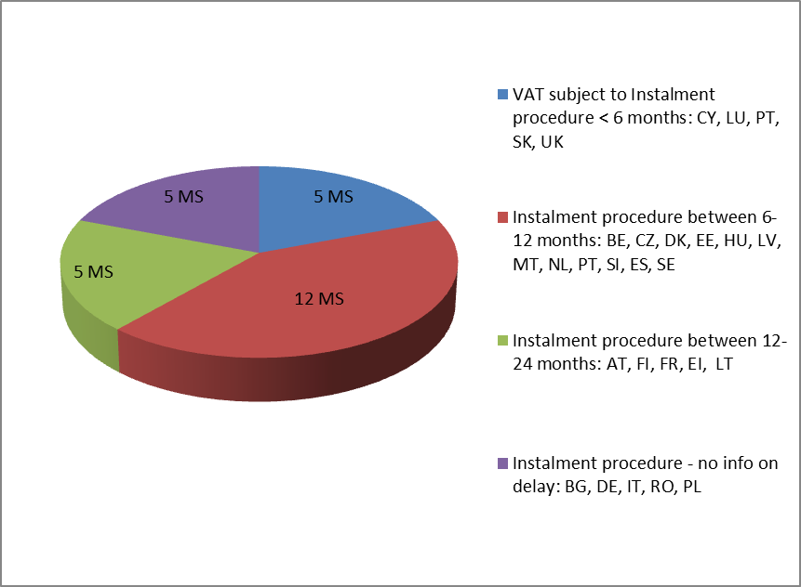
- Little use is made of offsetting arrears against tax credits. Only 13 Member States (AT, CY, CZ, ES, FI, HU, IE, LT, PL, PT, SE, SI and UK) offset only automatically tax VAT refunds against outstanding VAT debts and 7 Member States (AT, ES, FI, HU, IE, SE and SI) offset only automatically VAT credit entitlements against outstanding other taxes.
- The percentage of enforced collection in relation to the total collection are heterogeneous. One explanation is that the legal definition of enforceable debt differs amongst the Member States which has a significant impact on practices and data. The average performance is 10,79 per cent nonetheless.
Graph 20 – Percentage of enforced collection in relation to total collection
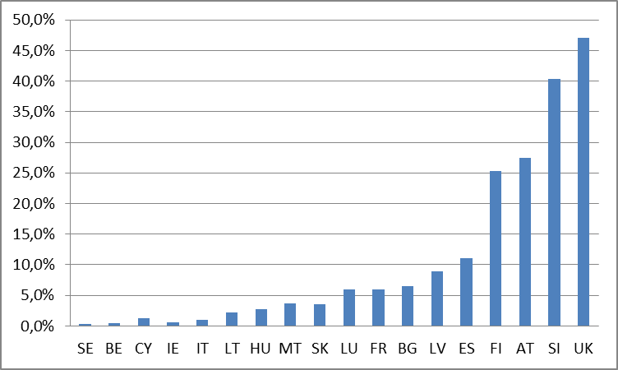
- There is a trend to combine tax and social security contribution debts offering significant economies of scale. Tax and social security claims are recovered by the same authorities in the following Member States: BG, DK, EE, FI, LV, NL, RO, SE, SI, and the UK.
Conclusions
- There is a growth in VAT arrears which can be, at least partly, explained by the recession. The increase in the stock of debts is in particular a concern in EL, ES, SI and SK.
- The absence of write-off procedures in many countries makes it difficult to compare the level of collectable debts. Debts proven uncollectible at a reasonable cost should be subject to a flexible write-off procedure.
- Efforts have been made to increase the efficiency of the debt collection. There is a clear trend towards non-sequential debt collection processes as well to combine tax and social security contribution debts. Around half of the Member States (BE, BG, CZ, DK, ES, FI, HU, IE, IT, LT, PT, SE and SI) have implemented fully or partly integrated recovery processes supported by automatic identification of assets based on internal or third party information.

CHAPTER 6: VAT Audit and Investigation
Overall Benchmarks
- The audit programme includes a range of audit approaches and a risk-based enforcement plan that, together with taxpayer services, provides a balanced approach to promoting voluntary compliance. A risk based management system should be in place for the selection of taxpayers to be audited. The existence of such risk management system allows allocating audit resources according to the taxpayers' risk. The tax administration has an appropriate number of staff with adequate training. The audit managers and staff are well trained and display a high level of professionalism and integrity in their dealings with taxpayers.
There is a separation of duties throughout the audit process with checks and balances in place to minimize opportunities for corrupt dealings. VAT audit results rely on sound evidence that is not disputed in an administrative or judicial appeal phase.
An annual operational plan is developed, implemented, and monitored to achieve a suitable level of operational performance (e.g., audit coverage of key taxpayer segments productivity of audit staff and revenue outcomes). Auditors have access to guidance on tax technical and procedural topics to ensure consistent and equitable decisions in the field and are equipped with modern audit tools (laptops, analytical software, etc.).
Current Situation
- The majority of Member States have mentioned a risk-based strategy decided centrally as a way of selection of taxpayers to be audited. Nevertheless, there are 5 Member States that do not have a risk-based strategy decided centrally as a way of selection of the taxpayers to be audited (EL, ES, LU, PT and RO) and the selection is partly made by the central headquarters and partly locally. Altogether 7 out of the 27 Member States (AT, DE, IE, IT, FI, PL and SI) have an express obligation to audit some taxpayers for all years. Even assuming that this obligation is only valid for large taxpayers, it prevents Member States from having the flexibility to allocate audit resources to taxpayers that represent higher risk.
- There are huge differences in EU Member States regarding the percentage of taxpayers that are subject to field audits. The median is around 2 per cent, but the average is around 6 per cent. The average is influenced by a group of Member States that have field audits to more than 10 per cent of the taxpayers (DE, HU, LT and MT).

Graph 21 – Percentage of taxpayers subject to field audits (2011)
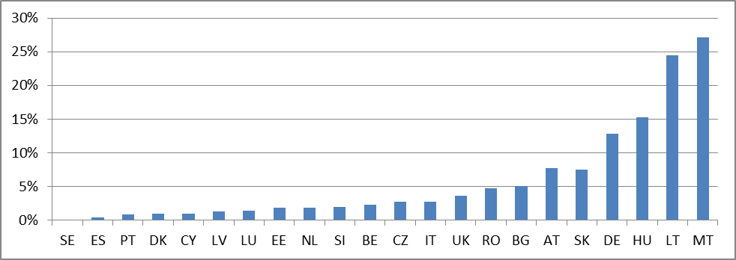
- There are also big differences in the percentage of VAT refunds that are subject to field audits. While 13 Member States (BE, BG, DK, EE, ES, FR, LT, LV, NL, SE, SI, SK and UK) have restricted field audits to less than 4 per cent of VAT refund requests, with some having 0.2 per cent or less (EE, LT, NL, SE and SI), there are 2 Member States (CY and HU) where more than 20 per cent of the VAT refunds requests are subject to field audits and in France 7 per cent of these requests are subject to in-depth audits.
- The differences in approach amongst Member States is also visible in the dichotomy between full audit/targeted audit. Of the 22 Member States that mentioned the percentage of full audits (AT, BE, BG, CY, DK, EE, ES, FI, FR, HU, IE, IT, LT, LU, LV, MT, PT, RO, SE, SI, SK and UK), 6 (BE, BG, CY, DK, FI and FR) have more than 80 per cent in all years, while the average (including these Member States) is close to 50 per cent.
Graph 22 – Percentage of target audits
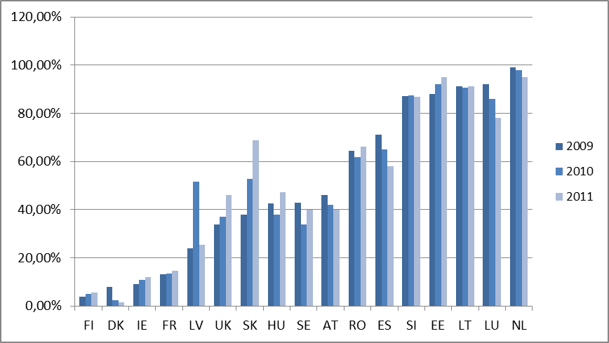
- The median of additional VAT assessed as a result of controls is around 3,7 per cent, but this value is significantly higher in some Member States. The results confirm the limited impact of audit in addressing tax fraud and evasion and the need for it to be seen as one of many tools to address this issue.
Graph 23 – Amount of additional VAT assessed as a result of the controls as percentage of the total VAT revenues
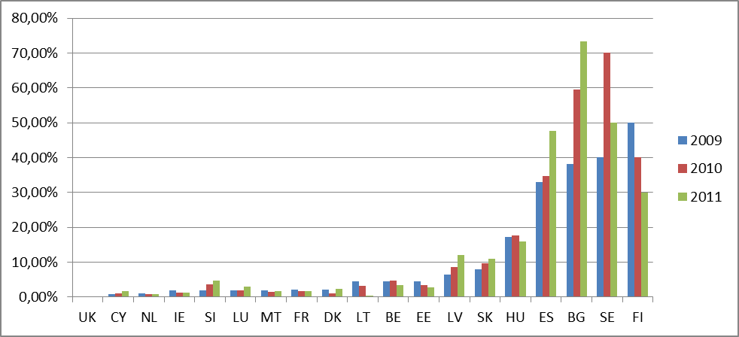
- Five Member States (CY, DK, FI, LU and MT) have mentioned that they do not have performance indicators to assess the effectiveness of their audits. With a large number of staff involved in audit tasks, tax administrations have to regularly assess the effectiveness of their audit work, in order to allocate resources accordingly.
- A large majority of Member States indicated that taxpayers must provide data in computer-based systems during tax audits. With the large number of transactions that even a medium-sized company makes and with electronic invoicing gaining importance, it is impossible for tax auditors to carry out their work efficiently with old-fashioned paper-based audits. It is natural that tax auditors should have the means to analyse data that is provided in computer-based systems. Nevertheless, most Member States do not have the obligation for taxpayers to have a Standard Audit File, which could represent additional gains in terms of efficiency and effectiveness of audit work.
- Most Member States have access to a wide range of categories of third party information, but not always in an automated manner. Effective audit work should not rely solely on the data collected from the taxpayer, but auditors should prepare in advance their audits by having access to relevant third party information. The level of access to third party information for audit work varies within the EU Member States, but there is a clear trend to provide auditors with more information. For some categories of information (e.g. real estate register and vehicle register) most Member States have automatic access to such information, while for other categories (e.g. social security and financial institutions) most tax administrations need to make a request before access to the information is allowed. The fact that important information is only available on request may prevent it from being obtained in time to be used during the audit and may as well discourage auditors from requesting it simply to avoid the additional burden.
- The majority of Member States frequently request information from other Member States. In a globalised economy, in which many companies have transactions with economic operators established in other countries, it is essential that auditors can get information from other Member States to assess correctly the tax situation of the companies being audited. However, though Member States do use this possibility frequently, there are still significant obstacles (legal, speed, quality of reply and language) that hamper the effectiveness of this tool.
- All Member States have indicated that there is a review, either systematic or occasional, of audit reports. This is important to ensure the level of professionalism that is expected from audit work and to minimise the occurrence of corruption, guaranteeing at the same time that audit reports rely on sound evidence avoiding unnecessary disputes with taxpayers.
- It is important to ensure that the auditors have adequate training and have the technical knowledge to produce high quality work. The median of training days per auditor is 5, with RO mentioned 30 days, which would mean that an auditor would spend on average close to 15 per cent of its working time on training.
Graph 24 – Annual Training Days per Auditor
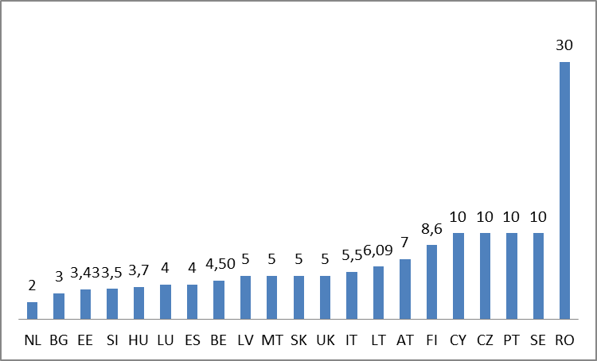
- The large majority of Member States provide e-audit training, divided almost equally between the group that provides this training to all auditors and those who provide it only to e-audit units. Only two Member States (IT and MT) do not provide any e-audit training. As all Member States mentioned the obligation for taxpayers to provide data in computer-based systems, it is important that tax auditors have the possibility of handling the data in an effective way, which requires the use of e-audit tools.
Graph 25 – Specific e-auditing training
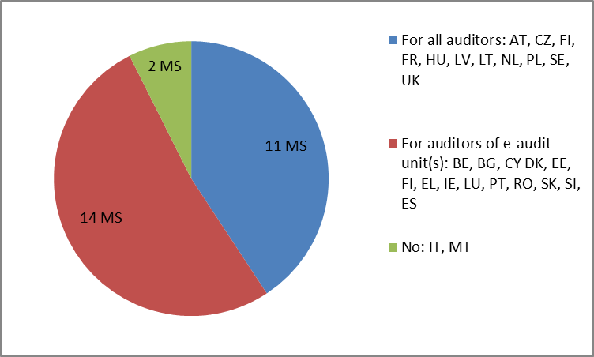
- The majority of Member States have specialized VAT anti-fraud units. Eight Member States still lack such units (AT, CZ, EE, EL, FI, HU, LV, RO and SI). The investigation of potential fraud cases requires a set of skills completely different from audit work. This task needs to be performed by trained investigators integrated in teams that are able to analyse fraud trends and identify early signs of fraudulent activity.
Graph 26 – Specialized VAT anti-fraud units
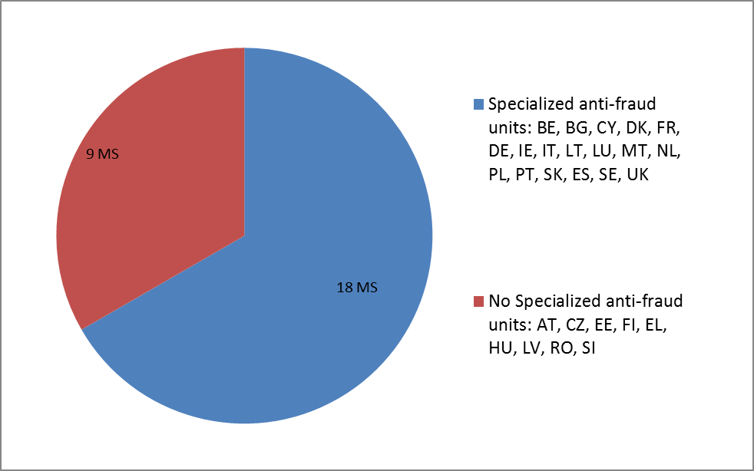
Conclusions
- The majority of Member States apply a risk-based strategy to the selection of taxpayers to be audited. However, 7 Member States (AT, DE, FI, IE, IT, PL and SI) still keep the obligation to audit some taxpayers for all years. This obligation prevents an optimal allocation of audit resources according to risk and prevents tax administrations from rewarding companies that voluntary comply with their tax obligations with less frequent audits.
- There has been a trend for the increase of number of targeted audits. However, in some Member States full audits are still the norm which prevents more focused and efficient audits making full use of the third party information collected before the audit procedure.
- E-auditing is well developed in many Member States. A large majority of Member States have the obligation for taxpayers to provide data in computer-based systems during tax audits and 24 Member States (AT, BE, BG, CY, CZ, DK, EE, EL, ES, FI, FR, HU, IE, LT, LU, LV, NL, PL, PT, RO SE, SI, SK and UK) provide e-audit training to their auditors. However, only a limited number of Member States have already introduced the obligation for a Standard Audit File in their legislation, which would result in efficiency gains in audit work.
- The use of third-party information for audit purposes is widespread. The majority of Member States make use of third party information to prepare their tax audits and make regular use of administrative cooperation requests for information from other Member States. Nevertheless, Member States identify significant obstacles that limit the usefulness of administrative cooperation (legal, speed, quality of reply and language).
- The majority of Member States have created VAT anti-fraud units with specialised investigators. Only 8 member States (AT, CZ, EE, EL, FI, HU, LV, RO and SI) do not tackle VAT fraud in a distinct and autonomous way.

CHAPTER 7: Tax Dispute Resolution System
Overall Benchmarks
- The dispute resolution process helps build community confidence in the tax system and reduces collection risks by ensuring the quick and equitable resolution of disputes. In an ideal situation a taxpayer can appeal against decisions by the tax administration in a codified, transparent, fast and low-cost tax dispute resolution system. This system includes a fast and efficient administrative appeal process, independent of the original decision-maker (usually an auditor), before addressing the dispute to the Courts. This administrative appeal process must ensure that only cases of legislative substance are submitted to the judicial appeal process. Payment of the disputed tax is required when a request for judicial review is made and there is minimal backlog of unheard cases. Therefore, there are specialized units and officers specially trained in dealing with tax disputes in or outside the tax administration. The tax administration is able to manage the tax dispute resolution system based on management information data. These data allow the tax administration if needed to adjust their practices.
Current Situation
- Most Member States have a compulsory administrative dispute resolution process. In the case of disagreements with a final decision of the tax administration, the majority of Member States (14 Member States) replied that the first stage in the tax dispute resolution process is an obligatory administrative appeal procedure within the tax administration. Other 5 Member States (DK, EL, ES, MT and SI) have an obligatory administrative procedure outside the tax administration (for instance, an appeal body at the Ministry of Finance or an administrative committee). In 7 Member States (BE, BG, CY, EE, EL, FI and IT) the dispute is directly dealt by the Court of First Instance. 4 Member States (BG, EL, IT and UK) offer the taxpayer a choice resulting in a dispute resolution system with multiple entries. Graph 27 depicts the first step of the dispute resolution process.
Graph 27 – First stage of the dispute resolution process
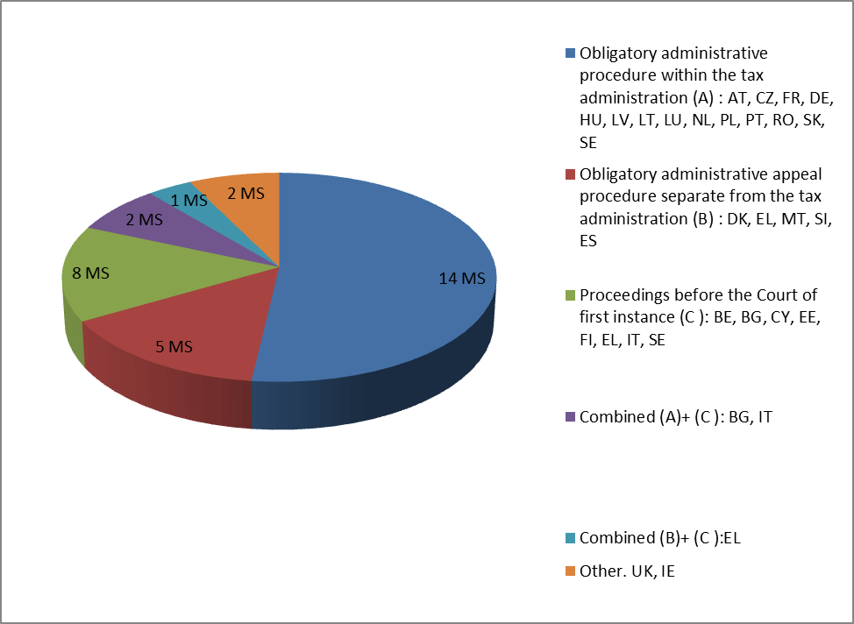
- Only a minority of Member States do not have deadlines for decisions in the administrative appeal process. Most Member States (21 Member states- AT, BG, CY, CZ, DE, DK, EE, EL, ES, FR, HU, IT, LT, LV, NL, PL, PT, SE, SI, SK and UK) apply deadlines for decisions in the administrative appeal process. These deadlines vary between 2 months (10 Member States-DE, EE, HU, IT, LT, LV, NL PL, SE, SI and SK), and one year (10 Member States-AT, BG, CY, CZ, DK, EL, ES, FR, IT and PT). In a minority of Member States no deadline is applied (6 Member States - BE, FI, IE, LU, MT and RO).
Graph 28 – Applicable deadlines in Administrative Appeals
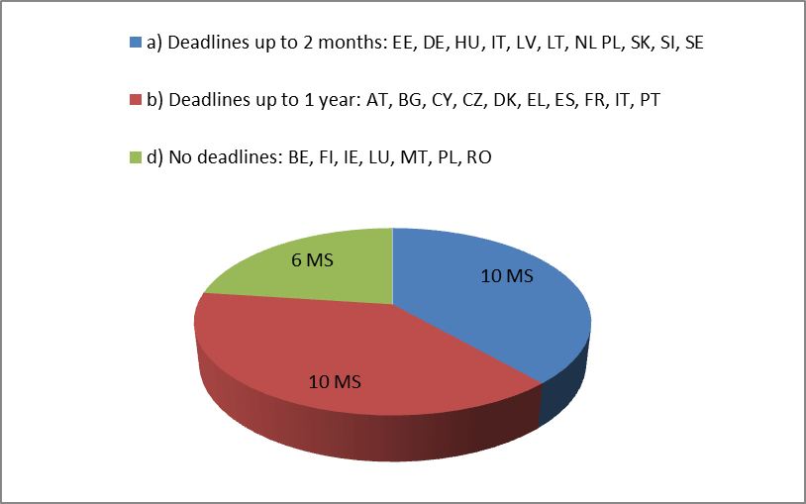
- In the majority of the Member States the disputed amounts remain fully or partly collectable during the appeal process. There are two main approaches towards the consequences of VAT collection in case of a VAT dispute, i.e., no postponement of the payment of VAT to the State budget (14 Member States-BG, DE, DK, EE, EL, ES, FI, FR, HU, LU, PL, RO, SI and UK) or postponement only of the disputed amount of VAT (12 Member States –AT, BE, CY, CZ, DE, IE, LT, LV, MT, NL, SE and SK). Only few Member States (3 in both cases) postpone a part of the disputed amount of VAT (DE, EL and IT) or all the assessed VAT (EL, PL and PT).
- The percentage of decisions fully or partly in favour of the taxpayer varies significantly across Member States. The average percentage of decisions in the first stage of the appeal process fully in favour of the taxpayer ranges differs between 1 and 61 per cent. For most Member States, the percentage is between 11 and 28 per cent over 2009-2011. Taking into account the second stage of the appeal process the percentage increases by a few points. Graphs 29 to 32 depict the number of decisions fully or partly in favour of the taxpayer, respectively at first and second stages.
Graph 29 – Percentage of decisions in favour of the tax payer after first stage compared to the number of total appeals
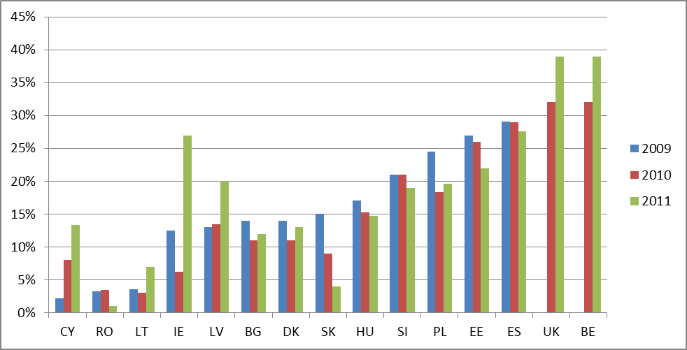
Graph 30 –Percentage of decisions in favour of the tax payer after second stage compared to the number of total appeals
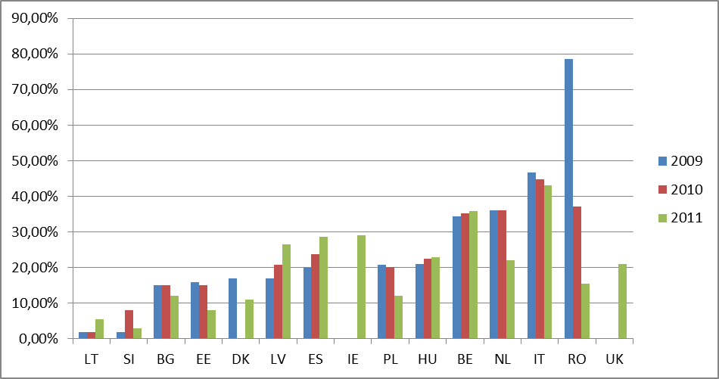
Graph 31 – Percentage of partially favorable first stage of decisions compared to the number of total appeals
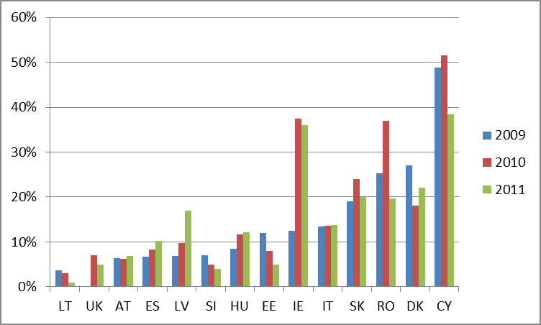
Graph 32 - Percentage of partially favorable second stage of decisions compared to the number of total appeals
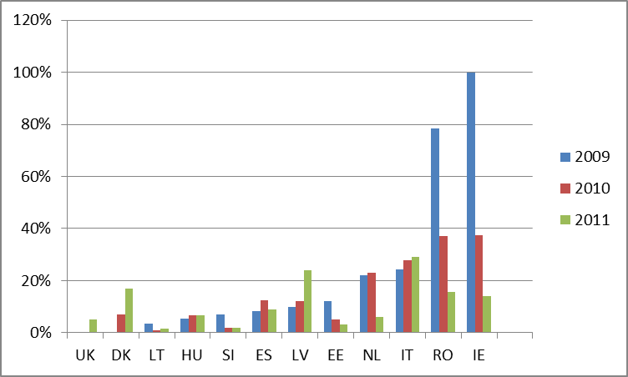
- In general the dispute resolution process is not managed from an end-to-end perspective. The collection of management information (data) is not a common practice. Several Member States do not have any information about their tax dispute resolution process. Others have only fragmented data available.
- There are significant differences in the efficiency of the dispute resolution in the Member States. The number of administrative appeals varies significantly amongst Member States. The number of administrative appeals varies between 7.039,00 and 10.997,00 on average, per Member State. This number, if compared to the VAT taxpayer population, equals 1,76 per cent on average with a maximum of 10 per cent (AT) (see Graph 33 below). Also the number of pending appeals varies significantly amongst Member States (see Graph 34 below), with, mostly, no direct correlation to the number of appeals. This suggests large differences in the efficiency of the dispute resolution process in Member states.
Graph 33 –Percentage of Administrative Appeals in 2011 compared to VATable persons
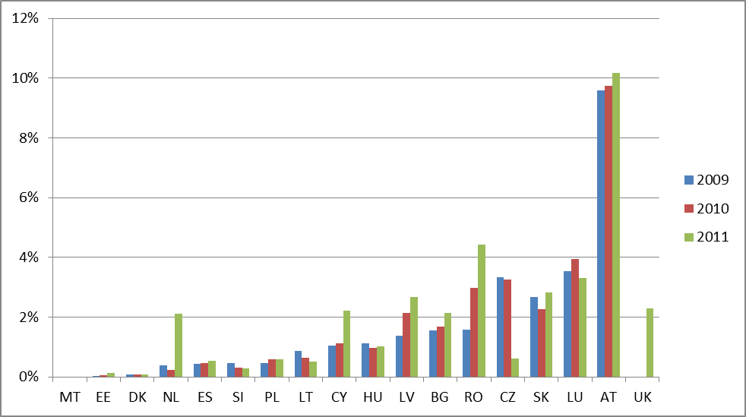
Graph 34 – Percentage of Pending Appeals compared to VATable persons
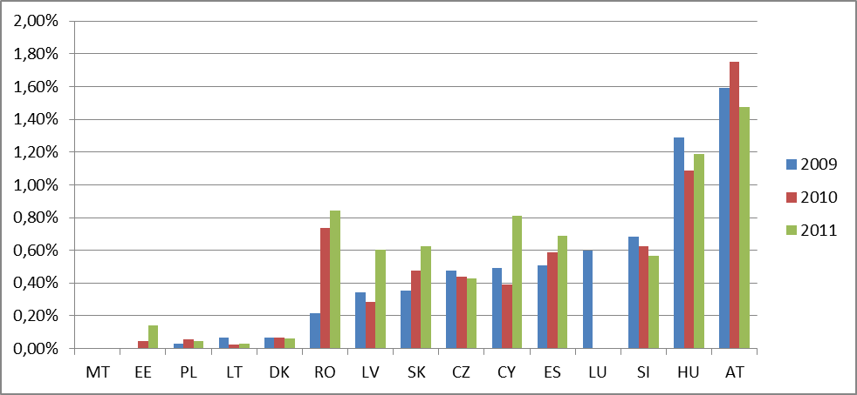
Conclusions:
- The organisation of the procedure differs, but most Member States have a compulsory administrative dispute resolution process. Such an approach focuses on the efficiency of the appeal procedure. It helps to clarify fact-based disputes, where the judicial phase will rather focus on the legal aspects and the quality of the appeal procedures. It contributes to reducing the number and length of appeals. Some countries have a separate tax tribunal as a first step in the judicial process as an appropriate alternative to the administrative phase. This confirms a trend to guarantee both the efficiency (number and duration) and the quality of the appeal procedure.
- Most Member States have deadlines for the administrative appeal procedure. This speeds up the dispute resolution and again confirms the focus on the efficiency of the procedures.
- The number of appeal varies but is high in certain Member States as well as the number of appeals in favour of the tax payer. Where possible, potential sources of tax disputes should be eliminated and tax administrations should work to establish an environment that minimises unnecessary disputes. This requires preventive measures such as, inter alia, clear and well-drafted laws and regulations, effective taxpayers services, binding rulings and high quality audits.
- In half of the Member States the disputed amounts remain full or partly collectable during the appeal process. This is good practice that safeguards revenue and avoids abuse of the appeal procedures.
- Many Member States do not collect sufficient information on their tax dispute resolution process. The collection of management information on disputes is not a common practice. All aspects of the appeal process should be monitored, including through the use of key performance indications. Increasing the number and the speed of the dispute resolution process requires an end-to-end approach, whereby the outcome of the appeals feeds into dispute preventive measures and gives rise to adjustments to the tax payers' services, clarifications of laws and regulations, etc.

CHAPTER 8: VAT Compliance
Overall Benchmarks
- The tax administrations follow a Compliance Risk Management Strategy, intervening to promote compliance and preventing non-compliance based on the knowledge of taxpayer behaviour. There is a risk based segmentation of taxpayers, allowing tax administration to interact with taxpayers according to their risk pattern. Tax administrations provide appropriate taxpayer services, making it easier for taxpayers that want to comply to fulfil their tax obligations and enhance voluntary compliance by influencing behaviour of taxpayers.
Current Situation
- There is a trend in most Member States to develop a Compliance Risk Management Strategy approach. These strategies segment taxpayers according to their risk profile and act accordingly to the specific risks of the segment. A majority of Member States indicated that they have different compliance strategies according to taxpayer segment, mainly based on business size (24 Member States –AT, BE, BG, CY, CZ, DK, EE, EL, ES, FI, FR, HU, IE, IT, LT, LU, LV, MT, NL, PT, SE, SI, SK and UK), economic activity (17 Member States –BE, BG, CY, CZ, IE, EL, ES, FI, FR, HU, IT, LU, LV, NL, PT, SI and UK) and compliance level (16 Member States). A description of risks for different segments of taxpayers is also developed in 18 Member States (AT, BE, BG, CZ, EE, EL, ES, FR, HU, IE, IT, LT, LV, PL, SE, SI, SK and UK) and 16 Member States (BE, BG, CZ, DE, DK, EE, EL, HU, IE, LT, LV, PT, SE, SI, SK and UK) indicate that they use the results of audits to update their risk model. However, ultimately, only 4 Member States (EL, FR, HU and IT) could effectively indicate the percentage of taxpayers falling within the different layers of the compliance pyramid.
Graph 35 – Description of risks developed for different segment of taxpayers
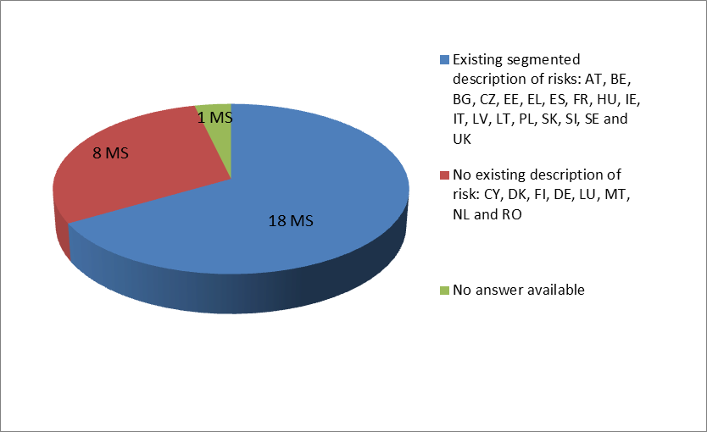
Without a clear segmentation of taxpayers into risk categories it is not clear how tax administrations can adjust their interaction with taxpayers. Furthermore, the effectiveness of the Risk Management Strategy in many Member States needs to be confirmed.
- The large majority of Member States do not have an estimate of the VAT gap and are unable to use the evolution of this indicator as a measure of the effectiveness of their tax administrations and their compliance risk management strategies. Only 5 Member States presented estimates of the VAT gap (EE, IT, PL, SK and UK).
- Member States apply different approaches to tackle this VAT gap, at different levels. The majority of Member States resort to information initiatives and the development of an information strategy (see Graph 36 below). Other Member States (18 –BE, BG, CZ, DE, DK, EE, EL, ES, FR, HU, IE, LT, LV, PT, SE, SI, SK and UK), use the systematic results of audit to update their risk model. Most Member States also give taxpayers the opportunity to request a binding ruling (18 Member States – BE, CY, CZ, DE, DK, ES, FI, FR, HU, IT, LT, LV, MT, PL, PT, SE, SI and UK), whereas only a small majority of Member States (15 - AT, BE, CY, DE, DK, FR, IE, IT, LV, MT, NL, PL, SI, SK and UK) offer voluntary disclosure arrangements.
Graph 36 – Information initiatives undertaken by the member states in the recent years
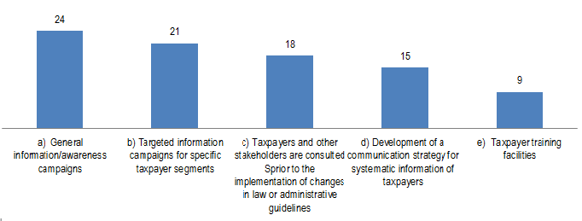
- However, the measurement of the impact on compliance of the various approaches to tackle the VAT gap can be significantly improved. Despite the development of new approaches to tackle the VAT gap in the recent years, the large majority of the Member States do not measure the impact on voluntary compliance of the various elements of tax policy. Significant efforts are, therefore, required to improve the monitoring and assessment of the performance.
Graph 37 – Measurement of impact on voluntary compliance of the various elements of tax policy
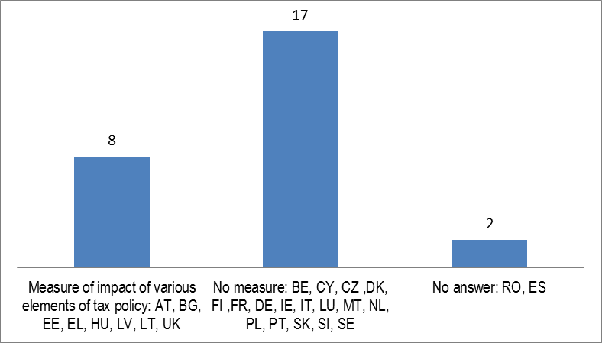
- Use of third-party information is crucial to developing a complete view of the risk of the taxpayers and to improve debt collection. There is a variety of sources made available to the tax authorities (see Graph 38 below) and, also, a trend in making increased use of data/information from third party information sources. This can nevertheless be significantly improved in particular for debt collection and tax payer segmentation.
Graph 38 – Use of third party information
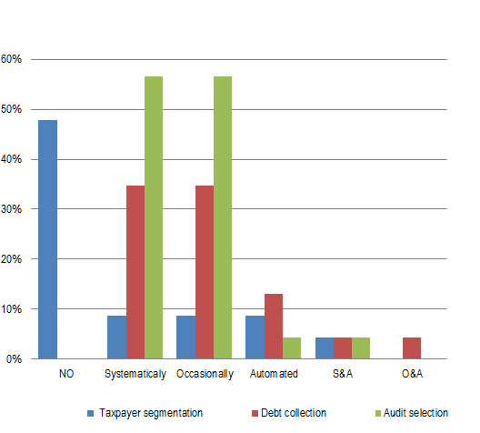
Conclusions
- There is a trend to develop and implement a compliance risk management strategy in most Member States. However, in many Member States the risk management strategy have to be further developed.
- More work could be done on the estimation of the VAT gap. Only five Member States produce estimates of the VAT gaps. The objective of a tax administration is to decrease the gap between the taxes due and the taxes collected. Without the knowledge of the evolution of this indicator, it is not possible to evaluate the effectiveness of the measures to tackle tax fraud and evasion.
- The measurement of the impact of the different components of the compliance strategy can be improved. Again only eight Member States (AT, BG, EE, EL, HU, LT, LV and UK) assess the outcome of the different measures implemented to promote of voluntary compliance, in order to identify best strategies to influence behaviour of taxpayers to voluntarily comply with their tax obligations.
- There is a trend in making increased use of data/information from third party information sources. This can nevertheless be significantly improved in particular for debt collection and tax payer segmentation.
- RECOMMENDATIONS
- In most fields a majority of tax administrations has implemented best practices. The following main recommendations are addressed to a number of Member States where improvements in the field of VAT collection and control can be made.
VAT Identification, Registration and Deregistration
- The compliance of voluntary registrations needs to further examined, in particular for those Member States where the segment has a negative VAT liability. (DK, EE, EL, FR, HU, LT, SI, SK and UK)
- Cross-check registration data with internal data sources and systematically compare with third-party information sources. (BG, CY, DE, DK, EL, IE, MT, PT, RO and SK)
- Issue clear instructions, guidelines and manuals for risk assessment at registration and on-site pre-registration visits. (BE, EL and LU)
- Implement post registration monitoring programmes for risky traders. (BG, CY, DE DK, EL, IE, LT, PT, RO and SK)
- Implement a fast-track procedure to deregister missing traders from the VAT system. (AT, CY, EL, HU, IE, PT and RO)
- Keep the information available in the VIES system up-to-date, complete and accurate. (BE, EL ES and PT)
Customs Procedure 42
- Ensure that at least the validity of the VAT identification numbers listed in box 44 of the SAD are systematically checked at the time of importation.(BE, BG, DE, EE, HU, IE, IT, LU, LV, NL, PL, PT, RO, SE, SK and UK)
- Guarantee automatic access to VIES to Customs Administration and, vice versa, ensure that all information on importations using the Customs Procedure 42 is transmitted domestically to the Tax Administrations. (EL, IT, NL and PL)
- Identify Customs Procedure 42 as an additional risk in domestic risk analysis systems and reinforce the exchange of information on transactions misusing the procedure, inter alia by active participation in Eurofisc working field nr. 3. (DE, DK, NL, PL and RO)
- Consider using licences or guarantees to prevent the misuse of the Customs Procedure 42, targeted at risky traders. (BE, BG, CY, CZ, DE, EL, FI, FR, IE, LT, LV, PL, PT, SE, SI and UK)
Submitting VAT Returns (Filing) and Payment
- Introduce modern and automatic end-to-end processes for filing and payment, including automated reminders by SMS or e-mail.(AT, BE, BG, CY, CZ, DE, ES, FI, FR, IT, LU, LV, MT, NL, PL, PT, RO, SE, SI and SK)
- Investigate the efficiency of interest and penalties schemes for late filing and payment. ALL
- Provide for compulsory electronic filing. (CY, EE, FI, HU, LT, MT, PL, RO, SE and SK)
- Consider immediate and automated estimated assessments in case of non-filing (AT, BE, BG, CZ, DK, EE, EL, ES, HU, IT, LT, LV, LU, PL, SI and SK)
- Introduce a standard effective period for VAT refund being between at least between 30-45 days.(AT, BE, CY, EL, ES, FI, IT, LU, MT and SE)
- Pay interest in case of late refunds.(AT, CY, LU, NL and UK)
VAT Collection and Recovery
- Implement best practices as regards write offs of debts proven uncollectible at a reasonable cost.(BG, CY, EE, EL, FI, IE, MT and SK)
- Reconsider policies in term of late payment interest, instalment length in line with best practice.(AT, BG, DE, FI, FR, IE, IT, LT, PL and RO)
- Implement non-sequential debt collection processes.(CY, CZ, DK, EE, EL, FI, IT, MT, NL, PL, RO, SI and SK)
- Combine collection of tax and social security contribution debts. (AT, BE, CY, CZ, DE EL, ES, FR, HU, IE, IT, LT, LU, MT, PL, PT and SK)
- Implement integrated recovery processes supported by automatic identification of assets based on internal or third party information. (AT, CY, DE, EE, EL, LU, LV, MT, NL, PL, RO, SK and UK)
VAT Audit and Investigation
- Abolish the obligation to audit some taxpayers for all years and apply risk-based systems.(AT, DE, FI, IT, NL, PL and SI)
- A risk-based selection of taxpayers to be audited should also highlight major risk areas and full audits should not be the norm.(BE, BG, CY, DK, FI and FR)
- Provide basic e-audit skills to all auditors and promote the use of e-audit tools; the number of transactions and the use of electronic invoicing preventing the effectiveness of paper-based audits.(IT and MT)
- Establish specialized VAT anti-fraud units; the requirements for staff dealing with potential fraudsters are totally different from those of regular tax auditors who deal with taxpayers who try to comply with their obligations.(AT, CZ, EE, EL, FI, HU, LV, RO and SI)
Tax Dispute Resolution
- Consider a compulsory independent administrative dispute resolution process and avoid multiple entries for dispute resolution.(BE, BG, CY, EE, EL, FI and IT)
- Consider deadlines for the administrative appeal procedure.(BE, FI, IE, LU, MT and RO)
- Eliminate potential sources of tax disputes and work to establish an environment that minimises unnecessary disputes.(AT, BG, CY, HU, IT, LU, LV, NL, RO and SK)
- Ensure that the disputed amounts remain fully or partly collectable during the appeal process.(EL, PL and PT)
- Collect management information on disputes and monitor all aspects of the appeal process, including with key performance indications.(BE, BG, CZ, DE, EL, FI, IE, FI, IT, LU, MT, NL, PL, PT, SE and SK)
VAT Compliance
- Implement a compliance risk management strategy, segment taxpayers according to their risk profile and act accordingly to the specific risks of the segment using a mix of tools.(CY, DE, DK, FI, LU, MT and NL)
- Produce reliable estimates of the VAT gaps as a mean of evaluating the effectiveness of the measures to tackle tax fraud and evasion.(AT, BE, BG, CY, CZ, DE, DK, EL, ES, FI, FR, HU, IE, LT, LU, LV, MT, NL, PT, RO, SE and SI)
- Assess the outcome of the different measures implemented to promote of voluntary compliance, in order to identify the best strategies to influence the behaviour of taxpayers to voluntarily comply with their obligations.(BE, CY, CZ, DE, DK, FI, FR, IE, IT, LU, MT, NL, PL, PT, SE, SI and SK)
- Further develop the use of third party information for audit selection, taxpayer segmentation and debt collection. ALL
************

Source: EUROSTAT
VAT theoretical liability is estimated by identifying the categories of expenditure that give rise to irrecoverable VAT and combining these with the appropriate VAT rates. The VAT gap is not a measure of VAT fraud and includes e.g. VAT not paid as a result of legitimate tax avoidance measures or VAT that is not collected due to insolvencies. Since the VAT gap is estimated primarily on the basis of national accounts data, it depends on the accuracy and the completeness of such data. Moreover, it does not take account of taxable activities that are outside the scope of national accounts.
Excluding Cyprus. Source: Case Study commissioned by the EC.
Council Regulation (EEC, EURATOM) 1553/89 of 29 May 1989 on the definitive uniform arrangements for the collection of own resources accruing from value added tax.
See footnote 2 : annex Commission staff working document/ Annex to the Sixth report under Article 12 of Regulation (EEC, Euratom) n° 1553/89 on VAT collection and control procedures COM(2008) 719 final: Summary of State of Implementation of Report Recommendations.
Croatia is not included in this working document as it was not yet an EU member when the data was being collected.
Cf. Tax administration in OECD and Selected Non-OECD Countries: Comparative Information Series (2008); 29 January 2009.
In the following Tables, "Y" stands for "YES" and "N" stands for "NO"
Federally structured tax administration. Given the particularity of the Federal Republic of Germany, which is a federation of Lander, the situation will differ according to the Lander.
Caption: ""T" stands for "Tax type" model, i.e. tax administration organization model based mainly on "type of tax" or "type of legislation" criterion, consisting in separate multifunctional departments or pillars responsible respectively for each tax, e.g. VAT and indirect taxes, Customs, Direct Taxes etc. "F" stands for "Functional" model, i.e. under this model, staff are organized according to processes by functional groupings (e.g. registration, filing and payment, IT, audit, debt collection, etc.). "TP" relates to "Tax Payers" and results from the organization of the tax administration principally around segments of taxpayers (e.g. large taxpayers, small/medium businesses, individuals, etc.). ALL" stands for a mixture of tax, functional and taxpayers type organisation. Lastly, the MATRIX model corresponds to an mixed form of organization where vertical lines are process-based and horizontal focus on taxpayers types.
In Austria, there is an anti-fraud unit at central level and correspondent units at local level. However, these units are not specialised in VAT only.
In Cyprus, there is a large trader function.
In Spain, there is a risk management function in each department (e.g. audit, collection).
In Italy enforcement of the collection of public and private debt is carried out by a separate Enforcement Agency.
In Sweden, functions such as large taxpayer function and high wealth individuals function are allocated to some regional tax offices.
In Sweden enforcement of the collection of public and private debt is carried out by a separate Enforcement Agency.
In order to compute this average, we have considered all thresholds in place in the 21 Member States who have set up such kinds of thresholds (i.e. 25 occurrences, since EL, FR and IE have several thresholds).
The national thresholds are converted in Euro according to the exchange rate of the ECB on the 30 December 2011.
The net VAT liability is the VAT due minus the VAT deductible or refunded.
According to the EU definition, micro enterprises have a turnover up to € 2 million.
The option for registration is in Article 290 of the EU VAT Directive.
In France, cross-checking of data is not possible due to legal constraints and regulations governing the protection of IT personal data.
Rejected registrations in percentage of 2011 number of taxpayers
This facility will be available for the UK during 2013.
Article 22 of COUNCIL REGULATION (EU) No 904/2010 of 7 October 2010 on administrative cooperation and combating fraud in the field of value added tax, published in OJ 12.1.2010 L 268/1.
See Article 23 a) and b) of the above mentioned Council Regulation 904/2010.
See article 33 of Council Regulation No 904/2010.
In France, a systematic and automatic control system is introduced with effect from 1 June 2013.
The NL has a general domestic reverse charge mechanism for VAT due upon importation As there is no exemption of VAT upon importation, the recommendations listed for this procedure in the report are not applicable to these types of importations. This does not, however, exclude that there could be importations where the Customs 42 procedure is used, and for which the comments made are valid.
Poland is currently in the process of becoming an active participant of the Eurofisc.
Special Report No 13//2011 - Does the control of the customs procedure 42prevent and detect VAT evasion? - from the European Court of Auditors refers, in its Recommendation 4, that "the Commission should encourage the automatic verification of the validity of VAT identification numbers in VIES in the Member States customs electronic clearance systems".
No information was made available by DE and FI.
In Spain, electronic filing of VAT returns is obligatory for certain groups of taxpayers, e.g. large taxpayers. In the Czech Republic and France, electronic filing of VAT returns is obligatory as of 1 January 2014.
In France, notifications are sent by written letters due to legal effects.
Taxpayers that have stopped to comply with the VAT return filing obligation.
Fifteen Member States did not provide data.
The UK does not automatically pay interest in all cases of late refunds, but the UK does pay repayment supplement where HMRC delay (excluding reasonable enquiry time) resulted in late refunds in relation to VAT return repayment claims.
DE and UK showing significant decreases over the period 2009-2011.
Statements to be filed by taxable persons making intra-Community transactions.
Growth in the stock of VAT debt at the end of the year calculated as a percentage of annual VAT revenue. For Romania, there were no figures available.
CZ is excluded since the delay for the instalment procedure can be up to 6 years as a maximum which corresponds with the general deadline for paying taxes in CZ. Nevertheless, the CZ tax administration may determine a shorter period usually based a case-by-case assessment.
In the UK the deadline for seeking review or appeal is 30 days.
In Spain, in case of a tax dispute, the debt collection is generally not postponed. However, it can be postponed if the debtor guarantees the amount of the debt by the endorsement of a credit institution or by a mortgage.
In France, the debtor can request the postponement of the payment of de disputed amount.
In the UK, the taxpayer does not have to pay the VAT in dispute prior to the appeal if either HMCR or the appeal tribunal on appeal are satisfied that payment would result in hardship.
In Poland, the postponement of the disputed amount is only for the period of the administrative appeal process (approximately 2 months).
The second stage can include all kind of courts, arbitration body or mediation body. In Spain, the second stage is also an administrative court.

