 | 
COUNCIL OF  THE EUROPEAN UNION |  |  | Brussels, 25 February 2014
 | Interinstitutional File:  2013/0408 (COD) |  | 6924/14
DROIPEN 31
COPEN 67
CODEC 566
INST 133
PARLNAT 68

OPINION
from: | The Italian Senate
date of receipt: | 19 February 2014
to: | Council
Subject: | Proposal for a Directive of the European Parliament and of the Council on procedural safeguards for children suspected or accused in criminal proceedings  [Doc. 17633/13 DROIPEN 159 COPEN 236 CODEC 2930 - COM(2013) 822 final]  - Opinion on the application of the Principles of Subsidiarity and Proportionality

Delegations will find attached the above mentioned Opinion.

_____________

Encl.

ANNEX
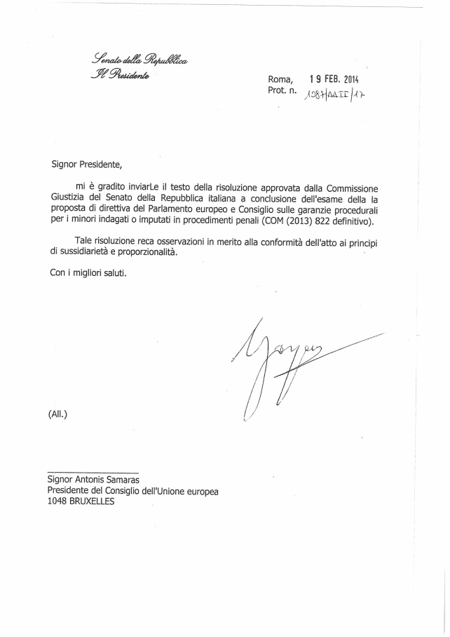
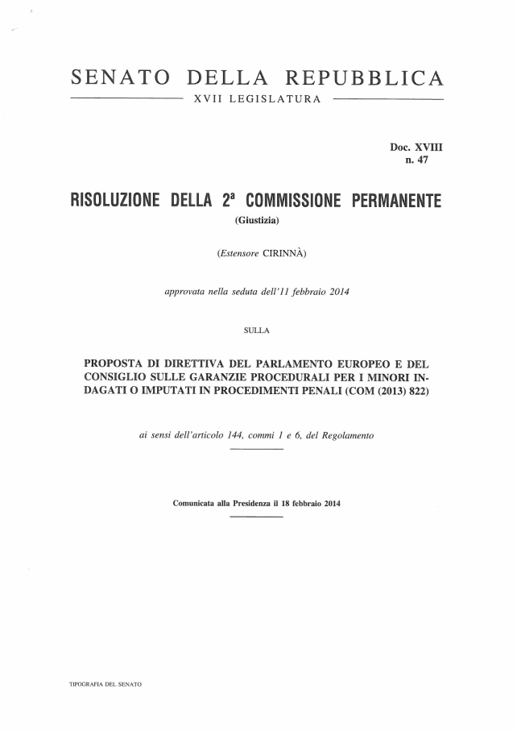

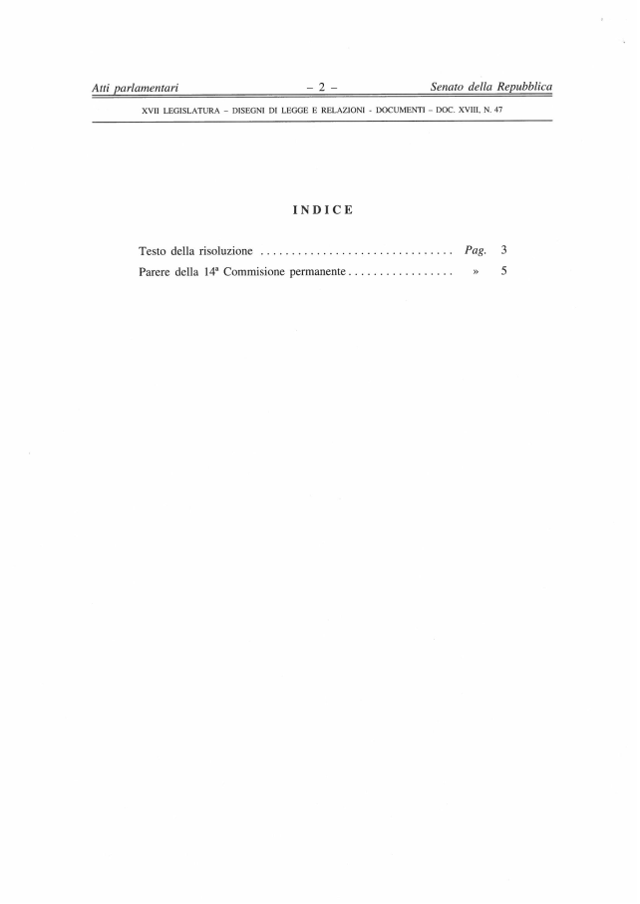

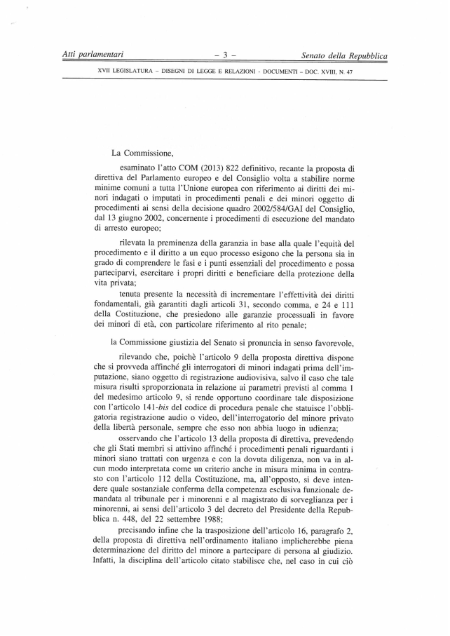

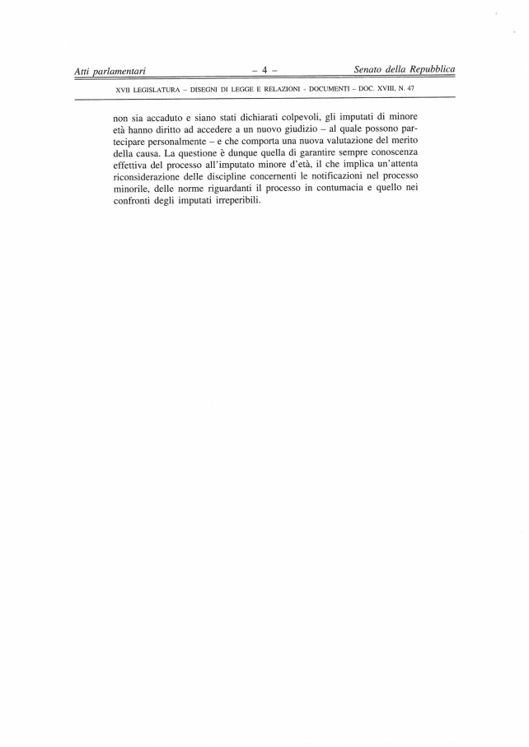

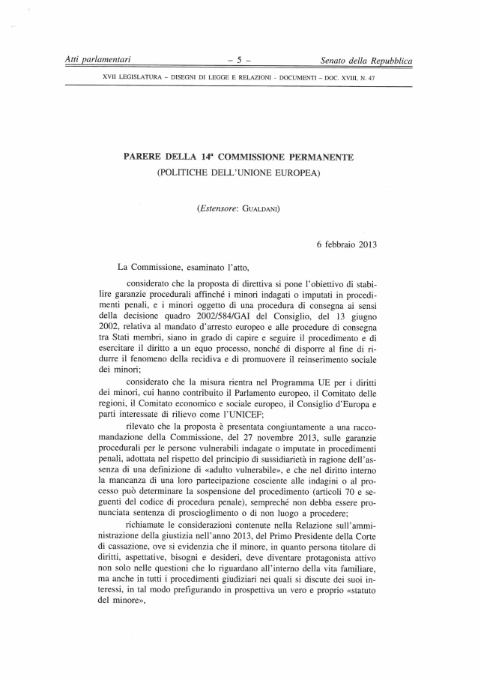

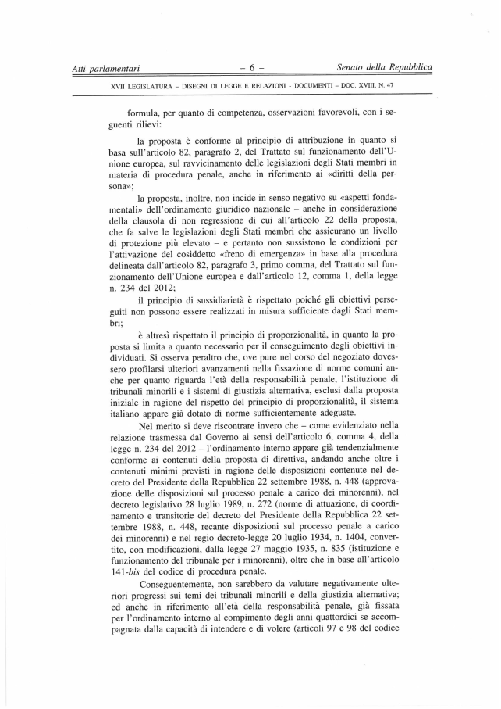

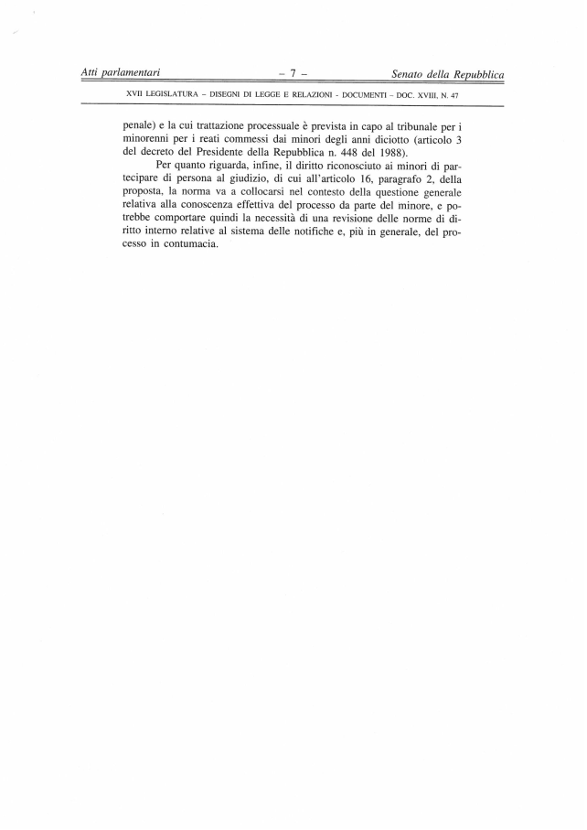
_______________

Translation(s) of the opinion may be available on the Interparliamentary EU Information Exchange site IPEX at the following address: http://www.ipex.eu/IPEXL-WEB/search.do

