 | 
COUNCIL OF  THE EUROPEAN UNION |  |  | Brussels, 25 February 2014
 | Interinstitutional File:  2013/0407 (COD) |  | 6921/14
DROIPEN 30
COPEN 66
CODEC 564
INST 131
PARLNAT 66

OPINION
from: | The Italian Senate
date of receipt: | 19 February 2014
to: | Council
Subject: | Proposal for a Directive of the European Parliament and of the Council on the strengthening of certain aspects of the presumption of innocence and of the right to be present at trial in criminal proceedings  [Doc. 17621/13 DROIPEN 158 COPEN 235 CODEC 2929 - COM(2013) 821 final]  - Opinion on the application of the Principles of Subsidiarity and Proportionality

Delegations will find attached the above mentioned Opinion.

_____________

Encl.

ANNEX
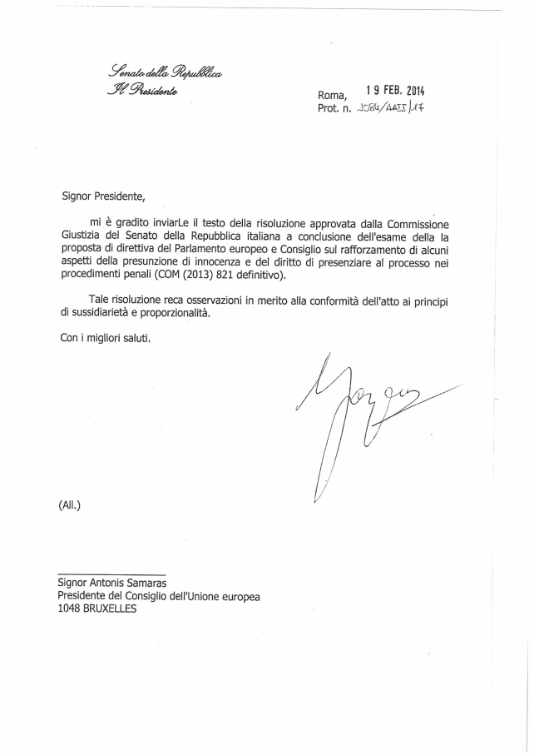
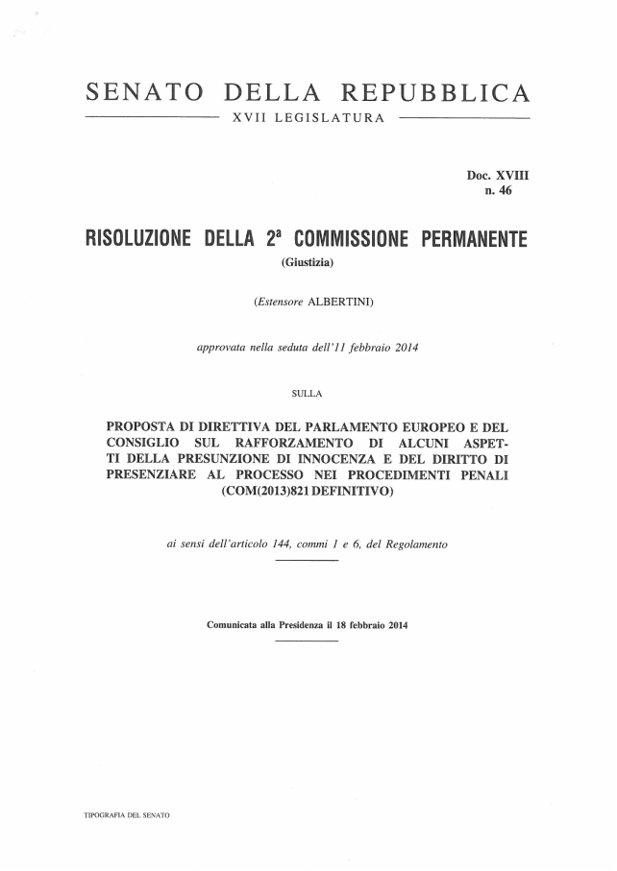

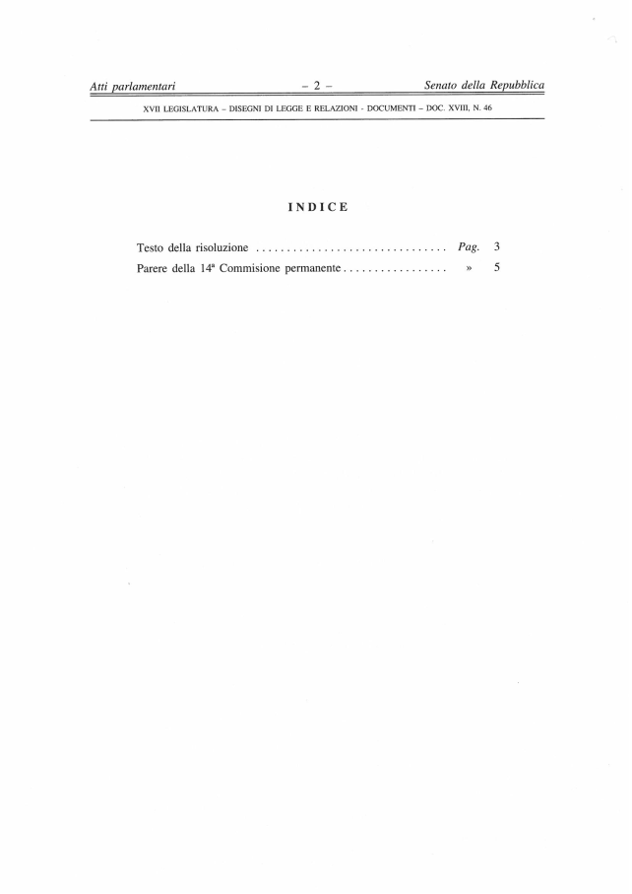

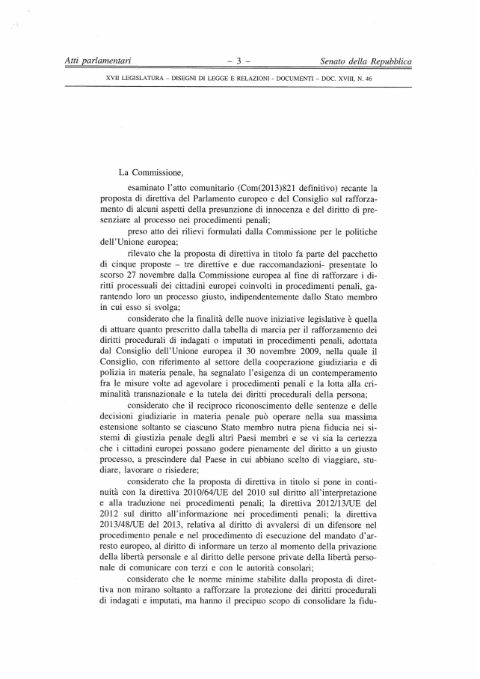

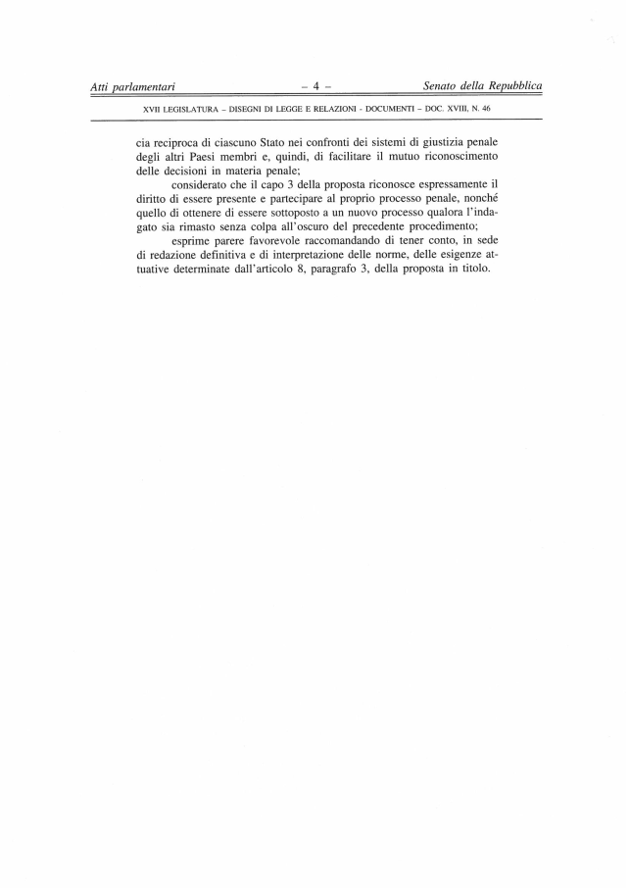

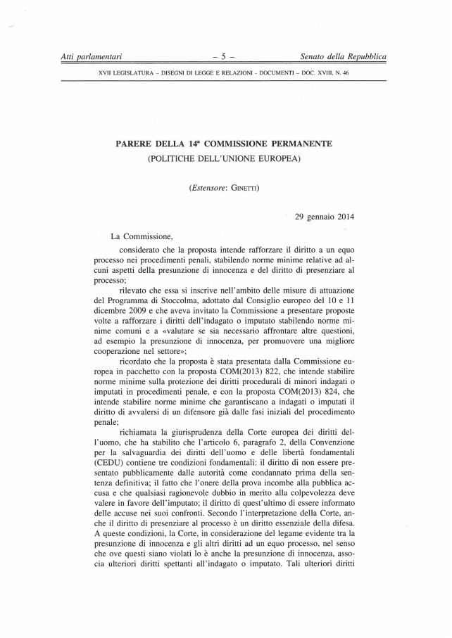

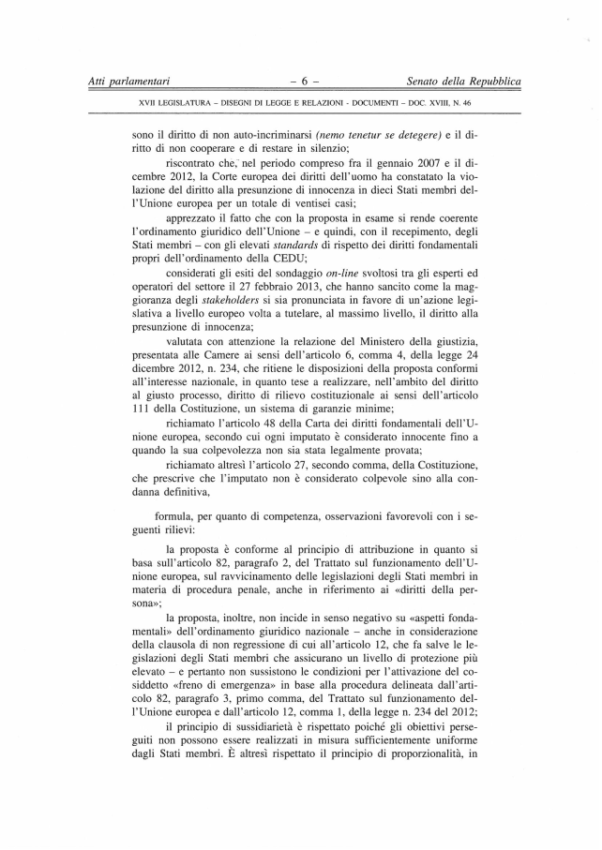

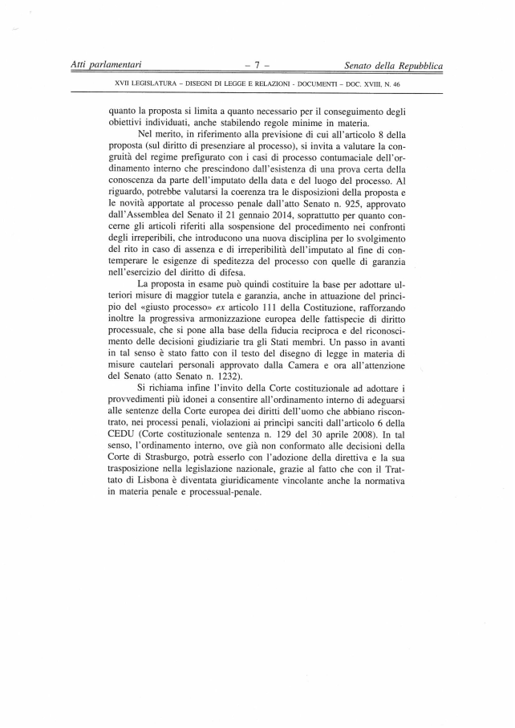
_______________

Translation(s) of the opinion may be available on the Interparliamentary EU Information Exchange site IPEX at the following address: http://www.ipex.eu/IPEXL-WEB/search.do

