 | 
COUNCIL OF  THE EUROPEAN UNION |  |  | Brussels, 25 February 2014
 | Interinstitutional File:  2013/0409 (COD) |  | 6957/14
DROIPEN 32
COPEN 69
CODEC 573
INST 134
PARLNAT 69

OPINION
from: | The Italian Senate
date of receipt: | 19 February 2014
to: | Council
Subject: | Proposal for a Directive of the European Parliament and of the Council on provisional legal aid for suspects or accused persons deprived of liberty and legal aid in European arrest warrant proceedings  [Doc. 17635/13 DROIPEN 160 COPEN 237 CODEC 2931 - COM(2013) 824 final]  - Opinion on the application of the Principles of Subsidiarity and Proportionality

Delegations will find attached the above mentioned Opinion.

_____________

Encl.

ANNEX
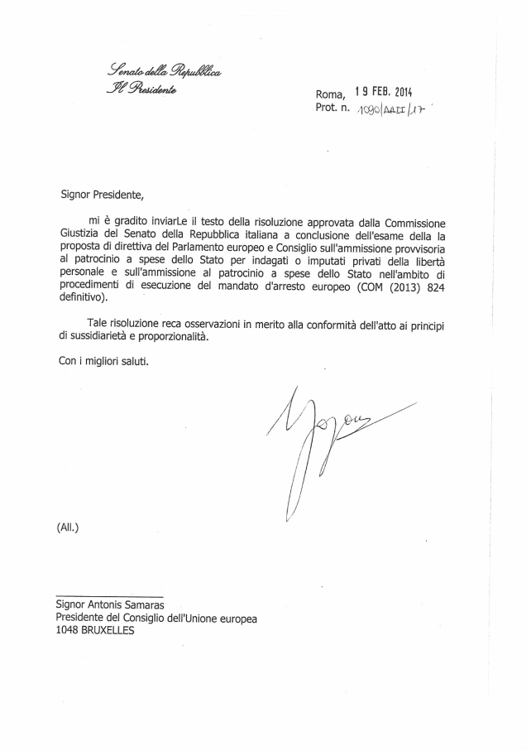
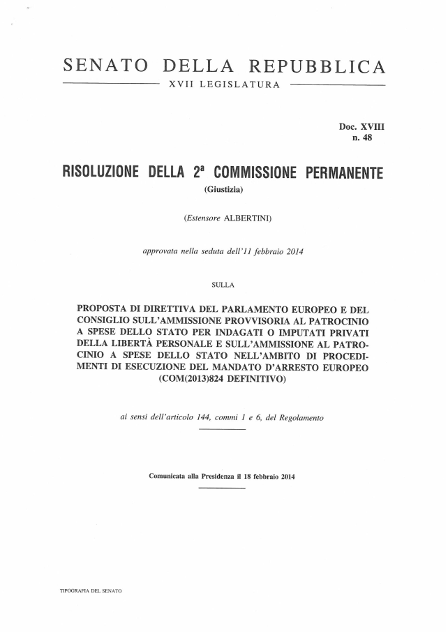

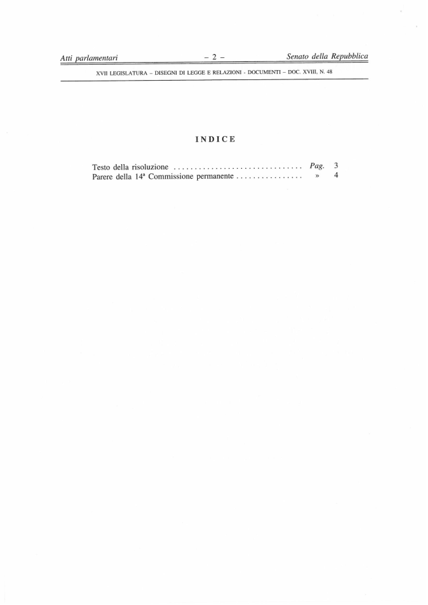

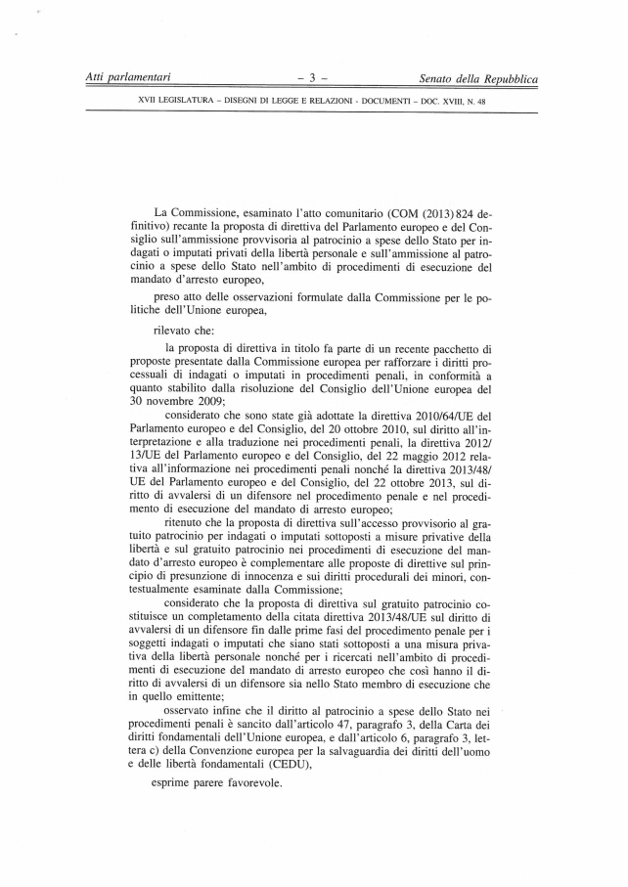

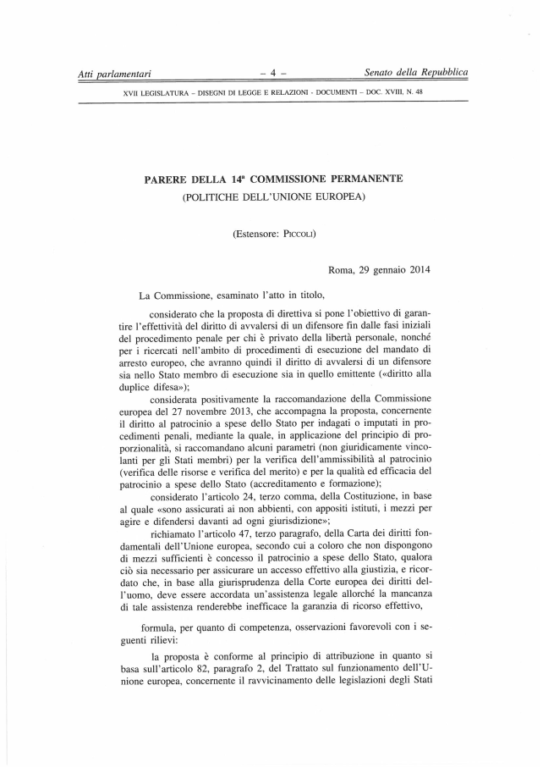

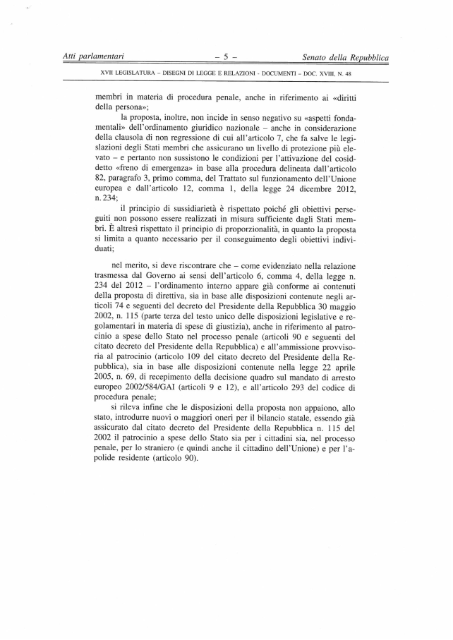
_______________

Translation(s) of the opinion may be available on the Interparliamentary EU Information Exchange site IPEX at the following address: http://www.ipex.eu/IPEXL-WEB/search.do

