Annex I: The Rule of law as a foundational principle of the Union

The rule of law and the Union legal system
The rule of law is a legally binding constitutional principle. It is unanimously recognised as one of the founding principles inherent in all the constitutional systems of the Member States of the EU and the Council of Europe.
Long before the principle of the rule of law was explicitly referred to in the EU Treaties, the Court of Justice in its judgment of 1986 "Les Verts" had emphasized that the EU is "based on the rule of law inasmuch as neither its Member States nor its institutions can avoid a review of the question whether the measures adopted by them are in conformity with the basic Constitutional Charter, the Treaty".
In its case law, the Court indicates that the rule of law is the source of fully justiciable principles applicable within the EU legal system. The Court also highlights that those principles are general principles of law stemming from the constitutional traditions common to the Member States. The following principles are noteworthy:
  - the principle of legality, which in substantial terms includes a transparent, accountable, democratic and pluralistic process for enacting laws. The Court has confirmed the principle of legality as being a fundamental principle of the Union, by stating that "[…] in a community governed by the rule of law, adherence to legality must be properly ensured";
  - legal certainty, which requires inter alia that rules are clear and predictable and cannot be retrospectively changed. The Court has emphasised the importance of legal certainty by stating that by virtue of the principles of legal certainty and the protection of legitimate expectation, "[…] the effect of [Union] legislation must be clear and predictable for those who are subject to it […]". The Court also stated that "[…] the principle of legal certainty precludes a [Union] measure from taking effect from a point in time before its publication and that it may be otherwise only exceptionally, where the purpose to be achieved so demands and where the legitimate expectations of those concerned are duly respected";
  - prohibition of arbitrariness of the executive powers. The Court of Justice has stated: "Nonetheless, in all the legal systems of the Member States, any intervention by the public authorities in the sphere of private activities of any person, whether natural or legal, must have a legal basis and be justified on the grounds laid down by law, and, consequently, those systems provide, albeit in different forms, protection against arbitrary or disproportionate intervention. The need for such protection must be recognized as a general principle of [Union] law. […]";
  - independent and effective judicial review, including respect for fundamental rights. The Court reiterated that the EU is a union based on the rule of law in which the acts of its institutions are subject to review of their compatibility with, in particular, the Treaties, the general principles of law and fundamental rights". The Court specified that this means, in particular, that "individuals are entitled to effective judicial protection of the rights they derive from the Union legal order". The Court clearly explained that the right to such protection is "one of the general principles of law stemming from the constitutional traditions common to the Member States, which has been enshrined in Articles 6 and 13 of the European Convention for the Protection of Human Rights and Fundamental Freedoms".
  - Moreover, with regard to the link between the right to a fair trial and the separation of powers the Court specifically stated that "[…] the general principle of [Union] law under which every person has a right to a fair trial, inspired by Article 6 of the ECHR […] comprises the right to a tribunal that is independent of the executive power in particular […]". The principle of the separation of powers is, of course, an important element of ensuring compliance with the principle of rule of law. Nevertheless, it can take different forms given the different parliamentary models and the different degrees to which this principle applies at national level. In this respect, the Court referred to the operational separation of powers implying an independent and effective judicial review, pointing out that "[…] EU law does not preclude a Member State from simultaneously exercising legislative, administrative and judicial functions, provided that those functions are exercised in compliance with the principle of the separation of powers which characterises the operation of the rule of law".
  - equality before the law. The Court has emphasised the role of equal treatment as a general principle of EU law by stating that "it must be recalled that the principle of equal treatment is a general principle of EU law, enshrined in Articles 20 and 21 of the Charter of Fundamental Rights of the European Union".
The rule of law and the Council of Europe
Those aspects of the rule of law as a common denominator of the Union are fully reflected at the level of the Council of Europe. While there is no definition in the statute of the Council of Europe or in the ECHR, and while the precise list of principles, standards and values stemming from the rule of law may vary at national level, the Venice Commission, in a report published in 2011 refers to the rule of law as "a fundamental and common European standard to guide and constrain the exercise of democratic powers" and as an "inherent part of any democratic society" which "requires everyone to be treated by all decisions-makers with dignity, equality and rationality and in accordance with the law, and to have the opportunity to challenge decisions before independent and impartial courts". More particularly, on the basis also of the relevant case law of the European Court of Human Rights, in its Report the Venice Commission identified the following important but not exhaustive common and generally shared traits of the rule of law:
  - legality (including a transparent, accountable and democratic process for enacting law);
  - legal certainty;
  - prohibition of arbitrariness;
  - access to justice before independent and impartial courts;
  - respect for human rights; non-discrimination and equality before the law.
The rule of law at national level
While not precisely or exhaustively defined by national constitutions or courts, and not always clearly and uniformly codified in written constitutions, the rule of law is a common denominator in modern European constitutional traditions. In many circumstances national courts refer to it in order to guide their interpretation of national law or use it as a source to develop fully justiciable principles.
Annex II

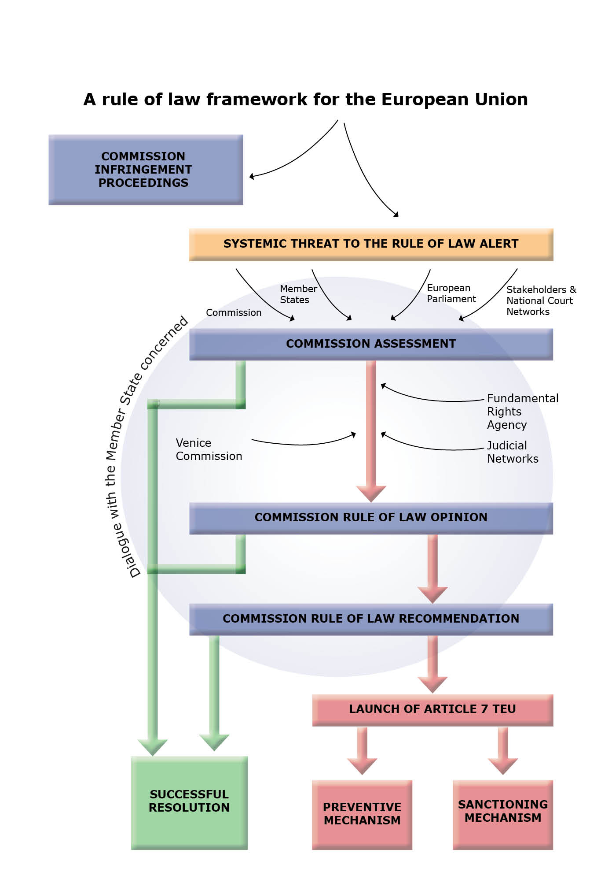

The first reference to the rule of law was made in the Preamble of the Maastricht Treaty of 1992. The Amsterdam Treaty referred to the Rule of law in Article 6(1) in substantially the same way as current Article 2 TEU.
Case 294/83, "Les Verts" v European Parliament, [1986] ECR 01339, para 23.
Case C-496/99 P, Commission v CAS Succhi di Frutta [2004] ECR I-03801, para 63.
Joined cases 212 to 217/80 Amministrazione delle finanze dello Stato v Salumi [1981] ECR 2735, para 10.
Joined cases 46/87 and 227/88 Hoechst v Commission [1989] ECR 02859, para 19.
Case C-583/11 P Inuit Tapiriit Kanatami and Others v Parliament and Council, not yet published, para 91; Case C-550/09 E and F, [2010] ECR I-06213, para 44; Case C-50/00 P Unión de Pequeños Agricultores [2002] ECR I-06677, para 38 and 39.
Joined cases C-174/98 P and C-189/98 P Netherlands and Van der Wal v Commission, [2000] ECR I-00001, para 17.
Case C-279/09 DEB, [2010] ECR I-13849, para 58.
Case C-550/07 P Akzo Nobel Chemicals and Akcros Chemicals v Commission [2010] ECR I-08301, para 54.
There is a reference but no definition of the Rule of law also in the preamble to the United Nations Universal declaration of Human Rights (1948).
See Report of the Venice Commission of 4 April 2011 Study No. 512/2009 (CDL-AD(2011)003rev).

