 | 
COUNCIL OF  THE EUROPEAN UNION |  |  | Brussels, 28 February 2014
 | Interinstitutional File:  2013/0443 (COD) |  | 7068/14
ENV 203
ENER 94
IND 81
TRANS 106
ENT 69
SAN 103
PARLNAT 71
CODEC 598
INST 136

COVER NOTE
from: | The President of the Italian Senate
date of receipt: | 20 February 2014
to: | The President of the Council of the European Union
Subject: | Proposal for a Directive of the European Parliament and of the Council on the reduction of national emissions of certain atmospheric pollutants and amending Directive 2003/35/EC  [18167/13 ENV 1235 ENER 600 IND 388 TRANS 693 ENT 356 SAN 555 PARLNAT 325 CODEC 3086 - COM(2013) 920 final]  - Opinion on the application of the Principles of Subsidiarity and Proportionality

Delegations will find annexed a copy of the above letter.

________________________
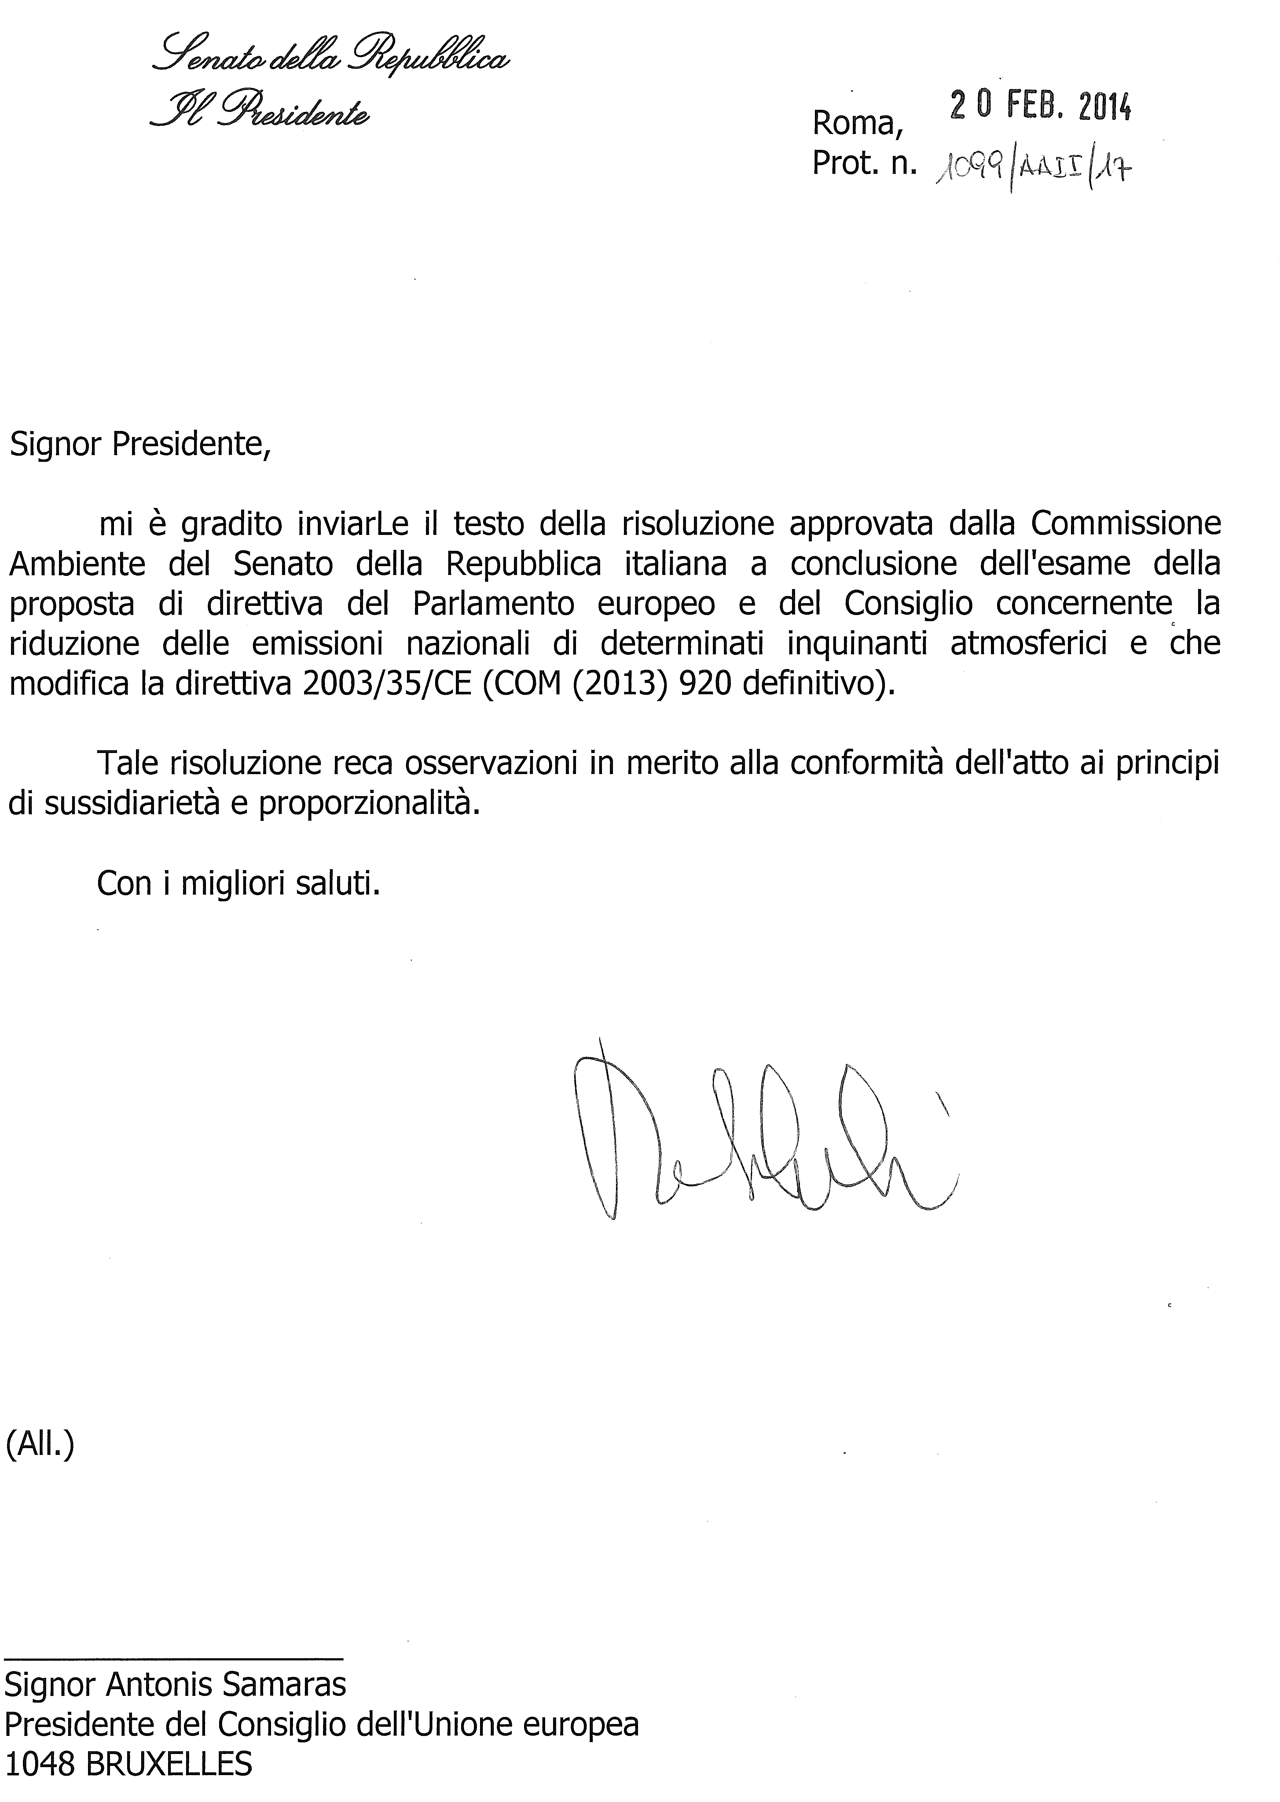

The translation of this document will be available in due course at the Interparliamentary EU information exchange site IPEX at the following address: http://www.ipex.eu/IPEXL-WEB/search.do

