 | 
COUNCIL OF  THE EUROPEAN UNION |  |  | Brussels, 18 March 2014
 | Interinstitutional File:  2014/0002 (COD) |  | 7835/14
SOC 202
ECOFIN 266
CODEC 803
MI 279
EMPL 42
JEUN 50
INST 158
PARLNAT 84

COVER NOTE
from: | The Italian Senate
date of receipt : | 17 March 2014
to: | President of the Council of the European Union
Subject: | Proposal for a Regulation of the European Parliament and of the Council on a European Network of Employment Services, workers' access to mobility services and the further integration of labour markets (EURES)  [doc. 5567/14 SOC 33 ECOFIN 57 CODEC 154 MI 63 EMPL 9 JEUN 13 - COM(2014) 6 final]  - Opinion on the application of the Principles of Subsidiarity and Proportionality

Delegations will find attached the above mentioned opinion.

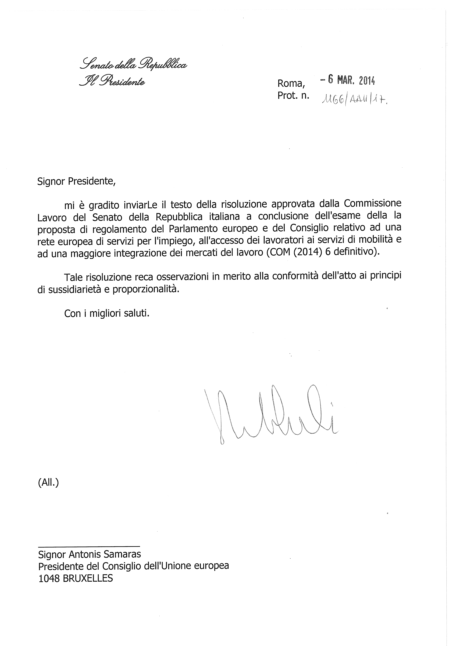
________________________

For available translations of this opinion see the interparliamentary EU information exchange site (IPEX) at the following address: http://www.ipex.eu/IPEXL-WEB/search.do

