1. Introduction
The 2014 edition of the EU Justice Scoreboard ('the Scoreboard') is presented in a context where a number of Member States are engaged in a process of reform of their justice systems to render them more effective for citizens and businesses. These reforms are of direct relevance for the EU and are followed closely by European institutions and stakeholders.
Quality, independence and efficiency are the key components for an effective justice system. Well-functioning justice systems are important structural condition on which Member States base their sustainable growth and social stability policies. For these reasons, since 2011, national judicial reforms have become an integral part of the structural components in Member States subject to the Economic Adjustment Programmes. Since 2012, the improvement of the quality, independence and efficiency of judicial systems has also been a priority for the European Semester, the EU annual cycle of economic policy coordination, as signalled in the Annual Growth Survey 2014. The Scoreboard feeds the European Semester process by providing objective data concerning the functioning of the national judicial systems. This contributes to identifying issues that deserve particular attention to ensure implementation of reforms.
Access to an effective justice system is an essential right which is at the foundation of European democracies and is recognised by the constitutional traditions common to the Member States. For this reason, the right to an effective remedy before a tribunal is enshrined in the Charter of Fundamental Rights of the European Union (Article 47). Whenever a national court applies EU legislation, it acts as a ‘Union court’ and must provide effective judicial protection to everyone, citizens and businesses, whose rights guaranteed in EU law were violated. The effectiveness of justice systems is therefore crucial for the implementation of EU law and for the strengthening of mutual trust.

What is the EU Justice Scoreboard?
The EU Justice Scoreboard is an information tool aiming to assist the EU and Member States to achieve more effective justice by providing objective, reliable and comparable data on the quality, independence and efficiency of justice systems in all Member States.
The Scoreboard contributes to identifying potential shortcomings, improvements and good practices and aims to present trends on the functioning of the national justice systems over time. It does not present an overall single ranking but an overview of the functioning of all justice systems based on various indicators which are of common interest for all Member States.
The Scoreboard does not promote any particular type of justice system. Whatever the model of the national justice system or the legal tradition in which it is anchored, timeliness, independence, affordability, and user-friendly access are some of the essential parameters of what constitutes an effective justice system.
The 2014 Scoreboard focuses on litigious civil and commercial cases as well as administrative cases in order to assist Member States in their efforts to improve business climate and to overcome the sovereign debt and financial crisis. The Scoreboard is a tool which evolves in dialogue with Member States and the European Parliament, with the objective of identifying the essential parameters of an effective justice system. The European Parliament has called on the Commission to progressively broaden the scope of the Scoreboard.
How does the EU Justice Scoreboard feed the European Semester?
Poor performance revealed by the Scoreboard indicators always requires a deeper analysis of the reasons behind the result. This country-specific assessment is carried out in the context of the European Semester process through bilateral dialogue with concerned authorities and stakeholders. This assessment takes into account the particularities of the legal system and the context of the concerned Member States. It may eventually lead the Commission to propose Council country-specific recommendations on the need to improve justice systems.
What is the methodology of the EU Justice Scoreboard?
The Scoreboard uses different sources of information. Most of the quantitative data are currently provided by the Council of Europe Commission for the Evaluation of the Efficiency of Justice (CEPEJ) with which the Commission has concluded a contract in order to carry out a specific study. These data are from 2012 and have been provided by Member States according to the CEPEJ methodology. The study also provides country fiches which give more context and should be read together with the figures.
For the 2014 Scoreboard, the Commission has also drawn upon additional sources of information, namely, Eurostat, World Bank, World Economic Forum, and the European judicial networks, in particular the European Network of Councils for the Judiciary which provided replies to a questionnaire on judicial independence. Further data has also been obtained through two pilot field studies on the functioning of national courts for the application of consumer and competition law rules.

The effectiveness of national justice systems as a structural component for growth
High-quality institutions, including effective national justice systems are a determinant for economic performance. In times of sovereign debt, financial and economic crisis they play a key role in restoring confidence and fostering the return to growth. Predictable, timely and enforceable justice decisions are important structural components of an attractive business environment. They contribute to trust and stability throughout the entire business cycle by maintaining the confidence for starting a business, enforcing a contract, attracting investment, settling private debt or protecting property and other rights.
The impact of national justice systems on the economy is underlined by the International Monetary Fund, the European Central Bank, the OECD, the World Economic Forum and the World Bank. The effectiveness of the justice system incentivizes investment in a given country. Research shows that there is a positive correlation between firm size and effective justice systems and weaker incentives to invest and to employ in the presence of shortcomings in the functioning of justice. Growth in more innovative sectors notably, those which often rely on intangible assets like intellectual property rights, is dependent on a well-functioning law enforcement system. Effective justice systems also foster competition in the market. Where justice systems guarantee a good enforcement of contracts, firms are dissuaded from opportunistic behaviour in their economic relationships and transaction costs are reduced. Finally, trust in well-functioning systems facilitates entrepreneurship. Shortcomings in judicial systems lead to higher borrowing costs. Creditors are more likely to lend when they are confident that the effectiveness of the justice system guarantees that they will be able to collect their loans.
A wide debate on the effectiveness of justice systems
The presentation of the first edition of the Scoreboard contributed to a wide exchange of views on the effectiveness of national justice systems in the EU. In its Resolution of 4 February 2014 on the EU Justice Scoreboard, the European Parliament expressed its great interest for the Scoreboard and called on the Commission to take this exercise forward. It highlighted the importance of ensuring an efficient and independent justice system that can contribute to economic growth in Europe and boost competitiveness and stressed that an effective and trustworthy justice system gives businesses incentives to develop and invest at national and cross-border level.
The Council had an exchange of views on the justice-related aspects of the 2014 European Semester, including the 2013 Scoreboard, in the informal Justice and Home Affairs Council meeting in December. In the Justice and Home Affairs Council meeting of March 2014, the Commission presented the main characteristics of the upcoming 2014 EU Justice Scoreboard. The Council and the Member States adopted on 4 March Conclusion on the civil and commercial justice systems of the Member States.
The effectiveness of the national justice systems and the 2013 Scoreboard were also discussed during the “Assises de la Justice”, a high-level conference organised by the European Commission in Brussels on 21 and 22 November 2013 on the shaping of justice policies in Europe for the years to come. Representatives of the judiciary (e.g. the Supreme Courts, the Councils for the judiciary and judges) and of practitioners (e.g. lawyers and judicial officers) expressed their interest and made suggestions for its future development. Certain Member States contributed to the discussion and highlighted aspects of the methodology that could be further improved. On this occasion, a Eurobarometer survey on "Justice in the European Union" was published which highlighted, notably, that the level of trust in national justice systems varies significantly between Member States.
The Commission initiated a systematic dialogue with Member States experts to promote the exchange of best practices on the effectiveness of justice systems and to further develop the Scoreboard. Member States have been asked to designate two contact persons, one from the Judiciary and one from the Ministry of Justice. The first two meetings of the contact persons discussed the availability of data on the functioning of justice systems and good practices on data collection.

2. Follow-up to the 2013 EU Justice Scoreboard
The findings of the 2013 Scoreboard helped, together with the specific assessment of the situation in Member States, to define country-specific-recommendations in the area of justice. Following a proposal from the Commission, the Council made recommendations to ten Member States to improve, depending on the country concerned, the independence, quality and/or efficiency of their justice system or to further strengthen the judiciary. Out of these ten Member States, six Member States were already identified in 2012 as facing challenges relating to the functioning of their justice system.
These Member States are taking measures concerning the functioning of the judiciary. These measures range from operational measures, such as the modernisation of the management process in court, the use of new information technology, the development of alternative dispute resolution; to more structural measures, such as restructuring the organisation of courts or simplification of civil procedural rules that may lead to decreasing the length of proceedings. The intensity and the state of the reforms vary according to the Member States. Whilst in certain Member States measures have already been adopted and are being implemented, in other Member States, the measures are still at the early stages. The Scoreboard presents data from 2012 and therefore cannot yet reflect the effects of on-going reforms, including for Member States which have already adopted ambitious measures.
The findings of the Scoreboard help to establish priorities for EU structural funds. Previous experiences have shown that EU funds can be used to improve the effectiveness of justice systems. For example, Estonia has used structural funds to develop e-justice tools and is now one of the most advanced countries in the use of ICT tools for the management of courts and for communication between courts and parties.
The Commission identified justice as a priority area for twelve Member States for funding in the context of the multi-annual financial framework 2014-2020. Member States are setting out their strategy on the deployment of EU funds to support the EU 2020 strategy in the so-called "Partnership Agreements". These agreements are an opportunity to ensure the adequate allocation of funds to fully reflect the importance of rendering judicial systems more effective.

3. Indicators of the 2014 EU Justice Scoreboard
Efficiency of justice systems
The 2014 Scoreboard maintains the same indicators relating to the efficiency of proceedings as were used in 2013: length of proceedings, clearance rate and number of pending cases. In addition, the 2014 Scoreboard presents the outcome of two pilot studies, aimed at providing more fine-tuned data on the length of judicial proceedings relating to competition law and consumer law, expressed in average days. The effectiveness of judicial systems in these two areas is important for the economy. For example, the negative consumer welfare impact of all the hard-core cartels, expressed as a proportion of the EU’s gross domestic product, is estimated as ranging from 0.20% to 0.55% of the EU’s GDP in 2011. Similarly, the application of consumer law is equally important to the economy as final household consumption represents 56% of GDP.
Quality of justice systems
As regards the quality of justice systems, the 2014 Scoreboard uses the same indicators as in 2013. It focuses on certain factors that can help to improve the quality of justice such as training, monitoring and evaluation of court activities, budget, human resources, the availability of Information and Communication Technology (ICT) systems for courts (which facilitate in particular the relation between the parties and the courts) and the availability of alternative dispute resolution methods (ADR) which enable the parties to find other methods for solving their disputes. In addition the 2014 Scoreboard provides more refined data on training in EU law, the use of satisfaction surveys, budget for courts and the number of judges.
Independence of the judiciary
The Scoreboard presents data on the perceived independence of the justice system as provided by the World Economic Forum (WEF) in its annual Global Competitiveness Report.
While the perceived independence is important, as it can influence investment decisions, what is more important is that judicial independence is effectively protected in a justice system through legal safeguards. As announced in the 2013 Scoreboard, the Commission has started cooperation on the structural independence of the judiciary with the European judicial networks, particularly the European Network of Councils for the Judiciary. The 2014 Scoreboard presents, in an annex, a first general comparative overview on the legal safeguards for the protection of the structural independence of the judiciary in the legal systems of Member States.

4. Key findings of the 2014 EU Justice Scoreboard

4.1 Efficiency of justice systems
Justice delayed is justice denied. Timely decisions are essential for businesses and investors. In their investment decisions, companies take into account the risk of being involved in commercial disputes, labour or taxation disputes or insolvencies. The efficiency with which a judicial system in a Member States handles litigation is very important. For example, the legal enforcement of a supply or services contract becomes very costly the longer the judicial dispute takes, and even meaningless beyond a certain time, as the probability of retrieving money from payments and penalties diminishes.
4.1.1 Length of proceedings
The length of proceedings expresses the time (in days) needed to resolve a case in court, that is the time taken by the court to reach a decision at first instance. The 'disposition time' indicator is the number of unresolved cases divided by the number of resolved cases at the end of a year multiplied by 365 days.
Except in figures 4, 11 and 12 all figures concern proceedings at first instance. Although different appeal procedures can have a major impact on length of proceedings, the efficiency of a judicial system should already be reflected at first instance, as the first instance is an obligatory step for everyone going to court.
Figure 1: Time needed to resolve civil, commercial, administrative and other cases* (1st instance/in days) (source: CEPEJ study)
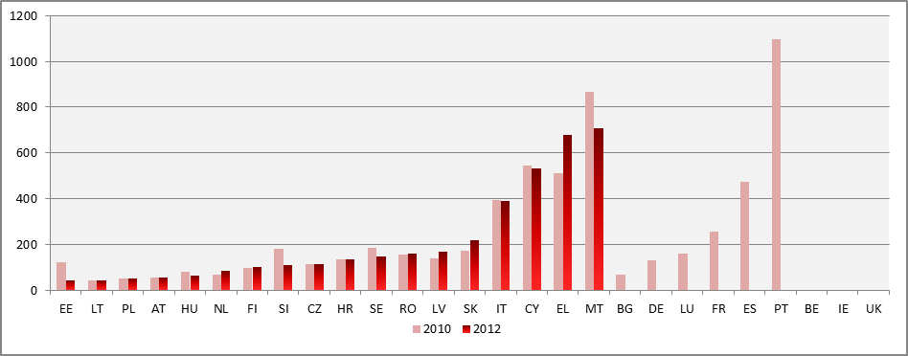
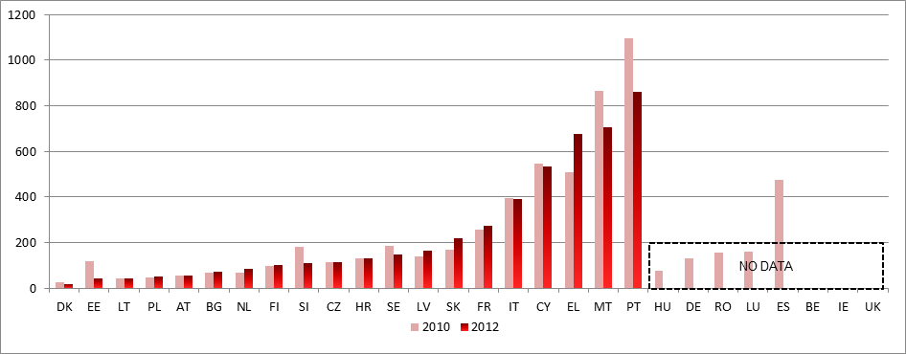
*According to the CEPEJ methodology this figure includes all civil and commercial litigious and non-litigious cases, enforcement cases, land-registry cases, administrative law cases (litigious or non-litigious) and other non-criminal cases.
Figure 2: Time needed to resolve litigious civil and commercial cases* (1st instance/in days) (source: CEPEJ study)
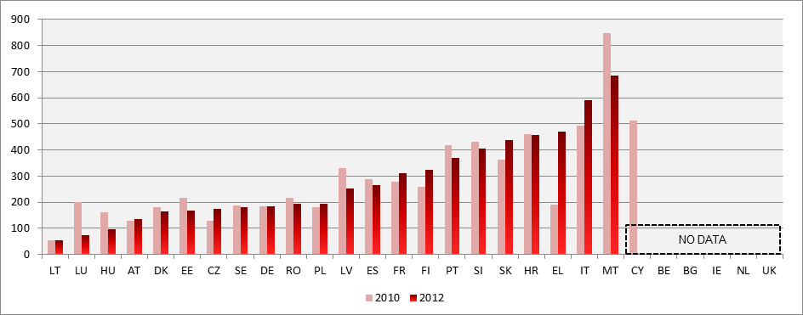
*Litigious civil (and commercial) cases concern disputes between parties, for example disputes regarding contracts, following the CEPEJ methodology. By contrast, non-litigious civil (and commercial) cases concern uncontested proceedings, for example, uncontested payment orders. Commercial cases are addressed by special commercial courts in some countries and handled by ordinary (civil) courts in others.
Figure 3: Time needed to resolve administrative cases* (1st instance/in days) (source: CEPEJ study)
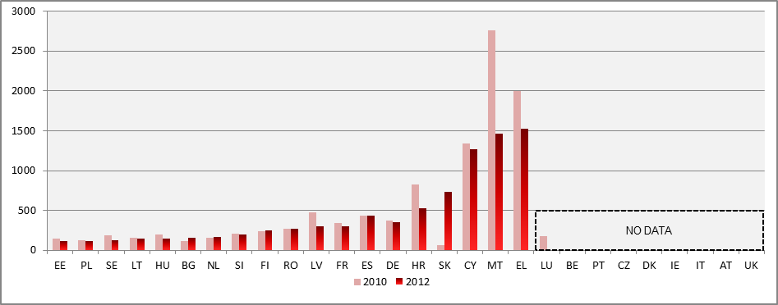
*Administrative law cases concern disputes between citizens and local, regional or national authorities, following the CEPEJ methodology. Administrative law cases are addressed by special administrative courts in some countries and handled by ordinary (civil) courts in others.
Figure 4: Time needed to resolve insolvency* (in years) (source: World Bank: Doing Business)
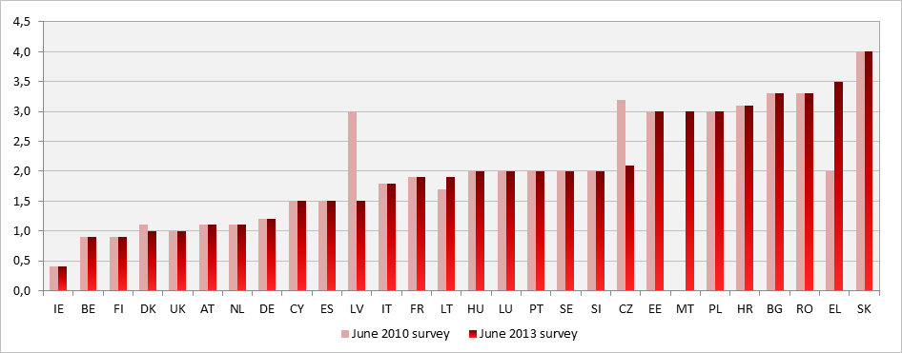
*Time for creditors to recover their credit. The period of time is from the company’s default until the payment of some or all of the money owed to the bank. Potential delay tactics by the parties, such as the filing of dilatory appeals or request for extension, are taken into consideration. The data are collected from questionnaire responses by local insolvency practitioners and verified through a study of laws and regulations as well as public information on bankruptcy systems.
4.1.2 Clearance rate
The clearance rate is the ratio of the number of resolved cases over the number of incoming cases. It measures whether a court is keeping up with its incoming caseload. The length of proceedings is linked to the rate at which the courts can resolve cases, the 'clearance rate', and to the number of cases that are still waiting to be resolved, 'pending cases'. When the clearance rate is about 100% or higher it means the judicial system is able to resolve at least as many cases as come in. When the clearance rate is below 100%, it means that the courts are resolving fewer cases than the number of incoming cases, and as a result, at the end of the year, the number of unresolved cases adds up as pending cases. If this situation persists over several years, this could be indicative of a more systemic problem as backlogs build up which further aggravate the workload of courts, and which cause the length of proceedings to rise further.
Figure 5: Rate of resolving civil, commercial, administrative and other cases (1st instance/in % - values higher than 100% indicate that more cases are resolved than come in, while values below 100% indicate that fewer cases are resolved than come in) (source: CEPEJ study)
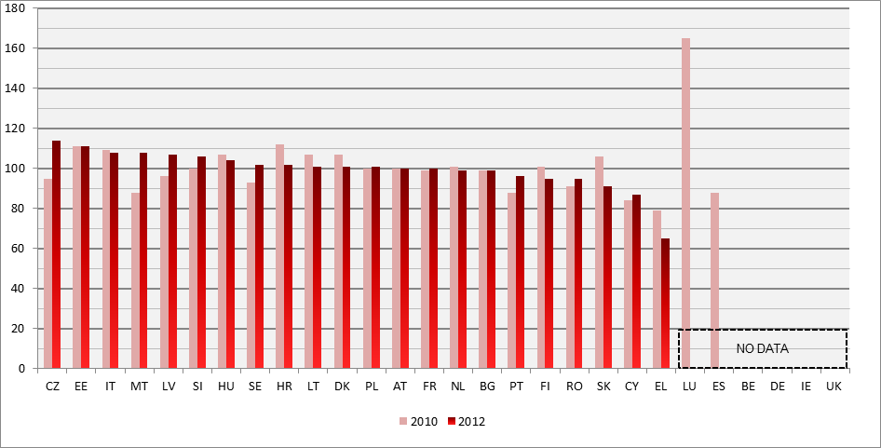
Figure 6: Rate of resolving litigious civil and commercial cases (1st instance/in %) (source: CEPEJ study)
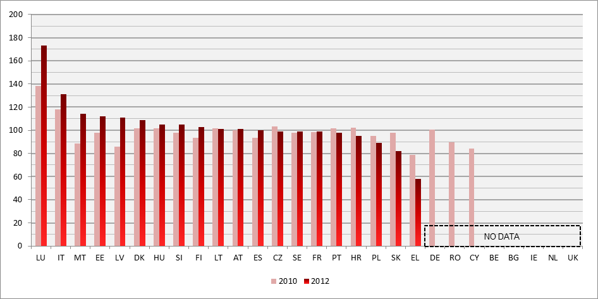

Figure 7: Rate of resolving administrative cases (1st instance/in %) (source: CEPEJ study)
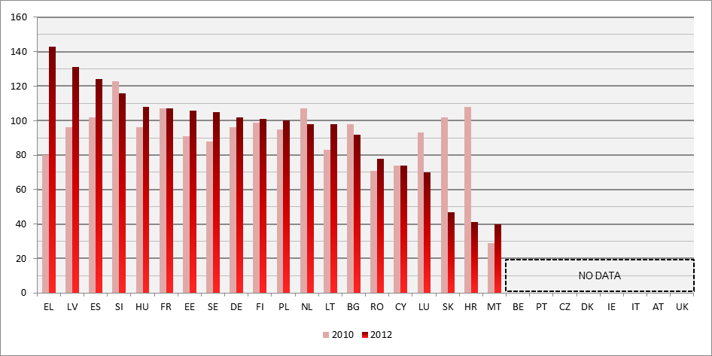

4.1.3 Pending cases
The number of pending cases expresses the number of cases that remains to be dealt with at the end of a period. The number of pending cases influences the disposition time. Therefore, in order to improve the length of proceedings measures to reduce the number of pending cases are required.

Figure 8: Number of civil, commercial, administrative and other pending cases (1st instance/per 100 inhabitants) (source: CEPEJ study)
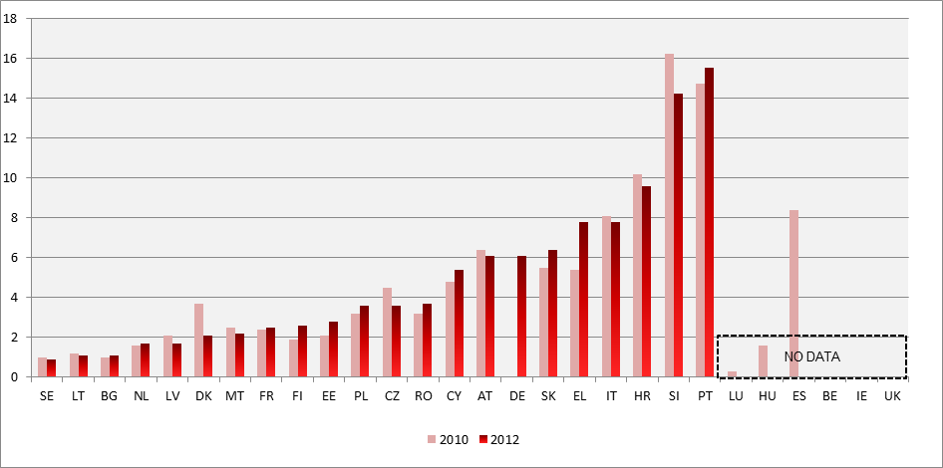

Figure 9: Number of litigious civil and commercial pending cases (1st instance/per 100 inhabitants) (source: CEPEJ study)
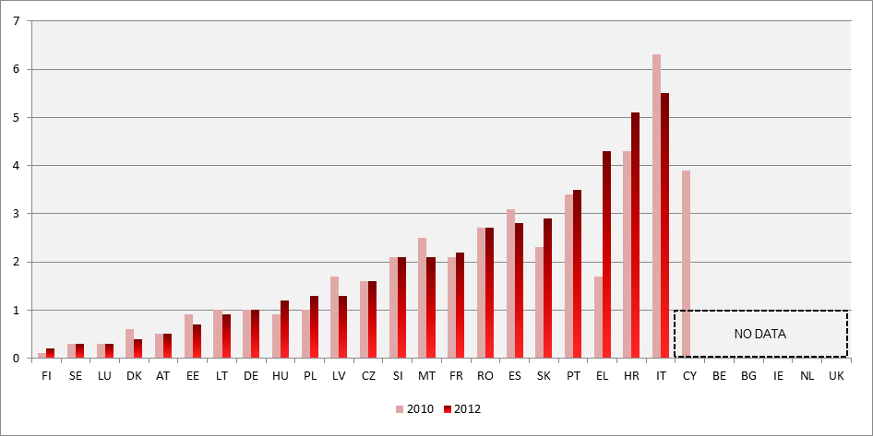

Figure 10: Number of administrative pending cases (1st instance/per 100 inhabitants) (source: CEPEJ study)
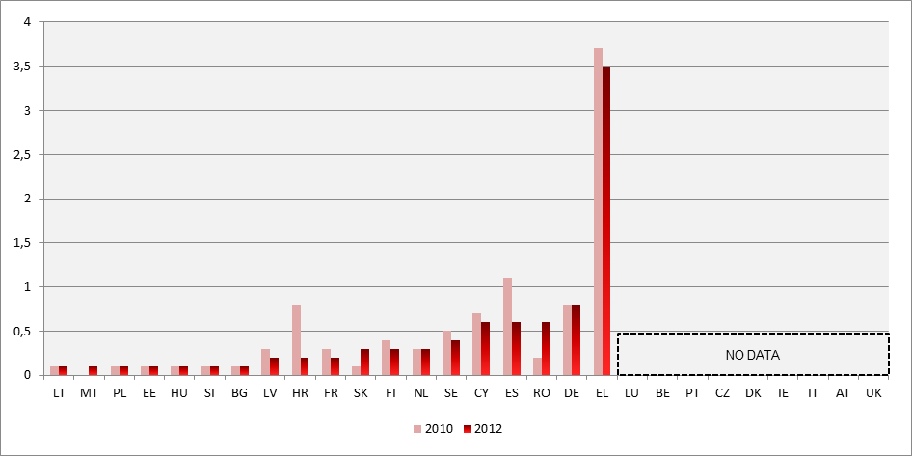

4.1.4. Results of the pilot field studies
The results of the pilot field studies concerning length of proceedings in the field of competition and consumer law show the average number of days which it takes to have a decision on the substance in cases pertaining to these two specific fields. The average duration in days is provided for first, second and (if relevant) third instance cases where such information is available. Given the divergences in the way data is presented for these instances, Member States are ordered alphabetically in their original languages.
The average length for resolving judicial review cases in competition law indicated below appears to be generally higher than the average length for civil, commercial, administrative and other cases in Figure 1. This could be due to the complexity involved in this type of specialized litigation. The figure below also shows that in several Member States significant differences in length can be observed between first, second (and where existing) third judicial review instances.
Figure 11: Average time needed to resolve judicial review cases against decisions of national competition authorities applying Articles 101 and 102 TFEU* (in days) (source: pilot field study)
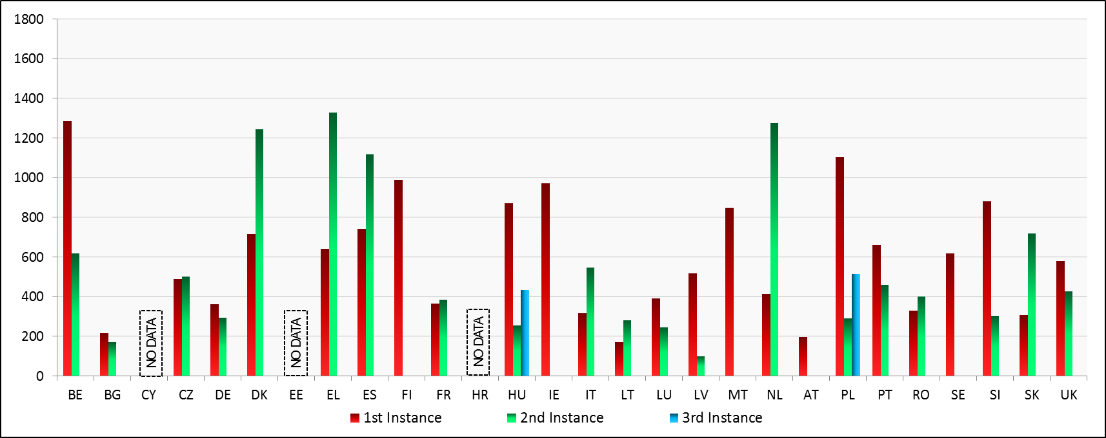
*The calculation on the length has been carried out on the basis of a study that sought to identify all cases of appeal of national competition authority decisions applying Articles 101 and 102 of the Treaty on the Functioning of the European Union for which judicial decisions on the substance were issued between 2008 and 2013. The figures are provided for1st and 2nd instance and, in those cases where it was relevant, for 3rd instance.

Figure 12: Average time needed to resolve consumer law cases* (in days) (source: pilot field study)
While the average length appears to be higher than that of litigious civil and commercial cases presented in Figure 2, account should be taken of the fact the length has been calculated on the basis of consumer litigation published cases, which tend to be more complex. The chart also confirms that a number of Member States present significant differences in average length between first, second and third instance for consumer litigation.
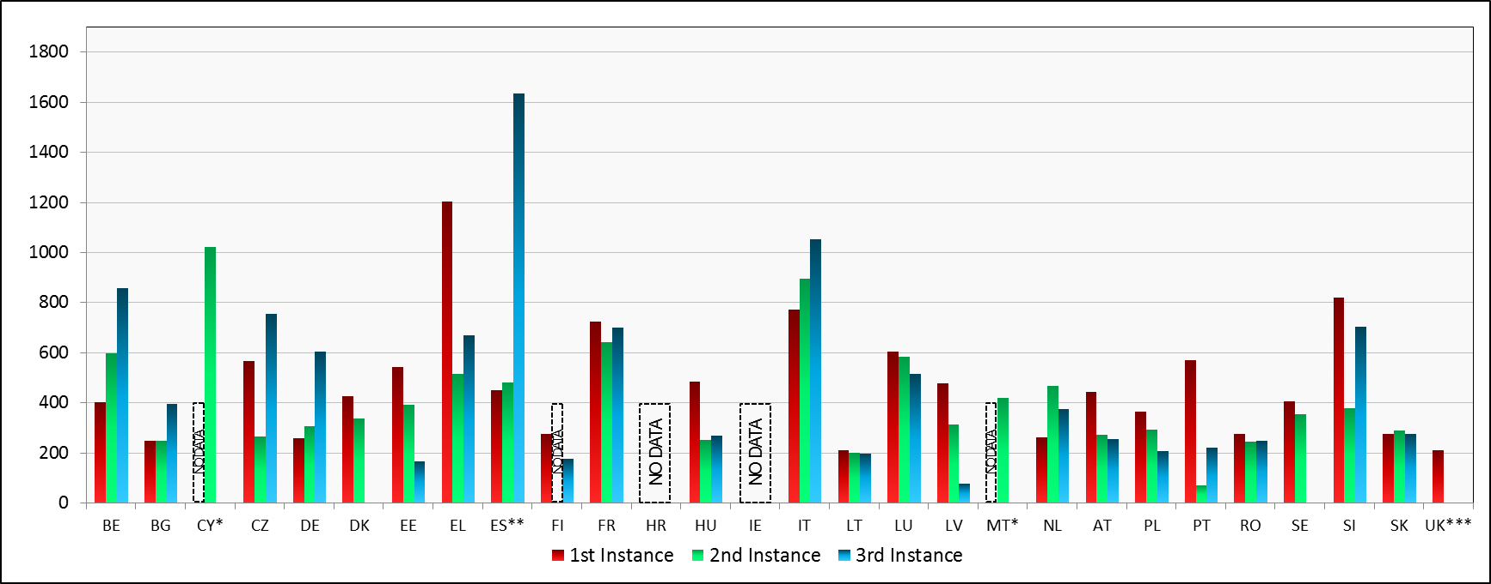
*The calculation on the length has been carried out on the basis of samples of cases relating to the application of the Unfair Contract Terms Directive, Distance Sales Directive, Consumer Sales and Guarantee Directive, Unfair Commercial Practices Directive and their national implementing provisions where decisions were issued between 2008 and 2013. As the sample size varied according to the availability of published decisions, the figures provided should be approached cautiously.

- Conclusions on the efficiency of justice systems

- The Scoreboard shows that there are Member States which continue to face particular challenges with regard to the efficiency of their justice systems, i.e. lengthy first instance proceedings together with low clearance rates or a large number of pending cases. These Member States have already been identified in the 2013 European Semester and the Economic Adjustment programmes and are in the process of defining, adopting or implementing measures for improving the functioning of their justice systems. The figures confirm the importance of committing to all necessary reforms and of pursuing these efforts with determination.
- For a few Member States the figures indicate an increase in the length of proceedings. The reasons behind this may differ. For example, for countries especially affected by the sovereign debt, financial and economic crisis, the increase of incoming cases has had an impact on the functioning of the justice system.
- The effects of ambitious reforms recently adopted in certain Member States cannot yet be reflected as the data are from 2012. Implementing and reaping the benefits of structural justice reforms, in particular for countries which are subject to the Economic Adjustment programmes, takes time. As the Scoreboard is a regular exercise, the outcome of these reforms could become visible in future Scoreboards.

4.2. Quality of justice systems
Effective justice requires quality throughout the whole justice chain. A lack of quality of justice decisions may increase business risks for large companies and SMEs and affect consumer choices. Certain input indicators, such as training, monitoring and evaluation of activities, availability of ICT systems and ADR methods and budgetary and human resources can help to improve the quality of justice systems.
4.2.1 Monitoring and evaluation help to shorten the length of proceedings
The definition of quality policies and the evaluation of the activities of courts are tools which increase the quality of justice in order to improve access to justice, trust, predictability and timeliness of justice decisions. These tools can consist in monitoring the day-to-day activity of the courts thanks to data collection or the evaluation of the performance of court systems by using indicators or by the introduction of quality systems in courts. The absence of reliable monitoring and evaluation can make improving the functioning of a justice system more difficult. An effective time management of court cases requires that the courts, the judiciary and all justice end-users can be informed on the functioning of courts through a regular monitoring system.
The data for stacked charts on quality factors are from 2012, as they reflect descriptive indicators which tend to remain stable. Divergences from previous exercises for certain Member States are explained individually. Member States on the right side of the charts without values are those for which data were not available. When the indicators do not exist or are not possible in certain Member States, this has been made explicit on the right side of the charts.
Figure 13: Availability of monitoring of courts' activities in 2012* (source: CEPEJ study)
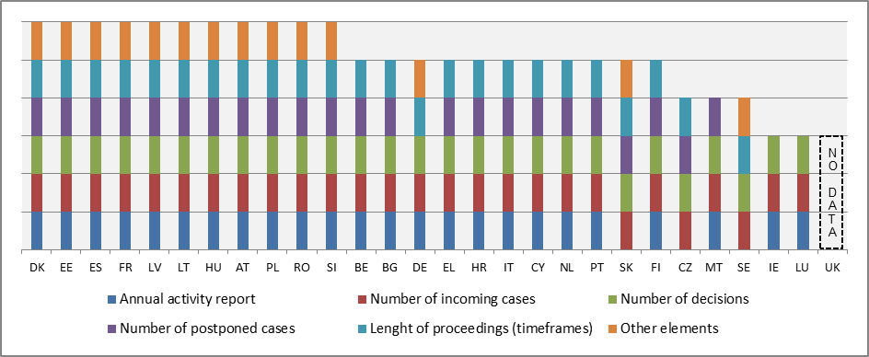
*Availability of monitoring tools has been reported as increasing in CY, EL (annual activity reports) and SI (other monitoring elements) and decreasing in SK (no annual activity report, as individual courts are required to send statistical data to the Ministry of Justice that publishes data for the whole judiciary).

Figure 14: Availability of evaluation of courts' activities in 2012* (source: CEPEJ Study)
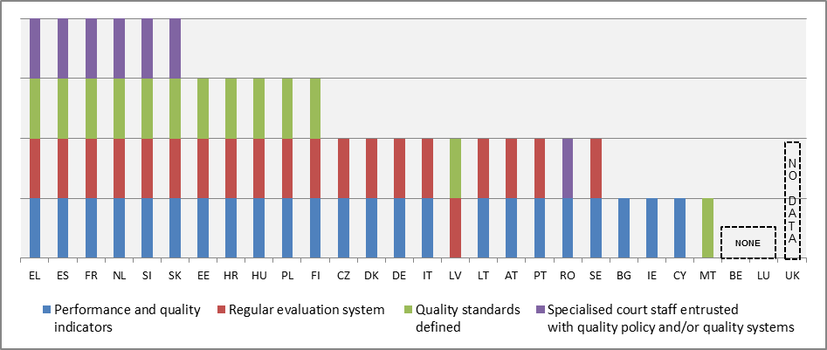
*Availability of these tools has been reported to have increased in EE, HU and SI and decreased in LV.

Figure 15: Surveys conducted among court users or legal professionals in 2012* (source: CEPEJ Study)
Surveys conducted amongst professionals who work in courts and/or users of the courts can provide relevant information on the quality of the justice system. An additional indicator has been introduced to reflect the target groups and the extent to which such surveys are used in Member States.
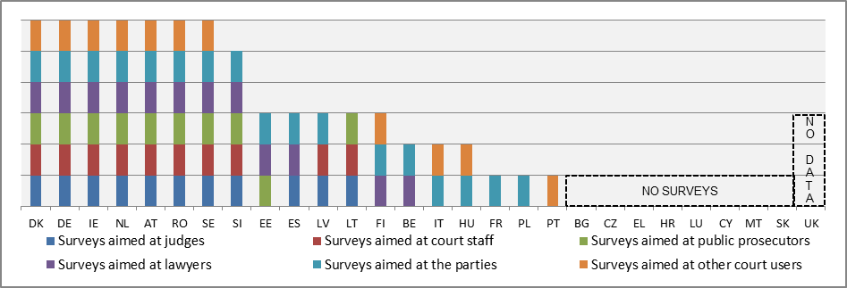
*Surveys aimed at persons who were in direct contact with a court (professionals, litigants and other courts users, for example witnesses, experts, interpreters, etc.) following the CEPEJ methodology.

4.2.2 Information and communication technology systems help to reduce the length of proceedings and to facilitate access to justice
ICT systems for the registration and management of cases are indispensable tools at the disposal of courts for an effective time management of cases, as they help to improve the rate at which the court can treat cases and thereby to reduce the overall length of proceedings.

Figure 16: ICT Systems for the registration and management of cases (weighted indicator-min=0, max=4) (source: CEPEJ study)
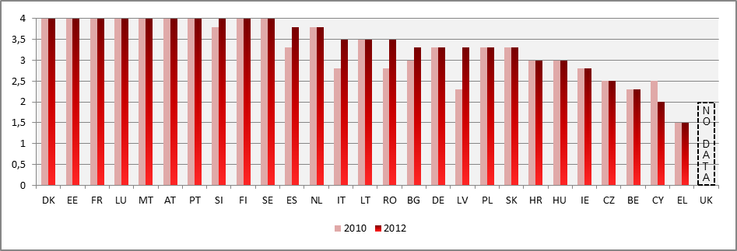
Figure 17: Electronic communication between courts and parties (weighted indicator -min=0, max=4) (source: CEPEJ study)
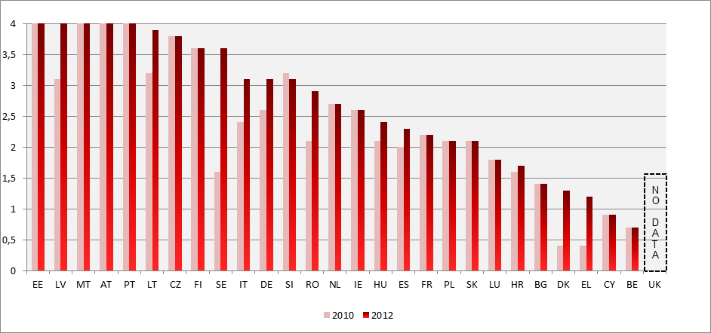
ICT systems for communication between courts and parties (e.g. electronic submission of claims) can contribute to reducing delays and costs for citizens and businesses by facilitating the access to justice. ICT systems also play an increasing role in cross-border cooperation between judicial authorities and thereby facilitate the implementation of EU legislation.

Figure 18: Electronic processing of small claims* (0 = available in 0% of courts; 4 = available in 100% of courts) (source: CEPEJ study)
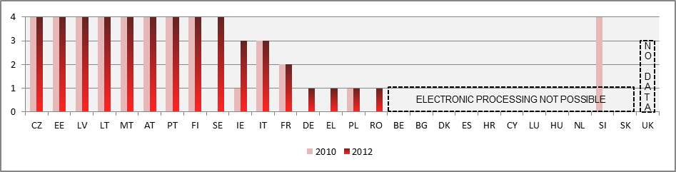
*The notion of "small claims" indicates a civil case where the monetary value of the claim is relatively low. This notion varies between the Member States and the CEPEJ Study uses the national definition in each Member State.
Figure 19: Electronic processing of undisputed debt recovery (0 = available in 0% of courts; 4 = available in 100% of courts) (source: CEPEJ study)
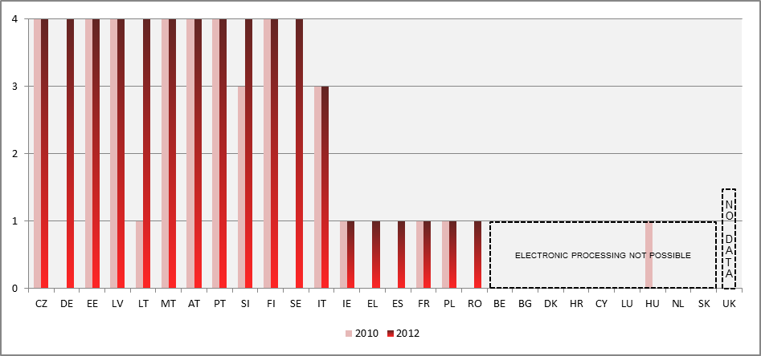
Figure 20: Electronic submission of claims (0 = available in 0% of courts; 4 = available in 100% of courts) (source: CEPEJ study)
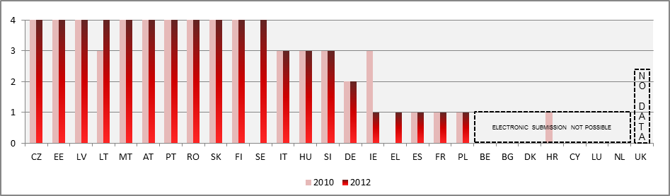

4.2.3 Alternative Dispute Resolution (ADR) methods help to reduce the workload of courts
Effective mediation and other alternative dispute resolution methods broaden the possibilities for citizens and businesses to have disputes solved and contribute to a culture of peaceful resolution of disputes. The interest in such methods is confirmed by a Eurobarometer survey which shows that 89% of respondents would seek an agreement out of court whilst 8% say they would go to court anyway. ADR also contributes to the better functioning of courts. By facilitating an early settlement between parties on a voluntary basis, ADR reduces the number of pending cases and can have a positive impact on the workload of courts, which are then better able to keep reasonable timeframes.
Figure 21: Availability of alternative dispute resolution methods in 2012* (source: CEPEJ study)
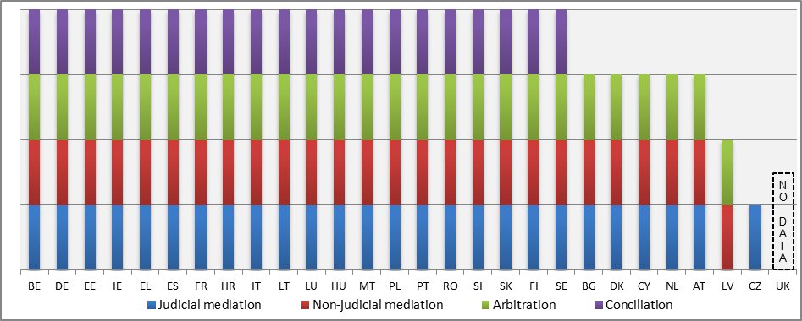
*Almost no changes have been reported on the availability of ADR which appeared to increase in CY and decrease in LV, that is in the early stage of establishing a new legal basis for mediation and a mediation institute.

4.2.4 Promoting training of judges can help to improve the effectiveness of justice
Training of judges is an important element for the quality of judicial decisions. An additional indicator has been introduced to provide information on the actual percentage of judges participating in continuous training in EU law or in the law of another Member State.
Figure 22: Compulsory training for judges in 2012* (source: CEPEJ study)
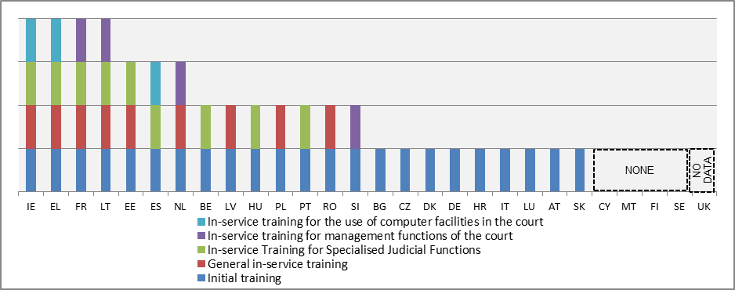
*EL, HU and LT have increased the number of compulsory training categories in comparison to 2010, whereas in LU, SE and RO some categories that were compulsory have become optional.

Figure 23: Judges participating in continuous training activities in EU Law or in the law of another Member State (as a % of total number or judges )* ( source: European Commission, European Judicial Training, 2012)
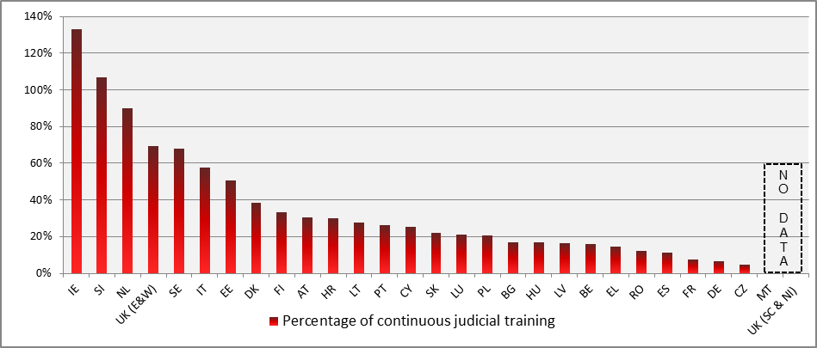
*In a few cases reported by the Member States the ratio of participants to existing members of a legal profession exceeds 100%, meaning that participants took part in more than one training activity on EU law. Some of the exceptionally high figures may suggest that, the data delivered concerns training in all subjects and not just in EU law.

4.2.5 Resources
Figure 24: Budget for courts (in EUR per inhabitant)* (source: CEPEJ study)
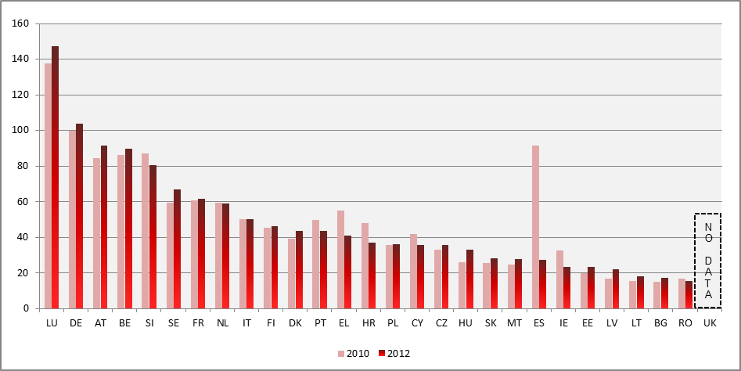
* Figure 24 indicates the annual approved budget allocated to the functioning of all courts, whatever the source and level of this budget (national or regional). It does not take into account Prosecution Services (except in BE, DE, EL, ES (for 2010), FR, LU and AT) or legal aid (except in BE, ES (for 2010) and AT).
Figure 25: General Government total expenditure on "law courts"* (in EUR per inhabitant) (source: Eurostat)
This additional indicator on resources draws upon Eurostat’s data on government expenditure. It presents the budget actually spent, which complements the existing indicator on allocated budget for courts. The comparison is made between 2010, 2011 and 2012.
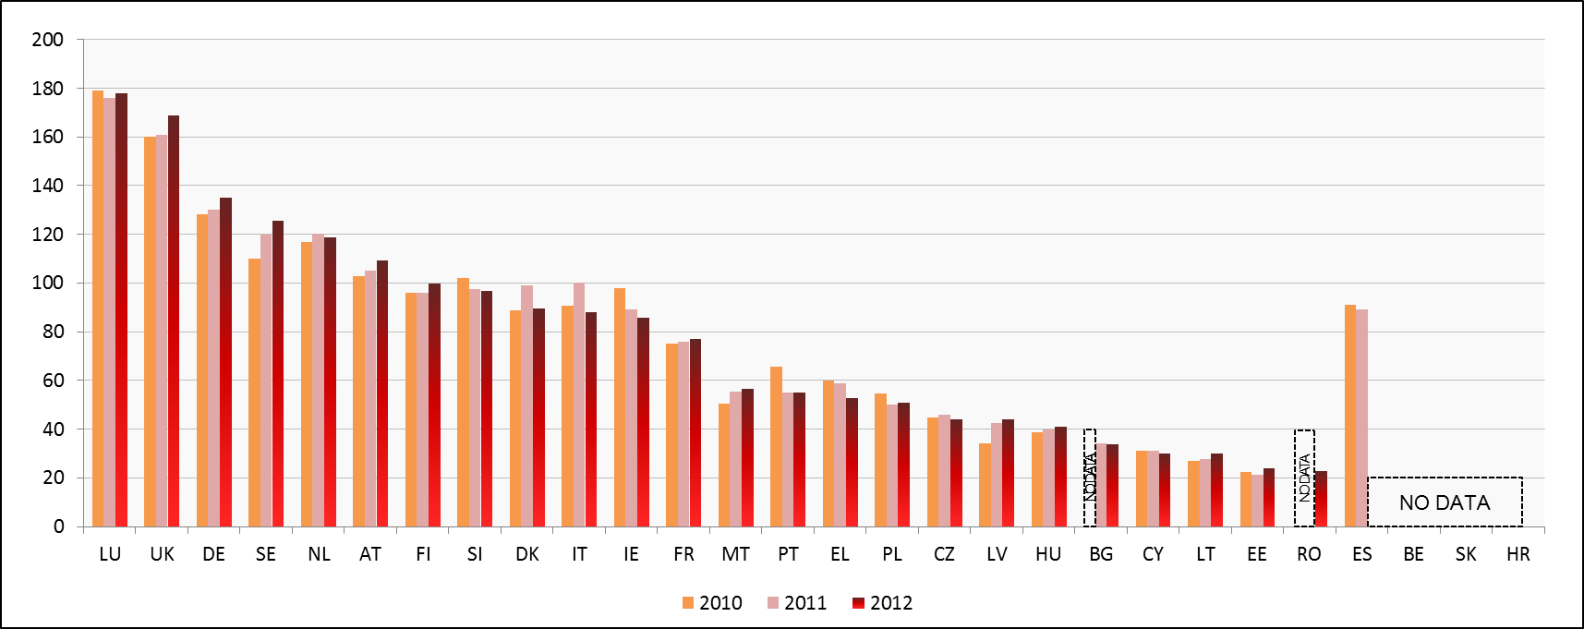
*Whereas Figure 24 indicates the annual approved budget allocated to the functioning of all courts, whatever the source and level of this budget (national or regional), Figure 25 presents general government total (actual) expenditure on courts (National Accounts Data, Classification of the Functions of Government, group 03.3). Figure 25 also includes probation systems and legal aid.
Figure 26: General government expenditure on law courts as a percentage of GDP (source: Eurostat)
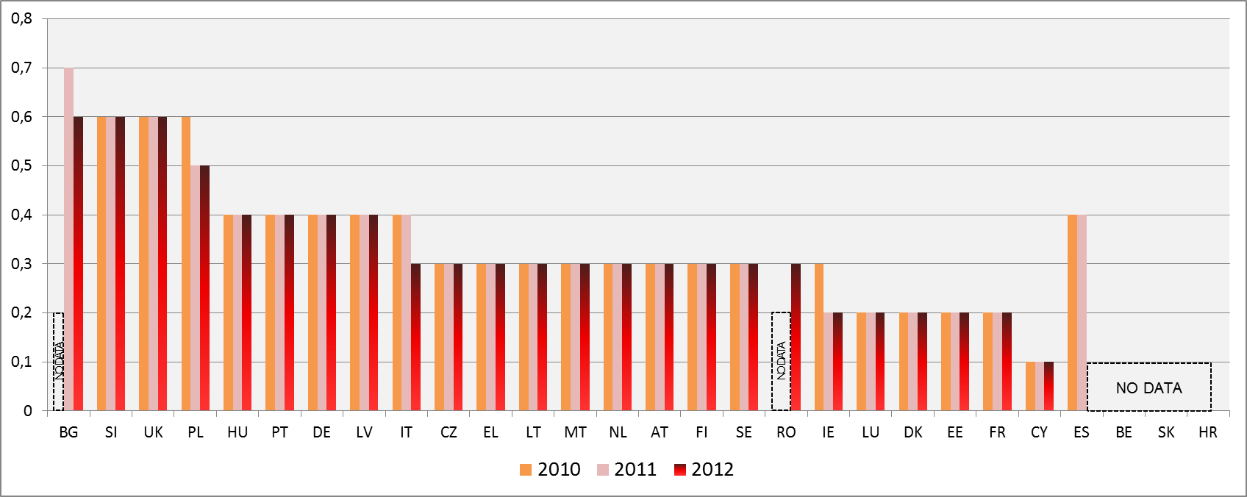

Figure 27: Number of judges* (per 100.000 inhabitants) (source: CEPEJ study)
In order to improve comparability and provide a more focused view, the indicator has been revised in comparison to the 2013 Scoreboard. It no longer includes Rechtspfleger/court clerks which exist only in some Member States. Exclusively full-time judges are taken into account.
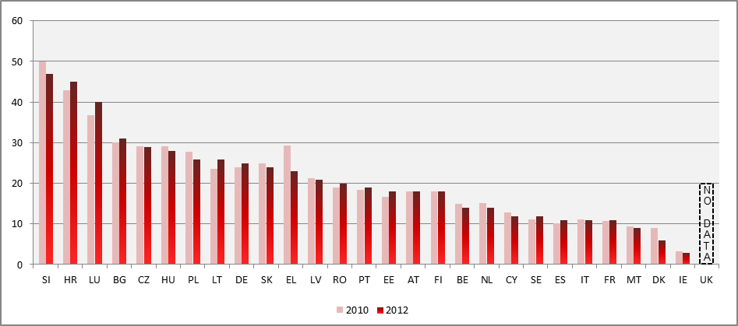
*The category consists of judges working full-time judges, following the CEPEJ methodology. It does not include Rechtspfleger/court clerks who exist in some Member States.
Figure 28: Number of lawyers *(per 100.000 inhabitants) (source: CEPEJ study)
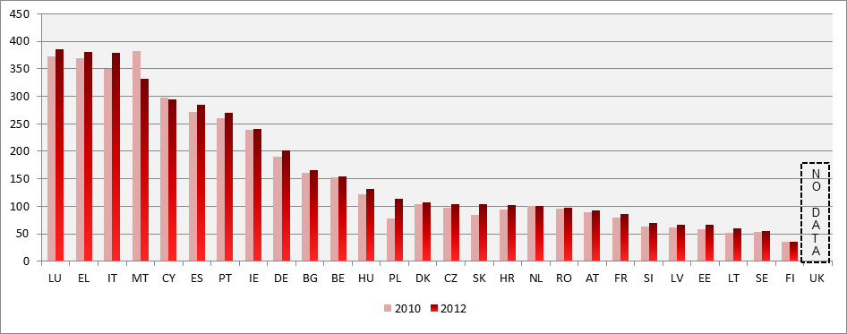
*A lawyer is a person qualified and authorised according to national law to plead and act on behalf of his or her clients, to engage in the practice of law, to appear before the courts or advise and represent his or her clients in legal matters (Recommendation Rec (2000)21 of the Committee of Ministers of the Council of Europe on the freedom of exercise of the profession of lawyer).

- Conclusions on the quality of justice systems

- Monitoring and evaluation of court activities already exist in most Member States. Only a few countries have no evaluation systems in place. User surveys are conducted among court users or legal professionals in more than half of the Member States.
- Alternative dispute resolutions methods are available in nearly all Member States. Updated data on the use of such methods are not available.
- The availability of information and communication technology (ICT) tools for courts increased. They are largely available for the administration and management of courts and to a lesser extent for electronic communications between courts and parties. Electronic processing of small claims, undisputed debt recovery and electronic submission of claims is not possible in a significant number of Member States.
- In nearly a third of Member States the participation rate of judges in continuous training activities on EU law is above 50%. For half of the Member States the participation of judges in EU law training represents less than 20%.

- Training of judges and legal practitioners and ICT tools are crucial for the effective functioning of a European area of justice based on mutual trust. The findings of the Scoreboard confirm that training and ICT should be key components of the future EU Justice policy and will help to consolidate what has been achieved during the past 15 years in this area.

4.3 Independence
Judicial independence is important for an attractive business environment. It assures the predictability, certainty, fairness and stability of the legal system in which businesses operate. For this reason, improving the independence of national judicial systems, together with their quality and efficiency, is an important element in the European Semester. The independence of the judiciary is also a requirement stemming from the right to an effective remedy enshrined in the Charter of Fundamental Rights of the EU. Judicial independence is also important for an effective fight against corruption, as highlighted in the EU Anti-corruption Report.
In order to provide information on the independence of the judiciary in Member States the 2013 Scoreboard used the indicator of the perception of independence of the judicial system. The perceived independence of the judiciary is indeed a growth-enhancing factor as a perceived lack of independence can deter investments. As a general rule, justice must not only be done, it must be seen to be done.
While perceived independence is a relevant indicator, information on how judicial independence is legally guaranteed and upheld is necessary. For this reason, the 2013 Scoreboard announced that the Commission, with the networks of judges and judicial authorities, will examine how the quality and availability of comparable data on structural independence could be improved.
In cooperation with the European Network of Councils for the Judiciary (ENCJ), the Commission has started to collect information on the legal protection of judicial independence in Member States. The figures in the annex present a first comparative overview on how justice systems are organised to protect judicial independence in certain types of situations where their independence can be at risk. Five indicators are used to cover the following situations: (i) the safeguards regarding the transfer of judges without their consent, (ii) the dismissal of judges, (iii) the allocation of incoming cases within a court, (iv) the withdrawal and recusal of judges and (v) the threat against the independence of a judge. For such situations, the 2010 Council of Europe Recommendation on judges: independence, efficiency and responsibilities ('the Recommendation') presents standards to ensure that the independence of the judiciary is respected.

Figure 29: Perceived judicial independence
(perception – higher value means better perception) (source: World Economic Forum)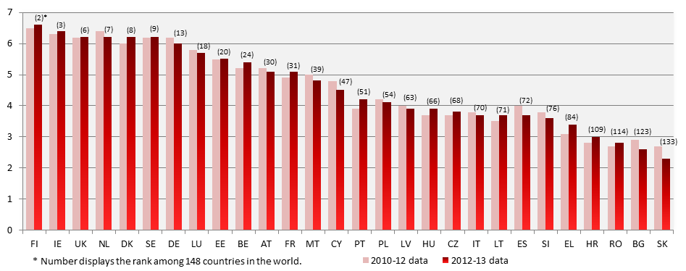

- Conclusions on judicial independence
- In several Member States the perception of independence has improved whilst in some Member States it has deteriorated.
- 2014 Scoreboard also presents in the annex a first factual comparative overview of the legal safeguards aiming at protecting judicial independence in certain situations where independence could be at risk. The Commission will further examine with the networks of judicial authorities and judges, as well as the Member States, how the Scoreboard could further develop comparative data on the effectiveness of these legal safeguards and on other safeguards relating to the structural independence.

5. Further steps
The findings of the Scoreboard will be taken into account in preparing the forthcoming country specific analysis of the 2014 European Semester. They will also be taken into account in the context of the Economic Adjustments Programmes.
The 2014 Scoreboard confirms that the gathering of objective, comparable and reliable data on the effectiveness of justice systems covering all Member States remains a challenge. This may be for different reasons: lack of availability of data due to insufficient statistical capacity, lack of comparability due to procedures or definitions which may vary significantly or the unwillingness to cooperate fully with the CEPEJ.
The Commission considers that it is important to make real progress in the ability to gather and provide relevant data on the quality, efficiency and independence of the justice systems. In view of the importance of well functioning national justice systems in achieving the objectives of the Union, all Member States should address, as a priority, the collection of sound, impartial, reliable, objective and comparable data and make it available in support of this exercise. There is a mutual interest for Member States and national judiciaries to develop the collection of such data in order to better define justice policies.
The Commission intends to intensify the work of the expert group on national justice systems to improve the availability, quality and comparability of data relevant for the EU. In addition to cooperating with the CEPEJ, the Commission is strengthening cooperation with the European networks in the area of justice, in particular the European Network of Councils for the Judiciary, the Network of the Presidents of the Supreme Judicial Court of the European Union, the Association of the Councils of State and Supreme Administrative Jurisdictions, and with the associations of legal practitioners, in particular the lawyers. The possibility to collect data on the functioning of justice systems in other focused areas relevant for growth, such as financial and economic crimes, will be explored.

6. Conclusions
The EU Justice Scoreboard contributes towards identifying, in an open dialogue with Member States, the good examples and possible shortcomings of national justice systems. In line with the principle of equal treatment, it is important that all Member States are covered by the Scoreboard and provide the necessary data. This is a matter of common interest for the smooth functioning of a common European area of justice based on mutual trust and more generally of the Union.
The 2014 EU Justice Scoreboard shows the importance of pursuing with determination the efforts made to improve the effectiveness of justice systems in order to enjoy the full benefits of these reforms. On the basis of this Scoreboard, the Commission invites the Member States, the European Parliament and all stakeholders to an open dialogue and constructive collaboration towards this objective.

ANNEX: STRUCTURAL JUDICIAL INDEPENDENCE
The figures below present a first overview of the legal safeguards in certain types of situations without making an assessment of their effectiveness. The figures are based on the replies to a questionnaire elaborated by the Commission in close association with the ENCJ.
Figure I: The safeguards regarding the transfer of judges without their consent (irremovability of judges)
The figure examines the scenario of the transfers of judges without their consent and shows whether such transfer is allowed and when it is allowed: (i) the authorities that decide on such transfers, (ii) the reasons (e.g. organisational, disciplinary) for which such a transfer is allowed and (iii) whether an appeal against the decision is possible.
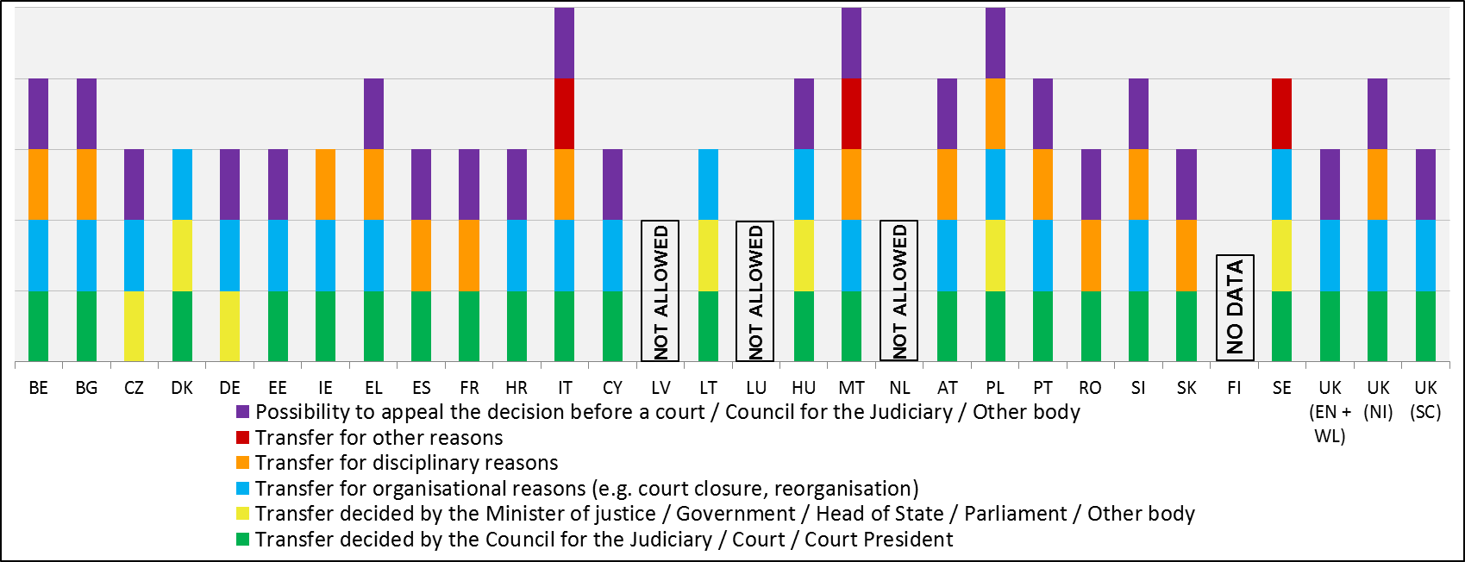

Figure II: The dismissal of 1st and 2nd instance judges
This figure presents the authorities that have the power to propose and decide on the dismissal of judges of first and second instance in the different Member States. The upper part of the column indicates who takes the final decision and the lower part shows – where relevant- who proposes dismissal or who must be consulted before a decision is taken.
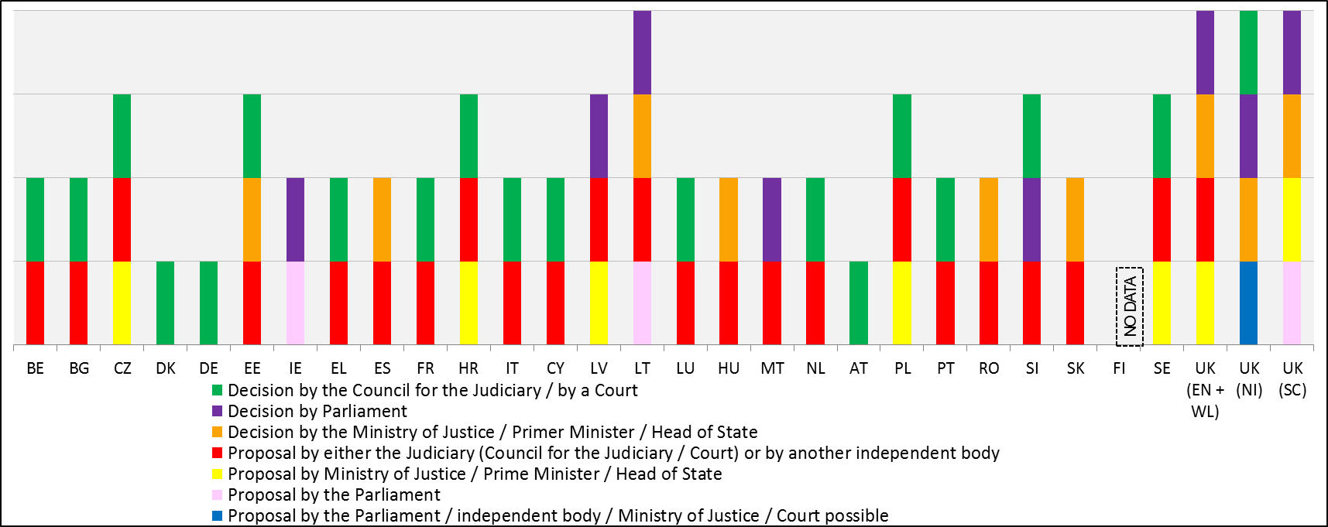

Figure III: The allocation of cases within a court
The figure presents at what level the criteria for distributing cases within a court are defined (e.g. law, well-established practice), how cases are allocated (e.g. by court president, by court staff, random allocation, pre-defined order) and which authority supervises the allocation.
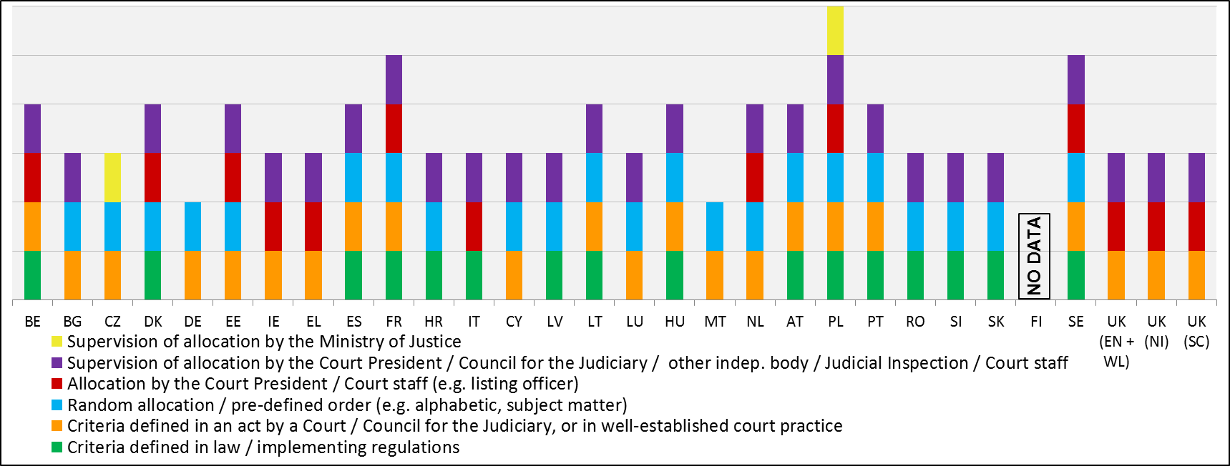

Figure IV: The withdrawal and recusal of a judge
The figure presents whether judges can be subject to sanctions if they disrespect the obligation to withdraw from adjudicating a case in which their impartiality is in question or is compromised or where there is a reasonable perception of bias. The figure also presents which authority decides on a recusal request by a party aimed at challenging a judge.
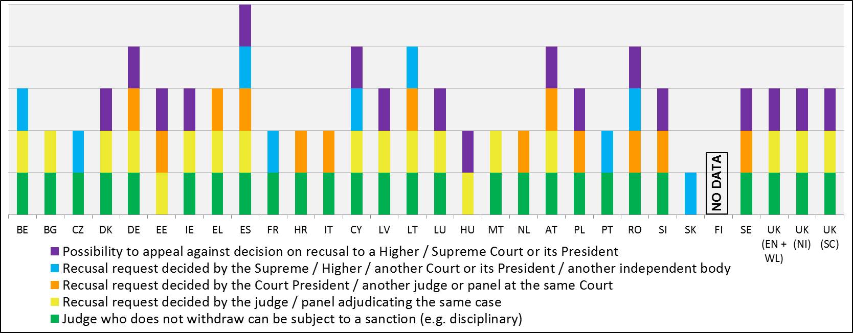

Figure V: The procedures in case of threat against the independence of a judge
The figure presents which authorities can act in specific procedures for protecting judicial independence when judges consider that their independence is threatened. It also presents the measures these authorities can adopt (e.g. issuing a formal declaration, filing of complaints or sanctions against persons seeking to influence judges in an improper manner). Action taken for the protection of judicial independence comes from a public prosecution service or a court in case of sanctions, or from the Council for the Judiciary in case of other measures.
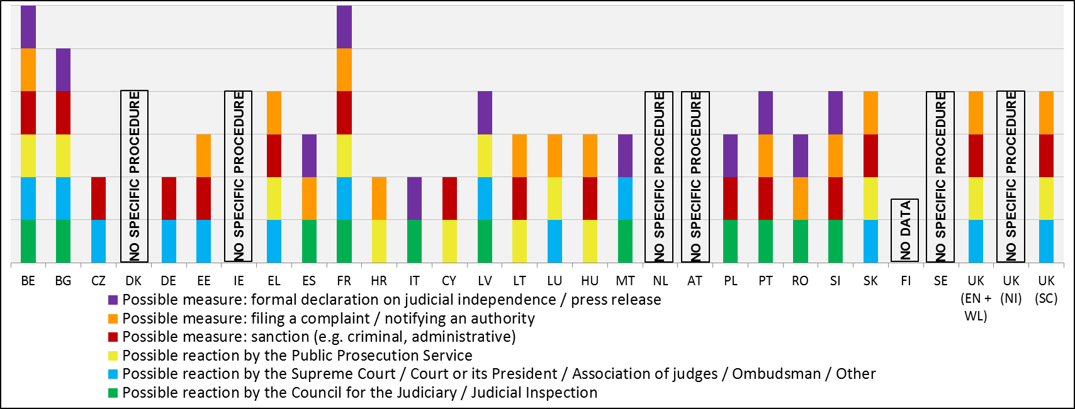

In 2014, Economic Adjustment Programmes in Greece, Portugal and Cyprus include conditionality on justice reforms.
Communication from the Commission, Annual Growth Survey 2013, COM(2012) 750 final.
Communication from the Commission, Annual Growth Survey 2014, COM(2013) 800 final.
The reasons for country-specific recommendations are presented by the Commission in a Staff Working Document, available at: http://ec.europa.eu/europe2020/europe-2020-in-your-country/index_en.htm
Available at: http://ec.europa.eu/justice/effective-justice/scoreboard/index_en.htm
Not all Member States have provided data to the CEPEJ.
Study on the functioning of national courts for the application of competition law rules, carried out by ICF GHK, 2014; Study on the functioning of national courts for the application of consumer law rules carried out by the Centre for Strategy and Evaluation Services LPP, 2014. Available at: http://ec.europa.eu/justice/effective-justice/scoreboard/index_en.htm
IMF, "Fostering Growth in Europe Now" 18 June 2012.
Available at: http://www.ecb.europa.eu/press/key/date/2013/html/sp130516.en.html
See for example "What makes civil justice effective?”, OECD Economics Department Policy Notes, No. 18 June 2013 and "The Economics of Civil Justice: New Cross-Country Data and Empirics", OECD Economics Department Working Papers, No. 1060.
World Economic Forum, "The Global Competitiveness Report; 2013-2014", available at: http://www3.weforum.org/docs/WEF_GlobalCompetitivenessReport_2013-14.pdf
Available at: http://www.doingbusiness.org/reports/global-reports/~/media/GIAWB/Doing%20Business/Documents/Annual-Reports/English/DB14-Chapters/DB14-Enforcing-contracts.pdf
See IMF Country Report No. 13/299.
See Bank of Spain Working Paper 1303; Bank of Italy Working Paper 898; IMF Country Report 13/299 referred to above.
OECD Economics Department referred to above.
IMF Country Report No. 13/299.
Resolution "EU Justice Scoreboard- civil and administrative justice in the Member States".
As regards the Committee of the Regions, the Chair of the Commission in charge of Citizenship, Governance, Institutional and External Affairs (CIVEX) transmitted a series of remarks underlining the importance of effective justice and growth at local and regional level.
Information on the conference, speeches and written contributions available at: http://ec.europa.eu/justice/events/assises-justice-2013/index_en.htm
Flash Eurobarometer 385 Justice in the EU, available at: http://ec.europa.eu/public_opinion/archives/flash_arch_390_375_en.htm#385
Council Recommendation (2013/C 217/03), of 9 July 2013, on the National Reform Programme 2013 of Bulgaria and delivering a Council opinion on the Convergence Programme of Bulgaria, 2012-2016 (see §5); Council Recommendation (2013/C 217/20), of 9 July 2013,on the National Reform Programme 2013 of Spain and delivering a Council opinion on the Stability Programme of Spain, 2012-2016 (see §9); Council Recommendation (2013/C 217/10), of 9 July 2013, on the National Reform Programme 2013 of Hungary and delivering a Council opinion on the Convergence Programme of Hungary, 2012-2016 (see §5); Council Recommendation (2013/C 217/11), of 9 July 2013, on the National Reform Programme 2013 of Italy and delivering a Council opinion on the Stability Programme of Italy, 2012-2017 (see §2): Council Recommendation (2013/C 217/12), of 9 July 2013, on the National Reform Programme 2013 of Latvia and delivering a Council opinion on the Convergence Programme of Latvia, 2012-2016, of 9 July 2013 (see §7); Council Recommendation (2013/C 217/15), of 9 July 2013, on the National Reform Programme 2013 of Malta and delivering a Council opinion on the Stability Programme of Malta, 2012-2016 (see §5); Council Recommendation (2013/C 217/16), of 9 July 2013, on the National Reform Programme 2013 of Poland and delivering a Council opinion on the Convergence Programme of Poland, 2012-2016 (see §7); Council Recommendation (2013/C 217/17), of 9 July 2013, on the National Reform Programme 2013 of Romania and delivering a Council opinion on the Convergence Programme of Romania, 2012-2016 (see §7); Council Recommendation (2013/C 217/19),of 9 July 2013, on the National Reform Programme 2013 for Slovenia and delivering a Council opinion on the Stability Programme of Slovenia, 2012-2016, (see §7); Council Recommendation (2013/C 217/18), of 9 July 2013, on the National Reform Programme 2013 of Slovakia and delivering a Council opinion on the Stability Programme of Slovakia, 2012-2016 (see §6). Available at: http://eur-lex.europa.eu/JOHtml.do?uri=OJ:C:2013:217:SOM:EN:HTML
BG, IT, LV, PL, SI, SK.
For example, following the signature of the Economic Adjustment Programme in 2011, PT has taken measures to improve the effective and timely enforcement of contracts, restructure the court system, and eliminate backlog of court cases. Preliminary data for 2013 show positive developments for instance as regards clearance rate of enforcement cases.
BG, CZ, EL, HR, IT, LV, LT, HU, PL, RO, SI and SK. Positions of the Commission Services on the development of Partnership Agreement and programmes for these countries are available at: http://ec.europa.eu/regional_policy/what/future/program/index_en.cfm
Study on the functioning of national courts for the application of competition law rules, carried out by ICF GHK, 2014; Study on the functioning of national courts for the application of consumer law rules carried out by the Centre for Strategy and Evaluation Services LPP, 2014.
Commission Staff Working Document, Impact Assessment Report, Damages actions for breach of the EU antitrust rules accompanying the proposal for a Directive of the European Parliament and of the Council on certain rules governing actions for damages under national law for infringements of the competition law provisions of the Member States and of the European Union, 11 June 2013, SWD 2013 (203) (paragraph 65).
Commission Staff Working Paper Consumer Empowerment in the EU, 7 April 2011, SEC (2011) 469, (paragraph 2).
Length of proceedings, clearance rate and number of pending cases, are standard indicators defined by CEPEJ. Their definition and interrelation is available at http://www.coe.int/t/dghl/cooperation/cepej/evaluation/default_en.asp
Report on the functioning of judicial systems in the EU Member States, carried out by the CEPEJ Secretariat for the Commission. All charts compare, where available, data for 2010 with data for 2012. 2010 data includes updates made by CEPEJ after the publication of their 2013 study as transmitted to the Commission.
Study on the functioning of national courts for the application of competition law rules, carried out by ICF GHK, available at: http://ec.europa.eu/justice/effective-justice/scoreboard/index_en.htm.
Study on the functioning of national courts for the application of consumer law rules carried out by Centre for Strategy & Evaluation Services LLP, available at: http://ec.europa.eu/justice/effective-justice/scoreboard/index_en.htm.
For some Member States (*) only length in last instance is indicated, as no sufficient data were available for other instances. For ES (**), the average length of proceedings at 3rd instance differs significantly between 2008 and 2012: in 2008 it was over 2,600 days and has been reduced to about 1,000 days in 2012. In the UK (***), data refer to England and Wales and they provide the average length of county court proceedings at 1st instance.
For example, in EL, the number of incoming civil and commercial litigious cases increased by 42% between 2010 and 2012.
See note 23.
CY, IE and SI indicated to CEPEJ that they have interpreted some questions on ICT differently than in 2010. This explains why the values for certain ICT indicators are lower in 2012 than in 2010.
Figures 16 and 17 show composite indicators constructed from several ICT indicators that each measures availability of these systems from 0 to 4 (0= available in 0% of courts; 4=available in 100% of courts).
Flash Eurobarometer 385, November 2013, available at: http://ec.europa.eu/public_opinion/flash/fl_385_en.pdf
Available at: http://ec.europa.eu/justice/criminal/files/european_judicial_training_annual_report_2012.pdf
In Figure 24, the significant decrease for ES reflects the fact that data from the Autonomous Communities and from the Council for the Judiciary have not been included in 2012 data.
The following values are provisional: BG, EL and HU for all years, SE for 2012.
The following values are provisional: BG, EL and HU for all years; for SE, values for 2012 are provisional.
COM (2014)38 final, 4.2.2014, available at: http://ec.europa.eu/dgs/home-affairs/e-library/documents/policies/organized-crime-and-human-trafficking/corruption/docs/acr_2014_en.pdf and http://ec.europa.eu/anti-corruption-report/
Recommendation CM/Rec(2010)12 of the Committee of Ministers to member states on judges: independence, efficiency and responsibilities.
The WEF indicator is based on survey answers to the question: "To what extent is the judiciary in your country independent from the influences of members of government, citizens, or firms?" The survey was replied to by a representative sample of firms in all countries representing the main sectors of the economy (agriculture, manufacturing industry, non- manufacturing industry, and services). The administration of the survey took different formats, including face-to-face interviews with business executives, telephone interviews and mailings, with an online survey as an alternative. Available at: http://www.weforum.org/reports/global-competitiveness-report-2013-2014
This overview contains only basic information on how the justice systems are organised and does not intend to reflect the complexity and details of these systems. The objective of this section is to provide a first mapping of safeguards for judicial independence and therefore the figures present the Member States according to the alphabetical order of their geographical names in the original language.
For those Member States where Councils for the Judiciary do not exist, the replies to the questionnaire have been obtained in cooperation with the Network of the Presidents of the Supreme Courts of the European Union.
§ 52 of the Recommendation contains guarantees on the irremovability of judges, in particular that a judge should not be moved to another judicial office without consenting to it, except in cases of disciplinary sanctions or reform of the organisation of the judicial system.
§ 46 and 47 of the Recommendation require that national systems provide for safeguards regarding the dismissal of judges.
It can be one or two different bodies depending on the reason for dismissal or the type of judge (e.g. president, etc.).
§ 24 of the Recommendation requires that the systems for the distribution of cases within a court follow objective pre-established criteria in order to safeguard the right to an independent and impartial judge.
Sometimes more than one authority can take this decision, depending on the level of the court where the recused judge sits.
§ 59, 60 and 61 of the Recommendation provide that judges should act independently and impartially in all cases and should withdraw from a case or decline to act where there are valid reasons defined by law, and not otherwise.
§ 8, 13 and 14 of the Recommendation provide that where judges consider that their independence is threatened, they should be able to have recourse to effective means of remedy.

