Annex I: Main steps under the European Semester
Annex II: Overview of progress
towards the Europe 2020 targets

Background:
For each of the Europe 2020 targets, this Annex reviews:
- Progress to date at EU level and illustrates possible scenarios until 2020.
- Latest data available on performances at national level and national targets for 2020.
- Trends in national performances, with some international comparisons where possible.

The graphs are based on the latest data available as of February 2014. EU averages correspond to EU28, unless otherwise indicated.
Detailed data, with more variables, are regularly updated and available on Eurostat's website at: http://epp.eurostat.ec.europa.eu/portal/page/portal/europe_2020_indicators/headline_indicators
Additional information and details on the targets are available at: http://epp.eurostat.ec.europa.eu/portal/page/portal/europe_2020_indicators/headline_indicators/targets
A complete report, with further methodological and statistical explanations, was produced in Autumn 2013 and is also available at: http://epp.eurostat.ec.europa.eu/cache/ITY_OFFPUB/KS-02-13-238/EN/KS-02-13-238-EN.PDF

EUROPE 2020 TARGET ON EMPLOYMENT
Raise the employment rate of the population
aged 20-64 to at least 75%

1. State of play at EU level
The employment rate in the EU has been stagnating for the last few years and remains below the Europe 2020 target of 75% of the population aged 20-64 in employment by 2020. Following a steady upward trend between 2000 and 2008, when it rose from 66.6% to 70.3%, the employment rate in the EU fell to 68.9% in 2009 as a result of the deep contraction of the economy. It decreased further to 68.5% in 2010 and has since then broadly stabilised at this level. At 68.4% in 2012, the EU employment rate currently stands 6.6 percentage points below the 75% target. This is due to the combination of the negative impact of the crisis and the time needed before improvements translate onto labour markets, as well as the slow pace of labour market reforms in some Member States.
Significant progress, particularly in action to favour the return to growth and job creation, would be required to reach the employment rate target by 2020. On the basis of the current state of play and the slight increases in the employment rate expected over the coming years, the Europe 2020 target would not be met and the employment rate would reach 71.8% in 2020. The EU would need to have around 16 million additional people in employment to meet the target by 2020.
EU employment rate in 2000*, 2012 and 2020
(share of people employed, 20-64 age group)
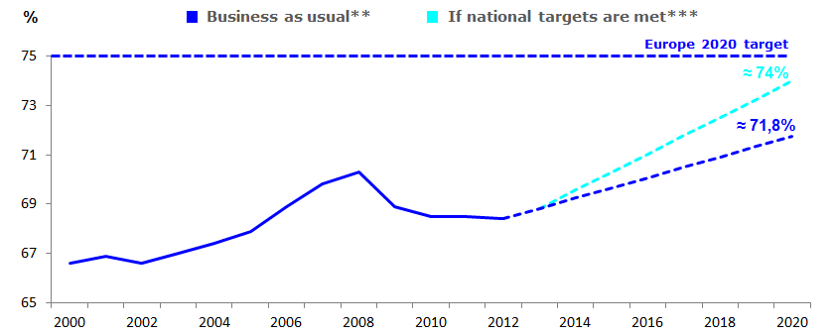
Source: European Commission
Reading: on the basis of current commitments, the EU employment rate could reach 71.8% by 2020.
* 2000 and 2001: EU27 data.
** Estimated values based on Commission 2013 Autumn Forecast for 2014-2015, assuming an employment growth to the levels of 2014-2015, taking into account a 1.0% reduction of the active population during the decade.
*** No target set by the UK: the projection for the EU assumes 75% for the UK in 2020.
2. State of play and progress at national level
Most Member States are a long way off from their Europe 2020 target. The employment targets set by Member States for 2020 range from 59% and 62.9% in Croatia and Malta respectively (with the latter already reaching this target), to 80% in Denmark, the Netherlands and Sweden. Sweden and Germany show employment rates of 79.4% and 76.7% in 2012 and are thus approaching their objectives of 80% and 77%. The distance between 2012 performance and the national Europe 2020 target is the highest in Spain, Greece, Bulgaria and Hungary, with a gap of more than 10 percentage points, which raises doubts about their ability to meet their objective by 2020. In terms of progress achieved, Germany and Austria appear as the best performers, with high employment rates and relatively strong growth since 2000. At the other end of the spectrum, Greece, Spain, Croatia, Romania and Ireland have been affected by sharp falls in employment and still have low employment rates compared to the other Member States.

Employment rates in EU Member States
(share of people employed, 20-64 age group)
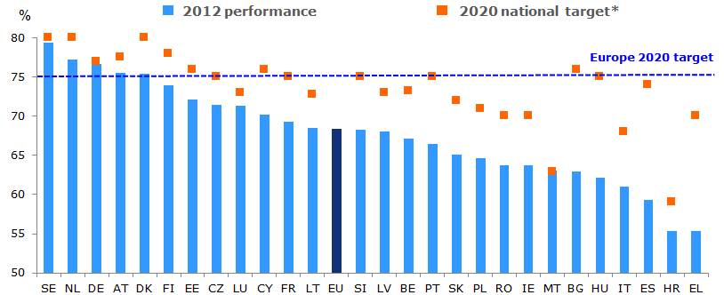
Source: European Commission
Reading: in 2012, the employment rate in the EU was 68.4%, against a target of 75% for 2020.
* No target set by the UK. SE: target well above 80 %. IE: 69-71% (70% assumed); IT: 67-69% (68% assumed); CY: 75-77% (76% assumed); AT: 77-78% (77.5% assumed).

Situation in 2012 and progress since 2000, by country
Progress between 2000 and 2012 (% point change)*
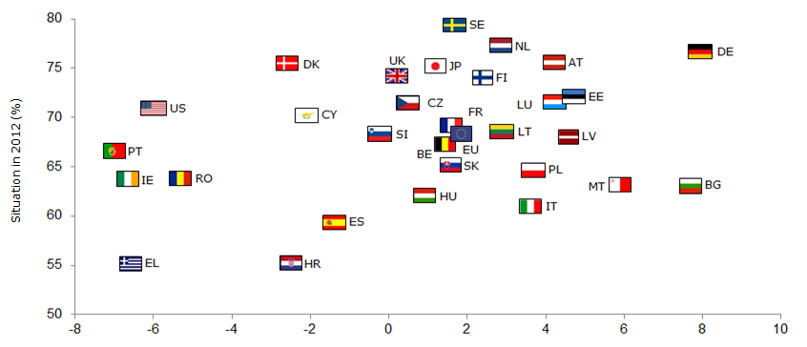
Progress over 2000 to 2012 (% point change)
Source: European Commission
Reading: for the EU as a whole, the employment rate increased by 1.8 percentage points over 2000-2012 (horizontal axis), to reach 68.4% in 2012 (vertical axis).
* 2000: EU27 data; HR: 2002-2012

Performance gaps between Member States are widening and regional discrepancies remain in Southern Member States. In 2012, the gap between the highest and the lowest values was 24.1 percentage points, with employment rates varying from 55.3% in Greece to 79.4% in Sweden. This can be compared to the situation in 2000, where 22.7 percentage points separated the lowest from the highest performance, with employment rates going from 55.3% in Bulgaria to 78% in Denmark. Generally, Northern and Central European countries tend to have higher employment rates than Southern and Eastern Member States. Furthermore, Southern and Eastern European countries display strong variations in terms of regional employment rates. The regional performance of Northern and Central European countries is rather homogeneous, with high employment rates.

EUROPE 2020 TARGET ON RESEARCH AND DEVELOPMENT
Invest 3% of GDP in Research and Development

1. State of play at EU level
Expenditure on research and development (R&D) in the EU has recently been slightly increasing, but remains lower than the 3% Europe 2020 target. The R&D objective set at EU level is expressed in terms of R&D intensity, which measures gross domestic expenditure of the public and private sector on R&D as a percentage of GDP, i.e. the share of GDP invested in R&D. Public funding of R&D is a direct measure of the level of public effort in support of R&D activities. Monitoring private funding of R&D allows for the assessment of the effectiveness of policies aimed at attracting and fostering business R&D investments and the development and growth of knowledge-intensive firms. After remaining flat at around 1.85% between 2000 and 2007, EU gross domestic expenditure on R&D as a share of GDP rose to 2.01% in 2009 and has only moderately increased since then. With a share of GDP amounting to 2.06% in 2012, EU gross domestic expenditure on R&D as a percentage of GDP remains almost 1 percentage point below the 3% target and visibly below the performance of the United States.
Recent progress towards the 3% target results mainly from policies at EU and Member State level. They aim to foster private investment in R&D (notably through increased leverage via public funding, improved framework conditions and fiscal incentives) and to protect and promote public funding of R&D despite the crisis, in line with the principle of growth-friendly fiscal consolidation. Compared to international competitors, Europe's shortfall mainly derives from low levels of private investment.
Under current circumstances, the Europe 2020 target on R&D is unlikely to be met by 2020. According to the latest projections and if current reforms and financial efforts continue, gross domestic expenditure on R&D as a percentage of GDP is expected to remain below the 3% threshold until 2020. To meet this target, the average annual growth rate of R&D expenditure in the EU would need to double compared to the 2007-2012 period. Progressing more rapidly towards the 3% target needs faster structural change towards more knowledge-based economic activities.
EU gross domestic expenditure on R&D as a % of GDP in 2000, 2012 and 2020
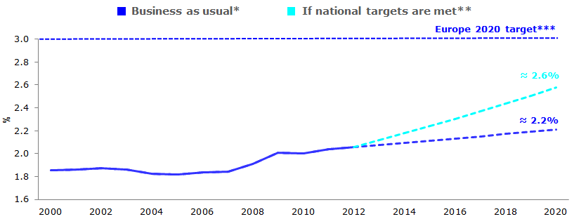
Source: European Commission
Reading: on the basis of current commitments, EU investment in R&D could reach 2.2% by 2020.
* Scenario based on the continuation of ongoing reforms and financial efforts.
**No targets sets by CZ and the UK: 2020 figures were estimated by Commission services.
***The EU target includes R&D expenditure by intergovernmental research infrastructures, which is not included in the R&D expenditure of the Member States.
2. State of play and progress at national level
Levels of ambition and progress towards the Europe 2020 targets differ across Member States. The national targets in terms of R&D highlight various levels in ambition of the Member States: Finland and Sweden, which already show the greatest R&D intensity in the EU, have set the highest targets of 4% of GDP invested in R&D by 2020. With targets of 0.50% and 0.67% respectively, Cyprus and Greece have the lowest objectives. Other countries have defined achievable but not overly ambitious goals, such as Italy with a target of 1.53%. Greece has already achieved its target of 0.67% of its GDP expenditure on R&D in 2012. Germany, Denmark and Cyprus are getting close to their respective objectives. Romania, Portugal, Malta and Lithuania remain far from their targets, with values at least 1 percentage point below their goal. Progress made since 2000 across countries is mixed: Estonia combines a performance above the EU average in 2012 with the biggest increase in investment in R&D as a share of GDP, whereas Croatia, Luxembourg and the United Kingdom display R&D intensity below the EU average and negative growth in this area.
R&D investment in EU Member States as a % of GDP
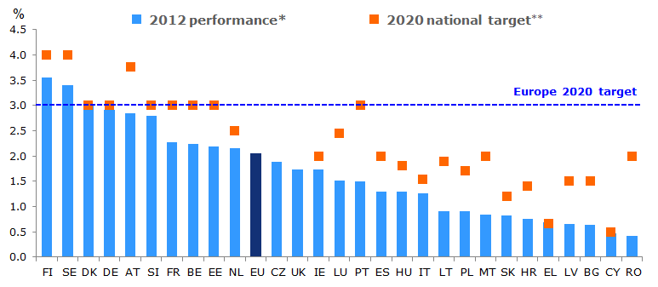
Source: European Commission
Reading: in 2012, R&D intensity in the EU amounted to 2.06% of GDP, against a target of 3% for 2020.
* LU: 2010.
**No targets set by CZ (only for the public sector) and the UK. IE: the target is 2.5% of GNP, which is estimated to be equivalent to 2% of GDP. LU: the target is between 2.30% and 2.60% of GDP (2.45% assumed). PT: the target is between 2.70% and 3.30% of GDP (3% assumed).

Situation in 2012 and progress since 2000, by country*
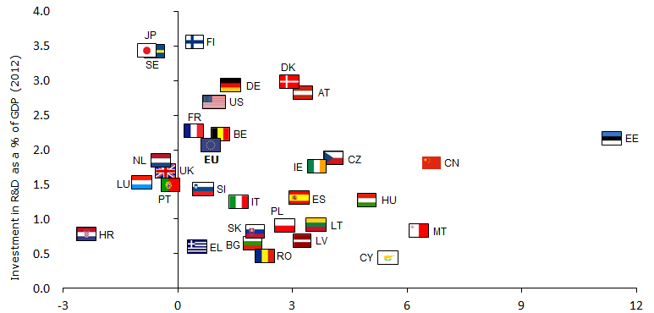
Average annual growth in investment in R&D, 2000-2012 (%)
Source: European Commission
Reading: investment in R&D in the EU has increased at an annual growth rate of 0.9% over 2000-2012 (horizontal axis), to reach 2.06% in 2012 (vertical axis).
*Performance: EL, SI: 2007; LU, NL, RO: 2010; US, JP, CN: 2011. Progress: SI: 2000-2007; LU, NL, RO: 2000-2010; CN: 2000-2011; EL: 2001-2007; HR: 2002-2012; HU, MT: 2004-2012; SE: 2005-2012; US: 2006-2011; DK: 2007-2012; JP: 2008-2011; PT: 2008-2012; FR: 2010-2012.
There is a North-South divide in R&D investment. The inter-country performance gap for R&D intensity has been widening over the last decade: on the basis of available data, gross domestic expenditure on R&D as a share of GDP ranged from 0.37% in Romania, to 3.35% in Finland in 2000, a difference of 2.98 percentage points. This gap increased to 3.13 percentage points in 2012, between 0.42% in Romania and 3.55% in Finland. Generally, Northern European countries show the highest levels of R&D intensity, whereas Eastern and Southern Member States score lower on this indicator. At regional level, the countries with the lowest levels of R&D intensity are rather homogeneous and predominantly made up of regions with low levels of investment in R&D. In Member States with the highest levels of R&D intensity, a number of regions remain below the ambitious national target.

EUROPE 2020 TARGET ON CLIMATE AND ENERGY (1)
Reduce greenhouse gas emissions by at least 20%
compared to 1990 levels

1. State of play at EU level
Following a sizeable reduction of greenhouse gas emissions, the EU is close to achieving its Europe 2020 target of a 20% reduction compared to 1990 levels. Between 1990 and 2012, greenhouse gas emissions at EU level decreased by 18% Current climate and energy policies have delivered on progress, with the economic slowdown also having a significant effect on emissions reduction. A slight increase in greenhouse gas emissions was observed in 2010, during the temporary recovery. This performance is all the more significant as the European economy has grown by around 45% in real terms since 1990 and it shows a clear decoupling of economic growth and greenhouse gas emissions. As a result, in 2012 the European economy was almost twice less carbon-intensive – carbon intensity refers to the amount of emissions released per unit of GDP – than in 1990.
Based on the latest trends, the Europe 2020 target related to greenhouse gas emissions seems within reach. In line with the encouraging developments of recent years, the reduction of greenhouse gas emissions could exceed the target and reach 24% by 2020.

Greenhouse gas emissions in 2000, 2012 and 2020
(index 1990=100)
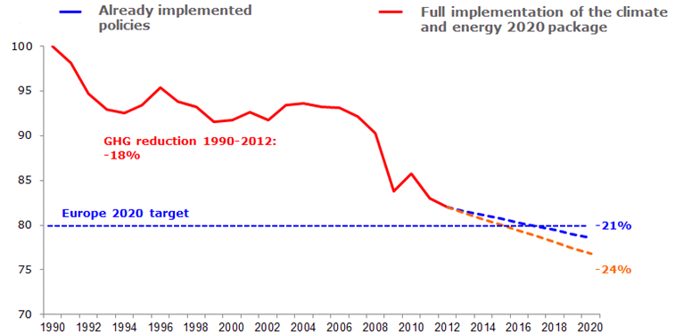
Source: European Commission
Reading: if the climate and energy 2020 package is fully implemented, the EU could reduce its greenhouse gas emissions by 24% by 2020, compared to 1990 levels.
2. State of play and progress at national level
Around half of the Member States have already reached their Europe 2020 target for reduction of greenhouse gas emissions in non-Emissions Trading Scheme (ETS) sectors. The national targets in this area measure greenhouse gas emissions in sectors not covered by the EU ETS, compared to 2005 levels. They range from an objective of a 20% reduction of emissions to a 20% increase. According to 2012 data, for 15 Member States (Cyprus, Hungary, Italy, Greece, Spain, Portugal, Czech Republic, Romania, Slovakia, Lithuania, Slovenia, Malta, Latvia, Bulgaria and Poland) greenhouse gas emissions were below their respective targets for 2020. Most of the other Member States have also lowered their emissions and thus achieved some progress, without meeting their target so far. Luxembourg, Denmark, Germany, Belgium, Finland and the Netherlands are the most distant from their objectives. According to the latest available national projections, in 13 Member States (Germany, the Netherlands, Latvia, Bulgaria, Italy, Finland, Austria, Spain, Lithuania, Belgium, Ireland, Slovenia and Luxembourg) the existing policies would not be sufficient to meet the national targets by 2020.

Change in greenhouse gas emissions in non-ETS sectors in EU Member States
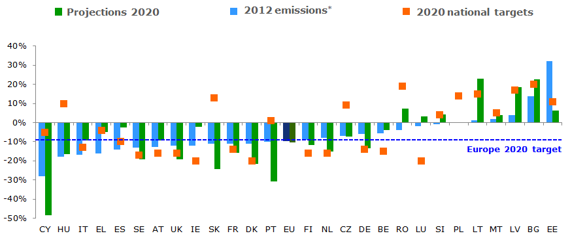
Source: European Environmental Agency
Reading: in 2012, greenhouse gas emissions in non-ETS sectors were 10% lower than in 2005 in the EU.
*Non-ETS, compared with 2005, based on approximated data.
Between 2000 and 2011, carbon intensity decreased in all Member States, although progress varies a lot. Highly carbon-intensive countries have generally achieved a sizeable reduction; low carbon-intensive countries display more limited progress.

Situation in 2011 and progress in terms of carbon intensity since 2000, by country
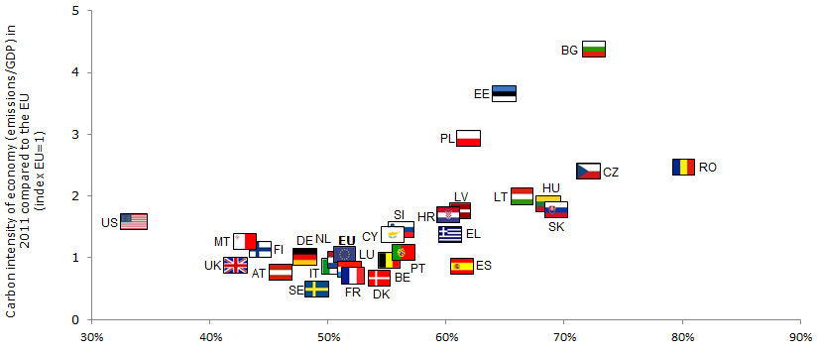
Reduction in carbon intensity between 2000 and 2011 (%)
Source: European Commission
Reading: in 2011, most Member States were close to the EU average in terms of carbon intensity and progress.

EUROPE 2020 TARGET ON CLIMATE AND ENERGY (2)
Increase the share of renewable energy
in final energy consumption to 20%

1. State of play at EU level
There has been a steady increase in the use of renewable energy at EU level since 2000 and, provided it is sustained, the EU is on the way to reaching the Europe 2020 target of increasing the share of renewables in final energy consumption to 20%. From 7.5% in 2000, the share of renewables in gross final energy consumption increased to 8.5% in 2005 and 14.4% in 2012, i.e. 5.6 percentage points below the Europe 2020 target, because of the deployment of support schemes and the introduction of incentives to foster the use of renewables. The EU is now in the lead in terms of investment in renewables, in particular a rapid development of wind and solar energy.
Based on the latest trends, the Europe 2020 target related to renewable energy sources seems within reach. In line with the encouraging developments of recent years, the share of renewables in gross final energy consumption might approach 21% in 2020, if the effort of recent years is maintained.

EU share of renewable energy in gross final energy consumption, 2000-2020
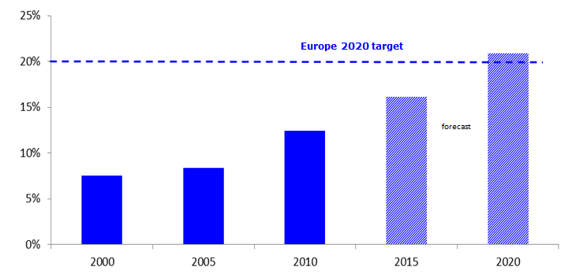Sources: European Commission, study commissioned by the European Commission
Reading: based on current developments and policies, EU share of renewables in energy consumption could reach 20.9% by 2020.

2. State of play and progress at national level
Overall progress has been observed but efforts are still needed in most Member States. The national targets range from 10% for Malta to 49% in Sweden. Generally, all Member States have increased the use of renewable sources of energy since 2005, however only three of them, Sweden, Estonia and Bulgaria, have so far reached their national targets. Finland, Austria and Czech Republic are very close to their respective objectives. France and the United Kingdom stand around 10 percentage points away from their targets.
Looking at developments over time, the group of best performers comprises Sweden, Austria and Estonia, which combine the greatest progress since 2005 and high levels of renewables’ use. Malta, Luxembourg, Belgium, the United Kingdom, the Netherlands and France show both low performances and only moderate progress since 2005. As regards the divergences across the EU, the inter-country gap has increased since 2005, from 40.4 percentage points to 52.1 percentage points in 2012, with values ranging from 0.3% in Malta to 52.4% in Sweden.

Share of renewables in EU Member States
(% of gross final energy consumption)

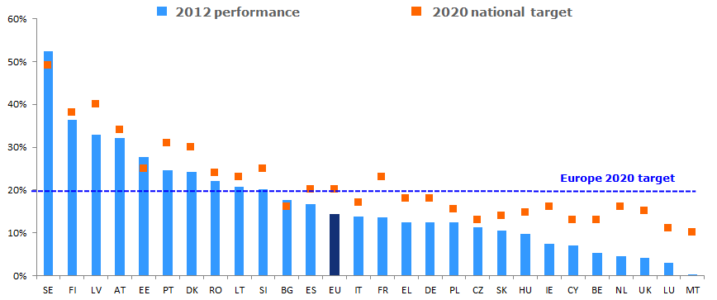
Sources: European Commission, EurObserv'ER
Reading: in 2012, EU share of renewables in energy consumption amounted to 14.4%, against a target of 20% for 2020.
Situation in 2012 and progress since 2005, by country
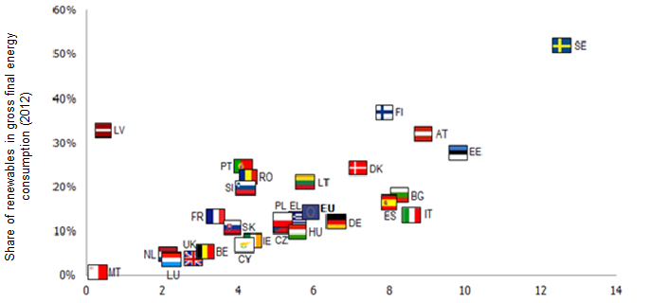
Progress over 2005-2012 (% point change)
Sources: European Commission, EurObserv'ER
Reading: EU share of renewables in energy consumption has increased by 5.9 percentage points over 2005-2012 (horizontal axis),
to reach 14.4% in 2012 (vertical axis).

EUROPE 2020 TARGET ON CLIMATE AND ENERGY (3)
Achieve a 20% increase in energy efficiency

1. State of play at EU level
Some progress has been achieved recently as regards energy efficiency, but needs to be consolidated over the coming years to meet the Europe 2020 target of a 20% increase in energy efficiency, corresponding to 1 483 Mtoe of primary energy consumption. Between 2000 and 2006, primary energy consumption has steadily increased, from 1 617.8 Mtoe in 2000 to a peak of 1 711.6 Mtoe in 2006. As of 2007, the onset of the crisis led to an almost uninterrupted fall in primary energy consumption, to 1 583.5 Mtoe in 2012. As for greenhouse gas emissions, a slight rebound in primary energy consumption was seen in 2010, as a result of the temporary recovery. A large amount of this fall in primary energy consumption can be explained by the contraction of economic activity generated by the crisis. However, some structural changes are also taking place. Reaching the 2020 target would mean cutting primary energy consumption by a further 6.3% by 2020.
Based on the latest trends, further efforts are needed to meet the energy efficiency target. The recent decrease in primary energy consumption needs to be pursued and anchored in long-lasting shifts in energy consumption patterns. Generally, the crisis has had an impact on primary energy consumption. Therefore, the durability of the encouraging latest developments, as well as the respective weight of the cyclical and structural factors can be questioned. Avenues for further action exist in all sectors, in particular in transport, where little progress has been obtained so far.

EU primary energy consumption, 2005-2020
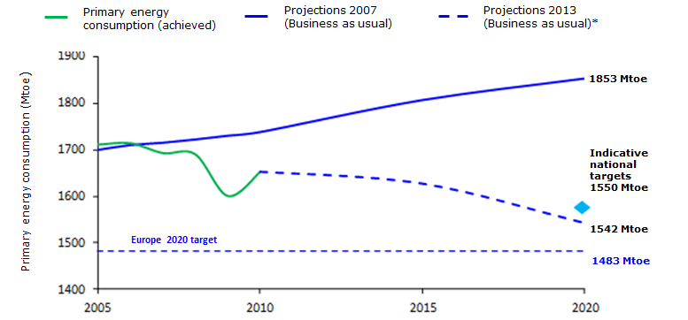
Source: European Commission
Reading: EU primary energy consumption could reach 1 542 Mtoe by 2020.
* 2013 projections (business as usual) are made on the basis of current policies.
2. State of play and progress at national level
The picture regarding energy efficiency is mixed. The Energy Efficiency Directive defines the energy efficiency target at European level and requires the Member States to have an indicative national target for 2020. This needs to be translated into levels of primary and final energy consumption for comparability reasons. Overall, in 2012, Cyprus, Estonia, Greece, Finland, Croatia, Hungary, Ireland, Lithuania, Latvia, Portugal, Romania, Slovakia, Luxembourg, Poland, Spain, Italy and Slovenia had levels of primary energy consumption below their indicative national targets.
Primary energy consumption in EU Member States
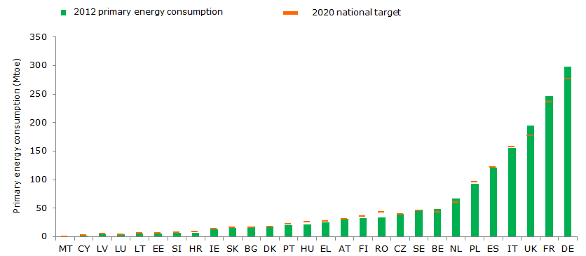
Source: European Commission
Reading: in 2012, 17 Member States had reached their indicative national targets on energy efficiency.
Energy intensity – the amount of primary energy consumption per unit of GDP – improved in all Member States between 2005 and 2011. Overall, the countries with the highest energy intensity have sizeably reduced it. The decrease is more moderate for less energy-intensive Member States.

Situation in 2012 and progress since 2005, by country
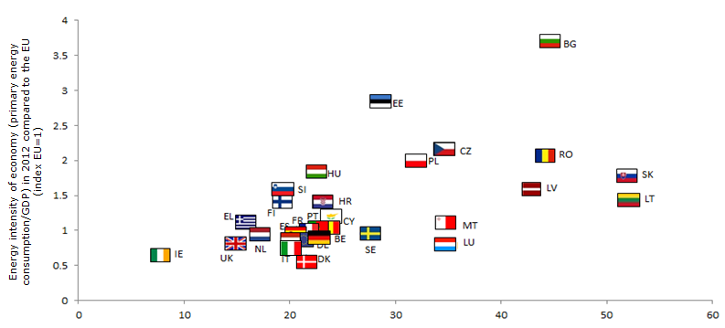
Reduction in energy intensity between 2005 and 2012 (%)
Source: European Commission
Reading: in 2012, most Member States were close to the EU average in terms of energy intensity and progress.

EUROPE 2020 TARGET ON EDUCATION (1)
Reduce the share of early school leavers to below 10%

1. State of play at EU level
Positive steps have been taken on early leaving from education and training: the share of early school leavers has been steadily declining since 2000, but the rate remains above the 10% Europe 2020 target so far. By 2020, the EU wants to bring down the share of early leavers from education and training aged 18-24 (those with at most lower secondary education and not in further education or training) to below 10%. This indicator has followed a steadily decreasing trajectory since 2000 and has declined from above 17% in 2000, to 15.7% in 2005 and 12.7% in 2012 in the EU. This however remains 2.7 percentage points above the Europe 2020 target. Part of this positive performance can be linked to the effect of the crisis, where worsening employment conditions and prospects, notably for young people, have encouraged them to stay longer in the education and training system.
The Europe 2020 target on early school leaving is achievable by 2020. Although the Europe 2020 target on early leaving from education and training seems within reach, this is not a given. Recent reductions in early school leaving due to the crisis, together with demographic projections, cast doubt on the ability of the EU to decrease the share of early leavers to less than 10% by 2020. Reaching the target will require a sustained, if not increased, effort from the EU and its Member States.
Early leavers from education and training in the EU in 2000*, 2012 and 2020
(aged 18-24, with at most lower secondary education and not in further education or training)
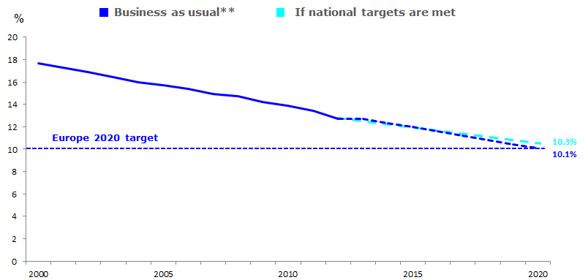
Source: European Commission
Reading: on the basis of current commitments, early school leaving rate in the EU could reach 10.1% by 2020.
* 2000 and 2001: EU27 data.
** Business as usual corresponds to an extrapolation of the 2000-2012 developments.
2. State of play and progress at national level
Ambition in terms of reducing early leaving from education and training varies across Member States. With national targets ranging from 4% in Croatia to 16% in Italy, the Member States have shown different levels of ambition, which makes the path to the target more or less difficult. In 2012, 9 Member States, namely Denmark, Slovenia, Czech Republic, Sweden, Luxembourg, Austria, Latvia, Lithuania and Slovakia, had already met their respective targets, nevertheless some of these countries had set less ambitious targets than other Member States. Croatia, Germany, the Netherlands and Finland are also approaching their targets, whereas Spain, Portugal, Malta and Romania remain far from their objectives. This can partly be explained by the fact that these countries have set somewhat ambitious targets.
Looking at developments over time, four main groups of countries can be identified: some Member States such as Spain, Romania and Italy, display high rates of early leaving from education and training and relatively slow progress. Portugal and Malta also show high rates of early school leaving, but have achieved substantial progress since 2000. On the other end of the spectrum, some good performers have only made slight progress since 2000 – in the case of Luxembourg and Croatia, the rate of early leaving from education and training even increased between 2000 and 2012. Denmark and Lithuania stand as the best performers, combining low early school leaving rates with notable progress since 2000. By 2020, according to the latest projections, most of the Member States are likely to meet their target, with the exception of Spain, Portugal and Romania.

Early leavers from education and training in EU Member States
(aged 18-24, with at most lower secondary education and not in further education or training)
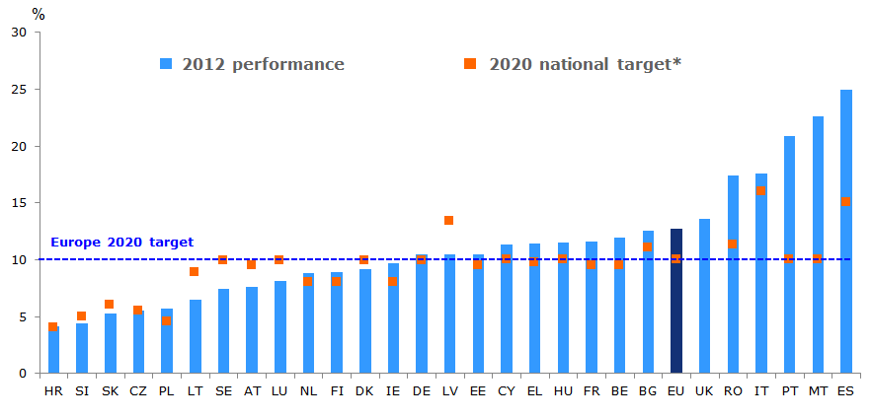
Source: European Commission
Reading: the EU average rate of early leavers from education and training was 12.7% in 2012, against a target of 10% for 2020.
* EU28, DK, DE, LU and SE: <10%; LT: <9%; SK: <6%. The UK has not set a target.
Situation in 2012 and progress since 2000*, by country

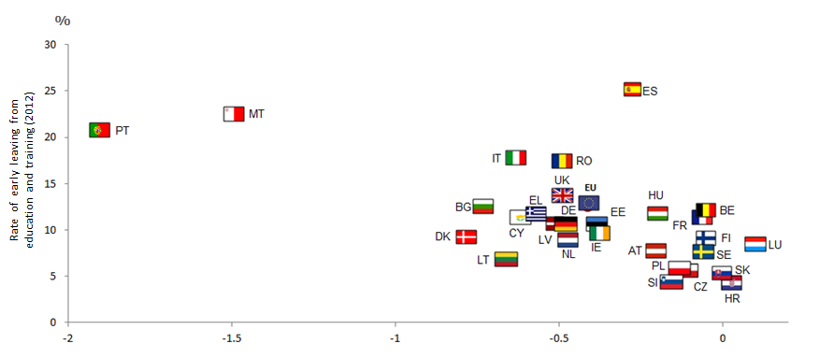
% point annual change in the rate of early leaving from education and training (2000-2012)
Source: European Commission
Reading: the rate of early leaving from education and training in the EU was reduced by around 0.4 percentage point every year over 2002-2012 (horizontal axis), to reach 12.7% in 2012 (vertical axis).
* EU: 2002-2012
Early school leaving is marked by gradually decreasing variations across the EU. The gap between the lowest and the highest early school leaving rate has declined by more than half between 2000 and 2012. With the lowest rate for Sweden, at 7.3% and the highest for Malta, at 54.2%, the gap reached 46.9 percentage points in 2000. In 2012, it decreased to 20.7 percentage points, with the lowest value at 4.2% for Croatia and the highest at 24.9% for Spain. Overall, Southern European countries tend to have highest shares of early leaving from education and training. Reflecting this pattern, regions in Northern and Eastern European countries have predominantly low rates of early school leaving, in contrast with Southern European regions.

EUROPE 2020 TARGET ON EDUCATION (2)
Increase the share of the population aged 30-34
having completed tertiary education to at least 40%

1. State of play at EU level
Good progress has been made towards the Europe 2020 target of 40% of tertiary (or equivalent) educational attainment and needs to be pursued. The second indicator related to education aims to raise the share of young people aged 30-34 having completed tertiary (or equivalent) education to 40%. With a rate of 22.4% in 2000, 27.9% in 2005 and 35.7% in 2012, corresponding to an increase of 13.3 percentage points in 12 years, the EU has significantly advanced towards its target and the number of tertiary graduates has rapidly increased. Only 4.3 percentage points separate the current EU performance from the 40% Europe 2020 target.
The Europe 2020 target on tertiary attainment rate is within reach by 2020. On the basis of the latest developments where significant progress has already been achieved, and assuming that the past trend will continue, there are good chances that the target on tertiary (or equivalent) attainment can be met.

Tertiary educational attainment rate in the EU, 2000-2020*
(% of population aged 30-34 with completed tertiary education – ISCED levels 5 and 6)
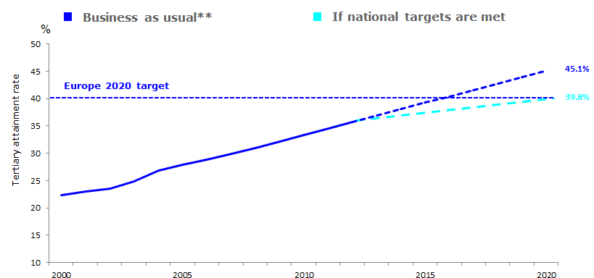
Source: European Commission
Reading: on the basis of current commitments, EU tertiary attainment rate could reach 45.1% by 2020.
* 2000-2001: EU27 data.
** Business as usual corresponds to an extrapolation of 2000-2012 developments.
2. State of play and progress at national level
Good progress has been achieved towards raising tertiary educational attainment, although some Member States are more ambitious than others. Mirroring the different levels of ambition of Member States, the national targets range between 26-27% in Italy and 60% in Ireland. In 2012, 9 Member States comprising Latvia, the Netherlands, Denmark, Finland, Sweden, Lithuania, Cyprus, Germany and Austria had already reached their targets. Hungary, Slovenia and Estonia are just behind and stand very close to their respective targets. Malta, Slovakia, Luxembourg, Portugal and Croatia are the furthest away from their targets and Ireland also stands at 9 percentage points from its objective; some of these countries like Slovakia, Portugal, Ireland and Luxembourg have defined ambitious targets, at 40%, 60% and 66% respectively, contrary to Italy's less ambitious target for instance, set at 26%. In terms of progress achieved over the last decade, four groups of countries can be distinguished: some Member States, notably Bulgaria, Greece, Croatia, Austria, Italy, Czech Republic and Romania, are characterised by both low tertiary educational attainment and low progress since 2000. Despite a low performance, other countries have made considerable progress since 2000. This is especially the case for Portugal and Hungary. Among the better performers in terms of tertiary educational attainment, slow progress in Finland, Belgium or Spain differs from the high progress reached by Luxembourg, Lithuania, Ireland and Sweden. As regards the projections for 2020, most Member States, aside from Malta, Portugal and Slovakia, are expected to meet their target.
Tertiary attainment rate in EU Member States
(population aged 30-34 with completed tertiary education – ISCED levels 5 and 6)
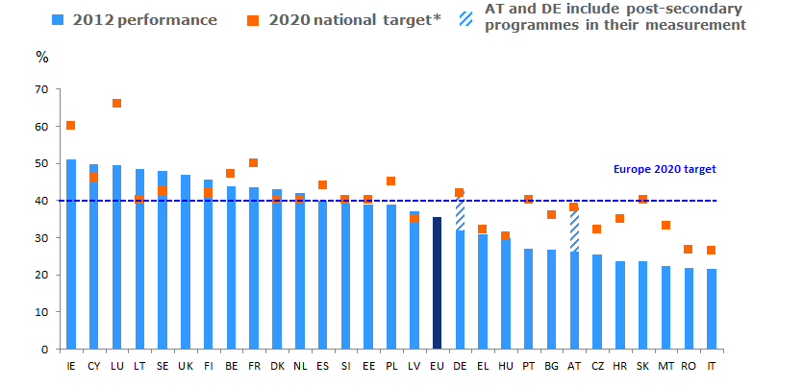
Source: European Commission
Reading: tertiary attainment rate stood at 35.7% in the EU in 2012, against a target of 40% for 2020.
* EU28, DK: at least 40%; DE: 42%, including ISCED 4; IT: 26-27% (26.5% was assumed); LV: 34-36% (35% was assumed); NL: more than 40%; AT: 38%, including ISCED 4/4a; SE: 40-45% (42.5% was assumed); the UK has not set a target; FI: 42% (narrower definition); FR: population aged 17-33
Situation in 2012 and progress since 2000, by country*

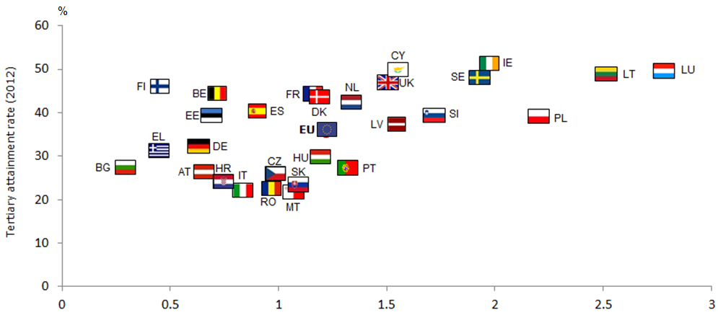
% point annual change in the tertiary attainment rate (2000-2012)
Source: European Commission
Reading: the tertiary attainment rate in the EU has increased by more than 1 percentage point annually since 2000 (horizontal axis), to reach 35.7% in 2012 (vertical axis).
* 2000: EU27 data

Inter-country performance shows a varied picture within the EU. Overall, Northern Europe shows the highest tertiary attainment levels, also reflected in the regional performances of the different countries. The large gap in tertiary outcomes, amounting to 35.2 percentage points between the weakest performance of Malta and the strongest results of Lithuania in 2000, has been declining over the years, reaching 29.4 percentage points in 2012. Italy has the lowest tertiary attainment rate, standing at 21.7%, whereas Ireland is the best performing country, with a rate of 51.1%. Regional outcomes show some intra-country dispersion, notably in Spain and Germany. In addition, the various ambitions of the Member States also translate to the regional performance, with some countries displaying a high number of well-performing regions, although they remain below the national target.

EUROPE 2020 TARGET ON POVERTY AND SOCIAL EXCLUSION
Lift at least 20 million people out of
the risk of poverty or social exclusion

1. State of play at EU level
The social impact of the crisis has been significant and the number of people exposed to poverty or social exclusion has increased, thus undermining progress towards the achievement of the Europe 2020 target of lifting 20 million people out of the risk of poverty or social exclusion. The target set by the EU corresponds to a situation where 96.4 million people are at risk of poverty or social exclusion in 2020. When referring to the number of people at risk of poverty or social exclusion, the indicator includes the number of people affected by at least one of the three types of poverty, namely income poverty (people at risk of poverty after social transfers), material poverty (severely materially deprived people) and people living in households with very low work intensity.
People at risk of poverty or social exclusion in the EU, 2012
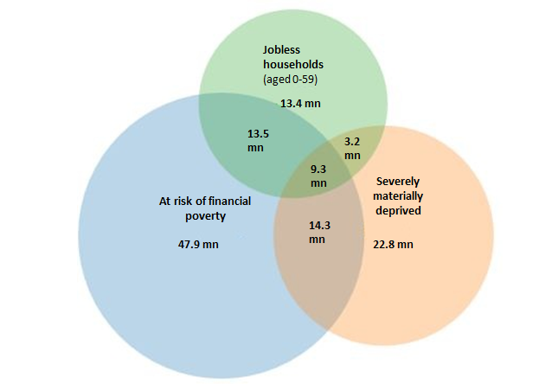
Source: European Commission
Reading: based on three different ways of measuring poverty, a total of 124.2 million people were at risk of poverty or social exclusion in the EU in 2012 (with 9.3 million people belonging to the three groups).
Given the harsh impact of the crisis, the Europe 2020 target on poverty seems out of reach. The years until 2009 were marked by a steady decrease in the number of people exposed to poverty or social exclusion. The lowest level was reached in 2009, with around 114 million people at risk of poverty or social exclusion, against more than 124 million in 2005. However, the crisis offset these positive developments and led to a rise in the values of the EU28 aggregates, with the number of people at risk of poverty or social exclusion increasing to more than 118 million in 2010, more than 121 million in 2011 and more than 124 million in 2012. Monetary poverty affects the highest number of people and severe material deprivation has increased most rapidly, by 7.1 million people since 2010. Based on recent trends and according to the latest projections, the EU target of reducing the number of people at risk of poverty or social exclusion to 96.4 million by 2020 is unlikely to be met and the indicator might remain close to 100 million.

People at risk of poverty or social exclusion and its sub-indicators, 2005-2020*
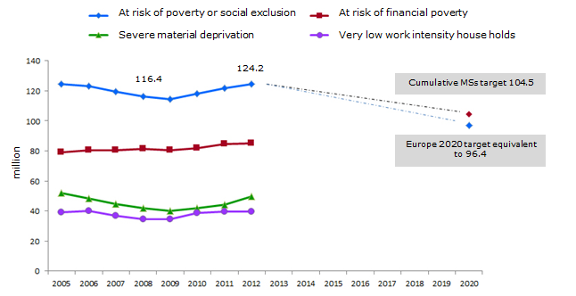
Source: European Commission
Reading: in 2012, 124 million people were at risk of poverty or social exclusion in the EU, namely 28 million more than the Europe 2020 target.
*2005-2009: EU27 data, 2010-2012: EU28 data. The 2020 target of 96.4 corresponds to the 2008 figure for EU27 (116.4) minus the 20 million people that the EU aims to lift out of poverty and social exclusion. HR excluded from the calculation of the target.
2. State of play and progress at national level
As a consequence of the crisis, progress on reducing poverty and social exclusion has been very limited. Compared to the European target of lifting 20 million people out of poverty and social exclusion, the aggregated national targets are less ambitious and correspond to reducing the number of people at risk of poverty or social exclusion by around 12 million. As a result of the crisis, vulnerability to poverty and social exclusion has increased in most Member States. Therefore, in 2012, only two countries, Germany and Latvia had met their targets. Poland is very close to achieving its target while Bulgaria, Lithuania, Czech Republic and Finland are moving in the right direction. Italy, Hungary, Greece and Spain are furthest from their respective targets.
Disparities between Member States are on the rise. The crisis has not affected all Member States to the same extent nor with the same intensity and has exacerbated the differences between Member States. In 2008, the distance between the two extremes, namely the Netherlands with 14.9% of the population at risk of poverty or social exclusion and Bulgaria with 44.8%, amounted to almost 30 percentage points. This gap rose to 34.3 percentage points in 2012, from 15% in the Netherlands to 49.3% in Bulgaria.

People at risk of poverty or social exclusion in EU Member States*
(% of population)

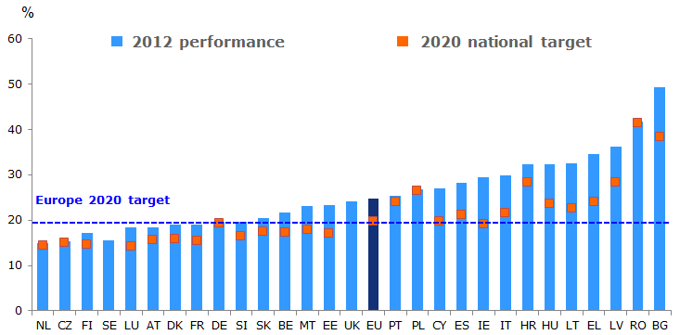
Source: European Commission
Reading: in 2012, 24.8% of the population was at risk of poverty or social exclusion in the EU, which is about 5 percentage points over the Europe 2020 target.
*2020 target refers to at risk of poverty or social exclusion rate if 2020 target achieved - UK, SE not included due to the specificity of their national targets; IE: 2011.

Situation in 2012 and progress since 2008, by country

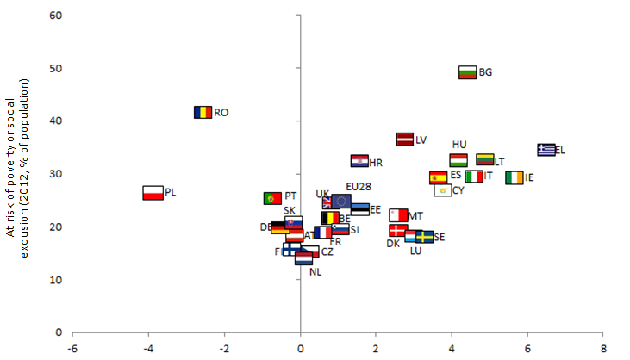
% point change (2008-2012)
Source: European Commission
Reading: the share of population at risk of poverty or social exclusion increased by more than 1 percentage point between 2008 and 2012 (horizontal axis), to reach 24.8% of the population in 2012 (vertical axis).
2008: EU27 data.
Annex III: State of play on Flagships initiatives
FLAGSHIP INITIATIVE "AGENDA FOR NEW SKILLS AND JOBS"
1. Objective of the flagship initiative
"An agenda for new skills and jobs" is an overarching initiative on employment, encompassing the issues of flexicurity, skills, working conditions and job creation. It aims to raise the employment rate with more and better jobs, help people anticipate and manage change by equipping them with the right set of skills and competences, modernise labour market and welfare systems, and ensure that the benefits of growth reach all parts of the EU. The flagship initiative set out four major priorities, (i) to make European labour markets function better through the adaptation of flexicurity policies to a post-crisis context, (ii) to endow people with skills adapted to labour market needs, (iii) to improve work quality and working conditions and (iv) to promote job creation and labour demand. The agenda was set as a joint effort between the Commission and European institutions, Member States, social partners, as well as education and training institutions to deliver 13 key actions accompanied by other support measures.
2. State of play in 2014
2.1 Deliverables and impact
Progress in the delivery of the initiative has been mixed. All actions in the areas of flexicurity and skills have been completed, with adaptations to the new economic context. Results in the area of quality of work and working conditions are more varied, with little progress in relation to working time and health and safety. No progress has been made in relation to a proposal for guiding principles to promote enabling conditions for job creation, even if this key action is addressed to a certain extent in the context of the European Semester.
2.2 Lessons learnt
The impact of the flagship initiative at a macroeconomic level has been limited. The individual initiatives that have been put in place will help improve the functioning of the labour market over time and tackle the main bottlenecks, especially in the areas of skills and mobility. Yet, against the background of the crisis, the overall macroeconomic effects of the flagship initiative have been limited.
Awareness of the flagship initiative has been hampered in several respects. In 2012, the deepening of the crisis made it necessary to complete the flagship with a comprehensive agenda for a job-rich recovery. The adoption of the Employment Package in April 2012 and the Youth Employment Package in December 2012 have to a large extent shifted the policy focus and communication efforts away from the flagship initiative. The flagship initiative did not fully succeed in creating a coherent framework for employment policies and exploiting the synergies between the different actions. The link with the European Semester has been limited, in particular between EU-level initiatives adopted in the context of the flagship initiative and the country-specific analysis and recommendations of the European Semester.

FLAGSHIP INITIATIVE "YOUTH ON THE MOVE"
1. Objective of the flagship initiative
"Youth on the move" covers education and employment and is intended to upgrade the performance of education, address the challenges faced by young people on the labour market and facilitate school-to-work transition. "Youth on the move" has set four priority areas, embracing the importance of (i) supporting the acquisition of skills through learning (formal, non-formal and informal), (ii) fostering the participation of young people in higher education, (iii) encouraging learning and job mobility and (iv) supporting youth employment. The initiative aims to use EU funds as catalysts for improving the education and training opportunities, the employability and the employment of young people.
2. State of play in 2014
2.1 Deliverables and impact
"Youth on the move" has adopted a comprehensive and integrated approach. By bringing together the issues of education and employment and striving to achieve smooth bridges between them, "Youth on the move" has opted for an all-embracing logic. This has allowed bringing together a set of EU actions relevant for young people and putting youth-related issues high on the European and national agendas.
Thorough implementation of "Youth on the move" has been achieved. All follow-up actions in the flagship initiative have been delivered, with the exception of the "Youth on the move card", which has been replaced by other tools. Actions were deployed in each of the four pillars of the initiative: (i) a Council Recommendation targeting early school leaving was formulated in 2011 and gave impetus to national action to reduce dropout rates, and cooperation at European level in the field of vocational education and training was strengthened; (ii) modernising higher education has been at the core of a Communication from the Commission; (iii) mobility was fostered through a range of instruments, notably the new integrated approach of the Erasmus+ programme, the European Skills Passport or the scheme "Your First EURES job" aimed at providing labour market opportunities for young people in the 28 Member States; (iv) to fight against youth unemployment and inactivity, a Council Recommendation establishing Youth Guarantees was adopted and Youth Guarantee schemes were launched – they can be supported by the European Structural and Investment Funds and the Youth Employment Initiative, for Member States with regions showing a youth unemployment rate of above 25%.
2.2 Lessons learnt
Communication on "Youth on the move" has been affected by several weaknesses. The framework agenda nature and long-term orientation of the actions contained in the initiative have contrasted with the expectations of some stakeholders of an operational spending programme. Communication on the programmes and initiatives launched in the education and youth employment area has created some confusion with the flagship initiative itself.

FLAGSHIP INITIATIVE "INNOVATION UNION"
1. Objective of the flagship initiative
"Innovation Union" is a comprehensive package of actions aimed at achieving an innovation-friendly environment within the EU. "Innovation Union" strives to boost research and innovation in the EU through a series of measures to the benefit of public authorities, entrepreneurs, researchers and engineers, and citizens. Priority is given to challenges of common interest, with the objective of improving framework conditions and access to finance for research and innovation activities, and in turn paving the way for a single innovation market. To achieve this objective, "Innovation Union" builds on 34 commitments and funding from the "Horizon 2020" programme among other instruments.
2. State of play in 2014
2.1 Deliverables and impact
The delivery of the initiative is well on track. 100% of the actions set out in the context of "Innovation Union" are on course, with different levels of implementation. In particular, five European Innovation Partnerships, dealing with (i) active and healthy ageing, (ii) agricultural sustainability and productivity, (iii) smart cities and communities, (iv) water and (v) raw materials, have been established in order to foster cooperation of EU, national and subnational stakeholders. Measures reinforcing the use of public procurement for innovation, introducing a passport for cross-country venture capital investment or creating unitary patent protection go in the direction of improving the innovation-friendliness of the business environment. Steps have also been made towards the achievement of the European Research Area in 2014, which aims at increasing the efficiency and effectiveness of public research systems to generate higher productivity, competitiveness and growth in the EU.
Monitoring tools have been set up. A comprehensive Innovation Scoreboard provides an assessment of the innovation performance of EU Member States and the respective strengths and weaknesses of their research and innovation systems. In addition, a new indicator of innovation output – work is however still ongoing to address some of its limitations – has been designed with a view to monitoring the EU's and its Member States' innovation outcomes against their main trading partners. It relies on four main dimensions, namely technological innovation, employment in knowledge-intensive activities, competitiveness of knowledge-intensive goods and services and employment in fast-growing firms of innovative sectors.
2.2 Lessons learnt
Full implementation of measures is key. The measures set out in the framework of "Innovation Union" go in the right direction; however, the materialisation of the associated benefits crucially depends on proper implementation.
"Innovation Union" has not prevented the increasing risk of innovation divide inside the EU. Since 2008, the EU has managed to close almost half of its innovation performance gap with the United States and Japan. Yet, within the EU, the dynamics of convergence between the innovation performance of Member States has come to a halt and disparities between countries are growing.

FLAGSHIP INITIATIVE "DIGITAL AGENDA FOR EUROPE"
1. Objective of the flagship initiative
"Digital agenda for Europe" was designed to help the EU and its Member States to reap the benefits of a competitive digital single market. Faced with the fragmentation of European markets, preventing the EU from grasping the advantages of the digital economy in terms of increased productivity, employment and growth, "Digital agenda for Europe" aims to unleash the digital potential and diffuse the digital culture widely across the EU. 101 actions, grouped around seven pillars, were initially identified to reach this objective. Following a review of the initiative carried out in December 2012, seven new key actions were flagged. They mainly highlight the importance of fostering digital infrastructure, improving the regulatory environment, promoting digital skills and jobs and implementing focused strategies in the areas of cyber-security, cloud computing and microelectronics.
2. State of play in 2014
2.1 Deliverables and impact
The flagship initiative managed to give the digital economy the necessary political attention. Its main strengths relate to the creation of a coherent and forward-looking framework for action. The annual publication of a Digital Agenda Scoreboard and the yearly "Digital Assembly" stakeholder meeting helped to attract political and media attention. "Digital agenda for Europe" also gave impetus to national replication and action in 20 Member States and a number of regions who set up their own digital agendas.
Progress has been achieved in the delivery of the planned actions. In January 2014, more than 90% of actions foreseen in the flagship initiative were completed or on track. The use of the internet has now become widespread across the EU, ecommerce is gaining strength, although its cross-border take-up remains limited so far, e-government services have been developed and basic broadband coverage across the EU is complete.
2.2 Lessons learnt
The digital single market is not yet a reality and more investment is needed in high-speed infrastructure. The persistence of obstacles such as fragmentation of European markets, infrastructure gaps and lack of consumer confidence still hampers the completion of the digital single market. The lack of high-speed broadband infrastructure is a serious concern as it could generate a new digital divide and foster social exclusion in certain areas, particularly in rural areas.
Efficiency of the "Digital agenda for Europe" was affected by a number of weaknesses. Visibility of the flagship initiative suffered from a lack of focus due to the high number of specific measures. The flagship initiative was also unable to bring information and communication technology topics to the core of structural reform agendas.

FLAGSHIP INITIATIVE "INDUSTRIAL POLICY FOR THE GLOBALISATION ERA"
1. Objective of the flagship initiative
"Industrial policy for the globalisation era" strives to improve the competitiveness of European industry through a coordinated approach. This initiative puts the emphasis on the need to combine innovation, diversification and sustainability and to encourage the creation and development of SMEs. Building on 70 actions to increase European industrial competitiveness, the initiative aims to achieve a more business-friendly environment and to accompany and support industry to cope with the new global challenges.
2. State of play in 2014
2.1 Deliverables and impact
Notable progress has been achieved towards the implementation of the initiative. 90% of the 70 key actions initially identified in the initiative have been completed or are ongoing. The Industrial Policy Communications released in 2010, 2012 and 2014 have supported the translation of the flagship initiative's objectives into policy. Many actions of the initiative are oriented towards support for SMEs: the Small Business Act for Europe was reviewed, and an Action plan to foster SMEs' access to finance and a strategy to promote SMEs' internationalisation were adopted in 2011; a standardisation package was presented in 2012 to make standard-setting more efficient; the Competitiveness and SME (COSME) programme was adopted in 2013 to buttress competitiveness and with Copernicus and Galileo, space policy initiatives provide a new dimension for service industries. A Communication to encourage entrepreneurship was presented in 2012. Other actions aim to improve the regulatory environment for businesses, notably by streamlining legislation through regular "fitness checks" and reducing the time and cost needed to set up a business, to reinforce and deepen the single market with the adoption of the Single Market Acts I and II in 2011 and 2012 and to boost innovation and the modernisation of industry. A number of sector-specific initiatives have also been undertaken.
2.2 Lessons learnt
"Industrial policy for the globalisation era" has adopted a medium- to long-term approach and a number of action strands will take time to deliver results. National budgets' investments in necessary network infrastructures have dwindled, the internal market is still insufficiently complete, conditions for access to finance for SMEs have experienced a setback through the crisis and progress in ensuring that adequately skilled labour is available for industrial jobs has been slow. Most of the actions included in the flagship initiative have a 3- to 10-year horizon. Only a minority of them have a short-term, operational orientation. Against the background of the economic crisis having a strong negative impact on several sectors of industrial activity in the EU, the flagship actions needed to be complemented by actions on key priority areas, which could produce a shorter or medium-term effect.

FLAGSHIP INITIATIVE "RESOURCE-EFFICIENT EUROPE"
1. Objective of the flagship initiative
The flagship initiative "Resource-efficient Europe" supports the shift towards a resource-efficient and low-carbon economy. "Resource-efficient Europe" aims to decouple growth and resource use and provides a long-term framework for embedding resource efficiency as a key principle in the design of policies, notably on climate change, energy, transport, industry, waste and raw materials, agriculture, fisheries, biodiversity and regional development. In light of the increasing strain on natural resources and the international dimension of this issue, "Resource-efficient Europe" aims to promote a smarter use of resources by 2020, and anchor this logic to achieve further results in the 2050 horizon. To this aim, it includes a series of initiatives launched since 2011.
2. State of play in 2014
2.1 Deliverables and impact
A range of actions contained in "Resource-efficient Europe" have already been initiated at EU level. Among the main measures covered by the initiative, all of them have already been tabled by the Commission. In particular, a long-term policy framework up to 2050 was presented in 2011. It consists of four roadmaps, namely the "Roadmap for moving to a competitive low-carbon economy in 2050", the "White Paper – Roadmap to a Single European Transport Area – Towards a competitive and resource-efficient transport system", the "Energy Roadmap 2050" and the "Roadmap to a Resource Efficient Europe". This strategic framework was complemented by a number of mid-term initiatives, including a new biodiversity strategy "Our life insurance, our natural capital: an EU biodiversity strategy to 2020" and "A Blueprint to Safeguard Europe's Water Resources" and the new "Clean Air Programme for Europe". The reform of the Common Agricultural Policy, with the introduction of a greening component, and the Common Fisheries Policy also derive from the initiative. The Commission will continue working on the follow-up actions announced in the roadmaps or action plans delivered as part of this initiative. Moreover, the Commission further specified the 2050 roadmaps on climate and energy in its Communication on "A policy framework for climate and energy in the period from 2020 to 2030" presented on 22 January 2014.
2.2 Lessons learnt
A more comprehensive approach is needed to measure resource efficiency. Resource efficiency spans many different policies and related resources. A single or limited set of indicators would be useful to monitor improvements in the use of resources such as energy, materials, land and water in an operational manner to drive policy development. However, it is difficult to analyse changes in the use of resources in a simplified way and to design sufficiently precise indicator(s). Work thus needs to be pursued. The resource-efficiency scoreboard published by Eurostat with resource productivity as lead indicator is an important step in this direction. Systematic monitoring with key indicators is also needed to assess progress towards a competitive, secure and sustainable energy use, as underlined in the 2030 climate and energy policy framework.

FLAGSHIP INITIATIVE "THE EUROPEAN PLATFORM AGAINST POVERTY AND SOCIAL EXCLUSION"
1. Objective of the flagship initiative
"The European platform against poverty and social exclusion" aims to ensure economic, social and territorial cohesion. Building on the 2010 European Year for combating poverty and social exclusion, it strives to raise awareness and recognise the fundamental rights of people experiencing poverty and social exclusion, in order to enable them to live in dignity and take an active part in society. The goal of the flagship initiative was to come to an integrated approach to fight poverty, by joining up various policies in the economic, fiscal, social or single market areas. It also relied on a partnership approach between civil society, social partners and Member States. The initiative identified the commitments for the Commission in 5 areas, (i) delivering actions across the policy spectrum, (ii) ensuring greater and more effective use of EU funds to support social inclusion, (iii) promoting evidence-based social innovation, (iv) working in partnership and harnessing the potential of the social economy and (v) fostering enhanced policy coordination among Member States. In particular, "The European platform against poverty and social exclusion" identified 64 actions to be delivered by the Commission.
2. State of play in 2014
2.1 Deliverables and impact
Delivery of the initiative is happening at a fast pace. The Commission has delivered approximately two thirds of the 64 actions. To help Member States address these challenges through structural reforms in the context of a protracted crisis, the Commission has issued policy guidance in the form of the Social Investment Package and the Recommendation "Investing in children: breaking the cycle of disadvantage", the "EU Framework for National Roma Integration Strategies up to 2020" and the White Paper on "An Agenda for Adequate, Safe and Sustainable Pensions". The Commission has presented a proposal for a directive on payment accounts. To support the social economy and social entrepreneurs, it has published the Social Business Initiative and established an EU Social Entrepreneurship Fund. The Commission has also published guiding principles for active ageing and solidarity between generations and launched an Active Ageing index. Another distinctive initiative carried out in the context of "The European platform against poverty and social exclusion" is the Annual Poverty Convention.
2.2 Lessons learnt
A number of obstacles have hindered full efficiency of the flagship initiative. The adoption of the Social Investment Package has to a large extent shifted the policy focus and communication efforts away from the flagship initiative. The flagship initiative also did not fully succeed in creating a coherent and integrated framework for social policies and exploiting the synergies between the different actions; it is rather a collection of initiatives and the value added of the flagship initiative is not self-evident.

EU27 data.
The EU ETS sets a cap on overall emissions from high-emitting industry sectors. Companies may buy and sell emission allowances within this cap.
Study commissioned by the European Commission.
EurObserv'ER.
As opposed to final energy consumption, primary energy consumption refers to energy that has not been subject to any conversion or transformation process.
OJ L315, 14 November 2012.
The energy intensity indicator depends on the industrial structure of the economy and thus is not an exact proxy for energy efficiency in Member States.
EU27 data.
EU27 data.
It must be noted that the targets of Germany and Austria are different from those of the other Member States since they include post-secondary attainment.
2008 is used as base year.
“Persons with an equivalised disposable income below the risk-of-poverty threshold, which is set at 60% of the national median equivalised disposable income (after social transfers)”. Source: European Commission.
“Severely materially deprived persons have living conditions severely constrained by a lack of resources, they experience at least 4 out of 9 following deprivation items: cannot afford (i) to pay rent or utility bills, (ii) keep home adequately warm, (iii) face unexpected expenses, (iv) eat meat, fish or a protein equivalent every second day, (v) a week holiday away from home, (vi) a car, (vii) a washing machine, (viii) a colour TV, or (ix) a telephone”. Source: European Commission.
“People living in households with very low work intensity are people aged 0-59 who are not students and live in households where the adults work less than 20% of their total work potential during the past year”. Source: European Commission.
EU27 data.
EU27 data.
These countries had met their national targets, which are not expressed in terms of people at risk of poverty or social exclusion.
COM(2012)173.
COM(2012)727.
2011/C191/01.
2013/C120/01.
Youth Guarantees ensure that all young people under the age of 25 years receive a good-quality offer of employment, continued education, an apprenticeship or a traineeship within a period of four months of becoming unemployed or leaving formal education.
COM(2011)112.
COM(2011)144.
COM(2011)885.
COM(2011)571.
COM(2011)244.
COM(2012)673.
COM(2013)918.
COM(2014)15.
COM(2013)83.
2013/112/EU.
COM(2011)173.
COM(2012)55.

