ANNEXES 1 to 8

TAble of contents
Contents
ANNEX 1: THE ORGANIC SECTOR IN THE EUROPEAN UNION 4
1. Structural indicators on the organic sector 5
1.1. Area 5
1.1.1. Utilised Agricultural Area (UAA) 5
1.1.2. Share of organic area 6
1.1.3. Size of organic crop area 9
1.2. Organic holdings 10
1.2.1. Number of organic holdings 10
1.2.2. Share of organic holdings 11
1.3. Organic operators 12
1.3.1. Registered processors 12
1.3.2. Registered importers 13
2. Organic aquaculture 13
3. The EU organic market 14
3.1. General aspects 14
3.2. Consumer behaviour 15
ANNEX 2: SYNTHESIS OF THE PUBLIC CONSULTATION AND OF TARGETTED STAKEHOLDERS' CONSULTATIONS 17
1. consultation process 17
2. Main results by topic 19
2.1. Relevance of a revew of the legislation on organic farming and policy options 19
2.2. Organic standard 20
2.3. Exceptions and derogations 21
2.4. Authorisation of substances in organic production 23
2.5. Sustainable use of energy and management of environmental impacts 23
2.6. Animal welfare 24
2.7. GMOs 25
2.8. Labelling, organic logo, confusion with other logos and Eco-label 25
2.9. Improvements in the control system 26
2.10. Move towards a risk based approach in the control system 27
2.11. Trade with third countries 28
2.12. Controls of imported products: equivalence vs compliance and risk of unfair competition 30
2.13. Presence of non-authorised substance residues in organic products 31
2.14. Small farms' issues and group certification 32
2.15. Information and promotion 34
2.16. Research and innovation 35
3. Presentation of the main stakeholders 35
ANNEX 3: MAIN INSTRUMENTS OF THE COMMON AGRICULTURAL POLICY (CAP) SUPPORTING THE ORGANIC FARMING POLICY 38
1. The current CAP in a nutshell 38
2. Organic farming in the context of the CAP 38
3. Support measures addressing organic farming under the current CAP 39
3.1. Rural Development Policy 39
3.1.1. Support under Axis 1: Improving the competitiveness of the agricultural and forestry sector 39
3.1.2. Support under Axis 2: Improving the environment and the countryside 40
3.1.3. Support under Axis 3: Improving the quality of life in rural areas and encouraging diversification of the rural economy 42
3.2. Market and income policy 42
4. Other national or regional organic support measures 43
5. Organic action plans 44
6. Support measures addressing organic farming in the future CAP 46
6.1. Rural development policy 47
6.2. Market and income policy 47
ANNEX 4: INFORMATION AND PROMOTION ON ORGANIC FARMING AT EU LEVEL 49
1. Cofinanced information and promotion campaigns 49
2. Information and promotion actions directly managed by DG AGRI 50
2.1. Own DG AGRI campaigns through the Council Regulation (EC) n°3/2008 on information provision and promotion measures for agricultural products on internal market and in third countries 50
2.2. Via the Council Regulation (EC) n°814/2000 on information measures relating to the CAP 51
ANNEX 5: RESEARCH AND INNOVATION IN ORGANIC FARMING 52
1. EU research framework programme 52
2. European Innovation Partnership 'Agricultural Productivity and Sustainability' (EIP) 53
3. Results of the on-line consultation concerning the need for research and innovation 54
ANNEX 6: THE EU ORGANIC PRODUCTION RULES 56
1. The EU organic production rules 57
1.1. Definition of organic farming 57
1.2. Scope of the legislation 57
1.2.1. Commission report 57
1.2.2. Identified problems 58
1.3. General production rules 59
1.4. Current situation regarding GMOS 60
1.4.1. Coexistence 61
1.4.2. Facts, figures and recommendations resulting from the autumn 2012 hearings 62
1.4.3. Results of the public consultation 62
1.4.4. GMO Identified issues relate to: 63
1.4.5. Analysis of options 63
2. Possible exceptional rules under Art 22 of regulation 834/2007 65
2.1. Overview 65
2.2. Exceptional rules for using non-organic young poultry 66
2.2.1. Legal provisions 66
2.2.2. Issues 67
2.3. Exceptional rules for using non-organic feed 68
2.3.1. Legal provisions 68
2.3.2. Issues 68
2.3.3. Results of the public consultation 70
2.4. The use of seed or vegetative propagating material not obtained by the organic production method 70
2.4.1. Legal provisions 70
2.4.2. Issues 73
2.5. Issues with the exceptional rules allowing the use of non-organic inputs 76
2.6. Transitional measures concerning animal housing 77
2.6.1. Legal provisions 77
2.6.2. View of stakeholders 77
3. Conclusions 78
3.1. Scope 78
3.2. GMOs 78
3.3. Exceptional rules 79
ANNEX 7: AUTHORISATION OF SUBSTANCES AND TECHNIQUES IN ORGANIC FARMING 81
1. Current situation and legal framework 81
2. The process of evaluation of substances and techniques 83
3. Issues 84
4. Conclusions and options 84
ANNEX 8: LOGO AND LABELLING 86
1. General rules on labelling of organic products 86
2. Awareness of the EU logo, confusion associated with multiple logos 88
3. Indication of the place of farming: complex but important for consumers 92
4. The issue of double labelling of country of origin 92
5. Complexity of the labelling of organic processed products 93
6. Policy options 93

ANNEX 1: THE ORGANIC SECTOR IN THE EUROPEAN UNION
This Annex aims at describing the most important indicators on the organic farming sector, notably the land area under organic cultivation and the number of operators (holdings, processors and importers). A short description of the EU organic market is also presented. When possible the available data is presented on a 10-year period, from 2000 to 2010 (or 2011 when available).
The source for the data is mostly Eurostat (annual survey and farm structure survey). The market analysis is based on data from "The world of organic agriculture statistics and emerging trends 2013" (FIBL and IFOAM) and on a study from the Organic Monitor. The source of the data on aquaculture is mostly from the study on "The current status and future perspectives of European Organic Aquaculture.
In 2011, more than 9.6 million ha were managed organically by more than 235 000 organic producers in the EU. Every year the organic land area has increased by 500 000 ha on average since 2000. In 2011, the organic land area in the EU represented 5.4 % of the total agricultural area.
The total value of the EU organic market was approximately 19.7 billion euro in 2011 with Germany being the biggest market in the EU followed by France, the United Kingdom and Italy.

Structural indicators on the organic sector

Area

Utilised Agricultural Area (UAA)
The area under organic agriculture has increased significantly in the last years. In the period 2000-2011, the total organic area has increased from 4.3 to an estimated 9.6 million ha (6.7% yearly growth on average).
In absolute terms, the MS with the largest areas in 2011 were Spain (1.8 million ha), Italy (1.09 million ha), Germany (1.01 million ha), France (977 000 ha) and the United Kingdom (638 000 ha). These countries together represent 57% of the EU organic area.
Graph 1 shows the regular increase in the total EU organic land area between 2000 and 2011.
Graph 1. Area under organic cultivation in the EU (million ha) between 2000 and 2011
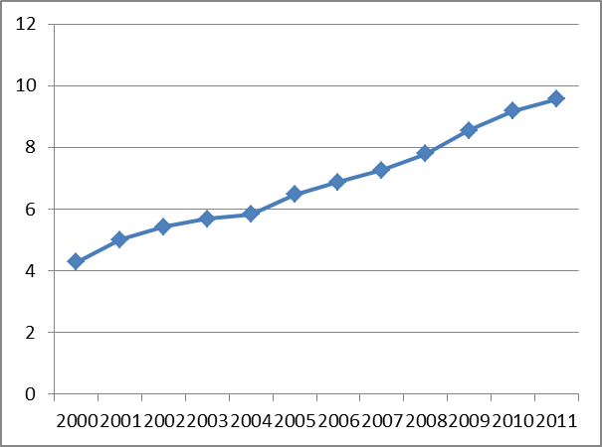
Source: Eurostat
Graph 2 shows the evolution of the organic area at MS level over the period from 2005 to 2010. Most MS and in particular the Czech Republic, Germany, Spain, Poland, France and Sweden, have shown a strong growth in the area of organic farming, while in others like Denmark, Estonia, Lithuania the organic farming area has grown to a lesser extent. Only a few countries did not experience any growth on the same period.
Graph 2. Evolution of the organic area (certified organic + in-conversion) in the MS in thousand ha from 2005-2010
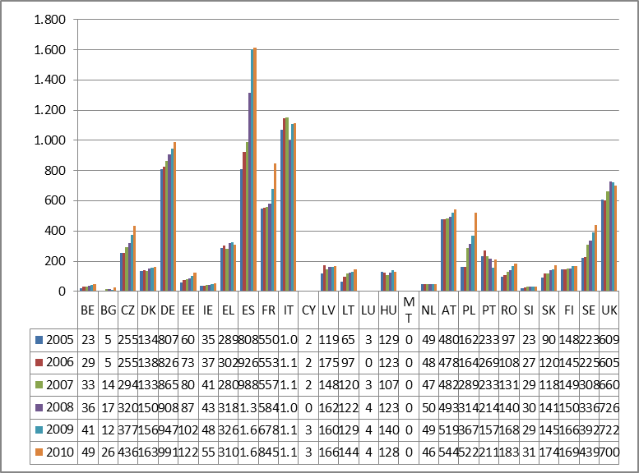
Source: Eurostat (no data for Malta)

Share of organic area
Graph 3 shows that in 2010, Austria with 17.2% was the MS with the highest share of organic land in the total UAA. Sweden followed with 14.3%. Estonia and the Czech Republic had 12.8% and 12.4% respectively. In 13 MS the share was below the EU average (5.4%).
Graph 3. Share of the organic area in the UAA in the EU in 2010 (%)
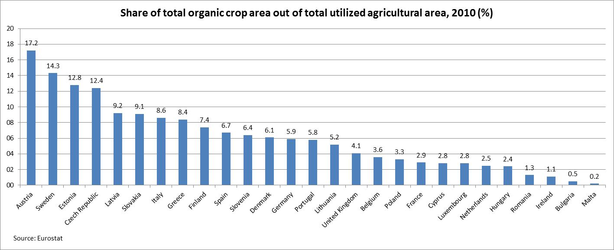
Source: Eurostat
Graph 4 shows the share of organic agricultural area in the total utilised agricultural area (UAA) at regional level. The highest shares in 2010 were recorded in regions of Austria, Sweden, Estonia and the Czech Republic, which is consistent with the results at national level.
Graph 4. Share of the organic area in the UAA in the EU at regional level, 2010 (%)
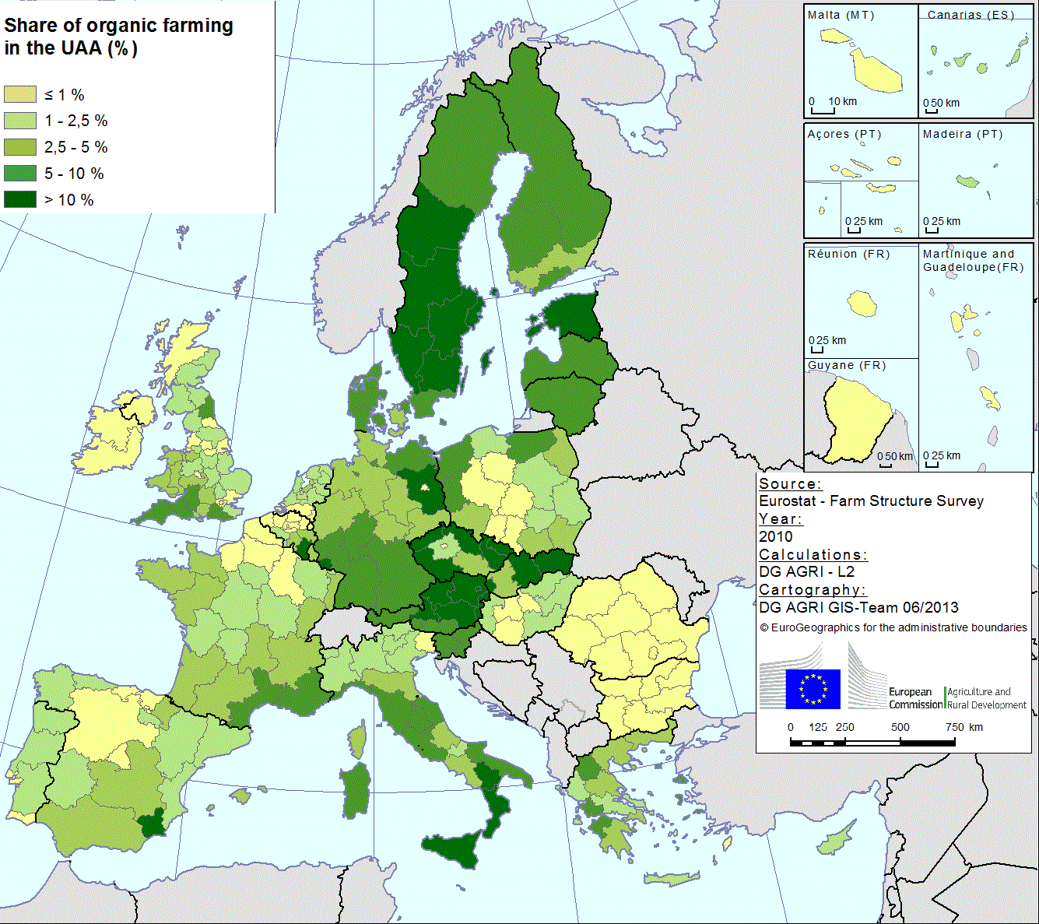
Source: Eurostat – Farm Structure Survey
Graph 5 shows the dynamics of the development of the sector with estimates of the area which enters annually the in-conversion process in the organic farming sector. The MS with the highest land share converted to organic was Spain followed by Italy, France and Poland. Over the period 2007-2010 the area entering the sector each year increased, with a notable acceleration in 2008.
Graph 5. Estimated annual area entering the in-conversion process in the EU (ha) between 2007 and 2010
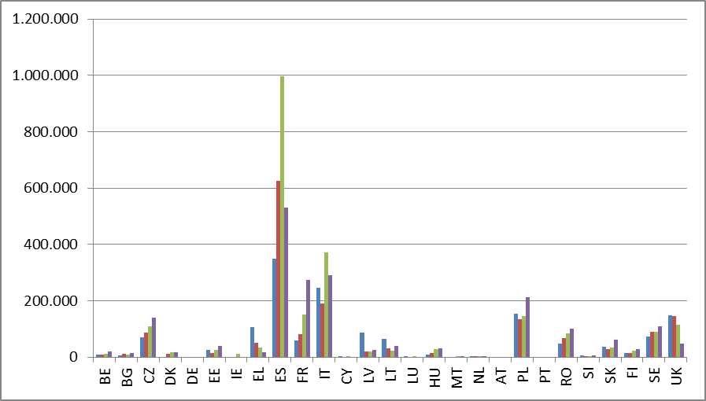
Source: Eurostat

Size of organic crop area
Graph 6 shows that since 2000 the organic crop area has been growing rapidly, it increased from 2.3 million ha in 2000 to 7.2 million ha in 2011. Despite the drop in 2005, the overall growth was higher than the growth of total land under organic cultivation (see Graph 1). The missing data of France for 2005 has caused the drop in the territory of certified organic crop. The missing figure for France is close to 0.5 million ha.
Graph 6. Certified organic crop area in the EU in million ha
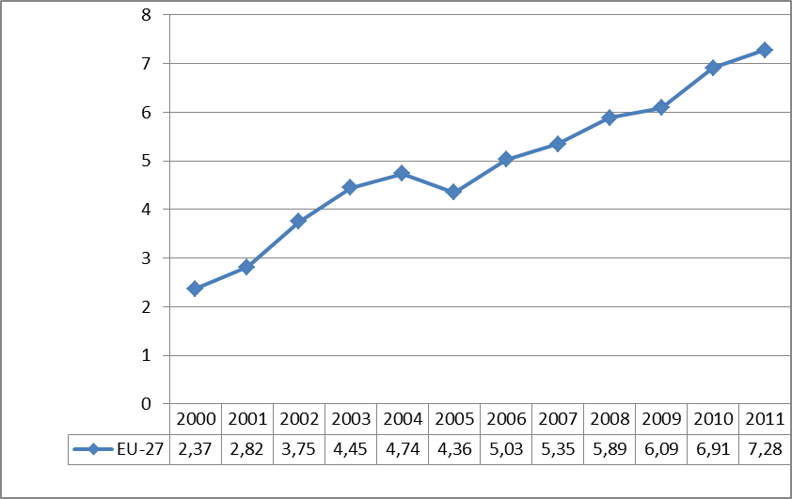
Source: Eurostat

Organic holdings

Number of organic holdings
The number of organic holdings was estimated at almost 200 000 holdings in 2010 in the EU, which represented 1.55% of the total number of farms. At MS level, the share varied between 0.3% in Romania and 14.4 % in Austria. The share of organic holdings has increased in most MS since 2003.
Graph 7 shows the steady growth in the total number of organic holdings since 2003. It has increased from 140 900 to 186 250 from 2003 to 2010.
Graph 7. Total number of organic holdings in the EU including in-conversion farms (2003, 2005, 2007 and 2010)
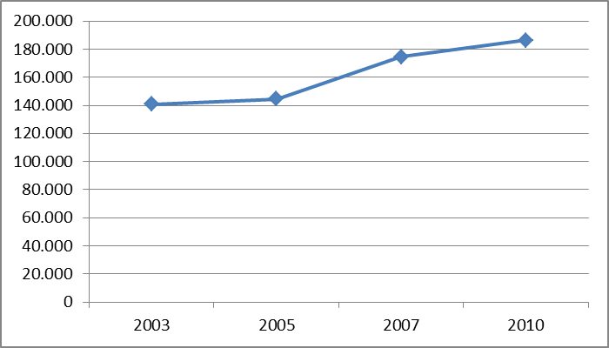
Source: Eurostat
The highest number of organic holdings is to be found in Italy (43 370) followed by Austria (21 080), Spain (20 970) and France (17 620).
Graph 8 shows the evolution of the number of agricultural holdings in the MS between 2003 and 2010. Poland experienced higher growth than any other MS in absolute number between 2007 and 2010, with 8 730 new organic holdings. The evolution of the sector can be linked to different factors, one of them is the support measures provided to the sector, which explains the number of organic holdings has grown exponentially. Due to the benefits of the support measures higher number of farmers started their organic operation than before. Such is the case in Greece for example: organic holdings have trippled between 2005 and 2007, but later halved in 2010. Another factor that explains the evolution is the better environment offering services, vocational training and research. Such is the case in Austria and Germany where steady growth of the number of organic holdings was registered. In parallel, the share of organic holdings in the total number of agricultural holdings increased from less than 1% in 2003 to 1.55% in 2010 (see Graph 9).
Graph 8. Evolution of the number of organic holdings in the MS (2003, 2005, 2007, 2010)
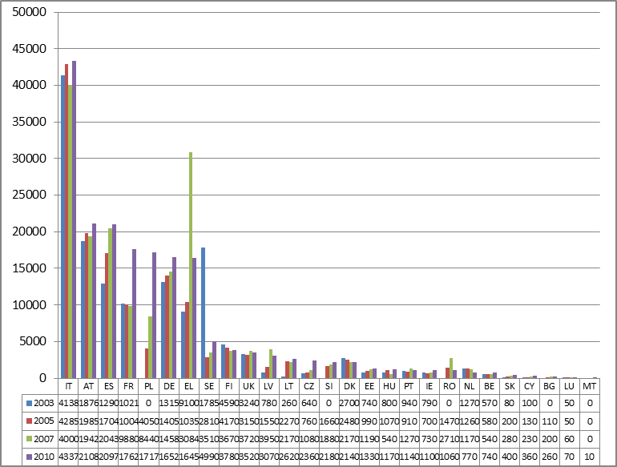
Source Eurostat. Data is not available for some countries for some years

Share of organic holdings
Graph 9. Evolution of the share of organic holdings in total agricultural holdings in percentage
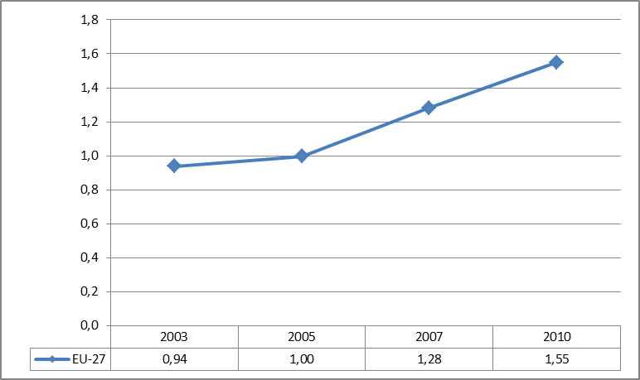
Source: Eurostat

Organic operators

Registered processors
The number of organic processors in the EU almost doubled in the last decade, from less than 18 000 in 2000 to around 35 500 in 2011 (data are not available for all MS). The number has been growing steadily with a slight drop in 2008 and in 2009 (see Graph 10). The reason might be the slowdown of the world economy or simply a lack of sufficient data for certain countries such as France and Austria.
The number of processors has increased significantly in some MS, like Germany (from 5 571 in 2003 to 8 905 in 2011) or the Czech Republic (from 109 in 2003 to 422 in 2011).
Graph 10. Evolution of the number of processors of organic products between 2000 and 2011 in the EU
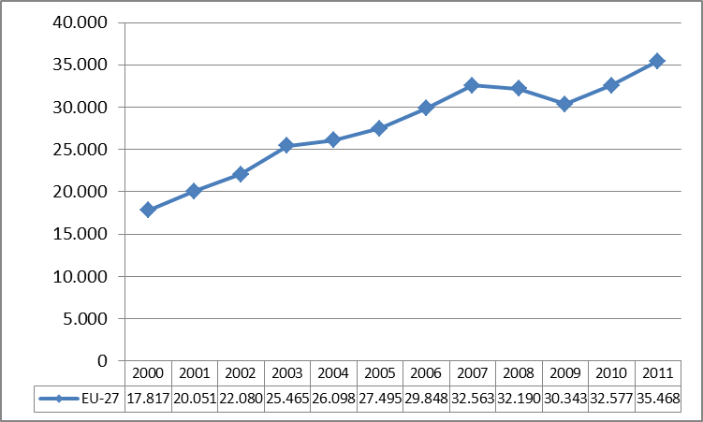
Source: Eurostat (for some years the figures for previous year were applied)

Registered importers
Almost 1.600 organic importers were registered in the EU at the end of 2011 compared to 623 in 2000. Their number increased steadily until 2007 (2.427), but then sharply decreased in 2008 (1.466), as shown by Graph 11. However the data is difficult to analyse because it is incomplete. Similarly to the case of processors, the data of registered importers was missing entirely for some relevant importers such as Austria and France. For Germany the number of importers has sharply fallen from 826 to 242 from 2007 to 2008.
Graph 11. Evolution of the number importers of organic products between 2000 and 2011 in the EU
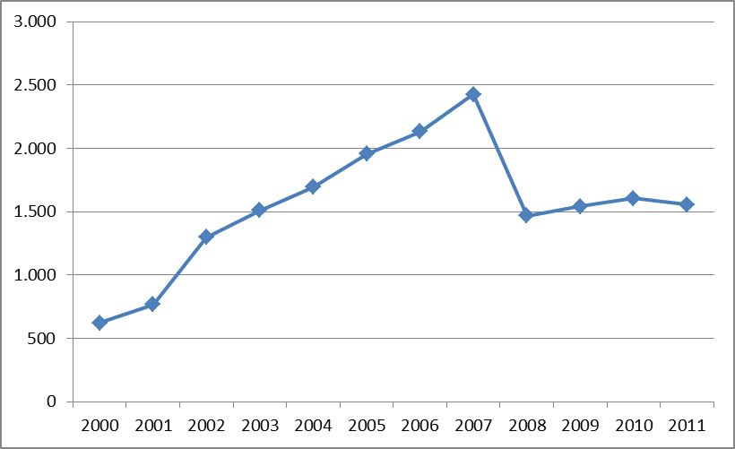
Source: Eurostat

Organic aquaculture
Organic aquaculture is a relatively new sector and EU implementing rules have only applied since 1 July 2010. Data available from Eurostat is quite limited; with 12 MS providing replies in 2010 and 10 in 2011. Most replies relate only to the total number of production units, which averaged 75 in total over this two year period. Salmon and trout are the largest sectors at present and EU production of organic salmon was an estimated 12.540 tonnes in 2012, which was 7.8% or total production. Ireland is the largest producer of organic salmon (9.600 tonnes) followed by the UK (2.940 tonnes). EU production of organic rainbow trout was an estimated 1.717 tonnes in 2012 (in France, Denmark, Ireland and Poland), which was 0.9% of total. Combined organic seabass and seabream production in the EU and Croatia in 2012 (Greece, France and Croatia) was an estimated 1.614 tonnes, an estimated 0.9% of total. Data for organic carp production is not available. Organic shellfish production had commenced since the EU rules were introduced in France, Ireland and the Netherlands. Ireland produced 5.200 tonnes of organic mussels in 2012. France has an estimated 18 organic shellfish units and nine organic seaweed units. There are significant imports of organic aquaculture products from outside the EU.

The EU organic market

General aspects
The EU market for organic food products was valued at 19.7 billion euro with a 9% growth rate in 2011. The EU market is the second largest in the world behind the US, home to some of the leading organic food companies.
The financial crisis had a negative impact on many European economies, reducing consumer purchasing power and raising unemployment. After reporting healthy growth rates for several years, revenue growth slowed to 3.5 % in 2009. The German organic market reported a slight contraction, mainly because of lower prices of organic products. Other organic food and drink markets, especially those in France, Sweden and the Netherlands, showed double-digit growth in 2009. The UK market for organic food experienced a 14% contraction in 2009 as consumers curtailed expenditure and retailers rationalised their organic product ranges. The above figures of 2011 prove that the market has regained its healthy growth.
The by far largest organic market in the EU was Germany with 6.6 billion euro in 2011. France held the second place with 3.8 billion euro. This market showed one of the most dynamic growth rates in the past couple of years. The UK organic market is estimated at 1.9 billion euro, while in Italy it is 1.7 billion euro.
Graph 12. The largest organic food markets in the European Union in billion euros
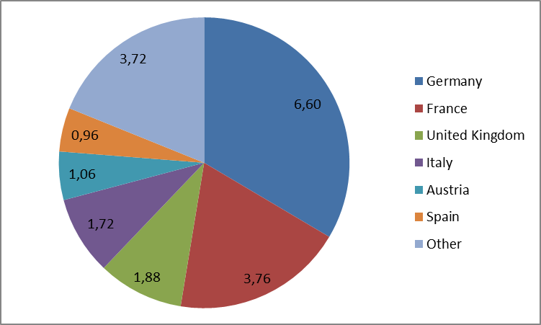
Source: Eurostat and FiBL
The current organic supply and demand situation in EU MS is also reflected in the numbers of processors and importers, which are mainly located either in countries characterised by a large organic market, a large organic area or both.
The market growth rates are expected to recover as the European economy strengthens. The European organic market is projected to post 7.2% compound annual growth rate, with revenues reaching 30.5 billion euro in 2016.

Consumer behaviour
Consumer behaviour can provide indication on the outlook of the market for organic farming products. Sales per capita in the MS were particularly high in Denmark (162 euro), Luxembourg (134 euro), Austria (127 euro), Sweden (94 euro) and Germany (84 euro). Domestic sales are low in Poland, Romania and Hungary despite the fact that these MS are important producers of organic crops, therefore the production is not intended for domestic consumption.
Graph 13. The 8 highest consumption of organic products per capita (annual per capita consumption in euro)
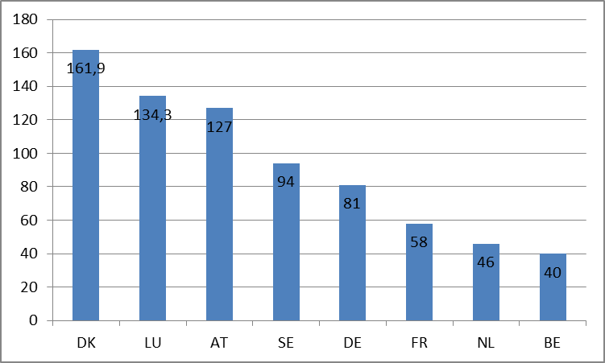
Source: FiBL
In terms of consumer behaviour, a common characteristic in many European countries is that a small consumer base is responsible for most organic food purchases. In Germany and the UK, researchers found that less than 10% of consumers comprise the bulk of organic food sales. Similar observations are made in other countries like France, Italy, Belgium and Finland.

Consumer confidence in organic products
The organic market has built on consumer confidence. This part summarises research results on consumer confidence in organic products, which show that consumer confidence is higher with strict production rules and control procedures:
- The CERTCOST project highlighted that "consumer trust is a crucial issue in the market for organic food, since consumers are not able to verify whether a product is an organic product, not even after consumption. An instrument to gain consumer trust is third-party certification of the supply-side".
- According to Jahn et al., "under asymmetric information, process-oriented quality characteristics such organic farming, animal welfare, or fair trade raise the question of mislabelling. In the long run, only a reliable control procedure can reduce the risk of food scandal" and "not fully credible standards jeopardize public confidence and lead to market failure on a higher level".
- A study on a consumer survey conducted as part of the "QualityLowInputFood" (QLIF) research project showed that communicating specific quality attributes represents a promising marketing tool of product differentiation. In addition, a study conducted in five European countries concluded that defining stricter production standards could be a promising strategy for existing certification schemes to differentiate themselves from the mandatory EU logo, which indicates the pertinence of defining stricter production rules in order to raise consumer confidence.
- A study on the State and consumer confidence in eco-labelling conducted in Denmark, Sweden, the UK and the US suggests that public authorities should themselves engage heavily in eco-labelling, because substantial State involvement increases consumer confidence. Consumers would be more likely to trust labelling schemes where the State plays an active and visible role.
.

ANNEX 2: SYNTHESIS OF THE PUBLIC CONSULTATION AND OF TARGETTED STAKEHOLDERS' CONSULTATIONS
This Annex presents a synthesis of the consultations conducted for the review of the EU organic farming policy (Regulation and Action Plan).

consultation process
Public consultation:
The public consultation ran from 15 January 2013 to 10 April 2013 through an on-line questionnaire. Almost 45.000 replies were submitted to the on-line questionnaire. In addition, about 1.350 additional contributions have been received by the Commission.
The majority (96%) of responses to the on-line questionnaire were submitted by EU citizens, while 4% were sent by stakeholders, the majority of which were companies (57%) and industry associations and NGOs (18%). The main interests represented by the 1 827 stakeholders who replied to the questionnaire were those of farmers (48%); consumers (10%); processors (9%); advisory services (5%); researchers (4%); national associations (3%); traders (3%); public competent authorities/public control authorities/accreditation bodies (3%); retailers (3%); private CBs (2%); public authorities in non-EU countries (0.3%).
Citizens who replied to the questionnaire can be characterised by a relative high awareness of organic production: 83% of them declared to be regular consumers and 15% occasional consumers. The knowledge of the EU organic logo appeared to be high, with 79% knowing the EU organic logo (compared to 24% following 2012 the Eurobarometer's survey).
The respondents were asked to indicate drives for purchasing and consuming organic products. Over 80% of all questioned citizens claimed that the most important rationales behind organic products consumption were concerns about the environment (83%) as well as purity of these products with regard to GMOs (81%) and pesticide and other chemical substances residues. A considerable number of citizens' respondents also emphasized that they purchased organic products because of belief in and support for seasonal and local products (78%) as well as strong conviction that organic farming system is more sustainable than conventional (74%). Approximately 63% of the respondents considered organic foodstuffs as healthier than their conventional counterparts. About half of them underlined that they are motivated to buy organic products because organic production respect animal welfare. Besides, important reasons that encouraged almost half of the questioned consumers to consume organic products are beliefs that these goods are of higher quality (47%) and better taste (43%). In addition, 10% of private consumers, who responded to the questionnaire, consume organic products for other beliefs than these stated above.
The majority of interviewees (78%) indicated that they were prepared to pay more for organic goods. Most consumers also consider that the price premium should not be higher than 10-25 %.
From a geographical point of view, France was overrepresented, with 56% of the replies, followed by Italy (15%) and Belgium (10%) (see graph 1).
The full analysis of the public consultation is published on the EUROPA website.
In addition to the public consultation, stakeholders have been consulted in various occasions:
Hearings:
The Commission inter-service steering group has listened to 72 stakeholders in 3 hearings: experts, academics and representatives of consumers, producers, retailers, operators, processors, third countries and associations representing third countries, traders, laboratories and researchers, animal welfare organisation, presented their views and were interviewed by the Commission services. They were organised around 3 main topics:
- The EU organic market – internal market and standards - 27 and 28 September 2012.
- Organic production - Controls and Enforcement - in the EU and in third countries - 25 and 26 October 2012.
- External trade in organic products and global issues - 20 and 21 November 2012.
AGOF meetings, some of them enlarged to experts who participated to the hearings:
- 10 December 2012: presentation of the results of the hearings,
- 11 April 2013: Impact assessment analysis on the organic farming review:
  - Presentation of the preliminary results of the public consultation on the organic farming review.
  - Analysis of the problem and the objectives of the policy.
  - Issues related to small farms.
  - Consultation on policy options.
- 26 June 2013:
  - Review of EU policy on organic farming (legislation and action plan) : information and discussion on the state of play and next steps
  - Administrative burden and costs
  - Consultation on the impacts of the options presented at the AGOF meeting of 11 April.
Special meeting on small farms – 26 June 2013
Issues related to small farms were on the agenda of the AGOF meeting, but the discussion proved to be limited. The Commission Services concluded that a technical meeting with experts needed to take place in order to examine further the difficulties faced by small farms to join the organic sector.
The following experts were invited:
  - Ms Diane BOWEN – IFOAM International
  - Mr Edouard ROUSSEAU - COPA-COGECA
  - Ms Ute EISENLOHR – IMO-Institute for Market Ecology (Switzerland)
  - Mr Andrea FERRANTE – AIAB-Associazione Italiana per l'Agricoltura Biologica
  - Mr Dominique MARION - FNAB-Fédération Nationale d'Agriculture Biologique des régions de France)
  - Mr Michel REYNAUD – ECOCERT- Organisme de contrôle et de certification
  - Mr Nabs SUMA – Fair Organics Solutions Ltd (apologies, but provided background information)
  - Mr Bo van ELZAKKER - AgroEco / Luis Bolk Institute- Advice and development services for sustainable agriculture – (apologies, but sent contribution)
MS consultation
- The Irish presidency sent a questionnaire to MS in January 2013. The replies have been used for this review. In addition, MS have been kept informed on the developments of the impact assessment process and have been asked to contribute, notably on administrative costs, in SCOF meetings. They were also invited to contribute to the public consultation.
In addition, the Commission staff participated to several meetings where the review was dicussed, notably to the IFOAM congress in Vilnius in June 2013.

Main results by topic

Relevance of a revew of the legislation on organic farming and policy options
When the consultation process started, the main stakeholders (notably IFOAM EU and COPA COGECA) disapproved the revision process, arguing the recent adoption of the current legislation (2007) and that fundamental legislative changes could have strong negative impacts on the sector. When the discussions on options started, they supported the improved status quo option. However, progressively, most stakeholders have agreed with the need for a more ambitious review. Notably, in a letter sent on 30 December to the Commission, IFOAM EU declared that it "clearly supports a principle driven development of the organic regulation, but emphasises that the development must ensure both increasing consumers trust and feasibility for the sector to comply with strengthened standards."
At the time of the public consultation, several stakeholders expressed their opposition to the review, notably the association Bio Austria.
Some stakeholders supported specific options for special reasons. The market-driven option was supported by Eurocommerce and FEFAC, because feed manufacturers would like the use of 5% non-organic feed in the ratio of pigs and poultry to be permanently authorised. The association highlights that a balanced ratio contributes to animal welfare. The principle-driven option was supported by FNAB and Via Campesina, for its likely positive impact on rural development and on small farms.

Organic standard
The public consultation showed the wish for harmonised rules at EU level: 74 % of all respondents requested that the European organic standard be strengthened. Around 40% of respondents stated that this should be done by making the rules stricter and/or introducing sanctions (penalties). 22% of interviewees stated that, to make the current European standard more robust, all flexibility should be removed.
The majority of respondents (86%), from most of the countries and representing all categories of stakeholders wished to have uniformity of organic rules in all EU countries for European farmers and other operators.
Online questionnaire: should the European organic production rules be strengthened?
Several stakeholders called for further harmonisation of the legislation on organic production, in several areas notably organic poultry production and organic glasshouse production (COPA, IFOAM EU, Freshfel, Grodan, Danish Agriculture and Food Council, SYVOFA, Bio Austria).
Conversely, a few of them were of the opinion that some flexibility is needed, like Organic Denmark and Interfel. They argued that some regulatory differences can be accepted to take into account the variability of soil and climatic conditions, as well as consumer sensitivity in different MS.
The issue of feed was addressed in the consultation. 49% of respondents stated that organic livestock should be fed with 100% feed from the farm or region. 27% of respondents opted for setting a minimum percentage of feed for organic livestock that should be from the farm or region. 16% of respondents considered that as long as feed is of organic quality, it could come from any location.
The majority of the respondents (66%) indicated that the effective solution for addressing the shortage of organic protein-rich feed in Europe is to introduce in the EU legislation, initiatives to boost European production of organic protein crops. In addition, 61% found that a specific organic protein-crop production strategy should be developed.

Exceptions and derogations
Most of the respondents (61%) were against keeping exemptions from production rules under specific conditions while allowing the certification of such products as organic. 29% of respondents were of the opposite opinion.
Online questionnaire: should the exemptions to production rules continue?
COPA COGECA was of the opinion that the conditions to grant exceptions must be strengthened and restricted, and must be limited in time. At the final stage, climatic events should be the only ground for derogations. The scheduled end of the derogations must be realistic and the timeframe must be agreed on in advance with the organic farming sector, in order to adapt. ERPA illustrated this issue with the example of poultry and eggs production, where producers invest for 15 to 20 years. Installation of young farmers or the construction of a new poultry building can be envisaged only if the farmer has assurance that the organic rules will not change.
IFOAM EU recommended limiting exceptional rules only to those linked to catastrophic circumstances by phasing out and/or converting them in transitional rules or transparent permanent rules in the new organic regulation. The movement indicated that on many issues, such as seeds & propagation material or protein feed, the regulation alone cannot deliver complete and effective solutions. The support of horizontal policies, further investments and provision of resources and the efforts of organic producers would be needed to ensure real progress. A new Organic Action Plan could include measures supporting research and investments in the organic sector. According to IFOAM EU, exceptions can be classified under:
1) Current exceptions to be deleted or converted to transitional rules:
- Use on non-organic animals
- Use of non-organic protein feed of plant and animal origin for livestock (request to prolong status quo until 2018, then review; to limit the exceptions to piglets up to 35 kg, young pullets and chicks; 100% organic feed remains the final aim)
- Addition of non-organic yeast extract (not necessary any more)
2) Current exception to be converted to permanent rules in the future Organic Regulation
- Tethering of animals (The largest part of tethering systems will disappear in organic farming due to the end of the transitional rules referred to in Art. 95(1) of Regulation (EC) No 889/2008. IFOAM EU recommends to keep and convert into a permanent rule the exemption laid down in Article 39 Regulation (EC) No 889/2008 for small operations. Progress is possible in the major part of organic production whereas some small traditional structures could not be able to move towards a new system since e.g. the stables are in mountainous locations where structural modifications are not possible).
- Parallel Production (exceptions for research and educational aims, for production of seeds, propagating material and transplants and for grazing grassland are considered still meaningful and concern only specific production areas).
- Management of beekeeping units for the purpose of pollination and use of non-organic beeswax (these two exceptions are considered still critical for the honey production sector. Pollination is in fact a specific and essential practice of bee-keeping and the exception is still needed. The use of non-organic beeswax exclusively for the conversion period should stay provided that the possibility to use non-organic beeswax is linked to very restrictive conditions.)
- Specific management problems in organic livestock (exception regarding the final fattening period exclusively for bovines is connected to the climatic conditions in many European regions and should be integrated).
3) The specific case of seeds and vegetative propagation material
- The deletion of possible exceptions to use non-organic seeds or propagating material could have an immediate negative impact on the sector, because the availability of sufficient amount of organic seed and vegetative propagating material cannot be ensured in the near future. However, the organisation recommended using the current revision process to make further progress in order to reduce the number of authorisations granted by MS, notably by exploring the feasibility of national lists of varieties for which exceptions are not possible. A new Action Plan is seen as essential to provide tools to encourage "organic breeding and multiplication activities as well as research for this purpose". Possible inconsistencies with other policies, notably CAP cross compliance, were mentioned.
WECF would like to see a limited number of derogations, where it is about a living organism the supply of which is not sufficient in organic form (seeds).
According to Euro Coop, organic farming should mainly make use of organic seeds and traditional varieties of seeds developed in specific local conditions. Considering that during the last century, 75% of genetically diverse seeds have been lost (according to FAO), Euro Coop favours seed security and the exchange of seeds among local farmers. The promotion of seeds diversification enhances food security and preserves traditional practices.

Authorisation of substances in organic production
The results of the public consultation show that citizens would like strict rules to be applied in terms of authorisation of pesticides and additives in organic farming. In fact, a majority of them (respectively 73% and 67%) requested that such categories of substances should not be allowed at all in organic production. With regards to fertilizers, feed materials, processing aids and products for cleaning and disinfection, the public demanded that they are evaluated according to strict criteria.
Some organisations showed concerns on the approval of substances (Freshfel, WECF). Freshfel called attention to the lack of harmonisation at EU level in the substance authorisation process, which put at risk the functioning of the single market and the confidence of operators and consumers. A strict procedure for authorising substances (regardless of the substance, from fertilisers to processing aids) is recommended, with rules equally applicable across Europe. Interfel suggested the authorisation process to be fully part of the legislation on organic farming.

Sustainable use of energy and management of environmental impacts
With regard to environmental performance, a large number of respondents (61%) to the public consultation requested the enforcement of an obligation for processors and traders to implement an EMS to measure and evaluate their environmental performance and impacts in addition to other European requirements.
Online questionnaire: do you think that producers and traders should be required to implement an EMS to measure and evaluate their environmental performance and impacts?
IFOAM EU recommended obliging processing and trade companies to implement an EMS. Farms and possibly small operators should be exempted. In a first step a primary simple EMS should be put in place by operators involved in processing and trading activities, based on the EMAS structure. IFOAM EU clarified that consumer expectation was not the only driver for this proposal, since one objective was also to avoid that the Eco-Label extents its scope to the food and drink sector.
This proposal was supported by several stakeholders, like the Bund Ökologische Lebensmittelwirtschaft, according to which "consumers expect that the production of organic food is sustainable at its whole. Therefore organic food processing could not only be defined by ingredients and processing methods. Operators have to improve their environmental performance too." BEUC indicated its support for the inclusion "of more sustainability and environmental criteria (climate, packaging, transportation etc.) in the criteria for organic production, so that organic products with no doubt is the most environment-friendly choice".
Other organisations called for a cautious approach in the implementation of an EMS, notably ERPA, according to which implementing an EMS would be very difficult for small organic farmers and it would provide dissuasive administrative burden. It considered environmental performance as the result of organic production standards. WECF agreed with the introduction of EMS, if the application is balanced and realistic.

Animal welfare
In the public consultation, more than 60% of respondents strongly insisted on strengthening animal welfare standards for all types of agricultural production systems. A third of respondents (34%) underlined that organic farmers should be obliged to comply with specific rules for animal welfare and 23% considered that animal welfare standards in organic farming should systematically be higher than in conventional farming.
IFOAM EU agreed there is still room for improvement in certain kind of organic livestock production. COPA COGECA was the opinion that more harmonisation in the way animal welfare standards are interpreted in MS is necessary in order to avoid unfair competition among producers, notably in the organic poultry meat production sector.
Detailed requests and opinions of animal welfare organisations are presented in Annex 14.

GMOs
More than 90% of the respondents to the online consultation, from almost all countries, representing all groups of stakeholders as well as regular and occasional organic goods’ consumers stated that ‘organic’, by definition, means ‘GMO-free’ and is a critical reason for purchasing these products. This was corroborated by a high number of free contributions from EU citizens.
The majority of respondents (68%), from all represented countries and also all types of consumers irrespective of the regularity of their consumption of organic products (70-80%), supported having the same labelling rules for organic products as for conventional products with regards to GMOs.
Online questionnaire: should the labelling threshold for accidental presence of GMOs be lower than for conventional products?
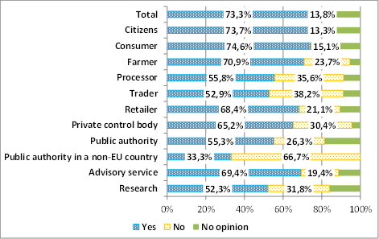
While recalling that organic farming does not allow the use of GMOs, COPA COGECA stated that an accidental GMO contamination in organic products can never be completely ruled out. The threshold of the adventitious presence of GMOs set out in horizontal legislation was determined based on an analysis of potential risk and an economic analysis. The producers do not see a justification to establish different thresholds for different production systems. IFOAM EU stated that, while such a threshold would not solve the problem, it would imply even higher costs for testing and certification on organic producers, while not significantly changing the situation for consumers. These views were confirmed by the contribution from the European Plant Science Organisation (EPSO). Euro Coop pointed out that the risk of contamination of organic products by GMOs is only significant in countries whose government has authorised the cultivation of GM crops on a commercial scale. In such countries, organic farmers run the risk of having their crops contaminated through cross-pollination, with possible heavy economic consequences.
Some organisations requested a lower GMO threshold for organic products: Interfel, WECF (but for all products including conventional), SYNABIO (a lower threshold for organic products for food (0.1%) while keeping the current threshold (0.9%) for organic feed products).
EUROPABIO had opposite views and stated that the incompatibility of GM and organics is unfounded. Provisions included in Council regulation (EC) No 834/2007 were qualified as "ideological statement". Certain GM crops would be able to fulfil the organic requirements very well, like the insect resistant GM crops which require less insecticide spraying.

Labelling, organic logo, confusion with other logos and Eco-label
The European organic logo was well-known by the public that took part in the public consultation (79%), irrespective of the country of origin or category of stakeholders. The majority of all respondents regardless of the regularity of their consumption of organic products indicated that the two main ways to recognise an organic product was the presence of the national organic logo (66%) and of the European organic logo (66%). In addition, a large number of respondents claimed that they purchase organic products directly from an organic producer without any kind of packaging or labels or by finding the word “organic” on the label.
The issue of confusion of logos, first of all with national and private organic logos, was highlighted by several stakeholders. According to BEUC, "the ideal would be to have ONE label = the EU Label, and we should work towards that. But for the present market situation, trust in national organic labels is so high that we need them as well for the coming years."
FRESHFEL also warned against the confusion of labels and pointed out the proliferation of “quality“ logos, besides the already large range of private brand logos available on the market and informing consumers (PGI, PDO, Fair Trade or even in the future possible logos for European promotion schemes or for “local” products). According to FRESHFEL, "a proliferation of logos is bringing more confusion to consumers or dilutes the efficiency of the message. A clear logo and the indication of the word organic work best for the identification of organic produce on the market despite that at retail level, organic fresh produce are often confined in a specific section of the supermarket shelf. Some of our members call for a simplification of the logo obligation and one should avoid a double labelling obligation."
MS representatives in the Council showed deep concerns about the confusion of the organic scheme with other labels, notably with the Eco-Label. Spain declared: "We detected incompatibilities between the EU regulatory framework on organic farming and Regulation (EC) No 66/2010 (…) on Eco-Label. We consider it was not appropriate to extend (…) its scope to food and drinks, although it has not been applied yet. The main reason is that we consider this term incompatible with the term reserved to organic farming…" and Ireland: "The organic label based on a robust control system is the core basis of consumer guarantees and confidence in the system. It is important that the labelling of organic products is unambiguous and such that it is not confused with other labels e.g. Eco-Label (…) The premium price of organic products attracts unscrupulous operators whose fraudulent activities completely undermine the sector."
According to IFOAM EU, the use of the Eco-Label on the labelling of organic products would lead to food products labelled with EU organic leaf and/or Eco-label logo and would lead consumers into confusion and to the idea that organic is not environmental-friendly. This was supported by the Bund Ökologische Lebensmittelwirtschaft, which recommended "defending organic labeling as a labeling of an integrated sustainable system against consumer misleading labels as Eco-label, Animal Welfare, Origin Labeling".

Improvements in the control system
Consumers trust organic products and insist on efficient controls: 71 % of all respondents to the online consultation, from almost all countries, and representing almost all categories of stakeholders as well as regular and occasional consumers of organic products indicated that they trust organic products.
However, more than half of the interviewees (58%), from almost all countries strongly required to improve the European control system for organic products even if it means an increase in prices. The vast majority of respondents (more than 70%), opted for two improvements, namely better controls on imported organic products and at all levels of the production chain. 50% of the respondents are in favour of the creation of a European database listing all certified organic operators in Europe. More than one third (i.e. 37% of the respondents) were in favour of the development of electronic means to ensure traceability.
Online questionnaire: should the control system of organic products sold in Europe be improved?
The most consensual suggested improvements to the control system in the free contributions from stakeholders were: better exchange of information on cases of non-compliance, more harmonisation among MS, more supervision by the Commission (regular audits), implementation of electronic certification (at least for imports), a harmonised system of sanctions and adequate controls on imported products.

Move towards a risk based approach in the control system
In the public consultation, half (22269) of the respondents knew, but the second half (22577) did not know that organic operators are controlled at least once a year. There was a similar level of awareness among consumers, irrespective of the regularity of their consumption of organic products.
The majority of respondents (57%) disapproved the idea of lowering the number of inspections for organic operators with a proven track record of abiding to the rules. To the contrary, a significant percentage (36%) of the respondents was in favour of a risk-based regularity of organic operators' inspections.
Online questionnaire: would you agree that organic operators with a proven track record of abiding by the rules could be inspected less often, for instance every 2 or 3 years?
Several MS declarations in the Council were in favour of a move towards a risk-based control system: "In the process, it should be possible to implement the risk-orientation of controls more clearly." (Germany); "The frequency of inspections (…) may be reduced to less than one year in special circumstances." (Italy); "Details on the risk-based inspection should not be regulated at EU level, as the conditions and the risks accordingly vary from state to state and according to the type of operators and their produce (…) To achieve efficiency in the control system, the requirements for the annual physical inspection should be waived. This would give possibility to allocate resources for more controls among operators and products of high risks and cross-inspections." (Finland); "With a fully risk-based approach, the requirement for one physical inspection yearly could be deleted." (Sweden).
The stakeholders in favour of more risk-based approach in the control system were FiBL (Research Institute for Organic Agriculture), according to which the focus should be put on 10 % of operators with risk of irregularities; the burden for compliant operators should be reduced by removing the obligation for a mandatory annual inspection. DakkS (National Accreditation Body for Germany) pointed out the need to intensify risk-oriented controls, in particular in third countries. The Finnish Food Safety Authority (Evira) considered that lowered inspection frequency should be an option for the future; additional inspections should focus on higher risk operators.
Several stakeholders expressed they would like the obligatory annual inspection to be maintained, notably ERPA, SYNALAF.

Trade with third countries
The majority of respondents (65%) to the online consultation, from all countries, representing all capacities and categories of stakeholders and irrespective of the regularity of their consumption of organic products, favoured the opening of the non-EU markets to EU organic products.
According to 72% of the respondents, the most relevant objective for the EU negotiations trade agreements for organic products was to support the development of more sustainable and eco-friendly agricultural practices in other countries. The second objective of great significance to respondents was to encourage organic farmers and other operators from developing countries to expand their production and exports of organic products (52 %).
Online questionnaire: do you agree that non-EU countries exporting to the EU should open their market to organic products produced in EU countries?
COPA has underlined that the consumption of organic products from the EU currently outstrips EU production of organic products, and today some demand is covered by imports. COPA considers important that the EU equips itself with instruments which will guarantee the development of organic production in the EU in order to meet EU consumers' demand. COPA also calls for a strategy to reach a balance between the EU and its trade partners, in order to develop export capacity of high added value EU organic products. There is a need to identify the most promising markets. Promotion campaigns would be considered an asset. IFOAM EU also mentioned that many MS are major exporters of organic processed food and feed and are interested in the new growing market. Freshfel underlined the EU has a great role to play in international organic trade, as matching demand on some markets implies trade (e.g. organic bananas on the German market are 100% imported from third countries) and indicated its support to the Commission efforts towards mutual recognition with third countries, provided trade is sustained behind the agreement on such recognition. It noted in the case of the EU-USA deal on mutual recognition that EU organic apples and pears cannot be shipped, given the lack of plant health protocols accepted by the USA. The same can be observed with New Zealand, Israel etc. where trade flows remain hindered by SPS matters preventing the export of EU fresh produce, being either conventional, IPM or organic.
Several organisations (Freshfel, FRUCOM) considered that the system of recognition of control bodies for the purpose of equivalence is a positive move towards simplification and less bureaucracy to import organic products. But "the framework needs to be matching operational perspectives and provide trust for operators". Therefore, there were calls to extend the lists of recognised third countries and recognised control bodies.
Some contributions highlighted that control costs are lower for local products than for imported products and suggested to support local products on this ground (WECF).

Controls of imported products: equivalence vs compliance and risk of unfair competition
According to several stakeholders, an effort is needed on controls on imported products. COPA COGECA stated the controls on organic products produced in third countries should be at least as rigorous as those in the EU, in order to ensure fair competition against products from third countries and to secure consumer confidence, even if that would lead to an increase in their price. It recommended paying "greater attention to the rules on mutual recognition set out in agreements with third countries where standards are recognised as equivalent in order to guarantee that imported products adhere to production and control standards which are a strict as those for EU organic products. Greater vigilance is also essential regarding the equivalence system for control bodies for imports from non-recognised third countries where we consider that the supervision guarantees made by the European Commission are lacking." Freshfel mentioned the need for a clear environment to create a level playing field among operators and confidence and indicated some loopholes which needed to be clarified to enhance trade opportunities (notably the aspects of cross contamination and of share of responsibilities between the Commission, MS and CBs).
Issues with imported products were reported by a representative from an informal group of importing MS, who participated in the hearings. This informal group has accumulated experience in dealing with import authorisations and has closely followed the implementation of the CB recognition system. The representative mentioned concerns over non-compliance product cases not being dealt with, problematic cases of products certified by different CBs from a non-equivalent country, cases where the correct assessment was in doubt (in one case, an inspection of a 30.000 ha operation took only two days). He also mentioned the following issues: "Imports that arrive via a complex route under equivalent CB cause problems"/ "Multiple operators on one certificate, a lack of control over the chain of provenance, and more than one CB for one operator with little communication between them, lack of risk-based inspections at operators are major concerns." "Reduced conversion period is a major concern; this allows operators to move in and out of the system or to use natural forest areas without proper control, CBs wish to offer these in order to obtain customers." "Major operators have greater power than the CBs". It was recommended to concentrate on problem products such as grain, oilseeds, bananas, soya, other animal feed and other bulk products,
A trader in organic products reported in the hearings, "Integrity of imported organic products is easily questioned and control is difficult". "Residue testing is now a major identifier for the integrity of organic produce, but the results are never black and white and widely interpretable".
According to the French processing industry association SYNABIO, "for processed products,.. the risk of distorsion of competition is objective. It is notaby linked to additive and processing aid lists, to the use of aroma … differently handled in different standards".
Cases of unfair competition have been directly reported to the Commission, for instance the following reported by a CB applying the equivalence regime in third countries:
"While Regulation (EC) 889/2008, Art 36(2) (b) determines that periods prior to officially starting the conversion period may be retroactively recognised only if the respective fields "were not treated with products not authorised for organic production", and competent authorities in the EU agree that this includes the use of chemically treated seeds, the equivalent standard developed by the CB X does not require a field to undergo a new conversion period after sowing chemically treated seeds." ; "it is obvious that a farmer in the EU who has to undergo a three year conversion period is subject to very significant economic disadvantages compared to farmers in third countries who have to undergo only a one year conversion period". "…each certification body is under continuous pressure to downgrade its "equivalent" standard, in order to avoid losing clients".
But some stakeholders like Euro Coop or FRUCOM consider the supply of organic food products not sufficient. It prevents the growth of the organic sector and increases the final price of organic products. They would like to see imports of organic products to be facilitated, and therefore recommend the EU to continue to favour equivalence against compliance.

Presence of non-authorised substance residues in organic products
Proposition of systematic testing
In the public consultation, 61% of the respondents wished for all organic products to be tested for pesticide residues. 25 % of the respondents were against.
Online questionnaire: should testing organic products for pesticide residues be made compulsory?
According to COPA and other stakeholders, the risk of adventitious contamination of organic products by non-authorised substances, mainly pesticides, can never be completely ruled out, despite the precautionary measures taken by organic producers. However the lower level of contamination of organic products, compared with conventional products has been underlined several times. A systematic testing for pesticide residues in all organic products was deemed inappropriate by many organisations: COPA, IFOAM EU, FRESHFEL, ERPA, SYNALAF, Soil Association. There was a consensus among producer organisations on the fact that testing for pesticide residues should remain one of the possible instruments to control organic products, which can be combined with other investigation tools. One stakeholder pointed out that the parameters for testing all products would be difficult to define (would it be applied just at the farm level, at each processing step, for each consignment, and with what quantity limit and for which pesticides?).
Issue of presence of pesticide residues in organic products tackled differently according to MS
The issue has been brought in the Council debates by several MS representative, like Sweden: "MS tackle findings of residues differently. This creates unfair competition." Or Italy: "The application in the MS of different (non-authorised substances) residue levels, beyond which the product cannot keep its organic status, can create barriers to trade."
The issue has also been mentioned by several stakeholders as one ground for unfair competition. FRESHFEL mentioned possible distortion of competition and uncertainties which are notably detrimental for perishable products: "FRUCOM believes that the European Commission should harmonise at EU level the way MS deal with cases of cross-contamination in order to prevent trade distortion amongst MS".
Threshold for organic products:
Online questionnaire: should the level of pesticide residues for organic products be set at a lower level than for conventional products?
The stakeholders were shared between the ones who could accept a lower threshold for organic products and the ones who don't see the justification for that. The level based on the Baby food-law seems the most appropriate to several stakeholders (notably IFOAM EU, FRESHFEL).

Small farms' issues and group certification
Issues faced by small-scale farmers have been shown in several free contributions to the public consultation, notably on certification costs: "I am a small scale (4 hectare) organic grower, mainly old varieties of apple, soft fruit and some vegetables. The annual fee charged by … for inspection is £560. This is sometimes more than my profit for the year… If I had 4,000 hectares, the certification cost would be £900!!. We, along with many other small scale organic producers will be forced out of organic production in the next 2 or 3 years. … a typical annual inspection takes about 45 minutes."/ "There should be help for small farms to be able to certify their farms as organic, as now very small farms cannot afford it."/ "There are too many small farms, which cannot afford the control costs."/ "Costs of certification should be lowered to promote small organic farming concepts."
Excessive administrative burden was also highlighted: "Primarily, the review should prioritise small-scale and local production as opposed to large-scale and intensive production. This includes minimising the burden on farmers in terms of paper-work…There should be incentives for switching to organic production focused on the education of the next generation of farmers in organic methods. This includes providing investment in training at school, college and life-long learning in how small-scale and local production is the only realistic long-term prospect for agriculture."/ "Our holding is 70ha. Small farmers are disproportionately burdened with paperwork and form filling in relation to their financial turnover. The EU must address this problem as it is a real disincentive to farm on a small scale and it is at that level that the best wildlife, community and environmental benefits can be gained. You need to move to a far more flexible system of regulation that respects the value of small producers."
In the meeting with experts, the following topics were discussed: definition of small farms, possible simplified requirements for small farms and group certification (including experiences in third countries).
The issue of definition appeared complex and opinions on what a small farm is varied. Several criteria were discussed, which could be combined: income, labour, size (possibly linked to the type of production). The situation can vary according to MS (and third countries) because of different levels of development. Some experts thought the definition should be left to MS or regions; others believed there should be one single definition for the whole EU. The advantages and drawbacks of a definition based on the relationship between turnover and certification cost, often used in third countries, were discussed. This can be an incentive for certifiers to adjust their fees according to specific situations.
Simplification: participants agreed that the administrative burden is too high. A suggestion was made to have a single administrative document giving a full description of the farm and to be updated once a year.
Group certification: one expert was of the opinion that the current control system has reached its limits and is not able to deal with high numbers of farms. Today the implementation of the system is not able to offer the required guarantees on the products. One example, the control before harvest is not carried out (too many farms should be visited in a few days). It would be useful to introduce social control. It could be achieved while taking into account social relations, rural communities and rural development. Integration of a group by a private operator is not necessarily the right solution.
Another expert highlighted the territorial dimension of group certification. Facilitating the conversion of small farms to the organic farming scheme could benefit to entire regions. For instance, in mountain areas, hundreds of farms apply farming practices close to organic farming but they are not in the system because of cost and administrative issues. Group certification can be an answer.
Some experts suggested to use RD funds for the set-up of internal control system needed that groups have to apply. A link could be made between RD and organic farming for this particular question.
One expert was of the opinion that group certification is not always cheaper than individual certification and suggested that the best answer to the problem may be to provide small farms with access to subsidies to cover the cost of certification. The internal control system has to be managed and cannot replace the external control system.
Experience in third countries: Group certification is not limited to developing countries. Canada and Korea have adopted such system. In Canada there is no limit in size and group certification is allowed for retailers but not for processors. In developing countries, group certification is generally cheaper than individual certification in particular because of lower labour costs of local staff managing the internal control system. The effects of group certification go beyond economic benefits and include improvements in the fields of training, education, poverty alleviation, etc. There are not always quantitative criteria to define small farmers in third countries.
In the public consultation, 70% of the respondents favoured the idea of permitting group certification in the EU, which is allowed for organic farmers in some non-EU countries. There were only 17% of responses against group certification.
Online questionnaire: do you think that group certification should be allowed in the EU?
COPA was against group certification: "Group certification is not compatible with the current mandatory annual on-site inspections. As a result, it should not be authorised in the EU."
According to Euro Coop, an effective way to encourage European organic production would be to offer a public and free of charge certificate for small farmers (possibly financed by RD funds), considering that they are also those contributing to the development of rural communities. The association Italia Nostra suggested that small producers, while being controlled, could be exempted from the obligation of labelling their products as organic, for the sake of simplification.
Other organisations were in favour of group certification: Slow Food, Soil Association, WECF (but only in specific cases: in peri-urban areas, mountains, picking).

Information and promotion
A vast majority of respondents (94%) to the online questionnaire required more information on organic products. The need for more information on organic products was expressed by respondents from every single country, category of stakeholders as well as consumers. A large number of respondents (59%) stated that they did not know about existence of such the EU's organic farming web-site.

Research and innovation
The respondents to the online questionnaire identified four areas which should benefit from more research and innovation into the organic food and farming sector, namely "Economic and social dimension of organic farming" (58%), "Seeds and plant propagating material adapted to low-input agriculture" (52%), "Local production of protein in-rich crops" (48%) and "Waste management".
Soil association: Research should be directed at improving the sustainability and self-sufficiency of organic production, and at addressing the limiting factors to better and more organic farming. There is no need for research into GMO co-existence – what is required is a proper and strict regime that ensures a similar level of control, traceability and accountability as the organic system already imposes, so that GMOs do not escape and contaminate non-GM production and the perpetrators can be identified. The specified areas for research rightly focus on applied research to deliver short and medium term benefits to farmers and growers, which will build increased resilience and security into food production. Nonetheless, there is also a need for more fundamental research and within the unspecified ‘other areas' should be improved understanding of pests and diseases. Organic farming is the leading edge of agriculture (e.g. energy efficiency, carbon sequestration, soil stabilisation, animal welfare, nutrient recycling, pest and disease management) and has strategic importance in delivering the objectives of the Common Agricultural Policy. Knowledge, techniques and innovations developed through research into organic systems can also have a significant positive impact on all systems of farming. Therefore, there should be a specific organic research budget and it should be several times more than would be indicated by the proportion of organic land, for the above reasons. Adoption of ecological principles into organic farming means adaptation to local environmental conditions. The distribution of research budgets should reflect this systems diversity, the understanding of which is fundamental to building resilience into food production.

Presentation of the main stakeholders
This chapter presents the stakeholders (interest groups, civil society organizations) represented in AGOF.
IFOAM EU Group is a European umbrella organisation, which advocates for the development and integrity of European organic food and farming. It has more than 160 member organisations that cover the organic food chain and beyond: from farmers and processors, retailers, certifiers, consultants, traders and researchers to environmental and consumer advocacy bodies. IFOAM has chaired the AGOF for the last two years.
EOOC, the European Organic Certifiers Council comprises control bodies for organic production, which are interested in cooperation and exchange of information.
Producers
COPA-COGECA is the union of COPA, the Committee of Professional Agricultural Organisations, historical European representative organisation for farmers established in 1958, and COGECA, European umbrella organisation of the agricultural cooperatives of the European Community created in 1959.
CEJA is the European Council of Young Farmers representing the interests of Europe’s young farmers.
ECVC, the European Coordination Via Campesina includes organisations that formerly gathered in the European Farmers Coordination (CPE 1986-2008) and other farmers’ and agricultural workers’ organisations of several European states. The principal objective of ECVC is to shape food and agricultural policies based on more legitimacy, fairness, solidarity and sustainability.
ERPA, the European Rural Poultry Association defends, supports and develops the production of rural poultry in the European Union.
Trade
CELCAA, the European Liaison Committee for Agricultural and Agri-Food Trade is an umbrella organisation representing at European level associations and companies active in the sector of agricultural and agri-food trading.
EUROCOMMERCE represents six million retailers, wholesalers and other trading companies. Its members include national commerce federations in 31 countries, Europe’s 27 leading retail and wholesale companies as well as federations representing specific sectors of commerce.
Fair Trade Advocacy Office strives for fair trade and trade justice with the aim to improve trading conditions for the benefit of small and marginalised producers and poor workers in developing countries.
Industry:
FoodDrinkEurope facilitates development of the environment for the European food and drink companies. It represents its members that are national federations, sector associations, as well as food and drink companies in the European Union.
Consumers
BEUC, the European Consumer Organisation is an umbrella organisation of 41 independent national consumer organisations from 31 European countries.
Euro Coop is the European Community of Consumer Co-operatives, whose members are the national organisations of consumer co-operatives in 18 European countries and 1 non-European member.
Environmental organisations
EEB/BEE (European Environmental Bureau) works on environmental questions at the European level.
WWF-EPO (the World Wide Fund European Policy Office) is the political advocacy center of WWF at the European Union level.
BIRDLIFE is a global partnership of conservation organizations that strives to conserve birds, their habitats and global biodiversity.
LE FORUM EUROPEEN POUR LE PASTORALISME ET LA CONSERVATION DE LA NATURE (European Forum on Nature Conservation and Pastoralism (EFNCP)) was established in 1988 as a Europe-wide network which raises awareness of the importance of low-intensity farming for nature conservation.
Animal welfare organisations
Eurogroup for Animals is a leading organization advocating for better animal welfare conditions at European Union level.
Compassion in World Farming is a campaign based organisation to fight for better conditions for animals.

ANNEX 3: MAIN INSTRUMENTS OF THE COMMON AGRICULTURAL POLICY (CAP) SUPPORTING THE ORGANIC FARMING POLICY

The current CAP in a nutshell
Over the last two decades, the CAP has undergone a substantial reform process, which reflects the changing societal concerns related notably to the environment, food quality and safety, territorial balance, as well as to the evolving needs of the EU economy. As a result of this process, the CAP provides today the general framework to address competitiveness and sustainability challenges of agriculture and rural areas across the EU territory. This framework takes the form of two complementary pillars.
Pillar I – market and income policy – includes instruments related to the functioning of agricultural markets and the food supply chain and to direct payments conditional upon statutory management requirements and good agricultural and environmental conditions. Combined, these measures provide a fundamental layer of support to EU farmers, creating the basis for keeping sustainable farming in place throughout the EU. Pillar I measures are mandatory for MS and, apart from very few exceptions, there is no co-financing.
Pillar II – rural development policy – includes measures that aim at improving the competitiveness of the agriculture sector, delivering specific environmental public goods and promoting the diversification of economic activity and quality of life in rural areas. These measures are largely voluntary, contractual in nature, co-financed and delivered within a strategic framework which links policy action to European, national, regional and local needs.

Organic farming in the context of the CAP
For more than 20 years, European policies for organic farming have been developed on a number of levels. The first scheme specifically targeted at organic farming was introduced in Denmark in 1987, shortly followed by other countries. As part of the MacSharry reform of the CAP in 1992, the introduction of agri-environment programmes provided a unified framework for supporting conversion to and maintenance of organic production across the EU. Today there are a wide range of different policy measures in EU MS that are financed by different funding sources and that address organic farming in different ways: with specific provisions (e.g. higher payment rates for organic farming), with partly specific provisions (e.g. higher payment rates for organic and other specified types of farming) or where organic farming is at least mentioned specifically (e.g. as one of a number of target groups) but without any specific provisions. In the following, based on the results of a previous study (Sanders et al., 2011), the support measures applied to organic farming are briefly described. There is also a description of the measures proposed in the framework of the upcoming CAP reform.

Support measures addressing organic farming under the current CAP

Rural Development Policy
According to the Community Strategic Guidelines for Rural Development, MS are encouraged to make use of the contribution of organic farming to the environmental and animal welfare objectives of the CAP. Most EU countries have followed this recommendation and provide specific area payments for organic farming under Axis 2 (Improving the environment and the countryside) of their rural development programmes. In addition, some MS have, to a varying degree, also implemented policy measures addressing organic farming under Axis 1 (Improving the competitiveness of the agricultural and forestry sector) and Axis 3 (Improving the quality of life in rural areas and encouraging diversification of the rural economy).

Support under Axis 1: Improving the competitiveness of the agricultural and forestry sector
In 22 MS or their regions, organic farming was addressed in one or several of the following 6 RDP measures under Axis 1 in the period 2007-2011.
- Setting up of young farmers (Measure 112): In the Czech Republic, applications are selected on the basis of a point system, where organic farmers receive extra points. In three Spanish and two Italian regions, organic farmers receive higher payment rates than conventional farmers. Furthermore, in some regions in Italy and Spain organic farming is mentioned as a reason for intervention or as one of several target groups.
- Modernisation of agricultural holdings (Measure 121): In Flanders (Belgium), Madeira (Portugal) and North Rhine-Westphalia (Germany) higher grants are given to organic farmers investing in agricultural holdings to improve the overall performance of the farm; in Austria this is limited to organic livestock farmers investing in farm buildings. Organic livestock farmers along with other groups of (non-organic) farmers receive higher investment grants in Mecklenburg-Western Pomerania and Bavaria (Germany). In Bulgaria, organic farmers receive the same level of support as non-organic farmers; however a minimum of 5 % of the Measure 214 funds is reserved for investments required for conversion to organic farming. Higher evaluation scores are given for applications related to organic farming in Cyprus, Czech Republic, Latvia and Slovakia. Furthermore, various countries have mentioned organic farming as one of several target groups, but it is not clear what direct advantage for organic farmers this implies.
- Adding value to agricultural and forestry products (Measure 123): In Bavaria (Germany) and Slovenia, projects related to organic food production, processing or marketing receive higher support rates. In Estonia, a sub-scheme specifically targets organic farming as well as conventional dairy farmers referring to specific circumstances of the organic and dairy sectors. Rather than higher grants, a higher priority is given to projects related to organic farming under the selection schemes in Cyprus, the Czech Republic, Latvia and Slovakia. A tiered support scheme is used in Austria and in two regions in Spain to determine the level of support within which organic farming is one criterion among others to be eligible to receive a top-up grant. In Bulgaria, Denmark, Hungary, Malta, Romania and some regions of Spain, organic farming has been defined as a (particular) target group or reason for intervention, but no special provisions are made for organic farming.
- Participation of farmers in food quality schemes (Measure 132): MS have adopted different approaches to refund certification and inspection costs of organic farmers. Several countries/regions use Measure 132 to cover parts of the certification and inspection cost incurred by farmers (Austria, Belgium, Cyprus, Estonia, Greece, Malta, the Netherlands, Poland, Portugal, Slovenia, most regions of Italy and Spain as well as parts of the UK). Flanders and Wallonia (Belgium) as well as Greece introduced support schemes for organic farmers in 2011. These schemes are usually also open to farmers participating in other approved quality schemes.
- Information and promotion activities (Measure 133): In some MS, Measure 132 is combined with Measure 133, which supports information and promotional activities for products or foodstuffs covered by approved quality schemes. In Malta and Estonia, only organic producers may receive support through Measure 133. Other countries offer no special provisions for organic producers.
- Setting up of producer groups (Measure 142): In Slovenia, financial support is given to organic farmers who set up producer groups and therewith strengthen the institutional structure of the primary sector. This measure is however not exclusively targeted at organic. Farmers producing other special agricultural products (e.g. food labelled as Protected Designation of Origin (PGO) or Protected Geographical Indication PGI)) are also eligible for aid.
- In addition to the measures described above, many MS have implemented specific training courses or advice for organic farming under Measure 111 (Vocational training and information actions) and/or Measure 114 (Use of advisory services). Since both activities are also relevant for conventional farmers, organic farming is, in most cases, neither addressed nor mentioned under these measures. Similarly, Wales uses Measure 124 (Cooperation for development of new products, processes and technologies in the agriculture and food sector and in the forestry sector) to improve supply-chain links. Whilst the measure itself does not address organic farming, it is used to finance a project which is highly relevant for organic sector development in Wales.

Support under Axis 2: Improving the environment and the countryside
In 25 MS or their regions, organic farming is addressed in one or both of the following two RDP measures under Axis 2 in the period 2007-2011.
- Agri-environment payments (Measure 214): For organic farming agri-environment payments are undoubtedly the most important support measure of the rural development programmes. With the exception of the Netherlands and France, all MS have implemented specific area payments for organic farming in the framework of national/regional agri-environmental schemes (Measure 214) to compensate for additional costs and/or income foregone resulting from organic management. Differentiation of seven land types is used including arable land, grassland, vegetables and herbs, greenhouse crops, perennials and orchards, vineyards, and olive trees. There are large variations in the payment rates for the same land type across countries. For example, maintenance payment rates per hectare for grassland varied between EUR 39 and EUR 450 across the EU (Figure 1). Even greater variations were observed for conversion payments. Differences in payment rates are the result of a number of factors including different payment differentiations within the broader land types (e.g. a specific cereal payment is likely to lead to a higher payment rate than an average arable payment), different economic assumptions and different cost and income foregone components in payment calculations. Policy priorities, budget allocations and constraints, consideration of different bio-physical land characteristics and the inclusion of (area-based) livestock payment components are also factors.
Figure 1: Maintenance payments in 2011 and average public expenditure per ha in 2008-2009 in EU MS
Source: Sanders et al. (2011)
High payment rates do not necessarily guarantee a high level of support for organic farms. Scheme access problems, as reported from several MS, can reduce the positive impacts of high support payments. Average public expenditure for organic support payments under the agri-environmental measure per certified organic hectare varied between EUR 7 and EUR 314 for the period 2008 to 2009. On average, public expenditure amounted to EUR 163 per hectare for the EU-27 (excluding Ireland, Romania and England). Substantial differences between the MS also exist in the design and application of eligibility criteria and requirements such as payment limits, stocking rates and additional scheme requirements beyond organic standards which are not necessarily reflected in the payment rates.
It is important to note that a wide range of options for combining organic with agri-environmental payments exists across most MS covering nearly all the key agri-environmental themes. “Topping up” organic support payments through other agri-environmental payments utilises the comparative advantages of organic farms in providing environmental benefits and public goods, and grants additional financial support to organic farms.
- Animal welfare (Measure 215): Cataluña (Spain) provides additional support for organic livestock farmers under Measure 215 aiming to cover additional costs or income foregone due to commitments regarding feeding facilities or free outdoor access. In some other countries, specific organic livestock payments are integrated in Measure 214.

Support under Axis 3: Improving the quality of life in rural areas and encouraging diversification of the rural economy
In the Czech Republic, organic farming was addressed in two RDP measures under Axis 3 in the period 2007-2011:
- Diversification into non-agricultural activities (Measure 311)
- Encouragement of tourism activities (Measure 313).
Both measures aim to diversify the rural economy through grants for the introduction or expansion of activities related to local services, products, trade and tourism. Similar to provisions made for Axis 1 measures, projects related to organic farming are awarded higher points in the Czech Republic which may increase the likelihood to receive support. References to organic farming are also made in Hungary under RDP measure 313.

Market and income policy
Besides rural development programmes, some EU MS provide financial support for organic farmers in the framework of Article 68 of Regulation (EC) 73/2009 as well as top-ups in the Common Market Organisation for fruit and vegetables.
The EU rules for direct support schemes under the CAP Pillar 1 allow MS to support specific types of farming and quality (so-called ˈArticle 68 measureˈ). France is using this measure – instead of RDP Measure 214 (agri-environment schemes) – for conversion and maintenance payments for organic farming. Romania is following a dual approach: while maintenance payments are paid under RDP Measure 214, Article 68 is used to finance conversion payments. In Denmark, the current RDP extensification scheme under Measure 214, which provides area payments for organic farmers, is stepwise replaced by a similar Article 68 measure. In addition Greece, Italy, Spain and Sweden have also implemented specific support to farmers for improving the quality of agricultural products. These schemes are targeted not only at organic farmers, but also at farmers participating in other food quality schemes.
The Fruit and Vegetables Regime of CAP Pillar 1 aims to increase the use of environmentally-friendly cultivation and production techniques. To receive a grant, producer organisations have to prepare an operational programme in which they describe how their activities contribute to the specific national goals defined in the national strategies for sustainable operational programmes. Specific provisions are made for organic producer organisations. The Community co-financing rate for organic production in the operational programmes is 60 % of the eligible costs (usually 50 %) with a maximum financial contribution of 4.1 % of the total value of marketed produce. In general, support for the environmental actions covers additional costs and income foregone resulting from that action. Several MS have, however, made country-specific provisions regarding the type of eligible costs related to organic farming. In Belgium, Ireland, the Netherlands and Sweden, only expenditure for specific equipment or means of production is eligible for aid (e.g. for packing and storing of organic products, use of organic dung and compost, etc.). Support for training and advisory costs are granted in Germany and Austria. The Czech Republic provides support for planting new organic orchards. In Spain, financial support is either given as a per-hectare payment or is based on invoices for specific cost items.

Other national or regional organic support measures
MS and regions have also introduced a wide range of other national and/or regional policy instruments not (co-)financed by the EU (see Figure 2). Examples include financial support for producing, processing and marketing organic products, a range of communication policies as well as support for research projects related to organic farming. In many cases, the identified measures have some similarities to those implemented under rural development programmes. This is particularly the case for investment aids, marketing aids and support for training programmes and advisory services. Some of them could probably also be financed under the RDP Measures 111, 114, 121 and 123. Clearly, some MS forgo the opportunity of co-financing these measures through the EU in order to retain greater flexibility in programme planning and implementation or to avoid reporting duties.
Figure 2: Overview of identified national or regional public measures addressing organic farming which are not (co-) funded by the EAFRD or EAGF in 2007-2011
Source: Sanders et al. (2011)

Organic action plans
National or regional organic action plans provide a strategic instrument to coordinate different supply-push and demand-pull instruments tailored to local conditions. In total, 17 national and 10 regional action plans or similar support schemes that have been implemented since 2007 were identified in EU MS (Table 1). In many cases, action plans bundle CAP measures and complementary national/regional measures not (co-) funded by the EU. The action plans differ substantially with respect to policy targets, running period, types of actions specified, financial resources, number of previous action plans, and initial year of implementation reflecting different support strategies and developmental stages of the EU’s national/regional organic sectors.
Table 1: Overview of organic action plans or similar support schemes in EU MS implemented in 2007-2011
Source: Sanders et al. (2011)

Support measures addressing organic farming in the future CAP
The CAP framework explained under section 1 above responded to the challenges EU agriculture faced during the past two decades. However, for the policy to remain relevant, the framework under which it functions has to prove itself capable also to address the evolution which EU agriculture is expected to face in the current decade: economic, environmental and climate change pressures as well as the territorial aspects of the policy.
In this context, the Commission adopted in November 2011 legal proposals to reform the CAP for the period 2014-2020. They aimed to fulfil the three broad objectives of the future CAP, i.e. "Viable food production", "Sustainable management of natural resources" and "Balanced territorial development".
It was proposed to adapt the current CAP framework along the following lines:
- Gearing the CAP measures towards increasing the productivity and the competitiveness of the agricultural sector by:
- improving the functioning of the advisory system and creating networks (of farmers, advisors, researchers, food operators, consumers etc.) for knowledge creation and transfer and favouring innovative approaches in granting funding for projects for rural development measures
- encouraging pro-competitive joint action among farmers in order to foster efficient use of resources, product development and marketing
- provide incentives to use risk management instruments and active prevention strategies
- Improving the environmental and climate change performance of the CAP by:
- increasing the number of agricultural areas which are under agricultural practices providing environmental and climate action benefits and encouraging the take-up of more advanced agri-environmental measures by MS and farmers;
- Enhancing the effectiveness and efficiency of the policy by:
- rebalancing the direct payment support to better reflect income support objective and environmental performance
- reducing the disparities in direct payment support levels between MS and farmers.
After almost two years of negotiations between the Commission, the European Parliament and the Council, a political agreement on the reform of the CAP was reached on 26 June 2013. A number of instruments agreed for the next programming period have a significant potential to increase the development and visibility of the organic farming sector.

Rural development policy
In the context of the RD policy for the period 2014-2020 as agreed among the institutions, a farmer engaging in organic production will be able to receive support through a number of measures, among which the following ones:
- knowledge transfer and information actions (article 15), covering participation in training activities,
- advisory services, farm management and farm relief services (article 16), for the use of advisory services,
- quality schemes for agricultural products and foodstuffs (article 17), covering certification costs for new participation in organic food quality schemes,
- investments in physical assets (article 18),
- farm and business development (article 20), granting business start-up aid for the development of small farms,
- agri-environment-climate (article 29), when an organic farmer undertakes an environmental or climate commitment not supported under article 30,
- organic farming (article 30), compensating for additional costs, income foregone and transaction costs when converting to and/or maintaining organic farming practices in line with Council Regulation 834/2007,
- animal welfare (article 34), for commitments going beyond mandatory standards and not already covered by article 30,
- cooperation (article 36), which supports the development of innovative products, processes, practices, technologies, and cooperation approaches among actors of the food chain.
It will be up to the MS or regions to include in their RD programmes the measures they consider relevant for supporting organic farming and to set out how these measures can be combined with one another in order to avoid double funding and to ensure complementarity/synergy between them.

Market and income policy
For the period 2014-2020, besides maintaining a basic direct payment for farmers (including organic farmers), the EU institutions have agreed to introduce a strong greening component into the first pillar to ensure that all EU farmers in receipt of support go beyond the requirements of cross-compliance and deliver environmental and climate benefits as part of their everyday activities. Thirty percent of direct payments will be tied to the 3 compulsory greening practices (i.e. crop diversification, establishment of ecological focus areas, maintenance of permanent grassland).
In order to avoid penalising farmers that already address environmental and sustainability issues, the agreement foresees a "Greening equivalency" system whereby the application of environmentally beneficial practices already in place are considered to replace the basic requirements. For example, organic producers will have no additional requirements as their practices are shown to provide a clear ecological benefit. For others, agri-environment schemes may incorporate measures that are considered equivalent. The new regulation contains a list of such equivalent measures. To avoid "double funding" of such measures, the payments through rural development programmes must take into account the basic greening requirements.
The current "article 68" measure is not prolonged in the next programming period.
In receiving support from several of the measures outlined above, a farmer will be able to achieve more easily the objectives of the organic farming regulation, i.e. establish a sustainable management system for agriculture, produce products of high quality and respond to consumers demands for goods produced using processes that do not harm the environment, human health, plant health or animal health and welfare.

ANNEX 4: INFORMATION AND PROMOTION ON ORGANIC FARMING AT EU LEVEL
The possibilities of financing information, communication or promotion actions in the organic sector are listed below:

Cofinanced information and promotion campaigns
Through the Council Regulation (EC) n°3/2008 on information provision and promotion measures for agricultural products on internal market and in third countries, the organic sector is eligible to the EU promotion scheme on internal market and in third countries. It is a horizontal policy covering almost all agricultural sectors and emphasising the general characteristics and added value of the CAP such as quality, safety, health, labelling, specific production methods, respect for the environment, animal welfare. The assistance is normally given to professional producer organisations, for example associations representing specific agricultural products, or associations promoting particular approaches to agriculture, such as organic farming. The European Commission allocates roughly €50 million annually in financial support.
Between 2006-2010, a total amount of 35.7m€ was spent in promotion activities in the organic sector (17.9m€ under EU co-financing), spread in 15 programmes representing 7.18% of the total programmes. This % is comparable to the amount spent on programmes for the promotion of other products under EU quality schemes (Protected Designations of Origin, Protected Geographical Indications and Traditional Specialities Guaranteed).
Source: DG AGRI, Unit D4

Information and promotion actions directly managed by DG AGRI

Own DG AGRI campaigns through the Council Regulation (EC) n°3/2008 on information provision and promotion measures for agricultural products on internal market and in third countries
In 2004, the European Action Plan for Organic Food and Farming set out 21 initiatives to achieve the objectives of developing the market for organic food and improving standards by increasing efficacy, transparency and consumer confidence. Action 1 referred to the promotion of the organic sector:
"Introduce amendments in Council Regulation (EC) No 2826/2000 (internal market promotion) which would give the Commission greater possibilities for direct action in order to organise information and promotion campaigns on organic farming. Launch a multi-annual EU-wide information and promotion campaign over several years to inform consumers, public institutions canteens, schools and other key actors in the food chain about the merits of organic farming, especially its environmental benefits, and to increase consumer awareness and recognition of organic products, including recognition of the EU logo. Launch tailored information and promotion campaigns to well-defined types of consumers such as the occasional consumer and public canteens. Increase Commission cooperation efforts with MS and professional organisations in order to develop a strategy for the campaigns."
As follow up of Action 1 of Action Plan a promotion campaign on organic food and farming was launched in 2008, with a budget of € 3 million (over 3 years) and covering all 27 MS. Its results were very positive because albeit its limited budget, simple and effective marketing and information tools were offered to a number of different target groups (see detailed report COM(2010) 692 final). Within the campaign, a multilingual website www.organic-farming.europa.eu was developed in 22 languages, offering a wide range of information on organic farming to different target groups, including organic and conventional farmers, stakeholders' organisations, final consumers and their associations, students, and children. The website is also used as a platform for distributing promotional material from a "toolbox" available free of charge in 22 languages to anyone wishing to promote organic food and farming in the EU.
The website provides information on organic farming in general, EU policy in the fields of environment, animal welfare, consumer confidence, and relevant institutions in the field of organic farming. After the launch of the website, the focus was shifted to the promotion of this campaign all over Europe to stakeholders, which were the primary target group of the campaign. In this perspective, the campaign was introduced at 17 promotional events all over Europe.
The development of the promotional campaign has been closely monitored by an expert group (made up of both governmental and private members) for the promotion of organic farming. National experts followed the development of the content of the website and the toolbox and helped with the revision of texts made available to the public on those supports.
Evaluation has shown that the tools are accepted and used by the target groups, especially in countries where the sector is less developed and there are fewer initiatives at national level. Various co-financed programmes for the promotion of organic products have made use of this new material developed within the campaign. This allowed the programmes to be run with a smaller budget than would have been possible otherwise, as they did not have to bear the cost of financing the development of new promotional material.
The statistical data on website traffic were also very positive. The website during that period was the most visited of all DG AGRI sub-sites on Europa, with on average 70-80 000 visits per month and 15 000-30 000 downloads of material. During 2009, the website was visited 1 070 000 times (this figure represents 63 % of the total visits to the whole of DG AGRI’s site). By scoring high on major search engines, the website has become a point of reference for all those looking for information on organic food and farming.
Current review of the existing EU information and promotion policy of agricultural products
The organic sector will benefit from the current revamp of the information and promotion policy of agricultural products, not only thanks to a budget increase compared to the € 60 million dedicated in 2013 but also because organics have been identified as one of the key themes of interest for the European Union for which information actions are needed. Moreover new elements of the promotion policy to be put in place such as the highlight of the European dimension (through the encouragement of multi-country and multi-product initiatives) as well as the introduction of a European strategy to better target the promotion programmes to specific markets, populations, themes, products or sectorswill contribute to various synergies of the organic sector stakeholders at European level.

Via the Council Regulation (EC) n°814/2000 on information measures relating to the CAP
One project submitted by IFOAM EU was financed in 2011. Its total budget amounted to 139.549€ (50% of eligible costs and 10.000€ for staff costs).
Various issues relate to the organic logo, which is dealt with on a separate fiche. Nevertheless, problems linked to the logo have been included in the present paper (Promotion and information fiche), the logo being the backbone of a promotion policy of organic products.

ANNEX 5: RESEARCH AND INNOVATION IN ORGANIC FARMING

EU research framework programme
During the past 12 years, the European Commission contributed over €150 million to almost fifty research projects on low-input and organic agriculture.
Close interaction between various actors in the organic sector, specifically within the Technology Platform Organics, resulted in development of a highly relevant research agenda. In acknowledgment of its important role, in July 2013, TP Organics was considered by the European Commission services to fulfil the criteria for recognition as a European Technology Platform (ETP), and is therefore included in the publicly available list of recognised ETPs on the European Commission website.
The completed and on-going research projects within the low-input and organic subject area have significantly contributed to the development of this sector by, for instance, improvement of organic regulation (e.g. ORWINE), provision of a wide range of methods for markets' assessments (e.g. OrganicDataNetwork) as well as enhancement of the productivity by creation and implementation of innovative production methods (e.g QualityLowInputFood – QLIF or LowInputBreeds).
Horizon 2020 is a financial instrument implementing the Innovation Union, a Europe 2020, – flagship initiative aimed at securing Europe's global competitiveness. Running from 2014 to 2020, the EU’s new programme for research and innovation is part of the drive to create new growth and jobs in Europe. Horizon 2020 reflects the policy priorities of the Europe 2020 strategy and addresses major concerns shared by citizens in Europe and elsewhere. It covers activities from research to market with a new focus on innovation-related activities and will include establishment of links with the activities of the European Innovation Partnerships. To address the challenges of the present and future, funding will be focused inter alia on the following Societal Challenges, which are of great relevance for organic farming, namely:
- Food security, sustainable agriculture, marine and maritime research and the bio-economy.
The research agenda for the next 7 years is under preparation. The Societal Challenges and the way to address them are of utmost importance in this exercise, which among others encompasses the identification of research and innovation goals that will leverage the organic sector’s contribution to healthy planet and healthy food production and enhancement of sustainability in the wider agricultural field.

European Innovation Partnership 'Agricultural Productivity and Sustainability' (EIP)
Knowledge management and exchange is of primary importance to low-input and organic systems. The diverse nature of organic farming makes it difficult to exchange knowledge between researchers, producers and other stakeholders. The newly developed European Innovation Partnership for 'Agricultural Productivity and Sustainability' will provide a vast array of opportunities to address this issue and boost multidimensional cooperation between the research community and farming practice.
Given that the aim of the EIP is to foster a competitive and sustainable agriculture and forestry that "achieves more from less" and works in harmony with the environment, organic farming can easily find its place in the EIP set up and take a great advantage of it.
The innovation model under the agricultural EIP goes far beyond speeding up transfer from laboratory to practice through diffusion of new scientific knowledge (referred to as a "linear innovation model"). The EIP adheres to the "interactive innovation model" which focuses on forming partnerships - using bottom-up approaches and linking farmers, advisors, researchers, businesses, and other actors within so-called Operational Groups. This will generate new insights and ideas and mould existing tacit knowledge into focused solutions. Such an approach will stimulate innovation from all sides and will help to target the research agenda.
For funding concrete innovative actions, the agricultural EIP will be implemented through actions that are mainly supported by two European Union policies:
- Rural Development Policy provides co-funding for innovative actions of "Operational Groups". The key measures include 'cooperation', 'knowledge transfer and information actions', 'advisory services', 'investment in physical assets' and 'farm and business development'. In addition, the Rural Development Policy will provide the means for setting up an EIP network facility at EU level.
- EU Research and Innovation Policy (Horizon 2020) plays its key role in providing the knowledge base for innovative actions on the ground. Key actions feeding into the EIP include 'applied research projects', 'cross-border initiatives', 'thematic networks', 'multi-actor approaches', 'pilot or demonstration projects', as well as supporting 'innovation brokers' and 'innovation centres'.
As a key instrument of the EIP, the network facility (or Service Point), in place since mid-April 2013, will act as a mediator for enhancing communication between science and practice and fostering their cooperation. It will encourage the formation of "Operational Groups" and support their work through focus groups, seminars and workshops, the establishment and maintenance of databases with inter alia relevant research results and good practice examples, support for partnering, and helpdesk functions.
In this respect, the first three focus groups under the EIP are ready to start their activities. They will work on the following issues directly or indirectly advantageous for the organic sector:
- Organic farming (optimizing arable yields): Why do yields vary so much between organic farms; how can this yield gap be minimized?
- Protein crops: What does the feed sector need in terms of protein? Why is EU farming not able to deliver? Why is EU farming in protein crops not competitive? How can this be remedied?
- Animal husbandry: How can we reduce the use of antibiotic treatments in the pig sector?
Each focus group will bring together up to 20 experts that have practical experience in the relevant field and that are able and willing to share their expertise with others. Experts will be chosen according to their competences based on proven expertise for supporting the progress of the focus group. Attention will be paid to covering a reasonable balance of expertise and represented interest (e.g. scientists, farmers, advisors, representatives from industries, environmental NGOs, consumer groups, etc.).

Results of the on-line consultation concerning the need for research and innovation
An overwhelming majority of the questioned citizens (i.e. 81%, 33411) during the on-line public consultation expressed the opinion that the organic sector should benefit from a public budget reserved only for research.
In addition, the respondents clearly identified four areas which should benefit from more research and innovation in organic food and farming sector:
- economic and social dimension of organic farming (58%, 26165),
- seeds and plant propagating material adapted to low-input agriculture (52%, 23519),
- local production of protein in-rich crops (48%, 21542) and
- waste management (45%, 20371) followed each other in the ranking set up by the respondents with only few percentage point of difference.
Two areas were selected as areas which would need more research and innovation but with a percentage much lower than the four above listed, namely "low-growth strains of animals" (15%, 6534) and "co-existence of organic farming with conventional farming and GMOs" (12%, 5532).
A significant number of respondents sent also by e-mail a range of other suggestions for research projects that are currently needed in organic farming sector such as: Innovations in organic farming are needed especially in the areas of plant breeding and the regional production of protein crops; Research comprising the comparison of the real production costs of agricultural /food products from organic and conventional farming systems; Research on environmental and health benefits of organic farming system; Research on innovative, renewable (=recyclable) and non-renewable (=non-recyclable) fertilizers and pesticides; etc.
Conclusion:
All the above-mentioned issues (research needs, funding for research and innovation, exchange of knowledge) have their rightful place in the new Action Plan for organic food and farming that will accompany the proposal for a future organic farming legislation.

ANNEX 6: THE EU ORGANIC PRODUCTION RULES
For many decades, the European organic sector was characterised by a system of private standards, with third party inspection and certification. National legislations on organic farming were introduced in the 1980s. France was the first country introducing such a legal framework in 1980, followed by Austria in 1983 and Denmark in 1987. The aims of these national legislations were to protect consumers from misleading claims and creating a level playing field for organic producers.
Council Regulation (EEC) 2092/91 introduced for the first time an EU-wide definition of organic farming and set out rules for organic crop production and indications referring thereto on agricultural products and foodstuffs. Rules on organic livestock and processed products were introduced eight years later with Council Regulation (EC) 1804/1999, supplementing the existing Regulation.
In the European Action Plan for Organic Food and Farming (EOAP) of 2004, the European Commission proposed to improve and reinforce the Community’s organic farming production rules as well as import and inspection requirements, and specified a number of actions with respect to production rules and inspection.
The legislation was substantially revised with the adoption of Council Regulation (EC) 834/2007 in June 2007, which notably:
- defined organic farming more accurately by describing its objectives and principles,
- improved the harmonisation of the organic production rules within the EU, by putting an end to national production rules for animal products,
- introduced the possibility of exceptions to the rules under the responsibility of MS, intended to replace a multitude of former derogations.
The aspects related to the labelling of organic products, to the control system and to the trade regime are dealt with in separate Annexes.
The new legislation was implemented from 2009 onwards. Since then, the legislation has been extended notably to organic aquaculture in 2009 (Commission Regulation (EC) No 710/2009) and to organic wine making in 2012 (Commission Regulation (EC) No 203/2012).
At international level, the EU plays an active role in the definition of Codex Guidelines GL-32-1999 for the Production, Processing, Labelling and Marketing of Organically produced Foods and contributes to the up-dates, like the current work for the inclusion of organic aquaculture.

The EU organic production rules

Definition of organic farming
The EU legislation actually defines organic farming. Articles 3 to 7 of Council Regulation (EC) No 834/2007 provide for detailed objectives and principles of organic farming translated into rules (in Regulations 834/2007 and 889/2008).

Scope of the legislation
Council Regulation (EC) No 834/2007 is limited in scope as it applies to products originating from agriculture, including aquaculture, where such products are placed on the market or intended to be placed on the market:
  - agricultural products (live or unprocessed),
  - processed agricultural products intended for food,
  - feed,
  - vegetative propagating material and seeds for cultivation,
  - yeast used for food or feed.
The legislation covers all stages of production, preparation and distribution of organic products. However, mass catering operations are specifically excluded from the scope of this Regulation. MS may apply national rules or, in the absence thereof, private standards, on labelling and control of products originating from mass catering operations, as long as these rules comply with EU law.
In Article 41 of Council Regulation (EC) No 834/2007, the Council asked the Commission to submit a report on different subjects including the scope of the Regulation and mass catering which is specifically excluded from the rules.

Commission report
The Commission produced a report in May 2012 which was forwarded to the European Parliament and to the Council.

Mass catering
The report analyses the experience with mass caterers. This sector is already subject to EU horizontal rules on hygiene and food labelling.
Currently, seven MS have introduced national rules for organic mass catering, while private standards are applied in ten other MS. These rules provide certification of ingredients, dishes, menus or complete catering operations. Following a survey carried out with the MS authorities in charge of organic production, most of them were of the opinion that mass catering operations should not be subject to EU Regulation on organic production in the short term, not only because of possible increased complexity, but also because of the limited impact on trade due to their local character. The report concluded that there was currently no need to include mass catering operations in the Regulation but that the Commission would closely follow developments in this sector.

Textiles and cosmetics
There has been significant market growth for textiles and cosmetics bearing reference to organic production. Those two product categories are not included in the scope of the EU organic legal framework, which is limited to non processed agricultural products or processed agricultural products for use as food or feed. A debate has started on the question of the reference to "organic" for agricultural products outside the scope of the current Regulation and the possible risk for the credibility of the term "organic".
The European Union's general legislation on textiles deals with fibre names and labelling rather than production methods. Within the voluntary EU Ecolabel scheme, criteria have been established for textile products. In the case of cotton, if 95 % of the product is made of organic cotton, the denomination "organic cotton" is allowed under this scheme.
Agricultural raw materials, such as plant oils and plant extracts, are present in many cosmetics. The Union's legislation on cosmetics regulates the use of claims on cosmetic products.
The report concluded that it may be worth exploring the opportunities offered by the Union's legislation to extend the protection of the use of the word "organic" to textiles and cosmetics.

Other
The status of certain products outside Annex I of the Treaty but which are closely linked to Annex I products or to rural economy, such as beeswax, essential oils, or maté was not examined in detail in the report but it was underlined that the Commission recognises a need for clarification regarding such products.

Identified problems
- Should mass catering be included in the scope of the framework?
Mass catering represents an additional outlet for organic products. The question is whether the introduction of EU harmonised rules is necessary or not. It has been put to the Commission and must be answered in the context of this review.
In the first hearing it was concluded by the experts that there is no need to extend the scope of EU implementing rules to mass catering, the preference is to keep this under the national rules.
- Should textiles and cosmetics be included in the scope of the framework?
Organic textiles and cosmetics constitute a valuable outlet for organically produced raw materials. Currently, as they are not included in the scope of the legislation, it could be considered that they are posing a risk to the integrity of the term "organic" in the EU because their organic nature is not regulated in the same way as for food and feedstuffs i.e. in accordance with a production process. To include these categories of products, the legal basis of the EU organic legislation would have to be reviewed.
In the first hearing on the future of organic farming, when this subject was discussed, it was concluded that if textiles were to be included in the scope of the EU organic legislation, the organic standard would have to be a global standard to cover the whole world because natural fibre is mainly produced and also processed outside the EU (cotton is no° 1 fibre in the world).
- Should the scope be extended to other/new products?
There was a general agreement on the following. Whatever choice is made regarding a possible extension for the scope, considering that the objectives of the policy are to achieve a level playing field and consumer trust, clear and simple rules are preferable in all cases. The current legislation requires repeated interpretation.
If changes are brought to the scope, this could have an impact on existing international arrangements.
Extension of the scope would add an extra burden in terms of controls (for MS) and compliance and possibly also increase costs for the concerned operators for instance if there was a change from national to EU rules for mass catering.
On the basis of the above mentioned Commission's report, the Council drew conclusions in May 2013. As regards these particular issues, there was a call for "clarifying the situation regarding protection of the use of the term 'organic' for non Annex I products" and "providing guidance on the organic claims associated with the preparation of organic products in mass catering operations."

General production rules
The EU organic production rules are described in Title III of Council Regulation 834/2007 and in Commission Regulation 889/2008.
The starting point for organic plant production is the soil. Prescribed practices aim at maintaining or increasing the soil organic matter and enhancing soil stability and soil biodiversity. The fertility and the biological activity of the soil are essentially ensured by using multiannual crop rotation including legumes and other green manure crops and by the application of livestock manure or organic material.
The use of inputs is strictly limited. Annexes I and II to Commission Regulation 889/2008 provide for positive lists of authorised substances (fertilizers, plant protection products, etc).
The organic livestock production rules are characterized by high animal welfare requirements which aim at meeting animals' species-specific behavioural needs. In particular, a permanent access for livestock to open air areas is required and minimum surface areas indoors and outdoors are set for each species. Animals shall be fed with organic feed preferably produced on the farm or in the region.
Annexes III to VII to Commission Regulation 889/2008 provides notably for positive lists of feed materials authorised, feed additives used in animal nutrition and products for cleaning and disinfection of buildings for livestock production.
Production rules for organic processed food or feed require that the production of processed organic food or feed is separated in time or space from non-organic feed or food. Organic ingredients shall be used but exceptions are possible.
Annex VIII to Commission Regulation 889/2008 provides for positive lists of food additives and processing aids which might be used in organic processed products. Products and substances for use or addition in organic wine are listed in Annex VIIIa. Annex IX provides for a list of ingredients which can be used in their non-organic form in processed organic products.
In addition, MS have the possibility to authorize the use of ingredients in their non-organic form on a temporary basis according to Article 29 of Regulation 889/2008. Before granting such authorization, a MS shall verify that the operator has undertaken the necessary contacts with suppliers in the EU to ensure himself of the unavailability of the ingredients concerned in the organic form.
Farmers willing to convert to organic farming have to undergo a conversion period, during which they have to fully apply the rules of organic farming but they cannot sell their products as organic.
Parallel conventional production on organic farms is prohibited according to the first paragraph of Article 11 of Regulation 834/2007. However, the following paragraph introduces the possibility to run a holding with organic and conventional production, under specific conditions: the holding has to be split into clearly separated units and different animal species or different plant varieties have to be involved.
The use of genetically modified organisms (GMOs) and of ionising radiation is prohibited in organic farming.
The perception of the public is that organic production rules should be strengthened (see Annex 2).

Current situation regarding GMOS
Council Regulation (EC) No 834/2007 prohibits
  - the use of genetically modified organisms or GMOs,
  - products produced from GMOs and
  - products produced by GMOs.
One exception only is made for veterinary medicinal products (vaccines and others).
As organic systems are not isolated from the general production chain, low and accidental presence of GM crops in non-GM farming systems such as organic farming cannot be completely excluded. Council Regulation (EC) No 834/2007 clarifies that the general rules on adventitious and technically unavoidable presence of authorised GMOs apply i.e. that the horizontal rules of Regulation (EC) No 1829/2003 on GM Food and Feed apply equally to products used in organic farming. That Regulation provides that food and feed containing, consisting of or produced from a GMO must be labelled. Exceptionally, a product is exempted from this labelling requirement where it consists of, contains, or is produced from GMOs in a proportion not higher than 0,9%, and provided that this presence is adventitious and unavoidable.
Council Regulation (EC) No 834/2007 also introduces specific provisions in Article 9 (3) on the responsibility of the organic operator for avoiding the presence of GMOs in organic products. The leading principles are to have the lowest possible adventitious presence of GMOs in organic products, as set out in recital 10, and at the same time to avoid undue constraints and additional burden on organic operators.
In order to ensure that no GMOs or products produced from GMOs are used as inputs for production processes, the Regulation stipulates in its article 9 (2) that operators can rely on the labels accompanying products or any other accompanying document, affixed or provided pursuant to Directive 2001/18/EC, Regulation (EC) No 1829/2003 or Regulation (EC) No 1830/2003 unless they have obtained information indicating that the labelling of the product in question is not in conformity with those Regulations for instance when the labelling threshold of 0,9% of adventitious presence of GMOs is exceeded.
Products produced from GMOs which are not food or feed are not covered by the GMO legislation and therefore no labelling and traceability obligations are imposed on them. Council Regulation (EC) No 834/2007 provides in its article 9 (3) that the organic operator has to request in such cases a confirmation or vendor declaration to be signed by the supplier of the products. In this document, the vendor must declare that his product has not been produced from GMOs. The vendor declaration represents a commitment of the supplier with legal value.
Council Regulation (EC) No 834/2007 provides within the exceptional production rules the possibility for the Commission to foresee exceptions to the prohibition of using products produced from GMOs when it would be necessary to use food and feed additives and other substances that would not be available on the market other than produced from GMOs. The Commission has not granted such exceptions so far.

Coexistence
The Commission's report to the Council and the European Parliament of 2009 on the coexistence of genetically modified crops with conventional and organic farming concluded that GM crops have not caused any demonstrable damage to existing non-GM farming. On 13 July 2010 the Commission issued a Commission Recommendation on guidelines for the development of national co-existence measures to avoid the unintended presence of GMOs in conventional and organic crops, which recognises that the potential loss of income for producers of particular agricultural products such as organic products may occur as a result of the presence of GMO traces at levels even lower than the GM labelling threshold set out in EU legislation at 0.9 %. Moreover, the Recommendation acknowledges the specific implications for producers of particular products such as organic farmers, impacting also the final consumer, since such production is often more costly, as it requires stricter segregation efforts to avoid GMO presence to guarantee the associated price premium.
In this same context, the Commission has submitted a Regulation proposal to the European Parliament and to the Council which, once adopted, would allow MS to restrict or prohibit cultivation of GMOs on their territory on grounds other than those based on a scientific assessment of health and environmental risks.

Facts, figures and recommendations resulting from the autumn 2012 hearings
- 180 mio ha of GMOs cultivated worldwide, mainly for feed purposes. They represent a 70 Bio$ market in the US. There are 118 single GMOs authorised worldwide. In the EU, there is a “0” tolerance for non-approved varieties but for feed (not for food) there is a 0,1% tolerance when there are adequate detection methods.
- In the 96 EU laboratories that analyse presence or not of GMOs, the research is conducted in relation to the application of EU legislation. Laboratory analyses complement paperwork. A recommendation was made to the Commission to consult with laboratories when legislating.
- Totally GM free products represent a challenge. A study has been conducted by an external consultant on behalf of the Commission to examine in detail the issue of GM free labelling taking into account the existing schemes and labelling systems, consumers' expectations, feasibility, in order to have the necessary background to launch a reflexion on the possible need for EU harmonisation of GM free labelling. It is possible to ensure imports of GM free supply of soya in the EU, for feed uses.
- Co-existence has a high cost.
- The lower the threshold, the larger the sample to be analysed, the higher the cost of testing. To test for 0,1% you need to test a sample of at least 3000 particles of a product. The cost of testing a sample varies between 300 and 500€. If the sample tests positive, then there needs to be a quantification per ingredient. If the sample tests positive for an unauthorised GMO, the cost of the analysis can run to 10.000€.
- Operators have complained that the "polluter/payer" principle is not being applied for accidental presence of GMOs.
- A balance has to be found between cost and risk.
- Attention must be paid to labelling in order not to confuse the consumer.

Results of the public consultation
- 77,47% of respondents buy organic products because they want GM free products
- 89,5% of respondents consider that GMOs are incompatible with the concept of organic farming
- 51,14% are aware of the 0,9% labelling threshold for adventitious and technically unavoidable presence, and 47,45% are not.
- 68,25% think that organic products should be subject to the same labelling rules as conventional products.
- 56% declared that they are prepared to pay a higher price for a lower labelling threshold and 31,55% are not.

GMO Identified issues relate to:
- Adventitious presence of EU-authorised GMOs in organic products and labelling threshold
Council Regulation (EC) No 834/2007 forbids the use of GMOs, but the labelling rules set in the EU Regulation (EC) No 1829/2003 on Genetically Modified Food and Feed apply. In the absence of specific rules, the horizontal rules of the EU Regulation on Genetically Modified Food and Feed thus apply equally to products used in organic farming. That Regulation lays down a general labelling threshold of 0.9% for the adventitious or technically unavoidable presence of authorised GMOs or products from authorised GMOs. Feed and in particular soya has been singled out as a product category likely to contain adventitious and unavoidable presence of EU-authorised GMOs below 0,9%. As regards organic products grown in an environment where GMOs are cultivated, the Organic Regulation does not determine the responsibility for the costs of analysis and of a possible declassification of the product due to EU-authorised GMO presence in harvest above the 0,9% labelling threshold, as this is an exclusive competence of the MS. The Commission Recommendation on guidelines for the development of national co-existence measures to avoid the unintended presence of GMOs in conventional and organic crops, recognises that the potential loss of income for producers of particular agricultural products such as organic products may occur as a result of the presence of GMO traces at levels even lower than the 0,9% GM labelling threshold. Moreover, the Recommendation acknowledges that the admixture of GMOs has specific implications for producers of particular products such as organic farmers, impacting also the final consumer, since such production is often more costly, as it requires stricter segregation efforts to avoid GMO presence to guarantee the associated price premium.
- Availability of certain products
Some substances such as vitamins, enzymes and amino-acids are regularly reported as available only produced by GMOs and cannot be used in organic production.

Analysis of options
The introduction of a lower GMO labelling threshold for organic food products was considered and extensively discussed.
The information collected during the hearings and in meetings with stakeholders shows that the cost for all operators of such an option would be significant and disproportionate in relation to the dimension of most EU organic operators. From the results of the hearings it can be concluded that the lower the threshold, the larger the sample to be analysed, the higher the cost.
Following the discussions in the Council (May 2013) and the broad consultation with the sector and with stakeholders, the Commission has concluded that the status quo in relation to the EU approach and legal provisions on GMOs for labelling of organic products are adequate. It was highlighted that current provisions provide a reasonable balance between benefits and costs. In particular, a specific lower tolerance threshold does not appear realistic in view of the practicalities, burden and costs of analysis.

Possible exceptional rules under Art 22 of regulation 834/2007
Article 22 of Regulation 834/2007 provides for conditions for possible exceptional production rules. These exceptions shall be kept to a minimum and, where appropriate, limited in time. They are usually granted by MS competent authorities, but some of them can be delegated to the CBs.

Overview
Exceptional rules intend to provide flexibility, enabling adaptation of the production rules to specific climatic, geographical and structural constraints or stages of development (Article 22 of Regulation (EC) 834/2007 and Chapter 6 of Regulation (EC) 889/2008). Many exceptions are related to the principle according to which the use of external inputs should be restricted to inputs from organic production (Article 4(b) of Regulation (EC) 834/2007). Exceptions can be granted where they are necessary to ensure access to inputs which are not available in organic form on the market (Article 22). Granting exceptions is thus necessary where no alternatives exist; but can also lead to distortion, because non-organic inputs are often cheaper than the organic alternatives.
Exceptions can be granted by the competent authority of the MS if inputs are not available in organic form on the market (or during catastrophic circumstances where temporary measures are necessary to protect organic production).
The possible exceptions according to Article 22 are the following:
- Up to 40% of non-organic female mammals on a holding for the renewal of a herd or flock,
- Management of animals (dehorning, etc),
- Retroactive recognition of a conversion period,
- Tethering of animals in small holdings,
- Parallel production of plant varieties that cannot be easily differentiated,
- Parallel organic and non-organic livestock of the same species for agricultural research or formal education,
- Parallel organic and non-organic bee-keeping units on the same holding,
- Bringing non-organically reared poultry into an organic poultry production unit when a flock is constituted for the first time,
- Use of non-organic beeswax,
- Use of seed or vegetative propagating material not obtained by the organic production method,
- Indoors final fattening phase of adult bovines for meat production (1/5 of their life),
- Use of non-organic feedings stuffs, renewal or reconstitution of a herd or flock, etc due to catastrophic circumstances.

The following possible exemptions are now being phased out:
- Use of non-organic protein feed of plant and animal origin for livestock. Where farmers are unable to obtain protein feed exclusively from organic production, the use of a limited proportion of nonorganic protein feed is allowed for porcine and poultry species. The maximum percentage of non-organic protein feed authorised per period of 12 months for those species shall be 5 % for calendar years 2012, 2013 and 2014.
- Bringing non-organically reared pullets for egg production of not more than 18 weeks into an organic livestock unit when organically reared pullets are not available (31 December 2014).
- Using natural eggshell colouring agents for traditional boiled Easter eggs (31 December 2013).
- The possible addition of non-organic yeast extracts has to be examined by the end of 2013.
In addition, some exceptions are based on other Articles of Regulation 834/2007, notably on Article 40 (transitional measures).
The three main exceptional measures providing temporary authorisation to use non-organic inputs (young poultry, feed and seeds) and the transitional rules for animal housing have been subject to a specific analysis in the framework of the external evaluation. In order to assess the justification for non-organic input use, the following aspects were considered: (a) current availability of organic farm inputs, (b) reasons for undersupply, (c) actions taken (or need to be taken) to develop an appropriate supply, (d) evolution of the supply in the past years, (e) implications of the exceptional rule, considering likely impact on developing supplies, and where appropriate on achieving the objectives of organic farming and on consumer confidence. Where quantitative evidence was available it is presented in the following, along with the analysis of provisions, experts’ points of view and literature.

Exceptional rules for using non-organic young poultry

Legal provisions
Article 42 of Commission Regulation (EC) No 889/2008, based on Article 22 of Council Regulation (EC) No 834/2007, provides that (1) non-organic young poultry up to 3 days old can be introduced when constituting or reconstituting a flock (without specified time limited) and (2) until 31 December 2014 (initially 31 December 2011), non-organic reared pullets for egg production of not more than 18 weeks may be brought into an organic livestock unit, when organically reared pullets are not available in sufficient numbers. There are currently no EU rules for the production of organic chicks or for the rearing of organic pullets.

Issues
Current availability of organic pullets: Out of the 13 countries considered by the evaluation, exceptions provided by Article 42 apply in all MS under various conditions, except for Denmark, which has set up national rules for the production of organic young poultry. In Denmark farmers must get supplied with organic young poultry for laying hens as well as broiler production. The supply in young organic poultry is thus adequate in Denmark. Also in Germany the use of non-organic poultry is forbidden, but producers can use non-organic eggs for hatching without derogations. Some regions like North Rhine-Westphalia are starting to set up stricter regulations; for example that from 1st March 2013 mixed flocks (organic and non-organic chicks) have to be built, and unavailability-declarations have to be issued by suppliers. In many other MS, the production of broilers or laying hens relies on the use of non-organic chicks, fed with organic food since the age of one day. Experts from Austria, Denmark, France and the Netherlands reported that there was no need for exceptional rules for young poultry, while experts from the Czech Republic, Estonia, Italy, Poland and Slovenia stressed that there is no or only a limited supply of organic young poultry in their countries.
Causes of the undersupply of organic young poultry: The lack of EU production rules regulating young organic poultry production constrains the development of the sector, as MS are reluctant to develop production rules at national level to avoid potential disadvantages for their producers. This is referred to in Recital (3) of Commission Regulation (EC) 505/2012 of 14 June 2012, “the development of harmonised organic production rules for young poultry at Union level is complex, the viewpoints on technical requirements vary widely between the parties concerned.” As a result, Recital 3 states that “in order to allow more time to develop detailed rules for the production of organic pullets, the exceptional rule for using non-organic pullets should be prolonged.”
Actions to develop the supply of organic chicks and pullets have been taken in Denmark. The Ministerial Order N° 1112 of 21 November 2008 of production and marketing of organic pullets sets provisions related to marketing conditions, feeding, welfare demands (physical production demands), prohibitions of trimming of beaks and the use of allopathic veterinary medicinal products and treatments. According to Danish operators and experts interviewed, the provision of using organic pullets led to the development of an appropriate production of organic pullets. In France and the United Kingdom producers tend to support the introduction of EU production rules for rearing organic pullets, but wish to maintain exceptions on using non-organic chicks for the time being. In France, producers appreciate the great diversity of breeding species that the exceptional rule allows them. Operators interviewed by the contractor have also highlighted that introducing organic chicks from organic breeding stocks will (a) raise the price of organic pullets (see further below) and (b) bring strong technical and sanitary constraints in breeding stock management, particularly because of the mandatory open-air access areas.
Implications of the exceptional rule for using non-organic pullets: The existence of these exceptional rules, (one of them with no end date, the other extended recently), has an adverse effect on the development of the organic supply. In case study countries, authorities and/or operators agreed that a 100 % organic supply would be possible if there were no market perturbation like the possibility provided by the exceptional rule. To postpone the ending date hampers the development of supplies and is not fair for sectors that have started to adapt to the end of the exception. In Denmark, the use of conventional young poultry has been prohibited for many years which fostered the development of a market for young organic poultry. Differences in supply, whether it is from (non-)organic chicks or part-organic pullets, leads to significant differences in costs.
In the United Kingdom, experts estimate full organic rearing of pullets to be approximately 40 % more expensive than part-organic pullets and in France the price of organic chicks is estimated to be twice as high as of conventional day-olds.

Exceptional rules for using non-organic feed

Legal provisions
For the feeding of pigs and poultry, Article 43 of Commission Regulation (EC) No 889/2008 based on Article 22(2, b) of Council Regulation (EC) No 834/2007 authorises the use of a maximum percentage of non-organic high protein feed when organic quality high protein feed is not available. Initially, the exception was in force between 2009 and 2010. In 2012, the 5 % rate was extended until the end of 2014.

Issues
Current availability of organic high protein feed: Typical high protein content feed for monogastrics is usually soy products, corn gluten or potato protein, because it contains specific amino acids such as lysine and methionine. It is not possible to estimate the availability of organically sourced protein feed in the EU, since official data on feedstuff demand and availability do not exist. The ICOPP project (Improved contribution of local feed to support 100 % organic feed supply to pigs and poultry) will assess available feed resources and the current demand in selected MS. A survey on feed resources is now in progress in 12 countries, making use of national information to provide best estimates. A report is due at the end of the project in October 2014.
Interviewed experts declared that these types of protein crops are not available in sufficient quantities from organic sources at EU level, and that the majority of pig and poultry farmers rely on the exceptions of the 5 % non-organic high protein feed rule. Insufficient supply of organic feed was specifically mentioned by experts from Austria, Czech Republic, Germany, Denmark, Estonia, France and Slovenia. They are concerned about the threat represented by imports of organic feedstuff from third countries (mostly China and India); with little guarantee on control and large carbon footprints. Recent cases of melamine contamination in organic soy imported from China and fake organic soy traded from Italy have had an impact on the demand for locally produced protein feedstuffs, which the market is unable to meet.
Causes of the systematic use of the 5 % of non-organic protein exceptional rule: Interviewed experts stated that a 100 % organic diet could hardly meet animal requirements (mostly with high performance breeds), and supplementation with non-organic high protein feed (as well as amino acids) is a necessity to reach a balanced supply of methionine and lysine for the high performance standards. Natural amino-acids are provided by corn gluten or potato protein incorporated in the 5 % of non-organic authorised ingredients, and by increasing the share of soy in feed. The obligation of 100 % organic feed would force farmers to find new sources of natural amino-acids, since corn gluten or potato protein are not available organically.. A number of potential high protein feed sources (rapeseed, peas & beans but also micro-algae) could be developed as alternatives, but some require further research. As part of the EU funded EEC (organic) 2092/91 Revision Project, Sundrum at al. (2005) carried out a meta-analysis of the available literature to evaluate whether restrictions in protein supply can be compensated for by other measures that are more in line with organic objectives and principles. The report concluded that due to the restricted availability of feedstuffs with a high content of limiting amino acids, growth rates and protein accretion of organic pigs and poultry are clearly lower in organic compared to conventional production. However, it claimed that there is sound scientific proof that both poultry and pigs can compensate to a high degree for imbalanced feed rations without the onset of specific health and welfare problems, with the exception of the animal’s first weeks of life. Strains with a high genetic yield capacity seem to be more sensitive to suboptimal feed rations than slow growing strains or robust breeds. There also are numerous studies that describe the undesirable side effects of breeding for high protein accretion, especially in poultry production, making the lower intensity of feeding potentially an asset of organic production and suggesting that organic production of pigs and poultry needs to be protected from unwanted intensification through feed ingredients (Sundrum et al., 2005). The ICOPP project is expected to contribute to new approaches of ration formulation.
Implications of the exceptional rule for using non-organic high protein feed: In the current situation, the financial implications of the phasing-out of this exceptional rule would represent an increase of the total feed budget to reach the required level of 100 % organic feed, because of the increase in price between non-organic and organic protein feed. Another impact would come from the change of the feeding content. Since some high value protein feedstuffs (e.g. potatoes protein, maize gluten, soy meal) used to balance rations are not (or not fully) available from organic sources, farmers will increase the overall protein content when increasing the share of organic raw materials to achieve a diet that provides adequate amounts of the limiting amino acids. This could result in a decrease in yield and, as a consequence, an increase in price. Consumers perceive organic husbandry as a production method based on natural/healthy feed (e.g. Zanoli et. al 2004). They are not aware of the details of production rules and expect livestock used for organic meat to have been fed 100 % organic feed and their preference goes to local feed sources. The organic principles for farming oblige farmers to practice land-related livestock production and the feeding rule also express a preference for feed from the farm or region.

Results of the public consultation
As an immediate and transitional measure, the use of synthetic amino acids for organic monogastric feed production is discussed in some MS (for example Germany). The argument is made that in this case animal needs and species-specific feeding should have higher priority than the principles to use 100 % organic inputs. However, some representatives of the organic farming movement e.g. in Germany, strongly dismissed this suggestion as not being in line with organic principles and stated that instead the search for alternative solutions needs to be intensified. Only 1% of the respondents to the public consultation would agree with such a measure.
The majority of the respondents (66%) 29575) stated that the effective solution for reduction of insufficiency in terms of organic protein-rich feed in Europe was to introduce in the EU legislation initiatives to boost European production of organic protein crops. Following, as many as 27336 (61%) questioned citizens found that in order to address this issue a specific organic protein-crop production strategy should be developed. In turn, only 11% (4947) claimed that the organic sector should be allowed to continue to rely on imports if needed. Promising alternatives are already developed: methods to produce methionine via enzymatic fermentation based on organic raw materials, or the use of insect larvae or algae as a protein source for feed (method in development). These new techniques are considered by interviewed experts as very promising, but not entirely ready for a broad practical use yet.

The use of seed or vegetative propagating material not obtained by the organic production method

Legal provisions
The general rule imposes the use of organic seeds: "for the production of products other than seed and vegetative propagating material only organically produced seed and propagating material shall be used. To this end, the mother plant in the case of seeds and the parent plant in the case of vegetative propagating material shall have been produced in accordance with the rules laid down in this Regulation for at least one generation, or, in the case of perennial crops, two growing seasons." (Article 12 1) i).
Exceptions are possible according to Article 22 b) where it is necessary to ensure access to seed and vegetative propagating material (seeds) where they are not available on the market in organic form. According to Article 45 of Commission Regulation (EC) No 889/2008, MS can authorise the use of seed from a production unit in conversion to organic farming or the use of non-organic seed if not available from organic production. Non-organic seed may be used provided they are not treated with plant protection products not allowed in organic farming.
MS may delegate the responsibility for granting the authorisation referred to in paragraph 1) b) to another public administration or to the control bodies in charge of the controls of the organic production on its territory.
Species for which it is established that organically produced seeds are available in sufficient quantities and for a significant number of varieties in all parts of the EU are set out in Annex X to Regulation 889/2008 and their use in the non-organic form may not be authorised. This list has always been empty.

According to Article 48 of Regulation 889/2008, each MS shall ensure that a computerised database is established for the listing of the varieties for which seeds obtained by the organic production method are available on its territory. Varieties for which seeds produced by the organic production method are available shall be registered in the database at the request of the supplier. Conditions for registration include the demonstration that the seeds to be placed on the market comply with the general requirements for organic production. Any variety which has not been registered in the database shall be considered as unavailable. However, there is no legal obligation for suppliers to notify their organic seed to the database.
The system of national seed databases is intended to encourage the use of the available organic seed supply nationally by making it easier to find information about availability. The management of the exceptional rule system is done at MS level based on three categories: (1) where organic seed availability for species/varieties is sufficient, exceptions are no longer granted; (2) species or varieties with partial availability of organic seed, so exceptions apply and (3) species or varieties where there is no organic seed available, so a general authorisation to use non-organic material is given (see Table 1).
Table 1: Management of the non-organic seed exceptional rule in 2011 in some EU MS
Source: Own data from on case studies and annual national reports
Bodies designated to grant authorizations to use non-organic seeds shall report to the MS competent authorities.
MS competent authorities shall send an annual summary report to the Commission and to the other MS.

Issues
Current availability of organic seeds and propagation material: The organic seed market is growing, but levels of supply vary between MS and crops. In Austria, Germany, Denmark and France the organic seed supply is reaching satisfactory levels overall, according to interviews with authorities and professionals (see Figure 2), exceptions for seeds were reported to be necessary in Bulgaria (although farmers usually use their own seeds), the Czech Republic, Spain, Italy, Poland and the United Kingdom. The sectors that mostly rely on exception requests are fruit and vegetable producers, as they use a wide range of species and varieties. To assess the degree of use of the exceptional rule system, the share of the organic area grown with conventional non-treated seeds (exceptional seeds) has been compared with total organic area, for three different crops in 8 MS. The data are presented as an index, the highest proportion for each crop being given an index of 100.
Figure 2: Share of area grown with exceptional rule non-organic seeds of total organic area, 2011 (ha)
Source: Data from the consultant
Among the countries observed, supply of organic varieties of wheat, maize and potatoes seems to be limited in Italy (the highest rate of use of non-organic seeds). This might also be the case in Denmark and Estonia, where the use of species or varieties classified in category 3 with general exception (see definition of categories below) means there is no record-keeping of non-organic seeds used. This may lead, in turn, to farmers favouring cheaper non-organic seeds, even when adequate organic supply is available for specific varieties. However, very high levels of organic supply for soft wheat have been achieved in Austria and the United Kingdom. For maize, the share of organic areas cultivated from organic seed is close to 100 % in the Netherlands, Austria and Spain. Organic supply for seed potatoes is adequate in Austria, Bulgaria, Denmark, the Netherlands and the United Kingdom (index below 30%).
Of the 12 countries studied, only France and the Netherlands developed a list of species for which organic seed supply is sufficient in quantity and diversity (Category 1). The majority of countries operate a regime where exceptions have to be justified for each species on a case by case basis. Requested exceptions vary significantly and can reach up to 4 000 varieties of around 600 species (United Kingdom). The third category, a list of species and varieties under permanent exception, is active in six MS.
Causes for undersupply: The reasons for the low level of organic seed use are twofold, technical and economic.
- According to ITAB (French Organic Farming Technical Institute) quoted by the consultant, obtaining organic seeds from conventional breeding techniques is not straightforward, since very few producers are compliant with organic principles. Research studies have been launched by multi-actor partnerships like ITAB and ECO-PB (European Consortium for Organic Plant Breeding), to further develop organic seed supply and quality, and are addressed in some research projects (e.g. SOLIBAM).
- From a financial perspective, organic seeds are more expensive than non-treated conventional ones, which is an adverse incentive at individual and collective level to use or develop organic seed production. Odefey et al (2011) compared the production costs of some organic enterprises with conventional in five countries. Based on FADN data, they showed that seeds represent an important share of production costs in organic crop production (from 21 % in Sweden to 35 % in France for wheat; from 18 % in Germany to 25 % in Sweden for potatoes). Indeed, the average costs for organic seeds are higher than for conventional seeds (two to four times higher in Sweden and Germany for wheat; two to five times higher in Sweden and Austria for potatoes). As a result, the potential to use non-treated conventional seeds under the exceptional rule leads to financial advantages.
Implications of the exceptional rules for using non-organic seeds: The organic seed supply was first limited by the size of the sector, which did not provide a large enough market. The sector has grown but the seed price difference is significant and the diversity of supply might not be sufficient to meet the need of the sector. Now, providing access to the conventional seed market through this exceptional rule plays against the development of the organic seed sector.
Generally, exceptions have increased over the past years. The overview (see Table 3) shows that there is only a limited number of cases where the quantity of exceptional seeds has decreased with regard to the respective organic area: for potatoes in Italy, for wheat and spelt in Denmark and for carrots in Italy and the Netherlands (of the thirteen MS considered, complete data was only available for Denmark, Spain, Italy, the Netherlands, Poland and the United Kingdom). The diversity of the varieties managed through the databases has increased in most cases. This data and the previous information on the use of the seed management database, shows generally an extensive and increasing use of the exceptional rule system at EU level. Accordingly, Annex X of the EC Regulation has remained empty, showing the limited progress made towards supply of organic seeds and propagating material at EU level.
The mandatory use of organic seeds will reduce the risk of contamination with pesticides and GMOs from using conventional seeds and propagation material. However, organic principles also require the use of locally adapted varieties, of which seeds are less likely to be available in organic quality. For this the reason, some stakeholders see the use of non-organic seeds as a necessity for the sector to develop, even though it impedes or slows down the development of organic seed production.
Table 3: Analysis of the evolution of the exceptions granted (volume and diversity) compared to the development of organic areas between 2007 and 2011 (Rate 2011 over 2007)
Source: calculation of the consultant based on national reports and Eurostat.

Issues with the exceptional rules allowing the use of non-organic inputs
The possibilities of use of non-organic inputs when they are not available in their organic form have been introduced with precautions in the EU legislation.
In particular, transparency about the availability of the inputs in their organic form has been sought. For instance, the availability of organic seeds should be known thanks to national seeds databases. In other respects, MS are required to notify their authorizations of use of non-organic ingredients in organic processed products via the "organic farming information system" (OFIS), a Commission software.
This transparency has entailed high administrative burden on national administrations (see assessment of administrative burden in Annex 17). The procedures in place often involve individual applications and decisions, which become numerous and difficult to manage for MS competent authorities. The seed database has been identified as particularly burdensome.
The transparency policy has not helped limiting the use of exceptions. To the contrary, the external evaluation shows that exceptions are more and more used. Inputs producers are not encouraged to develop inputs in their organic form, since the possibility of derogation is known and used.

Transitional measures concerning animal housing

Legal provisions
Transitional measures were designed to allow progressive adaptation to the EU production rules, by allowing flexibility regarding animal housing conditions (stocking density, Article 95(2) of Commission Regulation No 889/2008), and cattle tethering in buildings existing before August 2000 (Article 9(1)). These measures were intended to end on 31 December 2010, but they were extended until the 31 December 2013.
Both measures have been extended in a significant number of MS: the transitional measure concerning tethering of animals still applies in ten of the thirteen studied countries (Austria, Bulgaria, Czech Republic, Germany, Denmark, Estonia, France, Netherlands, Poland and Slovenia); and the measure regarding stocking density in nine of the 13 studied MS (as above but not in Slovenia). In countries which have extended these measures operators had a 13-year transition period from 2000 to 2013. Both rules are justified by the cost of adapting animal housing to organic welfare standards introduced in 2007 in Council Regulation (EC) 834/2007. To support the transition, specific aid is offered under rural development programmes, which enables farmers to invest in new buildings corresponding to the new requirements. However, this aid is offered/implemented with specific provisions for organic farming only in very few countries (e.g. Austria, parts of Germany).
Both transitional rules are exceptions to the animal welfare standards as stated in the principles of organic production (species specific behavioural needs and meeting consumers demand).

View of stakeholders
Stakeholders interviewed by the consultant argued that transitional measures concerning animal housing were adequate and justified to stop farmers quitting organic farming and to help to maintain supply on the market. However, when asked whether the transitional rules should continue or stop after 2013, views differed. On one hand, some stakeholders in Germany, Estonia, Italy and Netherlands considered that tethering is not in line with the organic principles and that the sector has had sufficient time to adapt and reorganise. On the other hand, some interviewees suggested that tethering of cattle, when done in conditions that respect animal welfare (regular exercise provided, access to outdoor pasture, spacious stables with sufficient bedding, etc.), could be allowed permanently (Czech Republic, Poland, Netherlands).

Conclusions

Scope
Harmonised and clear rules at EU level are essential to guarantee a level playing field for all EU organic operators. This is needed to ensure a smooth and well functioning EU market and to avoid unfair competition and fraud.
The three options that have been examined for the impact assessment, address the scope issue in the same way and include a clarification of the scope of the legislation by listing precisely the products covered, which can be labelled as "organic". The result will be to improve transparency and legal certainty for all operators of the sector and for consumers also. It will also contribute to reducing the administrative burden resulting from the frequent questions on scope that are put to the Commission and to the national administrations. Improved clarity and transparency will have a positive effect on consumers' and producers' confidence in the EU organic system.
The findings of the Commission's report, of the hearings and of the consultations did not show or justify the need for the inclusion of additional products or sectors of activity. In particular, as regards mass catering which hardly has any cross-border dimension, there is no evidence, at this stage, of an EU added value that would result from its inclusion in the scope of the European organic rules or from the elaboration of EU guidelines. Therefore the extension of the scope of EU organic legislation to mass catering was discarded.
The same conclusion was drawn for textiles and cosmetics. The introduction of EU production rules for textiles and cosmetics was considered but discarded because the need for EU action was not demonstrated.
To further encourage the consumption of organic products, the Commission intends to include in the Action Plan a general recommendation to prioritize the use of organic products in public procurement schemes.

GMOs
It results from the fact finding exercise and consultations carried out during the impact assessment that the GMO question is complex and cannot be addressed only from an organic agriculture point of view but must be considered for all agricultural crops. The issue is relevant to ensure GMO free organic (protein) feed.
The results of the public consultation have shown that consumers of organic products want GMO free products and the organic sector is committed to meet this expectation.
However, the sector is concerned about the consequences of the introduction of a lower labelling threshold notably for reasons of practicality, burden and costs. Lowering the labelling threshold or introducing a specific threshold for organic products would involve significant costs for operators which they do not consider worthwhile. Laboratories have also warned that this would involve heavy analysis costs. Furthermore, there is no specific request from MS to change the current rules (see 2013 Council conclusions).
An on-going exercise conducted by the Commission is examining the appropriateness and workability of introducing or allowing "GM-free" labelling and what this would encompass.
After having issued the first Best Practice Document for coexistence of genetically modified crops with conventional and organic farming on "maize crop production", the European Coexistence Bureau is now working on honey and co-existence. MS remain in charge of devising co-existence rules on their territory.
The conclusion is not to change the current rules and to leave the competences inside the Commission as they are, including as regards the European Coexistence Bureau.
Therefore the options that are being considered do not contain any proposal to amend the current approach or the EU legislation in force.

Exceptional rules
Exceptional rules have been identified as a key-issue, which is addressed in three different ways in the three policy options:
- Option 1: status quo
- Option 2: integration of exceptions as permanent rules in the EU legislation on organic production,
- Option 3: removal of exceptions to the rules.
Impacts:
Options 1 and 2 would have negative consequences on the long-term because exceptional rules contradict organic principles and consumers’ expectations. Their existence can adversely impact on the organic sector, notably by harming the development of the organic market and preventing the development of organic inputs.
In addition, option 1 is associated with heavy and increasing administrative costs (see Annex 17).
Option 3 could have short-term adverse but limited economic impacts on the production sector, notably organic chicks, seeds and propagating material. Precise data on the number of producers concerned is not available. The external evaluation shows that exceptions are more and more used. The sector had already time to adapt and at one point a decision to stop the exceptions is needed, otherwise the exceptions become the rule. Appropriate transitional measures should be decided. Exceptions in the case of catastrophic circumstances should in any case remain possible.
Several research projects financed by the Commission have been designed to find solutions to the issues of insufficient availability of some inputs in their organic form. Their results are expected in 2013 and 2014. It should help the transition towards the end of exceptions planned end 2014 (allowing the use of 5% non-organic feed and of non-organic pullets).
In the longer term, the sector will benefit from stricter rules which will maintain consumer confidence in organic products, allowing further developments of the market. In addition, the sector of "organic inputs" (organic seeds, organic pullets and cheeks) will be boosted.

ANNEX 7: AUTHORISATION OF SUBSTANCES AND TECHNIQUES IN ORGANIC FARMING

Current situation and legal framework
Organic farming relies on objectives and principles, as well as practices designed to minimise the impact on the environment. The substances and products used as inputs should follow as much as possible these principles.
Organic farming rules include:
- Restrictions on chemical synthetic pesticide and synthetic fertiliser use, livestock antibiotics, food additives and processing aids.
- Prohibition of the use of genetically modified organisms.
The legal base for the general principles is title II of Council Regulation (EC) No 834/2007 "objectives and principles of Organic farming".
Title III "production rules" provides the specific requirements for each of the different productions from general farm production with rules for plants, seaweed, livestock and aquaculture to the production of processed feed and food, including yeast.
The Commission is in charge of the authorisation of substances and products in accordance with Article 16 of Regulation (EC) No 834/20007. Restricted lists of products and substances that may be used in organic farming are established for the following purposes:
- plant protection products;
- fertilisers and soil conditioners;
- non-organic feed materials from plant origin, feed material from animal and mineral origin and certain substances used in animal nutrition;
- feed additives and processing aids;
- products for cleaning and disinfection of ponds, cages, buildings and installations for animal production;
- products for cleaning and disinfection of buildings and installations used for plant production, including storage on an agricultural holding.
Products and substances contained in the closed lists may only be used if the corresponding use is authorised in the MS concerned in accordance with the relevant EU provisions and/or national provisions.

Beside these general and specific rules, Commission Regulation (EC) No 889/2008 implements and develops more detailed rules, through positive lists (Annexes I to XIII) covering substances and products such as:
- Fertilisers, soil conditioners and nutrients in Annex I,
- Pesticides and plant protection products in Annex II,
- Minimum surface areas in Annex III,
- Maximum number of animal in Annex IV,
- Feed materials in Annex V,
- Feed additives in Annex VI,
- Products for cleaning and disinfection in Annex VII,
- Certain products such as food additives, carriers, processing aids in Annex VIII,
- Products for use in the wine sector in Annex VIII a,
- Products not produced organically but needed for the food organic industry in Annex IX,
- Aquaculture in Annex XIIIa.
Although Articles 15 to 21 of Council Regulation (EC) No 834/2007 explain in detail the criteria for the authorisation of substances and the rules of production, still in many cases, it is difficult for the Commission to judge if certain substances and/or techniques requested by MS to be included in the annexes, fall under these objectives, principles and criteria. Therefore, the Commission consults experts with technical and scientific knowledge in order to get advice on whether to update the legislation (usually Commission Regulation (EC) No 889/2008) and whether to include new substances or practices.
In the past this technical advice was provided by ad-hoc expert groups working on a temporary basis. In order to streamline this work, the 2004 European Action Plan on organic food and farming proposed the setting up of a group of experts for technical advice in the field of organic production (Action No 11).
Commission Decision 2009/427/EC, establishing the expert group for technical advice on organic production (EGTOP) was the first step towards the implementation of Action No 11. Further steps included (i) the publication of a call for applications with a view to select the relevant experts, followed by (ii) the appointment of the experts and the setting up of the pool list by Commission Decision 2010/C 262/03, and (iii) the publication on Internet of the rules of procedure for the group.
The expert group has ensured access to highly qualified technical expertise and has provided recommendations to the Commission on different fields such as plant protection products, feed, additives, food processing aids or greenhouse production.
The experts work under the principles of "Independence, Excellency and Transparency"; therefore, members of the group make an annual declaration of their commitment to act in the public interest and a declaration of interests indicating either the absence or existence of any interest which might be considered prejudicial to their independence.
However, as the sector is so specialised, the number of experts is limited.

The process of evaluation of substances and techniques
In order to request to include or withdraw a substance or a product from the lists in the Annexes to Commission Regulation (EC) No 889/2008, or to amend specifications of use, MS have to send a technical dossier to the Commission and to the other MS, on the basis of Article 16 (3, b) for farm production and Article 21 (2) for processed food.
On the basis of the dossier, the Commission drafts a mandate on which EGTOP is requested to give its advice in a given period of time.
The mandate is presented first to the SCOF (Standing Committee on Organic farming) and then to the plenary EGTOP group. The plenary group can consider and decide on the selection of member experts that may participate in a subgroup that will be created for evaluating that specific mandate. The experts from that subgroup are chosen from the pool of experts. The subgroup experts are temporary members, who have the mission to draft a report with some recommendations about the specific subject. Once it has been finalised, the report is adopted by the EGTOP plenary group.
Once the recommendations are adopted by EGTOP plenary group, under consensus decisions, the report is published together with the minutes of the meeting and the names of the experts who have participated in the subgroup.
So far EGTOP has met six times in plenary sessions (twice a year) and four times at subgroup level, on specific topic/s (e.g. fertilisers, plant protection products, etc.). The outcomes of those meetings are 6 final reports on: Feed, Fertilisers and soil conditioners, Plant protection products, Food (I), Poultry and greenhouse production. Two mandates are on-going in 2013, Food (II) and Aquaculture.
Once the reports are published, the Commission takes decisions on the basis of the EGTOP recommendations and possibly proposes to the SCOF the appropriate amendments of Commission Regulation (EC) No 889/2008.

Issues
More and more requests are received by the Commission, because the organic sector is growing and there is a need for technical advice on developing sectors such as greenhouses, pullets, processed food, etc.
The process by which EGTOP can provide technical recommendations to the Commission is complex, technical and time-consuming, for which a high degree of specialisation is required. The rules of procedure of EGTOP are intended to prevent any conflict of interest but a complete independence of the experts cannot always be ensured.
EGTOP experts work on a voluntary basis and perceive only the travel costs and per diem.
In November 2011 the Budget Authority voted at the initiative of the Parliament EUR 2 million in reserve on committees. The reserve was lifted only when the Commission committed to revise the rules on experts group. MEPs considered that smallholder farmers are underrepresented in DG Agri expert and advisory groups.

Conclusions and options
Two possibilities have then been envisaged during the impact assessment:
Examination by an expert group organised by the Commission, under options 1 (improved status quo) and 3 (principle-driven). The horizontal Commission Decision No 2004/391/CE of 23 April 2004 provides the possibility of designating such expert groups. Although that Decision will be revised in the near future, it relies on a longstanding procedure, well established and simpler than the EGTOP procedure. The technical requests would be examined by experts proposed by the stakeholders organisations already represented in the AGOF, who would transmit their conclusions to the Commission.
Impacts:
In one hand, it will solve one of the issues highlighted in the reserve from the European Parliament as smallholder farmers will be represented and in the other hand, the procedure of examination of the requests would be quicker and innovative techniques and practices could be incorporated more easily in the production rules. It would be to the benefit of organic producers' competitiveness.
The Commission could ensure a balanced representativeness of experts working on the technical assessment of requests.

Authorisation of substances and practices for organic farming under the responsibility of the sector under option 2.
The requests would be transmitted for examination to representative stakeholders, who would transmit their conclusions to the Commission.
Impacts:
It can be difficult in practice to determine the representative stakeholders. There is a risk of watering down of the standard, which could undermine consumer confidence. Finally this option raises the issues of transparency.

ANNEX 8: LOGO AND LABELLING

General rules on labelling of organic products
General rules on labelling of organic products are defined in detail in Title IV of Council Regulation (EC) No 834/2007. These rules are specified and defined (notably as regards the model of the EU organic logo) in detail in Title III of Commission Regulation (EC) No 899/2008.
Article 23 of Council Regulation (EC) No 834/2007 provides for the protection of the terms referring to the organic production method. These terms are listed in the Annex to this Regulation in all EU languages. The use of these terms and their derivatives and diminutives such as "bio" and "eco" for purposes of labelling and advertising is restricted to agricultural products produced according to the provisions of this regulation throughout the EU and in any language of the EU.
The labelling rules and the use of the EU organic logo are laid down in Articles 24 and 25.
Article 24 defines the compulsory indications where terms referring to the organic production method are used: code number of the control authority/body who carried out the most recent production or preparation operation, EU logo and an indication of the place of origin.
The following model shows the logo and the compulsory indications as printed on the product:

Rules on the use of the organic production logo are laid down in Article 25. The use of the EU logo is not exclusive, national and private logos are allowed. The use of the logo is optional for products imported from third countries.
FR-BIO-000
UE/non-UE Agriculture

EU organic logo (the colour may differ)

Code number of the control body/control authority

Indication of the place where the agricultural raw materials of which the product is composed have been farmed:
‘EU Agriculture/non-EU Agriculture’.
‘EU’ or ‘non-EU’ may be replaced or supplemented by a country in the case where all agricultural raw materials of which the product is composed have been farmed in that country.
FR-BIO-000
ISO code of the country where the controls took place (DE, ES, PL, etc.)
Link with the organic production such as BIO, ECO, ÖKO, ORG…
Reference number of maximum 3 digits

The use of this logo and the compulsory indications are obligatory for the labelling of processed pre-packaged food since 1 July 2010:
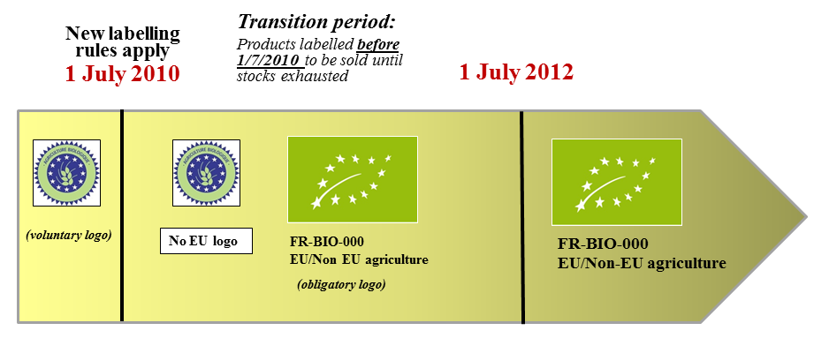
The EU organic logo may be displayed on non-pre-packaged or imported food products on a voluntary basis. When used on a product, the EU organic logo indicates that this product is in full conformity with the rules laid down in the EU Regulations. For processed products it means that at least 95% of the agricultural ingredients are organic.
The EU organic logo is registered since 2010 as a trade mark in the EU and has international registrations in key third countries such as Switzerland, the United States, Japan and Norway.

Awareness of the EU logo, confusion associated with multiple logos
According to a Eurobarometer survey conducted in July 2012, the EU organic logo had already gained 24% of the citizens' awareness. Taking into account 2 years of transitional period (to facilitate operators adapting to the new rules) and lack of costly campaigns, this result can be consider as successful. The logo was selected through a competition among students and finally chosen by European citizens through an Internet vote, which gave it already some recognition. In comparison the logo identifying Protected Designations of Origin (PDO) and Protected Geographical Indication (PGI) is recognised by 14% of the population.
Overall knowledge of the EU organic logo varies widely between MS (from 13% to 39%) depending on how developed the organic sector is and whether there was a strong national logo before.
The vast majority of respondents to the public consultation (35357, or 79% of the total), declared that they recognize the European organic logo. Only 20% of the questioned publics were not familiar with the European organic logo. This result confirms that the respondents to the public consultation were mostly familiar with the organic sector, but cannot be interpreted as a level of awareness among the general EU population.
The national and European logos were equally known by the respondents to the public consultation. National logos (66%; 29605) and the European logo (66%; 29416) are the most common and trusted indications of distinguishing organic among conventional products.
The EU organic logo has a long term potential: once understood, it can be easily recognised by European consumers in all MS without a need for translation every time it crosses an EU language border.
In addition, there are many private logos relating not only to private organic standards but also to other schemes, which add to the confusion.

Proliferation of quality (including organic) labels:
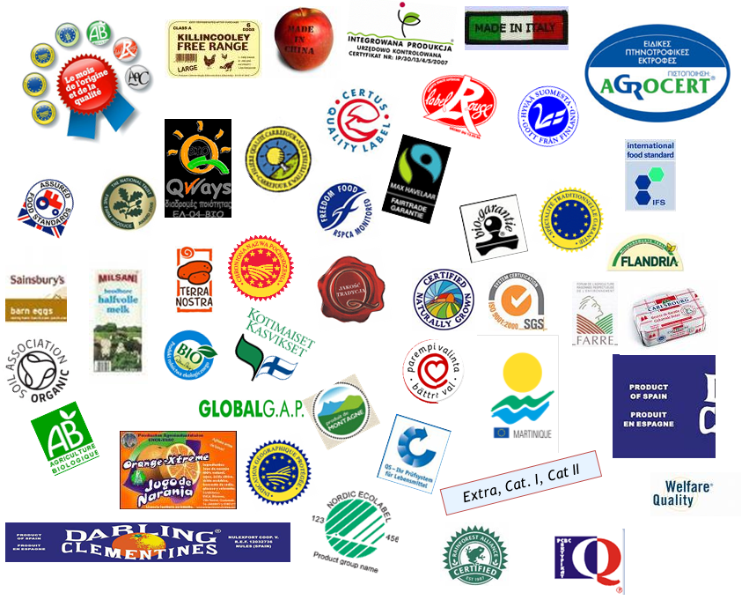
Fewer labels would likely diminish confusion amongst consumers, especially if consumers can reliably begin to attach credible association with one well known and well understood label:
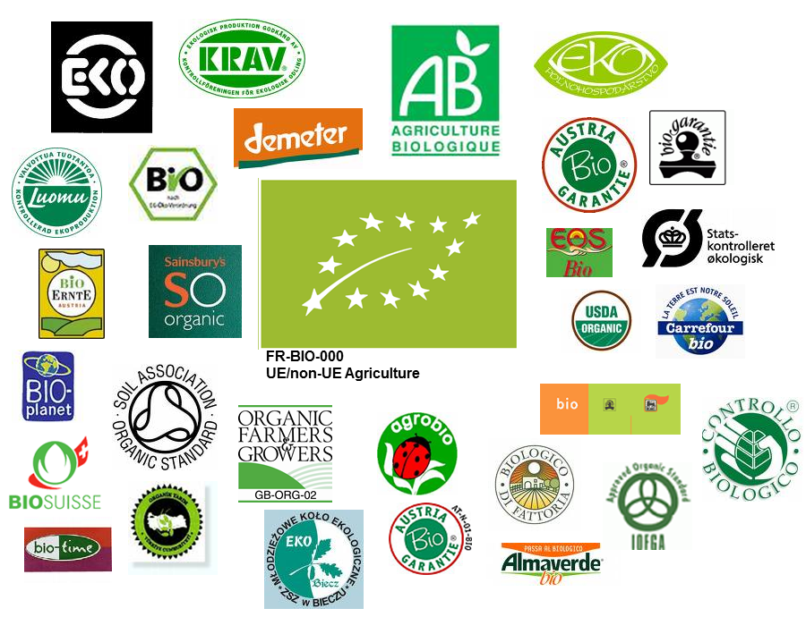
Examples of organic logos:
Name | Region | Label
Europe
EU Organic farming | EU | 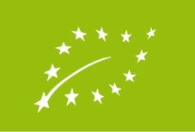  FR-BIO-000  EU/Non EU agriculture
Austria Bio garantie | Austria | 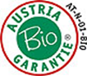
AB – agriculture biologique | France | 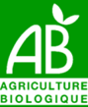
Bio-siegel | Germany | 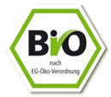
Biogarantie | Belgium | 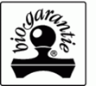
EKO | Netherlands | 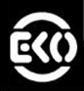
Soil Association | UK | 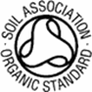
Organic farmers and growers | UK | 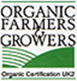
North America
USDA National Organic Program (NOP) | USA | 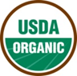
Canada Organic | Canada | 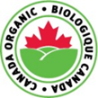

Other
Australian certified organic | Australia | 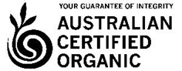
NASAA certified organic | Australia | 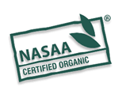
JAS | Japan | 
Bio-Gro | New Zealand | 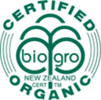

Indication of the place of farming: complex but important for consumers
Whenever the EU organic logo is used on a product, it always has to be accompanied by the code number of the control body and the place where the agricultural raw materials of which the product is composed have been farmed.
The geographical origin of food is considered very important by the majority of European consumers. The introduction of the obligatory indication of the place of farming on the packaging of organic products, besides the organic logo in Regulation 834/2007 was an improvement in this respect.
However, stakeholders have reported that the rules for the indication of the place of origin are complex and that they could be simplified.

The issue of double labelling of country of origin
The horizontal legislation provides with several cases where the indication of the country of origin of primary ingredients is required, notably Regulation (EU) No 1169/2011 on food information to consumers (not yet implemented). In these cases, it has been suggested that the legislation on organic farming should not impose the same indication twice. Currently the indication of country of origin is obligatory for beef and beef products in the EU. Mandatory origin provisions have been developed on the basis of vertical approaches for instance for honey, fruit and vegetables, fish, beef and beef products and olive oil. There is also a possibility to extend mandatory origin labelling for other food products. In particular, on the basis of Article 26(8) of Regulation (EU) No 1169/2011 the Commission shall adopt by 13 December 2013 an implementing act concerning the mandatory indication of the country of origin or place of provenance for meat of swine, sheep and goat, and poultry. The aim is to simplify the labeling of county of origin and avoid double labeling of products falling under the provisions of Regulation (EU) No 1169/2011.

Complexity of the labelling of organic processed products
According to the legislation on organic production, the country of origin can only be indicated on the packaging of processed products if all agricultural raw materials of which this product is composed are farmed in this country. The threshold for ingredients allowed from other origin is only 2 % by weight. This has as consequence that in the case of organic processed products including ingredients from various origins, the indication "EU agriculture", "non EU agriculture" or even "EU/non EU agriculture" has to be used. The sector has requested this 2% limit to be expanded to 5%, in order to be consistent with the possibility for processed food to be sold as organic provided they include at least 95% by weight of organic ingredients of agricultural origin.
Inexact obligatory labelling on organic aquaculture products
The legislation on organic production imposes to use the indication "EU agriculture", "non EU agriculture" or "EU/non EU agriculture", instead of "EU Aquaculture" / "non-EU Aquaculture" / "EU/non EU Aquaculture".

Policy options
Labelling issues are addressed by measures proposed proposed in the improved status quo option, and are therefore extended to all options. They are supported by stakeholders and MS.
The following improvements are proposed:
- Measures to avoid double labelling of the origin
- Simplification of the labelling of organic processed products (see above).
- Introduction of the possibility to use the indication "EU Aquaculture" / "non-EU Aquaculture" or "EU/non EU Aquaculture" instead of "EU agriculture", "non EU agriculture" or "EU/non EU agriculture" on the labelling of organic aquaculture products,
Impacts: the proposed measures intend to simplify the labelling requirements, thus improving the competitiveness of operators. It will also bring clarification to consumers, in particular in the case of aquaculture products.

Organic Monitor: the Global Market for Organic Food and Drink: business opportunities and future outlook (3rd edition, 2010, www.organicmonitor.com)
Zubiaurre C, 2013, The current status and future perspectives of European Organic Aquaculture. Aquaculture Europe 38 (2), pp14-21 (Based on MSc study University of Barcelona in conjunction with the European Aquaculture Society).
Estimation based on Official Eurostat data, the 2011 figures were missing for IE, CY, LU, thus their available data was used from 2010.
Estimation based on Official Eurostat data, the 2011 figures were missing for IE, CY, LT, LU, and UK, thus their available data was used from the previous year.
Total organic land area (ha) (certified and in-conversion area) - total area, including Arable land crops, Permanent grassland (pastures and meadows), Permanent crops, Fallow land as part of crop rotation
Conversion means the transition from non-organic to organic farming within a given period of time, during which the provisions concerning the organic production have been applied (Article 2 of Council Regulation (EC) No 834/2007)
Crops are arable crops (cereals, protein crops, root crops, industrial crops, fresh vegetables, forage plants and other arable land crops) and permanent crops (fruit, berries, citrus fruit, olives, vineyards and other permanent crops).
An analysis of the EU organic sector, June 2010 European Commission, DG for Agriculture and Rural Development
The Organic Monitor 2010
Ibid
The full set of reports from the CERTCOST projects is available at www.certcost.org
The Reliability of Certification: Quality Labels as a Consumer Policy Tool – Jahn et al. Journal of Consumer policy (2005) 28: 53-73.
Consumer attitudes towards organic versus conventional food with specific quality attributes – Stolz et al, NJAS – Wageningen Journal of Life Sciences 58(2011) 67- 72.
http://www.qlif.org
Consumer perception of different organic certification schemes in five European countries - Janssen, M. and Hamm, U. (2011). Organic Agriculture 1(1):31-43.
The state and consumer confidence in eco-labelling: organic labeling in Denmark, Sweden, The UK and the US – Kim Mannemar Sønderskov - Carsten Daugbjerg. Department of Political Science, Aarhus University, Denmark. Agric Hum Values (2001) 28:507-517.
The persons who replied on behalf of a consumer organisation are considered as consumers, while the ones who replied on personal behalf are considered as citizens.
To check whether some particular sub-classes (by country, capacity, attitude, orientation etc.) could introduce bias on average results from the sample, analyses based on groups were carried out: by selecting most relevant classes no distortive effect was proved.
http://ec.europa.eu/agriculture/organic/news_en
According to Reg. (EC) 1698/2005 payment rates shall cover additional costs or income foregone resulting from organic management (i.e. only those commitments going beyond the relevant mandatory requirements established by EU or national legislation). The level of payments is defined by Member States based on the following parameters: differences in yield, production costs, prices and transaction costs. Usually Member States define a typical regional organic farm and a conventional reference farm to calculate the additional costs. As reported by Sanders et al. (2011) not all countries/regions compensate 100 % of the additional costs. In most countries which do not compensate 100 % of the additional costs, there are large variations between individual crops or land use types. Since additional costs are calculated on the basis of a typical farm, low compensation levels do not necessarily mean that all farmers are only partially compensated. The real implications of compensation levels depend very much on the selected organic and conventional reference farms.
Schemes are based on Council Regulation (EC) 73/2009 establishing common rules for direct support schemes for farmers.
For the contracts concluded by 2010/11 France implements maintenance and conversion payments for organic farming under Axis 2 of its rural development programmes through agri-environment payments (Measure 214). These payments will continue to be carried out until the end of the contracts, having a duration of 5-7 years.
http://europa.eu/rapid/press-release_MEMO-13-621_en.htm
During the 2007-2013 programming period, support for organic farming was part of the compulsory agri-environmental measure. For the programming period 2014-2020, it has been proposed to establish a specific voluntary Organic farming measure. This is to recognise the importance of organic farming in contributing to various rural development objectives and priorities.
http://www.tporganics.eu/
http://cordis.europa.eu/technology-platforms/individual_en.html
Organic viticulture and wine-making: development of environment and consumer friendly technologies for organic wine quality improvement and scientifically based legislative framework, STREP (Specific Targeted Research or Innovation Project) Contract no.:022769, Sixth EU Framework Programme, Priority 8.1 - Policy-oriented Research (SSP), Area 1.2, - Task 1: Organic viticulture and wine processing, Project Coordinator: AIAB
http://ec.europa.eu/research/bioeconomy/agriculture/projects/organicdatanetwork_en.htm
http://ec.europa.eu/research/research-for-europe/agriculture-quality-low-input-food_en.html
http://ec.europa.eu/research/bioeconomy/agriculture/projects/lowinputbreeds_en.htm
http://ec.europa.eu/research/horizon2020/index_en.cfm
http://ec.europa.eu/research/innovation-union/index_en.cfm
http://ec.europa.eu/europe2020/index_en.htm
Communication from the Commission - Europe 2020 - A strategy for smart, sustainable and inclusive growth - COM(2010) 2020 of 3 March 2010
Council Regulation (EEC) No 2092/91 of 24 June 1991 on organic production of agricultural products and indications referring thereto on agricultural products and foodstuffs – UE OJ L 198, 22.7.1991, p. 1.
Council Regulation (EC) No 1804/1999 of 19 July 1999 supplementing Regulation (EEC) No 2092/91 on organic production of agricultural products and indications referring thereto on agricultural products and foodstuffs to include livestock production –UE OJ L 222, 24.8.1999, p. 1.
European Action Plan for Organic Food and Farming Com (2004) 415 final of 10.06.2004.
Commission Regulation (EC) No 710/2009 of 5 August 2009 amending Regulation (EC) No 889/2008 laying down detailed rules for the implementation of Council Regulation (EC) No 834/2007, as regards laying down detailed rules on organic aquaculture animal and seaweed production, UE OJ L 204, 6.8.2009, p. 15.
Commission Implementing Regulation (EU) No 203/2012 of 8 March 2012 amending Regulation (EC) No 889/2008 laying down detailed rules for the implementation of Council Regulation (EC) No 834/2007, as regards detailed rules on organic wine, UE OJ L 71, 9.3.2012, p. 42.
COM (2012) 212 final of 11.5.2012 Report from the Commission to the European Parliament and to the Council on the application of Regulation (EC) No 834/2007 on organic production and labelling of organic products
Products produced "by GMOs" are mentioned in Council Regulation (EC) No 834/2007, but they are not defined in Regulation (EC) No 1829/2003 on genetically modified food and feed. Therefore only products produced "from GMOs" are considered in the analysis.
Regulation (EC) No 1829/2003 of the European Parliament and of the Council of 22 September 2003 on genetically modified food and feed – UE OJ L 268, 18.10.2003, p. 1.
Directive 2001/18/EC of the European Parliament and of the Council of 12 March 2001 on the deliberate release into the environment of genetically modified organisms and repealing Council Directive 90/220/EEC – UE OJ L 106, 17.4.2001, p. 1.
Regulation (EC) No 1830/2003 of the European Parliament and of the Council of 22 September 2003 concerning the traceability and labelling of genetically modified organisms and the traceability of food and feed products produced from genetically modified organisms and amending Directive 2001/18/EC – UE OJ L 268, 18.10.2003, p. 24.
COM (2009) 153 final of 2.4.2009 Report from the Commission to the Council and the European Parliament on the coexistence of genetically modified crops with conventional and organic farming http://ec.europa.eu/agriculture/gmo/coexistence/index_en.htm
Commission Recommendation of 13 July 2010 on guidelines for the development of national co-existence measures to avoid the unintended presence of GMOs in conventional and organic crops, OJ C 200 of 22 July 2010
Commission Recommendation of 13 July 2010 on guidelines for the development of national co-existence measures to avoid the unintended presence of GMOs in conventional and organic crops, OJ C 200 of 22 July 2010
See a detailed analysis in Annex 6 on production rules.
In particular during discussions at the AGOF meeting of December 2012.
Based on stakeholders interviews
Among producers these pullets are often referred to as part-organic, because the articles states that the organic feeding and disease prevention rules must be complied with by the pullet rearing enterprise.
This point would not affect northern countries that require access to open-air areas only if weather conditions permit.
Example of costs of production difference in United Kingdom (exchange rate EUR/GPB = 1.19): - Costs of organic chicks for broilers: £0.70/per bird (0.83 €) whereas non-organic chicks likely at £0.40/per bird (0.47 €) - Fully organic reared pullets for layers (using non-organic chicks): £6.00 to 6.95/ per bird (7.12 to 8.25€). Part reared (free range using only organic feed): £4.40 to £4.70 (5.22 to 5.58 €). - Rapport ITAVI (text A), 2010 compares the price of conventional chicks of slow growing strains of 29.61€ for 100 heads to the price of organic chicks of intermediary growing strains of 65€ for 100 head).
This rule does not apply to herbivores.
The project is coordinated by the International Centre for Research in Organic Foods Systems (ICROFS) and funded under the CORE Organic II - FP7 ERA-Net project).
The report will present estimates of organic stock numbers of all animals (including herbivores) and of organic production of concentrated feedstuffs including protein, broken down by crop/type in 12 countries as well as balancing calculations and tentative conclusions.
For example in France, according to expert estimates, the need for organic soy for animal feed is around 55 000 tons, and national production is 5 000 tons, which means that 90 % of organic soy for feed is imported (mainly from third countries).
EGTOP (2011), Final report on feed, 3rd plenary meeting on 29 and 30 June 2011
According to United Kingdom expert interviewed, to move from 95 % to 100 % will cost producer + £15/t in increased feed cost and +3p/doz in production cost.
This assumption doesn’t take into account potential adjustments such as adaptation of breeds
Stakeholders in the United Kingdom mentioned that supply of organic seed potatoes has fallen dramatically in the last two years, because one major supplier withdrew from the organic market.
Data from Czech Republic could not be analysed.
No conventional seeds can be used by the operators for these crops, except for exceptional cases under appropriate justifications (e.g. specific use, e.g. pop-corn).
Strategies for Organic and Low-input Integrated Breeding and Management, financed by the European Commission under the 7th Framework programme- http://www.solibam.eu/
Decreased in greater proportion than the area or increased in smaller proportion.
Sufficient data allowing the analysis of both (a) exceptions granted and (b) organic areas for the selected species (potatoes, wheat and spelt, carrots) were available only in 5 countries. One of the limiting criteria was the different units used to specify the volume of exceptions, which prevented a clear view of the total amount granted.
There also is a permanent exceptional rule related to structural constrains, the tethering exemption for small holders in Article 39 of Regulation (EC) 889/2008.
See information about Measure 121: Modernisation of agricultural holdings in Sanders et al. (2011).
http://www.consilium.europa.eu/uedocs/cms_data/docs/pressdata/en/agricult/137076.pdf
Council Regulation (EC) No 834/2007 of 28 June 2007 on organic production and labelling of organic products and repealing Regulation (EEC) No 2092/91.(O.J. L 189 , 20/07/2007, p. 1.)
Commission Regulation (EC) No 889/2008 of 5 September 2008 laying down detailed rules for the implementation of Council Regulation (EC) No 834/2007 on organic production and labelling of organic products with regard to organic production, labelling and control, OJ L 250, 18.9.2008, p. 1–84
COMMISSION DECISION of 3 June 2009 establishing the expert group for technical advice on organic production (2009/427/EC) L139/29
COMMISSION DECISION of 28 September 2010 appointing the members of the group for technical advice on organic production and drawing up the pool list
http://ec.europa.eu/agriculture/organic/files/eu-policy/expert-recommendations/expert_group/rules_of_procedure_20-21_June.pdf
http://register.consilium.europa.eu/pdf/en/11/st17/st17470-ad05.en11.pdf
In particular, the Commission committed to modify the rules on expert groups as to adopt common selection criteria through out all DGs, that guarantee balance among different categories of stakeholders and absence of Conflict of Interests for experts. Is was agreed to establish an obligatory open selection process with a public call and a published mandate of each expert group which goes beyond a simple representation of Member states authorities.
Commission Decision No 391/2004 of 23 April 2004 on the advisory groups dealing with matters covered by the common agricultural policy UE OJ L 120, 24.4.2004, p. 50.
Even if the EU organic logo was compulsory from 1 July 2010 on, the gradual placing of the new logo on the market lasted until 2012. This transitional period was designed to help operators adapt to the new regulation and to avoid waste of existing packaging. Packaging material compliant to the organic legislation as in force before the introduction of the new logo could be used, and possibly renewed, until 1 July 2012, with or without the old organic logo. Products produced, packaged and labelled before 1 July 2010 could continue to be placed on the market and sold until stocks are exhausted.
The logo was filled as an individual and collective trademark in the Office for Harmonization in the Internal Market (Trade Marks and Designs) – OHIM. It is registered and protected as an individual trademark since 2010 and as a collective trademark since 2012.
The international registrations followed the EU legal protection and were completed in 2010-2012 period (with the exception of China). Internationally the logo is registered as a collective trademark.
Eurobarometer report n° 389 (What Europeans think of food security, food quality and the relation between agriculture & the countryside - July 2012)
SODEXO, COPA-COGECA, Carrefour, ECF-European Coffee Federation, Vossen&Co (organic essential oils) Autumn hearings
Regulation (EU) No 1169/2011 of the European Parliament and of the Council of 25 October 2011 on the provision of food information to consumers, amending Regulations (EC) No 1924/2006 and (EC) No 1925/2006 of the European Parliament and of the Council, and repealing Commission Directive 87/250/EEC, Council Directive 90/496/EEC, Commission Directive 1999/10/EC, Directive 2000/13/EC of the European Parliament and of the Council, Commission Directives 2002/67/EC and 2008/5/EC and Commission Regulation (EC) No 608/2004 – OJ L 304, 22.11.2011, p. 18.

