REPORT FROM THE COMMISSION
TO THE EUROPEAN PARLIAMENT, THE COUNCIL, THE EUROPEAN CENTRAL BANK, THE EUROPEAN ECONOMIC AND SOCIAL COMMITTEE AND THE COMMITTEE OF THE REGIONS
The introduction of the euro in Latvia

Introduction
The Council decided on 9 July 2013 that Latvia fulfilled the necessary conditions for the adoption of the euro and that its derogation from participating in the single currency was to be abrogated with effect from 1 January 2014.
Latvia followed the practice of all Member States that have adopted the euro after the first changeover wave (1999–2002) and used the so-called "big-bang" changeover scenario, i.e. euro banknotes and coins acquired legal tender status on the day of euro adoption. A two-week dual circulation period, during which both euro and Latvian lats banknotes and coins circulated in parallel, allowed for the gradual withdrawal of lats cash. This successful changeover demonstrates again that a short dual circulation period is sufficient if the changeover is well prepared. A large majority of Latvians (79%) perceived the changeover as smooth and efficient.
Following the two reports of the Commission on the practical preparations of the euro changeover in Latvia, this report covers the most important aspects of the changeover process from an ex post perspective focusing on the preparations for the cash changeover, the dual circulation period, measures taken to prevent abusive price practices and erroneous price perceptions, price trends and price perceptions and communication on the euro. Where relevant, the report also sets out the Commission's recommendations on further possible action to be taken by Latvian authorities and draws conclusions which may be of value for future changeovers.

The changeover

Preparations for the cash changeover
The cash changeover constitutes probably the most visible element of the currency switchover since virtually all financial institutions, businesses and citizens are involved. The smoothness and effiiency of this operation depends on a proper supply of euro cash to all parties involved and on banks and businesses being well prepared for the large extra workload.
400 million of euro coins bearing Latvian national sides were minted at the Staatliche Münzen Baden-Württemberg (Stuttgart, Germany) following a public tender. Some 110 million euro banknotes of various denominations were borrowed from the Deutsche Bundesbank.
Banks and enterprises were successively provided with euro cash before the end of 2013. Frontloading to credit institutions started on 1 November 2013. Regular sub-frontloading to commercial banks' major clients started on 10 December 2013, smaller corporate clients using simplified sub-frontloading were delivered euro cash as of 27 December 2013. Post offices received euro cash via sub-frontloading by Citadele Bank. The total value of frontloaded euro banknotes and coins was EUR 283.2 million.
800,000 starter kits containing a mix of all Latvian euro coins denominations (value: EUR 14.23 per kit), i.e. more or less one kit per household, have been available for the general public since 10 December 2013 via commercial banks, post offices and the branches of the Latvian central bank, the Bank of Latvia. By 1 January 2014, some 644,000 starter kits were sold. With hindsight, in the case of Latvia, the standard euro area rule of thumb that more or less one starter kit per household is needed proved too optimistic. Since 1 January 2014, remaining starter kits may be purchased by collectors and coin selling companies. 95,000 specific kits for retailers (each containing EUR 200) were available since 10 December 2013, of which some 70,000 kits were sold by 1 January 2014. Several commercial banks also produced individual starter kits adjusted to the average demand of their business customers.
Against the background of the increased security risk, a security action plan was developed providing for measures enhancing the safety of cash transports by the cash-in-transit sector during the changeover process. A dedicated action plan was set up to address possible bad weather conditions. A few weeks before and after the changeover, State police provided free of charge escorts to the cash transport vehicles of the Bank of Latvia, commercial banks and cash-in-transit companies.
In particular in the last days of December 2013, commercial banks and post offices had to handle exceptionally high amounts of cash. In order to facilitate the logistics of the withdrawal of lat coins, cash-in-transit companies and commercial banks had been provided with standard mobile containers to be used for coin collecting, storage and transportation.
The Latvian banking sector comprises 25 banks with 371 bank branches, out of which 19 banks with 321 branches provide cash services. With a view to facilitating the changeover, some banks extended their business hours in the last weeks of the year. Commercial banks will provide unlimited cash exchange services free of charge until 30 June 2014.
Since late September 2013, the Bank of Latvia together with the Employers' Federation of Latvia offered training sessions for cash handlers and accountants on euro cash in general and securitiy features in particular. These training sessions were attended, in particular, by retailers and post-office employees. Bank employees received specific training from their employers on the general principles of the euro introduction and its implications on bank services, as well as on the availability of bank services around 1 January 2014.
In order to improve the access to cash exchange services in particular in rural areas, Latvijas Pasts (the Latvian Post) played an active role in the cash changeover. Cash exchange services are being offered to the general public in 302 post offices until 31 March 2014 (may be extended by up to three more months).
According to a Commission survey carried out at the end of December 2013, a large proportion of Latvians already possessed euro cash before the changeover: 43% had euro banknotes (56% from a trip abroad, 46% from an exchange in a bank in Latvia) and 60% had euro coins (57% from a trip abroad and 48% from a starter kit).
The cash changeover in Latvia was well prepared and organised.
Banks and businesses and citizens were adequately supplied with euro cash in advance of the changeover.
In light of the Latvian experience, the standard estimate for the number of coin kits to be produced for the general public should be revised downward.

The dual circulation period
The two-week dual circulation period during which the euro and the Latvian lats where circulating in parallel expired on 14 January 2014.
All of the 1,061 automatic teller machines (ATMs) in Latvia were available for withdrawal of euro by 1:00 a.m. on 1 January 2014. ATMs were loaded with euro cash (mainly denominations of EUR 10, 20 and 50) mainly in the last days of December 2013. Denominations of 5 EUR have been available at 242 ATMs since 1 January 2014 and at 460 additional ATMs since 14 January 2014. In mid-January 2014, the EUR 5 denomination represents one third of issued euro banknotes. Point-of-sale terminals switched instantaneously to euro on 1 January 2014. 99.3% of them are currently Single Euro Payments Area (SEPA) compliant. Banks' clients have been encouraged to use electronic payments more often, particularly in the first days following 1 January 2014. During the dual circulation period, payment cards have been used in 6.6 million transactions with a total value of EUR 122 million. Compared to January 2013, use of electronic payments has increased by 20-30% in January 2014.
Some bank branches as well as all six cash-desks of the Bank of Latvia were open for cash services on 1 January 2014. Post offices which are usually closed on Saturdays were open on Saturday 4 January, with a view to facilitating access to cash exchange for the population, in particular in remote and rural areas.
Due to careful preparations, banks and post offices coped well with the extra workload during the dual circulation period. Several banks deployed additional staff in branches for cash operations. Cash collection services were proactively provided to retailers and other business clients. Counting and storage facilities in the branches had been adjusted.
By 9 January 2014, some EUR 120.15 million were exchanged in the largest commercial banks covering 77% of the total customers base (in total exchange of EUR 98.9 million), in post offices (EUR 16.1 million) and by the Bank of Latvia (EUR 5.15 million). The number and volume of withdrawals at ATMs remained the same as in "lats times" during the first days of January. 98% of vending machines were switched to euro by 6 January 2014.
According to a Commission survey carried out between 16 and 18 January 2014 in Latvia, 88% of those polled did not experience any problem when exchanging lat cash or withdrawing euro cash with banks in the first week of January. This is less than during the euro changeover in Estonia (95%) but overall in line with previous changeovers.
Graph 1 below shows the evolution of cash payments exclusively in euro during the dual circulation period in Latvia compared with Estonia, Slovakia and Slovenia.

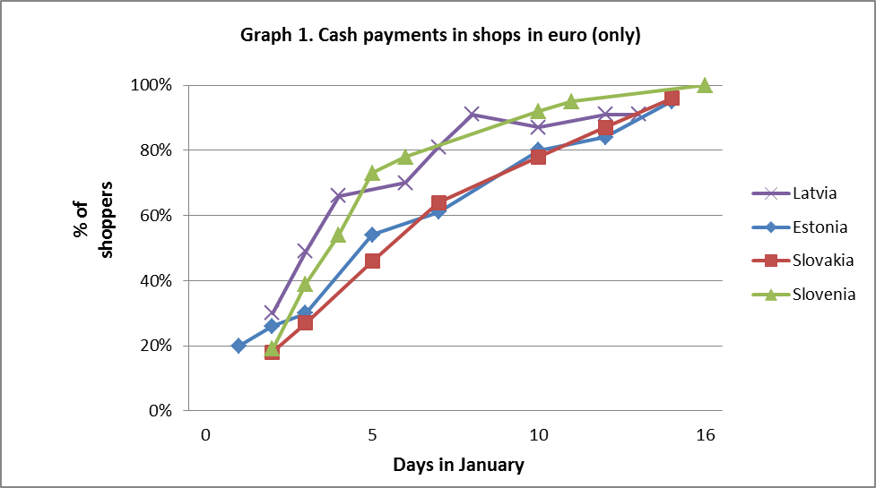

Already on the first business day following the changeover (2 January 2014), a comparatively large share of the public (30%) paying in cash paid with euro cash only. On 4 January, already two thirds of citizens polled paid in euro cash only. Thereafter, the share of euro cash only payments progressed towards the end of the dual circulation period with the exception of Friday 10 January 2014 where it decreased from 91% to 87%, but quickly picked up again to 91% on the following Monday. Overall, the evolution of euro cash only payments was faster than in Estonia and Slovakia but less steady than in Slovenia.
The retail sector also managed well with the challenges of the changeover process and the handling of two currencies at the same time. Retailers were well supplied with euro cash and no major problems with queues were reported. As can be seen from graph 2 below, already on 2 January, 94% of citizens received change in euro only. This share increased to 100 % on 7 January and remained at this level until 14 January 2014.
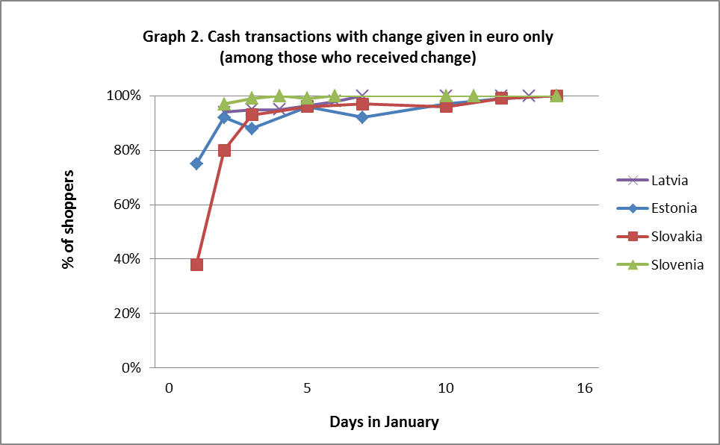
The Commission survey carried out just after the end of the dual circulation period shows that a very large majority of Latvians (79%) have perceived the changeover as smooth and efficient.

Withdrawal of the legacy currency
Though lats cash in circulation has been decreasing since the beginning of 2013, the withdrawal of lats cash from circulation has been a particular challenge.
A significant proportion of the Latvian lat cash in circulation was retrieved from circulation already before the changeover. By 31 December 2013, the value of lats in circulation had decreased by nearly 50% compared to January 2013 (from LVL 1.2 billion to LVL 630.8 million).
In total, 293 million coins (757 tons) had to be withdrawn. Demonetization of lat coins started on 5 September 2013. 33% of the estimated lat coins were destroyed by 31 December 2013. With a view to reducing lats cash already before 1 January 2014, several banks offered their clients to deposit lat coins on savings accounts free of charge from October 2013. Moreover, Bank of Latvia is offering unrestricted and free-of-charge exchange of lat coins into lat banknotes. Commercial banks stepped up promoting non-cash payments to clients. In order to reduce the number of high denomination lat banknotes in circulation towards 1 January 2014, cash-in-transit companies and enterprises were encouraged to refrain from ordering high denomination banknotes.

The changeover in Latvia was well prepared and smoothly implemented.
ATMs and point of sale -terminals were converted in time and banks and post offices coped well with the extra workload during the dual circulation period. Retailers managed well with the challenges of the changeover process and the handling of two currencies at the same time. They were well supplied with euro cash and pursuant to a Commission survey, already on 2 January 2014, 94 % of the citizens polled received change in euro only.

Preventing abusive price practices and erroneous price perceptions
The general public has been concerned about the possible impact of the changeover to the euro on prices. It has, therefore, been particularly important that the Latvian authorities take the necessary steps to prevent abusive practices and dispel erroneous perceptions of the evolution of prices.
Since January 2013, prices of 120 frequently purchased products and services in the most popular points of sale in the seven biggest cities of Latvia have been monitored. Monitored services include those which, based on the experience of previous changeovers, are most likely to be affected by changeover-related increase of prices such as hairdressers, restaurants/cafés and car-repair services. The results of the monitoring have been regularly published on the website of the Ministry of Economics and on the euro changeover website.
Compliance with the requirements for price display and conversion (e.g. rounding rules) during the dual display period and implementation of the "Fair Euro Introducer" Memorandum has been monitored by the Consumer Rights Protection Centre (CRPC), non governmental organisations (NGOs) protecting consumer rights, the State Food and Veterinary Service and the State Revenue Service. Intensive controls have started on 1 October 2013. Following the first dedicated report of the European Commission on Latvia's practical preparations for introducing the euro, the total number of inspectors involved has been significantly increased (now 346 inspectors).
The compulsory dual display of prices in lat and euro started on 1 October 2013 and will last until 30 June 2014. Since October 2013, 14,849 controls have been carried out (total number of controls planned: 28,000). The CRPC and the Consumer Interest Protection Association made 14,849 controls and detected violations in 5,486 points of sale. The most frequent shortcoming detected was incorrect conversion in 4,245 cases. The second most frequent shortcoming concerned the dual display of prices (1,720 cases). As at end of January 2014, the violations were remedied in 4,231 points of sale. In 2,453 points of sale this was done on the spot in the presence of a CRPC inspector. In 39 cases, a fine up to LVL 500 (EUR 711.44) was imposed. So far, administrative procedures have been launched in 83 cases. The State Food and Veterinary Service has carried out 4,454 price controls (violations detected in 186 points of sale) and the State Revenue Service 79 controls (violations detected in 22 points of sale). The number of infringements of the dual display requirements has decreased over time.
Latvians generally considered the dual display of prices to be a useful tool to facilitate price comparisons and to get used to thinking in their new currency. According to a Commission survey carried out in January, almost three out of four (74%) Latvians polled considered the dual price displays to be very or rather useful. 84% furthermore considered that they were always (44%) or mostly (40%) implemented correctly, which is in line with the results from the recent changeovers.
When asked about price conversions, 46% of Latvians had the impression that the price conversion to the euro was sometimes (33%), often (10%) or very often (3%) not correct. This result is somewhere in between the results of the previous changeovers.
The "Fair Euro Introducer" campaign which was launched on 12 July 2013 invites businesses to commit not to misuse the changeover for their own profit, respect the changeover rules and provide the necessary assistance to their clients. It follows the lines of the voluntary initiatives employed successfully in previous changeovers. The campaign is led by the Ministry of Economics. Subscribers to the campaign are entitled to use a sticker with a dedicated "Fair Euro Introducer" logo demonstrating their participation and are listed on a "white list" available on the Euro Project website. By end of January 2014, 1,224 companies (more than 11,000 points of sale) which sell goods or provide services have joined the "Fair Euro Introducer" campaign. Participants include the five biggest retail chains. The fair pricing agreement is a very important initiative in order to prevent potential price abuses and dispel erroneous price perceptions. Compared with the total number of businesses in Latvia, the target originally envisaged (at least some 10,000 companies or 30,000 points of sale) and the experience made in previous changeovers, there seems to have been scope to further expand the coverage of the scheme.
Since 1 October 2013, consumers have been able to submit complaints on violations of price indication rules to the CRPC via a dedicated complaints telephone line, the general euro information hotline, e-mails and letters. Complaints have been followed up by the CPRC or a cooperating NGO within a maximum of 48 hours after the complaint has been lodged. Concerns voiced by citizens have mainly related to issues such as the display of prices and the application of the rounding rules. Complaints on possible euro-related price increases have been assessed by the Latvian Competition Council.
Latvia has implemented the dual display of prices and a fair pricing initiative in line with the recommendations of the Commission. The Latvian authorities should continue to make sure that all complaints from citizens are duly investigated and to monitor the correct implementation of the "Fair Euro Introducer" Memorandum during the remaining duration of the campaign.
Participation to the fair pricing initiative has been rather disappointing in comparison with previous euro changeovers. Countries introducing the euro should target a subscription rate to the agreement of at least 75%.

Price trends and price perceptions

Price trends
The euro changeover was preceded by a period of very low, and occasionally negative, inflation in Latvia. Disinflation was driven primarily by the energy component and to a lesser extent by non-energy industrial goods and more recently by unprocessed food. These trends are similar to those observable in the euro area aggregate data and in Latvia's neighboring countries.
In line with the established practice following euro adoption in other Member States, Eurostat is planning to prepare an assessment of price developments after the euro changeover in Latvia, once sufficient data becomes available. The respective note is planned to be published by Eurostat in May 2014.

Price perceptions
According to a recent Commission survey, the majority of Latvians (57%) think that the euro will increase inflation in their country (compared to 55% of Estonians, 19% of Slovaks, 66% of Cypriots, 37% of Maltese and 52% of Slovenes just after their respective changeovers) while only 19% believed that joining the euro area would help Latvia to maintain price stability.
Until mid-2013, perceived inflation in Latvia had been steadily declining from its peak in spring 2011, closely mirroring actual inflation developments. Between July and November 2013, however, perceived inflation rose, while annual HICP inflation declined to rates below zero. While this increase in perceived inflation in the context of falling actual inflation may have been due to the imminent euro changeover, it is difficult to identify the specific causal impact of the changeover on inflation perceptions. Around the time of the changeover, in December 2013 and January 2014, perceived inflation declined. Data from the Joint Consumer Survey show that, in non-seasonally adjusted terms, it fell to 21.9 in January, from 24.6 in December.

Communication on the euro
Following the Council Decision of 9 July 2013, the Latvian authorities launched the intensive phase of the implementation of the euro changeover related communication activities.
The final version of the "Communication Strategy for the Euro Changeover in Latvia" which was approved on 22 October 2012 by the Euro Project Public Awareness and Communication Working Group laid down the guidelines for the euro introduction information campaign. Quantitatively, the campaign aimed at ensuring that 90% of all residents feel well informed about all practical aspects of the changeover to the euro.
The communication campaign, coordinated by the Ministry of Finance, involved a mix of communication tools and instruments (direct household mailing, seminars and trainings, social media, TV and print campaign) and targeted various groups (e.g. general public, school children, vulnerable groups, businesses). Complementary communication activities were undertaken by the State Chancellery, the Ministry of Economics, the Latvian Central Bank, the Ministry of Education and Science, the Latvian association of commercial banks and other public and private institutions.
Regular seminars, regional events and regional fora in the regions took place for businesses, professional cash-handlers and vulnerable groups starting from 2012. The Latvian Employers' Confederation, the Latvian Chamber of Commerce and the Latvian Traders Association organised workshops for businesses informing on the "Fair Euro Introducer" campaign, which included meetings with government officials and economists.
The Euro Changeover Conference, jointly organised by the Bank of Latvia, the European Central Bank, the European Commission and the Ministry of Finance, took place in Riga on 12 September 2013.
In September 2013, the mass media campaign started with TV spots aiming at involving the public emotionally and explaining practical aspects of the euro changeover process. The campaign was complemented by print, radio, online and outdoor media advertising. In the media selection process, special attention was given to reaching vulnerable groups in remote areas and the Russian-speaking population.
To inform teachers and school children, the Ministry of Education and Science distributed to all schools an information brochure for teachers and produced cartoons to be introduced in the schools’ curricula.
Several activities targeted both the visually impaired and the hard of hearing with trainings on the design of the new banknotes and coins, security features and general changeover modalities.
A direct mailing in five regionally adapted versions, including a Russian version, which had been prepared by the Ministry of Finance together with the European Commission, was sent to all households towards the end of 2013. Shortly thereafter, the European Central Bank and the Bank of Latvia together sent out a leaflet informing on the design of banknotes and coins and security features.
In the framework of a Partnership Agreement signed between the Latvian Ministry of Finance and the Commission on 10 July 2012, and a subsequent grant agreement signed on 30 April 2013, the European Commission contributed to the implementation of the communication strategy by financing up to 50% of eligible costs of communication activities. Moreover, the Commission financed the travelling euro exhibition in Riga and other major Latvian cities from September 2013 to January 2014, organised a seminar for Latvian journalists and co-operated on the Euro Changeover Conference in September 2013. The Commission also provided various publications and conducted Eurobarometer opinion polls before, during and after the dual circulation period.
The European Central Bank cooperated with the Bank of Latvia to use synergies and maximise the impact of the campaign. The European Central Bank provided publications, the ECB euro exhibition, co-organised the Euro Changeover Conference in September 2013 and implemented a mass media information campaign focusing on the visual appearance and security facts of euro banknotes and coins, key facts and dates of the changeover.
The communication and public awareness campaign contributed to a smooth changeover to the euro. Despite a somewhat belated start, the various target groups were appropriately informed on the practical aspects of the euro changeover, including specific groups such as minorities, people living in remote areas, young people and the elderly. The target of 90% of Latvian inhabitants feeling sufficiently informed can be judged to have been met with 89% of Latvians feeling well informed about the euro. Moreover, overall 80% are satisfied with the information provided by the Latvian authorities. Support for the euro has reached 52% (survey in Latvia, January 2014), starting from a rather low level early 2013 (33%, survey in Latvia, January 2013). In order to further increase it, it is recommended to continue some information efforts and to continue monitoring public opinion on euro-related aspects. In particular, the impact of the euro on prices and abusive price settings remains a concern for Latvians. Therefore, it is recommended to continue supervising the dual display of prices, the correct conversion and rounding rules and the evolution of prices in general for a few extra months.

Council Decision 2013/387/EU of 9 July 2013 on the adoption by Latvia of the euro on 1 January 2014 (OJ L 195, 18.7.2013, p. 24).
The first-wave Member States adopted the euro according to the 'Madrid Scenario', which involved a transitional period of three years (one year for Greece).
Estonia, Slovakia and Slovenia also had a two-week dual circulation period, whereas in Malta and Cyprus it was one month.
Flash Eurobarometer 393, field work carried out 16-18 January 2014, available at: [http://ec.europa.eu/economy_finance/euro/communication/polls/index_en.htm].
European Commission, Twelfth Report on the practical preparations for the future enlargement of the euro area - COM(2013) 540 final, 23.7.2013; http://ec.europa.eu/economy_finance/pdf/2013/twelfth_report_on_the_practical_preparations_en.pdf; http://ec.europa.eu/economy_finance/pdf/2013/thirteenth_report_on_the_practical_preparations_en.pdf; and Thirteenth Report on the practical preparations for the future enlargement of the euro area - COM(2013) 855 final, 3.12.2013 - http://ec.europa.eu/economy_finance/pdf/2013/thirteenth_report_on_the_practical_preparations_en.pdf.
Flash Eurobarometer 390, field work carried out on 28 and 30 December 2013, available at: http://ec.europa.eu/economy_finance/euro/communication/polls/index_en.htm.
Flash Eurobarometer 393 (see footnote Error: Reference source not found).
The corresponding figure was 90% in Slovakia, 88% in Cyprus, 85% in Malta and 96% in Slovenia.
Flash Eurobarometer 393 (see footnote Error: Reference source not found).
Flash Eurobarometer 393 (see footnote Error: Reference source not found).
Flash Eurobarometer 393 (see footnote Error: Reference source not found).
526 entities were covered by the corresponding scheme in Estonia, some 7,600 businesses in Cyprus, some 7,900 in Malta and some 20,000 sales points in Slovakia.
Commission Recommendation of 10 January 2008 on measures to facilitate future changeovers to the euro (OJ L 23, 26.1.2008, p. 30).
Flash Eurobarometer survey 393 (see footnote Error: Reference source not found).
Flash Eurobarometer survey 393 (see footnote Error: Reference source not found).
Flash Eurobarometer survey 393 (see footnote Error: Reference source not found).

