Executive Summary Sheet
Impact assessment on Proposal for a Directive amending Directive 2003/41/EC on the activities and supervision of institutions for occupational retirement provision
A. Need for action
Why? What is the problem being addressed?
Directive 2003/41/EC marked a first step on the way to a Single Market for Institutions for Occupational Retirement Provision (IORPs). This Directive needs to be revised for five reasons. First, prudential barriers remain which make it more expensive for employers to join an IORP in another MS. Second, market developments require a regulatory response since the number of Europeans relying on defined-contribution (DC) schemes, which shifts risks from IORPs and employers to individuals, has increased significantly. Third, recent financial and economic crises have shown that current minimum levels of protection for scheme members and beneficiaries need to be improved. Fourth, citizens do not receive essential information in a comprehensible manner, which prevents them from making informed decisions about their retirement financing. Fifth, supervisory powers are insufficient in several areas.
What is this initiative expected to achieve?
In line with the 2012 White Paper on pensions, this initiative aims at facilitating occupational retirement provision by making it safer and more efficient, following the European Parliament resolution of 21 May 2013. Removing prudential barriers will make joining a cross-border IORP less expensive for employers. Moreover, the more prominent role of DC schemes makes the Single Market more accessible for occupational retirement provision. Modernising prudential regulation that emphasises good governance and risk management of IORPs will increase their safety. In MSs with small IORP markets there is a great potential that the proposal will help to realise. Strengthening information disclosures will make citizens better informed. IORPs’ role as long-term investors in the EU will benefit from removing unnecessary investment limits. Finally, efficiency gains are expected from increasing the degree of harmonisation in all MSs.
What is the value added of action at the EU level?
Action at the EU level will add value substantially since MSs alone cannot: (i) remove obstacles to IORPs' cross-border activities; (ii) ensure a higher EU-wide minimum level of protection of members and beneficiaries; (iii) take into account cross-border workers' interests; (iv) enable employers to benefit from cost savings resulting from cross-border synergies; (v) avoid regulatory arbitrage between financial services sectors; and (vi) avoid regulatory arbitrage between MSs. Moreover, the chosen policy options are proportionate since they are adequate to reach this proposal's objectives and do not go beyond what is necessary in doing so. The proposal has specifically taken into account the nature, size and complexity of IORPs by choosing those options that do not increase the administrative burden unnecessarily and respect MSs' prerogative to design their pension systems.
B. Solutions
What legislative and non-legislative policy options have been considered? Is there a preferred choice or not? Why?
The initiative proposes to address the problems in the IORP sector through legislative action. Even though some further convergence might be achieved through co-operation between supervisors, differences in national law arising from divergent interpretations and implementation of key concepts in the Directive are expected to result only in temporary and limited clarification. The selected choices are as follows: (1) to remove prudential barriers for cross-border IORPs; (2) to ensure good governance and risk management by requiring IORPs to have staff performing key professional functions, well-functioning risk management systems and documentation and protection of DC scheme members against operational losses; (3) to require IORPs to provide members and beneficiaries a short and standardised Pension Benefit Statement with clear and relevant information about their pension entitlements and projections; and (4) to ensure that supervisors have the tools to effectively supervise IORPs, in particular verifying governance and risk management requirements, accessing information in case of chain-outsourcing, and conducting stress tests.
Who supports which option?
Extensive public consultations on all aspects of the Directive have taken place with many stakeholders involved since 2008. Modernising the governance, transparency and reporting aspects of the Directive is supported by the European Parliament, those MSs where insurance is the main vehicle of occupational pension provision (e.g. FR and SE), insurers and EIOPA. MSs with developed IORP markets such as UK, IE, NL and DE could agree to a revision of the Directive on these issues as long as the principle of proportionality is respected. Employers and employees recognise the benefits that can be gained from a review of the Directive, but remain wary of measures that raise costs without leading to more safety for members and beneficiaries. Finally, innovative employers stress the need of removing prudential barriers to cross-border provisioning of IORPs.
C. Impacts of the preferred option
What are the benefits of the preferred option (if any, otherwise main ones)?
Better governance and risk management benefits members and beneficiaries by increasing risk-adjusted investment returns, with positive effects on their retirement income. Moreover, improved personalised information will help individuals make better informed decisions about their retirement provision. Employers, including SMEs, are expected to benefit through reduced cost of joining an existing IORP. This enables them to focus on their core business activity and, at the same time, benefit from a more professional service level. Moreover, employers joining a pension scheme in an established IORP market can expect to reduce their administration and investment costs. Multinational companies will also benefit from consolidating their existing pension schemes into one IORP. MSs will benefit because well-governed IORPs and deeper IORP markets at both the national and EU level are expected to reduce some of the fiscal pressure on state pension systems.
What are the costs of the preferred option (if any, otherwise main ones)?
The expected cost of the proposed action is an increase of the administrative burden mainly as a one-off adjustment cost in the short-term, and somewhat higher recurrent costs in the new regime. An estimate from the IORP sector of the administrative burden has pointed to three elements that they expected to be the most expensive. The proposed action avoids the two most costly elements by taking into account proportionality, in the sense that IORPs are only required to report descriptions of four key qualitative elements determining their funding position and to have only a limited number of key governance functions in place. DC schemes in a few MSs are expected to incur an additional cost from the mandatory appointment of a depository.
Will there be significant impacts on national budgets and administrations?
The future regime is likely to have a positive impact on the sustainability of public finances. Better information about expected retirement benefits from occupational pensions will help individuals decide whether or not they need to save more, in accordance with their consumption preference before and after retirement. As such, well-informed individuals are likely to exert less pressure on national state pension systems. Some MSs might need to increase supervisory resources where the proposed supervisory powers are not yet in place.
Will there be other significant impacts?
The proposed action is expected to have significant positive social impacts. It is expected to contribute to increasing the coverage of occupational retirement savings. The take-up of occupational pension schemes, like for any financial product, is largely driven by trust and performance. The proposed action will make occupational retirement products more efficient and safer than today. Moreover, the clear and standardised information disclosures to members will assist the growing number of citizens who work in another MS. No major environmental impacts are foreseen.
D. Follow up
When will the policy be reviewed?
An ex-post evaluation of the application of the revised directive should take place five years after its adoption, in the form of a Commission report to the European Parliament, the Council, and the European Economic and Social Committee. It may be accompanied, if necessary, by policy recommendations or proposals for amendments to this Directive.

1. Introduction
European society is ageing. Pension systems across the European Union (EU) have to adapt in order to ensure adequate, safe and sustainable pensions. This is not a simple matter. Effectively addressing the challenge requires closely coordinated action by Member States (MS) and by the EU to benefit from synergies. Joint measures in relation to fiscal coordination, labour mobility and initiatives announced in the 2012 White Paper on pensions (White Paper) are already underway.
The Single Market, too, can contribute decisively. The White Paper announces that “[t]he Commission will, in 2012, present a legislative proposal to review [Directive 2003/41/EC on the activities and supervision of Institutions for Occupational Retirement Provision]”. The revision of the Directive was scheduled in the Commission's Work Programme for 2012 and 2013. The latter specifies that the Commission will "[p]ut in place the right framework for the institutions handling occupational pensions" and that "[a] review of this Directive is required in view of the importance of ensuring that appropriate structures are in place to fund retirement."
Institutions for Occupational Retirement Provision (IORPs) are, like other financial institutions, an integral part of the Single Market. Directive 2003/41/EC was adopted in 2003 in order to enable IORPs to provide their services to sponsoring employers and employees across the EU. The opening up of borders was accompanied by minimum harmonisation of prudential standards and mutual recognition of supervision in order to ensure a high level of member protection across the Single Market.
Ten years after its adoption, the Directive needs to be revised. Cross-border activity is possible but still too complex and too costly. Risk is being shifted from IORPs to individuals, with the greater significance of defined-contribution (DC) schemes. Around 25 million Europeans rely on DC schemes, considerably more than ten years ago, and looking forward the upward trend is set to continue. The performance of DC schemes hinges crucially on professional management, and DC schemes require individuals to engage with longevity and financial risks directly. Moreover, the more prominent role of DC schemes is making the Single Market more accessible for occupational retirement provision. Finally, the recent financial and economic crises have revealed vulnerabilities in the level of member protection, which have led to irreversible financial losses for millions of scheme members and beneficiaries across the MSs.
Regulation needs to adapt, to ensure that governance and transparency requirements are still suitable for today’s market challenges. This is what this proposal sets out to do. In MSs with small IORP markets there is a great potential that the proposal will help to realise. Improvements to the performance of occupational pensions require long periods of time to materialise. Failing to act now would lead to lost opportunities in terms of cost savings and investment returns, and inadequate financial planning by millions of Europeans. It would also increase the burden disproportionately for younger generations and undermine inter-generational solidarity.
This proposal does not consider the introduction of new solvency rules. Solvency rules are not directly relevant for DC schemes. Moreover, the Quantitative Impact Study (QIS) conducted by the European Insurance and Occupational Pensions Authority (EIOPA, 2013c) indicated that more complete data on solvency aspects are necessary before a decision can be taken on those aspects.

2. Procedural issues and consultation of interested parties

2.1. Procedural issues

2.1.1. Steering Group
The Steering Group for this Impact Assessment was formed by representatives of the Directorates General Internal Market and Services (MARKT), Economic and Financial Affairs, Enterprise and Industry, Employment, Social Affairs and Inclusion, Environment, Taxation and Customs Union, Health and Consumers, Research and Innovation, Home Affairs, Justice, Human Resources and Security, the Joint Research Centre, the Legal Service and the Secretariat General. The Group met on 24 September 2012, 24 May 2013 and 3 July 2013.

2.1.2. Impact Assessment Board
A meeting of the Impact Assessment Board (IAB) took place on 4 September 2013. During this meeting the IAB raised a number of issues which needed revisiting and requested resubmission of the Impact Assessment. In this revised report, MARKT has taken on board all comments made by the IAB. The main modifications to the report were: (1) a complete redraft of section 2.2 to include the views of the MSs and different stakeholder categories and explain how these views have been taken into account; (2) a clarification of the problems being addressed by this initiative in section 3.3; (3) a new section on subsidiarity in section 3.4.1, which sets out the case for EU action in greater detail; (4) a clarification that further harmonisation of supervisory reporting is not being proposed (section 6.5 and 6.6); and (5) a new section 6.1.3 on the impact on Small and Medium-sized Enterprises (SMEs).

2.2. External expertise and consultation of interested parties
This report builds on multiple public consultations, the first of which was launched in 2008. Although initially most attention was drawn to possible new solvency rules for IORPs, these consultations covered all aspects of the Directive, including cross-border issues, governance, transparency and reporting. The issue of possible new solvency rules greatly divided stakeholders with some - primarily in the insurance industry and supervisors – favouring new rules, whilst others - mainly in the IORP industry and employers organisations - strongly opposed them. As solvency rules remained the main point of contention in subsequent consultations, MARKT decided in 2012 to ask EIOPA to conduct a QIS on a possible new quantitative framework. The results of this study (EIOPA, 2013c) highlighted the need for deeper knowledge of this issue. It was therefore decided in May 2013 that the IORP II proposal would focus on governance, transparency and reporting. On these issues, the Commission Services have consulted external stakeholders extensively along with the solvency rules. This section summarises the most important consultations:
(i) Green Paper and White Paper on pensions (2010 and 2012): Following the concerns expressed by stakeholders after the first consultations, MARKT did not propose legislative action but decided to place the policy choice on the prudential standards for IORPs in the wider economic and social policy context. In July 2010, the Commission published a Green Paper on pensions. The paper included questions on the consistency of the EU regulatory framework for funded pension schemes, the need to modernise the information disclosure requirements for pensions products, and ways to amend the Directive to improve the conditions for cross-border activity. The consultation, which - in line with the minimum standards of consultation - lasted from July until November 2010, drew almost 1700 responses from across the EU, including 350 from MSs, national parliaments, business and trade union organisations, civil society and industry representatives. On governance and transparency a majority of stakeholders proved to be receptive to change, with a number of MSs pointing at room for improvement with respect to governance and risk management, safekeeping of assets and transparency to members and beneficiaries. All did stress the importance of proportionality, however.
Following the Green Paper, the Commission adopted the White Paper on pensions in February 2012, which announced a set of 20 EU-level initiatives. One of these initiatives was a revision of the Directive in 2012.
(ii) EIOPA advice and Public Hearing (2012): Taking into account the feedback on the 2010 Green Paper, MARKT asked EIOPA on 7.4.2011 to provide technical advice on how to change the Directive. Assisted by experts from national supervisors, EIOPA produced draft advice on 8.7.2011 in which it recommended that - taking into account the principle of proportionality - the governance framework set out in the Solvency II Directive should also apply to IORPs. The publication of the draft advice was followed by a consultation which lasted until 2.1.2012. 170 responses were received from 14 MSs and 20 European and international organisations. EIOPA evaluated the responses, producing a reasoned feedback statement, in which it specified what it would do with the various suggestions. For example, the suggestion from EIOPA's Occupational Pensions Stakeholder Group (OPSG) relating to the need for information to members to be written in simple and plain language was integrated into the final EIOPA advice.
EIOPA delivered its final advice in February 2012, on the basis of which MARKT organised an exchange of views amongst stakeholders during a public hearing on 1.3.2012. The hearing was well-attended. Most speakers at the hearing acknowledged the need to improve governance of IORPs, but stressed the importance of proportionality. Likewise, on transparency, most saw room for improvement. In particular, members of DC schemes were mentioned as most in need of more and better information.
(iii) Regular dialogue with external stakeholders: Outside the formal consultations mentioned above the Commission Services have received many reactions regarding this proposal. One such reaction was launched by seven groups representing the European pension industry, employers and workers. In a joint statement they urged the Commission to only propose measures that were specifically designed for pension funds and contribute to improvement of member protection and protection. They also called on the Commission to avoid time-consuming and complex implementing measures. This advice has been taken into account.
To conclude, a proposal to modernise the governance, transparency and reporting aspects of the Directive is supported by those MSs where insurance is the main vehicle of occupational pension provision (e.g. FR, SE), the insurance industry and EIOPA. National supervisory authorities are also generally supportive. MSs that have developed IORP markets (e.g. UK, IE, NL, DE) could, in principle, agree to a revision of the Directive on these issues as long as the principle of proportionality is respected. They do remain opposed against new solvency requirements. Employers and employees recognise the benefits that can be derived from a revision of the Directive, but remain wary of measures that raise costs without leading to increased security for members and beneficiaries. Innovative employers meanwhile stress the need to remove the remaining prudential barriers to cross-border provisioning of IORP services, while employees stress the importance of transparency of pension products.

3. Policy context, problem definition and subsidiarity

3.1. Market context

3.1.1. Institutions for occupational retirement provision
IORPs are financial institutions. They are set up by one or more employers (the sponsor) to provide retirement benefits to its employees (the scheme members and beneficiaries). Occupational pensions are a form of deferred compensation, whereby workers accept lower wages during their active careers in exchange for salary-based pension after they retire. Employers often supply occupational pensions on a voluntary basis, in order to benefit from lower staff turnover costs (employee retention) and encourage high productivity, possibly linked to efficiency wages (Laboul and Yermo, 2006). Employee participation in occupational schemes may be mandatory or voluntary. In any case the demand for such pensions by employees is driven by individual preferences for smoothing consumption throughout life (Dummann, 2008). In addition, favourable tax treatments for both employers and employees (e.g. contributions may be deducted from taxable income) intend to make occupational retirement products more attractive financially.

3.1.2. IORPs operate in the majority of MSs
There are some 125,000 IORPs operating across the EU. They hold assets worth €2.5 trillion on behalf of around 75 million Europeans, which represents 20% of the EU’s working-age population. Figure 1 illustrates that IORPs exist in the majority of MSs, but that there are differences in market size. These differences reflect that occupational retirement provision is part of the wider pension system which also comprises state pension schemes (first pillar) and voluntary private pension schemes (third pillar). The importance of state pension systems in the various MSs differs, reflecting that the overall organisation of the pension system is a MS competence.
Figure 1: Total number of IORPs and assets managed, end-2011*
 | Number | Assets  (€ millions) |  | Number | Assets  (€ millions) |  | Number | Assets  (€ millions)
BE | 226 | 15,910 | IT | 352 | 69,050 | PT | 197 | 12,650
BG | 1 | na | CY | 1.651 | na | RO | 11 | 110
DK | 26 | 7,060 | LV | 7 | 170 | SI | 9 | 1,835
DE | 181 | 138,570 | LU | 19 | 970 | SK | 5 | 1,180
IE | 68.500 | 70,000 | HU | 1 | na | FI | 56 | 4,120
EL | 9 | 60 | NL | 514 | 774,060 | SE | 86 | 30,900
ES | 363 | 31,690 | AT | 17 | 14,760 | UK | 50.880 | 1,319,930
FR | 1 | na | PL | 5 | 360 | Total | 125,129 | 2,492,485
Source: Commission Services, EIOPA, national sources.
Note: *) or latest data available ; data are not available for all MSs.
Although IORPs are important financing vehicles for retirement only in a few MSs at present, there is potential, looking forward, for further expansion in other MSs. In many MSs the state pension schemes have proven to be financially unsustainable as a result of increasing longevity and pressure on public finances. MSs have been reducing, and some are still reducing, pension benefits from state pensions. This means that an adequate replacement rate for Europeans will require additional retirement income from occupational and personal retirement provision. In many MSs private pensions are therefore expected to provide for a larger share of retirement income over the next decades. An approximation of the extent of this growth was presented by the Social Protection Committee in 2009. In MSs like IT, RO, BG, DE, HU, EE, LT, PL and SK, it is expected that occupational and statutory funded pensions will make up a considerably higher proportion of income replacement by 2046 (Figure 2).

Figure 2: Share of occupational and statutory funded pensions in total gross theoretical replacement rates in 2006 and 2046
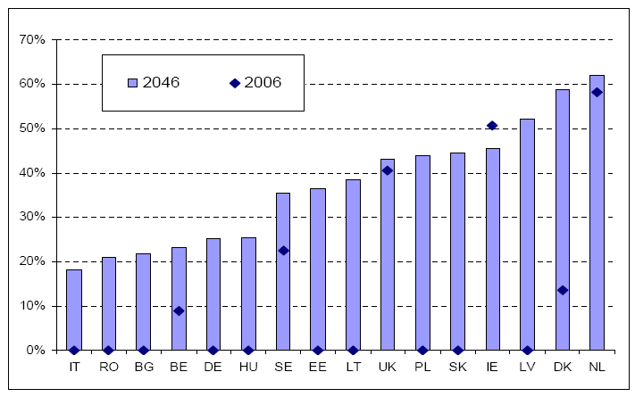
Source: Indicator Sub-Group (ISG) of the Social Protection Committee (2009)
Note: Data not available for all MSs.

3.1.3. IORPs operate an increasing amount of defined-contribution schemes
IORP operate different types of pension schemes. They can be categorised along a spectrum according to the entity that is exposed to risks. The initial forms of occupational retirement provision were defined-benefit (DB) schemes. The employer commits to pay to the employee a lifetime monthly benefit on retirement for each year of service (e.g. 1.5% of final salary for each year). The risks during the accumulation phase (e.g. investment and operational risk) and the biometric risk during the pay-out phase are fully borne either by the employer or by the IORP, or shared by both.
At the other end of the spectrum are DC schemes, where the employer commits to contribute on the employee's behalf a certain cash amount for each month of service. On retirement, the employee can access the savings accumulated in the IORP in order to finance the pay-out phase. The risks during the accumulation phase are fully borne by the employee. The employee also fully bears the biometric risk during the pay-out phase, unless national law mandates the purchase of an annuity. DC schemes therefore often need to be followed-on by a life assurance product during the pay-out phase.
Between the two ends of the spectrum are hybrid schemes such as average-salary DB schemes, DC with guarantees, part DB/DC schemes, etc. Hybrid schemes share the risks between employers and employees.
Pension schemes are similar to other financial products. DC schemes are comparable to investment funds because the outcome depends entirely on investment returns. DB schemes are comparable to life insurance products because they offer protection against risk. However it is important to note that DB schemes are not risk-free for members and beneficiaries because, unlike for insurance products, IORPs do have the possibility to reduce accrued pension rights if their funding position deteriorates.
Since the adoption of the Directive more than 10 years ago, the importance of DC and hybrid schemes has increased (Figure 3) and it is expected that this trend will continue. This is because the traditional final-salary DB schemes have become unaffordable for many sponsoring employers due to increasing longevity and adverse trends in financial markets, notably protracted periods of low interest rates and market volatility. The growing importance of DC schemes is also driven by changes in the labour market and technological progress. As a result sponsoring employers are increasingly providing DC and hybrid schemes, either to replace existing DB schemes or when creating new IORPs. In the UK, for example, the proportion of DB schemes open to new members fell from 33% of DB schemes in 2007 to 17% in 2012. In addition, the successive enlargements of the EU since 2004 have increased the importance of DC schemes (Figure 4).
Figure 3: Membership of IORPs per scheme type (millions) | Figure 4: Predominant scheme type in the MSs
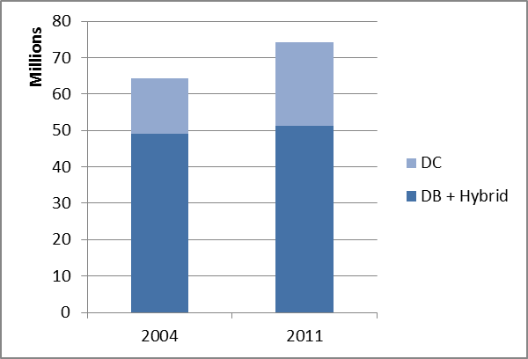
  Predominantly DC | Predominantly DB
  BG, DK, IE, EL, ES, FR, IT, CY, LV, LT, LU, HU, AT, PL, RO,  SL, SK | BE, DE, NL, PT, FI, SE, UK
Source: Commission Services, Eurostat, OECD and national sources. | Source: Commission Services, EIOPA (2013b).
Today around 25 million Europeans rely on DC schemes for an adequate retirement income. As a result of the trend towards DC schemes the risks are shifted from the IORP to scheme members and beneficiaries, and this raises new regulatory challenges (Ashcroft and Steward, 2010; OECD, 2012a). Moreover, the potential for cross-border IORPs is larger for DC schemes because product features are simpler. This reflects that many aspects of social and labour law applicable to occupational retirement provision, such as the preservation and the indexation of retirement benefits, are not relevant for DC schemes.

3.2. The current legislative framework
The Directive enables IORPs located in one MS to be sponsored by employers from other MSs. It enables sponsoring employers to organise occupational retirement provision on a European scale. The opening-up of borders was accompanied by a minimum harmonisation of prudential standards and mutual recognition of supervision - comprising quantitative, qualitative and disclosure requirements – in order to achieve a high degree of security for scheme members and beneficiaries across the Single Market. An IORP is supervised by the competent authority of the MS in which it is located (home MS) but needs to respect the social and labour legislation of the host MS, which typically is the MS where the sponsoring undertaking is located. The Directive is based on the Treaty provisions relating to the freedom to provide services and the freedom of establishment (Annex D for more details).

3.3. Problem definition

3.3.1. Specific problems
There are four specific problems, which will not resolve themselves without regulatory intervention.
First, cross-border activity is still expensive and complex for employers, which prevents IORPs from fully benefiting from the Single Market. As of June 2012, there were 84 cross-border IORPs, representing only 0.01% of IORPs with more than 100 members in the EU. By comparison, cross-border activity in the life insurance industry represents around 10% of gross written premiums, suggesting that there is considerable potential for the organisation of occupational retirement provision on a European scale. Although some employers prefer to continue the use of IORPs in their own MSs, other employers – SMEs and multinationals – take a more innovative approach by setting up or considering setting-up cross-border IORPs. Interest has been growing, particularly for the new DC schemes. This has prompted a number of MSs to incentivise cross-border provisioning. The remaining complexity, however, reduces the prospects of efficient price formation because of high entry or exit barriers and sunk costs, and a continued competitive advantage of domestic IORPs over IORPs located in other MSs.
Opening up the market needs to be accompanied by some harmonisation of prudential standards in order to guarantee a minimum level of protection for scheme members and beneficiaries, irrespective of where the IORP is located. The financial crisis has demonstrated that the current minimum level of protection is too low. Market developments, in particular the trend towards DC schemes – shifting risks from the IORP to the individual - call for an adjustment of regulation.
Experience over the ten years since the adoption of the Directive has clearly demonstrated that member protection is undermined by principal-agent problems in the sense that those who effectively manage IORPs might not necessarily act in the best interest of the scheme members or beneficiaries (specific problem 2). Member protection is also insufficient due to information inefficiencies arising from a lack of clear and effective communication (specific problem 3). Scheme members do not have access to essential information regarding their occupational pension in a comprehensible form, which considerably undermines their capacity to take informed decisions about savings and investments.
The fourth specific problem is that supervisory powers are insufficient to effectively ensure that IORPs comply with the prudential standards and information disclosures.

3.3.2. General problem
The specific problems have negative consequences for employers, future and current pensioners and MSs. Weak member protection and complex cross-border activity do not enhance trustworthiness and performance which, as for any financial product, are crucial for the take-up of occupational pensions. The specific problems hold back the development of complementary private retirement savings which is one of the two objectives of the White Paper. In a rapidly ageing society, this has negative consequences for the fiscal sustainability of MSs’ budgets and poses threats to pension adequacy. Moreover, employers may be missing opportunities to save costs in the supply of occupational pensions.

3.3.3. Problem drivers
The specific problems are caused by eight problem drivers. These are: (1) cross-border IORPs face additional prudential requirements; (2) some definitions and procedures for cross-border activity are unclear; (3) there is no obligation for IORPs to have professional managers; (4) risk management processes and documentation are not obliged to be systematic; (5) assets are not protected from operational risk; (6) members do not have to receive easy to understand pension information; (7) supervisory powers for chain-outsourcing and stress testing do not exist in all MSs; and (8) supervisory powers relating to new requirements need to be ensured. An overview of the problems and the underlying drivers is provided in Figure 5. The individual drivers are explained in more detail in the remainder of this sub-section.

Figure 5: Problem tree

3.3.3.1. Prudential barriers restricting the development of cross-border IORPs
The experience of employers, IORPs and supervisors over the past years has clearly shown that important prudential barriers restricting cross-border operations of IORPs remain. The mere preparations, i.e. feasibility studies by sponsoring employers, may take two years or even more. Setting-up a cross-border IORP takes nine months to a year, while adding an additional host MS takes about six months on average (Hewitt Associates, 2010). There is evidence that establishing cross-border IORPs can be a burdensome task and projects are therefore often abandoned (Annex E). Feedback from stakeholders suggests that there are two categories of problem drivers.
First, there are additional prudential requirements for cross-border activity (driver 1), notably the following:
  - The Directive allows MSs to limit the prudent person investment principle by enacting additional quantitative investment restrictions. This leads to a situation where either sponsoring employers or the IORP are faced with a number of different national investment rules, thereby imposing additional investment rules on IORPs wishing to operate in other MSs.
  - IORPs must be fully funded, but domestic IORPs are allowed to have considerable recovery periods (up to 10 years or more). As a consequence, IORPs wishing to operate across borders face more stringent funding requirements which generate further costs, significantly reducing their willingness to engage in such activities.
Second, several definitions and procedures for cross-border activity are not clear (driver 2), notably the following:
  - The Directive does not provide a clear definition of cross-border activity. The Directive intends to enable activity when the sponsoring undertaking and the IORP are located in two different MSs, but in practice there have been issues around the location of the sponsoring undertaking and the procedure to notify the applicable social and labour law. As confirmed by EIOPA (2012a), supervisors interpret the definitions differently in practice and might disagree as to whether a particular IORP intends to carry out cross-border activity. This significantly discourages or hinders the effective realisation of cross-border projects.
  - The Directive does not ensure the smooth transfer of occupational retirement schemes from one IORP to another located in a different MS. In the course of consultations, stakeholders testified that some MSs prevent cross-border transfers of past service assets and benefits and bulk transfers into new cross-border IORPs. This reduces the attractiveness of cross-border consolidation.
  - The scope of prudential regulation rules applicable in MSs is uncertain. This was confirmed by EIOPA (2012a). More specifically, an IORP has to comply with the prudential regulation of its home MS (the MS where it is registered or authorised) and the social and labour law requirements from the host MS (generally the MS where the sponsoring employer is located). What is social and labour law in one MS is, however, not necessarily social and labour law in another MS (see, for instance, Guardiancich, 2011). For example, qualitative investment rules are not part of social and labour law in most MSs. A sponsoring employer that intends to set-up a cross-border IORP needs to know whether it has to comply with the laws of the home or host MS. The different scope of prudential regulations in MSs causes legal uncertainty for sponsoring employers, IORPs and supervisors, involving legal costs for the sponsoring employer, which might increase overall transaction costs and, consequently, discourage such transactions.

3.3.3.2. Governance and risk management requirements are not sufficiently comprehensive
Financial institutions fail but direct failures of IORPs are difficult to observe. IORPs do fail however and there are several indications that these failures are caused by shortcomings in the governance and risk management practices of IORPs. First, the QIS has shown that the IORPs in three MSs, which cover a large share of all IORPs in the EU, are on average extremely underfunded. The combined deficit for the UK, NL and IE amounted to more than €500 billion (Figure 6). PT has retracted from the QIS exercise. There are indications that, at least for part of the extremely underfunded IORPs, this reflects a lack of realistic and forward-looking approach to risk-management. When a more comprehensive picture of the risks faced by IORPs is taken into account (see QIS results in Figure 6), the QIS clearly shows a deterioration of the funding position in nearly all the MSs. This applies particularly to UK, IE and Pensionskassen in DE, suggesting that those IORPs are currently not sufficiently comprehensive in their own risk assessment.
Figure 6 – Funding positions* (€ billions, end-2011)
 | BE | DE-PF** | DE-PK** | IE | NL | SE | UK
Current national regime (€ billions) | 1.2 | 3.7 | 1.6 | -23.9 | -131.1 | 0.8 | -349.9
Funding ratio*** | 109 | 116 | 101 | 64 | 86 | 107 | 77
QIS results (€ billions)**** | -2.7 | 0.1 | -8.6 | -80.3 | -147.7 | 0.5 | -431.2

Source: EIOPA.
Note: *) deficit (-) or surplus (+); ***) The DE results distinguish between Pensionsfonds (PF) and Pensionskassen (PK); ***) The funding ratio is calculated as the ratio between assets and liabilities plus capital requirements. The extent to which the ratio is less than 100 indicates the size of the funding deficit; ****) The results shown are those for the benchmark 3A scenario. Technical provisions are based on a risk-free interest rate and include a risk margin for adverse deviation. Ex post benefit reductions and sponsor default reductions are not taken into account. Sponsor support and participation in a pension protection scheme are treated as an asset. More details about benchmark 3A are contained in EIOPA (2013c).

Second, the total number of pension schemes transferred to the UK Pension Protection Fund (PPF) since its creation in 2005 has amounted to 602, with a total of 182,554 members, as of July 2013. The PPF was established to pay compensation to members of eligible DB schemes, when there is a qualifying insolvency event in relation to the sponsor and where there are insufficient assets in the pension scheme to cover PPF levels of compensation. The transfer of these 602 schemes into the PPF suggests a lack of professional risk-management within the IORPs concerned, including their inability to quantify their sponsor's support. Indeed, a study by Mercer (2006) on IORPs in the UK partly attributes improvements in deficit levels (which improved from £-40 to -2 billion in 2007) to strengthening pension fund governance. Moreover, the link with sponsor support is supported by the QIS. In the UK the funding deficit using national rules amounted to €350 billion at the end of 2011. According to the national funding regime this is allowed because it is implicitly assumed that the sponsoring employer will be willing and capable of financing shortfalls to pay pensions as they fall due. The QIS has attempted to make the value of the sponsor support more explicit. The results indicate that the sponsor support will still leave a considerable funding deficit of on average around €300 billion, suggesting that at least some IORPs in the UK are significantly overestimating the financial strength of their sponsor.
Third, a Parliamentary question to the German Bundestag of 2.1.2008 (16/7664) referred to cuts in accrued pension rights by six Pensionskassen between 2001 and 2007. The reason for these benefit cuts was that the management of these IORPs had not correctly anticipated future financial market developments. More recently, indications suggesting that there is a lack of professional risk-management and investment strategy in some Pensionskassen can be derived from the QIS. The deterioration of the funding position is more severe for Pensionskassen than for Pensionsfonds (Figure 6 above). An important difference between these two types of IORPs in DE is that Pensionskassen, notably those sponsored by industrial companies rather than by insurance undertakings, do not enjoy protection of the German pension protection scheme (PSV). However, considering that the QIS has indicated that the value of the PSV protection is relatively low, the larger deterioration of the funding position for Pensionskassen indicates that those IORPs, which are the dominant form of IORPs in DE, are particularly less comprehensive in their own risk assessment. This is worrying because sponsors, including large and historical companies, can and do fail. Data from the PSV indicate that there have been over 15,000 failures for a combined volume of more than €21 billion since 1975.
Fourth, IORPs in CY put a substantial percentage of their assets in bank deposits. According to statistics by the Central Bank of Cyprus, pension funds and insurers held €4.3bn of members' contributions in bank deposits at the end of January 2013. According to statistics produced by Aon Hewitt Cyprus in late 2011, local pension funds had around 60% of assets in local financial institutions. This percentage has decreased to around 50% by March 2013. In several cases the banks also happened to be the sponsor of IORPs concerned. After the CY bail-out of March 2013, these bank deposits were converted into equity in the same banks. This example points to a faulty investment strategy of the IORPs concerned, which strongly indicates that management was neither fit nor proper.
Fifth, OECD data on pension funds’ real average net annual rate of investment returns show large differences in average investment returns of pension funds between MSs in the period 2002-2011 (Figure 7). Clearly, investment returns depend on many factors such as the economic cycle, but considering that the vast majority of IORPs operate in leading economies with similar characteristics (notably DE, NL, UK) the wide variation in investment returns does suggest differences in the quality of governance and risk management. For example, investment returns in the UK have been on average considerably lower. In fact, a recent review by the UK pensions regulator has shown that a large proportion of IORPs in the UK had not reviewed their Statement of Investor Principles in the last three years. Moreover, little evidence exists that employers have the capability and resources to recognise the importance of prioritising key elements of value for money such as investment design and performance or scheme governance (OFT, 2013). Investment returns in DE, reflecting mostly the situation for Pensionskassen, are also considerably lower on average than those in NL despite both MSs being part of the euro area. IORPs in IE have been the worst performers during the height of the financial crisis (return of -35.7%) and the losses have been considerably higher than in the other mature IORP markets.
Figure 7: Pension funds’ real average net annual rate of investment returns in selected OECD countries, 2002-2011
 | 2002 | 2003 | 2004 | 2005 | 2006 | 2007 | 2008 | 2009 | 2010 | 2011
Selected OECD countries
AT | -6.9 | 5.7 | 3.6 | 9.0 | 3.8 | -1.8 | -14.4 | 7.3 | 3.7 | -6.0
BE | -11.6 | 6.0 | 6.0 | 10.3 | 10.3 | 7.7 | -22.3 | 13.4 | 4.4 | -4.6
CZ | 3.2 | 2.2 | 0.7 | 2.7 | 1.3 | -2.1 | -1.5 | -0.6 | -1.2 | 0.5
DA | -6.7 | 6.3 | 11.5 | 14.8 | 1.3 | -3.3 | 5.1 | 1.2 | 7.1 | 12.1
EE | 2.3 | 9.2 | 6.8 | 7.9 | .. | .. | -23.1 | 13.2 | 2.5 | -7.9
FI | -2.1 | 0.4 | 7.4 | 12.1 | 6.2 | 2.4 | -19.7 | 14.0 | 7.1 | -4.4
DE | 1.6 | 3.5 | 2.6 | 3.6 | 3.3 | 1.1 | 0.5 | 3.9 | 3.4 | ..
EL | .. | .. | .. | .. | .. | .. | 2.3 | 0.3 | -7.8 | -5.6
HU | 1.4 | -2.6 | 9.5 | 7.6 | 1.2 | -3.9 | -21.7 | 12.8 | 4.2 | -0.5
IC | -2.8 | 10.4 | 9.6 | 11.8 | 8.8 | 0.4 | -23.1 | 1.0 | 1.3 | 2.3
IE | .. | .. | .. | .. | .. | -7.4 | -35.7 | .. | .. | ..
IT | .. | .. | .. | .. | .. | .. | -5.3 | 5.3 | 1.2 | -2.8
LUX | .. | .. | .. | 29.0 | 4.9 | -2.5 | -11.3 | 6.5 | 0.7 | -2.2
NL | -10.6 | 8.7 | 8.4 | 10.9 | 6.8 | 0.6 | -17.3 | 11.5 | 8.8 | 8.2
NO | -5.2 | 11.4 | 7.5 | 9.2 | 7.4 | 3.1 | -10.6 | 9.8 | 5.5 | -0.1
PL | 11.8 | 8.8 | 8.6 | 12.9 | 13.4 | 1.5 | -17.3 | 8.9 | 7.2 | -9.1
PT | -6.7 | 7.3 | 6.6 | 7.0 | 7.2 | 5.5 | -13.2 | 11.6 | -3.0 | -7.3
SK | .. | .. | .. | .. | .. | -0.1 | -8.9 | 1.0 | 0.0 | -3.8
SL | .. | .. | .. | .. | .. | -1.0 | -5.4 | 4.2 | 1.8 | -1.8
ES | .. | .. | .. | .. | .. | .. | -9.9 | 6.9 | -2.2 | -2.2
CH | -7.2 | 4.9 | 2.8 | 9.2 | 5.3 | 0.2 | -13.8 | 9.9 | 2.8 | 0.6
UK | 0.9 | 1.2 | 0.6 | 0.2 | -0.9 | -0.2 | -0.9 | -0.9 | -2.1 | -2.5
BG | 4.8 | 7.6 | 5.0 | 3.3 | 0.9 | 6.2 | -32.3 | 5.6 | 2.5 | -3.0
MT | .. | .. | .. | .. | .. | .. | .. | .. | .. | -2.3
RO | .. | .. | .. | .. | .. | .. | 10.7 | 10.3 | 8.5 | -0.3
Source: OECD .
Sixth, several IORPs in the UK and NL lost $51.5 million in assets during the Madoff scandal. This case, revealed in December 2008, was an example of a so-called Ponzi scheme in which contributions from more recent subscribers to the scheme are used for handing out non-existent profits to earlier members of the scheme. The use of depositories could have prevented the loss of assets to such a scheme since these assets would remain in the hands of the depository. Furthermore, depositories would have been liable for any losses incurred. This is an example of a lack of proper custodianship of scheme assets.
The examples above provide strong indications that there is a lack of professionalism in the IORP industry. The following three underlying problem drivers emerge in particular:
First, IORPs may not have appropriate governance functions in place (driver 3). This concerns in particular the internal audit and risk management functions, as well as the actuarial functions for DB schemes (CEIOPS, 2010). These functions' roles and activities are not sufficiently defined either. Consequently, either these functions do not exist within IORPs or unqualified staff could occupy key positions in the governance structure of IORPs, leading to weak management. Moreover, a possible conflict of interest could arise, as the functions may be shared by an IORP and its sponsor.
Second, IORPs may not take a systematic approach to their own risk assessment and may not fully integrate the risk management system in the decision-making process of the IORP (driver 4). A general lack of a comprehensive approach to risk management of financial institutions in the EU was revealed during the recent financial crisis (European Commission, 2010). Insufficient understanding of the risks involved in decisions taken by IORPs has led to financial losses in various cases for the institution involved (DNB, 2013a).
Third, IORPs do not necessarily use a depository in order to ensure the safety of the assets held on behalf of scheme members (driver 5).

3.3.3.3. Members do not receive easy to understand pension information

Individuals need to be properly equipped to take informed decisions about pension savings, but there are several strong indications of unsustainable information inefficiencies. First, pension schemes allow for a reduction of accrued pension rights, unlike other financial contracts. Many individuals do not know this. During the financial crisis, many IORPs in several MSs have cut pensions, in some cases significantly. For example, the Dutch central bank reported that since the outbreak of the crisis 68 IORPs where compelled to curtail accrued pension rights in April 2013; this affected 300,000 individuals (DNB, 2013b). In the UK, IORPs that fail can be taken over by the PPF but in that case the pension rights are cut by 10%.

Second, members of DB and hybrid schemes generally expect their pension rights to be acquired, but are not aware that pensions are not fully guaranteed. For example, a question from an Irish MEP in January 2010 reported a case where Irish workers lost a large part of their pensions as a result of a refusal by the sponsoring employer to fund a €26 million deficit. Although this was permissible under national law, the case highlights the severe disappointment that can come from improperly disclosed information about the consequences of business closure or winding up.
Third, costs and charges have a significant impact on pension rights, but individuals are generally not aware of it. A report for the Irish market (Department of Social Protection of Ireland, 2012) found that “the charges incurred serve to reduce the level of income which individuals receive in retirement. Evidence suggests the impact of pension charges is not necessarily readily understood by the saver. This can mean that the monetary impact of each of these charges individually, and the cumulative impact of the charges overall in monetary terms, can be relatively difficult to identify and understand. Potentially adding to this challenge is the fact that pension savings are by their nature made over long periods of time, meaning that the impact of apparently smaller charges can be amplified over time.” Another example relates to the NL where a survey among Dutch IORPs (managing together 99% of the total assets) showed that for every euro saved for retirement 17 cents are deducted as charges. Total charges amount to around €5 billion per year. Employers and employees pay contributions worth €30 billion per year.
Fourth, there are indications that people in general lack a thorough knowledge of their financial situation. Aviva (2009) showed that a significant percentage of consumers say that they do not really understand savings and retirement products. This figure is almost 60% in HU, 48% in PL, 35% in IT and 30% in FR (Figure 8). Moreover, most people surveyed are worried that they will not have enough money in retirement, but relatively few are taking steps now to do anything about it (Figure 9). A recent Eurobarometer surveys suggest that 20% of EU citizens are very worried that their income in old age would be insufficient for them to live a decent life and 34% are fairly worried by such outlook. Other Eurobarometer surveys indicate that 57% of Europeans are not confident about the future of their pensions and 30% of respondents are concerned about their pensions. Looking forward, many more individuals are likely to worry about their retirement savings reflecting fiscal sustainability issues that have emerged during the recent financial crises.
Figure 8 - Percentage of respondents agreeing that they do not really understand about pensions and savings policies
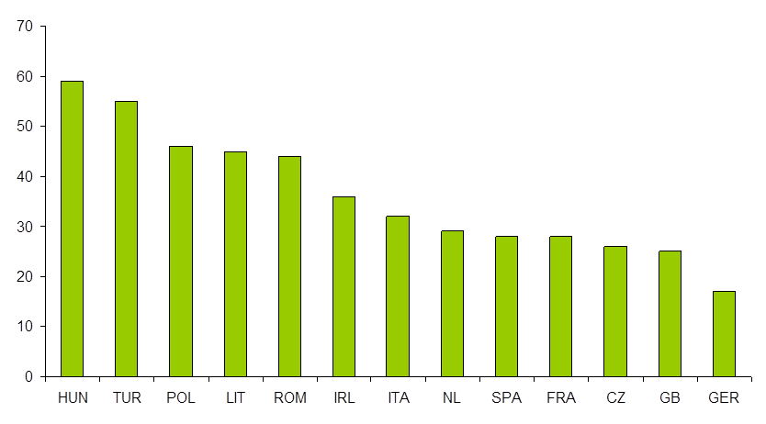
Source: Aviva (2009)

Figure 9 – Percentage of respondents agreeing with the following statements
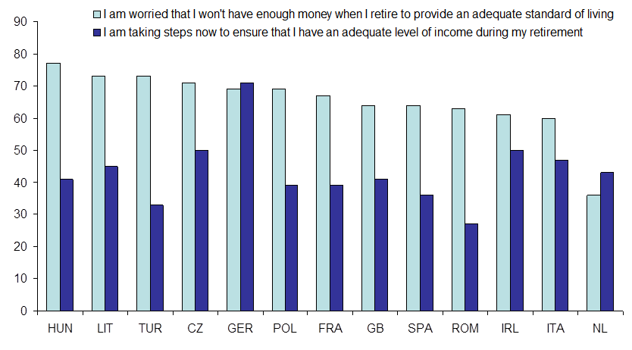
Source: Aviva (2009)
Fifth, individuals generally do not save enough for their pension, leading to a considerable pension gap. Aviva has measured the difference between what pension provision people need for an adequate standard of living in retirement and the pension amount they can currently expect to receive. Some citizens would need to increase savings by an average of €12,000 each year to fully close the pension gap. Across the EU this figure stands at €1.9 trillion. That is the equivalent of 19% of GDP and is higher than the estimated cost of the recent economic crisis. Figure 10 shows the average amount each person retiring between 2011 and 2051 would need to save every year in order to fully close their personal pension gap. If saved, these amounts would be available to financial institutions such as IORPs for investing in the real economy, promoting growth.

Figure 10 – Total EU annual pension gap for individuals retiring 2011-2051
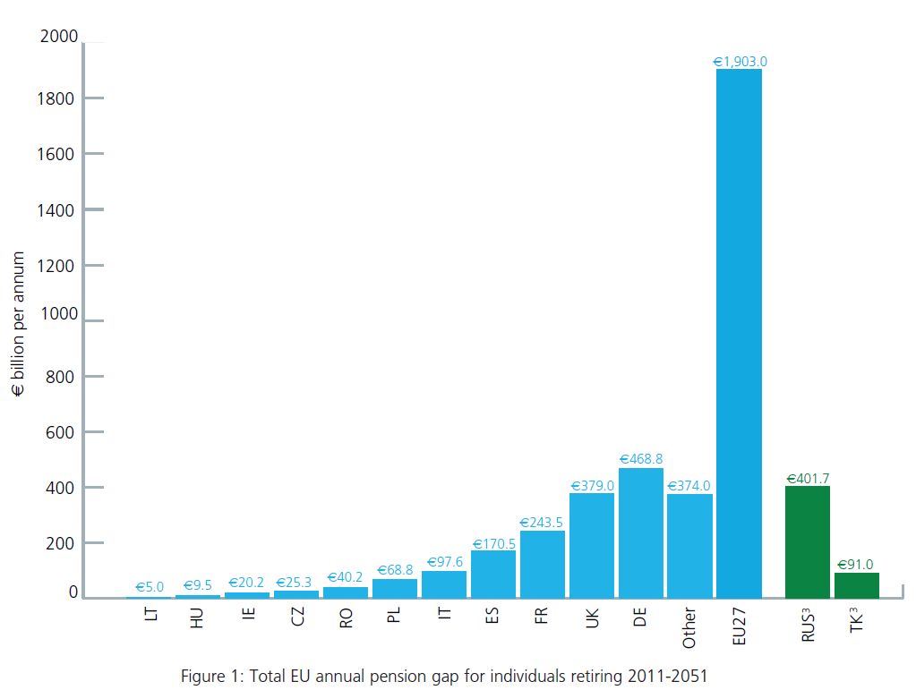
Source: Aviva (2010)

3.3.3.4. There are shortcomings in supervisory powers
In the course of the consultations on this proposal three issues regarding supervisory powers have been identified. First, EIOPA (2012a) has pointed out that IORPs have the possibility to circumvent prudential standards by chain outsourcing, i.e. third-party service providers transferring activities to subcontractors (driver 7). A survey (CEIOPS, 2008a) demonstrated that chain outsourcing is allowed in 15 out of 19 responding MSs and that in 6 of these 15 cases (including DE and NL) chain outsourcing is not specifically regulated. In these cases in particular it is important to lay down that supervisory authorities should have the same powers vis-à-vis subcontractors as vis-à-vis service providers.
Second, EIOPA (2012a) highlighted the fact that not all supervisory authorities have the power to develop necessary tools to stress test the financial situation of IORPs (driver 7). In fact, CEIOPS (2009) showed that only about half of the national supervisory authorities surveyed conducted stress tests or modeling exercises for IORPs with one-third of these being a result of the financial crisis. Stress-testing of individual IORPs is important to assess the systemic robustness of the IORP sector and to inform supervisory and policy decisions.
A final problem relating to supervisory powers arises in the context of this proposal. In order to effectively supervise new governance and transparency requirements, supervisory authorities could need additional powers (driver 8). Without these powers a situation could arise in which they cannot act if a breach of the requirements of this Directive is detected.

3.4. Baseline scenario, subsidiarity and proportionality
The Directive was adopted with two objectives: (i) enable IORPs in one MS to be sponsored by an employer in another MS and (ii) ensure a minimum security level for scheme members across the EU to accompany the opening up of the market. The proposed action aims at reinforcing those two objectives. It intends to make cross-border activity easier and to raise the minimum level of protection.
However, despite some first achievements, the Directive has not been able to prevent the problems described in the previous section. In the absence of EU action, the baseline scenario, it is likely that the problems will persist. Cross-border issues by definition cannot be resolved by MSs alone. As regards the problems relating to governance and transparency, MSs that have mature IORP markets have partly taken action, but no MS has taken comprehensive action. Moreover, as explained in section 3.1.2 above, IORPs are expected to become more prevalent also in other MSs and, in order to prevent financial losses looking forward as much as possible, coordinated action at EU level is more effective.
The Commission committed to revising the Directive by 2012 in the White Paper (action 11). This commitment has not yet been met. The IORP II proposal would, in line with the White Paper, help address the challenges of demographic ageing and public debt, not only by promoting cross-border activity but also by contributing to improve overall pension provision in the EU. Figure 11 shows that currently only a handful of MSs have a mature IORP market. In the other MSs there is a great potential market that the IORP II proposal will help to realise. EL is already taking measures to develop an IORP market. Other MSs are in fact waiting for the IORP review before starting to implement national reforms in this field.
Figure 11 - IORP market in relation to the size of the economy, end-2011*
(in percentage of GDP)
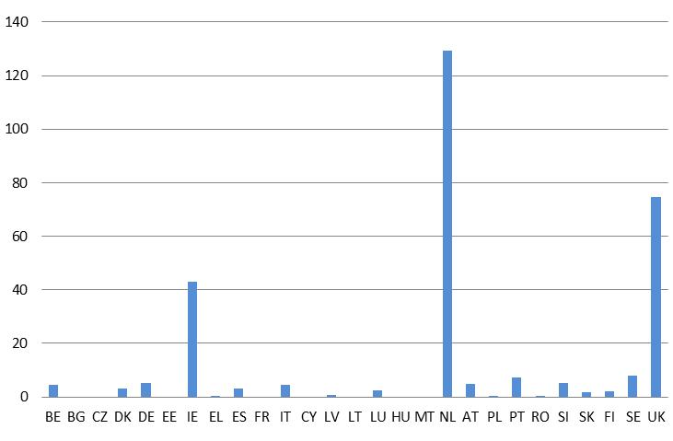
Source: Commission Services, national sources.
Note: *) or latest data available; data are not available for all MSs.

3.4.1. Subsidiarity
Under Article 4 TFEU EU action for completing the internal market has to be appraised in the light of the subsidiarity principle set out in Article 5(3) TEU. Hence it must be assessed whether the objectives of the proposal could not be achieved by the MSs alone in the framework of their national legal systems. EU level action can add value substantially because action by MSs alone will not:
i. remove obstacles to cross-border activities. Requirements in the Directive that raise the cost for cross-border IORPs and cause implementation divergences due to different interpretations of the Directive can only be solved by changing the Directive. Section 3.3.3.1 above provided clear evidence of employers that would benefit from the removal of cross-border barriers directly.
ii. ensure a higher EU-wide minimum level of consumer protection. Action from MSs alone is likely to result in different sets of rules in relation to governance and transparency, which will create unequal levels of protection in the EU. Uncertainty about the level of consumer protection undermines the confidence of the social partners to use an IORP abroad. Action at the EU level can export good practices to MSs with less developed prudential standards. Improved EU-wide protection can also foster cross-border competition and welfare in terms of price and security of IORPs. Article 114(1) TFEU, being a legal basis of the Directive, requires that the Single Market is based on a high level of consumer protection by reference to Article 169 TFEU. Reforms to strengthen consumer protection across the Single Market for other financial sectors have already been made (Solvency II, AIFMD, CRDIV) or are being proposed (MiFID).
iii. take into account positive externalities arising from scale economies, risk diversification and innovation inherent to cross-border activity. Again, action by MSs alone is likely to result in different sets of rules, which may undermine or even create new obstacles to the functioning of the IORP internal market. Market fragmentation would persist or even become more entrenched. The proposal eliminates the need to research 28 different regimes, reduces IORPs’ costs, realises economies of scale, thus facilitating cross-border IORPs and rendering them more attractive. While cross-border activity is relatively complicated for DB schemes, looking forward, the more prominent role of DC schemes makes the Single Market more accessible for occupational retirement provision.
iv. avoid regulatory arbitrage between financial services sectors. Sponsors or social partners in many MSs (e.g. AT, BE, DE, PL, UK) may choose among different old-age savings providers and financial products, such as IORPs, group life assurance or investment funds. The proposal fills a regulatory gap created by EU law and potential regulatory arbitrage since EU-wide micro-prudential regulations of other sectors have evolved considerably (e.g. Solvency II and UCITS Directives). The proposal also respects the G20 commitments (European Parliament, 2013) aiming at a safer and more resilient financial system.
v. avoid regulatory arbitrage between MSs. The strengthening of prudential regulation for IORPs only by some MSs could provide an incentive to locate IORPs in a MS that has laxer rules. This would be to the detriment of member protection. The proposal therefore contributes to a level playing field across borders.
vi. take into account interests of cross-border workers. The proposal ensures that workers have clear and comparable information about their pension schemes in a consistent manner across MSs. This is not only important for members of cross-border IORPs, but even more so for members of IORPs who work in two or more MSs during their career. The Acquisition and Preservation Directive currently in the process of being adopted no longer contains rules on cross-order transferability of pension rights. This implies that cross-border workers will build-up pension rights in different MSs. Although still relatively low, cross-border labour mobility has increased substantially from 2.1% of the EU labour force in 2005 to 3.1% in 2012. There are around 7.6 million EU citizens economically active in another EU country. Looking forward, cross-border labour mobility is likely to gain further in significance considering that it is an important macroeconomic adjustment factor particularly within the euro area.

3.4.2. Proportionality
The options analysed below take account of the principle of proportionality, as enshrined in Article 5(4) TEU, being adequate to reach the objectives and not going beyond what is necessary in doing so. The selected policy options seek to strike the right balance between public interest, protection of IORP members and beneficiaries, as well as the costs for IORPs, sponsoring employers and supervisors. Although IORPs are not SMEs - many IORPs would satisfy the criterion of staff headcount to be defined as SMEs but exceed the thresholds for either annual turnover or annual balance sheet – it is important that regulation properly takes into account the nature of their activities and the fact that the scale and complexity of IORPs’ activities are generally lower in comparison with most other financial institutions. More specifically, as will be explained in more detail in Section 5 below, the proposed action takes into account proportionality in each of the operational objectives in the following manner:
- The removal of prudential barriers for cross-border IORPs is limited to those that have raised the most important problems for stakeholders;
- The governance functions have been limited to those that are essential for IORPs, reducing the number of functions in comparison to Solvency II;
- The documentation of own-risk assessment has been streamlined to the specificities of IORPs, substantially reducing the requirements in comparison with the own risk and solvency assessment (ORSA) in Solvency II;
- The mandatory appointment of a depository is limited to DC schemes rather than for all IORPs;
- The pension benefit statement is limited to maximum two pages, focuses on essential information and does not prevent IORPs from using additional types of disclosure following national requirements and their own communication style;
- New supervisory powers are only granted to the extent that they are necessary to effectively supervise the activities of the IORP sector;
- Supervisory reporting is not harmonised, in order to respect different national supervisory approaches.
The envisaged requirements have been carefully considered, crafted as minimum standards and tailored to IORPs. Moreover, the de minimis Article 5 is maintained. It provides MSs with the possibility not to apply the Directive, in whole or in part, to any IORP with less than 100 members in total.

4. Objectives

4.1. General objective
The general objective of the proposed action is to facilitate the development of occupational retirement savings. This is fully in line with the White Paper, which announced 20 initiatives aimed at helping the MSs to better balance time spent in work and in retirement and to develop complementary private retirement savings. The White Paper mentions that the review of the Directive should make occupational retirement provision more efficient and safe. This in turn would make a decisive contribution to pension adequacy and sustainability by enhancing the contribution of complementary retirement savings to retirement incomes. In its resolution of 21 May 2013, the European Parliament (2013) considers that the IORP II proposal should strengthen prudential standards for governance and risk management and transparent information disclosures. Strengthening the credibility and solidity of IORPs across the EU also reinforces their position as institutional investors in the EU’s real economy. Enhancing the role of IORPs, including in the MSs where the market is currently small, and removing quantitative investment limits across the EU will contribute to reinforcing the capacity of the European economy to channel long-term savings to growth-enhancing project financing.
The achievement of the general objective of this proposal promotes human rights by protecting retirement provision. It is in line with Article 25 of the Charter of Fundamental Rights of the EU which calls for recognition and respect for the rights of the elderly to lead a life of dignity and independence. The proposed actions would have a positive impact on consumer protection under Article 38 and freedom to conduct business under Article 16, in particular by ensuring a higher level of transparency of retirement provisioning, informed personal financial and retirement planning as well as facilitating cross-border business of IORPs and their sponsors. The general objective justifies certain limitations on the freedom to conduct a business (Article 16) is to ensure the market integrity and stability.

4.2. Specific objectives
An enhanced role of occupational retirement savings requires better access to supplementary schemes, including cross-border ones. This in turn will be facilitated if employers can effectively supply complementary private retirement savings and if people trust pension schemes to deliver what they promise. Accordingly, the IORP II proposal – aiming to further facilitate cross-border activity and reinforcing safety by strengthening member protection – has the four following specific objectives: (1) remove remaining prudential barriers for cross-border IORPs; (2) ensure good governance and risk management; (3) provide clear and relevant information to members; and (4) ensure that supervisors have the necessary tools to effectively supervise IORPs. The latter three specific objectives contribute not only to more safety, but also to the take-up of cross-border activity. This is because reduced regulatory fragmentation in the areas of governance, information disclosure and supervisory powers and a higher degree of member protection will make IORPs less costly to establish from abroad and more trustworthy for non-resident members.

4.3. Operational objectives
The proposed action has eight operational objectives in order to attain the specific objectives (Figure 12). Remaining prudential barriers can be removed by taking away the extra requirements for cross-border IORPs and by clarifying definitions and procedures for cross-border activity. Better governance can be achieved with three complementary and mutually reinforcing operational objectives: (i) ensure that IORPs are managed professionally; (ii) require documentation concerning risk management; and (iii) protect assets from operational risk. Information to members can be made clearer and more effective by providing a simple statement with essential information about pension benefits on a yearly basis. Ensuring that supervisors have the necessary tools to effectively supervise IORPs can be achieved by granting them new powers in relation to chain-outsourcing and stress testing and by making sure that supervisors have sufficient powers to verify compliance with prudential and transparency requirements.

Figure 12: Objectives tree

White Paper - An Agenda for Adequate, Safe and Sustainable Pensions, COM(2012) 55 final, 16.2.2012.
Commission Communication « Commission Work Programme 2012 - Delivering European renewal », COM(2011) 777 final, 15.11.2011
Commission Communication « Commission Work Programme 2013 », COM(2012) 629 final, 23.10.2012, Vol. 1/2
Annex to the Commission Communication « Commission Work Programme 2013 », COM(2012) 629 final, 23.10.2012, Vol. 2/2
Specific terms are explained in the glossary in Annex A. On DC schemes, see section 3.1.3.
Statement by Internal Market and Services Commissioner Michel Barnier of 23.5.2013 available at http://europa.eu/rapid/press-release_MEMO-13-454_en.htm
References are in Annex B.
Statement by Internal Market and Services Commissioner Michel Barnier of 23.5.2013 available at http://europa.eu/rapid/press-release_MEMO-13-454_en.htm
Green Paper, “Towards adequate, sustainable and safe European pension systems", COM (2010) 365 Final, 7.7.2010
Consultation summary at: http://ec.europa.eu/social/main.jsp?catId=333&langId=en.
Directive 2009/138/EC of the European Parliament and of the Council of 25 November 2009 on the taking-up and pursuit of the business of Insurance and Reinsurance
Responses to the consultations of EIOPA's advice can be found via https://eiopa.europa.eu/consultations/consultation-papers/2011-closed-consultations.
A summary of the public hearing (European Commission, 2012) can be found via http://ec.europa.eu/internal_market/pensions/docs/iorp/summary_of_panel_discussions_en.pdf
Joint statement of 10 July 2013 by European Association of Paritarian Institutions of Social Protection (AEIP), BUSINESSEUROPE, European Centre of Employers and Enterprises providing Public services (CEEP), European Association of Public Sector Pension Institutions (EAPSPI), European Fund and Asset Management Association (EFAMA), European Trade Union Confederation (ETUC), European Private Equity and Venture Capital Association (EVCA), PensionsEurope (formerly EFRP) and European Association of Craft, Small and Medium-Sized Enterprises (UEAPME).
Annex C gives an overview of the investment portfolio held by IORPs by type of assets.
See, for example, the question from the European Parliament to the Commission (E-002485-13) of 4 March 2013 concerning the project to establish a cross-border IORP in the NL for members and beneficiaries in AT.
Examples include Luxembourg’s SEPCAV (Société d’épargne-pension à capital variable) and ASSEP (Association d’épargne-pension), Belgium’s OFP (Organization for Financing Pensions), SEPCAV or ASSEP or the Netherlands’ PPI (Premium Pension Institutions).
http://www.ipe.com/news/cypriot-pension-funds-still-hold-half-of-4bn-assets-in-deposits_50666.php#.UlZySHea98E
http://www.efinancialnews.com/story/2013-03-19/cyprus-pension-fund-bank-deposits
TPR, Occupational pension scheme governance: Accompanying Technical Report on the 13th (seventh) scheme governance survey, 2013
The report provides the following illustrative example: If an individual age 35 saves €250 per month for a pension for 30 years, a fund of approximately €200,000 is created which results in a pension of about €10,000 per annum. Apply an average charge of 2.18% of managed assets per annum to this fund and the final fund is reduced by 31% i.e. the fund is reduced by €62,000, resulting in a lower pension of €6,900 per annum.
"Pensioenpremie voor 17% op aan kosten", Het Financieel Dagblad, 2/10/2012.
Eurobarometer survey – Measuring public perceptions of poverty, June 2010.
Eurobarometer 71 - Future of Europe, January 2010.
Special Eurobarometer 273, February 2007.
https://www.aviva.com/europe-pensions-gap
For example, measures on transparency have been taken in NL and by the National Employment Savings Trust (NEST) in the UK. Measures on governance have been taken in NL (Act on governance), IE (handbook on governance) and DE (supervisory circular MaRisk).
The EL authorities have issued a request for proposal to perform a comprehensive study of different jurisdictions on the occupational-related structures for pre- and post-retirement benefits which will lead to a short list of proposals of policy options relevant to EL.
Directive 2011/61/EU of 8 June 2011 on Alternative Investment Fund Managers.
Directive 2013/36/EU of 26 June 2013 on access to the activity of credit institutions and the prudential supervision of credit institutions and investment firms.
Commission proposal of 20.10.2011 to amend the Markets in Financial Instruments Directive (MiFID).
See, for example, Ustawa z dnia 20 kwietnia 2004 r. o pracowniczych programach emerytalnych (in PL), Betriebspensionsgesetz (BPG) (in AT), the Occupational and Personal Pension Schemes (Automatic Enrolment) Regulations 2010 (in the UK), Betriebsrentengesetzes (BetrAVG) (in DE), Loi relative aux pensions complémentaires et au régime fiscal de celles-ci et de certains avantages complémentaires en matière de sécurité sociale (L.P.C.) (in BE).
Directive 2009/65/EC of 13 July 2009 on the coordination of laws, regulations and administrative provisions relating to undertakings for collective investment in transferable securities (UCITS) (recast) and the Commission proposal of 3 July 2012 for a directive amending Directive 2009/65/EC as regards depositary functions, remuneration policies and sanctions.
EU Labour force survey: http://epp.eurostat.ec.europa.eu/statistics_explained/index.php/EU_labour_force_survey
Six MSs use this provision: CY, DK, IE, IT, SE and UK. With the exception of IT, these are the MSs where there are many IORPs with less than 100 members (FI does not apply the exemption, although there are more IORPs with less than 100 members).

