Table of Contents
1. Chart of financial flows of the Fund 3
2. Graph 1: Guaranteed Lending covered by the Fund and Fund's assets (end of year, in EUR billion)* 4
3. Graph 2: Cover of defaults by Fund Resources and recoveries (in EUR million) 1994-2012 4
4. Graph 3: Geographical distribution of EIB lending operations by group of countries covered by the Fund at 31 December 2012 (% of the total outstanding amount covered, EUR 23.099 billion) 5
5. Graph 4: Risk profile of the loans covered by the fund in 2006, 2009 and 2013* [Moody's ratings] 5
6. Table 1: Flows in and out of the Fund since 1994 (in EUR million) 6
7. Table 2: Use of the budget line during the financial framework 2007-2013 (in EUR million, current prices) 7
8. Projections of Provisioning needs for 2014-2020 (in EUR million, current prices)* 7

1. Chart of financial flows of the Fund

2. Graph 1: Guaranteed Lending covered by the Fund and Fund's assets (end of year, in EUR billion)*
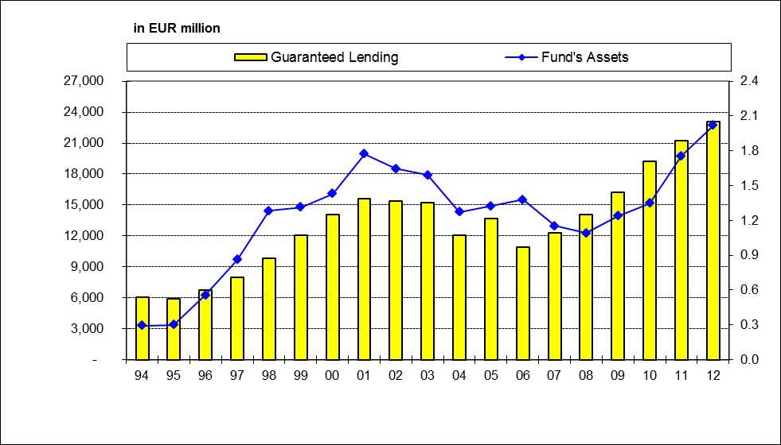
* (Fund's Assets - y axis on the right side of the graph, Guaranteed Lending - y axis on the left side of the graph)

3. Graph 2: Cover of defaults by Fund Resources and recoveries (in EUR million) 1994-2012
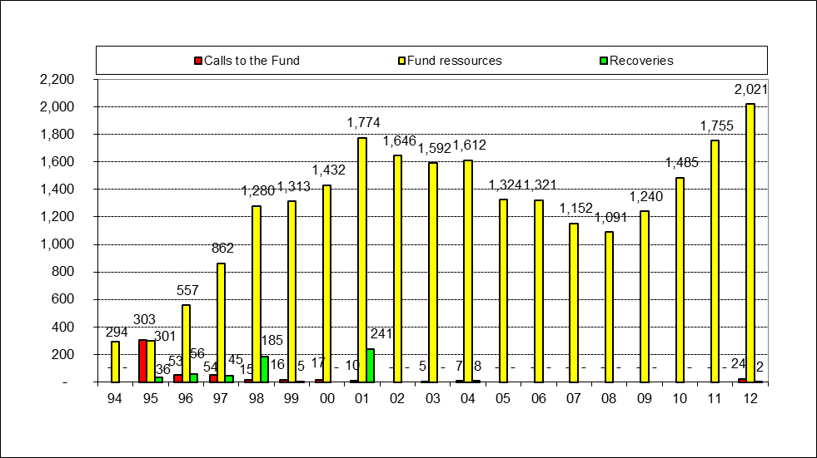

4. Graph 3: Geographical distribution of EIB lending operations by group of countries covered by the Fund at 31 December 2012 (% of the total outstanding amount covered, EUR 23.099 billion)
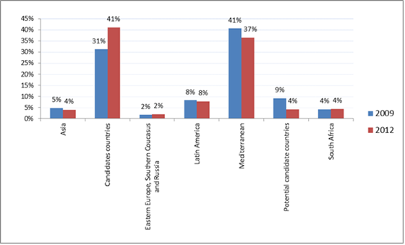
Details of countries belonging to each geographical region (at 31.12.2012):
Asia: | Afghanistan, Bangladesh, Bhutan, Brunei, Cambodia, China, India, Indonesia, Iraq, South Korea, Laos, Maldives, Mongolia, Nepal, Pakistan, the Philippines, Singapore, Sri Lanka, Taiwan, Thailand, Vietnam, Yemen, Kazakhstan, Kyrgyzstan, Tajikistan, Turkmenistan, Uzbekistan;
Candidate Countries: | Turkey, The former Yugoslav Republic of Macedonia;
Eastern Europe, southern Caucasus and Russia: | Republic of Moldova, Ukraine, Belarus, Armenia, Azerbaijan, Georgia, Russia,;
Latin America: | Argentina, Bolivia, Brazil, Chile, Colombia, Costa Rica, Ecuador, El Salvador, Guatemala, Honduras, Mexico, Nicaragua, Panama, Paraguay, Peru, Uruguay, Venezuela;
Mediterranean: | Algeria, Egypt, The West Bank and the Gaza Strip, Israel, Jordan, Lebanon, Libya, Morocco, Syria, Tunisia;
Potential candidate countries: | Albania, Bosnia and Herzegovina, Montenegro, Serbia, Kosovo*;
South Africa: | South Africa

5. Graph 4: Risk profile of the loans covered by the fund in 2006, 2009 and 2013* [Moody's ratings]
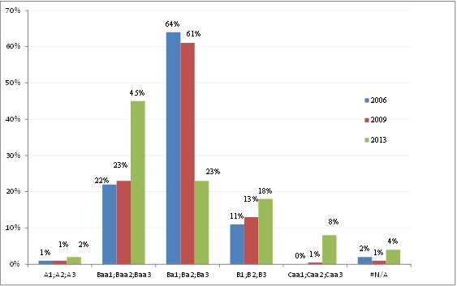

6. Table 1: Flows in and out of the Fund since 1994 (in EUR million)

¹ First time application of IFRS standards in 2005. Portfolio valued at "Mark-to-Market".
² Fund's net assets (EIB commission and other charges deducted)
³ Amount to be recovered from defaults = capital + interest + penalty interest for late payment.

7. Table 2: Use of the budget line during the financial framework 2007-2013 (in EUR million, current prices)

8. Projections of Provisioning needs for 2014-2020 (in EUR million, current prices)*
2014 | 2015 | 2016 | 2017 | 2018 | 2019 | 2020 | Total
58.482 | 239.759 | 273.164 | 199.039 | 178.055 | 159.750 | 84.820 | 1,193.069

* The final audited figure inserted in the 2014 budget is EUR 58.432 million. The projections for the remaining years are based on the Commission proposal for a decision of the European Parliament and of the Council on granting an EU guarantee to the European Investment Bank against losses under financing operations supporting investment projects outside the Union [COM(2013) 293 of 23.5.2013]. The total provisioning ceiling that appears in the above table takes into consideration only the fixed ceiling (EUR 25 billion) of the mandate.
Following subsequent negotiations between the Council, the European Parliament and the Commission, it was agreed on 17 December 2013 to increase the fixed ceiling of the EU Guarantee to the EIB by 2 billion to a maximum amount of EUR 27 billion. The agreement also foresees an additional amount of EUR 110 million for provisioning the Guarantee fund for external actions. This agreement will need to be formally approved by the Council and European Parliament during 2014.

This designation is without prejudice to positions on status, and is in line with UNSCR 1244/1999 and the ICJ Opinion on the Kosovo declaration of independence."

