Overview of EU initiatives to support SMEs’ access to finance

Introduction
SMEs’ particular dependence on bank funding has made them suffer the most during the crisis. They are still finding it challenging to obtain loans, particularly in the periphery economies. For example, according to the latest ECB survey on the access to finance of SMEs, only 33% of SMEs that apply for credit in Greece receive the full amount and only 50% do so in Spain and Italy (compared to a 65% average in the euro area and 87% in Germany).
A key issue is facilitating the transition from start-up to SME to mid-cap i.e. a transition across the so-called “funding escalator” (see Figure 1).
Figure 1 Funding escalator
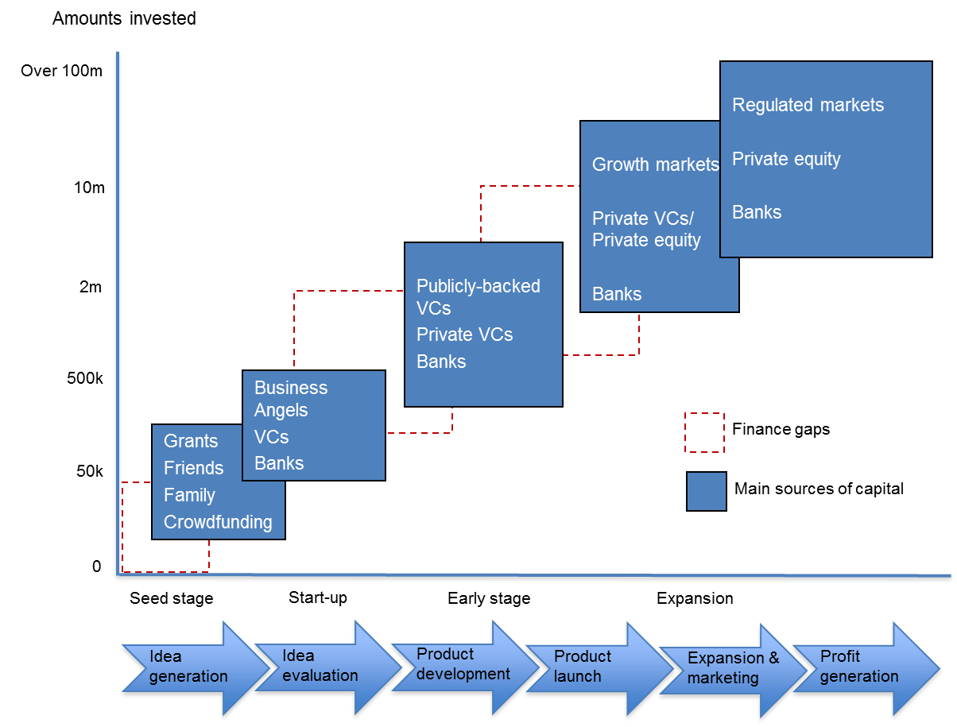
Source: adapted from NESTA “Reshaping the UK economy” (2009)

As they progress through the business life cycle, SMEs use a combination of financing sources including bank debt and mezzanine finance, external equity from business angels as well as venture capital or private equity from funds and the capital markets. While debt finance remains the predominant form of SME financing, it is difficult to obtain bank loans before companies are able to generate profits and a positive cash flow. In the early stages of their development, SMEs are typically dependent on equity financing. Initially capital may be provided by family, friends and eventually business angels. At a later stage, in order to scale-up, growing and innovative companies will typically seek funding from venture capital and private equity funds. Once these funds have taken the SME onto its next level of development, they will look to the capital market and an Initial Public Offer (IPO) as one of their exit options, in addition to trade finance and sale to other venture capital or private equity funds.
SMEs often find it challenging to transit from one mix of financing sources to another mix that would enable them to grow further. Between different stages of growth, companies face “financing gaps” (i.e. in accessing a different set or type of investor) and “education gaps” (i.e. in terms of the skills, organisational capability and professional advice needed to transition across the escalator).
The importance of SMEs to Europe’s economic success prompted the Commission to adopt in December 2011 a wide-ranging Action Plan to improve access to finance for SMEs. The Action Plan set out priorities in three main areas:
- Improving the regulatory framework for SMEs;
- Facilitating access to finance for SMEs from the EU budget; and
- Using the Commission’s coordinating role to exchange best practices and develop a number of other measures to improve the environment for SMEs.
This annex presents how the key actions have been implemented and covers also additional SME initiatives taken since 2011.
1. Improving the regulatory framework for SMEs
The EU financial regulation has been adapted considerably in the last three years to facilitate the financing of SMEs:
- The Capital Requirements Regulation (CRR) and the Capital Requirements Directive IV (CRD IV) of 27 June 2013 include a correcting factor that lowers the capital requirements related to credit risk for exposures to SMEs.
- The revised MiFID is creating a dedicated trading platform labelled "SME growth market" to make SME markets more visible and liquid.
- The Market Abuse Regulation (MAR) adapts the disclosure requirements for issuers on SME markets to their needs. For instance, the issuers on such markets will be subject to tailored rules for the requirement to draw up lists of insiders. The Regulation allows inside information to be published by those SME growth markets, on behalf of issuers whose financial instruments are admitted to trading on SME growth markets. Issuers on SME markets will also benefit from the clarification of the scope of the reporting obligations in relation to managers' transactions and the new provisions with respect to the thresholds which trigger the obligation to report such manager's transactions.
- The Commission delegated act of 30 March 2012 to the amending Prospectus Directive has implemented proportionate disclosure regimes aiming to increase the efficiency of the Prospectus regime by reducing administrative burdens for issuers where they were considered to be disproportionate. The reduction of disclosure requirements has been carefully calibrated in order to reach the right balance between the reduction of the administrative burden for the issuers and the need to preserve a sufficient level of investor protection, not to discourage potential investors from investing and not to hinder confidence in relation to the issuer. The proportionate disclosure regimes have also taken into account the amount of information already disclosed to the markets.
- The revised Transparency Directive of 22 October 2013 abolishes the requirement to publish quarterly financial information with the aim to reduce the administrative burden for listed companies and encourage long term investment.
- The revised Accounting Directive of 26 June 2013 simplifies the preparation of financial statements for small companies. In addition, the Directive provides for a specific simplified accounting regime for micro-undertakings, allowing Member States to exempt companies from producing certain notes to their financial statements or from presenting year-end cut-offs. This micro-regime also makes it possible to produce simplified balance sheet and profit and loss accounts and might allow a simplified filing system for micro-undertakings.
- The new legal framework for European Venture Capital Funds and European Social Entrepreneurship Funds of 25 April 2013 creates a special EU passport for fund managers investing in start-up SMEs and social businesses. As of the beginning of December 2013, 23 fund managers had applied for a EuVECA registration.
- The Commission proposal of 26 June 2013 for a new investment fund framework – European Long-Term Investment Funds (ELTIF) targets investors who wish to invest into companies and projects for the long term. To ensure that ELTIFs invest their money in clearly identifiable long-term asset classes, they must invest a substantial proportion of their portfolio in unlisted companies or projects, infrastructure or other real assets that need long-term capital to develop.

2. EU initiatives to support access to finance for SMEs

2.1 Initiatives in the context of the European Structural and Investment Funds
On the basis of data available so far for the period 2007-2013, it is expected that the ESIF could invest up to Euro 100 billion of EU public funds in support of enterprises for the 2014-2020 MFF of the EU. A major part of this support is expected to be channelled to SMEs, through investment subsidies for start-ups and expansion, investment in RTD, innovation and ICT. A substantial and increased share of this support, compared to previous periods of the EU cohesion policy, is expected to be delivered through Financial Instruments offering basically loans, guarantees or equity support for SMEs.
Financial instruments represent a resource-efficient way of deploying resources in pursuit of the Europe 2020 Strategy objectives. In the light of the current economic situation and the increasing scarcity of public resources, financial instruments are thus expected to play an even stronger role in the 2014-2020 programming period.
The legislative texts in force for the ESIF 2014-2020 provide for more possibilities and options offered to Member States and managing authorities with a view to enlarging the possibilities and enhancing the use of financial instruments in delivering the objectives of ESIF. In this context, it is envisaged that Member States and managing authorities may provide a financial contribution to the following financial instruments:
- financial instruments set up at Union level, managed directly or indirectly by the Commission, such as COSME or Horizon 2020 (the so called joint instruments such as the proposed SME initiative);
- financial instruments set up at national, regional, transnational or cross-border level, managed by or under the responsibility of the managing authority. These encompass the so called off the shelf instruments and tailor-made instruments.
In the context of the off the shelf instruments, which should be ready-to-use for a swift roll-out already in 2014 and compliant with State Aid rules, the Commission prepared a set of pre-defined financial instruments to enable a wider use of those supported by ESI funds in a more standardised way.
At least three of the envisaged off the shelf instruments target specifically SMEs:
- Loan for SMEs based on a portfolio risk sharing loan model (RS Loan);
- Guarantee for SMEs (Capped guarantee);
- Equity Investment fund for SMEs and start-up companies based on a co-investment model (Co-investment Facility).

2.2 Other EU financial instruments for SMEs in the current MFF (2014-2020)

2.2.i Financial instruments under COSME
The financial instruments under COSME build upon instruments established under the Competitiveness and Innovation Framework Programme CIP (2007-2013).

Equity instruments
COSME provides an Equity Facility for Growth (EFG) to enhance the supply of risk capital to SMEs in their growth and expansion phases. The facility is demand-driven and operates through direct investments in intermediary risk capital funds that provide equity and mezzanine finance.
Debt instruments
The COSME programme envisages under its loan guarantee window two products: a capped guarantee and a securitisation instrument.

Capped Guarantee under COSME
The capped guarantee product will provide counter-guarantees for guarantee schemes, including, where appropriate, co-guarantees as well as direct guarantees for any other financial intermediaries. The guarantees envisaged will aim at reducing the particular difficulties that viable SMEs face in accessing finance due to either their perceived high risk or their lack of sufficient available collateral.
Individual guarantee agreements with a financial intermediary will have a maximum duration of 10 years. The capped guarantee is provided for free, with a maximum guarantee rate of 50% and a maximum cap rate of 20%. Individual loans will have a minimum duration of 12 months.

Securitisation under COSME
The securitisation instrument under COSME is envisaged as a securitisation of SME debt finance portfolios, which will mobilise additional debt financing for SMEs under appropriate risk-sharing arrangements with the targeted institutions. Support for transactions will be conditional upon an undertaking by the originating institutions to use a significant part of the mobilised capital or the resulting liquidity for new SME lending in a reasonable period.
The amount of the additional debt financing will be calculated in relation to the amount of the guaranteed portfolio risk individually for each originating institution, subject to its negotiations with the entrusted entity.

2.2.ii Horizon 2020 Financial instruments
Horizon 2020 is the EU's framework programme to support research and innovation in the years 2014-2020. A part of the Horizon 2020 budget, approx. EUR 2.8 billion, will be dedicated to financial instruments facilitating access to risk finance, implemented through the financial markets and supporting lending to and equity investments in research, development and innovation intensive corporates, entities or projects. More than one third of this budgetary allocation is envisaged for SME access to risk finance.
The Work Programme for the Access to Risk Finance part of Horizon 2020 for the years 2014 and 2015 foresees three instruments focusing on SMEs: Equity Facility for R&I, Technology Transfer Financing Facility Pilot and SMEs (equity) & Small Midcaps R&I Loans Service.

Equity instruments
The Equity Facility for R&I succeeds and refines the GIF-1 scheme under CIP, and is part of a single equity financial instrument supporting the growth of enterprises and their R&I activities (which integrates the intervention by Horizon 2020 and COSME). It is designed to improve access to risk finance by early-stage research and innovation-driven SMEs and small midcaps through supporting early-stage risk capital funds that invest, on a predominantly cross-border basis, in individual enterprises. It will be a purely demand-driven facility implemented by the European Investment Fund.
As a window of this equity facility, a dedicated pilot scheme for co-Investments with business angels in innovative ICT firms is foreseen. This pilot scheme will co-finance investments by business angels in innovative SMEs and small midcaps that are aiming to commercialise new ICT-related products and services with potential co-investors such as family offices and equity crowd-funders.
Another equity facility, the Technology Transfer Financing Facility Pilot will co-finance investments made by existing technology transfer (TT) funds and vehicles. It will focus on TT undertaken via the creation of new companies and the licensing of intellectual property (IP), and concentrates on the proof-of-concept, development and early commercialisation stages of the TT process. While it will focus on the pre-SME stage and the very early stages of the corporate life cycle, it can also be seen as an SME support measures as it broadly aims to support financing projects that are likely to become SMEs.

Debt instruments
SMEs & Small Midcaps R&I Loans Service succeeds and refines the FP7 RSI pilot under the RSFF in FP7, and is part of a single debt financial instrument supporting the growth of enterprises and their research and innovation activities. It targets research and innovation-driven SMEs and small midcaps requiring loans of between EUR 25 000 and EUR 7.5 million. The European Investment Fund will implement this instrument, which will be delivered by financial intermediaries (such as banks), who will extend the actual loans to final beneficiaries. Financial intermediaries will be guaranteed against a proportion of their potential losses by EIF, which will also offer counter-guarantees to guarantee institutions.
The uncapped guarantee under the FP7 RSI successor will cover the first loss piece (20%) for free and envisage the guarantee rate of up to 50%.
In addition, the Loans Service for R&I will offer loans and hybrid or mezzanine finance for R&I projects emanating from large firms and medium and large midcaps; universities and research institutes; R&I infrastructures (including innovation-enabling infrastructures); public-private partnerships; and special-purpose vehicles or projects. It may also marginally finance SMEs, but they will not be the primary target group.

3. Other measures to improve the SME environment
The Commission has used its coordinating role to develop or facilitate a number of other measures to improve the business environment for SMEs:
- In December 2012 the Commission launched a single online portal on all EU financial instruments. The EU finance portal provides easy and up-to-date information on how entrepreneurs and SMEs can access over €100 billion of EU financing from various EU programmes.
- In May 2013 the Commission launched a targeted information campaign to promote SME listings and stimulate investors’ interest in SMEs and mid-caps. To this end the Commission published a web-based information guide for SMEs on how to go public. In addition, the Commission, together with leading European stock exchanges and EuropeanIssuers, launched the “European Small and Mid-Cap Awards” in November 2013 to promote the benefits of a stock listing.
- In October 2013 the Commission launched a series of information events in all Member States – the "EU Access to Finance Days". The events will help to explain how the new EU financial instruments will work and to encourage reputable financial market operators to become EU financial intermediaries.
- In December 2013 the Commission finalised a study on market practices and policies on SME rating. The study provides an overview of the bank practices in rating/scoring SMEs and policies that public authorities have taken to promote the transparency of SME rating in the banking sector and the supply of such feedback to SMEs.
- In January 2014, the Commission adopted the Risk Finance Guidelines that provide guidance to Member States on how to set up programmes that support SMEs' and midcaps' access to finance.

ECB Survey on the Access to Finance of SMEs in the Euro Area, April 2013 to September 2013, see http://www.ecb.europa.eu/pub/pdf/other/accesstofinancesmallmediumsizedenterprises201311en.pdf?acff8de81a1d9e6fd0d9d3b38809a7a0
Some data is timidly improving. For instance more than 60% of SMEs in Ireland report full success in obtaining a loan compared to just over 30% in the preceding six months, while in Spain this has also improved from 40% to just over 50%. Nevertheless, important differences in access to credit continue to exist and they cannot be explained only be differences in prevailing economic conditions, but are also due to the fragmentation of the banking sector. This has affected mainly SMEs, who have had to rely more heavily on domestic financial institutions. The Banking Union is an essential measure to overcome the increasing fragmentation of financial markets.
COM(2011) 870
Regulation 575/2013 of the European Parliament and of the Council of 26 June 2013 on prudential requirements for credit institutions and investment firms and amending Regulation 648/2012 and Directive 2013/36/EU of the European Parliament and of the Council of 26 June 2013 on access to the activity of credit institutions and the prudential supervision of credit institutions and investments firms, amending Directive 2002/87/EC and repealing Directives 2006/48/EC and 2006/49/EC
Commission Delegated Regulation (EU) No 486/2012 of 30 March 2012 amending Regulation (EC) No 809/2004 as regards the format and the content of the prospectus, the base prospectus, the summary and the final terms and as regards the disclosure requirements
Directive 2010/73/EU of the European Parliament and of the Council of 24 November 2010 amending Directives 2003/71/EC on the prospectus to be published when securities are offered to the public or admitted to trading and 2004/109/EC on the harmonisation of transparency requirements in relation to information about issuers whose securities are admitted to trading on a regulated market
Directive 2013/50/EU of the European Parliament and of the Council of 22 October 2013 amending Directive 2004/109/EC of the European Parliament and of the Council on the harmonisation of transparency requirements in relation to information about issuers whose securities are admitted to trading on a regulated market, Directive 2003/71/EC of the European Parliament and of the Council on the prospectus to be published when securities are offered to the public or admitted to trading and Commission Directive 2007/14/EC laying down detailed rules for the implementation of certain provisions of Directive 2004/109/EC
Directive 2013/34/EU of The European Parliament and of The Council of 26 June 2013 on the annual financial statements, consolidated financial statements and related reports of certain types of undertakings, amending Directive 2006/43/EC of the European Parliament and of the Council and repealing Council Directives 78/660/EEC and 83/349/EEC
Regulation (EU) No 346/2013 of the European Parliament and of the Council of 17 April 2013 on European social entrepreneurship funds
See http://ec.europa.eu/cip/eip/access-finance/index_en.htm
Subject to the successful conclusion of negotiations.
See http://www.eif.org/what_we_do/guarantees/RSI/index.htm
Subject to the successful conclusion of negotiations.
http://access2eufinance.ec.europa.eu
http://ec.europa.eu/enterprise/policies/finance/risk-capital/going-public/index_en.htm
http://ec.europa.eu/enterprise/policies/finance/risk-capital/european-small-and-mid-cap-awards/index_en.htm
OJ C 19 of 22.1.2014.

