Contents

Section I: Democracy, Good Governance and Human rights.............................5

1. State of ratification/signature of selected human rights conventions...….............…....5
2. Deep Democracy Indicators................................................................................................8
2.1 Transparency International Corruption Perception Index (2012-2013)................................8
2.2 Freedom House: Freedom in the World (2013-2014)............................................................9
2.3 The Economist Intelligence Unit’s Index of Democracy (2012)........................................10
2.4 World Press Freedom Index (2011-2013)...........................................................................11
2.5 Freedom House: Freedom on the Net 2013........................................................................12

3. Other Human Rights indicators........................................................................................13
3.1 Death Penalty (as of 30 June 2013)....................................................................................13
3.2 LGBT (Lesbian, Gay, Bisexual and Transgender) rights (2013)........................................14
3.3 Ratification of core labour standards (2013).......................................................................15
3.4 Gender Inequality Index (2013)..........................................................................................16
3.5 Global Gender Gap Index 2010-2013.................................................................................17

4. Other indicators..................................................................................................................18
4.1 UNDP Human Development Index (2012).........................................................................18
4.2 Global Peace Index Ranking (2012-2013)..........................................................................19
4.3 Ranking of Happiness (2010-2012)....................................................................................20
4.4 World Bank’s “Doing Business 2014” Ranking (2012-2013)............................................21
4.5 Global Competitiveness Index 2012–2014 ........................................................................22

Section II: Macroeconomic Indicators.......................................................................23
1. Basic data............................................................................................................................23
2. Real GDP Growth rate.......................................................................................................24
3. Inflation rate, average (%).................................................................................................25
4. GDP per capita (in EUR)...................................................................................................26
5. Unemployment rate (% of labour force).........................................................................27
6. Employment rate................................................................................................................28
7. Government debt and Current account balance (% of GDP)........................................29
8. Trade balance......................................................................................................................30

Section III: The EU and the Partners.........................................................................31
1. Main agreements in force with partners..........................................................................31
2. Trade flows..........................................................................................................................33
2.1 EU Trade with Partners (million EUR)...............................................................................33
2.2. Share of EU in ENP trade..................................................................................................34
2.3 EU trade with the world (2012-Oct 2013)..........................................................................35
2.4 Breakdown of Southern ENP Partners' trade with the EU (2012-Oct 2013)......................36
2.5 Breakdown of Eastern ENP Partners' trade with the EU (2012- Oct 2013).......................37

3. Participation of Neighbourhood countries in FP7..........................................................38
4. Schengen visas issued by partner in 2012.......................................................................39
5. European Integration Index for Eastern Partnership countries
Open Societies Foundations / Renaissance Foundation................................................40

Section IV: EU financial support to Partners................................................................41
1. Commitments amounts under ENPI................................................................................41
2. ENPI – Cross Border Cooperation (allocations 2007 – 2013).....................................42
3. Fiches covering EU financial support by partner (2007 – 2013) ................................43
ALGERIA.......................................................................................................................43
ARMENIA......................................................................................................................45
AZERBAIJAN................................................................................................................47
BELARUS......................................................................................................................49
EGYPT...........................................................................................................................51
GEORGIA......................................................................................................................53
ISRAEL..........................................................................................................................55
JORDAN........................................................................................................................56
LEBANON.....................................................................................................................58
LIBYA...........................................................................................................................60
REPUBLIC OF MOLDOVA............................................................................................62
MOROCCO....................................................................................................................64
PALESTINE...................................................................................................................66
SYRIA............................................................................................................................68
TUNISIA........................................................................................................................70
UKRAINE......................................................................................................................72

4. ENPI Regional East allocations 2007 – 2013.................................................................74
5. ENPI Regional South allocations 2007 – 2013..............................................................75
6. ENPI Interregional allocations 2007 – 2013...................................................................77
7. Mobility of students and researchers...............................................................................78
7.1 Participation of Partners in FP7 Marie Curie Actions 2007-2013......................................78
7.2 Youth in Action Mobility Figures 2012 – 2013..................................................................79
7.3 Mobility under Erasmus Mundus, Action 1 and Action 2, 2013........................................80
7.4 Tempus IV –projects per Partner accepted in 2013............................................................81

8. TAIEX Events, SIGMA Operations and Twinning projects with ENP Partners.......82
8.1 Breakdown of TAIEX requests from ENP Partner countries and Russia...........................82
8.2 Single ENP Partner Events 2007-2013...............................................................................83
8.3 Number of Participants (Single and Multi-ENP partner Events 2006-2013).....................84
8.4 TAIEX ENPI Sector coverage (2006-2013).......................................................................85
8.5 Type of assistance provided (2009-2013) ..........................................................................86
8.6 SIGMA 2008-2013.............................................................................................................87
8.7 Twinning projects...............................................................................................................89
8.8 Twinning projects ENP 2005 – 2013 (per sector) .............................................................90
8.9 Twinning projects by sector................................................................................................91
8.10 Number of twinning proposals by Member States (2005 – 2013)....................................92
8.11 Member States selected in twinning projects (2005 – 2013)............................................93

9. Neighbourhood Investment Facility (NIF) Projects in 2013........................................94
9.1 Projects approved for a contribution in 2013......................................................................94
9.2 Distribution of NIF contribution by sector in 2013............................................................96
9.3 NIF contributions pledged by Member States 2008 – 2013...............................................97
9.4 NIF contributions pledged by Partner country....................................................................98

Section I: Democracy, Good Governance and Human rights

1. State of ratification/signature of selected human rights conventions

* OP: Optional Protocol
* Date of signature in bold; date of ratification in standard. Also in bold where an instrument has been neither signed nor ratified (“NO”).
* R: text adopted with reservations

State of ratification/ signature of major HR conventions * | ICCPR  International Covenant on Civil and Political Rights  OP1*  OP2 | ICESCR  International Covenant on Economic, Social and Cultural Rights  OP | CEDAW  Convention on the Elimination of All Forms of Discrimination against Women  OP | CAT  Convention against Torture  OP  Right to Individual Complaint (Art.22) | CRC  Convention on the Rights of the Child  OP AC  OP SC
ALGERIA | 12/09/1989 | 12/09/1989 | 22/05/1996 - R | 12/09/1989 | 16/04/1993
ALGERIA | OP1 - 12/09/1989 | OP - NO | OP - NO | OP - NO | OP-AC – 06/05/2009
ALGERIA | OP2 - NO |  |  | Art. 22 11/05/1994 | OP-SC - 27/12/2006
ARMENIA | 23/06/1993 | 13/09/1993 | 13/09/1993 | 13/09/1993 | 23/06/1993
ARMENIA | OP1 - 23/06/1993 | OP – 29/09/2009 | OP - 14/09/2006 | OP 14/09/2006 | OP-AC - 30/09/2005
ARMENIA | OP2 - NO |  |  | Art. 22 - NO | OP-SC - 30/06/2005
AZERBAIJAN | 13/08/1992 | 13/08/1992 | 10/07/1995 | 16/08/1996 | 13/08/1992
AZERBAIJAN | OP1 - 27/11/2001 | OP-25/09/2009 | OP - 01/06/2001 | OP 28/01/2009 | OP-AC - 03/07/2002
AZERBAIJAN | OP2 - 22/01/1999 |  |  | Art. 22 4/02/2002 | OP-SC - 03/07/2002
BELARUS | 12/11/1973 | 12/11/1973 | 04/02/1981 | 13/03/1987 | 01/10/1990
BELARUS | OP1 - 30/09/1992 | OP - NO | OP - 03/02/2004 | OP – NO | OP-AC - 25/01/2006
BELARUS | OP2 - NO |  |  | Art. 22 - NO | OP-SC - 23/01/2002
EGYPT | 14/01/1982 | 14/01/1982 | 18/09/1981 R | 25/06/1986 | 06/07/1990 R
EGYPT | OP1 - NO | OP - NO | OP - NO | OP - NO | OP-AC - 06/02/2007
EGYPT | OP2 - NO |  |  | Art. 22 - NO | OP-SC - 12/07/2002

* OP: Optional Protocol
* Date of signature in bold; date of ratification in standard. Also in bold where an instrument has been neither signed nor ratified (“NO”).
* R: text adopted with reservations

GEORGIA | 01/05/1994 | 3/05/1994 | 26/10/1994 | 26/10/1994 | 02/06/1994
GEORGIA | OP1 - 03/05/1994 | OP – NO | OP – 01/08/2002 | OP - 09/08/2005 | OP-AC – 03/08/2010
GEORGIA | OP2 - 22/03/1999 |  |  | Art. 22 30/06/2005 | OP-SC - 28/06/2005
ISRAEL | 03/10/1991 | 03/10/1991 | 03/10/1991 R | 03/10/1991 R | 03/10/1991
ISRAEL | OP1 - NO | OP - NO | OP - NO | OP - NO | OP-AC - 18/07/2005
ISRAEL | OP2 - NO |  |  | Art. 22 - NO | OP-SC - 23/07/2008
JORDAN | 28/05/1975 | 28/05/1975 | 01/07/1992 R | 13/11/1991 | 24/05/1991 R
JORDAN | OP1 - NO | OP - NO | OP - NO | OP – NO | OP-AC - 23/05/2007
JORDAN | OP2 - NO |  |  | Art. 22 - NO | OP-SC - 04/12/2006
LEBANON | 3/11/1972 | 03/11/1972 | 16/04/1997 R | 05/10/2000 | 14/05/1991
LEBANON | OP1 - NO | OP - NO | OP - NO | OP – 22/12//2008 | OP-AC - 11/02/2002
LEBANON | OP2 - NO |  |  | Art. 22 - NO | OP-SC - 08/11/2004
LIBYA | 15/05/1970 | 15/05/1970 | 16/05/1989 – R | 16/05/1989 | 15/04/1993
LIBYA | OP1 - 16/05/1989 | OP - NO | OP - 18/06/2004 | OP – NO | OP-AC - 29/10/2004
LIBYA | OP2 - NO |  |  | Art. 22 - NO | OP-SC - 18/06/2004
MOROCCO | 03/05/1979 | 03/05/1979 | 21/06/1993 R | 21/06/1993 R | 21/06/1993 R
MOROCCO | OP1 - NO | OP - NO | OP - NO | OP - NO | OP-AC - 22/05/2002
MOROCCO | OP2 - NO |  |  | Art. 22 19/10/2006 | OP-SC - 02/10/2001
REPUBLIC OF MOLDOVA | 26/01/1993 | 26/01/1993 | 01/07/1994 | 28/11/1995 | 26/01/1993
REPUBLIC OF MOLDOVA | OP1 - 23/01/2008 | OP - NO | OP - 28/02/2006 | OP 24/07/2006 | OP-AC - 7/04/2004
REPUBLIC OF MOLDOVA | OP2 - 20/09/2006 |  |  | Art. 22 - NO | OP-SC - 12/04/2007
* OP: Optional Protocol
* Date of signature in bold; date of ratification in standard. Also in bold where an instrument has been neither signed nor ratified (“NO”).
* R: text adopted with reservations

SYRIA | 21/04/1969 | 21/04/1969 | 28/03/2003 | 19/08/2004 | 15/07/1993
SYRIA | OP1 - NO | OP - NO | OP - NO | OP - NO | OP-AC - 17/10/2003
SYRIA | OP2 - NO |  |  | Art. 22 - NO | OP-SC - 15/05/2003
TUNISIA | 18/03/1969 | 18/03/1969 | 20/09/1985 R | 23/09/1988 R | 30/01/1992
TUNISIA | OP1 – 29/06/11 | OP - NO | OP - 23/09/2008 | OP – 29/06/2011 | OP-AC - 02/01/2003
TUNISIA | OP2 - NO |  |  | Art. 22 22/09/1988 | OP-SC - 13/09/2002
UKRAINE | 12/11/1973 | 12/11/1973 | 12/03/1981 | 24/02/1987 | 28/08/1991
UKRAINE | OP1 - 25/07/1991 | OP – 24/09/09 | OP - 26/09/2003 | OP - 19/09/2006 | OP-AC - 11/07/2005
UKRAINE | OP2 - 25/07/2007 |  |  | Art. 22 12/09/2003 | OP-SC - 03/07/2003

Source:
http://treaties.un.org
Art. 22 CAT: http://www.ohchr.org/Documents/Issues/HRIndicators/Ratification//Status_CAT.pdf
2. Deep Democracy Indicators

2.1 Transparency International Corruption Perception Index (2012-2013)

The Corruption Perceptions Index ranks countries/territories based on how corrupt their public sector is perceived to be. A country/territory’s score indicates the perceived level of public sector corruption on a scale of 0 – 100, where 0 means that a country is perceived as highly corrupt and 100 means that a country is perceived as very clean. A country's rank indicates its position relative to the other countries/territories included in the index.

2012 2013

Rank (1-174) Score Rank (1-177) Score
Algeria | 105 | 34 | 94 | 36
Armenia | 105 | 34 | 94 | 36
Azerbaijan | 139 | 27 | 127 | 28
Belarus | 123 | 31 | 123 | 29
Egypt | 118 | 32 | 114 | 32
Georgia | 51 | 52 | 55 | 49
Israel | 39 | 60 | 36 | 61
Jordan | 58 | 48 | 66 | 45
Lebanon | 128 | 30 | 127 | 28
Libya | 160 | 21 | 172 | 15
Republic of Moldova | 94 | 36 | 102 | 35
Morocco | 88 | 37 | 91 | 37
Palestine | N/A | N/A | N/A | N/A
Syria | 144 | 26 | 168 | 17
Tunisia | 75 | 41 | 77 | 41
Ukraine | 144 | 26 | 144 | 25

Source:
2012 report: http://cpi.transparency.org/cpi2012/results/

2013 report: http://cpi.transparency.org/cpi2013/results/

2.2 Freedom house: Freedom in the World (2013 - 2014)

Freedom in the world report assesses the real-world human rights and fundamental freedoms enjoyed by individuals. Freedom house assessment 2014 is based on data from January 1, 2013, through December 31, 2013. Freedom score is graded using a scale from 1 to 10, where 1 represents the maximum freedom. The 2014 edition covers developments in 195 countries and 14 territories.
 | 2013 |  |  | 2014
 | Freedom rating | Freedom  Status | Freedom rating |  | Freedom  Status
Algeria | 5.5 | Not Free | 5.5 |  | Not Free
Armenia | 4.5 | Partly Free | 4.5 |  | Partly Free
Azerbaijan | 5.5 | Not Free | 6 ▼ |  | Not Free
Belarus | 6.5 | Not Free | 6.5 |  | Not Free
Egypt | 5 | Partly Free | 5.5 ▼ |  | Not Free
Georgia | 3 | Partly Free | 3 |  | Partly Free
Israel | 1.5 | Free | 1.5 |  | Free
Jordan | 5.5 | Not Free | 5.5 |  | Not Free
Lebanon | 4.5 | Partly Free | 4.5 |  | Partly Free
Libya | 4.5 | Partly Free | 4.5 |  | Partly Free
Republic of Moldova | 3 | Partly Free | 3 |  | Partly Free
Morocco | 4.5 | Partly Free | 4.5 |  | Partly Free
Palestine | 5.5 West Bank 6 Gaza Strip | Not Free | 5.5 West Bank 6.5 Gaza Strip ▼ |  | Not Free
Syria | 7 | Not Free | 7 |  | Not Free
Tunisia | 3.5 | Partly Free | 3▲ |  | Partly Free
Ukraine | 3.5 | Partly Free | 3.5 |  | Partly Free

Source:
Freedom in the World 2013: http://www.freedomhouse.org/report/freedom-world/freedom-world-2013#.UuIySnevmUk
Freedom in the World 2014: http://www.freedomhouse.org/report/freedom-world/freedom-world-2014#.UuIyCXevmUm

2.3 The Economist Intelligence Unit’s Index of Democracy (2012)

The Economist Intelligence Unit’s Index of Democracy provides a snapshot of the state of democracy worldwide for 165 independent states and two territories - this covers almost the entire population of the world and the vast majority of the world’s states (micro states are excluded). The Democracy index is based on five categories: electoral process and pluralism; civil liberties; the functioning of government; political participation; and political culture. Countries are placed within one of four types of regimes: 1) full democracies; 2) flawed democracies; 3) hybrid regimes; and 4) authoritarian regimes.

 | Rank 2012 | Type of regime
Algeria | 118 | Authoritarian
Armenia | 114 | Hybrid
Azerbaijan | 139 | Authoritarian
Belarus | 141 | Authoritarian
Egypt | 109 | Hybrid
Georgia | 93 | Hybrid
Israel | 37 | Flawed
Jordan | 121 | Authoritarian
Lebanon | 99 | Hybrid
Libya | 95 | Hybrid
Republic of Moldova | 67 | Flawed
Morocco | 115 | Hybrid
Palestine | 103 | Hybrid
Syria | 164 | Authoritarian
Tunisia | 90 | Hybrid
Ukraine | 80 | Hybrid

Source:
Report 2012: http://www.eiu.com/public/thankyou_download.aspx?activity=download&campaignid=DemocracyIndex12
Report 2013: data not available at the time of writing
2.4 World Press Freedom Index (2011-2013)
The index is a reflection of the attitudes and intentions of governments towards media freedom, ranking from 1-179. Many criteria are considered, ranging from legislation to violence against journalists.

Rank 2011-2012 Rank 2013 Change in rating
Algeria | 122 | 125 | -3
Armenia | 77 | 74 | +3
Azerbaijan | 162 | 156 | +6
Belarus | 168 | 157 | +11
Egypt | 166 | 158 | +8
Georgia | 104 | 100 | +4
Israel | 92 | 112 | -20
Jordan | 128 | 134 | -6
Lebanon | 93 | 101 | -8
Libya | 154 | 131 | +23
Republic of Moldova | 53 | 55 | -2
Morocco | 138 | 136 | +2
Palestine | 153 | 146 | +7
Syria | 176 | 176 | 0
Tunisia | 134 | 138 | -4
Ukraine | 116 | 126 | -10

Source http://en.rsf.org/press-freedom-index-2013,1054.html

2.5 Freedom House: Freedom on the Net 2013

Country | Freedom on the Net 2013  Status | Freedom on the Net 2013  Total  0-100 Points | A. Subtotal:  Obstacles to Access  0-25 Points | B. Subtotal:  Limits on Content  0-35 Points | C. Subtotal:  Violations of User Rights  0-40 Points
Armenia | Free | 29 | 8 | 9 | 12
Azerbaijan | Partly Free | 52 | 13 | 17 | 22
Belarus | Not Free | 67 | 16 | 22 | 29
Egypt | Partly Free | 60 | 15 | 12 | 33
Georgia | Free | 26 | 8 | 7 | 11
Jordan | Partly Free | 46 | 13 | 13 | 20
Lebanon | Partly Free | 45 | 14 | 10 | 21
Libya | Partly Free | 45 | 17 | 9 | 19
Morocco | Partly Free | 42 | 11 | 7 | 24
Syria | Not Free | 85 | 24 | 25 | 36
Tunisia | Partly Free | 41 | 12 | 8 | 21
Ukraine | Free | 28 | 7 | 7 | 14

Source: Freedom House, 2013 Global Scores,
http://freedomhouse.org/report/freedom-net-2013-global-scores

3. Other Human Rights indicators

3.1 Death Penalty (as of 30 June 2013)

Is death Penalty applied?

Death Penalty |  | UN resolution in favour of a universal moratorium on the Death Penalty  (adopted on 20 December 2012)
Algeria | De facto moratorium since 1993 |  | In favour
Armenia | Abolished by Constitution |  | In favour
Azerbaijan | Abolished by Constitution |  | In favour
Belarus | Applied |  | Abstained
Egypt | Applied |  | Against
Georgia | Abolished by Constitution |  | In favour
Israel | Abolished for ordinary crimes by Constitution |  | In favour
Jordan | De facto moratorium since 2006 |  | Abstained
Lebanon | Applied |  | Abstained
Libya | De facto moratorium since 2011 |  | Against
Republic of Moldova | Abolished by Constitution |  | In favour
Morocco | De facto moratorium since 1993 |  | Abstained
Palestine | De facto moratorium in West Bank since 2005  Applied in Gaza Strip |  | Non UN  member State
Syria | Applied |  | Against
Tunisia | De facto moratorium since 1991 |  | In favour
Ukraine | Abolished by Constitution |  | In favour

Source: http://www.handsoffcain.info/bancadati/index.php?tipotema=arg&idtema=17000605

3.2 LGBT (Lesbian, Gay, Bisexual and Transgender) rights (2013)

Is homosexuality legal / illegal?
Algeria | Illegal
Armenia | Legal
Azerbaijan | Legal
Belarus | Legal
Egypt | Illegal for male to male relationships / Unclear for female to female relationships
Georgia | Legal
Israel | Legal
Jordan | Legal
Lebanon | Illegal
Libya | Illegal
Republic of Moldova | Legal
Morocco | Illegal
Palestine | Illegal for male to male relationships / Legal for female to female relationships
Syria | Illegal
Tunisia | Illegal
Ukraine | Legal

Source: http://ilga.org

3.3 Ratification of core labour standards (2013)
The core labour standards are fundamental principles that protect basic human rights in the workforce. As stated in the ILO Declaration on Fundamental Principles and Rights at Work (1998) the core labour standards aim to: (1) eliminate all forms of forced or compulsory labour; (2) effectively abolish child labour; (3) eliminate discrimination in respect of employment and occupation; and (4) ensure the freedom of association and the right to collective bargaining.

 | Elimination of forced and compulsory labour |  | Abolition of child labour |  | Elimination of discrimination in respect of employment and occupation |  | Freedom of association and collective bargaining
Convention | C29 | C105 | C138 | C182 | C100 | C111 | C87 | C98
Algeria | X | X | X | X | X | X | X | X
Armenia | X | X | X | X | X | X | X | X
Azerbaijan | X | X | X | X | X | X | X | X
Belarus | X | X | X | X | X | X | X | X
Egypt | X | X | X | X | X | X | X | X
Georgia | X | X | X | X | X | X | X | X
Israel | X | X | X | X | X | X | X | X
Jordan | X | X | X | X | X | X | Not ratified | X
Lebanon | X | X | X | X | X | X | X | X
Libya | X | X | X | X | X | X | X | X
Republic of Moldova | X | X | X | X | X | X | X | X
Morocco | X | X | X | X | X | X | Not ratified | X
Palestine | - | - | - | - | - | - | - | -
Syria | X | X | X | X | X | X | X | X
Tunisia | X | X | X | X | X | X | X | X
Ukraine | X | X | X | X | X | X | X | X
Source: ILOLEX, http://www.ilo.org/ilolex/english/newratframeE.htm

3.4 Gender Inequality Index (2013)
The Gender Inequality Index (GII) reflects women’s disadvantage in three dimensions: reproductive health, empowerment and the labour market. The index shows the loss in human development due to inequality between female and male achievements in these dimensions. It ranges from 0, which indicates that women and men fare equally, to 1, which indicates that women fare as poorly as possible in all measured dimensions.

Ranking (1-187) GII Human development category
Algeria | 74 | 0.391 | High
Armenia | 59 | 0.340 | High
Azerbaijan | 54 | 0.323 | High
Belarus | N/A | N/A | High
Egypt | 126 | 0.590 | Medium
Georgia | 81 | 0.438 | High
Israel | 25 | 0.144 | Very high
Jordan | 99 | 0.482 | Medium
Lebanon | 78 | 0.433 | High
Libya | 36 | 0.216 | High
Republic of Moldova | 49 | 0.303 | Medium
Morocco | 84 | 0.444 | Medium
Palestine | N/A | N/A | Medium
Syria | 118 | 0.551 | Medium
Tunisia | 46 | 0.261 | High
Ukraine | 57 | 0.338 | High

Source: UNDP, http://hdr.undp.org/en/reports/

3.5 Global Gender Gap Index 2010 - 2013 Rankings

The Global Gender Gap Report, introduced by the World Economic Forum in 2006, provides a framework for capturing the magnitude and scope of gender-based disparities around the world. The index benchmarks national gender gaps on economic, political, education- and health-based criteria and provides country rankings that allow for effective comparison across regions and income groups and over time. The Global Gender Gap Report 2013 benchmarks national gender gaps of 136 countries.

 | Rank 2010 | Rank 2011 | Rank 2012 | Rank 2013
Algeria | 119 | 121 | 120 | 124
Armenia | 84 | 84 | 92 | 94
Azerbaijan | 100 | 91 | 99 | 99
Belarus | N/A | N/A | N/A | N/A
Egypt | 125 | 123 | 126 | 125
Georgia | 88 | 86 | 85 | 86
Israel | 52 | 55 | 56 | 53
Jordan | 120 | 117 | 121 | 119
Lebanon | 116 | 118 | 122 | 123
Libya | N/A | N/A | N/A | N/A
Republic of Moldova | 34 | 39 | 45 | 52
Morocco | 127 | 129 | 129 | 129
Palestine | N/A | N/A | N/A | N/A
Syria | 124 | 124 | 132 | 133
Tunisia | N/A | N/A | N/A | N/A
Ukraine | 63 | 64 | 64 | 64

Source:
Gender Gap Report 2012, http://www3.weforum.org/docs/WEF_GenderGap_Report_2012.pdf
Gender Gap Report 2013, http://www3.weforum.org/docs/WEF_GenderGap_Report_2013.pdf

4. Other indicators

4.1 UNDP Human Development Index (2012)

The Human Development Index is a summary measure for assessing long-term progress in three basic dimensions of human development: a long and healthy life, access to knowledge and a decent standard of living. It ranges from 0 to 1, with the higher-scoring countries being "developed" and the lower ones being "developing" or "undeveloped".

Ranking (1-187) HDI Human development category
Algeria |  | 93 | 0.713 |  | High
Armenia |  | 87 | 0.729 |  | High
Azerbaijan |  | 82 | 0.734 |  | High
Belarus |  | 50 | 0.793 |  | High
Egypt |  | 112 | 0.662 |  | Medium
Georgia |  | 72 | 0.745 |  | High
Israel |  | 16 | 0.900 |  | Very high
Jordan |  | 100 | 0.700 |  | Medium
Lebanon |  | 72 | 0.745 |  | High
Libya |  | 64 | 0.769 |  | High
Republic of Moldova |  | 113 | 0.660 |  | Medium
Morocco |  | 130 | 0.591 |  | Medium
Palestine |  | 110 | 0.670 |  | Medium
Syria |  | 116 | 0.648 |  | Medium
Tunisia |  | 94 | 0.712 |  | High
Ukraine | 78 |  |  | 0.740 |  | High

Source: UNDP, "Human Development Report 2013", http://hdr.undp.org/en/reports/

4.2 Global Peace Index Ranking (2012-2013)
The Global Peace Index (GPI) comprises more than 20 indicators of the existence or absence violence or fear of violence (measures on on-going domestic and international conflict, safety and security in society, militarisation). The indicators were originally selected with the assistance of an international panel of independent experts in 2007 and have been reviewed by the expert panel on an annual basis.

2012 2013

Rank (1-158) Score Rank (1-162) Score
Algeria | 121 | 2.255 | 119 | 2.284
Armenia | 115 | 2.238 | 98 | 2.123
Azerbaijan | 132 | 2.360 | 126 | 2.350
Belarus | 109 | 2.208 | 96 | 2.117
Egypt | 111 | 2.220 | 113 | 2.258
Georgia | 141 | 2.541 | 139 | 2.511
Israel | 150 | 2.842 | 150 | 2.730
Jordan | 62 | 1.905 | 52 | 1.858
Lebanon | 136 | 2.459 | 142 | 2.575
Libya | 147 | 2.830 | 145 | 2.604
Republic of Moldova | 68 | 1.927 | 74 | 1.984
Morocco | 54 | 1.867 | 57 | 1.897
Palestine | N/A | N/A | N/A | N/A
Syria | 147 | 2.830 | 160 | 3.393
Tunisia | 72 | 1.955 | 77 | 2.005
Ukraine | 71 | 1.953 | 111 | 2.238

Source:
2012 report: / http://economicsandpeace.org/wp-content/uploads/2011/09/2012-Global-Peace-Index-Report.pdf
2013 report: http://www.visionofhumanity.org/pdf/gpi/2013_Global_Peace_Index_Report.pdf

4.3 Ranking of Happiness (2010-2012)
It assembles the available international happiness data on how people rate both their emotions and their lives as a whole, so it aims to measure subjective well-being. The ranking is based on each country’s average answers to Gallup World Poll question WP16, where respondents are asked to evaluate the current state of their lives, using the image of a ladder, with the best possible life for them as a 10 and the worst possible life as a zero.

2010 - 2012
 |  | Rank (1-156)
Algeria |  | 73 (5.422)
Armenia |  | 128 (4.316)
Azerbaijan |  | 116 (4.604)
Belarus |  | 66 (5.504)
Egypt |  | 130 (4.273)
Georgia |  | 134 (4.187)
Israel |  | 11 (7.301)
Jordan |  | 74 (5.414)
Lebanon |  | 97 (4.931)
Libya |  | 78 (5.340)
Republic of Moldova |  | 53 (5.791)
Morocco |  | 99 (4.885)
Palestine |  | 113 (4.700)
Syria |  | 148 (3.892)
Tunisia |  | 104 (4.826)
Ukraine |  | 87 (5.057)

Source: World Happiness Report 2013, http://unsdsn.org/files/2013/09/WorldHappinessReport2013_online.pdf

4.4 World Bank’s “Doing Business 2014” Ranking
Economies are ranked on their ease of doing business, from 1-189 (2013). A high ranking on the ease of doing business index means the regulatory environment is more conducive to the starting and operation of a local firm. This index averages the country's percentile rankings on 10 topics, made up of a variety of indicators, giving equal weight to each topic. The 2014 rankings for all economies are benchmarked to June 2013.

Rank 2012 (2013)* Rank 2013 (2014) Change in rating
Algeria | 151 | 153 | -2
Armenia | 40 | 37 | +3
Azerbaijan | 71 | 70 | +1
Belarus | 64 | 63 | +1
Egypt | 127 | 128 | -1
Georgia | 9 | 8 | +1
Israel | 33 | 35 | -2
Jordan | 119 | 119 | 0
Lebanon | 105 | 111 | -6
Libya | 188 | 187 | +1
Republic of Moldova | 86 | 78 | +8
Morocco | 95 | 87 | +8
Palestine | 145 | 138 | +7
Syria | 147 | 165 | -18
Tunisia | 49 | 51 | -2
Ukraine | 140 | 112 | +28

*Last year's rankings are adjusted: they are based on 10 topics and reflect data corrections.
Source: http://www.doingbusiness.org/rankings

4.5 Global Competitiveness Index (2012 – 2014)
The Global Competitiveness Report 2013-2014 assesses the competitiveness landscape of 148 economies, providing insight into the drivers of their productivity and prosperity.

 | Rank 2012-2013 | Rank 2013-2014 | Change in rating
Algeria | 110 | 100 | +10
Armenia | 82 | 79 | +3
Azerbaijan | 46 | 39 | +7
Belarus | N/A | N/A | N/A
Egypt | 107 | 118 | -11
Georgia | 77 | 72 | +5
Israel | 26 | 27 | -1
Jordan | 64 | 68 | -4
Lebanon | 91 | 103 | -12
Libya | 113 | 108 | +5
Republic of Moldova | 87 | 89 | -2
Morocco | 70 | 77 | -7
Palestine | N/A | N/A | N/A
Syria | N/A | N/A | N/A
Tunisia | N/A | 83 | N/A
Ukraine | 73 | 84 | +11

Source: http://www3.weforum.org/docs/GCR2013-14/GCR_Rankings_2013-14.pdf

Section II: Macroeconomic indicators

1. Basic data
 | Population  (1000) |  | Population under 15  (% of total population) |  | Population over 65  % of total population) |  | Population, annual average growth rates
 | 2000 (¹) | 2013 (²) | 2000 (¹) | 2013 (²) | 2000 (¹) | 2013 (²) | 2000 (¹) to 2013 (²) (%)
Algeria | 30 415 | 37 495 | 33.7 | 27.8 | 4.6 | 5.5 | 1.8
Armenia | 3 227 | 3 027 | 24.7 | 18.8 | 9.0 | 10.6 | -0.5
Azerbaijan | 8 033 | 9 357 | 31.7 | 22.3 | 5.2 | 5.8 | 1.2
Belarus | 10 003 | 9 464 | 19.0 | 15.4 | 13.3 | 13.8 | -0.4
Egypt | 63 255 | 84 629 | 35.4 | 30.9 | 3.6 | 4.5 | 2.3
Georgia | 4 435e | 4 484 | 21.3 | 17.0 | 12.4 | 13.9 | 0.1
Israel | 6 289 | 7 911 | 28.6 | 28.2 | 9.8 | 10.3 | 1.9
Jordan | 4 738 | 6 388 | 41.4 | 37.3 | 2.6 | 3.2 | 2.5
Lebanon | 3 755 | 3 780 | 27.2 | 23.0 | 7.5 | 10.4 | 0.1
Libya | n/a | n/a | n/a | n/a | n/a | n/a | n/a
Republic of Moldova | 3 644 | 3 559 | 23.8 | 16.1 | 9.4 | 9.9 | -0.2
Morocco | 28 466e | 32 950 | 30.7 | 26.2 | 5.5 | 6.0 | 1.1
Palestine | 3 053 | 4 421 | 47 | 40.1 | 3.5 | 3.0 | 2.9
Syria | n/a | n/a | n/a | n/a | n/a | n/a | n/a
Tunisia | 9 564 | 10 871 | 29.9 | 23.5 | 6.3 | 7.1 | 1.0
Ukraine | 49 115 | 45 453 | 17.9 | 14.4 | 13.9 | 15.2 | -0.6
Source: Eurostat, based on data supplied by the national statistical offices of the countries
1) Lebanon, 2004.
2) Algeria, Israel, Jordan, Ukraine, 2012; Lebanon, 2011.
n/a = not available / e = estimated value

2. Real GDP Growth Rate (%)

 | 2008 | 2009 | 2010 | 2011 | 2012 | 2013
Algeria | 2.4 | 1.6 | 3.6 | 2.8 | 3.3 | 2.7f
Armenia | 6.9 | -14.1 | 2.2 | 4.7 | 7.2 | 3.2e*
Azerbaijan | 10.8 | 9.3 | 5.0 | 0.1 | 2.2 | 5.8e
Belarus | 10.2 | 0.2 | 7.7 | 5.5 | 1.5p | 0.9e
Egypt | 7.2 | 4.7 | 5.1 | 1.8 | 2.2* | 2.1e
Georgia | 2.3 | -3.8 | 6.3 | 7.2 | 6.1p | 3.1e
Israel | 4.5 | 1.2 | 5.7 | 4.6 | 3.4 | 3.4e
Jordan | 7.2 | 2.3 | 3.1 | 2.6 | 2.7p | 3.3e
Lebanon | 8.6 | 9.0 | 7.0 | 2.0 | 2.5f | 1.5f
Libya | n/a | n/a | n/a | n/a | n/a | n/a
Republic of Moldova | 7.8 | -6.0 | 7.1 | 6.8 | -0.8p | 5.5f
Morocco | 5.6 | 4.9 | 3.6 | 5.0p | 2.7 | 4.5e
Palestine | 7.1 | 7.4 | 9.3 | 12.2e | 5.9 | 14.5e
Syria | 4.5 | 5.9 | 3.4 | n/a | n/a | n/a
Tunisia | 4.5 | 3.1 | 3.2 | -1.9 | 3.6 | 2.7e
Ukraine | 2.3 | -14.8 | 4.1 | 5.2 | 0.2 | -0.0e
Source: Eurostat, based on data supplied by the national statistical offices of the countries; IMF; national authorities; * indicates European Commission staff estimates
Note: Egypt’s fiscal year runs from July to June
p=provisional / f=forecast / e=estimate / n/a = not available

3. Inflation rate, average (%)

 | 2008 | 2009 | 2010 | 2011 | 2012 | 2013
Algeria | 4.9 | 5.7 | 3.9 | 4.5 | 8.9 | 5.0f
Armenia | 9.0 | 3.4 | 8.2 | 7.7 | 2.5 | 5.8*
Azerbaijan | 20.8 | 1.5 | 5.7 | 7.9 | 1.1 | 2.4
Belarus | 14.8 | 13.0 | 7.8 | 53.2 | 59.2 | 18.3
Egypt | 18.3 | 11.8 | 11.1 | 10.1 | 7.1 | 9.5
Georgia | 10.0 | 1.7 | 7.1 | 8.5 | -0.9 | -0.5
Israel | 3.8 | 3.9 | 2.7 | 2.2 | 1.6 | 1.8f
Jordan | 13.9 | -0.7 | 5.0 | 4.4 | 4.8 | 5.5f
Lebanon | 5.5 | 3.4 | 4.6 | 3.1 | 10.1 | 6.3f
Libya | n/a | n/a | n/a | n/a | n/a | n/a
Republic of Moldova | 12.7 | 0.0 | 7.4 | 7.6 | 4.6 | 5.2
Morocco | 3.9 | 1.0 | 0.9 | 0.9 | 1.3 | 1.9
Palestine | 9.9 | 2.8 | 3.7 | 2.9 | 2.8 | 1.7
Syria | 15.1 | 2.8 | 4.4 | n/a | n/a | n/a
Tunisia | 4.9 | 3.5 | 4.4 | 3.5 | 5.6 | 6.1
Ukraine | 25.2 | 15.9 | 9.4 | 8.0 | 0.6 | -0.3

Source: Eurostat, based on data supplied by the national statistical authorities; IMF; national authorities; *indicates European Commission staff estimates
f= forecast / n/a = not available

4. GDP per capita (in EUR)
 | 2008 | 2009 | 2010 | 2011 | 2012 | 2013**
Algeria | 3,366 | 2,793 | 3,359 | 3,859 | 4,136 | 4,360*
Armenia¹ | 2,451 | 1,909 | 2,142 | 2,415 | 2,560 | 2,444
Azerbaijan | 3,805 | 3,596 | 4,472 | 5,233 | 5,824 | 6,148
Belarus | 4,472 | 3,629 | 4,325 | 4,455 | 5.170p | 5,582
Egypt | 1,497 | 1,802 | 2,087 | 2,060 | 1,940 | 1,841
Georgia | 1,989 | 1,760 | 1,978 | 2,321 | 2,737p | 2,679
Israel | 19,807 | 19,807 | 23,073 | 23,910 | 25,366 | 26,251
Jordan | 2,551 | 3,019 | 3,396 | 3,318 | 3,805p | 3,982
Lebanon | 5,300 | 6,643 | 7,166 | 7,080 | 8,025 | 8,063
Republic of Moldova² | 1,152 | 1,091 | 1,230 | 1,415 | 1,586 | 1,667
Morocco | 1,947 | 2,066 | 2,151 | 2,217p | 2,297 | 2,375*
Palestine | 1,181 | 1,301 | 1,649 | 1,788e | 1,972 | 1,980
Syria | 1,739 | 1,833 | 2,117 | n/a | n/a | n/a
Tunisia | 2,966 | 2,983 | 3,171 | 3,097 | 3,295 | 2,947
Ukraine | 2,663 | 1,828 | 2,245 | 2,574 | 3,018 | 2,908
Source: Eurostat, based on data supplied by the national statistical authorities; IMF; national authorities *indicates European Commission staff estimates; ECB for exchange rates
**figures for 2013 are projections
p=provisional / e=estimate / n/a = not available
1) [2000 - 2010] - Estimated using the GDP in euro and average annual population data. [2011 - 2012] - Calculated on the basis of 2011 population census results (average annual data).
2) Estimated using the GDP in euro and the average population without Transnistria. [2006] - GDP per capita in euro is 756.9 (the annual average number of population without Transnistria is 3585.2 ths.pers.)

5. Unemployment rate (% of labour force)
 | Unemployment rate |  |  |  |  |  | Unemployment rate – 2012 (⁵)
 | 2008 | 2009 | 2010 | 2011 | 2012 | 2013** | Male | Female | youth
Algeria | 11.3 | 10.2 | 10.0 | 10.0 | 9.9 | 9.8 | 8.4 | 17.2 | 22.4
Armenia¹ | 16.4b | 18.7 | 19.0 | 18.4 | 17.3 | 16.2 | 16.5 | 18.2 | 35.4
Azerbaijan | 5.9 | 5.7 | 5.6 | 5.4 | 5.2 | 6.0 | 4.3 | 6.1 | 14.2
Belarus² | 0.9 | 0.9 | 0.8 | 0.7 | 0.6 | 0.5a | 0.6 | 0.6 | n/a
Egypt | 8.7 | 9.2 | 9.0 | 12.0 | 12.3 | 13.4 | 8.9 | 22.7 | 29.7
Georgia | 16.5 | 16.9 | 16.3 | 15.1 | 15.0 | 16.7 | 16.1 | 13.8 | 33.3
Israel³ | 6.2 | 7.7 | 6.8 | 5.7 | 6.9 | 6.4 | 6.9 | 7.1 | n/a
Jordan | 13.1 | 12.9 | 12.5 | 12.9 | 12.2 | 12.7 | 10.4 | 19.9 | n/a
Lebanon | n/a | 6.4 | n/a | 10.0 | n/a | 20.0* | 7.8 | 14.9 | 18.7
Libya | n/a | n/a | n/a | n/a | n/a | n/a | n/a | n/a | n/a
Republic of Moldova | 4.0 | 6.4 | 7.4 | 6.7 | 5.6 | 6.2 | 6.8 | 4.3 | 13.1
Morocco | 9.6 | 9.1 | 9.1 | 8.9 | 9.0 | 8.9 | 8.7 | 9.9 | 18.6
Palestine | 26.9 | 24.7 | 23.9 | 21.1 | 23.2 | 24.5a | 20.7 | 33.3 | 38.8
Syria | 10.9 | 8.1 | 8.6 | n/a | n/a | n/a | n/a | n/a | n/a
Tunisia | 14.2 | 13.3 | 13.0 | 18.3 | 17.6 | 15.9º | 14.6 | 25.6 | 37.6
Ukraine⁴ | 6.4 | 8.8 | 8.1 | 7.9 | 7.5 | 8.0 | 8.5 | 6.4 | 17.3
Source: Eurostat, based on data supplied by the national statistical authorities; IMF; national authorities; *World Bank; ºILO; **figures for 2013 are projections / b = break in series / a = actual
1) Break in series due to methodological changes. The ILO standard definition of unemployment is used from 2008.[2008 - 2012] - Data are related to the persons aged 15-75.[2009, 2010] - As of whole year. Survey results have been weighted.
2) Belstat does not calculate the unemployment figures in accordance with the ILO standards. It takes into account only the share of unemployed registered in employment institutions compared to the general number of economically active population and not the total number of unemployed which includes the persons who are also job seekers. Gallup survey estimates the unemployment figure to be 40 times higher – around 24% (data for 2012, source: ILO).
3) As of 2012, the data refer to the entire labour force (including those who are in compulsory or permanent military service); see explanation in the introduction: http://www.cbs.gov.il/publications13/saka0313q/pdf/intro_e_e.pdf
4) Unemployment rates of the population aged 15-70.
5) Algeria, Egypt, Lebanon, 2011
6. Employment rate
 | Note |  | 2008 | 2009 | 2010 | 2011 | 2012 | 2013
Algeria |  |  | 39.4 | 40.1 | 40.4 | 39.1 | n/a | n/a
Armenia |  |  | 51.7 | 49.6 | 51.4 | 53.3 | 53.7 | n/a
Azerbaijan |  |  | 66.2 | 66 | 65.6 | 65.1 | 65.6 | n/a
Belarus¹ |  |  | 78.2 | 79.2 | 80.1 | 80.6 | 80.0 | n/a
Egypt |  |  | 46.0 | 45.5 | 46.2 | 50.3 | n/a | n/a
Georgia |  |  | 55.3 | 56.2 | 57.4 | 59.3 | 60.4 | n/a
Israel |  |  | 59.8 | 59.2 | 60.1 | 60.8 | 66.3 | n/a
Jordan |  |  | n/a | 87.1 | 87.5 | 87.1 | 87.8 | n/a
Lebanon |  |  | n/a | 47.6 | n/a | 49.2 | n/a | n/a
Libya |  |  | n/a | n/a | n/a | n/a | n/a | n/a
Republic of Moldova |  |  | 47.0 | 44.6 | 43.0 | 43.8 | 42.7 | n/a
Morocco |  |  | 47.4 | 47.0 | 46.8 | 46.9 | 46.1 | n/a
Palestine |  |  | 31.4 | 32.6 | 32.6 | 35.2 | 34.8 | n/a
Syria |  |  | n/a | n/a | n/a | n/a | n/a | n/a
Tunisia |  |  | 43.1 | 43.1 | 43.7 | 41.4 | 42.5 | 43.3
Ukraine |  |  | 63.4 | 61.0 | 61.5 | 61.9 | 62.4 | n/a
Source: Eurostat, based on data supplied by the national statistical authorities
1) Share of employed population of all ages in the total population of working-age (men aged 16-59, women aged 16-54). Since 2005 population employed in the economy includes individuals who perform work under civil law contracts for whom this work was the only work.

n/a = not available

7. Government debt and current account balance (% of GDP)

 | General government debt relative to GDP (%) |  |  | Current account balance relative to GDP (%)
 | 2010 | 2011 | 2012 | 2008 | 2009 | 2010 | 2011 | 2012 | 2013**
Algeria | n/a | n/a | n/a | 20.1 | 0.3 | 7.5 | 8.9 | 6.3 | 1.1
Armenia | 40.0 | 42.2 | 44.1 | -11.8 | -15.8 | -14.8 | -10.9 | -11.2 | -8.5*
Azerbaijan | 7.3 | 7.6 | 8.8 | 33.7 | 22.9 | 28.5 | 26.5 | 21.7 | 15.9
Belarus | 36.9 | 23.3 | 23.1 | -8.7 | -13.0 | -15.2 | -7.2 | -3.0p | -9.4
Egypt | n/a | n/a | n/a | 0.5 | -2.3 | -2.0 | -2.6 | -3.9 | -1.9a
Georgia | 33.8 | 32.4 | 31.7p | -21.9 | -10.5 | -10.2 | -12.7 | -11.5p | -6.5
Israel | 70.0 | 68.5 | 66.9 | 1.4 | 3.8 | 3.1 | 1.3 | 0.3 | 0.6
Jordan | 61.1 | 65.5 | 75.5 | -9.3 | -3.3 | -7.1 | -12.0 | -17.3 | -11.1
Lebanon | 121.3 | n/a | n/a | -7.7 | -9.7 | -9.9 | -12.4 | -16.2 | -16.7
Libya | n/a | n/a | n/a | n/a | n/a | n/a | n/a | n/a | n/a
Republic of Moldova | 26.8 | 23.6p | 24.4 | -16.1 | -8.2 | -7.7 | -11.3 | -7.0p | -7.6
Morocco | 12.1 | 12.3 | 4.8 | -5.2 | -5.0 | -4.5 | -8.0 | -9.9 | -7.2a
Palestine¹ | n/a | n/a | n/a | -13.4 | -11.9 | -10.3 | -23.5 | -28.0 | -22.4
Syria | n/a | n/a | n/a | -1.3 | -2.9 | -2.8 | n/a | n/a | n/a
Tunisia | 40.2 | 44.3 | n/a | -3.8 | -2.8 | -4.7 | -7.3 | -8.2 | -8.2a
Ukraine | 39.9 | 36.3 | 36.6 | -7.0 | -1.5 | -2.2 | -6.3 | -8.1 | -8.9a
Source: Eurostat based on data supplied by the national statistical authorities; IMF; national authorities; *indicates European Commission staff estimates
** figures for 2013 are projections
Note that Egypt’s fiscal year runs from July to June
p = provisional / n/a = not available / a = actual
1) Including official transfers

8. Trade balance

 | (% of GDP)
 | 2007 | 2008 | 2009 | 2010 | 2011 | 2012
Algeria | 22.2 | 19.3 | -0.6 | 7.0 | 10.0 | 9.5
Armenia | -20.9 | -26.1 | -28.8 | -30.0 | -27.5 | -28.5
Azerbaijan | 1.0 | 83.2 | 19.4 | 27.7 | 25.4 | 20.7
Belarus | -9.7 | -11.2 | -14.7 | -17.4 | -6.7 | -0.5
Egypt | -4.6 | -5.6 | -6.6 | -5.2 | -4.2p | n/a
Georgia | -39.1 | -35.6 | -30.0 | -30.2 | -33.7 | -34.5
Israel | -0.9 | -0.7 | 2.8 | 1.7 | -0.5 | 0.2
Jordan | n/a | n/a | n/a | n/a | n/a | n/a
Lebanon | -24.8 | -30.2 | -23.5 | -25.6 | -28.0 | n/a
Libya | n/a | n/a | n/a | n/a | n/a | n/a
Republic of Moldova | -53.2 | -54.6 | -36.7 | -39.8 | -42.4 | -42.1
Morocco | -9.2 | -13.4 | -11.0 | -9.9 | -13.1 | -14.2p
Palestine | -58.1 | -50.0 | -51.8 | -41.7 | -43.6e | -46.8e
Syria | n/a | n/a | n/a | n/a | n/a | n/a
Tunisia | -1.9 | -3.0 | -2.9 | -5.1 | -7.4 | -9.4p
Ukraine | -7.9 | -10.2 | -4.9 | -6.8 | -8.7 | -9.1
Source: Eurostat based on data supplied by the national statistical authorities
p = provisional
n/a = not available
e = estimated

Section III: The EU and the Partners

1. Main agreements in force with partners

Main Agreeements | Association Agreements | Partnership and  Co-operation Agreements | Action Plans or equivalent documents
Algeria | 2005 | - | Under negotiation
Armenia | Discussions to start on new legal basis to replace the current PCA | 1999 | Adoption date: 2006
Armenia |  | 1999 | Expiry date: The ENP Action Plan was rolled over in 2011.
Azerbaijan | Negotiations began in 2010 | 1999 | Adoption date: 2006
Azerbaijan | Negotiations began in 2010 | 1999 | Expiry date: no date
Egypt | 2004 | - | Adoption date: 2007
Egypt | 2004 | - | Expiry date: 06.03.2012 (extended until 06.03.2015)
Georgia | Initialled in 2013, signature expected summer 2014 | 1999 | Adoption date: 2006
Georgia | Initialled in 2013, signature expected summer 2014 | 1999 | Expiry date: to be replaced by Association Agenda (currently being negotiated)
Israel | 2000 | - | Adoption date: 2005
Israel | 2000 | - | Expiry date: 2008 (extended until 31 December 2013)
Jordan | 2002 | - | Adoption date: 2012
Jordan | 2002 | - | Expiry date: 2017
Lebanon | 2006 | - | Adoption date: 01.01.2013
Lebanon | 2006 | - | Expiry date: 31.12.2015
Libya | Negotiations of the EU – Libya Framework Agreement (equivalent of an Association Agreement) were suspended in February 2011. Currently exploratory talks are being held between the EU and the Libyan authorities in view of a possible re-launch of negotiations. | - | -
Republic of Moldova | Initialled in 2013 | Signed in 1994  Entry into force: 1998 | Adoption date: 2005
Republic of Moldova | Initialled in 2013 | Signed in 1994  Entry into force: 1998 | Expiry date: upon entry into force of Association Agenda (Action Plan prolonged tacitly since 2008)
Morocco | 2000 | - | Adoption date: 2013
Morocco | 2000 | - | Expiry date: 2017
Palestine | 1997: Interim Association Agreement (IAA) on trade and cooperation;  2005: Agreement on reciprocal liberalisation measures and the replacement of Protocols 1 and 2 to the IAA;  2012: Agreement providing further liberalisation of agricultural products, processed agricultural products and fish and fishery products and amending the IAA on trade and cooperation | - | Action Plans adopted in 2005 and 2013.
Palestine |  | - | Expiry date: in 3 – 5 years
Syria | - | - | -
Tunisia | 1998 | - | Adoption date: a political agreement has been reached on the text of the new Action Plan in November 2012
Tunisia | 1998 | - | Expiry date:
Ukraine | Initialled in 2012. In November 2013, the government of Ukraine decided on suspending preparations for signature of the Agreement | 1998 | Adoption date: EU-Ukraine Association Agenda, which is supposed to prepare for and to facilitate the entry into force of the Association Agreement, was endorsed in November 2009. Latest updated in June 2013.
Ukraine |  | 1998 | Expiry date: no date.

Source: European External Action Service
For a detailed list of the agreements between the UE and the partners on sector policies consult the agreements database of the European Council:
http://www.consilium.europa.eu/policies/agreements/search-the-agreements-database?command=party&letter=U&doclang=EN&lang=en

2. Trade flows

2.1. EU trade with partners (million EUR)
 |  | 2010 |  |  |  | 2011 |  |  | 2012 |  |  | 2013 (Jan-Aug) |  |  | 2013 (Jan-Aug)
 |  | EU Imports |  | EU Exports |  | EU Imports | EU Exports |  | EU Imports | EU Exports |  | EU Imports | EU Exports |  | Trade balance
Algeria |  | 21,075.3 |  | 15,595.2 |  | 27,849.6 | 17,311.7 |  | 32,764.3 | 21,124.0 |  | 24,024.5 | 16,594.9 |  | -7,429.6
Armenia |  | 259.9 |  | 556.5 |  | 322.1 | 644.5 |  | 274.2 | 682.1 |  | 189.1 | 521.6 |  | 332.5
Azerbaijan |  | 10,045.3 |  | 2,348.3 |  | 15,461.5 | 2,882.7 |  | 14,283.5 | 2,988.5 |  | 10,697.6 | 2,766.2 |  | -7,931.4
Belarus |  | 2,672.0 |  | 6,631.2 |  | 4,337.2 | 7,229.2 |  | 4,591.7 | 7,838.2 |  | 2,643.0 | 5,619.0 |  | 2,976.0
Egypt |  | 7,244.4 |  | 15,056.1 |  | 9,602.8 | 14,126.6 |  | 8,510.8 | 15,536.5 |  | 5,846.0 | 10,847.1 |  | 5,001.1
Georgia |  | 567.4 |  | 1,227.5 |  | 614.5 | 1,609.3 |  | 583.7 | 2,068.8 |  | 474.2 | 1,527.2 |  | 1,053.0
Israel |  | 11,142.7 |  | 14,526.4 |  | 12,769.7 | 16,893.0 |  | 12,708.0 | 17,052.2 |  | 9,147.7 | 12,435.2 |  | 3,287.5
Jordan |  | 249.3 |  | 2,790.2 |  | 314.3 | 3,265.9 |  | 334.7 | 3,448.8 |  | 284.8 | 2,827.9 |  | 2,543.1
Lebanon |  | 330.2 |  | 4,964.3 |  | 411.6 | 5,294.0 |  | 375.5 | 6,737.1 |  | 229.3 | 5,029.4 |  | 4,800.1
Libya |  | n/a |  | n/a |  | n/a | n/a |  | n/a | n/a |  | n/a | n/a |  | n/a
Republic of Moldova |  | 585.4 |  | 1,562.7 |  | 847.1 | 1,862.2 |  | 943.8 | 2,036.6 |  | 661.7 | 1,638.2 |  | 976.5
Morocco |  | 7,775.3 |  | 13,776.5 |  | 8,873.4 | 15,407.0 |  | 9,325.3 | 16,943.5 |  | 7,460.1 | 13,036.6 |  | 5,576.5
Palestine |  | 34.7 |  | 79.8 |  | 12.4 | 87.6 |  | 15.8 | 103.0 |  | 8.7 | 76.3 |  | 67.6
Syria |  | 3,599.8 |  | 3,730.9 |  | 3,215.7 | 3,039.1 |  | 274.0 | 1,183.6 |  | 100.6 | 488.5 |  | 387.9
Tunisia |  | 9,553.8 |  | 11,135.5 |  | 9,910.2 | 11,109.8 |  | 9,528.1 | 11,208.3 |  | 7,013.3 | 8,514.1 |  | 1,500.8
Ukraine |  | 11,520.8 |  | 17,412.5 |  | 15,152.3 | 21,283.1 |  | 14,642.4 | 23,858.6 |  | 10,171.5 | 17,580.4 |  | 7,408.9
EU trade with ENP countries |  | 86,656.3 |  | 111,393.6 |  | 109,694.4 | 122,045.7 |  | 109,155.8 | 132,809.8 |  | 78,952.1 | 99,502.6 |  | 20,550.5
Source: Eurostat, (COMEXT database).
Based on data reported by EU 28 countries.
Trade balance = Exports minus Imports
n/a = not available

2.2. Share of EU in ENP trade
 | EU share of total Partner Country imports (%) |  |  |  |  |  |  | EU share of total Partner Country exports (%)
 | 2009 |  | 2010 |  | 2011 |  | 2012 | 2009 | 2010 | 2011 |  | 2012
Algeria | 53.0 |  | 51.2 |  | 52.2 |  | 52.3 | 51.7 | 49.1 | 50.8 |  | 55.2
Armenia | 26.4 |  | 25.6 |  | 26.0 |  | 23.8 | 45.3 | 49.6 | 46.0 |  | 39.3
Azerbaijan | 26.7 |  | 25.4 |  | 32.4 |  | 27.7 | 45.0 | 51.2 | 60.9 |  | 48.4
Belarus | 23.0 |  | 21.7 |  | 18.9 |  | 20.0 | 43.7 | 30.2 | 37.9 |  | 38.0
Egypt | 33.0 |  | 32.4 |  | 29.3 |  | 29.5 | 28.2 | 29.9 | 30.7 |  | 27.9
Georgia | 28.4 |  | 28.2 |  | 29.1 |  | 31.0 | 20.6 | 18.5 | 19.4 |  | 14.9
Israel | 32.4 |  | 48.6 |  | 34.6 |  | 30.3 | 26.0 | 30.5 | 27.7 |  | 27.1
Jordan | 21.1 |  | 20.0 |  | 20.6 |  | 17.5 | 3.0 | 3.7 | 4.7 |  | n/a
Lebanon | 38.5 |  | 36.1 |  | 36.3 |  | 39.1 | 13.0 | 18.1 | 11.9 |  | 9.9
Libya | n/a |  | n/a |  | n/a |  | n/a | n/a | n/a | n/a |  | n/a
Republic of Moldova | 43.4 |  | 44.3 |  | 43.5 |  | 44.5 | 52.0 | 47.3 | 48.9 |  | 46.9
Morocco | 52.4 |  | 49.2 |  | 48.3 |  | 46.4 | 66.2 | 59.9 | 57.6 |  | 57.4
Palestine | 9.7 |  | 9.3 |  | 10.5 |  | 10.0 | 0.9 | 1.3 | 1.5 |  | 1.8
Syria | 17.9 |  | 25.3 |  | n/a |  | n/a | 32.9 | 40.5 | n/a |  | n/a
Tunisia | 62.8 |  | 61.2 |  | 57.7 |  | 53.5 | 73.8 | 73.3 | 76.4 |  | 71.4
Ukraine | 34.0 |  | 31.5 |  | 31.2 |  | 31.0 | 24.0 | 25.5 | 26.3 |  | 24.9

Source: Eurostat
n/a = not available

2.3. EU trade with the world (2012 – Oct 2013)

EU-28 trade with the world, 2012 | Southern ENP countries | Eastern ENP countries | China | US | Russia | Rest of the world
Trade weight (EUR million) (¹) | 167,173.5 | 74,792.1 | 435,490.6 | 498,934.4 | 337,867.2 | 1,963,575.7
% of total EU trade | 4.8 | 2.2 | 12.5 | 14.3 | 9.7 | 56.5

EU-28 trade with the world (Jan – Oct 2013) | Southern ENP countries | Eastern ENP countries | China | US | Russia | Rest of the world
Trade weight (EUR million) (¹) | 167,173.5 | 74,792.1 | 435,490.6 | 498,934.4 | 337,867.2 | 1,963,575.7
% of total EU trade | 4.8 | 2.2 | 12.5 | 14.3 | 9.7 | 56.5
(1) Trade weight is the sum of import and exports
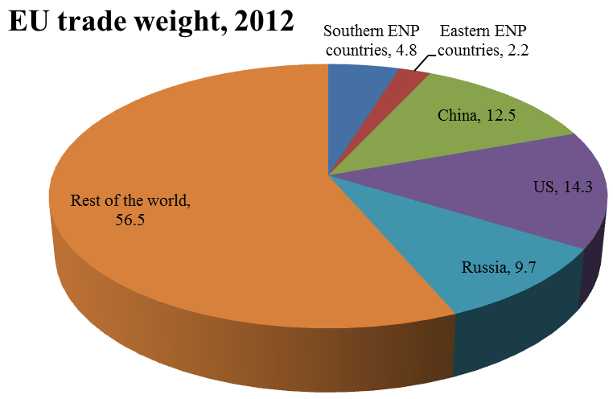
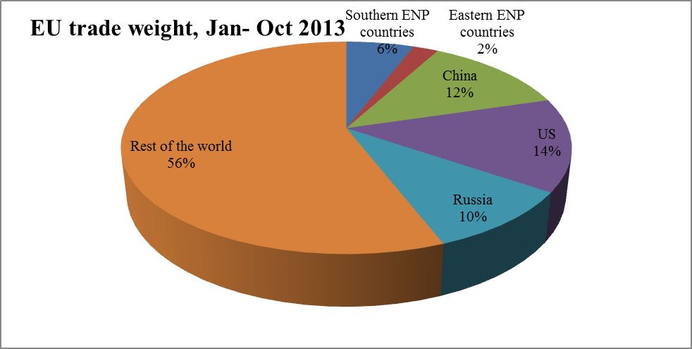

2.4. Breakdown of Southern ENP Partners' trade with the EU (2012-Oct 2013)

Southern ENP partners' trade with the EU, 2012 | Algeria | Egypt | Israel | Libya | Jordan | Lebanon | Morocco | Palestine | Syria | Tunisia
Trade weight (EUR million) | 53,888.3 | 24,047.3 | 29,760.2 |  | 3,783.5 | 7,112.6 | 26,268.8 | 118.8 | 1,457.6 | 20,736.4
ENP-South trade with EU as % of total trade | 32.2 | 14.4 | 17.8 |  | 2.3 | 4.3 | 15.7 | 0.1 | 0.9 | 12.4

Southern ENP partners' trade with the EU (Jan-Oct 2013) | Algeria | Egypt | Israel | Libya | Jordan | Lebanon | Morocco | Palestine | Syria | Tunisia
Trade weight (EUR million) | 45 045 | 18 611 | 24 046 | 28 452 | 3 487 | 5 868 | 22 808 | 105 | 663 | 17 217
ENP-South trade with EU as % of total trade | 27.1 | 11.2 | 14.5 | 17.1 | 2.1 | 3.5 | 13.7 | 0.1 | 0.4 | 10.4

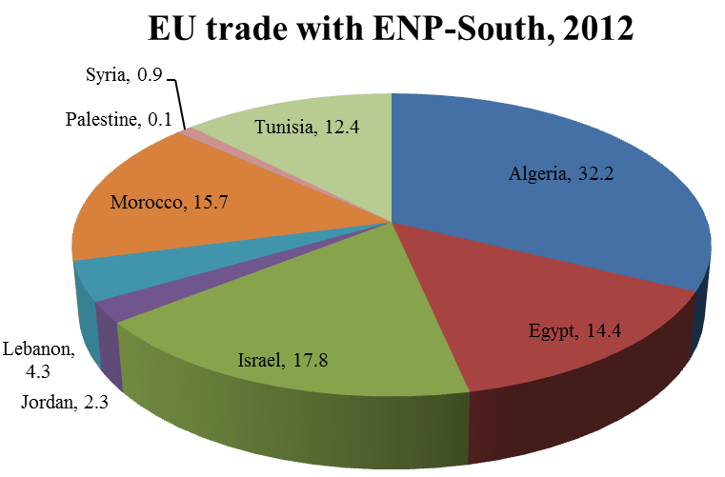
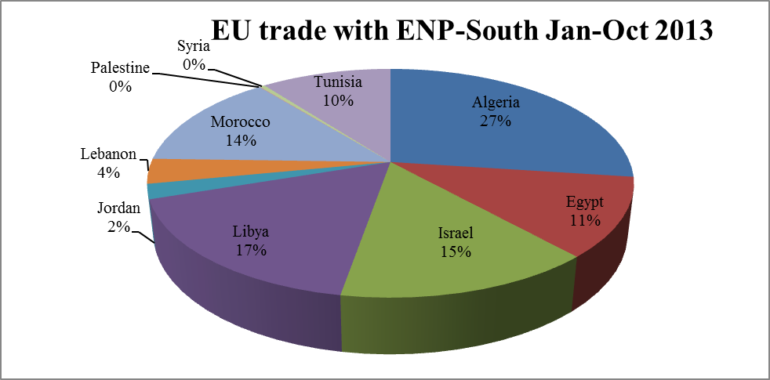

2.5. Breakdown of Eastern ENP Partners' trade with the EU (2012-Oct 2013)

Eastern ENP partners' trade with the EU  2012 | Armenia | Azerbaijan | Belarus | Georgia | Republic of Moldova | Ukraine
Trade weight (EUR million) | 956.3 | 17,272.0 | 12,429.9 | 2,652.5 | 2,980.4 | 38,501.0
ENP-East trade with EU as % of total trade | 1.3 | 23.1 | 16.6 | 3.5 | 4.0 | 51.5

Eastern ENP partners' trade with the EU  (Jan-Oct 2013) | Armenia | Azerbaijan | Belarus | Georgia | Republic of Moldova | Ukraine
Trade weight (EUR million) | 825 | 15 005 | 10 032 | 2 277 | 2 637 | 31 222
ENP-East trade with EU as % of total trade | 1.3 | 24.2 | 16.2 | 3.7 | 4.3 | 50.4

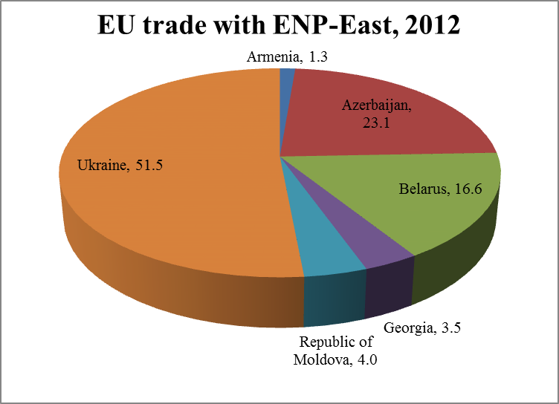
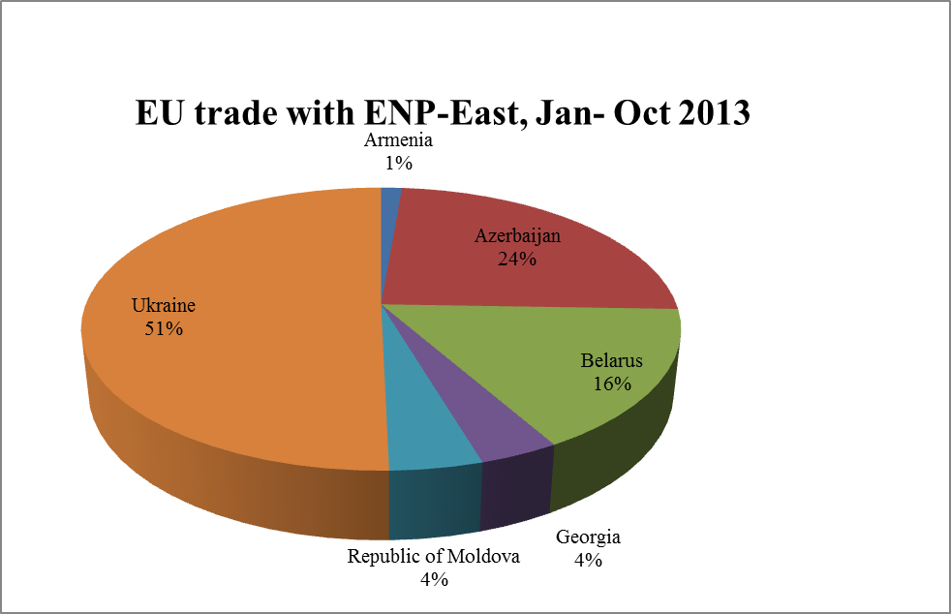
Source: Eurostat (COMEXT database)

3. Participation of Neighbourhood countries in FP7 (2007 – January 2014)
FP7 Specific Programme |  | COOPERATION |  | CAPACITIES |  | Signed agreements*
 | Proposals |  | Main listed | Proposals | Main listed | Signed agreements*
Algeria | 138 |  | 25 | 53 | 13 | 29
Armenia | 100 |  | 15 | 52 | 17 | 32
Azerbaijan | 66 |  | 10 | 46 | 10 | 21
Belarus | 153 |  | 20 | 71 | 13 | 37
Egypt | 498 |  | 67 | 127 | 30 | 95
Georgia | 139 |  | 25 | 82 | 20 | 45
Israel | - |  | - | - | - | -
Jordan | 143 |  | 15 | 73 | 26 | 36
Lebanon | 129 |  | 13 | 45 | 11 | 19
Libya | 20 |  | 3 | 20 | 2 | 2
Republic of Moldova | 129 |  | 16 | 57 | 16 | 33
Morocco | 386 |  | 76 | 104 | 25 | 95
Palestine | 59 |  | 8 | 29 | 10 | 20
Syria | 53 |  | 12 | 24 | 5 | 14
Tunisia | 341 |  | 65 | 101 | 28 | 84
Ukraine | 619 |  | 101 | 162 | 28 | 131
TOTAL | 1206 |  | 187 | 470 | 104 | 693

FP7 is the short name for the Seventh Framework Programme for Research and Technological Development. This is the EU's main instrument for funding research in Europe for the period from 2007 to 2013. FP7 is also designed to respond to Europe’s employment needs and competitiveness. FP7 supports research in selected priority areas - the aim being to make, or keep, the EU as a world leader in those sectors. FP7 is made up of 4 main blocks of activities forming 4 specific programmes plus a fifth specific programme on nuclear research: cooperation (collaborative research); ideas (European Research Council); people (human potential, Marie Curie actions); capacities (research capacities); nuclear research and training. Some of these programmes count significant cooperation with Neighbourhood partners.

*Number of signed grant agreements in FP7 with participants from Neighbourhood countries by partner country

Source: European Commission

4. Schengen visas issued by partner in 2012*

 | Short -stay visas (C) issued | Of which multiple entry  Visas (MEV C)
Algeria | 280,416 | 96,131
Armenia | 35,780 | 6,276
Azerbaijan | 49,867 | 9,432
Belarus | 693,425 | 326,482
Egypt | 120,896 | 40,819
Georgia | 59,363 | 18,362
Israel | 11,335 | 2,252
Jordan | 34,616 | 9,440
Lebanon | 85,501 | 35,070
Libya | 45,022 | 23,465
Republic of Moldova | 48,615 | 12,984
Morocco | 322,094 | 133,837
Palestine | 2,516 | 423
Syria | 3,343 | 1,612
Tunisia | 110,085 | 41,180
Ukraine | 1,283,014 | 494,749

NB: Citizens of all the ENP partners (except Israel) are required to hold a visa to enter the Schengen area. The data for Israel may include visas issued to Palestinians, as most Schengen consulates dealing with Palestinian applications are located in Israel.
*No figures available for 2013 at the time of writing
Source: European Commission

5. European Integration Index for Eastern Partnership countries, Open Societies Foundations / Renaissance Foundation

European integration is assessed through three dimensions:
- Linkage: growing political, economic and social ties between each of the six Eastern Partnership (EaP) countries and the EU;
- Approximation: structures and institutions in EaP countries converging towards EU standards and in line with EU requirements;
- Management: evolving management structures for European integration in EaP countries.
Benchmarks were defined by assigning 1 to the best and 0 to the worst possible performance.

 | Linkage |  | Approximation |  | Management
 | 2012 | 2013 | 2012 | 2013 | 2012 | 2013
Armenia | 0.48 | 0.49 | 0.56 | 0.59 | 0.43 | 0.51
Azerbaijan | 0.38 | 0.41 | 0.42 | 0.42 | 0.34 | 0.33▼
Belarus | 0.31 | 0.31 | 0.31 | 0.33 | 0.19 | 0.24
Georgia | 0.54 | 0.57 | 0.58 | 0.63 | 0.58 | 0.58
Republic of Moldova | 0.70 | 0.70 | 0.65 | 0.67 | 0.57 | 0.59
Ukraine | 0.67 | 0.65▼ | 0.55 | 0.58 | 0.52 | 0.52
*The Index does not cover the situation in the break-away territories of Transnistria, Nagorno-Karabakh, Southern Ossetia and Abkhazia

Source: http://www.eap-index.eu/sites/default/files/EaP_Index_2013_0.pdf
Section IV: EU financial support to Partners

1. Commitments amounts under ENPI

 | 2007 | 2008 | 2009 | 2010 | 2011 | 2012 | 2013 | Total | Average
Algeria | 57 | 32.5 | 35.6 | 59 | 58 | 74 | 50 | 366.1 | 52.3
Armenia | 21 | 24 | 24.7 | 27.7 | 43.1 | 35 | 66 | 241.5 | 34.5
Azerbaijan | 19 | 22 | 20 | 7 | 31 | 19.5 | 25 | 143.5 | 20.5
Belarus | 6 | 5 | 10 | 10 | 17.1 | 22.3 | 23.8 | 94.2 | 13.5
Egypt | 137 | 149 | 140 | 192 | 92 | 250 | 47 | 1007 | 143.9
Georgia | 24 | 90.3 | 70.9 | 37.2 | 50.7 | 82 | 97 | 452.1 | 64.6
Israel | 2 | 2 | 1.5 | 2 | 2 | 2 | 2 | 13.5 | 1.9
Jordan | 62 | 65 | 68 | 70 | 116 | 120¹ | 88¹ | 589 | 84.1
Lebanon | 50 | 50 | 43 | 44 | 33 | 92² | 76² | 388 | 55.4
Libya | 2 | 4 | 0 | 12 | 10 | 25 | 30 | 83 | 11.9
Republic of Moldova | 40 | 62.3 | 57 | 66 | 78.6 | 122 | 135 | 560.9 | 80.1
Morocco | 190 | 228.7 | 145 | 158.9 | 166.6 | 207 | 334.9 | 1431.1 | 204.4
Palestine | 447.7 | 382 | 352.6 | 367.9 | 413.7 | 224 | 313.7 | 2501.6 | 357.4
Syria | 20 | 20 | 40 | 50 | 10 | 48.4 | 170 | 358.4 | 51.2
Tunisia | 103 | 73 | 77 | 77 | 180 | 130 | 135 | 775 | 110.7
Ukraine | 142 | 138.6 | 116 | 126 | 65 | 149 | 199 | 935.6 | 133.7
Total | 1322.7 | 1348.4 | 1201.3 | 1306.7 | 1366.8 | 1602.2 | 1792.4 | 9940.5 | 1420
Regional
Regional/interregional cooperation East | 62 | 38 | 40 | 84.25 | 99.14 | 90.64 | 122.87 | 536.9 | 76.7
Regional/interregional cooperation South | 97.4 | 89 | 99* | 99.4 | 104.6 | 114.2* | 118.2 | 721.8 | 103.1
Total | 159.4 | 127 | 139 | 183.65 | 203.64 | 204.84 | 241.07 | 1258.7 | 179.8
Cross Border Cooperation ENPI |  |  |  |  |  |  |  | 947.2
Grand Total |  |  |  |  |  |  |  | 12146.4
(EUR Million)
( ¹ ) Not including special measures to support Syrian refugees in Jordan: EUR 20.85M committed in 2012 and EUR 51.6M in 2013; those commitments are included in the figures for Syria
( ² ) Not including measures to support Syrian refugees in Lebanon: EUR 15M committed in 2012 and EUR 67M in 2013; those are included in the figures for Syria
*Excluding amounts for EP preparatory actions (EUR 2 M in 2009 and EUR 1.5 M in 2012).
Source: European Commission

2. ENPI – Cross Border Cooperation (allocations 2007 – 2013)
The ENPI Cross Border Cooperation (CBC) programmes have four key objectives:
- promoting economic and social development in regions on both sides of common borders;
- working together to address common challenges, in fields such as the environment, public health and the prevention of and the fight against organised crime;
- ensuring efficient and secure borders;
- promoting local cross border 'people-to-people' actions.

CBC programmes are co-funded from the European Neighbourhood and Partnership Instrument (ENPI) and from the European Regional Development Fund (ERDF). The CBC Indicative Programme 2007-2010 allocated EUR 583 million (EUR 275 million from the ENPI and EUR 308 million from the ERDF). Following the mid-term review, a second CBC Indicative Programme allocated further EUR 538 million for the period 2011-2013 (EUR 260 million from the ENPI and EUR 278 million from the ERDF).
CBC programmes | Commitments (2007-2013) | Disbursements (end 2013)
Land Border Programmes
Kolarctic/Russia (Finland, Sweden, Russia, Norway) | 30,471,018 | 20,121,835
Karelia/Russia (Finland, Russia) | 23,202,507 | 18,071,149
SE Finland/Russia (Finland, Russia) | 36,185,361 | 23,324,933
Estonia/Latvia/Russia | 47,774,729 | 30,169,542
Latvia/Lithuania/Belarus | 41,736,666 | 21,631,189
Lithuania/ Poland /Russia | 124,212,272 | 78,213,772
Poland/Belarus/Ukraine | 186,201,367 | 109,335,338
Hungary/Slovakia/Romania/Ukraine | 68,638,283 | 49,455,275
Romania/ Ukraine/Rep. of Moldova | 126,718,066 | 77,563,018
Sea-Crossing Programmes
Italy/Tunisia | 25,191,423 | 18,065,500
Sea-Basin Programmes
Black Sea (Romania, Bulgaria, Greece, Turkey, Ukraine, Rep. of Moldova, Georgia, Armenia) | 28,118,954 | 19,771,382
Baltic Sea Region (Belarus, Denmark, Estonia, Finland, Germany, Latvia, Lithuania, Norway, Poland, Sweden) | 8,800,000 | 8,800,000
Mediterranean (Cyprus Egypt, France, Greece, Israel, Italy, Jordan, Lebanon, Malta, Palestinian Authority, Portugal, Spain, Syria, Tunisia | 200,000,000 | 92,147,421
TOTAL | 947,250,646 | 566,670,354
Source: European Commission
The figure for the 'Baltic Sea Region' CBC programme is adjusted to de-commitment following Russia's non signature of the Financing Agreement

3. Fiches covering EU financial support by partner (2007 – 2013)

ALGERIA

1) ENPI allocations

Under the National Indicative Programme 2007-2010 for Algeria, EUR 220 million was programmed for the following priorities of which EUR 184.1 million was committed.

Priority | Planned | Actual
Reform of Justice | 7.7% | 9.2%
Economic growth and employment | 51.4% | 54.6%
Reinforcement of basic public services | 40.9% | 36.2%

Algeria | 2007 | 2008 | 2009 | 2010
Programmed | 57 | 55 | 54 | 54
Committed | 57 | 32.5 | 35.6 | 59
Disbursed | 51.3 | 46.1 | 47.9 | 28.1
(EUR Million)

Under the National Indicative Programme 2011-2013 for Algeria, EUR 172 million was programmed for the following priorities.

Priority | Planned | Actual*
Sustainable development and culture | +/-43% | 52.6%
Economic growth and development | +/-57% | 47.4%
*This does not take into account the amount allocated through the SPRING programme

Algeria | 2011 | 2012 | 2013
Programmed | 54 | 58 | 60
Committed | 58 | 74 | 50
Disbursed | 42.9 | 30.3 | 37.3
(EUR Million)

Additional EUR 10 million was allocated to Algeria from the SPRING programme to support governance.

2) Support to civil society / NIF / Support under thematic instruments

Other instruments | 2011 | 2012 | 2013
Civil Society Facility | 400,000 | 600,000 | 400,000
Instrument for Nuclear Safety Cooperation | n/a | n/a | n/a
European Instrument for Democracy and Human Rights | 600,000 | 900,000 | 700,000
Neighbourhood Investment Facility | n/a | n/a | n/a
Non-state Actors and Local Authorities (NSA/LA) | 400,000 | 500,000 | 400,000
Migration and asylum | n/a | 1,875,000 | n/a
(EUR)
n/a = not available

Source: European Commission
ARMENIA

1) ENPI allocations

A total of EUR 97.40 million of ENPI funding was committed for Armenia under the National Indicative Programme (NIP) 2007-2010 for the following priorities:

Priority | Planned | Actual
Support for strengthening of democratic structures and good governance | 30% | 30%
Support for regulatory reform and administrative capacity building | 30% | 34%
Support for poverty reduction efforts | 40 % | 36%

Armenia | 2007 | 2008 | 2009 | 2010
Programmed | 21 | 24 | 24.7 | 28.7
Committed | 21 | 24 | 24.7 | 27.7
Disbursed | 10.90 | 7 | 17.5 | 15.8
(EUR Million)

A total of EUR 114.10 million of ENPI funding was committed during the period 2011-2013. Out of this total, EUR 104.10 million was provided under the NIP 2011-2013 for the following priorities:

Priority | Planned | Actual
Democratic structures and good governance | 30-35% | 47%
Trade and investment regulatory alignment and reform | 20-25% | 19%
Socio-economic reform and sustainable development | 40-45 % | 34%
*The NIP 2011-2013 integrates funding for the Eastern Partnership bilateral programmes on Comprehensive Institution Building (CIB) and regional development (PRDP).
*Actual percentages adjusted to commitments.

Additional allocations of EUR 40 million were granted to Armenia under the EaPIC programme (Eastern Partnership Integration and Cooperation) in 2012 and 2013. EaPIC funds were allocated to continue support for the justice system reform; civil service modernisation and the fight against corruption; better mobility and border management; and vocational education and training.

During the period 2008-2013, the Neighbourhood Investment Facility (NIF) contributed a total of EUR 67.1 million for nine projects in Armenia.

Armenia | 2011 | 2012 | 2013
Programmed | 43.1 | 60 | 54
Committed AAPs | 43.1 | 20 | 41
EaPIC | n/a | 15 | 25
Disbursed | 27.2 | 25.5 | 25.7
*Figures adjusted to the de-commitment of EUR 40 million following non-signature of two Financing Agreements linked to support for DCFTA implementation
*Disbursements include country-specific payments for regional and inter-regional programmes (such as NIF)

2) Allocations under other instruments

In addition to ENPI funding, support is provided also under other instruments such as the European Instrument for Democracy and Human Rights (EIDHR), the thematic programme 'Non-state actors and local authorities' (NSA/LA) of the Development Cooperation Instrument (DCI), and the Instrument for Nuclear Safety Cooperation (INSC).

Other instruments | 2011 | 2012 | 2013
Instrument for Nuclear Safety Cooperation | 1.9 | 1 | 1
European Instrument for Democracy and Human Rights | 0.9 | 0.9 | 0.9
Non-state Actors and Local Authorities (NSA/LA) - Development Cooperation Instrument | 0.65 | 0.6 | 0.7
(EUR Million)

Source: European Commission

AZERBAIJAN

1) ENPI allocations

A total of EUR 68 million of ENPI funding was committed for Azerbaijan under the National Indicative Programme (NIP) 2007-2010 for the following priorities:

Priority | Planned | Actual
Support for democratic development and good governance | 33% | 43%
Support for socio-economic reform, fight against poverty and administrative capacity building | 34% | 29%
Support for legislative and economic reforms in the transport, energy and environment sectors | 33% | 28%

Azerbaijan | 2007 | 2008 | 2009 | 2010
Programmed | 19 | 22 | 24 | 27
Committed | 19 | 22 | 20 | 7
Disbursed | 3.7 | 6.5 | 5.1 | 11.3
(EUR Million)

A total of EUR 75.5 million of ENPI funding was committed for Azerbaijan under the NIP 2011-2013 for the following priorities:

Priority | Planned | Actual
Democratic structures and good governance | 25-30% | 9%
Socio-economic reform and sustainable development, trade and investment, regulatory approximation and reform | 35-40% | 57%
PCA and ENP AP implementation, including energy security, mobility and security | 30-35% | 34%
*The NIP 2011-2013 integrates funding for the Eastern Partnership bilateral programmes on Comprehensive Institution Building (CIB) and regional development (PRDP)
*Actual percentages adjusted to commitments.

Azerbaijan did not benefit from the EaPIC programme (Eastern Partnership Integration and Cooperation).
During the period 2008-2013, the Neighbourhood Investment Facility (NIF) contributed a total of EUR 3.4 million for one project in Azerbaijan.

Azerbaijan | 2011 | 2012 | 2013
Programmed | 28 | 42 | 25
Committed | 31 | 19.5 | 25
Disbursed | 15.2 | 18.7 | 8.6
[*]Figures are adjusted to the reduction of the NIP 2011-2013 from the initially planned amount of EUR 122.5 million
[*]Disbursements include country-specific payments for regional and inter-regional programmes (such as NIF)

2) Allocations under other instruments

In addition to ENPI funding, support is provided also under other instruments such as the European Instrument for Democracy and Human Rights (EIDHR), the thematic programme 'Non-state actors and local authorities' (NSA/LA) of the Development Cooperation Instrument (DCI), and the Instrument for Nuclear Safety Cooperation (INSC).

Other instruments | 2011 | 2012 | 2013
Instrument for Nuclear Safety Cooperation | n/a | n/a | n/a
European Instrument for Democracy and Human Rights | n/a | 0.9 | 0.9
Non-state Actors and Local Authorities (NSA/LA) - Development Cooperation Instrument | n/a | 0.7 | n/a
(EUR Million)

Source: European Commission

BELARUS

1) ENPI allocations

A total of EUR 48.10 million of ENPI funding was committed for Belarus during the period 2007-2011. Out of this total, EUR 44.10 million was provided under the National Indicative Programme (NIP) 2007-2011 for the following priorities:

Priority | Planned | Actual
Support for social and economic development | 70% | 78%
Democratic development and good governance | 30% | 22%

An additional allocation of EUR 4 million was granted under a 'Special Measure' in support of civil society in 2011.

Belarus | 2007 | 2008 | 2009 | 2010 | 2011
Programmed | 5 | 5 | 10 | 10 | 16.07
Committed AAPs | 6 | 5 | 10 | 10 | 13.10
Special Measure | n/a | n/a | n/a | n/a | 4
Disbursed | 0.6 | 3 | 2.7 | 5.1 | 1.1
(EUR Million)
The initial NIP 2007-2010 was extended by one year (2007-2011)

A total of EUR 46.10 million of ENPI funding was committed for Belarus during the period 2012-2013. Out of this total, EUR 28.60 million was provided under the NIP 2012-2013 for the following priorities:

Priority | Planned | Actual
Good governance and people-to-people contacts | 50% | 17%
Economic modernisation | 50% | 83%

While the reduced NIP allocation was mainly devoted to economic modernisation, additional allocations of EUR 17.5 million were granted under two 'Special Measures' in support of civil society and people-to-people contacts in 2012 and 2013. This means that 49% of the total ENPI funding for Belarus over the period 2012-2013 was specifically devoted to activities in support of civil society. Belarus did not benefit from the EaPIC programme (Eastern Partnership Integration and Cooperation).
During the period 2008-2013, there was no Neighbourhood Investment Facility (NIF) project in Belarus.
Belarus | 2012 | 2013
Programmed | 17 | 11.5
Committed AAPs | 17 | 11.6
Special Measures | 5.3 | 12.2
Disbursed | 9.3 | 15.7
(EUR Million)

2) Allocations under other instruments

In addition to ENPI funding, support is provided also under other instruments such as the European Instrument for Democracy and Human Rights (EIDHR), the thematic programme 'Non-state actors and local authorities' (NSA/LA) of the Development Cooperation Instrument (DCI), and the Instrument for Nuclear Safety Cooperation (INSC).

Other instruments | 2011 | 2012 | 2013
Instrument for Nuclear Safety Cooperation | n/a | n/a | 4.5
European Instrument for Democracy and Human Rights | 0.5 | 0.5 | 0.56
Non-state Actors and Local Authorities (NSA/LA) - Development Cooperation Instrument | 2.4 | 0.2 | 1.4
(EUR Million)

Source: European Commission

EGYPT

1) ENPI allocations

Under the National Indicative Programme 2007-2010 for Egypt, EUR 558 million was programmed but EUR 618 million was committed for the following priorities.

Priority | Planned | Actual
Support for reform in democracy, human rights and justice | 7% | 6.7%
Developing competitiveness and productivity of the Egyptian economy | 40% | 44.8%
Ensuring sustainability of the development process with better management of human and natural resources | 53% | 48.9%

Egypt | 2007 | 2008 | 2009 | 2010
Programmed | 137 | 139 | 140 | 142
Committed | 137 | 149 | 140 | 192
Disbursed* | 170.3 | 148.1 | 151 | 106.2
(EUR Million)
*including country specific interregional NIF payments

Under the National Indicative Programme 2011-2013 for Egypt, EUR 449.3 million was programmed for the following priorities.

Priority | Planned | Actual
Support for reform in democracy, human rights and justice | 11.1% | 0%
Competitiveness and productivity of the Egyptian economy | 42.2% | 43.1%
Support for socio economic reform and sustainable development | 46.7% | 56.9%

Egypt | 2011 | 2012 | 2013
Programmed | 144 | 150 | 155.3
Committed | 92 | 250 | 47
Disbursed* | 39.1 | 93.2 | 28.2
(EUR million)
*including country specific interregional NIF payments

Additional EUR 90 million was allocated to Egypt from the SPRING programme to support socio-economic development and civil society.

2) Support to civil society / NIF / Support under thematic instruments:

Other instruments | 2011 | 2012 | 2013
Civil Society Facility | 600,000 | 900,000 | 1,200,000
Instrument for Nuclear Safety Cooperation | n/a | n/a | n/a
European Instrument for Democracy and Human Rights | 2,000,000 | 1,780,000 | 1,000,000
Neighbourhood Investment Facility | 23,500,000 | 50,000,000 | 15,000,000
Non-state Actors and Local Authorities (NSA/LA) | 1,000,000 | 760,000 | 1,000,000
Instrument for Stability (IfS) | 4,000,000 | 260,000 | n/a
Migration and asylum | n/a | 2,000,000 | n/a
(EUR)

Source: European Commission

GEORGIA

1) ENPI allocations

A total of EUR 222.4 million of ENPI funding was committed for Georgia during the period 2007-2010. Out of this total, EUR 117.4 million was provided under the National Indicative Programme (NIP) 2007-2010 for the following priorities:

Priority | Planned | Actual
Support for democratic development, rule of law and governance | 26% | 37%
Support for economic development and ENP Action Plan implementation | 26% | 26%
Poverty reduction and social reforms | 32% | 29%
Support for peaceful settlement of Georgia's internal conflicts | 16% | 8%

In the aftermath of the 2008 crisis, additional allocations of EUR 105 million were granted to Georgia under two 'Special Measures' in 2008 and 2009 to support the implementation of national action plans on Internally Displaced Persons (IDPs).

Georgia | 2007 | 2008 | 2009 | 2010
Programmed | 24 | 28.8 | 30.4 | 37.2
Committed | 24 | 28.8 | 27.4 | 37.2
Special Measures | n/a | 61.5 | 43.5 | n/a
Disbursed* | 14.7 | 32.7 | 69 | 41.7
(EUR Million)

A total of EUR 229.7 million of ENPI funding was committed for Georgia during the period 2011-2013. Out of this total, EUR 180.7 million was provided under the NIP 2011-2013 for the following priorities:
Priority | Planned | Actual
Support for democratic development, rule of law, good governance | 25-35% | 22%
Support for trade and investment, regulatory alignment and reform | 15-25% | 27%
Support for regional development, sustainable economic and social development, poverty reduction | 35-45% | 49%
Support for peaceful settlement of conflicts | 5-10% | 2%
*The NIP 2011-2013 integrates funding for the Eastern Partnership bilateral programmes on Comprehensive Institution Building (CIB) and regional development (PRDP)

Additional allocations of EUR 49 million were granted to Georgia under the EaPIC programme (Eastern Partnership Integration and Cooperation) in 2012 and 2013. EaPIC funds were allocated to continued support for reforms of the criminal justice system and human rights protection; better mobility and border management; modernisation of employment policies and the vocational education and training system.
During the period 2008-2013, the Neighbourhood Investment Facility (NIF) contributed a total of EUR 63.9 million for nine projects in Georgia.

Georgia | 2011 | 2012 | 2013
Programmed | 50.7 | 61.8 | 67.7
Committed AAPs | 50.7 | 60 | 70
EaPIC | n/a | 22 | 27
Disbursed* | 66.3 | 61.2 | 47.6
(EUR million)
*Disbursements include country-specific payments for regional and inter-regional programmes (such as NIF)
*The 2013 EaPIC allocation is partly funded with 2012 commitments

2) Allocations under other instruments

In addition to ENPI funding, support is provided also under other instruments such as the European Instrument for Democracy and Human Rights (EIDHR), the thematic programme 'Non-state actors and local authorities' (NSA/LA) of the Development Cooperation Instrument (DCI), and the Instrument for Nuclear Safety Cooperation (INSC).

Other instruments | 2011 | 2012 | 2013
Instrument for Nuclear Safety Cooperation | n/a | n/a | n/a
European Instrument for Democracy and Human Rights | 1.2 | 1.2 | 1
Non-state Actors and Local Authorities (NSA/LA) - Development Cooperation Instrument | 0.4 | 0.7 | 0.4
(EUR Million)

Source: European Commission

ISRAEL

I) ENPI allocations

Under the National Indicative Programme 2007-2010 for Israel, EUR 8 million was programmed for the following priorities of which EUR 7.5 million was committed.

Priority | Planned | Actual
Support for implementation of the joint priorities in the EU-Israel Action Plan | 100% | 100%

Israel | 2007 | 2008 | 2009 | 2010
Programmed | 2 | 2 | 2 | 2
Committed | 2 | 2 | 1.5 | 2
Disbursed* | 2.8 | 2.7 | 2.5 | 3.5

Under the National Indicative Programme 2011-2013 for Israel, EUR 6 million was programmed for the following priority.

Priority | Planned | Actual
Support for implementation of the joint priorities in the EU-Israel Action Plan | 100% | 100%

Israel | 2011 | 2012 | 2013
Programmed | 2 | 2 | 2
Committed | 2 | 2 | 2
Disbursed* | 4.5 | 3.5 | 3.6
(EUR million)

2) Support to civil society / NIF / Support under thematic instruments:

Other Instruments | 2011 | 2012 | 2013
Civil Society Facility | 500,000 | 500,000 | 500,000
Instrument for Nuclear Safety Cooperation | n/a | n/a | n/a
European Instrument for Democracy and Human Rights | 1,200,000 | 1,200,000 | 1,200,000
Neighbourhood Investment Facility | n/a | n/a | n/a
Non-state Actors and Local Authorities (NSA/LA) | n/a | 300,000 | n/a
Investing In People / Gender | 248,000 | n/a | n/a
(EUR)
Source: European Commission
JORDAN

1) ENPI allocations

Under the National Indicative Programme 2007-2010 for Jordan, EUR 265 million was programmed for the following priorities.

Priority | Planned | Actual
Political reform, human rights, justice and cooperation on security and fight against extremism | 6.5% | 6.4%
Trade and investment development | 29.5% | 23.8%
Sustainability of the growth process | 24.0% | 20.8%
Institution building, finance and public administration reform | 40.0% | 49.1%

Jordan | 2007 | 2008 | 2009 | 2010
Programmed | 62 | 65 | 68 | 70
Committed | 62 | 65 | 68 | 70
Disbursed | 46.1 | 63.6 | 49 | 92
(EUR Million)

Under the National Indicative Programme 2011-2013 for Jordan, EUR 223 million was programmed for the following priorities.

Priority | Planned | Actual*
Supporting Jordan's reform in democracy, human rights, media, justice | 20.2% | 34.1%
Trade enterprise and investment development | 17.9% | 9%
Sustainability of the growth process | 41.7% | 45.7%
Support in the implementation of the Action Plan | 20.2% | 11.2%
*This does not take into account the amount allocated through the SPRING programme

Jordan | 2011 | 2012 | 2013
Programmed | 71 | 75 | 77
Committed | 116 | 120* | 88*
Disbursed | 76.3 | 91.6 | 96
(EUR Million)
*not including special measures to support Syrian refugees in Jordan: EUR 20.848M committed in 2012, and EUR 51.6 M committed in 2013; those commitments are included in the fiche for Syria

Additional EUR 101 million was allocated to Jordan from the SPRING programme:

Priority | Amount
Education reform | 10
Support to electoral system | 7
Justice preparatory project | 3
Support to enterprise and export development | 10
Good governance and development contract | 55
Support to host communities | 16
(EUR Million)

2) Support to civil society / NIF / Support under thematic instruments:

Other Instruments | 2011 | 2012 | 2013
Civil Society Facility | 300,000 | n/a | 500,000
Instrument for Nuclear Safety Cooperation | n/a | n/a | n/a
European Instrument for Democracy and Human Rights | 900,000 | 900,000 | 900,000
Neighbourhood Investment Facility | n/a | n/a | n/a
Non-state Actors and Local Authorities (NSA/LA) | 200,000 | 450,000 | n/a
Instrument for Stability (IfS)* | n/a | 2,900,000 | 20,000,000
(EUR)
*In the context of the response to the Syria crisis

Source: European Commission

LEBANON

1) ENPI allocations

Under the National Indicative Programme 2007-2010 for Lebanon, EUR 187 million was programmed for the following priorities.

Priority | Planned | Actual
Support to political reform | 11.76% | 11.76%
Support to social and economic reform | 45.99% | 45.99%
Support to reconstruction and recovery | 42.25% | 42.25%

Lebanon | 2007 | 2008 | 2009 | 2010
Programmed | 50 | 50 | 43 | 44
Committed | 50 | 50 | 43 | 44
Disbursed | 32.6 | 43.5 | 24.6 | 26.1
(EUR Million)

Under the National Indicative Programme 2011-2013, EUR 150 million was programmed for the following priorities.

Priority | Planned | Actual*
Support to political reform | 16.7% | 11.76%
Support to socio-economic reforms | 60.7% | 45.99%
Recovery and re-invigoration of the economy | 22.6% | 42.25%
*This does not take into account the amount allocated through the SPRING programme

Lebanon | 2011 | 2012 | 2013
Programmed | 45 | 50 | 55
Committed | 33 | 92* | 76*
Disbursed | 14.1 | 29.3 | 79,3
(EUR Million)
*not including measures to support Syrian refugees in Lebanon: EUR 15M committed in 2012 and EUR 67M in 2013; those commitments are included in the fiche for Syria

Additional EUR 51 million was allocated to Lebanon from the SPRING programme:

Priority | Amount
Reinforcing Human Rights and Democracy | 10
Top-up support Security and Rule of Law | 4
Top-up support to Reform of the Judiciary | 4
Support to Electoral Reform | 6
Infrastructure for Palestine Refugees | 6
Solid Waste Management Capacities (SWAM) | 14
Recovery of Local Economies (crisis affected communities) | 7

2) Support to civil society / NIF / Support under thematic instruments:

Other Instruments | 2011 | 2012 | 2013
Civil Society Facility | n/a | 500,000 | 500,000
Instrument for Nuclear Safety Cooperation | n/a | n/a | n/a
European Instrument for Democracy and Human Rights | 600,000 | 600,000 | 600,000
Neighbourhood Investment Facility | n/a | 10,000,000 | n/a
Non-state Actors and Local Authorities (NSA/LA) | 350,000 | 350,000 | 300,000
Instrument for Stability (IfS)* | n/a | 15,000,000 | 32,000,000
(EUR)
*EUR 27.6 M of the total amounts is in the context of the response to the Syria crisis

Source: European Commission

LIBYA

1) ENPI allocations

There was no NIP for the period 2007-2010 in Libya. A total of EUR 8 million under ENPI was earmarked for the Benghazi Action Plan (BAP) on HIV/AIDS and funds were committed as special measures. An additional EUR 10 million was committed in 2010 as a special measure in the field of migration.

Special measure | Planned | Actual
BAP : HIV/Aids | n/a | 44.4%
Migration | n/a | 55.6%

Libya | 2007 | 2008 | 2009 | 2010
Programmed: BAP | 2 | 2 | 2 | 2
Programmed: Migration | 2 | 4 | 0 | 12
Committed: overall | 0 | 1.2 | 1.3 | 0.6
(EUR Million)

The NIP 2011-2013 with an overall budget of EUR 60 million was signed with the Libyan government in June 2010 including two focal areas: (i) Improving the quality of human capital; (ii) Sustainability of economic and social development. A revised version of the NIP 2011-2013 was signed on 30 August 2012. The country allocations were reoriented towards the most urgent needs caused by the armed conflict and the subsequent transitional period in the following areas:

Priority | Planned | Actual*
Support to the transition process | 37.6% | 37.6%
Improving the quality of human capital | 29% | 29%
Increasing the sustainability of economic and social development | 16.7% | 16.7%
Addressing jointly the challenge of managing migration | 16.7% | 16.7%
*This does not take into account the amount allocated through the SPRING programme

Libya | 2011 | 2012 | 2013
Programmed | 10 | 25 | 25
Committed | 10 | 25 | 30
Disbursed | 8 | 2.9 | 7.7
(EUR Million)

Additional EUR 5 million was allocated to Libya from the SPRING programme.

Priority | Amount
Support to Civil society and Media | 3
Support to the Constitutional Process | 2
(EUR Million)

2) Support to civil society / NIF / Support under thematic instruments:

Other Instruments | 2011 | 2012 | 2013
Civil Society Facility | n/a | 600,000 | 600,000
Instrument for Nuclear Safety Cooperation | n/a | n/a | n/a
Instrument for Stability (IfS) | 3,700,000 | 13,400,000 | 1,700,000
Humanitarian Aid | 80,500,000 | n/a | n/a
European Instrument for Democracy and Human Rights | 3,000,000 | 1,000,000 | 1,000,000
Neighbourhood Investment Facility | n/a | n/a | n/a
Migration and asylum | 1,630,000 | 5,940,000* | n/a
Non-state Actors and Local Authorities (NSA/LA) | 3,000,000 | 2,000,000 | 2,000,000
(EUR)

*including EUR 4.5M regional programme covering Algeria, Egypt, Libya and Tunisia

Source: European Commission

REPUBLIC OF MOLDOVA

1) ENPI allocations

A total of EUR 225.3 million of ENPI funding was committed for Moldova during the period 2007-2010. Out of this total, EUR 208.70 million was provided under the National Indicative Programme (NIP) 2007-2010 for the following priorities:

Priority | Planned | Actual
Support for democratic development and good governance | 25-35% | 25%
Support for regulatory reform and administrative capacity building | 15-20% | 19%
Support for poverty reduction and economic growth | 40-60% | 56%

An additional allocation of EUR 16.6 million was granted to Moldova under the Governance Facility in 2008.
Moldova | 2007 | 2008 | 2009 | 2010
Programmed | 40 | 45.7 | 57 | 67
Committed AAPs | 40 | 45.7 | 57 | 66
Governance Facility | n/a | 16.6 | n/a | n/a
Disbursed | 8 | 23.7 | 66.1 | 56.6
(EUR Million)

A total of EUR 335.6 million of ENPI funding was committed for Moldova during the period 2011-2013. Out of this total, EUR 272.6 million was provided under the NIP 2011-2013 for the following priorities:

Priority | Planned | Actual
Good governance, rule of law and fundamental freedoms | 35-40% | 40%
Social and human development | 25-30% | 17%
Trade and sustainable development | 35-40% | 44%
*The NIP 2011-2013 integrates funding for the Eastern Partnership bilateral programmes on Comprehensive Institution Building (CIB) and regional development (PRDP)

Additional allocations of EUR 63 million were granted to Moldova under the EaPIC programme (Eastern Partnership Integration and Cooperation) in 2012 and 2013. EaPIC funds were allocated to continued support for the economic development of rural areas; promotion of energy efficiency; justice system reform, protection of human rights and fight against corruption; modernisation of the health system.
During the period 2008-2013, the Neighbourhood Investment Facility (NIF) contributed a total of EUR 103.47 million for 15 projects in Moldova.

Moldova | 2011 | 2012 | 2013
Programmed | 78.6 | 94 | 100.5
Committed AAPs | 78.6 | 94 | 100
EaPIC | n/a | 28 | 35
Disbursed | 79.3 | 53.1 | 65
(EUR million)
*Disbursements include country-specific payments for regional and inter-regional programmes (such as NIF)

2) Allocations under other instruments
In addition to ENPI funding, support is provided also under other instruments such as the European Instrument for Democracy and Human Rights (EIDHR), the thematic programme 'Non-state actors and local authorities' (NSA/LA) of the Development Cooperation Instrument (DCI), and the Instrument for Nuclear Safety Cooperation (INSC).

Other instruments | 2011 | 2012 | 2013
Instrument for Nuclear Safety Cooperation | n/a | n/a | n/a
European Instrument for Democracy and Human Rights | 1.2 | 1 | 1
Non-state Actors and Local Authorities (NSA/LA) - Development Cooperation Instrument | 0.45 | 0.45 | n/a
(EUR Million)

Source: European Commission

MOROCCO

1) ENPI allocations

Under the National Indicative Programme 2007-2010 for Morocco, EUR 654 million was programmed for the following priorities.

Priority | Planned | Actual
Social Sector | 45.3% | 44.6%
Governance, human rights | 4.3% | 1.1%
Institutional Support | 6.1% | 12.5%
Economic sector | 36.7% | 35.1%
Environmental sector | 7.6% | 6.7%

Morocco | 2007 | 2008 | 2009 | 2010
Programmed | 162 | 163 | 164 | 165
Committed | 190 | 228.7 | 145 | 158.9
Disbursed* | 227.5 | 224.9 | 200.7 | 170.1
(EUR Million)
* included country specific interregional NIF payments

Under the National Indicative Programme 2011-2013 for Morocco, an amount EUR 580.5 million was programmed in the following:

Sector | Planned | Actual*
Social | 20% | 31.9%
Economic | 10% | 10.3%
Institutional Support | 40% | 43.6%
Governance human rights | 15% | 7.8%
Environmental | 15% | 6.4%
*This does not take into account the amount allocated through the SPRING programme

Morocco | 2011 | 2012 | 2013
Programmed | 178.5 | 193.5 | 208.5
Committed | 166.6 | 207 | 334.9
Disbursed* | 151.5 | 110.1 | 84.1
(EUR Million)
*including country specific interregional NIF payments

Additional EUR 128 million was allocated to Morocco from the SPRING programme. This amount was allocated as follows:

Programme | Amount
Support to National Council and Inter-Ministerial Delegation of Human Rights | 2.9
Support to SMEs and job creation | 40
Agricultural Strategy Council | 16.1
Literacy programme | 35
Top up of Support to Health sector reform programme | 12
Top-up Hakama | 9
Support to the Moroccan Parliament | 3
Support to the implementation of the Mobility Partnership | 10
(EUR Million)

2) Support to civil society / NIF / Support under thematic instruments:

 | 2011 | 2012 | 2013
Civil Society Facility | 1,400,000 | 200,000 | 200,000
Instrument for Nuclear Safety Cooperation | n/a | n/a | n/a
European Instrument for Democracy and Human Rights | 1,200,000 | 1,000,000 | 1,200,000
Neighbourhood Investment Facility | 37,000,000 | 15,000,000 | 15,000,000
Migration and asylum | 873,300 | 1,594,264 | 5,000,000
Non-state Actors and Local Authorities (NSA/LA) | 750,000 | 750,000 | 0
(EUR)

Source: European Commission

PALESTINE

1) Financial allocations (BL 19.080.102)

There is no NIP for the Occupied Palestinian Territory and each year ad hoc measures were adopted to respond to the needs of this country. Under the period 2007-2010, EUR 1,550.2 million was committed for the following priorities:

Priority | Planned | Actual
Direct & Indirect Financial Support for PA | n/a | 61.0%
Institution-building | n/a | 3.5%
Infrastructure Development | n/a | 4.5%
Private Sector Development | n/a | 2%
Support to UNRWA | n/a | 29%
East Jerusalem initiatives | n/a | 0.9%

Palestine | 2007 | 2008 | 2009 | 2010
Programmed | 158 | 158 | 158 | 158
Committed | 447.7 | 382 | 352.6 | 367.9
Disbursed | 381.4 | 425.9 | 327.8 | 325.5
(EUR Million)

Under the period 2011-2013, EUR 951.4 million was committed for the following priorities.

Priority | Planned | Actual
Direct & Indirect Financial Support to PA | n/a | 51.8%
Support to UNRWA | n/a | 28.6%
Institution Building | n/a | 7.1%
Infrastructure Development | n/a | 5.6%
East Jerusalem initiatives | n/a | 2.5%
Private Sector Development | n/a | 4.4%

Palestine | 2011 | 2012 | 2013
Programmed | 158 | 168 | 178
Committed | 413.7 | 224 | 313.7
Disbursed* | 322.3 | 264.7 | 305.5
(EUR Million)
*Of which EUR 100 million have been committed on 2011 credits

2) Support to civil society / NIF / Support under thematic instruments:

 | 2011 | 2012 | 2013
Civil Society Facility | 400,000 | 500,000 | 900,000
Instrument for Nuclear Safety Cooperation | n/a | n/a | n/a
European Instrument for Democracy and Human Rights | 1,500,000 | 1,500,000 | 1,500,000
Neighbourhood Investment Facility | n/a | n/a | n/a
Non-state Actors and Local Authorities (NSA/LA) | 2,400,000 | 2,400,000 | 2,400,000
Middle East Peace Process (MEPP) (regional South Programme) | 5,000,000 | 5,000,000 | 5,000,000
Investing in people / Gender | 380,000 | 3,190,000 | n/a
Instrument for Stability (IfS) | 8,890,000 | 4,110,000 | n/a
(EUR)

Source: European Commission

SYRIA
- SUSPENDED -

1) ENPI allocations

Under the National Indicative Programme 2007-2010 for Syria, EUR 130 million was programmed for the following priorities:

Priority | Planned | Actual
Support to political and administrative reform | 23% | 23%
Support for economic reform | 46% | 38.5%
Support for social reform | 23% | 30.8%
Environment / sustainable energy | 8% | 7,7%

Syria | 2007 | 2008 | 2009 | 2010
Programmed | 20 | 20 | 40 | 50
Committed | 20 | 20 | 40 | 50
Disbursed | 34.1 | 26.5 | 31.2 | 18.4
(EUR Million)

Under the National Indicative Programme 2011-2013 for Syria, EUR 129 million was programmed for the following priorities:

Priority | Planned | Actual
Support for political and administrative reform | 19% | n/a
Support for economic reform | 44% | n/a
Support for social reforms | 37% | n/a

However, due to the ongoing repression in Syria, the bilateral cooperation under ENPI and NIP 2011-2013 was suspended on 25th May 2011. A special measure for 2011 (EUR 10 million) was adopted to support two UNRWA projects targeting both Palestinian refugees and the Syrian population. Two special measures were adopted in 2012 (EUR 48.4 million in total) to support the population in Syria as well as Syrian refugees in Jordan and Lebanon and various special measures were adopted in 2013 (EUR 170M) for the same purpose.

Syria | 2011 | 2012 | 2013
Programmed | 41.67 | 42.67 | 44.67
Committed | 10 | 48.4* | 170**
Disbursed* | 18.8 | 1.8 | 29.6
(EUR Million)
*including measures to support Syrian refugees in Jordan (EUR 20.848M) and Lebanon (EUR 15M) and Syrian population affected by the crisis (EUR 12.6 M).
**including measures to support Syrian refugees and host communities in Jordan (EUR 51.56M), Lebanon (EUR 67M) and Syrian population affected by the crisis (EUR 51M).

2) Support to civil society / NIF / Support under thematic instruments:

 | 2011 | 2012 | 2013
Civil Society Facility | n/a | n/a | n/a
Instrument for Nuclear Safety Cooperation | n/a | n/a | n/a
European Instrument for Democracy and Human Rights | n/a | 2,000,000 | 6,000,000
Neighbourhood Investment Facility | n/a | n/a | n/a
Investing In People / Gender | 408.000 | n/a | n/a
Non-state Actors and Local Authorities (NSA/LA) | 250,000 | 0 | 0
Instrument for Stability (IfS) | n/a | 14,770,000 | 12,400,000
(EUR)

Source: European Commission

TUNISIA

1) ENPI allocations

Under the National Indicative Programme 2007-2010 for Tunisia, EUR 300 million was programmed for the following priorities:

Priority | Planned | Actual
Economic governance, competitiveness and convergence with the EU | 60% | 41%
Improvement of graduate employability, support to the employment system, support to less favoured areas | 21.7% | 21.7%
Sustainable development | 18.3% | 37.3%

Tunisia | 2007 | 2008 | 2009 | 2010
Programmed | 73 | 73 | 77 | 77
Committed | 103 | 73 | 77 | 77
Disbursed | 97.9 | 56 | 74.4 | 68.5
(EUR Million)

Under the National Indicative Programme 2011-2013 for Tunisia EUR 240 million were initially programmed. However, in the immediate aftermath of the revolution, the NIP 2011 – 2013 was reviewed and additional amount of EUR 50 million was allocated to Tunisia. The priorities in the NIP were the following:

Priorities | Planned | Actual*
Employment and social protection | 20-27% | 17.5%
Integration support programme II | 35-38% | 0%
Governance and justice | 6-8% | 0%
Business competitiveness (industry and services) | 32-35% | 85.5%
*This includes the additional EUR 50 M allocated after the NIP review but does not take into account the amount allocated through the SPRING programme.

Tunisia | 2011 | 2012 | 2013
Programmed | 80 | 80 | 80
Committed | 180 | 130 | 135
Disbursed | 114.3 | 145.2 | 80.3
(EUR Million)

Additional EUR 155 M was allocated to Tunisia from the SPRING programme. This amount was allocated as follows:

Programme | Amount
Top-up programmes of Economic Recovery (PAR 1 and 3) | 55
Support to the Association Agreement ant to the Transition (parts 1 and 2) | 25
Civil society capacity building programme | 7
Programme of support to the justice sector (PARJ) | 25
Programme of support to the integration of popular neighbourhoods (PPIQP) | 33
ENPARD | 10
(EUR Million)

2) Support to civil society / NIF / Support under thematic instruments:

 | 2011 | 2012 | 2013
Civil Society Facility | 1,400,000 | 1,000,000 | n/a
Instrument for Nuclear Safety Cooperation | n/a | n/a | n/a
European Instrument for Democracy and Human Rights | 5,200,000 | 1,000,000 | 1,000,000
Neighbourhood Investment Facility | 800,000 | n/a | 15,000,000
Non-state Actors and Local Authorities (NSA/LA) | 1,200,000 | 300,000 | n/a
Instrument for Stability | 2,000,000 | 305,000 | n/a
Migration and Asylum | n/a | 1,445,293 | n/a
(EUR)

Source: European Commission

UKRAINE

1) ENPI allocations

A total of EUR 522.6 million of ENPI funding was committed for Ukraine under the National Indicative Programme (NIP) 2007-2010 for the following priorities:

Priority | Planned | Actual
Support for democratic development and good governance | 30% | 7%
Support for regulatory reform and administrative capacity building | 30% | 42%
Support for infrastructure development | 40% | 51%

Ukraine | 2007 | 2008 | 2009 | 2010
Programmed | 120 | 122 | 124 | 128
Committed | 142 | 138.6 | 116 | 126
Disbursed | 52.1 | 123.3 | 100.9 | 121.3
(EUR Million)

A total of EUR 413 million of ENPI funding was committed for Ukraine under the NIP 2011-2013 for the following priorities:

Priority | Planned | Actual
Good governance and the rule of law | 20-30% | 7%
Facilitation of the entry into force of the EU-Ukraine Association Agreement (including a DCFTA) | 25-35% | 32%
Sustainable development | 45-55% | 61%
*The NIP 2011-2013 integrates funding for the Eastern Partnership bilateral programmes on Comprehensive Institution Building (CIB) and regional development (PRDP)
*Actual percentages adjusted to commitments

Ukraine did not benefit from the EaPIC programme (Eastern Partnership Integration and Cooperation). During the period 2008-2013, the Neighbourhood Investment Facility contributed a total of EUR 23.7 million for six projects in Ukraine.

Georgia | 2011 | 2012 | 2013
Programmed | 135 | 152.5 | 180.2
Committed | 65 | 149 | 199
Disbursed | 103.7 | 79.9 | 152.8
*Figures adjusted to the de-commitment of EUR 70 million following non-signature of a Financing Agreement linked to public administration reform
*Disbursements include country-specific payments for regional and inter-regional programmes (such as NIF)

2) Allocations under other instruments

In addition to ENPI funding, support is provided also under other instruments such as the European Instrument for Democracy and Human Rights (EIDHR), the thematic programme 'Non-state actors and local authorities' (NSA/LA) of the Development Cooperation Instrument (DCI), and the Instrument for Nuclear Safety Cooperation (INSC).

Other instruments | 2011 | 2012 | 2013
Instrument for Nuclear Safety Cooperation | 50.2 | 49.4 | 25.1
European Instrument for Democracy and Human Rights | 1.2 | 1.2 | 1.2
Non-state Actors and Local Authorities (NSA/LA) - Development Cooperation Instrument | 0.95 | 0.95 | 0.95
(EUR Million)

Source: European Commission

4. ENPI Regional East – Allocations 2007 – 2013

Under the Regional Indicative Programme (RIP) 2007-2010 for the Eastern Neighbourhood, EUR 223.5 million was programmed for the following priorities:

Priority | Planned
Networks | 25-35%
Environment and forestry | 25-35%
Border and migration management, the fight against transnational organised crime and customs | 20-30%
People-to-people activities and information & support | 10-15%
Anti-personnel landmines, explosive remnants of war, small arms, light weapons | 5-10%

The year 2010 was reprogrammed to take into account the objectives and priorities of the Eastern Partnership. The RIP 2010-2013 progarmmed a total of EUR 348.57 million for the following priorities:
Priority | Planned
Democracy, good governance and stability | 30.7%
Economic development | 20.7%
Climate change, energy and environment | 25.8%
Advancing integration with the EU and regional cooperation | 22.8%

Regional East  (2007-2013) | 2007 | 2008 | 2009 | 2010 | 2011 | 2012 | 2013
Committed | 62.00 | 38.00 | 40.00 | 84.25 | 99.14 | 90.64 | 122.87
Disbursed | 36.70 | 51.40 | 70.20 | 110.60 | 80.70 | 123.80 | 116.60

*Figures include the Neighbourhood Civil Society Facility
*Disbursements include non-country specific payments for inter-regional programmes (such as NIF)
*Country-specific payments for regional and inter-regional programmes are reported in the country tables

During the period 2008-2013, the Neighbourhood Investment Facility (NIF) contributed a total of EUR 83.7 million for 10 regional projects in the Eastern Partnership.

Source: European Commission

5. ENPI Regional South – Allocations 2007 – 2013

1) ENPI allocations

Regional South  (2009-2013) | 2007 | 2008 | 2009 | 2010 | 2011 | 2012 | 2013
Programmed | 94.4 | 73.9 | 83.1 | 91.9 | 87.8 | 96.7 | 103.5
Committed | 97.4 | 89 | 99* | 99.4 | 104.6 | 114.2* | 118.2
Disbursed** | 106.9 | 97.7 | 99.8 | 156.8 | 115.6 | 118.3 | 97.1
(EUR million)
* Excluding amounts for EP preparatory actions (EUR 2M in 2009 and EUR 1.5M in 2012)
**Figures also include disbursements made on interregional programmes.

Under the ENPI South Regional Indicative Programme 2007-2010, EUR 343.3 million was programmed for the following priorities.

Priority | Planned | Actual
Global allocation | 9% | 15.8%
Political, Justice, Security and Migration Cooperation | 13% | 11.4%
Sustainable Economic Development | 58% | 57.0%
Social Development and Cultural Exchanges | 20% | 15.8%

Under the ENPI South Regional Indicative Programme 2011-2013, EUR 288 million was programmed for the following priorities.

Priority | Planned | Actual*
Global allocation | 12% | 15.3%
Common regional institutions, confidence building  measures and media development | 16% | 12.4%
Regional integration, investment, regulatory convergence (including  approximately 30% of the total regional allocation for the FEMIP). | 43% | 42.3%
Sustainable development | 15% | 13.3%
Social inclusion and cultural dialogue | 14% | 16.7%
* Including additional allocations following the Arab Spring events.

2) Additional ENPI funding / NIF / Support under thematic instruments:

 | 2011 | 2012 | 2013
Civil Society Facility* | 12,032,000 | 11,000,000 | 11,000,000
Strengthening democratic reform in the Southern Neighbourhood | 4,800,000 | n/a | n/a
Youth (additional) | n/a | 6,000,000 | n/a
Neighbourhood Investment Facility | 30,000,000 | 34,000,000 | 26,500,000
European Instrument for Democracy and Human Rights | 1,572,415.00 | 2,133,445.96 | 1,000,000
Non-state Actors and Local Authorities (NSA/LA) | n/a | 1,898,058 | 2,000,000
Instrument for Stability | n/a | n/a | n/a
Migration and Asylum | 1,152,000.00 |  | 2,000,000
Investing in People / Gender | 1,785,410.86 | n/a | n/a
(EUR)
*Total amounts of the adopted decisions, including the allocations already mentioned in the country fiches.

Source: European Commission

6. ENPI Interregional – Allocations 2007 – 2013

Under the Interregional Indicative Programme 2007-2010, EUR 523.9 million was programmed for the following priorities:
Priority | Planned
Promoting reform through European advice and expertise | 7.0%
Promoting higher education and student mobility | 42.0%
Promoting cooperation between local actors in the EU and in the partner countries | 3.0%
Promoting Investment projects in ENP partner countries | 48.0%
Promoting implementation of the ENP and of the Strategic partnership with Russia | ad hoc

Under Interregional Indicative Programme 2011-2013, further EUR 757.6 million was programmed for the following priorities:
Priority | Planned
Promoting reform through European advice and expertise | 4.0%
Promoting higher education and student mobility: | 33.0%
Promoting cooperation between local actors in the EU and in the partner countries | 2.0%
Promoting Investment projects in ENP partner countries | 59.5%
Promoting cooperation between ENP partners and EC agencies | 0.5%
Promoting Inter-Regional Cultural Action | 1.0%

Interregional  (2007-2013) | 2007 | 2008 | 2009 | 2010 | 2011 | 2012 | 2013
Committed | 129.5 | 132.9 | 159.4 | 178.4 | 239 | 331.12 | 386.05
Disbursed | disbursements are reported in the country and regional tables
(EUR Million)
*Figures include the European Endowment for Democracy
Source: European Commission

7. Mobility of students and researchers

7.1 Participation of ENP Partners in FP7 Marie Curie Actions (People Programme) 2007 – 2013

ENP Country | Number of researchers funded under MCA¹ | Number of organisations funded under MCA | Budget (EUR million) allocated to the institutions in the country
Algeria | 23 | 4 | 0.311
Armenia | 21 | 11 | 0.375
Azerbaijan | 1 | 3 | 0.256
Belarus | 44 | 17 | 0.798
Egypt | 50 | 39 | 2.1
Georgia | 17 | 11 | 1.1
Israel* | 502 | 498 | 66.5
Jordan | 8 | 8 | 0.71
Lebanon | 32 | 3 | 0.135
Republic of Moldova** | 25 | 15 | 0.79
Morocco | 24 | 34 | 1.9
Palestine | 3 | 3 | 0.381
Syria | 15 | 0 | 0
Tunisia | 40 | 19 | 0.93
Ukraine | 192 | 82 | 5.1
ALL PARTNERS | 997 | 747 | 81.386

* Israel is a country associated to FP7 and therefore, enjoys equal rights to the EU member states with regard to FP7 funding
**Republic of Moldova is associated to FP7 since 1st January 2012
(1) Secondments in IRSES are excluded and data on fellows recruited under COFUND is only partial
Source: European Commission

7.2 Youth in Action Mobility figures 2012 - 2013

Statistics refer to the number of young people and youth workers involved in projects dealt with at decentralised level by the Youth in Action National Agencies.

 | Youth Exchanges and Youth Workers Mobility |  | Voluntary Service
 | 2012 | 2013 | 2012 | 2013
Algeria | 94 | 114 | 4 | 10
Armenia | 1024 | 1093 | 99 | 119
Azerbaijan | 565 | 703 | 18 | 15
Belarus | 866 | 924 | 46 | 58
Egypt | 272 | 283 | 7 | 10
Georgia | 1384 | 1637 | 113 | 188
Israel | 215 | 364 | 11 | 6
Jordan | 107 | 211 | 8 | 31
Lebanon | 102 | 131 | 4 | 4
Libya | 0 | 0 | 2 | 0
Republic of Moldova | 1019 | 1011 | 24 | 37
Morocco | 199 | 260 | 1 | 13
Palestine | 355 | 391 | 26 | 9
Syria | 12 | 21 | 0 | 0
Tunisia | 141 | 252 | 15 | 20
Ukraine | 1918 | 2205 | 155 | 201
Total per Action | 8273 | 9600 | 533 | 721
*Libya was included in the Youth in Action Programme Guide as eligible Mediterranean Partner country in 2012.
Source: European Commission

7.3 Mobility under Erasmus Mundus, Action 1 and Action 2, 2013

ENP Country | Action 1 scholarship  selection, 2013* |  | Action 2  2013 planned mobility** |  |  |  |  |  |  |  |  | Total
ENP Country | EM Masters | EM Joint Doc | Under-graduate | Master | Doc. | Post-  doct. |  |  | Staff
Algeria | 7 | 1 | 58 | 39 | 25 | 14 |  |  | 33 |  |  | 177
Armenia | 20 | 0 | 57 | 49 | 35 | 20 |  |  | 35 |  |  | 216
Azerbaijan | 8 | 0 | 44 | 41 | 26 | 14 |  |  | 32 |  |  | 165
Belarus | 12 | 1 | 52 | 46 | 38 | 13 |  |  | 32 |  |  | 194
Egypt | 64 | 3 | 55 | 37 | 23 | 14 |  |  | 30 |  |  | 226
Georgia | 17 | 0 | 85 | 63 | 51 | 22 |  |  | 43 |  |  | 281
Israel | 11 | 0 | 54 | 18 | 15 | 7 |  |  | 18 |  |  | 123
Jordan | 4 | 0 | 48 | 29 | 22 | 13 |  |  | 36 |  |  | 152
Lebanon | 9 | 1 | 35 | 25 | 20 | 11 |  |  | 23 |  |  | 124
Libya | 0 | 0 | 40 | 23 | 14 | 7 |  |  | 22 |  |  | 106
Republic of Moldova | 9 | 0 | 45 | 40 | 32 | 17 |  |  | 29 |  |  | 172
Morocco | 12 | 0 | 74 | 41 | 27 | 18 |  |  | 40 |  |  | 212
Palestine | 12 | 0 | 45 | 30 | 22 | 14 |  |  | 34 |  |  | 157
Syria | 21 | 0 | 39 | 25 | 15 | 12 |  |  | 25 |  |  | 137
Tunisia | 30 | 1 | 107 | 69 | 49 | 28 |  |  | 59 |  |  | 343
Ukraine | 87 | 7 | 79 | 73 | 63 | 30 |  |  | 51 |  |  | 390
TOTAL | 323 | 14 | 917 | 648 | 477 | 254 |  |  | 542 |  |  | 3175
*selected students/doctoral candidates - scholarships for joint programmes: study starting in AY 2013/2014
**planned mobility under Action 2 partnerships selected in 2013
Source: European Commission

7.4 Tempus IV: projects per partner selected in 2013

Country | Joint Projects* | Structural Measures* | Institution from partner country as Grant Holder
Algeria | 7 | 2 | 0
Armenia | 11 | 7 | 6
Azerbaijan | 12 | 1 | 3
Belarus | 11 | 2 | 0
Egypt | 15 | 1 | 5
Georgia | 14 | 5 | 2
Israel | 7 | 0 | 3
Jordan | 8 | 3 | 3
Lebanon | 9 | 3 | 1
Libya | 2 | 0 | 0
Republic of Moldova | 7 | 2 | 0
Morocco | 12 | 8 | 2
Palestine | 7 | 1 | 3
Syria | 2 | 0 | 0
Tunisia | 14 | 2 | 0
Ukraine | 26 | 7 | 0
*These figures can't be added as several countries can be part in one project
Number of projects for Eastern Partnership countries selected in 2013: 59
Number of Southern Mediterranean countries selected in 2013: 53

Source: European Commission
8. TAIEX Events, SIGMA Operations and Twinning projects with ENP Partners

8.1 Breakdown of TAIEX requests from ENP Partner countries and the Russian Federation (number of requests per country) 2006-2013

Technical Assistance and Information Exchange (TAIEX) was introduced to the ENPI region in 2006 to offer short-term assistance and advice to Partners as they implement their ENP Action Plans (Association Agendas for Eastern Partner countries). It was initially set up in 1996 to provide short-term, targeted technical assistance to the candidate countries. It supports Neighbouring partners and Russia in the approximation, application and enforcement of EU legislation. It is mainly demand driven, channels requests for assistance, and contributes to the delivery of appropriate tailor-made expertise to address problems at short notice. Assistance is given through expert missions, workshops or seminars and study visits.

ENPI-EAST | 2006 | 2007 | 2008 | 2009 | 2010 | 2011 | 2012 | 2013 | Total
Armenia | 2 | 7 | 29 | 20 | 22 | 26 | 29 | 23 | 158
Azerbaijan | n/a | 12 | 6 | 8 | 20 | 31 | 42 | 47 | 166
Belarus | n/a | 1 | 11 | 24 | 35 | 67 | 58 | 67 | 263
Georgia | 3 | 15 | 24 | 54 | 56 | 50 | 26 | 27 | 255
Republic of  Moldova | 4 | 42 | 39 | 30 | 62 | 77 | 113 | 154 | 521
Ukraine | 14 | 22 | 41 | 139 | 171 | 129 | 100 | 111 | 727
Russia | 1 | 25 | 14 | 18 | 25 | 11 | 8 | 6 | 108
ENPI-EAST Total | 24 | 124 | 164 | 293 | 391 | 391 | 376 | 435 | 2198
ENPI-SOUTH | 2006 | 2007 | 2008 | 2009 | 2010 | 2011 | 2012 | 2013 | Total
Algeria | n/a | n/a | n/a | 16 | 37 | 15 | 22 | 40 | 130
Egypt | 5 | 31 | 22 | 22 | 24 | 10 | 19 | 18 | 151
Israel | 10 | 18 | 36 | 30 | 22 | 9 | 29 | 23 | 177
Jordan | 6 | 7 | 25 | 17 | 29 | 33 | 21 | 26 | 164
Lebanon | n/a | 3 | 7 | 6 | 14 | 9 | 31 | 36 | 106
Libya | n/a | n/a | n/a | 8 | 43 | 1 | n/a | n/a | 52
Morocco | 6 | 27 | 10 | 26 | 26 | 29 | 30 | 8 | 162
Syria | n/a | n/a | 5 | 1 | n/a | n/a | n/a | n/a | 6
Tunisia | 1 | 7 | 15 | 18 | 12 | 12 | 32 | 17 | 114
Palestine | n/a | n/a | 4 | 12 | 13 | 20 | 28 | 11 | 88
ENPI-SOUTH Total | 28 | 93 | 124 | 156 | 220 | 138 | 212 | 179 | 1150

Source: European Commission
8.2 Single ENP Partner Events 2007 -2013

ENPI-EAST | 2006 | 2007 | 2008 | 2009 | 2010 | 2011 | 2012 | 2013 | Total
Armenia | 1 | 2 | 21 | 11 | 22 | 20 | 25 | 20 | 122
Azerbaijan | 1 | 1 | 6 | 2 | 11 | 17 | 36 | 20 | 94
Belarus | n/a | 1 | 3 | 14 | 28 | 29 | 38 | 38 | 151
Georgia | 1 | 4 | 12 | 19 | 36 | 34 | 23 | 21 | 150
Republic of  Moldova | n/a | 24 | 14 | 21 | 38 | 67 | 69 | 119 | 352
Russia | n/a | 6 | 20 | 12 | 20 | 10 | 8 | 9 | 85
Ukraine | 3 | 14 | 14 | 38 | 73 | 72 | 61 | 49 | 324
ENPI-EAST Total | 6 | 52 | 90 | 117 | 228 | 249 | 260 | 276 | 1278
ENPI-SOUTH | 2006 | 2007 | 2008 | 2009 | 2010 | 2011 | 2012 | 2013 | Total
Algeria | n/a | n/a | n/a | 4 | 20 | 16 | 18 | 22 | 80
Egypt | n/a | 9 | 10 | 11 | 18 | 6 | 11 | 13 | 78
Israel | 2 | 12 | 19 | 23 | 17 | 10 | 14 | 18 | 115
Jordan | 5 | 2 | 10 | 18 | 23 | 29 | 11 | 20 | 118
Lebanon | n/a | n/a | 4 | 3 | 10 | 10 | 7 | 24 | 58
Libya | n/a | n/a | n/a | 1 | 18 | n/a | 2 | 1 | 22
Morocco | 1 | 5 | 14 | 14 | 21 | 26 | 19 | 11 | 111
Syria | n/a | n/a | n/a | n/a | n/a | n/a | n/a | n/a | n/a
Tunisia | n/a | 3 | 10 | 8 | 13 | 7 | 18 | 17 | 76
Palestine | n/a | n/a | n/a | 7 | 6 | 19 | 23 | 6 | 61
ENPI-SOUTH Total | 8 | 31 | 67 | 89 | 146 | 123 | 123 | 132 | 719

Source: European Commission
8.3 Number of Participants (Single and Multi-ENP partner Events)
Participants | 2006 | 2007 | 2008 | 2009 | 2010 | 2011 | 2012 | 2013 | Total
Algeria | n/a | 14 | 19 | 35 | 356 | 345 | 564 | 782 | 2115
Armenia | 72 | 44 | 218 | 233 | 697 | 556 | 416 | 212 | 2448
Azerbaijan | 110 | 34 | 149 | 78 | 307 | 395 | 511 | 374 | 1958
Belarus | 1 | 309 | 76 | 369 | 769 | 713 | 1337 | 1376 | 4950
Egypt | 9 | 142 | 176 | 410 | 769 | 219 | 345 | 510 | 2580
Georgia | 84 | 144 | 130 | 274 | 754 | 661 | 274 | 289 | 2610
Israel | 228 | 315 | 421 | 463 | 373 | 291 | 591 | 716 | 3398
Jordan | 27 | 75 | 49 | 423 | 525 | 437 | 160 | 374 | 2070
Lebanon | 4 | 23 | 61 | 77 | 351 | 120 | 85 | 459 | 1180
Libya | n/a | n/a | 2 | 8 | 1582 | 3 | 113 | 20 | 1728
Republic of  Moldova | 14 | 559 | 473 | 576 | 695 | 1010 | 1238 | 2387 | 6952
Morocco | 30 | 55 | 353 | 298 | 390 | 374 | 599 | 125 | 2224
Palestine | n/a | 15 | 14 | 176 | 76 | 136 | 347 | 79 | 843
Syria | n/a | 10 | 15 | 13 | 17 | 2 | n/a | n/a | 57
Tunisia | 1 | 131 | 148 | 74 | 496 | 37 | 906 | 554 | 2347
Ukraine | 231 | 901 | 290 | 1091 | 2904 | 1834 | 1653 | 1406 | 10310
Russian  Federation | 7 | 433 | 613 | 302 | 913 | 290 | 154 | 161 | 2873
Total | 818 | 3204 | 3207 | 4900 | 11974 | 7423 | 9239 | 9824 | 50643
Source: European Commission
Areas covered by single-country workshops
Areas Covered | 2006* | 2007 | 2008 | 2009 | 2010 | 2011 | 2012 | 2013
Agriculture (incl. vet & phyto) | 3 | 7 | 3 | 5 | 27 | 13 | 11 | 16
Energy, transport, environment | 3 | 10 | 15 | 8 | 20 | 15 | 10 | 17
Justice, Home Affaires | 5 | 6 | 8 | 18 | 53 | 36 | 48 | 36
Internal market | 2 | 16 | 27 | 40 | 74 | 40 | 46 | 58
Information | 1 | 5 | 1 | 5 | 0 | 0 | n/a | n/a
Total | 14 | 44 | 54 | 76 | 174 | 104 | 115 | 127
* 2006 = 6 months of operation

8.4 TAIEX ENPI Sector coverage (2006-2013)
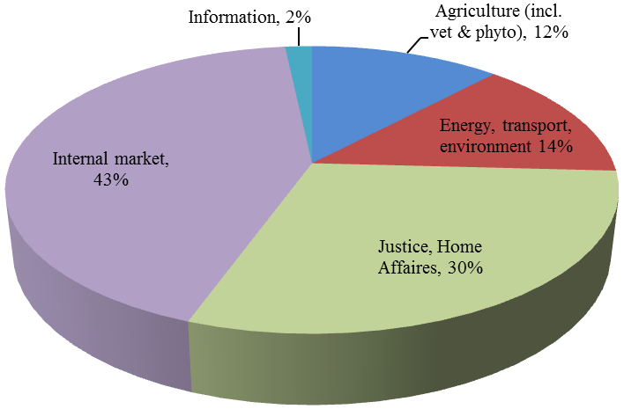

Source: European Commission

8.5 Type of assistance provided (period 2009-2013)

 | Expert Mission | Study Visit | Workshop | Total
Algeria | 43 | 13 | 24 | 80
Armenia | 30 | 32 | 36 | 98
Azerbaijan | 39 | 16 | 31 | 86
Belarus | 12 | 73 | 62 | 147
Egypt | 26 | 16 | 17 | 59
Georgia | 46 | 58 | 29 | 133
Israel | 20 | 26 | 36 | 82
Jordan | 39 | 42 | 20 | 101
Lebanon | 21 | 22 | 11 | 54
Libya | 1 | 1 | 20 | 22
Republic of Moldova | 81 | 139 | 94 | 314
Morocco | 57 | 20 | 14 | 91
Palestine | 11 | 36 | 14 | 61
Tunisia | 24 | 21 | 18 | 63
Ukraine | 62 | 93 | 138 | 293
Russian Federation | 17 | 15 | 27 | 59

Source: European Commission

8.6 SIGMA – Support for Improvement in Governance and Management

SIGMA, a joint initiative of OECD (Organization for Economic Cooperation and Development) and the EU, was founded in 1992. Principally financed by the EU, it focuses on strengthening public management in areas such as administrative reform, public procurement, public sector ethics, anti-corruption, and external and internal financial control. On a demand-driven basis, it has been assisting countries in installing governance and administrative systems appropriate to a market economy, functioning under the rule of law in a democratic context.

Activities per country / sector 2008 - December 2013

Country | Sector | N° of actions 06.2008 – 06.2011 | N° of actions 07.2011- 12.2013
Algeria | Legal Framework, Civil Service and Justice | 0 | 1
Algeria | Financial Control and External Audit | 0 | 1
Armenia | Legal Framework, Civil Service and Justice | 2 | 2
Armenia | Financial Control and External Audit | 4 | 2
Armenia | Public Procurement | 2 | 2
Armenia | Policy-making | 2 | 0
Azerbaijan | Legal Framework, Civil Service and Justice | 1 | 1
Azerbaijan | Public Procurement | 1 | 2
 | Financial Control and External Audit | 1 | 1
Egypt | Legal Framework, Civil Service and Justice | 5 | 2
Egypt | Policy-making | 5 | 1
Georgia | Legal Framework, Civil Service and Justice | 4 | 2
Georgia | Financial Control and External Audit | 2 | 1
Georgia | Public Procurement | 1 | 1
Jordan | Legal Framework, Civil Service and Justice | 1 | 1
Jordan | Financial Control and External Audit | 1 | 4
Jordan | Policy-making | 2 | 1
Lebanon | Legal Framework, Civil Service and Justice | 0 | 4
Lebanon | Public Procurement | 1 | 2
Lebanon | Policy making | 0 | 1
Republic of Moldova | Legal Framework, Civil Service and Justice | 3 | 2
Republic of Moldova | Public Procurement | 0 | 2
Republic of Moldova | Financial Control and External Audit | 0 | 2
Morocco | Legal Framework, Civil Service and Justice | 5 | 7
Morocco | Financial Control and External Audit | 1 | 1
Morocco | Public Procurement | 1 | 1
Tunisia | Legal Framework, Civil Service and Justice | 4 | 4
Tunisia | Financial Control and External Audit | 1 | 0
Tunisia | Public Procurement | 1 | 0
Ukraine | Legal Framework, Civil Service and Justice | 2 | 2
Ukraine | Financial Control and External Audit | 2 | 1
Ukraine | Public Procurement | 1 | 1
Multi- country South | Fiscal management | 1 | 2
Multi- country East | Financial Control and External Audit | 1 | 1
Multi- country East | Public procurement |  | 1
Multi- country | Networking Seminar | 1 | 3
TOTAL |  | 59 | 62

Number of SIGMA actions per country for the periods June 2008- June 2011 and June 2011-December 2012

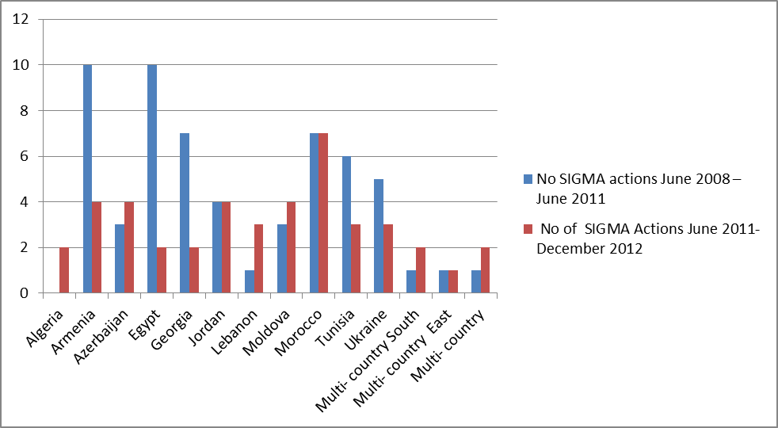

Source: European Commission
8.7 Twinning projects
Twinning is a joint implementation tool of cooperation between Public Administration of an EU Member State and of a Beneficiary Country. Twinning is used to support the efforts of neighbour countries to harmonise their regulations with EU legislation. It aims at modernising the institution of the Beneficiary Country through training, reorganization as well as drafting of laws and regulations modelled after the EU acquis. It should be related to the domains of cooperation foreseen by the Action Plan of the European Neighbourhood Policy. It consists of sending to the Beneficiary Country at least one resident adviser and a number of medium and short-term missions, all to be carried out by public officials of the EU Member State institution.

Number of Twinning Projects

Country | Concluded | Ongoing | Negotiation of contract | Call for proposal open | Call for proposals unsuccessful
Algeria | 5 | 5 | 3 | 2 | 2
Armenia | 6 | 6 | 1 | 1 | 0
Azerbaijan | 15 | 8 | 3 | 0 | 3
Egypt | 13 | 8 | 0 | 2 | 1
Georgia | 9 | 5 | 1 | 2 | 0
Israel | 5 | 3 | 0 | 0 | 1
Jordan | 16 | 9 | 0 | 0 | 0
Lebanon | 6 | 4 | 0 | 0 | 1
Republic of Moldova | 5 | 5 | 3 | 1 | 2
Morocco | 21 | 8 | 0 | 1 | 1
Tunisia | 23 | 14 | 0 | 1 | 2
Ukraine | 26 | 11 | 2 | 1 | 2
Total | 150 | 86 | 13 | 11 | 15
Source: European Commission

8.8 Twinning projects ENP 2005 – 2013 (per sector)

Sector | Number of projects
Agriculture | 11
Employment and social affairs | 22
Energy | 13
Environment | 16
Finance | 57
Health and consumer protection | 24
Justice and home affairs | 32
Telecommunications | 7
Trade and industry | 43
Transport | 22
Statistics | 13
Other | 14
Total | 275

Source: European Commission

8.9 Twinning projects by sector

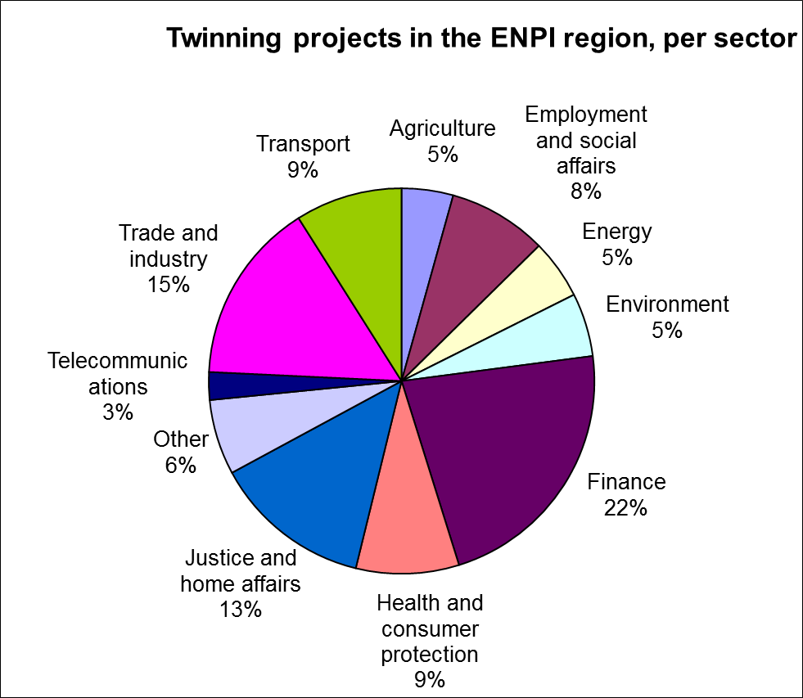

Source: European Commission

8.10 Number of twinning proposals by Member State (2005 – 2013)

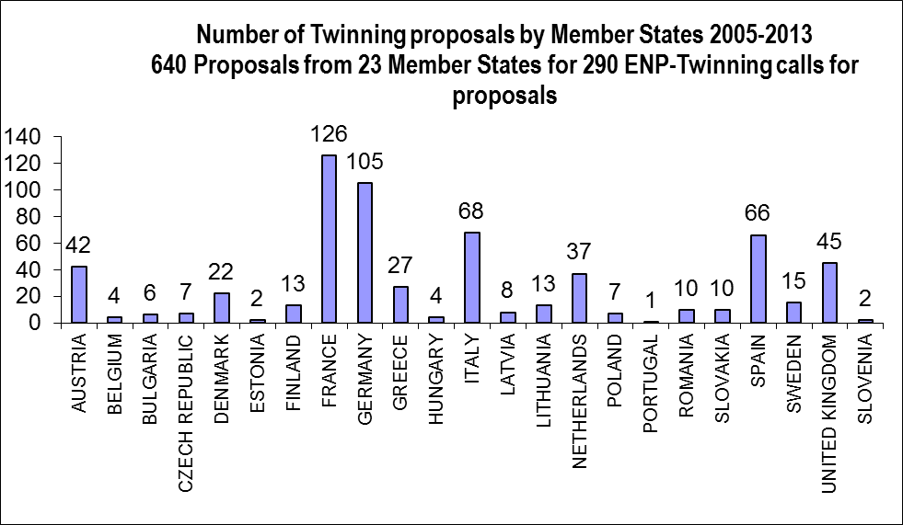

Source: European Commission
Note: The Croatia joined the European Union on 1 July 2013

8.11 Member States selected in twinning projects (2005 – 2013)

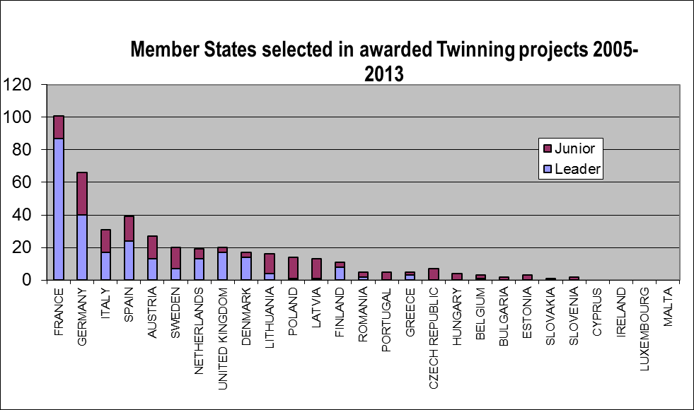

Source: European Commission
Note: The Croatia joined the European Union on 1 July 2013

9. Neighbourhood Investment Facility (NIF) Projects in 2013

9.1 List of projects approved for a contribution in 2013

Projects in the ENP East Region

Country | Title | Lead FI | Sector | NIF contribution (in EUR million) | Total project cost (in EUR million)
Armenia | Yerevan Water Supply Improvement Project | EBRD | Water/  Sanitation | 5.5 | 17.2
Armenia | Communal Infrastructure Programme | KfW | Water/  Sanitation | 15.0 | 87.5
Regional | Caucasus Sustainable Energy Finance Facility | EBRD | Energy | 5.1 | 64.6
Republic of Moldova | Chisinau Water Development Programme | EBRD | Water/  Sanitation | 13.4 | 62.1
Regional | SME Direct Support Facility | EBRD | Private | 10.0 | 61.5
Armenia | North-South Road Corridor | EIB | Transport | 12.0 | 381.0
Armenia | NMC Social & Energy Efficiency Housing Finance | AFD | Social | 1.5 | 11.5
Republic of Moldova | Moldova Roads Rehabilitation IV | EBRD | Transport | 15.0 | 315.5
Republic of Moldova | Moldova Railways fleet renewal | EBRD | Transport | 5.0 | 66.5
Georgia | Jvari-Khorga Interconnection (Transmission line and substation) | KfW | Energy | 8.0 | 71.4
TOTAL |  |  |  | 90.5 | 1138.8

Source: European Commission
Projects in the ENP South Region

Country | Title | Lead FI | Sector | NIF contribution (in EUR million) | Total project cost (in EUR million)
Morocco | Integrated Wind Programme | KfW | Energy | 15.0 | 859.0
Regional | SEMED Sustainable Energy Financing Facility | EBRD | Energy | 16.5 | 141.7
Regional | PPP Project preparation "MED P5 Initiative" | EIB | Mixed | 5.0 | 5.0
Regional | EU Neighbourhood Programme Management and Support in the Transport sector | EIB | Transport | 5.0 | 7.1
Jordan | AFD Sustainable Credit Facility harmonization with SEMED SEFF | AFD | Energy | 1.5 | 38.50
Egypt | Kafr El Shekh Wastewater Expansion (KESWE) | EIB | Water/  Sanitation | 15.0 | 163.5
Tunisia | Integrated Depollution Programme (Lake Bizerte) | EIB | Water/  Sanitation | 15.0 | 90.0
TOTAL |  |  |  | 73 | 1304.8

Source: European Commission

9.2 Distribution of NIF contribution by sector in 2013

Source: European Commission

9.3 NIF contributions pledged by Member States (2008 – 2013)

Member State | Total pledges 2008-2013  (in EUR million)
Austria | 3
Bulgaria | 1
Czech Republic | 2
Estonia | 2
Finland | 3
France | 25
Germany | 31
Greece | 1
Italy | 1
Luxembourg | 1
Poland | 3
Portugal | 1
Romania | 1
Spain | 2
Sweden | 1
TOTAL | 78

Source: European Commission
9.4 NIF contributions by Partner Country

ENP East Region

Country | N° of projects approved in 2013 | Amount of contributions 2013  (EUR million) | N° of projects approved  2008-2013 | Amount of total contributions  (EUR million)
Armenia | 4 | 34 | 9 | 67.1
Azerbaijan | 0 | 0 | 1 | 3.4
Georgia | 1 | 8 | 9 | 63.9
Republic of Moldova | 3 | 33.42 | 15 | 103.47
Ukraine | 0 | 0 | 6 | 23.7
Regional East | 2 | 15.1 | 10 | 83.68
TOTAL | 10 | 90.52 | 50 | 345.25

ENP South region
Country | N° of projects approved in 2013 | Amount of contributions 2013  (EUR million) | N° of projects approved  2008-2013 | Amount of total contributions  (EUR million)
Egypt | 1 | 15 | 12 | 137.3
Jordan | 1 | 1.5 | 2 | 3.7
Lebanon | 0 | 0 | 3 | 14.0
Morocco | 1 | 15 | 9 | 109.8
Tunisia | 1 | 15 | 7 | 52.8
Regional South | 3 | 26.5 | 9 | 90.5
TOTAL | 7 | 73 | 42 | 408.1

Source: European Commission

Action in support of employment and local development: location Algeria, Morocco, Tunisia and France
Action covering migrants’ human rights along East Africa Route: location Egypt, Ethiopia and Sudan
If we add to this amount, the bilateral funds for Lebanon re-oriented to address the consequences of the Syrian crisis as well as the SPRING envelopes in Lebanon and Jordan used for the same purpose (included in Lebanon and Jordan fiches), the overall amount of funds committed in 2013 to address the consequences of the Syrian crisis amount to EUR 278.8 M.
This amount only includes disbursement in Syria, whereas the amount committed in 2012 also include activities in the neighbouring countries to address the Syrian crisis but disbursed by other delegations.
Idem.
EUR 1 M EIDHR country allocation for 2013 + EUR 5 M additional mobilised in the frame of the joint HR/VP communication “towards an EU comprehensive response to the Syrian crisis” on 24 June 2013.
Action in support of Maghreb-Mashreq children: location Egypt, Morocco, Tunisia and Italy.

