Introduction
In 2011 the Commission adopted a Communication on Blue Growth showing how Europe's coasts, seas and oceans have the potential to be a major source of new jobs and growth that can contribute to the Europe 2020 strategy and improve the way we harvest the planet's resources. The Communication singled out particular emerging industries for special attention. It outlined its approach to realising the potential of ocean energy in January 2014 and subsequently launched the Ocean Energy Forum to identify bottlenecks to growth and suggest ways to unblock them.
Innovation across all sectors of the blue economy is crucial for realising its growth and jobs potential. Innovation can also bring about significant environmental benefits. This can be through "eco-innovations", for example to reduce sulphur emissions from ships through improved on-board exhaust gas cleaning systems, cleaner traditional fuels or alternative fuel sources. Innovation can also help to develop cost-effective marine protection measures that can contribute to the implementation of the Marine Strategy Framework Directive (MSFD).
The EU's Innovation Union Flagship Initiative is already helping to create an innovation-friendly environment. Small and medium enterprises (SMEs) have been supported by the Competitiveness and Innovation Framework Programme which mobilised more than €15 billion for SME's from 2007-2012. The new €79 billion Horizon 2020 programme has now become the EU's largest ever research and innovation programme and includes enhanced measures to support SMEs. In addition, a significant proportion of the EU's Structural and Investment Funds have been earmarked for innovation.
However, a number of weaknesses identified by the Innovation Union Flagship need to be tackled: under-investment in knowledge, poor access to finance, the high cost of intellectual property rights, slow progress towards interoperable standards, ineffective use of public procurement and duplications in research. The Commission's Annual Growth Survey for 2014 also reported that there is not yet enough collaboration between the public and private sectors on innovation and that the inability to transfer research results into goods and services as well as a growing skills gap are affecting knowledge intensive sectors.
In order to develop the potential of the blue economy in Europe, Member States need to put in place policies and local solutions that effectively address these barriers. In the context of the European semester, the Commission will make sure that Member States' National Reform Plans mainstream policies reflect blue growth priorities.
But complementary action is needed. The Commission will therefore examine how action at EU level can tackle the following issues that are specific to the blue economy:
- gaps in knowledge and data about the state of our oceans, seabed resources, marine life and risks to habitats and ecosystems;
- diffuse research efforts in marine and maritime science that hinders inter-disciplinary learning and slows the progress of technological breakthroughs in key technologies and innovative business sectors;
- lack of scientists, engineers and skilled workers able to apply new technologies in the marine environment.
This document sets out the Commission's plans for addressing these three issues.

Marine Knowledge and Seabed Mapping
Innovation in the blue economy is held back by a lack of information about the sea, the seabed and the life it supports. Increased knowledge of our seas will promote growth in the blue economy, through both a better knowledge of the resources it contains and a better understanding of how these can be used, in tandem with achieving our environmental objectives.
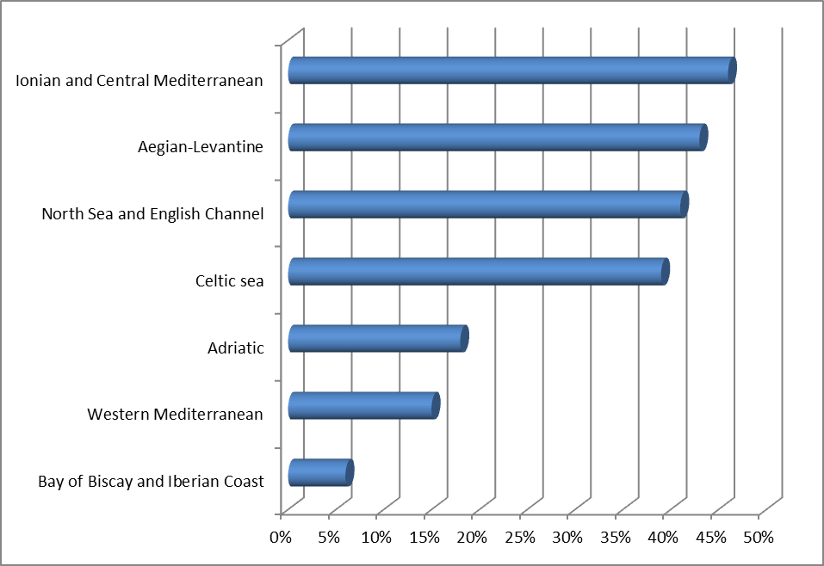
Figure 1Percentage of selected European sea basins that have not been surveyed
Over recent decades there have been substantial investments in ocean observation systems. These have led to improvements in oceanography and weather forecasting through subsequent use of the data in modelling. There are also better processes for making observation data available.
In contrast, the hydrographic, geological and biological research communities dealing with seabed observations and surveys in Europe have taken initial steps to integrate their efforts but still have some way to go. The result is an incomplete knowledge of the basic characteristics of the seafloor: up to 50% of the seafloor lacks high resolution bathymetric surveys (see Figure 1 above) and a far higher proportion lacks mapping of its seabed habitats and communities.
In addition, data from those parts of the seafloor that have been surveyed are not easily accessible. Different sets of marine data are held by many different organisations. Finding out who holds data and obtaining authorisation to use them can be time-consuming and expensive. Assessments show that making data more available and accessible to both public and private sector users will drive forward innovation and competition.
It is estimated that making high-quality marine data held by public bodies in the EU widely available would improve productivity by over €1 billion a year. It would stimulate innovation in the blue economy by making information on the behaviour of the sea and the geology of the seabed more readily available. The benefits of increased innovation could be of the order of €200 - €300 million a year. Furthermore, higher quality and more readily available marine data would facilitate implementation of the Marine Strategy Framework Directive. It would also help the public and private sectors manage risks and uncertainties connected with the sea – for example, the weather, major transport accidents, marine pollution or loss of critical infrastructure.
The Commission has therefore established a sustainable process that aims to ensure that marine data is easily accessible, interoperable and free of restrictions on use, with the specific target of developing a multi-resolution map of the entire seabed and overlying water column of European waters by 2020 as a flagship initiative. This will be achieved by:
- improving the European Marine Observation and Data Network (EMODnet). This is part of the EU's open data initiative and as well as seabed mapping includes information on the physical, chemical and biological characteristics of the overlying water column. Over 100 European organisations are already working together to make their marine data more accessible, interoperable and useful to end-users. Data is now available through a single web portal and a low-resolution sea-bed map of all EU waters, available by 2016, will be progressively improved in resolution;
- integrating data systems. Three further EU initiatives, the Copernicus Marine Service, the Data Collection Framework for fisheries and WISE-Marine for environmental data will be integrated with EMODnet using common standards such as INSPIRE and comply with the principles of the Shared Environmental Information System. Shared research infrastructures such as Euro-Argo and the European Multidisciplinary Seafloor and Water Column Observatory that are currently being consolidated under the European Research Infrastructure Consortium legal framework will also contribute data to EMODnet;
- facilitating the ingestion into EMODnet of non-confidential data collected by private companies, particularly data arising from licensing requirements and environmental impact assessments;
- encouraging EU research programme consortia to grant open access to marine data, including through EMODnet;
- developing a mechanism for strategic coordination of observation systems, sampling programmes and surveying priorities for European sea-basins, through funding from the European Maritime and Fisheries Fund. This will also contribute to develop the EU's Arctic policy, for instance by identifying areas where uncertainty in water depth restricts navigation in newly ice-free waters.
Taken together, these efforts will increase the scope for innovation and investment by public and private operators in the blue economy. They will also strengthen the European Union's position in international efforts such as the Global Earth Observation System of Systems (GEOSS).
A Staff Working Document setting out the milestones and timetable for the Marine Knowledge and seabed mapping processes in more detail, as requested by Council and Parliament, accompanies this Communication.

A Marine Research Information Platform
Remarkable progress has been made since the Commission adopted its European Strategy for Marine and Maritime Research in 2008. Under the Seventh Framework Programme for research (2007-2013) the Commission contributed an average of around €350 million a year towards marine and maritime research.
In addition, as Figure 2 shows, a substantial amount of marine research is carried out through Member States' programmes.
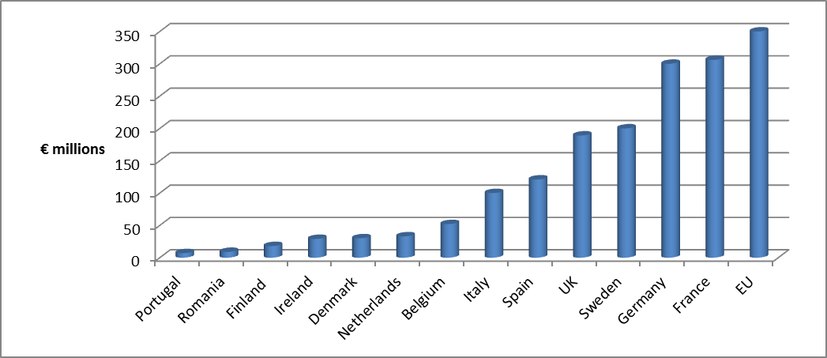
Figure 2: Estimated spending on marine research of selected Member States and the EU (2011) Source: JPI Oceans
Under Horizon 2020, research will focus on how new technologies can put marine resources to productive use and create sustainable growth and jobs, while at the same ensuring that these resources can be enjoyed by future generations.
So as to capture the cross-cutting nature of marine research and the potential for discoveries in one area to have applications in others, the Oceans of Tomorrow initiative has funded 31 projects for a total EU contribution of nearly €195 million. The cross-cutting approach is being continued through a blue growth "focus area" in Horizon 2020 with a €145 million budget for 2014-2015, of which €8 million is earmarked for SMEs.
There are further opportunities for marine research all across the Horizon 2020 programme – in areas such as food security, energy, transport, materials, information technology and research infrastructure.
To ensure complementarity between the strategic research and innovation agenda of Member States and Horizon 2020, the Commission will work closely with the Joint Programming Initiative ‘Healthy and Productive Seas and Oceans’ which has been set up to allow Member States to align their national marine research programmes. This will also improve the knowledge and evidence base for environment policy, a priority objective of the 7th Environment Action Programme.
The private sector also has an important role in helping the Commission to formulate research needs under Horizon 2020 through existing sector-specific initiatives such as LeaderShip 2020, the Waterborne Platform, the Aquaculture Platform and the European Sustainable Shipping Forum. In order to examine further cross-fertilisation of ideas and research results between industrial sectors, NGOs and other stakeholders with a common interest in the blue economy, a Blue Economy Business and Science Forum will be established. It will meet for the first time in the margins of the 2015 European Maritime Day in Piraeus, Greece.
A number of challenges for blue growth, such as ocean acidification, are global in nature and best tackled at an international level. Moreover, certain underpinning research can benefit from international coordination. International cooperation will be intensified through Horizon 2020 by building on the recently signed Galway Statement and the launch of the Canada-EU-US Atlantic Ocean Research Alliance.
In order to make new research opportunities widely accessible and increase synergies between nationally funded research activities and Horizon 2020, the Commission will build on and complement existing information systems to establish an information platform on marine research across the whole Horizon 2020 programme and work with Member States to include information on nationally funded marine research projects. This will deliver a gateway into insights emerging from research projects that can accelerate the uptake of new ideas by industry. It will help ensure that public research funding pays off through innovation by business.

Skills for the Blue Economy
Growth in the blue economy will require an appropriately skilled workforce, able to apply the latest technologies in engineering and a range of other disciplines. There is currently a skills gap that must be tackled.
The figure below illustrates the skills gaps in the offshore wind industry until 2030.
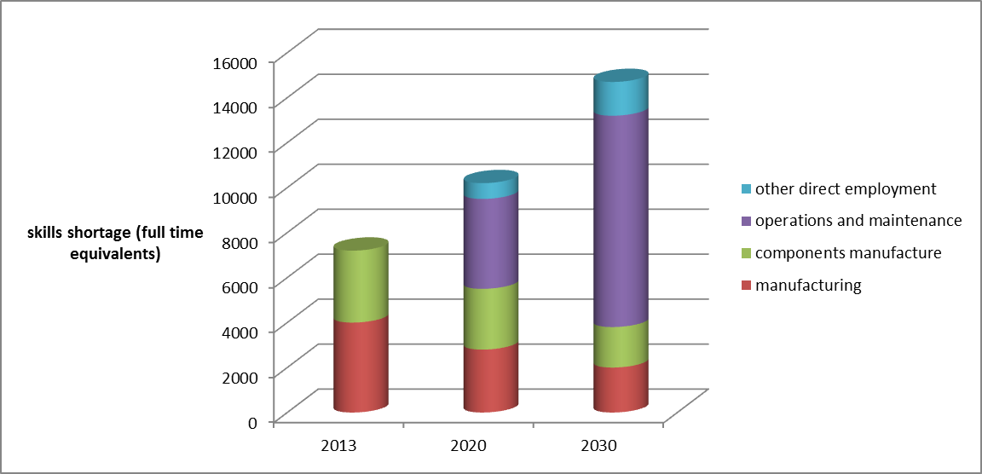
Figure 3 Projected skills gap in the offshore wind industry 2013-2030 (source TPWind survey)
The Marie Sklodowska-Curie Actions (MSCA) are the main support mechanism in Horizon 2020 for human resources in all areas of research and innovation. With a strong focus on building researcher skills for the long term, MSCA combine research excellence with mobility, training and attractive career opportunities. To foster the employability of researchers and to better match their competences with labour market requirements, MSCA encourage researchers to be exposed to a non-academic environment from an early stage of their career. The actions foster sustained collaboration between academia and industry, including by ensuring the participation of a broad spectrum of small and large enterprises in the career development of researchers. MSCA are bottom-up in their nature and do not predetermine a specific scientific field. In the period 2007-2013, the programme that preceded the MSCA awarded nearly €165 million to 374 research projects on marine and maritime themes (including Arctic research). 39 of these projects included the non-academic sector. It is particularly notable that several projects involved scientific cooperation beyond Europe.
To facilitate mobility, EU measures to increase recognition and transparency of skills, competences and qualifications and their related tools, such as the European Qualifications Framework, the European Skills, Competences, qualifications and Occupations (ESCO) portal, Europass and quality assurance and credit systems will need to take the requirements of the blue economy into account.
A further avenue for supporting the development of skills in the blue economy and closer cooperation between higher education and the private sector are Knowledge Alliances, a new scheme under the Erasmus Programme. Knowledge Alliances are structured partnerships bringing together relevant actors from higher education and business to stimulate innovation in and through higher education.
A Sector Skills Alliance (SSA) could also help by bridging the gap between education/training and the labour market. In 2013, the EU supported four pilot SSAs to foster dialogue between industrial sectors and bodies involved in designing, accrediting, implementing and evaluating education and training systems. The SSAs aim to design and deliver joint curricula and methods which provide learners with the skills required by the labour market. The Commission encourages stakeholders in the blue economy to apply for a Knowledge Alliance and marine Sector Skills Alliance
The European Institute of Innovation and Technology (EIT) and its Knowledge and Innovation Communities (KIC) bring together major players from higher education, research and business to stimulate innovation via the full integration of the Knowledge Triangle. The EIT has so far set up three KICs addressing climate change, sustainable energy and ICT-related challenges. Five more KICs are planned under Horizon 2020 in the areas of innovation for healthy living and active ageing, raw materials, food for the future, added value manufacturing and urban mobility. There are currently no plans for a KIC devoted specifically to the blue economy. In the context of the preparation of the Strategic Innovation Agenda and amended legal base of the EIT for the period beyond 2020 the Commission will examine whether the creation of a specific KIC for the blue economy after 2020 could be of value.

Conclusion
Innovation can help develop the blue economy in a way that not only fuels EU growth and job creation but also maintains public support for the commercial use of marine resources while ensuring the protection of the marine environment. As we are standing at the dawn of a century that will be largely affected by how we are able to manage our oceans and their resources, it is important to take concrete steps to develop our understanding of the seas and advance technology so that we can develop their economic potential in a sustainable manner.
The following actions are proposed in this Communication:
Action | Timeline
Establishing a sustainable process ensuring that marine data is easily accessible, interoperable and free of restrictions of use (built around EMODnet, the Data Collection Framework, Copernicus and WISE-Marine) | From 2014 onwards
Delivery of a multi-resolution map of the entire seabed of European waters | January 2020
Creation of an information platform on marine research across the whole Horizon 2020 programme as well as information on nationally- funded marine research projects. | Before 31 December 2015
Creation of a Blue Economy Business and Science Forum | First meeting on European Maritime Day 2015
Encourage the development of a marine Sector Skills Alliance | 2014-2016
The Commission looks forward to the opinions of the European Parliament, the Council and other Institutions on this Communication.

Blue Growth opportunities for marine and maritime sustainable growth COM(2012)494
Blue Growth Scenarios and drivers for Sustainable Growth from the Oceans, Seas and Coasts, Final Report, Call for tenders No. MARE/2010/01, August 2012
Blue Energy Action needed to deliver on the potential of ocean energy in European seas and oceans by 2020 and beyond COM(2014) 8
1999/32/EC, amended by 2012/33/EU. In SECA (in the EU: Baltic and North Sea) the sulphur content of marine fuels will be reduced from 1.50% to 0.10% as of 2015 and it other sea areas from 3,50% to 0,50% as of 2020.
Directive 2008/56/EC establishing a framework for community action in the field of marine environmental policy (Marine Strategy Framework Directive)
Europe 2020 Flagship Initiative Innovation Union COM (2010)546 final
European Commission Press Release MEMO/13/393 of 02/05/2013
Annual Growth Survey 2014, COM(2013) 800
As required under the Marine Strategy Framework Directive (2008/56/EC) to achieve good environmental status, and other environmental policies.
Source: Preparatory Actions for European Marine Observation and Data Network. Service Contract No. "MARE/2009/07 – Seabed Mapping – SI2.563144" Based on 6000 seabed surveys of which approximately 1000 were high-resolution multi-beam surveys.
"Roadmap for Marine Knowledge 2020" which accompanies this Communication provides an estimate of the benefits.
In its report on the first round of implementation of that Directive, entitled "The first phase of implementation of the Marine Strategy Framework Directive 52008/56/EC), The European Commission's assessment and guidance COM(2014)097", the Commission identified a series of shortcomings in Member States’ assessments of the state of their marine waters.
Green Paper "Marine Knowledge 2020: from seabed mapping to ocean forecasting", 29 August COM(2012) 473
Open data An engine for innovation, growth and transparent governance COM(2011) 882
http://emodnet.eu/
Council Regulation (EC) No 199/2008 concerning the establishment of a Community framework for the collection, management and use of data in the fisheries sector and support for scientific advice regarding the Common Fisheries Policy
Directive 2007/2/EC of the European Parliament and of the Council of 14 March 2007 establishing an Infrastructure for Spatial Information in the European Community (INSPIRE)
EU Shared Environmental Information System Implementation Outlook, SWD(2013) 18
fleet of drifting robotic probes deployed worldwide.
Council Regulation (EC) No 723/2009 of 25 June 2009
Developing a European Union Policy towards the Arctic Region: progress since 2008 and next steps JOIN(2012) 19
http://www.earthobservations.org/geoss.shtml
Integrated Maritime Policy General Affairs Council meeting Luxembourg, 24 June 2013
European Parliament report on Marine Knowledge 2020: improving seabed mapping for fisheries purposes (2013/2101(INI)) Committee on Fisheries (Rapporteur Maria do Céu Patrão Neves)
A European Strategy for Marine and Maritime Research A coherent European Research Area framework in support of a sustainable use of oceans and seas COM (2008) 534
Decision No 1386/2013
Such as National Contact Points and the Enterprise Europe Network
Through the Joint Programming Initiative on Seas and oceans.
According to the Leadership2020 report from the stakeholders in the EU's shipbuilding industry the increased complexity of the products has created additional demand for highly skilled staff. Therefore a large part of the industry is suffering from a pronounced scarcity of skilled personnel and this is a restriction on growth.
The European Qualifications Framework (EQF) acts as a translation device to make national qualifications more readable across Europe
an initiative to make your skills and qualifications clearly and easily understood

