 | 
COUNCIL OF  THE EUROPEAN UNION |  |  | Brussels, 21 May 2014
 | Interinstitutional File:  2014/0096(COD) |  | 10087/14
DENLEG 100
AGRI 377
CODEC 1335
INST 245
PARLNAT 139

COVER NOTE
from: | Spanish Parliament
date of receipt: | 20 May 2014
to: | The President of the Council of the European Union
No Cion doc.: | 8099/14 DENLEG 72 AGRI 245 CODEC 3117 - COM(2014) 174 final
Subject: | Proposal for a DIRECTIVE OF THE EUROPEAN PARLIAMENT AND OF THE COUNCIL on the approximation of the laws of the Member States relating to caseins and caseinates intended for human consumption and repealing Council Directive 83/417/EEC  - Opinion on the application of the Principles of Subsidiarity and Proportionality

Delegations will find attached for information a copy of the above opinion.

________________________

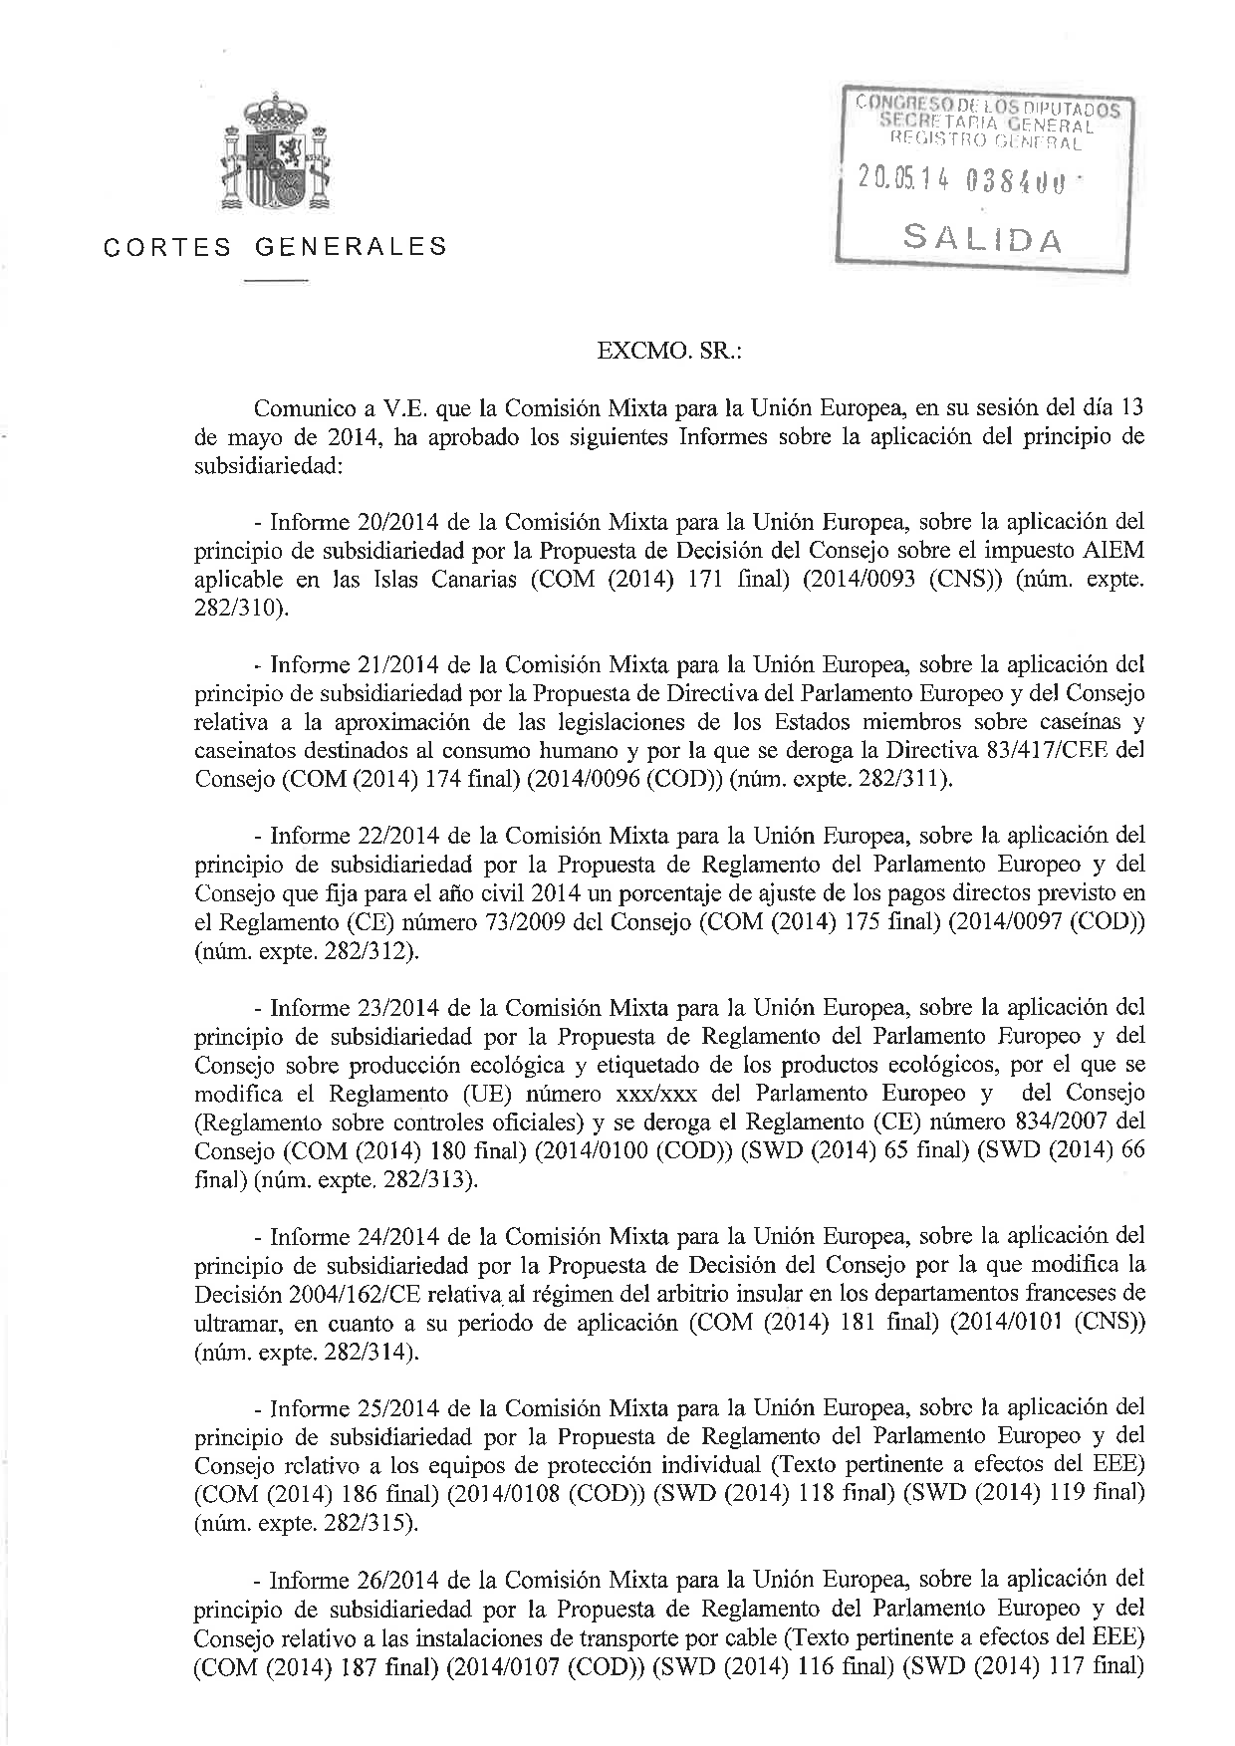
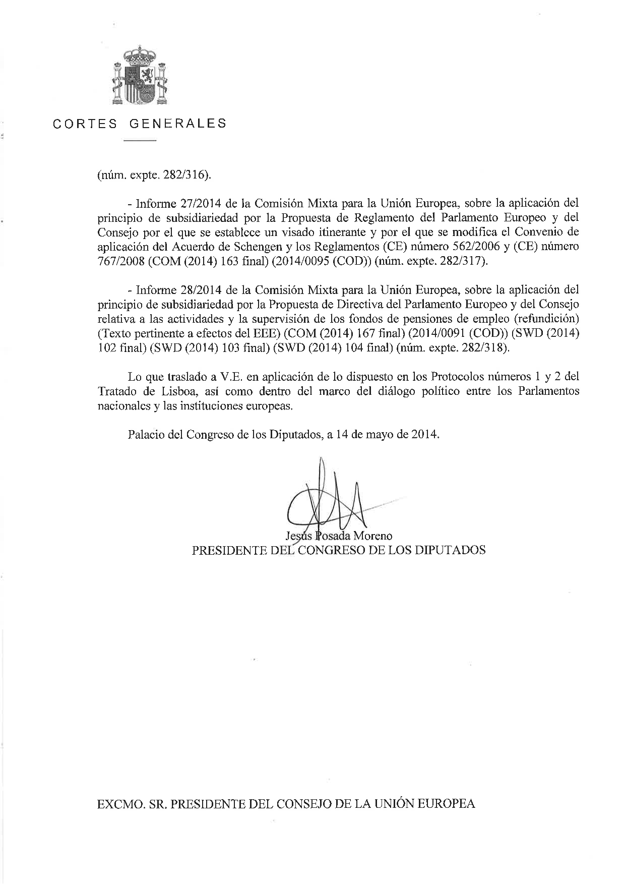
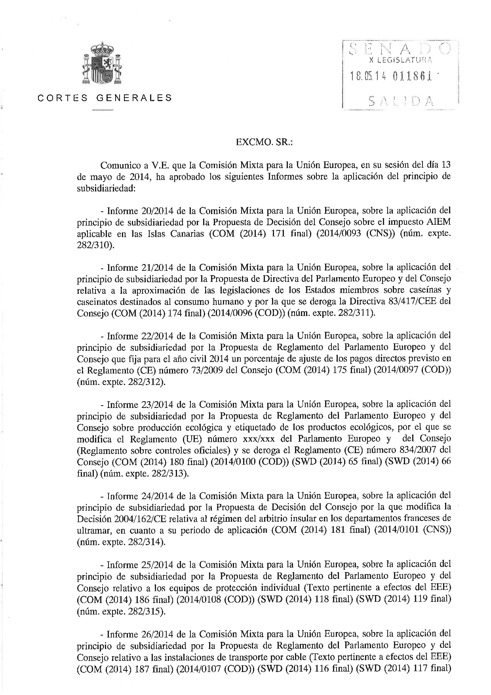
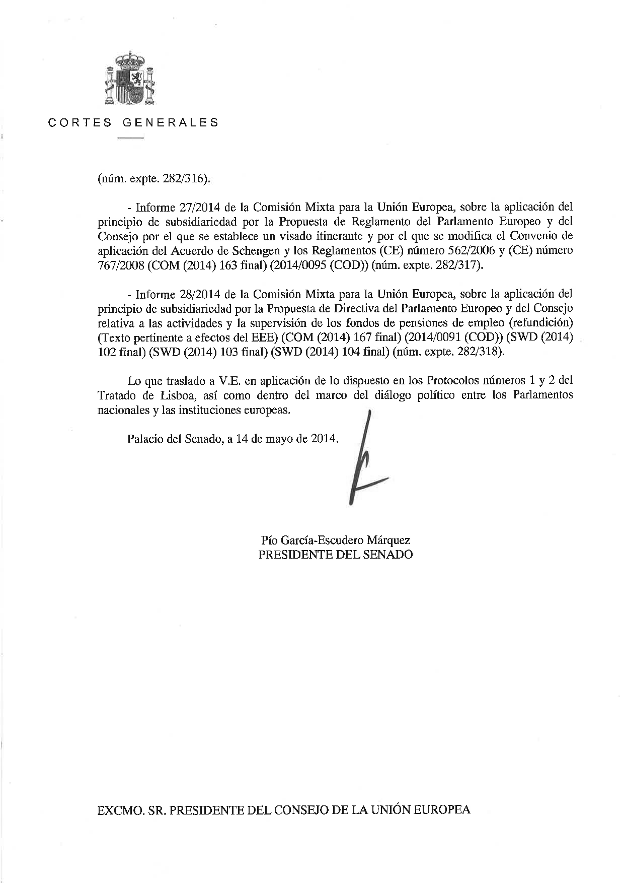
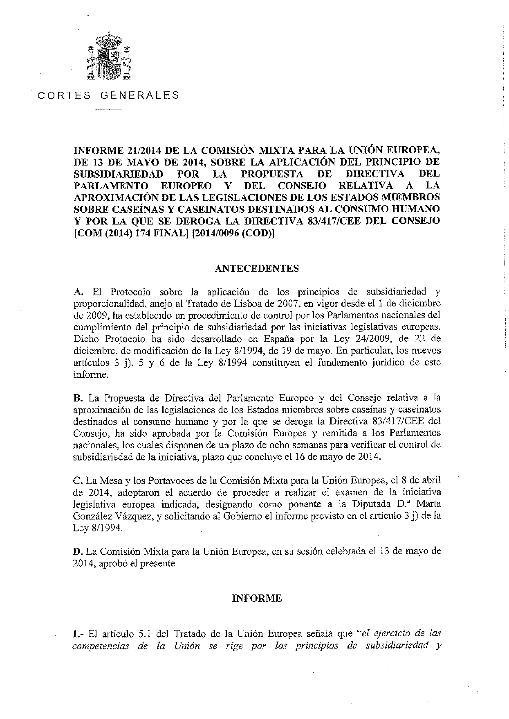
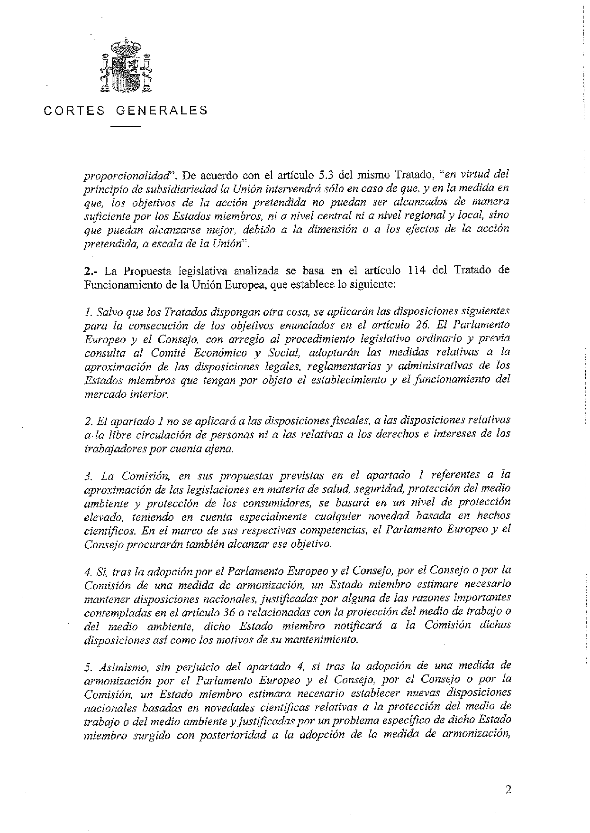
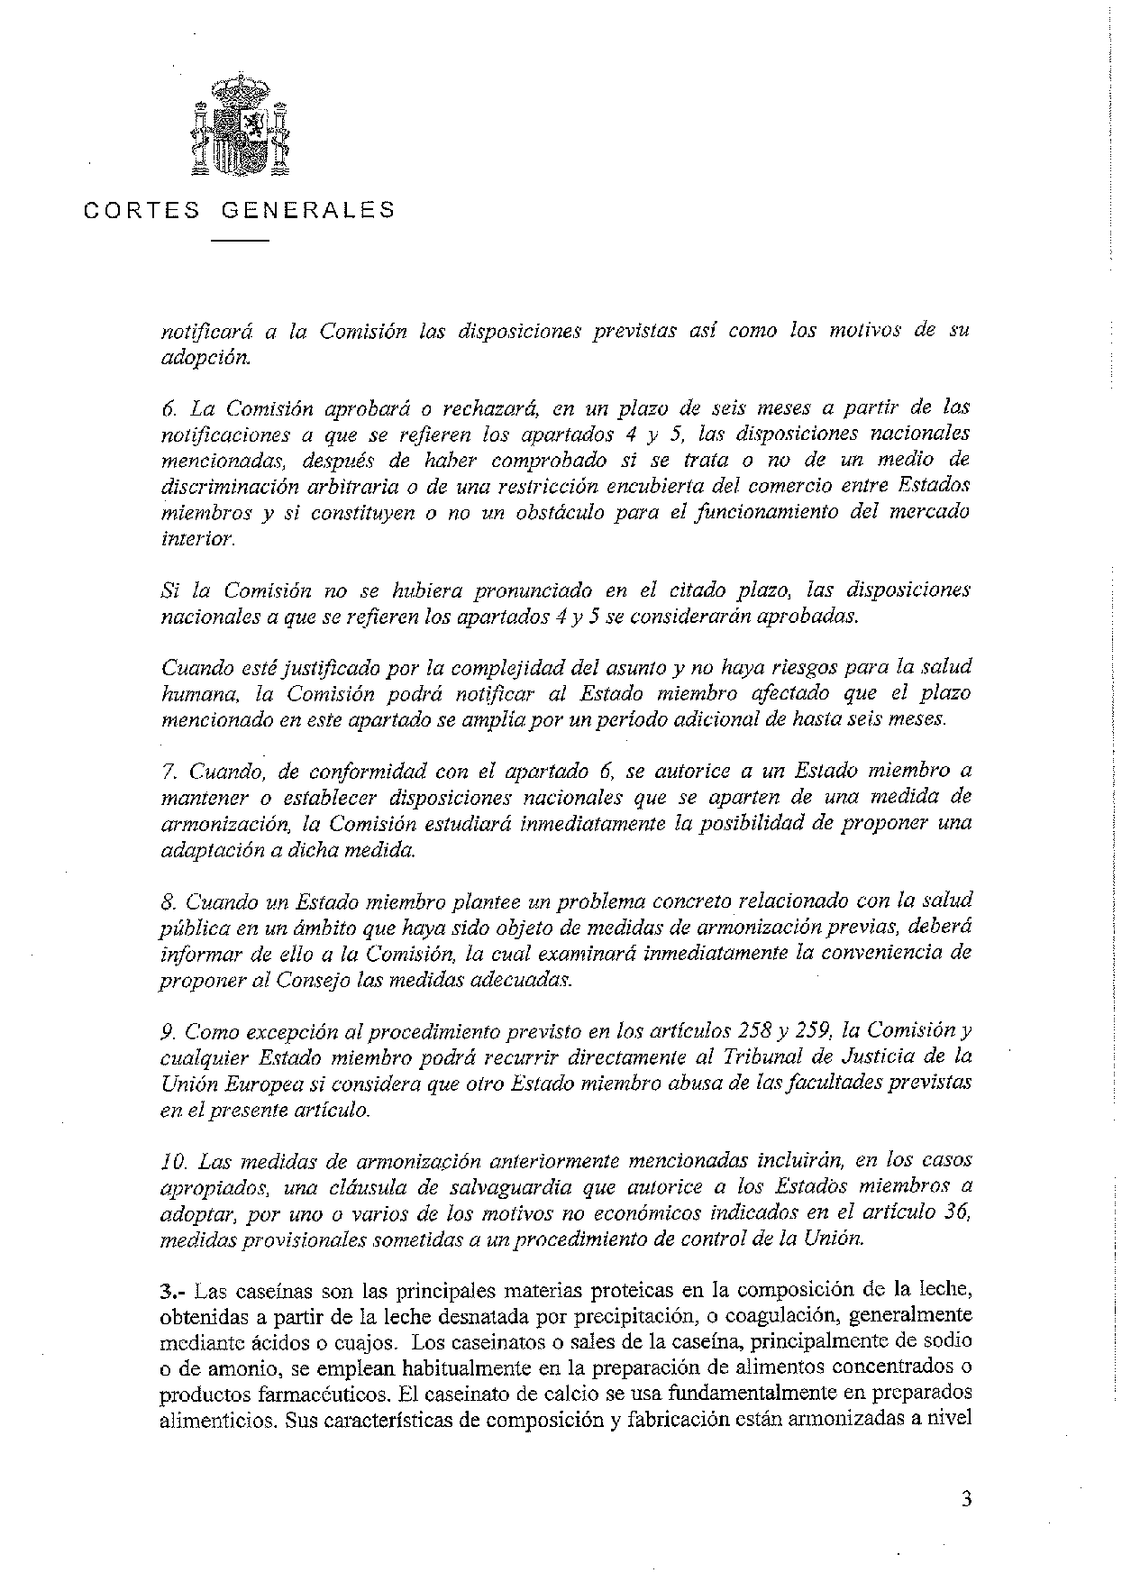
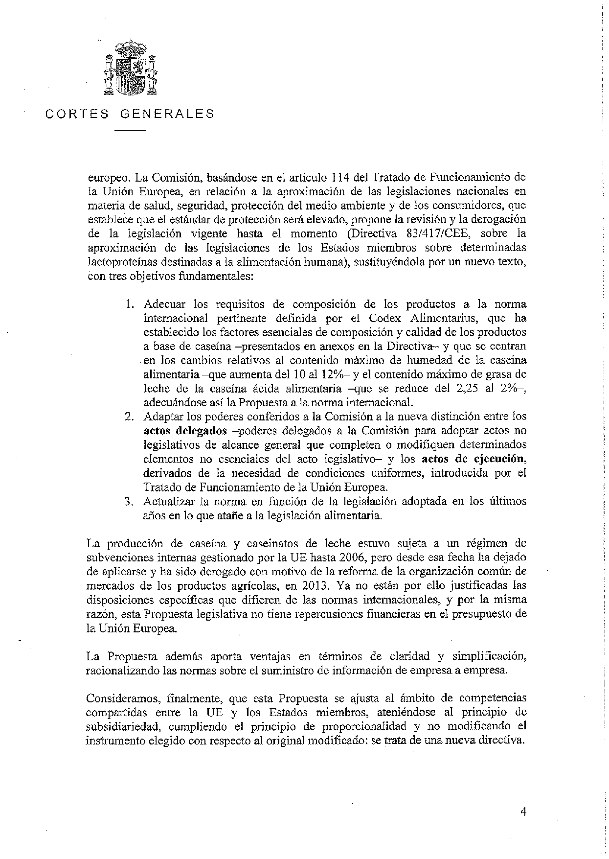
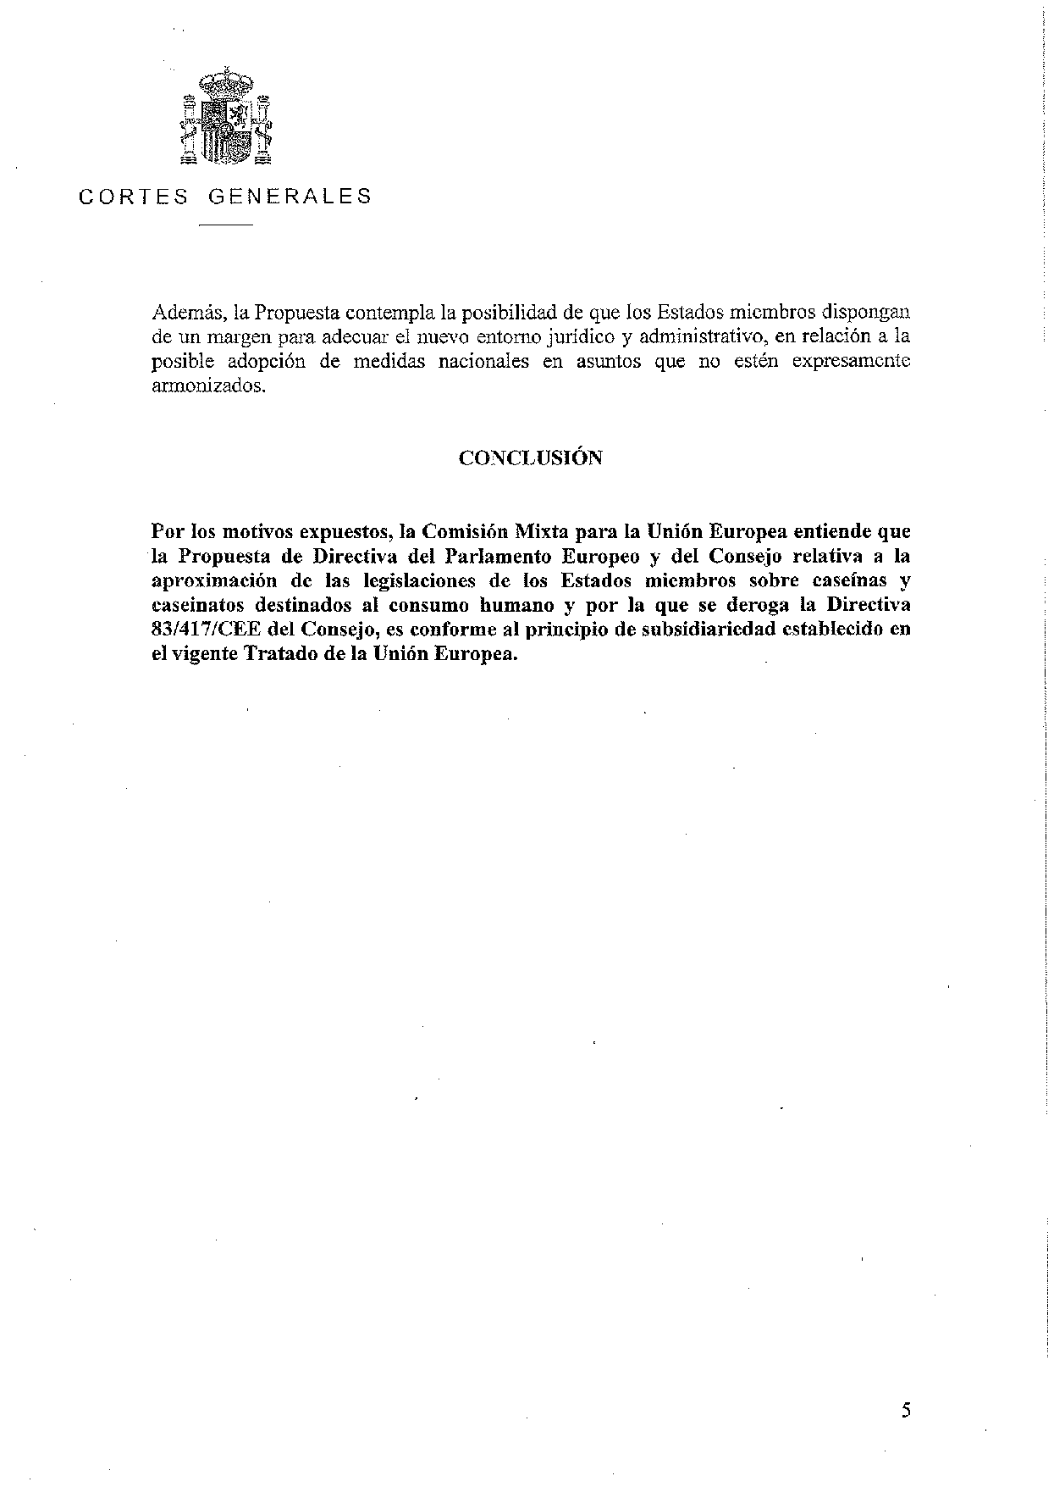
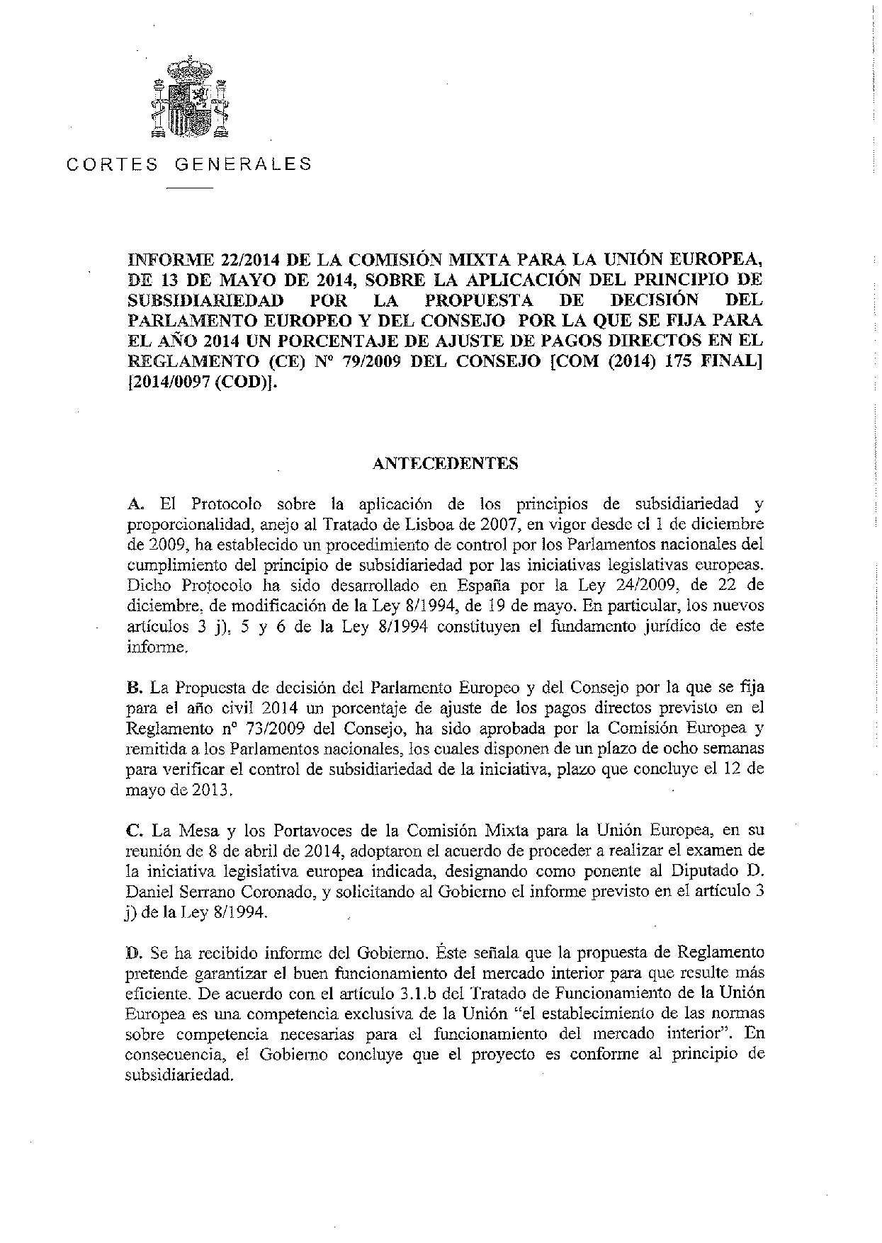
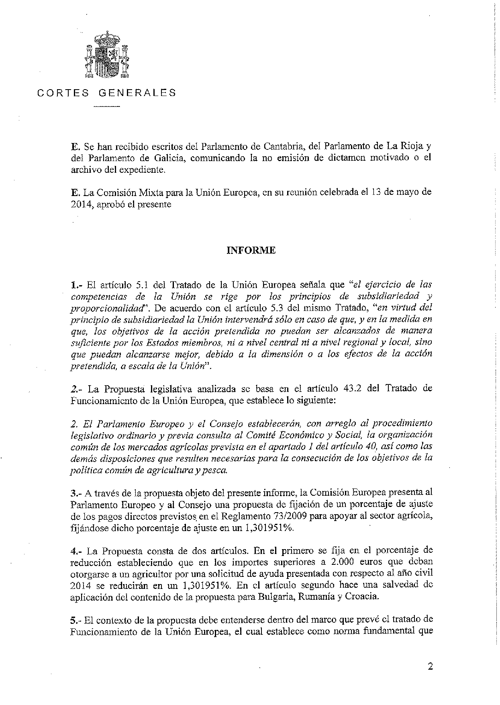
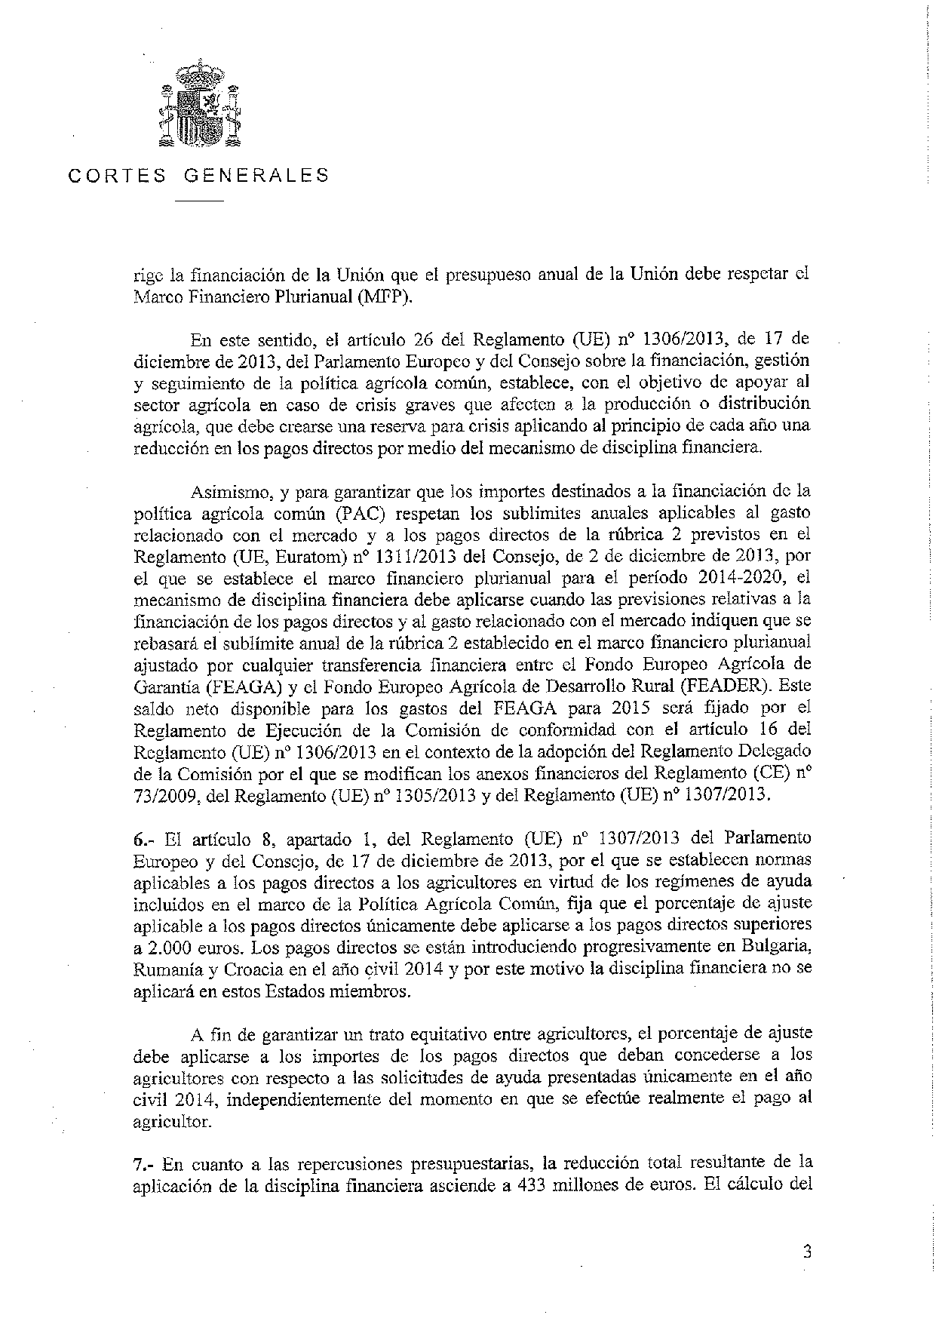
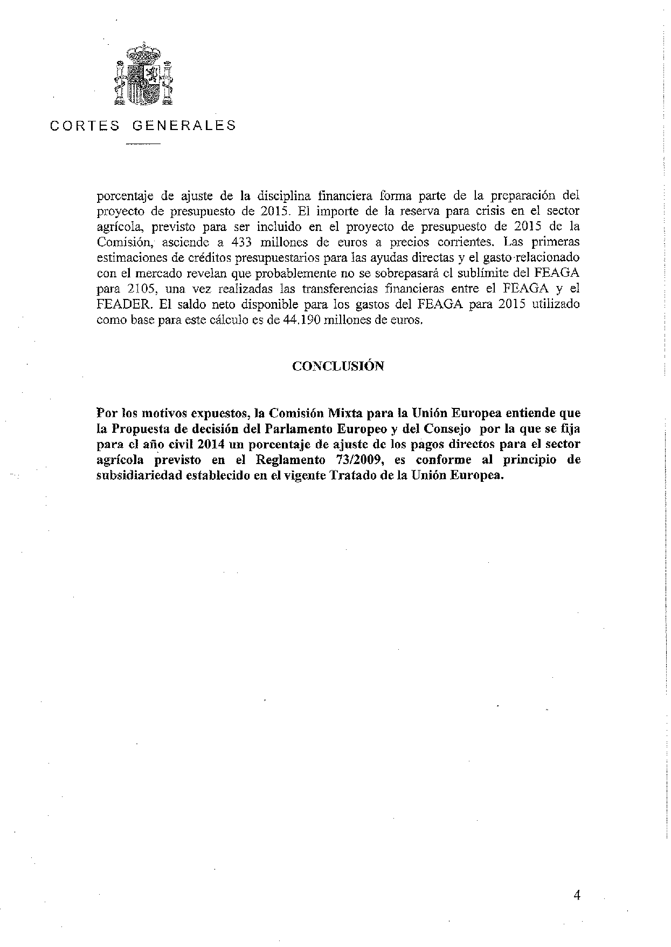

The translation may be available at the Interparliamentary EU information exchange site IPEX at the following address: http://www.ipex.eu/IPEXL-WEB/search.do

