 | 
COUNCIL OF  THE EUROPEAN UNION |  |  | Brussels, 3 January 2014
 | Interinstitutional File:  2013/0343 (CNS) |  | 5007/14
FISC 1
INST 1
PARLNAT 1

COVER NOTE
from: | The Portuguese Parliament
date of receipt: | 18 December 2013
to: | The President of the Council of the European Union
Subject: | Proposal for a COUNCIL DIRECTIVE amending Directive 2006/112/EC on the common system of value added tax as regards a standard VAT return  [doc. 15337/13 FISC 206 - COM(2013) 721 final]  - Opinion on the application of the Principles of Subsidiarity and Proportionality

Delegations will find attached the abovementioned opinion.

________________________

Encl.

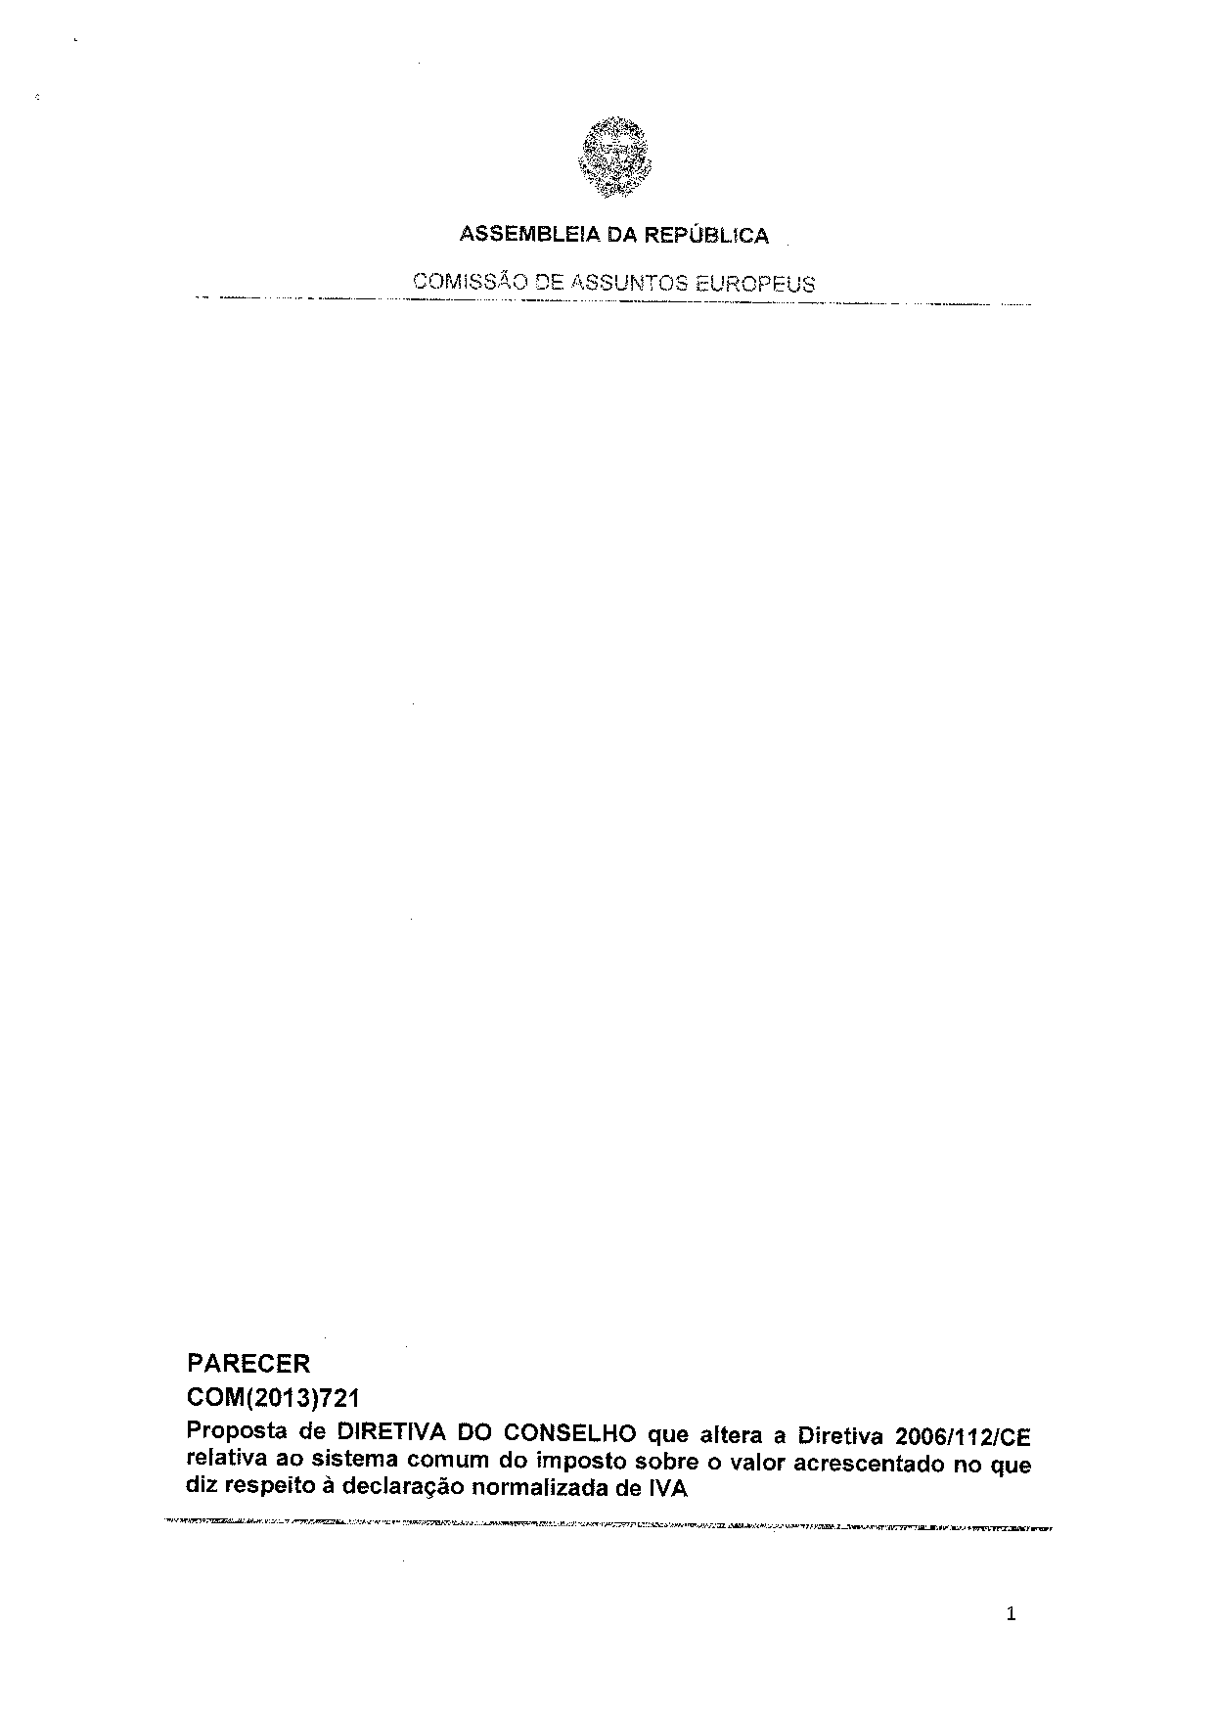
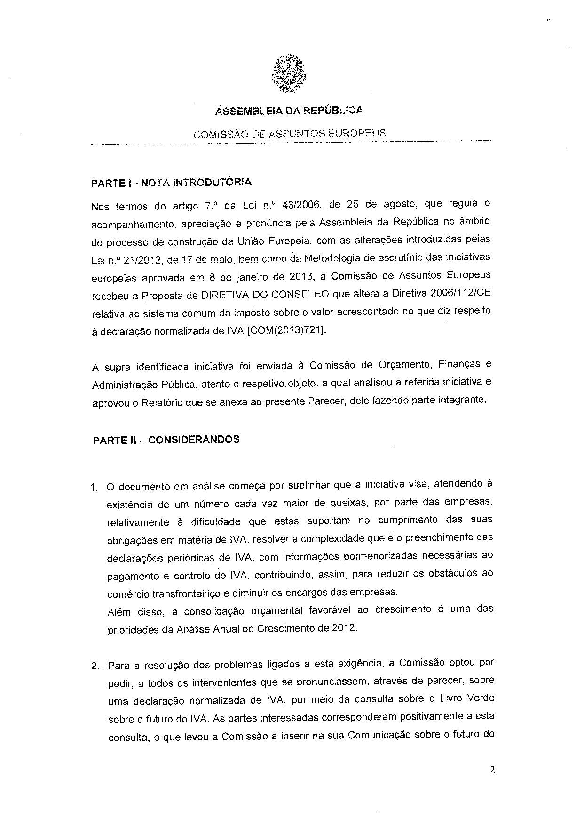
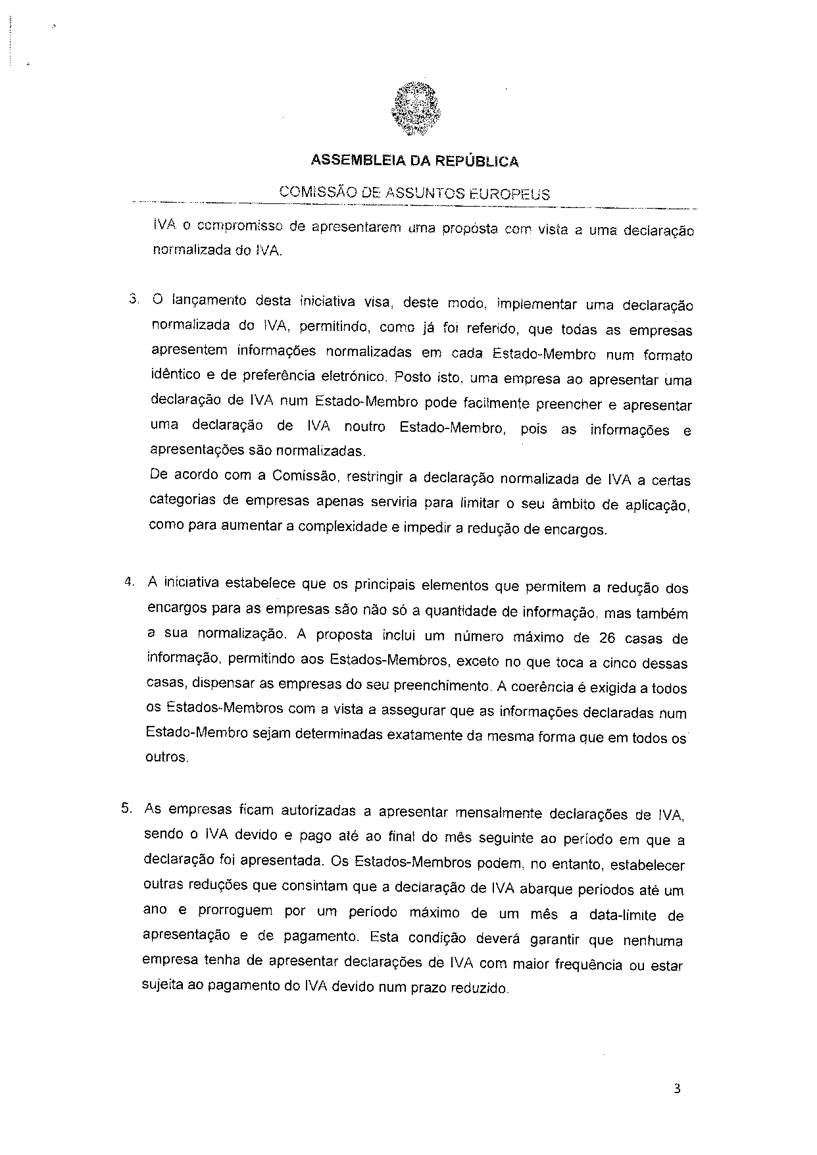

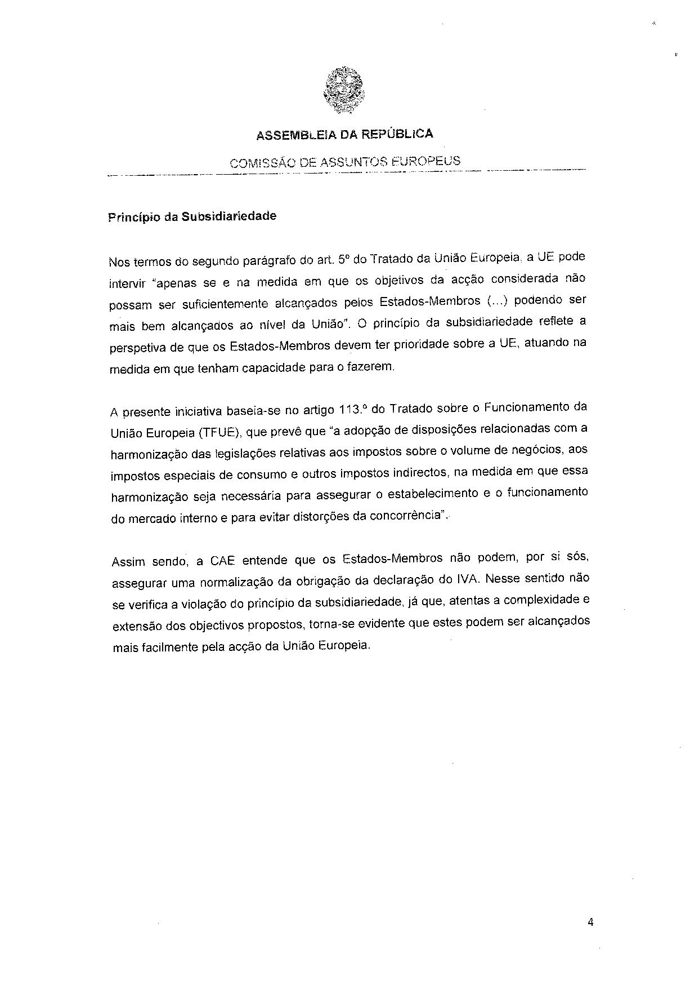

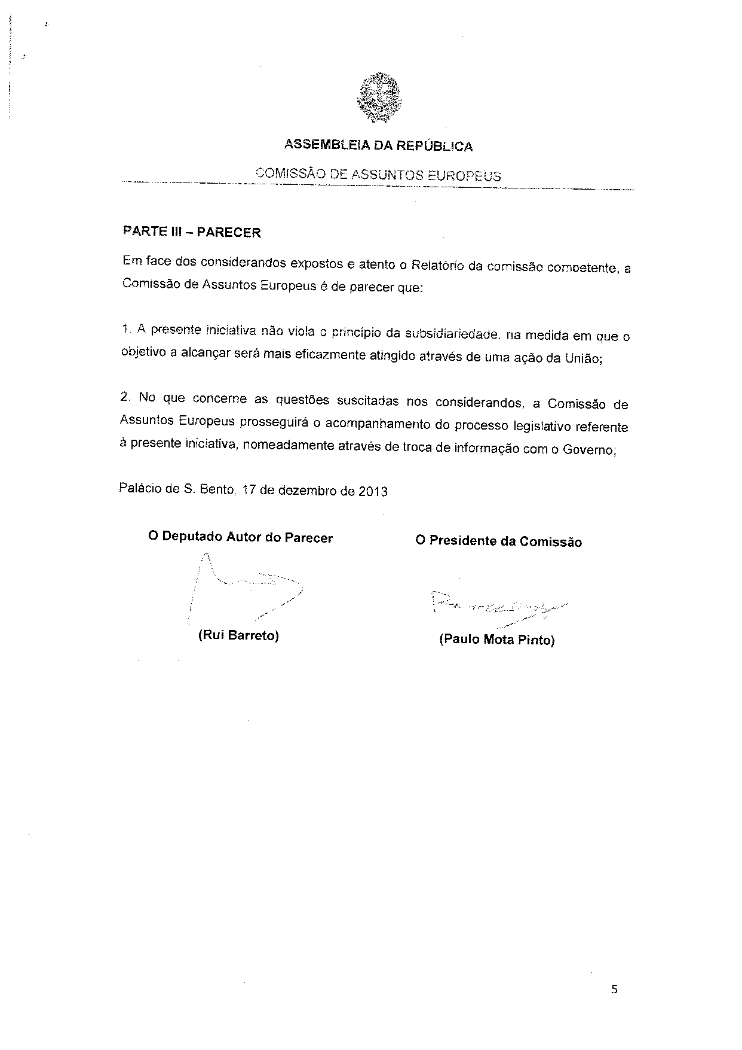

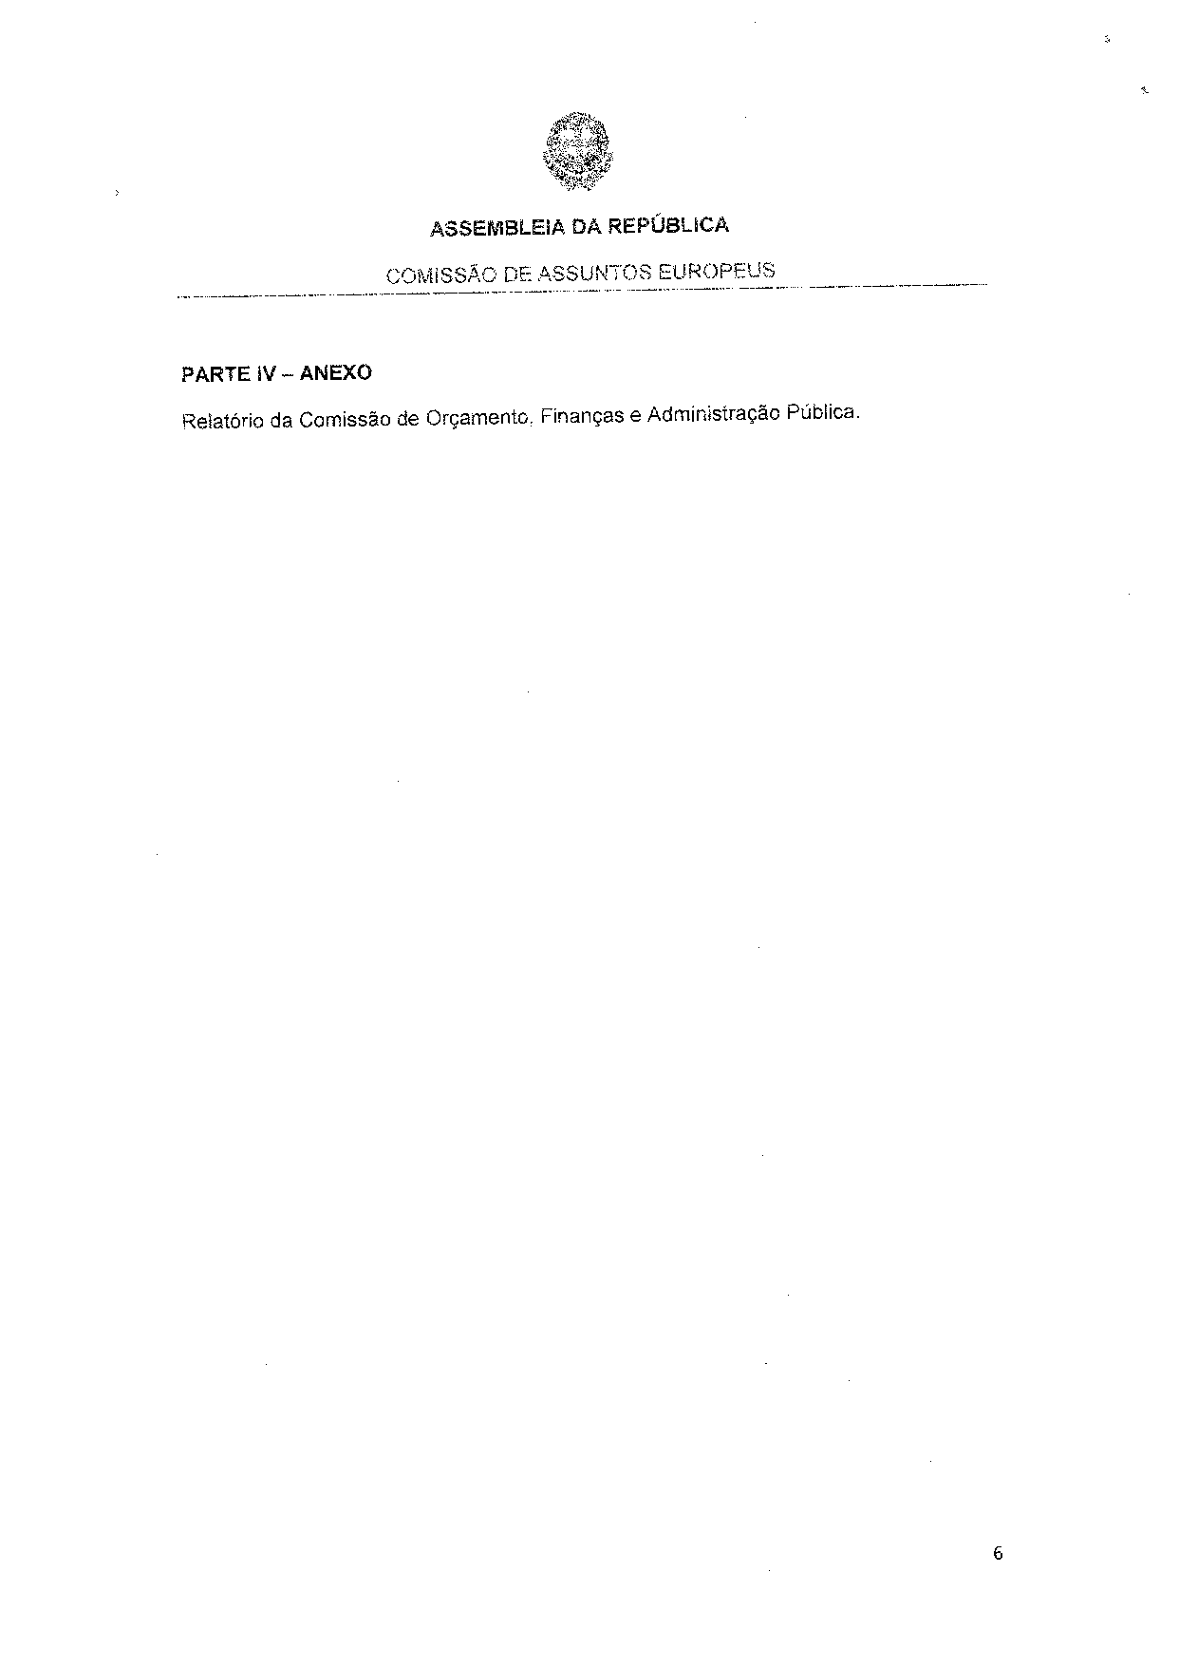

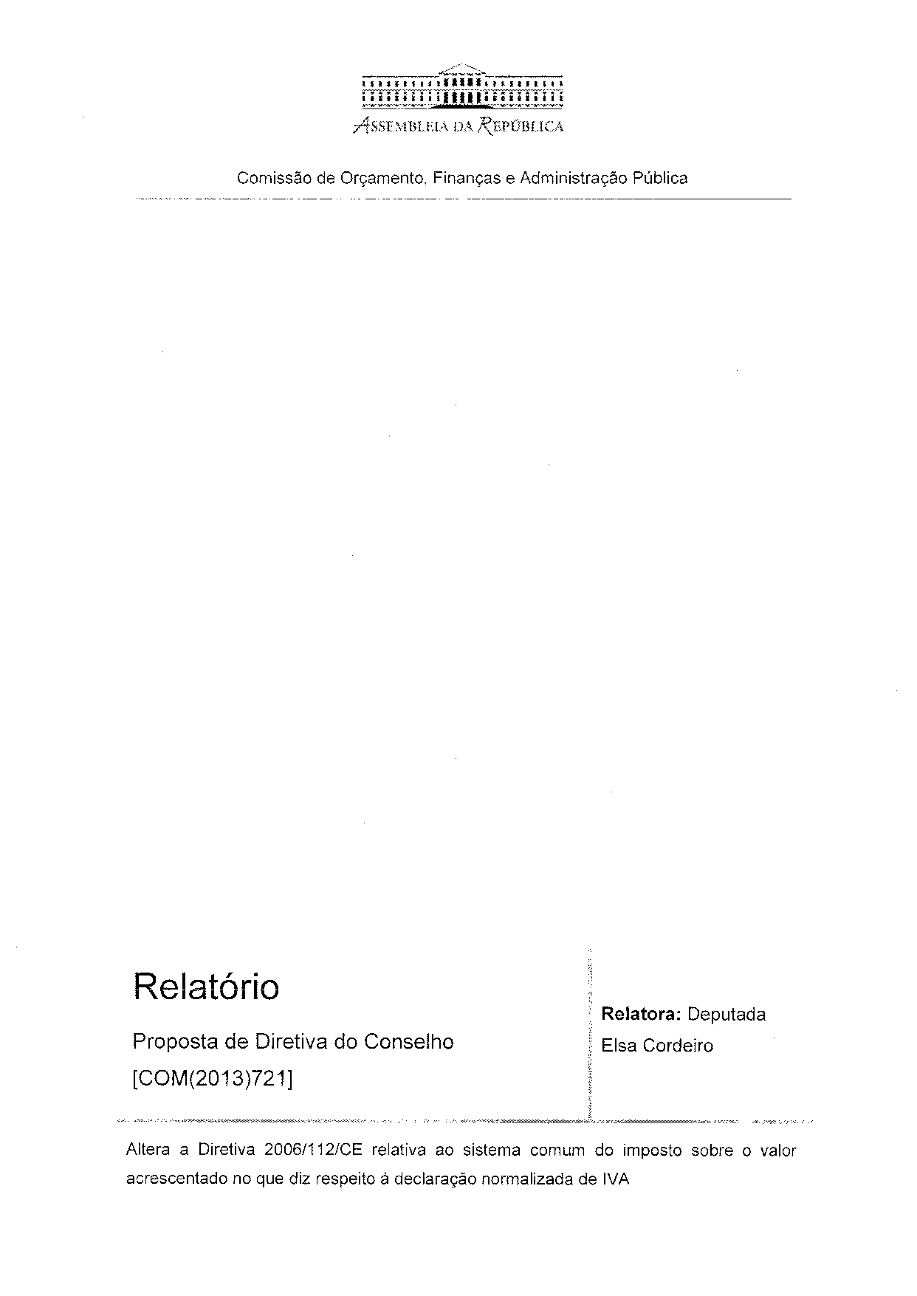

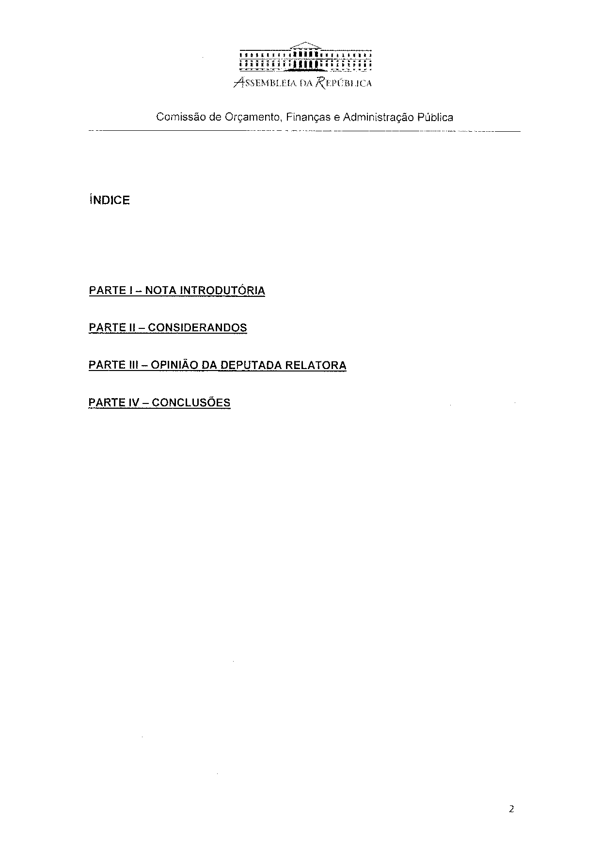

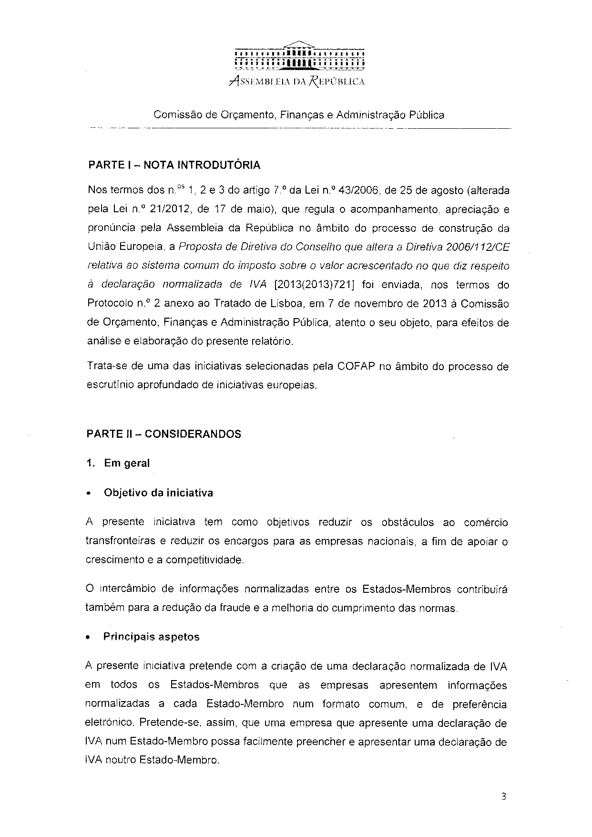

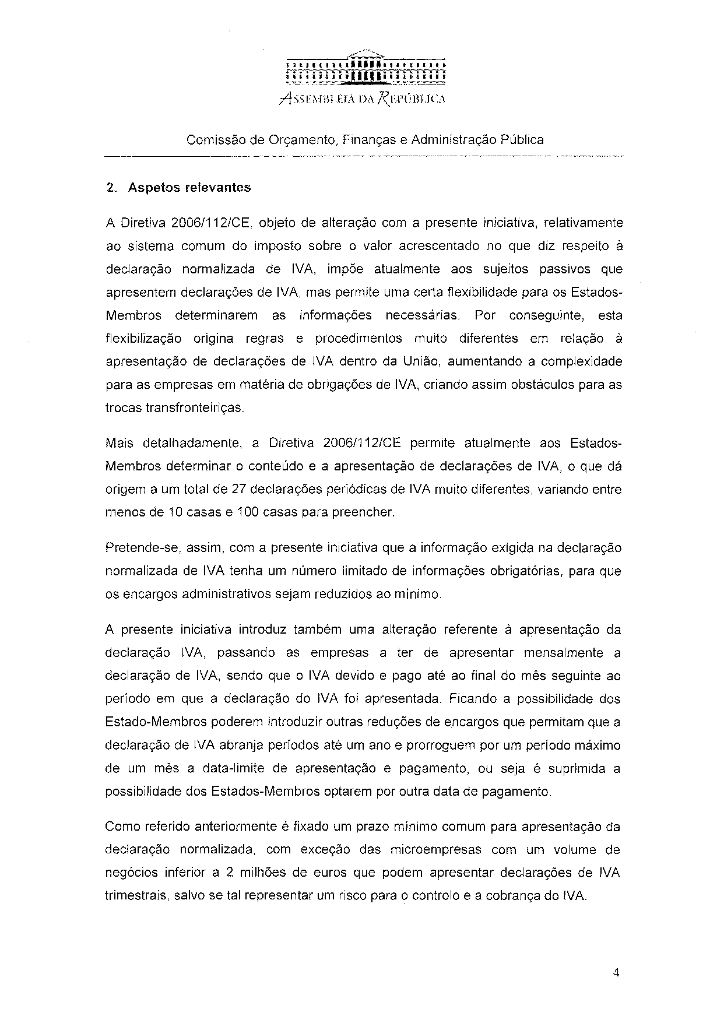

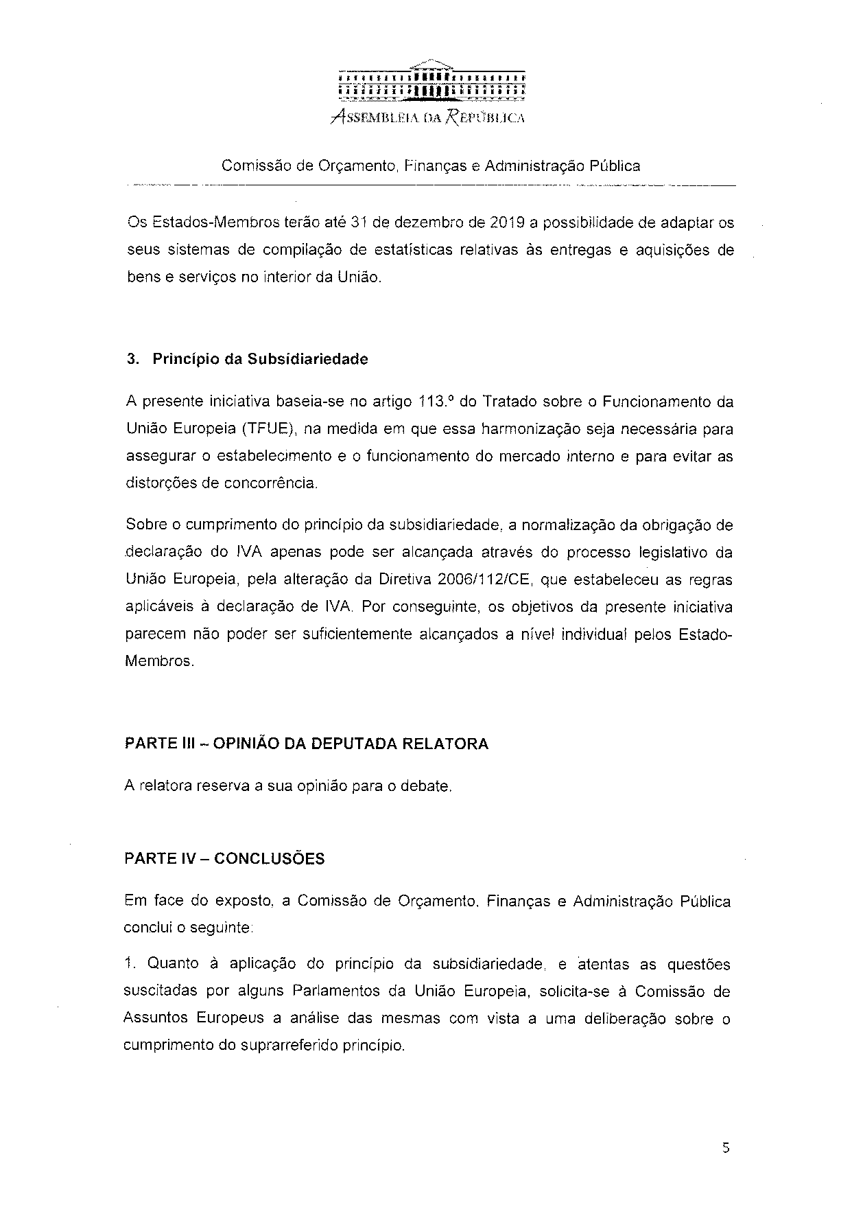
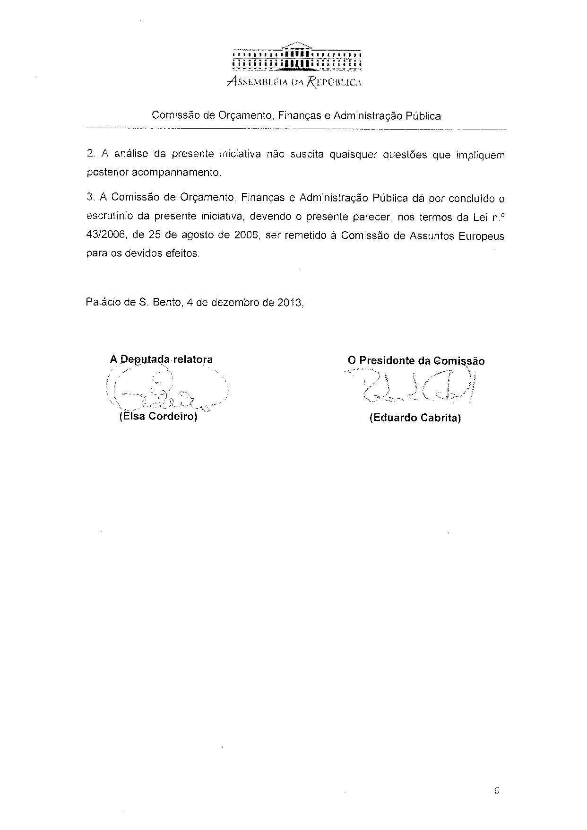

Translation(s) of the opinion may be available on the Interparliamentary EU Information Exchange Site IPEX at the following address: http://www.ipex.eu/IPEXL-WEB/search.do

