 | 
COUNCIL OF  THE EUROPEAN UNION |  |  | Brussels, 13 November 2013
 | Interinstitutional File:  2013/0255 (APP) |  | 16023/13
EPPO 18
EUROJUST 112
CATS 75
FIN 732
COPEN 189
INST 595
PARLNAT 271

OPINION
from: | The Seanad Éireann (Irish Senate)
date of receipt: | 25 October 2013
to: | Council
Subject: | Proposal for a Council Regulation on the establishment of the European Public Prosecutor's Office  Doc. 12558/13 EPPO 3 EUROJUST 58 CATS 35 FIN 467 COPEN 108 [COM(2013) 534 final]  - Opinion on the application of the Principles of Subsidiarity and Proportionality

Delegations will find attached the above mentioned Opinion.

_____________

Encl.

ANNEX

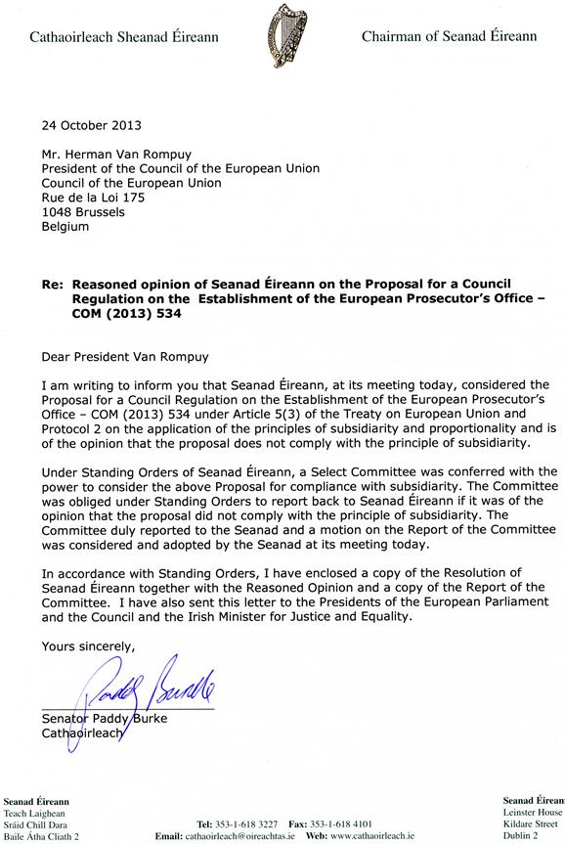

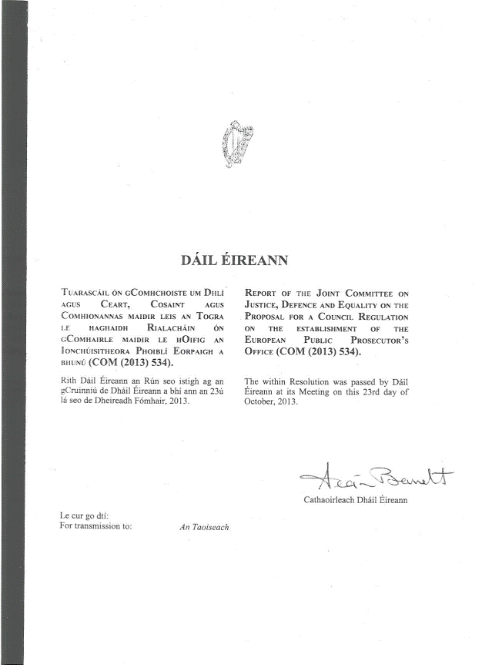

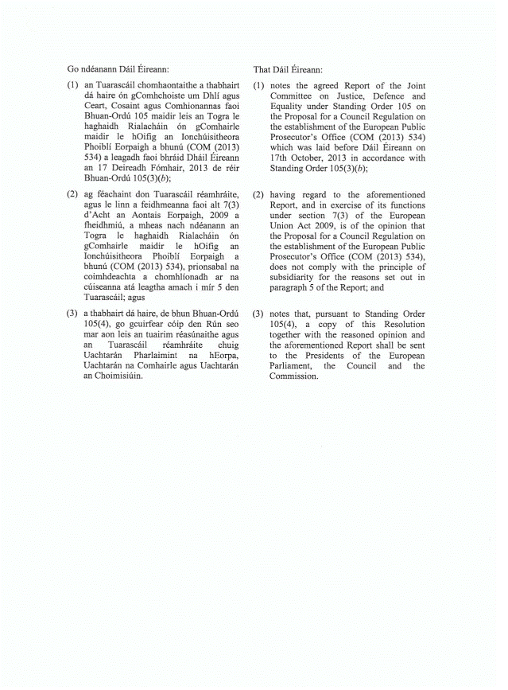

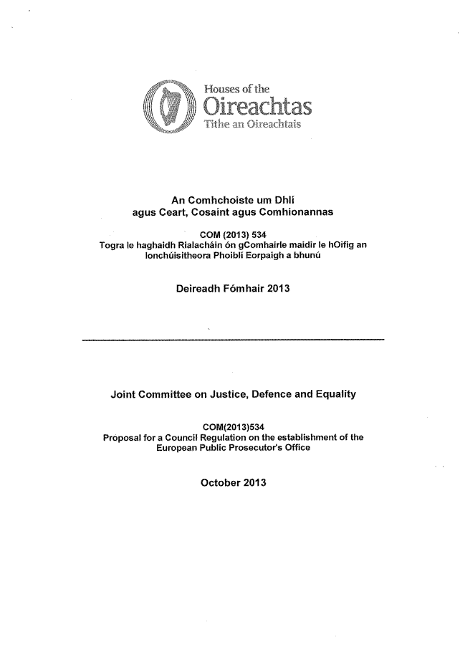

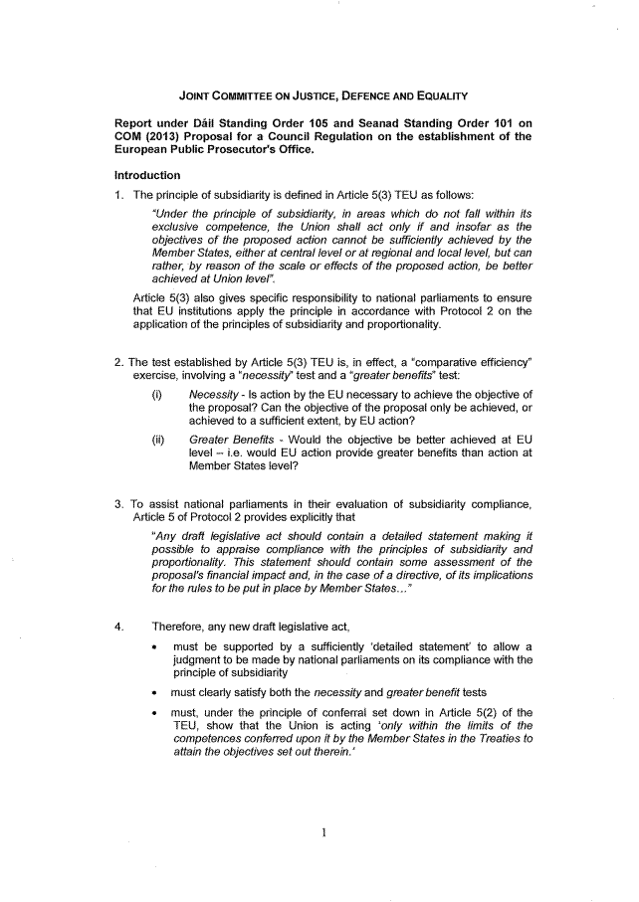

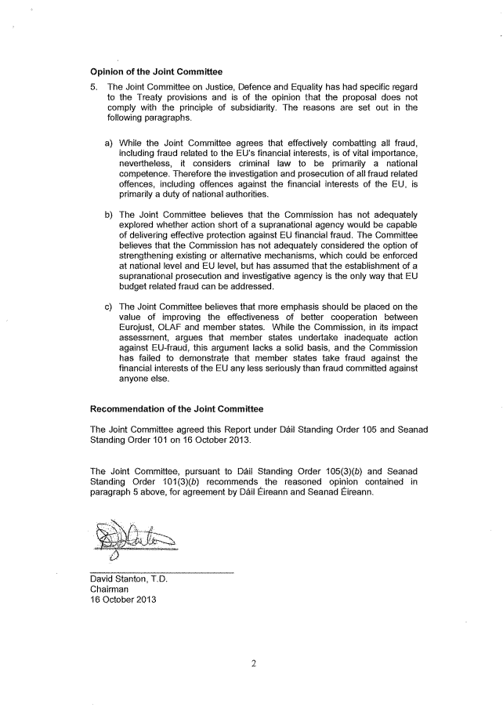____________________

This opinion is available in English on the interparliamentary EU information exchange site (IPEX) at the following address: http://www.ipex.eu/IPEXL-WEB/search.do

