 | 
COUNCIL OF  THE EUROPEAN UNION |  |  | Brussels, 7 November 2013
 | Interinstitutional File:  2013/0309 (COD) |  | 15810/13
TELECOM 286
COMPET 782
MI 972
CONSOM 185
CODEC 2470
INST 575
PARLNAT 258

COVER NOTE
from: | Portuguese Parliament
date of receipt: | 6 November 2013
to: | The President of the Council of the European Union
Subject: | Proposal for a Regulation of the European Parliament and of the Council laying down measures concerning the European single market for electronic communications and to achieve a Connected Continent, and amending Directives 2002/20/EC, 2002/21/EC and 2002/22/EC and Regulations (EC) No 1211/2009 and (EU) No 531/2012  - Opinion on the application of the Principles of Subsidiarity and Proportionality  [doc. 13555/13 - COM (2013) 627 final + ADD1 +ADD2]

Delegations will find attached for information a copy of the above opinion.

_____________________

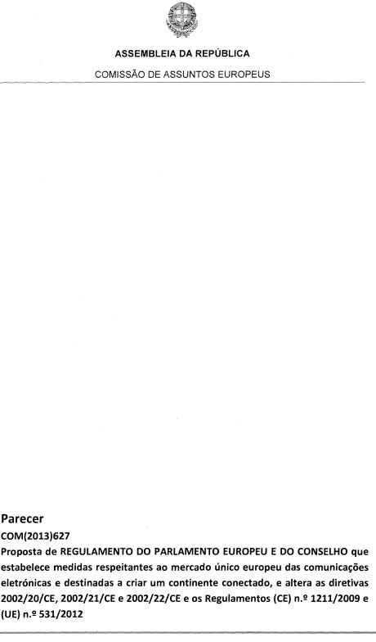
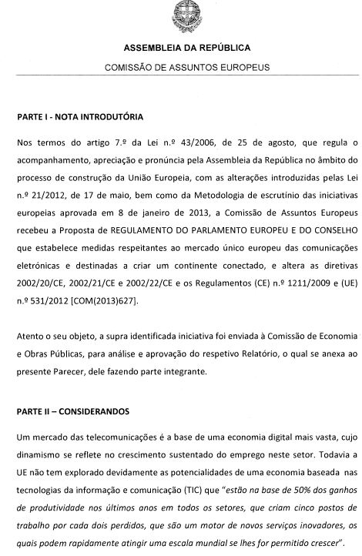
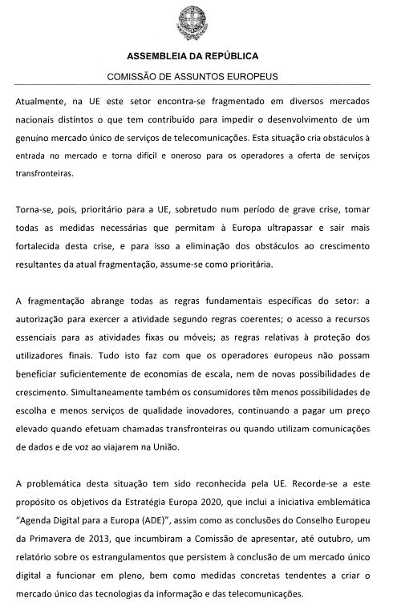
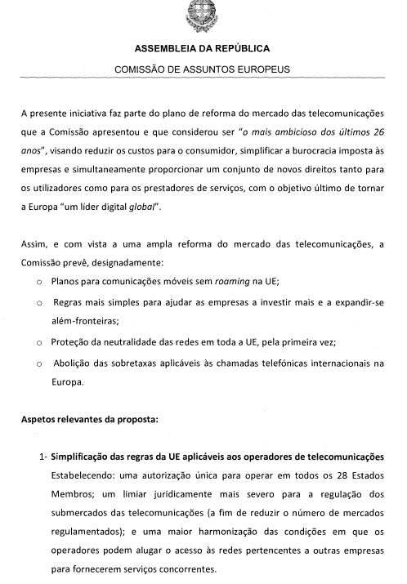
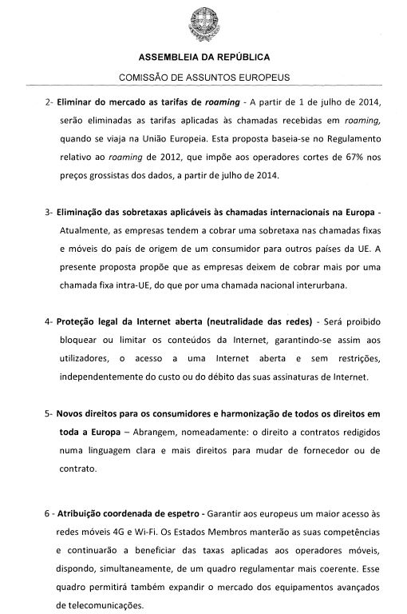
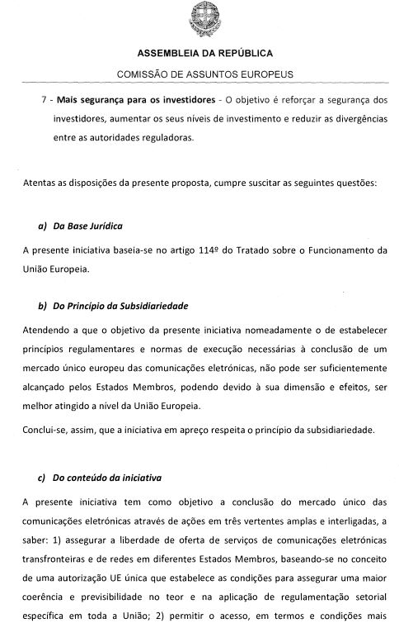
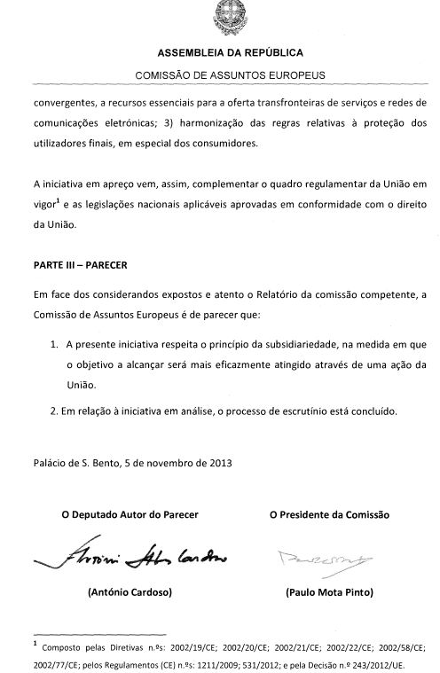
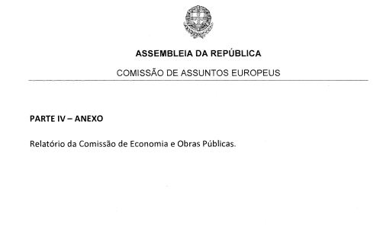
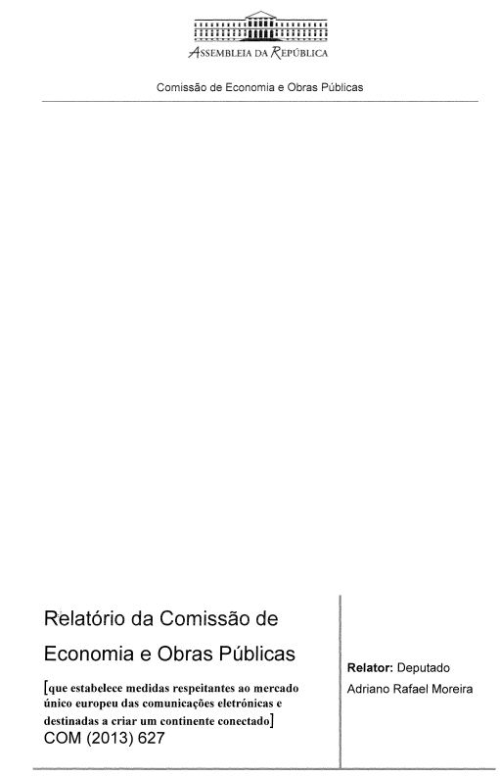
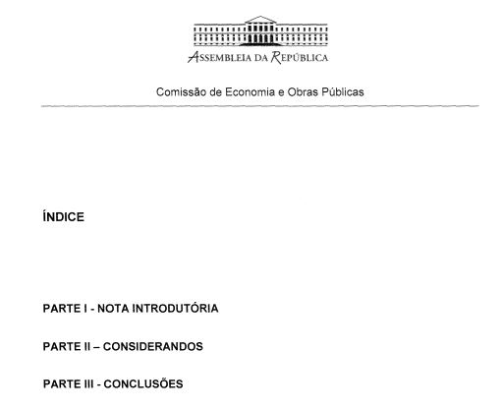
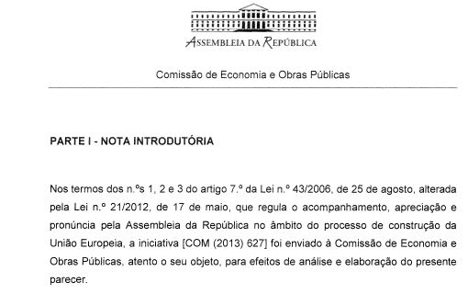
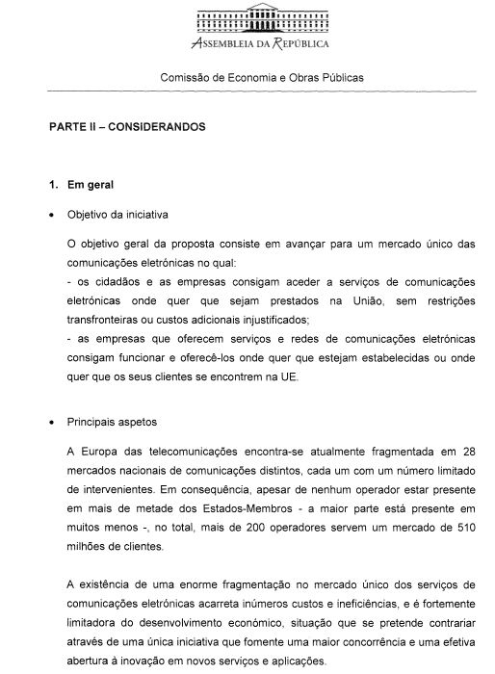
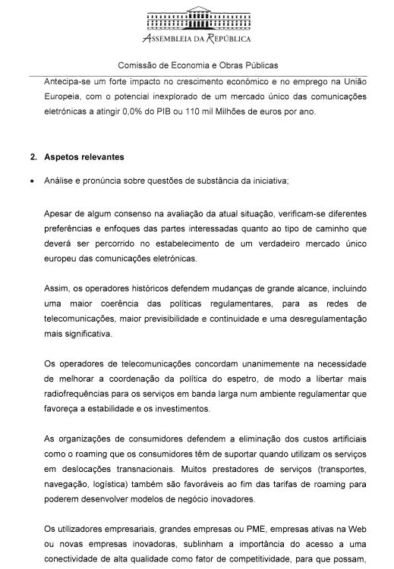
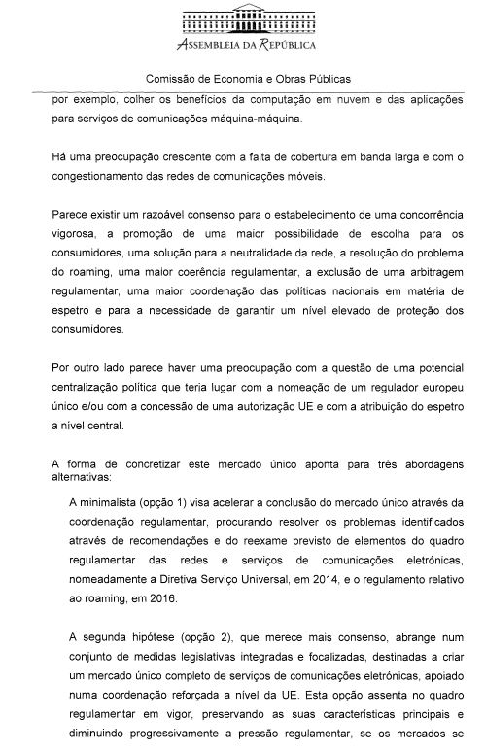
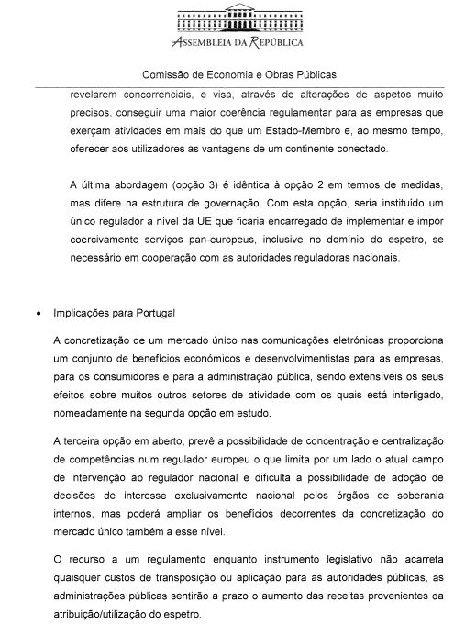
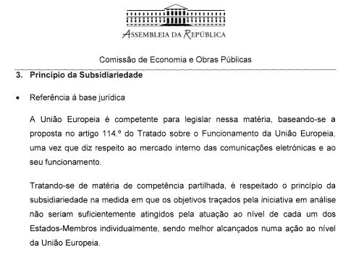
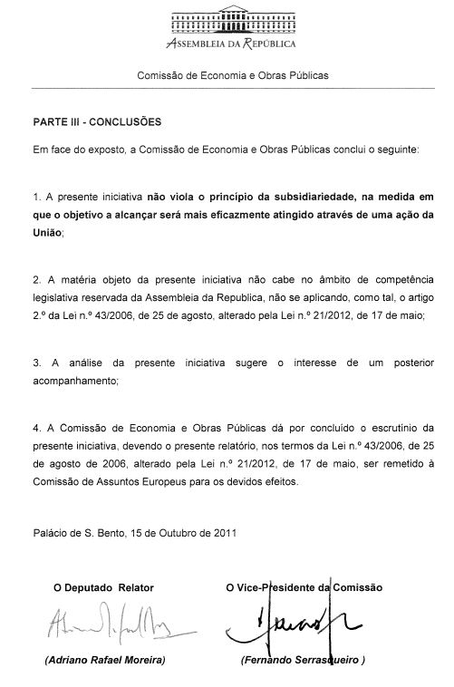

The translation can be found at the Interparliamentary EU information exchange site IPEX at the following address :http://www.ipex.eu/IPEXL-WEB/search.do

