 | 
COUNCIL OF  THE EUROPEAN UNION |  |  | Brussels, 20 February 2013
 | Interinstitutional File:  2012/0364(COD) |  | 6677/13
ECOFIN 127
EF 27
SURE 4
DRS 33
CODEC 379
INST 87
PARLNAT 42

COVER NOTE
from: | The Portuguese Parliament
date of receipt: | 13 February 2013
to: | President of the Council of the European Union
Subject: | Proposal for a Regulation of the European Parliament and of the Council on establishing a Union programme to support specific activities in the field of financial reporting and auditing for the period of 2014-2020  [doc. St 5213/13 ECOFIN 13 EF 2 SURE 2 DRS 5 CODEC 46 - COM(2012) 782 final]  - Opinion on the application of the Principles of Subsidiarity and Proportionality

Delegations will find attached the above mentioned opinion.

________________________

Encl.:

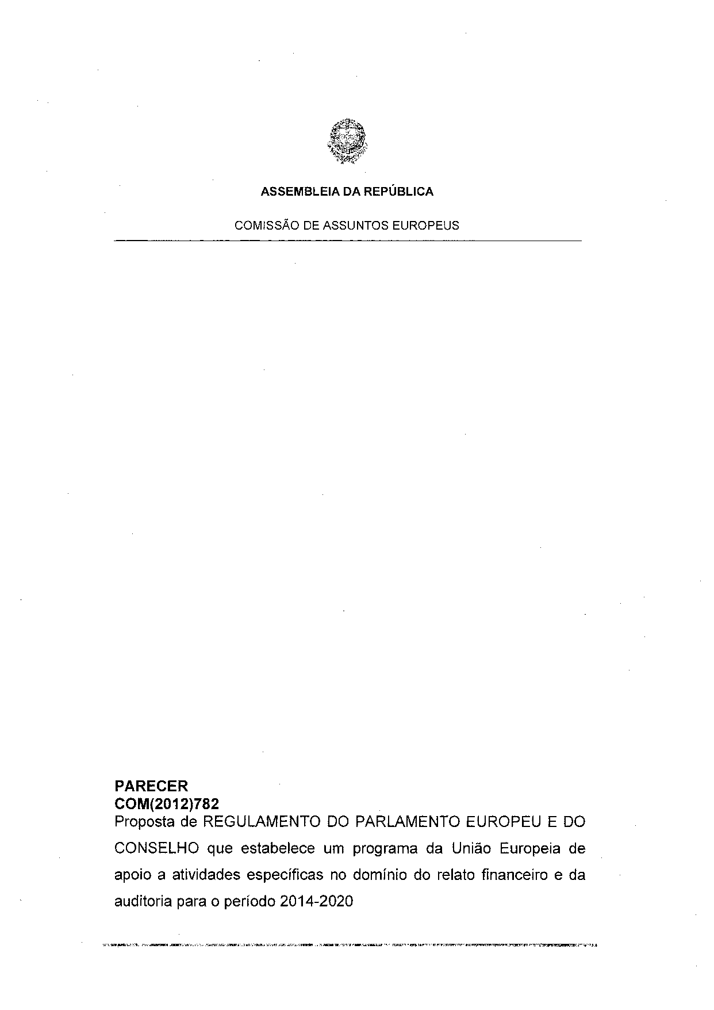
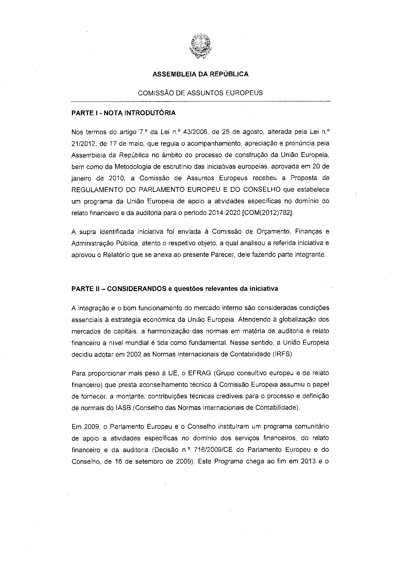
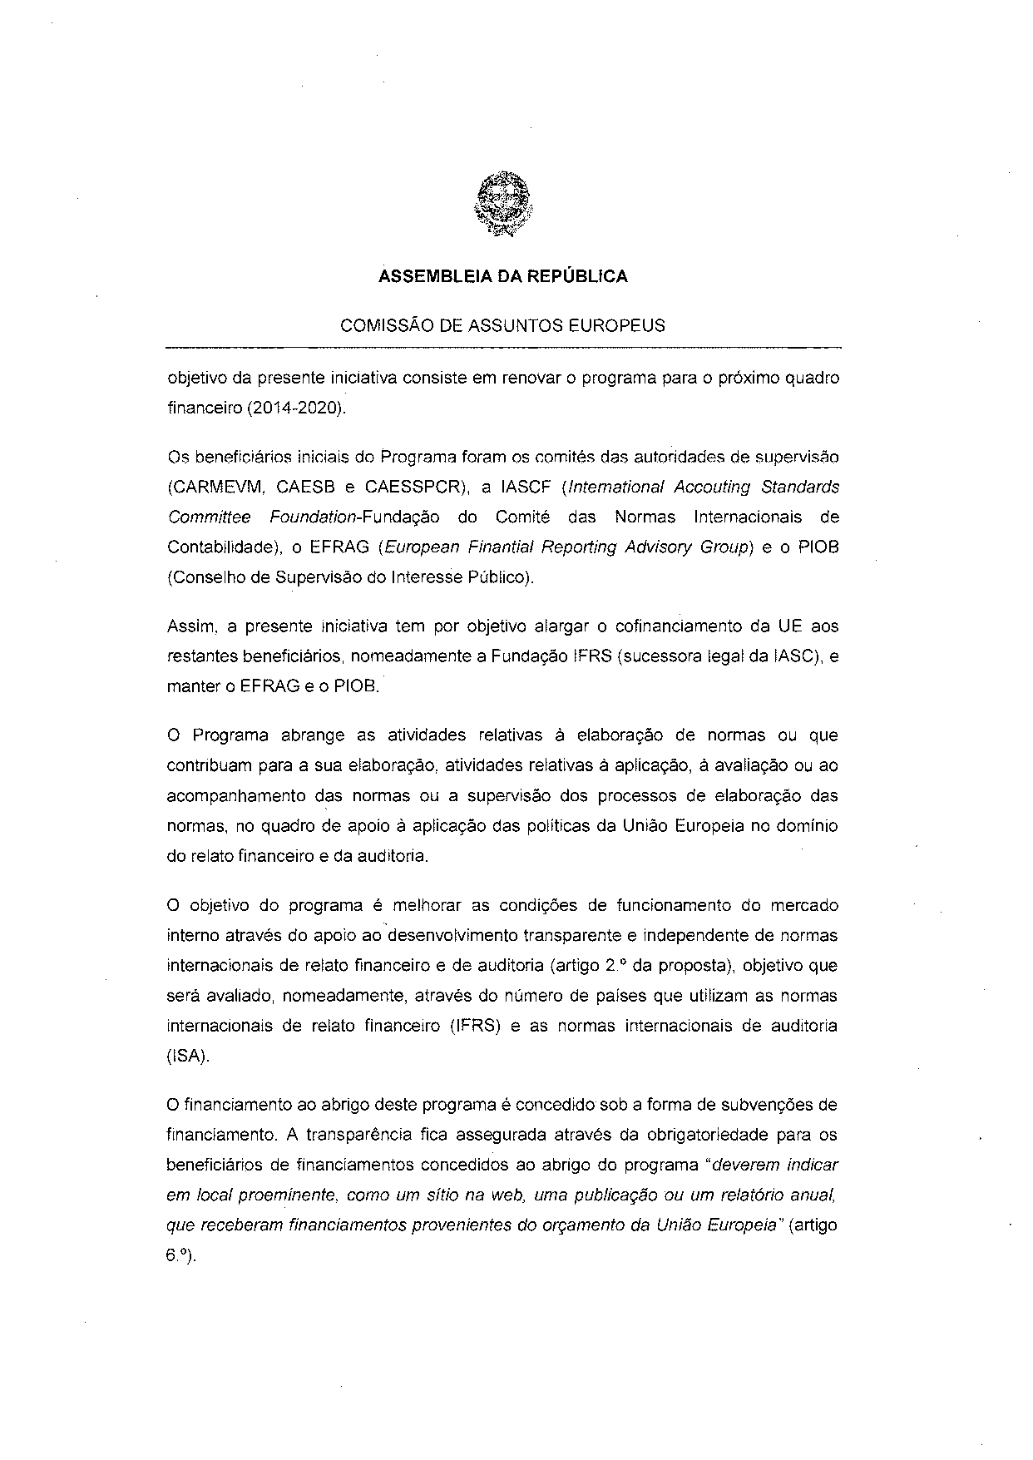
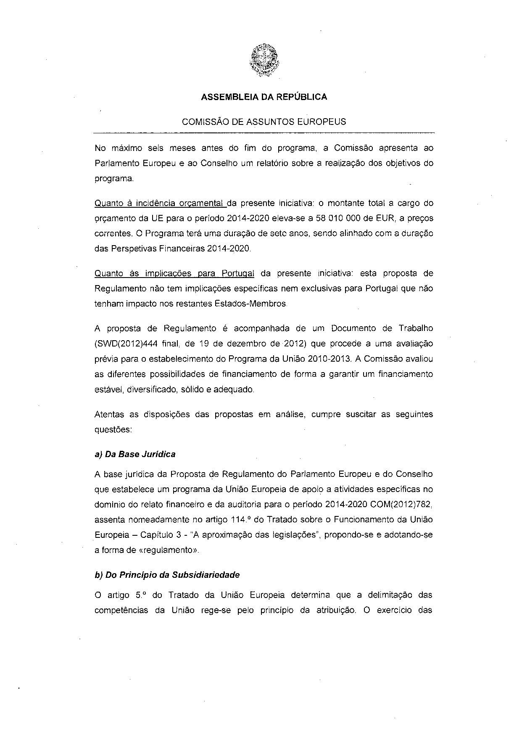
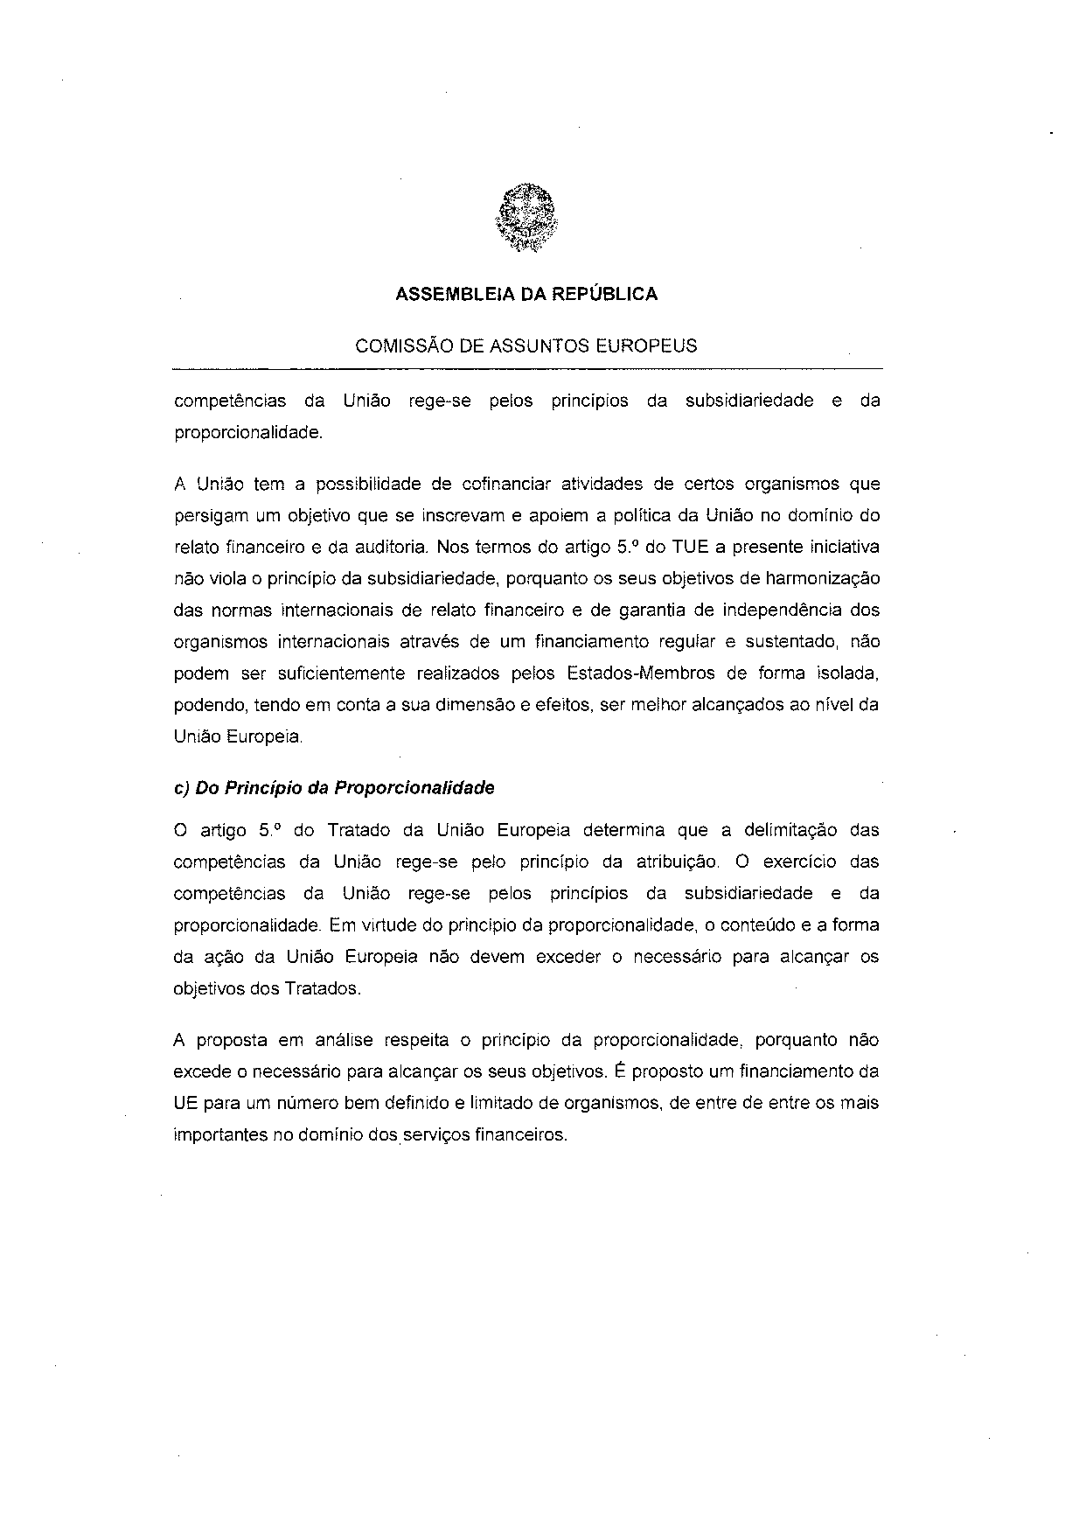
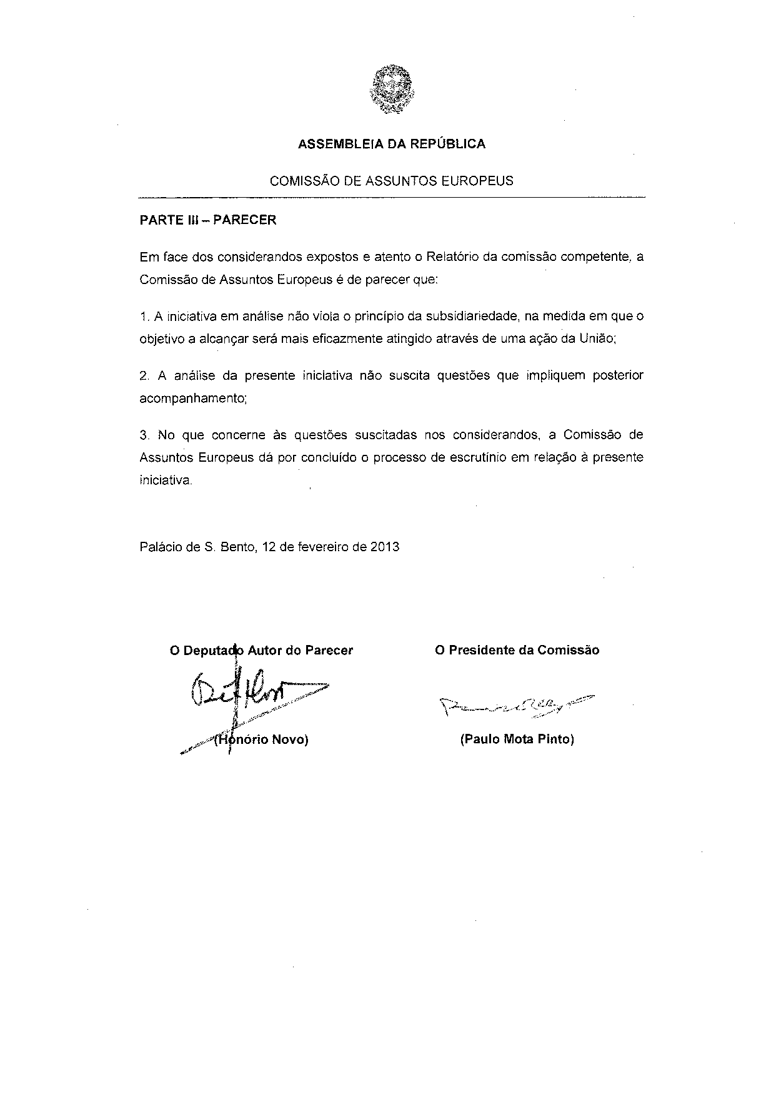
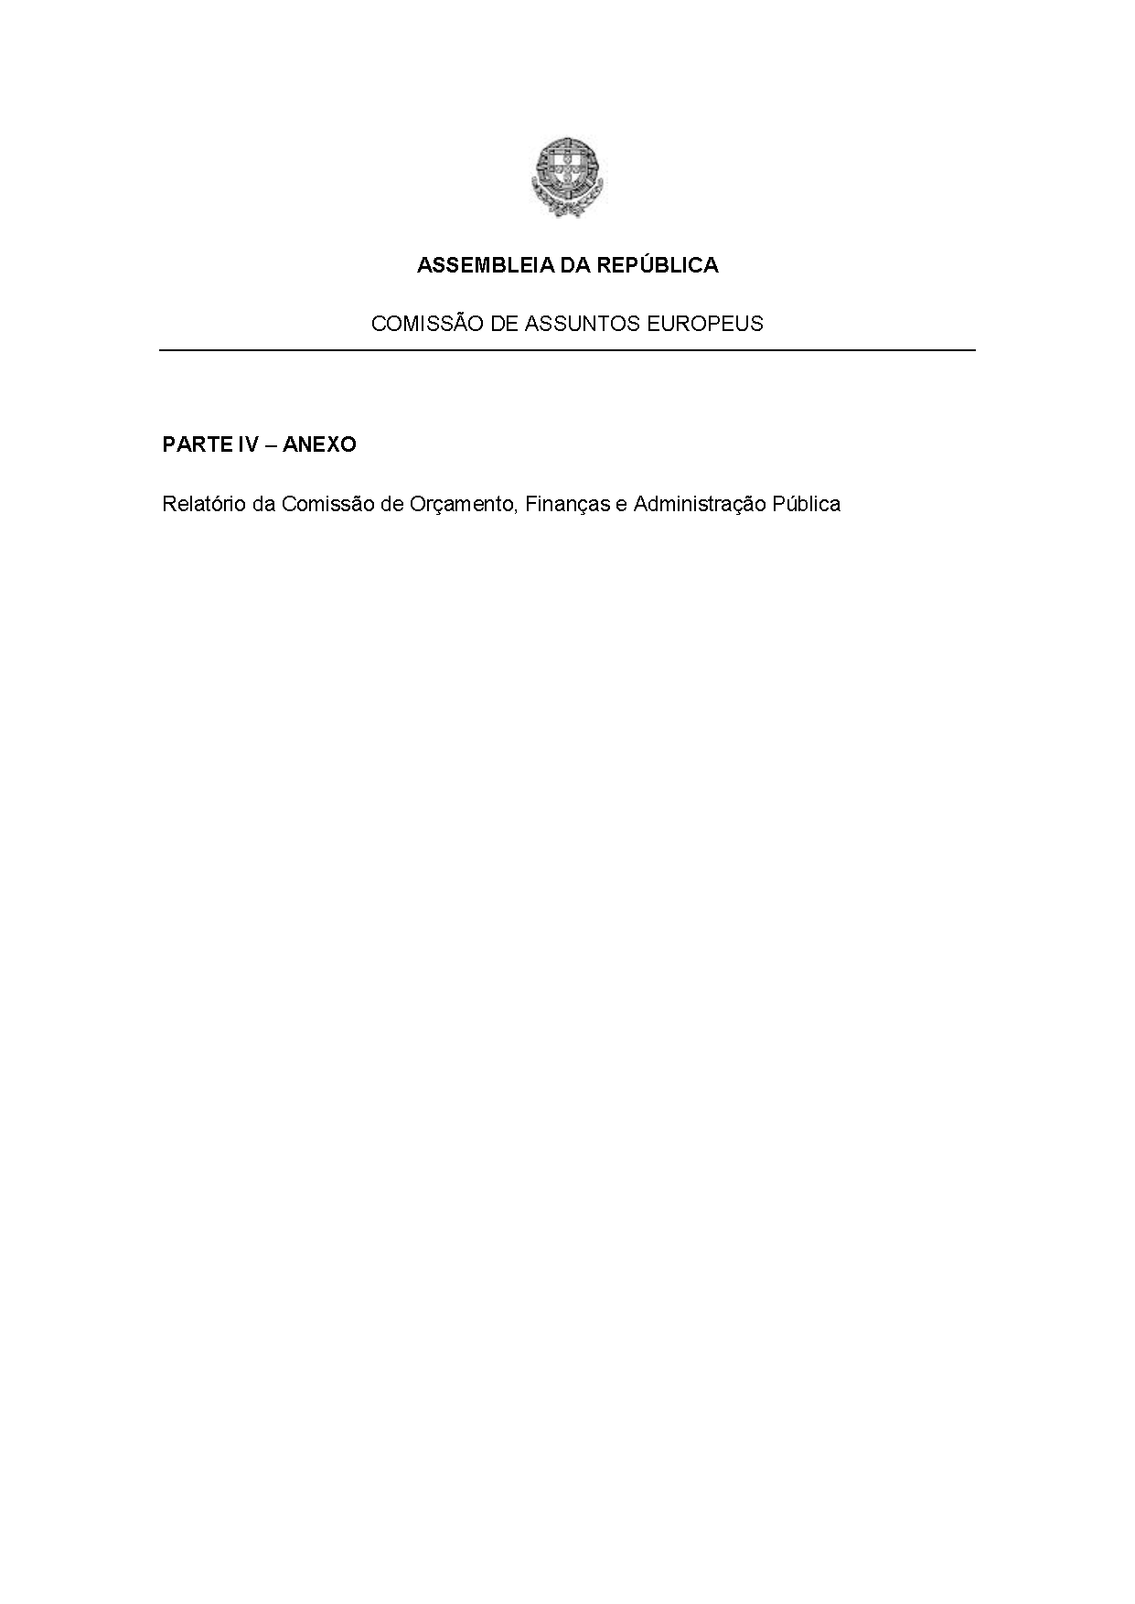
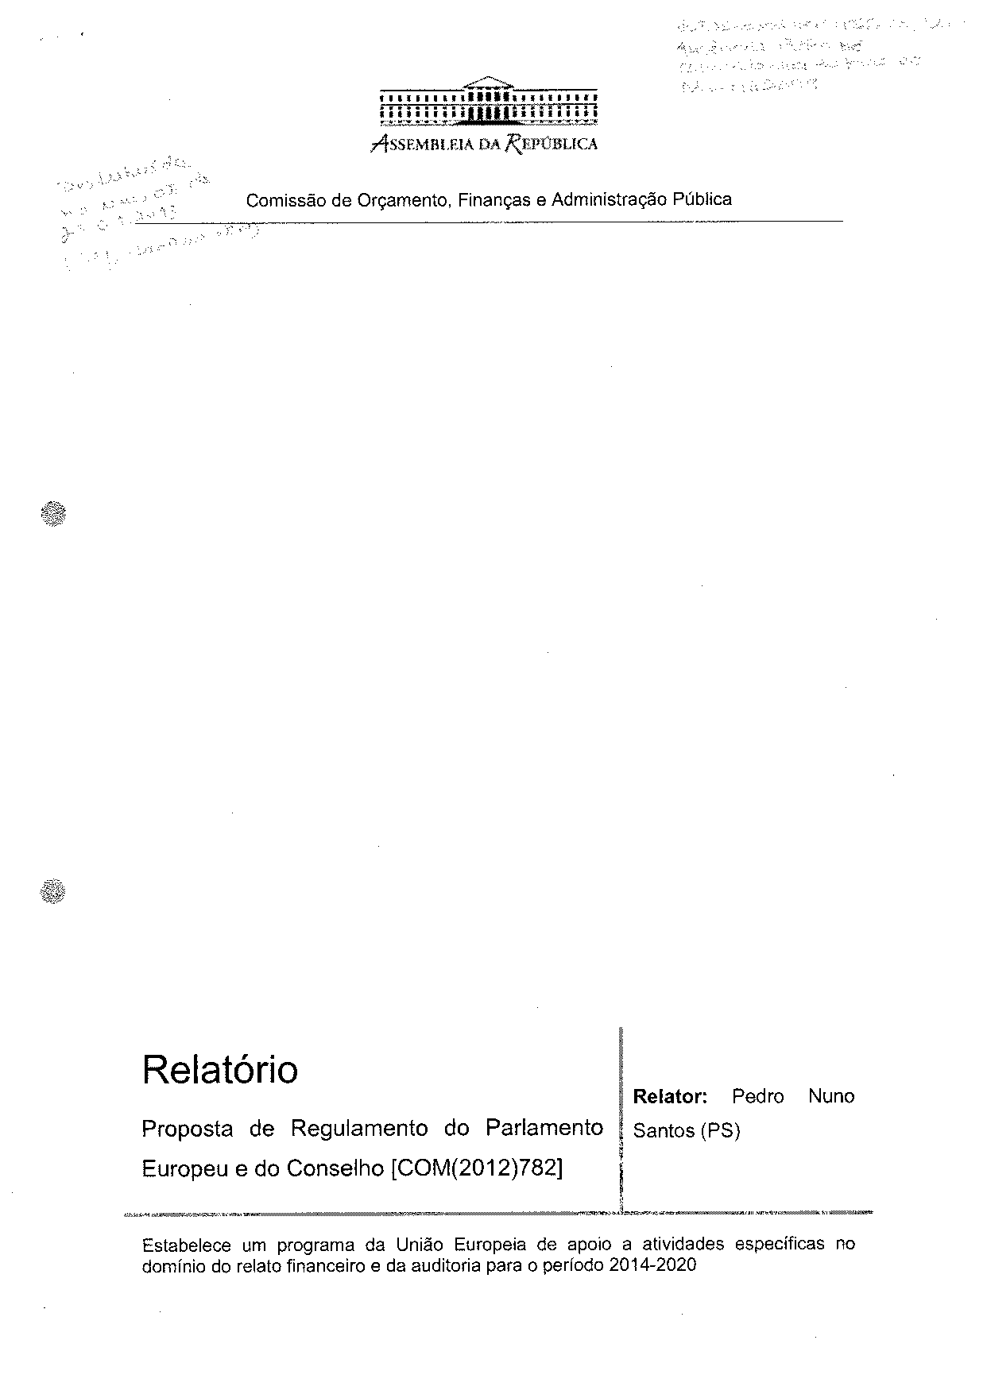
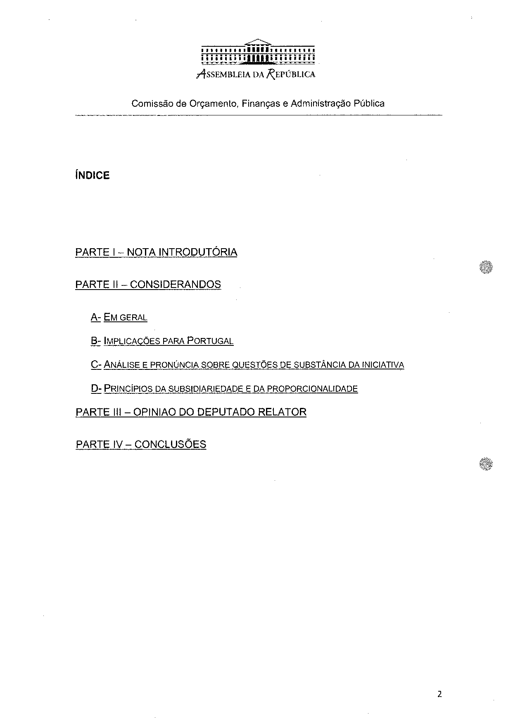
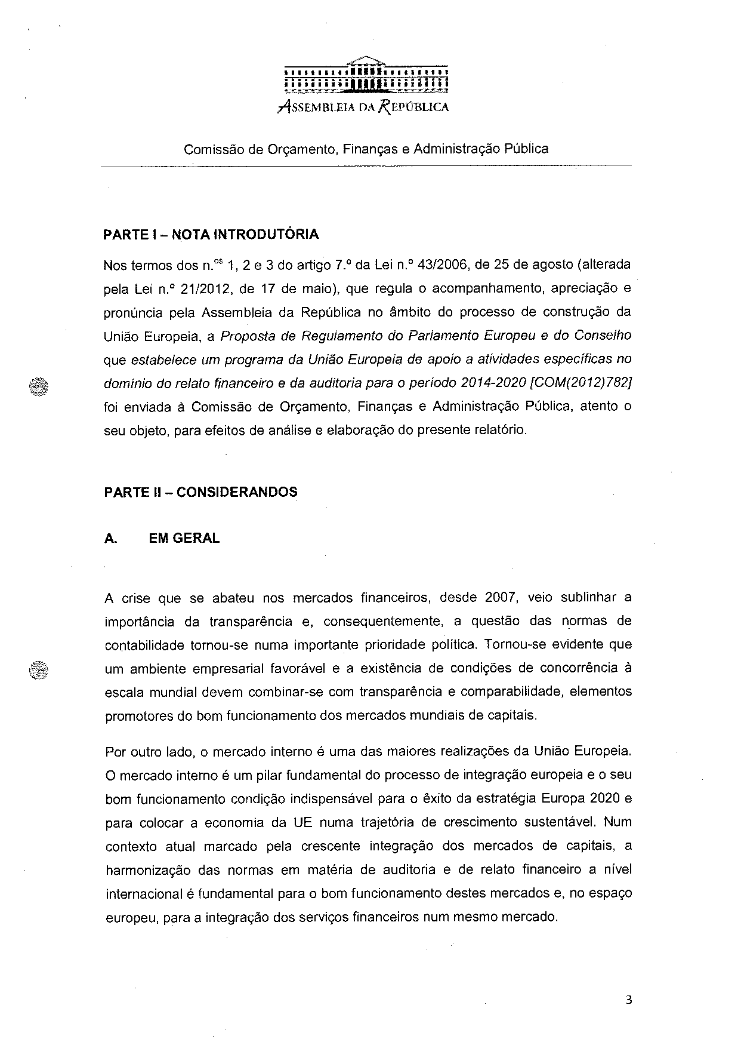
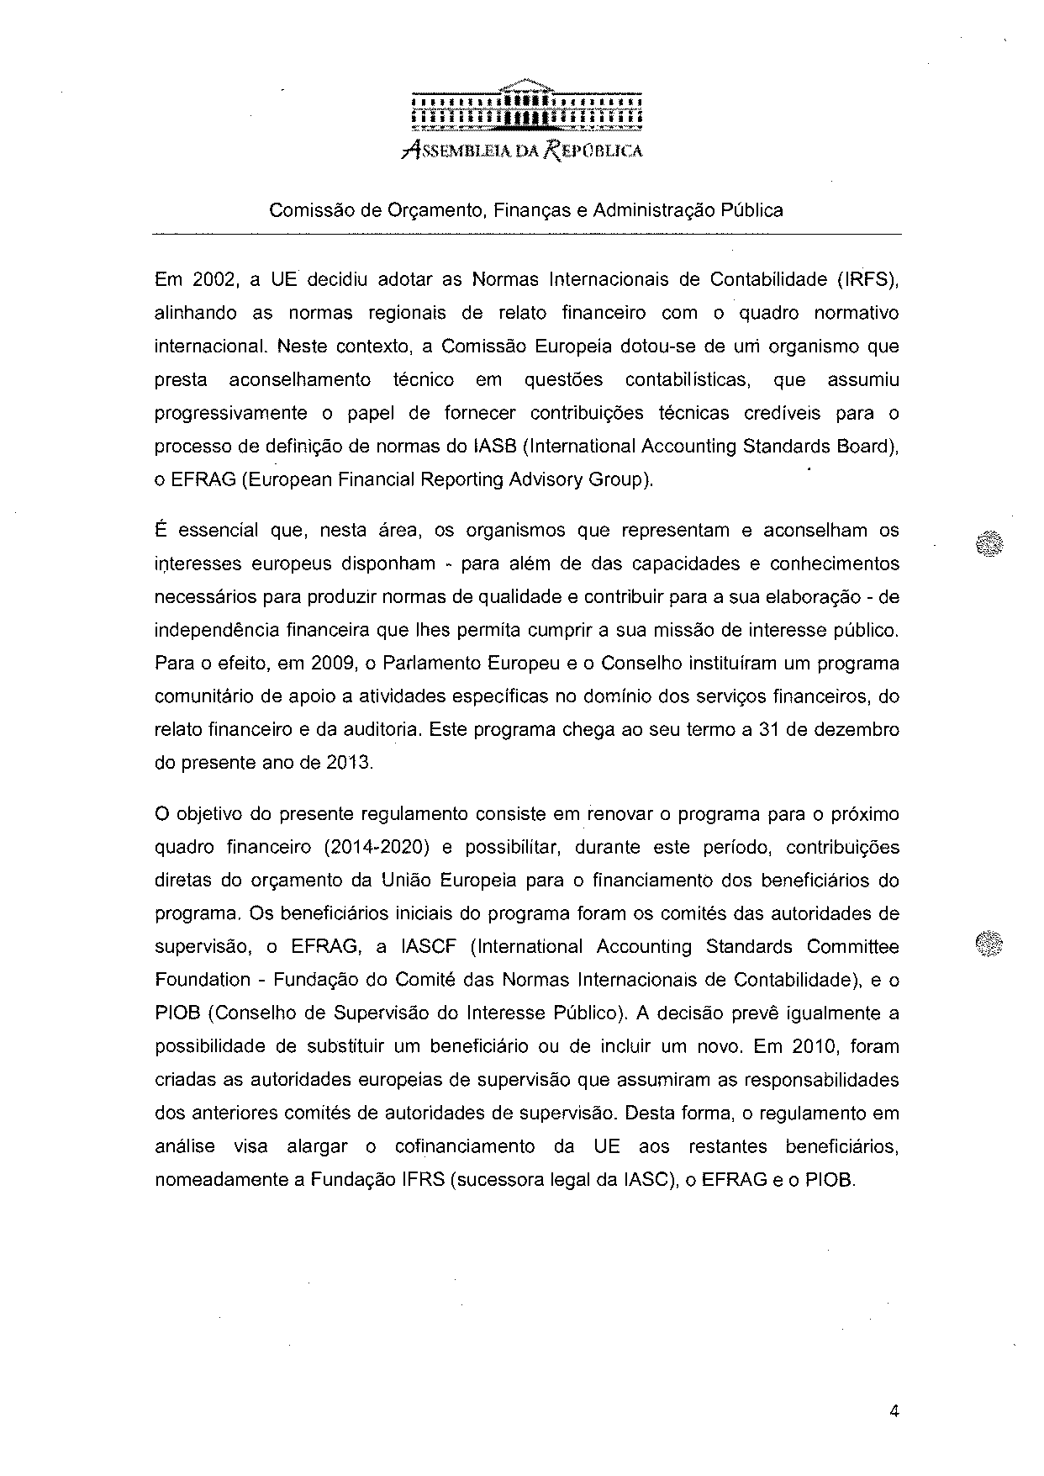
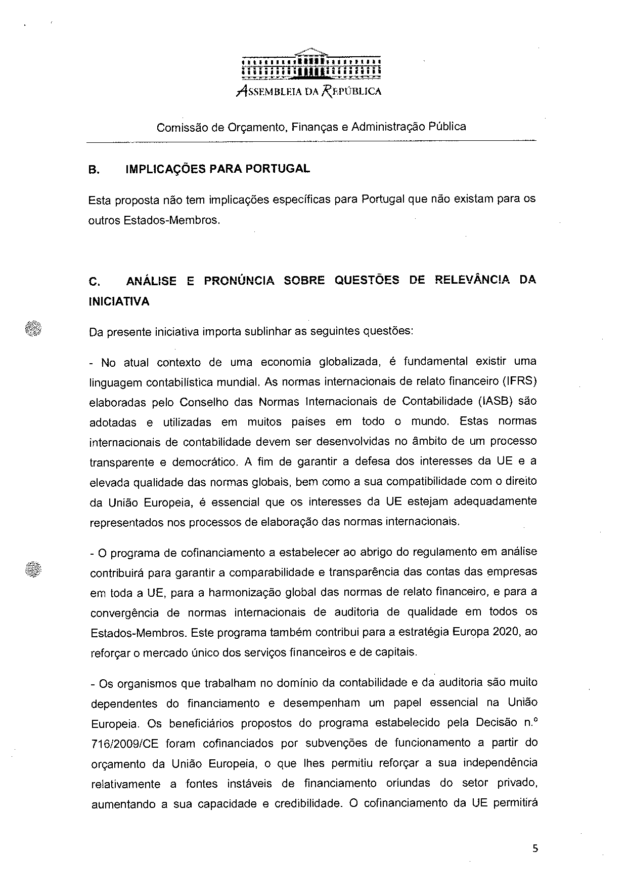
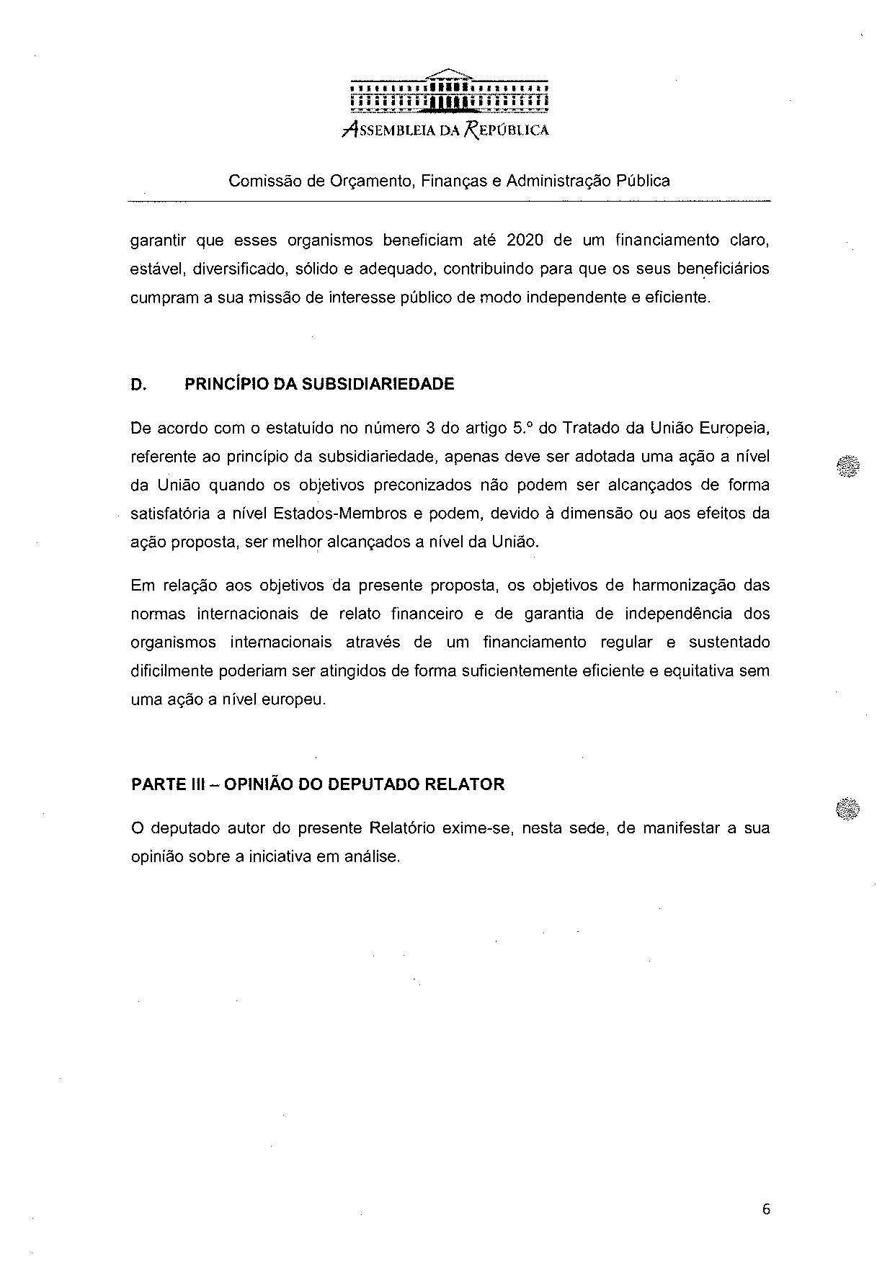
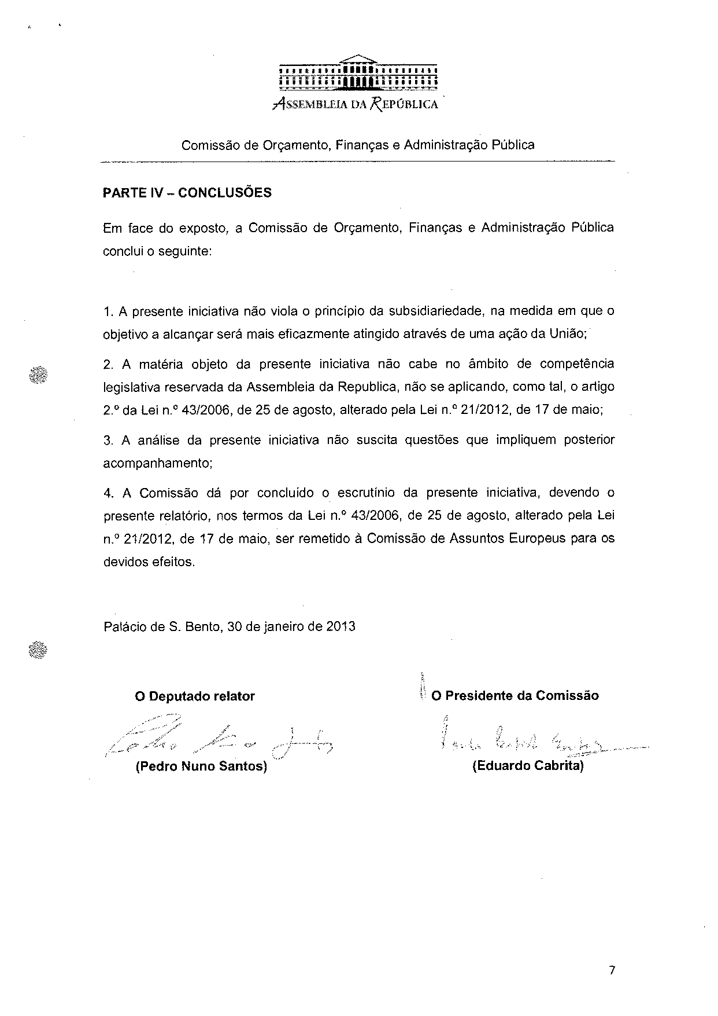

Translation(s) may be available in the Interparliamentary EU information exchange site IPEX at the following address: http://www.ipex.eu/IPEXL- WEB/search.do

