 | 
COUNCIL OF  THE EUROPEAN UNION |  |  | Brussels, 20 February 2013
 | Interinstitutional File:  2012/0255 (NLE) |  | 6652/13
WTO 44
INST 85
PARLNAT 41
SERVICES 8
COASI 23

COVER NOTE
from: | the President of the Assembly of the Republic of Portugal
date of receipt: | 13 February 2013
to: | Mr Enda KENNY, President of the Council of the European Union
Subject: | Proposal for a Council Decision establishing the European Union position within the General Council of the World Trade Organization on the accession of the Lao People's Democratic Republic to the World Trade Organization  [doc. 14170/12 WTO 309 SERVICES 63 COASI 164 - COM(2012) 534 final]  - Opinion on the application of the Principles of Subsidiarity and Proportionality

Delegations will find attached the above-mentioned opinion.

________________________

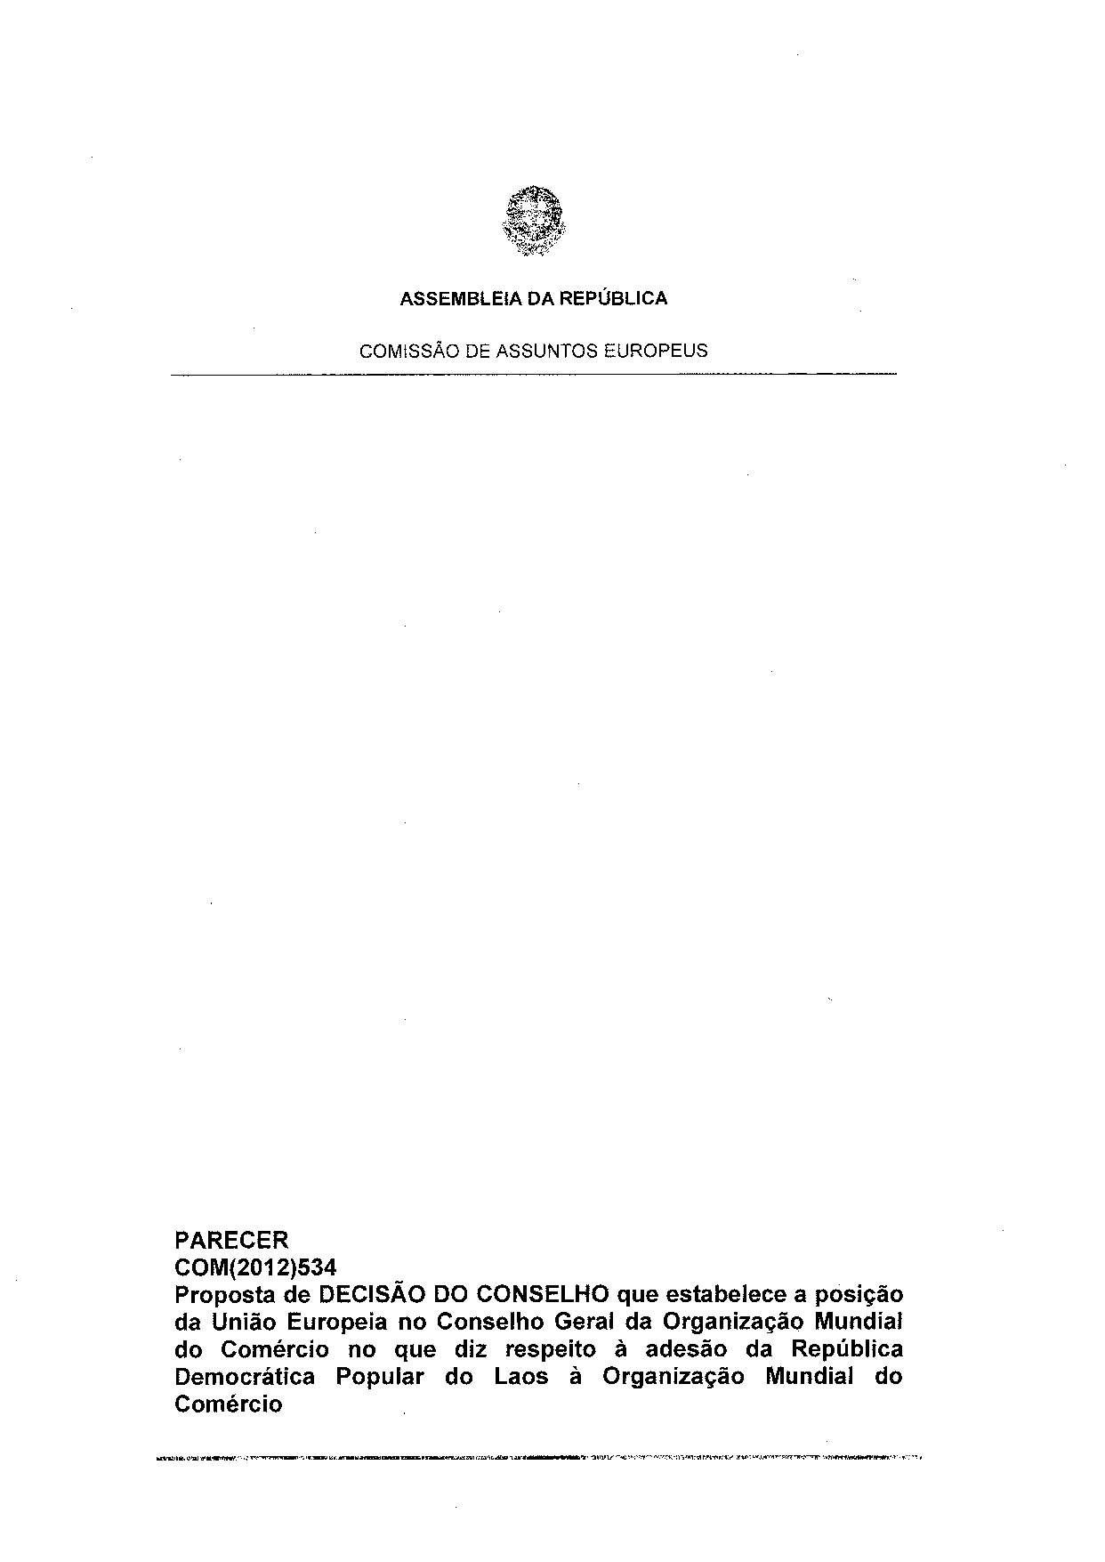
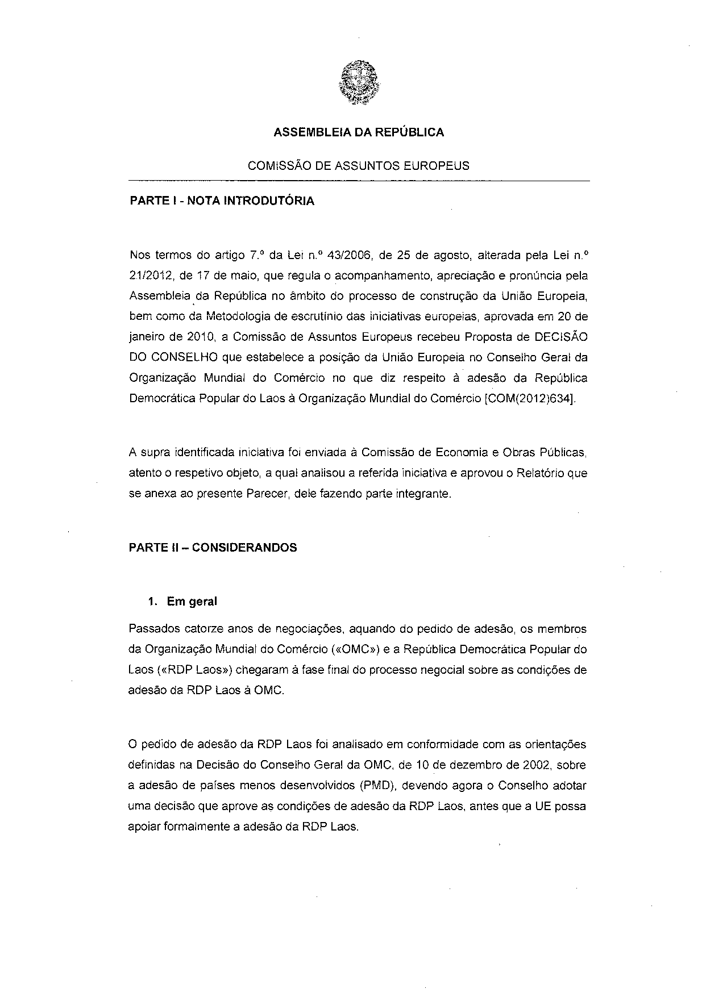
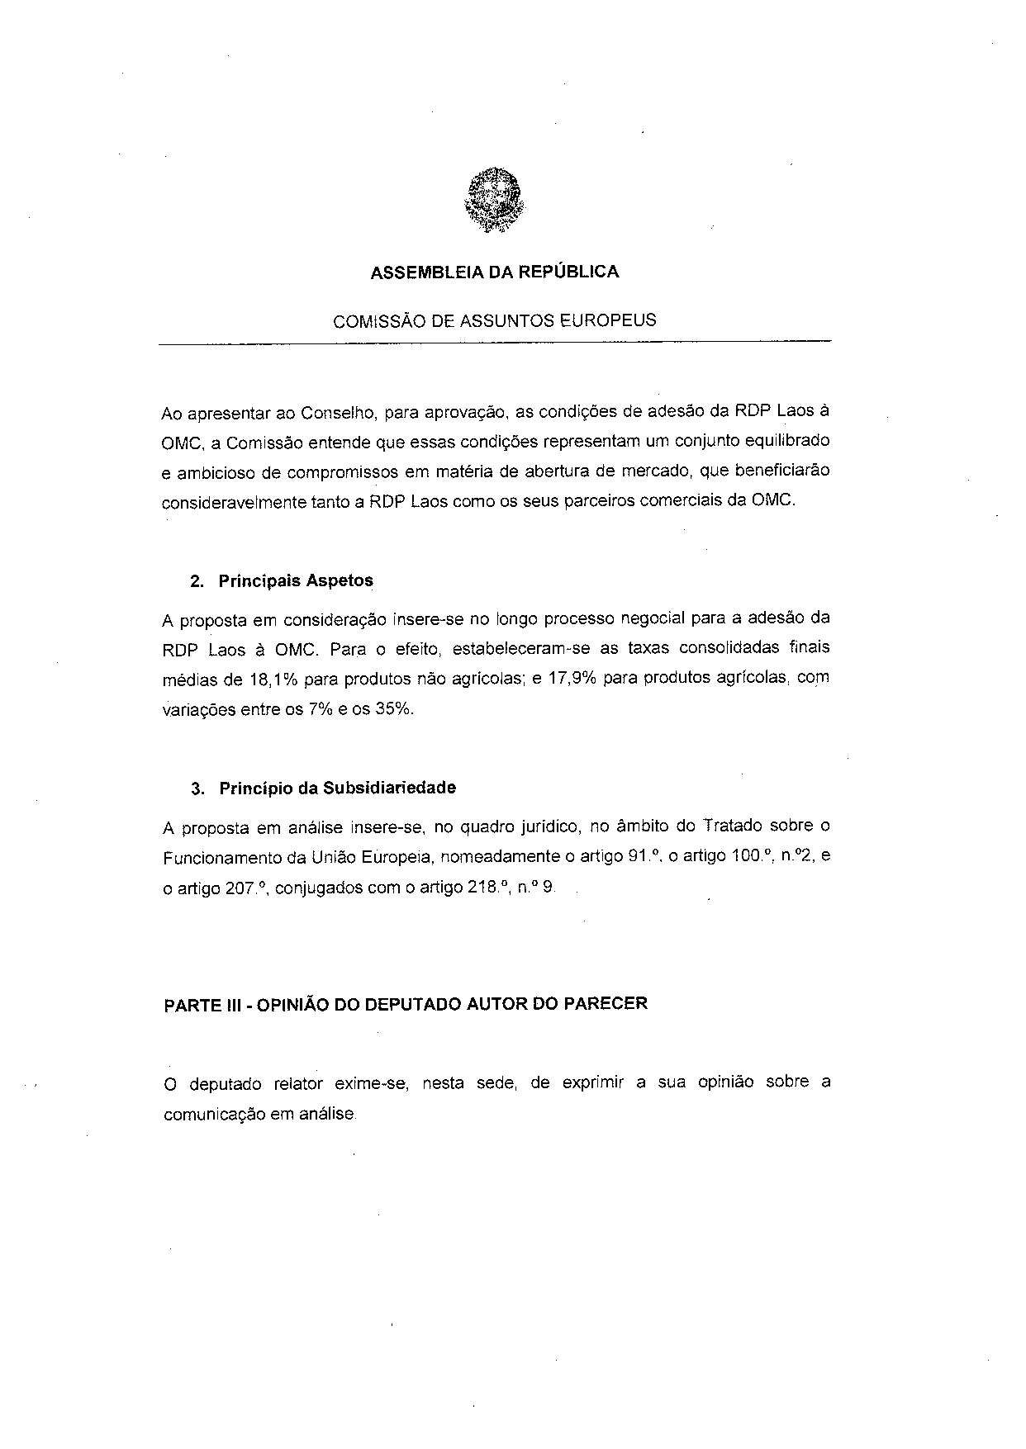
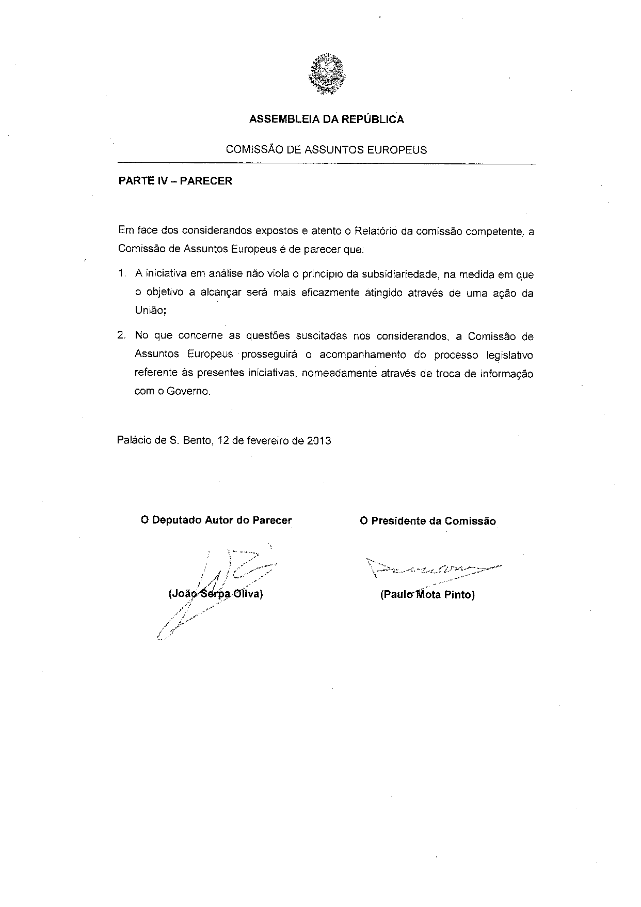
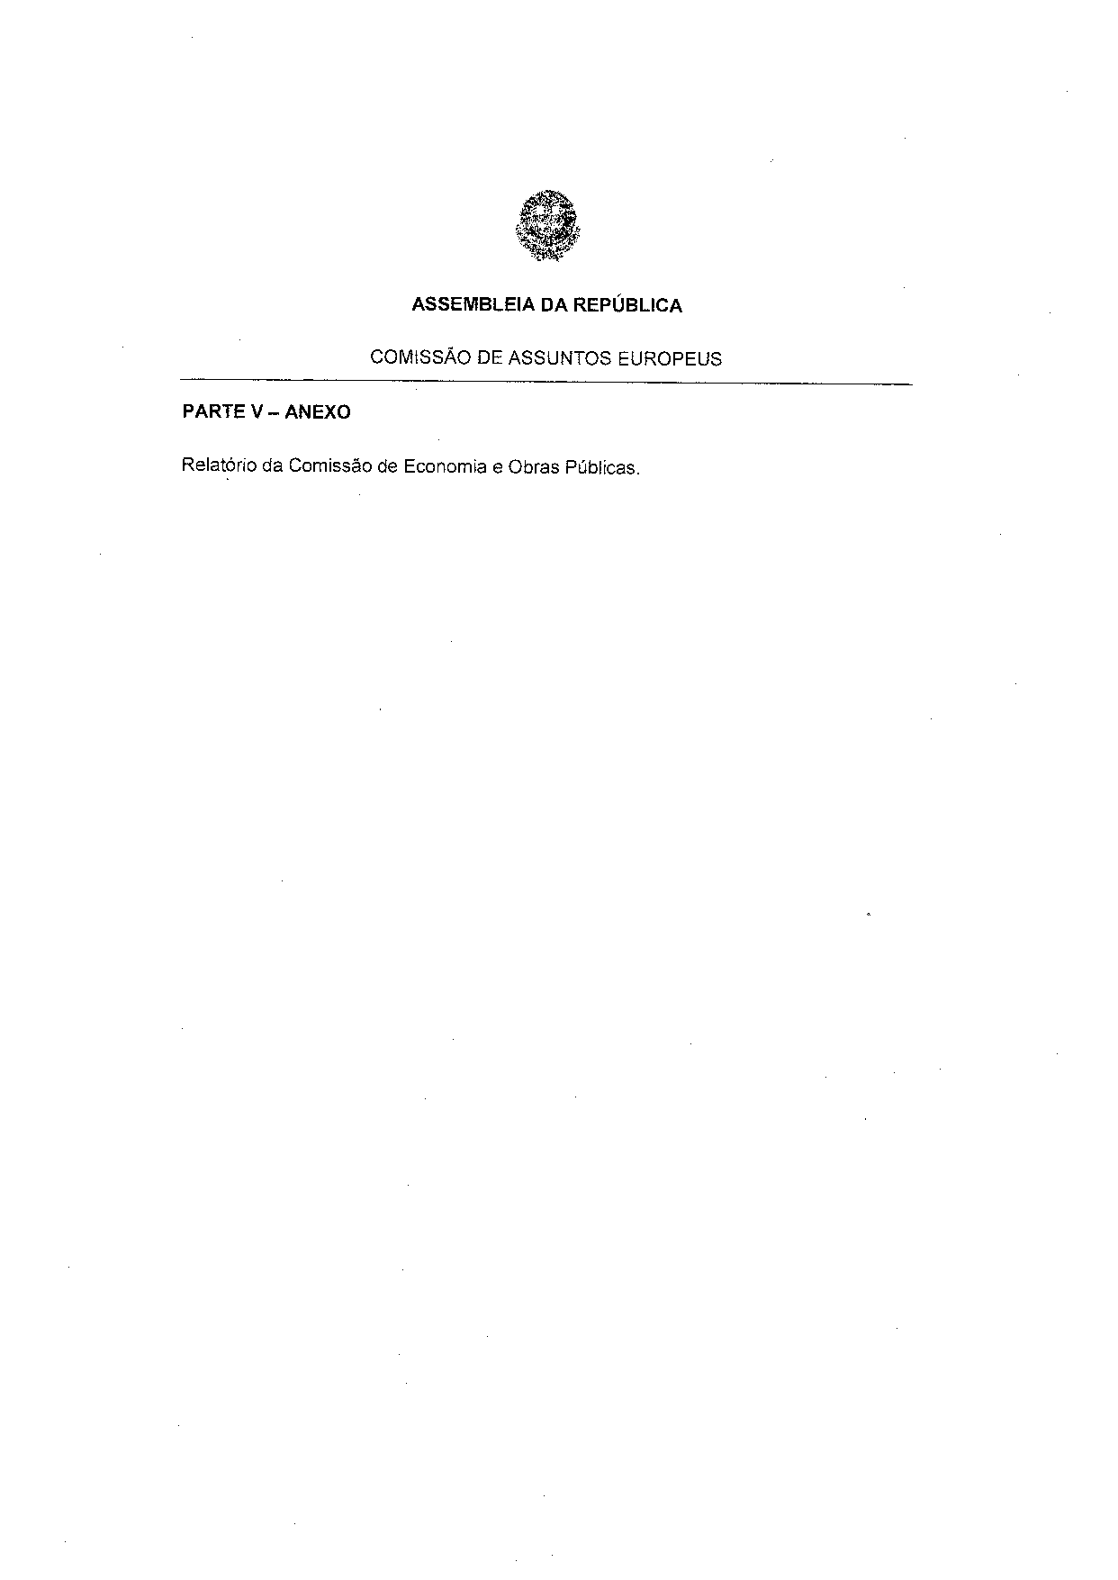
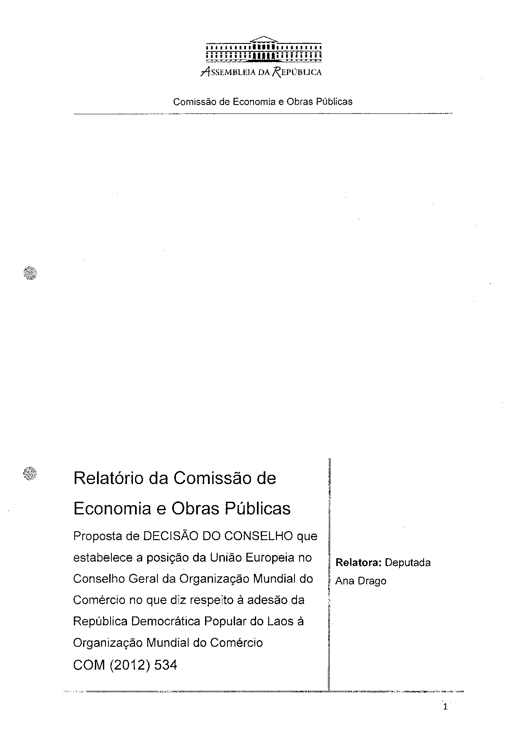
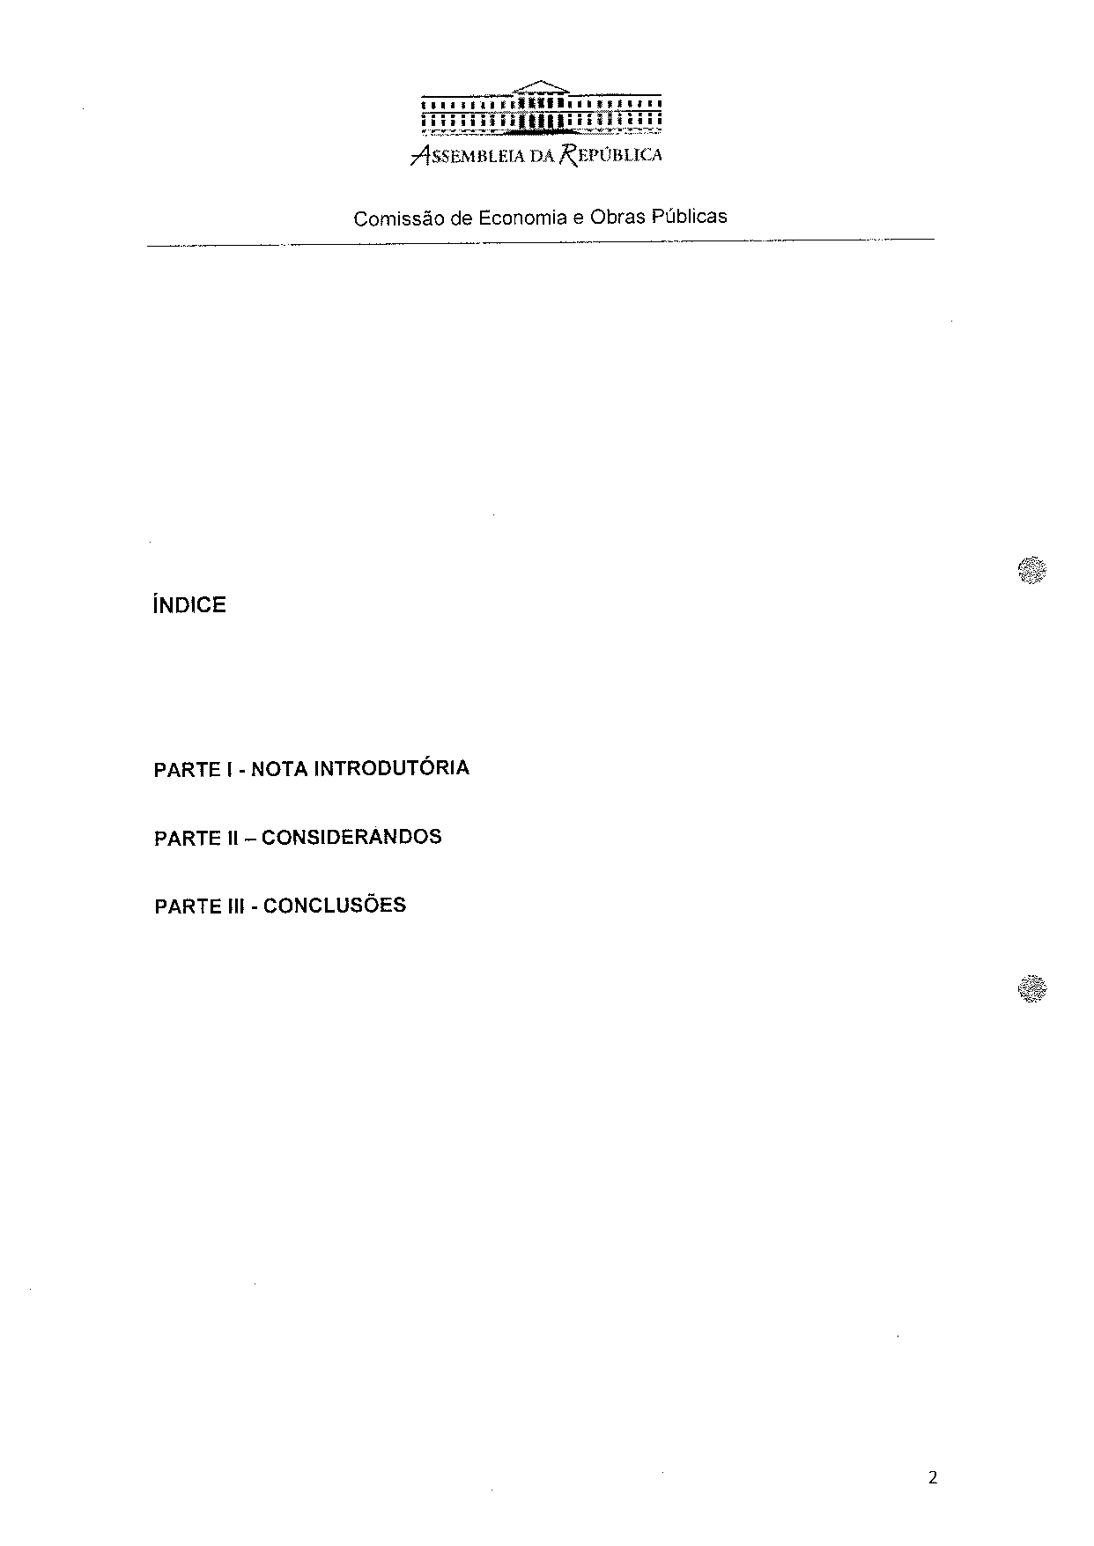
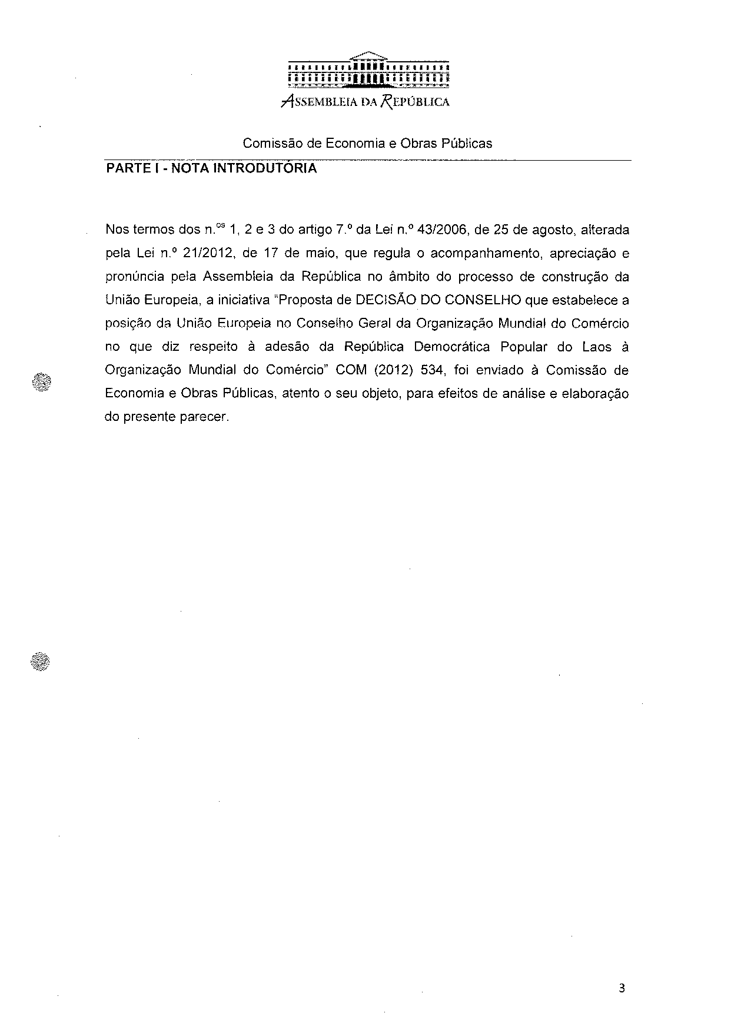
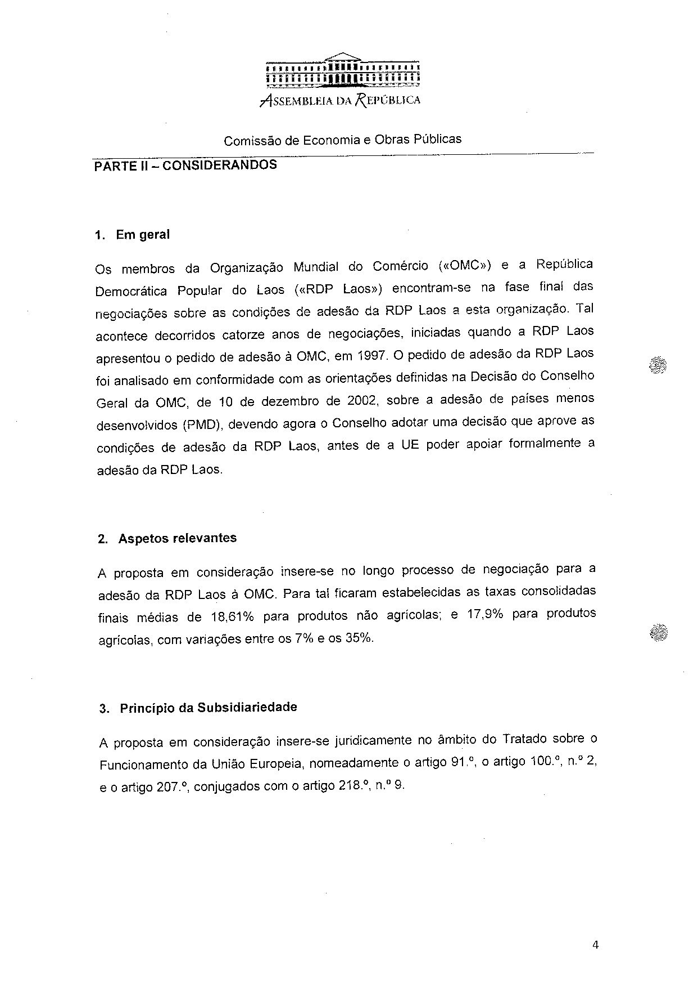
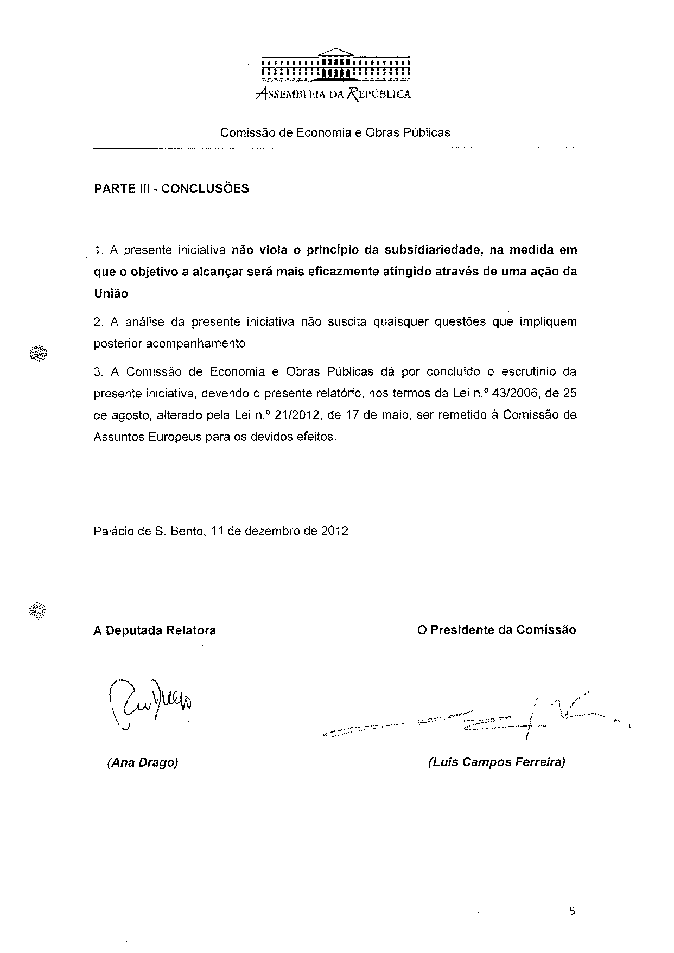

Translation(s) of the opinion may be available at the Interparliamentary EU Information Exchange site IPEX, at the following address: http://www.ipex.eu/IPEXL-WEB/search.do.

