 | 
COUNCIL OF  THE EUROPEAN UNION |  |  | Brussels, 12 February 2013
 | Interinstitutional File:  2012/0251 (COD) |  | 6344/13
SPG 3
WTO 33
COASI 16
CODEC 314
INST 72
PARLNAT 38

COVER NOTE
from: | the President of the Assembly of the Republic of Portugal
date of receipt: | 6 February 2013
to: | Mr Enda KENNY, President of the Council of the European Union
Subject: | Proposal for a Regulation of the European Parliament and of the Council repealing Council Regulation (EC) No 552/97 temporarily withdrawing access to generalized tariff preferences from Myanmar/Burma  [doc. 13897/12 SPG 24 WTO 304 COASI 157 CODEC 2161 - COM(2012) 524 final]  - Opinion on the application of the Principles of Subsidiarity and Proportionality

Delegations will find attached the above-mentioned opinion.

________________________

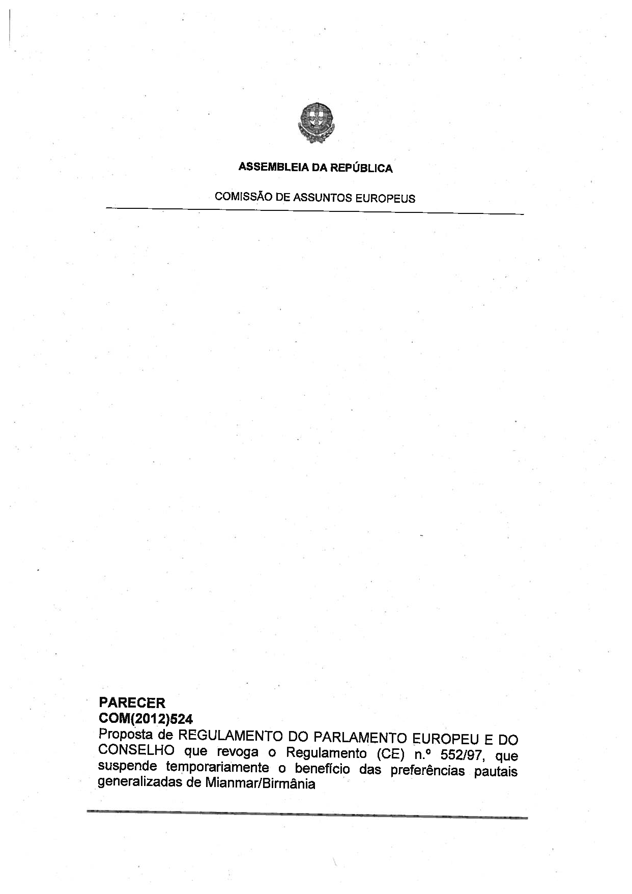
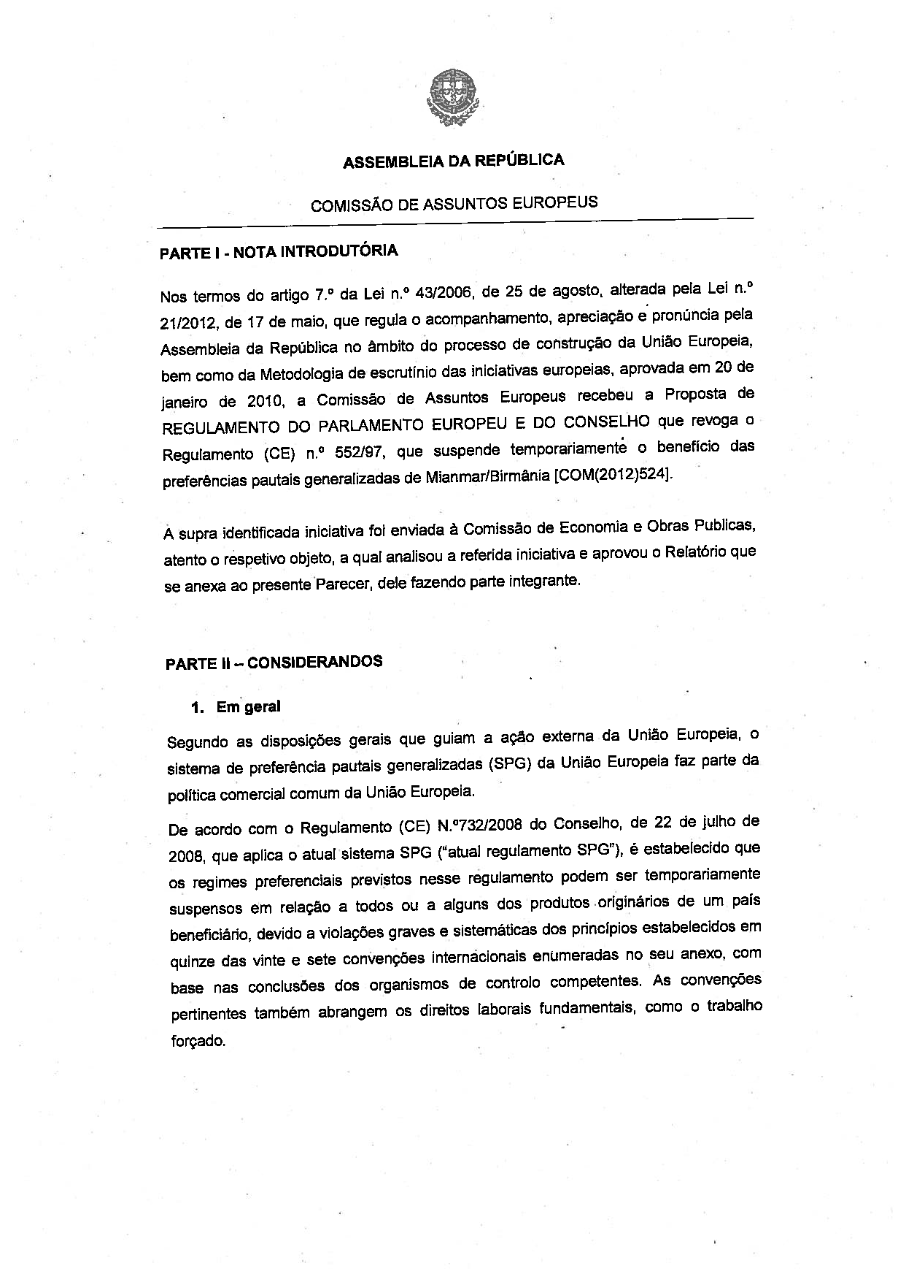
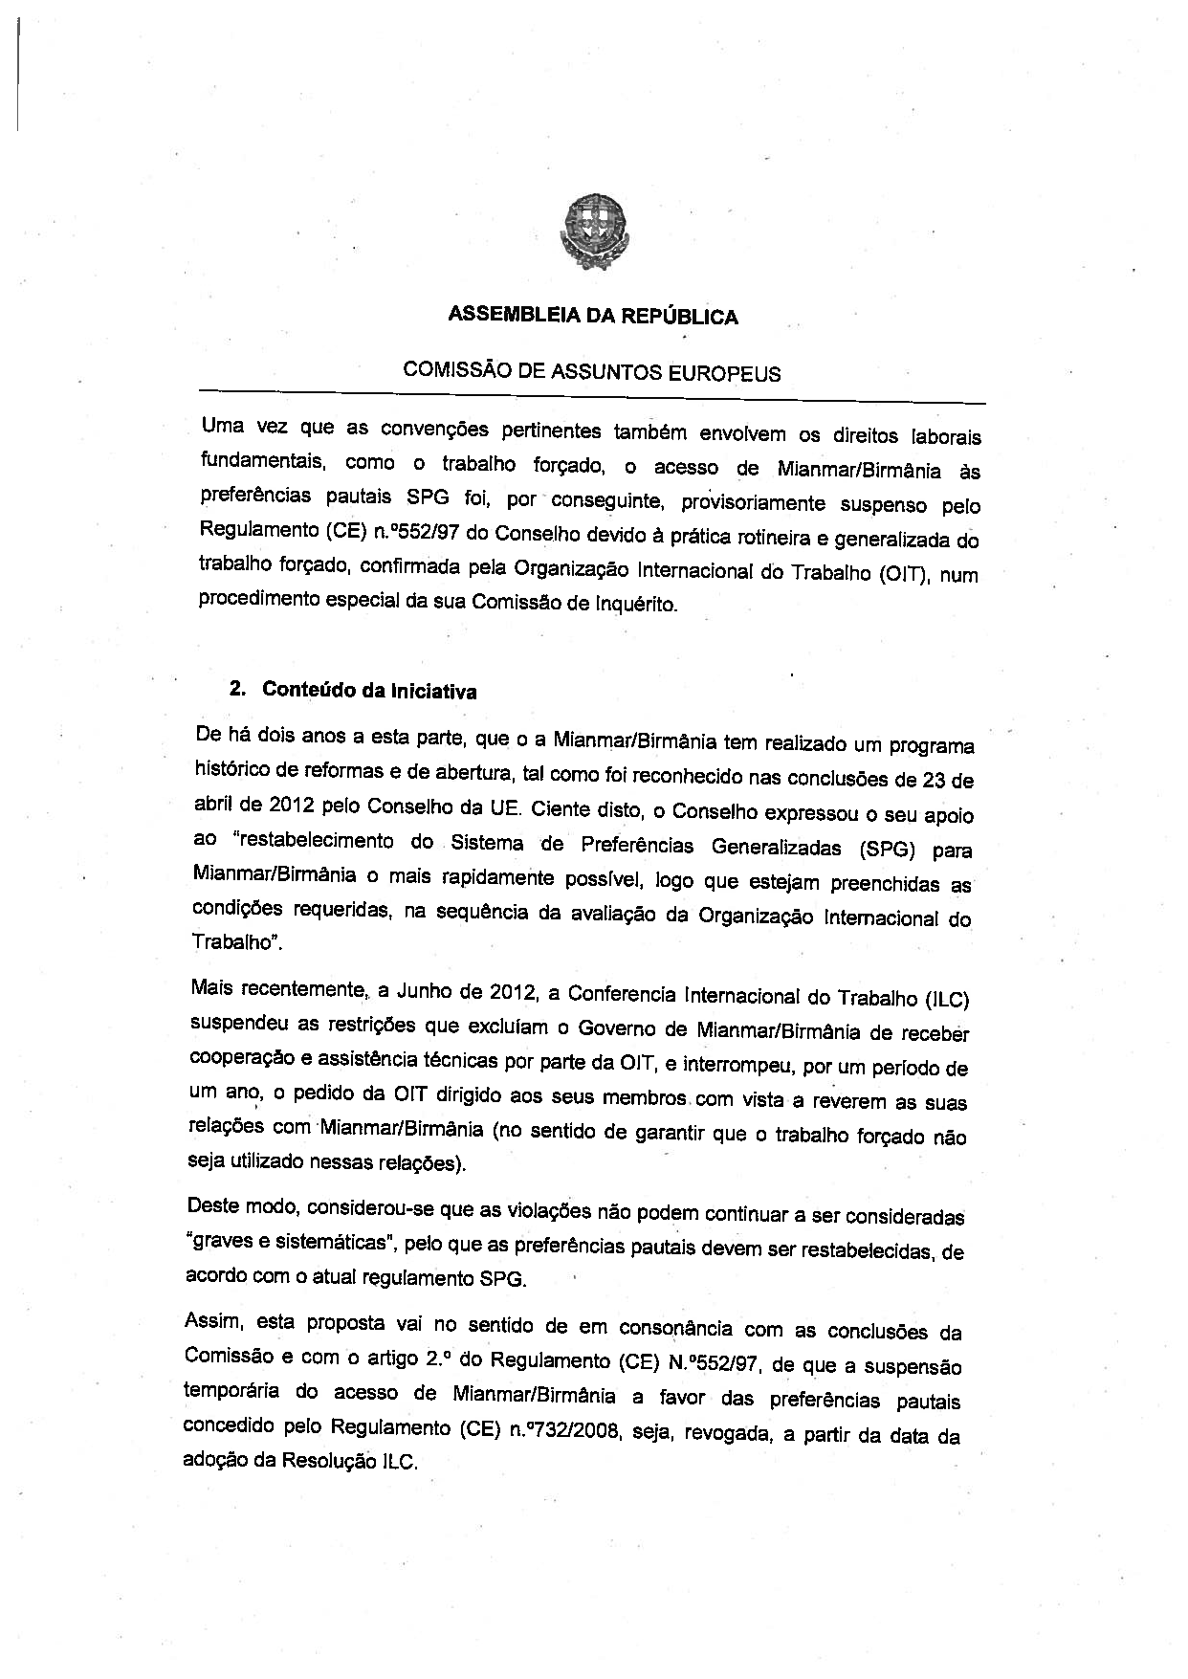
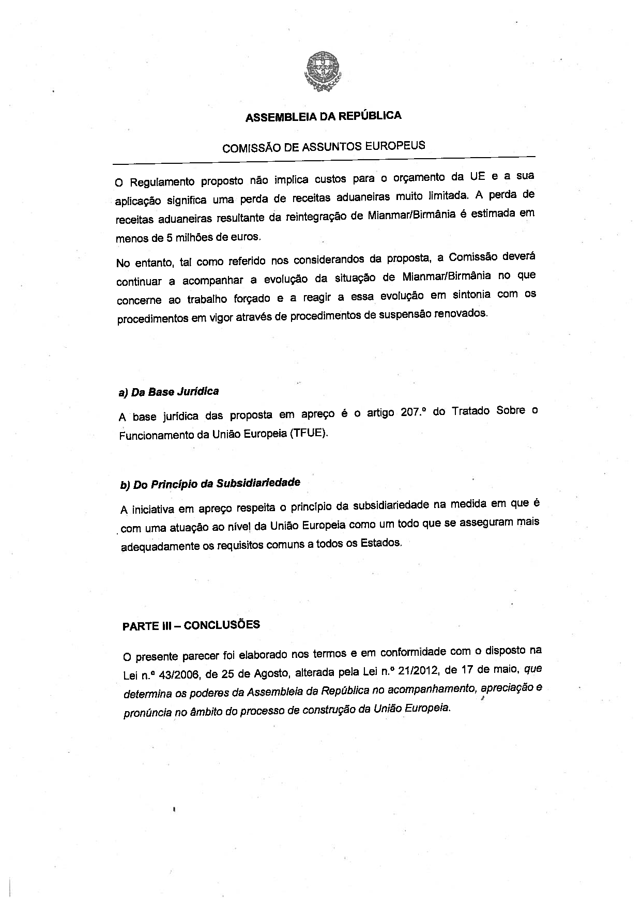
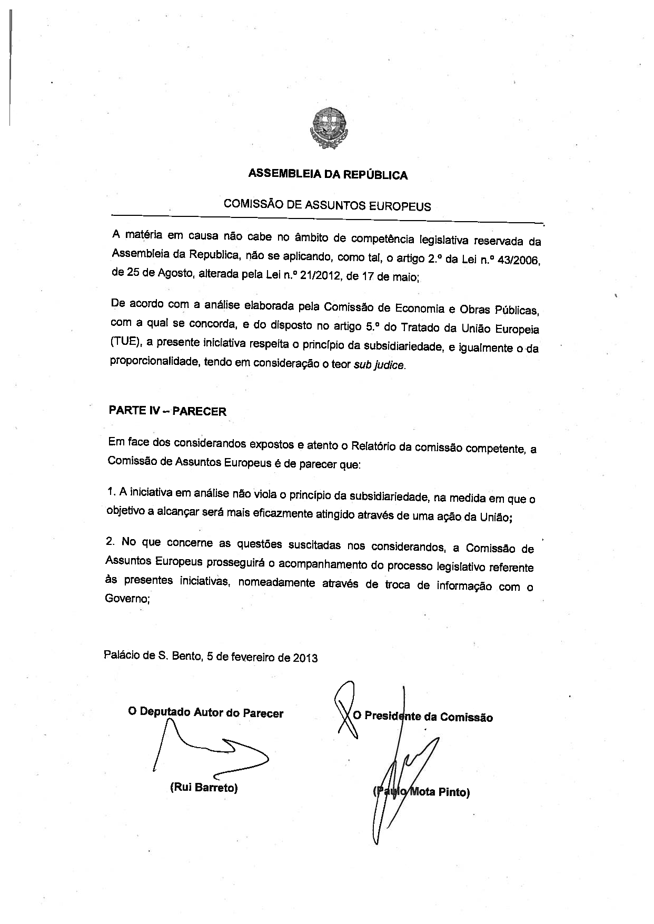
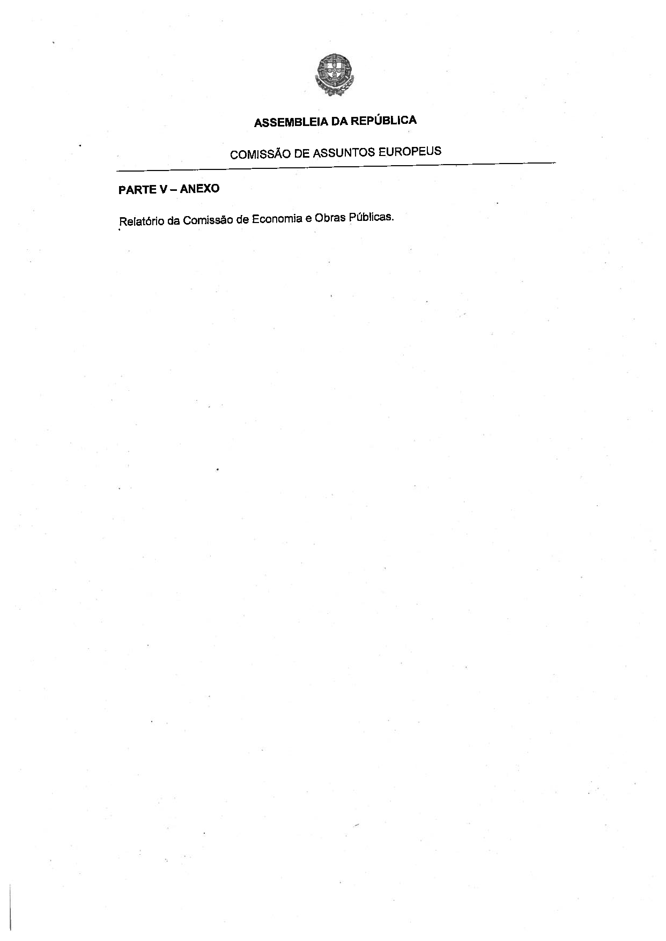
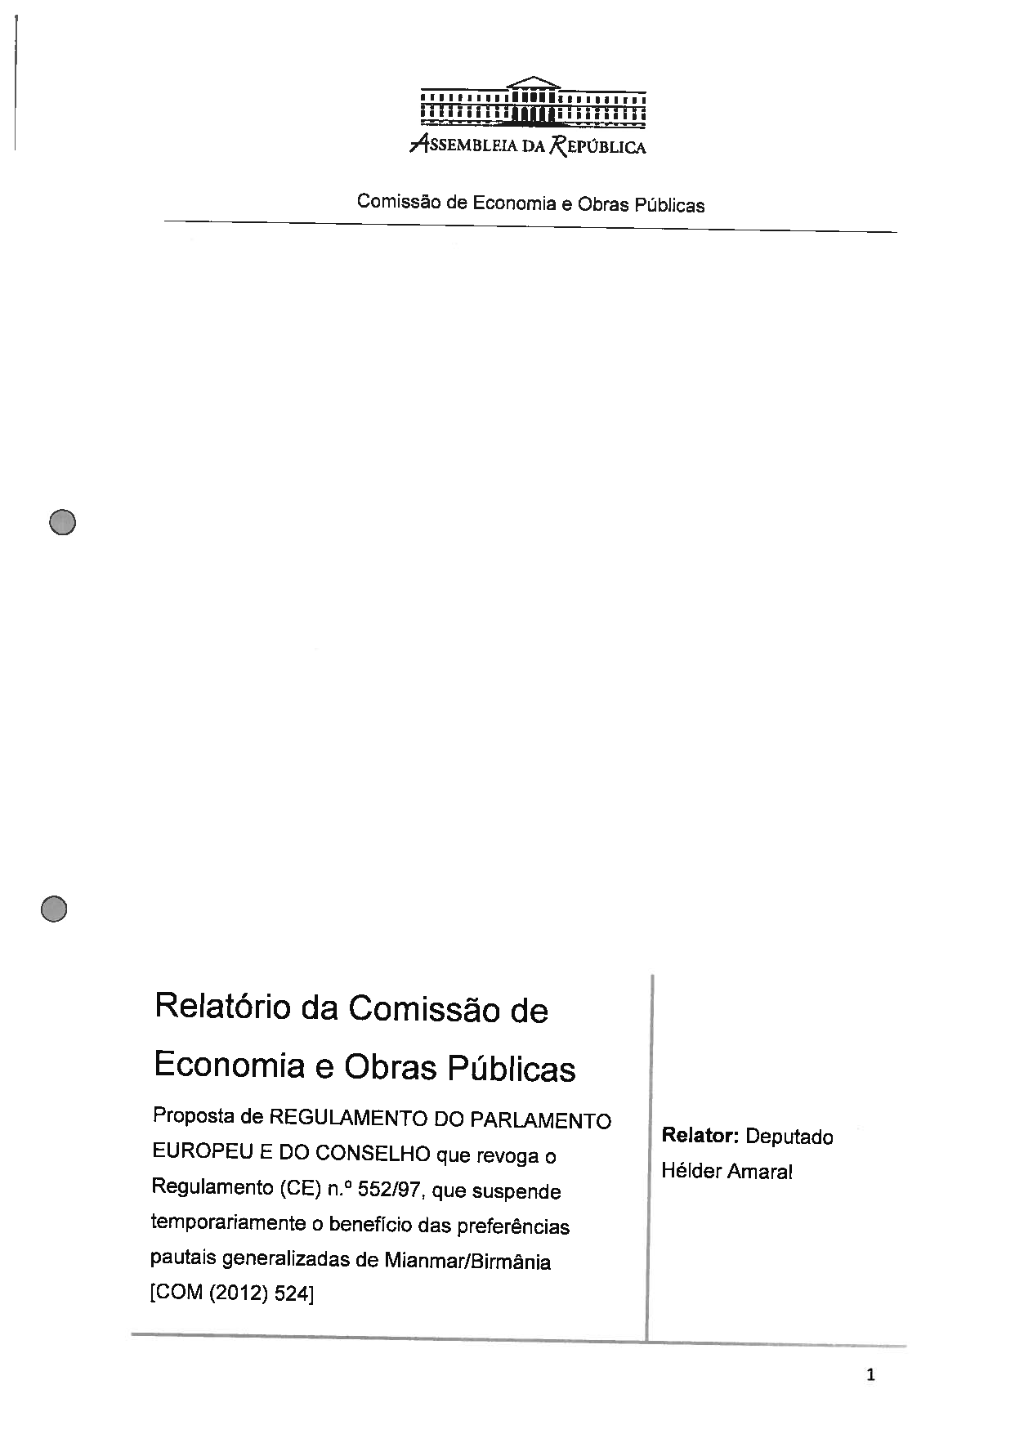
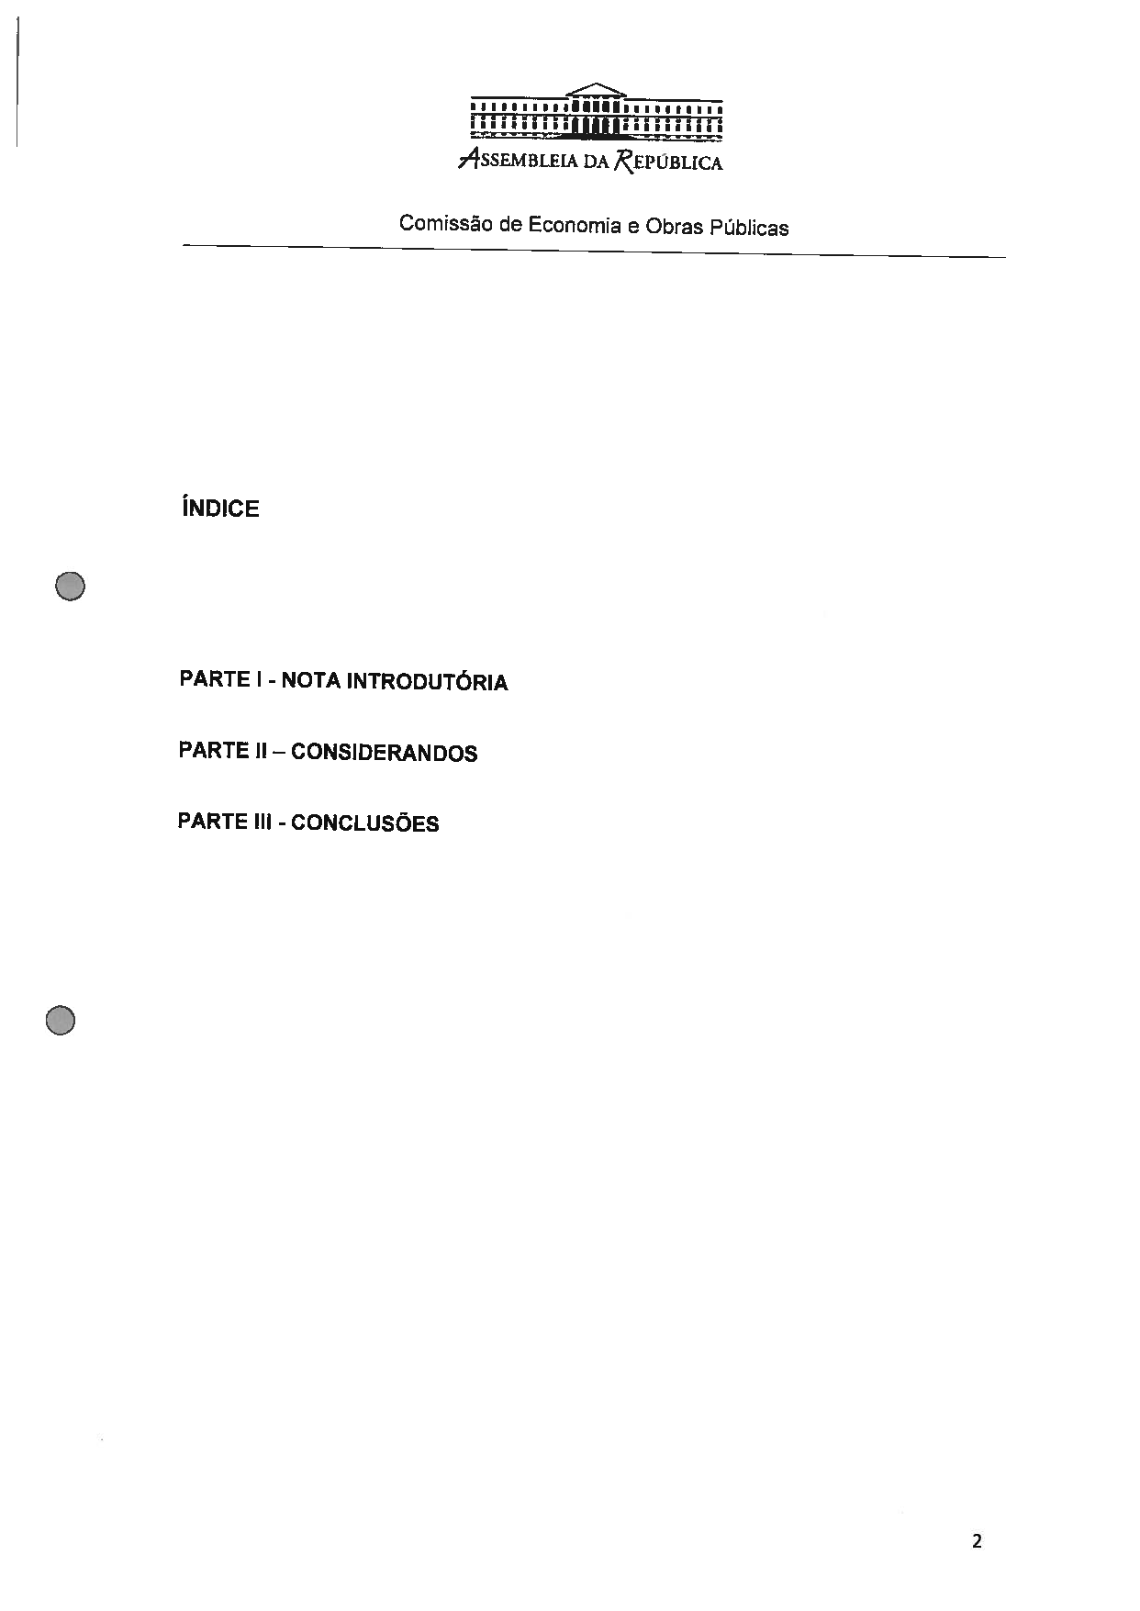
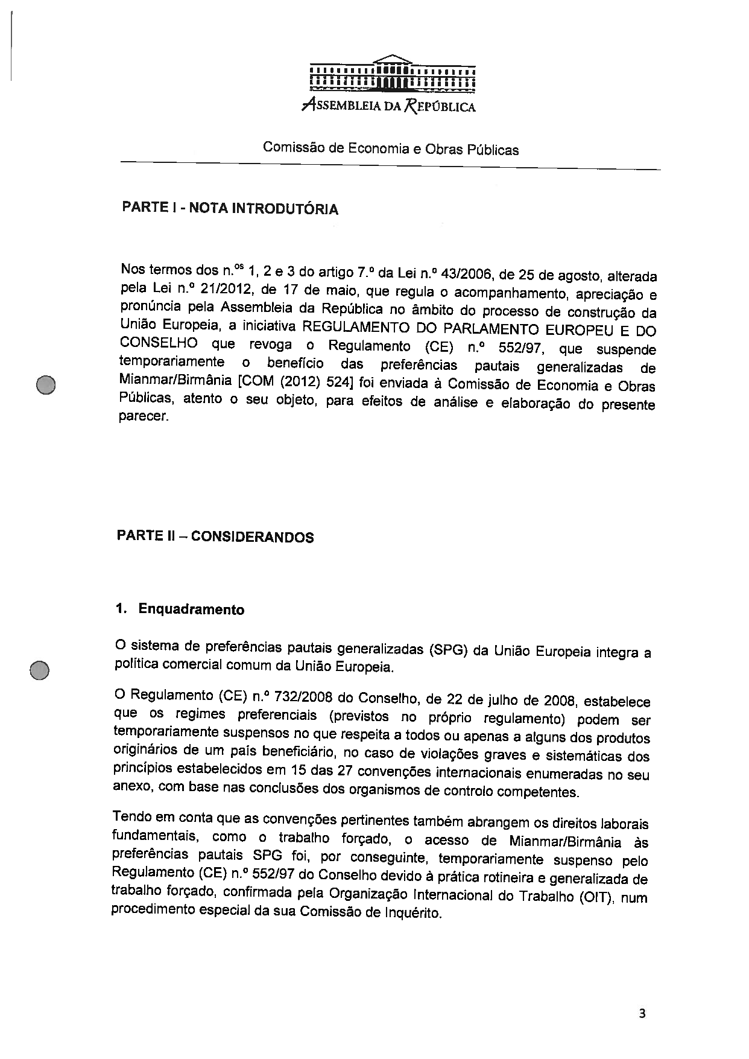
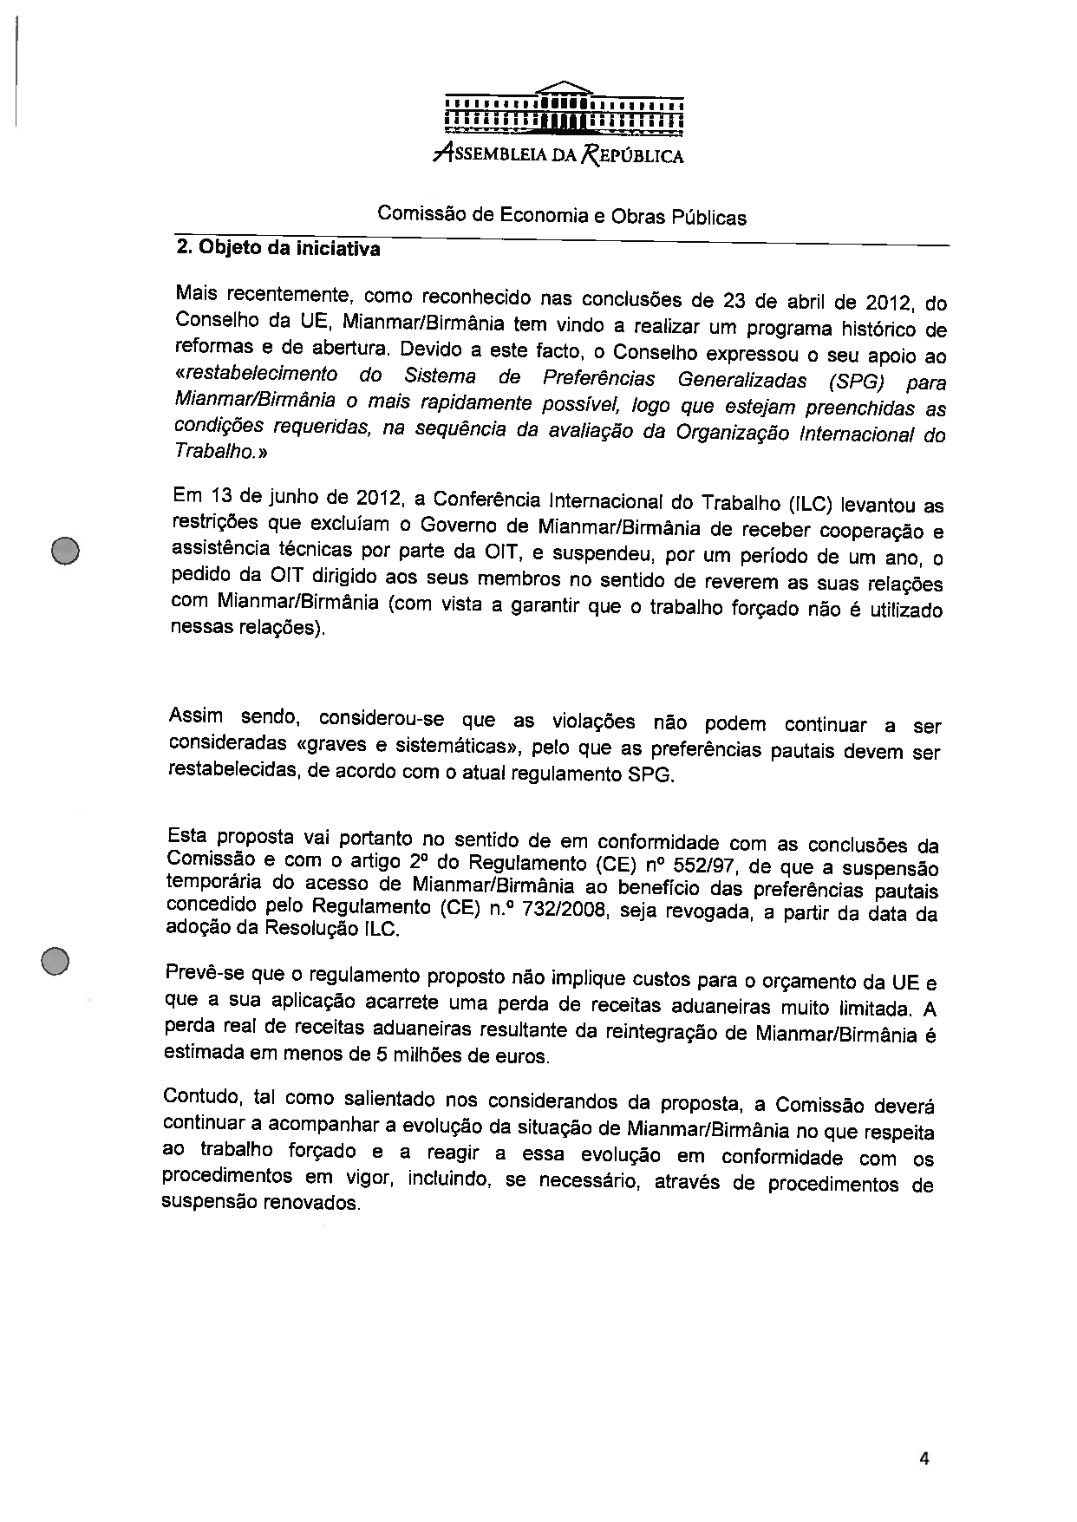
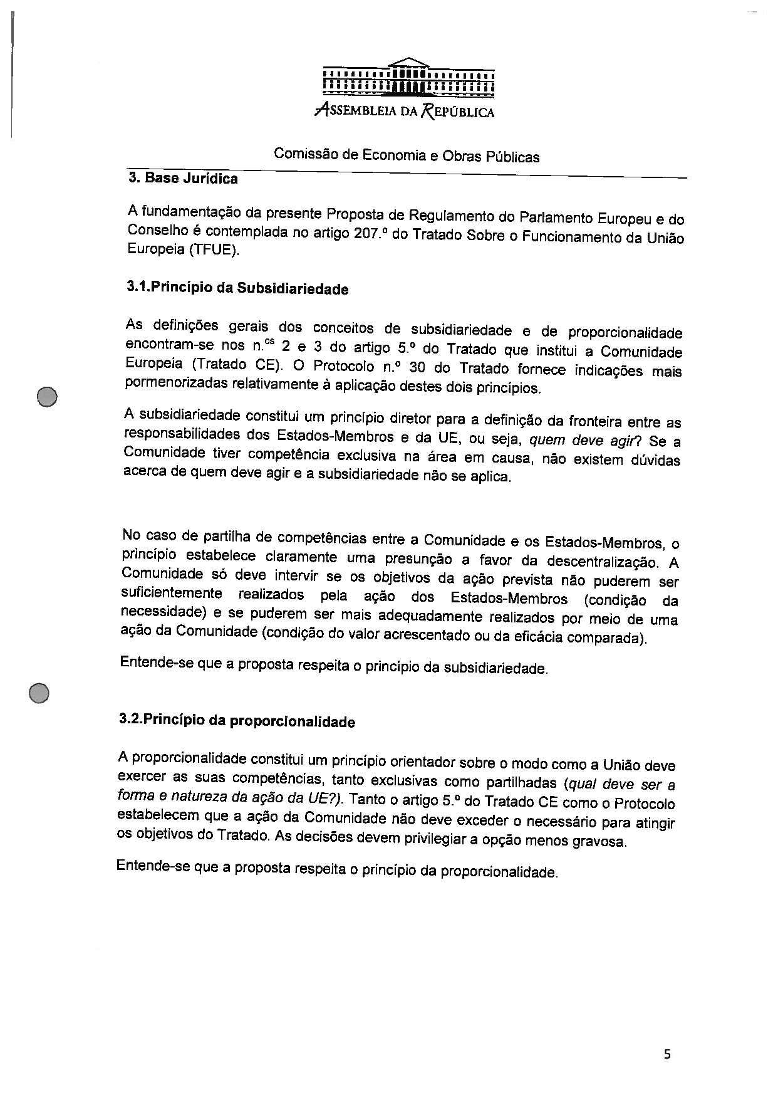
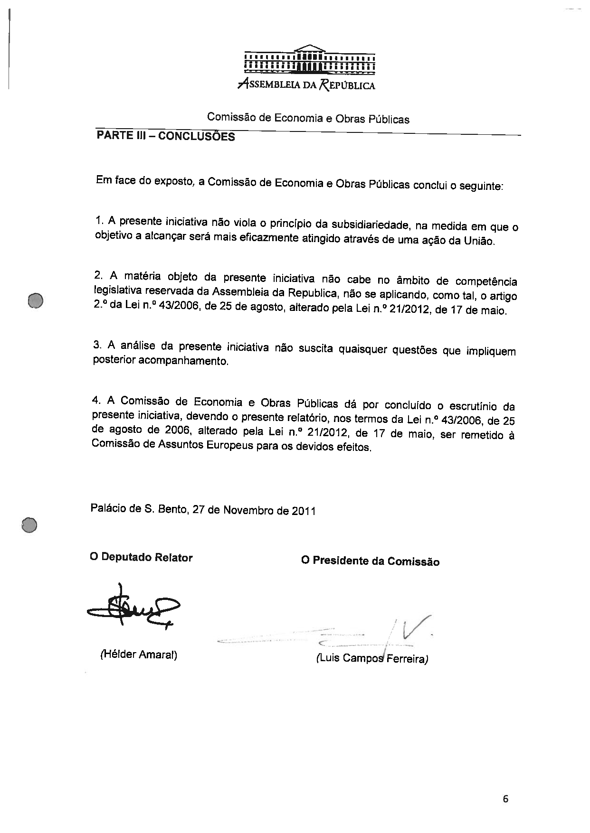

Translation(s) of the opinion may be available on the Interparliamentary EU Information Exchange site IPEX, at the following address: http://www.ipex.eu/IPEXL-WEB/search.do.

