 | 
COUNCIL OF  THE EUROPEAN UNION |  |  | Brussels, 11 February 2013
 | Interinstitutional File:  2012/0366(COD) |  | 6240/13
SAN 44
MI 101
FISC 27
CODEC 285
INST 65
PARLNAT 37

COVER NOTE
from: | Italian Senate
date of receipt: | 8 February 2013
to: | The President of the Council of the European Union
No Cion doc.: | 18068/12 SAN 337 MI 206 FISC 850 CODEC 3117 - COM(2012) 788 final
Subject: | Proposal for a Directive of the European Parliament and of the Council on the approximation of the laws, regulations and administrative provisions of the Member States concerning the manufacture, presentation and sale of tobacco and related products (Text with EEA relevance)  - Opinion on the application of the Principles of Subsidiarity and Proportionality

Delegations will find attached for information a copy of the above opinion.

________________________

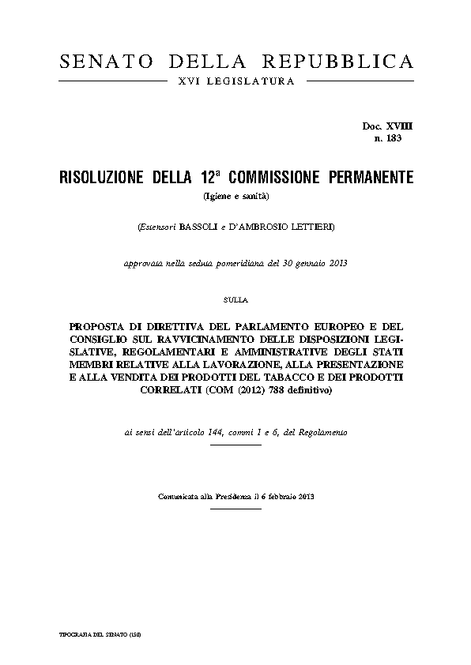
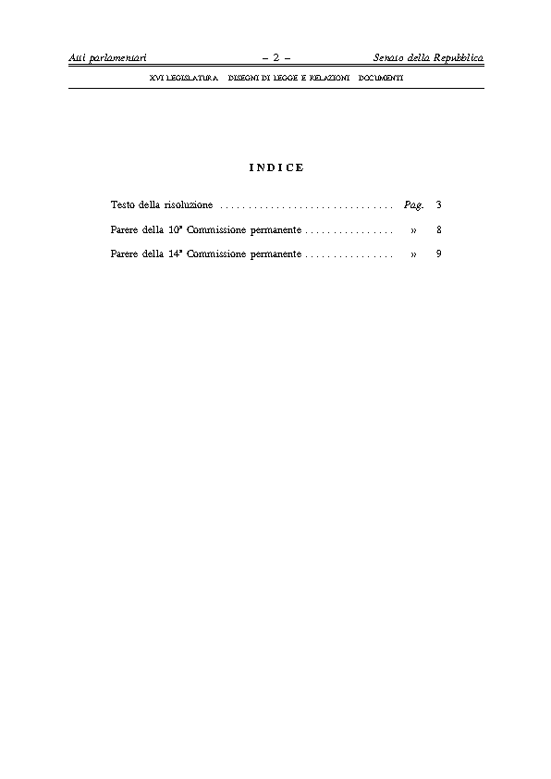
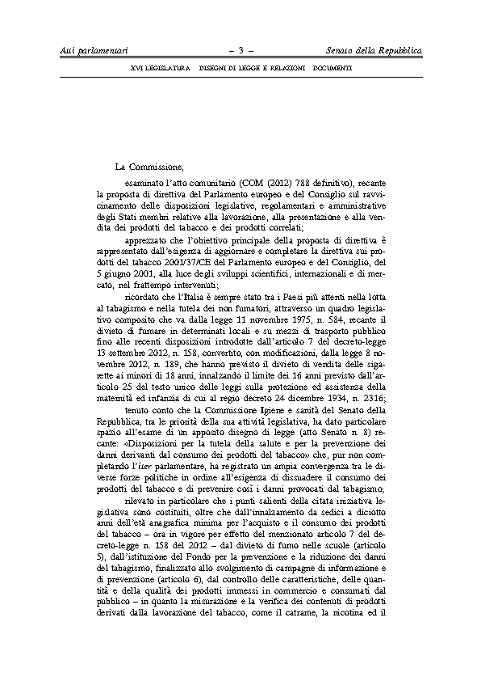
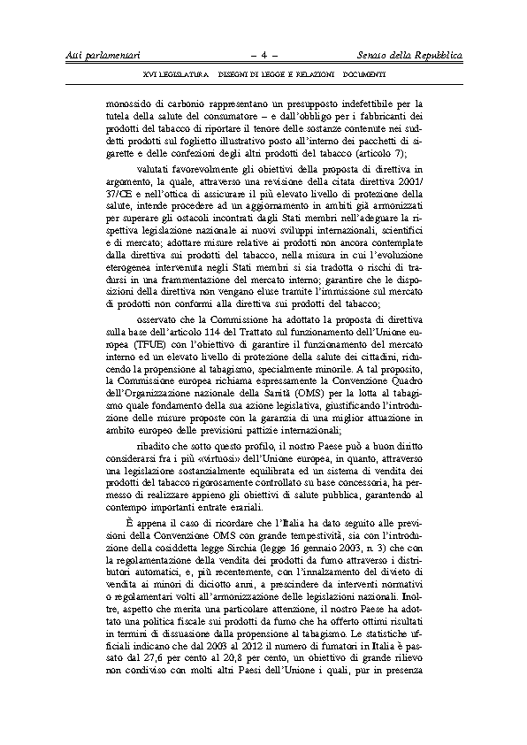
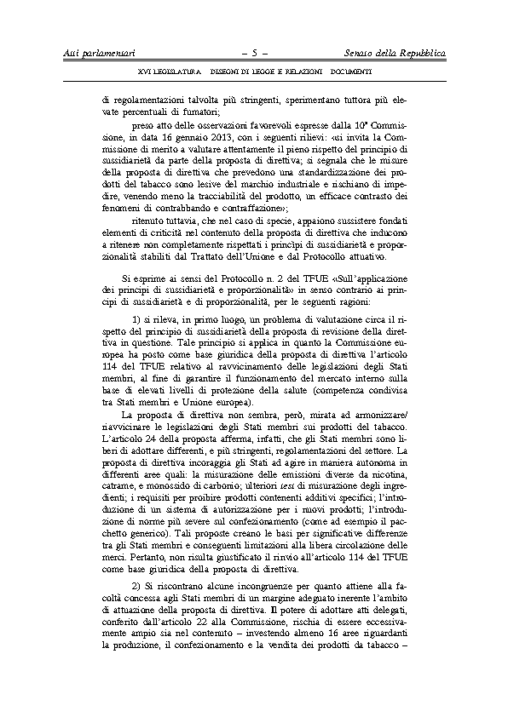
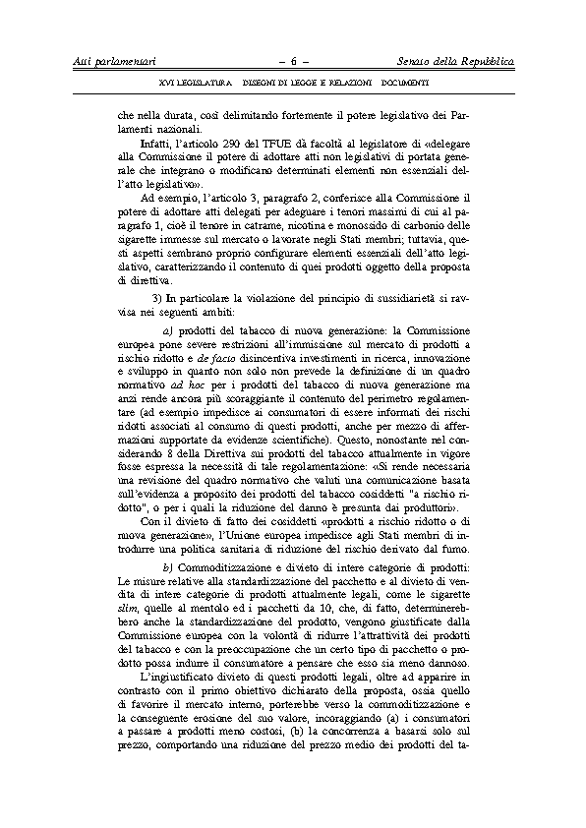
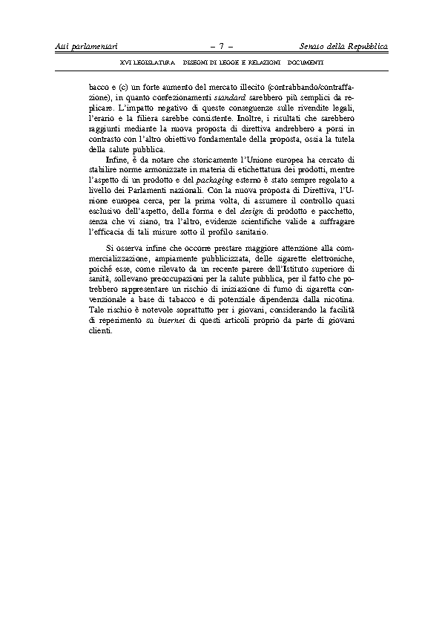
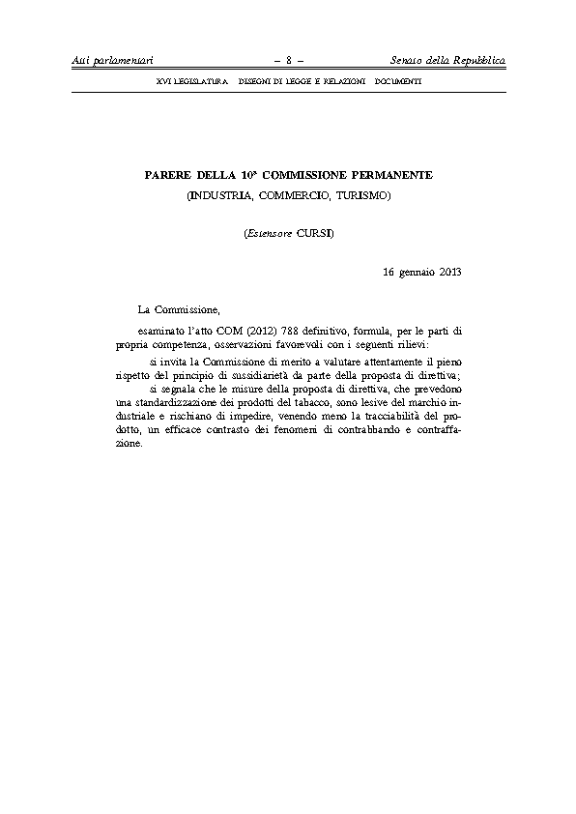
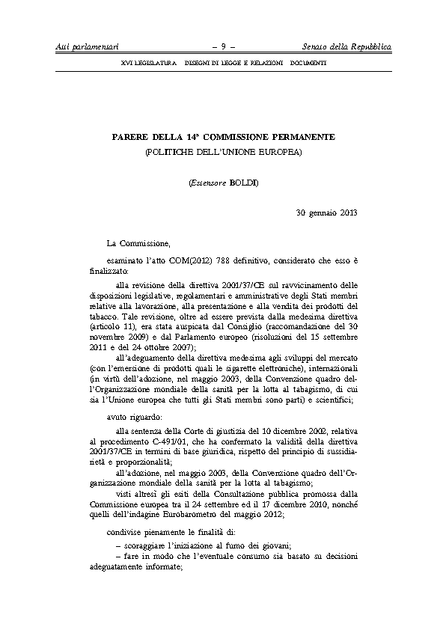
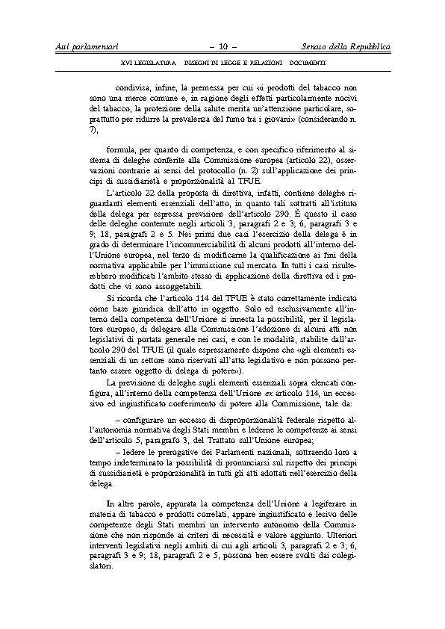
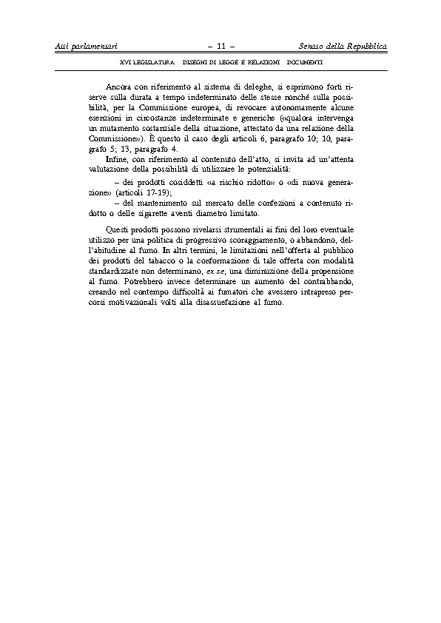

The translation can be found at the Interparliamentary EU information exchange site IPEX at the following address: http://www.ipex.eu/IPEXL-WEB/dossier/document/COM20120788.do#dossier-COD20120366

