 | 
COUNCIL OF  THE EUROPEAN UNION |  |  | Brussels, 6 January 2013
 | Interinstitutional File:  2012/0343 (COD) |  | 6149/13
STATIS 13
AGRI 69
CODEC 267
INST 59
PARLNAT 34

COVER NOTE
from: | Portuguese Parliament
date of receipt: | 31 January 2013
to: | President of the Council of the European Union
Subject: | Proposal for a Regulation of the European Parliament and of the Council amending certain legislative acts in the domain of agricultural and fishery statistics  [doc. 17546/12 STATIS 102 AGRI 854 CODEC 2995- COM (2012) 724 final]  - Opinion on the application of the Principles of Subsidiarity and Proportionality

Delegations will find attached a copy of the above letter.

________________________

ANNEX
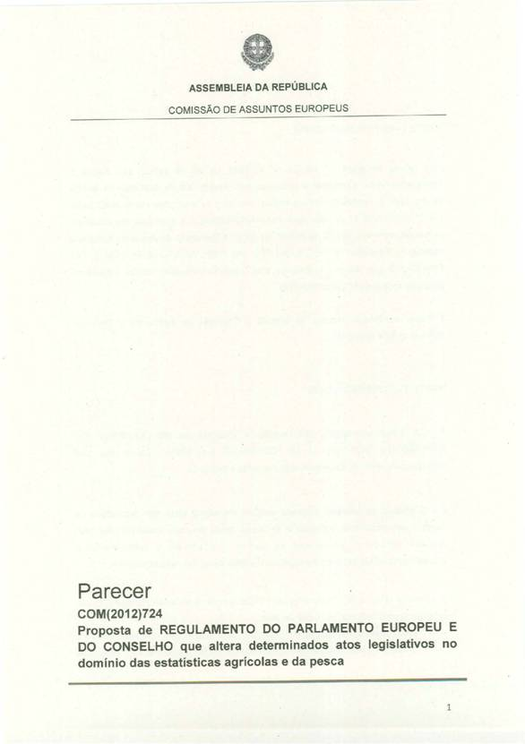

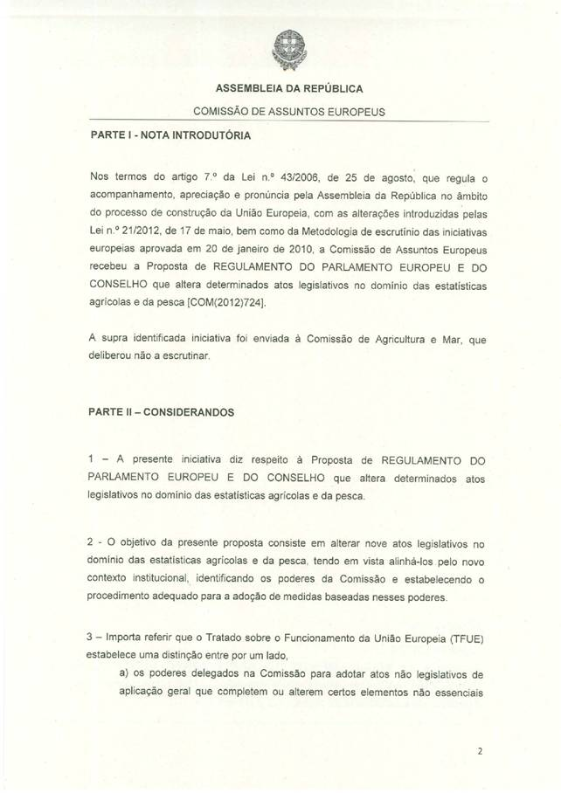
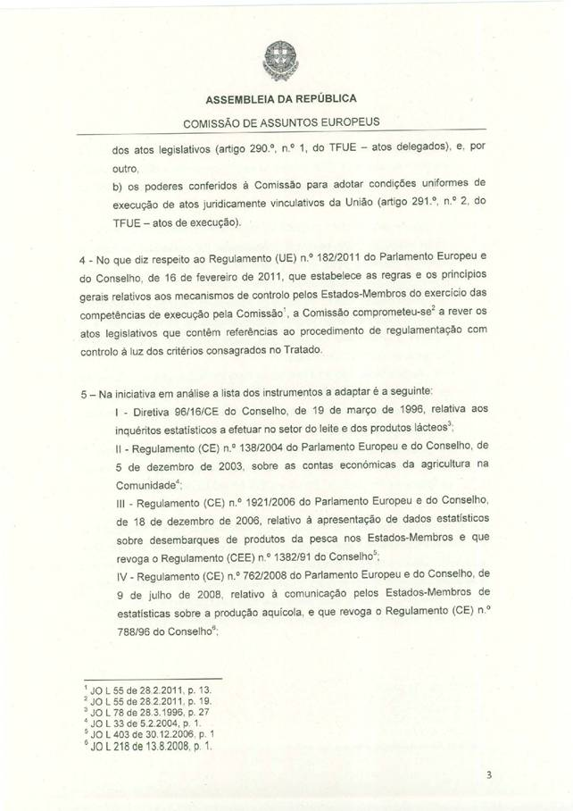
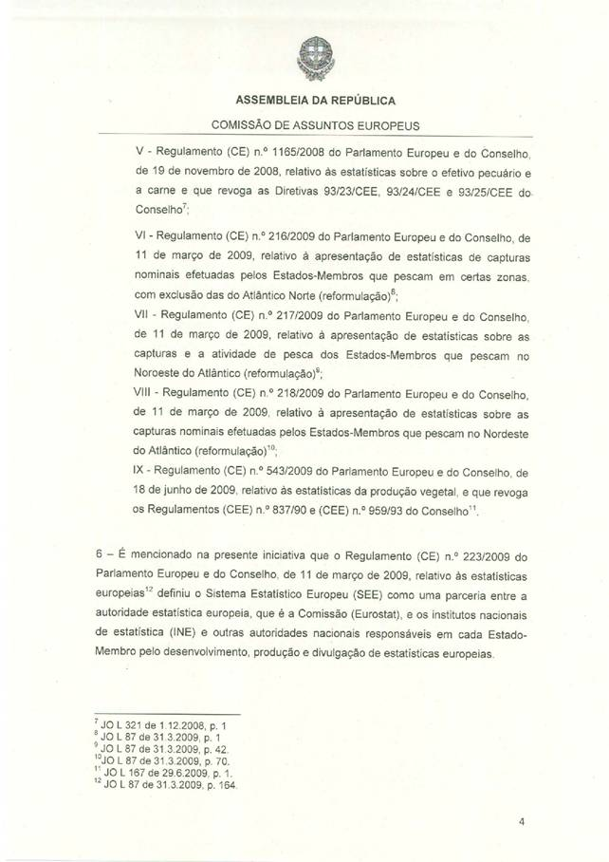
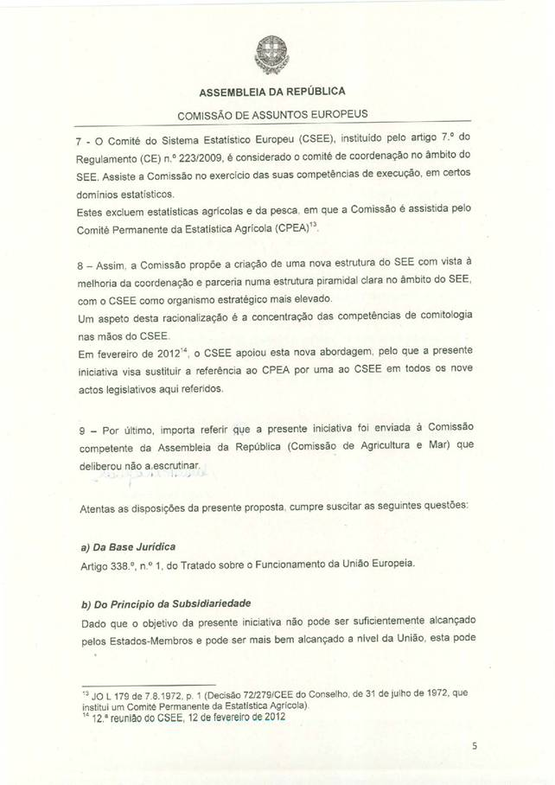
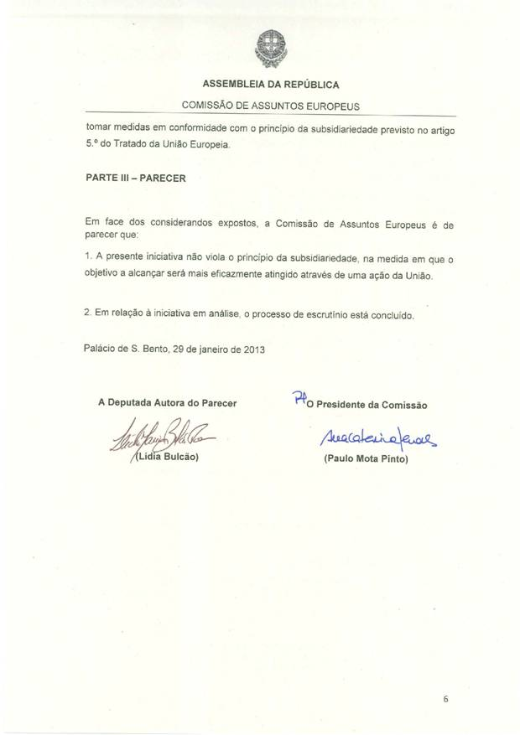
______________

This opinion is available in English on the Interparliamentary EU information exchange Internet site (IPEX) at the following address: http://www.ipex.eu/IPEXL-WEB/search.do

