 | 
COUNCIL OF  THE EUROPEAN UNION |  |  | Brussels, 30 January 2013
 | Interinstitutional File:  2011/0341a (COD) |  | 5751/13
UD 22
AELE 11
CODEC 161
INST 39
PARLNAT 28

COVER NOTE
from: | The Portuguese Parliament
received on: | 24 January 2013
to: | The Council of the European Union
Subject: | Amended proposal for a Regulation of the European Parliament and of the Council establishing an action programme for customs in the European Union for the period 2014-2020 (Customs 2020) and repealing Decision N°624/2007/EC  - Opinion on the application of the Principles of Subsidiarity and Proportionality

Delegations will find attached a copy of the above opinion.

________________________

Encl.:
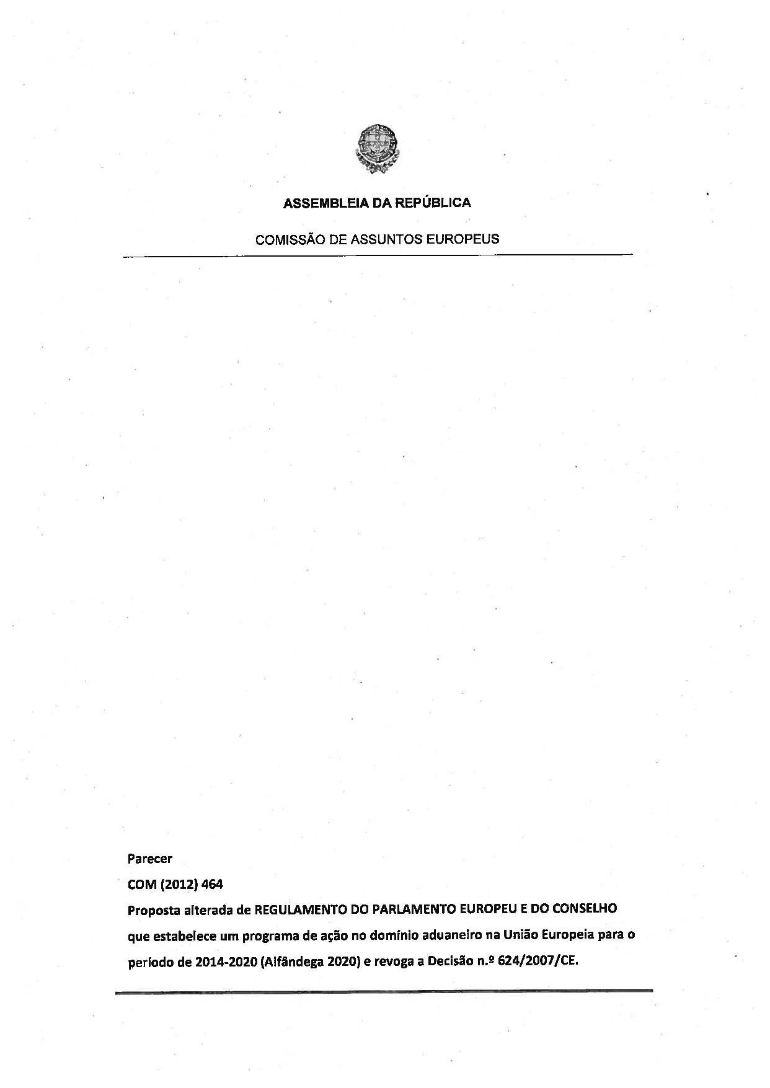
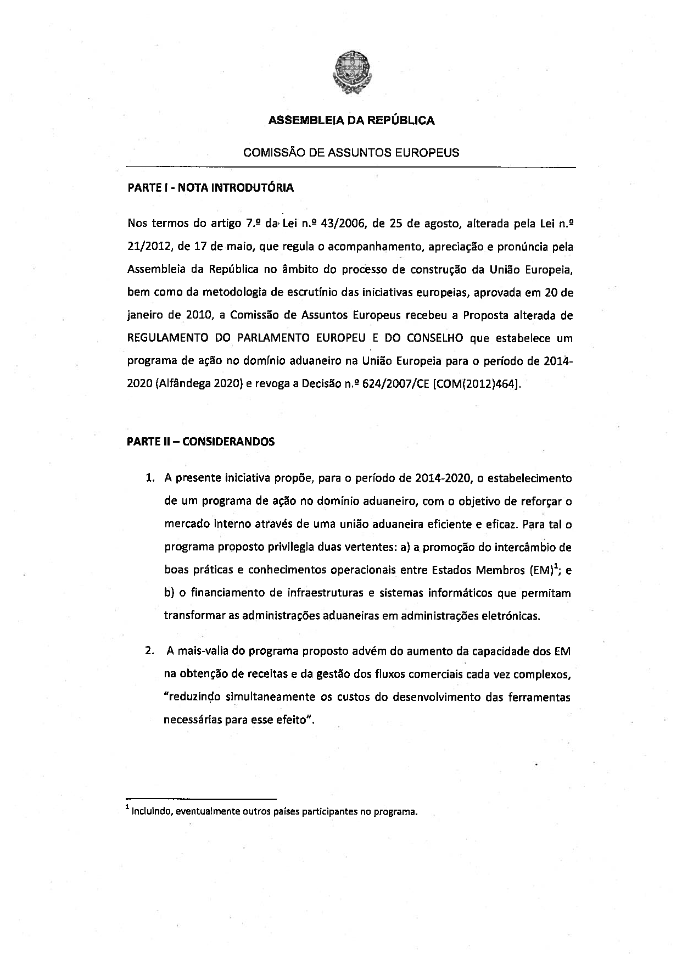
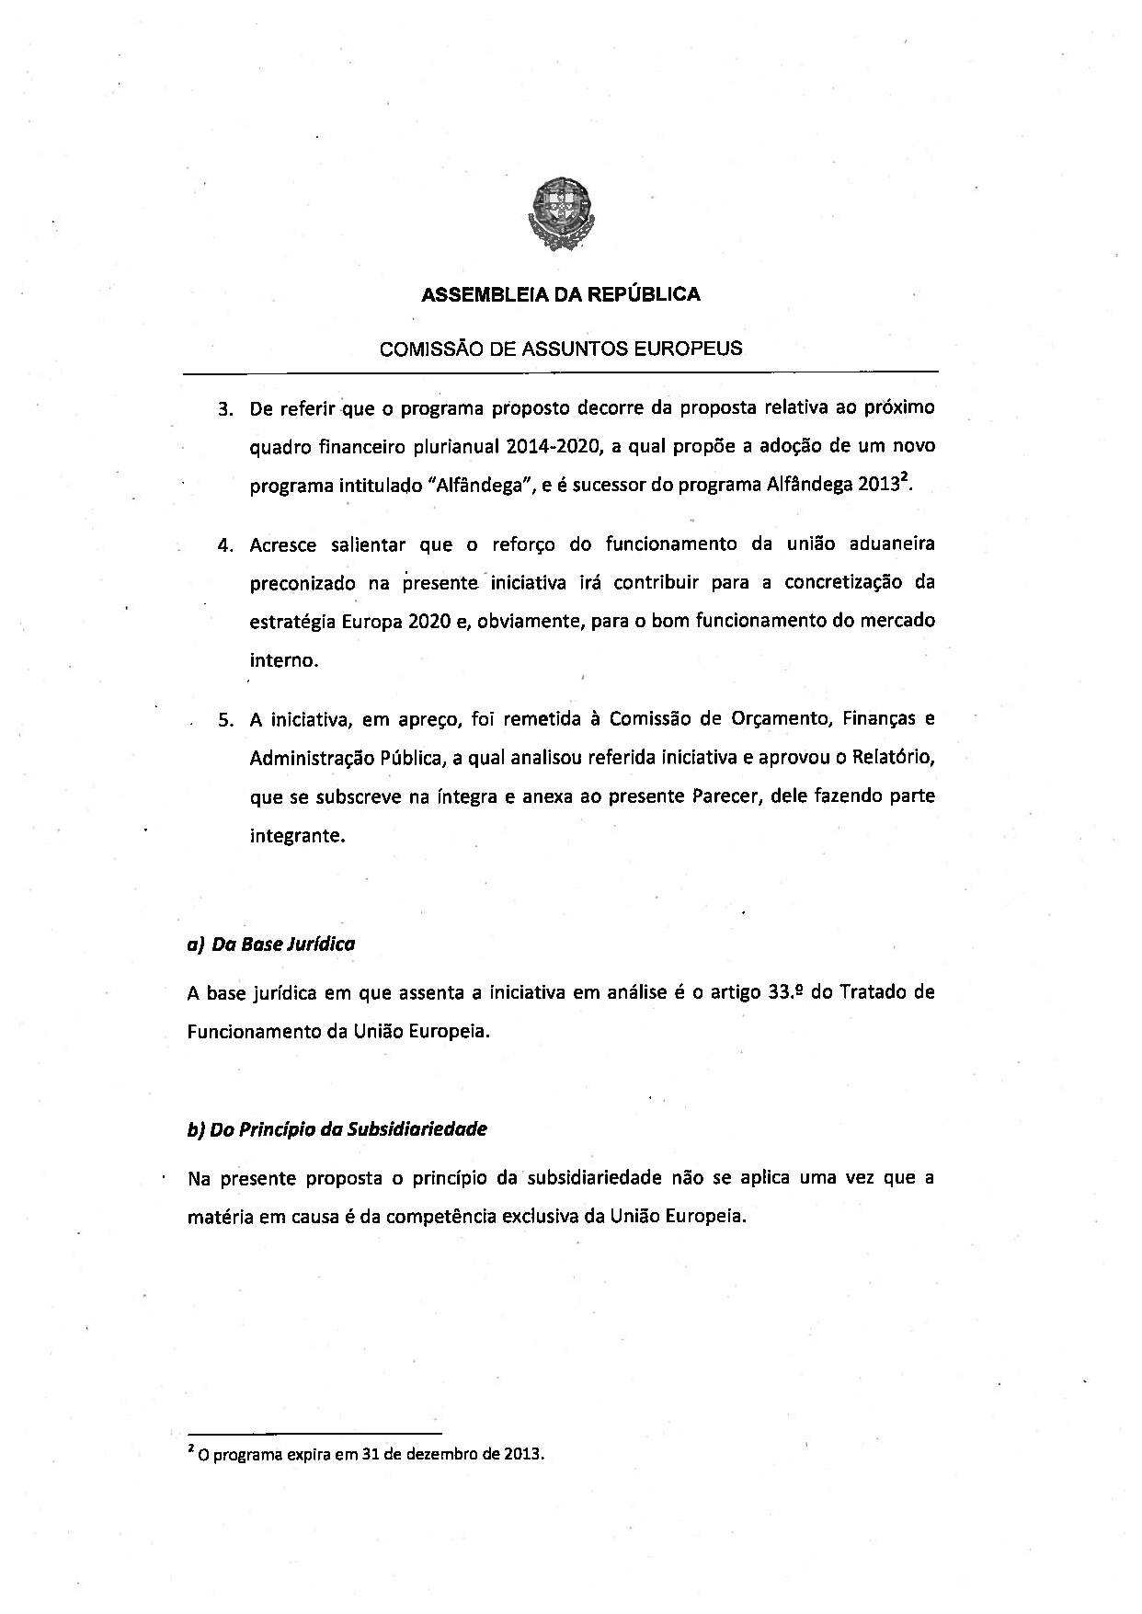
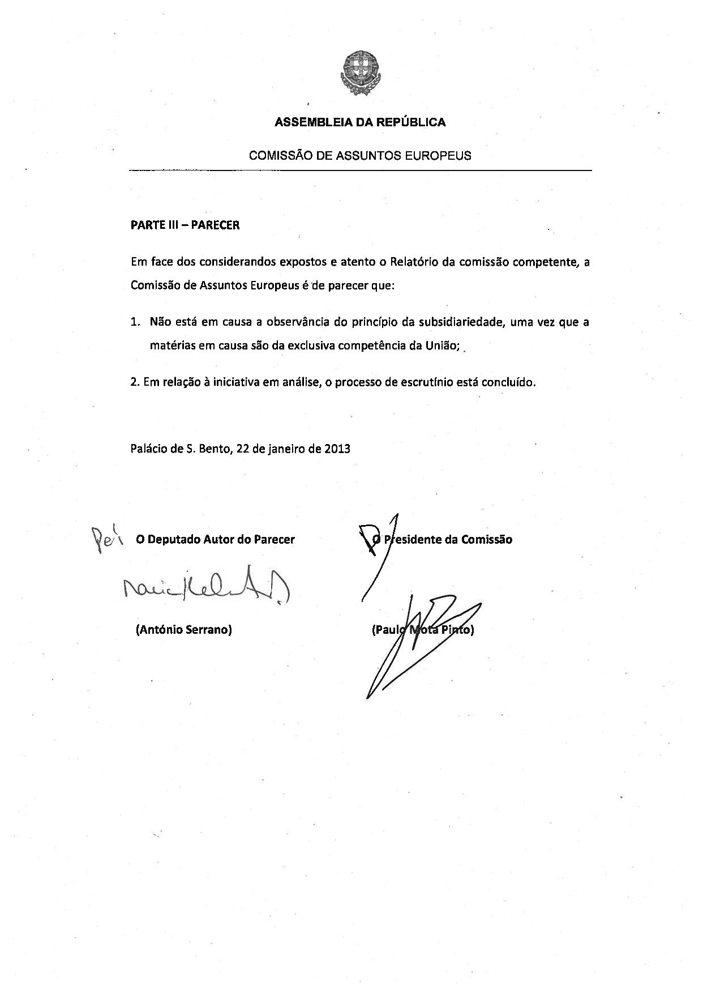
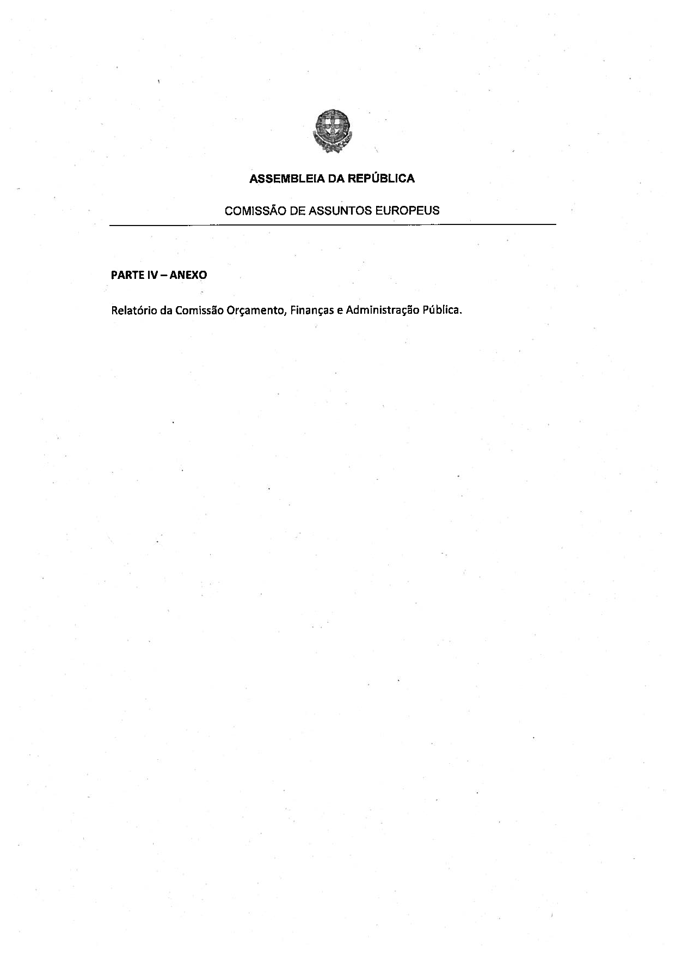
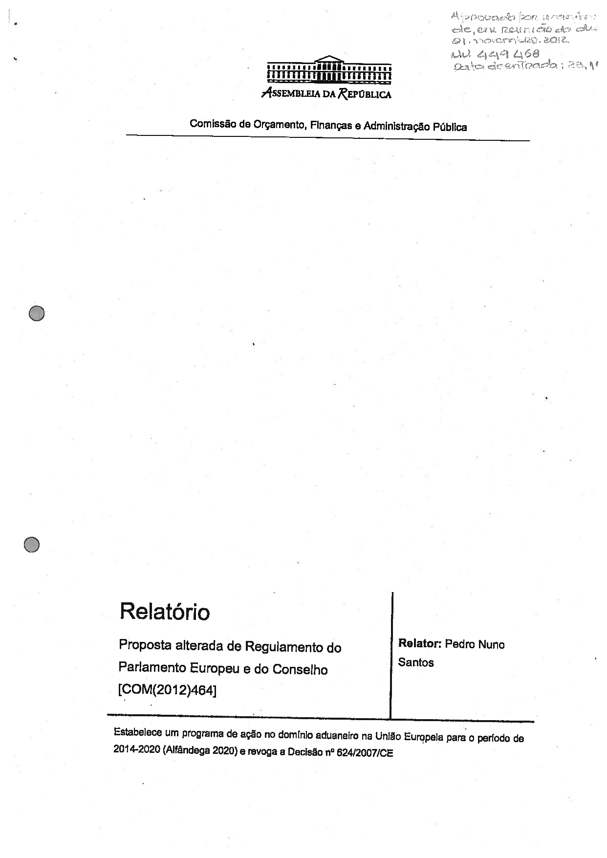
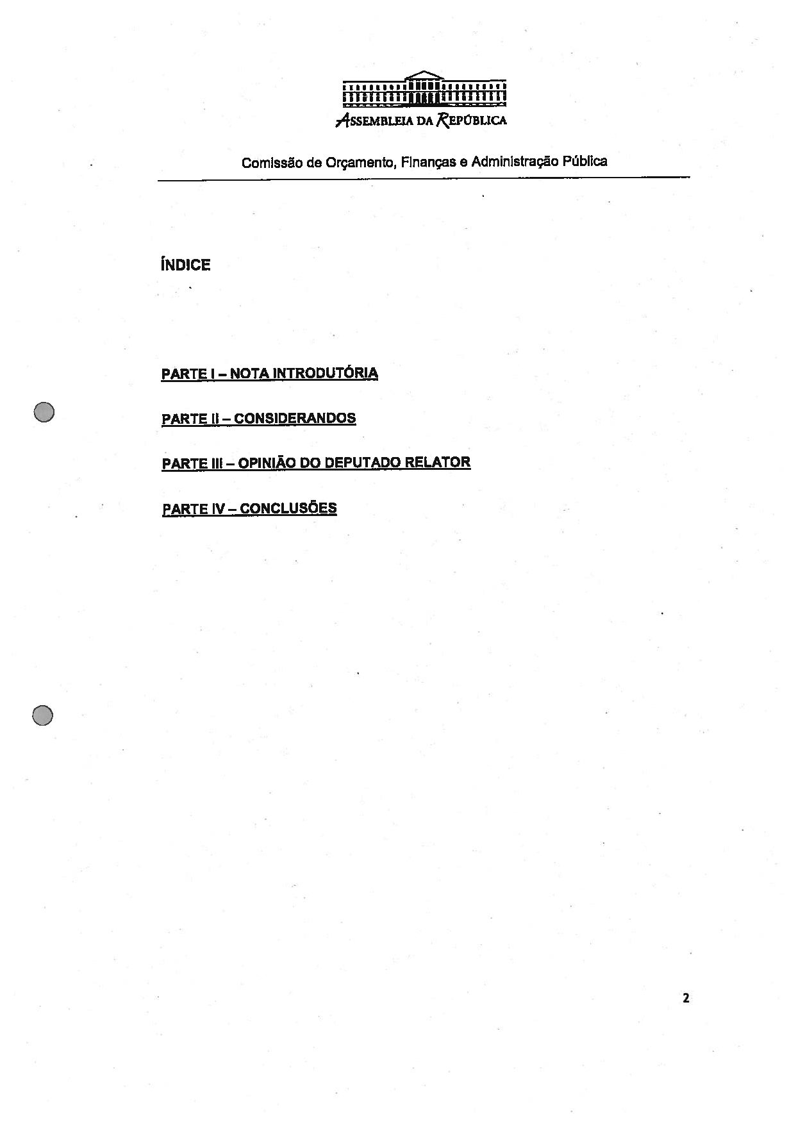
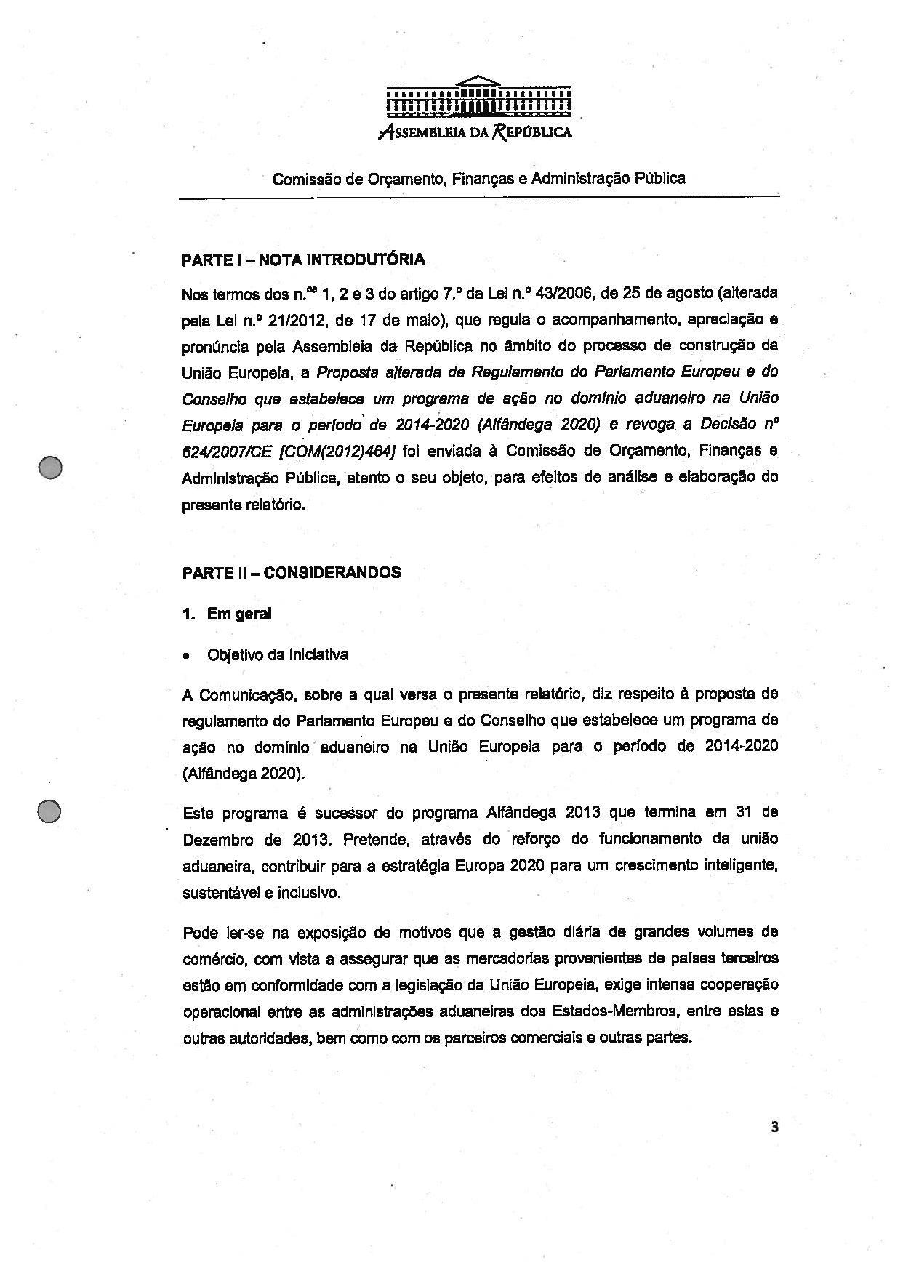
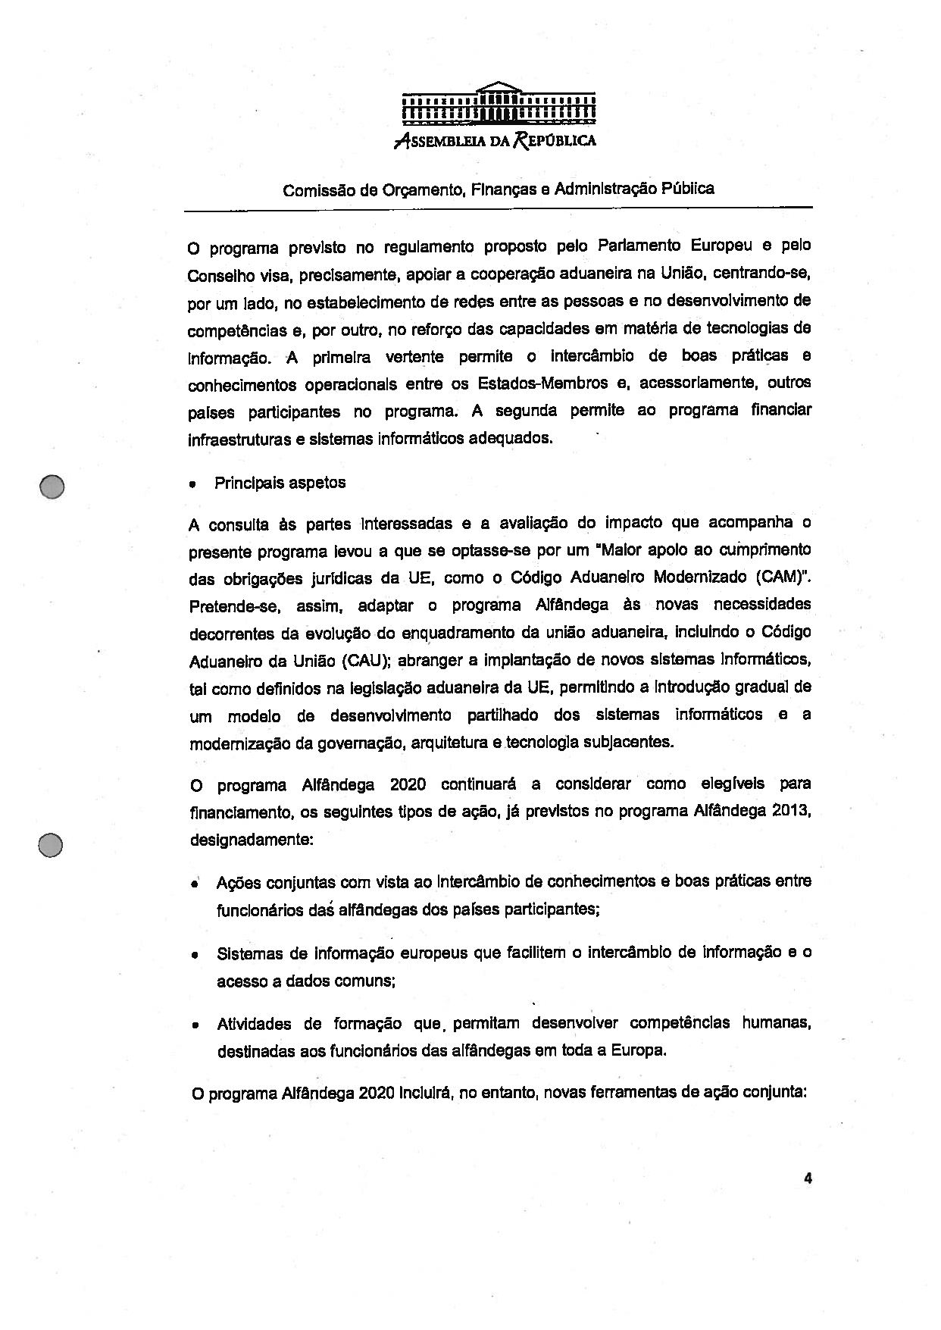
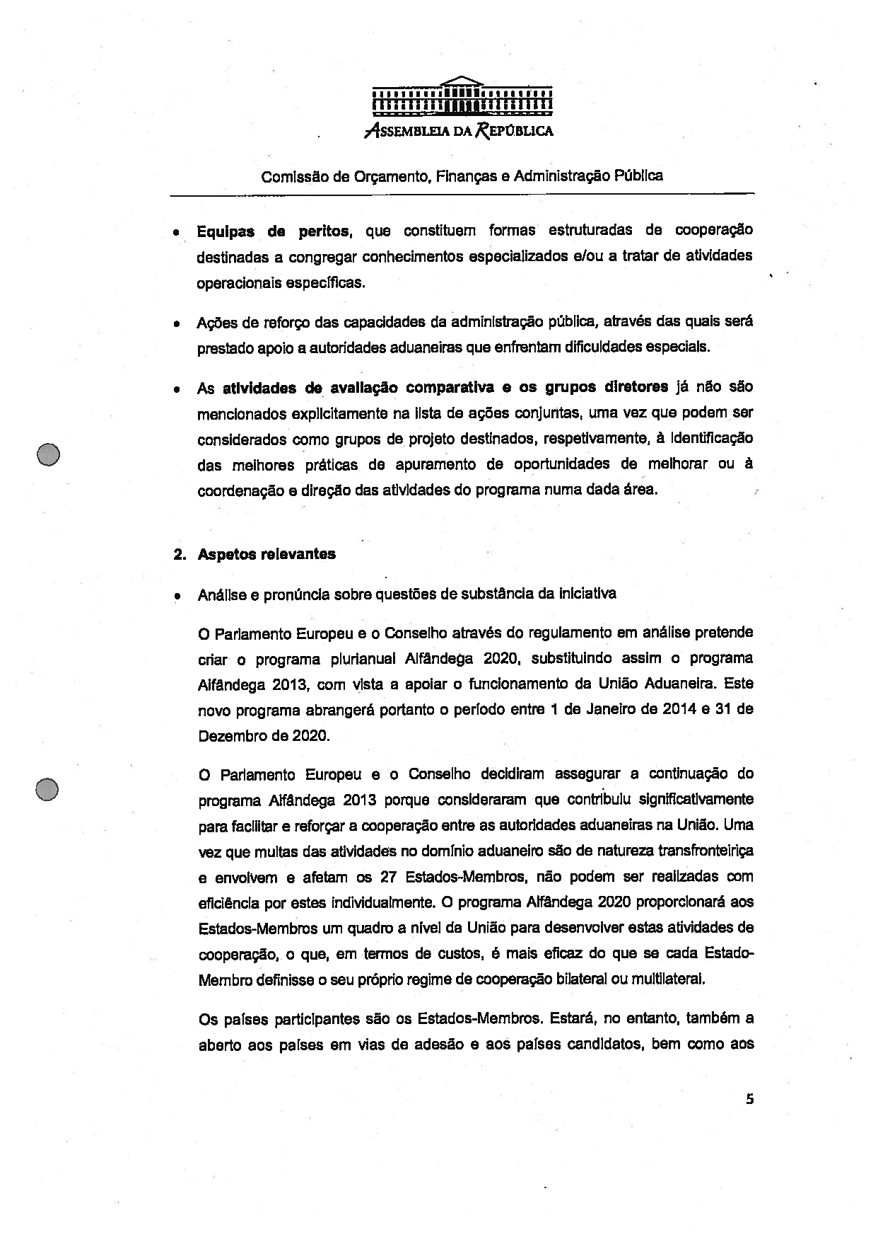
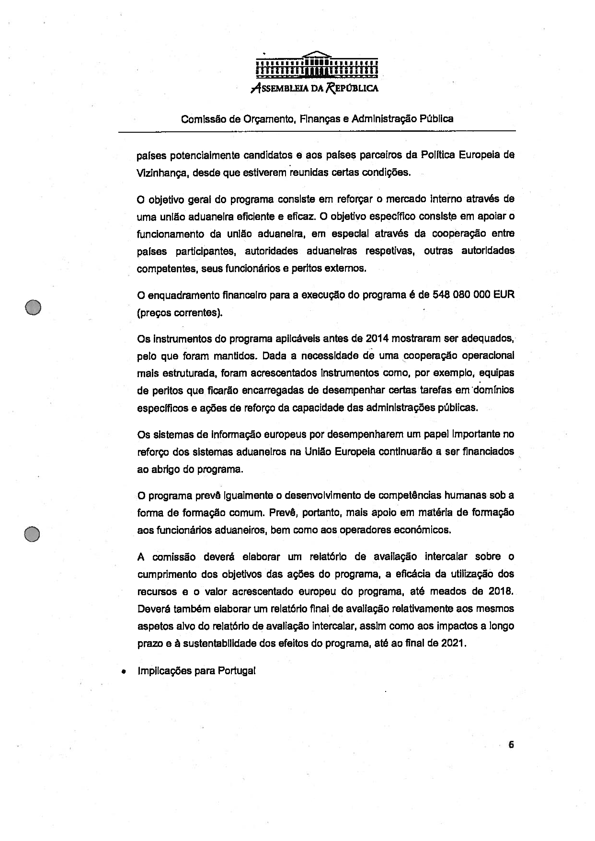
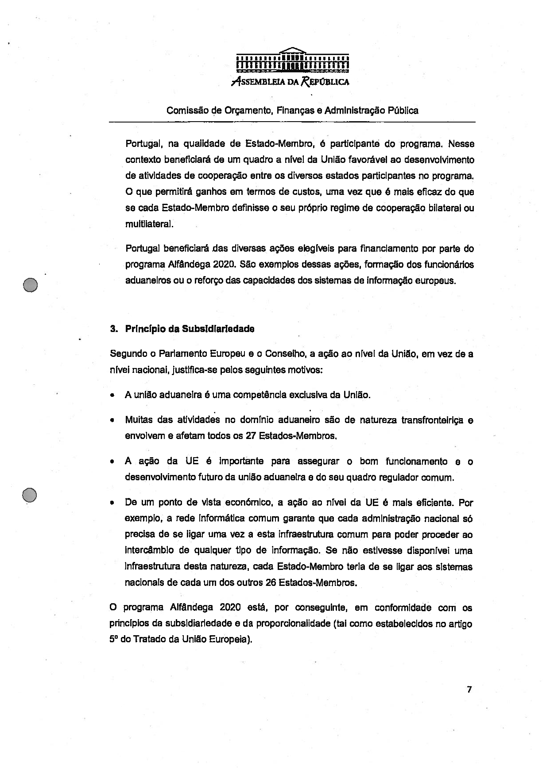
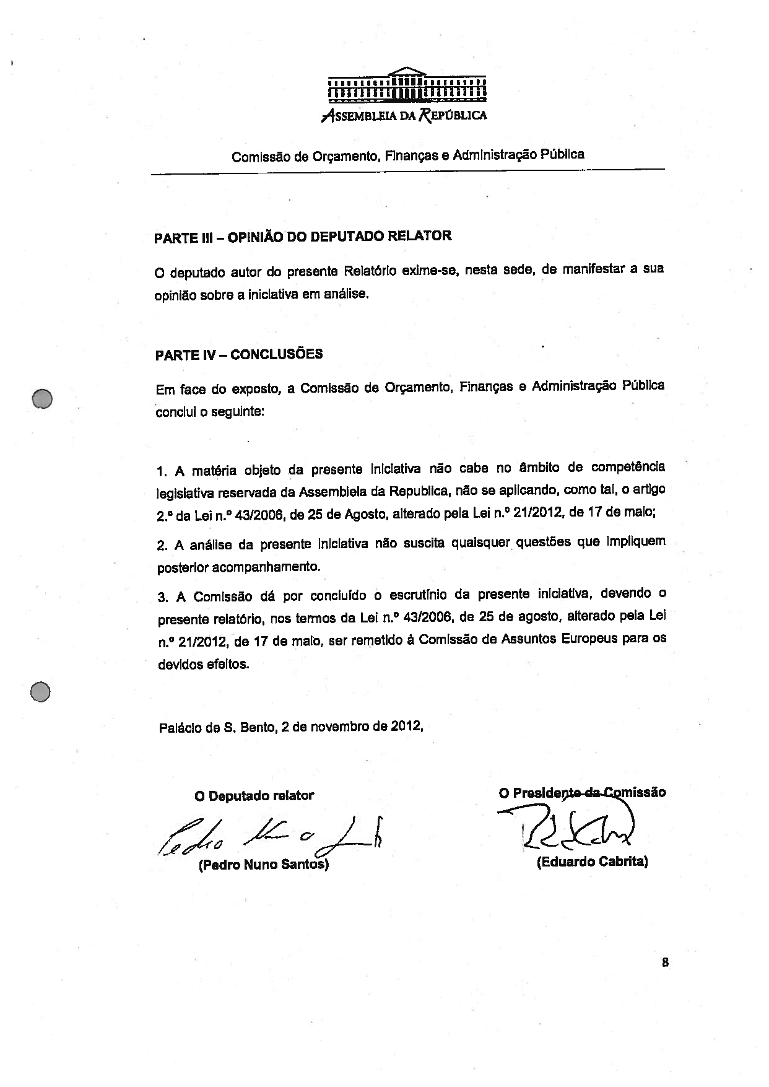

Translation(s) of the opinion may be available at the Interparliamentary EU information exchange site IPEX at the following address: http://www.ipex.eu/IPEXL-WEB/search.do

