 | 
COUNCIL OF  THE EUROPEAN UNION |  |  | Brussels, 30 January 2013
 | Interinstitutional File:  2011/0295 (COD) |  | 5883/13
EF 17
ECOFIN 71
DROIPEN 7
CODEC 189
INST 50
PARLNAT 33

COVER NOTE
from: | The Portuguese Parliament
date of receipt: | 24 January 2013
to: | President of the Council of the European Union
Subject: | Amended proposal for a REGULATION OF THE EUROPEAN PARLIAMENT AND OF THE COUNCIL on insider dealing and market manipulation (market abuse)  (submitted in accordance with article 293(2) TFEU)  [doc. 13023/12 EF 187 ECOFIN 734 DROIPEN 114 CODEC 1999 - COM(2012) 421 final]  AND  - Opinion on the application of the Principles of Subsidiarity and Proportionality

Delegations will find enclosed the above mentioned Opinion.
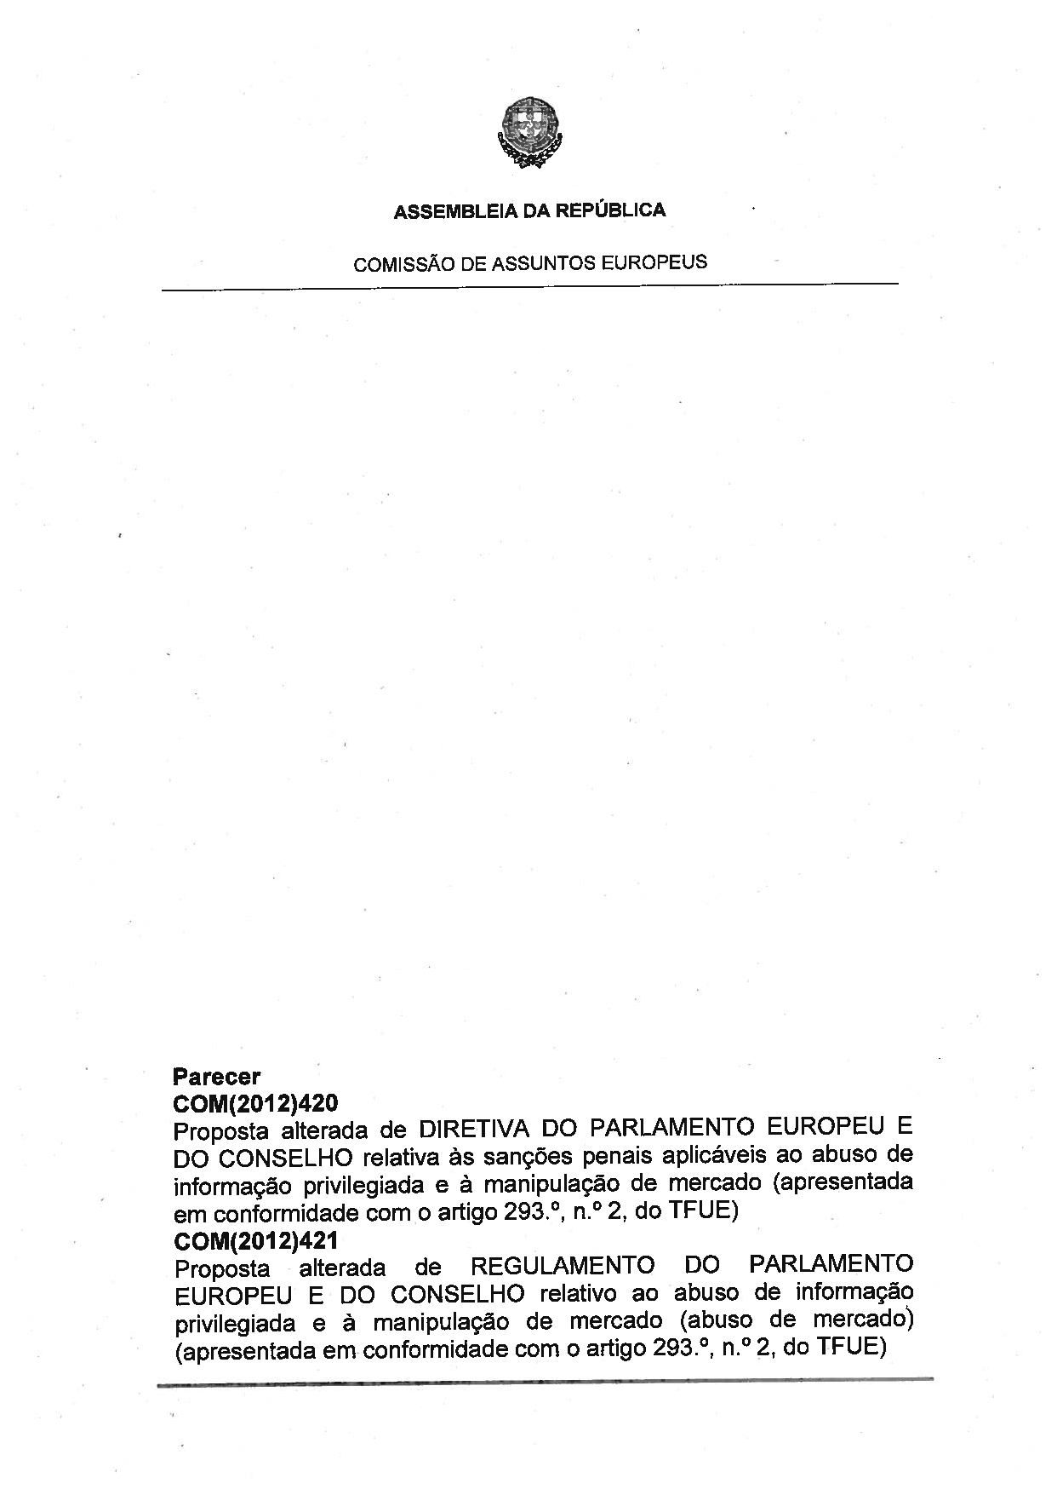
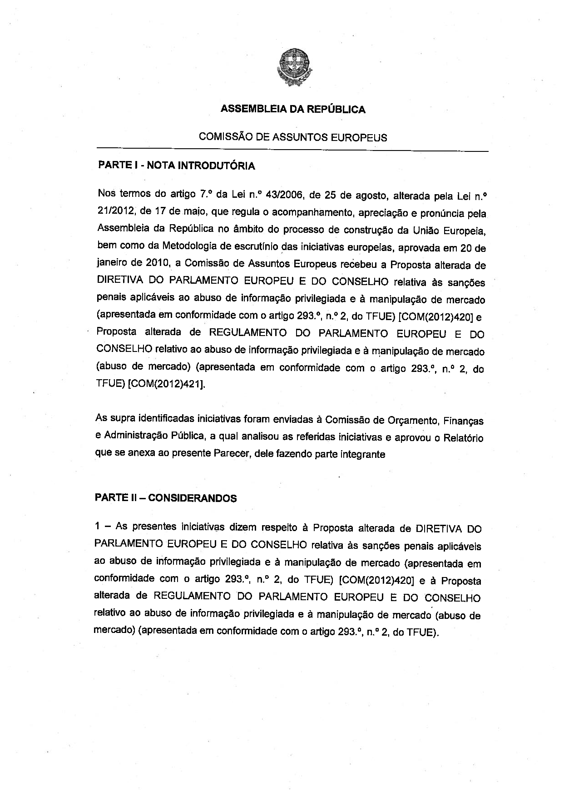
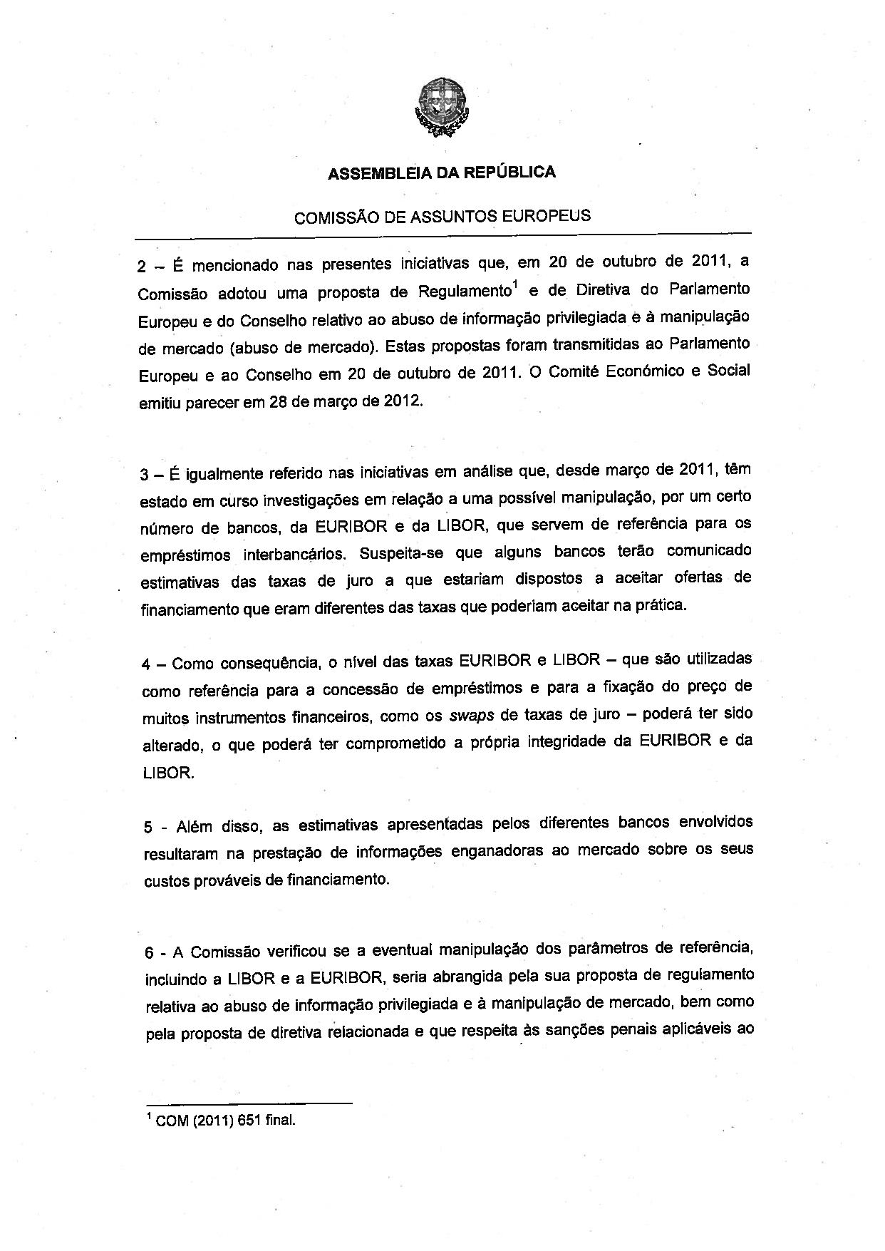
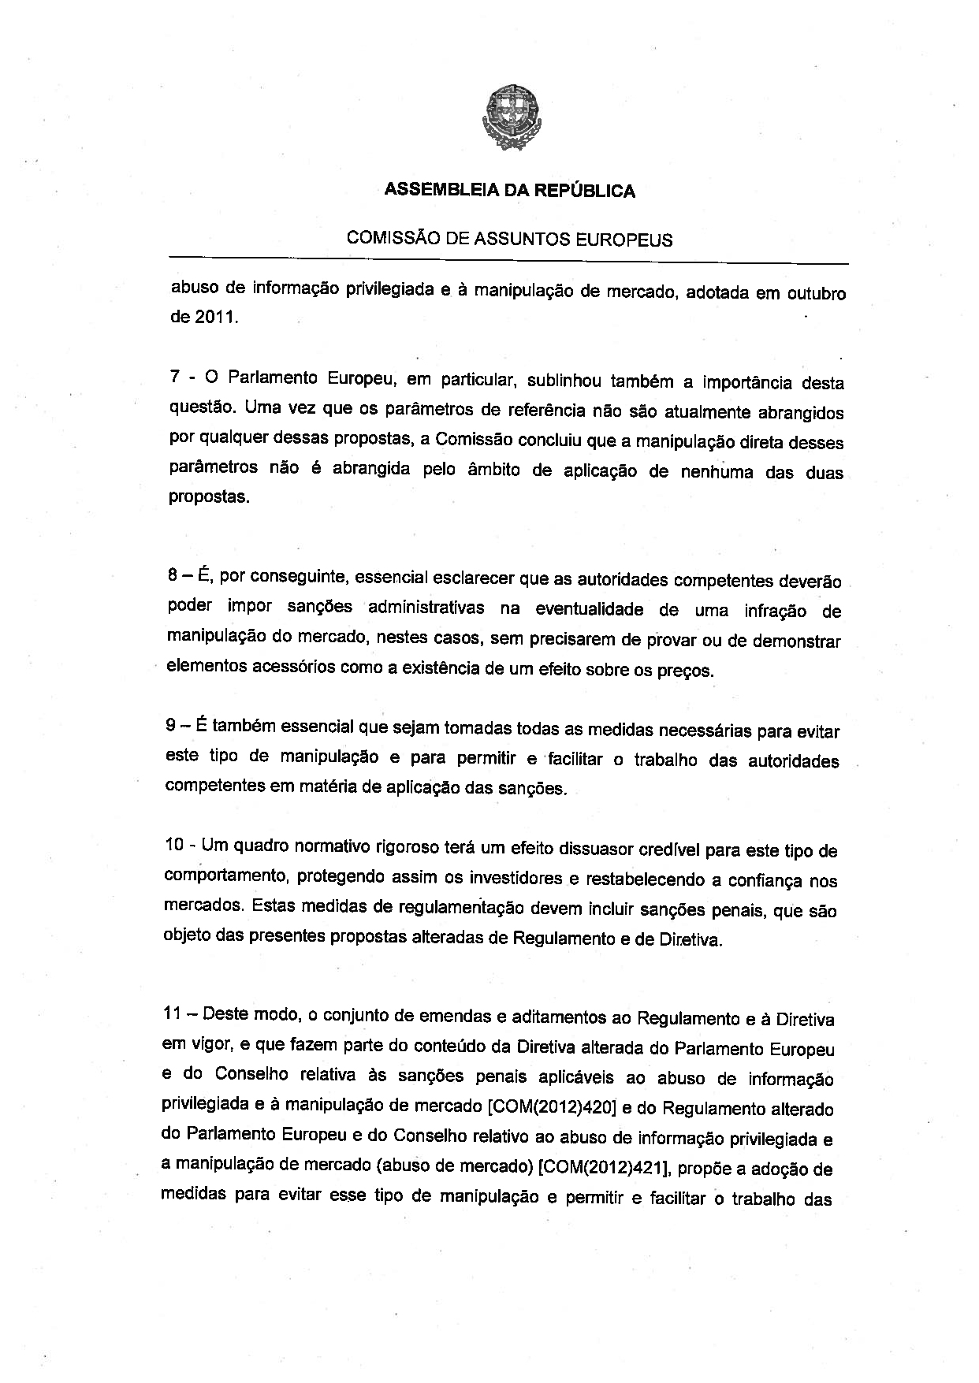
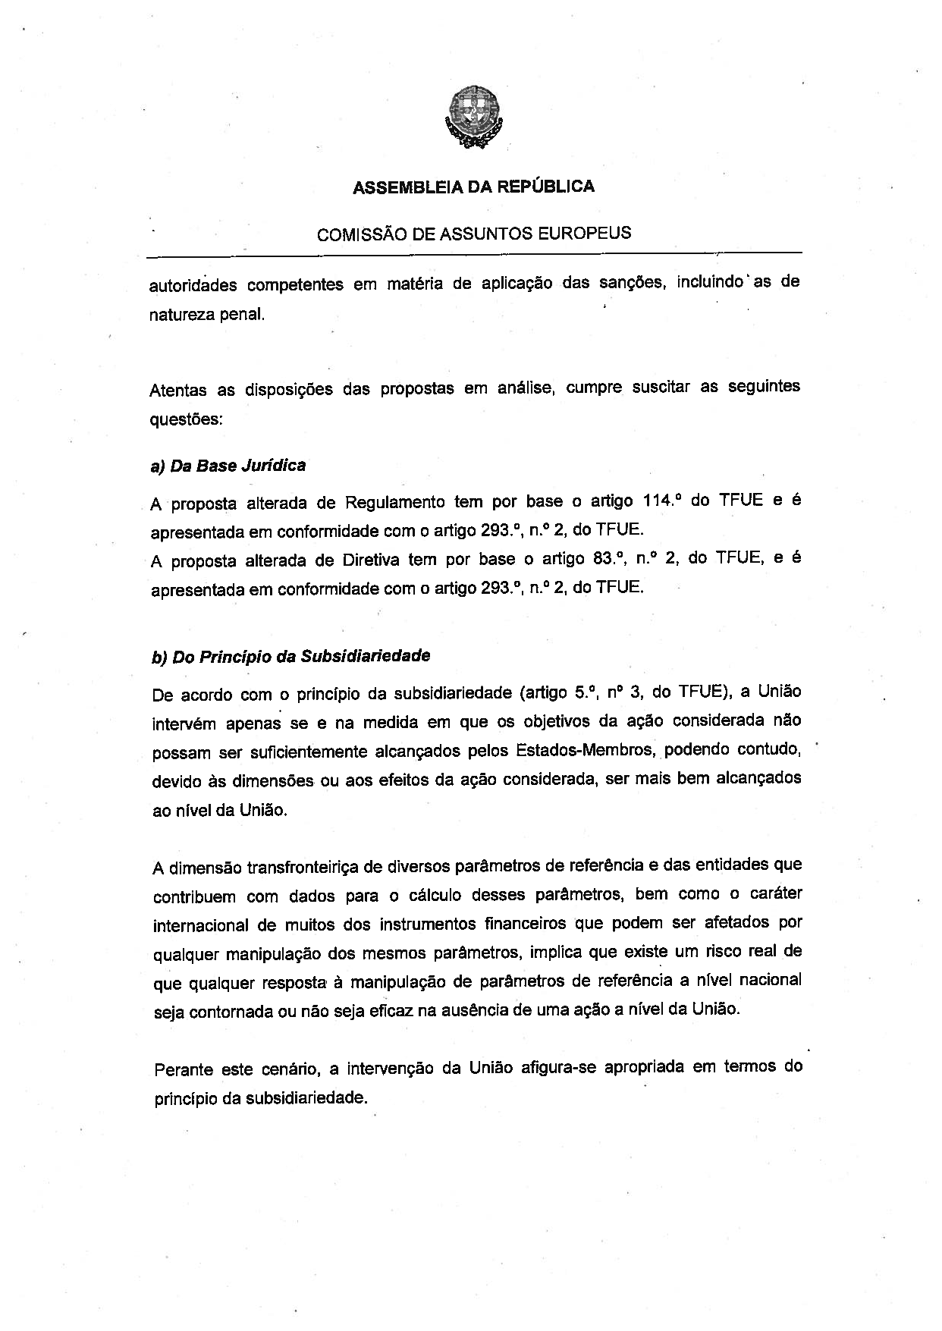
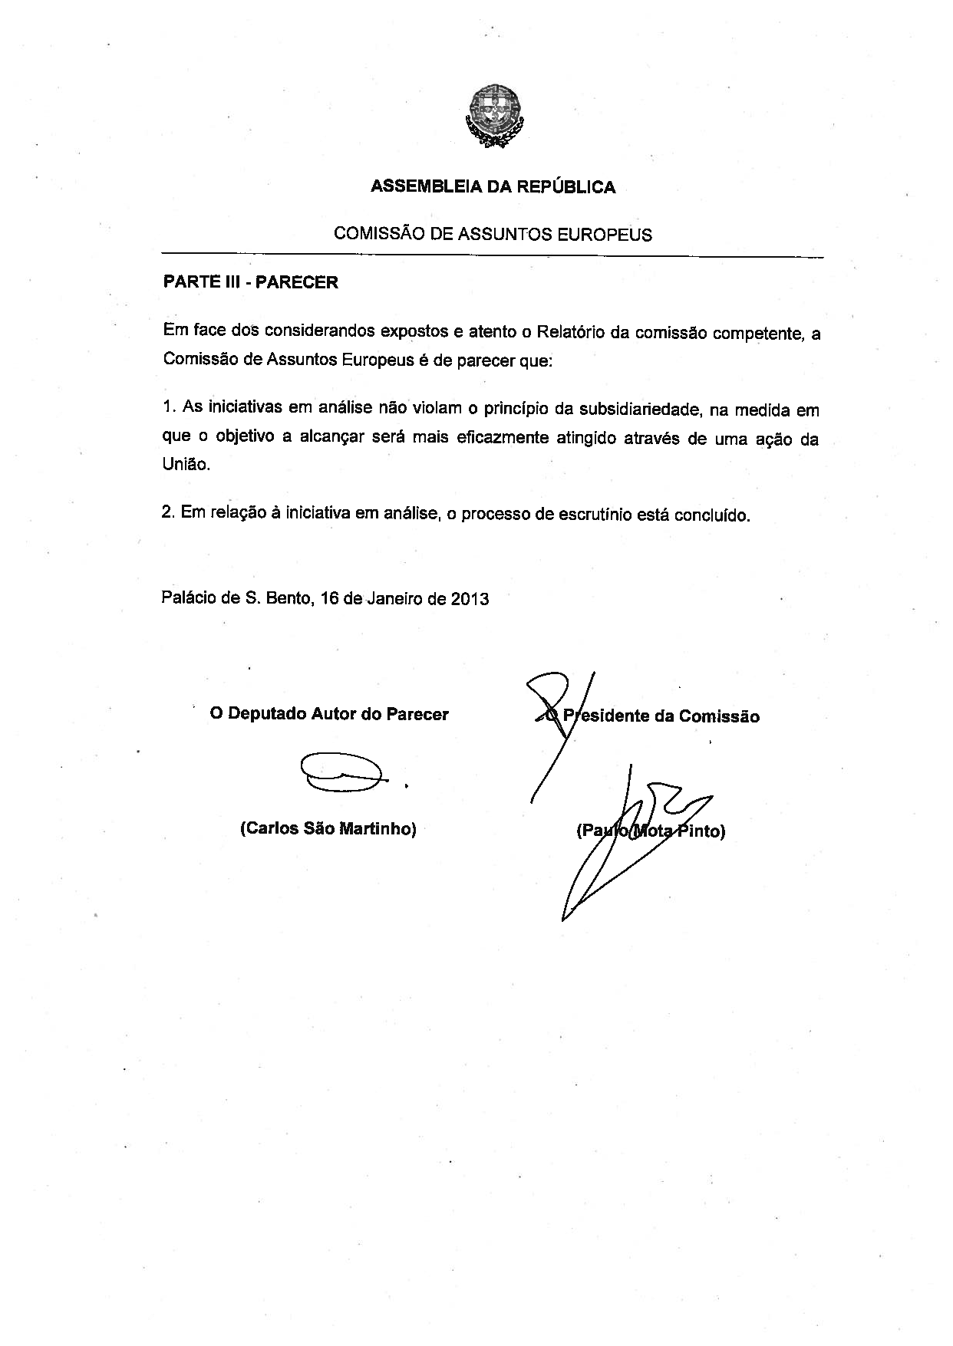

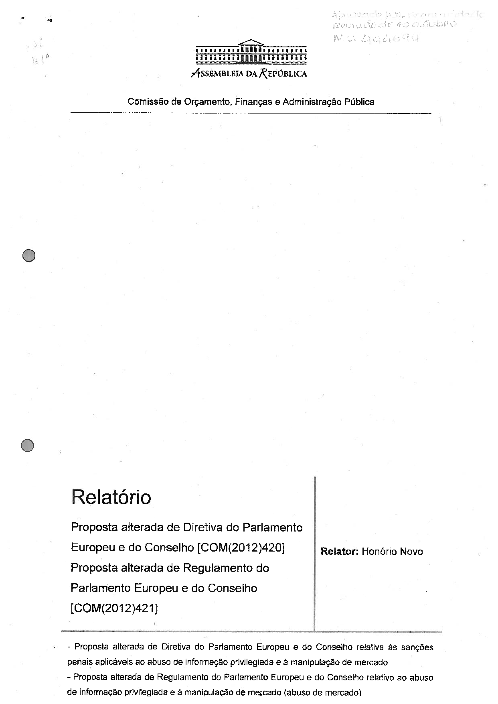
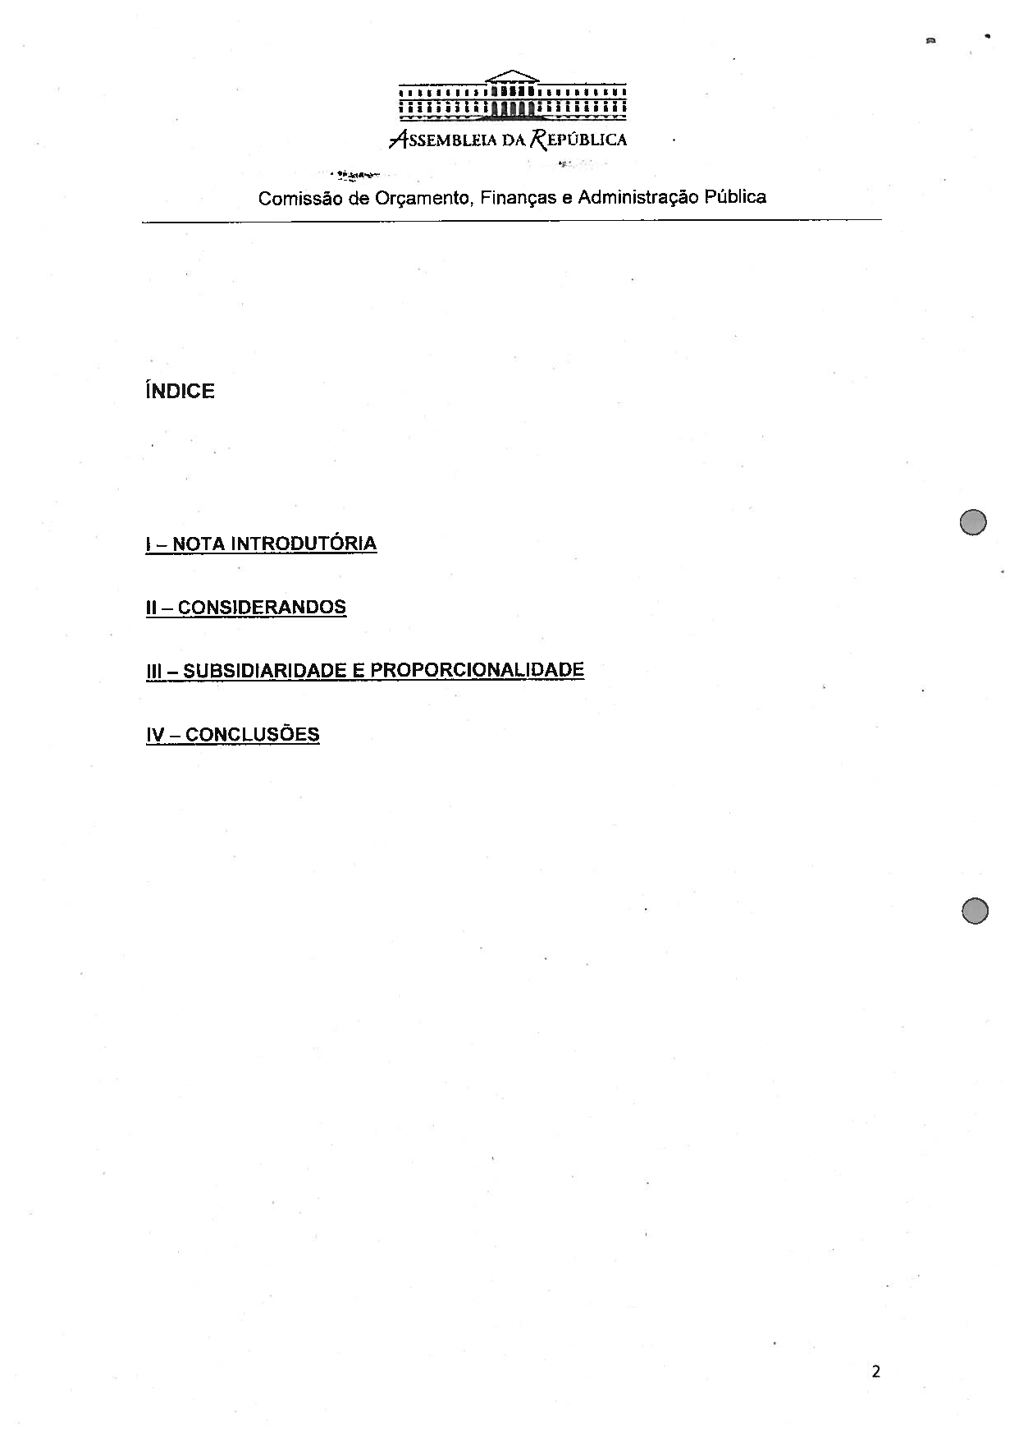
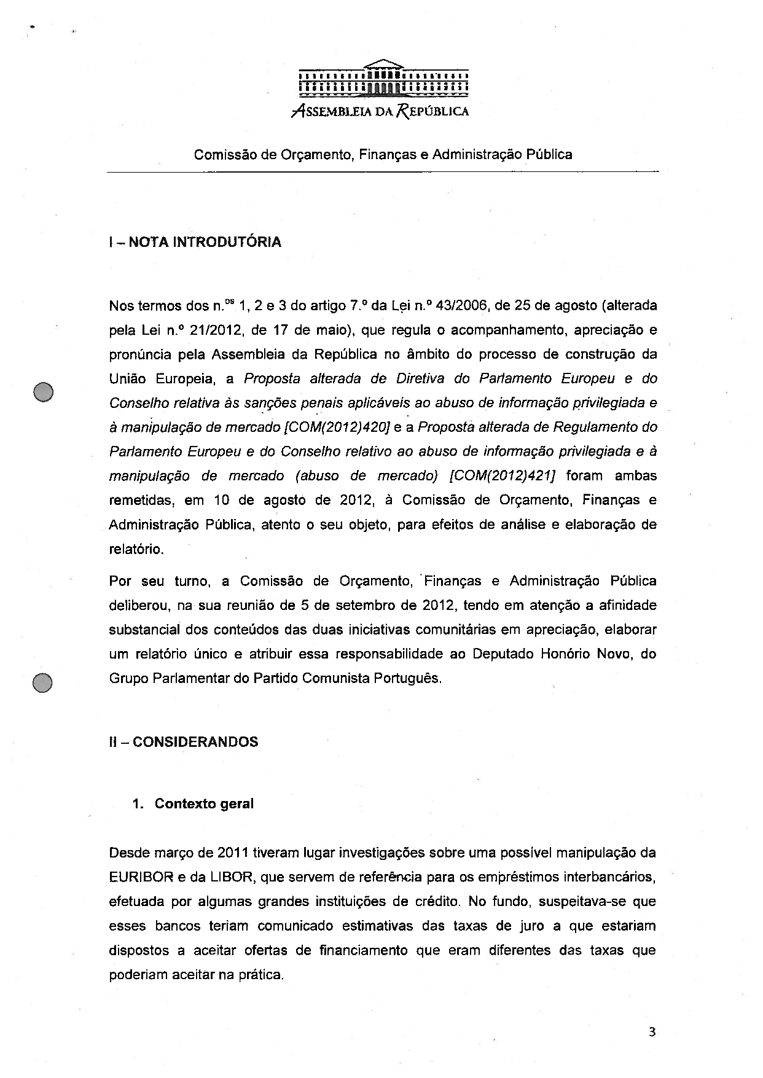
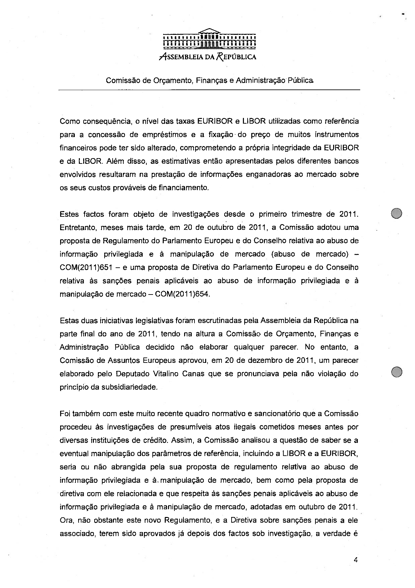
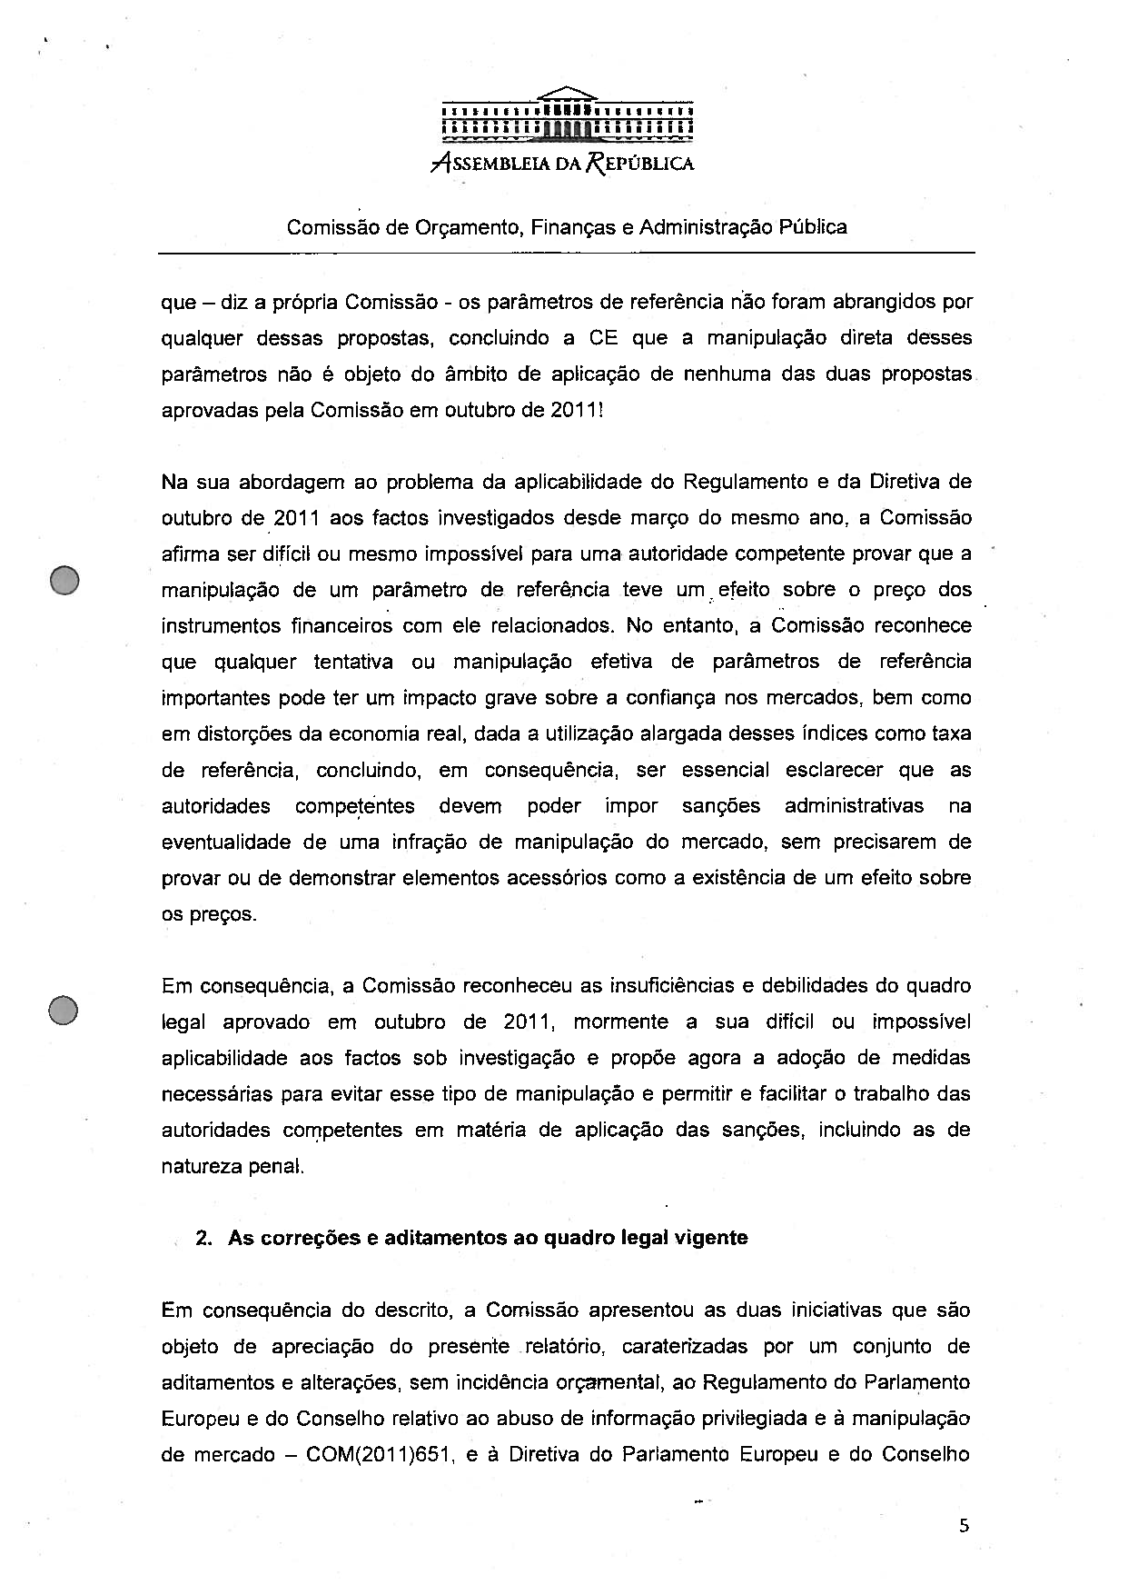
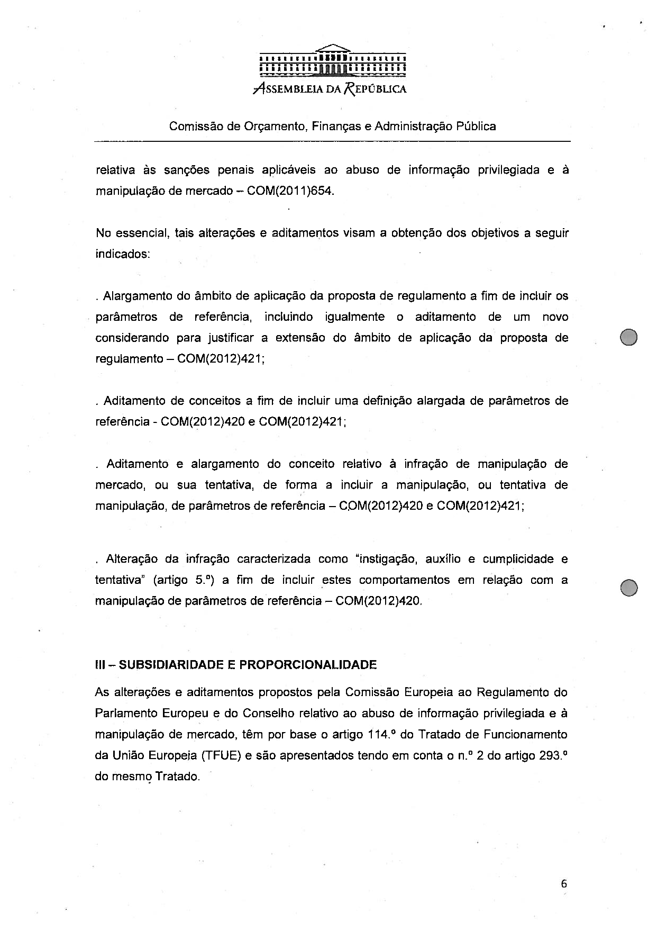
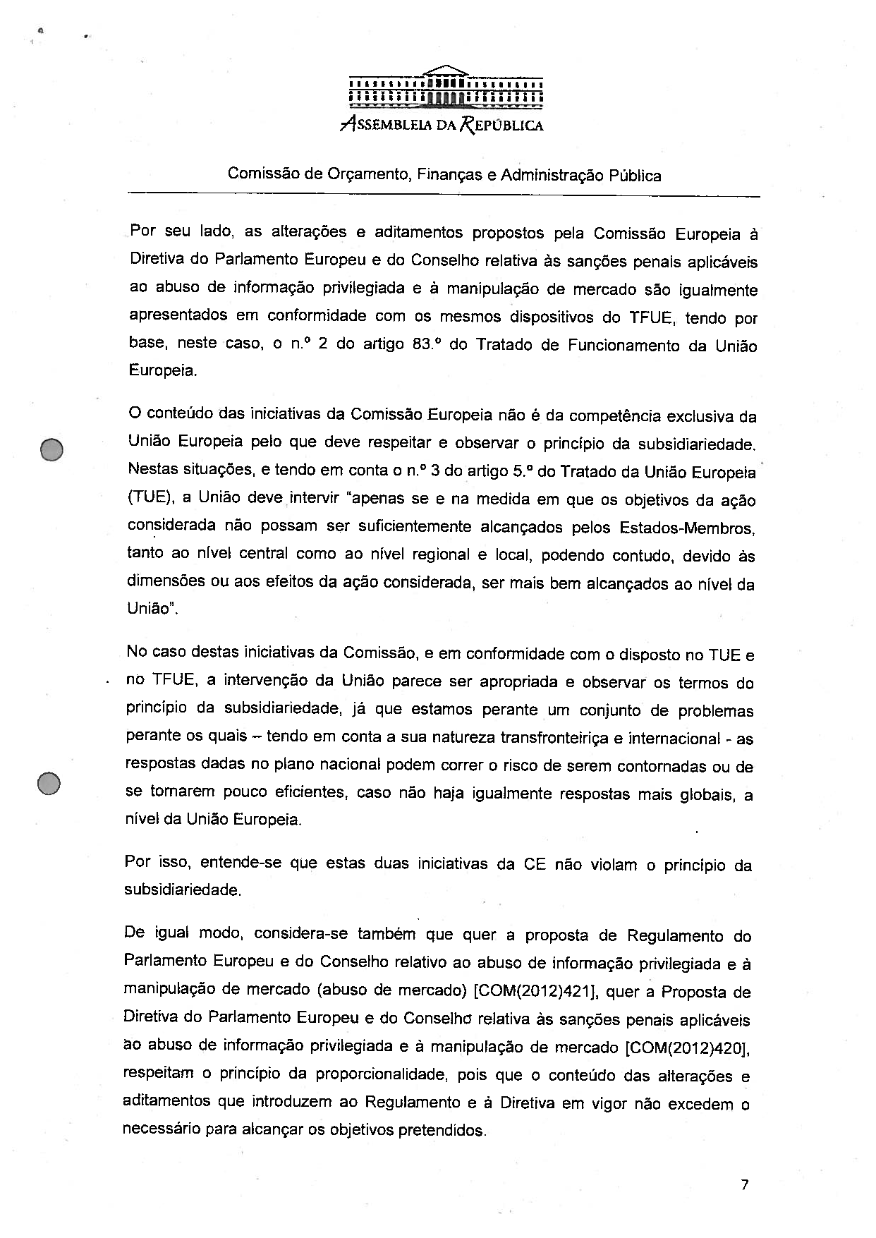
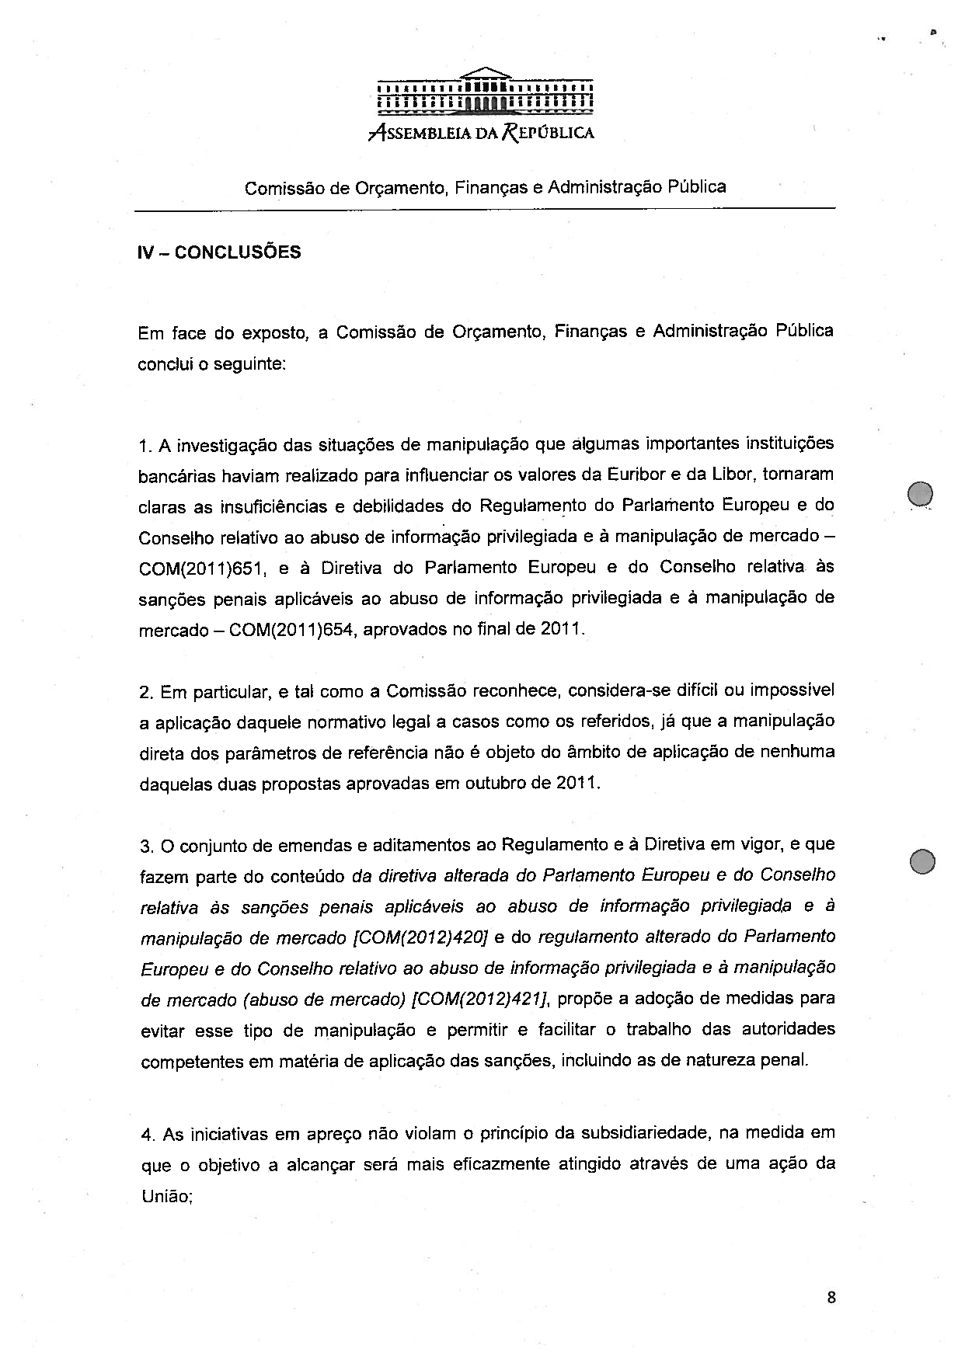
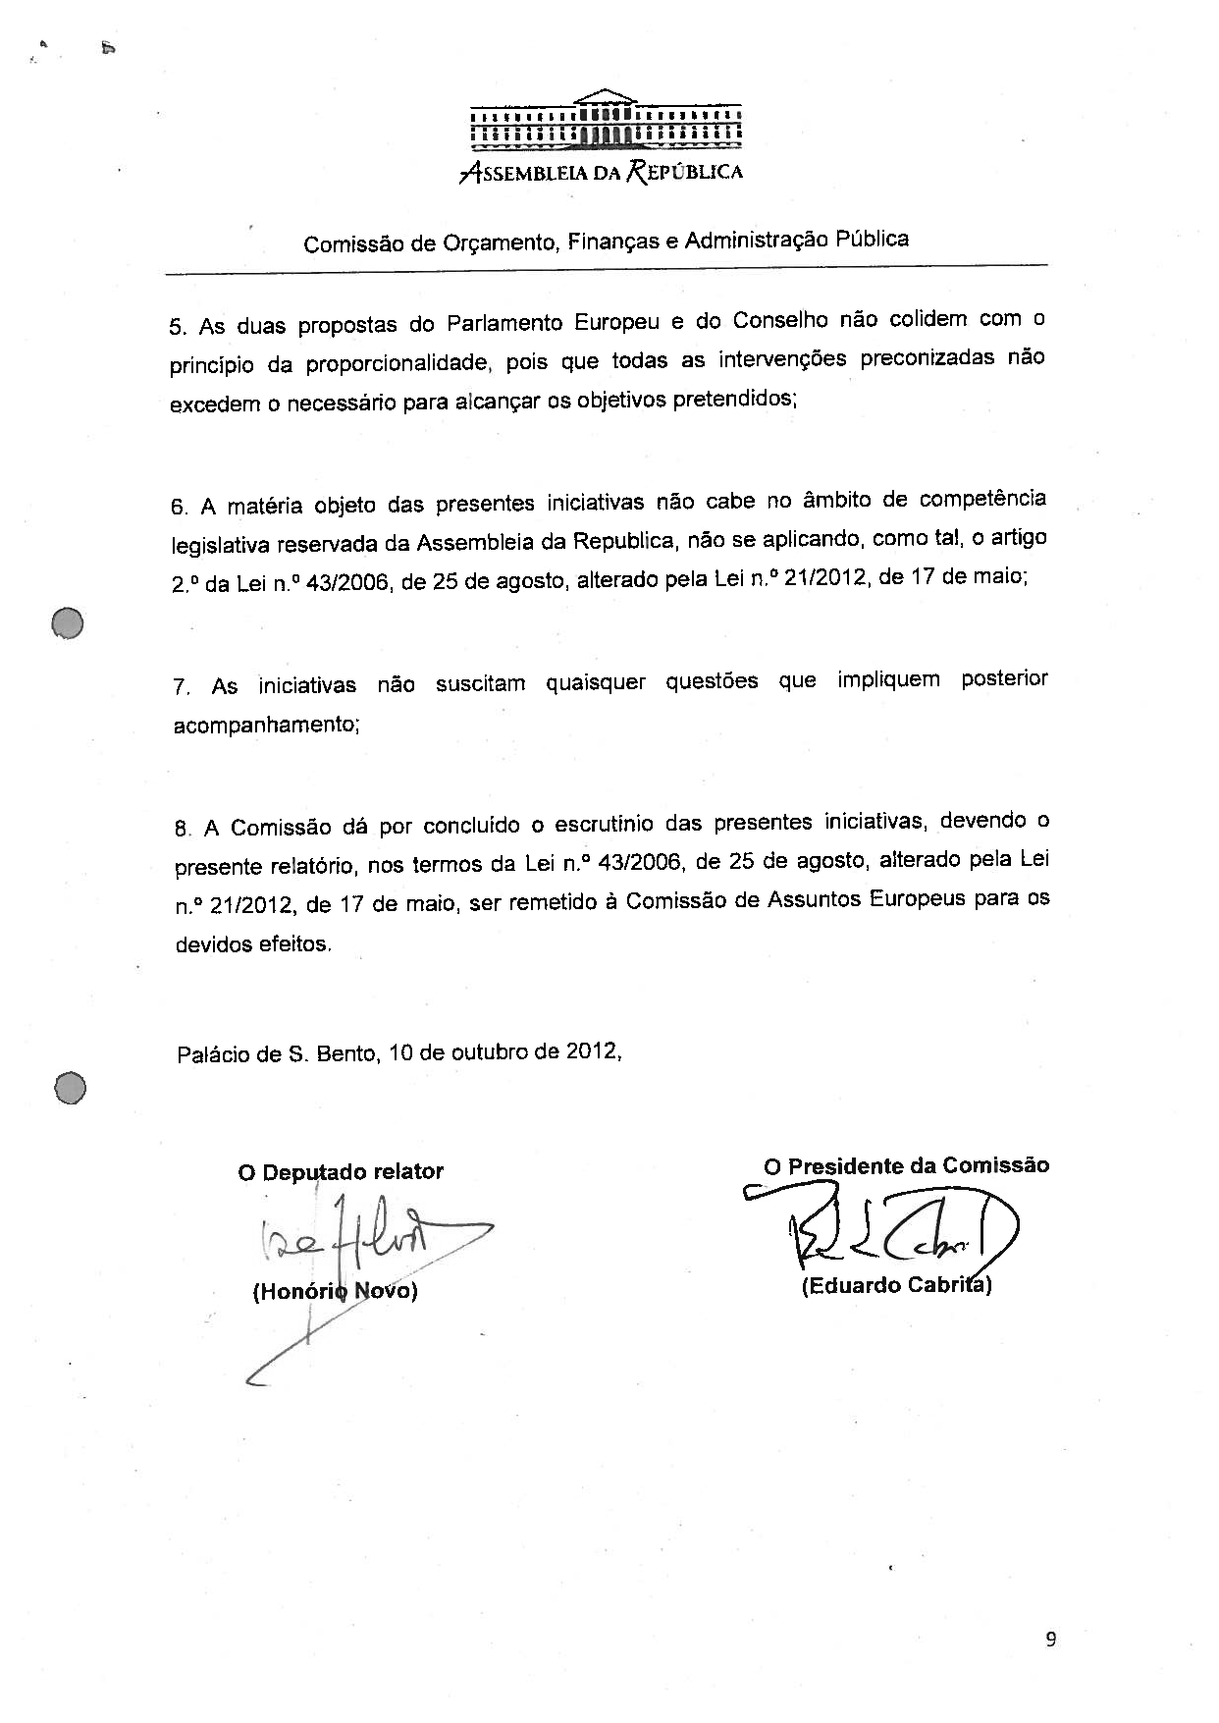

This opinion is available in English on the interparliamentary EU information exchange site (IPEX) at the following address: http://www.ipex.eu/IPEXL-WEB/search.do

