 | 
COUNCIL OF  THE EUROPEAN UNION |  |  | Brussels, 29 January 2013
 | Interinstitutional File:  2011/0341B (COD) |  | 5816/13
FISC 20
CODEC 174
ECOFIN 64
INST 48
PARLNAT 32

COVER NOTE
from: | The Portuguese Parliament
date of receipt: | 25 January 2013
to: | The President of the Council of the European Union
Subject: | Amended proposal for a Regulation of the European Parliament and of the Council establishing an action programme for taxation in the European Union for the period 2014-2020 (Fiscalis 2020) and repealing Decision N° 1482/2007/EC  [doc. 13346/12 FISC 117 CODEC 2043 - COM(2012) 465 final]  - Opinion on the application of the Principles of Subsidiarity and Proportionality

Delegations will find attached the abovementioned opinion.

________________________

Encl.

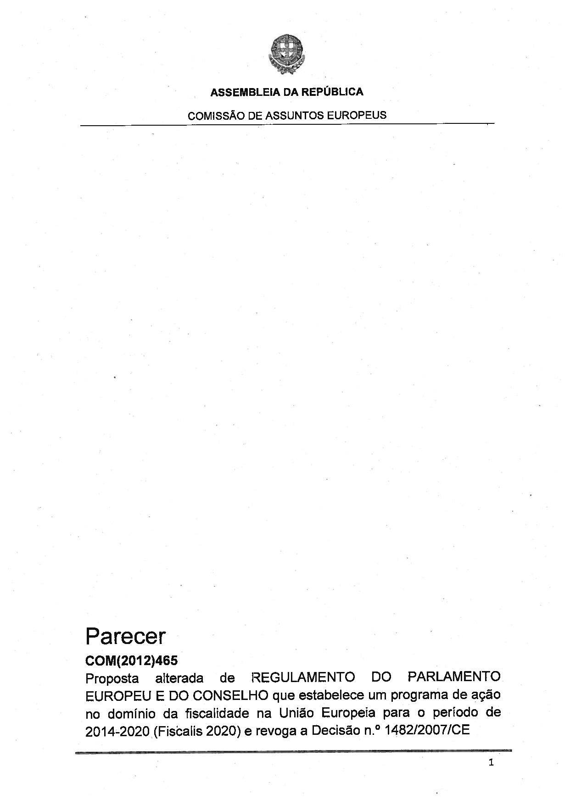

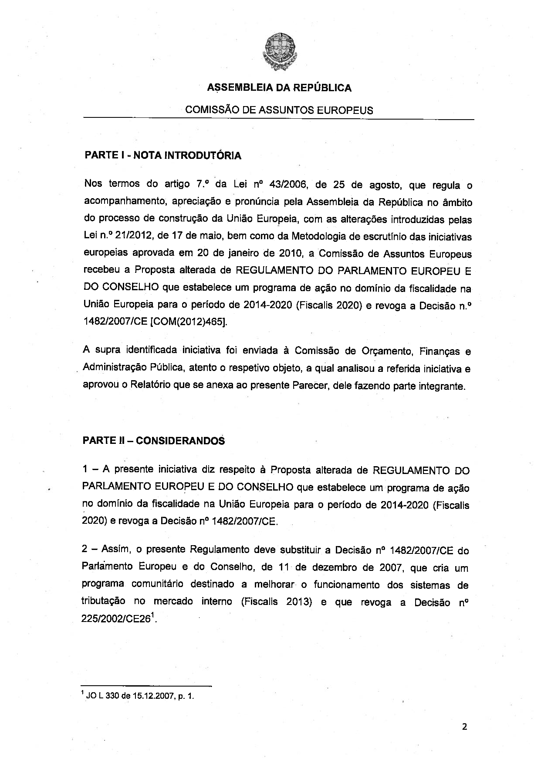

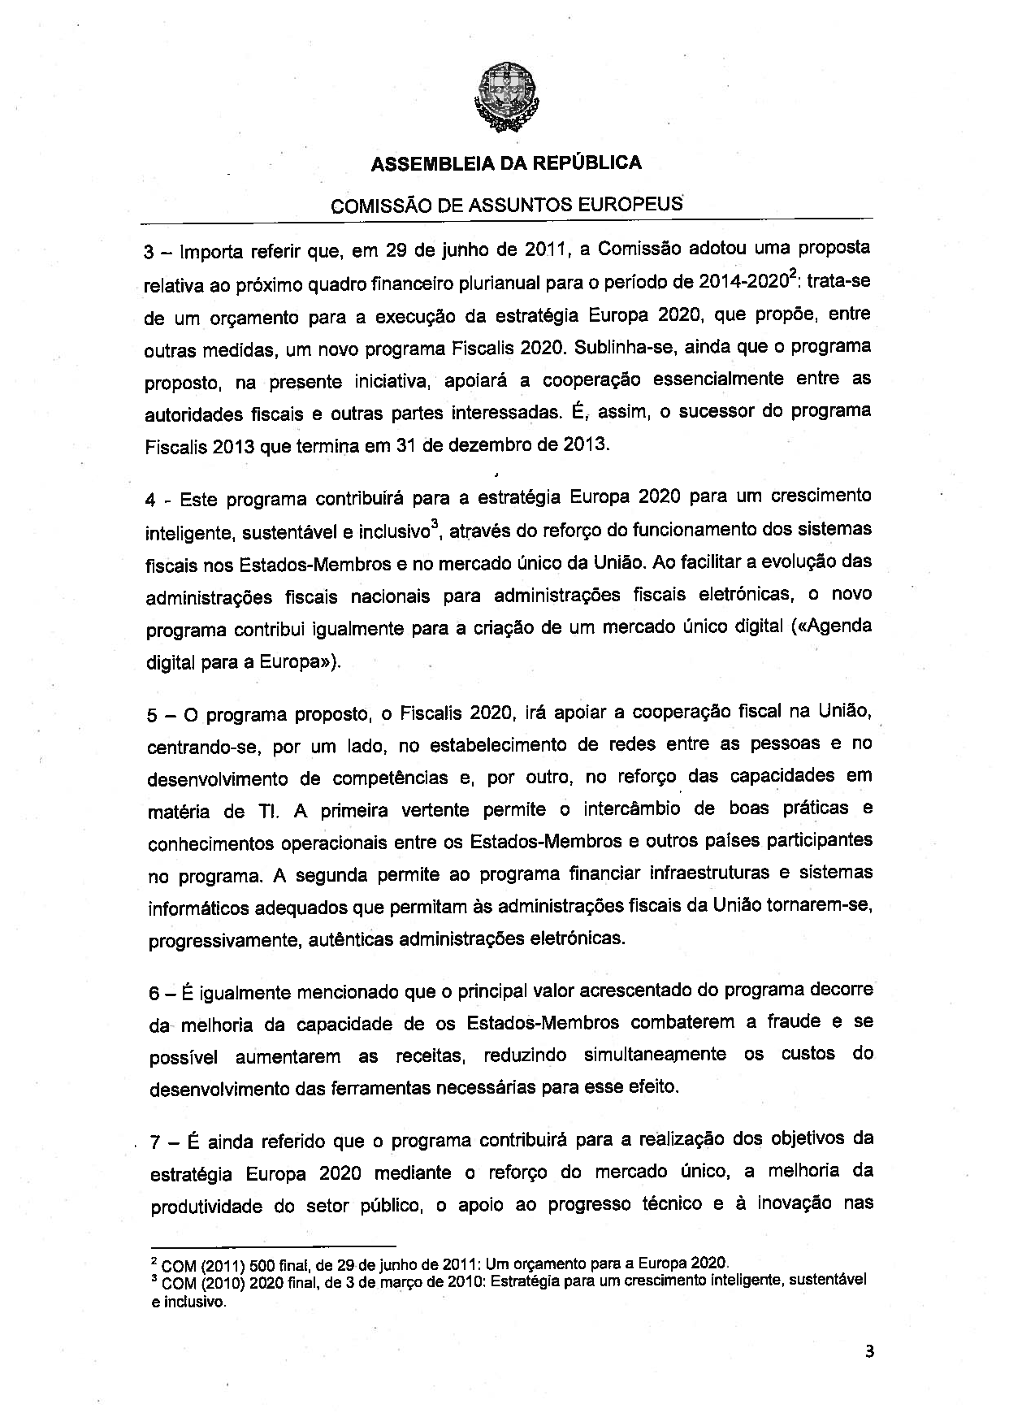

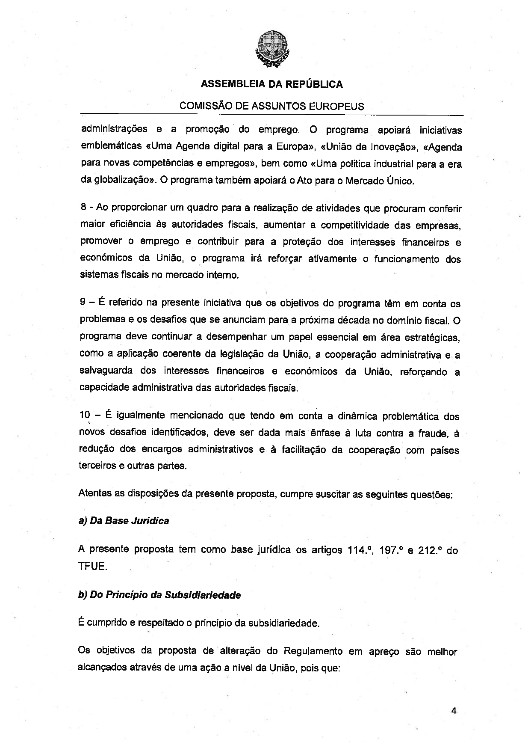

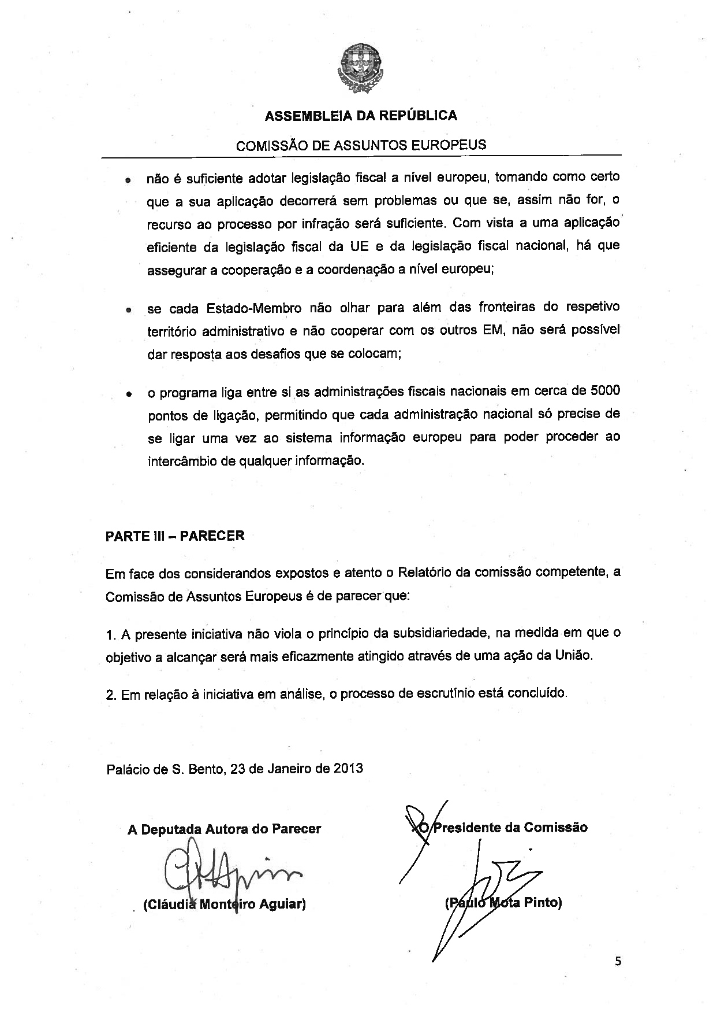



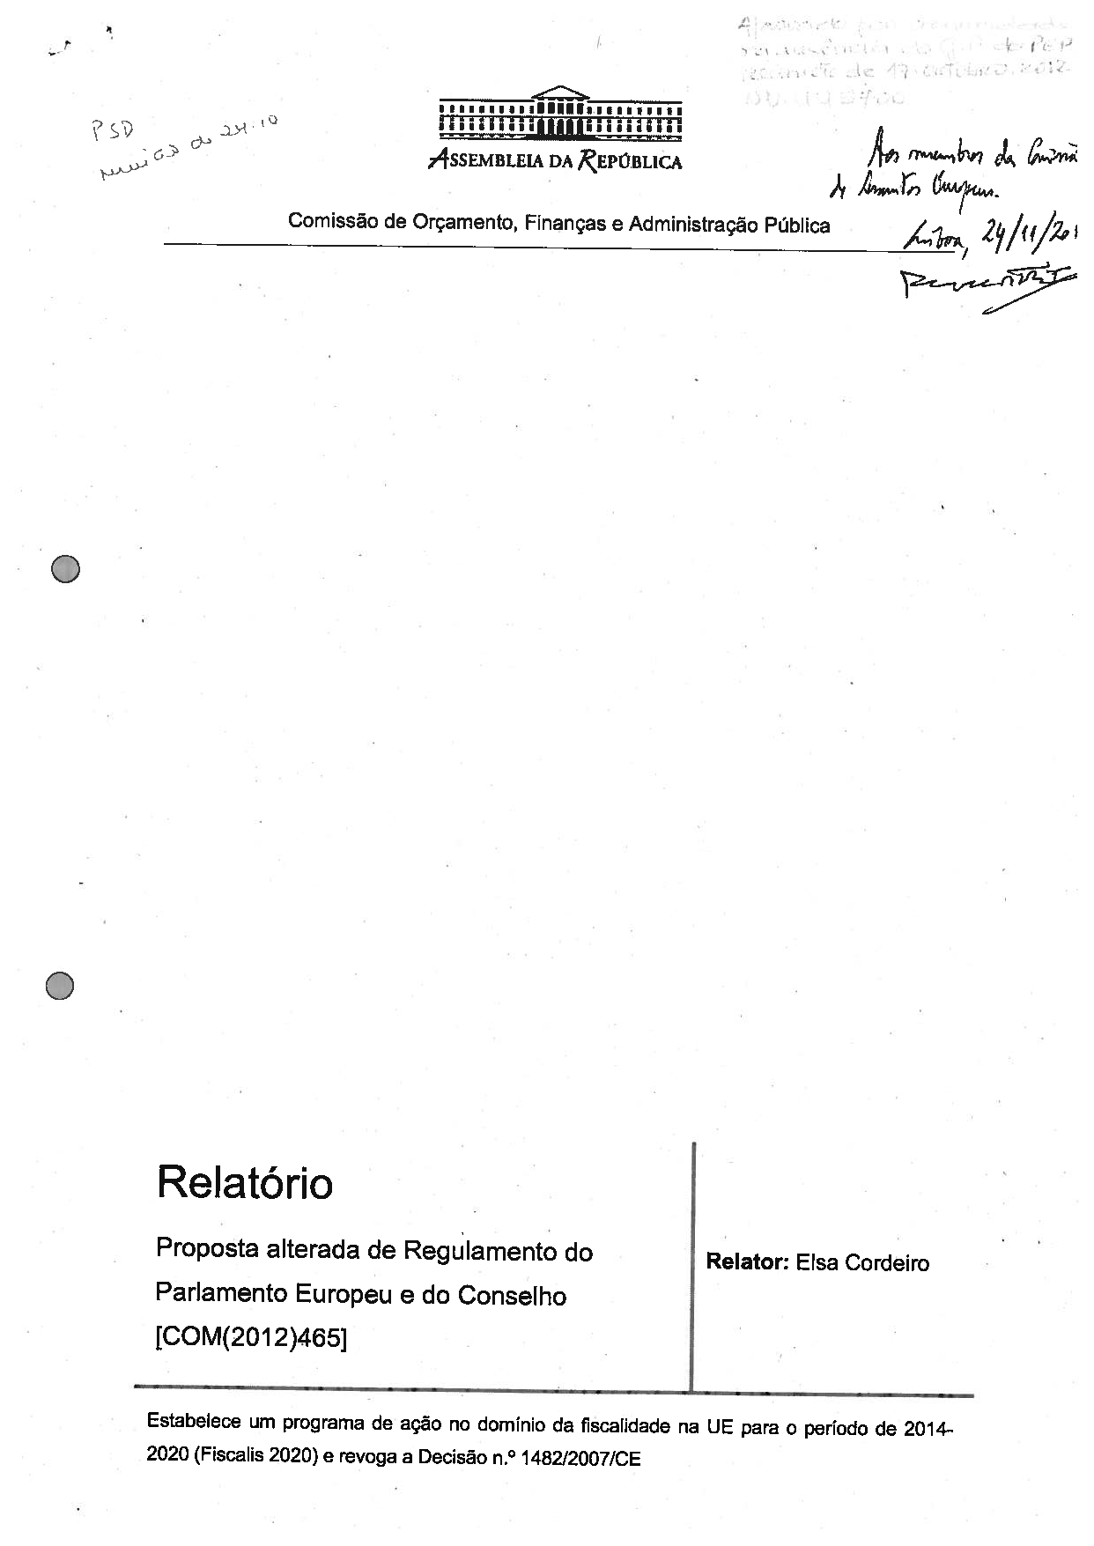

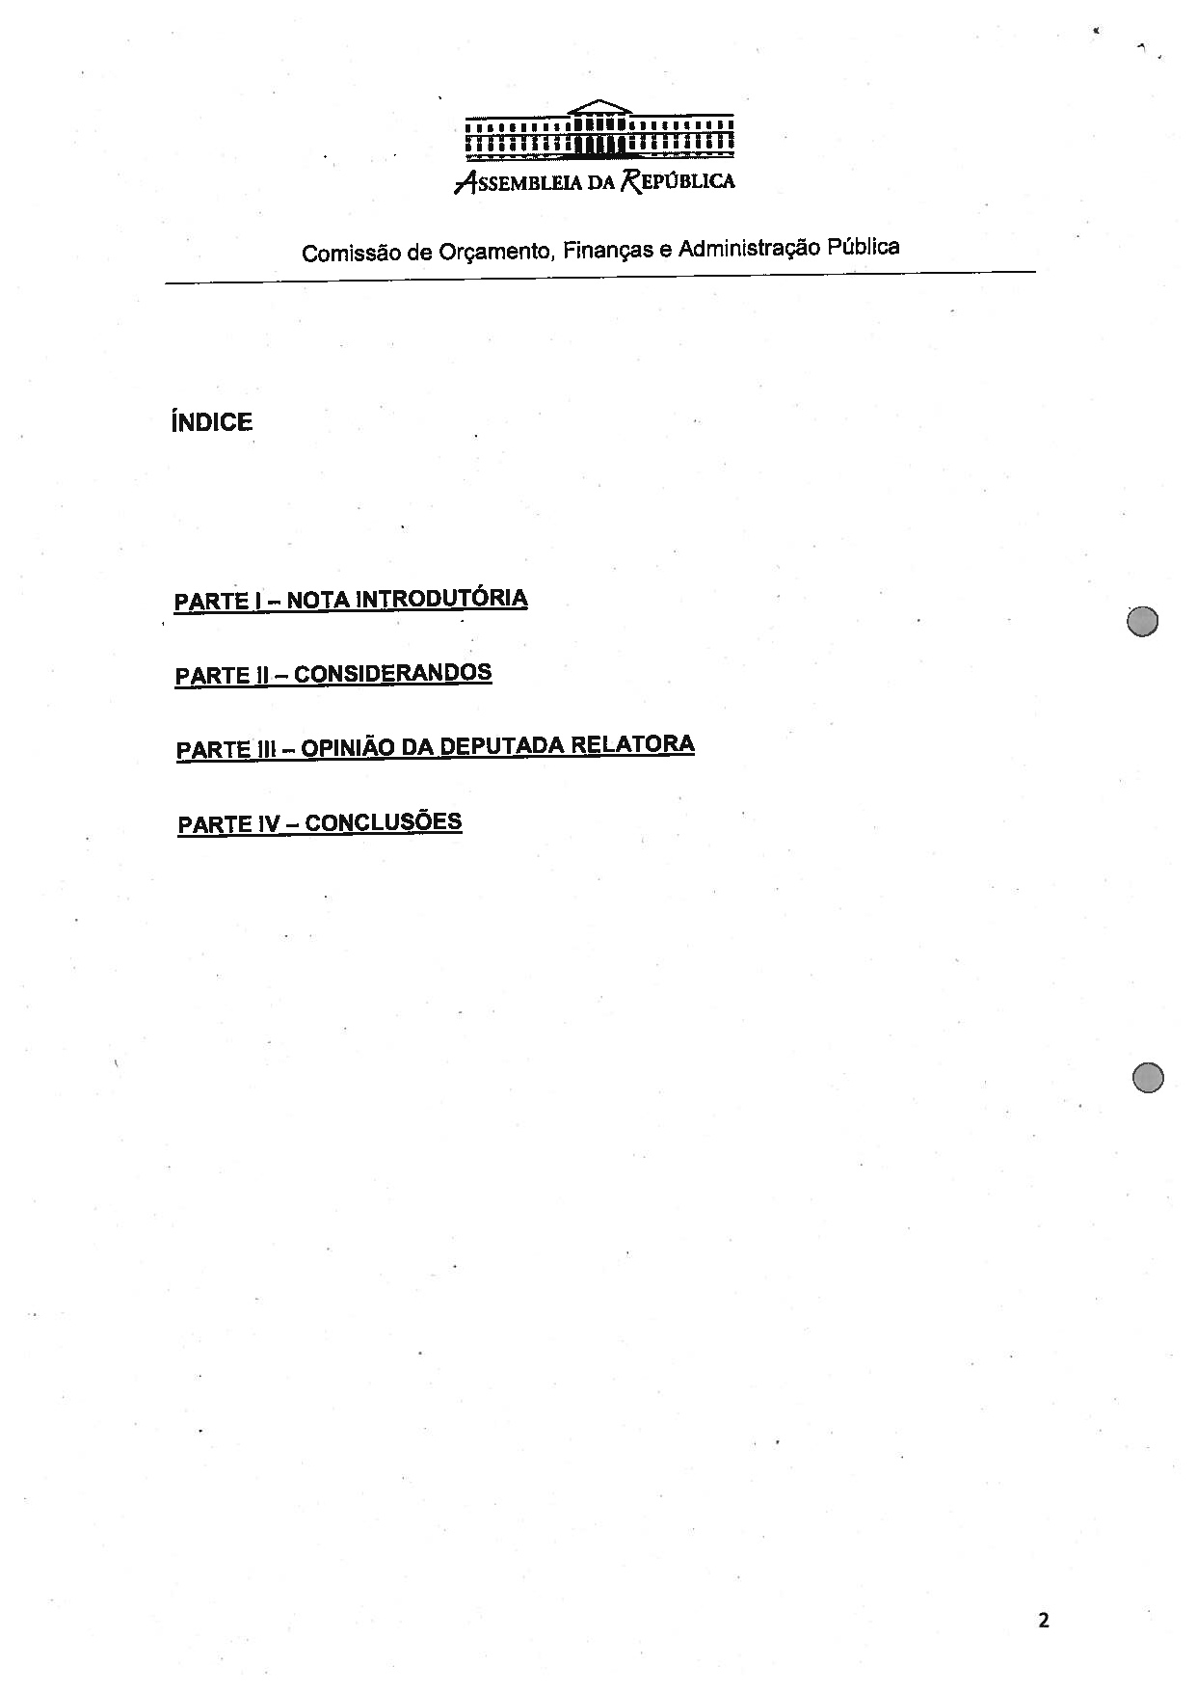
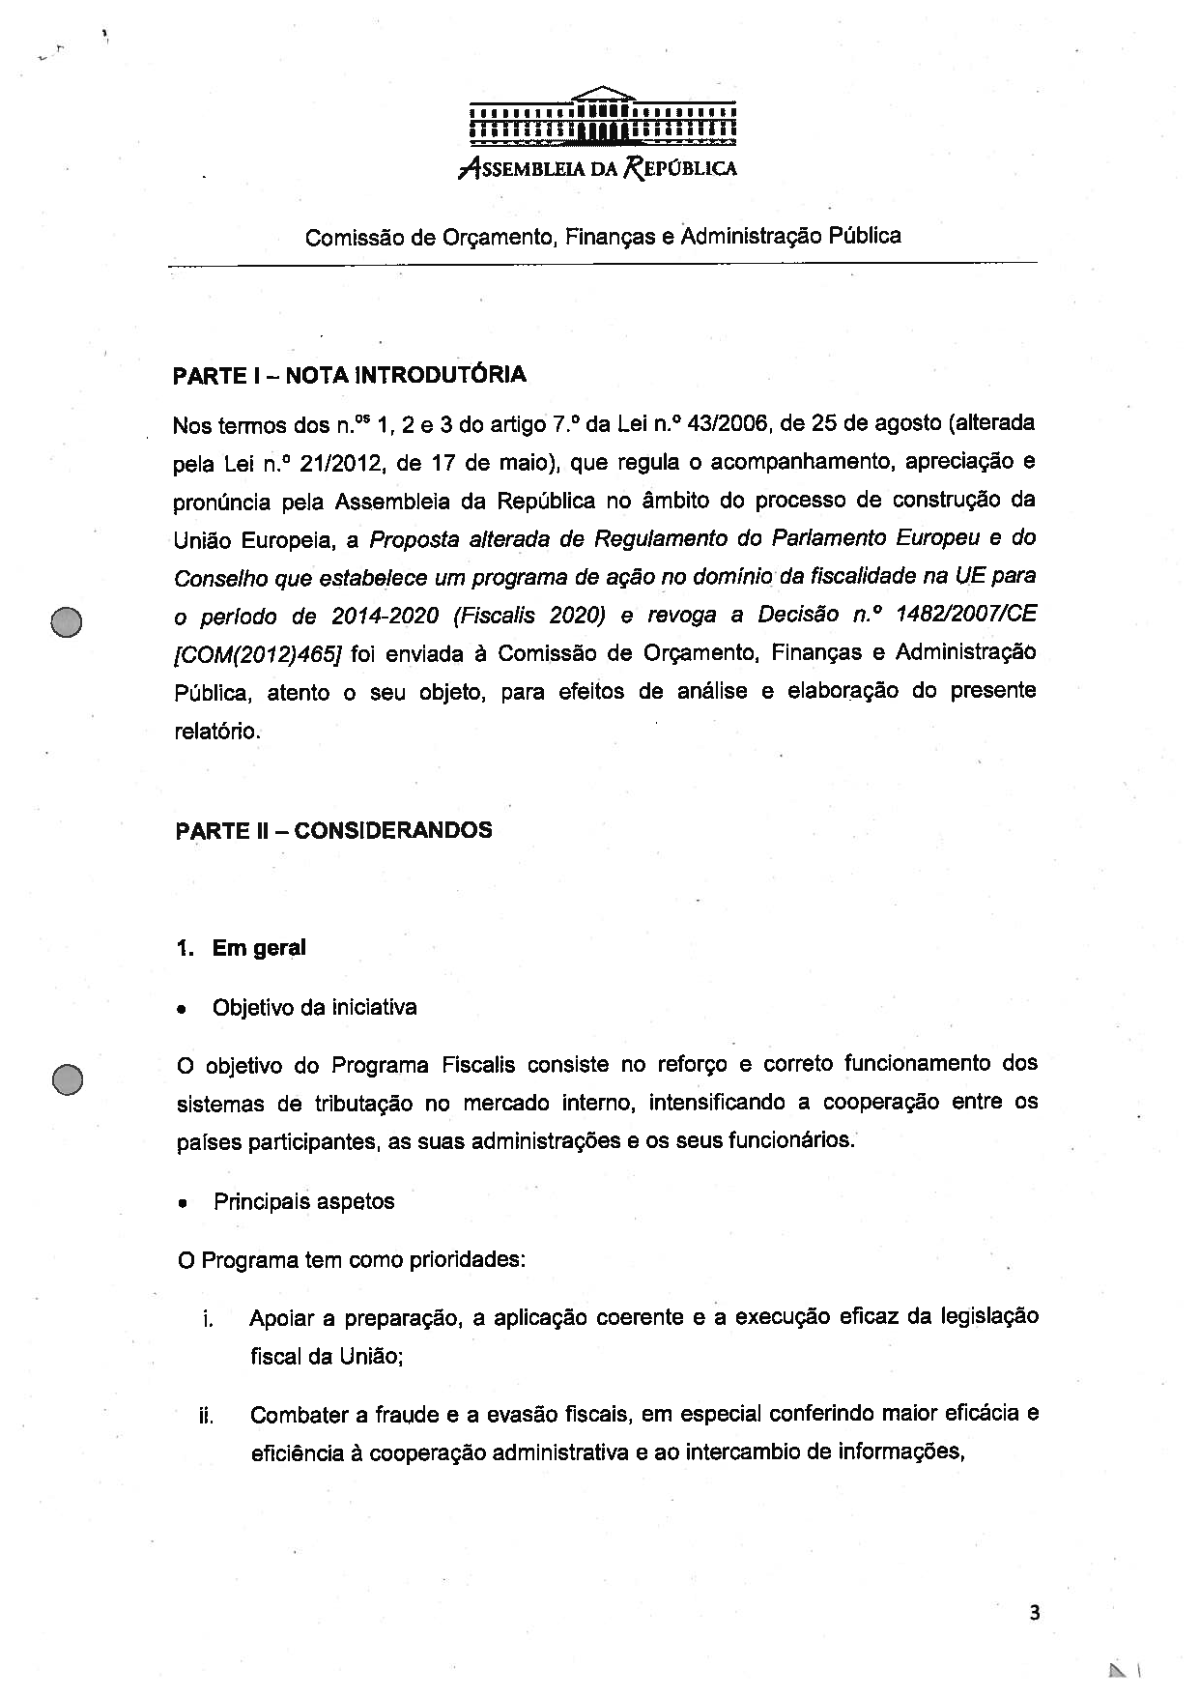

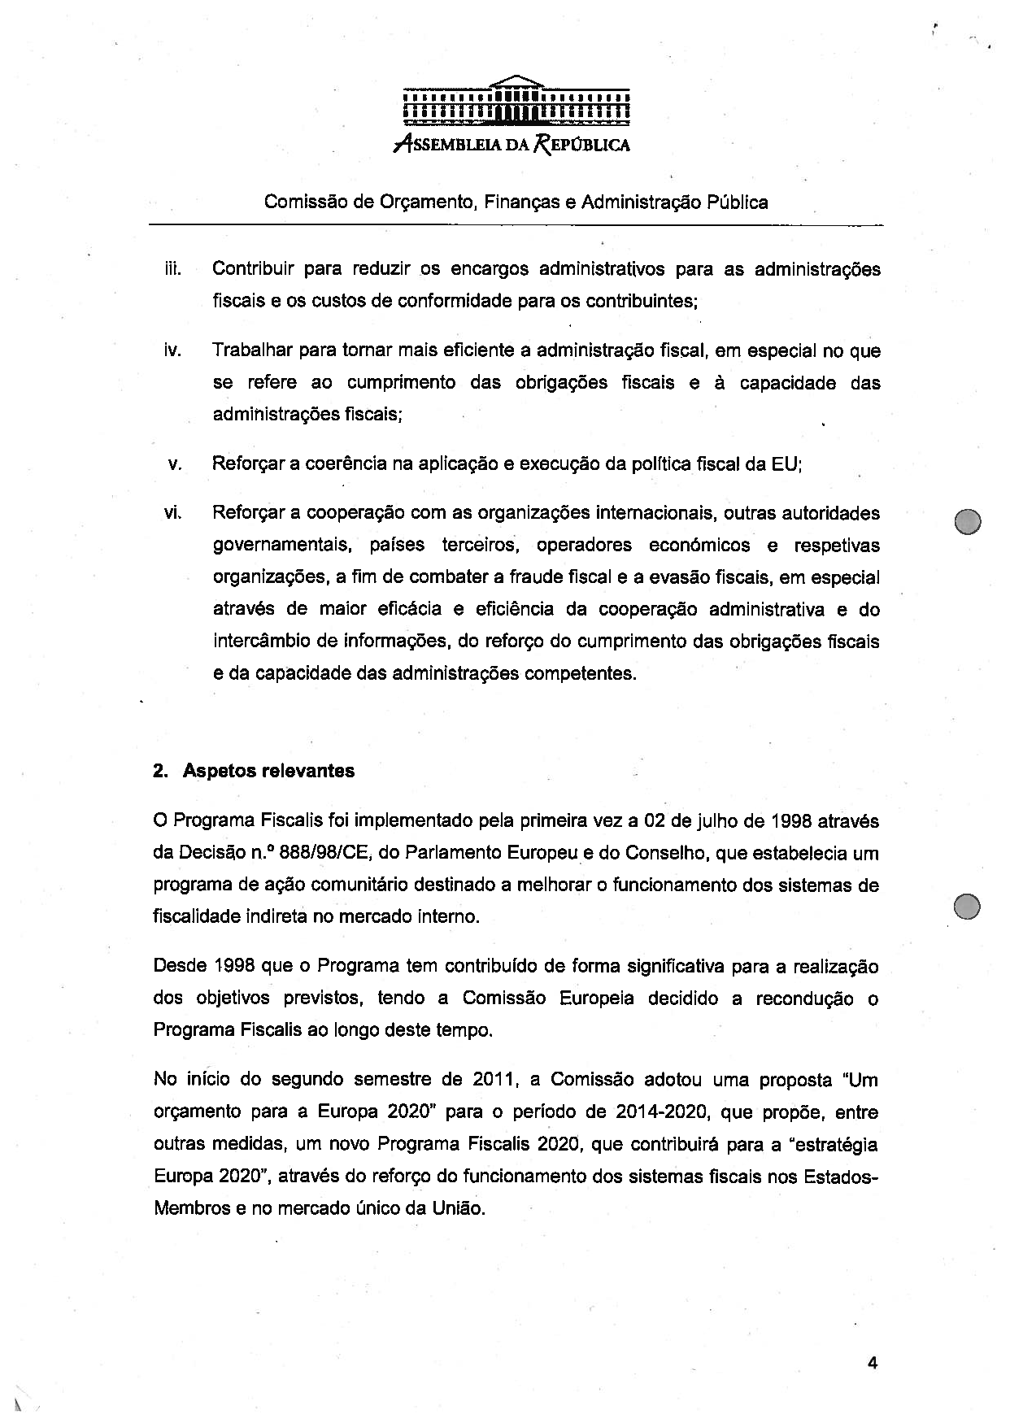

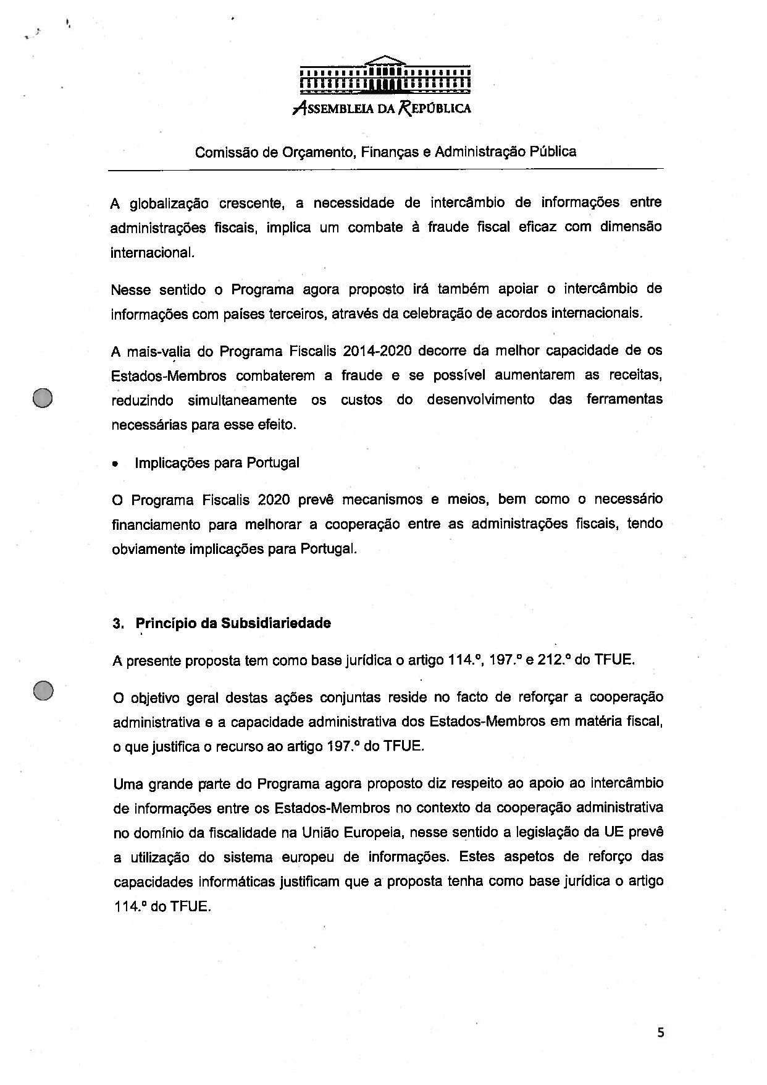

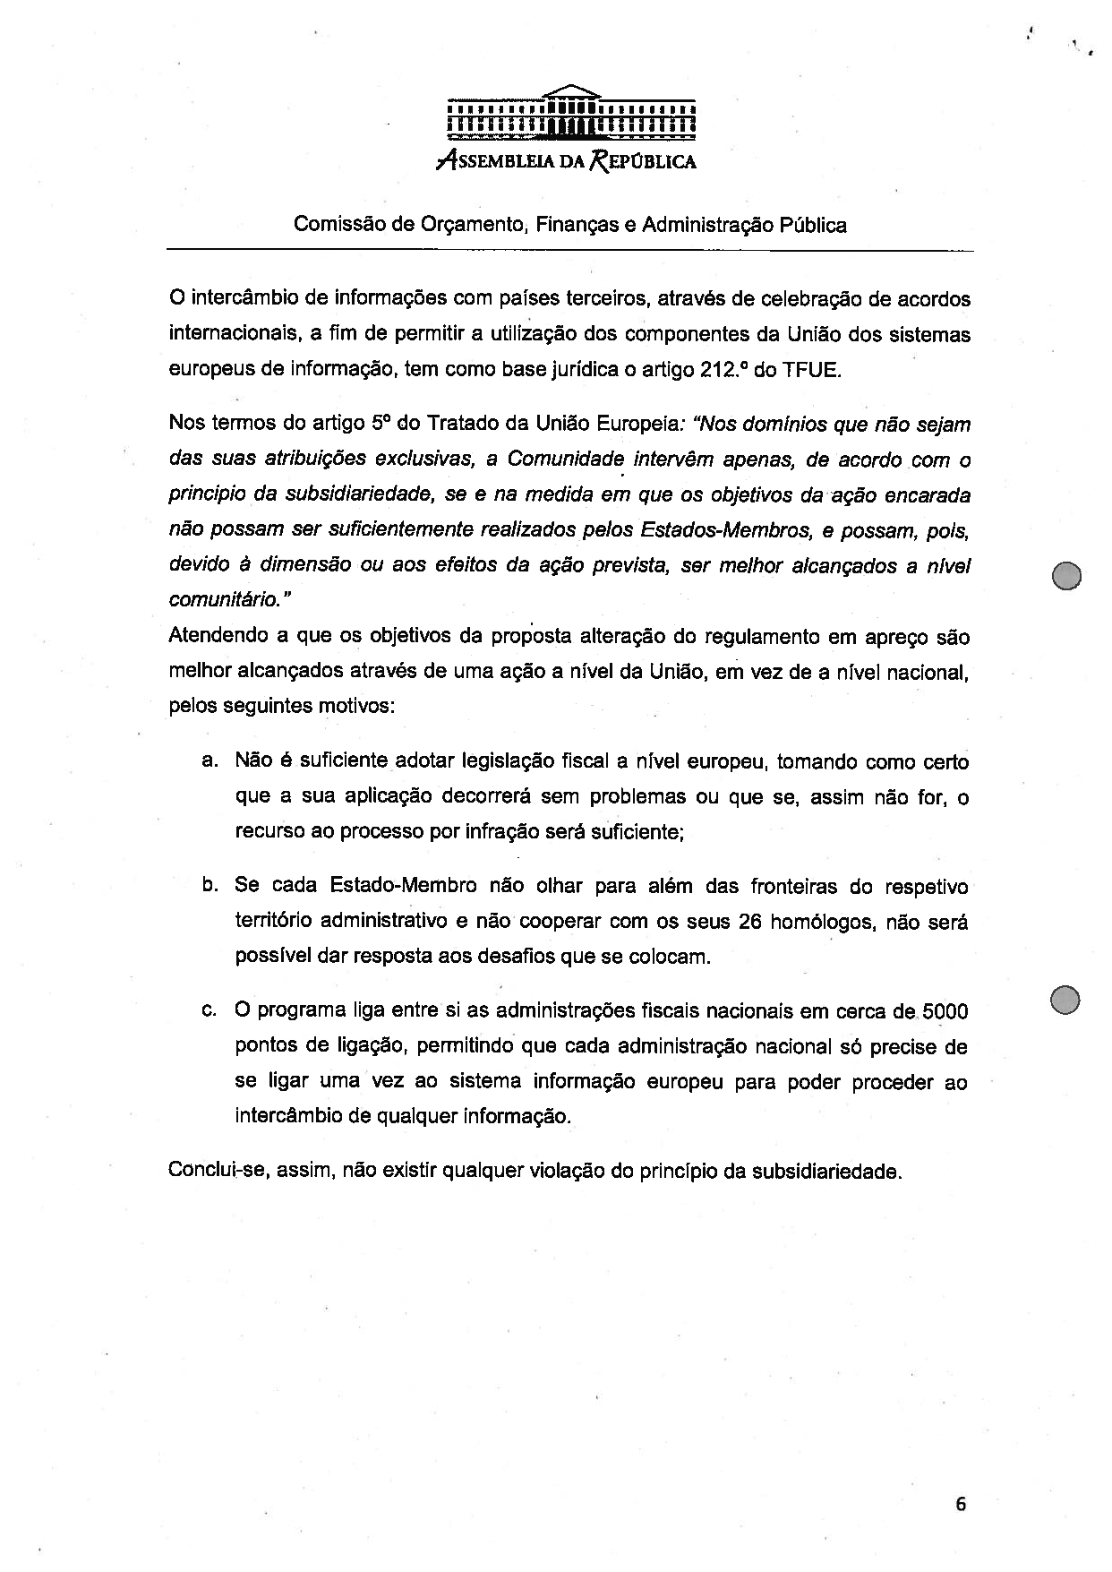

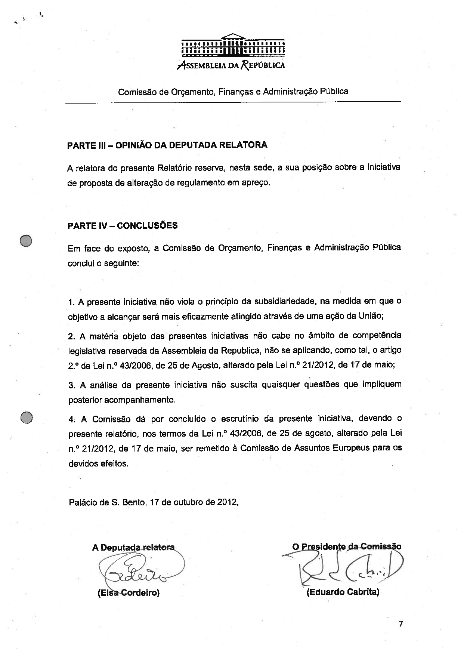

Translation(s) of the opinion may be available on the Interparliamentary EU Information Exchange site IPEX at the following address: http://www.ipex.eu/IPEXL-WEB/search.do

