 | 
COUNCIL OF  THE EUROPEAN UNION |  |  | Brussels, 11 January 2013
 | Interinstitutional File:  2012/0242 (CNS)  2012/0244 (COD)  2012/0150 (COD) |  | 5260/13
EF 10
ECOFIN 22
CODEC 65
INST 24
PARLNAT 20

COVER NOTE
from: | Italian Chamber of Deputies
date of receipt: | 21 December 2012
to: | President of the European Union
Subject: | Proposal for a COUNCIL REGULATION conferring specific tasks on the European Central Bank concerning policies relating to the prudential supervision of credit institutions AND Proposal for a REGULATION OF THE EUROPEAN PARLIAMENT AND OF THE COUNCIL amending Regulation (EC) No 1093/2010 establishing a European Supervisory Authority (European Banking Authority) as regards its interaction with Council Regulation (EU) No…/… conferring specific tasks on the European Central Bank concerning policies relating to the prudential supervision of credit institutions AND Proposal for a DIRECTIVE OF THE EUROPEAN PARLIAMENT AND OF THE COUNCIL establishing a framework for the recovery and resolution of credit institutions and investment firms and amending Council Directives 77/91/EEC and 82/891/EC, Directives 2001/24/EC, 2002/47/EC, 2004/25/EC, 2005/56/EC, 2007/36/EC and 2011/35/EC and Regulation (EU) No 1093/2010  [doc.13683/12 EF 199 ECOFIN 770 - COM(2012) 511 final and  doc.13682/12 EF 198 ECOFIN 769 CODEC 2115 - COM(2012) 512 final, doc.11066/12 EF 136 ECOFIN 552 DRS 91 CODEC 1600 - COM(2012) 280 final]  - Opinion on the application of the Principles of Subsidiarity and Proportionality

Delegations will find attached the above mentioned Opinion.
________________________

Encl.:

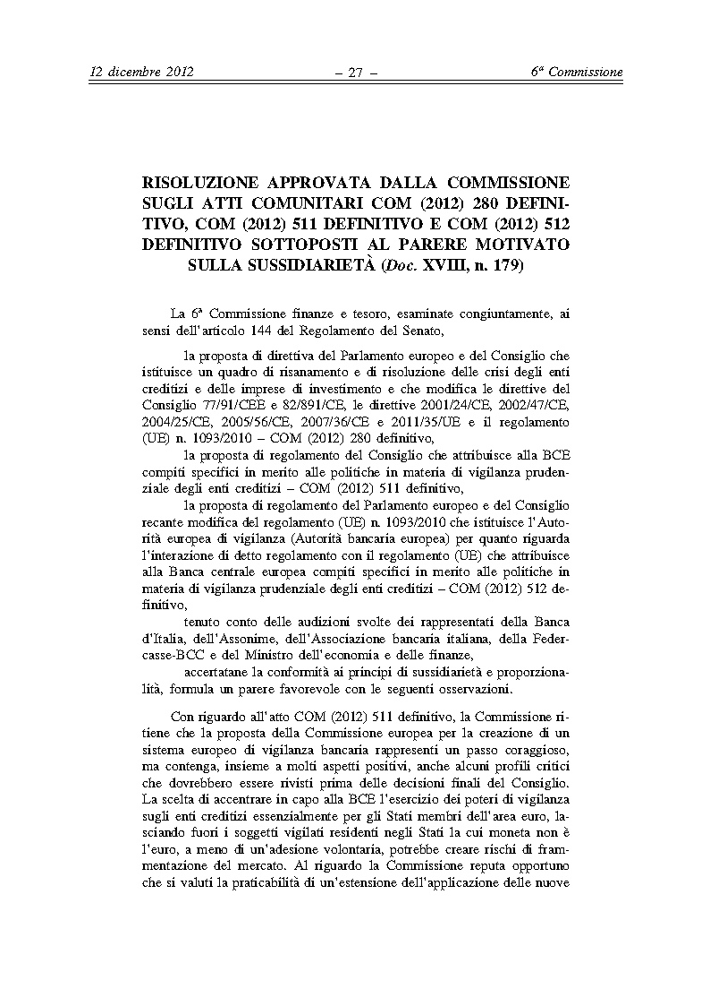
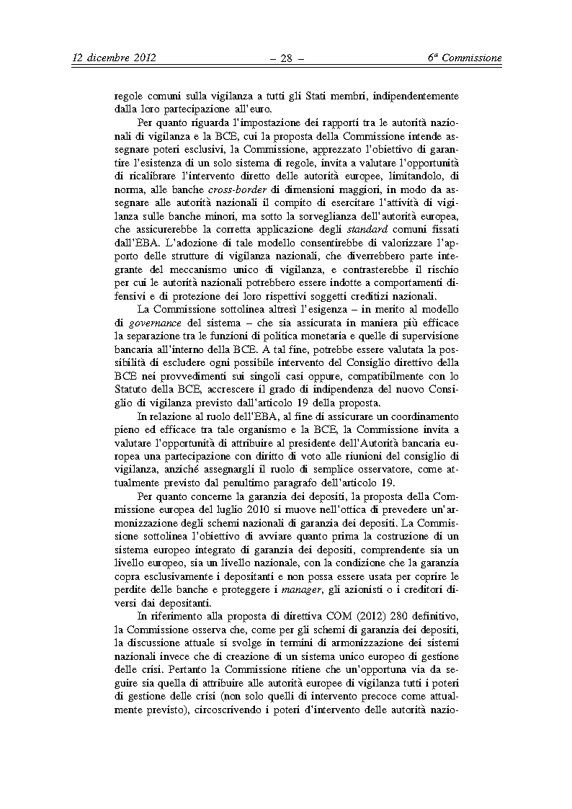
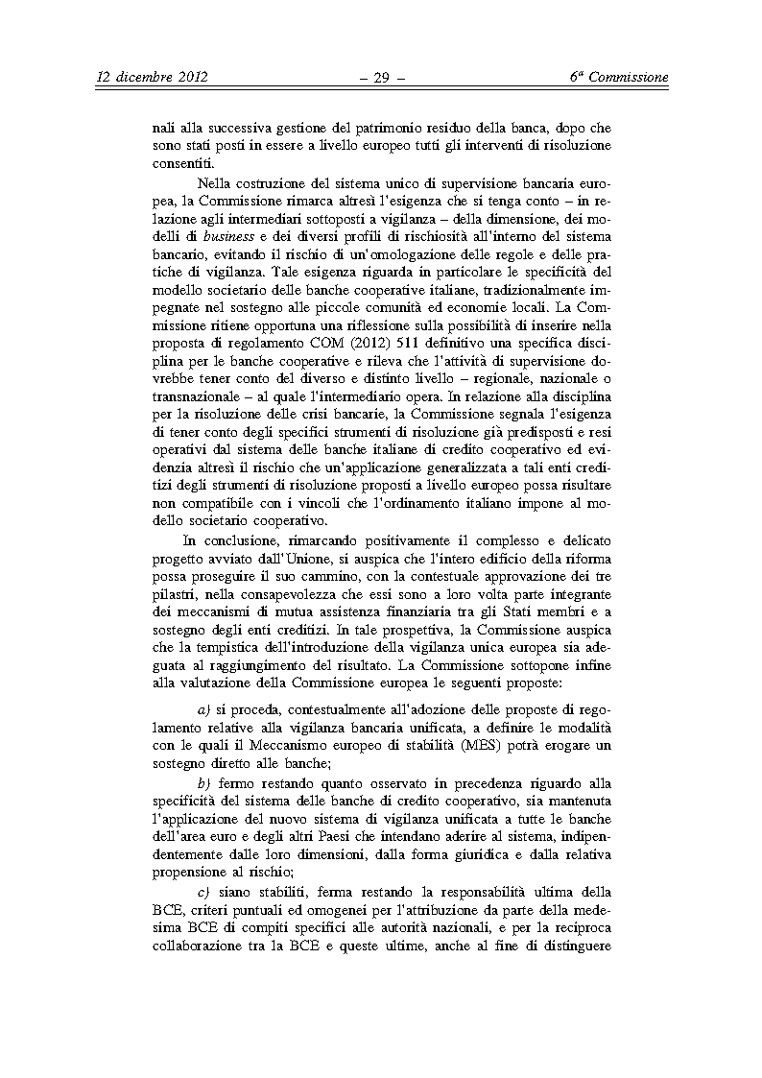
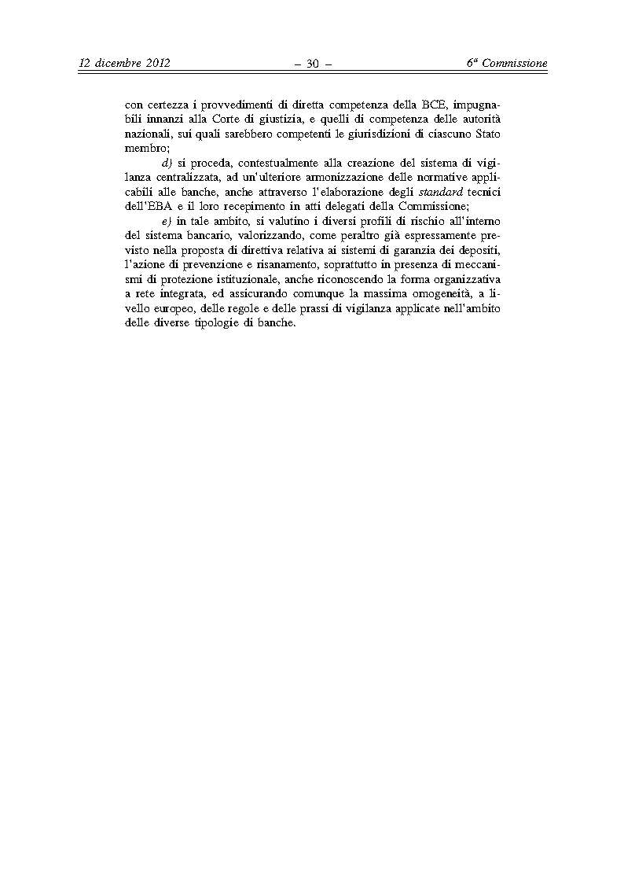

Translation(s) may be available in the Interparliamentary EU information exchange site IPEX at the following address: http://www.ipex.eu/IPEXL-WEB/search.do

