 | 
COUNCIL OF  THE EUROPEAN UNION |  |  | Brussels, 11 January 2013
 | Interinstitutional File:  2012/0299 (COD) |  | 5241/13
SOC 14
COMPET 12
DRS 7
CODEC 54
INST 22
PARLNAT 18

COVER NOTE
from: | The Senate of the Republic of Poland
date of receipt: | 10 January 2013
to: | The President of the Council of the European Union
Subject: | Proposal for a Directive of the European Parliament and of the Council on improving the gender balance among non-executive directors of companies listed on stock exchanges and related measures  [doc. 16433/12 SOC 943 COMPET 708 DRS 130 CODEC 2724 - COM(2012) 614 final]  - Opinion on the application of the Principles of Subsidiarity and Proportionality

Delegations will find attached the above mentioned opinion.

____________________

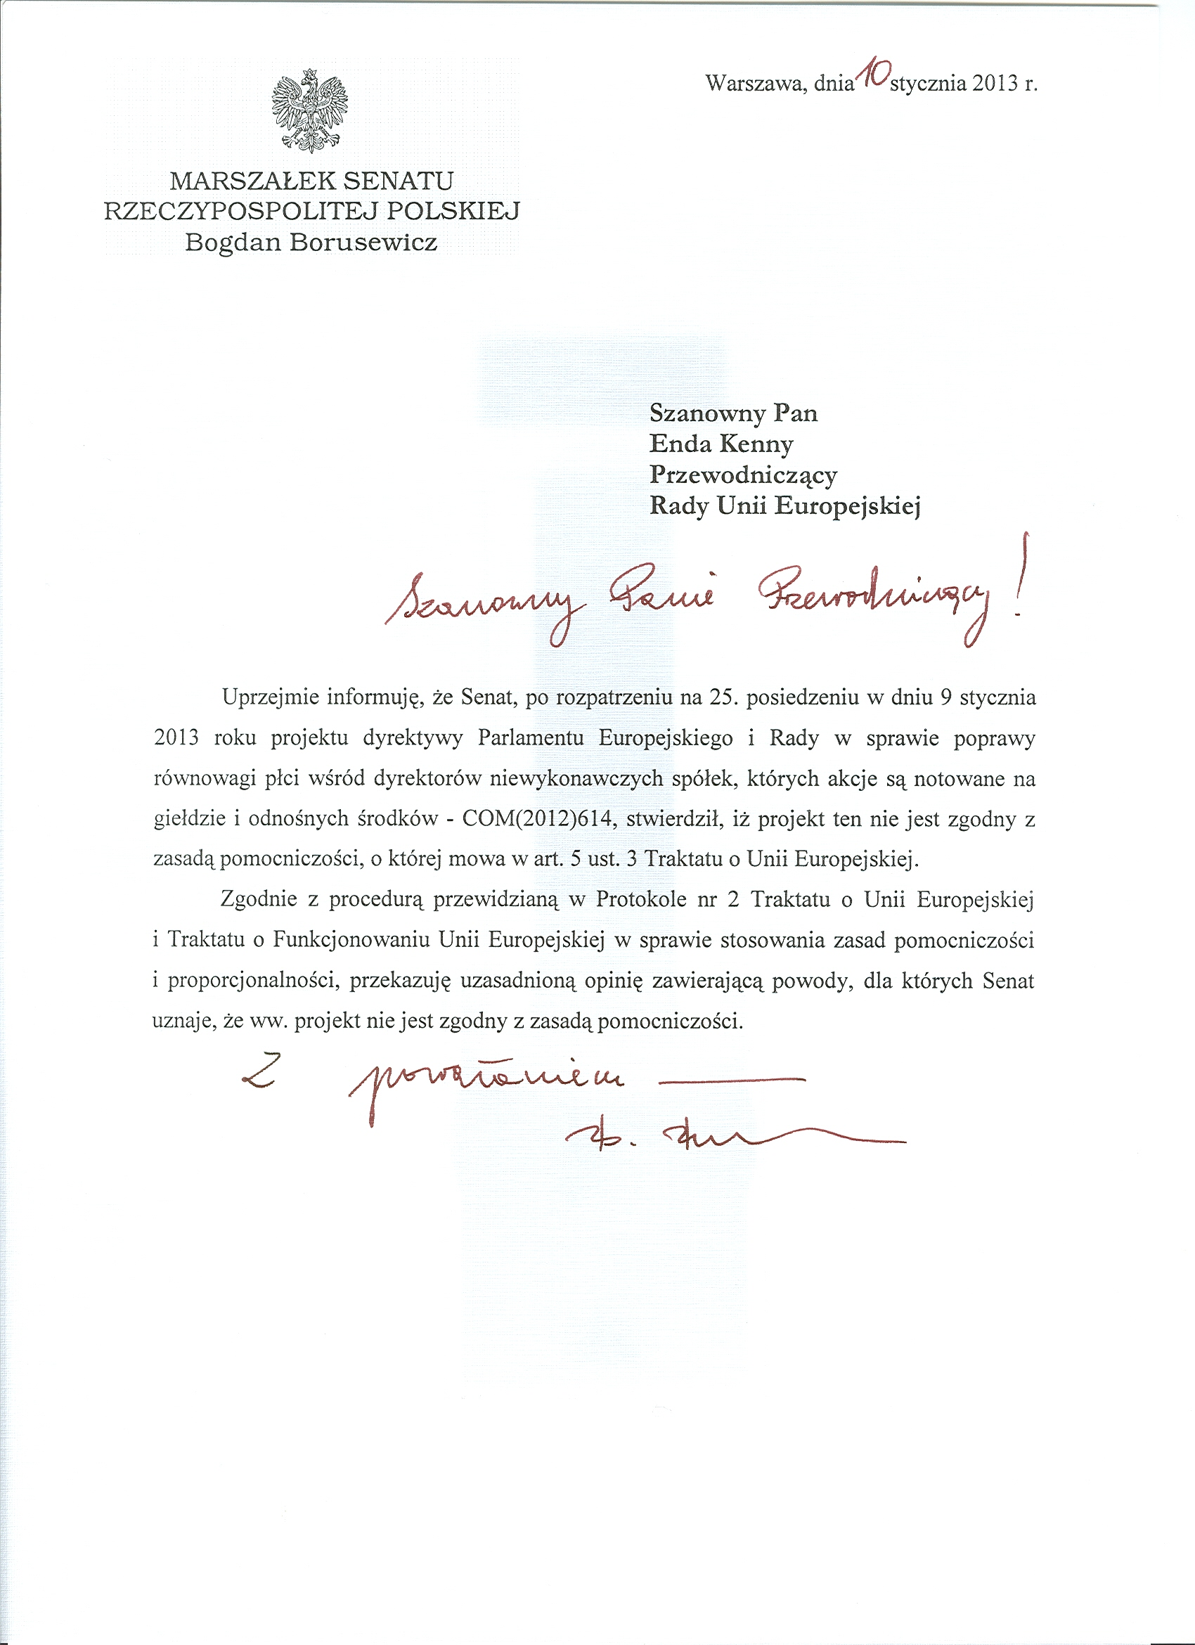
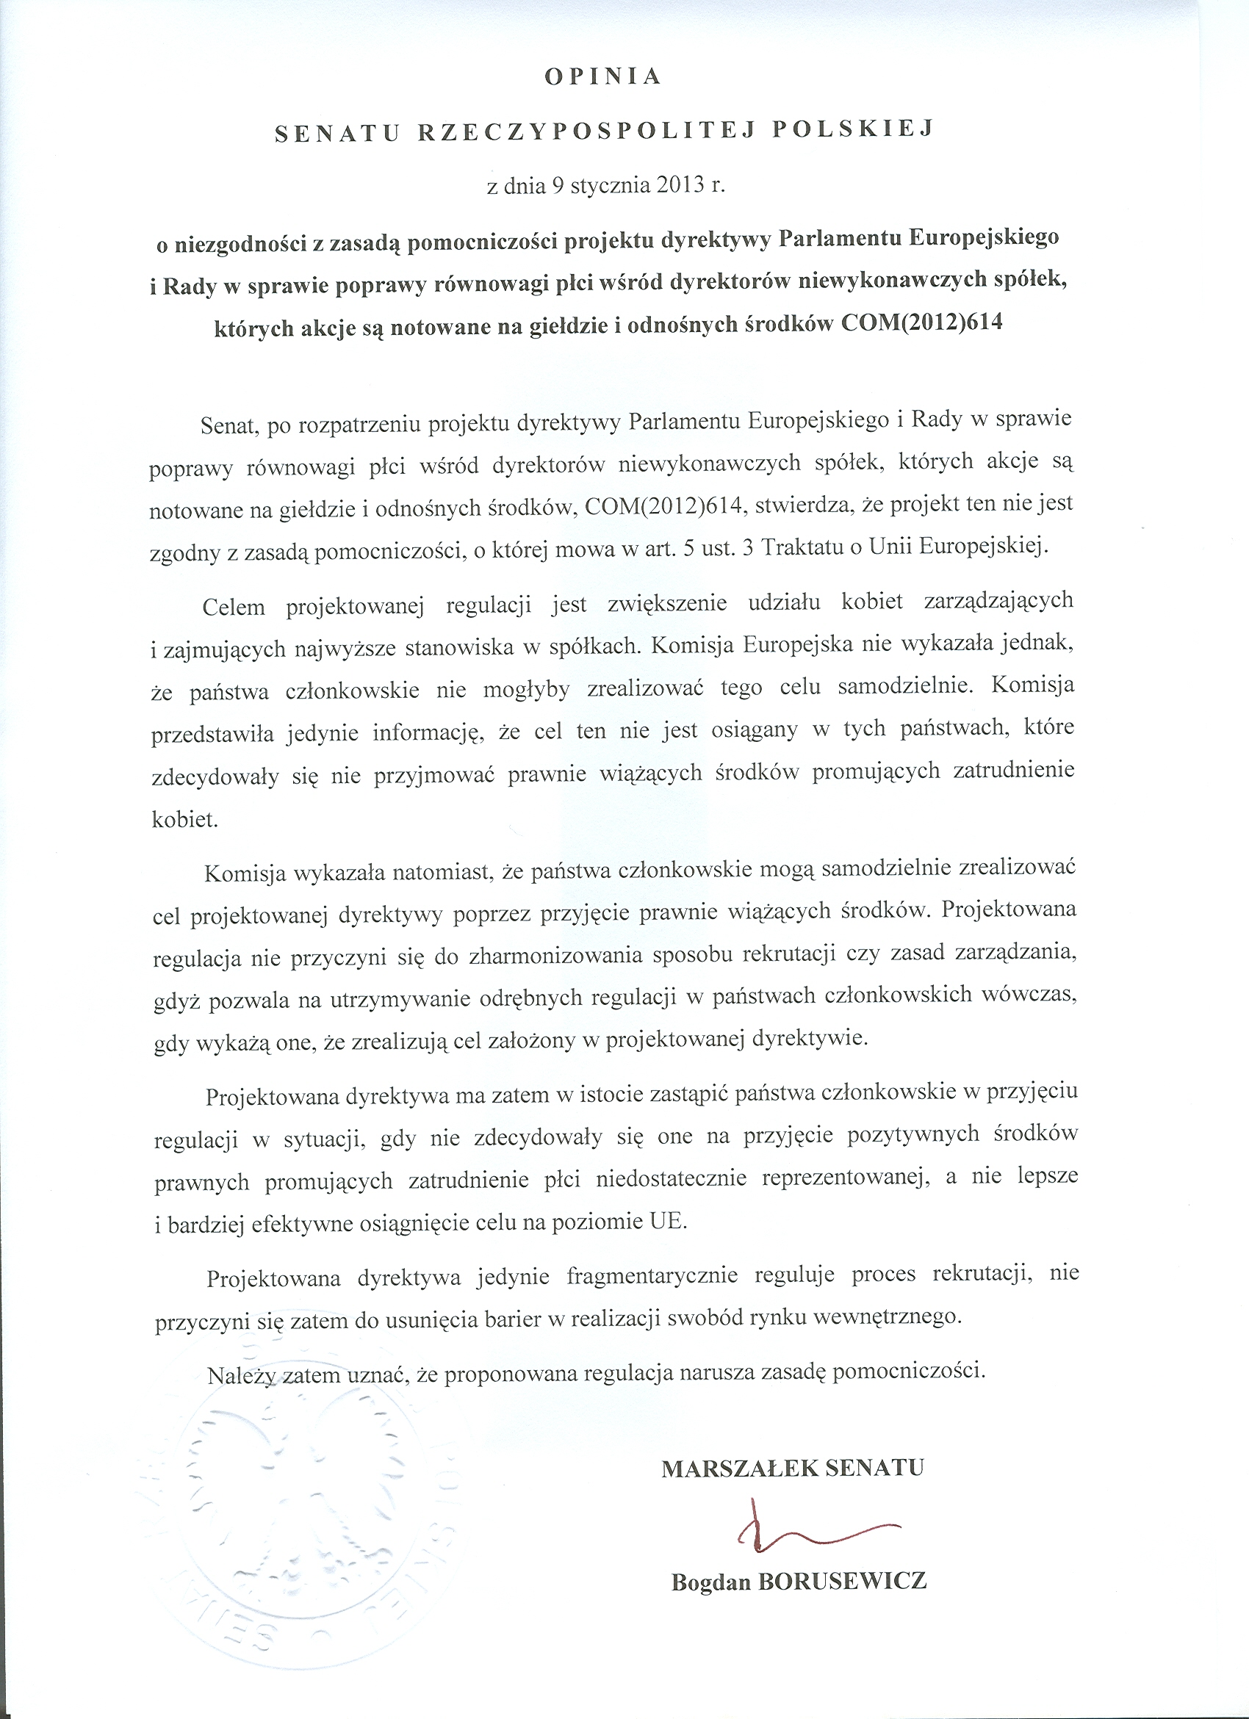

Courtesy translation

I would like to inform that the Senate, at the 25th session held on 9 January 2013, examined the proposal for a Directive of the European Parliament
and of the Council on improving the gender balance among non-executive directors of companies listed on stock exchanges and related measures - COM(2012)614 and decided that the proposal did not comply with the subsidiarity principle, referred to in Article 5 para. 3 of the Treaty on European Union.
Pursuant to the procedure provided for in Protocol No. 2 of the Treaty on European Union and the Treaty on the Functioning of the European Union as regards the application of the principles of subsidiarity and proportionality, I hereby submit the Senate’s justified opinion stating that the above proposal does not comply with the principle of subsidiarity.

Bogdan Borusewicz

Courtesy translation

OPINION
OF THE SENATE OF THE REPUBLIC OF POLAND
of 9th January 2013

on declaring the proposal for a Directive of the European Parliament
and of the Council on improving the gender balance among non-executive directors of companies listed on stock exchanges and related measures to be incompatible with
the principle of subsidiarity
COM(2012)614

Having considered the proposal for a Directive of the European Parliament and of the Council on improving the gender balance among non-executive directors of companies listed on stock exchanges and related measures (COM(2012) 614), the Senate declares that this proposal is incompatible with the principle of subsidiarity, as referred to in Article 5(3) of the Treaty on European Union.

1. The purpose of the proposed directive is to increase the presence of women holding managerial and other highest positions in companies. However, the European Commission failed to prove that the Member States would not be able to fulfil this objective on their own. The Commission only presented information that this objective has not been met in these Member States which decided not to adopt legally binding measures promoting women employment.

2. On the other hand, the Commission did demonstrate that Member States may independently meet the objective of the proposed directive by adopting legally binding measures. The proposed directive shall not contribute to harmonising the recruitment procedures or management principles since it allows Member States to keep in force separate national regulatory measures, provided that they prove that the objective set by the proposal will be met.

3. Therefore, rather than pursuing a better and more effective achievement of the objective at the EU level, the proposal is in effect aimed at substituting for legislation of those Member States, which do not decide to adopt positive legal measures to promote the under-represented sex .

4. The proposed directive regulates the recruitment process only in a fragmentary way, so it shall not contribute to removing the barriers to implementing internal market freedoms.

Therefore, it should be stated that the proposal is in breach of the principle of subsidiarity.

_____________________

For available translations of this opinion see the interparliamentary EU information exchange site (IPEX) at the following address: http://www.ipex.eu/IPEXL-WEB/search.do

