MERGEFORMAT
Delegations will find attached the above mentioned opinion.

Encl.:
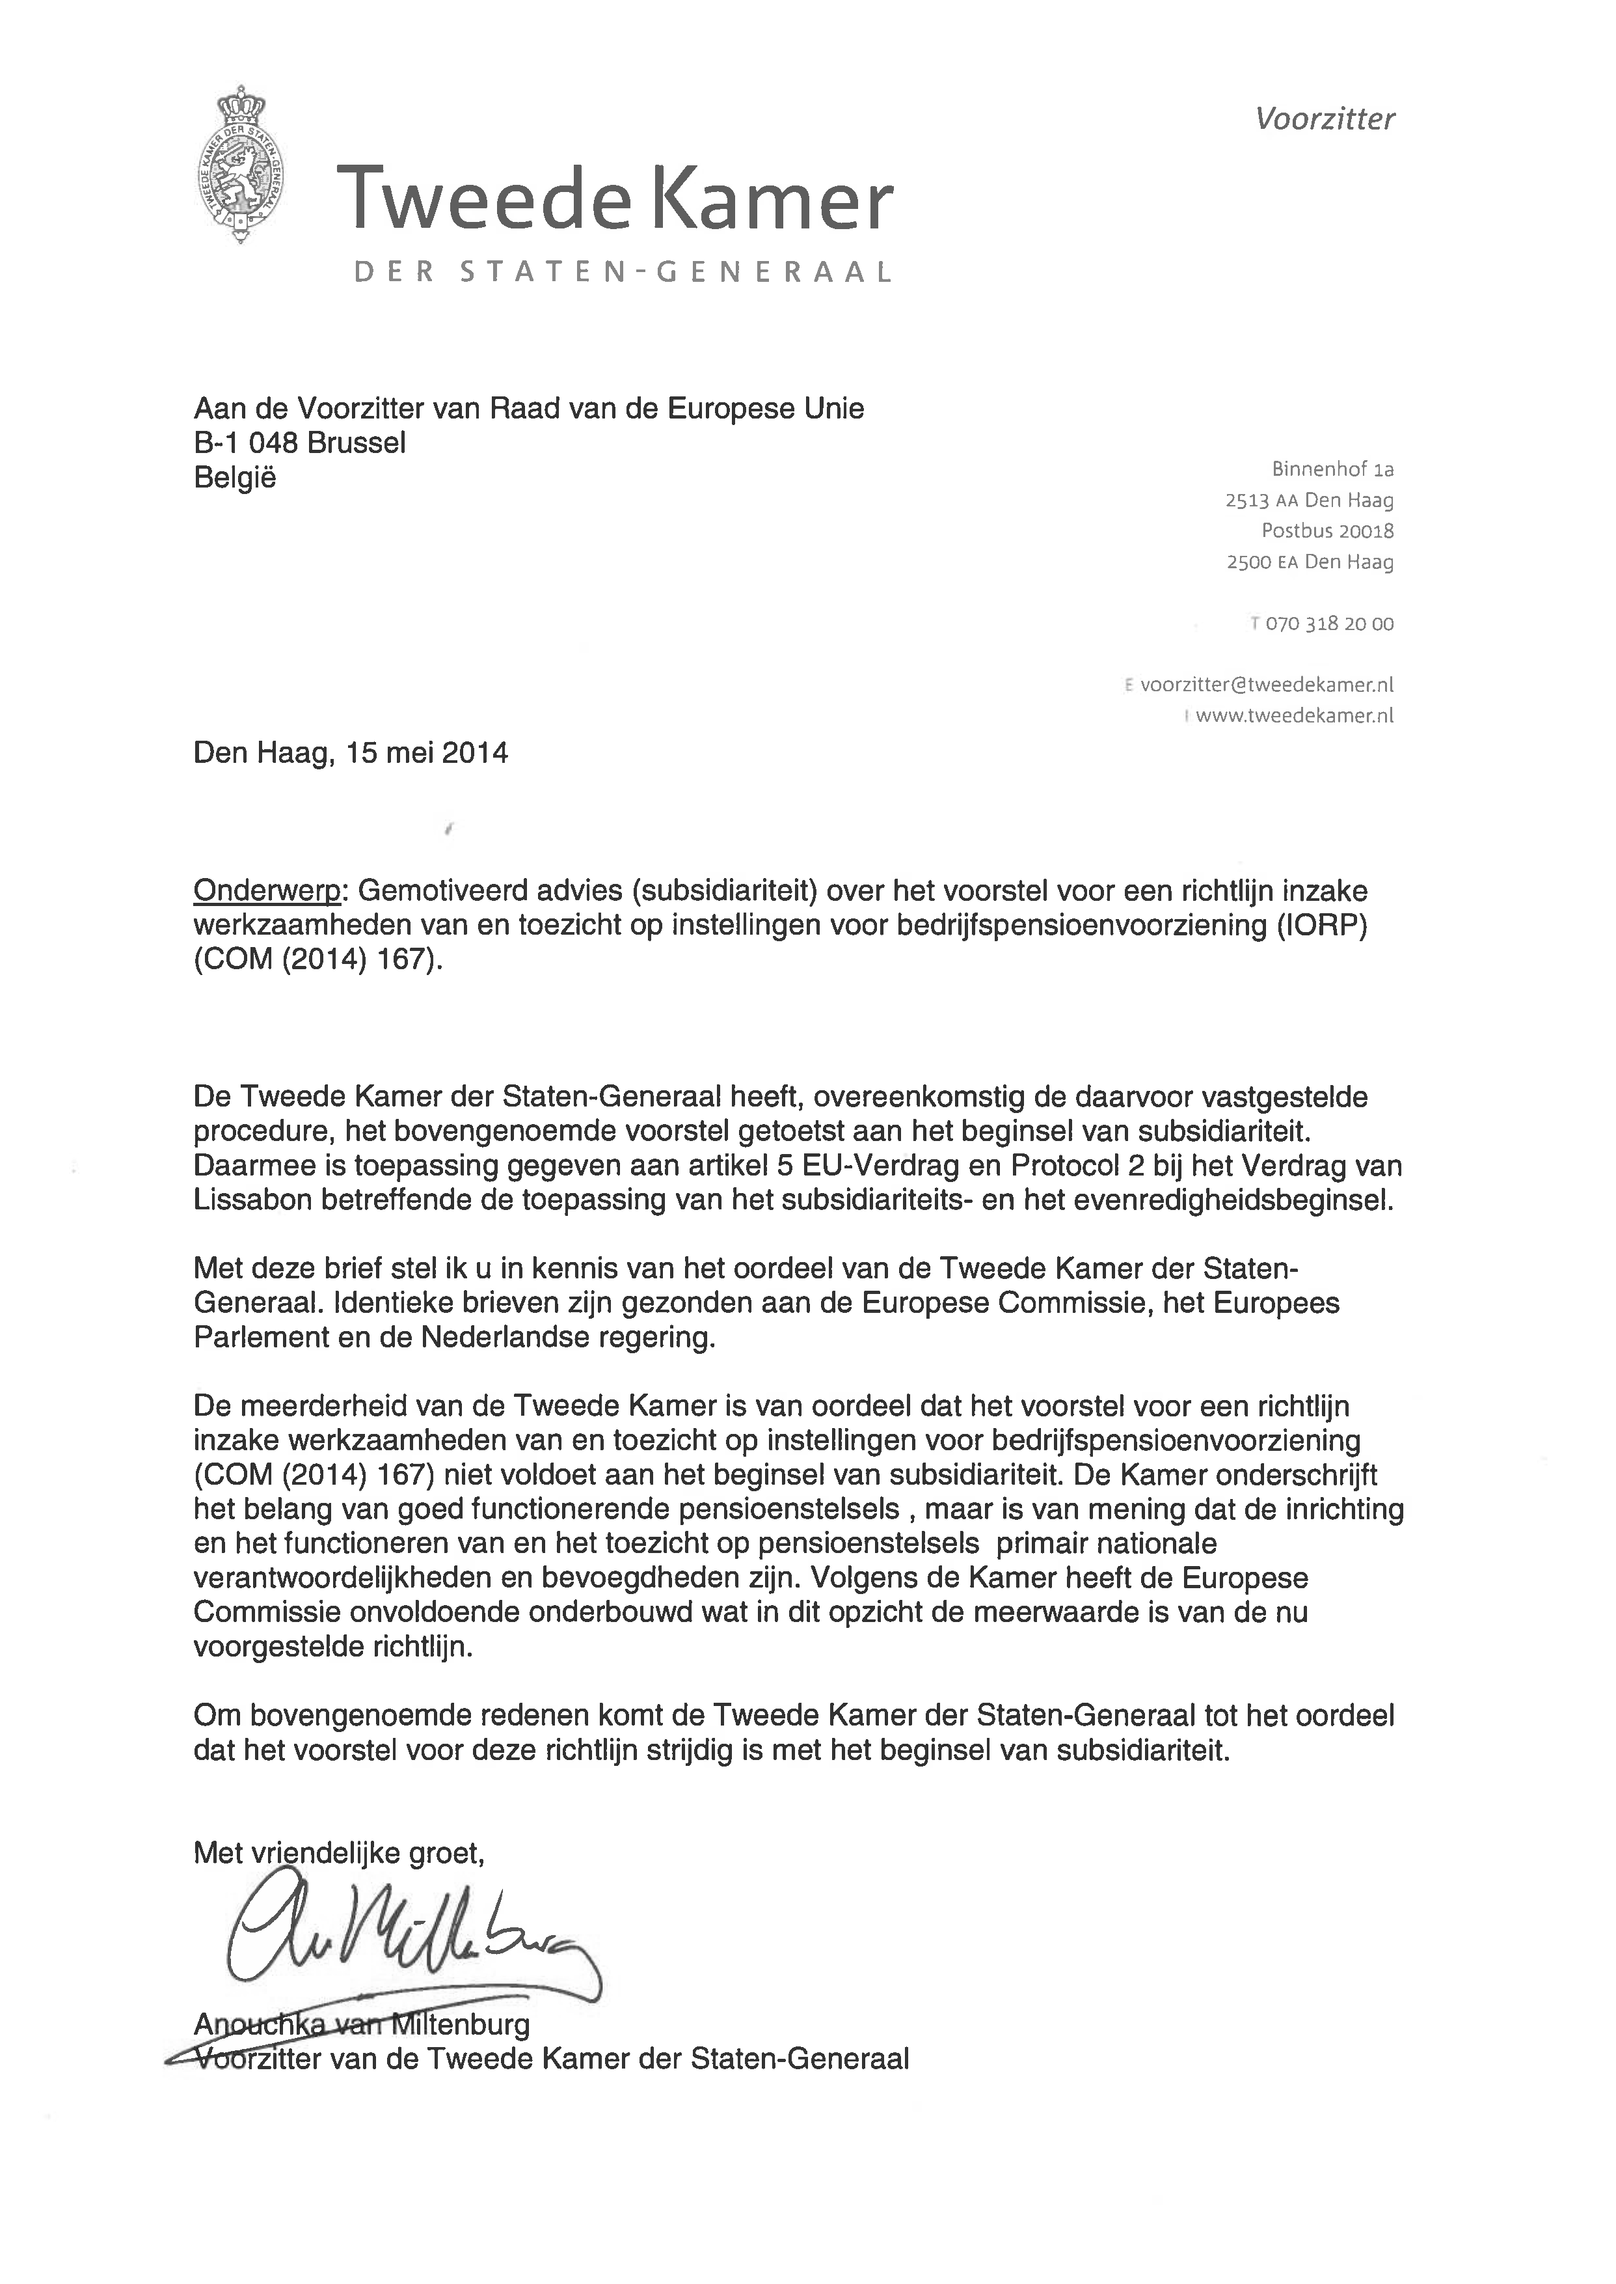

COURTESY TRANSLATION of letter to the President of the European Commission

The Hague, 15 May 2014
Subject:
Reasoned opinion (breach of subsidiarity) on the proposal for a directive on the activities and supervision of institutions for occupational retirement provision (COM (2014) 167).

In accordance with the applicable procedure, the House of Representatives of the States General in The Netherlands has assessed the proposal for a directive on the activities and supervision of institutions for occupational retirement provision on the basis of the principle of subsidiarity. As such, use was made of Article 5 of the EU Treaty and Protocol 2 of the Treaty on the Functioning of the European Union concerning the application of the principles of subsidiarity and proportionality.

This letter serves to inform you of the opinion of the House of Representatives of the States General. Identical letters have been sent to the European Parliament, the Council, and the Dutch government.

The majority of the House is of the opinion that the proposal for a directive on the activities and supervision of institutions for occupational retirement provision (COM (2014) 167) does not meet with the requirements of the subsidiarity principle.

The House endorses the importance of well functioning pension systems, but considers the design, functioning and supervision of pension systems to be primarily national responsibilities and competences.

According to the House, the European Commission fails to sufficiently justify the added value of the proposed directive in this respect.

For the aforementioned reasons, the House of Representatives of the States General considers the proposal to be inconsistent with the principle of subsidiarity.

Yours sincerely,

(signed)
Anouchka van Miltenburg
Speaker of the House of Representatives
of the States General

____________________

